Analysis of writing for communication at tertiary level in terms fluency, accuracy, lexical density and complexity

Abstract
This study explored and analyzed the EFL writing at tertiary level (university level) in Palestine. Therefore, the researcher analyzed fifty essays of Palestinian EFL students at the university level. The analysis was in terms of four writing measures: complexity, accuracy, fluency, and lexical density. For the sake of analysis, means, standard deviations, and Pearson’s Correlation Coefficient were used. The results showed that the students’ essays lacked accuracy, fluency, complexity, and lexical density. Further, the correlation between complexity and fluency was strong. However, the relationship between accuracy and fluency was weak. These results imply that the writing skill at tertiary level is low and unconvincing. Therefore, the researcher recommended improving fluency through power writing, accuracy through reading longer reading texts and avoids reading blogs, Facebook entries, and tweets, complexity through having more in class and home practice and activities, and lexical density through encouraging the students to read Wikipedia, news articles, fiction, and general prose. The decision makers, universities, curricula designers, and teacher are also advised to set plans, which pay more attention to writing and even prioritize witting as a must.
Keywords: accuracy; complexity; fluency; lexical density; tertiary

1. Introduction

Writing is a significant and essential productive skill, which is regarded as the pot of the other skills, i.e. listening, speaking, and reading. Through writing, learners can express their personality, develop critical and thinking skills, and foster mutual understanding and effective communication (Chappell, 2011). Maley (2009), Ariana (2010) and Walsh (2010) underscored the importance of the writing skill and considered it as one of the pivotal pillars and backbones of language learning. Accordingly, writing develops language at different levels like grammar, diction, morphology, syntax, pragmatics, and discourse. It is also an effective means of communication at the tertiary level since learners with well- rounded writing experience can communicate their ideas with their professors, and peers. More importantly, they can excel in writing memos, proposals, job interviews, emails, and projects. However, writing is difficult and requires more effort, knowledge, hard-work, and perseverance. Nunan (1989) said, “Learning to write fluently and expressively is the most difficult of the macroskills of all language users” (p.35). Similarly, Fareed, Ashraf and Bilal (2016) and Klimova (2013) claimed that although writing is an integral part of the development of an educated individual, it is difficult to master. That is, writing is a cumulative skill which develops over years of learning and teaching; therefore, considerable attention should be paid to the language education from the outset. Specifically, much focus should be placed on the basic criteria of effective writing in the areas of complexity, accuracy, fluency, and lexical density. These four standards of writing production provide proper measurement for the students’ writing development and open up our insights about how the students think and apply what they learn in writing (Lambert & Kormos, 2014; Skehan, 2009). Kim, Nam and Lee (2016) investigated the relationship between the development of L2 proficiency and complexity, accuracy, and fluency (CAF) for 130 Korean learners. They concluded that CAF develops alongside the development of L2 proficiency. Nishimara, Kawaguchi and Abe (2018) studied the relationship between fluency and complexity through analyzing 342 writing essays of Japanese EFl learners. They concluded that both fluency and complexity are intertwined. Similarly, Plakans, Gebril, and Biki (2016) investigated the correlation between fluency and complexity through analyzing 480 writing essays from TOEFL. They concluded that both complexity and fluency are significant, but fluency scored the highest predictor of writing proficiency. Wang and Slater (2016) studied the complexity of EFL Chinese students’ writing. They divided the students into non- major English and English proficient and were all asked to write personal statements. The results showed that the average length of sentences and clauses produced by EFL Chinese students is much lower compared to those of the English proficient users. Sato (2008) investigated the relationship between fluency and accuracy in writing classes at Japanese high schools. The students were divided into accuracy groups and fluency groups and were given the topic to write about for 30 minutes. The results showed that there was a weak correlation between fluency and accuracy. Accordingly, recommendations were highlighted to improve EFL writing teaching. Sayarif and Putri (2018) investigated the lexical density of Indonesian EFl learners. The researchers analyzed 30 research proposals presented by graduate students. The results showed that the EFL learners writing is less dense and that the students still have limited ability and knowledge about the language use in writing academic texts. Ha (2019) analyzed the writing tasks of 35 undergraduate students from a Korean women’s university in Seoul. The analysis of the correlation showed that the use of lexical diversity, sophistication, and fluency affects writing quality. It also concluded that students can develop writing skills if they use familiar and appropriate vocabulary with a variety of functions.
In Palestine, the writing skill of the students is extremely substandard and unconvincing. More specifically, they have problems with, fluency, accuracy, complexity, and lexical density. To explore this problem, the researcher uses T-units to measure complexity and accuracy. For complexity, T- units are defined as the number of independent clauses and the dependent clauses attached to them. In this respect-units are regarded as one of the most productive units (Myllari,
2020; Foster, Tonkyn, Wigglesworth,2000; Ortega, 2003; Wolfe-Quintero, Inagaki, Kim, 1998; Hunt, 1970). For accuracy, T-units are defined as the proportion error free clauses to all clauses (Ahmedi & Meihami, 2017; Ellis & Barkhuizen, 2005; Wigglesworth & Storch, 2009). For fluency, it is defined as “nativeness, standardness, length, ease of reading, idomaticity” (Tarone, Downing, Cohen, Gillette, Murie, Dailey, 1993, p. 170). Therefore, Wigglesworth & Storch, 2009 suggested measuring fluency using the average number of words per text. That is, they wanted to figure how much the students can produce regarding length and the flow of words naturally. For lexical density, it shows us how much the text is informative. It contains the content words like nouns, verbs, adjectives, and adverbs. Therefore, the lexical density is computed through dividing the total number of the lexical words by the total number of words in a text (Johnson, 2008; Ure, 1971).
1.1 Purpose and significance of the study
This study aimed to explore the writing skill of the university students in Palestine. The results will help universities, decision makers, curricula designers, and teachers to set plans for improving the unconvincing writing level at the university level.
1.2 Questions of the study
The following questions are the focus of this study:
- How complex are the students’ sentences?
- How accurate are the students’ sentences?
- How fluent are the students in writing essays?
- Are the students’ texts lexically dense?
-Is fluency linked to complexity?
- What is the correlation between fluency and accuracy?
2. Methodology and methods
This study aimed to explore and analyze the writing skill of the students at tertiary level. This analysis and exploration address the basic pillars of the writing skill, namely, complexity, accuracy, fluency and lexical density constructs. The following questions are the focus of this study:
- How complex are the students’ sentences?
- How accurate are the students’ sentences?
- How fluent are the students in writing essays?
- Are the students’ texts lexically dense?
-Is fluency linked to complexity?
- What is the correlation between fluency and accuracy?
This study was conducted at the English Language Centers (ELCs) at two universities in Palestine.The sample of study consisted of 50 students, whose level of English was B1 according to CEFR. These students were asked to write at least a three paragraph essay about one of the following topics: "Tourism' or " Bicycles" of no less than 150 words. The assigned time was 50 minutes. In the session, the students were given the directions that their final writing draft will be graded in terms of complexity, accuracy, fluency and lexical density. To analyze the sample performance and production, the researcher followed certain procedures. In measuring complexity, the T-units (main clause plus subordinate clause and non-clausal structures) were counted divided by the total number of the whole group. For accuracy, grammatically error – free T-units were calculated divided by the total number of T-units. For fluency, the total number of words per text was calculated. For lexical density, adjectives and adverbs were counted divided by the total group number (15).
3. Results
After analyzing the essays of the sample, the researcher did some mathematics and statistics, and came up with some quantitative results, which he organized in tables and graphs below:
3.1. Complexity
- The students were able to produce 239 complex sentences. The total mean is 15.93 as shown in Table 1.

Table (1)
Number and mean of complex sentences
SD | Mean | T- units | N
3.88 | 15.93 | 239 | 50
.
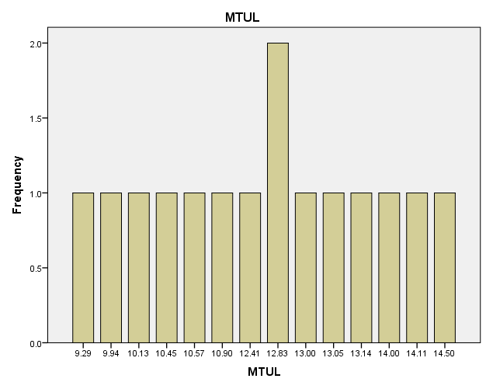

3.2 Accuracy
Almost half of the sample’s sentences were accurate. That is, many mistakes were made regarding grammar, spelling and mechanics as shown in Table 2.
Table (2)
Mean of accurate sentences
SD | Mean | N
0.13 | 0.53 | 50

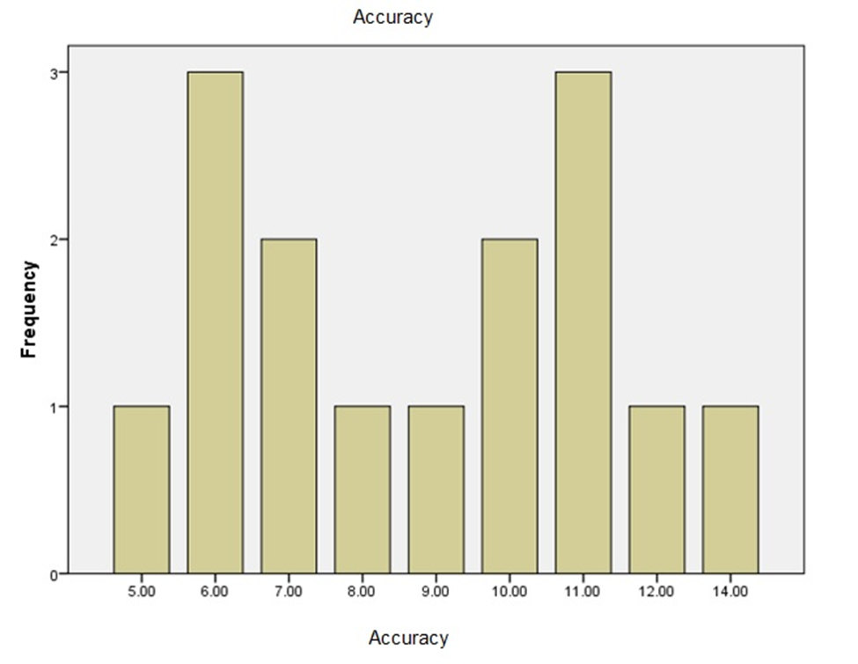

3.3 Fluency
The mean of the total words of all the sample’s essays was 189.8. This means some essays were extremely less than 189.8 or a little bit higher. Therefore, the students were not fluent in writing as shown in Table 3.
Table (3)
Fluency rate of students’ essays
SD | Mean | Total N. of words | N
40.48 | 189.8 | 2847 | 50

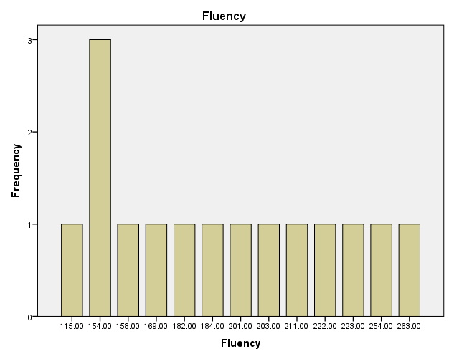

4. Lexical density
- The students’ essays were less lexically dense. That is, the total number of content words is 1616 out of 2847 as shown in Table 4.
Table (4)
The density of the essays
SD | Mean | Number | Lexical items
11.78 | 59.87 | 898 | Nouns
8.69 | 24.80 | 372 | Verbs
6.01 | 19.80 | 297 | Adjectives
2.79 | 3.27 | 49 | Adverbs

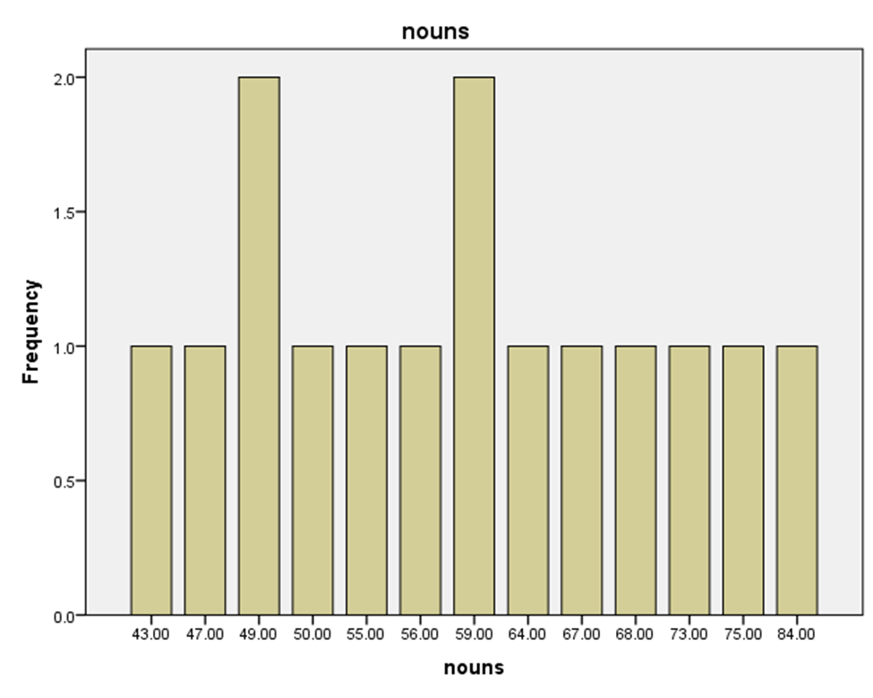
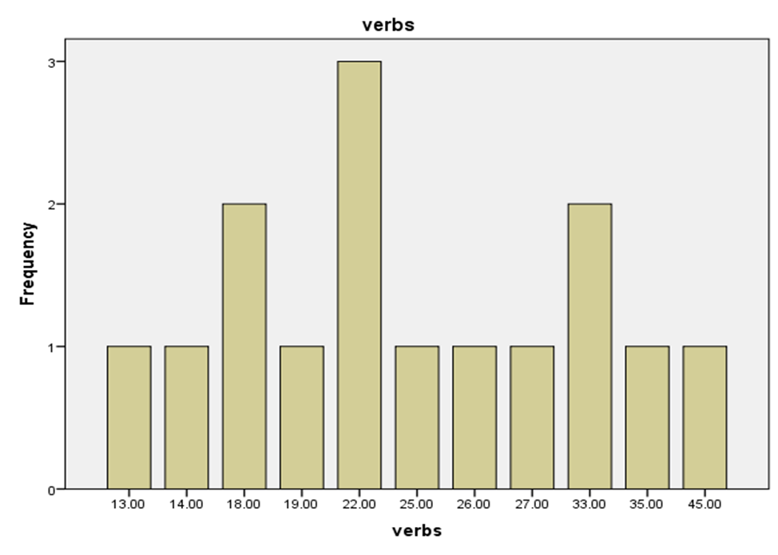
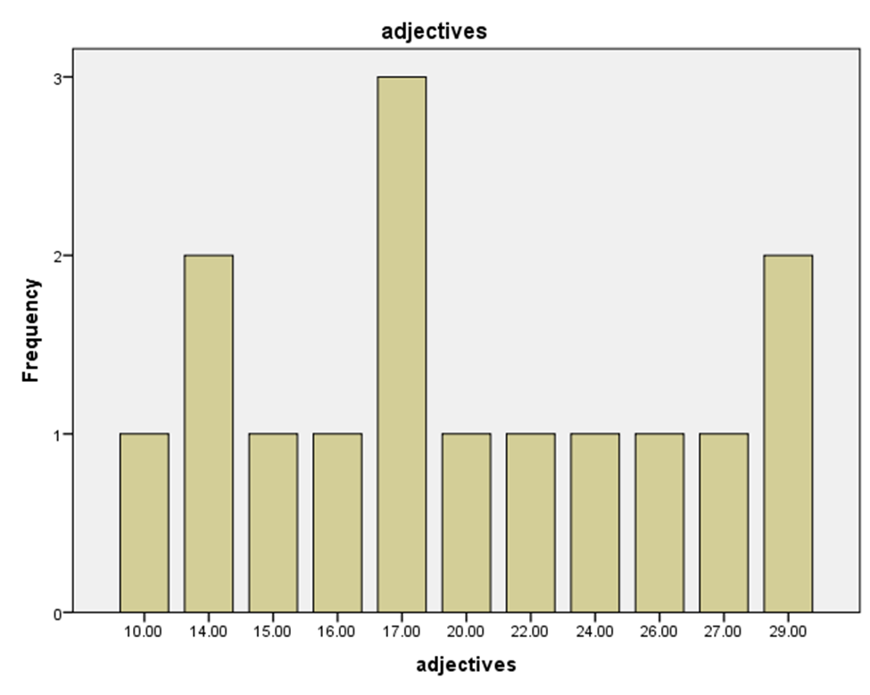

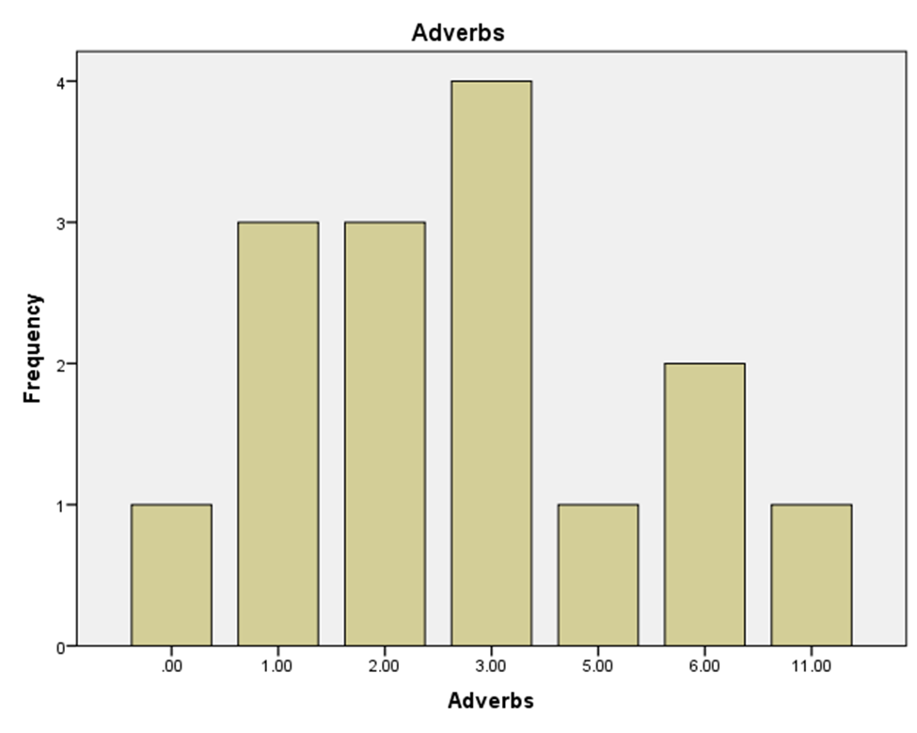
5. Fluency and complexity correlation
- There is a strong relationship between fluency and complexity as shown in
Table 5.
Table (5)
Pearson's correlation | N
.806 | 50

Correlation is significant at the 0.05 level

6. Fluency and accuracy correlation
- The correlation between fluency and accuracy is weak as shown in Table 6.
Table (6)
Pearson's correlation | N
.419 | 50

Correlation is significant at the 0.05 level

4. Discussion
The first result answers the first question, which is “How complex are the students’ sentences?” That is to say, Palestinian students at tertiary level produced 239 complex sentences, the mean of which is 15.93 out of the whole writing tasks. This means that the students failed to develop their ideas, lacked the grammatical competence needed for writing, and did not extend their ideas or make them more detailed and precise. IELTS (2015) confirmed that complex sentences are essential for writing essays since they support, explain and extended the main ideas. In addition, complex sentences are needed because they establish relationships between cause and effect, contrast, and time relationship. They also show the development of the students’ advanced grammatical proficiency since the number of complex sentences is an important indicator (Tsang & Wongo, 2000; Canhyono, Mukminatien & Amrina, 2016; Rayan, 2018).
The second result answers the second question, which is “How accurate are the students’ sentences?” Specifically speaking, the students’ sentences were not as accurate as stated by the studies about the importance of writing accuracy. That is, almost half the number of the produced sentences was grammatically inaccurate, i.e. the students made mistakes regarding spelling, structure, and mechanics. To produce an efficient and readable written work, the students should constantly improve their grammatical accuracy ( Baleghizadel & Gordani, 2012). Celce – Muricia (1991) Leki and Carson(1997) emphasized that the high frequency of inaccurate and ungrammatical sentences make the writing task unacceptable from university students. They even stated that 7.2 inaccurate words out of 100 would make writing unacceptable. Therefore, they suggested providing the student with the due linguistic and writing skills to make their writing intelligible and informative.
The third result answers the third question, which is “How fluent are the students in writing essays?”
That is, the whole sample produced 2847 words, the mean of which is 189.8. The highest number of words was 263, and the lowest was 115. This means there was a fluctuation in the sample’s fluency and the students’ writing fluency is low since the essay length should be 300- 1000 words for high school students and 200- 650 words to college students (Shona, 2019). Lack of writing fluency means that the students devote much time to form individual words, which digress focus to other things away from conveying their thoughts ( Rayan, 2014; Fisher, 2003). In addition, fluent writing is more enjoyable, logically organized and intelligible ( Shreiner). This result agrees with Sayarif and Putri (2018) and Ha (2019).

The fourth result answers the fourth question, which is “Are the students’ texts lexically dense?”
More specifically, the students’ essays were less lexically dense. That is, the total number of content words is 1616 out of 2847. Opposed to function words, lexical words (nouns, verbs, adjectives, and adverbs) provide more information about the text. The more lexically dense, the more informative the text will be. There should be high percentage of lexical density ( Didau, 2013; Johansson, 2008; Ure, 1971). Therefore, as a result of the lack of lexical density, the sample’s essays are less informative.
The fifth result answers the fifth question, which is “Is fluency linked to complexity?”
That is, there is a strong relationship between fluency and complexity. Using Pearson’s Correlation Coefficient, the researcher concluded that the correlation between fluency and complexity is significant since it was .806. That is to say, the more word count the essay has, the more complex sentence will be produced. This result agrees with the studies of Wang and Slater (2016), Kawaguchi,Nishimura, and Abe (2018), and Plakans, Gebril, and Biki (2018).
The sixth result answers the sixth question, which is “What is the correlation between fluency and accuracy?” More profoundly, the statistical analysis by using Pearson’s Correlation Coefficient showed that the correlation between fluency and accuracy was not significant since it was .419. This means that the relationship between accuracy and fluency is weak. This implies that students, who have are fluent in writing may have problems with accuracy and vice versa. This result agrees with Sato (2008).
5. Conclusions
This study explored the EFL writing at tertiary level in Palestine in terms of complexity, accuracy, fluency, and lexical density. The researcher used the means and standard deviations to explore how much the students’ writing is complex, accurate, fluent, and lexically dense. Consequently, the researcher concluded that the students’ level in writing is unstable and unconvincing; their essays lacked accuracy, fluency, complexity, and density.
To investigate the correlation between complexity and fluency on the one hand and accuracy and fluency on the other, the researcher used Pearson’s Correlation Coefficient. Thus, he concluded that the correlation between complexity and fluency is strong. That is, the students should write more to achieve more complex sentences. However, the correlation between accuracy and fluency is weak. Therefore, the students should be trained and have more practice on writing fluent and accurate essays if they wish to fully convey their message and make their writing more informative.
This study is the first to tackle this writing issue and provides insights for the decision makers to amend the present writing practices and approaches.
6. Recommendations
To improve the writing skill at the tertiary level (university level), the researcher recommends the following:
- To improve writing fluency, the students can practice power writing, in which they write about a certain term or question for one minute and then they count the words and circle the errors they notice.
- For lexical density, the students can be encouraged to read topics from Wikipedia, news articles, fiction, and general prose.
- The students can write more accurately if they read more academic essays and longer passages. They should avoid reading tweets, Facebook entries, and blog posts, which are regarded as sources of errors.
- To write complex sentences, the students should be given more practice on how to write different types of sentences: simple, compound, and complex. That is, simple sentences should have subject verb agreement; compound sentences should include coordinators; complex sentences should have subordinators, main clauses and subordinate clauses. Therefore, more in class and home practice should be involved.
- The decision makers should design the curricula, which prioritize writing and its basic components.

References
Ahmedi, A. & Meihami, H. (2017). The development of complexity, accuracy, and fluency in ESL learners’’ writing: A dynamic systems theory. XLinguae Journal, 3/10.
Ariana, S. M. (2010). Some thoughts on writing skills. Annals of Faculty of Economics, 1 (1), 127-133.
Baleghizadel, S. & Gordani, Y. (2012). Academic Writing and Grammatical Accuracy: The Role of Corrective Feedback. Gist Education and Learning Research Journal, 6, 159- 176.
Cahyono, B. Y., Mukminatien, N. & Amrina, R. (2016). Indonesian students’ writing proficiency and their ability in using complex sentences. International Journal on Studies in English Language and Literature (IJSELL), 4/ 9, 22-32.
Celce-Murcia, M. (1991). Grammar pedagogy in second and foreign language teaching. TESOL quarterly, 25 / 3, 459-480.
Chappell, V. (2011). What makes writing so important? Retrieved December 27, 2012, from http://www.marquette.edu/wac/.
Didau, D. (2013), Black space: improving writing by increasing lexical density. Retrieved from https://learningspy.co.uk/writing/black-space-increasing-lexical-density.
Ellis, R. & Barkhuizen, G. (2005). Analyzing learner language. Oxford University Press.
Fareed, M., Ashraf, A. & Bilal, M. (2016) . ESL learners' writing skills: problems, factors and suggestions. Journal of Education & Social Sciences, 4/2, 81-92. DOI: 10.20547/jess0421604201.
Fisher, D. & Frey, N. (2003) . Writing instruction for struggling adolescent readers: a gradual release model. Journal of Adolescent & adult Literacy 46 / 5, 398 -405.
Foster, P., Tonkyn A., & Wigglesworth G. (2000). Measuring spoken language: A unit for all reasons. Applied Linguistics, 21 (3), 354–375. DOI: https://doi.org/10.1093/applin/21.3.354.
Ha, S. H. (2019). Lexical richness in EFL undergraduate students’ academic writing. English Teaching, 74/ 3.DOI: 10.15858/engtea.74.3.20190.
Hunt, K., W. (1970). Do Sentences in the Second Language Grow Like Those in the First? TESOL Quarterly, 4/3, 195–202.
IELTS, (2015). IELTS Writing- How To Write a Complex Sentence. Retrieved from https://www.ieltsadvantage.com/2015/03/27/ielts-writing-complex-sentence/.
Johnson, V. (2008), Lexical diversity and lexical density in speech and writing: a developmental perspective, Working Papers 53, 61-79.
Kim, Y., Nam, S. & Lee, S. Y. (2016). Correlation of proficiency with complexity, accuracy, and fluency in spoken and written production: evidence from L2 Korean. Journal of the National Council of Less Commonly Taught Languages, 19, 147-181.
Klimova, B. F. (2013). The importance of writing. PARIPEX-INDIAN JOURNAL OF RESEARCH, 2/ 1, 9-11.
Lambert, C. & Kormos J. (2014). Complexity, Accuracy, and Fluency in Task-Based L2 Research: Toward More Developmentally Based Measures of Second Language Acquisition. Applied Linguistics, 35 / 5, 607-614. DOI: 10.1093/applin/amu047.
Leki, I., & Carson, J. (1997). “ Completely Different Worlds”: EAP and the Writing Experiences of ESL Students in University Courses. TESOL quarterly, 31 / 1, 39-69.
Maley, A. (2009). ELF: a teacher's perspective. Language and Intercultural Communication, 9:3, 187-200, DOI: 10.1080/14708470902748848.
Mylläri, T. (2020). Words, clauses, sentences, and T-units in learner language: Precise and objective units of measure? Journal of the European Second Language Association, 4 / 1, 13–23. DOI: http://doi.org/10.22599/jesla.63.
Nishimara, Y., Kawaguchi, Y. & Abe, D. (2018). The relationship between complexity and fluency in L2 writing: An approach using network analysis. Retrieved from https://www.researchgate.net/publication/330182241_The_relationship_betweencomplexity_and_fluency_in_L2_writing_An_approach_using_network_analysis.
Nunan, D. (1989). Designing tasks for the communicative classroom. Cambridge University Press, United Kingdom.
Ortega, L. (2003). Syntactic complexity measures and their relationship to L2 proficiency: A research synthesis of college-level L2 writing. Applied Linguistics, 24/ 4, 492-518. DOI: https://doi.org/10.1093/applin/24.4.492.
Plakans, L., Gebril, A., & Bilki, Z. (2016). Shaping a score: Complexity, accuracy, and fluency in integrated writing performances. SAGE Journals,36 (2), 161- 179. https://doi.org/10.1177/0265532216669537.
Rayan, A. P. ( 2018). Complexity vs. simplicity: English should not be taught like any other subject but as a life skill. Retrieved from https://www.edexlive.com/opinion/2018/oct/03/complexity-vs-simplicity-4056.html Language.
Sato, R. (2008). The relationship between fluency and accuracy in writing. ARELE, 19, 71-80.
https://doi.org/10.20581/arele.19.0_71.
Shreiner, E. How to Improve Writing Fluency. Retrieved from https://www.theclassroom.com/fifth-grade-writing-fluency-activities-38232.html.
Skehan, P. (2009). Modeling second language performance: Integrating complexity, accuracy, fluency, and lexis. Applied Linguistics, 30/4, 510-532.
Shona, M. (2019). How long is an essay? Retrieved from https://www.scribbr.com/academic-essay/length/.
Sayarif, H. & Putri, R. E. (2018). How lexical density reveals students’ ability in writing academic text. Lingua Didaktika,12 / 2, 86 -94.
Tarone, E. Downing, B., Cohen, A., Gillette, S., Murie, R. & Dailey, B. (1993). The writing of southeast Asian-American students in secondary school and university. Journal of Second Language Writing, 2/2, 149-172.
Tsang, W.K., & Wong, M. (2000). Giving grammar the place it deserves in process writing. Prospect, 15, 34-45.
Ure, J. (1971), Lexical density and register differentiation. In G. Perren and J.L.M. Trim (eds), Applications of Linguistics (pp.443 – 452). London: Cambridge University Press.
Walsh, K. (2010). The importance of writing skills: Online tools to encourage success. |Retrieved December 27, 2012, from http://www.emergingedtech.
Wang, S. & Slater, T. (2016).Syntactic complexity of EFL Chinese students’ Writing. English Language and Literature Studies, 6 /1, 81-86.
Wigglesworth, G. – Storch, N. (2009). Pair versus individual writing: Effects on fluency, complexity and accuracy. Language Testing, 26/3, 445-466.
Wolfe-Quintero, K., Inagaki, S., & Kim, H. (1998). Second language development in writing: Measures of fluency, accuracy, and complexity. Technical report No. 1. Honolulu: Second Language Teaching and Curriculum Center.

.

