IMPROVEMENT, UPGRADE, AND DEVELOPMENT OF ROBOTS FOR THE "ROBOT 2025 – WINNING FAITH" COMPETITION

Nguyễn Văn Lâm¹, Nguyễn Thị Lan Hương^{2*}
¹Faculty of Mechanical and Electrical Engineering, Hanoi Industry and Trade University
²Faculty of Mechanical and Electrical Engineering, Hanoi Industry and Trade University
ABSTRACT: In the era of Industry 4.0, integrating robotics into academic environments plays a pivotal role in fostering engineering mindsets among students. This paper presents the research, design, and improvement of a cooperative robotic system-comprising an autonomous robot (AR) and a manual robot (MR)-engineered to satisfy the rigorous technical requirements of the "Robot 2025 - Winning Faith" competition. The study primarily focuses on mechanical structure optimization, the integration of an intelligent control system based on the Arduino Mega 2560 platform, and solving complex problems regarding line tracking and automated target aiming and firing. Empirical results demonstrate that the upgraded robotic system achieves high operational stability, structural flexibility, and fully satisfies the competition's strict technical benchmarks
Keywords: Autonomous robot, manual robot, arduino mega 2560, automated control, laser sensor, robot competition
INTRODUCTION
The "Robot 2025 – Winning Faith" competition held at Hanoi Industrial Textile Garment University serves as a critical technological platform, stimulating creativity and practical problem-solving skills among engineering students. This competition marks a significant paradigm shift in educational philosophy: transitioning from operating basic "demonstration" models to solving complex, integrated engineering problems encountered in real-world industrial systems.
For the autonomous robot (AR), the core challenge extends far beyond basic line tracking; it requires the optimization of real-time control algorithms (Rubio et al., 2019). Students are required to implement Proportional-Integral-Derivative (PID) or Proportional (P) control schemes to ensure high trajectory precision while simultaneously resolving sensor fusion problems for target detection. Furthermore, the design of the firing mechanism is no longer a matter of trial-and-error assembly. Instead, it demands rigorous kinematic calculations regarding ballistic trajectories, spring compression forces, and structural chassis rigidity. The optimization of robotic efficiency depends heavily on the synergy between agile hardware and intelligent algorithms (Mac et al., 2016). This competition provides an ideal environment for students to engage with modern machine design principles, where even the slightest geometric or algorithmic tolerance directly impacts operational performance.
Regarding the manual robot (MR), the research emphasizes the optimization of the Human-Machine Interface (HMI). The MR must be optimized in terms of motor gear ratios, joint durability, and gripping mechanism flexibility. The deployment of Mecanum wheels enables omnidirectional mobility, representing a sophisticated control system challenge that demands synchronous processing of wireless control signals transmitted from a PS2 controller to the respective motor drivers. The technical objective is to engineer a robust system capable of enduring continuous working loads throughout the match without experiencing wireless signal dropouts or mechanical fatigue.
The engineered robots are developed not merely as isolated equipment upgrade projects, but through a comprehensive systems engineering workflow: spanning requirement analysis, Computer-Aided Design (CAD) modeling, structural chassis fabrication, embedded control programming, and empirical field testing. The prototypes were systematically upgraded from baseline architectures into professional systems capable of executing complex tasks. These tasks include autonomous line-following, target detection, and automated firing for the AR, alongside precise picking and placing operations for the MR. Through this comprehensive lifecycle, students develop systematic thinking-a vital attribute for engineers in the Industry 4.0 era. This methodology effectively bridges the gap between theoretical lecture halls and industrial production, transforming textbook concepts into highly applicable technological solutions.
METHODOLOGY & DESIGN
Research methodology
The research methodology is executed through an optimal synthesis of fundamental engineering theory and rigorous empirical validation, structured as follows:
Theoretical framework: Comprehensive literature reviews in science and engineering serve as the foundation for system design. Closed-loop and open-loop control principles, proportional control algorithms, and Pulse Width Modulation (PWM) speed regulation techniques are thoroughly investigated to implement precise line-tracking behaviors based on real-time sensor telemetry. The architecture fuses precision mechanics, electronics, and embedded programming. Mechanical design principles and power transmission theories are applied to the chassis frame, Mecanum wheels, hoisting winches, end-effectors, and lead screw-nut mechanisms. Furthermore, the optical reflection and refraction physics of infrared, photoelectric, and industrial laser sensors are analyzed. Consequently, power electronics principles are utilized to design resistive voltage divider circuits, converting 24V industrial sensor outputs into safe 5V logic levels compatible with the Arduino Mega 2560 microcontroller.
Problem analysis, comparison, and modular decomposition: The scope of innovation was explicitly defined: transitioning from fragile acrylic (PMMA) sheets to robust industrial aluminum profiles, replacing conventional ultrasonic sensors with high-precision laser rangefinders, and upgrading the processing core from the Arduino Nano to the high-performance Arduino Mega platform. The overarching system architecture was decomposed into discrete functional blocks tailored for each robot. For the AR, the focus was placed on line tracking (employing bang-bang combined with proportional control algorithms), precise obstacle-triggered stopping, automated multi-axis servo-driven aiming, and a spring-loaded ammunition feeding and firing mechanism. For the MR, the design focused on omnidirectional mobility (Mecanum wheel kinematics), vertical transmission via synchronous belts or vertical lead screws, and a high-torque servo-driven gripping mechanism.
Simulation-driven design and empirical fabrication: Conceptual ideas were translated into 3D geometric CAD models-particularly for the complex mechanical linkages of the manual robot-prior to physical fabrication. This step optimized spatial layouts, bolt patterns, and module mounting tolerances. Following simulation validation, the physical systems were assembled using industrial aluminum profiles, actuator assemblies, high-power motor drivers (BTS01, BTS02, L298N), and field sensors. Source code was compiled and deployed to the microcontrollers, followed by extensive empirical iterations on the competition field. Testing involved tuning locomotion velocities, compensating for line tracking deviations, calibrating the weapon system’s elevation/azimuth angles, verifying the signal response of the wireless PS2 controller, and synchronizing interlocking triggers between both robots until peak operational efficiency was achieved.
Design specifications
The match takes place on a unified competition field, requiring teams to optimize spatial maneuvers due to the extensive operational range of the robots. The core objective centers on the seamless coordination between a manual robot (MR) and an autonomous robot (AR).
The manual robot's actuation system must handle payloads of diverse geometries and masses. Therefore, the hoisting/lifting mechanism must be optimized in terms of gear ratios and torque profiles to ensure rapid, efficient, and precise vertical translation. In addition to material handling and staging, the MR is responsible for generating the hardware trigger that initiates the autonomous robot's trajectory.
The autonomous robot incorporates a complex embedded control system capable of adapting to continuous variations in line width, requiring highly adaptive line-tracking algorithms combined with a high-sensitivity photoelectric sensor array. To allow the robot to perceive the environment, forbidden zones, and obstacles, a multi-sensor fusion architecture must be integrated to mitigate measurement errors and signal noise (Thrun et al., 2005). Implementing industrial-grade laser sensors offers superior precision compared to conventional infrared or ultrasonic sensors. This sensor array demands that the AR detect obstacles and execute precise braking commands to prevent collisions.
The final task to differentiate advanced teams is the automated weapon system. This mechanism integrates flexible rotational axes to automatically adjust elevation and azimuth angles, achieving precise alignment with the target center. To operate this highly integrated system synchronously, mandatory visual status indicators (LED lamps) are implemented on both robots. These allow the referee panel to monitor operations and enable the engineering team to control and mitigate hardware failures or software exceptions in real-time during the match.
System Architecture
The overall system consists of two cooperative robots executing distinct tasks:
Autonomous robot: Programmed to autonomously track pre-defined trajectories, detect designated targets, and execute automated firing sequences at specified positions, which are staged beforehand by the manual robot. Upon system initialization, an infrared sensor triggers the AR to begin its trajectory along the line. Once it reaches designated firing zones, a retroreflective laser sensor detects the station, commanding the robot to stop. High-precision servo motors are then energized to adjust the weapon's alignment. The microcontroller subsequently activates a DC motor via intermediate electromagnetic relays, driving the firing mechanism through a pre-programmed duty cycle to launch projectiles at the targets placed by the MR. Upon completing the firing sequence, the AR resumes its trajectory to the subsequent stations. After clear-out of all targets, the AR executes a final stop command.
The AR is heavily optimized for tasks demanding high precision and algorithmic computation. The optimal pathfinding problem on the competition layout is resolved using graph-based algorithms or advanced data structures (Cormen et al., 2022). The system utilizes an Arduino Mega 2560 embedded microcontroller as the central processing unit, leveraging its Flash memory (256KB) and SRAM (8KB) to execute high-speed control loops. This platform is widely favored in mobile robotics due to its capability to compute shortest paths with minimal computational overhead (Duchoň et al., 2014). Environmental perception is achieved via an integrated multi-sensor array comprising: an 8-channel line-tracking sensor module with adjustable detection thresholds, retroreflective industrial laser sensors, photoelectric sensors, and infrared proximity sensors. Actuation systems include specialized high-torque DC motors for locomotion, a synchronous belt lift for mechanical manipulation, and a spring-loaded energy-storage firing mechanism. To guarantee electrical stability and isolate digital logic from inductive noise, the system utilizes a dedicated 12V supply for the actuators, a buck DC/DC converter to step down to 5V for the MCU, and a DC/DC boost converter to step up to 24V, ensuring optimal performance from the industrial-grade sensors.
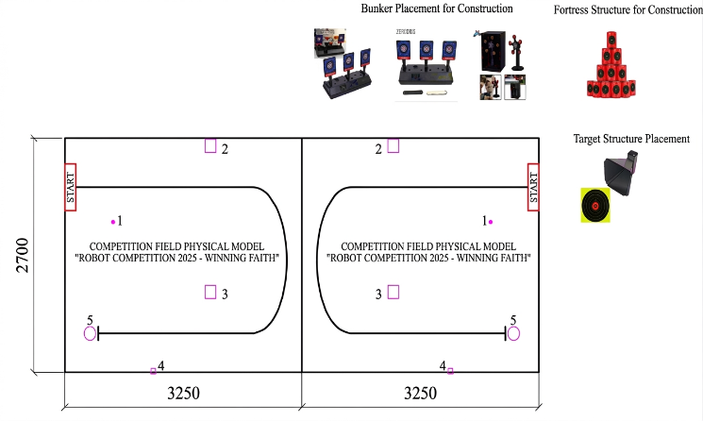
Figure 1. Competition field
Manual robot: Controlled via a wireless 2.4GHz PS2 gamepad interface, the chassis is constructed from structural aluminum profiles and engineering plastics, riding on a Mecanum wheel assembly for fluid, omnidirectional mobility. The operator uses the gamepad to execute the following operational requirements pick up targets and projectiles from the staging zone and precisely position them at designated target stations (Stations 1, 2, 3, and 5), generate the digital interlocking trigger to initiate the AR's autonomous routine.
The robot is driven via a wireless PS2 controller interface. Button presses on the gamepad transmit RF signals to the onboard receiver, which decodes and routes the command packets to the microcontroller via SPI communication to drive the actuators. The Manual Robot features a rigid metal frame constructed from standard aluminum profiles, with overall physical dimensions of 750x750x900 mm to withstand structural impacts during intense competition. The powertrain utilizes high-friction rubber Mecanum wheels driven by independent H-bridge motor controllers, separating the top and bottom motor pairs to optimize rotational and translational kinematics. The primary actuators consist of JGA25-370 DC Servo motors for locomotion and high-torque MG995 servo motors (with a stall torque of 10 kg·cm) for the gripping and hoisting mechanisms. This configuration grants the MR superior maneuverability across the field, handling payloads from 2.5kg up to 5.0kg without geometric gripping constraints. Notably, the wireless 2.4GHz remote control system delivers near-zero latency and high noise immunity, meeting the stringent standards of professional robotic competitions.
Upgraded engineering solutions
Object-oriented design framework of the autonomous robot
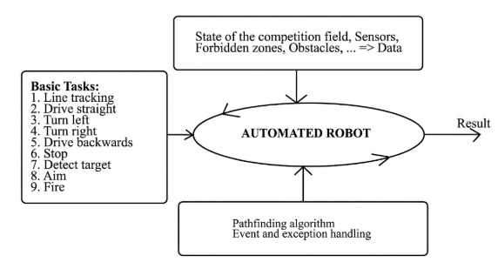
Figure 2. Concept of automated robot objectification
Structural materials: Transitioned from fragile acrylic/plastic layouts to industrial aluminum profiles, significantly increasing structural rigidity and payload capacity (up to 5kg). The standardized T-slots facilitate modular reconfiguration and component mounting via sliding T-nuts and fasteners. Lightweight acrylic plates are utilized as intermediate mounting decks due to their ease of machining and excellent electrical isolation properties. The chassis features a dual-deck architecture: the lower deck hosts the heavy drivetrain and structural frames to maintain a low center of gravity, while the upper deck (isolated via brass standoffs) houses the microcontrollers, sensor routing boards, and control modules.
Sensor integration: Integrated high-accuracy time-of-flight (ToF) laser ranging sensors (VL53L0X) for precise obstacle and target detection, replacing low-reliability ultrasonic sensors. To interface the 24V industrial-grade sensors with the microcontroller logic, custom resistive voltage divider networks were engineered to step down signals to safe thresholds. The fusion of laser, infrared, and photoelectric sensors allows the robot to acquire external environmental telemetry and stream these states to the MCU for real-time closed-loop adjustments. This sub-system dictates the "intelligence" and efficiency of the robot, executing optimal path planning, forbidden zone avoidance, and obstacle-triggered firing routines
Infrared proximity sensing: Implemented E18-D80NK photoelectric sensors, utilizing modulated infrared light to evaluate obstacle proximity with rapid response times and high immunity to ambient light interference. The detection threshold of the E18-D80NK can be manually calibrated via an onboard multi-turn potentiometer.
Microcontroller and signal conditioning: The processing core of the AR is driven by an Arduino Mega 2560. Because the MCU’s I/O pins operate strictly within a 0–5V logic level (or 3.3V depending on the module), they cannot directly accept the 24V outputs of industrial laser sensors. Direct connection would result in overvoltage conditions and catastrophic failure of the digital ports. The custom-engineered resistive voltage divider circuits provide a cost-effective, reliable, and highly stable solution to scale down the sensor outputs to safe digital logic levels.
Operational principle: Upon receiving a valid trigger signal from the photoelectric sensor or the match start condition, stabilized power is distributed across all buses to initialize the system. The AR utilizes its 8-channel line-tracking array and ToF laser sensors to decode line trajectories and map obstacle coordinates. The central MCU runs kinematic equations to calculate heading and velocity, translating these into PWM commands sent to the dual BTS01/BTS02 H-bridge drivers to power the four independent motors.
Aiming and Firing Sequence: Once the sensor array registers that the target is within the firing arc: Servo 1 rotates the entire launcher assembly to align with the target azimuth. Servo 2 articulates the elevation angle to compensate for ballistic trajectories. Relay 1 closes the high-current circuit to energize the firing motor.
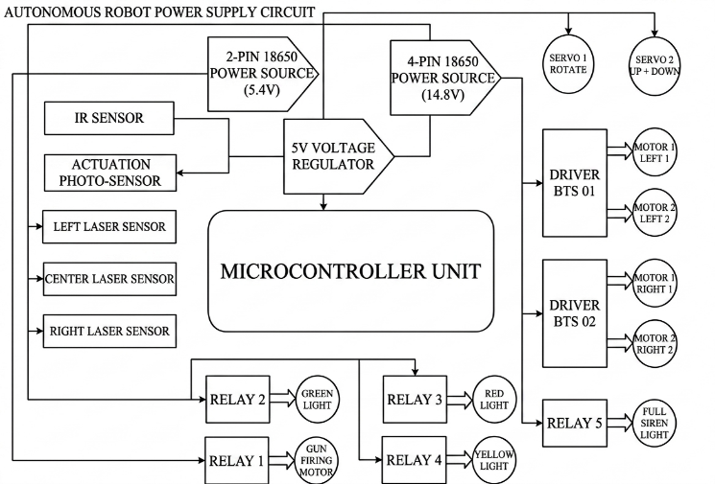

Figure 3: Power supply and distribution circuit diagram of the autonomous robot
Status telemetry: Electromagnetic relays drive visual stack lights and audible buzzers to indicate system states (ready, firing, or fault warning).
Termination: Upon task execution or timer expiration, the MCU cuts drive signals to stop locomotion and disengages the weapon system.
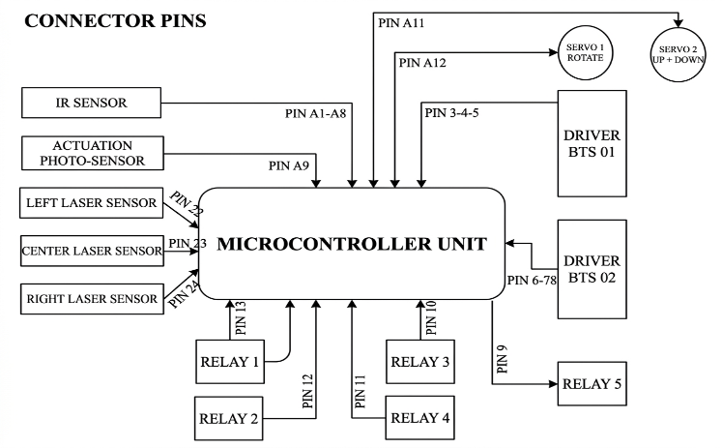
Figure 4. Pin connection diagram for the autonomous robot microprocessor.
Microcontroller unit (MCU): Central processing core executing the primary control loop.
Power subsystem: Driven by a high-discharge 18650 Li-ion battery pack, regulated via a 5V buck converter.
Sensor matrix: Consists of IR proximity and ToF laser sensors to feed real-time input telemetry.
Servos and actuators: Provide multi-axis articulation for aiming and mechanical manipulation.
BTS01/BTS02 drivers: High-current H-bridge circuits controlling the locomotion drivetrain.
Relay array (Relays 1-5): Solenoid switches controlling inductive high-power loads (stack lights, buzzers, and the firing motor).
Control algorithm optimization
The conventional on-off control scheme was replaced with a Proportional (P) control algorithm to eliminate trajectory deviation oscillations during line tracking, yielding smooth and highly precise path-following characteristics. By defining all possible sensor state permutations during tracking, the embedded controller samples the real-time sensor array data and compares it against pre-defined error matrices. Based on the calculated error value, the microcontroller outputs differential PWM signals to the left and right wheel actuators, dynamically centering the robot on the track axis and ensuring tracking accuracy.
System-wide control principle: The control system operates on a sequential, parallel-processing architecture coordinating states between the autonomous robot (AR) and manual robot (MR). The workflow comprises the following operational phases: System initialization phase: Upon power-up, the firmware initializes the I/O configurations, registers, and timers on the Arduino core. A status LED (LED 1) turns ON, confirming system readiness and indicating that the mechatronic linkages have successfully calibrated to their home positions. Polling and activation phase: The system enters a deterministic polling loop. The AR enters an idle wait-state, holding its position until it registers an activation pulse transmitted from the MR. Branching condition: The routine continuously evaluates the state of the activation trigger flag. If False (no trigger), the AR remains stationary in its idle state. If True (trigger registered), the control loop transitions to the next phase, enabling locomotion.
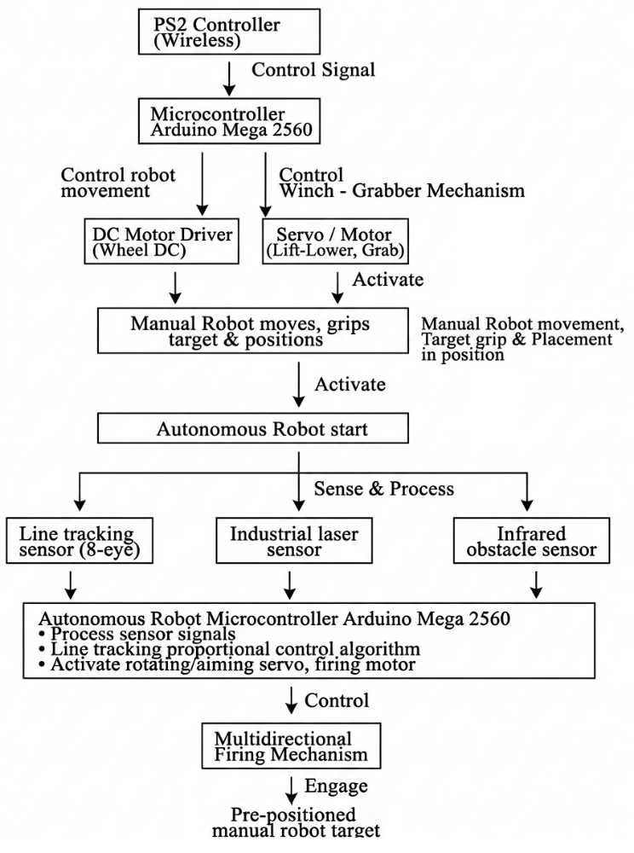
Figure 5: Control flowchart and algorithmic logic of the manual robot
Trajectory execution and tracking phase: Upon activation, the DC servo/geared motors receive calculated PWM duties to initiate acceleration. During transit, the 8-channel photoelectric sensor array samples the field surface at high sampling rates to read the guide line. The proportional control loop processes these error signals in real-time, modulating differential wheel speeds to maintain the center line even under sudden variations in track geometry.
Obstacle detection and precision braking phase: In parallel with the line-tracking loop, the MCU concurrently samples telemetry data from the industrial ToF laser sensors.
Branching condition: Evaluate obstacle detection flags. If False (path clear), the robot maintains its line-tracking locomotion. If True (obstacle detected within the threshold zone), the processor immediately cuts PWM signals and applies electronic braking, locking the drivetrain at the precise firing station coordinates.
Weapon system and firing sequence phase: Once the AR comes to a complete rest, the controller commands the multi-axis servo assembly to align the launcher barrel with the target center (azimuth and elevation adjustments). Following mechanical settling, the firing sequence is executed, triggering the actuator to release the compressed spring assembly and launch the projectile.
Task completion and telemetry feedback phase (end): Following the completion of the firing sequence, the robot completes its run. A completion LED (LED 2) turns ON, providing direct visual feedback to operators and referees that the autonomous cycle has successfully concluded. The program then enters a terminal termination loop (End).
EXPERIMENTAL RESULTS & DISCUSSION
Through rigorous empirical field testing conducted on the official competition sa bàn, the engineered robotic system achieved highly optimized technical performance metrics:
Kinematic agility: The AR demonstrated smooth tracking transitions across varying line widths and geometries, while the MR exhibited responsive and stable control characteristics via the wireless PS2 interface.
Electrical stability: By integrating optocouplers and intermediate electromagnetic relays to isolate high-current inductive actuator noise from digital logic, the embedded controllers achieved zero runtime exceptions, preventing component damage and signal interference.
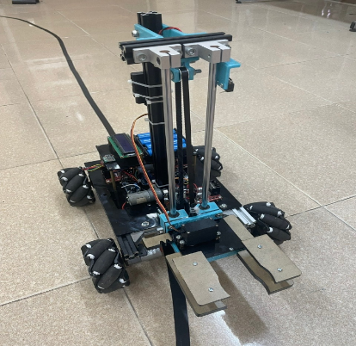
Operational precision: The spring-loaded weapon mechanism, combined with dual-axis servo aiming, yielded a high target hit-rate, successfully fulfilling the competition's accuracy benchmarks.

Figure 6: Empirical prototype of the developed manual robot
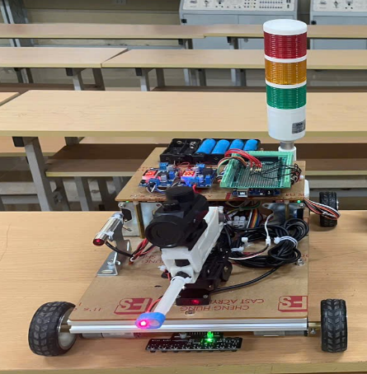

Figure 7. Autonomous robot
In industrial contexts, this cooperative multi-robot framework can be effectively adapted across various sectors. The autonomous platform is highly suited for automated assembly lines, material sorting, automated guided vehicles (AGVs) in logistics, automated inspection, or precision sorting operations within manufacturing plants. Leveraging its multi-sensor fusion matrix (infrared, laser, photoelectric), the autonomous system can operate continuously, minimizing labor overhead while maximizing geometric precision. Conversely, the manual platform-with its highly agile end-effector and omnidirectional mecanum drivetrain-is ideal for operating within tight, spatially constrained industrial environments, machine maintenance assistance, flexible material handling in smart warehouses, or as high-fidelity educational emulators in advanced technical training centers. Both platforms feature an open-source, modular architecture, facilitating rapid scaling and seamless integration into modern industrial automation ecosystems.
CONCLUSION
The cooperative robotic system engineered for the "Robot 2025 – Winning Faith" competition was successfully designed, fabricated, and validated. The strategic engineering improvements applied to the mechanical chassis, industrial-grade sensor integration, and advanced proportional control loops successfully mitigated structural vulnerabilities and trajectory errors observed in previous design iterations. Beyond its demonstrated efficiency within the competition, these robots serve as high-value educational assets for teaching and recruitment demonstrations, utilizing accessible, easily machinable, and cost-effective materials. These empirical results validate both the technical efficacy of the design and its practical value within the educational curriculum of the Faculty of Electromechanical Engineering, empowering students to master cutting-edge paradigms in modern machine design and robotic systems integration

REFERENCES
- Cormen, T. H., Leiserson, C. E., Rivest, R. L., & Stein, C. (2022). Introduction to algorithms (4th ed.). MIT Press..
- Duchoň, F., Kajan, A., Beňo, P., Florek, M., Fico, T., & Jurišica, L. (2014). Path planning with modified A star algorithm for a mobile robot. Procedia Engineering, 96, 59-69. https://doi.org/10.1016/j.proeng.2014.12.102
- Mac, T. T., Copot, C., Tran, D. T., & De Keyser, R. (2016). Heuristic approaches in robot path planning: A survey. Robotics and Autonomous Systems, 86, 13-28. https://doi.org/10.1016/j.robot.2016.08.011 (Bài báo tổng quan thuộc danh mục ISI/Scopus xếp hạng Q1, đánh giá rất kỹ về các thuật toán tìm đường heuristic).
- Rubio, F., Valero, F., & Llopis-Albert, C. (2019). A review of mobile robots pathogenic planning techniques. Trends in International Journal of Advanced Robotic Systems, 16(1), 1-10. https://doi.org/10.1177/1729881419822926.
- Thrun, S., Burgard, W., & Fox, D. (2005). Probabilistic robotics. MIT Press.

