EXPERT SYSTEMS IN CCTV AND ACCESS CONTROL MANAGEMENT.

BY

ENGR. JERRY EBRUVWIYOR OSIOBE.
ND, B.ENG, MSc (In view), MNSE, MNIMMME.

1/17/2026.

INTRODUCTION.
Background and Motivation.
In an era of increasing security demands, organizations are under pressure to protect assets, ensure personnel safety, and maintain operational continuity. Traditional CCTV and access control systems, while effective for passive monitoring, often lack the intelligence and responsiveness needed to address modern threats. These systems typically operate in silos, requiring manual review and intervention, which can lead to delays, human error, and missed incidents.
Expert systems—AI-driven platforms that simulate human decision-making using rule-based logic and inference engines—offer a transformative solution. By integrating expert systems into CCTV and access control infrastructure, organizations can automate surveillance analysis, detect anomalies, verify identities, and enforce access policies with minimal human oversight. This shift from reactive to proactive security management is driven by the need for faster response times, reduced operational costs, and enhanced situational awareness.
Expert systems apply knowledge‑based rules and machine intelligence to CCTV and access control, enabling automated decision‑making (e.g., anomaly detection, identity verification, and policy enforcement). These systems unify video analytics with access logs to provide a single source of truth for security teams and executives. Expert systems in CCTV and access control combine rule‑based AI, real‑time analytics, and integrated data sources to turn passive surveillance into proactive security—improving incident detection, access verification, and operational efficiency for enterprises and campuses.
The motivation behind adopting expert systems in this domain includes:
- Real-time threat detection: Automated alerts based on predefined rules and behavioral patterns.
- Improved access verification: Intelligent cross-referencing of credentials, biometrics, and access logs.
- Operational efficiency: Streamlined workflows that reduce manual tasks and improve incident resolution.
- Scalability: Ability to manage multi-site operations with centralized intelligence.
- Data-driven insights: Analytics that support strategic planning and compliance reporting.
As organizations embrace digital transformation, the integration of expert systems into physical security infrastructure becomes a strategic imperative. These systems not only enhance protection but also provide actionable intelligence that supports broader organizational goals.

Key components
- Knowledge base: repository of rules, policies, and labeled examples used for decision logic.
- Inference engine: applies rules to live inputs (video, badge reads) to generate alerts.
- Sensor & data layer: cameras, door controllers, and IoT sensors feeding structured and unstructured data.
- Integration layer: APIs and middleware that link CCTV, access control, and enterprise systems (HR, directories).
- User interface & reporting: dashboards and automated executive summaries for rapid action.
How expert systems add value.
Automated correlation of video and access events reduces investigation time and false positives by providing contextual evidence (who, when, where) rather than isolated alerts.
Operational efficiency: automated workflows (lockdown, badge revocation, incident ticketing) cut manual steps and speed response. Integration of video with access control improves situational awareness across multi‑site organizations.

SCOPE OF THE STUDY.
This study explores the architecture, applications, and benefits of expert systems in CCTV and access control management. It examines how rule-based AI can be applied to real-time surveillance and access control data, the technical components required for integration, and the challenges associated with deployment. The goal is to provide a comprehensive understanding of how expert systems can elevate security operations from passive monitoring to intelligent decision-making.

Technical Architectural Diagram.
Here’s your technical architecture diagram for expert systems in CCTV and Access Control Management.
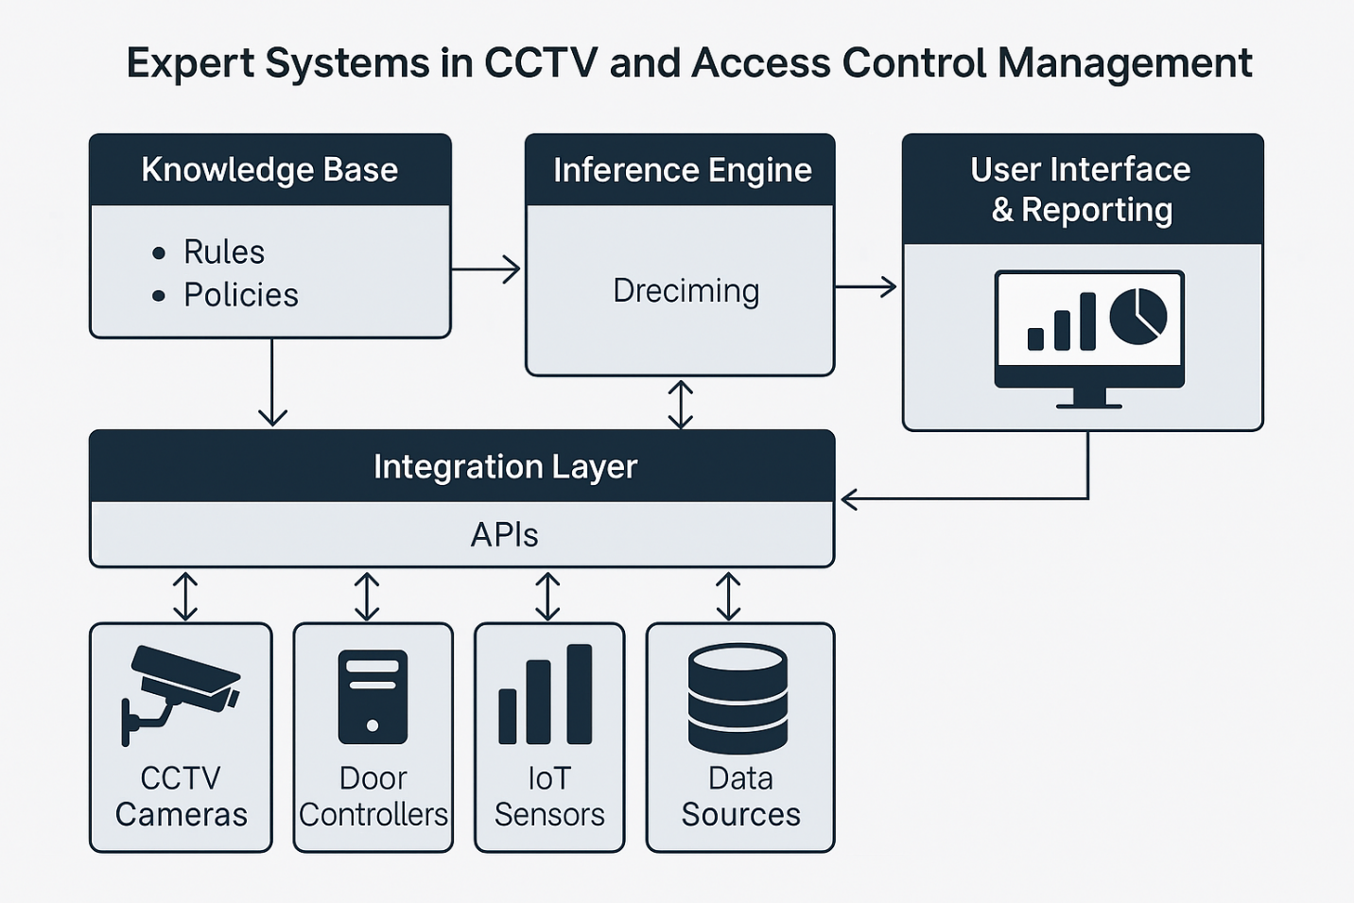
The diagram illustrates:
- Sensor & Data Layer: CCTV cameras, door controllers, IoT sensors feeding raw data.
- Integration Layer: APIs and middleware connecting devices to higher systems.
- Knowledge Base: Rules, policies, and labeled examples.
- Inference Engine: Applies rules to live inputs, generating alerts and decisions.
- User Interface & Reporting: Dashboards, alerts, and executive summaries for operators and management.
Data flows upward from sensors → integration → inference engine → user interface, with the knowledge base guiding decision logic.

APPLICATIONS OF EXPERT SYSTEMS IN CCTV AND ACCESS CONTROL MANAGEMENT
1. Access Verification & Identity Management
- Automated cross-checking of credentials, biometrics, and access logs.
- Detects tailgating or unauthorized entry attempts.
- Provides multi-factor verification by combining card readers, facial recognition, and behavioral patterns.
2. Real-Time Threat Detection
- Monitors CCTV feeds for anomalies such as loitering, unattended objects, or restricted area breaches.
- Uses rule-based inference to trigger instant alerts for suspicious activity.
- Reduces reliance on manual monitoring, minimizing human error.
3. Incident Response & Workflow Automation
- Automatically initiates lockdown procedures when unauthorized access is detected.
- Generates incident tickets and forwards them to security teams.
- Integrates with emergency systems (alarms, notifications) for faster response.
4. Forensic Analysis & Investigations
- Correlates video footage with access control logs for evidence gathering.
- Enables rapid search and retrieval of relevant events.
- Supports compliance audits and legal investigations with structured reporting.
5. Operational Analytics & Business Intelligence
- Tracks occupancy trends, peak access times, and facility usage.
- Provides insights for resource allocation and energy management.
- Generates compliance reports for regulatory bodies.
6. Multi-Site Security Management
- Centralized monitoring across multiple facilities.
- Expert systems unify CCTV and access control data into a single dashboard.
- Supports scalability for enterprises, campuses, and government institutions.
7. Integration with Cybersecurity & IT Systems
- Links physical access control with network access policies.
- Detects insider threats by correlating physical presence with system logins.
- Enhances Governance, Risk, and Compliance (GRC) frameworks.

BENEFITS AND LIMITATIONS: OPERATIONAL IMPACT AND CHALLENGES.
Benefits:
- Real-time threat detection: Automated alerts reduce response time and improve situational awareness.
- Enhanced access verification: Cross-checks credentials, biometrics, and logs to minimize unauthorized entry.
- Operational efficiency: Streamlines workflows, reduces manual monitoring, and lowers staffing costs.
- Scalability: Centralized intelligence supports multi-site operations and large organizations.
- Data-driven insights: Provides analytics for compliance, resource allocation, and strategic planning.
- Reduced human error: Rule-based decision logic ensures consistency in incident handling.

Limitations & Challenges.
- Integration complexity: Legacy CCTV and access systems may lack compatibility with expert system frameworks.
- High implementation cost: Initial investment in AI infrastructure, sensors, and skilled personnel can be significant.
- Data privacy concerns: Handling biometric and video data requires strict compliance with regulations (e.g., GDPR, NDPR).
- False positives/negatives: Inference engines may misinterpret behaviors, leading to unnecessary alerts or missed incidents.
- Skill requirements: Security teams need training to manage and interpret expert system outputs effectively.
- System reliability: Dependence on AI and automation introduces risks if systems fail or are compromised.
Operational Impact
- Positive: Faster incident resolution, improved compliance, and reduced manual workload.
- Negative: Potential disruption during system rollout, need for continuous updates, and reliance on high-quality data.
IMPLEMENTATION STRATEGY.
1. Needs Assessment & Requirement Gathering
- Conduct a security audit to identify vulnerabilities in current CCTV and access control systems.
- Define objectives: real-time threat detection, compliance reporting, or multi-site integration.
- Engage stakeholders (IT, security, compliance, facilities) to align goals.
2. System Design & Architecture
- Develop a technical blueprint including:
  - Sensor Layer: CCTV cameras, door controllers, IoT sensors.
  - Integration Layer: APIs/middleware to unify data streams.
  - Knowledge Base: rules, policies, and compliance standards.
  - Inference Engine: AI logic for anomaly detection and decision-making.
  - User Interface: dashboards, alerts, and reporting tools.
- Ensure scalability for future expansion across multiple sites.
3. Technology Selection
- Choose hardware (IP cameras, biometric readers, IoT sensors).
- Select software platforms for expert system inference engines.
- Adopt AI-powered development tools (e.g., Cursor, Windsurf) to accelerate coding, testing, and collaboration.
- Ensure MCP (Model Context Protocol) integration for connecting LLMs with live data sources.
4. Pilot Deployment
- Implement the system in a controlled environment (e.g., one building or department).
- Test rule sets for accuracy (e.g., tailgating detection, unauthorized access alerts).
- Validate integration with existing IT and security infrastructure.
- Collect feedback from operators and refine workflows.
5. Full-Scale Rollout
- Expand deployment across all facilities.
- Train staff on system usage, dashboards, and incident response protocols.
- Establish governance policies for data privacy, compliance, and audit trails.
- Integrate with enterprise systems (HR, IT, compliance).
6. Monitoring & Continuous Improvement
- Set up performance metrics: response time, false positives, compliance scores.
- Use analytics to refine rules and improve inference accuracy.
- Conduct periodic audits to ensure system reliability and regulatory compliance.
- Update knowledge base and inference engine as threats evolve.
7. Risk Management
- Implement redundancy (backup servers, failover systems).
- Secure APIs and data pipelines against cyber threats.
- Establish incident escalation protocols for system failures.

CONCLUSION AND RECOMMENDATIONS.
Conclusion
Expert systems represent a significant advancement in the management of CCTV and access control systems. By combining rule‑based logic, inference engines, and integrated data sources, these systems transform traditional surveillance from passive monitoring into proactive, intelligent security management.
The study has shown that expert systems deliver real‑time threat detection, enhanced access verification, operational efficiency, and data‑driven insights. They also support scalability across multi‑site operations and strengthen compliance reporting. However, challenges such as integration complexity, high implementation costs, data privacy concerns, and potential false positives must be carefully addressed to ensure successful deployment.
Ultimately, expert systems bridge the gap between raw sensor data and actionable intelligence, empowering organizations to respond faster, reduce human error, and align physical security with broader digital transformation goals.
Recommendations
- Start with Pilot Projects
  - Deploy expert systems in a controlled environment (e.g., one building or department) to validate rules and workflows before scaling.
- Invest in Training & Change Management
  - Equip security teams with the skills to interpret system outputs and manage AI-driven workflows.
- Prioritize Data Governance
  - Establish strict policies for handling biometric and video data to ensure compliance with privacy regulations.
- Integrate with Enterprise Systems
  - Link CCTV and access control with HR, IT, and compliance systems for unified intelligence.
- Continuous Improvement
  - Regularly update the knowledge base and inference engine to adapt to evolving threats and operational needs.
- Balance Costs with Value
  - Evaluate long-term savings from reduced manual monitoring and improved incident resolution against initial investment costs.
REFERENCES.
- Huzaifa, S. M., et al. (2025). Dynamic presence tracking system in shared environments. International Journal of Scientific and Advanced Technology (IJSAT).

- Yu, M., Ding, X., Wang, X., & Gong, Y. (2011). The design of intelligent access control systems based on Jess. In Lecture Notes in Computer Science, CCIS 216. Springer.

- Secure biometric-based access control scheme for future IoT-enabled cloud-assisted video surveillance system. (2022). Computer Communications, 195, 27–39. https://doi.org/10.1016/j.comcom.2022.07.004 (doi.org in Bing)

