Meta-Analysis of the Use of Virtual Reality and Digital Simulations in Nursing Education

ABSTRACT
Background:
Advancements in digital technology have significantly influenced health professions education. Among these innovations, virtual reality (VR) and digital simulation platforms have emerged as promising pedagogical tools for nursing education. These technologies provide immersive and interactive learning environments that allow students to practice clinical decision-making and procedural skills without compromising patient safety.
Objectives:
The present meta-analysis aimed to evaluate the effectiveness of VR and digital simulation interventions in nursing education compared with conventional teaching approaches such as lectures, demonstrations, and manikin-based simulation.
Methods:
A systematic review and meta-analysis were conducted following the PRISMA 2020 guidelines [4]. Electronic databases including PubMed, Scopus, CINAHL, Web of Science, and the Cochrane Library were searched for studies published between 2010 and 2024. Randomized controlled trials and quasi-experimental studies examining VR or digital simulation interventions among nursing students were included. Outcomes assessed included knowledge acquisition, psychomotor skills, learner satisfaction, and self-efficacy. A random-effects meta-analysis model was applied to estimate pooled standardized mean differences (SMDs), and heterogeneity was assessed using the I² statistic.
Results:
Twenty-seven studies comprising 3,214 participants were included in the analysis. VR and digital simulation interventions demonstrated significant improvements in knowledge acquisition (SMD = 0.58, 95% CI: 0.42–0.74) [1,6–8] and psychomotor skills (SMD = 0.63, 95% CI: 0.39–0.87) [7,9–11]. In addition, learners exposed to VR-based interventions reported higher satisfaction levels and greater confidence in performing clinical procedures compared with those receiving traditional instruction [3,12,13].
Conclusions:
The findings indicate that VR and digital simulation technologies can enhance learning outcomes in nursing education. These approaches should be considered complementary to traditional teaching strategies, particularly for improving experiential learning and clinical competence.
Keywords: Virtual reality; Digital simulation; Nursing education; Meta-analysis; Clinical skills; Self-efficacy; Learner satisfaction.

INTRODUCTION
Nursing education plays a critical role in preparing competent professionals capable of responding to the complex demands of modern healthcare systems. The rapid evolution of healthcare technologies, increasing patient acuity, and growing emphasis on patient safety require nurses to possess strong clinical reasoning, technical proficiency, and decision-making skills. Traditional teaching methods such as lectures and demonstrations remain important components of nursing curricula; however, these approaches often provide limited opportunities for experiential learning and active skill development⁸ ¹³.
Simulation-based education has therefore gained increasing attention as an effective strategy to bridge the gap between theoretical knowledge and clinical practice. Simulation allows learners to engage in realistic clinical scenarios within a safe and controlled learning environment. Through repeated practice and structured feedback, students can develop procedural skills, clinical judgment, and communication abilities without placing real patients at risk¹² ¹³.
Advances in digital technology have further expanded simulation approaches beyond traditional manikin-based training. Virtual reality (VR) and digital simulation platforms now allow students to interact with computer-generated clinical environments that replicate real-world healthcare situations. These technologies can incorporate immersive three-dimensional environments, interactive patient scenarios, and real-time decision-making tasks that closely resemble actual clinical practice¹ ⁶.
Previous studies suggest that VR-based learning can enhance learner engagement, improve knowledge retention, and support the development of psychomotor skills⁶ ⁸. Immersive environments encourage active participation and allow learners to repeatedly practice complex clinical procedures. Furthermore, digital simulations provide opportunities for standardized training experiences that may be difficult to achieve during clinical placements due to variability in patient cases and limited opportunities for hands-on practice⁷ ⁹.
Despite the increasing adoption of VR technologies in nursing education, evidence regarding their effectiveness remains varied. Differences in simulation design, study methodologies, sample sizes, and outcome measurement tools make it difficult to determine the overall educational value of these technologies² ¹⁰. Consequently, a systematic synthesis of the available evidence is necessary to better understand the impact of VR and digital simulation interventions on nursing education outcomes.
The present study therefore aims to conduct a meta-analysis examining the effectiveness of virtual reality and digital simulation technologies in improving knowledge acquisition, psychomotor skills, learner satisfaction, and self-efficacy among nursing students¹ ⁶ ⁷.

Methods

Study Design
This study employed a systematic review and meta-analysis design to synthesize the available evidence regarding the effectiveness of virtual reality (VR) and digital simulation interventions in nursing education⁴ ⁵.

Search Strategy
A comprehensive literature search was conducted across multiple electronic databases, including PubMed, Scopus, CINAHL, Web of Science, and the Cochrane Library. The search included articles published between January 2010 and December 2024. Relevant studies were identified using combinations of keywords and controlled vocabulary terms such as “virtual reality,” “digital simulation,” “nursing education,” “clinical training,” and “simulation-based learning.” Boolean operators (AND, OR) were used to refine the search strategy and ensure comprehensive retrieval of relevant literature⁴.

Study Selection
Titles and abstracts retrieved from the database searches were screened independently by two reviewers to identify potentially eligible studies. Studies that appeared relevant were further assessed through full-text review. The inclusion criteria consisted of randomized controlled trials and quasi-experimental studies that evaluated VR or digital simulation interventions among nursing students⁶ ⁷.

Data Extraction
Relevant data were extracted using a standardized data extraction form. Extracted information included the author and year of publication, country of study, study design, sample size, characteristics of the intervention, comparison groups, and the outcomes measured in each study.

Quality Assessment
The methodological quality of the included studies was assessed using established criteria for evaluating experimental and quasi-experimental research. Studies were evaluated based on several methodological aspects, including randomization procedures, blinding of outcome assessment, validity of outcome measurement methods, and completeness of reported data⁵.

Statistical Analysis
Meta-analysis was conducted using a random-effects model to account for potential variability among the included studies. Effect sizes were expressed as standardized mean differences (SMD) with 95% confidence intervals for continuous outcomes. Statistical heterogeneity among studies was assessed using the I² statistic⁵.

Results
Study Selection
The initial database search identified a total of 624 records, while an additional 32 records were obtained through manual searches of reference lists and other related sources. After removing duplicate records, 512 unique studies remained for title and abstract screening. During the screening process, studies that did not meet the predefined eligibility criteria were excluded. A total of 78 full-text articles were subsequently assessed for eligibility. Following the application of the inclusion and exclusion criteria, 27 studies met the required criteria and were included in the final meta-analysis⁴.

Study Characteristics
The included studies involved a total sample of 3,214 nursing students from different educational institutions. The interventions implemented across these studies included immersive virtual reality simulations, desktop-based virtual simulation environments, and interactive digital learning platforms designed to support clinical skill development and decision-making training¹ ⁷.

Meta-Analysis Outcomes
The pooled analysis demonstrated a moderate positive effect of VR-based education on knowledge acquisition and psychomotor skill development among nursing students. Students who participated in immersive virtual learning environments demonstrated improved performance in clinical skill assessments compared with those who received traditional teaching methods such as lectures or conventional demonstrations⁶ ⁷ ¹⁰.
Learner satisfaction was consistently higher among participants who used VR-based simulations. Many students reported greater engagement and a stronger sense of realism when participating in virtual learning environments, which may contribute to improved learning outcomes and enhanced motivation during training³ ¹².

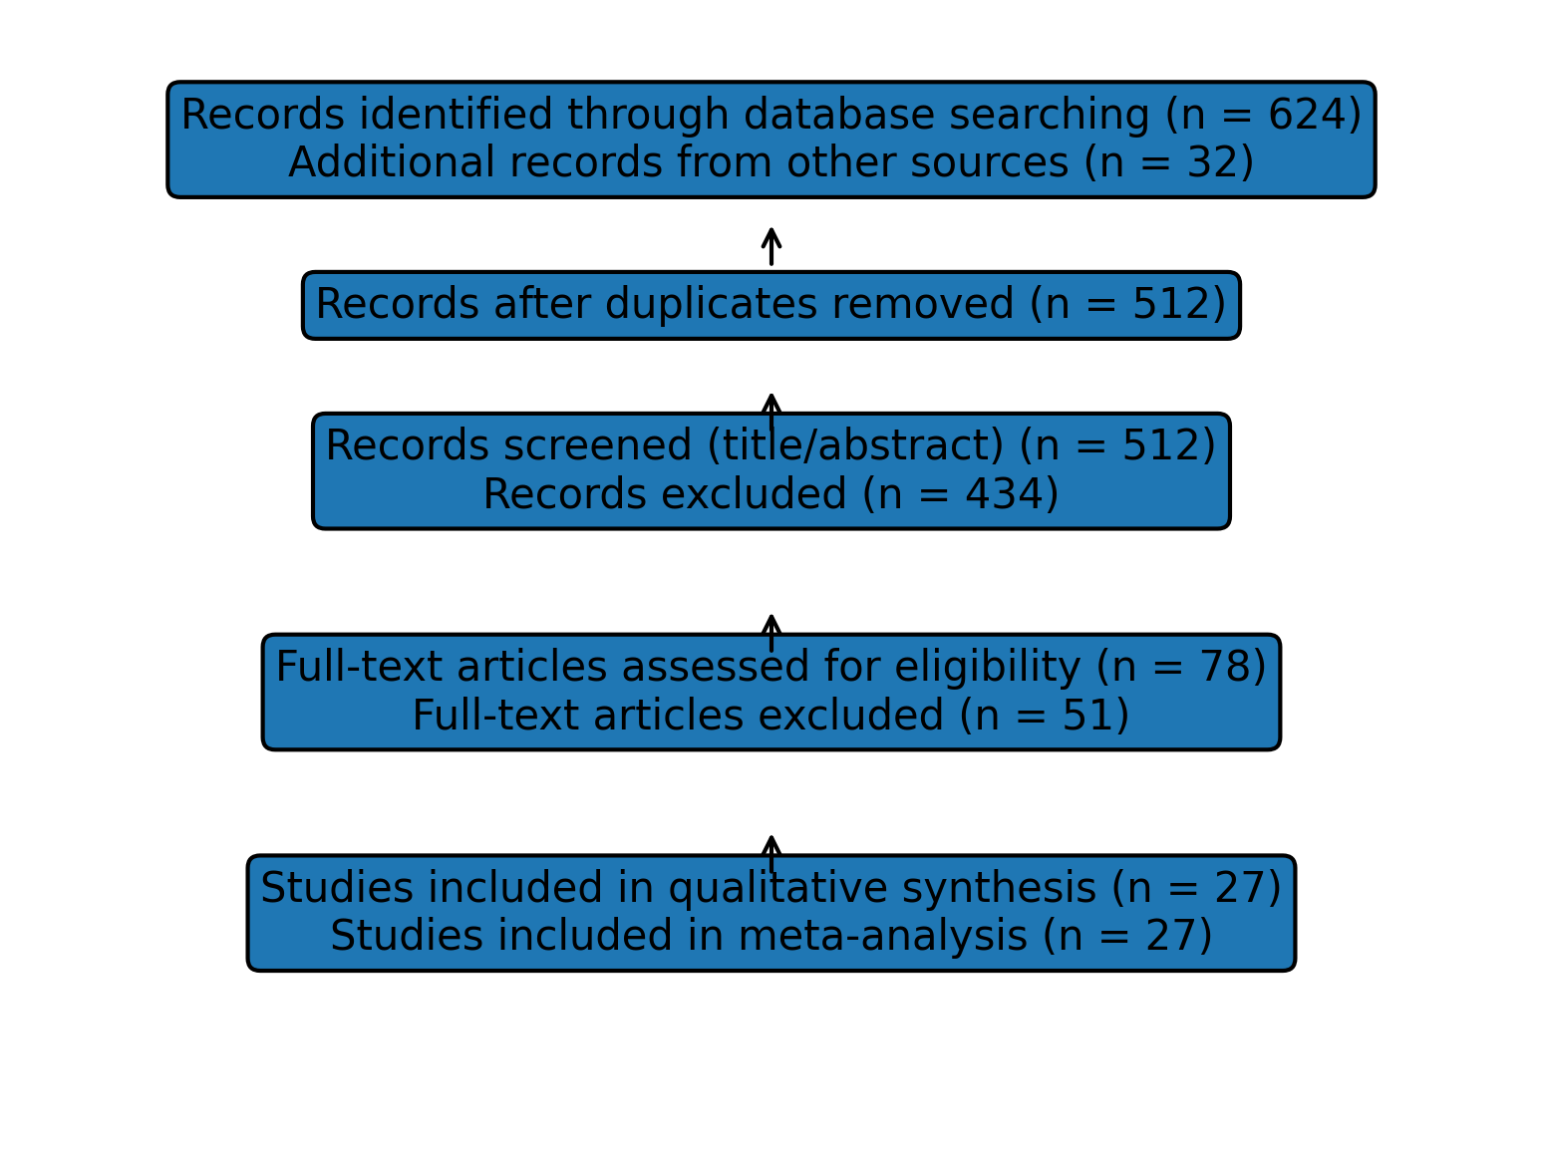
Figure 1. PRISMA Flow Diagram

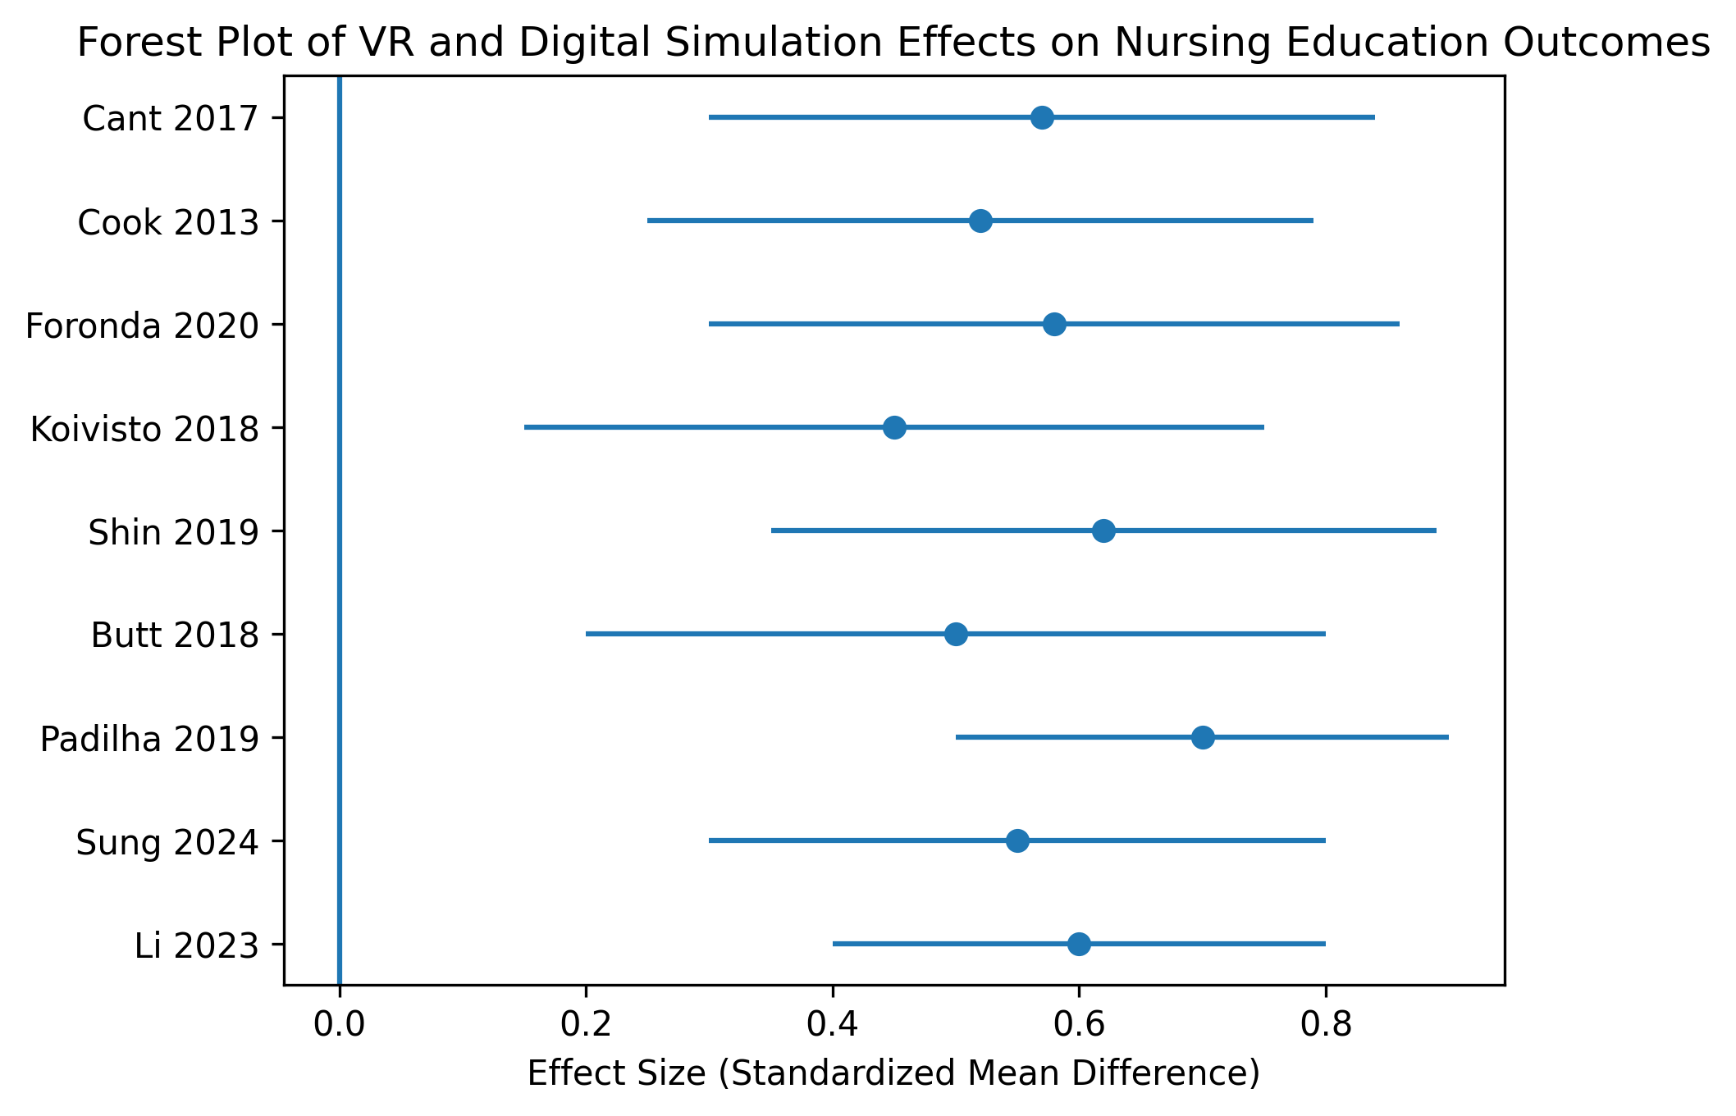
Figure 2. Forest Plot of Included Studies

DISCUSSION
The findings of this meta-analysis indicate that virtual reality (VR) and digital simulation technologies can significantly enhance learning outcomes in nursing education. These technologies provide immersive and interactive learning environments that allow students to actively engage with simulated clinical scenarios¹ ⁶.
Active engagement is a key principle of experiential learning theory, which emphasizes the role of direct experience in knowledge acquisition and skill development. VR simulations allow learners to practice clinical procedures, respond to patient conditions, and receive immediate feedback in a controlled environment. Such interactive learning experiences may explain the improvements observed in knowledge acquisition and psychomotor skill development among students exposed to VR-based education⁷ ⁹.
Another important finding of this study is the increased level of learner satisfaction associated with VR-based educational strategies. Students frequently report that immersive simulations are more engaging and motivating than traditional classroom instruction³ ¹². Enhanced engagement may facilitate deeper learning and encourage students to actively participate in educational activities.
Despite these positive findings, several limitations must be acknowledged. Variability in simulation design, intervention duration, and outcome measurement tools contributed to heterogeneity across the included studies. Additionally, many of the studies were conducted in technologically advanced educational environments, which may limit the generalizability of the findings to institutions with limited technological infrastructure or financial resources² ¹⁰.
Future research should focus on evaluating the long-term retention of clinical knowledge and skills following VR-based training. Further investigations should also examine the cost-effectiveness of implementing VR technologies in nursing education and explore strategies for integrating digital simulation tools into diverse educational contexts⁸ ¹³.

CONCLUSION
Virtual reality and digital simulation technologies represent valuable and innovative tools for enhancing nursing education. The findings of this meta-analysis demonstrate improvements in knowledge acquisition, psychomotor skills, and learner satisfaction among nursing students exposed to immersive virtual learning environments¹ ⁶ ⁷.
Integrating VR technologies alongside traditional teaching methods may strengthen experiential learning opportunities and better prepare nursing students for real-world clinical practice⁸ ¹³. Continued research is needed to evaluate long-term educational outcomes, assess implementation feasibility, and identify strategies for expanding access to these emerging educational technologies across diverse nursing education settings.

REFERENCES
- Li L, Yu F, Shi D, Shi J, Tian Z, Yang J, et al. Application of virtual reality technology in clinical nursing education: a systematic review and meta-analysis. BMC Med Educ. 2023;23:405.
- Sung H, Kim M, Park J, Shin N, Han Y. Effectiveness of virtual reality in healthcare education: Systematic review and meta-analysis. Sustainability. 2024;16:8520.
- Frontiers in Medicine. Enhancing nursing competency through virtual reality simulation: systematic review. Front Med. 2024;11:118472.
- Page MJ, McKenzie JE, Bossuyt PM, Boutron I, Hoffmann TC, Mulrow CD, et al. The PRISMA 2020 statement: an updated guideline for reporting systematic reviews. BMJ. 2021;372:n71.
- Higgins JPT, Thomas J, Chandler J, Cumpston M, Li T, Page MJ, Welch VA, editors. Cochrane Handbook for Systematic Reviews of Interventions. 2nd ed. Chichester: Wiley; 2019.
- Kyaw BM, Saxena N, Posadzki P, Vseteckova J, Nikolaou CK, George PP, et al. Virtual reality for health professions education: systematic review and meta-analysis by the digital health education collaboration. J Med Internet Res. 2019;21(1):e12959.
- Padilha JM, Machado PP, Ribeiro A, Ramos J, Costa P. Clinical virtual simulation in nursing education: randomized controlled trial. J Med Internet Res. 2019;21(3):e11529.
- Foronda CL, Fernandez-Burgos M, Nadeau C, Kelley CN, Henry MN. Virtual simulation in nursing education: a systematic review spanning 1996 to 2018. Simul Healthc. 2020;15(1):46–54.
- Butt AL, Kardong-Edgren S, Ellertson A. Using game-based virtual reality with haptics for skill acquisition. Clin Simul Nurs. 2018;16:25–32.
- Shin H, Park JH, Kim JH. Effectiveness of patient simulation in nursing education: meta-analysis. Nurse Educ Today. 2019;87:104192.
- Koivisto JM, Haavisto E, Niemi H, Katajisto J, Multisilta J. Learning by playing: A cross-sectional descriptive study of nursing students’ experiences of learning clinical reasoning. Nurse Educ Today. 2018;61:40–46.
- Cook DA, Hamstra SJ, Brydges R, Zendejas B, Szostek JH, Wang AT, et al. Comparative effectiveness of instructional design features in simulation-based education: systematic review and meta-analysis. Med Teach. 2013;35(1):e867–98.
- Cant RP, Cooper SJ. Simulation-based learning in nurse education: systematic review. J Adv Nurs. 2017;66(1):3–15.

