ISLALINK: A Web-Based Navigation, Booking and Tourism Guide for Santiago Island Travelers

Christian Rey C. Caasi¹, Jhon Jomer B. Magat², John Kenneth R. Mazon³,
Lanlou C. Navarro⁴, Carlo Genster P. Camposagrado⁵
¹²³⁴⁵Department of Information Technology, Pangasinan State University-Alaminos City Campus, Philippines
¹christianreyccaasi@gmail.com, ²magatjomer@gmail.com, ³johnkennethmazon027@gmail.com, ⁴navarrolanlou1@gmail.com, ⁵cpcamposagrado@psu.edu.ph

*corresponding author: Christian Rey C. Caasi¹
¹christianreyccaasi@gmail.com

ABSTRACT

For many years, traditional motorized boats (bangkero) and large transport ba rges have been the primary forms of public transportation connecting the mainland to Santiago Island in Bolinao, Pangasinan. However, managing these services presents significant difficulties due to their decentralized nature, lack of standardized booking, and heavy reliance on traditional cash fare and paper manifest collection methods. Enhancing fare collection, capacity management, and route information has become increasingly important to address the inefficiencies of these manual processes, such as payment delays, human transcription errors, and capacity uncertainties. This study developed IslaLink: A Web- based Navigation, Booking, and Tourism Guide for Santiago Island Travelers. This comprehensive system integrates automated booking. The system uses digital booking technology to streamline reservations, allowing passengers to confirm and pay for their slots electronically while enabling real- time manifest tracking and location information for operators and tourism staff. This digital integration significantly enhances transaction speed, data accuracy, and operational efficiency, ultimately transforming the island commuting and tourism experience. The study is intended for Santiago Island travelers and boat operators / stakeholders, aiming to implement technological solutions that optimize commuting and tourism operations, specifically along the Santiago Island transport routes within Bolinao, Pangasinan. The system enables travelers to effortlessly book slots digitally, which automatically calculates the fee and tracks capacity. This method removes the need for manual fare management, booking delays, and human mistakes. The study concludes with recommendations for future expansion and further improvements to enhance overall efficiency in public transportation and tourism management.

Index Terms – Web-Based Navigation, Booking, Tourism Management, Santiago Island, Bolinao Pangasinan

INTRODUCTION

Transport and tourism systems are essential in supporting regional connectivity and economic growth. The barge transport ecosystem consists of various interrelated actors, from shippers and carriers to barge and inland terminal operators, whose roles may overlap, particularly in terminal management and last-mile delivery to final destinations (Bulchand-Gidurnal, 2022). Likewise, in developing island destinations such as Siargao, studies highlight service challenges in local maritime transport, including manual ticketing and limited real-time information, which point to the need for digital and user-friendly travel solutions (Chan-Edmiston et.al., 2020). Furthermore, experiences from other countries emphasize that a strong legal and policy framework is crucial in sustaining tourism development and elevating it to a global standard (Dacquel et.al.,2024).

Santiago Island, located in Bolinao, Pangasinan, is a historically and culturally significant destination known for its scenic beaches, marine biodiversity, and heritage sites. The island serves as an important tourism hub, attracting both local and foreign visitors.

Despite its tourism potential, travelers to and from Santiago Island often encounter difficulties due to the absence of a centralized system for boat and barge booking, limited access to real-time travel information, and the lack of an integrated platform that connects tourists to essential services such as restaurants, swimming pools, and grocery stores. These challenges result in inefficiencies, long waiting times, and inconvenience, particularly during peak travel seasons.

Effective tourism development requires not only adequate infrastructure but also strong destination management, technology adoption, and transport coordination. Studies on tourism destination management emphasize alignment with national development plans to enhance governance, service delivery, and sustainability in major destinations (Gonzales et.al.,2023). From a technology perspective, user satisfaction and acceptance models demonstrate that system usability, perceived usefulness, and ease of use significantly influence travelers’ willingness to adopt digital platforms for reservations and services (Llanos et.al.,2023)

In the tourism context, extended technology acceptance frameworks further confirm that online reservation intentions are shaped by trust, perceived risk, and system performance, particularly in post-pandemic environments (Mejas et.al., 2024). Supporting this, web-based ticketing and booking systems for maritime travel have been shown to improve operational efficiency, reduce manual processes, and enhance passenger experience in island destinations (Mulyana et.al., 2023). At the strategic level, research on smart tourism highlights how digital integration and stakeholder collaboration enhance tourist experiences and operational efficiency across destinations ((Roukouni & Zuidwijk, 2020). Meanwhile, intelligent transportation planning and coordinated mobility systems are essential in improving accessibility, safety, and reliability, which are critical to tourism competitiveness and service continuity (Sulaymanov & Kaypova, 2025). Finally, futures-oriented tourism studies underscore the need for adaptive, technology-driven strategies to address long-term uncertainties and ensure resilience in an evolving global tourism landscape (Zhao et.al., 2022).This study presents framework reasons for development and feasibility of the Islalink System.

METHODOLOGY

A descriptive developmental technique was employed to help the researchers perform the study. Descriptive research was used to accurately explain the existing processes and conditions involved in barge and boat booking and tourism management on Santiago Island, Bolinao, Pangasinan. Developmental research in software development played a vital role in creating a practical system that addresses real-world challenges encountered by tourists, boat operators, and tourism administrators. A descriptive approach was used to understand the situation of the intended users of the IslaLink system, while the developmental approach was applied to design and implement an online barge and boat booking and tourism management system. The proposed system was implemented through a web-based application.

The researchers employed an iterative software development approach that emphasized flexibility and continuous improvement throughout the system development process. The IslaLink system development included several phases: requirements analysis, design, development, testing, deployment, and review. Interviews and observation were the primary data gathering methods used to understand existing booking procedures and tourism operations on Santiago Island. Questionnaires were also administered to assess the acceptability and usability of the system among tourism staff, barge and boat operators, and tourists. System analysis tools such as flowcharts, entity relationship diagrams, and three-tier architecture were utilized to ensure a structured, efficient, and quality system design. Table 1 shows the respondents of the study where vital information were taken from.

Table 1. Respondents of the Study

Respondents | Number of Respondents
Tourism Management Staff in Bolinao | 6
Tourists | 10
Barge and Boat Operators | 4
Total Respondent | 20

Primary data were collected through interviews with a landing barge captain and selected key stakeholders using purposive sampling. Semi-structured interviews with five qualified participants provided qualitative insights into operational challenges and system requirements relevant to improving maritime and tourism services.

The development of the proposed system was undertaken using an adopted software development model as shown in Figure 1 below.

Figure 1. Agile Model

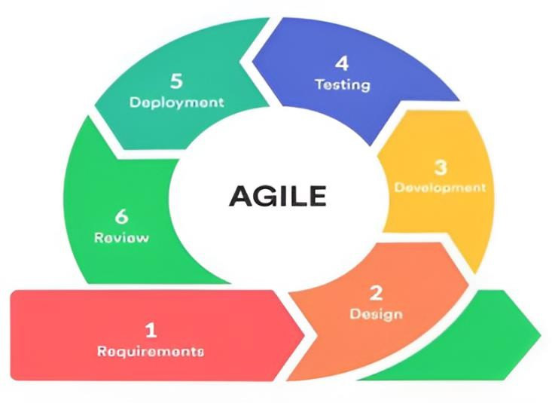

Source://targettrend.com/agile.methodology//images.app.goo.gl/VCNgRjfUsxWfwn84A

The Agile methodology was used as a flexible approach to software development that emphasizes iterative processes, collaboration, stakeholder feedback, and adaptability to change. This approach allowed the research team to continuously improve the system through incremental development and regular reviews, ensuring the outputs remained aligned with user needs and stakeholder expectations.

RESULTS AND DISCUSSION

The existing tourism management and transport booking process for Santiago Island relied heavily on manual walk-in procedures and pen-and-paper documentation. Under this system, boat and barge operators, along with the local Tourism Office, managed bookings, capacity tracking, and manifest creation through decentralized, time-consuming tasks. Without a centralized digital record, the island's maritime logistics lacked real-time updates, making the day-to-day operations vulnerable to data discrepancies and administrative delays.

The primary problem identified in this manual setup was a significant communication gap that led to operational risks and traveler frustration. Stakeholders frequently faced long queues, while the absence of a real-time tracking system increased the likelihood of overbooking and safety concerns during manifest creation. Travelers suffered from a critical lack of service information, forcing them to rely on informal negotiations and in-person inquiries, which resulted in significant pre-trip uncertainty and delays, especially during peak tourism seasons.

To address these inefficiencies, the proposed IslaLink system introduced a suite of digital features designed to streamline operations and enhance the visitor experience. The platform centralized Boat and Barge Booking alongside a Search Booking function to ensure organized scheduling and capacity management. Additionally, the system integrated an Interactive Map to assist with navigation and monitoring tourism density, complemented by dedicated sections for Tourist Spots and Restaurants to provide travelers with a comprehensive, real-time digital guide for their journey.

The system evaluation, conducted through a survey based on ISO 25010 standards, confirmed a high level of quality and acceptability across all measured criteria. The assessment validated the system's performance in key areas such as Functional Suitability, Usability, and Performance Efficiency, while also ensuring robust standards for Security, Portability,

Compatibility, and Reliability. Overall, the feedback gathered by the researchers indicated that the platform is well- designed and effectively meets the requirements of its intended users.

Process Involved in Tourism Information and Navigation Practices

The existing information ecosystem for Santiago Island relied on a fragmented mix of manual and informal sources, including physical brochures, social media pages, verbal referrals, and independent travel blogs. While brochures and Facebook pages provided general announcements and travel advisories, they often suffered from outdated content and a lack of integration with real-time booking systems. Furthermore, the heavy reliance on word-of-mouth from local drivers or resort staff and user-generated content from online forums led to inconsistent, unstandardized information regarding pricing and logistics. These decentralized channels created significant discrepancies for travelers, highlighting the urgent need for a single, verified digital platform to provide accurate and real-time tourism data.

Navigation and booking for Santiago Island currently relied on informal, manual, and location-dependent methods, as the lack of digital tools for water travel forced tourists to depend on word-of-mouth and physical presence at mainland ports. For both barge and boat transport, the process was decentralized and managed through pen-and-paper documentation, requiring travelers to arrive on-site to inquire about rates, confirm availability, and negotiate fares directly with operators. This reliance on manual manifests and cash transactions made real-time capacity management impossible, leading to logistical uncertainties, potential overbooking, and a lack of standardized safety oversight for visitors.

Problems Encountered by the Santiago Islands Travelers and Stakeholders

An interview with Santiago Island travelers and stakeholders in Bolinao, Pangasinan were conducted, several challenges were identified in the current tourism and transport management system, including the absence of centralized information, manual record-keeping, and limited regulatory oversight. These issues led to inaccurate data, inefficient booking processes, long queues, and the lack of an online reservation platform, resulting in reduced operational efficiency and a less convenient travel experience.

The tourism and transport ecosystem for Santiago Island is marked by inefficiencies due to its reliance on decentralized and manual processes. The absence of a centralized database limits data accuracy and accessibility, making it difficult for the Tourism Office to verify operator accreditation and for travelers to obtain reliable information on pricing and availability. This results in inconsistent services and uncertainty in travel planning.

These issues are further aggravated by the use of handwritten records, which are prone to errors, data loss, and incomplete entries. The lack of updated digital mapping also constrains navigation and may pose safety risks, particularly during emergency situations where accurate and timely information is critical.

Moreover, the manual booking system requires physical transactions, leading to long queues, delays, and increased administrative workload. This reduces operational efficiency and negatively affects the overall tourist experience. The absence of an online reservation platform further limits flexibility, preventing travelers from planning and securing bookings in advance.

Overall, these challenges highlight the need for a digital solution to improve data management, streamline operations, and enhance service delivery. Figure 2 presents the fishbone diagram used to analyze the root causes of the problems in the existing booking process in Bolinao.

Figure 2. The Cause-and-Effect analysis of the manual tourism management using the fishbone diagram

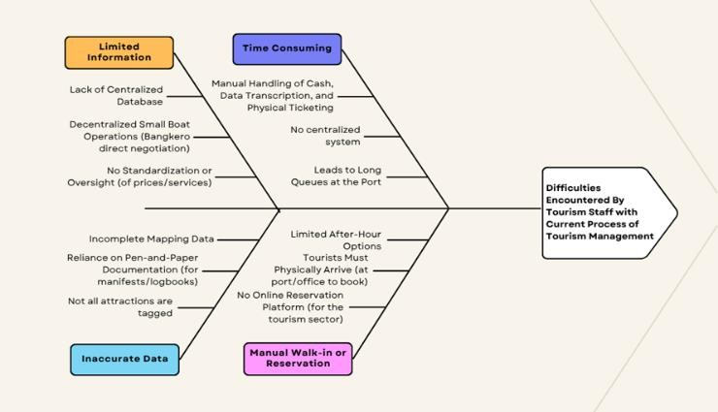

Features Integrated to IslaLink

The design and development of the proposed system were carefully constructed to analyzed the needed features to address issues of the stakeholders. This design was used to illustrate the system architecture of the proposed system as shown in Figure 3 using a layer structure.

Figure 3. Three-Tier Architecture

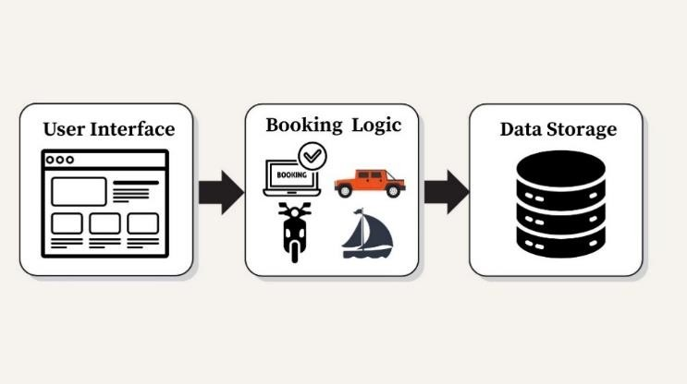

This system architecture shows three-tier layers of the proposed system: presentation tier, which identifies needed design layout, fields, and information for the user interface; application tier, which includes the implementation of the business logic; and data tier, which includes the structure of the data storage designed to accommodate needed information to be stored and how it will be processed.

The IslaLink system introduces a suite of integrated modules designed to replace inefficient manual processes with a streamlined digital infrastructure. The Boat and Barge Booking modules resolve the issues of decentralized information and inaccurate data by providing standardized input fields, automated scheduling, and electronic manifests that eliminate human error and informal price negotiations. To enhance navigation, the Interactive Map provides real-time heat-mapping of tourist density and precise location tagging, while the Tourist Spot and Restaurants features offer centralized, verified directories with exact pricing and contact details, removing the need for unreliable verbal referrals. Figure 4 shows the Boat Booking features of the proposed system. Figure 5 shows the Barge booking mechanism of the proposed system.

Figure 4. Boat Booking Feature

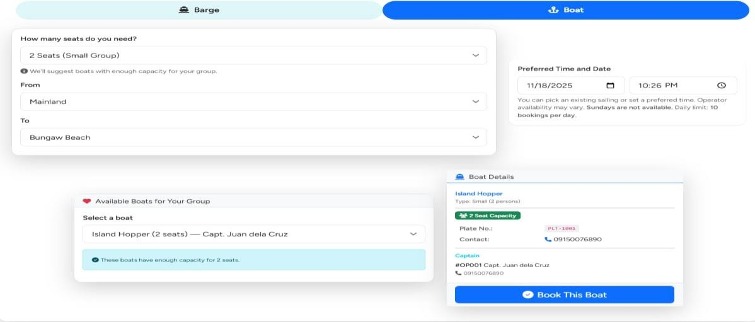

The Boat Booking module served as the core component of the IslaLink system by centralizing and standardizing boat transport information. It allowed travelers to plan and confirm bookings using structured inputs and real-time availability while providing verified boat and operator details to improve transparency, safety, and efficiency.

Figure 5. Barge Booking Feature

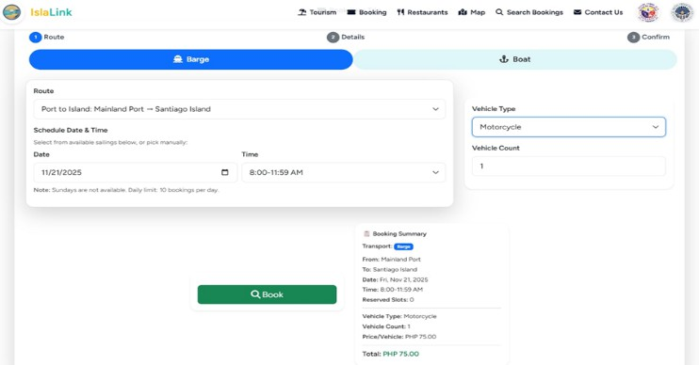

The Barge Booking module standardized the booking process through a guided, digital workflow that automated scheduling, capacity management, and manifest generation. This approach reduced manual errors, ensured pricing transparency, and replaced inefficient walk-in transactions with a secure and consistent system.

The researcher integrated a feature that will help travelers find different destinations that the island can offer. This feature guides the traveler from their current location to their destination as shown in Figure 6 below.

Figure 6. Interactive Map

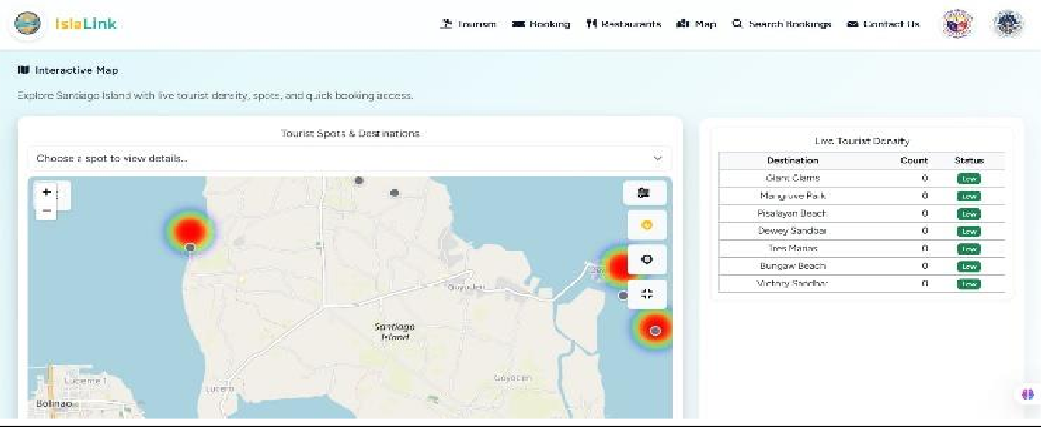

The Interactive Map displayed real-time navigation and tourism insights by visualizing tourist density and location data through an open-source map. This feature improved mapping accuracy and provided travelers with up-to-date information for more effective travel planning.

Acceptability of the Developed System

The developed ISLALINK system was evaluated using the ISO/IEC 25010 software quality model across eight key characteristics, with responses gathered from 20 participants consisting of tourism staff, tourists, and barge and boat operators selected through purposive sampling. The evaluation yielded an overall weighted mean of 3.97, interpreted as very good, indicating a high level of user acceptance of the system. Table 2 shows the tabulated results of the acceptability of the system.

Table 2. System Evaluation using ISO 25010

Category | Mean | Descriptive Equivalent
Functional Suitability | 4 | Very Good
Usability | 3.83 | Very Good
Performance Efficiency | 3.66 | Very Good
Security | 4 | Very Good
Portability | 4 | Very Good
Compatibility | 4 | Very Good
Reliability | 4 | Very Good
Maintainability | 4 | Very Good
Overall Weighted Mean | 3.97 | Very Good

In terms of functional suitability, the system obtained a mean score of 4.00 (very good), demonstrating that it effectively delivers the required features and functions. Similarly, security, portability, compatibility, reliability, and maintainability each received a mean score of 4.00, reflecting strong performance in ensuring data protection, system adaptability, interoperability, consistent operation, and ease of maintenance.

Meanwhile, usability recorded a mean of 3.83 (very good), suggesting that users generally find the system easy to learn and use, with minor opportunities for interface enhancement. Performance efficiency received a mean of 3.66 (very good), indicating acceptable system responsiveness and resource utilization, though further optimization may improve overall efficiency.

Overall, the consistently very good ratings across all ISO 25010 characteristics, supported by the overall weighted mean of 3.97, confirm that the ISLALINK system is highly acceptable to its intended users. These findings suggest that the system successfully meets user requirements and provides an effective digital solution to improve tourism navigation, booking, and management processes in Santiago Island.

CONCLUSION

The study concludes that the existing tourism booking and information management process for Santiago Island in Bolinao, Pangasinan is inefficient due to its reliance on manual, walk-in transactions and paper-based procedures. These practices result in long queues, inaccurate capacity tracking, and uncertainty among travelers, particularly during peak seasons.

The developed IslaLink web-based system successfully addressed these issues by providing a centralized platform for real- time booking, capacity management, navigation, and access to accredited tourism information. By digitizing key processes, the system improved operational efficiency, data accuracy, and overall traveler experience.

System evaluation using ISO 25010 standards confirmed that IslaLink is reliable, user-friendly, and acceptable for actual deployment. Thus, the study affirms that IslaLink is an effective digital solution for modernizing tourism and transport management in Santiago Island.

REFERENCES

- Bulchand-Gidumal, J. (2022). Post-COVID-19 recovery of island tourism using a smart tourism destination framework. Journal of Destination Marketing & Management, 23, Article 100689. https://doi.org/10.1016/j.jdmm.2022.100689
- Chan-Edmiston, S., Fischer, S., Sloan, S., & Wong, M. (2020). Intelligent transportation systems (ITS) joint program office: Strategic plan 2020–2025 (Report No. FHWA-JPO-18-746). U.S. Department of Transportation. https://doi.org/10.21949/1527606
- Dacquel, M. I. A. P., Abellana, E. J., & Diňo, M. J. S. (2024). Tourism destination management of Palawan vis- à-vis the National Tourism Development Plan 2016–2022: Basis for enhancement. International Journal of Research and Innovation in Social Science, 8(11), 217–224. https://doi.org/10.47772/IJRISS.2024.81100018
- González, J. A., & Pizmony-Levy, O. (2023). Title of the article. Futures, 139, Article 102928. https://doi.org/10.1016/j.futures.2023.10298
- Llanos, J. A. P., & Montalbo, J. A. (2023). A web-based ticketing and booking application for enhancing maritime travel operations and services in Siargao Island. ResearchGate. https://doi.org/10.13140/RG.2.2.29042.7521
- Mejas, J. G. S., & Encarnacion, R. E. (2024). Enhancing maritime travel through digital booking systems: A case study of Siargao Island. https://psa.gov.ph/sites/default/files/Mejas-Encarnacion_2024.pdf
- Mulyana, A., & Utami, S. (2023). Analysis of user satisfaction with the implementation of the Shopee application using the TAM method. Journal of Information Technology and Management, XX(YY), 1–10. https://doi.org/10.1234/jitm.381640646
- Roukouni, A., & Zuidwijk, R. (2020). Port of Rotterdam: Booking.com for container transport. RSM Case Development Centre. http://hdl.handle.net/1765/128158
- Sulaymanov, S. A., & Kaypova, M. D. (2025). Internal academic publication – no public access link available.
- Zhao, Y., Wang, H., Guo, Z., Huang, M., Pan, Y., & Guo, Y. (2022). Online reservation intention of tourist attractions in the COVID-19 context: An extended technology acceptance model. Sustainability, 14(16), Article 10395. https://doi.org/10.3390/su141610395
- TargetTrend. (n.d.). Agile methodology [Infographic]. https://targettrend.com/wp-content/uploads/2021/03/Agile-Methodology-1.png
- International Organization for Standardization. (n.d.). ISO/IEC 25010: Systems and software quality models. https://www.iso.org/obp/ui/#iso:std:iso-iec:25010:ed-1:v1:en

