Justice Under Threat: Legal Practitioners Narrative on National Issues and the Erosion of Professional Space

Research Presented to the Faculty
of the College of Criminal Justice of University of Cebu
Cebu City

In Partial Fulfillment
of the Requirements for the Degree Bachelors in science in Criminology

by

IVAN H. CAMPOREDONDO SIBYL CLAIRE S. HEREDIA CHRISLENE JANE S. CATANO
HOPE CESELY BAQUERO
BALTAZAR DELPOSO
DODELON F. SABIJON

FEBRUARY 2026

TABLE OF CONTENTS

Page No.
Title Page i
Table of Contents ii

Chapter 1
THE PROBLEM AND ITS SCOPE 1
INTRODUCTION 1
Rationale of the Study 5
Theoretical Background 9
THE PROBLEM 28
Statement of the Problem 28
Significance of the Study 29
RESEARCH METHODOLOGY 32
Research Design 32
Research Environment 32
Research Informants 33
Research Instrument 34
Research Procedures 35
Data Gathering 35
Data Analysis 35
Ethical Considerations 36

Beneficence 36
Nonmaleficence 37
Autonomy 37
Justice 37
Trustworthiness of Research 38
Credibility 38
Transferability 38
Dependability 38
Confirmability 39
Bracketing and Reflexivity 39

DEFINITION OF TERMS 40

PRESENTATION AND ANALYSIS OF DATA 43
Presentation of Data 43
Analysis of Data 70

SUMMARY, FINDINGS, AND IMPLICATION 84

REFERENCES 94

APPENDICES 104

  - Transmittal Letter 104
  - Informed Consent Form 105
  - Interview Guide 120
  - Endorsement for oral defense 125
  - Protocol Approval 126
  - Location Map 127
  - Sample of Verification Form of the Transcription 128
  - Sample Coded Significant Statements 133
  - Sample Formulation of Core Meaning 142
  - Development of Cluster Themes 147

CURRICULUM VITAE 151

Rationale of the study

THE PROBLEM AND ITS SCOPE INTRODUCTION

All countries in this world have national issues whether economic, political, or even jurisdiction related issues. This means that every single has an occurring issue and the only thing that matters is how did they address that issue. National issues as defined as the pressing concerns that affect the overall well-being of a country and its citizens, including economic challenges, corruption, social justice, environmental problems, and public health crises. These issues often shape public opinion, influence policymaking, and drive political debate, revealing the attitudes and values of the populace ( Fiveable, 2024)

Despite of being one of the best countries then Philippines still suffers from many social problems which impede progress and development – poverty, corruption, insufficient healthcare provision, and inadequate education are just some of the pressing concerns (Santiago, 2023). The issues of poverty and inequality in the Philippines arise from multiple factors, such as insufficient job prospects, lack of access t o education and healthcare , and inadequate infrastructure development. These elements combine to widen the inequality gap, making it increasingly difficult for those already in poverty to escape its confines.

Economic disparity is still one of the most urgent issues facing the world, according to a recent Pew Research Center global study (2025). People in 36 nations, including China, Germany, Brazil, and the Philippines, show intense concern about growing costs, joblessness, and the growing wealth disparity, despite differing degrees of economic expansion and national confidence. The report also emphasizes that, like worries expressed over twenty years ago, corruption and environmental degradation are still ranked highly among perceived national problems (Danilo V Rogayan Jr., 2025,)

Corruption stands as a major social issue in the Philippines, characterized by instances where power, positions, or resources are exploited for individual benefit. In the Philippines, corruption appears in diverse forms, including bribery, nepotism, cronyism, and embezzlement, among others. The Corruption Perceptions Index 2022 indicates that the Philippines holds the 116th position out of 180 countries assessed. The consequences of corruption are extensive and detrimental to both society and the economy. It weakens the rule of law, diminishes public confidence in government institutions, deters foreign investment, contributes to ongoing poverty and inequality by misallocating vital social service funds, and reallocates resources to cover illegal activities
(Santiago, 2023).

High-ranking officials and civil servants frequently find themselves involved in corruption scandals, while businesses struggle with bureaucratic hurdles and requests for bribes when attempting to obtain government contracts. Even with initiatives aimed at addressing corruption, the enforcement mechanisms are still inadequate, and the public procurement processes are not transparent enough, enabling corrupt activities to continue (Hays, 2015).

The jurisdiction matter was raised when the dispute in the West Philippine Sea involves conflicting territorial claims between China and the Philippines, with China claiming sovereignty over almost the whole South China Sea via its nine-dash line. Nevertheless, the 2016 decision by the Permanent Court of Arbitration nullified China's claim, confirming the Philippines' sovereign rights within its Exclusive Economic Zone (EEZ) (Limos, 2019).

China maintains its refusal to accept the decision and has increased its activity in the area by sending maritime militia ships and coast guard units, resulting in regular clashes with Philippine forces (Argosino, 2025).

Another issue arose when the International Criminal Court (ICC) has launched an official inquiry into the concerning human rights abuses in the Philippines, especially regarding President Duterte’s contentious “war on drugs”

and the extrajudicial killings that have occurred in Davao City. These measures have led to the fatalities of many civilians, while activists encounter ongoing threats and violence, with journalists being particularly targeted (Pinay Wise, 2024).

Vice President Sara Duterte is undergoing an impeachment trial amid the continuing issues related to her father, former President Rodrigo Duterte, and his situation with the International Criminal Court (ICC). The impeachment actions against her arise from accusations of misuse of power and poor management of confidential funds, which critics claim were utilized without adequate oversight. The Senate impeachment court was originally scheduled to commence hearings on June 11; however, delays have sparked concerns regarding the trial's progression before the 19th Congress adjourns (Sarao, 2025).

If the trial isn't finished by June 30, legal experts caution that it may be essentially dismissed since incomplete matters do not automatically transfer to the 20th Congress. This ambiguity has sparked conjecture about political strategies, with certain senators contending that the trial needs to be accelerated to prevent jurisdictional issues (OMBAY, 2025).

At the same time, Vice President Duterte has fervently supported her

father's ICC case, contending that the Philippines ought not to acknowledge the court's authority. Her impeachment trial has added complexity to the political scene, as Duterte’s supporters in the Senate might sway the process. Several legislators have voiced worries that the trial may be terminated because of procedural holdups, while others maintain that the Senate is obligated to carry out its constitutional responsibility to advance the case (PANTI, 2025).

Theoretical Background

This study was mainly anchored on the Theory of Law by Dworkin, R. (1986). and supported by two theories: the Theory of Legal Pluralism by Hart,
H. L. A. (1961) and the Cognitive Dissonance Theory by Festinger, L. (1957).

Ronald Dworkin’s Theory of Law, often described as “law as integrity,” posits that law was not merely a system of rules but an interpretive practice grounded in moral principles. Dworkin argues that judges and legal advocates should interpret legal texts by constructing the best moral justification that fits coherently with the legal system and the community’s political morality (Flores, 2014). This approach rejects a purely mechanical application of rules and instead embraces a constructive and evaluative method where legal decisions aim to achieve fairness and justice within the framework of existing laws (Lyons, 2010).

In the Philippine context, where national issues often involve complex moral and political questions, Dworkin’s theory provides a valuable lens to understand how legal advocates form their perspectives. Legal advocates do not merely apply laws but engage in principled reasoning to reconcile legal texts with societal values, especially when addressing contentious issues like human rights and governance. This interpretive role shapes their views on national issues as they seek to uphold justice while respecting the coherence of the legal system (Soper, 1987).

Thus, Dworkin’s theory helps explain the perspectives of legal advocates as an exercise in moral and legal interpretation, where they strive to find “one right answer” that best justifies the use of collective force and legal authority in the Philippines’ democratic setting (Flores, 2014). Their role was both normative and constructive, balancing respect for constitutional principles with the pursuit of social justice.

H.L.A. Hart’s legal theory (1961) acknowledges the coexistence of multiple legal systems within a single society, a concept known as legal pluralism. Hart, a foundational figure in legal positivism, recognized that law consists of rules created and enforced by recognized authorities but also accepted that societies often contain overlapping normative orders, such as customary and

religious laws Hart, as cited in general legal theory literature.

In the Philippines, legal pluralism was particularly relevant due to the presence of national laws alongside indigenous customary laws and Islamic legal traditions, especially in regions like Mindanao. This pluralistic legal environment complicates how legal advocates perceive and address national issues, as they must navigate multiple legal frameworks that sometimes conflict or overlap. Understanding legal pluralism allows for a nuanced exploration of how advocates reconcile these diverse legal orders in their professional roles (Flores, 2014).

Legal pluralism thus contextualizes the perspectives of legal advocates by highlighting the complexity of applying national laws in a culturally and legally diverse society. It underscores the challenges they face in ensuring justice and coherence within a multifaceted legal landscape, which directly impacts their views on the effectiveness and fairness of laws addressing national issues.

Leon Festinger’s Cognitive Dissonance Theory explains the psychological discomfort individuals experience when holding contradictory beliefs or attitudes, motivating them to reduce this dissonance through changes in perception or behavior. This theory is widely used in qualitative research to understand how people reconcile conflicting information or values in complex

social environments. (Festinger, 1957).

Applied to legal advocates in the Philippines, cognitive dissonance theory helps explain how they manage tensions between their professional duties, personal beliefs, and the realities of national issues. For instance, advocates may face dissonance when laws or government policies conflict with their ethical views or when state actions undermine the rule of law. To alleviate this discomfort, they may reinterpret legal principles, adjust their attitudes, or push for reforms (Festinger, 1957).

This theory enriches the understanding of legal advocates’ perspectives by acknowledging the internal conflicts they navigate in a politically charged environment. It sheds light on how they reconcile inconsistencies between legal norms, government conduct, and their commitment to justice, shaping their nuanced views on national issues and the role of law in society.

Cognitive Dissonance Theory, introduced by Leon Festinger, explains the psychological discomfort individuals feel when they hold conflicting beliefs, values, or attitudes, particularly when their actions contradict their principles. Legal advocates in the Philippines often experience cognitive dissonance when defending clients or policies that conflict with their personal beliefs. Festinger’s

theory suggests that individuals strive for consistency between their attitudes and actions, leading lawyers to rationalize their positions or adjust their perspectives to reduce psychological discomfort. For instance, Filipino law practitioners navigating cases involving the death penalty may struggle with moral dilemmas, balancing legal obligations with personal convictions. Research indicates that lawyers employ modification strategies to align their professional responsibilities with their ethical values, sometimes adopting uniquely Filipino approaches to resolve dissonance. This phenomenon highlights the psychological complexities of legal advocacy in a system where justice, morality, and national policy often intersect (Cataquiz, 2002)

Cognitive dissonance also plays a role in legal debates surrounding human rights and national security in the Philippines. Lawyers advocating for civil liberties may experience internal conflict when defending government policies that impose restrictions on freedoms in the name of security. Studies show that attorneys often justify their positions by emphasizing legal precedents or broader societal benefits, even when these arguments contradict their personal beliefs. This dissonance can lead to shifts in legal reasoning, where practitioners gradually align their perspectives with the dominant legal framework to maintain professional integrity (Baguio Chronicle, 2025)

The tension between advocacy and policy underscores the psychological burden legal professionals face in navigating national issues. In cases involving environmental law, Filipino legal advocates frequently encounter cognitive dissonance when representing corporate clients accused of ecological harm. While many lawyers personally support environmental protection, their professional obligations may require them to defend industrial interests. Research suggests that attorneys mitigate this dissonance by framing their arguments within existing legal statutes, emphasizing procedural fairness over ethical concerns His rationalization allows them to maintain their professional roles while reconciling conflicting values. The struggle between legal duty and environmental advocacy illustrates how cognitive dissonance shapes legal decision-making in the Philippines(Cataquiz, A.S., Marino, J.A., & Salvacion, J.G., 2002)..

Another major obstacle facing legal activists who are struggling with cognitive dissonance is the Philippine drug war. Moral dilemmas frequently arise for defense lawyers defending people charged with drug-related crimes, especially when extrajudicial murders are involved. According to research, rather than directly challenging contentious state policies, legal professionals resolve these conflicts by focusing on procedural justice ensuring fair trials and due process. Through tactics like plea bargaining and moral reframing, this approach

enables them to balance their own principles with their professional responsibilities (Lamchek, 2021).

This shift in reasoning helps them manage psychological discomfort while fulfilling their legal responsibilities. The interplay between legal ethics and national policy demonstrates how cognitive dissonance influences advocacy in high-stakes legal battles.

Finally, cognitive dissonance is evident in legal discussions surrounding gender rights and equality in the Philippines. Despite the Philippines' reputation as an LGBTQ+-friendly country, tensions arise for lawyers due to the lack of a national anti-discrimination law and fierce resistance from conservative and religious organizations. According to Ramos, a lot of attorneys strive to overcome this cognitive dissonance by focusing their advocacy on international human rights frameworks and constitutional protections, such the Universal Declaration of Human Rights and the Yogyakarta Principles (Ramos, 2022)

The National Coalition for Human Rights Defenders Philippines (2017) focuses on strengthening networks of legal advocates and human rights defenders to combat impunity and promote respect for human rights treaties. This advocacy work informs the legal community’s engagement with national issues and their

collective perspective

The World Justice Project (2018) survey reveals that only 20% of Filipinos have access to legal help, exposing a significant gap in legal services. This scarcity affects how legal advocates perceive their role and the urgency of national issues related to justice and equity.

The Philippine legal system is a hybrid framework influenced by Spanish civil law traditions, American common law, and local customary law. This Intricate legal legacy necessitates sophisticated research techniques. Milagros Santos-Ong (2020) provides a thorough analysis of the Philippine legal system, covering its sources of law, institutional frameworks, and research methodology in her paper Philippine Legal Research. Legal scholars and practitioners who want to comprehend how Filipino legal advocates interpret and use laws in response to national challenges frequently mention her work.

Lawyers for Lawyers (2022) documents a disturbing trend of extrajudicial killings and harassment of lawyers in the Philippines, which undermines the independence of the legal profession and access to justice. These challenges affect legal advocates’ views on government adherence to the rule of law and their own professional safety.

A report by Lawyers for Lawyers (2022) documents serious threats to the safety and independence of Filipino lawyers, including extrajudicial killings and harassment. The hostile environment undermines lawyers’ ability to perform their duties freely and affects their views on the government’s adherence to the rule of law. This situation critically shapes legal advocates’ perspectives on national issues, especially those involving human rights and political dissent.

Namati (2023) discusses the critical role of community paralegals in the Philippines as a response to the scarcity of public interest lawyers. Formal recognition of paralegals is argued to improve access to justice, especially for marginalized communities, highlighting the legal community’s role in bridging gaps in legal representation on national issues.

Just Security (2023) "Lawyers Under Threat Highlighting Their Plight" talks on how populism and authoritarianism are causing more attacks on lawyers globally, especially in situations when governments target advocates for delicate issues (human rights, corruption, marginalized groups). It makes the case for more robust safeguards to maintain legal systems, which is pertinent to Philippine attorneys considering the drug war and red-tagging issues.

A memorandum by the Legal Education Board (2023) discusses the

evolving landscape of legal education and practice in the Philippines. It emphasizes the need for law schools to adopt community-based and advocacy-oriented curricula that prepare future lawyers to address the unique legal needs of their localities. The study also critiques the bar examination as the sole gatekeeper to legal practice, suggesting reforms to better align legal education with the realities faced by legal advocates addressing national issues.

The National Union of Peoples' Lawyers (NUPL) (2024) reports that human rights lawyers in the Philippines face death threats, surveillance, and intimidation, e s p e c i a l l y w h e n handling politically sensitive c a s e s . This environment shapes legal advocates’ perspectives on national issues, highlighting risks associated with defending human rights.

Regalado (2024) conceptualizes declining trust in Philippine legal institutions (police/courts) through frameworks of social trust, institutional performance, and media exposure amid authoritarian shifts (e.g., Duterte/Marcos eras). It critiques erosion of bureaucratic autonomy via political elite control and corruption, tarnishing legitimacy and procedural justice. This theoretical lens highlights how national issues undermine practitioners' professional space and public confidence in the rule of law.

Dressel (2024) "Courts and Authoritarian Populism in Asia: Reflections from Indonesia and the Philippines" explores how executives use courts as a tool and undermine judicial and legal independence through attacks on autonomy and loyalty dynamics, which are closely linked to the diminution of legal space under Duterte-era populism.

Lamchek (2024) Literature review on the drug war as penal populism/moral politics, synthesizing harms to legal norms and practitioners.

Baguio Chronicle (2025) and associated extensions. Talks about cognitive dissonance in legal and political conflicts, when proponents use precedents or the advantages of society to support their positions, which leads to alignment with prevailing frameworks

A 2024 panel by ABA International highlights ongoing human rights challenges in the Philippines, including repression of dissent and threats to the judiciary and legal professionals. The perspectives shared by prominent Filipino lawyers illustrate the difficult environment in which legal advocates operate on national issues.

Caravana Filipina / International Fact-Finding Mission (2025) "Black Robes, Red Targets: Report on Extrajudicial Killings and Other Human Rights

Violations Against Legal Professionals in the Philippines" (headed by a coalition comprising the NYC Bar Association, International Observatory for Lawyers in Danger, and Lawyers for Lawyers). records 59 extrajudicial executions, red-tagging, threats, surveillance, and lawfare against attorneys, judges, prosecutors, and paralegals between 2016 and 2023; these incidents are frequently connected to human rights work or victim representation in the drug war. highlights the "extraordinary risks" and the "justice system under siege."

Madrigal et al. (2025) conceptualize tensions between the Indigenous Peoples' Rights Act (IPRA, 1997) and customary systems in Mindanao, where state-centric frameworks often inadequately integrate indigenous norms, leading to land/resource conflicts and displacement. This pluralism requires hybrid approaches for equitable justice, influencing advocates' perspectives on reconciling formal law with cultural values in national issues like environmental and ancestral domain disputes.

Research on legal pluralism in the Philippines emphasizes the coexistence of national laws with indigenous customary laws, particularly in Mindanao. Legal advocates must navigate these plural systems when addressing national issues involving indigenous peoples, affecting their perspectives on law and justice (Holbrook, J. 2014).

Festinger’s Cognitive Dissonance Theory applied to legal professionals explains how lawyers reconcile conflicts between their ethical beliefs and the political realities they face. This psychological framework helps understand the internal struggles of Filipino legal advocates confronting national issues under challenging conditions (Festinger, 1957).

According to (Namati, 2019) highlights the significant role of community paralegals in the Philippines, particularly in providing legal education, advocacy, and representation in quasi-judicial bodies. Although paralegals are not formally recognized as lawyers and cannot litigate in courts, they play a vital role in assisting marginalized groups in agrarian, labor, indigenous peoples’, and environmental disputes. This study sheds light on how legal advocates, including paralegals, perceive their role in addressing systemic national issues through grassroots legal empowerment.

An investigative report on the World Justice Project. (2019) reveals that despite constitutional guarantees, only about 20% of Filipinos can access legal help, with many relying on informal networks rather than professional lawyers. The study identifies barriers such as cost, distance, and lack of awareness, which affect the legal community’s capacity to serve the poor and marginalized. This context informs the perspective of legal advocates who grapple with systemic

challenges in delivering justice on national issues.

According to Balisacan, R. H. C. 2006 A scholarly paper critiques the Philippine Code of Professional Responsibility, arguing that it inadequately addresses emerging non-litigation legal practices and the changing demographics of the legal profession. This gap affects how legal advocates perceive their professional duties in a complex and evolving legal environment, influencing their approach to national issues that require diverse legal strategies beyond courtroom litigation.

Jaafar, 2007 studied the information-seeking behavior of lawyers in the Public Attorney’s Office and Prosecutor’s Office in Pasig City. The study found that lawyers heavily rely on personal communication and external resources due to limited institutional support and time constraints. These findings highlight the practical challenges legal advocates face in staying informed and effectively addressing national legal issues.

Prill-Brett, J. (2007) "Contested Domains The Indigenous Peoples Rights Act (IPRA) and Legal Pluralism in the Northern Philippines." Journal of Legal Pluralism and Unofficial Law. Examines IPRA's impact on customary practices and resource management.

Holbrook, J. (2010) "Legal Hybridity in the Philippines Lessons in Legal Pluralism from Mindanao and the Sulu Archipelago." Tulane Journal of International and Comparative Law. On hybrid systems in Mindanao.

Amnesty International (2021), with ongoing relevance "Philippines: Surge in Killings of Lawyers and Judges Shows Justice System 'in Deadly Danger'." Links killings/red-tagging to drug war and counterinsurgency.

ALG (2024) Annual reports with "Stories from the Field" and paralegal case studies. Empirical: Practitioner narratives on overcoming barriers through community participation. Highlights threats to paralegals as "threats to abusive practices."

Human Rights Watch (2024) "Philippines: Supreme Court Rejects 'Red-Tagging'" (May 8, 2024). Analyzes Deduro v. Vinoya ruling that red tagging threatens rights, with implications for lawyers facing vilification in sensitive cases.

Caravana Filipina / International Fact-Finding Mission (2025) "Black Robes, Red Targets: Report on Extrajudicial Killings and Other Human Rights Violations Against Legal Professionals in the Philippines." Documents 59 extrajudicial killings (2016–2023), plus surveillance, intimidation, red-tagging,

and lawfare against lawyers, judges, prosecutors, and paralegals—often linked to drug war victim representation or human rights cases.

The legal frameworks governing national issues like corruption, economic issue and jurisdictional related issue that provide the foundation for analyzing the role of legal institutions in their perspective about the national issue within the Philippine context.

Republic Act No. 3019, known as the Anti-Graft and Corrupt Practices Act, provides the essential legal framework for addressing corruption among government officials. It identifies corrupt activities like bribery, influence-peddling, and the improper use of public resources, imposing penalties on individuals convicted of these offenses. The law also requires public officials to submit their Statement of Assets, Liabilities, and Net Worth (SALN) to promote transparency in government operations. Offenses under this act can lead to imprisonment, financial penalties, and disqualification from public office.

Revised Penal Code (Articles 210-212) – These articles make both direct and indirect bribery illegal, holding both the bribers and the bribed accountable under the law. Article 210 punishes public officials who take bribes in return for special treatment, whereas Article 211 deals with indirect bribery in which

officials are given gifts or advantages connected to their role. Article 212 broadens the scope of liability to encompass private individuals who propose bribes.

Republic Act No. 6713 (Code of Conduct and Ethical Standards for Public Officials and Employees) – This legislation outlines ethical standards for public servants, obligating them to maintain honesty, integrity, and accountability. It requires the disclosure of assets, liabilities, and financial interests to ensure that officials refrain from engaging in corrupt activities. The law also forbids conflicts of interest, stopping officials from leveraging their positions for personal benefit.

United Nations Convention on the Law of the Sea (UNCLOS) – The Philippines depends on UNCLOS, especially its stipulations regarding Exclusive Economic Zones (EEZs), to claim sovereignty over the West Philippine Sea. The 2016 arbitral decision based on UNCLOS nullified China’s nine-dash line assertion, reinforcing the Philippines' sovereign rights within its EEZ.

1987 Philippine Constitution (Article II, Section 7) – This section emphasizes that national sovereignty, territorial integrity, national interests, and the right to self-determination are crucial in the country's foreign relations. It strengthens the Philippines' legal assertion over the West Philippine Sea and

requires the government to safeguard its territorial rights.

A study on the prospect of multi-jurisdictional legal practice in the Philippines (2024) discusses how Filipino lawyers increasingly engage with international legal systems through advanced degrees and cross-border practice. This trend affects legal advocates’ perspectives by broadening their understanding of national issues within global legal contexts.

Raymond Rodis (2025) highlights the significance of easily available and trustworthy legal research platforms for Filipino legal professionals in his article Best Legal Research Databases in the Philippines: A Guide for Lawyers and Law Students. To handle the increasing complexity of jurisprudence, statutes, and administrative issuances, he contends that thorough digital resources are crucial for attorneys, law students, and researchers. These resources not only improve legal analysis but also increase advocates' ability to competently and morally rigorously address national issues.

The Integrated Bar of the Philippines (IBP) and the Public Attorney's Office (PAO) continue to offer impoverished clients free legal aid, upholding the constitutional right to seek justice. Nonetheless, research shows that the need for legal assistance greatly outweighs the staff and resources that are available.

Filipinos were able to obtain legal assistance, according to Tiongco (2021), Many of them relied on unofficial sources like friends or family, and very few of them received support from institutions or attorneys. Pro bono attorneys frequently deal with severe resource limitations, which affects how they see the viability and efficacy of legal aid initiatives in resolving domestic legal concerns.

Alternative Law Groups’ annual report (2025) highlights the advocacy role of lawyers in upholding human dignity and promoting social justice amid digital and political challenges. Legal advocates’ perspectives on national issues are shaped by their commitment to ethical practice and the protection of fundamental rights in a rapidly changing society.

THE PROBLEM

Statement of the Problem

The study delved into the legal perspectives of legal advocates on major national issues in the Philippines.
Specifically, it sought to answer the following questions:

- What was the perspective of the informants on the major national issues in the Philippines?
- How did the legal community perceive its role in addressing current national issues?
- What are the prevailing views of the Legal Community on the effectiveness of the existing laws and policies related to national issues?
- How did the legal community assess the government's adherence to the Rule of Law in handling national issues?
- How have recent national issues affected the practice of law and legal professions in the country?
- What was the perspective of the Legal Community on the balance between human rights and national security in policy making?

Significance of the Study

This study benefited the following:

Lawyers. This study provided the lawyers with a deeper understanding of how their perspectives align with or differ from prevailing legal theories and national issues It helped them reflect on their role in shaping legal discourse and policy in the Philippines. Moreover, it can enhance their ability to advocate effectively by grounding their arguments in both legal principles and social realities.

Integrated Bar of the Philippines (IBP). The study offered the IBP valuable insights into the collective views of its members regarding critical national concerns. This informed the organization’s advocacy, continuing legal education, and policy recommendations. It also supports the IBP’s mission to uphold the integrity and professionalism of the legal community

Local Government Units (LGU). The study offered the IBP valuable insights into the collective views of its members regarding critical national concerns. This informed the organization’s advocacy, continuing legal education, and policy recommendations. It also supports the IBP’s mission to uphold the integrity and professionalism of the legal community

Department of Justice (DOJ). This research assisted the DOJ by highlighting how legal practitioners perceive and interpret major national issues within the justice system. It informed the department’s policy-making, reform initiatives, and training programs for prosecutors and legal officers. The study supports the DOJ’s goal of ensuring justice is administered fairly and efficiently.

Community. The community stood to gain from improved legal advocacy and judicial processes informed by the perspectives gathered in this study. Enhanced understanding and application of the law can lead to better protection of citizens’ rights and promotion of social justice. This contributes to strengthening the rule of law and public trust in legal institutions

Researchers. This study provided the researchers with a rich qualitative dataset and theoretical framework for analyzing legal perspectives on national issues. It contributed to the growing body of knowledge in legal studies, particularly in the Philippine context. Researchers can use the findings to explore related topics or develop comparative studies

Future researchers. Future researchers would benefit from the methodological approach and theoretical insights presented in this study as a foundation for further investigation. The study identified gaps and emerging

themes that can inspire new research questions and projects. It also encourages the continued examination of the dynamic relationship between law, society, and governance in the Philippines.

RESEARCH METHODOLOGY

Research Design. This study employed a qualitative exploratory method, which focuses on exploring, interpreting, and understanding complex social phenomena through in-depth analysis of non-numerical data. Specifically, it employs an exploratory or descriptive research design, depending on the nature of your inquiry. An exploratory design is used if your goal is to uncover new perspectives and insights from legal advocates regarding major national issues in the Philippines. A descriptive design, on the other hand, seeks to systematically document and analyze these perspectives to provide a detailed representation of legal professionals' viewpoints. This research relies on methods such as interviews, focus group discussions, and document analysis to capture the depth and complexity of their experiences, ensuring a rich, contextualized understanding of the issues at hand

Research Environment. The researchers conducted the study in Barangay Duljo-Fatima and Barangay Bulacao a large barangay in Cebu City. Cebu City, known as the Queen City of the South, is a highly urbanized city in the Central Visayas region of the Philippines. It serves as the regional center and is a major hub for commerce, trade, and industry. As of the 2025 estimate, Cebu City has a population of approximately 1,061,620 people. This marks a steady increase from

previous years, reflecting its status as a growing metropolitan area. The city is the most populous in the Visayas and ranks among the largest cities in the Philippines.

This study focus specifically in Duljo-Fatima is an urban barangay with a population of 15,851 as of the 2020 census. It is characterized by a mix of residential and commercial areas, with a significant working-age population. The barangay has a diverse demographic structure, making it a relevant location for understanding legal concerns affecting different social groups.

Barangay Bulacao, on the other hand, is known for its environmental and socio- economic challenges. Studies have been conducted on the Bulacao River, assessing its water quality and pollution levels. This indicates that the barangay faces environmental concerns that may intersect with legal advocacy, governance, and policy-making.

Research Informants. This study acquired 10 participants that belongs to the legal community residing in Brgy. Duljo-Fatima and Brgy. Bulacao to answer the research questions. The research informants are those individuals who doesn’t only study law but who also passed the Philippine Bar Examination or a licensed lawyer. This study gathered insights from legal experts, human rights advocates,

and policymakers who actively engage with laws shaping accountability and justice in the Philippines. Judges, lawyers, and law professors shared their interpretations of key legal frameworks, offering valuable perspectives on how international and domestic laws interact in real cases.

Beyond legal professionals, the study also includes voices from human rights organizations and government officials, providing firsthand accounts of how policies are enforced and their real-world impact on justice and governance. Their perspectives helped highlight the challenges, effectiveness, and practical implications of these legal provisions in shaping the country's approach to human rights. (Refer to Appendix D for the Location Map)

Research Instruments. This study utilized a semi-structured interview guide serves as a primary tool, ensuring consistency while providing flexibility for participants to elaborate on key issues. Additionally, an observation checklist may be used to document relevant behaviors or interactions that contribute to the understanding of legal advocacy in national issues. To analyze relevant legal documents, policies, or court decisions, a document analysis framework helps extract patterns and thematic insights that align with your research objectives. These instruments collectively support a comprehensive and nuanced approach to data collection, ensuring a rich and meaningful exploration of legal

perspectives.

Research Procedures. Before conducting the study, the researchers provides the ethical considerations to legally ask permission to conduct this study. The researchers contact potential participants via email or phone to arrange convenient times and locations for the interviews, considering their busy schedules as legal professionals. Before the actual interview, researchers explains the study’s purpose, the voluntary nature of participation, confidentiality measures, and how the data be used. The researcher records every detail from the beginning until the end of the interview.

Data Collection. The data was gathered through interviews with the use of voice recorder to record conversations. The researcher records every detail from the beginning until the end of the interview to ensure the accuracy of the data collected with the participants approval. The participants are free to answer based on their knowledge and are asked to honestly answer the question without fabrication. In addition, numerous references, including websites, articles, news, a previous case and others, were utilized to gain insight with the topic.

Data Analysis. This study used a qualitative research design, it focuses on interpreting and organizing non-numerical data to identify meaningful patterns

and themes. This study employs thematic analysis, where responses from interviews or focus group discussions are systematically coded and categorized based on recurring themes that emerge. Additionally, content analysis may be used to examine legal documents, policies, and statements to uncover key legal perspectives on national issues. Researchers typically transcribe interviews, review participant responses, and apply coding techniques to classify insights under relevant themes. Through this process, your study ensures a deep exploration of legal advocates' perspectives, allowing for a rich and contextual understanding of the issues at hand.

Ethical Considerations. The researcher should establish informed consent ensuring participants understand the study’s purpose and can withdraw at any time. Confidentiality protects respondents, particularly legal professionals, from potential political repercussions by anonymizing data. Objectivity and Avoidance of bias to represent balanced perspectives without favoring a political stance. Responsible use of secondary data ensures accurate citation and adherence to copyright laws, preventing misinterpretation. Lastly, respect for political sensitivities requires framing discussion professionally to maintain factual analysis while acknowledging unresolved legal debate

Beneficence. The researcher upholds beneficence by ensuring participants

are treated with dignity, respect, and confidentiality, while minimizing potential risks. Informed consent guarantees voluntary participation, allowing individuals to withdraw at any time. Beyond ethical safeguards, the researcher aims to generate valuable insights that contribute to legal reforms and human rights protections in the Philippines, ensuring the study not only avoids harm but actively promotes justice and accountability.

Nonmaleficence. The researcher upholds nonmaleficence by ensuring participants' confidentiality, minimizing risks, and maintaining objectivity throughout the study. Informed consent guarantees voluntary participation, while ethical safeguards prevent harm in data collection, interpretation, and reporting. By implementing these measures, the researcher ensures that the study contributes positively to justice and accountability without compromising the rights or well-being of those involved.

Autonomy. The researcher prioritizes autonomy by allowing participants complete control over their participation in the study. Informed consent ensures that individuals can make voluntary and well-informed choices and have the option to withdraw at any point without facing any repercussions. By honoring participants' freedoms and decisions, the study upholds ethical standards while encouraging trust and transparency.

Justice. The researcher promotes justice by guaranteeing fair and equal treatment for all participants. The criteria for selection cleared and unbiased, avoiding any discrimination or exclusion. The results presented objectively, ensuring that the research supports legal accountability and human rights without any bias or distortion.

Trustworthiness of Research. There are four key components for the trustworthiness of research which is credibility, transferability, dependability and confirmability. It makes its results credible, relevant, reliable, and impartial qualities that are crucial for research to be valued and used by the academic and professional community

Credibility. The researchers clearly document the research process, including sampling methods, data collection, and analysis steps. Systematic and transparent procedures help others assess the rigor and replicability of the study.

Transferability. The researchers offer rich, detailed accounts of the research context, participants, and processes. This includes describing the legal community in Cebu City, the backgrounds of participants, and the specific legal environments in which they operate.

Dependability. The researcher maintains a comprehensive and transparent

record of all research steps, including sampling methods, interview guides, data collection processes, and analysis techniques. This audit trail allows others to understand and follow your research path, supporting dependability. They clearly state any assumptions, cultural factors, or unique aspects of Cebu City’s legal community that may have influenced the findings. This transparency helps others assess the relevance of your results to different settings.

Confirmability. The researcher recorded and shared summaries or interpretations of findings with participants to confirm accuracy and ensure that the analysis genuinely reflects their views, not the researchers’ own interpretations to avoid potential bias.

Bracketing and Reflexivity. The researcher practiced bracketing by putting aside personal biases to preserve objectivity in the interpretation of data. To maintain reliability, uniform research methodologies and clear documentation utilized, guaranteeing that the results are precise, replicable, and unaffected by external influences.

DEFINITION OF TERMS

Legal community assess the government's adherence to the Rule of Law in handling national issues. This refers to the process in which legal experts such as lawyers, judges, and scholars evaluate whether a government follows the principles of the Rule of Law when addressing national concerns. The Rule of Law means that laws are applied fairly, consistently, and without favoritism, ensuring government actions comply with legal frameworks rather than being arbitrary or politically motivated. In practice, legal communities may review government decisions, policies, or crisis responses to determine if they align with constitutional and legal standards.

Legal community perceive its role in addressing current national issues. These are lawyers, judges, and legal scholar sees its responsibility in handling important national matters. It means that legal professionals recognize their duty to help solve problems affecting the country, whether through lawmaking, court decisions, or legal advice.

Perspective of the informants on major national issues in the Philippines. It is the point of view of the research respondents which are the lawyers, judge prosecutors about the major issues in the Philippines. Informants

share their views on significant national issues affecting the Philippines. Their perspectives help provide insight into the country's current challenges and possible solutions.

Perspectives of the legal community on the balance between human rights and national security in the policy making. Legal professionals share their views on how to balance human rights and national security when creating policies. Their perspectives help shape laws that protect people’s freedoms while ensuring the country’s safety.

Prevailing views of the legal community on the effectiveness of existing laws and policies related to national issues. This refers to what most legal professional like lawyers, judges, and scholars think about how well current laws and policies handle national problems. Most legal professionals share their opinions on whether current laws and policies are effectively solving national problems. It means the opinions of the legal community on whether the laws and rules in place are working effectively to solve issues in the country.

Recent national issues affected the practice of law and the legal profession in the country. Recent national problems have changed how law is

practiced in the country. These issues have also impacted the legal profession, affecting lawyers and the way they work.

CHAPTER 2 PRESENTATION AND ANALYSIS
OF DATA

Presentation of Data

To get a descriptive essence of feeling from their perspective from major national issues, the data was read and thoroughly examined extracted from the informants pertaining directly to the research phenomena (see Appendix H for sample of significant statements.

The researcher in this phenomenological study properly gathered all the data or information acquired from the informants coming from the in-depth interviews. All the data extracted were comprehensively read and systematically analyzed by the researcher to come up with a description of the experiences of the informants. Significant statements were extracted from the informants’ transcripts about the research phenomena. Formulated meanings from the significant statements are developed into clusters. Then from the clustered themes, the researcher created emergent themes that answer the sub-problems of the study.

The emerging themes are pointed out as a response to the sub-problems and are summarized as follows:

What was the perspectives of the informants on Major National issues in the Philippines?
- Structural Power, Corruption, and the Erosion of Democratic Integrity

- Structural Reform and Legal Sovereignty in a Politicized System

How did the legal community perceive its role in addressing current national issues?
- Legal Advocacy and Civic Engagement as Pathways to Reform

- Legal Advocacy, Civic Empowerment, and Democratic Renewal

What are the prevailing views of the Legal Community on the effectiveness of the existing laws and policies related to national issues?
- Structural Legal Deficiencies and the Struggle for Sovereignty and Reform

- Structural Inefficiencies and the Fragility of Governance

How did the legal community assess the government's adherence to the Rule of Law in handling national issues?

- Legal Advocacy, Constitutionalism, and the Pursuit of Reform
- Legal Sovereignty, Public Safety, and Civic Rights in a Globalized Context

How had recent national issues affected the practice of law and legal professions in the country?
- Ethics and Moral Responsibility in Legal Practice
- Legal Empowerment, Civic Engagement, and Rights-Based Education

What was the perspectives of the Legal Community on the balance between human rights and national security in policy making?
- Legal Advocacy, Civic Empowerment, and the Balance of Rights and Security
- Sovereignty, Human Rights, and the Limits of Legal Enforcement

What was the perspectives of the informants on Major National issues in the Philippines?
  - Structural Power, Corruption, and the Erosion of Democratic Integrity

This theme highlights the informants’ deep concern over the systemic nature of corruption and its corrosive impact on democratic institutions in the Philippines. Perspectives reveal how entrenched political dynasties, politicized

social programs, and moral decline have normalized corrupt practices across generations. The erosion of democratic integrity is seen not only as a legal failure but as a cultural and structural crisis that demands urgent reform and moral recovery.

Informant 3 profound that:

Corruption is systemic it is something that is systemic and also part of human nature. I think our culture encourage corruption, in the way how we look up, and normalize vote buying though it is illegal but it is something that is an open secret. Corruption does not only exist in public sector because it also exists in private sector. That’s why its systemic and cultural (IDI3:SS1).

Informant 6 genuinely stated that corruption cannot be eradicated but mitigated at the very least.

Corruption is something that for me, cannot be eradicated. I believe this can only be mitigated at the very least. From the root of the cause is Election, maybe we can improve our election process. Educating the electorate because it all begins by electing the public officers by choosing the right leaders, and the people follow their leaders. I believe that would cause a domino effect. Maybe we can improve the budgeting system (IDI6:SS2).

Informant 9 indicate that corruption is already existed during past administration. However during those time it was least visible. He added that corruption was being normalize nowadays.

Kanang corruption kay sauna paman na akong maingon ana is corruption has long been a persistent issue in the Philippines, dating back to the time of our grandparents. Diba sa panahon panas akong lolo ug lola ing-

ana najud sila. What is particularly concerning today is how normalized it has become in society, (I9:SS4). Corruption has been around for a long time. I would say it has been a persistent issue in the Philippines, dating back to our grandparents’ time. Even during my grandparents’ era, it was already happening. What’s especially concerning today is how normalized it has become in our society. Remember that issue about flood control? It was handled so carelessly.

Informant 5 states that the reason why corruption is very prevalent is because it is very easy to tempt politicians to financially gain.

naa kay free will at the same time corruptible ka, so mao na ang corruption lisod jud kaayu wad on, labina karong panahona , labina sa atong pang goberno na dali ra kaayu matintal ang mga kandidato nga maka financially gain sa ilang pag panarbaho, lisod jud na sya wad on, in the battle of corruption is a hard fought battle na kinahanglan gyud sya e continue ug wage ang kana nga battle ,sa public servants dapat naa jud kay accountability sa people and the members of the legal community is to assist and make sure that justice is served (IDI5: SS2). you have free will at the same time you are corruptible, so corruption is very difficult to fight, especially in this time, especially in our government where it is very easy to tempt candidates to financially gain from their job, it is very difficult to fight, in the battle of corruption is a hard fight battle that you really need to continue and wage that battle, in public servants there must be accountability to the people and the members of the legal community are to assist and make sure that justice is served

  - Structural Reform and Legal Sovereignty in a Politicized System

This theme explores the informants’ perspectives on the Philippines’ struggle to assert legal sovereignty amid internal and external political pressures. Discussions center on jurisdictional challenges, international

legal obligations, and the influence of global power dynamics on national decision-making. Informants emphasize the need for structural reform to reclaim sovereignty, strengthen rule of law, and ensure that legal institutions serve the interests of the Filipino people rather than political ambition.

Informant 1 indicates that there are laws that need to be fine tuned specially those spoon-feeding programs because the implementation of was being politicize.

The implementation of it na politicize na politica ba there is a need of modifications about that law because some of the known ecenomist niana naa juy effect if mo spoon feed lang ta tho helpful sya in minority group kay naka elevate sa life pero when it cones to national issue in whole need sya i fine tune (IDI1:SS1). The implementation of it has been politicize, there is a need of modifications about that law because some of the known economist that has an effect if you just spoon feed it though he is helpful in minority group because it elevates the life but when it comes to national issue in whole he needs fine tune.

Informant 5 genuinely stated that we need to review the existing laws if it still fit on this generation. If does not then therefore we need to amend the said law.

Siguro from time to time kailangan sa balikan, e review or revisit kay naa may mga balaod nga e amend ,if ng angkop pa ni sya sa panahon. That’s why makabantay ka , kasagaran sa nagkupot ana kasagaran mga lawyers nga connected ana sa either sa executive or sa house of representatives ug sa senate, kanang mga lawyers nga nag trabaho diha (IDI5:SS8). surely from time to time there is a need to return, review or revisit because there are laws that are amended, if they are still appropriate at the time. that’s why

you should be careful, usually those who are holding them are lawyers who are connected to either the executive or the house of representatives and the senate, those lawyers who work there.

Informant 6 articulated that our existing laws are well crafted. However, the implementation was the problem.

For me, my view here is our current and existing laws are well crafted. They are well crafted itself, meaning to say they all went through all the good processes, they went through debate but you know what is lacking is proper enforcement (IDI6:SS7).

How did the legal community perceive its role in addressing current national issues?

  - Legal Advocacy and Civic Engagement as Pathways to Reform

This theme reflects the study's focus on the legal community's proactive role in tackling national concerns through ethical behavior, public education, and participation. By advancing legal literacy, upholding due process, and fostering civic consciousness, attorneys, educators, and advocates act as catalysts for democratic renewal, according to informants and legal experts. In an environment where political meddling and corruption frequently threaten the rule of law, legal advocacy serves as a weapon for both defending rights and inspiring communities

to reform. The study's examination of how the legal profession influences public opinion, gives citizens more power, and upholds democratic principles in the face of systemic obstacles is supported by this theme.

Informant 5 reflects the belief that legal professionals must go beyond technical expertise and actively contribute to national development through civic education and moral leadership.

legal community more in education gyud na sila, nag educate sila sa mga different kind of points sa katong mga different advocates sa katong national issues. Based on my observation, ang ila lang pag hatag ug mga katin awan sa lain lain nga punto para maka decide ang mga tao basi sa ilang nakita ug nadunggan, ug asay sakto, mao nay role sa legal community to educate lang ang mga tao. Maghatag ug different point of views, dependi sa kinsay resource speaker, para ang mga tao makabalo sa issues and concern sa nasud. (IDI5:SS7). legal community is more into education, they are educating different kind of points from our different advocates on our national issues. based on my observation, they just give a few points on different points so that people can decide based on what they have seen and heard, and that is right, that is the role of the legal community to educate people. give a different point of view, depending on who the resource speaker is, so that people can know about the issues and concern of the nation

Informant 7 illustrates how legal aid and community-based legal services empower marginalized sectors, reinforcing the lawyer’s role as a civic educator and advocate.

They conduct free seminars, free legal aid and at the same time also there are lawyers who freely and voluntarily exercise their rights when they file petitions as against to other political. When they see its not that anymore justifiable or these politicians need to be accounted for what they are doing. As

to corruption, some lawyers are already filing petitions to the Ombudsman before the senate just to address this very important matters that we Filipino people are also seeking (IDI7:SS5).

The informant 8 reflects on the role of legal practitioners in public discourse, particularly through social media and teaching, as a means of demystifying legal procedures and promoting justice.

Lawyers are very important ,it is the light house in the middle of ocean. I even commend those lawyers who are very open to discussing this matter ,it's a hit or miss kind of thing and also professionally speaking , we are rendering legal services, so those lawyers who post on Facebook to provide you additional knowledge for that specific issue, consider that as pro buno, for them they are very patriotic, they stand for what is right and for what the law says (IDI8:SS10).

  - Legal Advocacy, Civic Empowerment, and Democratic Renewal

This theme highlights the legal community’s commitment to revitalizing democratic values through civic empowerment. Informants stress that legal professionals must not only interpret laws but also serve as catalysts for change. By educating the public about their rights and encouraging participation in governance, lawyers contribute to a more informed and active citizenry. This Renewal of democratic engagement is seen as essential in countering political apathy, resisting authoritarian tendencies, and restoring public trust in institutions.

The informant 6 highlights how lawyers contribute to democratic renewal by expressing informed views and encouraging civic responsibility, especially in politically sensitive contexts.

The present national issues, it was able to spark discourse, meaning to say dialogue between the legal profession, the lawyers. It prompted many lawyers to openly express also their views regarding the national issues (IDI6:SS9).

The informant 10 illustrates the legal community’s role in maintaining checks and balances, emphasizing that civic empowerment and legal advocacy are essential to preserving democratic integrity.

I am a member of the IBP Cebu Chapter, and I can confidently say that our chapter is actively engaged in monitoring government agencies and maintaining checks and balances. We provide valuable insights on governance, and many of our members are practicing lawyers who uphold the integrity of the profession. Their affiliation with IBP lends credibility and trustworthiness. As for other regions, I cannot speak with certainty, but we maintain close communication and offer guidance to ensure consistency in legal standards and principles across chapters (IDI10:SS9).

Informant 5 emphasizes the lawyer’s role in defending human rights and promoting civic awareness, suggesting that legal advocacy must be grounded in moral conviction and public service

Karon mas ing aktibo ang legal community ron sa pag fight sa mga pressing issues, usahay makita nimo ang mga dili kaayu nga mga abogado or

aktibista makita nimo sila sa mga media, nga motingog gyud sila about sa ilang advocacy, so mas nabuhi gamay ron ang atong kauban sa propisyon ug motingog para sa ilang mga adbokasiya. Sauna di kaayu sila maningog kay mahadlok man gud sila, sauna di raman mga civilian ang pamatyon, hasta ang mga abogado pamatyon sad, so karon issue about karon nga pang goberno, corruption, sitwasyon sa baha ug kagutom ug mga politiko. Kita nimo nga karon mo lihok na ug motingog na kay di naman sila mahadlok, kay kung di lang pinatyanay, molihok gyud sila (IDI5:SS9). now the legal community is more active in fighting pressing issues, sometimes you see non-lawyers or activists, you see them in the media, who are really speak out about their advocacy, so our fellows in the profession have become less voiced and speak up for their advocacy. they don't speak up because they are very afraid, they don't want civilians to be killed, even lawyers to be killed, so now the issues are about the government, corruption, flood situation and politicians. we see that now you are acting and speak up because they are not afraid, because if they were not killed, they would really act.

What are the prevailing views of the Legal Community on the effectiveness of the existing laws and policies related to national issues?
  - Structural Legal Deficiencies and the Struggle for Sovereignty and Reform

This theme reflects the legal community’s frustration with the disconnect between the existence of laws and their actual enforcement. Informants acknowledge that the Philippines has a robust legal framework, but point to deficiencies in implementation, institutional support, and political will.

The struggle for reform is not about creating more laws— it’s about empowering legal institutions to function independently and effectively. Sovereignty, in this context, means reclaiming the integrity of the legal system from political manipulation and ensuring that justice is accessible and impartial.

Informant 1 points out that while laws exist to protect justice actors, the legal system lacks institutional support, leaving prosecutors and judges vulnerable and undermining their ability to uphold justice.

we are not lacking laws our laws are more or less complete ang kulang nalng guro we haveto implement laws that will protect who are the protectors of justice like for example police force, prosecutors, justices they should feel that they are secured in dispensing justice. Our laws are complete bisan mohunong patag buhat ug balaod except lng haa sa pagkuan sa budge. My perspective on that wala namo na feel ang security as part sa legal system kulang kaau ang support sa legal system (IDI1:SS7). We are not lacking laws, our laws are more or less complete, maybe we have to implement laws that will protect who are the protectors of justice like for example police force, prosecutors, justices, they should feel that they are secured in dispensing justice. Our laws are complete even if the laws and acts stop, except for the budget. My perspective is that we no longer feel security as part of the legal system, the support of the legal system is lacking

Informant 3 acknowledges the presence of anti-corruption laws but laments that those in power are adept at evading accountability, revealing a gap between legal provisions and actual enforcement.

We do have existing laws. We have Graft and Corruption, Plunder Law and other provisions in the Revised Penal Code. We do have a lot of laws but they are good in keeping secrets in relation to the DPWH issue. This people are very intelligent and they said “criminal minds are always two steps ahead” (IDI1:SS7).

Informant 6 highlights the disconnect between well-crafted laws and their poor implementation, pointing to systemic weaknesses that prevent legal institutions from functioning effectively.

My view here is our current and existing laws are well crafted. They are well crafted itself, meaning to say they all went through all the good processes, they went through debate but you know what is lacking is the proper enforcement. (IDI6:SS7).

  - Structural Inefficiencies and the Fragility of Governance

This theme expresses concern over the fragility of governance structures that fail to uphold the rule of law. Despite having comprehensive laws, enforcement is often compromised by personal biases, corruption, and weak institutional mechanisms. Political families and entrenched interests are seen as barriers to reform, perpetuating cycles of inefficiency and injustice. The legal community views these structural flaws as threats to national stability, calling for stronger checks and balances, better leadership, and more inclusive policymaking

Informant 2 expresses skepticism about the effectiveness of law enforcement, noting that those tasked with implementing laws are often the same

individuals violating them. This paradox reflects a deeper structural flaw in governance.

Those who are expected to implement the laws are actually ni violate sa law sa current administration mga political families from sauna pa jud ba walay bag ong apilyedo na makadaog so how to implement na sila gihapon so how to implement na sila ra gihapon ang naa sa administration. So dli sd hopeless but im not holding too much na ma implement pa sya kay lisud pag implement ika duha ang implementors kay mao sd ang violators (IDI2:SS2.) Those who are expected to implement the laws are violating the law in the current administration, political families from the sauna, there's still no new nominee to win, so how can they implement it? So how can they implement it? They're still in the administration. So it's not hopeless, but I'm not holding out too much that it can still be implemented because it's difficult to implement both of them, because they're the violators.

Informant 6 points to electoral reform as a necessary intervention, suggesting that systemic inefficiencies in governance stem from flawed political structures and entrenched interests.

Corruption is something that for me, cannot be eradicated. I believe this can only be mitigated at the very least. From the root of the cause is Election, maybe we can improve our election process. Educating the electorate because it all begins by electing the public officers by choosing the right leaders, and the people follow their leaders. I believe that would cause a domino effect. Maybe we can improve the budgeting system (IDI6:SS2).

Informant 10 critiques the deeply embedded nature of corruption and political manipulation, arguing that these structural inefficiencies prevent meaningful implementation of laws and perpetuate governance failures.

Corruption remains a deeply entrenched issue in the Philippines. I believe it is one of the primary reasons the country continues to be classified as part of the developing world. Alarmingly, many of our leaders who should be the foremost enforcers of the law are often the first to violate it. Despite the presence of numerous government agencies tasked with implementing anti-corruption measures, the problem persists. Whether due to a lack of personnel or the difficulty of dismantling a system where corruption is embedded, addressing this issue remains a formidable challenge (IDI10:SS2.)

How did the legal community assess the government's adherence to the Rule of Law in handling national issues?
  - Legal Advocacy, Constitutionalism, and the Pursuit of Reform

This theme explores how legal professionals assess the government’s adherence to constitutional principles. Informants highlight the importance of upholding the rule of law, especially in times of political uncertainty. They advocate reforms that reinforce constitutional safeguards and ensure that legal processes are not undermined by executive overreach or partisan interests. Legal advocacy is seen as a means to hold government accountable and to protect the foundational values of democracy.

Informant 2 advocates for legal professionals to lead across all branches of government, arguing that their constitutional grounding and legal expertise are essential for crafting and interpreting laws that uphold democratic values.

Sa atong government gd nay tulo ka branches naam n mi sa judiciary. Gamit jud unta kung nay legal professional sat ulo ka branches. The

judiciary is only limited to interpreting the law mas maau jud unta sa pagbuhat lang sa balaod naa nay perspective daan sa legal professional (IDI2:SS5). In our government, we have three branches, including the executive legislative and judiciary. It would be better if there was a legal professional at the head of the each branches. The judiciary is only limited to interpreting the law, it would be better if there was a legal professional at the head of the other branches.

Informant 10 discusses the Philippines’ obligations under international law, particularly the ICC, and stresses that constitutional adherence must guide the country’s legal decisions and foreign commitments

In my view, crimes committed by an individual should be prosecuted based on the time and place they occurred. The Philippines, in this case, is simply fulfilling its obligations as a former member of the International Criminal Court (ICC). The alleged crimes attributed to the former president took place during a period when the Philippines was still a signatory to the Rome Statute. Therefore, even though we are no longer a member today, we remain bound by the commitments made during our membership (IDI10:SS6).

Informant 6 highlights the current administration’s deliberate adherence to legal processes, contrasting it with previous regimes and suggesting that constitutionalism, though slow, is a necessary safeguard for reform.

I think on the surface level on what we see in the public, there is adherence in the Rule of Law. Because if there is no adherence to the Rule of Law, we may not have peace and a functional system. Although there are lot of circumstances, we can still see that the institution are striving to adhere to the laws (IDI6:SS8).

  - Legal Sovereignty, Public Safety, and Civic Rights in a Globalized

Context

This theme addresses the complex interplay between national sovereignty and global legal obligations. Informants discuss how international treaties, such as UNCLOS and ICC membership, challenge the Philippines to balance domestic autonomy with international accountability. At the same time, issues like red-tagging and extrajudicial actions raise concerns about public safety and civic rights. Legal professionals stress the need for a nuanced approach that respects both sovereignty and human rights, ensuring that legal enforcement does not compromise democratic freedoms.

Informant 9 expresses the importance in complying the obligation of the Philippines to the international treaty

Para nako sa akoa lang ni, the arrest of Former President Rodrigo Duterte is maconsider jud siya nga lawful. Kay ang pilipinas nag remain sa Rome Statute until ni withdraw siya pag 2019. for proceedings before the International Criminal Court (ICC) is considered lawful. Since the alleged crimes occurred during his presidency, which iyang term nagsugod pag 2016, they fall within the period when the country was still under the jurisdiction of the ICC. The principle of continuing obligations under international law supports the ICC’s authority to investigate and prosecute offenses committed while the Philippines was a member state, regardless nga ni withdraw a na si Duterte 2019 but ang mga crimes nahitabo pag 2016 man (IDI9:SS1). in my personal opinion, the arrest of Former President Rodrigo Duterte can be considered lawful. The Philippines remained a party to the Rome Statute until it officially withdrew in 2019. Therefore, any proceedings before the International Criminal Court (ICC) are considered valid. Since the alleged crimes took place during his presidency,

which began in 2016, they fall within the period when the country was still under the ICC’s

Informant 3 highlights the informant’s view that the current administration, while slow-moving, prioritizes legality and due process. The emphasis on legalism is seen as a deliberate shift from previous regimes, reflecting a cautious but principled approach to governance.

My personal view, with the current administration is very legalize that’s why we feel that it acts very slow. As much as possible the current administration want everything to be legal unlike in the term of Duterte and Gloria (IDI3:SS8).

Informant 8 discusses the complexities of ICC jurisdiction and state obligations, emphasizing the need for the Philippines to balance its international commitments with domestic legal processes and sovereignty.

As for me lang the Philippines is just doingthere job under its obligations with the ICC , since the crime alleged to be committed by the president was under such time was still a member of the ICC, It means that just because the Philippines is not a member anymore, there is this term in law, where you have to make to of your obligations as a member, so even if karon wala nata, at that time when the Former president committed the crime, we are still member of the ICC (IDI8:SS6). For me, crimes committed by a person should be tried in the jurisdiction where they were committed. I believe the Philippines is simply fulfilling its obligations to the International Criminal Court (ICC), since the alleged crime by the former president occurred during the time when the country was still a member of the ICC. This means that even though the Philippines is no longer a member now, there is a legal principle that obligations made while being a member must still be honored. So even if we’re no longer part of it today, at the time the crime was committed, we were still under its jurisdiction.

How had recent national issues affected the practice of law and legal professions in the country?
  - Ethics and Moral Responsibility in Legal Practice

This theme delves into the ethical dilemmas faced by legal professionals in a politically charged environment. Informants reflect on the moral challenges of defending clients accused of corruption or human rights violations. They emphasize the importance of maintaining personal integrity, upholding legal principles, and resisting the normalization of unethical practices. The legal profession is portrayed as a moral compass for society, with lawyers expected to lead by example and advocate for justice even when it is unpopular or risky.

Informant 1 reflects on the moral challenges of defending clients involved in corruption, emphasizing the tension between professional duty and personal conscience in legal representation.

In a practice of law for example haa naa kay giprotectahan na client na gicharge for corruption it wouldreally affect nahulog man gud nga na norm nang mga SOPs nya murag somewhat challenges your core principle nga gitudlo na gikan sa pagkabata nimo naa juy impact that is why there is a need na i constant reminder jud sa legal community na stand ground sa imong morality sa legal principles (IDI1:SS8). In a practice of law, for example, you have a protected client who was charged for corruption. It would really affect the fact that the SOPs have become the norm. It seems to challenge your core

principle that you have been taught since childhood. It has an impact that is why there is a need for me to constantly remind the legal community that you stand on the ground of your morality in legal principles

Informant 3 underscores the commitment to due process and legal integrity, even when faced with politically sensitive or high-risk cases.

I did not accept drug related cases during the time of Duterte because many lawyers are being killed that time. As of now, I’m not into litigation but I value the due process, slow but at least there is progress ( IDI3:SS9).

Informant 10 discusses the evolving public perception of lawyers, noting that their moral stance and civic engagement influence whether they are seen as defenders of justice or enablers of corruption.

With the growing number of issues surrounding the government, the practice of law is sometimes undermined. Many individuals feel entitled to express their opinions on social media, and not all lawyers are public figures or influencers. As a result, we may be portrayed as either heroes or villains in their narratives. Lawyers serve as interpreters of the law—we help people understand what is said and how it applies to specific legal criteria (IDI10:SS10).

  - Legal Empowerment, Civic Engagement, and Rights-Based Education

This theme highlights the transformative role of legal education in empowering citizens and strengthening democratic institutions. Informants stress that legal professionals must engage in public education, helping people understand their rights and responsibilities. Through seminars, social media, and

community outreach, lawyers contribute to a more informed society capable of holding leaders accountable. Rights-based education is seen as a foundation for civic participation and a safeguard against authoritarianism.

Informant 10 reflects on the evolving role of lawyers in digital spaces, noting that online platforms offer opportunities to educate the public and promote rights-based legal understanding.

In today’s digital age, social media is flooded with opinions and conflicting statements that can easily mislead people. Without proper guidance from legal professionals who understand the nuances of these issues, misinformation can lead to confusion and unrest. That’s why I make it a point to speak regularly in various communities, organizations, and associations. I consistently include discussions on timely and relevant legal topics to help raise awareness and promote informed discourse ( IDID10:SS7).

Informant 9 illustrates how legal discourse, when made public and inclusive, fosters civic awareness and strengthens democratic participation, positioning lawyers as educators and advocates.

These issues have led to a divergence of opinions among lawyers, with some supporting particular positions and others opposing them. This division has fostered more robust academic and political debates, encouraging deeper legal analysis and engagement. As officers of the court, legal professionals must maintain decorum and professionalism, especially when expressing views in public forums such as social media. While healthy debate is essential, it must be conducted with respect for the integrity of the legal profession (IDI9:SS7).

Informant 6 emphasizes the institutional role of IBP in public service, portraying legal organizations as key actors in bridging the gap between law and society through outreach and education.

Since we are lawyers’ members of the legal community our perception here is that we are bound by our solemn oath to serve the public. So that is our duty to assist the public in all of these national issues like corruption and poverty. That is what the IBP is doing, they create resolutions and dialogue to talk about laws that maybe enacted. That is the role of the legal community (IDI6:SS6).

What was the perspectives of the Legal Community on the balance between human rights and national security in policy making?
- Legal Advocacy, Civic Empowerment, and the Balance of Rights and Security

This theme explores the legal community’s efforts to navigate the tension between protecting human rights and ensuring national security. Informants discuss how policies like red-tagging and surveillance challenge constitutional freedoms. They advocate for legal literacy and civic education as tools to maintain this balance, ensuring that citizens are aware of their rights while recognizing the need for public safety. Legal professionals play a key role in defending civil liberties and promoting responsible governance.

Informant 9 calls for a nuanced understanding of national security,

suggesting that legal professionals must help the public distinguish between legitimate enforcement and rights violations.

Human rights and national security are both enshrined in the Philippine Constitution and must be upheld in tandem. The state possesses police power to enforce laws and safeguard the nation, but this authority must not infringe upon fundamental human rights, particularly the right to due process. National security should never be pursued at the expense of human dignity, nor should human rights be interpreted in a way that compromises the safety and stability of the nation. A balanced approach is essential one that ensures both the protection of individual freedoms and the preservation of public order. Ultimately, the goal is to uphold social equity and justice through a legal framework that respects both principles (IDI9:SS8).

Informant 6 highlights the Constitution as a vital safeguard against authoritarian tendencies, with the informant stressing that legal professionals must defend its provisions to ensure both freedom and order.

There’s still a balance. You know why because the lawmakers, the congressman, the senators they still have to refer to the constitution. The constitution has the bill of rights, the fundamental rights stated, everything is there, so that when they craft the laws, they had to still refer to the constitution. They cannot create laws that are against the constitution. Nonetheless, if all else fails there is still a supreme court that will rule unconstitutional any in all laws that are against the constitution (IDI6:SS10).

Information 10 frames that social equity as a guiding principle in balancing rights and security, with the informant advocating for inclusive legal frameworks that protect the marginalized while addressing national threats.

Balancing human rights and national security is a delicate and nuanced issue. In my view, it's essential to prioritize both, but not at the expense of one another. Overemphasizing national security can compromise human rights, while an overly humanitarian approach might undermine national security. To strike a balance, I'd consider the specific context and weigh the competing interests. This requires a thoughtful and multi-faceted approach, taking into account the potential consequences of our actions. Ultimately, the goal should be to find a balance that upholds both human rights and national security, guided by principles of social equity, justice, and respect for human dignity (IDI10:SS11).

- Sovereignty, Human Rights, and the Limits of Legal Enforcement

This final theme examines the boundaries of legal enforcement in the face of sovereignty and human rights concerns. Informants reflect on the limitations of international legal bodies, the politicization of justice, and the challenges of prosecuting powerful individuals. They stress that while legal mechanisms must evolve to address modern threats, they must also remain grounded in human rights and constitutional values. The theme calls for a recalibration of legal enforcement that respects both national autonomy and global standards.

Informant 5 condemns extrajudicial killings as a flawed approach to crime control, arguing that such methods disproportionately target the poor and violate fundamental human rights, thereby undermining the legitimacy of legal enforcement.

Ang lisod lang sa atong sitwasyon kay dili tanan educated about unsa na ang human rights, ni abot ta na sa punto nga gikontrahan nila ang chr, ngano man ang chr nga ang ilang mang ge protektahan ang mga kriminal. Lumo kaayu nga maka kita kag in ana , but ang chr man gud, dili man kriminal iyang ge protektahan, ge protektahan nila ang tawo, ma kriminal mana o di , ge protektahan nila ang tawo. Mao nay buot pasabot ana , nga dili ka maabusaran sa atong pang goberno nga mawad an nakag katungod nga ma depensahan imong kaugalingon. (IDI5:SS5) the only difficulty in our situation is that not everyone is educated about human rights, we have reached the point that they are contrary to the chr, why is the chr they are protecting criminals. it's very soft that you can see that, but the chr is also, they are not criminals to protect, they are protecting the people, whether they are criminals or not, they are protecting the people. this is what i wanted to explain, that you cannot be abused by our government to lose your right to defend yourself. remember, one does not have the right to kill another person or a criminal without proper due process.

The informant 8 explores the tension between international legal obligations and domestic political realities, with the informant suggesting that the Philippines’ cooperation with the ICC is often constrained by sovereignty concerns and political maneuvering.

Kasagaran sa gitugis sa atog time sa Extrajudicial Killing are those small scale,yes dili makasukol and we can’t even prove that they are actually, or they actually committed the crime. So for me, while it is effective and inflicting fear to the people it is not effective in eliminating the crimes. (IDI8:SS5) Most of those targeted during the time of extrajudicial killings were small-scale individuals—yes, those who couldn’t fight back—and we couldn’t even prove if they committed the crime. So, for me, while it may be effective in creating fear among people, it’s not truly effective in eliminating crime.

Informant 10 reflects on the climate of fear created by extrajudicial killings, noting that while such actions may project strength, they fail to address

the root causes of crime and ultimately weaken the rule of law.

Regarding extrajudicial killings, I believe no individual should take justice into their own hands. However, given the inefficiencies of the Philippine justice system, it's understandable, though not justifiable, that vigilante actions occur. A troubling pattern emerges in these killings they disproportionately affect the poor. Most victims of extrajudicial killings are small-scale suspects who lack the means to defend themselves, and in many cases, there is insufficient evidence to prove their guilt. While such actions may instill fear, they fail to effectively eliminate crime. (IDI10:SS5)

Analysis of Data

This study employed a qualitative phenomenological research design to explore the lived experiences, perceptions, and insights of legal professionals regarding major national issues in the Philippines. Through in-depth interviews and focus group discussions, the researcher sought to understand how legal practitioners interpret, respond to, and engage with pressing societal concerns.
This study was mainly anchored on the Theory of Law by Dworkin and supported by two theories: the Theory of Legal Pluralism by Hart and the Cognitive Dissonance Theory by Leon Festinger.

Theory of Law, also known as “law as integrity,” views law not merely as a system of rules but as a principled practice rooted in moral reasoning. Dworkin argues that legal interpretation should aim to construct the most coherent and

justifiable understanding of legal texts within the broader context of a society’s political morality. Judges and legal advocates, therefore, are tasked with finding the “best fit” between existing laws and ethical principles, ensuring that legal decisions uphold fairness, justice, and democratic integrity. This theory is particularly relevant in the Philippine context, where legal professionals often navigate complex moral and political issues in pursuit of justice.

Leon Festinger’s Cognitive Dissonance Theory explains the psychological discomfort individuals experience when holding conflicting beliefs, values, or attitudes, especially when their actions contradict their principles. Legal professionals in the Philippines often encounter cognitive dissonance when their ethical convictions clash with the demands of legal practice or government policy. To reduce this tension, they may reinterpret legal norms, adjust their perspectives, or advocate for reform. This theory sheds light on the internal struggles of legal advocates as they strive to maintain integrity and professional responsibility while confronting systemic challenges and moral dilemmas in the legal landscape.

Theory of Legal Pluralism recognizes the coexistence of multiple legal systems within a single society, including formal state law, customary law, and religious norms. While Hart is known for his legal positivism, he acknowledges

that law is not monolithic and that societies often operate under overlapping normative orders. In the Philippines, this theory is especially applicable due to the presence of indigenous and Islamic legal traditions alongside national legislation. Legal pluralism provides a framework for understanding how legal advocates reconcile diverse legal sources and navigate conflicts between formal law and community-based norms when addressing national issues.

Analysis of Data

- Perspectives of the informants on Major National issues in the Philippines

  - Structural Power, Corruption, and the Erosion of Democratic Integrity

This theme reveals how corruption in the Philippines is perceived as systemic, cultural, and deeply embedded in both public and private sectors. Informants emphasized how political dynasties, vote-buying, and moral decline have normalized corrupt practices, eroding democratic institutions and public trust. The legal community views corruption not just as a legal violation but as a structural crisis requiring moral recovery and institutional reform.

Ronald Dworkin’s Theory of Law as Integrity is applicable here. Dworkin argues that law must be interpreted through moral principles that uphold justice and coherence. Legal advocates confronting corruption must reconcile legal texts with ethical imperatives, especially when enforcement is weak or politicized. Their interpretive role becomes crucial in restoring democratic integrity, as they seek to justify legal action through principled reasoning rather than mere rule-following.

Corruption Perceptions Index 2022, which ranks the Philippines 116th out of 180 countries. This supports the informants’ view that corruption undermines governance and public confidence, reinforcing the need for legal professionals to act as moral agents within the system.

Lawyers for Lawyers (2022) report, which documents threats and harassment against Filipino lawyers. These risks illustrate how corruption not only weakens institutions but also endangers those who challenge it, validating the theme’s emphasis on structural power and democratic erosion.

  - Structural Reform and Legal Sovereignty in a Politicized System

This theme explores the legal community’s concern over politicized law implementation and the need to reclaim legal sovereignty. Informants stressed

that while laws may be well-crafted, their enforcement is often compromised by political interests. There is a call for structural reform to ensure that legal institutions serve the Filipino people rather than political elites.

H.L.A. Hart’s Theory of Legal Pluralism is more fitting here than Dworkin’s. Hart acknowledges that law operates within overlapping normative systems. In the Philippine context, legal sovereignty is challenged by political interference and international obligations. Legal advocates must navigate these plural systems to assert national autonomy while maintaining legal coherence. The 1987 Philippine Constitution (Article II, Section 7), which emphasizes sovereignty and territorial integrity. This constitutional mandate supports the informants’ call for reforms that reinforce national legal authority.

The legal community perceive its role in addressing current national issues?

  - Legal Advocacy and Civic Engagement as Pathways to Reform

This theme highlights the proactive role of legal professionals in promoting civic education, legal literacy, and democratic renewal. Informants described lawyers as educators and advocates who empower communities to understand their rights and participate in governance, especially in the face of

corruption and political interference.

Ronald Dworkin’s theory applies well here. His view of law as a moral and interpretive practice aligns with the idea that lawyers must go beyond technical expertise to promote justice and civic engagement. Legal advocacy becomes a tool for shaping public morality and democratic participation.

Alternative Law Groups (2025) annual report, which emphasizes lawyers’ role in promoting human dignity and social justice. This supports the theme’s portrayal of legal professionals as civic educators and reformers.

Namati (2023), which highlights the role of community paralegals in legal education and advocacy. Though not formally recognized as lawyers, paralegals contribute to grassroots empowerment, reinforcing the legal community’s broader role in civic engagement.

  - Legal Advocacy, Civic Empowerment, and Democratic Renewal

This theme builds on the previous one by emphasizing the legal community’s role in revitalizing democratic values. Informants stressed that lawyers must not only interpret laws but also inspire civic responsibility and challenge authoritarian tendencies. Legal advocacy is seen as essential to

restoring public trust and democratic integrity.

Dworkin’s theory remains relevant. His emphasis on principled legal interpretation supports the idea that lawyers must act as moral leaders in times of democratic decline. Their role in civic empowerment reflects a commitment to justice that transcends technical legalism.

Integrated Bar of the Philippines (IBP) Journal, which documents efforts to uphold the rule of law and democratic principles. This aligns with the informants’ view of lawyers as defenders of civic integrity.

ABA International Panel (2024), which discusses threats to the judiciary and legal professionals. These challenges underscore the importance of legal advocacy in preserving democratic values amid political repression.

Prevailing views of the Legal Community on the effectiveness of the existing laws and policies related to national issues

  - Structural Legal Deficiencies and the Struggle for Sovereignty and Reform

This theme reflects the legal community’s frustration with the gap between the existence of laws and their actual enforcement. Informants emphasized that

while the Philippines has a comprehensive legal framework, weak institutional support, political interference, and lack of implementation hinder its effectiveness. The struggle for reform is not about creating more laws but about empowering legal institutions to function independently and uphold justice.

Ronald Dworkin’s Theory of Law as Integrity is applicable here. Dworkin argues that legal interpretation must be grounded in moral coherence and institutional integrity. Legal advocates, in this context, are not merely applying rules—they are interpreting the law in ways that expose the moral failures of enforcement and demand reform. Their pursuit of sovereignty is a call to restore the law’s authority through principled application and institutional accountability.

Republic Act No. 3019 (Anti-Graft and Corrupt Practices Act), which outlines penalties for corruption but is often undermined by poor enforcement. This supports the informants’ view that laws exist but are ineffective without institutional will and protection for justice actors.

Trust.org (2024) investigative report, which reveals that only 20% of Filipinos have access to legal help. This lack of access reflects systemic deficiencies and reinforces the legal community’s call for reforms that ensure justice is not only written but realized.

  - Structural Inefficiencies and the Fragility of Governance

This theme highlights the legal community’s concern over governance structures that fail to uphold the rule of law. Informants pointed to political dynasties, weak enforcement, and entrenched interests as barriers to reform. The fragility of governance is seen in the inability of institutions to implement laws impartially, leading to cycles of inefficiency and injustice.

H.L.A. Hart’s Legal Pluralism offers a useful lens here. Hart acknowledges that law operates within multiple normative systems, and in the Philippines, political power often overrides legal norms. Legal advocates must navigate a fragmented legal landscape where formal laws coexist with informal power structures, complicating governance and legal accountability.

Revised Penal Code (Articles 210–212), which criminalizes bribery but is often circumvented by those in power. This supports the informants’ view that enforcement is compromised by the very actors tasked with upholding the law.

Lawyers for Lawyers (2022) report, which documents how corruption and political manipulation undermine the independence of the legal profession. This fragility in governance validates the theme’s emphasis on structural inefficiencies and the need for stronger institutional safeguards.

Legal community assess the government's adherence to the Rule of Law in handling national issues
  - Legal Advocacy, Constitutionalism, and the Pursuit of Reform

This theme explores how legal professionals assess the government’s adherence to constitutional principles. Informants emphasized the importance of upholding the rule of law, especially in politically sensitive contexts. Legal advocacy is seen as a tool to hold the government accountable and to reinforce constitutional safeguards against executive overreach.

Ronald Dworkin’s theory is again relevant. His concept of law as a moral enterprise aligns with the legal community’s role in defending constitutionalism. Legal advocates interpret and apply the law not just to resolve disputes but to preserve democratic values and institutional integrity.

The 1987 Philippine Constitution (Article II, Section 7), which mandates the protection of sovereignty and the rule of law. This constitutional foundation supports the informants’ emphasis on legal advocacy as a means to uphold democratic governance.

ABA International Panel (2024), which highlights threats to the judiciary and legal professionals. These challenges underscore the importance of

constitutionalism and legal reform in safeguarding the rule of law.

  - Legal Sovereignty, Public Safety, and Civic Rights in a Globalized Context

This theme addresses the tension between national sovereignty and international legal obligations. Informants discussed how treaties like UNCLOS and ICC commitments challenge the Philippines to balance domestic autonomy with global accountability. Legal professionals emphasized the need to protect civic rights while respecting international norms.

Legal Pluralism by Hart is the most fitting theory here. Hart’s recognition of overlapping legal systems explains how Filipino legal advocates must reconcile domestic laws with international treaties. This pluralistic legal environment requires nuanced interpretation to ensure that sovereignty does not come at the expense of human rights.

The United Nations Convention on the Law of the Sea (UNCLOS), which underpins the Philippines’ legal claim over the West Philippine Sea. This illustrates how international law intersects with national sovereignty.

A related study is the ICC-related impeachment proceedings (Pinay Wise,

2024), which highlight the legal and political complexities of international accountability. Legal advocates’ perspectives on sovereignty and civic rights are shaped by these high-profile cases.

How have Recent national issues affected the practice of law and legal professions in the country
  - Ethics and Moral Responsibility in Legal Practice

This theme explores the ethical dilemmas faced by legal professionals in a politically charged environment. Informants reflected on the tension between professional duty and personal conscience, especially when defending clients accused of corruption or human rights violations. The normalization of unethical practices challenges lawyers to uphold integrity and resist moral compromise, positioning the legal profession as a moral compass for society.

Leon Festinger’s Cognitive Dissonance Theory is highly applicable. Legal advocates experience psychological discomfort when their professional obligations conflict with personal values. To reduce this dissonance, they may reinterpret legal principles, reaffirm ethical commitments, or advocate for reforms. This internal struggle shapes their legal reasoning and reinforces the importance of moral responsibility in legal practice.

The Philippine Code of Professional Responsibility, which has been critiqued for inadequately addressing emerging non-litigation practices. This supports the theme’s emphasis on evolving ethical standards and the need for moral clarity in legal advocacy.

Lawyers for Lawyers (2022) report, which documents threats and harassment against lawyers handling politically sensitive cases. These risks intensify ethical dilemmas and highlight the importance of moral courage in defending justice under pressure.

  - Legal Empowerment, Civic Engagement, and Rights-Based Education

This theme highlights how legal professionals respond to national issues by promoting legal literacy, civic participation, and rights-based education. Informants emphasized the role of lawyers and paralegals in empowering marginalized communities through seminars, social media engagement, and advocacy. Legal empowerment is seen as a strategy to bridge gaps in access to justice and foster democratic resilience.

Ronald Dworkin’s Theory of Law as Integrity remains relevant. Legal empowerment reflects Dworkin’s view that law is an interpretive practice grounded in moral reasoning. Lawyers act not only as legal technicians but as

educators and reformers who help citizens understand and assert their rights within a coherent legal framework.

World Justice Project (2018) survey, which reveals that only 20% of Filipinos have access to legal help. This underscores the urgency of legal empowerment and supports the informants’ emphasis on rights-based education.

Namati (2023), which highlights the role of community paralegals in providing legal education and advocacy. Their grassroots efforts reflect the theme’s focus on civic engagement and the democratization of legal knowledge.

Perspectives of the Legal Community on the balance between human rights and national security in policy making?
  - Legal Advocacy, Civic Empowerment, and the Balance of Rights and Security

This theme addresses the legal community’s perspectives on balancing human rights with national security. Informants emphasized that while security is essential, it must not override constitutional protections and civil liberties. Legal professionals advocate for policies that respect both public safety and individual rights, especially in contexts involving red-tagging, surveillance, and extrajudicial actions.

Festinger’s Cognitive Dissonance Theory applies well. Legal advocates often experience dissonance when defending policies that restrict freedoms in the name of security. To resolve this, they may emphasize procedural justice or reinterpret legal norms to align with broader societal values. This psychological negotiation informs their stance on rights-security balance.

The 1987 Philippine Constitution, which enshrines both national security and human rights. This dual mandate supports the informants’ call for balanced policymaking that respects democratic principles.

National Union of Peoples’ Lawyers (NUPL) report, which documents threats against human rights lawyers. These experiences illustrate the risks of defending civil liberties and validate the theme’s emphasis on civic empowerment and legal advocacy.

  - Sovereignty, Human Rights, and the Limits of Legal Enforcement

This theme explores the tension between asserting national sovereignty and complying with international human rights obligations. Informants discussed the Philippines’ relationship with the ICC and UNCLOS, emphasizing the need to honor treaty commitments while safeguarding domestic autonomy. Legal professionals stressed that enforcement must be principled and not used to

suppress dissent or violate rights.

H.L.A. Hart’s Legal Pluralism is the most fitting theory. Hart’s recognition of overlapping legal systems explains how Filipino lawyers navigate both national and international legal frameworks. This pluralism requires careful interpretation to ensure that sovereignty does not compromise human rights or legal accountability.

Rome Statute and ICC proceedings, which challenge the Philippines to uphold international obligations despite political resistance. This supports the theme’s focus on the limits and responsibilities of legal enforcement.

Pinay Wise (2024) report on the ICC inquiry into extrajudicial killings. Legal advocates’ responses to this case illustrate the complexities of balancing sovereignty with human rights, reinforcing the need for principled legal interpretation in globalized contexts.

CHAPTER 3
SUMMARY, FINDINGS, AND IMPLICATIONS

This chapter presents the summary, findings and the implications about the phenomenon under study.

Summary

This study delved into the perspectives of the legal advocates on the major national issues in the Philippines.

Specifically, the study sought to answer the following questions:

- The perspectives of the informants on the major national issues in the Philippines?

- The legal community perceive its role in addressing current national issues?

- The prevailing views of the Legal Community on the effectiveness of the existing laws and policies related to national issues?

- The legal community assess the government's adherence to the Rule of Law in handling national issues?

- Recent national issues affected the practice of law and legal professions in the country?

- The perspectives of the Legal Community on the balance between human rights and national security in policy making?

Qualitative method was utilized in this study, employing the exploratory or descriptive approach using interview guide questions with an open-ended questions for the individual interview in exploring the perspectives of the informants. Furthermore, the study was conducted at Barangay Duljo Fatima and Barangay Bulacao, Cebu City. There were four (4) female lawyers and six (6) males, for a total of ten informants. All of them underwent in-depth individual interviews with the researchers.

Proportionally, all the participants in this study are all licensed lawyers who passed the Philippine Bar Examination whether practicing law or not, offering valuable perspectives on how international and domestic laws interact in real cases. Their insights are shaped accountability and justice in the Philippines, adding credibility and depth to the data.

During the interview, an audio recording was used, and notes were taken

to record every detail from the beginning until the end of the interview to ensure accuracy of the data collected with the participants’ approval. This approach led to the identification of twelve (12) emerging themes indicating the highlighted the core findings of the study.

Findings

The identified twelve (12) emergent themes were formulated as follows:

Structural Power, Corruption and the Erosion of Democratic Integrity; Structural Reform and Legal Sovereignty in a Politicized System, Legal Advocacy and Civic Engagement as Pathways to Reform; Legal Advocacy, Civic Empowerment, and Democratic Renewal; Structural Legal Deficiencies and Struggle for Sovereignty and Reform; Structural Inefficiencies and the Fragility of Governance; Legal Advocacy, Constitutionalism, and the Pursuit of Reform; Legal Sovereignty, Public Safety, and Civic Rights in a Globalized Context; Ethics and Moral Responsibility in Legal Practice; Legal Empowerment, Civic Engagement, and Rights- Based Education; Legal Advocacy, Civic Empowerment, and the Balance of Rights and Security; Sovereignty, Human Rights, and the Limits of Legal Enforcement.

The researcher generated twelve (12) themes for the perspectives of the

informants as part of the legal community here in the Philippines.

Implications

Implications for Practice

Based on the findings of the study, the following recommendations, proposals, and implementation strategies are presented:

Several key recommendations and proposals emerge that aim to strengthen the legal community’s role in addressing national issues. First, it is recommended that legal education be enhanced to include civic literacy and ethical leadership, empowering both law students and practicing professionals to engage more actively in public discourse and community development. Law schools and bar associations should collaborate to integrate civic engagement into their curricula and continuing legal education programs. Additionally, there is a strong need to review and amend outdated laws, particularly those that have been politicized or rendered ineffective by changing societal conditions. A national legal reform task force composed of legal experts, civil society leaders, and government representatives could be established to evaluate existing legislation and propose necessary amendments.

To address the gap between legal theory and enforcement, institutional support for justice actors must be improved. This includes providing adequate security, resources, and independence for prosecutors, judges, and law enforcement agencies. Ethical standards in legal practice should also be reinforced through mentorship programs and support systems that help lawyers navigate moral dilemmas, especially in politically sensitive cases. Furthermore, legal advocacy and public participation must be encouraged through community-based legal education initiatives, mobile legal clinics, and digital platforms that make legal information accessible to the public. Lawyers should be supported in their efforts to engage with media and social platforms to promote transparency and accountability.

Implementation strategies should focus on policy integration and collaboration with academic institutions, local government units, and non-governmental organizations. These partnerships can help embed legal literacy into community development plans and ensure that reforms are grounded in local realities. Monitoring and evaluation mechanisms must be established to assess the effectiveness of legal reforms and advocacy efforts, using data from legal aid services and civic engagement activities to refine strategies. Capacity building is essential, with funding allocated for training programs, legal aid, and institutional support. Finally, public awareness campaigns using both traditional and digital

media should be launched to promote the importance of the rule of law, ethical governance, and civic responsibility, thereby revitalizing democratic participation and restoring public trust in legal institutions.

For Lawyers, the study highlights the need to go beyond technical legal expertise and embrace a more proactive role in civic education and ethical leadership. Legal practitioners are encouraged to engage with communities through public forums, social media, and legal aid initiatives that promote transparency and empower citizens. Lawyers must also uphold the highest standards of integrity, especially when navigating politically sensitive cases, and serve as moral exemplars in the pursuit of justice.

For the Integrated Bar of the Philippines (IBP), the findings suggest a strategic opportunity to institutionalize legal advocacy and civic empowerment. The IBP should expand its outreach programs, provide continuing legal education focused on ethics and public service, and strengthen its monitoring of government agencies to ensure accountability. By fostering collaboration among chapters nationwide, the IBP can unify efforts to uphold democratic principles and support lawyers who champion reform.

For Local Government Units (LGUs), the study recommends closer

collaboration with the legal community to integrate legal literacy into local governance. LGUs can partner with law schools, bar associations, and civil society organizations to conduct seminars, workshops, and mobile legal clinics that bring legal services to underserved populations. Moreover, LGUs should support electoral reforms and transparency initiatives that reduce corruption and promote inclusive policymaking.

For the Department of Justice (DOJ), the study underscores the importance of strengthening institutional integrity and enforcement mechanisms. The DOJ is urged to prioritize the protection of justice actors—prosecutors, judges, and law enforcers—by ensuring adequate resources, security, and independence. It must also lead efforts to review and amend outdated laws, streamline legal processes, and reinforce the rule of law through consistent and impartial application of justice.

For the Community, the study calls for active participation in legal and civic matters. Citizens are encouraged to seek legal knowledge, engage in public discourse, and hold leaders accountable. Community organizations can play a vital role in promoting voter education, human rights awareness, and grassroots advocacy that challenges corruption and strengthens democratic engagement.

For Researchers, the study opens avenues for further exploration of the intersection between law, governance, and civic empowerment. Scholars are encouraged to investigate the impact of legal advocacy on public trust, the effectiveness of legal reforms, and the role of legal professionals in shaping national discourse. Interdisciplinary approaches that combine law, sociology, and political science can yield deeper insights into systemic challenges and potential solutions.

Implications for Future Studies

The findings of this research offer a strong foundation for future scholarly study into the interaction of law, government, and civic participation in the Philippines. The study found that in addition to interpreting and upholding the law, the legal community is essential in influencing public opinion, advancing democratic ideals, and addressing structural issues such institutional inefficiencies, corruption, and politicization. These revelations pave the door for a number of future studies that could expand knowledge and guide better legislative and policy initiatives. The necessity of longitudinal research that look at how legal advocacy changes over time in response to changing political environments and national crises is one important implication. Future researchers may explore how legal professionals adapt their role in time of democratic reform

or decline and how their involvement affects public confidence in legal institutions. Comparative research between nations or regions may also offer insightful viewpoints on how various legal systems handle comparable issues, with lessons that could be relevant to the Philippine setting.
Moreover, future studies should consider the perspectives of marginalized legal actors and communities, including public defenders, paralegals, and grassroots legal advocates. Through elevating various perspectives, researchers may reveal the complex realities of practicing law in marginalized communities and evaluate the success of community-based legal aid and education initiatives. A more inclusive view of legal empowerment and its function in advancing social justice would result from this strategy. Examining how social media and digital platforms affect legal advocacy and civic engagement is a crucial area for future research. According to the report, a lot of legal experts are now educating the public and dispelling false information online. Examining these digital initiatives' efficacy, scope, and moral ramifications may shed light on how technology is changing the legal system.

Finally, future researchers may explore the relationship between domestic legal sovereignty and international legal duties. Understanding how international law affects national policy and legal practice is crucial given the Philippines'

complicated treaty, human rights, and global accountability challenges. Legal changes and diplomatic tactics that support both national interests and international norms could be influenced by studies that examine the harmony between autonomy and compliance.

In conclusion, this study lays the foundation for a variety of future research opportunities. Researchers can advance a more comprehensive and dynamic knowledge of the legal profession's role in forming a just and democratic society by expanding on its results. In addition to enhancing empirical discussion, these upcoming investigations will aid in the creation of resilient, inclusive, and responsive legal systems.

REFERENCES

Books

Festinger, L. (1957). A theory of cognitive dissonance. Stanford University Press.

Flores, I. (2014). The legacy of Ronald Dworkin: Legal theory and moral interpretation.
Georgetown Law Faculty Publications.

Hart, H. L. A. (2012). The concept of law (3rd ed.). Oxford University Press. (Original work published 1961)

Journal Articles

Balisacan, R. H. C. (2006). To what is truth and equity, they will both agree to unplume them: Towards recognizing and accommodating differentiation within the legal profession: A critique of the Code of Professional Responsibility's treatment of the non-litigation practice of law. Philippine Law Journal, 81(2), 322–366.

Caravana Filipina. (2025). Black robes, red targets: Report of a fact-finding mission on extrajudicial killing and other gross human rights violations against legal professionals in the Philippines between 2016 and 2023.

Ciocchini, P., & Lamchek, J. (2023). The "war on drugs" in Philippine criminal courts: Legal professionals' moral discourse and plea bargaining in drug- related cases. In G. B. Radics & P. Ciocchini (Eds.), Criminal legalities and minorities in the Global South: Rights and resistance in a decolonial world (pp. 209–228). Palgrave Macmillan. https://doi.org/10.1007/978-3-031-17918-1_10

Delgado, M. (2024). Significant features and factors affecting the practice of Philippine government lawyers: A qualitative study. Journal of Management and Development Studies, University of the Philippines Open University.

Danilo V Rogayan Jr., Z. A. ( 2025,). Education inequalities, child health and nutrition: insights from the Philippines,. Journal of Public Health,, e455–e456.

Dressel, B., & Bonoan, C. R. (2024). Courts and authoritarian populism in Asia:Reflections from Indonesia and the Philippines. Law & Policy, 46(1), 277–297. https://doi.org/10.1111/lapo.12240

Fiveable. (2024, August 1). National Issues – AP US Government.

Garcia, R. (2025). Will artificial intelligence replace lawyers in the Philippines?

SSRN. Retrieved from

Holbrook, J. (2014). Legal hybridity in the Philippines: Lessons in legal pluralism from Mindanao and the Sulu Archipelago. Tulane Journal of International and Comparative Law, 18(2), 305–338. https://journals.tulane.edu/jicl/article/download/3305/3092/10645

Integrated Bar of the Philippines. (n.d.). IBP journal – Promoting the rule of law in the Philippines.

Jaafar, T. M. A. V. (2007). Information seeking behavior of lawyers from Public Attorney’s Office (PAO) and the Prosecutor’s Office of Pasig City [Unpublished thesis/journal article]. Journal of Philippine Librarianship / University of the Philippines.

JR., D. V. (2025). Journal of Public Health. Education inequalities, child health and nutrition: insights from the Philippines , 455-456.

Lamchek, J. S., & Jopson, T. (2024). Confronting the Philippines' war on drugs: A literature review. Sociology Compass, 18(5), Article e13209.

Legal Education Board. (2023). Memorandum Circular No. 147, series of 2023: Law school information report submission for AY 2022–2023. Legal Education Board, Republic of the Philippines.

Madrigal, L., Cuesta, J., & Somerville, S. (2025). Indigenous peoples, land, and conflict in Mindanao, Philippines. Asian Development Review, 42(2).

Namati. (2019, March). Philippines community paralegals: Recognition and financing research brief.

National Union of Peoples' Lawyers. (2024). Under siege: Attacks and threats on Filipino lawyers and judges.

Prill-Brett, J. (2007). Contested domains: The Indigenous Peoples Rights Act (IPRA) and legal pluralism in the Northern Philippines. Journal of Legal Pluralism and Unofficial Law, 55, 27–58. https://doi.org/10.1080/07329113.2007.10756609

Santos, A. (2023). De-monopolizing the Philippine legal practice. UP Law Journal.Retrieved from Integrated Bar of the Philippines. (n.d.). IBP journal – Promoting the rule of law in the Philippines.

Regalado, J., & Sun, I. Y. (2024). Trust in legal institutions: An examination of the Philippines. Asian Journal of Criminology, 19(4), 527–550. https://doi.org/10.1007/s11417-024-09441-1

Soper, P. (1987). Dworkin’s Domain [Review of Law’s Empire, by R. Dworkin]. Harvard Law Review, 100(5), 1166–1186. https://doi.org/10.2307/1341059
Lamchek, J. (2021). The "War on Drugs" in Philippine Criminal Courts: Legal Professionals' Moral Discourse and Plea Bargaining in Drug-Related Cases.

Institute of International Legal Studies, UP College of Law. (n.d.). Perspectives on terrorism in the Philippine context. Retrieved from https://tuklas.up.edu.ph/Record/UP-99796217613906175

Integrated Bar of the Philippines. (n.d.). IBP journal – Promoting the rule of law in the Philippines.

Lawyers for Lawyers. (2022). The Philippines: Concerns on safety of lawyers and effective access to independent legal services. Universal Periodic Review: 41st

Session. https://lawyersforlawyers.org/wp-content/uploads/2022/09/Advocacy- Charter-Philippines-Lawyers-for-Lawyers-final.pdf

Lawyers for Lawyers. (2022). UPR submission: The Philippines – March 2022. https://www.lawyersforlawyers.org/wp-content/uploads/2022/04/Final-UPR- The-Philippines-March-2022-L4L.pdf

Internet Source

Africa Jurists. (2021, July 27). The Philippines: Attacks against lawyers escalating. https://africajurists.org/category/press-releases/page/6

Amnesty International. (2021, March 26). Philippines: Surge in killings of lawyers and judges shows justice system under threat. Retrieved from / https://www.amnesty.org/en/latest/press-release/2021/03/philippines-surge- killings-lawyers

Alternative Law Groups. (2023–2024). Annual report 2023–2024. https://alternativelawgroups.ph/wp-content/uploads/2025/05/ALG-2023-2024- Report.pdf

Alternative Law Groups. (2025). 2023-2024 annual report. Retrieved from

.https://alternativelawgroups.ph/2023-2024-report

Argosino, F. (2025). Chinese ship issues radio challenge to PH vessels in West PH Sea. https://www.inquirer.net/445423/chinese-ship-issues-radio- challenge-to-ph-vessels-in-west-ph-sea

Baguio Chronicle. (2025, March 16). Editorial: Cognitive dissonance in Philippine politics.

https://thebaguiochronicle.com/2025/03/16/editorial-cognitive-dissonance-duterte-icc-trial-2025

CENTER, P. R. (2008). National Issue. https://2009-2017.state.gov/j/drl/rls/hrrpt/2008/eap/119054.htm.

Franco, J., Soliman, H., & Cisnero, M. R. (n.d.). Community-based paralegalism in the Philippines: From social movements to democratization. Grassroots Justice Network. Retrieved https://grassrootsjusticenetwork.org/resources/community- based-paralegalism-in-the-philippines-from-social-movements-to-democratization

Hays, J. (2015). facts and details . Retrieved from https://factsanddetails.com/southeast-asia/Philippines/sub5_6g/entry- 3916.html

Human Rights Watch. (2024, May 8). Philippines: Supreme Court rejects 'red- tagging'. https://www.hrw.org/news/2024/05/08/philippines-supreme-court- rejects-red-tagging

Limos, M. A. (2019). A Brief Explainer on the West Philippine Sea.
.https://www.esquiremag.ph/long-reads/west-philippine-sea-explained- a00293-20191115 Legal Education Board. (2021). 2nd Philippine pro bono summit. Retrieved
fromhttps://mb.com.ph/2021/12/02/cj-gesmundo-lawyers-free-legal-
service-must-be-visible-readily-available-quick-to-action

Namati. (2022). Historical perspectives on community paralegal and human rights lawyer movements in the Philippines.https://namati.org/search/?swpquery=Historical+perspectives+ on+comm unity+paralegal+and+human+rights+lawyer+movements+in+the+Philipp ines.

Namati. (2023). 2023 in review: Walking towards justice. Retrieved from https://namati.org/2023-in-review/

Namati. (2023). Philippines community paralegal research brief. Retrieved from

https://namati.org/publications/philippines-community-paralegals-recognition-and-financing-research-brief/

Namati. (n.d.). Researching community paralegals: Six country research project. Retrieved from https://namati.org/news-stories/community-paralegals- posing-the-hard-questions/

National Coalition for Human Rights Defenders Philippines. (2017). Annual report. https://www.frontlinedefenders.org/sites/default/files/annual_report_digit al.pdf)

OMBAY, G. (2025). 'functionally dismissed' if trial not done by June 30 – Tolentino. https://www.gmanetwork.com/news/topstories/nation/948102/vp-sara-duterte-impeachment-case-functionally-dismissed-june-30-tolentino/story

PANTI, L. T. (2025). Idea that impeachment trial may not proceed 'disturbing,' complainants' lawyer says. https://newsinfo.inquirer.net/2066105/drilon-senate-can-finish-duterte-impeachment-trial-by-june-30

Pinay Wise. (2024). Retrieved from https://pinaywise.com/philippines-facts/understanding-national-issues-in-the-philippines/

Rodis, R. (2025, February 20). Best legal research databases in the Philippines (2025 guide). Digest PH Blog. Updated November 25, 2025. https://www.digest.ph/blog/best-legal-research-databases-in-the-philippines-a- guide-for-lawyers-and-law-students

Santiago, B. (2023). The Top 7 Social Problems in the Philippines. https://filipinobusinesshub.com/top-social-problems-in-the-philippines

Sarao, Z. (2025). Drilon: Senate can finish Duterte impeachment trial by June

30. https://newsinfo.inquirer.net/2066105/drilon-senate-can-finish- duterte-impeachment-trial-by-june-30

APPENDIX A TRANSMITTAL LETTER
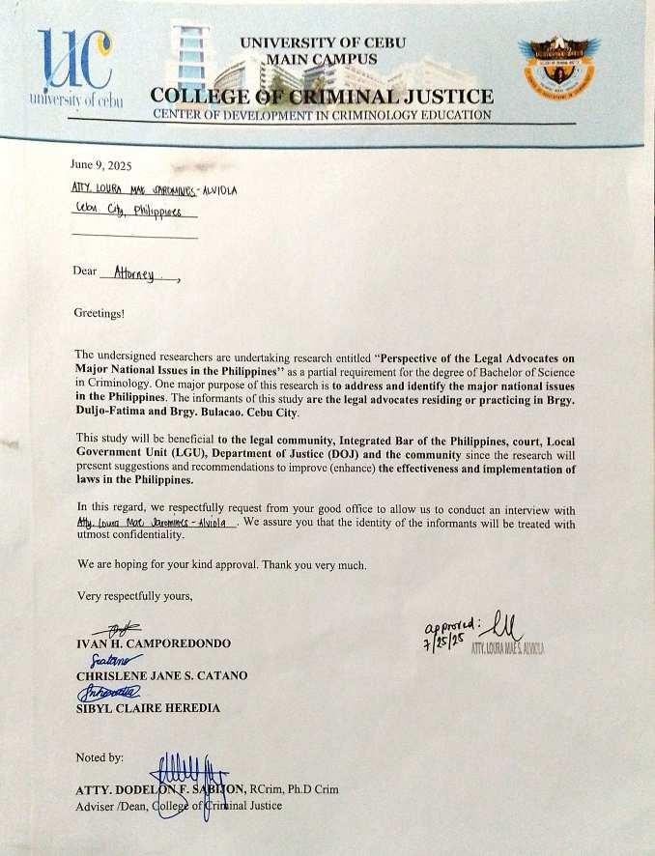



APPENDIX B INFORMED CONSENT

University of Cebu Research Office
(032) 255 – 7777 local 183

[Informed Consent for the Study on PERSPECTIVES OF THE LEGAL ADVOCATES IN CEBU CITY ON THE MAJOR NATIONAL ISSUES IN THE PHILIPPINES]

Name of Principal Investigator: Ivan H. Camporedondo

Name of Organization: University of Cebu Main Campus

Name of Proposal: PERSPECTIVES OF THE LEGAL ADVOCATES ON THE MAJOR NATIONAL ISSUES IN THE PHILIPPINES

This Informed Consent Form has two parts:

- Information Sheet (to share information about the research with you)
- Certificate of Consent (for signatures if you agree to take part) You will be given a copy of the full Informed Consent Form
PART I: Information Sheet. Introduction

The Philippines is confronted by a range of persistent national issues that shape its social, economic, and political landscape. Among the most pressing are poverty, corruption, political instability, jurisdictional disputes, and human rights concerns. Despite notable progress in some sectors, challenges such as inadequate access to education and healthcare, unemployment, and social inequality continue to hinder

national development and threaten social cohesion (Santiago, 2023). These issues are further compounded by systemic corruption, which undermines public trust in institutions, weakens the rule of law, and perpetuates poverty and inequality, as

reflected by the country’s ranking of 116th out of 180 in the Corruption Perceptions Index (Santiago, 2023).
Jurisdictional disputes, notably the ongoing conflict in the West Philippine Sea, have heightened tensions in the region. Although the 2016 Permanent Court of Arbitration ruling affirmed the Philippines’ sovereign rights within its Exclusive Economic Zone, China’s continued rejection of the decision and increased maritime activity have led to frequent confrontations and raised concerns over national sovereignty (Limos, 2019; Argosino, 2025). These territorial issues remain a focal point of national policy and international diplomacy.
Human rights remain a critical concern, particularly in light of the International Criminal Court’s investigation into alleged abuses linked to the previous administration’s “war on drugs.” Reports of extrajudicial killings, threats against activists, and attacks on journalists have drawn international scrutiny and intensified debates about accountability and the protection of civil liberties (Pinay Wise, 2024). Political controversies, such as the impeachment proceedings against Vice President Sara Duterte and ongoing questions about the handling of confidential government funds, further complicate the national landscape and highlight challenges in governance and the justice system (Sarao, 2025; OMBAY, 2025; PANTI, 2025).
These multifaceted issues have profound implications for the legal community, which is at the forefront of advocating for justice, upholding the rule of law, and navigating the complexities of both domestic and international legal frameworks. Legal advocates play a crucial role in interpreting laws, defending rights, and shaping policy responses to these challenges. Their perspectives provide valuable insights into the effectiveness of existing laws and the broader struggle for social justice and good governance in the Philippines.
This study seeks to explore the perspectives of legal advocates on the major national issues facing the Philippines. By examining their views and experiences, the research aims to contribute to a deeper understanding of the legal community’s role in addressing these challenges and to inform future reforms that promote justice, accountability, and national development.

Purpose of the research

The purpose of this study is to enable a thorough and well-informed understanding of the study “PERSPECTIVES OF THE LEGAL ADVOCATES IN CEBU CITY ON MAJOR NATIONAL ISSUES IN THE PHILIPPINES

Type of Research Intervention

This research involved doing interviews through face to face interaction by using the researcher made interview guide questionnaire with 5 main questions. The researchers will ask follow-up questions to fill in the gaps and provide more accurate data. For other instruments, the researchers will use smartphones to record the interviews, ensuring that responses are captured comprehensively for analysis.

Participant selection

The informants will be the legal advocates or practitioners who reside or work in Cebu City. The informants possess knowledge about the law and have an expertise on explaining the interconnectedness of the law and the existing major national issues in the Philippines and they will be expected to be interviewed. The researchers will use purposive sampling to identify legal advocates or practitioners in the population who will likely have certain experiences. Purposive sampling is a non- probability sampling method used in research to deliberately select individuals with certain characteristics that meet particular criteria relevant to the research objectives. In this way, they could identify individuals who would fit the study by focusing on a relatively small sample.

Voluntary Participation

Your involvement in this study is totally voluntary in which your enrollment in the

review center where you are currently studying will not change regardless of whether you choose to engage or not. Even though you have accepted the interview beforehand, you still have the freedom and right to subsequently change your mind and withdraw from the activity. This will not be used against you.

Procedures and Protocol

The initial step in the data collection process will be obtaining formal approval by submitting a request letter to the dean and an invitation letter to the participants. Upon receiving the necessary permissions, the researchers will prepare the research instruments, including the interview guide and a voice recorder. The interviews will be conducted primarily with legal advocates or practitioners who have expertise on the law and have valuable insights towards the major national issues in the Philippines. The researchers will carefully schedule the interviews during the legal professional's vacant or given schedule or periods to prevent any disruption to their workload.

Duration
Two semesters.

Risks
There are minimal risks involved, such as emotional discomfort while sharing your experiences. However, all data collected will be kept strictly confidential and will only be used for academic purposes.

Benefits
You may not directly benefit, but your participation may help educators enhance the use of virtual laboratories in Physics education.

Reimbursements
You will not be provided with any payment or monetary remuneration if you will take part in this
research.

Confidentiality
All of the information and responses that you give during this investigation will be held

strictly
confidential and will not be disclosed to any other parties or individuals. Your information and any other information obtained from this research will be stored, and only the field interviewers and the researchers will have access to it. No one else will be able to see it or use it in any way. Your identities as participants will be concealed from the public. The only people who will have access to the files pertaining to this investigation are the people who are proposing carrying out the investigation, as they will be the only ones who will have the cabinet secured with a lock and key.

Sharing the Results
After the investigation has been completed, the results will be shared and examined at a research conference held on the main campus of the University of Cebu. All individuals involved in the research defense will be given a copy of the research paper that presents the study's findings, which includes the research instructor, the research adviser, and the members of the research defense panel. It will be released as required to ensure it is available for the academic community and the school to benefit from its knowledge. When it is necessary, feel free to discuss the results, and the researcher will provide you with a report copy. Kindly specify the timeline and reasons for sharing the information, along with the details, if you have a strategy in place and if you plan to proceed.

Ivan H. Camporedondo (Lead Researcher) | - 09686949033
Chrislene Jane S. Catano (Researcher) | - 09955783496
Sibyl Claire S. Heredia (Researcher) | - 09499398845
Atty. Dodelon F. Sabijon (Research Adviser) | - 09209284621
This research project has been reviewed and scrutinized by the technical panel of the University of Cebu as part of the completion requirement in Bachelor of Science in Criminology. If you have any questions, please contact the University of Cebu at 032 - 255 – 7777 and you may also contact Dr. Juanito N. Zuasula, Jr. - MD - 233- 5503 UCAREC.

PART II: Certificate of Consent.

I have read the foregoing information, or it has been read to me. I have had the opportunity to ask questions about it and any questions that I have asked have been answered to my satisfaction. I consent voluntarily to participate in this research.

Print Name of Participa nt Signature of Participant Date

Day/Month/Year

If Illiterate:

A literate witness must sign (if possible, this person should be selected by the participant and should have no connection to the research team). Participants who are illiterate

should include their thumb-print as well.

I have witnessed the accurate reading of the consent form to the potential participant, and the individual has had the opportunity to ask questions. I confirm that the individual has given consent freely.

Print Name of Witness AND Thumb Print of the Participant

Signature of Witness
Date

Day/Month/Year

Statement by the researcher/person taking consent

I have accurately read out the information sheet to the potential participant, and to the best of my ability made sure that the participant understands that the following will be done:

1. face to face or online survey.

I confirm that the participant was given an opportunity to ask questions about the study, and all the questions asked by the participant have been answered correctly and to the best of my ability. I confirm that the individual has not been coerced into giving consent, and the consent has been given freely and voluntarily.

A copy of this ICF has been provided to the participant.

Print Name of Researcher/Person Taking the Consent

Signature of Researcher /Person Taking the Consent

Date

Day/Month/Year

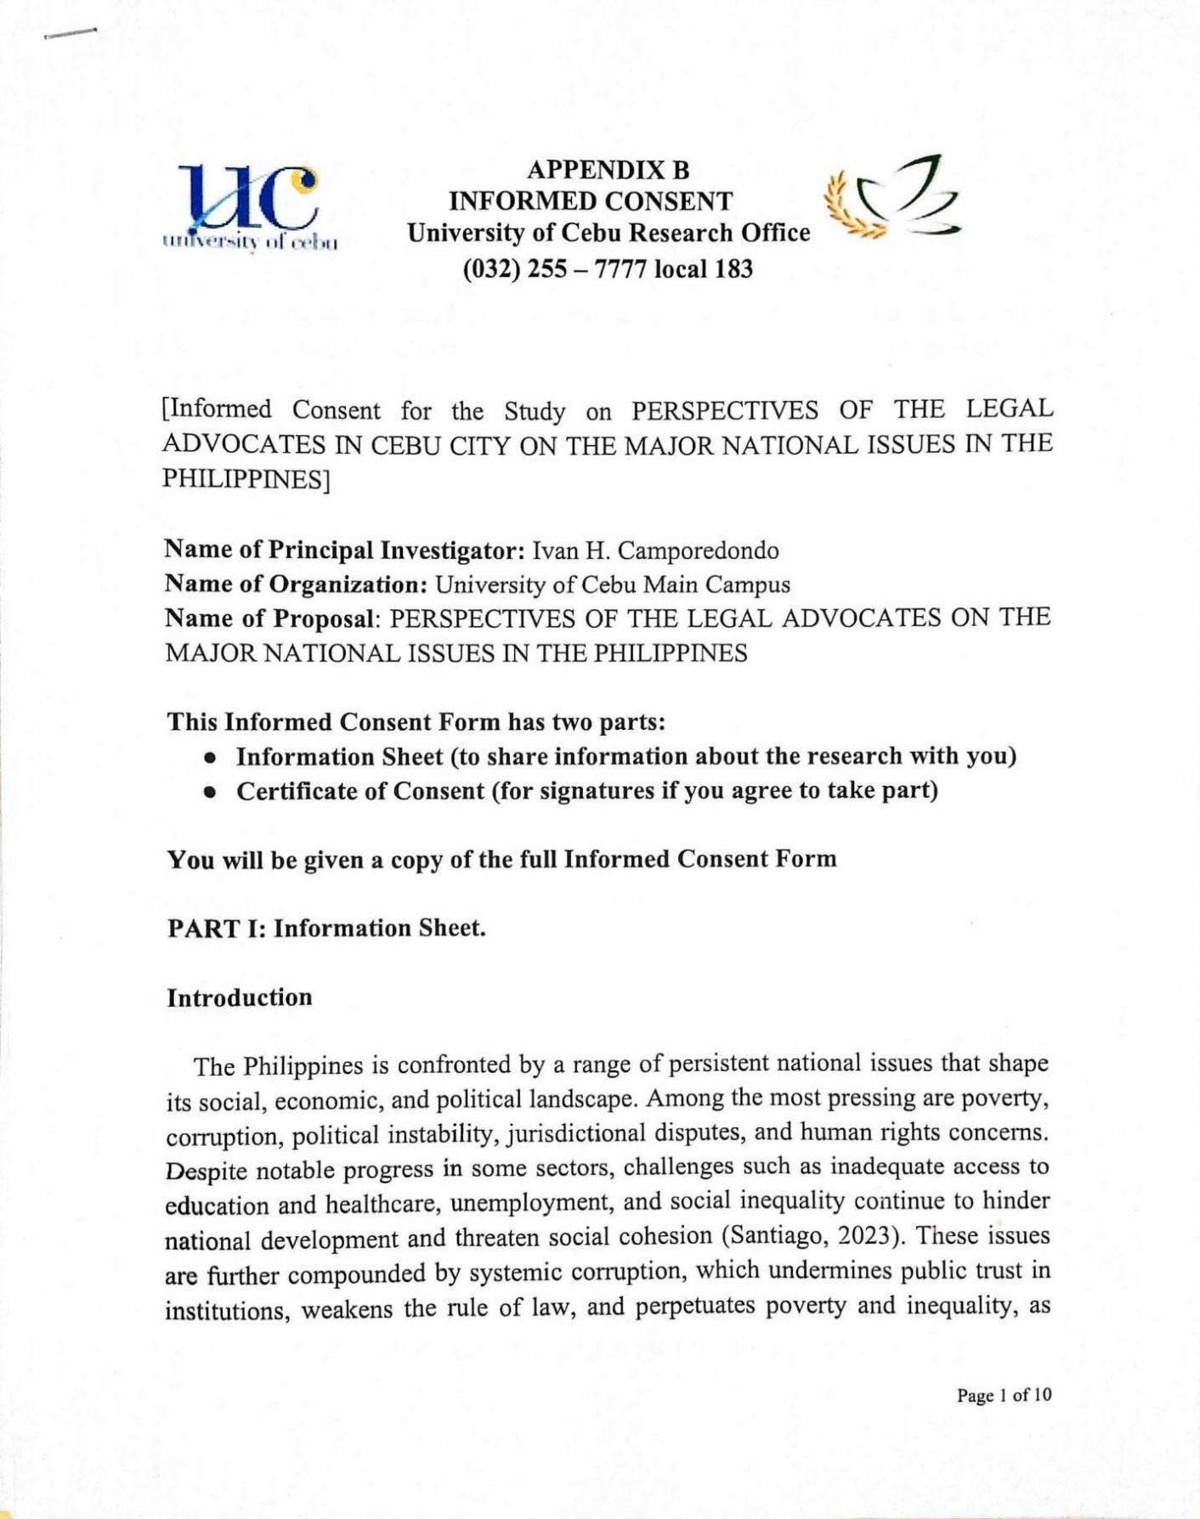

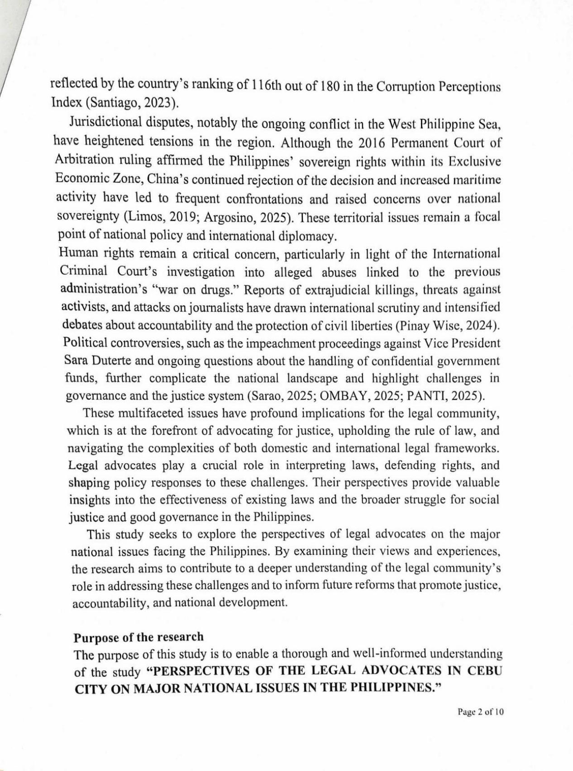

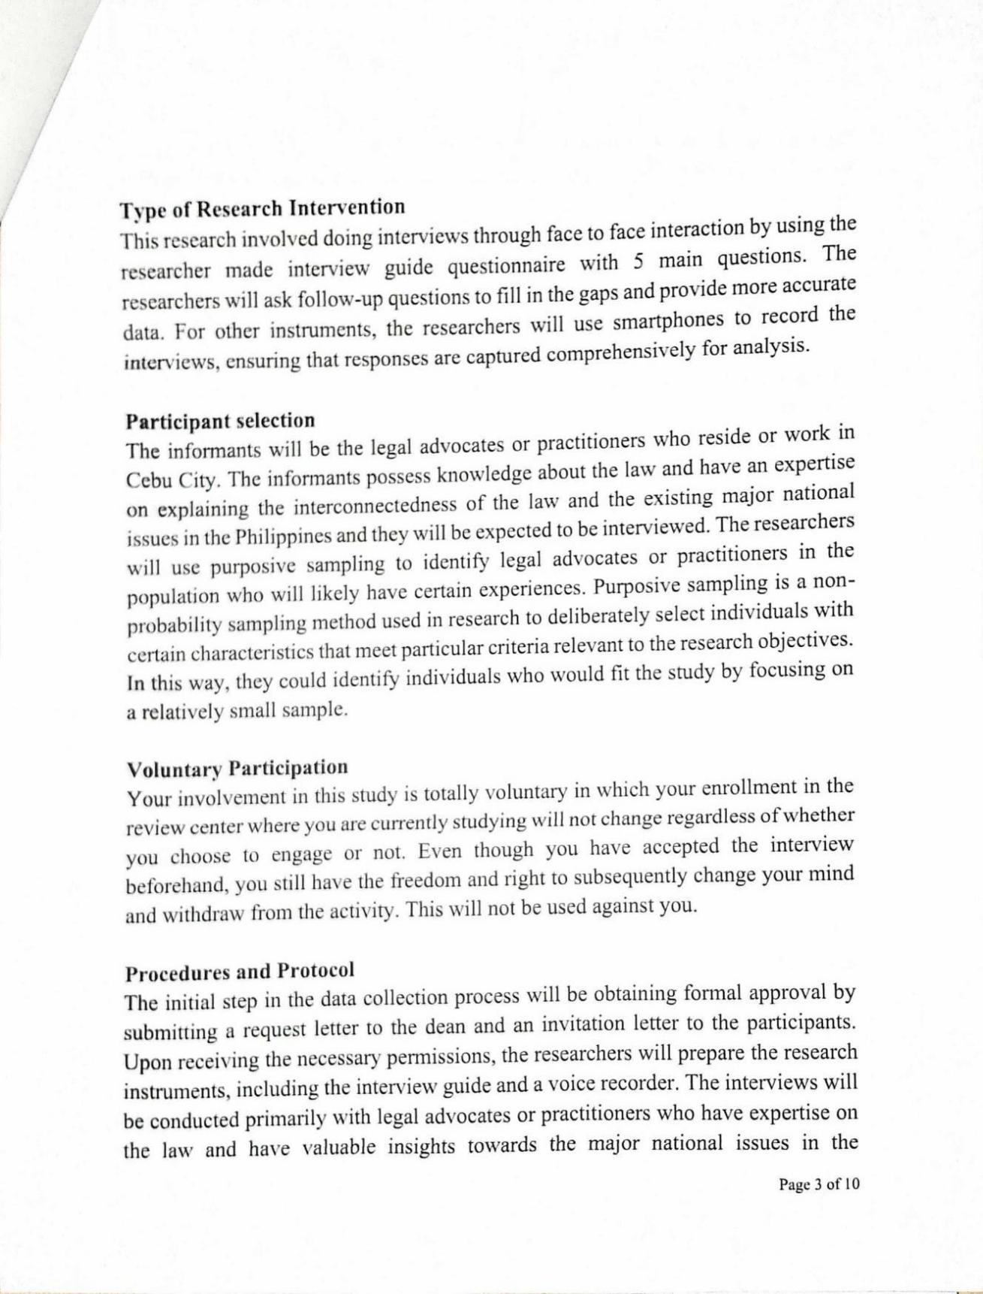

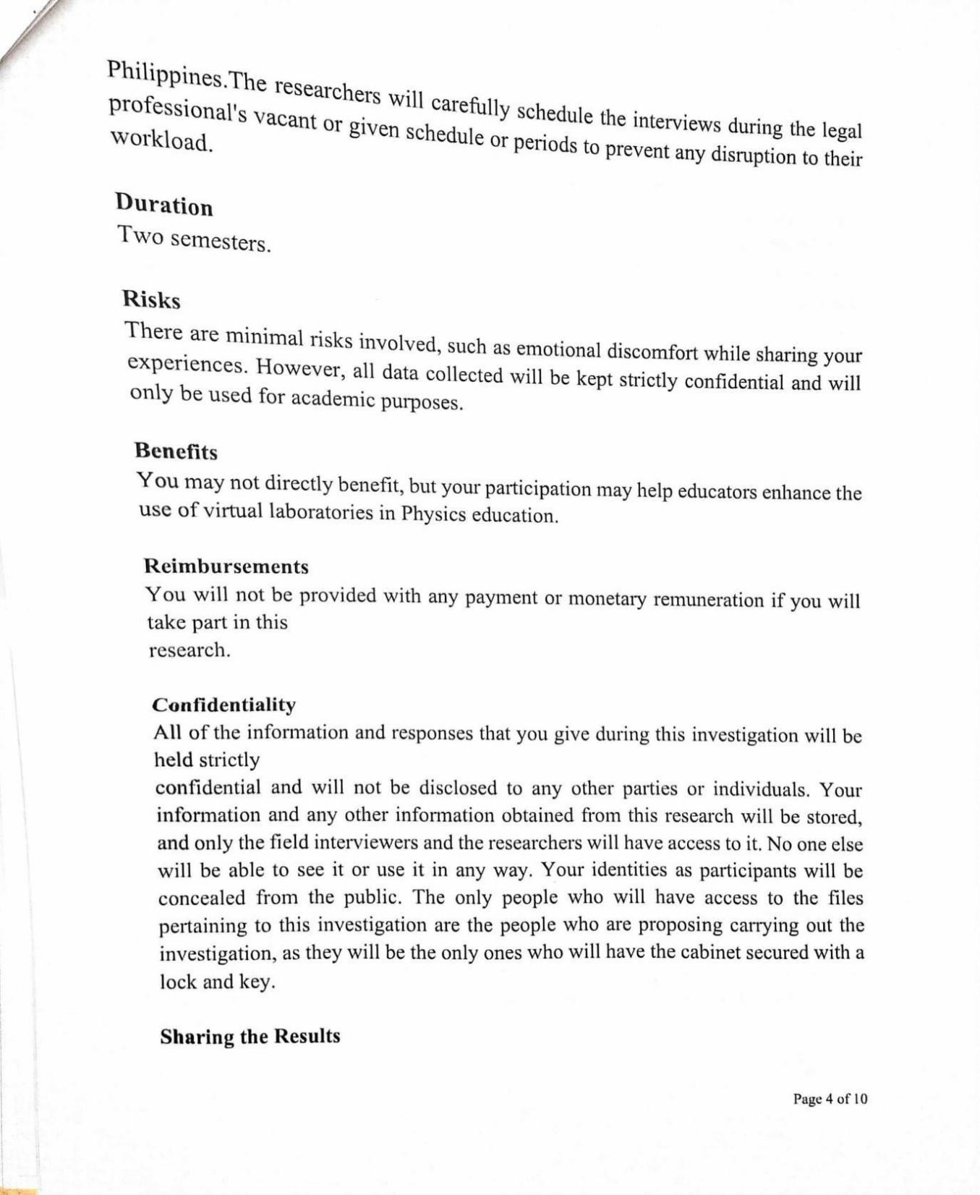

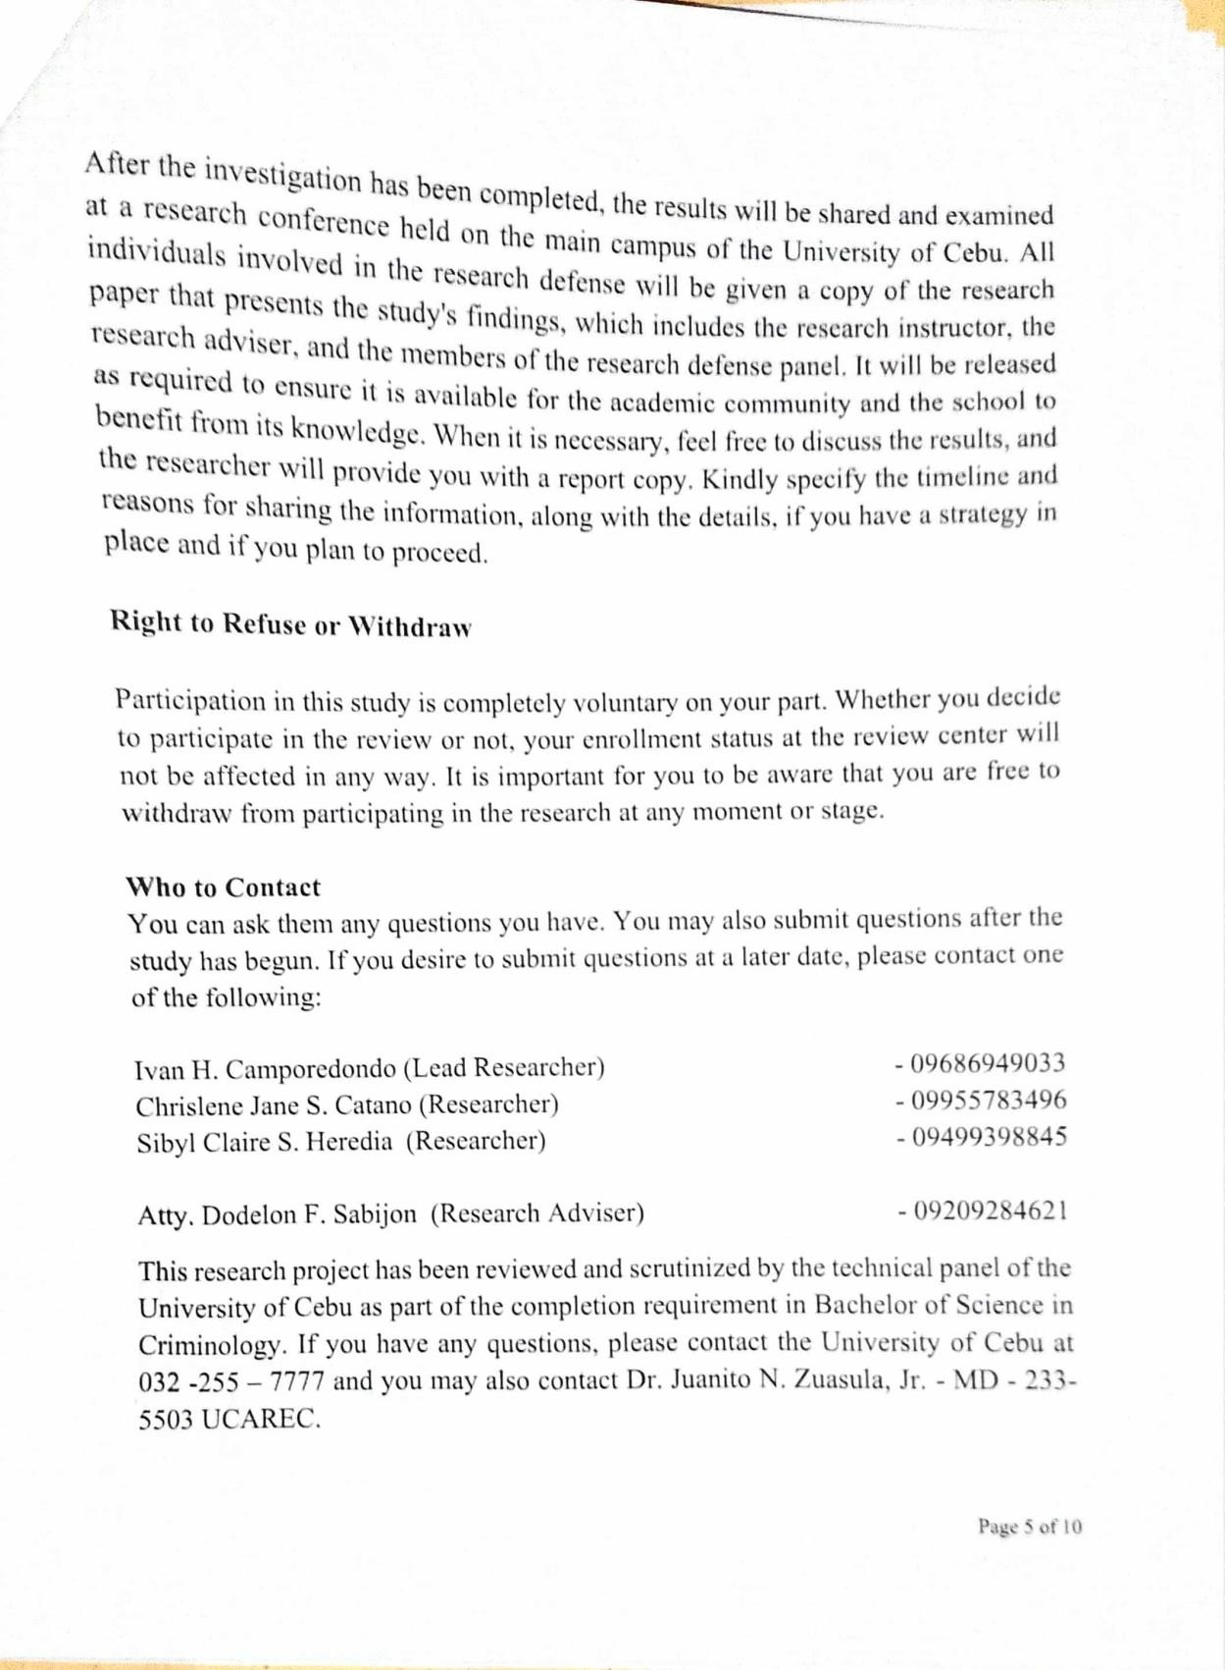

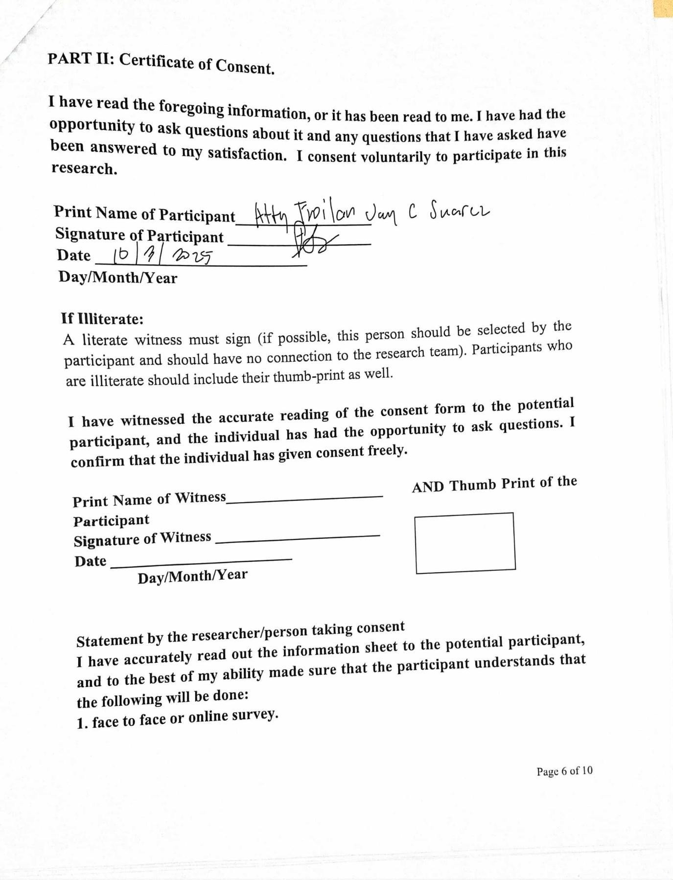

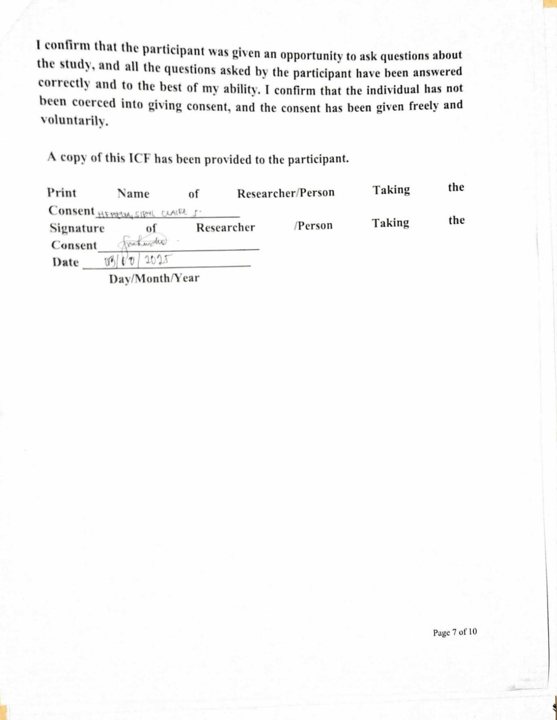

APPENDIX C
 | University of Cebu Research Office (032)-255-7777 Local 4149 | 

INTERVIEW GUIDE

Instruction:
The purpose of this study is to explore the perspectives of legal advocates in Brgy. Duljo- Fatima and Brgy. Bulacao, Cebu City about the major national issues in the Philippines. Your insights will offer a richer understanding of how legal professionals interpret and engage with governance, policymaking, and the judicial system.
Before the interview takes place, please be aware that your participation is entirely voluntary, and everything shared will remain strictly confidential. If you ever feel uneasy about answering a question, you may choose not to answer it. The interview will be recorded to ensure accuracy, but any personal details will be anonymized in the final study for confidentiality

Name: (Optional) Address: (Optional)

Section 1: Legality of theArrest and Delivery of the FPRRD to the ICC
Main Questions:
- How do you perceive the legal basis of the arrest and delivery of the FPRRD to the International Criminal Court?

  - What are the implications of this case for the Philippines’sovereignty and international law obligations?

  - In your experience, how do such cases affect the relationship between national justice systems and international legal bodies?

Probing Questions:
    - Can you elaborate on any specific laws or legal principles that support or challenge the arrest?

    - How do you think this case influences public trust in the justice system?

    - What role should the Philippines’ constitution play in such international legal matters?

Section 2: Human Rights and Extrajudicial Killings (EJK)
Main Questions:
- What is your perspective on the current human rights situation in the Philippines, especially concerning extrajudicial killings?

  - How do you think the legal system has responded to allegations of EJK?

  - What challenges do legal advocates face in protecting human rights within this context?

Probing Questions:
    - Could you share examples where the law was effective or ineffective in addressing EJK?

    - How does political pressure impact legal proceedings related to human rights violations?

    - What improvements would you suggest for the legal framework to better safeguard human rights?

Section 3: West Philippine Sea Dispute
Main Questions:
- How do you interpret the Philippines’legal position in the West Philippine Sea dispute, especially in light of the 2016 PCA ruling?

  - What are the legal challenges in enforcing the country’s sovereign rights in the disputed maritime areas?

  - How do you think international law, such as UNCLOS, influences the Philippines’strategy and legal claims in this dispute?

Probing Questions:
- What role do you think the judiciary should play in upholding maritime sovereignty?

- How effective are diplomatic and legal efforts in resolving the dispute?

- Can you discuss any precedents or international cases that might inform the Philippines’approach?

Section 4: Corruption
Main Questions:
- From your professional experience, how pervasive is corruption within the Philippine legal and political systems?

  - What legal mechanisms are currently effective or ineffective in combating corruption?

  - How can legal advocates contribute to strengthening anti-corruption efforts?

Probing Questions:

- Are there specific laws or institutions that you believe need reform?

- How does corruption affect the administration of justice?

- What role do you think transparency and public accountability play in addressing corruption?

Section 5: Political Dynasty
Main Questions:
- What is your view on the legality and impact of political dynasties in the Philippines?

  - How do political dynasties affect governance and the rule of law in the country?

  - What legal reforms or actions do you think are necessary to address issues related to political dynasties?

Probing Questions:

- How do existing laws regulate or fail to regulate political dynasties?

- Can you share examples of how political dynasties influence legal or political processes?

- What challenges exist in enforcing anti-political dynasty provisions?

Closing Questions
- Based on your experience, what are the most pressing legal challenges the Philippines faces regarding these national issues?

- How can lawyers and judges better contribute to resolving these challenges?

- Is there anything else you would like to share about your perspectives on these topics?

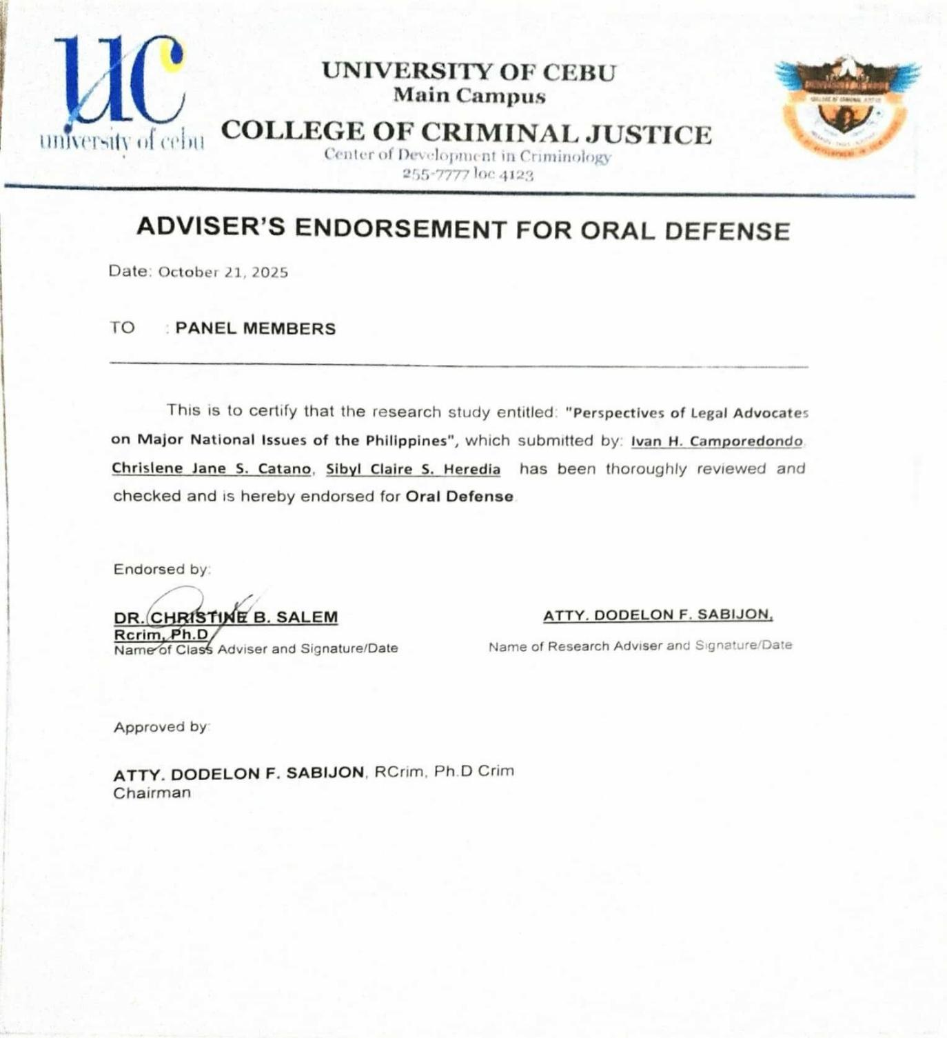

APPENDIX E

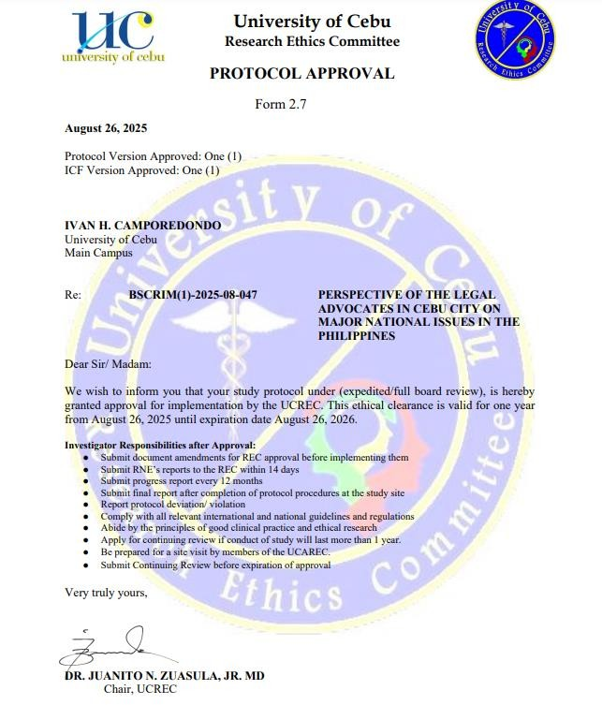

APPENDIX F LOCATION MAP

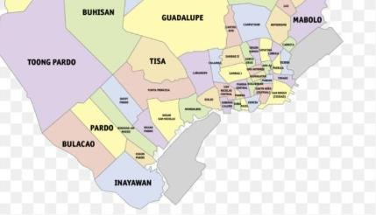

FIGURE 1. CEBU CITY MAP

APPENDIX G

SAMPLE VERIFICATION FORM OF TRANSCRIPTION

Informant : | Participant 1
Session No. : | One (1)
Date/s : | September 7, 2025
Time Started | : 1:30 PM
Time Ended : | 1:55 PM
Duration : | 25 minutes
Location : | Barangay Day-as, Cebu City, Philippines
Interviewed by : | Chrislene Jane Catano, Ivan Camporedondo, | Sibyl
Claire | Heredia
Transcribed by : | Chrislene Jane Catano, Ivan Camporedondo, | Sibyl
Claire | Heredia
Reviewed by | :

LINE  NUMBER | RESPONSES | CODE
1 | Daghan mang national issue that concerns about economics our political independence another issue is internal sovereignty as to economic national issue like crisi bitaw we cannot deny the fact that naay crisis sa philippines like for example one of the report dri sa cebu We can say that naa juy existing na food crisis. So my perspective on this is because of the effect of poor economic policy making because as we observe our law maker  focuses on spoon feeding programs like the 4Ps | I1

 | program. And also the implementation of it na politicize na politica ba there is a need of modifications about that law because some of the known ecenomist niana naa juy effect if mo spoon feed lang ta tho helpful sya in minority group kay naka elevate sa life pero when it cones to national issue in whole need sya i fine tune.
2 | Another national issue is affecting sovereignty like for example our pagiging independent nation ang question karon pede ba jud diay ta madaog daog sa ubang nation, my perspective on sa law school gi train man gd mi if ever the philippine will decide who has the jurisdiction syempre atoa jud diay nang buhian atoang jurisdiction naa man tay kaugalingon say dri in leymans term naa tay say sa atong philippine law. | I1
3 | My perspective is that murag atoang gi look down ang ang atoang legal proceeding dri sa philippines where in fact we can established nga naa tay jurisdiction and we can punished people na nilabag sa atoang balaod pero nahulog man gug nga naay political ambition nga naay color of international force that is why mo reflect na sa administration nato nga if dili madala sa local kay magpatabang sa local naay outside force ba. | I1
4 | And the third one is massive corruption and systemic corruption nganu makaingon kog systemic somewhat coordinated nga mga  scheme ba. But i call this this is not only | I1

 | nahitabo karon bisan sa pre history corruption is not new to us i think systemic corruption it is because of dwindling morality. We cannot solve problems like summary na execution dili nana because it is systemic. My perspective we have to rehashed our moral u think moral recovery program sa mga politicians mga legislators mga law enforcers i think naay need for moral recovery ibalik ang morality because nahulog man gud na norm ang corruption and the legality is the exemption.
5 | Wala pamn gud na na define naay gi attempt na gidefined ang mga kuan ra pud ato dili jud to complete na law against political dynasty. Para nako this is what jose rizal abhors ang gi prevent man gd ana kay one family rule nga prone to biases nawala ang essence sa democracy ba it will against sa principle of Vox populi, vox dei if incase one family holding a position especially daghan kaau na rampant kaau para nako we need to craft law to prohibit it the next question will be the senators and congressman will craft against it | I1
6 | So when it comes to the role we know as legal advocates, first of all we are sworn to protect the constitution and the secondary is the protection of our client. In addressing the national issue that is why law practitioner is very important personally in my part i really advocate what is just and legal. As much as possible be vocal i think that’s one of my role sa society with regards sa national issue because ypu cannot handle national issue base on small steps ang word nmo kay helpful kaau sa pagshape sa unsay nindot sa regarding sa national issue. Do not be affraid be vocal | I1

7 | When it comes to effectiveness noh we are not lacking laws our laws are more or less complete ang kulang nalng guro we have to implement laws that will protect who are the protectors of justice like for example police force, prosecutors, justices they should feel that they are secured in dispensing justice. We should be secured because today unlike other jurisdictions like US pinangga ang mga lawyers ang ilaha nalang hunahunaon ang ilaha nlng pag apply sa ilahang naabot na trabaho. Our laws are complete bisan mohunong patag buhat ug balaod except lng haa sa pagkuan sa budge. My perspective on that wala namo na feel ang security as part sa legal system kulang kaau ang support sa legal system | I1
8 | It really affects in a sense for example naa kay idefend na client na dli kaau influential na tao. Tingali wala pako kasugay personally but i think on that practice of law i define nmo is the application of law nga dapat in accordance with the legal principle perp usahay when it comes to national issue karon ma feel nmo nga naay lawlessness. In a practice of law for example haa naa kay giprotectahan na client na gicharge for corruption it would really affect nahulog man gud nga na norm nang mga SOPs nya murag somewhat challenges your core principle nga gitudlo na gikan sa pagkabata nimo naa juy impact that is why there is a need na i constant reminder jud sa legal community na stand ground sa imong morality sa legal principles and also mo dapat mo develop ka isip usa ka tao for example sa practice of law dli lng kutob mopasar kag bar exam, mopa daog kag  client, dapat tingali naa kay himoon na mga | I1

 | steps that will have impact on national issues like gianswers nako permiro you should be vocal it should be resounding ang mo gawas sa imohang baba ba.
9 | We will define first what is human rights naa tay idea ba it’s about tawhanong katungod bitaw when we talk about human rights we limit our topic on this this to protect or direct ordinary human from the abuses of the government kay dli man molusot ang human rights between persons lang human right between government and individual. Like for example prevalent dili mawala na issue kaning insurgences its part of the scope sa policy making sa policy making security man prevalent karon ang red tagging man. Para nako ang balancing diha kay education ang mobalance ana mo educate ka unsay imohang katungod for example freedom of expression. | I1

CODED SIGNIFICANT STATEMENTS

SIGNIFICANT STATEMENT NUMBER | SIGNIFICANT STATEMENTS | INFORMANT NUMBER
1 | Daghan mang national issue that concerns about economics our political independence another issue is internal sovereignty as to economic national issue like crisi bitaw we cannot deny the fact that naay crisis sa philippines like for example one of the report dri sa cebu. We can say that naa juy existing na food crisis. my perspective on this is because of the effect of poor economic policy making because as we observe our law maker focuses on spoon feeding programs like the 4Ps program. And also the implementation of it na politicize na politica ba there is a need of modifications about that law  ( There are many national issues that concerns about economics our political independence another issue is internal sovereignty as to economic national issue like crisis we cannot deny the fact that there is a crisis in the Philippines like for example one of the report from  cebu We can say that there is already an | I1

 | existing food crisis. my perspective on this is because of the effect of poor economic policy making because as we observe our law maker focuses on spoon feeding programs like the 4Ps program. And also the implementation has been politicize there is a need of modifications about that law.)) IDI1:SS1
2 | Another national issue is affecting sovereignty like for example our pagiging independent nation ang question karon pede ba jud diay ta madaog daog sa ubang nation, my perspective on sa law school gi train man gd mi if ever the philippine will decide who has the jurisdiction syempre atoa jud diay nang buhian atoang jurisdiction naa man tay kaugalingon say dri in leymans term naa tay say sa atong philippine law.  (My perspective is that it seems like we are looking down on our legal proceedings here in the Philippines where in fact we can establish that we have jurisdiction and we can punish people who have violated our laws but we have also fallen into the trap of having political ambition that has the color of international force that is why  you should reflect on our | I1

 | administration that if it cannot be brought to the local level, why should it help the local level.) IDI1:SS2
3 | My perspective is that murag atoang gi look down ang ang atoang lehal proceeding dri sa philippines where in fact we can established nga naa tay jurisdiction and we can punished people na nilabag sa atoang balaod pero nahulog man gug nga naay political ambition nga naay color of international force that is why mo reflect na sa administration nato nga if dili madala sa local kay magpatabang sa local naay outside force ba.  ( My perspective is that we seem to be looking down on our legal proceedings here in the Philippines where in fact we can establish that we have jurisdiction and we can punish people who have violated our law but we have also fallen into the trap of having political ambitions that have the color of international force that is why you reflect on our administration that if it is not brought to the local because there is an outside force to help the local.) IDI1: SS3 | I1
4 | the third one is massive corruption and systemic corruption nganu makaingon kog systemic somewhat coordinated  nga mga scheme ba. But i call this this | I1

is not only nahitabo karon bisan sa pre history corruption is not new to us i think systemic corruption it is because of dwindling morality. We cannot solve problems like summary na execution dili nana because it is systemic. My perspective we have to rehashed our moral u think moral recovery program sa mga politicians mga legislators mga law enforcers i think naay need for moral recovery ibalik ang morality because nahulog man gud na norm ang corruption and the legality is the exemption

( the third one is massive corruption and systemic corruption why can I say systemic somewhat coordinated schemes? But i call this this is not only happening now even in pre history corruption is not new to us i think systemic corruption it is because of dwindling morality. We cannot solve problems like summary execution because it is systemic. My perspective we have to rehashed our moral u think moral recovery program for politicians, legislators, law enforcers i think there is a need for moral recovery to bring back morality because corruption has fallen to the norm and the legality is the exemption.)

IDI1: SS4

5 | Para nako this is what jose rizal abhors ang gi prevent man gd ana kay one family rule nga prone to biases nawala ang essence sa democracy ba it will against sa principle of Vox populi, vox dei if incase one family holding a position especially daghan kaau na rampant kaau para nako we need to craft law to prohibit it the next question will be the senators and congressman will craft against it.  ( . For me, this is what Jose Rizal abhors what was prevented because of one family rule that is prone to biases, the essence of democracy has been lost, will it be against the principle of Vox populi, vox dei if incase one family holding a position especially many are rampant, for me we need to craft law to prohibit it the next question will be the senators and congressman will craft against it.) IDI1:SS5 | I1
6 | In addressing the national issue that is why law practitioner is very important personally in my part i really advocate what is just and legal. As much as possible be vocal i think that’s one of my role sa society with regards sa national issue because ypu cannot handle national issue base on small  steps ang word nmo kay helpful kaau sa | I1

pagshape sa unsay nindot sa regarding sa national issue.

( . In addressing the national issue that is why law practitioner is very important personally in my part I really advocate what is just and legal. As much as possible be vocal I think that's one of my role in society with regards to the national issue because ypu cannot handle national issue based on small steps the word nmo is very helpful in shaping what is beautiful regarding the national issue..) IDI1:SS6
7 | we are not lacking laws our laws are more or less complete ang kulang nalng guro we have to implement laws that will protect who are the protectors of justice like for example police force, prosecutors, justices they should feel that they are secured in dispensing justice. Our laws are complete bisan mohunong patag buhat ug balaod except lng haa sa pagkuan sa budge. My perspective on that wala namo na feel ang security as part sa legal system kulang kaau ang support sa legal system  ( we are not lacking laws, our laws are more or less complete, maybe we have | I1

 | to implement laws that will protect who are the protectors of justice like for example police force, prosecutors, justices they should feel that they are secured in dispensing justice. Our laws are complete even if the laws and acts stop, except for the budget. My perspective is that we no longer feel security as part of the legal system, the support of the legal system is lacking.).IDI1:SS7
8 | In a practice of law for example haa naa kay giprotectahan na client na gicharge for corruption it would really affect nahulog man gud nga na norm nang mga SOPs nya murag sonewhat challenges your core principle nga gitudlo na gikan sa pagkabata nimo naa juy impact that is why there is a need na i constant reminder jud sa legal community na stand ground sa imong morality sa legal principles and also mo dapat mo develop ka isip usa ka tao for example sa practice of law dli lng kutob mopasar kag bar exam, mopa daog kag client, dapat tingali naa kay himoon na mga steps that will have impact on national issues like gianswers nako permiro you should be vocal it should be resounding ang mo gawas sa imohang baba ba. | I1

 | ( . In a practice of law, for example, you have a protected client who was charged for corruption. It would really affect the fact that the SOPs have become the norm. It seems to challenge your core principle that you have been taught since childhood. It has an impact that is why there is a need for me to constantly remind the legal community that you stand on the ground of your morality in legal principles and also you must develop as a person. and client, you should probably take steps that will have an impact on national issues like I answered permiro you should be vocal it should be resounding.) IDI1:SS8
9 | .  human right between government and individual. Like for example prevalent dili mawala na issue kaning insurgences its part of the scope sa policy making sa policy making security man prevalent karon ang red tagging man. Para nako ang balancing diha kay education ang mobalance ana mo educate ka unsay imohang katungod for example freedom of expression.  ( human rights do not penetrate between persons only human right between government and individual.  Like for example, the issue of | I1

insurgency will not go away, its part of the scope of policy making, security is also prevalent now, red tagging is also prevalent. For me, the balancing is because education balances that, you educate what your rights are, for example freedom of expression.)IDI1:SS9

APPENDIX I

SAMPLE FORMULATION OF CORE MEANINGS

SIGNIFICANT STATEMENT | FORMULATED MEANINGS
There are many national issues that concerns about economics our political independence another issue is internal sovereignty as to economic national issue like crisis we cannot deny the fact that there is a crisis in the Philippines like for example one of the report from Cebu We can say that there is already an existing food crisis. my perspective on this is because of the effect of poor economic policy making because as we observe our law maker focuses on spoon feeding programs like the 4Ps program. And also the implementation has been politicized there is a need of modifications about that law. IDI1:SS1 | The informant observes a growing food crisis in the Philippines, particularly in Cebu, which they attribute to poor economic policymaking and an overdependence on politicized welfare programs like the 4Ps. They believe these programs require legislative reform to promote long-term solutions rather than short-term relief.  FM1
Another national issue is affecting sovereignty like for example our being an independent nation the question now is whether we can win over other nations, my perspective on law school we were trained if ever the Philippines will decide who has the jurisdiction of course it is ours when we release our jurisdiction we have our own right here in layman’s term we have a say in our Philippine law. IDI1:SS2 | This informant expresses concern that the Philippine legal system is being weakened by political ambitions influenced by international forces. They argue that national governance must be localized to effectively serve communities and uphold legal sovereignty.

 | FM2
( My perspective is that we seem to be looking down on our legal proceedings here in the Philippines where in fact we can establish that we have jurisdiction and we can punish people who have violated our law but we have also fallen into the trap of having political ambitions that have the color of international force that is why you reflect on our administration that if it is not brought to the local because there is an outside force to help the local.) IDI1: SS3 | The informant emphasizes the importance of maintaining jurisdiction over domestic legal matters to protect national sovereignty. They assert that Filipinos must have a voice in shaping and enforcing their own laws to preserve independence.
 | FM3
the third one is massive corruption and systemic corruption why can I say systemic somewhat coordinated schemes? But I call this this is not only happening now even in prehistory corruption is not new to us I think systemic corruption it is because of dwindling morality. We cannot solve problems like summary execution because it is systemic. My perspective we have to rehashed our moral u think moral recovery program for politicians, legislators, law enforcers i think there is a need for moral recovery to bring back morality because corruption has fallen to the norm and the legality is the exemption.) | This informant identifies systemic corruption as a deeply rooted issue driven by moral decline, making legality the exception rather than the norm. They advocate for a moral recovery program targeting public officials to restore ethical standards and rebuild trust.  FM4
IDI1: SS4

For me, this is what Jose Rizal abhors what was prevented because of one family rule that is prone to biases, the essence of democracy has been lost, will it be against the principle of Vox populi, vox Dei if incase one family holding a position especially many are rampant, for me we need to craft law to prohibit it the next question will be the senators and congressman will craft against it.) IDI1:SS5 | The informant criticizes the dominance of political dynasties, arguing that it undermines democracy and contradicts the principle of vox populi, vox Dei. They call for legislation to prohibit such practices but doubt lawmakers would support reforms that threaten their own interests.  FM5
In addressing the national issue that is why law practitioner is very important personally in my part I really advocate what is just and legal. As much as possible be vocal I think that's one of my role in society with regards to the national issue because you cannot handle national issue based on small steps the word is very helpful in shaping what is beautiful regarding the national issue.) IDI1:SS6 | The informant emphasizes the vital role of legal practitioners in addressing national issues, advocating for justice and legality as guiding principles. They believe that being vocal and actively engaged in public discourse is essential, as meaningful change requires bold, collective efforts rather than small, incremental steps.  FM6
we are not lacking laws, our laws are more or less complete, maybe we have to implement laws that will protect who are the protectors of justice like for example police force,  prosecutors, justices they should feel that they | The informant believes that the Philippines has sufficient laws, but lacks proper implementation and support for those who uphold  justice, such as police officers,

are secured in dispensing justice. Our laws are complete even if the laws and acts stop, except for the budget. My perspective is that we no longer feel security as part of the legal system, the support of the legal system is lacking.).IDI1:SS7 | prosecutors, and judges. They emphasize that while the legal framework is complete, the absence of security and institutional backing weakens the effectiveness of the justice system.  FM7

In a practice of law, for example, you have a protected client who was charged for corruption. It would really affect the fact that the SOPs have become the norm. It seems to challenge your core principle that you have been taught since childhood. It has an impact that is why there is a need for me to constantly remind the legal community that you stand on the ground of your morality in legal principles and also you must develop as a person. and client, you should probably take steps that will have an impact on national issues like I answered first you should be vocal it should be resounding.) I1:SS8 | The informant reflects on the ethical challenges faced by legal practitioners, especially when defending clients accused of corruption, noting how standard practices (SOPs) can conflict with personal moral principles. They emphasize the importance of upholding morality within the legal profession and encourage both lawyers and clients to take vocal, meaningful action that contributes to addressing national issues.  FM8

human rights do not penetrate between persons only human right between government and individual. Like for example, the issue of insurgency will not go away, its part of the scope of policy making, security is also prevalent now, red tagging is also prevalent. For me, the balancing is because education balances that, you educate what your rights are, for example freedom of expression.)IDI1:SS9 | The informant emphasizes that human rights primarily govern the relationship between the state and individuals, not between private persons. They highlight ongoing issues like insurgency and red-tagging as policy and security concerns, asserting that education plays a crucial role in balancing these by informing citizens of their rights, such as freedom of expression  FM9

APPENDIX G2
DEVELOPMENT OF CLUSTER THEMES

I - Experiences

Formulated Core Meanings | Cluster Themes
The informant observes a growing food crisis in the Philippines, particularly in Cebu, which they attribute to poor economic policymaking and an overdependence on politicized welfare programs like the 4Ps. They believe these programs require legislative reform to promote long-term solutions rather than short-term relief. | - – Governance and Political Influence  - – Legal System and Institutional Gaps  - – Ethics and Moral Leadership  IV- Legal Literacy and Civic Engagement
FM1 | V – Human Rights and Public Education
This informant expresses concern that the Philippine legal system is being weakened by political ambitions influenced by international forces. They argue that national governance must be localized to effectively serve communities and uphold legal sovereignty.
FM2
The informant emphasizes the
importance of maintaining jurisdiction

over domestic legal matters to protect national sovereignty. They assert that Filipinos must have a voice in shaping and enforcing their own laws to preserve independence.

FM3
This informant identifies systemic corruption as a deeply rooted issue driven by moral decline, making legality the exception rather than the norm. They advocate for a moral recovery program targeting public officials to restore ethical standards and rebuild trust.

FM4
The informant criticizes the dominance of political dynasties, arguing that it undermines democracy and contradicts the principle of vox populi, vox Dei. They call for legislation to prohibit such practices but doubt lawmakers would support reforms that threaten their own interests.

FM5
The informant emphasizes the vital role of legal practitioners in addressing national issues, advocating for justice
and legality as guiding principles. They

believe that being vocal and actively engaged in public discourse is essential, as meaningful change requires bold, collective efforts rather than small, incremental steps.

FM6
The informant believes that the Philippines has sufficient laws, but lacks proper implementation and support for those who uphold justice, such as police officers, prosecutors, and judges. They emphasize that while the legal framework is complete, the absence of security and institutional backing weakens the effectiveness of the justice system.

FM7
The informant reflects on the ethical challenges faced by legal practitioners, especially when defending clients accused of corruption, noting how standard practices (SOPs) can conflict with personal moral principles. They emphasize the importance of upholding morality within the legal profession and encourage both lawyers and clients to take vocal, meaningful action that contributes to addressing national issues.

FM8
The informant emphasizes that human rights primarily govern the relationship between the state and individuals, not between private persons. They highlight ongoing issues like insurgency and red-tagging as policy and security concerns, asserting that education plays a crucial role in balancing these by informing citizens of their rights, such as freedom of expression

FM9

CURRICULUM VITAE



Name : CAMPOREDONDO, IVAN H.

Date of Birth : June 20, 2003

Place of Birth : San Carlos City , Negros Occidental

EDUCATIONAL BACKGROUND
Elementary
:Jose Chona Jo Elementary School
S.Y. 2015-2016
Secondary
: Jose Chona Jo National High School
S.Y. 2018 – 2019
SENIOR HIGHSCHOOL
:Nangka National High School
S.Y. 2021-2022
Tertiary
:Bachelor of Science in Criminology University of Cebu-Main Campus
Sanciangko St., Cebu City


Name : CATANO, CHRISLENE JANE S.

Date of Birth : July 17,2003

Place of Birth : Barili, Cebu

EDUCATIONAL BACKGROUND
Elementary
:Bitoon Central School
S.Y. 2015-2016
Secondary
: Little Flower School Inc.
S.Y. 2018 – 2019

SENIOR HIGHSCHOOL
:Bitoon National Vocational High School
S.Y. 2021-2022

Tertiary
:Bachelor of Science in Criminology University of Cebu-Main Campus Sanciangko St., Cebu City



Name : HEREDIA, SIBYL CLAIRE S.

Date of Birth : March 19,2003

Place of Birth : Balud, Dalaguete, Cebu

EDUCATIONAL BACKGROUND
Elementary
:Balud Elementary School
S.Y. 2015-2016
Secondary
: Dalaguete National High School
S.Y. 2018 – 2019

SENIOR HIGHSCHOOL
:Dalaguete National High School
S.Y. 2021-2022
Tertiary
:Bachelor of Science in Criminology University of Cebu-Main Campus

