Analysis of PI controller tuning strategies aimed at improving transient performance and dynamic stability in doubly fed induction generator (DFIG)- based wind energy conversion systems
Umesh Kumar Sinha
Department of Electrical Engineering, National Institute of Technology, Jamshedpur (Jharkhand)
uksinha.ee@nitjsr.ac.in
ABSTRACT: The design parameters of a PI controller are optimized in order to perform transient response analysis for a wind energy conversion system based on a doubly fed induction generator (DFIG). An integral component of wind energy production is the DFIG system. Both the rotor side and the grid side should be carefully managed since the grid's voltage is constant, the system functions dependably, and the grid is appropriately integrated. In order to improve the dynamic performance of the system, this work employs the genetic algorithm (GA) and static output feedback (SOF) approaches to determine the optimal system parameters in a controller. For estimating the controller design parameters, a 6th order transfer function (TF) of the DFIG model is created using Simulink. This study does time domain analyses (TDA) of the system and compares it with and without the PI controller. It evaluates the system based on important metrics such as maximum overshoot, steady state error, Tr, Tp, Ts, and GM. In order to ascertain gain and phase margins, the research also examines system stability in terms of frequency domain analysis using a Bode plot. In the TDA, the GA-based method has been compared to the SOF-based method in terms of greater stability, superior transient response, and improved frequency domain characteristics. The findings are useful for designing and optimizing PI controllers for DFIG-based WECS applications.
KEYWORDS: WECS, proportional integral controller, genetic algorithm, static output feedback, time response analysis, and doubly-fed induction generator.
1. INTRODUCTION
Variable speed wind turbines (VSWTs) are getting more and more popular due to the quick development of wind energy as a renewable energy source. On the other hand, VSWTs perform exceptionally well in terms of increased energy capture, better power quality, reduced mechanical stress, reduced cost effectiveness, and improved system reliability [1]. The ability of WFs to stabilize the network and guarantee its steady operation with traditional power plants is crucial given the increasing integration of WFs with contemporary power systems. Wind farms must regulate the grid's voltage, frequency, and dampen system disruptions in addition to being effective electricity producers [2]. The wound rotor induction generator (WRIG) enables the variable speed operation of the doubly fed induction generator (DFIG) system, which is a common generation method in wind energy conversion systems (WECSs) based on permanent magnet synchronous generators. Therefore, squirrel cage induction generators (SCIGs) or fixed speed induction generators (FSIGs) were used in wind farms in the past; however, the incorporation of DFIGs increases total energy conversion efficiency by allowing the turbines to run across a larger range of wind speeds (Ws) [3,4]. Squirrel cage induction generators, also known as fixed speed induction generators (FSIGs) or SCIGs, have historically been used in wind farms. When a DFIG is incorporated into a wind turbine system, the turbine may function across a broad range of wind speeds, increasing the system's energy conversion efficiency [5]. Understanding the behaviour of DFIG-based WECSs and simulating the power system with high wind power penetration require proper modelling [6]. Understanding how DFIG-based solutions impact grid performance and reliability is crucial to ensuring dependable power system operation in places where wind energy integration is expanding [7]. By using a rotor side converter (RSC) and a grid side converter (GSC), the WECS with the DFIG benefits from decoupling control of active (P) and reactive (Q) power, which enables the WECS to be effortlessly integrated into modern power grids [8]. In order to enable stable grid operation, a conventional power system connected with DFIG-based WECS power electronics converters must be studied using the synchronous speed (Ns) equation. The fundamental Ns equation (N = 120f/P) determines the features shown in Figure 1 (a), (b), and (c), which also offer key insights into frequency, speed, and voltage management on how the DFIG-based WECS can be effectively integrated into the current power grid [10]. Figure 1(a) shows the relationship between speed conditions, frequency (f), and number of poles (P). The graph shows the five distinct speed values (N)—1200, 1800, 2400, 3000, and 3600 rpm—from bottom to top in increasing sequence. It is clear from analyzing the number of poles (P) versus frequency (f) curve for a certain frequency (f = 100Hz) that N can only be increased by decreasing P. Because of this, N can only increase by decreasing the number of poles at a specific frequency. To demonstrate that, for a given number of poles (for example, p = 4), the N may be increased, but only by increasing frequency (f), the f-P curve is further examined for five specific speed values. Therefore, for a given number of poles, the frequency directly determines the Ns, and any increase in speed necessitates an increase in frequency [11]. Indian frequencies have a specific limit of 50 Hz, which cannot be increased or decreased. Due to variations in wind speed, the DFIG-based WECS offers changeable speed characteristics while in operation [12]. In DFIG-based WECS systems, this aspect develops speed control techniques.
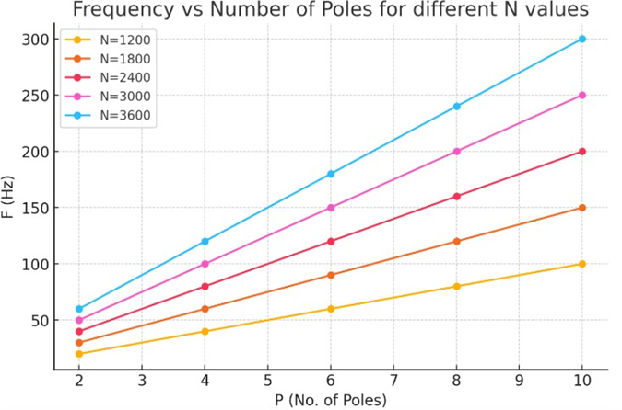
Figure 1(a). Frequency Verses Number of Poles Characteristics of DFIG System
A DFIG-based WECS system's N-P curve from the number of pole (P) and the Ns at various frequencies (40, 45, 50, 55, and 60 Hz, from bottom to top) is displayed in Figure 1(b). It turns out that frequency can only rise with the number of poles, P, at a fixed Ns (for instance, N = 1000 rpm). Similarly, when frequency increases, the Ns can only rise at a certain number of poles (for example, P = 4). However, the frequency is only permitted to exceed a specific maximum limit. When combined with modern power systems, these observations point to ways that control techniques might be improved to the reserve dependability of the DFIG-based WECS [13].

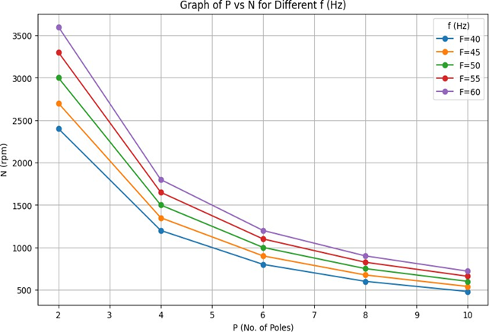
Figure 1(b). Number of Poles Verses Synchronous Speed Characteristic of DFIG System
Figure 1(c) presents the frequency N-f characteristic of the design of the controllers for the specified
system response. The curves present the N-f relationship for varying degrees of poles (10, 8, 6, 4, and 2, from bottom to top respectively). The number of poles decreases as frequency increases at a fixed synchronous speed (e.g., N = 750 rpm) that can be analysed graph extrapolation. On the contrary, the synchronous speed decreases with the number of poles at a given frequency (e. g., f = 50 Hz). These characteristics are important for the design of reliable controllers to keep the voltage and frequency of DFIG based WECS close to their nominal levels for grid integration [14].
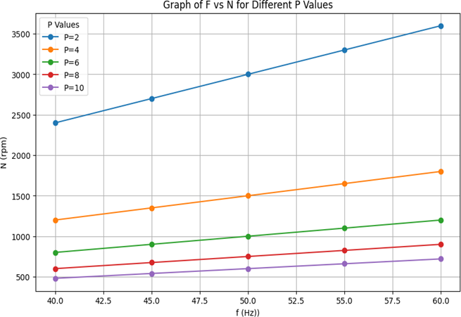
Figure 1(c). Frequency Verses Synchronous Speed Characteristics of DFIG System
The aim of this manuscript is to evaluate design parameters of a PI controller for a proposed DFIG based WECS to improve the stability of a grid integrated renewable energy systems. The key response parameters in the time domain are the settling time (Ts), peak time (Tp), gain margin (GM), rise time (Tr), and maximum overshoot and steady state error are considered. In the first part of the manuscript, control strategies for RSC-GSC voltage, P and Q power and frequency control are devised based on the static output feedback (SOF) approach.
Simultaneous comparison between the SOF and the GA methodology is provided and their suitability and applicability for the controller design are studied. The performance of the system is then assessed by simulating three phase terminal voltage, supplied P power to the grid, Q power required by the grid, and the DC link voltage between the RSC and GSCs using the estimated controller parameters. These are compared with experimental data. Graphical descriptions in the time and frequency domains are presented for a comprehensive performance analysis of the SOF based and GA based controller. This paper is organized as follows. In Section 1, the introduction of DFIG based WT system along with comprehensive literature review on proposed state of the art of the research work is described in details. The basic synchronous speed equation of the ac machine is analysed graphically to understand the basic problems associated with DFIG based WT system and importance of control actions in grid integrated renewable energy systems. Frequency variation and voltage variation due to variable nature of the WT system is presented graphically. In Section 2, system configuration and comprehensive arrangement of the WECS components including DFIG, gear boxes, DFIG WT grid integration with RSC and GSC arrangement, stator – rotor circuitry with power flow directions and additional control accessories is presented. The brief modelling of DFIG system and operating modes of DFIG based WT system are illustrated in this section. The estimation of the WECS controller design parameters using SOF methodology for proposed PI controller with GA configuration comparison is illustrated in section 3. The time response analysis and frequency domain assessment of DFIG based WECS system’s Simulink results along with comparative analysis of SOF and GA based controller performances are described successfully in sector 4. The overall conclusions and short discussion on stability conditions of system are presented in section 5 of the manuscript.
2.DFIG Based WECS System Configuration and Modelling
Wind power is a promising renewable energy source with benefits such as short gestation periods, low capital cost, and pollution-free operation. Challenges difficulties faced by the induction generators include limited usage of Q and unregulated voltage profiles. Fig. 2: DFIG and power electronic converters are used to address these challenges. An induction machine with wound rotor [15]. Operated in super-synchronous and sub-synchronous mode is referred to DFIG. It improves the power performance and reduces the fluctuations and mechanical stress as compared to fixed speed generators. The grid is connected to the stator winding of the DFIG through a power transformer, and the generator power output can be in the range of several kilowatts to several megawatts [16]. The DFIG transfers energy to the grid in super-synchronous mode with both the stator and rotor windings and in sub-synchronous mode with the stator supplying energy to the rotor winding and grid [17]. Figure 2 shows the WECS system consists of aerodynamic and electrical power control strategies.
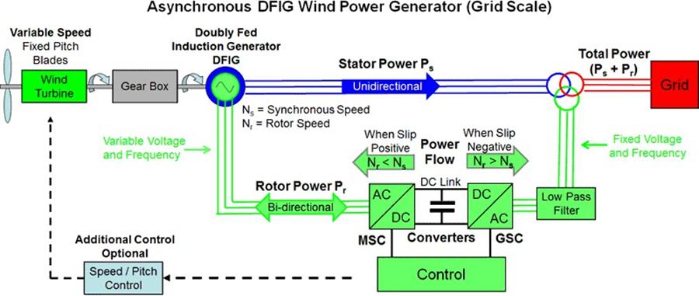
Figure 2. DFIG based WECS with Power Electronic Converters
Previous literature has covered extensively the analysis of DFIG based WECS using analogous circuit
Model and mathematical representations of the wound rotor induction machine in both motoring and generating modes of operation. Appropriate electrical control strategies based on power electronic converters are employed to control the rotor circuit of the DFIG. By doing this, the system can operate at different speeds, depending on the Ws differences. To capture the system dynamic behaviour, a final sixth order TF for the DFIG is derived and can be expressed as follows: TF= Numerator/ Denominator, The DFIG system dynamics including the rotor and stator circuits, and the control strategy for the system are incorporated in the TF which depicts the dynamic of the relationship between the input and output variables of the system [18, 19].
The RSC control of this thesis uses a two-loop control structure, which includes an outer loop for the
control of P and rotor speed, while an inner loop for the control of rotor current, respectively [20]. In this configuration the control of P and Q power is effectively decoupled. Due to their variability and because WFs are being increasingly integrated into modern power systems, the interaction between WFs and modern power systems constitutes several challenges especially for voltage stability, protection, and transient stability. As such, the system must be able to control Q power when normal operation is taking place, and protect the system in the event of a fault [21]. The dual functionality provides stable grid integration while being able to deal with grid disturbance in an effective manner in order to achieve both operational stability and fault tolerance.
3. Assessment of PI Controller Parameters Using SOF Methodology
Grid integration requires stability analysis of DFIG based WECSs. The reliability of system components is taken into account in the design of PI controller. Stability is assessed using methods that include SOF and GA. To evaluate design parameters for the WT system, the SOF methodology is applied to perform a design (to maintain SOF gain stability and consistent results with linear continuous time and discrete time systems) [22].

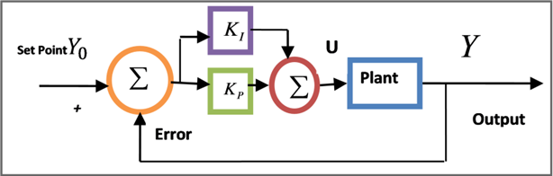
Figure 3. Representation of A Closed-Loop System with PI Controller Configuration
A PI controller is designed for a DFIG based WECS using coupled LMIs employed in the SOF methodology to guarantee stable and impulse free closed loop performance to random disturbances [23].
Through the use of the MATLAB LMI Toolbox, the optimization theorem resolves the model matrices. The determination of the SOF based controller gains is outlined in Table 1. The DFIG based WECS is controlled by PI based on SOF according to the algorithmic flowchart of Figure 4.
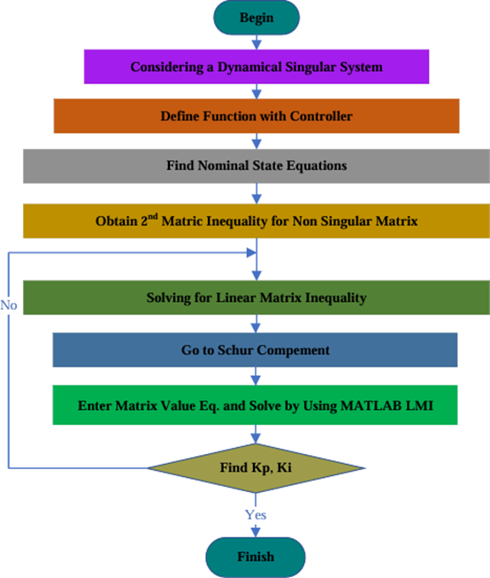
Figure 4. Methodology Flowchart of SOF-based Controller
Table 1. Gain of the PI Controller based on SOF

In Figure 5 GA based PI controller parameter estimation and the SOF based parameter assessment are compares in this paragraph. As it is motivated by biological evolution, GA not only optimizes the constrained problems but also the unconstrained problems [25]. Specifically, it maintains the solution population and selects individuals to be parents of the new generation, where offspring are formed and evolved towards the best solution [26], [27]. GA is used for control system selection, combination and mutation as selection, in order to find the fitness of control system [28], [29]. The results of GA approach using PI controller gains are presented in the Table 2.
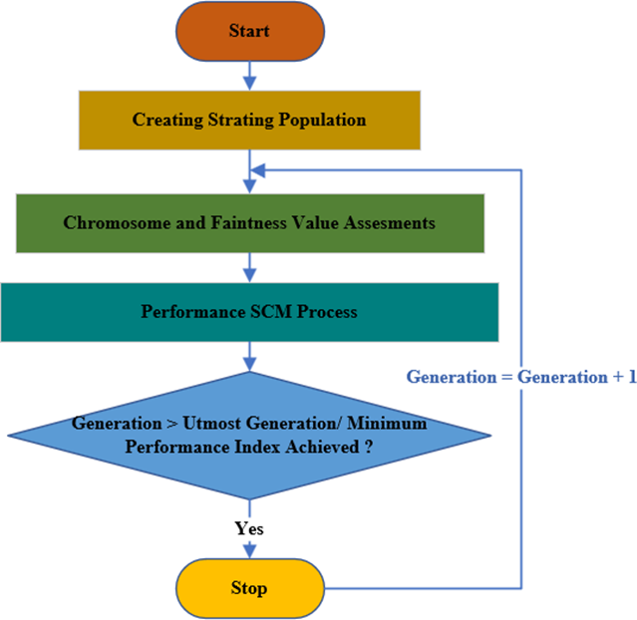
Figure 5 GA-based Controller Design Flowchart for WT Systems
Table 2. GA Algorithm-based PI Controller Gain
4. Simulation and Validation of DFIG based WECS Response
4.1 Response of the WT Simulink based on DFIG
Figure 6 shows the DFIG based WECS MATLAB model which will incorporate a DFIG connect to a variable speed WT system, having a total generation capacity of 9000 kW. In addition, the model assumes a Ws of 15 m/s and six WTs with capacity of 1500 kW each. Transmission lines for 30 km from the wind farm (WF) to the network are used, along with 25kV feeder to deliver power to the network, through a 25kV delivery system. Table 3 shows the P, Q, and DC voltage fluctuation regulated by the proposed control strategy; the output values are to be maintained at set point.

Table 3. Regulated Parameters Along with Set Points
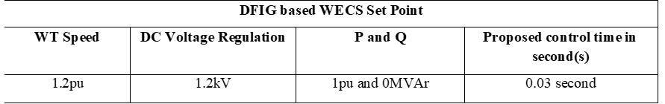

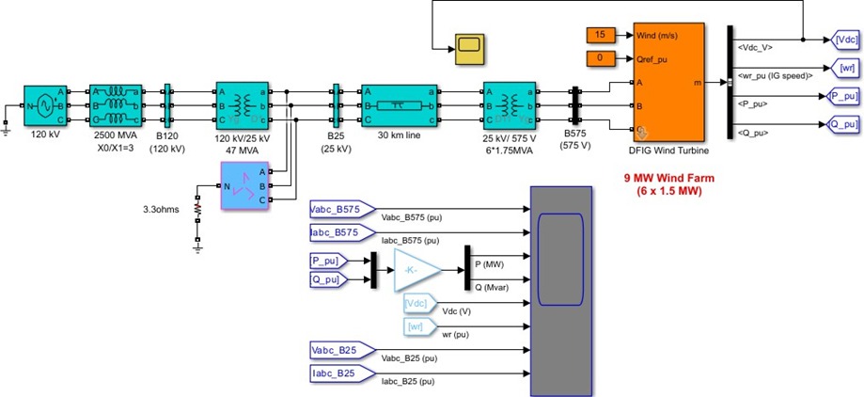
Figure 6. DFIG-WT Schematic using MATLAB Simulink

Terminal Vabc, P, Q and Vdc are studied for the variations as the controllers upon the SOF and GA are proved. The DFIG terminal voltages for the SOF controller is shown in figure 7 in per unit (pu), whereas the same voltages in figure 8 are controlled using the GA-based controller. In Fig. 9, the P power delivered by the DFIG WT system under both controllers is compared. The Q power demands of the DFIG system with the controller based on SOF and GA are shown in Figure 10 in pu. At last, the behavior of DC-link voltage under both controllers is in Figure 11. These figures represent the differences performance of all control strategies on the voltage regulation, power delivery and DC link voltage stability.
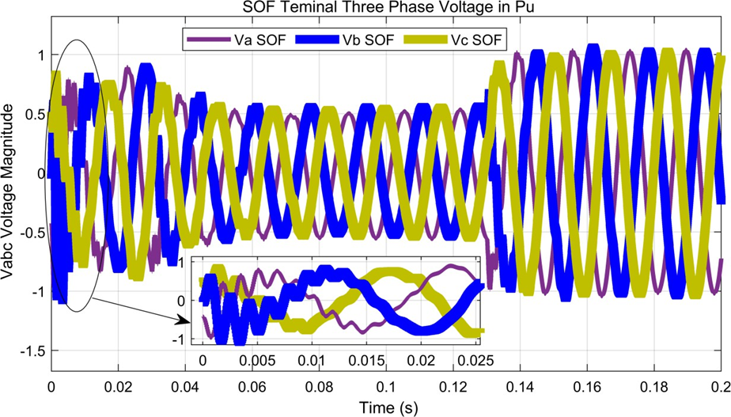
Figure 7: Three-phase DFIG terminal voltage in a pu using a controller based on SOF
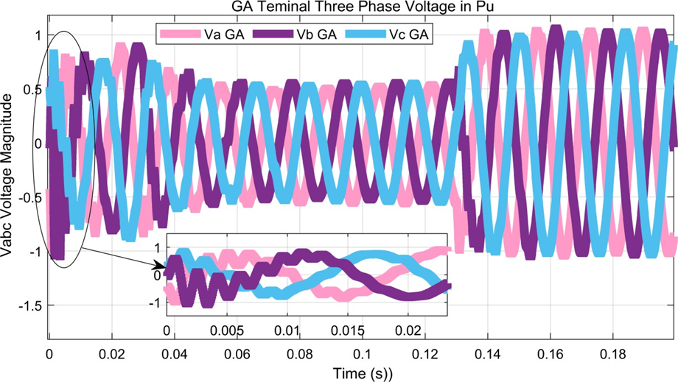
Figure 8. Three-Phase DFIG Terminal Voltages in Pu are Controlled Using a GA Controller
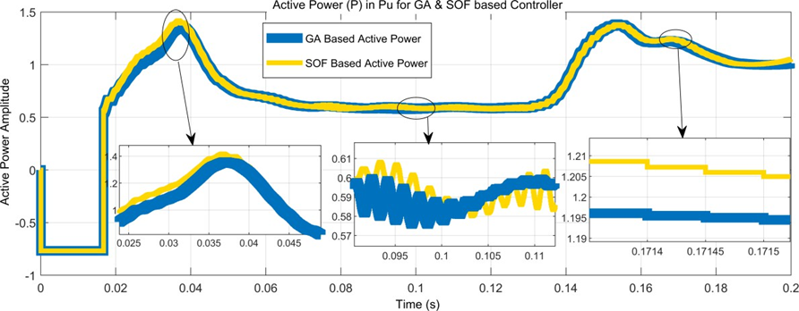
Figure 9. Active Power by DFIG WT System with Controllers based on SOF and GA
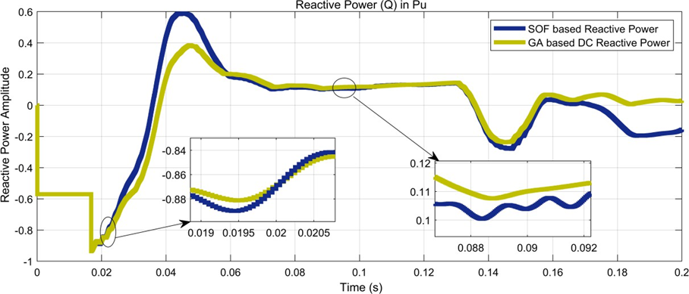
Figure 10. DFIG System with SOF and GA-based Controller in Pu Requires Reactive Power
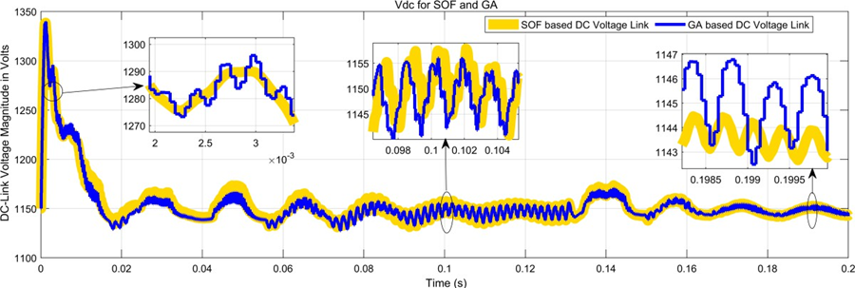
Figure 11. DC-Link Voltage to Use with Controllers based on GA and SOF
The figure shows the output of a SOF based PI controller compared to that of a GA based controller; the superiority of the DFIG based WECS with the process SOF. It suggests that the controller based on the SOF performs better than the GA controller in regulating (Vabc), P, Q, and in DC-link voltage (Vdc).
4.2 Open Loop Transfer Function's Time-Domain Response Without a Controller
The TDA proposed the DFIG based WT system model, as presented in Figure 12 does not include any controllers. The parameters Tr, Tp, Ts, Mp, and Pc, estimated in Table 4 represent the Tr, Tp, Ts, and GM and percent overshoot of the output response from the DFIG based WECS respectively.
Table 4. Time Domain Analysing 6th Order DFIGs based WECS System
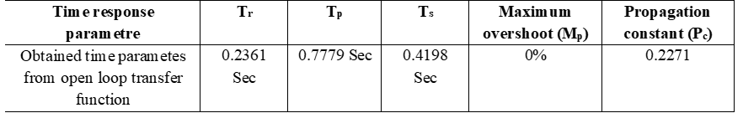

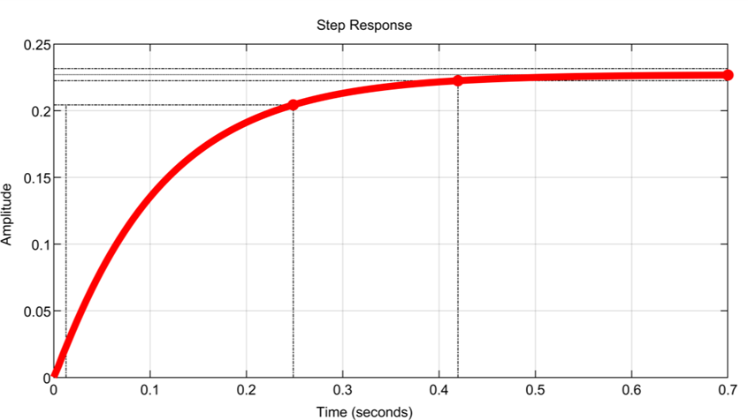 Figure 12. Step Response in Time Domains of 6th Order DFIG-Based WECS Systems
4.3 Time Domain Response Evaluation with PI Controllers Based on GA and SOF
The TDA for the DFIG based WECS model acting under a unit step input, with SOF and GA-PI controller parameters estimation is shown in Figure 13. The figure compares the two control methods analytically using colours to indicate comparative performance differences between the two methods. The analytical values with time domain response are presents in Table 5.
Table 5. Comparative Analysis of GA and SOF based Controller in Time Domain
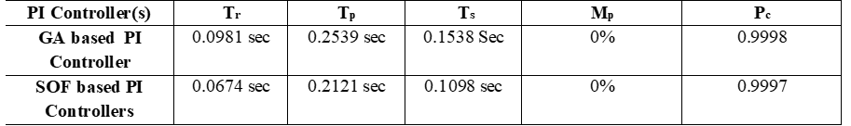
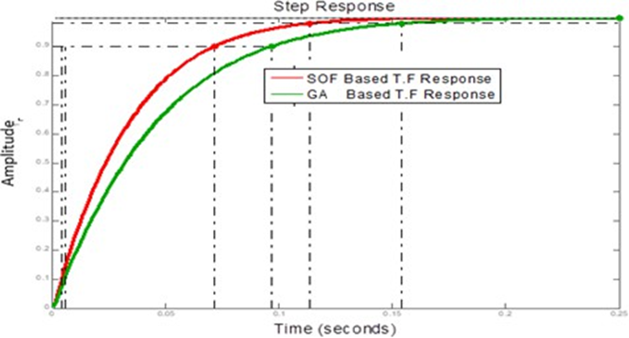
Figure 13. Presentation of the SOF and GA based PI Controllers Time Domain Step
Response
4.4 Step Responses Techniques- Based Controller
The step response of the 6th order TF DFIG system controlled by the GA and SOF based controllers is shown in Figure 14. Table 6 presents the system perform in terms of the output step response in numerical forms, and this detail is provided for both of the control strategies.
Table 6: TF Step Response Techniques-based PID Controllers
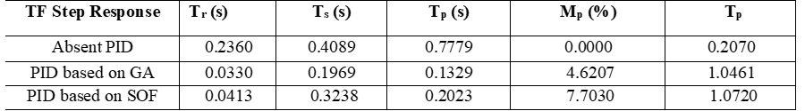
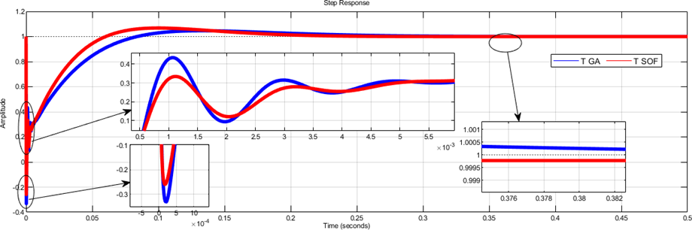
Figure 14. Step Response Output for the DFIG For GA and SOF based Controller
4.5 Frequency Domain Specifications for Closed Loop TF
The proposed DFIG based WECS model frequency domain analysis in Fig 15 is illustrated in a Bode plot. The plot compares the GM, phase margin (PM), and cross-over frequencies of SOF and GA based PI controllers. Also included is the original TF. Numerical values, gain crossover frequency as well as phase crossover frequency are also provided in the comparative analysis both with and without the use of PI controllers, as explained in Table 7.
Table 7. Bode-plot based frequency domain analysis for Open-Loop, GAO, and SOF based TF
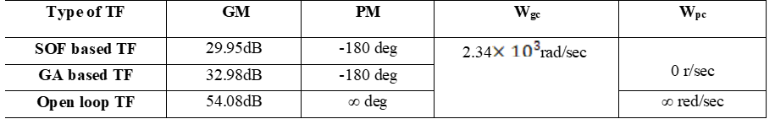
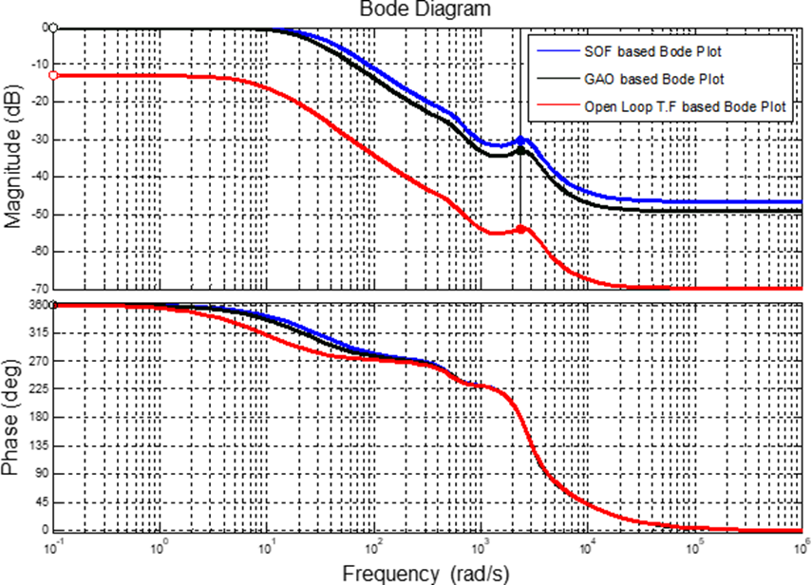
Figure 15. Bode-plot based frequency analysis for open loop, GAO, and SOF based TF
5. CONCLUSIONS
In conclusion, PI controller-based response parameters are presented for comparative analysis for the DFIG based WECS that are analysed in the time domain and frequency response. It is shown that the SOF-optimized methods exhibit superior performance to the open loop transfer function. Also, a comparison against the open loop system (without a controller) is given, and it is shown that SOF based PI controller optimization gives an improved system’s response. Specifically, the SOF based PI controller results in a reduction of 0% to the peak (Mp) as well as rapid stabilization of the system compared to the GA based PI controller. As can be seen from Tables 5 and 6, the SOF based PI controller reduces Tr, Tp, Ts, and GM over the GA based PI controller. As such, the SOF control method is proposed as a potential alternative for the controller design of the DFIG based WT systems in order to achieve improved performances, in terms of terminal voltage (Vabc), P and Q, and the DC link voltage (Vdc). The SOF approach, applied to a reduced order DFIG wind scheme, can be extended to large-scale wind farms (WFs) for stability assessment as well as higher level study, with or without energy storage system (ESS) and backup schemes operating in a utility’s mixed operations.
REFERENCES
[1] Infield, D. and Freris, L., 2020. Renewable energy in power systems. John Wiley & Sons.
[2] Fernández-Bustamante, P., Barambones, O., Calvo, I., Napole, C. and Derbeli, M., 2021. Provision of frequency response from wind farms: A review. Energies, 14(20), p.6689.
[3] Raouf, A., Tawfiq, K.B., Eldin, E.T., Youssef, H. and El-Kholy, E.E., 2023. Wind energy conversion systems based on a synchronous generator: comparative review of control methods and performance. Energies, 16(5), p.2147.
[4] Desalegn, B., Gebeyehu, D. and Tamrat, B., 2022. Wind energy conversion technologies and engineering approaches to enhancing wind power generation: A review. Heliyon, 8(11).
[5] Rahimi, M., 2018. Improvement of energy conversion efficiency and damping of wind turbine response in grid connected DFIG based wind turbines. International Journal of Electrical Power & Energy Systems, 95, pp.11-25.
[6] Vardhan, A.S.S. and Sinha, U.K., 2024. Control strategies and performance analysis of doubly fed
induction generator for grid-connected wind energy conversion system. Electrical Engineering, 106(2), pp.1203-1224.
[7] Kumar, S., Saket, R.K., Dheer, D.K., Holm-Nielsen, J.B., Sanjeevikumar, P. 2020. Reliability Enhancement of Electrical Power System Including Impacts of Renewable Energy Sources: A Comprehensive Review. IET Generation, Transmission & Distribution, 14(10), pp: 1799-1815.
[8] Islam, M.M. and Chowdhury, D., 2021. Advanced and comprehensive control methods in wind energy systems. In Emerging Power Converters for Renewable Energy and Electric Vehicles (pp. 191-24). CRC Press.
[9] Bansal, R.C., Zobaa, A.F. and Saket, R.K., 2005. Some issues related to power generation using Wind Energy Conversion Systems: an overview. International Journal of Emerging Electric Power Systems, volume: 3, Issue: 2, pp: 01-19.
[10] Wang, Z., Sun, Y., Li, G. and Ooi, B.T., 2010. Magnitude and frequency control of grid-connected doubly fed induction generator based on synchronised model for wind power generation. IET Renewable Power Generation, 4(3), pp.232-241.
[11] Kumar, S., Sarita, K., Saket, R.K., Dheer, D.K., Bansal, R.C., Mekhilef, S. 2021. Reliability Assessment for DFIG-based WECS Considering the Impact of 3-phase fault and Lightning Impulse Voltage. International Transactions on Electrical Energy Systems, e12952.
[12] Bharti, O.P., Vardhan, A.S.S., Vardhan, A.S.S., Saket, R.K. and Kothari, D.P., 2024. Static output feedback-based DFIG controller design for the wind-driven scheme. IETE Journal of Research, 70(2), pp.1833-1842.
[13] Kothari, D.P. and Nagrath, I.J., 2003. Modern power system analysis. Tata McGraw-Hill Publishing Company, New Delhi, India.
[14] Chhipą, A.A., Chakrabarti, P., Bolshev, V., Chakrabarti, T., Samarin, G., Vasilyev, A.N., Ghosh, S. and Kudryavtsev, A., 2022. Modelling and control strategy of wind energy conversion system with grid-connected doubly-fed induction generator. Energies, 15(18), p.6694.
[15] Mohammadpour, H.A. and Santi, E., 2022. Analysis of sub-synchronous resonance (SSR) in doubly-fed induction generator (DFIG)-based wind farms. Springer Nature.
[16] Kong, X., Wang, X., Abdelbaky, M.A., Liu, X. and Lee, K.Y., 2022. Nonlinear MPC for DFIG-based wind power generation under unbalanced grid conditions. International Journal of Electrical Power & Energy Systems, 134, p.107416.
[17] Bharti, O.P., Saket, R.K. and Nagar, S.K., 2019. Reliability assessment and performance analysis of DFIG-based WT for wind energy conversion system. International Journal of Reliability and safety, 13(4), pp.235-266.
[18] Sahoo, P.R., Goyal, J.K., Ghosh, S. and Naskar, A.K., 2019. New results on restricted static output feedback controller design with regional pole placement. IET Control Theory & Applications, 13(8), pp.1095-1104.
[19] Kayikçi, M. and Milanovic, J.V., 2008. Assessing transient response of DFIG-based wind plants—the influence of model simplifications and parameters. IEEE Transactions on power systems, 23(2), pp.545-554.
[20] Patel, R., Hafiz, F., Swain, A. and Ukil, A., 2021. Nonlinear rotor side converter control of DFIG based wind energy system. Electric Power Systems Research, 198, p.107358.
[21] Khan, K.R., Kumar, S., Srinivas, V.L., Saket, R.K., Jana, K.C. and Shankar, G., 2025. Voltage Stabilization Control with Hybrid Renewable Power Sources in DC Microgrid. IEEE Transactions on Industry Applications. Early Access, pp. 1-12.
[22] Desalegn, B., Gebeyehu, D. and Tamrat, B., 2022. Evaluating the performances of PI controller (2DOF) under linear and nonlinear operations of DFIG-based WECS: A simulation study. Heliyon, 8(12).
[23] Hollweg, G.V., Khan, S.A., Chaturvedi, S., Fan, Y., Wang, M. and Su, W., 2023. Grid-connected converters: A brief survey of topologies, output filters, current control, and weak grids operation. ergies, 16(9), p.3611.
[24] Bharti, O.P., Sarita, K., Vardhan, A.S.S., Vardhan, A.S.S. and Saket, R.K., 2021. Controller design for DFIG‐based WT using gravitational search algorithm for wind power generation. IET Renewable Power Generation, 15(9), pp.1956-1967.
[25] Musarrat, M.N., Fekih, A. and Islam, M.R., 2021. An improved fault ride through scheme and control strategy for DFIG-based wind energy systems. IEEE Transactions on Applied Superconductivity, 31(8), 14 pp.1-6.
[26] Canovi, M., Succi, C., Labaki, R. and Calabrò, A., 2023. Motivating next-generation family business members to act entrepreneurially: A role identity perspective. Journal of the Knowledge Economy, 14(3), pp.2187-2214.
[27] Pandit, D., Bera, A., Saket, R.K., Mitra, J. and Nguyen, N., 2024. Probabilistic sizing of energy storage systems for reliability and frequency security in wind-rich power grids. IEEE Transactions on Industry Applications, 60(3), pp.4608-4621.
[28] Piri, J., Sengupta, M. and Bandyopadhyay, G., 2024. Grid synchronised three phase VSI-based hardware emulator to realise low frequency electromechanical oscillations in power systems and their effects on physical distance relay. Sādhanā, 49(3), p.197.
[29] Prasad, R.M. and Mulla, M.A., 2020. Position-sensor less direct torque control of grid-connected DFIG with reduced current sensors. Sādhanā, 45(1), p.41.

