RESEARCH ARTICLE
“EFFECT OF CHILD NEGLECT AND ABUSE AMONG MOTHERS OF UNDER FIVE CHILDREN”
Dr. Thressiamma K.L(Sr.Teena)¹ Ms.Sunu K Rajan ² Ms.Amala james³,Ms.Ancy Joy,³Ms.Angel Maria Jolly³,Ms .Anoofa Prasad³,Ms Anugraha Tresa,³Ms Jency Jhonson,³Ms Jissa Jesso³,Ms.Nithya³
¹Professor, &HOD of Child Health Nursing, Holy Cross College of Nursing Kottiyam
²Associate Professor, Department of Child Health Nursing, Holy Cross College of Nursing Kottiyam
³Seventh Semester B.Sc Nursing students, Holy Cross College of Nursing Kottiyam
ABSTRACT
Introduction: Child abuse and neglect, as defined by the World Health Organization (WHO), include physical, emotional, and sexual abuse, as well as neglect and exploitation. These forms of maltreatment jeopardize a child's health, development, and dignity within a relationship of responsibility, trust, or power. Due to its profound physical and psychological effects, child maltreatment is a serious public health concern, with significant short- and long-term consequence. Methodology: A quantitative study was conducted to assess the effect of structured teaching program on level of knowledge regarding child neglect and abuse among mothers of under-five children in a selected hospital at Kollam district .The objective of study were to assess the level of knowledge regarding child neglect and abuse among mothers of under five children, to evaluate the effect of structured teaching program on knowledge regarding child neglect and abuse among mothers of under five children, to find out the association between the pre-test knowledge on child neglect and abuse among mothers of under five children with selected socio demographic variable. Purposive sampling technique was used to select 30 mothers of under five children for the study. The tools used were demographic profile and structured knowledge questionnaire. Result and discussion: The findings of the study showed that there was significant improvement in the knowledge regarding child neglect and abuse among mothers of under five children and statistically significant at 0.001 level. Conclusion: Hence the study concluded that structured teaching programme on child abuse and neglect was effective in improving the knowledge of mothers of under five children.
Key words: Child Abuse, Child Neglect, Under-five children.

INTRODUCTION AND BACKGROUND OF THE STUDY
Child abuse and neglect, as defined by the World Health Organization (WHO), include physical, emotional, and sexual abuse, as well as neglect and exploitation. These forms of maltreatment jeopardize a child's health, development, and dignity within a relationship of responsibility, trust, or power. Physical abuse involves intentional harm committed against a child, which often presents with injuries such as rib fractures, head trauma, or unexplained injuries. Neglect is the most common and lethal form of maltreatment, which results from the failure to provide essential care. Due to its profound physical and psychological effects, child maltreatment is a serious public health concern, with significant short- and long-term consequence.¹ From 2011 to 2017, there were 1285 reported cases of child abuse in Kashmir, according to a report by the Jammu and Kashmir State Commission for Protection of Child Rights in 2018. A 2019 study by the organization Child Rights revealed that three out of every five children in Kashmir had undergone some kind of violence, which included physical, sexual or emotional abuse.² In 2020, the Jammu and Kashmir Police launched a campaign to raise awareness about child abuse, stating that they had received over 200 complaints of child abuse in the first 6 months of the large number of child abuse cases are quite often overlooked by healthcare professionals.³
A National Study on Child Abuse, a programme was conducted “Save the Children and Prayas “by the Ministry of Women and Child Development in India with the support of UNICEF. The study, which covers 13 states in India and a sample size of 12,447 children, looks at the extent and characteristics of child abuse and girl neglect in India.⁴ The study has provided revealing statistics on the extent and magnitude of various forms of child abuse and has generated data on variations among different age groups, gender variations, state variations and variations within evidence groups. According to findings, children who have experienced child abuse are at an increased risk of numerous problematic, developmental, health, and mental health outcomes. These include, Learning difficulties such as inattention and shortfalls in executive functions. Difficulty bonding with peers due to fear of rejection, internalizing their fears, leading to related issues like anxiety and depression, externalizing their symptoms in the form of aggression, defiance, and poor conduct.
NEED AND SIGNIFICANCE OF THE STUDY
Abuse was more frequent in the higher age groups and classes at school. Abuse was also more frequent in nuclear families and families that reported alcohol use. The One-year prevalence of any abuse was 89.9% (95% CI: 89.1–90.7) suggesting that child Maltreatment was widespread. Physical and emotional abuses were also very common. Recently a case reported in Ernakulum, a 4 year old child was thrown into the river by her mother and the post-mortem report shows that the child was abused shortly before death and her paternal uncle was responsible. Child abuse and neglect has been determined to be highly prevalent across the globe⁵. Epidemiology survey has established globally that at least 50% of the child and youth population (aged 2 to 17) Experience violence in the past year. Adverse childhood experiences (ACEs) estimates Show that the majority of adolescents and adults report at least one ACE. Further, a Staggering global estimate of female victims of child sexual abuse is about 25%. The Online environment has led rapidly changing victimization contexts. Similarly, changing policies, pandemics and extended conflict zones have created different modes Compromised child well-being⁶.
The United Nations target for 2030 on reduced levels of violence against children is rapidly approaching. This special issue is intended to profile review articles of topical Interest to the areas of child abuse, neglect and adversity. Topics may range from Epidemiology to intervention to policy. A Descriptive study on child abuse shows that 70% of respondents came across Child abuse cases, wherein sexual abuse was found to be the commonest (58%), Followed by physical abuse (28%). Nearly 40% of child abuse cases were reported in the hospital where they worked, while 15% of child abuse cases occurred in other Hospital areas. The study also revealed that 81% of respondents had knowledge about Child sexual abuse. However, only 34% were aware of the repercussions of non-Reporting of a child abuse case. Nearly 64% of respondents had an idea about an online Complaint system for child abuse, and 70% were aware of the availability of a one-stop Centre at a respondent’s hospital. The majority (68%) were aware of the POCSO (Protection of Children from Sexual Offences) Act on sexual abuse. On seeking Information regarding evidence of anal sexual abuse among children and adolescents, 36% were completely aware, and 13% were partly aware of it.⁷ Child abuse and neglect remain deeply relevant issues in today’s society, With long-lasting consequences on the physical, emotional, and psychological well-Being of children.⁷ Their impact extends beyond the individual, affecting, communities, and broader societal development. Recognizing the signs, raising awareness, and implementing effective prevention and intervention strategies are critical steps in Protecting children and ensuring their right to a safe and nurturing environment. Hence, the researcher decided to conduct a study to assess the effect of structured teaching program on level of knowledge regarding child Neglect and abuse among mothers of under-five children in selected hospitals at Kollam District
MATERIAL AND METHODS
Research Approach
A quantitative research approach was used to assess the effect of a structured teaching programme on the level of knowledge regarding child neglect and abuse among mothers of under-five children in a selected hospital at Kollam district.
Research Design
The study adopted a one-group pre-test–post-test research design to evaluate the effect of the structured teaching programme on mothers’ knowledge regarding child neglect and abuse.
Variables
Independent Variable
Structured teaching programme on child neglect and abuse.
Dependent Variable
Knowledge of mothers regarding child neglect and abuse.
Setting of the Study
The study was conducted in the paediatric ward of Holy Cross Hospital, at Kottiyam.
Population
Mothers of children aged 0–5 years.
Sample: Mothers of under-five children who met the sampling criteria.
Sampling Technique: Non-probability sampling technique.
Inclusion Criteria
Mothers of children aged 0–5 years.
Mothers available during data collection.
Exclusion Criteria
Mothers who had attended any training programmes on child abuse and neglect.
Mothers not available at the time of data collection.
Tools: Structured knowledge questionnaire to assess the level of knowledge regarding child neglect and abuse among mothers of under-five children.
Section A
Demographic profile of mothers of under five children. It included age, education, occupation, religion, family type, number of children, and previous information regarding child neglect and abuse.
Section B
Structured knowledge questionnaire regarding child neglect and abuse. It included multiple items, each carrying one mark for the correct answer and zero for an incorrect answer.
Data Collection Process
Phase 1
After obtaining permission from concerned authorities, the demographic tool, questionnaire, and structured teaching programme were prepared.
Phase 2
Eligible mothers were selected according to the sampling criteria. The researcher explained the purpose of the study, obtained informed consent, and collected demographic data. A pre-test was conducted using the structured knowledge questionnaire. The structured teaching programme was administered with the help of audio-visual aids.
Phase 3
A post-test was conducted after 7 days to assess the change in knowledge regarding child neglect and abuse following the structured teaching programme.
ORGANIZATION OF FINDINGS:
SECTION A: Distribution of demographic variables.
SECTION B: To assess the pre-test and post-test knowledge regarding child neglect and abuse among mothers of under five children in a selected hospital at Kollam district
SECTION C: To determine association between mean pre-test score on knowledge regarding child neglect and abuse among mothers of under five children in a selected hospital at Kollam district, with selected demographic variable.
SECTION A
Description of socio demographic variables of mothers of under five children.
The section deals with the description of demographic variables which include age, education, occupation, and number of children and previous knowledge on child neglect and abuse
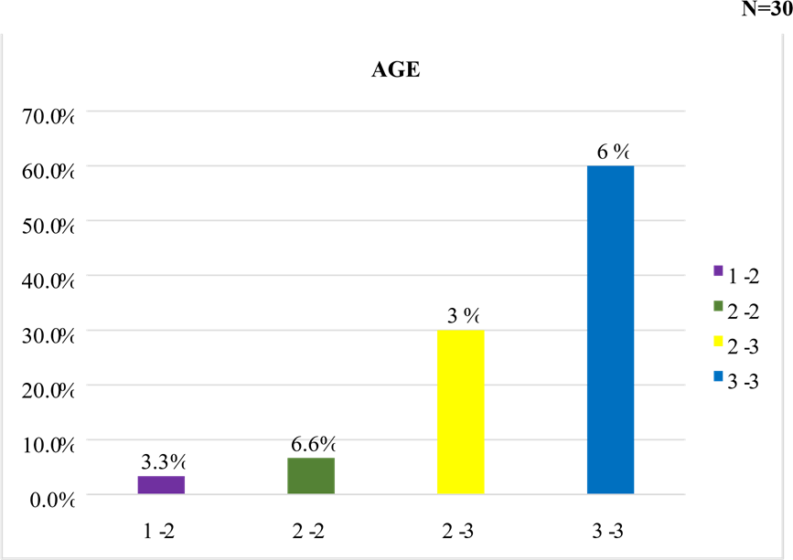

Figure 1: bar diagram showing the percentage distribution of the sample according to age:

Figure 1 shows that most of the under five children belongs to the age group of 3134(60%), about 30% belongs to the age group of 27-30, 6.66% belongs to the2326 and 3.33% mothers belongs to the age group19-22.



1

90

%
2

10

%

NUMBER OF CHILDREN

1

2

Figure 2: Pie diagram showing percentage distribution of the sample according to the number of under five children.
Figure 2 shows that 90% of the sample indicates number of children under one year of age among mothers of under five children and 10% of the sample indicates number of children under two years of age among mothers of under five children.


0.0
%
10.0
%
%
20.0
30.0
%
40.0
%
%
50.0
60.0
%
%
70.0
80.0
%
90.0
%
lower
upper
high
degree

EDUCATION

Figure 3: Bar diagram showing the percentage distribution of the sample according to the educational qualification.
Figure 3 shows that 6.66% of the sample indicates lower primary education, 3.33% shows upper primary education, 10% shows high school education and 80% shows degree qualification among mothers of under five children.

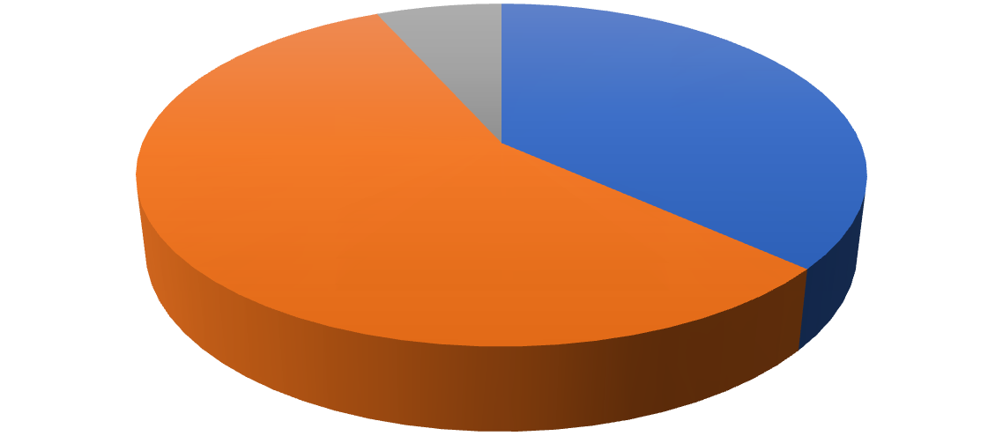

36

%

57

%

7

%

OCCUPATION

House wife

Daily wages

Business

Figure 4: Pie diagram showing the percentage distribution of the sample according to the occupation of under- five mothers.
Figure 4 shows that 36%of the sample indicate housewife, 57% shows daily wages ,7% shows business among mothers of under five children .
SECTION B

Description of pre-test and post-test knowledge scores of mothers of under five children about child neglect and abuse
The section deals with the knowledge scores of mothers of under five children about child neglect and abuse. The knowledge of 30 mothers of under- five children were assessed using structured knowledge questionnaire and analysed using descriptive statistical method


N = 30

1

2

3

20

%

40

%

40

%

Pre-test score

Good

Average

Poor

Figure 5: cylindrical diagram showing percentage distribution of sample according to pre-test score of knowledge.
The figure 5 shows that before conducting structured teaching programme 40% of mothers had poor knowledge and 40% had average knowledge and 20% had good knowledge about child neglect and abuse.


N = 30

0

%

10

%

20

%

30

%

40

%

50

%

60

%

good

average

60

%

40

%

Post test

Good

Average

Figure 6: cylindrical diagram showing percentage distribution of the sample according to post-test score of knowledge
The figure 6 shows that more than half sample is having good knowledge 60% and 40% of the sample had average knowledge after conducting structured teaching programme about child neglect and abuse.
SECTION B
A study to assess the effect of structured teaching program on level of knowledge regarding child neglect and abuse among mothers of under-five children in a selected hospital at Kollam District.
Table 1: A study to assess the effect of structured teaching program on level of knowledge regarding child neglect and abuse among mothers of under-five children in a selected hospital at Kollam District.

Knowledge | Mean | Standard deviation | N | Mean difference | Paired t value | P value
Pretest | 12.033 | 4.049 | 30 | 2.827 5.22 0.001
Posttest | 14.87 | 3.041 | 30
*Significant at 0.001 level
The above table shows that the paired t test value for the pre-test and post-test knowledge scores is 5.22 which is greater than the table value at 0.01 level of significance and there is significant difference in the mean post-test knowledge score. Therefore, research hypothesis H₁ was accepted hence this indicates that the structured teaching programme was effective in improving the knowledge regarding child neglect and abuse among mothers of under five children.
SECTION C
The association between the pre-test knowledge scores of mothers of under five children on child neglect and abuse with the selected socio demographic variables.
Data revels that the calculated chi-square values were greater than the table values. The findings showed there was no significant association between the pre-test levels of knowledge with selected socio demographic variables. Hence research hypothesis H₂ was rejected
Conclusion
The findings of the study indicates that more than half of the samples had good knowledge 60% and 40% of the samples had average knowledge after conducting structured teaching programme on child neglect and abuse .The present study concluded that the structured teaching programme was effective in improving the knowledge of mothers of under five children. The findings of the study can be used in the areas of Nursing Practice, Nursing Education, Nursing Administration, and Nursing Research.
Delimitations:
- The sample size is limited to30 Mothers of under five children
- The study is limited to selected hospitals.
Recommendation:
- Similar study can be conduct on a large sample
- Similar study can be done with different population and setting.
Reference

- Researchgate.net. [cited 2026 Feb 26]. Available from: https://www.researchgate.net/publication/395558427_A_Study_to_Assess_the_Effectiveness_of_Structured_Teaching_Programme_on_Knowledge_regarding_Child_Abuse_among_mothers_of_Under-Five_Children_at_Selected_Rural_Area_of_Banaskantha_Gujarat
- Lww.com. [cited 2026 Feb 26]. Available from: https://journals.lww.com/ijcn/fulltext/2023/24020/child_abuse_and_neglect.2.aspx
- https://journals.lww.com/ijcn/fulltext/2023/24020/child_abuse_and_neglect.2.aspx
- Loveleen Kacker1 Publication, Pravesh Kumar1 Publication, Srinivas Varadan1 Publication. Study on child abuse: India 2007 [Internet]. Save the Children’s Resource Centre. [cited 2026 Feb 26]. Available from: https://resourcecentre.savethechildren.net/document/study-child-abuse-india-2007
- Kumar MT, Kar N, Kumar S. Prevalence of child abuse in Kerala, India: An ICAST-CH based survey. Child Abuse Negl [Internet]. 2019;89:87–98. Available from: http://dx.doi.org/10.1016/j.chiabu.2019.01.002
- Sciencedirect.com. [cited 2026 Feb 26]. Available from: https://www.sciencedirect.com/special-issue/10X3FD91L4Z
- Lww.com. [cited 2026 Feb 26]. Available from: https://journals.lww.com/jfmpc/fulltext/2022/06000/a_descriptive_study_on_child_sexual_abuse_act_in.106.aspx#:~:text=Results%3A,occurred%20in%20other%20hospital%20areas

