GEOLOGICAL FIELD MAPPING REPORT OF SOME PARTS OF ABEOKUTA, SOUTHWESTERN NIGERIIA
Tunde Gideon ERINFOLAMI^{1, Solomon OMITOGUN1}
¹University of Lagos, Faculty of Science, Geosciences Department, Lagos, Nigeria
Email: tosgid@yahoo.com

ABSTRACT
Geological mapping exercise, which was carried out in parts of Abeokuta(Abeokuta south/Odeda LGA) , Ogun state; between the period of November 27-December 3, 2021 was to determine the different rock types within the study area as well as the mineral composition and structural features associated with these rock types. The materials used for the mapping exercise included a 2.0 sq. km. base map with landmarks and topographical features, a GPS, and a compass clinometer.
A systematic mapping and detail lithological, structural and mineralogical description of outcrops when located was employed during the exercise.
A total of 34 outcrop locations were mapped thus delineating three rock types which are Porphyritic granites, normal Granites and Gneiss with notable structural features such as fractures, faults, joints, foliations, etc.
The porphyritic granites in the area are intrusive bodies which intruded normal(fine-grained) granites (the parent rock) in the study area. The porphyritic granites occur as massive hilly rocks, and in some cases as low lying with observable fine grained xenoliths, and fewer gneiss. The major mineralogical composition of the porphyritic granites , normal granites and gneiss observed on the field were quartz, feldspar and mica. The major structural features identified on the rock units includes fractures, folds, faults and foliations. These features suggest different episodes of stress regimes and tectonic activities have affected the rock types in the area. The strike of the intrusions, faults and fractures are north-east/south west which is a slight deviation from the major trends of structures across Nigeria.
The area can be harnessed for quarry activities and as tourist attraction/relaxation centers which can boost the economy of the state.
The direction of strike orientation of foliations and the trend of the outcrops will serve as a good guide for employing geotechnical techniques during mineral resources exploration on the study area.

Key words: field mapping ; granite; outcrop; rock.
Abbreviations: GM: Group Mapping; GPS: Global Positioning System; IM: Individual Mapping; L: Location; LGA: Local Government Area; MSL: Mean Sea Level

1.0 INTRODUCTION
Geological field mapping involves careful and detailed systematic observation of exposed outcrops on the field which are delineated on a topographic map with a specified range of geographic coordinates and indicated with the respective symbol/colour according to their texture, structure and mineral constituents for each rock type.(Fig.4.20)
The nature of the outcrop (low-lying, massive, etc) as well as notable features such as folds,faults, lineations, fractures, mineral alignments and orientation, etc) are noted, which help in predicting stress regimes, deformatioin history, depositional history for sedimentary rocks,etc.
Geologic maps have a wide range of uses which include predicting zones of aquifers for water exploration and exploitation, ground water quality and contamination risks, earthquake predictions, zones of possible oil accumulations, landslide hazards, harnessing energy and mineral resources for economic growth, land-use planning and land management. (Soller 2002)
A geologic map is also a good guide for geophysical surveys; which help in knowing the right areas of target and the best geophysical methods and planning to be adopted
Prior to Geologic mapping, a geoscientist must be skilled on how to produce geologic maps from a topographic/base map by being able to locate him/herself and features in the map, how to read and interpret topographic/base map, how to interpret features on the map as well as how to analyze outcrops on the field.
The geological mapping exercise in this report was carried out in some parts of Abeokuta, within Abeokuta south/Odeda LGA, Southwestern Nigeria (Fig.1.2). The mapping exercise was carried out between November 28-December 3, 2021 with the aim of delineating the different rock types, notable features on outcrops, mineral alignments0 and outcrop orientation.
The area has a topography that ranges from mountains, hills to flat lying outcrops. The indigenous economic activity of Abeokuta usually revolves around agriculture which are mainly farming, animal rearing and trading.
The area mapped falls within latitude N7˚12΄00” and N7˚13΄00” and longitude E3˚20΄00” and E3˚21΄00”. with an average area of 2km square.

  - Climate and Location of the Study Area

The climatic condition of Abeokuta is characterized by alternate wet and dry seasons with rainfall varying between 750mm-
1000mm in the rainy season (between March-October) and 250mm-500mm in the dry season( Between November and March) (Akanni, 1992).
Ogun State, lie on the geographical coordinate of Latitude 6.2º N to 7.8º N and Longitude 3.0º E to 5.0º E, tropical rainforest region, southwestern, Nigeria (Badmus & Olatinsu, 2009).
..
Abeokuta, the capital of Ogun State, is the most prominent urban settlement of the state and lies within the southwestern basement complex of Nigeria. Ogun State is bounded in the west by Benin Republic, in the south by Lagos, in the north by Oyo and Osun and in the east by Ondo State (Figure 1.1).. The geology of the study area is primarily made up of Basement complex (Olurin et al.,2016)

The study area is Abeokuta, one of the prominent urban settlements in southwestern Nigeria. Abeokuta falls within the basement complex of the geological setting of southwestern Nigeria (Figure 2.2), characterised by the basement complex rocks of the pre-Cambrian age (made up of older and younger granites) as well as the younger and older sedimentary rocks of both tertiary and secondary ages .

Abeokuta area is characterized by an undulating topography with elevation
ranging from 100 to 400m above sea level. In the area, the older granite masses and in some cases, the gneisses form rugged topography. It is underlain mainly by crystalline basement rocks described as older granites (Rahaman et al., 1988)
Abeokuta is the headquarters of the federal Ogun-Oshun River Basin Authority, which is responsible for development of land and waterLagos, OgunOyoirrigationelectrification.

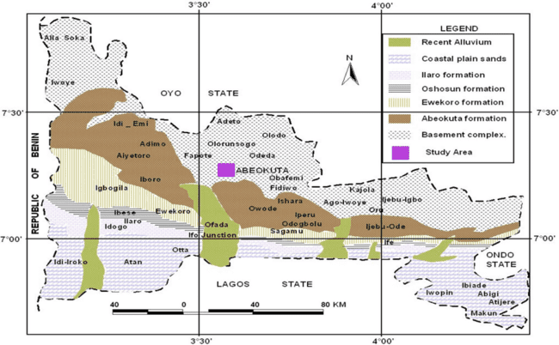
Fig. 1.1: Geological map of Ogun state(Mordified after Petters, 1982)
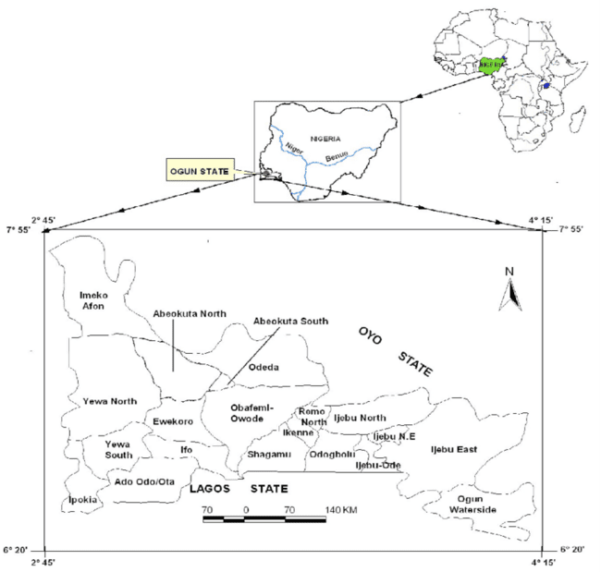
Fig. 1.2 : LGA of Ogun state

1.2 Aim and Objectives
The Aim of the geological mapping exercise was to determine the types and distribution of basement rock types within the study area and to observe notable structural features on outcrops
The objectives include;
- searching and locating of rock outcrops
- identification of the type of rocks
- observation of lithological characteristics and mineral composition of rock types
- measurements of strike and dips on relevant structural features on rocks
- making necessary inference on outcrops

2.0 LITERATURE REVIEW

Regional Geology Of Nigeria
Nigeria is approximately situated between latitude 4°N and 12°N and longitudes 3°E and 14°E, within the Pan African mobile belt in between the West African and Congo Craton.(Figure 2.1)
The Geology of Nigeria is predominantly made up of crystalline and sedimentary rocks in approximately equal proportions. (Woakes et al., 1987).
The rocks are categorized into three based on their ages and mode of formation (Obaje, 2009).
These are;
- Basement Complex: Pan-African and Older (Precambrian) > +600million years
- Younger Granites: Jurassic 200 - 145million years
- Sedimentary Basins: Cretaceous to Recent <145million years

2.1.1. THE BASEMENT COMPLEX
The Nigerian basement complex which is one of the three major litho-petrological components of the geology of Nigeria forms a part of the Pan-African mobile belt and lies between the West African and Congo Craton and south of the Tuareg shield (Black, 1980). It is intruded by the Younger Granites of the Jos Plateau and is uncomfortably overlain by Cretaceous and younger sediments.
The rocks are generally assumed to be Precambrian in age (600ma). It is made up of a variety of migmatite-gneisses, schists, amphibolites, and quartzite to doloritic intrusive. (Rahman, 1976).
The basement rocks are believed to be the results of at least four major orogenic cycles of deformation, metamorphism and remobilization corresponding to the Liberian (2,700 Ma), the Eburnean (2,000 Ma), the Kibaran (1,100 Ma), and the Pan-African cycles (600 Ma).
The first three cycles were characterized by intense deformation and isoclinal folding accompanied by regional metamorphism, which was further followed by extensive migmatization. The Pan-African deformation was accompanied by regional metamorphism, migmatization and extensive granitization and gneissification which produced syntectonic granites and homogeneous gneisses. (Obaje, 2009).
The rocks of the basement complex are generally divided into three units namely;
- The Migmatite-Gneiss complex
- The Schist belts or Metasediments
- The Older Granites

i. The Migmatite-Gneiss Complex
The Migmatite-Gneiss Complex is generally considered as the most widespread of the component units in the Nigerian Basement. It has a heterogeneous assemblage comprising migmatites, orthogneisses, paragneisses, and a series of basic and ultrabasic metamorphosed rocks. The Migmatite-Gneiss Complex has ages ranging from Pan-African to Eburnean. The Migmatite-Gneiss Complex also termed by some workers as the “migmatite-gneiss-quartzite complex” makes up about 60% of the Nigerian basement. (Rahman and Ocan, 1978).
ii. The Schist Belt
The schist belt comprises low-grade, metasediment-dominated belts trending N-S which are best developed in the western half of Nigeria. These belts are considered to be Upper Proterozoic supracrustal rocks that have been infolded into the migmatite-gneiss-quartzite complex. The lithological variations of the schist belts include coarse to fine-grained clastics, pelitic schists, phyllites, banded iron formation, carbonate rocks (marbles/dolomitic marbles), and mafic metavolcanics (amphibolites). Some may include fragments of ocean floor material from small back-arc basins.
iii. The Older Granites
The term “Older Granite” was introduced by Falconer, 1911, to distinguish the deep-seated, often concordant or semi-concordant granites of the Basement Complex from the high level, highly discordant tin-bearing granites of Northern Nigeria. The Older Granites are believed to be pre-, syn- and post-tectonic rocks that cut both the migmatite-gneiss-quartzite complex and the schist belts (Obaje, 2009). They range widely in age (750-450Ma) and composition. They represent a varied and long-lasting (750-450Ma) magmatic cycle associated with the Pan-African orogeny. The rocks of this suite range in composition from tonalities and diorites through granodiorites to true granites and syenites. Charnockites form an important rock group emplaced during this period. They are generally high-level intrusions and anataxis has played an important role. (Rahman et al., 1988).

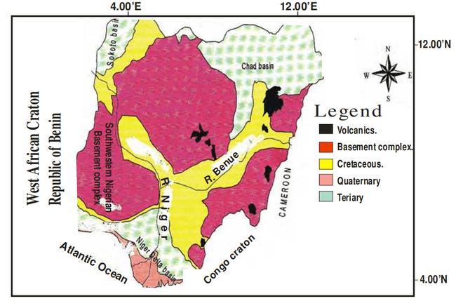

Figure 2.1 . Geological Map of Nigeria showing the rock type covering the southwestern Nigeria (modified after Elueze, 1982)

2.1.2 The Younger Granites
The Younger Granites is a Jurrasic ring of complexes of Nigeria which formed part of a wider province of alkaline anorogenic magmatism. They occur in a zone 200 km wide and 1,600 km long extending from northern Niger to south-central Nigeria. (Obaje, 2009)
The granites of the Younger Granites series are mainly in the form of ring complexes which are made of soda pyroxenes and amphiboles, biotite, and fayalite granites, syenites and trachytes with minor gabbros and dolerites. Rhyolites, tufts, and ignimbrites are rarely preserved. (Obaje, 2009)
2.1.3 Geology Of The Study Area
The area covered by the southwestern Nigeria basement complex lies between latitudes 7ºN and 10ºN and longtitudes 3ºE and 6ºE right in the equatorial rain forest region of Africa (Figure 2.2). The main lithologies include the amphibolites, migmatite gneisses, granites and pegmatites. Other important rock units are the schists, made up of biotite schist, quartzite schist talk-tremolite schist, and the muscovite schists. The crystalline rocks intruded into these schistose rocks. For the purpose of this chapter, discussion is limited to the crystalline basement rocks of southwestern Nigeria.(Olurin et al., 2016)

Fig. 2.2 Geological map of Abeokuta(After Olurin et al, 2016)

3.0 MATERIALS AND METHODS
3.1 Materials
The following materials were used for the mapping exercise:
- Compass Clinometer; this was used to know direction of geographic north as well as taking strike and dip of structural features seen on the rocks e.g. foliation planes, fault planes, etc.
Knowing the directions of true north helped in locating ourselves on the map; using major landmarks on the topographic map
- Topographical Map; this was used to determine the areal extent of where to map and also shows elevations and landmarks that guided the search for rock exposures or outcrops
- GPS; a mobile phone enabled handy GPS application was used to determine geographical coordinates of outcrops before locating on map. It was also helpful to locate ourselves easily on the topographic map.
- Field note; this was used to document observations of structural features and relevant measurements made on each outcrop
- Geological hammer: This was used to take fresh samples of outcrops for further observations and probably petrographic studies
- Digital camera: This was used to take pictures of notable structural features on outcrops and other necessary structures
3.2 Methods
The mapping exercise commenced with a general field orientation on how to observe outcrops on the field by watching out for striking structural features and the type of mineral constituents, their size, orientation/alignments as well as observing the general description and orientation of the outcrop.
The second day was used to start off the geological mapping exercise, using the topographic map provided. The mapping exercise was carried out in group for independent field report.
The topographic map provided was gridded for easy locating of outcrops.
The mapping exercise was carried out for a period of one week. The area of the provided map was approximately about 2 sq. km. Once the outcrop was located from searching through the area, the GPS coordinates of the outcrop was determined and the outcrop was properly studied and descriptions were made based on the following criteria;
- Nature of the outcrop exposure i.e. size orientation (low lying, linear, elevated, massive etc.), exfoliations etc.
- Lithological descriptions; igneous metamorphic
- Textural description; i.e. granular, porphyritic, porphyroblastic etc.
- Mineralogical compositions; i.e. what types of minerals are present e.g. quartz, feldspar, mica etc.
- Structural features e.g. fractures, faults, folds, veins, foliations etc.
- Date on which outcrop was found
- Appearance of Outcrops
- Weather condition at the time outcrop is located (this is essential because different mineral have different appearances based on the condition of the weather)

4.0 RESULTS AND DISCUSSION
4.1 Results
4.1.1 Description Of Ourctops
4.1.1.1 General Field Mapping/ Orientation
LOCATION 1 (Isale Oja, Kuto, Abeokuta)
Outcrop 1:
Coordinates; 7.14240082, 3.35060723
Weather: 31ºC, sunny
Strike/Dip of lineation: 180º//38ºE
Outcrop name: Porphritic granite
Outcrop description: A low-lying outcrop with quarts and feldspar as predominant minerals. Parts of the textures have aligned minerals suggesting it to be porphiritic gneissic while major parts are porphiritic granites

Table 4.1 Axis lengths and orientation of phenocrysts(L1,GM)
S/N | Long axix(mm) | Short axis(mm) | Orientation(degree)
1 | 63 | 42 | 78
2 | 75 | 23 | 170
3 | 70 | 20 | 174
4 | 55 | 25 | 2
5 | 30 | 18 | 128
6 | 50 | 13 | 200
7 | 100 | 15 | 178
8 | 40 | 13 | 152
9 | 55 | 17 | 114
10 | 60 | 12 | 128
11 | 90 | 20 | 124
12 | 100 | 20 | 175
13 | 30 | 12 | 156
14 | 78 | 25 | 148
15 | 45 | 14 | 156
16 | 50 | 33 | 164
17 | 70 | 28 | 163
18 | 60 | 21 | 175
19 | 50 | 12 | 182
20 | 43 | 18 | 184
21 | 60 | 22 | 208
22 | 50 | 20 | 168
23 | 70 | 25 | 189
24 | 60 | 12 | 197
25 | 68 | 23 | 195
26 | 32 | 12 | 178
27 | 50 | 18 | 182
28 | 75 | 20 | 184
29 | 50 | 15 | 152
30 | 40 | 10 | 165
31 | 50 | 16 | 68
32 | 80 | 20 | 156
33 | 70 | 15 | 148
34 | 48 | 17 | 94
35 | 40 | 22 | 91
36 | 35 | 13 | 189
37 | 50 | 20 | 142
38 | 80 | 25 | 108
39 | 60 | 22 | 95
40 | 30 | 12 | 108
41 | 45 | 15 | 125
42 | 50 | 12 | 140
43 | 43 | 19 | 185
44 | 50 | 18 | 114
45 | 55 | 18 | 178
46 | 40 | 10 | 209
47 | 70 | 25 | 215
48 | 60 | 25 | 104
49 | 50 | 15 | 178
50 | 70 | 24 | 104
Fig. 4.01 Rose diagram of pheocysts orientation(Outcrop 1, General mapping)

LOCATION 2 (Close to Olumo Rock, Abeokuta)

Coordinates; 7.165556, 3.346111
Weather: 31ºC, sunny
Strike/Dip of foliation plane: 168º//31ºE
Outcrop name: Porphritic granite
Outcrop description: A massive outcrop close to the popular Olumo rock.
It is a porphiritic granite with large visible phenocrysts mostly disorientated (Fig.4.02). Foliation planes were observed within the body of the granite; which suggests the occurrence of metamorphism as a result of the flowing of magma within the rock (wrap).(Fig. 4.03)
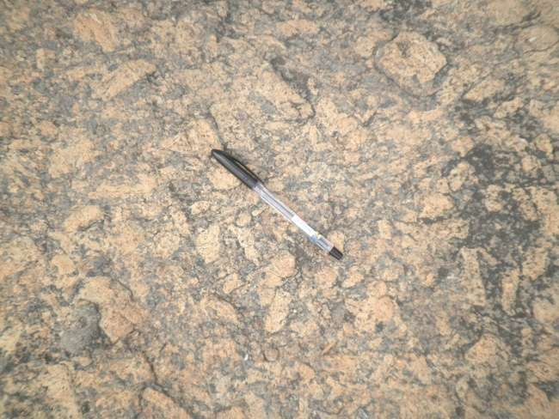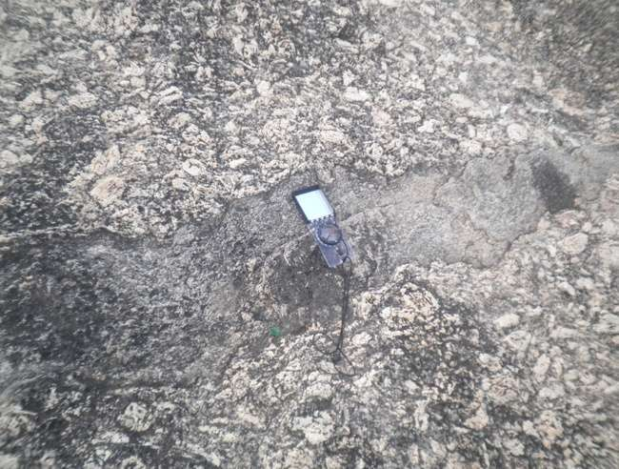
Fig.. 4.02 Visible large disorientated pheocrysts Fig, 4.03 Presence of a wrap in a part of the outcrop

Table 4.2 Axis lengths and orientation of phenocrysts(L 2, GM)
S/N | Long axix(mm) | Short axis(mm) | Orientation(degree)
1 | 70 | 22 | 129
2 | 65 | 18 | 173
3 | 55 | 21 | 144
4 | 52 | 28 | 152
5 | 58 | 17 | 200
6 | 24 | 21 | 216
7 | 69 | 22 | 248
8 | 55 | 25 | 236
9 | 56 | 23 | 285
10 | 44 | 19 | 285
11 | 72 | 21 | 243
12 | 70 | 31 | 261
13 | 65 | 26 | 236
14 | 40 | 31 | 255
15 | 55 | 28 | 216
16 | 80 | 25 | 270
17 | 65 | 30 | 228
18 | 72 | 20 | 236
19 | 55 | 20 | 176
20 | 70 | 25 | 220
21 | 82 | 22 | 340
22 | 65 | 20 | 264
23 | 40 | 25 | 245
24 | 68 | 22 | 212
25 | 56 | 15 | 203
26 | 72 | 25 | 188
27 | 68 | 15 | 150
28 | 80 | 23 | 133
29 | 42 | 12 | 149
30 | 70 | 28 | 166
31 | 56 | 15 | 197
32 | 44 | 18 | 220
33 | 28 | 12 | 180
34 | 55 | 10 | 168
35 | 66 | 14 | 165
36 | 72 | 24 | 223
37 | 74 | 18 | 180
38 | 58 | 24 | 144
39 | 70 | 20 | 213
40 | 68 | 22 | 187
41 | 75 | 25 | 216
42 | 65 | 22 | 220
43 | 72 | 24 | 233
44 | 58 | 22 | 151
45 | 70 | 24 | 221
46 | 64 | 18 | 239
47 | 55 | 22 | 155
48 | 80 | 25 | 148
49 | 65 | 24 | 259
50 | 72 | 18 | 196

Figure 4.04 Rose diagram of pheocysts orientation( Location 2, general mapping)

4.1.1.2 Independent(Group) Field Mapping
LOCATION 1
Coordinates; 7.2052330, 3.3460667
Weather: 34ºC, sunny
Altitude: 134m Above MSL
Strike/Dip of foliation plane: 122º//34ºE

Outcrop name: Porphiritic granite
Descriptions: A massive outcrop with visible large-size phenocrysts within dark-coloured matrix. The phenocrysts are randomly orientated as shown in the Rose diagram.(Fig.4.05)

Table 4.3 .Axis lengths and orientation of phenocrysts(Location 1, IM)
S/N | Long axix(mm) | Short axis(mm) | Orientation(degree)
1 | 75 | 30 | 60
2 | 71 | 15 | 44
3 | 100 | 50 | 46
4 | 75 | 35 | 22
5 | 85 | 20 | 30
6 | 70 | 40 | 140
7 | 55 | 30 | 178
8 | 45 | 15 | 220
9 | 60 | 20 | 191
10 | 70 | 32 | 142

Fig.4.05 Rose diagram of pheocysts orientation(L1,IM)

LOCATION 2
Coordinates; 7.2076670, 3.3489500
Weather: 34ºC, sunny
Altitude: 100m Above MSL
Strike/Dip of foliation plane: 122º//34ºE
Outcrop name: Porphiritic granite
Description: A low lying porphiritic granite with distinct grain sizes of quarts with biotite matrix. There is the presence of zenoliths with darker colour which suggests the presence of an older rock before magmatization.(Fig.4.06)
There is also the presence of fault shown with the displacement of zeolith along the fault plane. The zenolith is fine grained and darker in colour compared to the host rock. This suggests the occurrence a pre-existing volcanic rock before intrusion of a plutonic rock.(Fig.4.07)
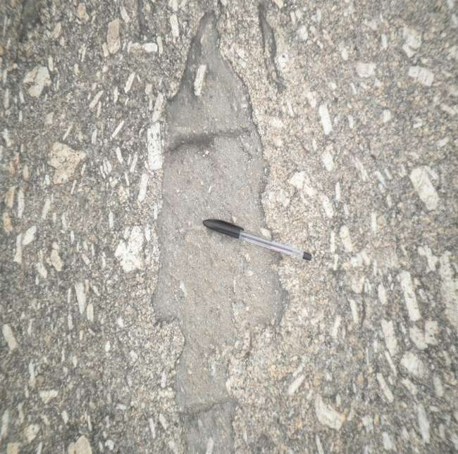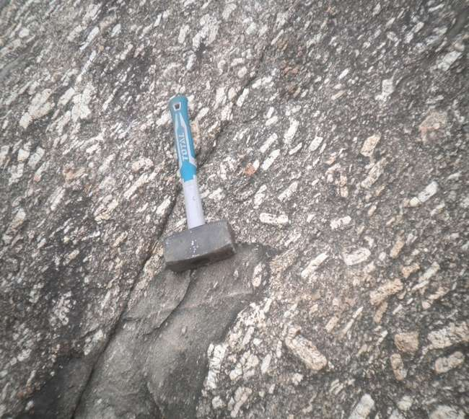
Fig.4.06 Zenolith emplaced in the rock mass Fig.4.07 A mini strike-slip fault

Table 4.4 .Axis lengths and orientation of phenocrysts(L2,IM)
S/N | Long axix(mm) | Short axis(mm) | Orientation(degree)
1 | 80 | 25 | 224
2 | 60 | 24 | 173
3 | 78 | 20 | 187
4 | 80 | 25 | 153
5 | 83 | 40 | 191
6 | 58 | 40 | 191
7 | 60 | 25 | 214
8 | 74 | 35 | 183
9 | 87 | 40 | 142
10 | 80 | 20 | 262

Fig 4.08 .Rose diagram of pheocysts orientation(L2,IM)

LOCATION 3
Coordinates; 7.2071388, 3.3494167
Weather: 34ºC, sunny
Altitude: 112m Above MSL

Outcrop name: Porphiritic granite
Description: A low-lying outcrop showing phenocryts quite large without preferred orientation with a darker matrix. There is the presence of granitic zenolith intruded b granitic rocks, A nearby boulder was observed to host a fine-grained granitic rock suggesting that the pervious rock was granitic in nature; with a matrix of coarse-grained granitic rock.
Table 4.5 Axis lengths and orientation of phenocrysts(L3, IM)
S/N | Long axix(mm) | Short axis(mm) | Orientation(degree)
1 | 48 | 14 | 49
2 | 40 | 24 | 36
3 | 41 | 15 | 118
4 | 45 | 12 | 46
5 | 50 | 13 | 118
6 | 55 | 15 | 124
7 | 75 | 16 | 105
8 | 60 | 30 | 35
9 | 55 | 25 | 138
10 | 83 | 15 | 186

Fig. 4.09 Rose diagram of pheocysts orientation(L3,GM)

LOCATION 4
Coordinates; 7.2077222, 3.3434722
Weather: 36ºC, sunny
Altitude: 115m Above MSL
Orientation of Outcrop: 122º
Outcrop name: Porphiritic granite
Description: A massive granitic rock that has undergone biological and physical weathering. There is the presence of fractures. There are visible large phenocrysts with orientation in the Nortgh-East direct; which also conform with the orientation of the outcrop.

LOCATION 5
Coordinates; 7.2063833, 3.3420500
Weather: 36ºC, sunny
Altitude: 81m Above MSL

Outcrop name: Porphiritic granite
Description: A massive outcrop with part as an abandoned quarry.(Fig.4.10) There are the presence of joints, quartz vein and fractures(possibly induced by the quarrying activity(Fig.4.11)
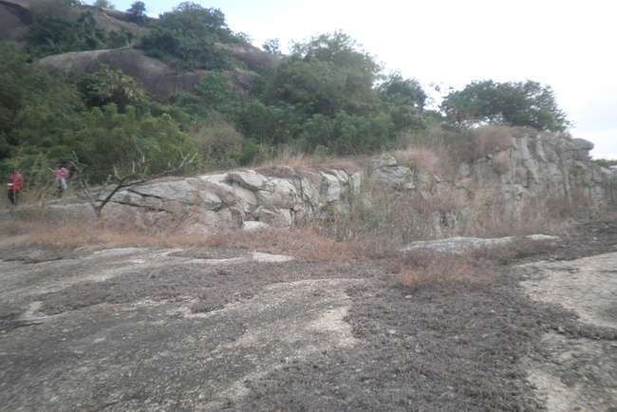
Fig. 4.10 Abandon quarry
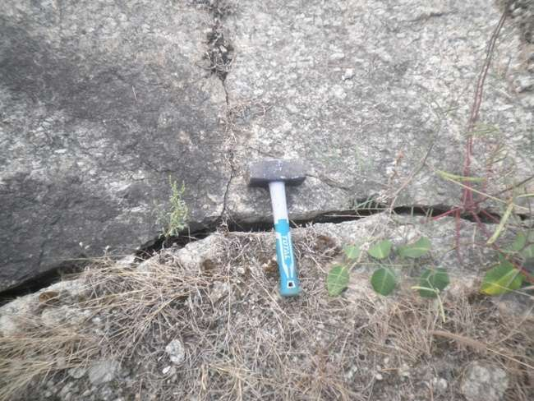
Fig. 4.11 Presence of fracture in parts of the abandon quarry
LOCATION 6
Coordinates; 7.2089333, 3.3465833
Weather: 36ºC, sunny
Altitude: 82m Above MSL
Outcrop name: Porphiritic granite
Description: Moderately big outcrop that have undergone some weathering. The three different types of granites observed are normal are fine, medium and large grained-granites with porphiritic granite being predominant.
Migmatites were also noticed in some parts of the rock; suggesting that the pre-existing rocks underwent three phases of intrusion.
Quarts veins were also observed in some parts of the rock.
The mega pheocrystals in the porphiritic granites are without preferred orientation.

LOCATION 7
Coordinates; 7.2105000 , 3.3469833
Weather: 36ºC, sunny
Altitude: 85m Above MSL
Outcrop name: Porphiritic granite
Description: A low-lying outcrop which have undergone physical and biological weathering. There are presence of large-sized pheocrysts without preferred orientation

LOCATION 8
Coordinates; 7.2125000, 3.3457167
Weather: 36ºC, sunny
Altitude: 77m Above MSL
Outcrop name: Porphiritic granite
Description: A low-lying outcrop with similar features as that of location 7. There are presence of large-sized pheocrysts without preferred orientation

LOCATION 9
Coordinates; 7.2150500, 3.3448833
Weather: 34ºC, sunny
Altitude: 80m Above MSL
Outcrop name: Porphiritic granite
Description: A moderate outcrop with nearby boulders of the same textures.with similar textures. There are presence of large-sized pheocrysts without preferred orientation in a darker minerals matrix

LOCATION 10 (Oke-Ona Grammar School 1)
Coordinates; 7.2164167, 3.3406333
Weather: 34ºC, sunny
Altitude: 76m Above MSL
Outcrop name: Normal Granite
Description: A low-lying outcrop with nearby boulders of the same textures.with similar textures. It is fine grained granites with predominantly mafic minerals and has undergone biological and physical weatherings; as evident with presence of fractures.

LOCATION 11 (Oke-Ona Grammar School 2)
Coordinates; 7.2166000, 3.3412500
Weather: 34ºC, sunny
Altitude: 69m Above MSL
Outcrop name: Normal Granite
Description: A low-lying outcrop with nearby boulders of the same textures. With similar textures. It is fine grained granites with predominantly mafic minerals with presence of fractures and visible quartz veins.(Fig.4.12)

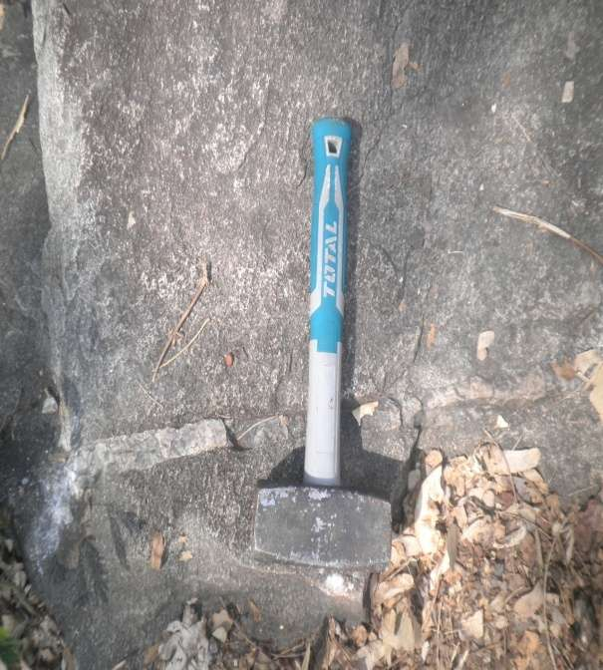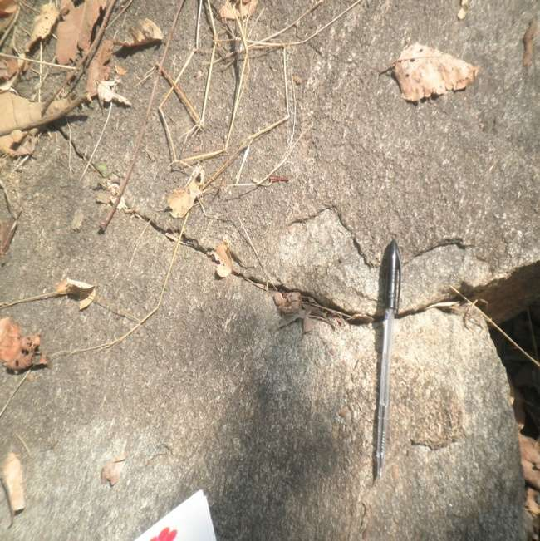
Fig. 4.12 Quartz vein ( L11) Fig. 4.13 Fracture (L11)
LOCATION 12 (Close to Opeji Road)
Coordinates; 7.2163667, 3.3386167
Weather: 34ºC, sunny
Orientation of Outcrop: Trending North-South
Altitude: 61m Above MSL

Outcrop name: Normal Granite
Description: A low-lying outcrop with nearby boulders of the same textures. With similar textures. It is fine grained granites with predominantly mafic minerals with presence of fractures and visible quartz veins.

LOCATION 13 (Close to Opeji Road)
Coordinates; 7.2158833, 3.3383333
Weather: 34ºC, sunny
Altitude: 52m Above MSL
Outcrop name: Normal Granite
Description: A low-lying outcrop that is fine grained with predominantly mafic minerals with presence of fractures.

LOCATION 14 (Close to Opeji Road)
Coordinates; 7.2083333, 3.3383333
Weather: 34ºC, sunny
Altitude: 59m Above MSL

Outcrop name: Normal Granite
Description: A low-lying outcrop that is fine grained with predominantly mafic minerals..

LOCATION 15
Coordinates; 7.2023500, 3.3504500
Weather: 34ºC, sunny
Altitude: 95m Above MSL
Orientation of Outcrop: Trending North-East
Outcrop name: Porphiritic Granite
Description: A massive outcrop with visible phenocrysts have no preferred orientation. There is also the presence of zenoliths enclosed within some parts of the outcrop.(Fig.4.14)
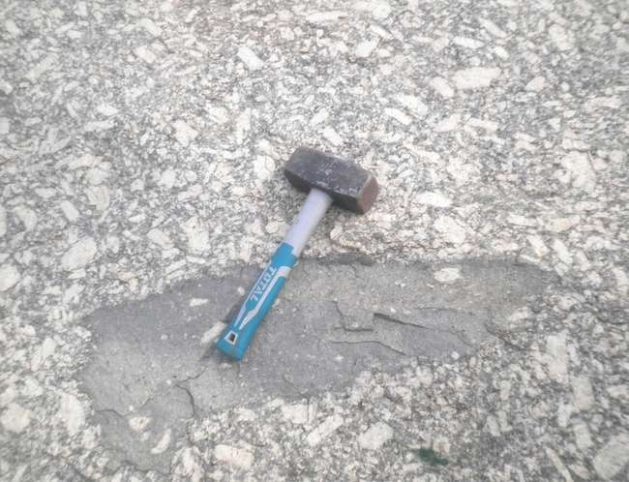
Fig.4.14: Dark, fine grain xenoliths within a porphyritic granite(L15)

LOCATION 16
Coordinates; 7.2022000, 3.3492667
Weather: 34ºC, sunny
Altitude: 89m Above MSL
Orientation of Outcrop: Trending North-East
Stike/Dip of foliation plane: 092º//33ºE
Outcrop name: Porphiritic Granite
Description: A massive outcrop with porphiritic granite intruding a fine grained granite that has undergone an intense metamorphism.
There is also the presence of banding within the metamorphosed rock suggesting high level of metamorphism in the areas of the metamorphic rock.
The mixture of porphyritic granite, fine grain granites and gneiss suggests it to be a migmatite(Fig.4.15); although the predominant rock is porphyritic granite. The outcrop has also undergone some weathering processes.
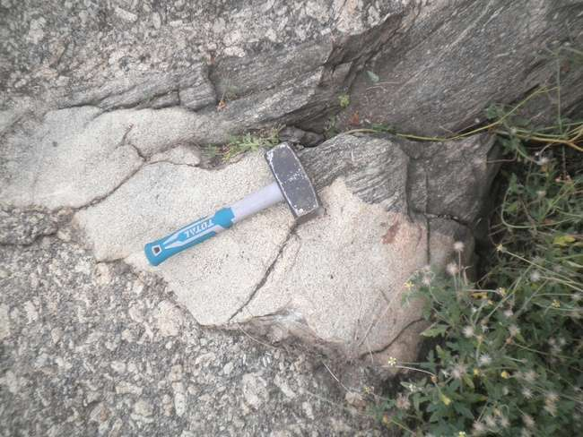
Fig.4.15: Migmatite( A combination of porhyritic granite, fine grain granite and gneiss, L16)

LOCATION 17 (Extension of Dam outcrop)
Coordinates; 7.2016667, 3.3469000
Weather: 34ºC, sunny
Altitude: 82m Above MSL
Outcrop name: Porphiritic Granite
Description: A massive outcrop which is porphiritic granite due to visible large phenocrysts without any preferred alignment
The outcrop has also undergone some weathering processes.
LOCATION 18 (Close to Araganke river)
Coordinates; 7.2075000, 3.3441833
Weather: 34ºC, sunny
Altitude: 62m Above MSL
Orientation of phenocrysts: Trending North-East
Outcrop name: Porphiritic Granite
Description: A low-lying outcrop with visible quartz veins. The phenocrysts generally form alignment in the North-East direction.

LOCATION 19 (Close to Opeji road)
Coordinates; 7.2011000, 3.3418500
Weather: 34ºC, sunny
Altitude: 84m Above MSL
Orientation of phenocrysts: Trending North-East
Outcrop name: Porphiritic Granite
Description: A massive outcrop surrounded by boulders of same textural features. The outcrop has undergone both biological and physical weathering with visible fractures.

LOCATION 20 (Ajegunle)
Coordinates; 7.2026000, 3.3390330
Weather: 34ºC, sunny
Altitude: 71m Above MSL
Orientation of outcrop: Trending North-West
Outcrop name: Normal Granite
Description: A low-lying granite that has undergone an intense weathering process. A very fine grain granitic rock with mafic minerals as the matrix.

LOCATION 21
Coordinates; 7.2067667, 3.3390000
Weather: 34ºC, sunny
Altitude: 68m Above MSL
Orientation of outcrop: Trending North-West

Outcrop name: Normal Granite
Description: A low-lying granite that has undergone an intense weathering process. A very fine grain granitic rock with mafic minerals as the matrix. Quarts veins were also observed.

LOCATION 22
Coordinates; 7.2065167, 3.3404667
Weather: 34ºC, sunny
Altitude: 75m Above MSL
Orientation of foliation plane: Trending North-West

Outcrop name: Porphyritic Granite
Description: A moderate outcrop with porphyritic granite as the predominant rock. There is the presence of banding showing a part to be gneissic with foliation surface(Fig.4.16). Quartz veins were also observed in some parts of the outcrop.
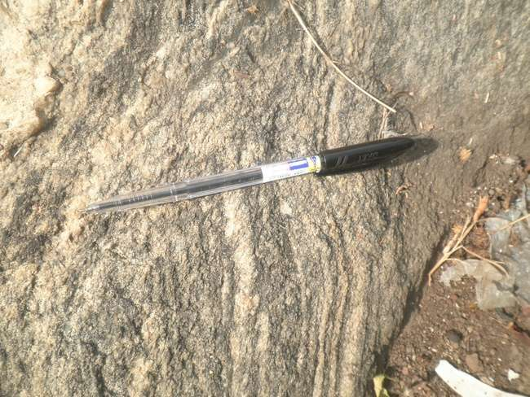
Fig.4.16: Microfolds (L22)
LOCATION 23
Coordinates; 7.2069333, 3.3408167
Weather: 34ºC, sunny
Altitude: 76m Above MSL

Outcrop name: Porphyritic Granite
Description: A moderate outcrop with porphyritic granite as the predominant rock. Some fractutres were observed due to biological weathering.

LOCATION 24
Coordinates; 7.2068167, 3.3379500
Weather: 34ºC, sunny
Altitude: 71m Above MSL
Outcrop name: Normal Granite
Description: A low-lying outcrop with fine –grain mafic minerals .

LOCATION 25
Coordinates 7.2071333, 3.3363000
Weather: 34ºC, sunny
Altitude: 66m Above MSL
Outcrop name: Normal Granite
Description: A low-lying granitic outcrop with multiple quartz veins(Fig.4.17) and mafic minerals as matrix. The outcrop is fine-grained .
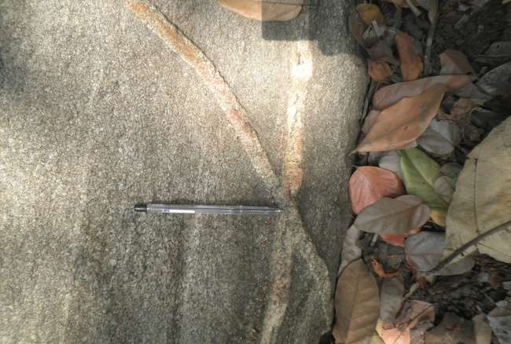
Fig. 4.17: Cross-cutting Quartz veins (L25)
LOCATION 26
Coordinates; 7.2076833, 3.3352333
Weather: 34ºC, sunny
Altitude: 58m Above MSL
Orientation of outcrop: Trending North-East
Outcrop name: Porphyritic Granite
Description: A low-lying porphyritic granite with visible large phenocrysts without preferred orientation. Quarts veins were also observed.
LOCATION 27
Coordinates; 7.2090167, 3.3352333
Weather: 34ºC, sunny
Altitude: 43m Above MSL
Strike//Dip of foliation: 150º//36.9ºE
Outcrop name: Gneiss
Description: A low-lying weathered gneiss along an erosion part(Fig.4.18) with visible flakes of muscovites and quartzphenocrysts. Quarts veins were also observed.
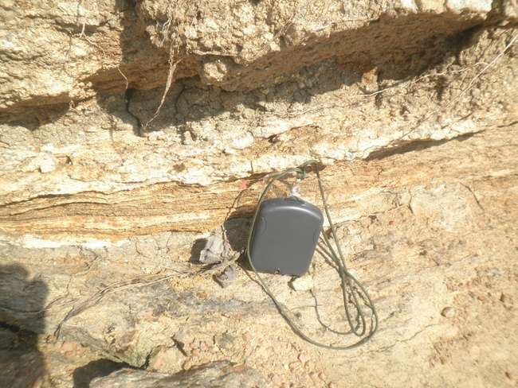
Fig. 4.18: Weathered gneiss (L27)

LOCATION 28
Coordinates; 7.2085333, 3.3360167
Weather: 34ºC, sunny
Altitude: 57m Above MSL
Outcrop name: Normal Granite
Description: A low-lying granite with very fine grained granites with predominantly mafic minerals.

LOCATION 29
Coordinates; 7.2075500, 3.3330833
Weather: 34ºC, sunny
Altitude: 42m Above MSL
Strike//Dip of foliation: 153º//39.7ºE
Outcrop name: Gneiss
Description: A low-lying migmatite- gneiss with the gnessic part being highly foliated visible foliation planes and bands(See fig.4.19) Quarts veins were also observed.
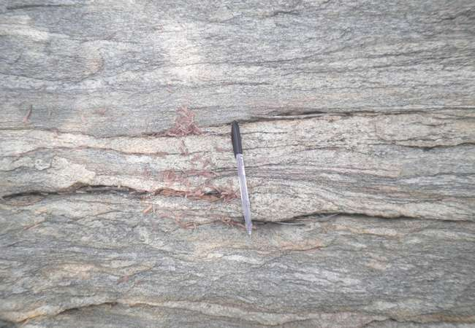
Fig. 4.19: Foliations on a gneissic outcrop (L29)

LOCATION 30
Coordinates; 7.2079500, 3.3332833
Weather: 34ºC, sunny
Altitude: 34m Above MSL
Strike//Dip of foliation: 132º//28.8ºE
Outcrop name: Gneiss
Description: A low-lying gneiss being highly foliated. Quarts veins were also observed.

LOCATION 31
Coordinates; 7.2156167, 3.3451000
Weather: 34ºC, sunny
Altitude: 58m Above MSL
Orientation of outcrop: Trending North-East
Outcrop name: Porphyritic Granite
Description: A low-lying porphyritic granite with visible large phenocrysts without preferred orientation. Quarts veins were also observed.

LOCATION 32
Coordinates; 7.2152000, 3.3423500
Weather: 34ºC, sunny
Altitude: 72m Above MSL
Orientation of foliation plane: 105^{O}//22ºE
Outcrop name: Gneiss
Description: A low-lying outcrop with visible banding and microfolds. There are also presence of joints.
LOCATION 33
Coordinates; 7.2135167, 3.3526667
Weather: 36ºC, sunny
Altitude: 102m Above MSL
Outcrop name: Porphyritic Granite
Description: A massive porphyritic granite with visible large phenocrysts without preferred orientation. Quarts veins were also observed. Some boulders with same textural features were observed around the massive outcrop.

LOCATION 34
Coordinates; 7.2101833, 3.3526000
Weather: 36ºC, sunny
Altitude: 120m Above MSL
Outcrop name: Porphyritic Granite
Description: A massive porphyritic granite with visible large phenocrysts without preferred orientation. Quarts veins were also observed.Fractures and joints were also observed on some parts of the outcrop. Some boulders with same textural features were observed around the massive outcrop.

4.1.2 GEOLOGICAL MAP OF STUDY AREA
The geologic map, which was generated from the base map with coordinates Latitdes 7º12’, 7º13’ and Longitudes 3º20’, 3º21 as shown in figure ’4.20 below.shows that the massive porphyritic granite occupies the eastern part of the map covering about half of the entire map while the western part of the map is characterized by mostly low lying fine-grained granites with gneissic outcrops in few outcrops towards the boundry of the map.
Some of the notable structural features in the study areas are quartz veins, foliations, faults, fractures, zenoliths etc which are later explained in detail below with pictural displays.
The outcrops are generally trending NW-SE direction as shown in the rose diagram for foliation planes orientation (Fig,4.21 )dipping East.

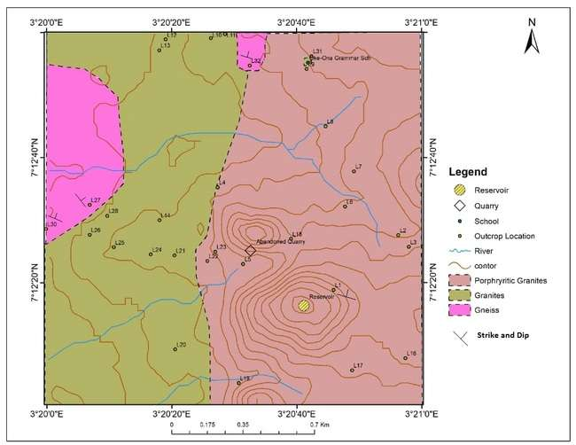
Fig.4.20 : Digitized Geological map of the study area
Fig. 4.21: General trend of outcrop’s orientatation of the study area
4.1.3 MINERAL COMPOSITION
Most of the minerals present within the rocks units are majorly feldspar, quartz and micas as characteristic of most igneous rocks, from the observations made on outcrops from all the outcrop locations visited. The micas observed from the outcrrops are predominathly biotite (datk colored) on the porphiritic granites, normal graites and gneiss. Muscovite (light coloured) were observed in weathered gneiss with characteristic luster under sunlight.
4.1.4 TEXTURES
Porphyritic textures (large grain phenocrysts within a background of fine grained matrix) make up the fabric of the granitic intrusions .The presence of xeoliths were also pronounced in most of the porphiritic granites observed. Moreover,it was observed that most of the phenocryts are elonagated or stretched (suggesting a porphyroblastic texture) in an approximately north-west/south-east direction.(Fig.4.21.)This phenomena is possibly due to response of the minerals to increase in temperature and pressure caused possibly due to low grade or partial matermorphism at the contacts between the intrusive granitic bodies and the fine grain granitic xenolith .

4.1.5 STRUCTURAL FEATURES;
Some of the structural features observed on the outcrops within the study area are foliations, veins, fractures, faults and microfolds.
Foliations; the foliations (Figure 4.22) were observed in some locations to have well foliated planes, while in some locations have not well-defined foliation planes. The foliations appear as banded alternation of white and dark minerals in some locations while in some places are not. Most of the foliations are within the migmatite and gneiss with some occurring as xenoliths within the porphyritic granitic intrusions( Fig.4.23). Most of the foliation planes observed trend approximately north-west/south-east while they dip east (see rose diagram in Figure 4.21)
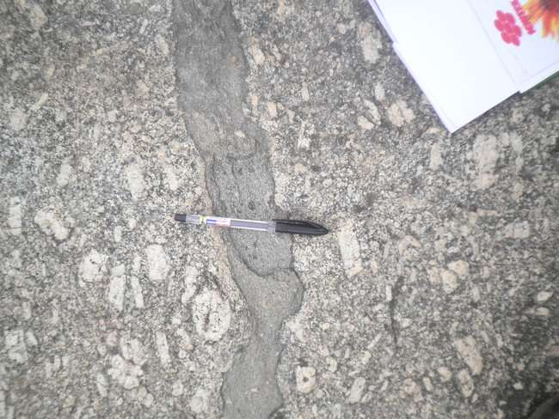
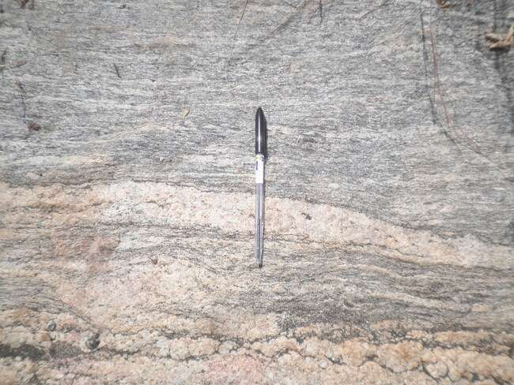

Fig.4.22 Foliation Fig. 4.23 Trend direction of xenolith

Veins; Most of the veins (Figure 4.6) are characterized by quartz and felspar and were majorly observed to strike in a north East direction. Several veins were observed within the low-lying outcrops. Some veins are of relatively large sizes while some are small. The length of the veins was also observed to vary across the outcrops. Some were observed to have shorter lengths were some veins observed to have longer lengths across the outcrops.

Folds; microfolds were observed on some of the low-lying outcrops (Figure 4.24). In some cases, the one of the axes of the fold of a major fold was observed as well.
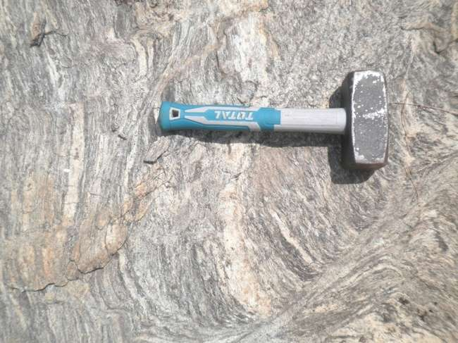

Fig. 4.24: Microfolding

4.2 DISCUSSION
4.2.1 Rock types;
The rock types within the study area are basically porphyritic granitic intrusions, normal(fine-grained) granites and Gneiss The massive/ hilly rocks are predominantly or entirely Porphyritic granite in nature. The phenocrysts of the porphyritic texture in some areas are stretched/elongated especially in regions close to the intrusions. Xenoliths observed on the porphiritic granites occur as fine grain granites(Fig.4.25), suggesting the presence of pre existing fine granites before the intrusion of the porphiritic granites.
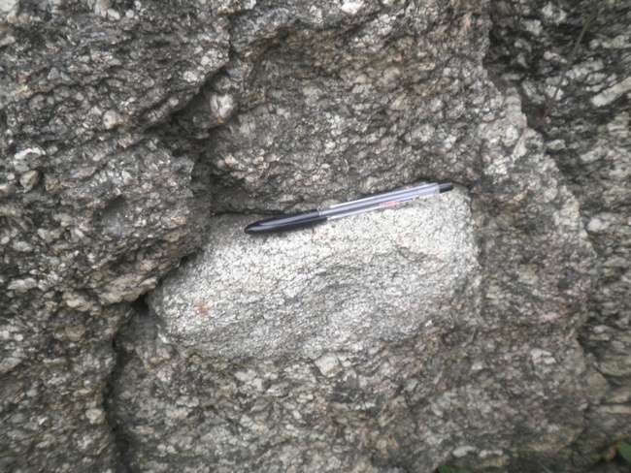
Fig.4.25 Fine grain xeolith emplaced within a porphyritic granite
4.2.2 Structural Features
Most of the structural features i.e. veins, xenoliths, foliations, faults and folds observed on the outcrops are an indication that the different rock types in the area have undergone different stages of stresses caused most likely by the pan African orogenic events that has affected the basement rocks in Nigeria. Most of the veins averagely strike in a North-east direction. The fractures and faults within the subsurface would give a better clue for groundwater aquifers in the study area.
4.2.3 Geologic History
The history of the study area possibly suggests the parent rock in the area as normal (fine grained) granites, which was later intruded by porphyritic granites. The partial or low-grade metamorphism that has affected the rocks mostly related to the orogenic activity that also possibly led to the formation of the intrusive features. This orogenic event is most likely the Pan African Orogeny which occurred about 600 million years ago.
The gneissic area suggests the occurrence of a high grade metamorphism prevalent over the pre existing granitic rock.
The outcrops’ general orientation is along NE-SW direction, dipping east (Fig.4.21)

5.0 CONCLUSION AND RECOMMENDATION
5.1 Conclusion
The study area is mainly made up of porphyritic granites, normal granites with some area around the boundary to the west made of Gneiss(Figure 4.20) Some of the rocks occur as hilly massive bodies and some are low-lying.
The rocks of the study area are mainly composed of quartz, feldspar and mica (biotite and muscovite)
The study area is characterized by structural features such as foliations, quarts veins, fractures, wrap, granitic xeoliths within porhyritic granites.
The outcrops of the study area majorly trend in the NW-SE direction dipping East.
5.2 Recommendation
Some of the massive outcrops can be harnessed for quarry to boost the economy of the state
Some massive, high outcrops can be developed and beautified for tourist attractions or relaxation centres.
Knowing the direction of strike of the outcrops and foliation orientation will guide when adopting geophysical techniques for mineral exploration in the study area.

REFERENCES
Akanni, C. O. (1992). Relief, drainage, soil and climate of Ogun state in maps (pp 6-20). In Onakomaiya, S. O., Oyesiku, O. O., & Jegede, F. J. (Eds.), Published by Rex Charles publication
Badmus B.S. and O. B. Olatinsu O.B.,2009, Geoelectric mapping and characterization of limestone
deposits of Ewekoro formation, southwestern Nigeria Journal of Geology and Mining Research Vol. 1(1) pp. 008-018 March, 2009 Available online http://www.academicjournals.org/jgmr
Black R (1980) Precambrian of West Africa. Episodes 4:3–8
Brownfield M.E and Charpentier R.R, 2006 Geology and Total Petroleum Systems of the Gulf of Guinea Province of West Africa: U.S Geological Survey Bulletin 2207-C -2006 32p
Elueze A.A.,1982, Geochemistry of the Ilesha granite-gneiss in the Basement complex of the Sothwestern Nigeria. Precambrian Res., 19, pp.167-177
Falconer JD (1911) The geology and geography of Northern Nigeria. Macmillan, London, 135pp
Lar UA, Bata TP, Dibal HU, Daspan RI, Isah LC, Fube AA, Bassi DA (2018) Field, petrographic and geochemical studies of basement, clastic and carbonate petroleum reservoirs in The Northern Benue Trough, Nigeria. Pet Technol Dev J 8(2):36–52
Obaje, N.G. (2009) Geology and Mineral Resources of Nigeria. Springer, Dordrecht Heidelberg London New York, 221 p.
Olurin Oluwaseun T.1, Ganiyu Saheed A. , Hammed Olaide S. and Aluko Taiwo J.(2016)Interpretation of aeromagnetic data over Abeokuta and its environs, Southwest Nigeria, using spectral analysis (Fourier transform technique) Original scientific paper,DOI: 10.1515/rmzmag-2016-0018 pp.199
Petters,S.W. Palaeontographica Abt A 179,1 (1982).
Rahaman M.A. (1976). Review of the basement geology of South-Western Nigeria. In: Kogbe CA (ed) Geology of Nigeria, 2nd ed., Elizabethan Publishers, Lagos, pp. 41–58
Rahaman MA and Ocan O (1978). On relationships in the Precambrian Migmatite-gneisses of Nigeria. Niger J Min Geol 15: 23–32.
Rahman A.M.S., Ekwere S.J., Azmatullah M., and Ukpong E.E. (1988) Petrology and geochemistry of granitic intrusive rocks from the west- ern part of Oban Massif, Southeastern Nigeria [J]. Journal of African Earth Sciences. 7, 149–157.
Soller, D. R., 2002, Digital Mapping Techniques '02-Workshop Proceedings, USGS Open-file Report. 02-370.
Woakes M, Rahaman MA, Ajibade AC. 1987. Some metal- logenetic features of the Nigerian basement. J Afr Earth Sci. 6:54–6
https://www.colorado.edu/geologicalsciences/research/petrology-mineralogy
https://www.sciencedirect.com/book/9780124081338/introduction-to-mineralogy-and-petrology
https://www.geographynotes.com/rocks/folds/folds-meaning-parts-and-causes-rocks-geology/5654

