Effect of Short-Term Task-Oriented Rehabilitation on Pain and Disability in Post-Fracture Upper-Limb Malunion: A Single-Group Pre–Post Interventional Study

Authors:
Vedanti Bhure¹, Khushi Gelda², Rajas Mudey³, Pratiksha Sayam⁴, Harshada Wasade⁵, Asavari Barshikar⁶

Affiliations:
¹Department of Musculoskeletal Physiotherapy, Datta Meghe College of Physiotherapy, Nagpur, Maharashtra, India
² Department of Musculoskeletal Physiotherapy, Datta Meghe College of Physiotherapy, Nagpur, Maharashtra, India
³ Department of Musculoskeletal Physiotherapy, Datta Meghe College of Physiotherapy, Nagpur, Maharashtra, India
⁴ Department of Musculoskeletal Physiotherapy, Datta Meghe College of Physiotherapy, Nagpur, Maharashtra, India
⁵ Department of Musculoskeletal Physiotherapy, Datta Meghe College of Physiotherapy, Nagpur, Maharashtra, India
⁶ Department of Musculoskeletal Physiotherapy, Datta Meghe College of Physiotherapy, Nagpur, Maharashtra, India

Corresponding Author:
Vedanti Bhure^{1*}
Email Id: vedantibhure06@gmail.com

Orchid ID: 0009-0008-4757-5107
Contact No: +919730267586

ABSTRACT
Background
Upper-limb fracture malunion is a common musculoskeletal complication resulting in persistent pain, altered biomechanics, restricted mobility, and functional disability. Conventional physiotherapy commonly emphasizes range of motion and muscle strengthening but may inadequately address functional performance required for daily activities. Task-oriented rehabilitation, based on motor learning principles, emphasizes repetitive, goal-directed functional tasks and may enhance functional recovery.
Objective
To evaluate the effect of short-term task-oriented rehabilitation on disability and pain in individuals with post-fracture upper-limb malunion.
Methods
A single-group pre–post interventional study was conducted on 20 participants aged 18–60 years with upper-limb fracture malunion of ≥3 months duration. Participants underwent a structured 2-week task-oriented rehabilitation program consisting of 45-minute sessions, three times per week. Disability was assessed using the Disabilities of the Arm, Shoulder and Hand (DASH) questionnaire, and pain intensity was measured using the Visual Analog Scale (VAS). Pre- and post-intervention outcomes were analysed using the paired t-test, with the level of significance set at p < 0.05.
Results
Results: DASH scores improved significantly from 52.3 ± 8.7 to 34.6 ± 7.5 (p < 0.001). VAS scores reduced from 6.1 ± 1.2 to 3.2 ± 1.0 (p < 0.001).
Conclusion
Short-term task-oriented rehabilitation significantly reduces disability and pain in individuals with post-fracture upper-limb malunion and may serve as an effective clinical approach for improving functional performance and independence.
Keywords: Upper-limb malunion; Task-oriented rehabilitation; Disability; Pain; DASH; VAS.

INTRODUCTION
Upper-limb fractures are among the most common musculoskeletal injuries and may lead to long-term functional impairment when healing occurs with malalignment¹. Post-fracture upper-limb malunion alters normal joint biomechanics, causing persistent pain, restricted mobility, muscle imbalance, and functional impairment that have a major impact on daily activities and quality of life^{1,2}.
Pain and disability from upper-limb malunion are driven not only by structural deformity, but also by impaired neuromuscular control and compensatory movement patterns³. Prolonged pain and disuse can cause sensory dysfunction and alterations in motor control, impeding functional recovery^{3,4}.
Conventional physiotherapy following upper-limb fractures commonly focuses on improving range of motion and muscle strength⁴. However, improvement in these impairments does not always translate into meaningful functional performance in daily activities, highlighting the need for rehabilitation approaches that emphasize functional task execution⁶.
Task-oriented rehabilitation is based on motor learning and neuroplasticity principles, with a focus on repeated, goal-directed, and context-specific functional task practice. This method has shown promise in improving functional results by improving motor control and encouraging experience-dependent brain plasticity^{7,10}. While task-oriented training is well established in neurological rehabilitation, its use in people with post-fracture upper-limb malunion is understudied¹⁰.
Therefore, the present study aimed to evaluate the effect of short-term task-oriented rehabilitation on disability and pain in individuals with post-fracture upper-limb malunion using a single-group pre–post interventional study design. Understanding the impact of this intervention may help physiotherapists adopt evidence-based, function-oriented rehabilitation strategies to improve patient outcomes and functional independence.
METHODOLOGY
This study adopted a single-group pre–post interventional study design to evaluate the effect of short-term task-oriented rehabilitation on disability and pain in individuals with post-fracture upper-limb malunion. The study was conducted in the Department of Musculoskeletal Physiotherapy, Datta Meghe College of Physiotherapy, Nagpur, after obtaining approval from the Institutional Ethics Committee. Written informed consent was obtained from all participants prior to enrolment.
Twenty participants aged 18–60 years with clinically and radiologically confirmed upper-limb fracture malunion of at least three months’ duration were recruited using convenience sampling. Participants with persistent pain and functional limitation of the affected upper limb were included. Individuals with recent fracture fixation or corrective surgery within the past three months, neurological disorders affecting upper-limb function, severe osteoarthritis, inflammatory joint disease, cognitive impairment, or unstable medical conditions were excluded.
Baseline assessment was performed prior to the intervention. Upper-limb disability was assessed using the Disabilities of the Arm, Shoulder and Hand (DASH) questionnaire, a validated self-reported outcome measure, while pain intensity was assessed using the Visual Analog Scale (VAS). All assessments were conducted by the same investigator to minimize measurement bias.
Participants then underwent a structured task-oriented rehabilitation program for two weeks. The intervention was administered three times per week, with each session lasting 45 minutes. The program focused on repetitive, goal-directed functional tasks simulating activities of daily living, including reaching, grasping, lifting, carrying, pouring, and fine motor activities. Task difficulty was progressively increased based on individual performance, following motor learning principles such as task specificity, repetition, and functional relevance. Verbal feedback was provided to facilitate optimal movement patterns.
Post-intervention assessment was conducted at the end of the two-week program using the same outcome measures. Data were analysed using descriptive and inferential statistics. Continuous variables were expressed as mean and standard deviation. Pre- and post-intervention scores were compared using the paired t-test, with the level of significance set at p < 0.05.
RESULTS
A total of 20 participants completed the study, and all were included in the final analysis. No adverse events were reported during the intervention period. Descriptive and inferential statistics were used to analyse pre- and post-intervention outcomes related to disability and pain.
Upper-limb disability, measured using the Disabilities of the Arm, Shoulder and Hand (DASH) questionnaire, showed a statistically significant improvement following the task-oriented rehabilitation program. The mean DASH score decreased from 52.3 ± 8.7 at baseline to 34.6 ± 7.5 after the intervention. The mean difference of 17.7 points indicated a clinically meaningful reduction in disability. Paired t-test analysis revealed that this improvement was statistically significant (p < 0.001).
Pain intensity assessed using the Visual Analog Scale (VAS) also demonstrated a significant reduction following the intervention. The mean VAS score decreased from 6.1 ± 1.2 pre-intervention to 3.2 ± 1.0 post-intervention, with a mean reduction of 2.9 points. This change was found to be statistically significant on paired t-test analysis (p < 0.001).
The magnitude of improvement observed in both outcome measures was large. Effect size analysis using Cohen’s d indicated a large treatment effect for disability (d ≈ 2.18) as well as pain reduction (d ≈ 2.63), suggesting a strong clinical impact of the task-oriented rehabilitation program.

Outcome Measure | Pre-Intervention (Mean ± SD) | Post-Intervention (Mean ± SD) | Mean Difference | p-value
DASH | 52.3 ± 8.7 | 34.6 ± 7.5 | 17.7 | <0.001*
VAS | 6.1 ± 1.2 | 3.2 ± 1.0 | 2.9 | <0.001*
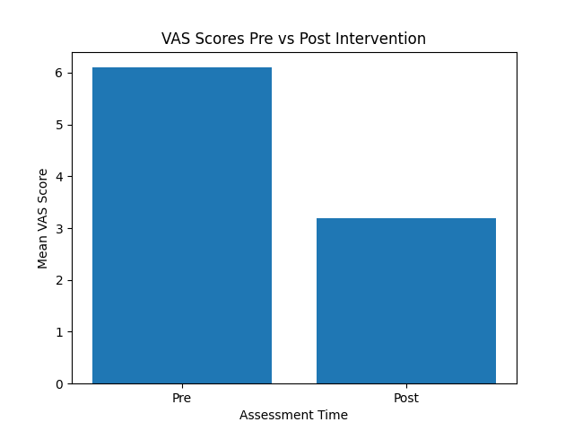
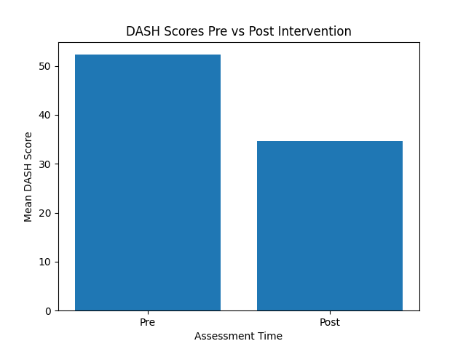

DISCUSSION
The present study investigated the effect of short-term task-oriented rehabilitation on disability and pain in individuals with post-fracture upper-limb malunion using a single-group pre–post interventional design. The findings demonstrated statistically and clinically significant improvements in both disability and pain following the intervention, supporting the effectiveness of task-oriented rehabilitation in this population.
A substantial reduction in DASH scores was observed after the two-week intervention, indicating improved upper-limb functional ability. The magnitude of change exceeded the minimal clinically important difference reported for the DASH questionnaire, suggesting that the improvement was not only statistically significant but also meaningful from a clinical perspective⁶. These findings are consistent with previous studies reporting that task-oriented training enhances functional performance by integrating strength, coordination, and motor control within context-specific activities^{11,12}.
Pain intensity, as measured by the Visual Analog Scale, also showed a significant reduction following the intervention. This improvement may be attributed to enhanced movement efficiency, reduction in compensatory muscle activity, and improved joint mechanics achieved through repetitive functional task practice^{3,5}. Additionally, task-oriented rehabilitation may contribute to central pain modulation by promoting adaptive sensorimotor integration and reducing fear-avoidance behaviour, as suggested by contemporary pain science literature⁵.
The large effect sizes observed for both disability and pain outcomes indicate a strong therapeutic impact of the intervention. Unlike conventional impairment-based rehabilitation, task-oriented training directly targets functional limitations relevant to daily activities, thereby facilitating better carryover to real-life situations⁷. This approach aligns with motor learning principles that emphasize task specificity, repetition, and functional relevance as key determinants of successful skill acquisition and retention¹⁰.
Overall, the findings of the present study suggest that short-term task-oriented rehabilitation is an effective and practical intervention for reducing disability and pain in individuals with post-fracture upper-limb malunion and may be beneficial in routine musculoskeletal physiotherapy practice.
CONCLUSION
Short-term task-oriented rehabilitation was found to be effective in reducing disability and pain in individuals with post-fracture upper-limb malunion. The intervention led to clinically meaningful improvements in functional performance and pain intensity, highlighting the value of function-based rehabilitation strategies.
Limitations
The absence of a control group, small sample size, short intervention duration, and lack of long-term follow-up limit the generalizability and causal interpretation of the study findings.
Future recommendations
Future research should include randomized controlled trials with larger sample sizes and long-term follow-up to confirm the effectiveness and sustainability of task-oriented rehabilitation. Comparative studies with conventional physiotherapy and inclusion of quality-of-life outcomes are also recommended.
REFERENCES
- Grewal R, MacDermid JC. The risk of adverse outcomes in distal radius fractures with malalignment. J Hand Surg Am. 2011;36(6):1039–1046.
- Ring D, Jupiter JB. Treatment of malunion and nonunion of the upper extremity. Hand Clin. 2013;29(4):509–519.
- Hodges PW, Tucker K. Moving differently in pain: A new theory to explain the adaptation to pain. Pain. 2011;152(3 Suppl):S90–S98.
- Tsao H, Galea MP, Hodges PW. Reorganization of the motor cortex is associated with postural control deficits in recurrent low back pain. J Orthop Sports Phys Ther. 2015;45(9):689–697.
- Moseley GL, Flor H. Targeting cortical representations in the treatment of chronic pain: A review. Pain. 2012;153(7):1148–1158.
- Kamper SJ, Apeldoorn AT, Chiarotto A, Smeets RJ, Ostelo RW, Guzman J, et al. Multidisciplinary biopsychosocial rehabilitation for chronic low back pain. Br J Sports Med. 2015;49(15):965–972.
- Kleim JA, Jones TA. Principles of experience-dependent neural plasticity: Implications for rehabilitation after brain damage. J Speech Lang Hear Res. 2008;51(1):S225–S239.
- Winstein CJ, Stein J, Arena R, Bates B, Cherney LR, Cramer SC, et al. Guidelines for adult stroke rehabilitation and recovery. Stroke. 2016;47(6):e98–e169.
- French B, Thomas LH, Coupe J, McMahon NE, Connell L, Harrison J, et al. Repetitive task training for improving functional ability after stroke. Cochrane Database Syst Rev. 2016;(11):CD006073.
- Shumway-Cook A, Woollacott MH. Motor Control: Translating Research into Clinical Practice. 5th ed. Philadelphia: Lippincott Williams & Wilkins; 2017.
- Valdes K, Naughton N, Algar L. Patient-centered goal setting in hand therapy: A critical appraisal. J Hand Ther. 2013;26(2):97–105.
- Karimi MT, Esrafilian A, Bagherzadeh Cham M. Task-oriented training in musculoskeletal rehabilitation: A systematic review. Physiother Theory Pract. 2019;35(10):929–942.
- McKee P, McDermid JC, Grewal R. Functional rehabilitation following upper limb fractures. J Orthop Sports Phys Ther. 2018;48(6):448–456.
- Michielsen ME, Selles RW, van der Geest JN, Eckhardt M, Yavuzer G, Stam HJ, et al. Motor recovery and cortical reorganization after mirror therapy in chronic stroke patients: A phase II randomized controlled trial. Neurorehabil Neural Repair. 2011;25(3):223–233.
- Page SJ, Levine P, Leonard AC. Modified constraint-induced therapy in chronic stroke: Results of a single-blinded randomized controlled trial. Phys Ther. 2008;88(3):333–340.
- Moseley AM, Herbert RD, Sherrington C, Maher CG. Evidence for physiotherapy practice: A survey of the Physiotherapy Evidence Database (PEDro). Aust J Physiother. 2002;48(1):43–49.
- Bekkering GE, Hendriks HJ, van Tulder MW, Knol DL, Oostendorp RA, Ostelo RW. Prognostic factors for low back pain disability. Pain. 2003;102(1–2):115–123.
- van Vliet PM, Wulf G. Extrinsic feedback for motor learning after stroke: What is the evidence? Disabil Rehabil. 2006;28(13–14):831–840.
- Bohannon RW, Andrews AW. Rehabilitation outcomes following upper-extremity fracture. J Orthop Sports Phys Ther. 2011;41(10):734–739

