Enhancing Learners’ Autonomy and Engagement in Personalized Learning Approach in Social Studies Classes in Batangas City Private Schools

ABSTRACT
Student’s autonomy and engagement have been the center of topic when it comes to improving pedagogy. Educators employed technology integration, competency-based progression, and flexibility of learning environment under personalized learning approach. However, there was a moderate level of exposure in personalized learning, and a moderate manifestation of autonomy and engagement in teaching Understanding Culture Society and Politics (UCSP).
To address this research gap, a study aimed to create a learning plan for Batangas City private schools, enhancing their autonomy and engagement. The objectives included assessing the level of exposure in personalized learning relative to technology integration, competency-based progression, and flexibility of learning environment, determining respondent’s extent of manifestation of autonomy and engagement, testing significant relationship, identifying respondent’s problems and challenges, and creating a learning plan. The study used a mixed method with explanatory sequential approach, involving 285 Senior High School (SHS) students from Batangas City Private Schools, with five SHS students as their school’s representative for focus group discussion (FGD).
Data collection included survey-questionnaires and focus group discussion analyzed using statistical tools such as Weighted Mean, Standard Deviation, Pearson’s Correlations, and Thematic Analysis. Findings revealed a moderate exposure to personalized learning and significantly related, indicating personalized learning approach has positively related in enhancing autonomy and engagement. Despite the advantages of personalized learning approach, learners experienced problems and challenges such as limited alternative assessment options, activities not aligned with strengths and preferences, broad coverage of topics, hesitation and low academic confidence, digital distraction, etc. The personalized learning plan outlined learning objectives, topic, learning strategies, goal, resources, timeline, and assessment.
Keywords: Personalized Learning Approach, Understanding Culture Society and Politics, Autonomy, Engagement
INTRODUCTION
Education serves as a foundation for societal progress which plays a significant role in the development of an individual, community, and nation. It gives a paradigm of how education interplays in each sector of society. In the Philippines, a learner must take an education from pre-elementary to college to achieve the societal standards, so, learning must be beyond what skills and knowledge are taught in the four-corners of the classroom. As education progresses, shifting to student-centered is important as they discover more about themselves while they are in the learning process. Under the Enhanced Basic Education Act of 2013 (Republic Act No. 10533) mandates that a learner-centered curriculum should foster critical thinking, creativity, and engagement.
Engagement is the totality of an individual to respond, react, and interact among others. Students’ engagement is vital in the process of learning and teaching where it creates student involvement, autonomous learning, and enhances critical thinking skills. However, when engagement is lacking, students may struggle to absorb content, lose interest in academic tasks, and ultimately perform poorly in assessments. Despite the importance of student engagement and autonomy, the Department of Education (DepEd) Region IV-A in the School Year 2023-2024 National Achievement Test (NAT) result of Batangas City Private Senior High School performance in learning area in Social Science exhibited 58.03 mean percentage score (MPS) which is against the national standard of acceptable MPS of 75%. This alarming data reflects a significant gap not only in content mastery but also in students’ active participation and interest in Social Studies, highlighting the urgent need to strengthen autonomy and engagement strategies in the classroom. Additionally, according to the Programme for International Student Assessment (PISA) 2022, approximately around 50% of students across OECD (Organisation for Economic Co-operation and Development) countries reported struggling to motivate themselves to complete school works at least once a week and only approximately 60% of students expressed confidence in their ability to motivate themselves to learn independently, in which students struggle in self-regulation and autonomous learning. The findings reflected the persistent challenges in learner autonomy, engagement, motivation, and self-regulation in contemporary education.
The importance of addressing these challenges has been associated with Self-determination theory developed by Ryan and Deci (2020) in which learners are more likely to engaged and intrinsically motivated when their needs for autonomy, competence and relatedness are supported. Thus, when students are given the opportunity for meaningful choices, self-direction, and the sense of belongingness tend to demonstrate higher engagement and academic achievement. Likewise, Self-regulated Learning Theory by Zimmerman (2002) emphasizes that students take an active role to plan, monitor, and evaluate their own learning process in which the students take part of setting their learning goals, employ appropriate learning strategies, and adjust to improve academic performance. Hence, the need to foster students to take ownership of their learning experiences in contemporary education, particularly in social studies classes.
Social Studies is a group of school subjects aimed at developing primarily the understanding of society and social relations in students at the elementary and secondary level. In the Philippines, one of the social studies subjects of senior high school student is Understanding Culture Society and Politics (UCSP) where it promotes to deepen the understanding of cultural diversity of the people. In spite of being an interesting subject, the study revealed that learners are disinterested in Social Studies which impacts lack of motivation to learn, unable to finish subject activities and tasks, limited participation during class discussions (Cosme, 2019). Additionally, majority of students find social studies a boring subject. (Crisolo et al. 2021). Consequently, there is no single mode of teaching which learners are expected to learn the same content at the same pace and through similar instructional methods. While such approach promotes uniformity, it frequently overlooks individual differences in learning preferences, styles, interest, needs, and skills. As contemporary classrooms become increasingly diverse, there is a need for instructional approach that provides flexibility, meaningful and relevant to learners’ experiences.
Moreover, private schools in Batangas City enjoy a peculiarly distinctive advantage in terms of access to resources and technologies that can help realize the power of personalized learning approach. What is somewhat relatively underexplored is the extent to which these schools have implemented such personalized learning strategies, together with its impact on learners' autonomy and engagement. Although the literature on personalized learning is increasingly prominent, there are specific gaps this research needs to address. First, most of the existing studies have discussed the generalized effects of personalized learning across different subjects and educational levels. Second, there is a dearth of localized research on personalized learning in the context Batangas City private schools. Lastly, as an educator who observes that twenty-first century learners have different learning needs, preferences, styles, interests, and skills, a new learning approach must be considered. Thus, personalized learning approach fits the necessary student needs to understand the subject. Understanding Culture, Society and Politics (UCSP) provides a suitable context for personalized learning approach because of its content linked to cultural identities, political concepts and social realities that encourages the learners to connect with their lived experiences. Personalized learning enables students to relate complex concepts with their real-life experiences and situations that promote active engagement in UCSP instruction.

To address these challenges, education sector needed to improve the student-centered approach and incorporate innovative teaching strategies that engaged students and fostered deeper connection with the subject. Research emphasized that personalized learning could enhance engagement and autonomy by providing learners with content tailored to their interests and needs. This can increase their motivation to learn, autonomous learning leading to a more enjoyable and fulfilling learning experience (Evanick, 2023). Given these considerations, this study, in general, was conducted to enhance learners’ autonomy and engagement in personalized learning approach in Social Studies Classes in Batangas City Private Schools.
METHODOLOGY
Research design
This study utilized mixed method explanatory sequential as a research design. This design is deemed to be the most appropriate in this study as it allows for the systematic collection and analysis of both quantitative and qualitative data to describe the current state of personalized learning approach among respondents. The mixed method explanatory sequential research design is particularly suitable for assessing the learner’s exposure and identifying the problems and challenges in personalized learning experiences. As defined by Creswell & Creswell (2018) this design involves initially gathering and analyzing quantitative data and followed by the collection and analysis of qualitative data collection and analysis to further explain and deepen the quantitative findings. By doing this, the quantitative data serve as the basis for developing the focus group discussion (FGD) guide. The qualitative phase enabled the researcher to gain deeper insights into the reasons of quantitative results by identifying the learner’s experiences, problems and challenges in personalized learning in Social Studies classes.
Subject of the study
This consisted of Senior High School (SHS) students in Batangas City private schools who are enrolled in the core subject of Understanding Culture Society and Politics (UCSP). The table below shows the distribution of respondents in Batangas City private schools.
Table 1. Distribution of Respondents in Batangas City Private Schools
Private Schools in Batangas City | No. of Population | Total number of respondents
School A  School B  School C  School D  School E  School F | 402  106  471  61  20  41 | 104  27  122  16  5  11
Total | 1101 | 285
To determine the sample population of Senior High School students in Batangas City private schools, the study used Raosoft sample size calculator, identifying two-hundred eighty-five students from these schools as the respondents in survey-questionnaire. The study employed stratified proportionate sampling to ensure adequate representation of students from all participating schools. This technique was utilized to ensure that every student in the population had an equal and unbiased chance of being selected as a respondent. Additionally, six respondents were initially identified in focus group discussion (FGD), however, only five were able to participate in FGD due the non-approval of one participant’s school. These respondents were chosen through purposive sampling because they represented the key variations in the survey-questionnaire results, allowing the researcher to gain deeper understanding of quantitative results, and their ability to provide rich and meaningful insights regarding their experiences with autonomy and engagement in personalized learning approach in Social Studies classes particularly in the UCSP subject.
Data Gathering Instruments
The study used a survey questionnaire and focus group discussion as a data gathering instrument. The researcher used a research-made questionnaire that served to gather the necessary information about the level of exposure of students in personalized learning relative to technology integration, competency-based progression and flexibility of learning environment and the extent of manifestation of personalized learning relative to learners’ autonomy, and learners’ engagement. On the other hand, focus group discussion was used in determining the problems and challenges of learners in personalized learning.
Validation and Reliability of the Instrument
The research instrument was evaluated by experts in terms of clarity, relevance, and alignment with the objectives of the study. It underwent validation by three (3) panel members and three (3) subject-matter experts, who provided comments and suggestions that were carefully reviewed and incorporated into the improved version of the instrument. After integrating all recommendations, it was presented to the chairman and adviser for the approval to reproduce the questionnaire and was subsequently recommended for administration.
Pilot testing follows, and the instrument was subjected to a reliability test with the aid of Cronbach’s Alpha to ensure the reliability and internal consistency of the instrument prior to its final administration. Golden Key Integrated School of St. Joseph Inc. and St. Paul School of San Jose Batangas Inc. were subjected for pilot test. The questionnaire consisting of 80 items was subjected to reliability testing using Cronbach’s Alpha. The results revealed Cronbach’s Alpha coefficient of 0.938 for the responses of 30 students, interpreted as excellent reliability. Since the minimum acceptable value of Cronbach’s Alpha is 0.70, the results indicate that the responses were reliable and that the questionnaire items were appropriate for utilization. These findings justified the final administration of the research instrument.
Ethical Considerations
The study adhered to the following ethical guidelines throughout the research process to uphold and protect the dignity and well-being of the students. The researcher adhered to high standards of ethical considerations in pursuit of the research objectives, in full compliance with the Data Privacy Act of 2012, ensuring the protection and responsible handling of all personal information collected. Since Senior High School students were minors, parental consent was secured prior to their participation in the study. Participation in the study was entirely voluntary, and the identities of the respondents were not revealed in any portion of the manuscript. All data gathered were treated with the utmost confidentiality.
Furthermore, the students’ knowledge, perspectives, and experiences were neither used against them nor disclosed for purposes other than this study during or after the research period. Access to the tabulated data was limited solely to the researcher and the statistician. No identifying information regarding the respondents or their respective schools was disclosed in the presentation of the results. In addition, the transcription and video recordings were accessible only to the researcher, ensuring that all qualitative data sources remained confidential and securely handled during and after the research period.
RESULTS AND DISCUSSION
1. Level of Exposure of Students in Personalized Learning Approach in Social Studies Classes
Table 1. Level of Exposure of Students in Personalized Learning Approach Relative to Technology Integration
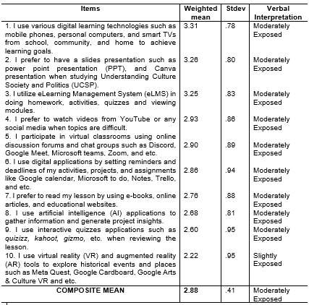
The data revealed that most of the respondents are moderately exposed to personalized learning approach in social studies relative to technology integration. This implies that majority of the students are moderately exposed to the use of various digital learning technologies such as mobile phones, personal computers, and smart TVs from school, community, and home to achieve learning goals. Since most of the respondents were born into digital native where technologies surrounded them and literally, they used it in their learning process. With the help of various digital learning technologies, it promotes ease of access to educational resources. However, inconsistent use of different digital learning technologies indicates lacking technology-assisted learning and limited technological access that hinder the inconsistence of technology integration. Further, among all the indicators of students’ level of exposure in personalized approach in relation to technology integration, respondents are slightly exposed to use virtual reality (VR) and augmented reality (AR) tools to explore historical events and places such as Meta Quest, Google Cardboard, Google Arts & Culture VR and etc. This suggests that while advanced immersive digital learning technologies are available, their integration in UCSP subject is limited. The slight exposure of students in virtual reality (VR) and augmented reality (AR) can be indicated some factors such as lack of virtual and augmented reality teaching aid, lack of teachers’ training, lack of curriculum integration, and poor internet connectivity. Despite their potential to provide interactive and engaging learning experiences it hinders the complexity to integrate in teaching and learning process. In the study of Fauzi et. al (2023), the findings implied the need to train and familiarize the educators in using VR for continuously the intention to use it. It is highlighted that when more teachers are deeply knowledgeable in VR, the more students benefit regardless of if the classes are online or otherwise. Incorporating AR and VR in teaching cultural, social and political aspects, especially the historical landmarks have added student’s excitement to participate in the class.
Table 2. Level of Exposure of Students in Personalized Learning Approach Relative to Competency-based Progression
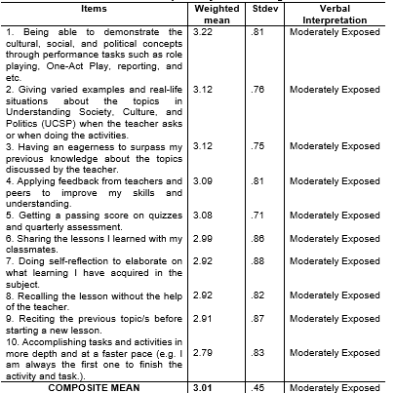
The data revealed that majority of the students are moderately exposed in being able to demonstrate the cultural, social, and political concepts through performance tasks such as role playing, One-Act Play, reporting, and etc. This suggests that most of the Batangas City private schools followed engaging and collaborative tasks that students exhibit to see the required knowledge and skills in UCSP. Students are not only engaging in theoretical concepts but rather capable of demonstrating cultural, social and political concepts in an authentic way. These performance tasks allow students to express the concepts, show diverse views, and connect in a real-life situation taken from the UCSP subject. This finding aligns with the study of Le et. al (2014) which students showed evidence of mastery through task performance rather than based on traditional assessment like quizzes. When students internalize the key concepts of culture, society and politics and apply it on themselves, personalized learning achieved. Therefore, the student’s ability to perform in achieving competencies set by UCSP subject known to have simulation to foster mastery of learning.
Furthermore, respondents have moderate exposure in accomplishing tasks and activities in more depth and at a faster pace. This suggests that students have an average in completing a task and have a moderate depth of analysis in understanding the topics on cultural, social and political aspects. Student critical thinking skills are being developed but not yet consistently applied across tasks and activities for the possible reasons of limited options in task and activities, inconsistent self-regulated learning, and lack of teacher’s feedback that could enhance learning pacing. In the findings of Mehta and Fine (2019) emphasizes that deeper learning is fostered through meaningful, authentic tasks that require critical thinking, collaboration, and application of knowledge in real-world contexts. Applying experiences promotes creative thinking and a sense of pacing skills. Through this, students were being able to achieve a higher mastery of knowledge and skills since the learning would be more personalize.
Table 3. Level of Exposure of Students in Personalized Learning Approach Relative to Flexibility of Learning Environment
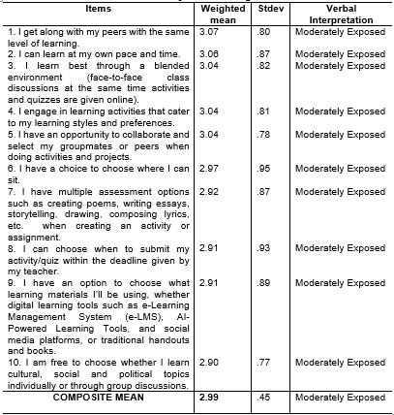
The data revealed that majority of the respondents are moderately exposed to personalized learning approach relative to flexibility learning environment. This suggests that there is a need for improvement to maximize the flexibility of their learning. Based on the data, students experienced moderate exposure in collaborative learning, self-paced learning, blended learning, and multiple assessment options. These results show opportunities for personalized learning approach exist but not yet maximized and inconsistently execute in the class. This may be caused by time constraints as teachers only follow the lesson planning pacing, lack of teacher’s training to incorporate multiple assessment options to diverse learners, and inconsistent instructional strategy. These attributions are supported in the conducted FGD where students experience limited assessment options that are struggling with activities that are not appropriate with their learning needs. In addition, this finding supports Pane et al. (2017), students who have autonomous learning, several pathways for learning, and multiple assessment aligned with their preferences and strengths has the most exhibited to effective personalized learning.
Even though, flexible learning environment paves the way for more student-centered approach to education, it is undeniable that there are some students who have moderately exposed to choose whether they learn cultural, social and political topics individually of group discussions. The moderately exposure to flexibility particularly in modes of learning may imply that students possess a traditional approach—teacher directed rather than self-directed or collaborative learning. This aligns with the findings of Liu et al. (2016), teacher-directed instruction still plays an important role to promotes autonomy and address different learning needs where scaffolding is necessary to help the students develop their self-regulation. Therefore, autonomous learning doesn’t mean removing teacher’s guidance but instead facilitating and guiding them in the learning process.
2. Respondent’s Extent of Manifestation of Personalized Learning
Table 4. Extent of Manifestation of Personalized Learning in terms of Goal Setting
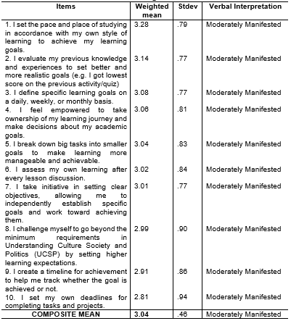
From this result, students set the pace and place of studying in accordance with their own style of learning to achieve their learning goals which has clearly a moderate manifestation. This implies that to achieve the desired learning goals of the students it must be based on their preferences that allow them to do. This finding reflects the study of Panadero & Alonso-Tapia (2016), noted that learners often rely to teachers’ schedules and classroom standards rather than making themselves to regulate their own learning pace. Consequently, while self-directed learning is emerging, it still entails further development to enhance student ownership of academic tasks. Although goal setting immensely becomes an essential skill for the students, it is often practiced in a classroom setting. As most of the respondents moderately manifested on setting their own deadlines for completing tasks and projects. It means that the respondents lack of self-imposed deadlines in their tasks and projects, it can be gleaning that students’ complete tasks and projects anytime whatever they want but not consistently in their time management. As a result, low academic output quality and reduced achievement of learning objectives. This supports from the study of Schunk and DiBenedetto (2020), emphasizing that to improved academic achievement, goal setting and time management should be systematic and consistent in the learning outcomes. Similarly, to have a better outcome and sustain motivation, students must consistently use structured planning and goal-setting technique (Aeon & Aguinis, 2017; Wolters & Brady, 2020). Thus, students must improve time management while prioritizing setting their own deadlines and completing tasks and projects simultaneously. Through this, students will maximize their potential to be autonomous in achieving a desired outcome.
Table 5. Extent of Manifestation of Personalized Learning in terms of Motivation
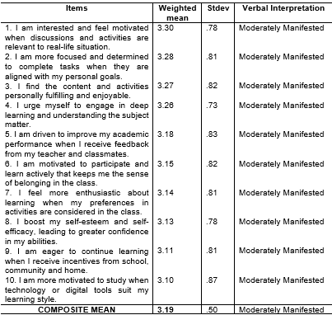
From the above table, the respondents moderately manifested the motivation in personalized learning approach. This highlights that students felt motivated when their learning preferences were prioritized in the subject of Understanding Culture Society and Politics because of this they are more driven to study in their own. Aside from this, students’ motivation came from intrinsic and extrinsic that energizes them to fulfill a task or an activity required by the course. The intrinsic motivation of the students came from their interest, confidence, and excitement to discover more about the lesson. One noteworthy study of Deci, Ryan, & Williams (1996) as cited in Almari, (2019) in Self-determination Theory highlighted that individuals are more motivated and engaged in learning when psychological needs such as competence, autonomy, and relatedness are fulfilled. While extrinsic motivation of the students came from the incentives or rewards that students can get after they achieve their learning goals. Thus, a moderate manifestation of the students in motivation in personalized learning approach should be given emphasis of the education sector to increase enthusiasm and promote independent learning.
Further, there are items in the extent of manifestation in personalized learning in terms of motivation that is the least choice of students which the students moderately manifested in I am more motivated to study when technology or digital tools suit my learning style. This highlights that the moderate level of manifestation could indicate the students recognize the use and integration of technology in enhancing their motivation but not fully maximized nor used in a classroom setting. This supports the study of Beboso & Bual (2022) highlighted the grade 12 student’s motivation and perception of learning social science are addressed when schools effectively provide and review their interactive learning strategies. Hence, interactive learning strategies play a significant role in driving student’s learning. In personalized learning, those are digital learning technologies which are helpful for the students to accomplish the task that motivates them to finish ahead of time.
Table 6. Extent of Manifestation of Personalized Learning in terms of Cognitive Engagement
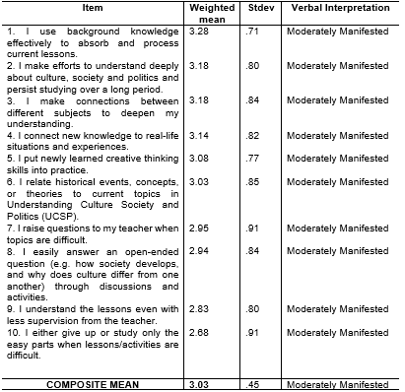
The data revealed that majority of the respondents are moderately manifested in personalized learning in terms of cognitive engagement. a moderate level of manifestation to cognitive engagement may be attributed to varying learner’s interest, limited opportunities for higher order thinking skills and lack of instructional strategies that support students background knowledge. These implications needs for intervention for lesson planning such as identifying students’ interest and fitting assessment to learning needs, so that they engage better in classroom discussions and activities. In the study of Dong, et.al (2020) showed that students with greater prior knowledge experienced lower cognitive load, which in turn allowed them to engage more deeply with learning tasks cognitively (e.g., by using effective strategies and self-regulation). Moreover, students either give up or study only the easy parts when lessons/activities are difficult and understand the lessons even with less supervision from the teacher were the lowest rated among the ten indicators which also falls to moderately manifested. This implies that students were likely to set aside those difficult tasks and much preferred the easy ones. When this happens, there is a potential decrease in cognitive engagement among the students. This supports the study of Borup et. al (2020), cognitive engagement refers to the extent to which students actively use their mental abilities in learning through activities such as paying attention, maintaining focus, asking questions, thinking critically, and solving problems.
Table 7. Extent of Manifestation of Personalized Learning in terms of Emotional Engagement
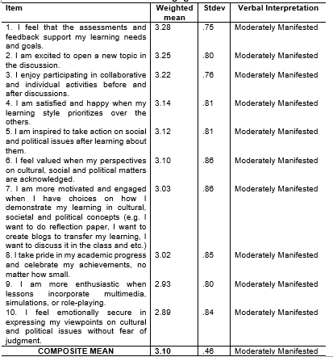
It can be gleaned from the table that the students demonstrated a moderate manifestation of personalized learning in terms of emotional engagement. Students who took the subject--Understanding Culture, Society, and Politics are emotionally inclined in the learning process, indicating that the subject matter are relevant and meaningful to their personal experiences and social contexts. Students felt that the assessments and feedback support their learning needs and goals. Parallel in the present study, Mayordomo et al. (2022) found that constructive and goal-oriented feedback promotes students’ sense of validation and support that significantly influences their emotional engagement. Although the personalized assessments and feedback support the student’s learning needs and goals it is undeniable that it is not fully manifested by them. Therefore, educators must refine and improve the implementation of personalized learning to fully maximize students’ emotional engagement in personalized contexts. Furthermore, the moderate manifestation of emotional security in expressing their viewpoints on cultural and political issues without fear of judgment points out that some students may still feel hesitant and anxious when engaging in the class, especially in a particular sensitive discussion that is opposing with their beliefs. This suggests that although students provided to voice their opinions others may not perceive a classroom with a fully safe space for expressing themselves. Thus, emotional engagement may decline and result in fear and criticism. Similarly, Kahu and Nelson (2018) noted that emotional engagement is strongly shaped by students’ perceptions of safety, belonging, and teacher support. When these conditions are weak, students’ emotional engagement tends to decline.

Table 8. Extent of Manifestation of Personalized Learning in terms of Social Engagement
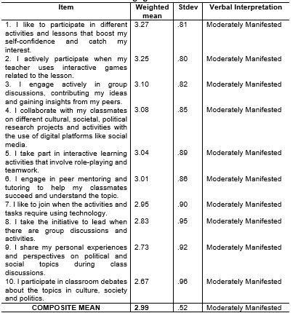
Students rated “I like to participate in different activities and lessons that boost my self-confidence and catch my interest.” as moderately manifested. a moderate manifestation may be ascribed to inconsistent varied classroom activities, difference in learner participation, and irregular use of varied instructional strategies. These implications the need to enhance student’s assessment design to accommodate individual differences. This is given emphasize in Self-determination Theory which posits that an individual’s engagement and motivation are influenced by the extent of psychological needs—autonomy. When students feel a lack of participation, thereby autonomy learning experiences may decrease and result to moderate level of participation in classroom activities and task. The study emphasized that engaging and learner-centered activities contribute to increased interest and involvement in learning tasks, thereby strengthening students’ self-confidence (Bond et al., 2020; Zainuddin & Perera, 2019). Therefore, teachers should continue the existing different activities that drive the students to be involved in the class as well as to enhance the lesson planning which directly piques the curiosity and interest of the students. Moreover, students rated “I participate in classroom debates about the topics in culture, society and politics.” and “I share my personal experiences and perspectives on political and social topics during class discussions.” as moderately manifested. This reluctance may be attributed to factors such as misunderstood by their peers, fear of judgement when their views and opinions misconstrue and differ from others, and low self-confidence in expressing their point of view. In addition, some of them may have limited prior exposure to debates and discussions in the topics of culture, society, and politics. To support this claim, empirical studies have shown that students’ fear of judgment and lack of psychological safety significantly reduce their willingness to speak during classroom discussions and debates (Bond et al., 2020; Hess, 2018). Moreover, limited opportunities for prior exposure to dialogic and debate-oriented activities hinder students’ confidence and competence in engaging with controversial social and political issues (Kahne et al., 2016).
3. Significant Relationship Between the Respondents’ Level of Exposure to Personalized Learning Approach and Manifestation of Autonomy and Engagement
Table 9. Relationship Between Level of Exposure (technology integration) and Manifestation of Autonomy and Engagement
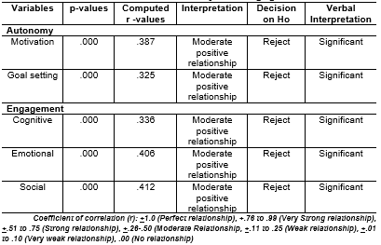
It can be gleaned from the table that there is a significant relationship between the students’ level of exposure in technology integration and manifestation of autonomy relative to motivation and goal setting. Therefore, the null hypothesis is rejected. As a result, it can be inferred that technology integration affects the students’ autonomy in motivation and goal setting because students nowadays are more into technology and always use their gadgets for a long period of time. In personalized learning approach, technology integration contributed a positive impact to the students to be motivated and achieve their goals. In this approach it utilizes a variety of technological tools to adjust instruction to each student’s unique needs and interest. Therefore, it significantly plays a positive effect in the role of learning process.
On the other hand, the level of exposure in technology integration was found to have a significant relationship to student’s engagement. This confirms that students tend to engage when technology is integrated. Consequently, their cognitive, emotional and social engagement are more likely to enhance as they are being exposed to it. Within personalized learning, engagement really matters to personalize the instruction as it indicates what level of engagement can be adjusted. This suggests that teachers, being the facilitator of the learning process, should choose the best and appropriate technological learning tools in making more engaging in the class. The use of technological learning tools should pique student’s curiosity, excites and motivates them, and allows to collaborate in the learning process. This finding is supported by the study of Schindler et al. (2017), which emphasized that the integration of educational technology is significantly linked to increased student engagement particularly in cognitive, emotional, and social participation in learning process. The study revealed that those who are in the higher education classrooms exhibited that technology-integration activities such as interactive platforms, collaborative digital tools, and multimedia resources can stimulate students’ interest, sustain motivation, and encourage active participation in learning tasks.
Table 10. Relationship Between Level of Exposure (competency-based progression) and Manifestation of Autonomy and Engagement
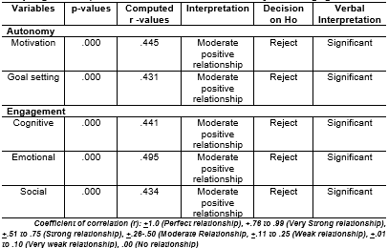
Table 10 displays the results of a moderate positive relationship between the level of exposure in competency-based progression and manifestation of autonomy and engagement in personalized learning. It indicates that there is a significant relationship between competency-based progression relative to motivation and goal setting, therefore the null hypothesis is rejected. This suggests that students who exhibited mastery of learning in understanding the context of cultural, social, and political concepts through individual and group assessments such as performance tasks, standardized assessments, relating topics from their experiences, peer tutoring, and differentiated activities—tend to feel more motivated and urge themselves in deep learning. As a result, they are more likely to take initiative in improving their academic performance and achieving their learning goals. These findings are parallel by a local study of Adlit & Adlit (2023) emphasizing the efficacy of differentiated assessment practices—which adapt instruction and assessment to meet individual student needs—promote self‑efficacy, create an inclusive classroom culture, and allow for personalized feedback and instruction. The study also highlighted that the used of competency-based progression helped support diverse learners, increased motivation, and improved understanding of UCSP concepts by addressing individual strengths and learning needs. Additionally, personalized instructional practices such as differentiated assessments and tailored feedback were perceived to enhance student engagement and learning outcomes in social studies education.
Further, a moderate positive relationship between the level of exposure in competency-based progression relative to cognitive, emotional, and social engagement was significantly related, hence, null hypothesis is rejected. Indicating that when students demonstrate the targeted knowledge and skills that focus to mastery and performance goals tend to increase student’s engagement in the teaching-learning process. Therefore, they can advance their mastery of learning in a specific topic. This finding suggests that it is needed to continue and improve the suitable competency assessment based on the student’s learning needs and goals. One of the notable competency assessment based from a local study of Soriano et al. (2024) found that when student’s cultural practices and personal experiences are highlighted in the teaching of Understanding Culture, Society and Politics (UCSP), their academic performance and engagement tends to improve. Within personalized learning, integrating student’s individual contexts and personal experiences into UCSP can strengthen cognitive, emotional, and social engagement by making learning more relevant and meaningful to their everyday lives.
Table 11. Relationship Between Level of Exposure (flexibility of learning environment) and Manifestation of Autonomy and Engagement
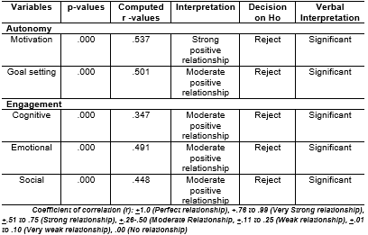
Table 11 presents the relationship between level of exposure in flexibility of learning environment and manifestation of autonomy and engagement in personalized learning approach. The results revealed that there is a significant relationship between flexibility of learning environment in autonomy relative to motivation and goal setting, therefore null hypothesis is rejected. It highlights a strong positive relationship between flexibility of learning environment and motivation. This indicates that students have a choice and voice when choosing variety of learning options, having flexible pacing opportunities and flexible learning modality—blended learning, face- to-face learning, and digital learning in which they’re motivated to engage in the learning process. In personalized learning approach, it is significant to allow the students to choose variety of learning options including differentiated activities, blended learning environment, and flexible pacing opportunities where they can learn at their own pace. This is highlighted from the study of Patterson (2016) found that through blended environment, students improve student engagement with the learning material, increased peer interaction, and integrate other learning resources to achieve K-12 learning outcome. Additionally, personalized learning encourages students to manage their learning experience through differentiated instruction and personalized real-time teacher and student feedback that are mixed throughout the learning process (Bahçeci & Gürol, 2016). Thus, giving student’s autonomy in the learning process tends them to feel motivated and engage themselves in the activity or in the class.
On the other hand, there is a significant moderate positive relationship between the flexibility of learning environment in relation to cognitive, emotional and social engagement. This indicates that students who are exposed to flexible learning environments such as blended learning modality, differentiated instruction, self-paced instruction tend to demonstrate higher levels of investment in cognitive, more positive feelings towards their learning process, and increased collaboration and interaction with their classmates and teacher. Further, it implies when students given an opportunity to access varied instructional materials, participate in technology-aided instruction, and choose how they will learn, they become more attentive, and invested in learning process particularly in classroom activities. In personalized learning approach, flexibility allows the students to actively construct their own knowledge, express their opinions confidently, and participate actively in the class. Similar in the study of Onyema et al. (2024), personalized learning approach under social studies instruction positively contributed to the student’s academic achievement and increase focus and attention in learning task among secondary schools.
4. Problems and Challenges of Learners in Personalized Learning
In this section, the FGD revealed several recurring themes categorized into structural problems and learner-level challenges that affect the implementation of personalized learning approach. The structural problems are instructional gaps that limits student-centered and personalizing learning within student’s principles. The students who are part of the focus group discussion were requested to share their problems and challenges faced in personalized learning relative to learner autonomy in Understanding Culture, Society, and Politics. The recurring comments underscored “limited alternative assessment options”, “activities not aligned with strengths and preferences”, “hesitation and low academic confidence”, and “random grouping” for student’s task and activity. Learners expressed that they have limited options in assessments particularly in performance task. Activities such as painting, songwriting, One Act Play, and essay writing were described as mandatory and uniform for all students, regardless of individual strengths and preferences. Asunori (2024), conducted research that aligns with this finding. The main point of the study found that students had limited choices in learning methods and choosing activities or assignments therefore the perceived autonomy decreased. It is noted that flexible assessments could improve diverse learning preferences. Another study, in line with the students’ perspective, is presented by Svenningsen et al. (2018). Svenningsen et al. notes that when students have a limited forms of assessment which varies only to standardized assessment such as true/false and multiple-choice tests hinder to think deeply in the subject matter as well as a decreased teachers attention which is meaningful to have a personalized learning strategy in classroom setting. Therefore, when the provided learning methods and strategies do not consider the diverse learning preferences and fail to provide multiple assessments, personalized learning to the students cannot be successfully implemented into practice.
It was stated by one student that, … “Minsan po wala po kaming ibang option na maaari naming gawin katulad po nung aming task performance na nag-painting kami about sa cultural and societal issue lahat po kami ganon ang ginawa. Pagka po walang option, nahihirapan po sa mga bagay na hindi po kami magaling.” While one student mentioned that …“May pagkakataon na mayroon pong hindi naka-align sa preferences ‘ko ganon din po sa aking mga kaklase lalo na po sa task performance. For example, po ay gagawa kami ng kanta sa tema na pag-preserve ng kultura at kakantahin po namin yun kaso nga lang may mga ilang kaklase ako na hindi marunong kumanta at ang kabuuan po nagiging sintonado ang presentation.”
While the students mostly derived limited autonomy from personalized learning approach to learn Understanding Culture Society and Politics, they also encountered challenges and difficulties of learning, including broad coverage of topics and overwhelming text-heavy materials. This could hinder the student’s ability to learn from their own style and preferences. The challenges faced by the students align with the findings from Gunawardena et al. (2023) explain that broad coverage content, and curriculum demands and difficulties tailoring learning materials make personalized learning complex in practice and sometimes resulted in student’s disengagement.
“...Sobrang dami po kasi ng topics sa UCSP kaya nao-overwhelmed po ako. Madaming mga terminologies na kinakailangan tandaan.” While, other student said that …“Masyado pong madaming nakalagay sa presentation na texts kaya nao-overwhelm ako dahil hindi ko na masyado naiintindihan ang lesson dahil ako nga po ay isang visual learner.”
Apart from this, students also experience challenges in time management and cramming due to pressure that affects the quality of their academic output. Some students’ response that they tend to be motivated to complete tasks only when deadlines are approaching, as the pressure pushes them to act. This often results in rushed output which lacks depth and critical thinking. Additionally, despite being given a week to complete tasks in UCSP, some students admit that they delay working on their assignments, assuming there is still ample time before the deadline. This tendency leads to overlapping submissions, forcing them to rush their output at the last minute.
This suggests that while students demonstrate awareness in their learning responsibilities, they still struggle with self-regulation and time management. This finding emphasizes the importance of integrating personalized learning approach that can support them for better planning, time management strategy, and flexible pacing. Moreso, to enhance the quality of their academic output.
…“Saka po ako na-momotivate na magpasa pagka malapit na ang due date dahil mas napre-pressure po ako at kinakailangan na matapos kaso nga lang dahil nga po minamadali na hindi na sya gaano kaganda ang paggawa at hindi na masyadong napapagisipan ng maayos kasi minamadali na. For example po, sa paggawa ng essay hindi na napapagisipan ng maayos ang maiisagot na sana ay may maiiganda pa po yun.” Other student said …“Dahil nga po meron kaming one week na submission ng aming mga gawain sa UCSP, minsan hindi ko po agad ginagawa dahil iniisip ko po na matagal pa ang pasahan kaso nga lang po minsan ay nagkakasabay-sabay ang pasahan kaya may pagkakataon na minamadali ko na matapos ang gawain.”
It underscores the importance of self-regulation and time management of the students while they are in the learning process. Similarly, in the theory of Zimmerman (2002), self-regulated learning theory emphasizes the significance of how learners take an active role in their learning through goal setting, self-monitoring, and self-reflection. It also emphasizes that students who have difficulty in managing their time, lack of goal setting, and limited self-regulated learning behaviors may experience challenge in achieving their academic outcome. Thus, students are expected to manage their own learning as they are proactive in achieving their learning goals.
Furthermore, many of the students also highlighted the technological and resource constraints including no internet connection, power interruption, and digital distraction particularly the social media. This finding revealed that technological and resource constraints significantly affect students’ engagement in digital personalized learning. Digital distraction is a notable challenge for students. When students use mobile devices to access their learning materials they also expose to social media that divert attention and reduce concentration in their learning.
These experiences reflect self-regulated learning and controlling distractions, as research shows that since personalized learning places students at the center of their own learning process, it requires them to take greater responsibility in managing their time, controlling distractions, and maintaining focus (Panadero, 2017). By doing and allowing this, students are given more autonomy and flexibility of their learning. Without higher self-regulation, students may struggle to stay engaged, productive, and independent as a result limiting the effectiveness of personalized learning approach. Some of the responses are the following:
One student mentioned that …“ Lahat po ng aming handouts ay nasa eLMS at madalas po ang mga activities ay sa eLMS din sinasagutan kahit kami ay nasa school, kaya minsan hindi po agad makapagpasa dahil walang internet connection wala pong data.”
Other said that …“ Madalas po gumagamit kami ng TV para i-present ang lesson, pero kapag nagbrown-out po hindi po nagagamit ang presentation kaya nag-rerelay na lang po kami sa book na kalimitan po nabo-bored ako.”
While one of the students response that …“Minsan hindi maka-concentrate sa online materials dahil naaagaw po ang attention ng social media.”

5. Proposed Learning Plan on How Learners Use Personalized Learning in Social Studies Classes
This personalized learning plan serves as the comprehensive framework that aligns educational objectives and real-world applications that highlight personalized learning approach into teaching and learning process. It will be implemented through student-centered approach by allowing learners to select their learning strategies, actively participate in goal setting, and monitor their progress throughout their learning process. At the beginning of learning unit, learners will identify their learning goals, interests, learning preferences, skills, and strengths. Through that, teachers will collaboratively create a personalized learning plan that is suitable with their learning needs and aligned to course objectives. Further, it offers structured approach of learning objectives, topic, learning strategies, goal, resources, timeline, and assessment which promotes a higher learning engagement, further supporting their efforts to provide a high-quality education.
For easy and full access of the output, follow the link below.
https://drive.google.com/drive/folders/1mbc5vcfH4xXMxKwEw61AR7v_kkco80zF?usp=sharing
CONCLUSIONS
1. Students were moderately exposed in personalized learning relative to technology integration, competency-based progression, and flexibility of learning environment.
2. Students demonstrated a moderate manifestation in personalized learning in autonomy relative to goal setting and motivation, and cognitive, emotional and social engagement.
3.There was a significant relationship between the respondents’ level of exposure to personalized learning approach and manifestation of autonomy and engagement, implying that the key components of personalized learning in social studies classes positively influence student’s autonomy and engagement.
4. Learners’ problems and challenges in personalized approach highlighted recurring themes categorized into structural problems— instructional gaps and learner-level challenges.
5. A proposed personalized learning plan was developed to enhance learners’ autonomy and engagement in personalized learning approach in Social Studies classes.
ACKNOWLEDGEMENTS
The researcher would like to express her sincere gratitude to the following persons who helped her in the completion of the study:
To Dr. Jonelyn B. Sandoval, the researcher’s adviser, for her painstaking effort in giving suggestions and advice;
To Dr. Realiza M. Mame, Dean of the College of Teacher Education, for her utmost support and encouragement to finish the study and for her factual treatment of the data as the statistician that yields significant conclusions in this study;
To Dr. Mary Ann C. Abril, Dr. Anna Maria V. Rivera, and Dr. Jennifer Manalo-Cueto, the members of the panel of examiners, for their incomparable help, advice, and suggestions to improve this study;
To the respondents, for exerting effort and finding time to read and answer the research instruments, which paved the way for yielding substantial results and baseline data;
To the researcher’s friends and family, for giving her words of encouragement and support to fulfill her study.
To Ms. Mary Jane R. Abrahan, for giving her utmost support for researcher’s professional development and for her endlessly understanding when the researcher needed time to complete this study;
Above all, to the Almighty God, who never ceased to love, guide, and protect the researcher, and for giving wisdom and knowledge to accomplish this study.
LS. H. D
REFERENCES
- Adlit, M.F., & Adlit, M.F. (2023). Exploring the efficacy of differentiated assessment in UCSP: perceptions of senior high school teachers and students on enhancing learning outcomes. Asian Pendidikan, 3(2), 29–43. https://doi.org/10.53797/aspen.v3i2.5.2023
- Aeon, B., & Aguinis, H. (2017). It’s about time: New perspectives and insights on time management. Academy of Management Perspectives, 31(4), 309-330. https://doi.org/10.5465/amp.2016.0166
- Alamri, H. (2019). Effects of personalized learning as an instructional approach on students’ self-determination and learning engagement in online higher education. Doctoral Dissertation. Purdue University, West Lafayette, India.
- Asunori F. (2024). Exploring autonomy support and learning preference in higher education: Introducing a flexible and personalized learning environment with technology. Education. Springer. https://doi.org/10.1007/s44217-024-00111-z
- Bahçeci, F., & Gürol, M. (2016). The effect of individualized instruction system on the academic achievement scores of students. Education Research International, 1–9. https://doi.org/10.1155/2016/7392125
- Beboso, C.G., & Bual, J. (2022). Students' motivation and perception in learning social science using distance learning modality during covid-19- pandemic. Asian Journal of Education and Social Studies, 31(3), 16-28. https://doi.org/10.9734/AJESS/2022/v31i330750
- Bond, M., Buntins, K., Bedenlier, S., Zawacki-Richter, O., & Kerres, M. (2020). (2020). Mapping research in student engagement and educational technology in higher education: A systematic evidence map. International Journal of Educational Technology in Higher Education, 17(2), 1-30.
- Borup, J., Graham, C. R., West, R. E., Archambault, L., & Spring, K. J. (2020). Academic communities of engagement: An expansive lens for examining support structures in blended and online learning. Educational Technology Research & Development, 68(2), 807-832. https://doi.org/10.1007/s11423-020-09744-x.
- Creswell, J.W., & Creswell, J.D. (2018). Mixed methods procedures. In, research design: Qualitative, quantitative, and mixed methods approaches. (5th ed., pp. 213-246). Los Angeles, CA: SAGE Publications, Inc.
- Cosme, M. (2019). Impact of Grade 9 Students' Behavior in the Academic Performance in Araling Panlipunan at Wenceslao Trinidad Memorial National High School. Ascendens Asia Journal of Multidisciplinary Research Abstracts, 3(2E).
- Crisolo, O., Camposano, S., Rogayan Jr. D. (2021). Relevance of social studies in the 21st-century society: students’ perspectives. Journal of Education and Human Resources, 2(1).
- Department of Education, Regional IV-A CALABARZON. National Achievement Test for Grade 12 School Year 2023-204.
- Dong, A., Yung-Jong, M.S., King, R. (2020). How does prior knowledge influence learning engagement? The mediating roles of cognitive load and help-seeking. Frontiers in Psychology, 11, 591203. https://doi.org/10.3389/fpsyg.2020.591203
- Evanick, J. (2023). From one-size-fits-all to tailored online education: the advantages of personalized learning. https://elearningindustry.com/from-one-size-fits-all-to-tailored-online-education-advantages-of-personalized-learning.
- Fauzi, W.J., Radzuan, N.R., Rosli A. K., Ngah, E., Romli, A., Wab, R.D., Ahmad, W.A. (2023). Tertiary educators' awareness of and readiness to use virtual reality (VR) in remote online learning. International Conference on Research in Education and Science. 256-274.
- Gunawardena, M., Bishop, P., Aviruppola, K. (2023). Personalized learning: The simple, the complicated, the complex and the chaotic. Elsivier. https://doi.org/10.1016/j.tate.2023.104429
- Hess, D. E. (2018). Teaching controversial issues: An introduction. Social Education, 82(6), 300–302.
- Kahu, E.R., & Nelson, K. (2018). Student engagement in the educational interface: Understanding the mechanisms of student success. Higher Education Research & Development, 37(1), 58–71. . https://doi.org/10.1080/07294360.2017.1344197
- Kahne, J., Hodgin E., Eidman-Aadahl, E. (2016). Redesigning civic education for the digital age: Participatory politics and the pursuit of democratic engagement. Theory & Research in Social Education, 44(1), 1–35.
- Le, C., Wolfe, R., & Steinberg, A. (2014). The past and the promise: today’s competency education movement. Students at the Center: Competency Education Research Series. Boston, MA: Jobs for the Future.
- Liu, W.C., Kang, J.C.K., Ryan, R.M. (2016). Building autonomous learners: Perspectives from research and practice using self-determination theory. Springer Singapore.
- Mayordomo, R.M., Guash, T., Espasa, A., Melo, M. (2022). Perceived feedback and its influence on emotional engagement with feedback in online environments. Education and Information Technologies, 27(6), 7947–7971. https://doi.org/10.1007/s10639-022-10948-2
- Mehta, J., & Fine, S. (2019). In search of deeper learning: the quest to remake the American high school. Harvard University Press.
- Onyema, C., Emeana, B., &Nwakamm, C. (2024). Effects Integrating Personalized learning environment on students' achievement in social studies in secondary schools in imo state. International Journal of Education, Learning and Development, 12(4), 1-15. https://doi.org/10.37745/ijeld.2013/vol12n4115
- Organisation for Economic Co-operation and Development (OECD). (2023). PISA 2022 results (Volume V): Learning strategies and self-directed learning. OECD Publishing. https://www.oecd.org/en/publications/pisa-2022-results-volume-v_c2e44201-en.html
- Panadero, E. (2017). A review of self-regulated learning: Six models and four directions for research. Frontiers in Psychology, 8, 422. https://doi.org/10.3389/fpsyg.2017.00422
- Panadero, E., & Alonso-Tapia, J. (2016). How do students self-regulate? Review of Zimmerman's cyclical model of self-regulated learning. Anales de Psicología, 32(3), 450-462. https://doi.org/10.6018/analesps.32.3.219151
- Pane, J.F., Steiner, E.D., Baird, M.D., Hamilton, L.S., Pane, J.D. (2017). Informing progress: insights on personalized learning implementation and effects. Santa Monica, CA: RAND Corporation.
- Patterson, T. (2016). Personalized Learning in Social Studies Teacher Education. Center on Innovations in Learning, Temple University, Philadelphia, PA.
- Schindler, L. Burkholder, G., Mora, O., Marsh, C., (2017). Computers in education: A meta-analysis of engagement outcomes. International Journal of Educational Technology in Higher Education, 14(25), 1-20. https://doi.org/10.1186/s41239-017-0063-0
- Schunk, D.H., & DiBenedetto, M.K. (2020). Motivation and social-emotional learning: Theory, research, and practice. Contemporary Educational Psychology, 60, 101830. https://doi.org/10.1016/j.cedpsych.2019.101830
- Soriano, P.P., Abare, M.K., Santiago, J.L. (2024). Learners’ cultural practices and its relation to academic performance in Understanding Culture, Society and Politics. Psychology and Education: A Multidisciplinary Journal, 18(1), 80-87. https://doi.org/10.5281/zenodo.10841793
- Svenningsen, L., et al. (2018). The impact of decreased instructor attention on student engagement and critical thinking. Journal of Educational Development, 45(2), 123-135.
- Wolters, C.A., & Brady, A.C. (2020). College students’ time management: A self-regulated learning perspective. Educational Psychology Review, 33(4), 1319–1351. https://doi.org/10.1007/s10648-020-09519-z
- Zainuddin, Z., & Perera, C.J. (2019). Exploring students’ competence, autonomy and relatedness in the flipped classroom pedagogical model. Educational Technology & Society, 22(3), 176–186.
- Zimmerman, B.J. (2002). Becoming a self-regulated leaner: an overview. Theory into Practice.

