Image Segmentation On Satellite Images
K Hema,  Assistant Professor, Department of CSE,  Siddharth Institute of Engineering and  Technology, Puttur, Tirupati,  Andhra Pradesh, India,  goldenhema@gmail.com |  |  | Shaik Mujeeb,  U.G. Scholar, Department of CAI,  Siddharth Institute of Engineering and  Technology, Puttur,  Andhra Pradesh, India,  mujeebshaik1038@gmail.com
H Monica,  U.G. Scholar, Department of CAI,  Siddharth Institute of Engineering and  Technology, Puttur,  Andhra Pradesh, India, monicagiri9985@gmail.com |  | D Suneel,  U.G. Scholar, Department of CAI,  Siddharth Institute of Engineering and  Technology, Puttur,  Andhra Pradesh, India,  royalsunilkumar557@gmail.com |  | C Sarath Prakash,  U.G. Scholar, Department of CAI,  Siddharth Institute of Engineering and  Technology, Puttur,  Andhra Pradesh, India,  sp2535464@gmail.com

Abstract— This study is dedicated to satellite imagery segmentation with the help of the YOLOv8 algorithm. The goal will be to identify the different types of land covers such as agricultural land, water bodies and urban buildings using satellite images. The dataset that was used has annotated images of various land classes. The suggested methodology utilizes the YOLOv8 which is a deep learning-based model to segment and identify the images with high efficiency. The model is measured based on two important indices namely mAP50 and mAP50-95. The findings indicate that the model has mAP50 of 0.47 and mAP50-95 of 0.311 on overall segmentation. The water class has the highest accuracy and recall rates and agricultural land and urban structures have lower values. Such results prove the possibility of the use of YOLOv8 to segment the satellite image accurately, which can be used in environmental monitoring and urban planning.
Keywords: Image segmentation, YOLOv8, satellite images, deep learning, mAP50, mAP50-95.

INTRODUCTION
Satellite imagery segmentation Image segmentation is an important process in many domains such as remote sensing, environmental and urban planning. The satellite images can contribute significantly to the study of the earth since it is possible to determine the land cover type of agricultural land, water bodies, forests and urban areas. Conventionally, these images have been classified and segmented in a time and labour-consuming manner. Nevertheless, since the introduction of deep learning methods, it has achieved a high level of automation and analysis has become more efficient and more accurate.
The state-of-the-art deep learning model, the YOLOv8 (You Only Look Once), has become one of the powerful tools of object detection and segmentation. YOLOv8 is also associated with speed and accuracy, and it is especially applicable in large-scale image segmentation, e.g., in the analysis of satellite images. The model applies convolutional neural networks (CNNs) to process and identify images enabling real-time detection and segmentation.
The aim of the study is to investigate how YOLOv8 can be used to extract land cover classes in satellite images including agricultural land, water bodies and urban structures. Using YOLOv8, our intentions are to have the automatic classification of land cover out of the satellite images and enhance the accuracy and efficiency of satellite imagery land cover classification. The present paper examines the possibility of using YOLOv8 to address the task of satellite image segmentation and its success in performing this particular task. The training procedure includes training the model on a set of annotated satellite images and evaluating the performance of the model by standard performance measures.
The findings of this research are anticipated to help in the development of automated segmentation methods that offer good tools that can be used in the application of the environmental monitoring, development of cities and other geospatial analysis fields.

RELATED WORK
The application of deep learning has significantly improved satellite image segmentation to make it possible to perform effective land cover analysis in environmental monitoring, urban planning, and remote sensing. Much of the 2025 literature is devoted to YOLO based methods, due to their real time performance in high dimensional satellite images in terms of segmentation. Silpalatha and Jayadeva introduced a YOLOv8 specific model to segmentation in remote sensing which demonstrated better speed and accuracy on the WHDLD dataset compared to the classical models and overcomes the real time and multifaceted image problems.[1] Equally, Zhang et al. presented MD YOLOv8, which is an adaptation of YOLOv8 to remote sensing images (i.e. multi object detection) to enhance the detection strengths of dense object in remote sensing scenarios [2]
Improvement of YOLO architectures remains one of the main areas of research. To enhance the features representation and the accuracy of detecting landslides with satellite data, Chandra et al. added attention modules (CBAM, ECA, SA) to the YOLOv8.[3] YOLOv8s Improved is another improvement, and it applies multi scale feature pyramids and varying branch blocks to enhance the ability of small targets in remote sensing images.[4] Other papers also note the flexibility of variants of YOLO: Li et al. have designed small target detection algorithms, which are lightweight (LI YOLOv8) and trade off between detection performance and computational efficiency [5], and SRM YOLO used reuse fusion structures to achieve better small object detection.[6] In addition, hybrid-based detectors, based on YOLOv8 with segmentation refinement algorithms, such as SAM demonstrated a better segmentation quality in aerial image tasks.[7]
Other than YOLO family, classical segmentation architectures are also still in play. U Net based models are still showing strong pixel wise segmentation accuracy of satellite images, which are verified by high IoU results and good overall performance.[8] Review studies also highlight the development of deep learning-based agricultural and land cover segmentation, with transformer based networks and hybrid networks emerging as the new trend to complement regression based detectors such as YOLO.[9] All these studies demonstrate various research directions of both architectural optimization and attention improvement to hybrid segmentation pipelines showing the current attempts to make the segmentation performance in satellite image analysis higher.
Transformer based and hybrid deep learning architectures have also been investigated as a novel field of recent research in satellite image segmentation by departing from the conventional CNN architecture and improving its ability to model context and capture long range dependencies in remote sensing images. Ingole et al. proposed TranSegNet, a hybrid transformer CNN network, which integrates transformer attention with convolutional processing to enhance quality segmentation in satellite images with very high IoU than other traditional baselines on benchmark datasets.[10] This means that transformer centric designs are better placed to capture the global spatial relationships which tend to be of importance in the process of isolating intricate land cover patterns in high resolution satellite images.
Besides transformer hybrid networks, a recent extensive survey by Ren et al. presents the development of deep learning approaches to the task of agricultural remote sensing segmentation, with an emphasis on the growing use of lightweight frameworks, transformer fusions, and self supervised approaches that aim to eliminate the need of annotations and achieve better generalization to a wide range of settings[11]
Moreover, Deressu et al. tested the results of a set of state-of-the-art segmentation frameworks (DeepLabV3+, UNet, and LinkNet), but in this case, compared them to a variety of backbone networks, which demonstrated that more sophisticated deep learning models with optimised backbones (e.g., Xception, ResNet) can deliver a higher quality of multi class land cover maps on satellite images.[12] All these studies point out to the fact that hybrid solutions and backbone optimization are some of the main directions towards enhancing the performance of satellite image segmentation.

PROPOSED METHODOLOGY
a) Data Collection
Satellite Image Segmentation dataset is an individual dataset of satellite image of high-resolution, created by Roboflow and it is specifically used in land cover segmentation tasks. In this dataset, there are various land classes, including urban, agricultural area, and water bodies. The images are labeled by marking the pixels, and therefore can be used to train a deep learning model in image segmentation. The data sample covers a wide geographical location, which provides a wide scope of the model to train on.
The annotated images make it very easy to distinguish various land cover types, which is critical in segmentation of the satellite imagery. Having strong labels and a wide range of imagery, it becomes possible to train models which are generalizable to other types of satellite data. It is most suitable in the use in urban planning, environmental monitoring and land use classification. This rich and diverse collection of annotated satellite images in the dataset improves the segmentation capabilities of the model as it can be able to perform efficient and accurate segmentation.
b) Data Preprocessing
The preprocessing of data is relevant in the YOLO-based satellite image segmentation project because data must be ready to train a model. YOLO requires the images to be reduced to a standard input size (typically 416x416 or 608x608 pixels) but with equal aspect ratio to ensure that important features are not distorted.
The bounding box annotations of the land cover types are translated to the YOLO-friendly format, where each annotation takes the shape of a piece of text containing the class label, the normalized center location of the bounding box and width and height. On top of it, one may speak of data augmentation techniques, such as rotation, flipping and scaling, as means to increase the diversity of the dataset and strengthen the model. It is also possible to use noise reduction filters or contrast adjustments in order to enhance the generalizability of the model. Resizing, annotation formatting and augmentation process enables resizing to ensure a well-prepared data is given in order to maximize the performance of training and segmentation accuracy.
c) Yolov8 working process
YOLOv8 (You Only Look Once version 8) is a sophisticated deep learning network that is efficient in object detection and image segmentation. As a segmentation image, YOLOv8 further sub-divides an image into many regions and labels each pixel with a class, and it can be considered to segment an image into the target categories of agricultural land, water bodies, and urban areas. YOLOv8 use Convolutional Neural Networks (CNNs) to extract feature and Region Proposal Networks (RPN) to divide the image into the object and background categories.
The working process of YOLOv8 for segmentation can be described by the following equation:
$$\hat{y}=\text{softmax}\left(W⋅\text{CNN features}+b\right)$$
Where:
- $\hat{y}$ represents the segmentation mask that is estimated, each pixel will have its own class.
- W is the weights of the model that have been learned.
- CNN features CNN features represent the result of the convolutional layer components that extract spatial information of the image.
- b is the bias term that adjusts the predictions.
During the segmentation procedure, the YOLOv8 works by initializing the process with the extraction of spatial features via CNN layers to then assign probabilities to every pixel by the use of the softmax function. These probabilities are associated with the risk that a pixel will be a part of a particular class, which can be in the form of agricultural land or water. This enables the model to effectively complete both localization and segmentation tasks within a common pipeline so as to give high accuracy and real time processing.
YOLOv8 is very efficient when used in large-scale satellite image segmentation tasks, since it can perform both jobs at the same time and thus can be used in environmental monitoring and urban planning.
d) Model Evolution
A popular metric of evaluation applied in object detection, namely the evaluation of models such as YOLOv8, is mAP50. It quantifies the model performance at an Intersection over Union threshold of 0.5, that is, a predicted bounding box is counted as an accurate prediction in case its intersection with a ground truth bounding box measures more than 50%. It is obtained by averaging the scores of the precisions of each class at the point of IoU = 0.5.
$$mAP50=\frac{1}{C}\sum_{i=1}^{C}{{\text{AP}}_{i}}$$
Where:
- $C$ is the number of classes.
- ${\text{AP}}_{i}$ is the Average Precision for class $i$.
Average Precision (AP) is computed by integrating the precision-recall curve for each class.
The more detailed measure is mAP50-95: This metric is used to compute the mean of all the IoU thresholds; 0.5, 0.6, 0.7, 0.8, and 0.95, each with a step of 0.05. This gives a more pronounced assessment of model performance, in that it discusses the level of model performance with different degrees of overlap. The mAP50-95 value is an average of the average precision values of these IoU thresholds.
$$mAP50-95=\frac{1}{N}\sum_{i=1}^{N}{{\text{AP}}_{i}}$$
Where:
- $N$ is the number of IoU thresholds (10 in this case).
- ${\text{AP}}_{i}$ is the Average Precision at each IoU threshold (from 0.5 to 0.95).

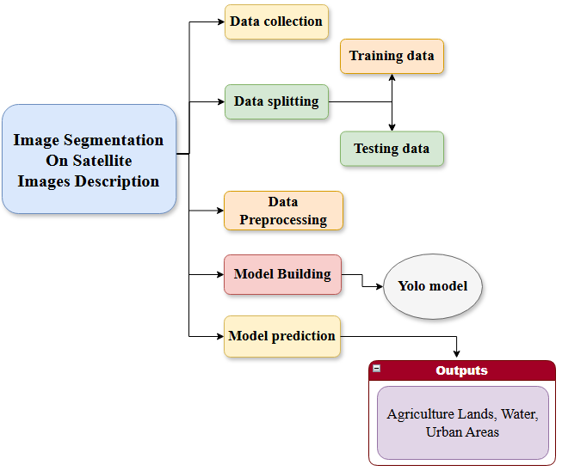
Fig. 1. Proposed System Work Flow

RESULTS
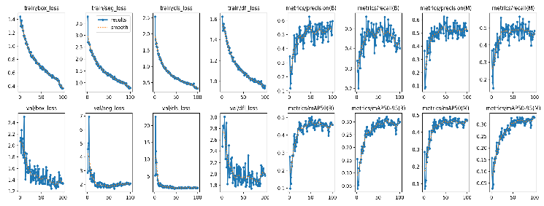
Fig. 2. Yolov8 Segmentation Performance
Figure 2 shows the training and validation loss curves and other metrics (precision, recall, mAP50, mAP50-95 and so on) of the YOLOv8 model. The figure shows that performance is gradually increasing with the training, and both loss functions and evaluation measures converge significantly. The train box and train segmentation losses show a gradual reduction, which signifies that the model gradually reduces the error during the iterations. Equally, the loss metrics of validation are of a similar trend of decreasing, albeit with minimal variations, which is typical at the initial stages of training.
The accuracy and recall curve of both B (background) and M (main object) categories depicts a steady enhancement in the model, indicating that it is increasingly effective in labeling objects correctly and maintaining a false positive and false negative ratio. The mAP50 and mAP50-95 values indicate further the strength of the model, and the performance is increasing with the increasing thresholds of the IoU, which additionally proves the performance of the model to generalize to various data.
These results prove that the model is gradually becoming able to segment objects more precisely, demonstrating the capability of the YOLOv8 architecture in the task of segmentation of objects in satellite images.
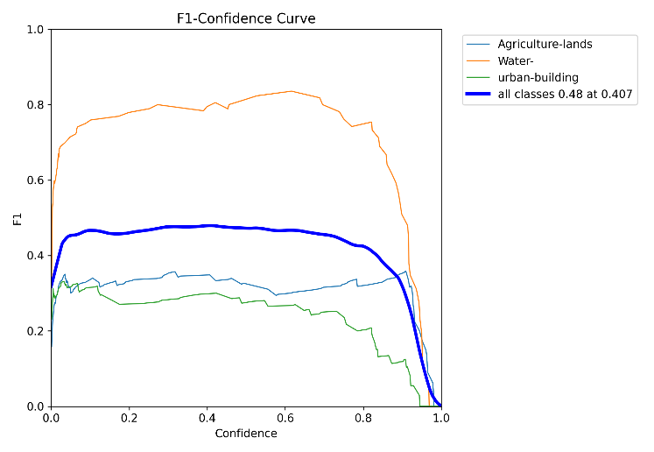
Fig. 3. F1-Confidence Curve of Yolov8
Figure 3, the F1-Confidence curve of the various land cover classes: Agriculture-lands, Water, and Urban-building is plotted and the overall F1 score of classes. The curve shows the correlation between confidence of the model in its predictions and F1 score which is a metric of balance between precision and recall.
Based on the graph, it is possible to note that the Water class has the best F1 score, particularly when the confidence is high, which indicates that the model is more confident and correct in identifying water bodies. Conversely, Agriculture-lands and Urban-building have a lower F1 scores especially as we increase the confidence, showing that the model might have more problems in the precise segmentation of the said classes.
The blue curve that indicates the F1 score of all the classes achieves an average F1 score of 0.48 at a confidence level of 0.407. This points out the trade-off between high precision and recall at different confidence levels, where the model has attained a satisfactory balance across all classes at the middle range confidence level.
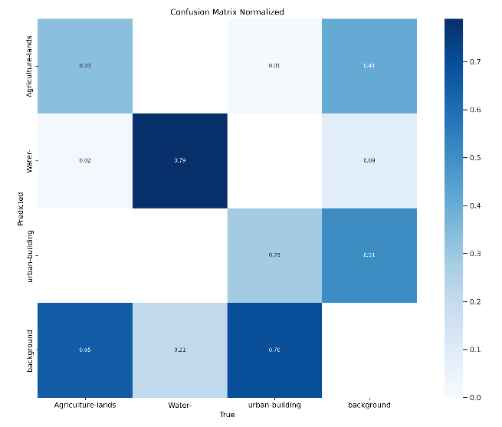
Fig. 4. Normalized Confusion Matrix of yolov8
A normalized confusion matrix of a satellite image segmentation task is provided in Figure 4, where the results of the YOLOv8 model are demonstrated in terms of classifying various types of land cover, including agricultural lands, water bodies, urban buildings, and background. The matrix points at the fact that the model is precise when predicting each of the classes by true labels.
Based on the matrix, we can note that the model is very effective in detecting the presence of water bodies with a high recall of 0.79 which means that the model identifies the majority of water regions. The urban buildings are also performing well with a recall of 0.51 which can be improved. The relative recall in terms of agricultural land and background classes is relatively low at 0.33 and 0.65. This is an indication that the model finds it more difficult working with these classes, particularly when separating agricultural land and other forms.
Water and background categories are the most accurate with the model, which indicates that it most accurately predicts these categories. But the misclassifications, especially between the agricultural land and background, demonstrate the weakness of the model and therefore more optimization or refinement of the features might be used to enhance the accuracy of the segmentation in such locations.

CONCLUSION
The analysis of the performance of the YOLOv8 model on the satellite image segmentation indicates that, despite the segmentation accuracy and real-time performance being improved, the outcomes are rather promising. These measures of evaluation like mAP50 and mAP50-95 and F1 indicate that the model works effectively in identifying and delineating land cover types including water bodies, agricultural land, and urban buildings. The precision and recall curves show that the capacity of the model to deal with objects correctly increases with the level of confidence particularly in dealing with some types of land covers such as water. Nevertheless, the fact that the F1 scores of agricultural lands and urban buildings are relatively lower indicates that there is yet to be improvements especially in the generalization abilities of the model to more complex and diverse environments.
This model can be improved in a number of areas in the future. To begin with, it is possible to implement the latest augmentation methods, including synthetic data generation or adversarial training, to enhance performance on underrepresented land cover classes.
Second, the addition of hybrid models, that is, the combination of YOLOv8 with transformer-based models, may improve the feature extraction, particularly that of small and distant objects. The other area of the potential improvement would be refining the model by using more diverse and large scaled data to accommodate the challenges associated with varied geographical settings. Moreover, it may be possible to look into the use of multi-task learning or implement domain adaptation methods to enable the model to be more accommodating to different terrain types and weather conditions. Lastly, edge deployment optimization with model pruning or quantization would be useful to real-time applications in satellite imagery analysis to be implemented on a wider range of resource-constrained systems.

V. References

- G. Silpalatha and T. S. Jayadeva, "Enhancing rapid and precise segmentation with YOLOv8 for satellite image analysis," Remote Sens. Appl., vol. 37, p. 101502, Jan. 2025, doi: 10.1016/J.RSASE.2025.101502.
- P. Zhang, J. Liu, J. Zhang, Y. Liu, and X. Li, "MD-YOLOv8: A multi-object detection method for satellite images in remote sensing," IET Image Process., vol. 19, no. 1, p. e70106, Jan. 2025, doi: 10.1049/IPR2.70106.
- N. Chandra, H. Vaidya, M. Koch, R. Bhookya, S. Singh, and S. R. Meena, "YOLOv8 optimized with multi-level attention for detecting landslides in satellite imagery," Adv. Space Res., vol. 76, no. 4, pp. 2072–2085, Aug. 2025, doi: 10.1016/J.ASR.2025.06.010.
- B. Chen, Z. Ma, and X. Li, "Improving detection performance: An upgraded YOLOv8 for small object detection in remote sensing," Int. J. Comput. Intell. Syst., vol. 18, no. 1, pp. 155-, Dec. 2025, doi: 10.1007/S44196-025-00895-4/TABLES/5.
- P. Yan, L. Jian, and X. Qi, "LI-YOLOv8: A lightweight small object detection approach combining GSConv and PConv for satellite images," PLoS One, vol. 20, no. 5, p. e0321026, May 2025, doi: 10.1371/JOURNAL.PONE.0321026.
- B. Yao et al., "SRM-YOLO for detecting small objects in remote sensing imagery," Remote Sensing, vol. 17, no. 12, Jun. 2025, doi: 10.3390/RS17122099.
- R. Dahiya, M. K. Ojha, S. Saini, and S. Ratna, "U-Net-based satellite image segmentation," 15th Int. Conf. Comput. Commun. Netw. Technol., ICCCNT 2024, 2024, doi: 10.1109/ICCCNT61001.2024.10726242.
- K. K. Pai, M. Agarwal, A. Sinha, M. Jasmine, and K. N. Jagrath Chengappa, "Satellite image segmentation with YOLO v8 and SAM pipeline," IEEE Silchar Subsection Conf., SILCON 2024, 2024, doi: 10.1109/SILCON63976.2024.10910484.
- Q. Ren, Y. Wu, Q. Zeng, and N. Yang, "Review of deep learning techniques for satellite image segmentation in agriculture," J. Agric. Eng., Dec. 2025, doi: 10.4081/JAE.2025.1954.
- R. V. Ingole, A. M. Giradkar, A. A. Deshmukh, R. Agrawal, C. Dhule, and N. C. Morris, "TranSegNet: A transformer-based model for satellite image segmentation and benchmarking against U-Net variants," Procedia Comput. Sci., vol. 258, pp. 775–784, Jan. 2025, doi: 10.1016/J.PROCS.2025.04.310.
- I. Kotaridis and M. Lazaridou, "Recent advancements in remote sensing image segmentation: A meta-analysis," ISPRS J. Photogramm. Remote Sens., vol. 173, pp. 309–322, Mar. 2021, doi: 10.1016/J.ISPRSJPRS.2021.01.020.
- T. F. Deressu, A. K. Bojer, T. G. Debelee, W. G. Negera, S. Nadarajah, and K. W. Gebissa, "Deep learning-based segmentation for land use classification in satellite images," Int. J. Appl. Earth Observ. Geoinf., vol. 144, p. 104839, Nov. 2025, doi: 10.1016/J.JAG.2025.104839.

