Development of a Disaster Risk Reduction Readiness (DRRR) Mobile Application
Joan S. Rajah
AMA University, Manila Philippines
University of San Jose Recoletos, Cebu Philippines
jsrajah@usjr.edu.ph
https://orcid.org/0009-0008-9028-5981
Eduardo R. Yu II
AMA University, Manila Philippines
eduardoryuii@gmail.com
https://orcid.org/0009-0004-5050-5805
Reagan B. Ricafort
AMA University, Manila Philippines
reagan.ricafort@ama.edu.ph
https://orcid.org/0009-0002-0816-1522

Abstract: Disasters pose significant risks to communities, yet localized solutions for disaster preparedness are limited. Mobile technologies offer opportunities to develop an application like the DRR focusing on the Disaster Risk Reduction Readiness (DRRR). This study addresses the need for a mobile application that enhances awareness and readiness for disasters. The study aims to develop a Disaster Risk Reduction Readiness (DRRR) mobile application that supports users in disaster preparedness through an interactive application. The Rapid Application Development(RAD) was used in this study particularly on requirement planning, user design, cutover, and construction. MIT App Inventor is used as a platform in the development of the DRR Application. The use of 5 point likert scale scoring in the evaluation of the development of the DRR mobile application which derives from the ISO/IEC 25010:2011 Systems and Software Quality Requirements and Evaluation (SQuaRE) Model. focusing on engagement, usability, and preparedness awareness particularly on IT experts and users of the application. The DRRR mobile application provides hazard information, emergency kit checklists, evacuation maps, warning alerts, The results of the evaluation demonstrated improvements across all measured areas: engagement increased, usability was rated high, and preparedness awareness improved among users.
Key Words: Development, Disaster Risk Reduction and Resilience (DRRR), Mobile Application

1.INTRODUCTION
Disasters such as typhoons, floods, earthquakes, and fires have become increasingly frequent and severe worldwide, largely driven by climate change, urbanization, and population growth. This growing trend highlights the urgent need for effective disaster preparedness strategies to minimize loss of life and property (IPCC, 2023; UNDRR, 2022). In disaster-prone countries such as the Philippines, strengthening community readiness through education, early warning systems, and coordinated response mechanisms is essential in reducing disaster impacts and enhancing resilience (UNDRR, 2022; Dalisay & De Guzman, 2016). Advances in mobile and digital technologies have introduced innovative approaches to disaster preparedness and education, where mobile applications serve as interactive and accessible platforms that deliver real-time alerts, risk information, and emergency coordination features, thereby improving user awareness and response capability (Reuter et al., 2017; Tan et al., 2021). Evidence further shows that these technologies enhance disaster literacy and community engagement, particularly in developing contexts such as the Philippines (Domingo & Manejar, 2018), although challenges remain in ensuring accessibility, usability, and large-scale adoption.
Despite global and local efforts in Disaster Risk Reduction (DRR), significant gaps persist in translating knowledge into effective preparedness actions, as disaster outcomes are influenced not only by natural hazards but also by community vulnerability and resilience (Shaw et al., 2013). The disconnect between scientific frameworks and local practices continues to limit the effectiveness of DRR initiatives (Gaillard et al., 2013), while the integration of cultural and community-specific contexts remains insufficient in many disaster planning efforts, leading to suboptimal preparedness outcomes (Kulatunga et al., 2010). Although mobile applications present promising solutions, their effectiveness is highly dependent on user-centered and context-sensitive design processes. Institutional mechanisms such as the Adelante Life Emergency Rescue Team (ALERT) of the University of San Jose–Recoletos demonstrate the importance of organized emergency response systems in supporting campus safety and disaster preparedness through trained personnel and coordinated operations (USJ-R, 2019; UNDRR, 2015). The ALERT team also promotes proactive disaster awareness through drills, training, and outreach activities (IFRC, 2018), yet there remains a need for more integrated technological systems that enhance coordination, communication, and real-time response efficiency.
In response to these challenges, this study aims to design, develop, and evaluate a Disaster Risk Reduction and Resilience (DRRR) mobile application using platforms such as MIT App Inventor. It seeks to identify DRRR knowledge and preparedness gaps among target users to inform system design, leading to the development of a functional prototype that visualizes system screens, flows, and interactions. The application will be evaluated using ISO/IEC 25010 software quality standards or the System Usability Scale (SUS) to assess usability and effectiveness, and recommendations will be formulated to improve its functionality, usability, and overall impact on disaster preparedness. The study is limited to hazards such as typhoons, earthquakes, and floods, and includes features such as hazard information, emergency hotlines, evacuation maps, and emergency kits, while excluding real-time government integration and GPS tracking, and is intended primarily as a prototype for evaluation and educational purposes.
This research contributes to Disaster Risk Reduction and mobile learning by promoting systematic, user-centered development approaches such as RAD, co-design, and Design Thinking that ensure stakeholder engagement and iterative refinement (Basadre et al., 2025; Nguyen et al., 2019;). It further integrates mobile technology with DRR strategies by incorporating features that support hazard awareness and emergency preparedness, while bridging the gap between scientific DRR frameworks and locally relevant, culturally sensitive applications. It also provides evidence-based insights into how mobile systems can improve disaster preparedness, response readiness, and user engagement. At the practical level, the application enhances student awareness and preparedness, supports educators in delivering DRRR concepts through interactive learning tools, and assists Local Government Units (LGUs) and Disaster Risk Reduction and Management Offices (DRRMOs) in disaster planning and communication. From a research perspective, it offers a structured foundation for integrating mobile application development with disaster education, contributing to future work in educational technology and community resilience initiatives.
2 METHOD
This study utilized quantitative design that involves development of the DRRR Mobile Application using the phases of the Rapid Application Development (RAD) model. These phases include requirements planning, user design, rapid construction, and cutover.
Figure 1. RAD DRRR APP
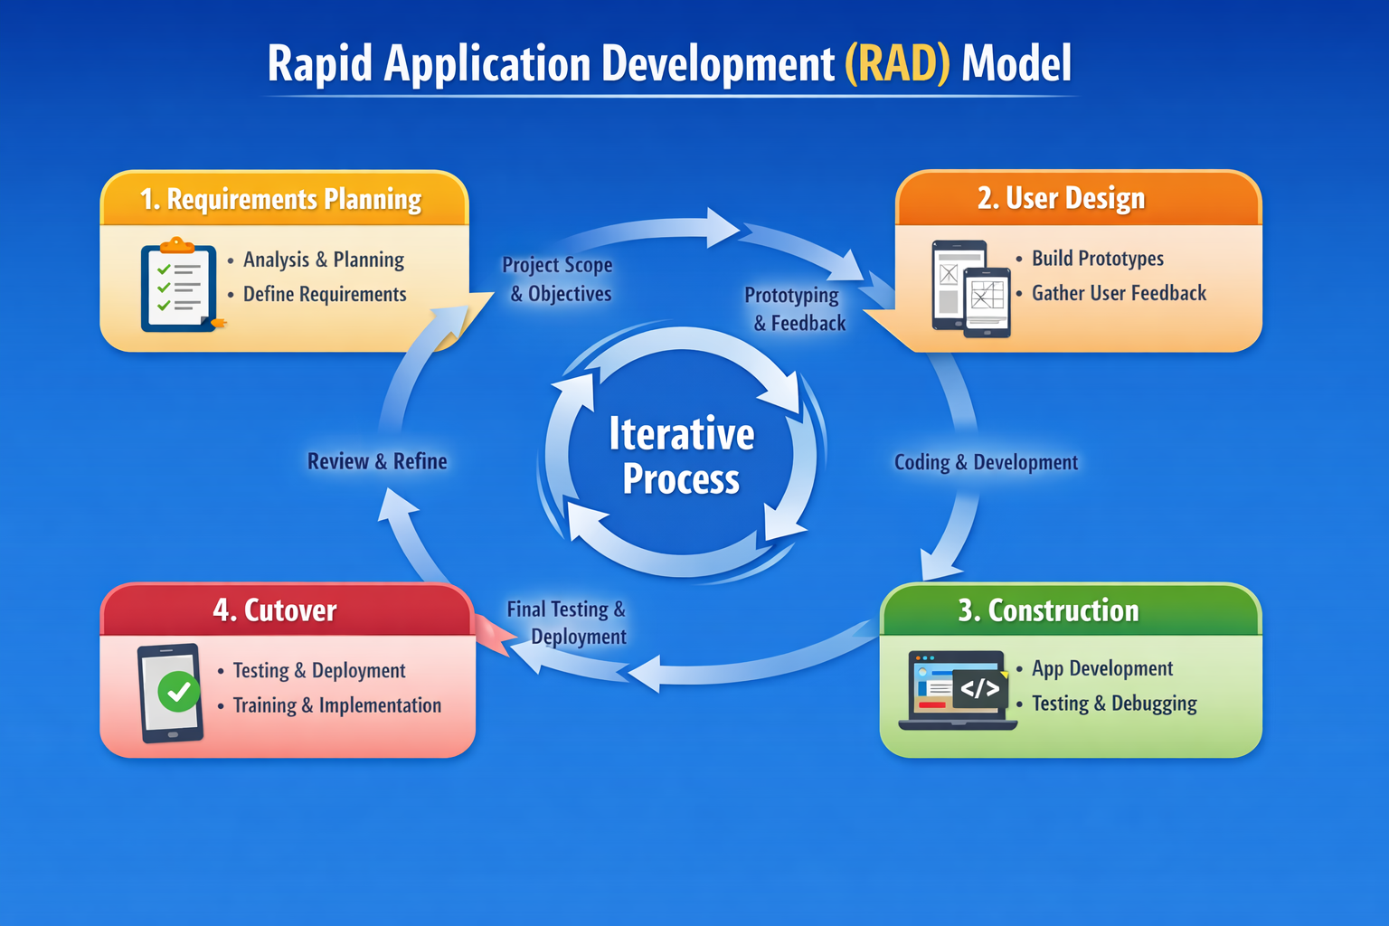
Requirements Planning Phase
In this phase, the researchers identified the objectives and functional requirements of the DRR Mobile Application. Information was gathered through literature reviews, consultation with potential users, and analysis of disaster preparedness resources. The researchers determined the key features that the application should include, such as disaster alerts, safety guidelines, emergency contacts, evacuation information, and preparedness tips.
User Design Phase
During the user design phase, the researchers created prototypes and interface designs of the mobile application. Wireframes and user interface layouts were developed to visualize the structure and navigation of the system. Potential users evaluated the prototype to ensure usability, accessibility, and relevance of the system features. Feedback gathered from users helped refine the design and improve the overall functionality of the application.
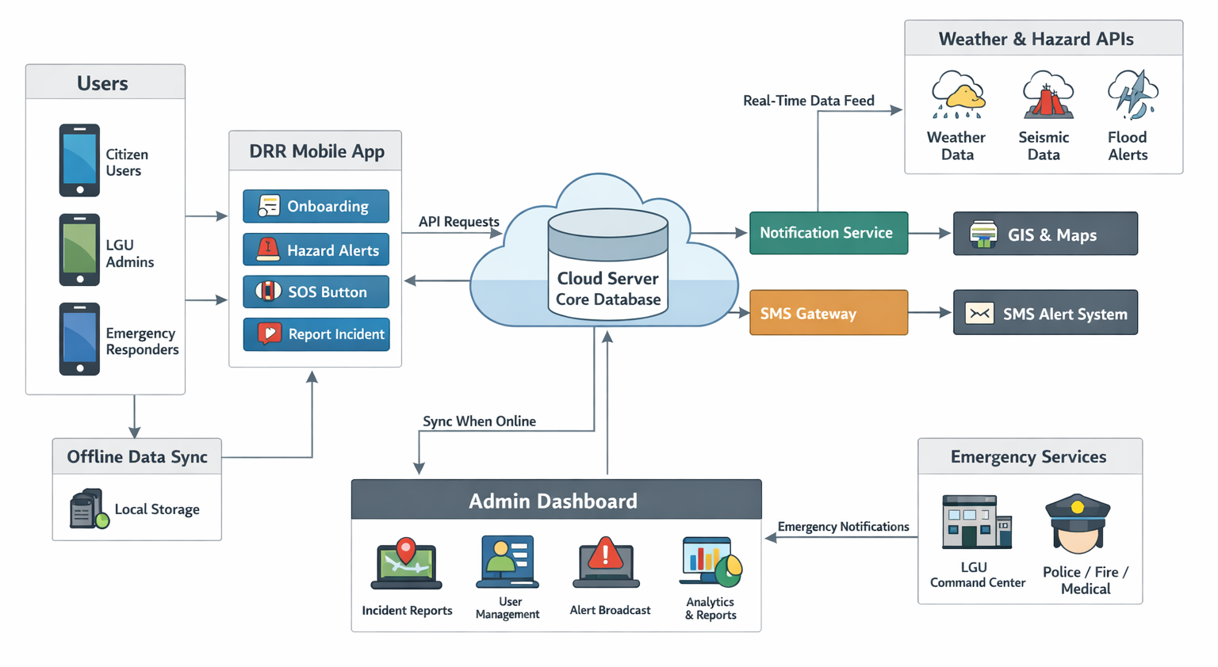
Figure 2. DRR Mobile Application System Architecture
Figure 2 presents the high-level system architecture of a Disaster Risk Reduction (DRR) mobile application designed to support hazard identification, risk assessment, and coordinated emergency response. The system integrates key modules including onboarding, hazard monitoring and alerts, SOS and incident reporting, and emergency services to enhance community preparedness and response. It leverages real-time hazard data through weather and hazard APIs, while SMS gateways and notification services ensure continuous dissemination of alerts even under limited connectivity. An administrative dashboard supports authorities in monitoring incidents and making data-driven decisions, while cloud computing provides scalable and resilient data storage and processing (NIST, 2011). Overall, the architecture demonstrates an integrated approach to disaster management by enabling timely communication, improved situational awareness, and strengthened coordination among users, responders, and local government units, aligning with principles of effective early warning and disaster risk reduction systems emphasized by UNDRR (2019), WMO (2018), ITU (2017), World Bank (2020), and FEMA (2021).
Construction Phase
In this phase, the actual development of the DRR Mobile Application was carried out using the MIT App Inventor. The Integrated Development Environment (IDE) utilized in this project is MIT App Inventor, a web-based platform developed by the Massachusetts Institute of Technology. It enables users to design and develop mobile applications through a visual, block-based programming approach, thereby reducing the complexity associated with traditional text-based coding. This environment supports rapid prototyping and is particularly beneficial in educational contexts, as it promotes computational thinking, problem-solving skills, and user-centered design. By providing an intuitive interface and real-time testing capabilities, MIT App Inventor facilitates the efficient creation of functional mobile applications, making it an appropriate tool for both novice and intermediate developers (Massachusetts Institute of Technology, n.d.). The system modules were developed and integrated to form the complete application.
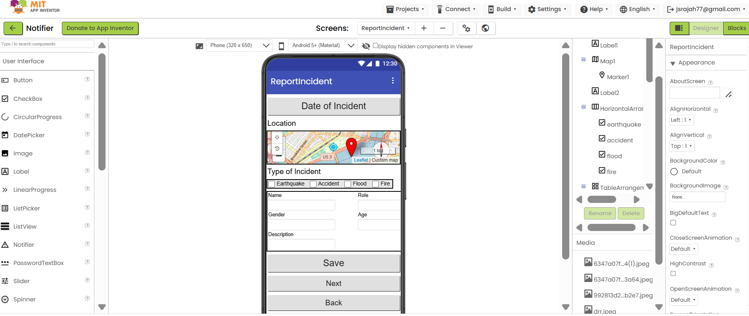Figure 3. A Mock Up User Interface Development of the DRRR App
Figure 3 presents the design interface of a mobile application developed using the MIT App Inventor integrated development environment (IDE). The application was created within the IDE’s visual development environment, which supports drag-and-drop component assembly and rapid prototyping of mobile applications. This demonstrates how the IDE facilitates structured and user-centered system development for emergency or disaster-related reporting functionality.
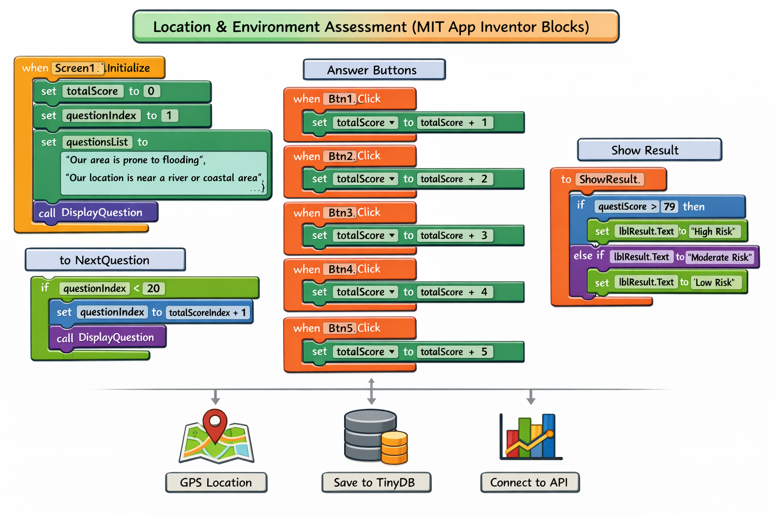
Figure 4: Location and Environment Risk Assessment
Figure 4 illustrates the workflow of a mobile Location and Environment Risk Assessment App developed using MIT App Inventor, where the system begins by initializing variables and loading a set of environmental questions. Each question is displayed sequentially, and the user responds to a 5-point Likert scale, with each selection contributing a corresponding value to a cumulative score. The app then automatically progresses through all questions using a looping mechanism controlled by a question index. Once all responses are collected, the total score is evaluated using conditional logic to classify the user’s risk level as low, moderate, or high. Additionally, the system can store the results using local storage (TinyDB), capture the user’s geographic location via GPS, and optionally connect to an external API for further analysis, making it a functional decision-support tool for environmental and disaster risk assessment.

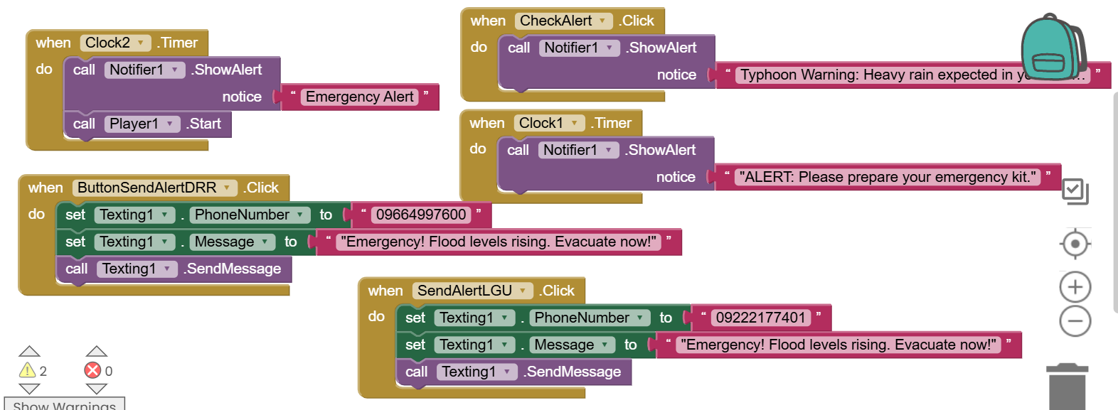
Figure 5: Send Alert to DRR Team/LGU
Figure 5 shows a mobile emergency alert application developed using MIT App Inventor. The app is designed to support disaster preparedness and response by providing both automatic and manual alert features. Timer components trigger notifications such as emergency alerts and preparedness reminders, while a button allows users to display a typhoon warning message. Additionally, the app can send SMS alerts directly to designated contacts, such as the DRR team and LGU, informing them of urgent situations like rising flood levels and the need for evacuation. Overall, it serves as a basic but functional disaster risk reduction and communication tool.

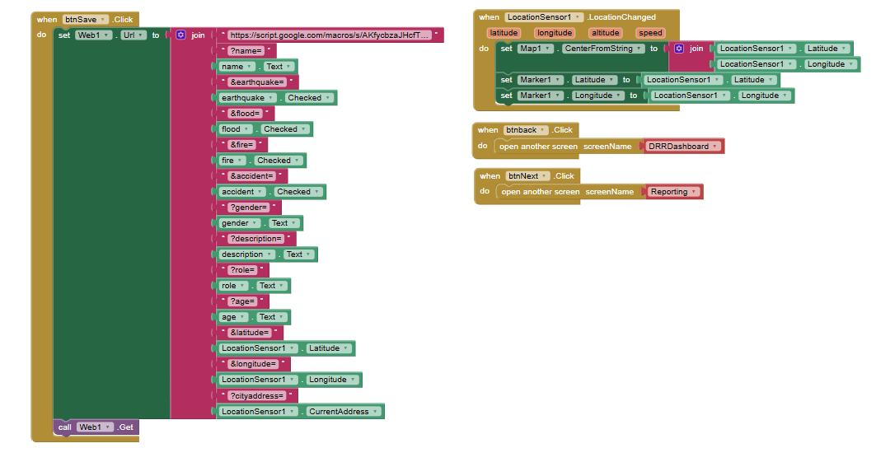
Figure 6: Report Incident
The figure 6 illustrates the block-based implementation of a disaster reporting feature developed using MIT App Inventor. Specifically, it demonstrates the integration of user input, geolocation services, and web connectivity to transmit incident data to an external database via a Google Apps Script URL. Upon the btnSave.Click event, the application dynamically constructs a query string by concatenating multiple parameters, including personal information (name, gender, age, role), incident type indicators (earthquake, flood, fire, accident), and descriptive details. In addition, real-time geographic data—latitude, longitude, and current address—are captured using the LocationSensor component, ensuring spatial accuracy of the report. The assembled data are then sent through a Web component using an HTTP GET request. Furthermore, it shows the utilization of the LocationSensor1.LocationChanged event to continuously update the map interface, centering the map and positioning a marker based on the user’s current coordinates. Navigation controls are also implemented, allowing users to transition between screens such as the DRR Dashboard and the Reporting interface. Overall, the design reflects a functional integration of mobile sensing, user-driven input, and cloud-based data storage, supporting real-time disaster reporting and situational awareness.
Cutover/Development Phase
The deployment of the Disaster Risk Reduction (DRR) Mobile Application utilized both hardware and software tools. A laptop or personal computer served as the primary platform for application design, coding, testing, APK compilation, and documentation. Android smartphones functioned as the deployment and end-user devices, leveraging the Android operating system developed by Google. The application was developed using MIT App Inventor, a web-based, block-based programming environment created by the Massachusetts Institute of Technology, which enables users to build mobile applications without extensive coding. For real-time testing and debugging, the MIT AI2 Companion was used, allowing developers to preview applications instantly via QR code or Wi-Fi connection. The final output of the development process was an Android Package (APK) file, specifically DRR_App.apk, which contains all necessary code, resources, and configurations required for installation and execution on Android devices.
ISO/IEC 25010 Software Quality Model
The ISO/IEC 25010 standard offers a rigorous and comprehensive framework for the systematic evaluation of software quality, encompassing eight principal characteristics, each articulated through a set of well-defined sub-characteristics. Functional Suitability pertains to the degree to which the system satisfies stated and implied user requirements, with particular emphasis on functional correctness, completeness, and appropriateness. Performance Efficiency examines the relationship between system performance and the amount of resources utilized, including considerations of response time, throughput, and capacity. Compatibility addresses the system’s ability to operate effectively within shared environments, ensuring both interoperability with other systems and coexistence without adverse impact. Usability reflects the extent to which the system can be used by specified users to achieve defined goals with effectiveness, efficiency, and satisfaction, incorporating aspects such as learnability, operability, and accessibility. Reliability denotes the system’s capacity to maintain a specified level of performance under defined conditions over time, including fault tolerance, availability, and recoverability. Security concerns the protection of information and data, ensuring confidentiality, integrity, authenticity, and accountability. Maintainability refers to the ease with which the system can be modified to correct faults, improve performance, or adapt to a changing environment, highlighting modularity, analyzability, and reusability. Finally, Portability evaluates the system’s ability to be transferred and adapted across different hardware, software, or operational environments, encompassing installability, adaptability, and replaceability (ISO 25010, 2026) .
The instrument used in this study is a 35-item questionnaire created by the researcher based on the ISO/IEC 25010:2011 Systems and Software Quality Requirements and Evaluation (SQuaRE) Model. Respondents rated each statement on a five-point Likert scale, with the following options:
Table 1 : Five-point Likert Scale for System Performance Evaluation
Values | Interpretation
1 | Poor
2 | Fair
3 | Good
4 | Very Good
5 | Excellent

Respondents of the Study
The respondents of this study were selected using a purposive sampling technique, wherein participants were deliberately chosen based on their expertise, roles, and relevance to the research objectives. The sample comprised selected IT experts, Disaster Risk Reduction (DRR) coordinators or members of the Emergency Response Team, Local Government Unit (LGU)/Barangay officials, faculty members, and students. These individuals were identified as appropriate respondents due to their direct involvement in disaster preparedness initiatives and their potential to utilize and evaluate the DRR mobile application. Their inclusion ensures that the data collected are derived from informed perspectives, thereby enhancing the validity and relevance of the study findings.
Table 2 : Respondents of the Study for System Performance Evaluation
Role | Number of Respondents | Description
IT Experts | 3 | IT Experts provide technical evaluation and validation of the DRR mobile application. Their role is to assess the system in terms of software functionality, usability, reliability, security, and performance. They also review the application design, system architecture, and implementation to ensure that the application follows good software development practices and meets quality standards such as ISO/IEC 25010.
DRR Coordinator/Emergency Response Team | 3 | The Disaster Risk Reduction (DRR) Coordinator or Emergency Response Team members provide expert knowledge on disaster preparedness, response procedures, and emergency management. They help validate whether the information included in the mobile application—such as evacuation procedures, emergency guidelines, and disaster safety tips—is accurate, relevant, and aligned with disaster management protocols.
Barangay Officials/ LGU Officers | 3 | Barangay Officials and LGU Officers contribute community-level disaster management insights. They provide information about local disaster risks, evacuation centers, community preparedness programs, and emergency contact services. Their feedback ensures that the DRR mobile application is relevant to the local community and supports local disaster preparedness initiatives.
Faculties | 3 | Faculty members evaluate the educational value and usability of the DRR mobile application. They assess whether the application effectively supports teaching and learning about disaster preparedness, particularly for students. Faculty also provide feedback on the clarity of content, instructional design, and accessibility of learning materials within the app.
Students | 3 | Students serve as the primary end-users of the DRR mobile application. They evaluate the application in terms of ease of use, user interface design, accessibility, and overall user experience. Their feedback helps determine whether the application is engaging, understandable, and helpful for improving disaster awareness and preparedness among learners.
3.RESULTS AND DISCUSSIONS
The developed mobile application is comprehensively examined in this section, encompassing a detailed presentation of its features, an evaluation of its performance based on the Software Quality Model, and the results of the IT expert assessment conducted in accordance with the criteria established by the aforementioned standards.
Key Features of the Developed Mobile Application for Disaster Risk Reduction
The developed system is a Disaster Risk Reduction (DRR) mobile application designed to enhance user preparedness, safety awareness, and real-time responsiveness during emergency situations. It integrates essential functionalities that support proactive risk management, timely dissemination of hazard information, and efficient incident communication, thereby aligning technological innovation with community-based disaster resilience efforts.

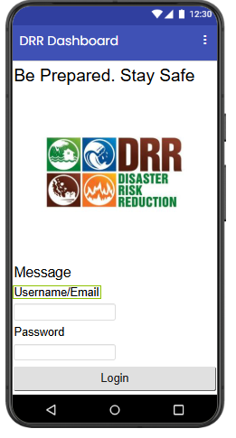
Figure 7 : Onboarding
Figure 7 Onboarding: The onboarding feature provides a seamless introduction to the application through a splash screen and secure user authentication, enabling users to register or log in efficiently and gain immediate access to the system’s core functionalities.
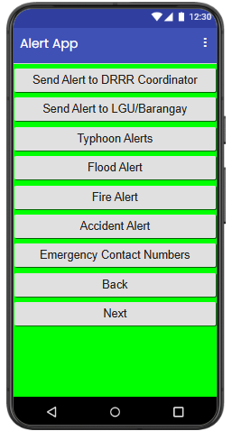
Figure 8: Hazard Alerts
Figure 8 Hazard Alerts:The hazard alerts feature delivers real-time notifications on potential risks and emergencies using color-coded warning levels, allowing users to quickly interpret alert severity and access detailed information for informed decision-making.
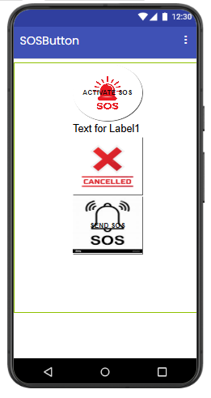
Figure 9: SOS Button
Figure 9 SOS Button: The SOS button enables users to instantly send distress signals along with their location during emergencies, facilitating rapid response from authorities or designated contacts to enhance user safety.

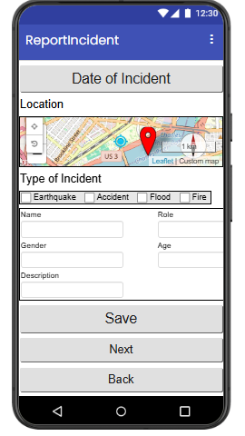
Figure 10: Report Incident
Figure 10 Report Incident: The report incident feature allows users to submit detailed reports of emergencies by providing incident type, descriptions, images, and GPS-based location, ensuring accurate and timely communication with system administrators for appropriate action.
Summary Results Evaluation using ISO/IEC 25010 or Software Product Quality Model
This subsection presents the summary of the evaluation results of the developed system based on the ISO/IEC 25010 Software Product Quality Model, highlighting its performance across the defined quality characteristics as assessed by IT experts in accordance with the established criteria of the standard.
Table 3 : System Performance Evaluation Summary
Indicators | Weighted Mean | Rank | Verbal Interpretation
Functional Suitability | 4.2 | 4 | Very Good
Performance Efficiency | 4.22 | 2 | Very Good
Compatibility | 4.0 | 4 | Very Good
Usability | 3.94 | 7 | Good
Reliability | 4.25 | 1 | Very Good
Security | 4.18 | 2 | Very Good
Maintainability | 4.0 | 2 | Very Good
Portability | 4.0 | 4 | Very good
Overall Weighted Mean | 4.210 | 4 | Very Good
As gleaned from Table 3, The system evaluation results reveal that the System Performance Evaluation, as summarized in Table 3, indicates that the developed system demonstrates a high level of overall quality, achieving an overall weighted mean of 4.210, which is interpreted as “Very Good.” Among the evaluated indicators, Reliability received the highest weighted mean of 4.25, highlighting the system's consistent performance and dependability. Performance Efficiency (4.22) and Security (4.18) also ranked highly, reflecting the system’s effectiveness in processing tasks efficiently while ensuring data protection. Indicators such as Functional Suitability (4.20), Compatibility (4.00), Maintainability (4.00), and Portability (4.00) were rated as very good, indicating that the system meets functional requirements, integrates well with other environments, and can be maintained and deployed across platforms with minimal effort. Usability received a slightly lower rating of 3.94, suggesting that while the system is generally user-friendly, minor improvements could enhance the overall user experience. Collectively, these results affirm that the system performs well across multiple quality dimensions in accordance with software evaluation standards.
Analysis of Variance Between the Respondents Group of the DRR Application
This subsection presents the analysis of variance among the different respondent groups in evaluating the DRR application, examining whether significant differences exist in their assessments of the system based on the established evaluation criteria.
Table 4 : One-Way ANOVA Results of Evaluation Scores Across Respondent Groups
Source of Variation | SS | df | MS | F | P-value | F crit
Between Groups | 0.76462 | 2 | 0.38231 | 5.74826 | 0.00913 | 3.40282611
Within Groups | 1.59621 | 24 | 0.06651
Total | 2.36082 | 26
Table 4 presents the results of the one-way Analysis of Variance (ANOVA) on the evaluation of the DRR application based on ISO/IEC 25010 software product quality characteristics across different respondent groups. The analysis compares the perceived system performance among IT Experts, DRR Coordinators, and Students. The results indicate that Students obtained the highest mean score (M = 4.44), followed by DRR Coordinators (M = 4.24), and IT Experts (M = 4.03), suggesting variation in system perception across stakeholder groups. The ANOVA results show a between-groups sum of squares (SS) of 0.7646 with 2 degrees of freedom and a mean square (MS) of 0.3823. The computed F-value of 5.748 exceeds the critical value of 3.403, and the p-value of 0.0091 is less than the 0.05 level of significance, indicating a statistically significant difference among the group means. In contrast, the within-groups variation yielded an SS of 1.5962 with 24 degrees of freedom and an MS of 0.0665, reflecting inherent variability among respondents within each group. Overall, the findings demonstrate that stakeholder group membership significantly influences the evaluation of system performance, with Students providing more favorable ratings compared to IT Experts and DRR Coordinators, highlighting the importance of incorporating diverse stakeholder perspectives in system evaluation and improvement.

Results of DRR Application Black Box Testing
Table 5: DRRR Mobile Functional Testing

Test Case Id | Screen | Test Description | Expected Results | Test Results | Conclusion
TC1 | DRRR Dashboard Screen | shows label Be Prepared. Stay Safe with DRR Logo, Username/Email as required fields to fill up. If correct then open screen , if not then stay on dashboard until condition is met. | Login Successful, Invalid Login | Successful | Valid
TC2 | Alert App | shows button for check alert, send alert to DRRR Coordinator, Send Alert to LGU/Baranggay | When the check alert button is clicked then notify alert message Emergency, when send alert button to DRRR Coordinator or LGU/Barangay it will send Message Emergency using the temporary contact no of DRRR and LGU. | Successful | Valid
TC3 | Emergency Checklist | shows Go Bag Emergency Kit CheckList with checked box Water, Ready to Eat Food, FlashLight, First Aid Kit,PowerBank/Radio, Face Masks, Alcohol, Hygiene kit, Important Documents with Next and Back Button | if emergency items is checked using checked box data must be save thru googlesheet | Successful | Valid
TC4 | ReportIncident | shows date as Timestamp,LocationSensor, Map, Type of Incident using checkbox, Name of Person sending the incident report, age, gender, and role in the community with next and back button | dates like timestamp, location, longitude, latitude from map, type of incident flood, fire, accident, typhoon, name of person, age, gender and role in the community are data that must be saved in the googlesheet. | Successful | Valid
TC5 | Preparedness Information | shows the button for Safety Tips, Emergency Kit Checklist | this will open screen for Safety Tips and another button for Emergency Checklist | Successful | Valid
TC6 | Safety Tips | shows the button for Safety Tips ready for Clicked | it open screen for gov.ph | Successful | Valid
TC7 | DRR Mobile App Screen | show the four button like OnBoarding, SOS Button, Report Incident, Hazard Alert | by clicking the button it will open screen for Onboarding, SOS, Reportincident, Hazard Alert | Successful | Valid'
TC8 | Flood Prone Area | showsbutton for determining Flood Prone Area | shows ready for navigation for flood prone area | Successful | Valid
Table 5 shows the functional testing results of the developed Disaster Risk Reduction (DRR) Mobile Application demonstrate that all core system components operate in accordance with the specified requirements. Using a structured black-box testing approach, eight (8) major modules—including the Dashboard, Alert System, Emergency Checklist, Incident Reporting, Preparedness Information, Safety Tips, Main Navigation Screen, and Flood-Prone Area feature—were systematically evaluated. Findings indicate that all test cases (TC1–TC8) achieved a “Successful” outcome, with corresponding conclusions marked as “Valid.” This suggests that the application consistently meets its intended functional specifications. Critical features such as user authentication, emergency alert dissemination to DRRR coordinators and local government units (LGUs), real-time incident reporting with geolocation data, and checklist data storage via Google Sheets integration were all verified to function accurately. Moreover, user interface navigation across multiple screens—including onboarding, SOS functionality, hazard alerts, and preparedness resources—was confirmed to be responsive and reliable. The system also demonstrated effective data handling capabilities, particularly in capturing and storing user inputs such as timestamps, geographic coordinates, and demographic information. Overall, the results affirm that the DRR Mobile Application exhibits a high level of functional correctness and usability. These outcomes align with established software quality standards, indicating that the system is suitable for deployment as a reliable tool for enhancing disaster preparedness, response, and communication within the community.

4. SUMMARY,CONCLUSION AND RECOMMENDATIONS

Summary of the Study
This study aimed to develop and evaluate a Disaster Risk Reduction Readiness (DRRR) Mobile Application intended to enhance disaster preparedness, facilitate timely emergency response, and provide accessible information to users. The application was systematically assessed using the ISO/IEC 25010 Software Product Quality Model, focusing on essential software quality characteristics, including functional suitability, usability, performance efficiency, compatibility, reliability, security, and portability. The respondents of the study were senior high school students who evaluated the application through a structured survey questionnaire. The evaluation employed both quantitative measures and qualitative feedback, including comments and suggestions, to provide a comprehensive understanding of the system’s performance and user experience. The findings indicate that the application is generally functional, effective, and user-friendly, particularly in enabling users to send emergency alerts promptly and efficiently. Respondents positively highlighted the simplicity and convenience of key features, such as incident reporting and alert notifications. Despite these strengths, several areas requiring improvement were identified. These include system performance issues, such as memory management inefficiencies, high RAM usage, and battery consumption, as well as usability challenges, particularly regarding navigation and interface clarity. Moreover, respondents emphasized the need for offline functionality, enhanced system reliability, and strengthened security features. Overall, the results suggest that while the application successfully fulfills its primary objectives, further technical and design enhancements are necessary to optimize its overall effectiveness, usability, and user satisfaction.

Conclusions
Based on the analysis of survey data and qualitative feedback, the following conclusions are drawn: (1) The developed DRRR mobile application is functional and effective in achieving its intended purpose, particularly in facilitating rapid and convenient emergency alert communication.(2) The application demonstrates acceptable levels of usability, although some respondents experienced difficulty navigating the interface, indicating a need for improvements in user-centered design. (3) In terms of performance efficiency, the system requires optimization due to identified issues such as high memory consumption and battery usage, which may limit performance on low-end devices. (4) The application demonstrates potential as a tool for disaster preparedness, yet its effectiveness is constrained by the lack of offline capabilities and suboptimal performance under poor internet connectivity conditions. (5) Observed deficiencies in security, reliability, and error recovery suggest that the system is not yet fully robust, necessitating further technical enhancements.(6) Despite the aforementioned limitations, the application received positive user feedback, indicating its relevance and potential as an effective instrument for disaster risk reduction and emergency preparedness initiatives.

Recommendations
In accordance with the findings and conclusions of this study, the following recommendations are proposed to improve the DRRR mobile application: (1) Enhancement of System Performance
Developers should address memory management inefficiencies and optimize RAM utilization to ensure smoother operation and consistent performance across a range of devices.(2) Reduction of Battery Consumption .(3) System processes should be refined to minimize battery usage, particularly during extended operation and background activities, thereby improving device efficiency.(4) Improvement of User Interface and User Experience (UI/UX): The application interface should be redesigned to enhance usability and navigation. Implementing clear layouts, intuitive controls, and well-organized features will improve user interaction and accessibility.(5) Implementation of Offline Functionality: Incorporating offline capabilities is recommended to maintain access to essential features during emergency situations when internet connectivity may be unavailable.(6) Enhancement of System Reliability and Error Recovery:The application should include robust error-handling mechanisms to ensure system stability and facilitate rapid recovery from technical failures.(7) Optimization for Low Connectivity Environments: Developers should optimize the system to operate effectively under unstable or low-quality internet connections, ensuring reliable access and data transmission.(8) Strengthening of Security Features: Security protocols should be enhanced to protect user data and ensure safe and confidential transmission of sensitive information during emergency reporting.(9) Continuous System Improvement and Testing: Regular updates, iterative testing, and integration of user feedback are recommended to continuously enhance the application’s quality, reliability, and overall performance.
REFERENCES
Basadre, J. A., et al. (2025). Development of a campus disaster risk reduction response system using ADDIE model. https://cam.ijfmr.com/research-paper.php?id=50320
Dalisay, S. N. M., & De Guzman, M. F. D. (2016). Risk communication and community participation in disaster preparedness: The case of the Philippines. International Journal of Disaster Risk Reduction, 19, 1–9. https://doi.org/10.1016/j.ijdrr.2016.08.001
Domingo, S. N., & Manejar, A. J. A. (2018). Disaster preparedness in the Philippines: Assessing mobile learning applications for disaster risk reduction. Philippine Institute for Development Studies Discussion Paper Series. https://pids.gov.ph
Federal Emergency Management Agency (FEMA). (2021). Integrated public alert and warning system (IPAWS). https://www.fema.gov
Gaillard, J., et al. (2013). Disaster recovery: Issues and challenges. In R. Shaw (Ed.), Disaster recovery: Used or misused development opportunity (pp. 1–16). Springer.
International Federation of Red Cross and Red Crescent Societies. (2018). Public awareness and public education for disaster risk reduction: Key messages.
Intergovernmental Panel on Climate Change (IPCC). (2023). Climate change 2023: Synthesis report. https://www.ipcc.ch/report/ar6/syr/
ISO 25010. (2026). https://iso25000.com/index.php/en/iso-25000-standards/iso-25010
Kulatunga, U., et al. (2010). Impact of culture towards disaster risk reduction. https://journals.vilniustech.lt/index.php/IJSPM/article/view/5738
Massachusetts Institute of Technology. (n.d.). MIT App Inventor. https://appinventor.mit.edu/
National Institute of Standards and Technology (NIST). (2011). The NIST definition of cloud computing (SP 800-145). https://doi.org/10.6028/NIST.SP.800-145
Nguyen, N., et al. (2019). User experience design for disaster management mobile application using design thinking approach.
Reuter, C., Hughes, A. L., & Kaufhold, M. A. (2017). Social media in crisis management: An evaluation and analysis of crisis informatics research. International Journal of Human-Computer Interaction, 34(4), 280–294. https://doi.org/10.1080/10447318.2017.1286761
Shaw, R., Mallick, F., & Islam, A. (2013). Disaster risk reduction approaches in Bangladesh. Springer.
Tan, M. L., Prasanna, R., & Stock, K. (2021). Mobile applications in disaster management: A systematic review. International Journal of Disaster Risk Reduction, 58, 102–214. https://doi.org/10.1016/j.ijdrr.2021.102214
United Nations Office for Disaster Risk Reduction (UNDRR). (2019). Global assessment report on disaster risk reduction. https://www.undrr.org
United Nations Office for Disaster Risk Reduction (UNDRR). (2022). Global assessment report on disaster risk reduction 2022: Our world at risk. https://www.undrr.org/gar2022
University of San Jose–Recoletos. (2019). Adelante Life Emergency Rescue Team (ALERT). https://recoletos.ph
World Meteorological Organization (WMO). (2018). Multi-hazard early warning systems: A checklist. https://public.wmo.int

