Legal Awareness and Access to Legal Assistance among Overseas Filipino Workers in Riyadh, Saudi Arabia: Basis for an OFW Legal Support Awareness Framework

ABSTRACT
This study examined legal awareness and access to legal assistance among Overseas Filipino Workers (OFWs) in Riyadh, Saudi Arabia, as a basis for developing an OFW Legal Support Awareness Framework. It addressed the practical gap between the availability of migrant worker support mechanisms and the extent to which OFWs understand, locate, and use such assistance when legal or legally related concerns arise. Using a quantitative descriptive-correlational and predictive design, data were collected through an anonymous online questionnaire completed by 60 qualified OFW respondents in Riyadh. Frequency and percentage were used for common legal issues and preferred support measures, while weighted mean and standard deviation described legal awareness, access to legal assistance, and barriers affecting access. Spearman's rank correlation and multiple regression analysis tested the relationships and predictive effects among the variables. The most common issues reported were employment disputes (43.33%), contract-related concerns (40.00%), unpaid or delayed salary/wages (35.00%), and benefits or end-of-service pay concerns (31.67%). Respondents demonstrated a high level of legal awareness (M = 3.79), but access to legal assistance was only moderate (M = 3.32). Barriers were likewise moderate (M = 3.11), particularly lack of time due to work schedule, fear or hesitation in reporting concerns, and lack of required documents. Legal awareness had a significant positive relationship with access to legal assistance (rho = .663, p < .001). Legal awareness dimensions significantly predicted access, F(5, 54) = 13.57, p < .001, R² = .557, while overall awareness and barriers also formed a significant model, F(2, 57) = 33.57, p < .001, R² = .541. The proposed framework emphasizes legal issue recognition, legal awareness strengthening, access pathways, barrier reduction support, and community and digital dissemination.
Keywords: legal awareness, access to legal assistance, Overseas Filipino Workers, Riyadh, legal support framework
INTRODUCTION
Overseas employment remains an important part of Filipino life because it supports family income, education, housing, and long-term security. At the same time, migration exposes workers to unfamiliar legal, cultural, and employment environments. For Overseas Filipino Workers (OFWs), legal concerns may arise from employment disputes, unpaid or delayed wages, contract-related concerns, documentation problems, immigration matters, recruitment issues, or workplace conflicts. These concerns become more difficult when workers are unsure about their rights, the available remedies, the complaint procedure, or the proper office to approach.
Saudi Arabia remains a major destination for Filipino migrant workers. The Philippine Statistics Authority reported that Saudi Arabia accounted for 21.9% of the total number of OFWs in 2024, making it the leading destination among Asian countries (Philippine Statistics Authority [PSA], 2025). This makes Riyadh an important setting for examining legal awareness and access to legal assistance, especially because the capital hosts many Filipino workers across different occupations and employment arrangements.
The Philippine legal framework recognizes migrant worker protection. Republic Act No. 8042, as amended by Republic Act No. 10022, provides for the protection and welfare of migrant workers and overseas Filipinos in distress, including legal assistance mechanisms. Republic Act No. 11641 later created the Department of Migrant Workers to strengthen and consolidate services for OFWs. These laws show that support mechanisms exist; however, the existence of such mechanisms does not automatically mean that workers know how to use them or feel confident seeking help.
Access to justice literature emphasizes that legal problems should be understood from the perspective of ordinary people who experience them in daily life. Access is not limited to courts or formal agencies; it also includes the ability to recognize that a problem has a legal dimension, obtain reliable information, seek advice, and pursue realistic remedies (OECD & Open Society Foundations, 2019; World Justice Project, 2019). This perspective is particularly relevant to migrant workers because legal problems often occur away from home and within an unfamiliar host-country system.
This study therefore examined legal awareness and access to legal assistance among OFWs in Riyadh, Saudi Arabia. Specifically, it identified common legal issues, determined levels of legal awareness and access to assistance, assessed barriers affecting access, tested the relationship and predictive effects among the variables, and developed an OFW Legal Support Awareness Framework based on the findings.
LITERATURE REVIEW
Legal awareness refers to a person's understanding of rights, obligations, remedies, procedures, and sources of assistance. In the context of OFWs, it does not require technical legal expertise. Rather, it means practical awareness that concerns such as unpaid wages, contract substitution, documentation problems, recruitment issues, or workplace disputes may require formal guidance, referral, or legal assistance. This is connected to legal empowerment, which focuses on helping people use legal information in practical situations (Commission on Legal Empowerment of the Poor & United Nations Development Programme, 2008).
People-centred justice stresses that legal systems must be assessed according to whether they respond to the actual needs and capacities of people (OECD, 2021). Legal needs research shows that people may fail to obtain justice not only because institutions are absent, but also because they lack knowledge, confidence, time, documentation, or practical support (World Justice Project, 2023). For migrant workers, such barriers may be intensified by employer dependence, unfamiliar procedures, language or communication constraints, and fear of consequences.
Studies on migrant worker protection identify wage theft, recruitment-related concerns, delayed salaries, contract issues, and limited access to remedies as persistent problems (Farbenblum & Berg, 2021; International Labour Organization [ILO], 2022). Research and policy literature on migrant workers also emphasize the importance of information, referral systems, documentation support, and worker-friendly access channels (ILO, 2024; International Organization for Migration [IOM], 2024). These themes support the present study's focus on the relationship between legal awareness and practical access to legal assistance.
The theoretical basis of the study draws from the Theory of Planned Behavior and Andersen's Behavioral Model of Services Use. The Theory of Planned Behavior suggests that a person's beliefs, perceived control, and intention influence behavior (Ajzen, 1991). In this study, legal awareness may support an OFW's confidence and readiness to seek assistance. Andersen's model explains that service use is affected by enabling and limiting factors (Andersen, 1995), which aligns with the study's inclusion of barriers such as fear, lack of time, uncertainty about procedures, communication barriers, documentation issues, limited digital access, and lack of confidence.
METHODOLOGY
Research design
The study used a quantitative descriptive-correlational and predictive research design. The descriptive component identified common legal issues, measured levels of legal awareness, access to legal assistance, and barriers affecting access, and identified preferred support measures. The correlational component tested the relationship between overall legal awareness and overall access to legal assistance. The predictive component used multiple regression to determine whether legal awareness dimensions, overall legal awareness, and barriers predicted access to legal assistance.
Respondents and sampling
The respondents were 60 qualified OFWs currently residing or working in Riyadh, Saudi Arabia. Eligibility was limited to Filipino citizens who were at least 18 years old, were currently residing or working in Riyadh, and voluntarily agreed to participate in the study. Because a complete sampling frame of qualified OFWs in Riyadh was not publicly available, the study used online and referral-based recruitment. The results therefore reflect the respondents included in the study and should not be treated as a complete representation of all OFWs in Riyadh or Saudi Arabia.
Table 1: Screening Eligibility of Respondents
Screening criterion | Qualified respondents | Percentage
Filipino citizen | 60 | 100.00%
Currently residing or working in Riyadh, Saudi Arabia | 60 | 100.00%
At least 18 years old | 60 | 100.00%
Voluntary consent to participate | 60 | 100.00%
Note. N = 60. Percentages are based on the total number of valid respondents.
Instrumentation
Data were gathered through an online questionnaire containing screening and consent questions, a checklist of common legal issues, Likert-scale items on legal awareness, Likert-scale items on access to legal assistance, Likert-scale items on barriers affecting access, and preferred support measures for the proposed framework. The Likert items used a five-point scale from 1 (Strongly Disagree) to 5 (Strongly Agree). The instrument was designed to avoid collection of names, employer names, case numbers, passport numbers, iqama numbers, or other personal identifiers.
Table 2: Reliability of the Main Survey Scales
Scale | Cronbach's alpha | Interpretation
Legal Awareness | 0.927 | Excellent internal consistency
Access to Legal Assistance | 0.931 | Excellent internal consistency
Barriers Affecting Access | 0.941 | Excellent internal consistency
Note. Cronbach's alpha values indicate excellent internal consistency for the three major scales.
Data analysis
Frequency and percentage were used for checklist-type items. Weighted mean and standard deviation were used for Likert-scale dimensions. For legal awareness and access to legal assistance, the interpretation scale was: 4.21 to 5.00, Very High; 3.41 to 4.20, High; 2.61 to 3.40, Moderate; 1.81 to 2.60, Low; and 1.00 to 1.80, Very Low. For barriers, the same ranges were interpreted from Very High Barrier to Very Low Barrier. Spearman's rank correlation was used to test the relationship between legal awareness and access. Multiple regression analysis was used to test predictive effects.
RESULTS
Common legal issues
Respondents were allowed to select more than one issue. The most frequently reported legal or legally related issues were employment disputes, contract-related concerns, unpaid or delayed salary/wages, and benefits or end-of-service pay concerns. The multiple-response pattern suggests that OFW legal concerns may overlap and are not always limited to a single issue.
Table 3: Common Legal Issues Encountered by OFWs
Common legal issue | Frequency | Percentage
Employment dispute | 26 | 43.33%
Contract-related concern | 24 | 40.00%
Unpaid or delayed salary/wages | 21 | 35.00%
Concern involving benefits or end-of-service pay | 19 | 31.67%
Documentation concern | 18 | 30.00%
Immigration-related concern | 18 | 30.00%
Workplace conflict | 16 | 26.67%
Concern involving termination or resignation | 14 | 23.33%
Recruitment-related problem | 9 | 15.00%
Others | 5 | 8.33%
Note. Multiple responses were allowed; therefore, percentages do not total 100 percent.

Level of legal awareness
The overall legal awareness mean was 3.79, interpreted as High. All five legal awareness dimensions were also rated High. Awareness of basic rights and responsibilities received the highest mean, while awareness of complaint procedures received the lowest mean among the awareness dimensions.
Table 4: Level of Legal Awareness among OFWs
Dimension | Mean | SD | Interpretation
Awareness of basic rights and responsibilities | 3.90 | 0.64 | High
Awareness of employment-related legal remedies | 3.81 | 0.64 | High
Awareness of complaint procedures | 3.67 | 0.64 | High
Awareness of Philippine government assistance channels | 3.86 | 0.63 | High
Awareness of proper referral points for legal concerns | 3.73 | 0.56 | High
Overall legal awareness | 3.79 | 0.52 | High
Note. Weighted mean interpretation: 4.21-5.00 Very High; 3.41-4.20 High; 2.61-3.40 Moderate; 1.81-2.60 Low; 1.00-1.80 Very Low.
Level of access to legal assistance
The overall mean for access to legal assistance was 3.32, interpreted as Moderate. The ability to seek advice or referral was rated High, but the ability to obtain legal information, contact assistance channels, use support services confidently, and actually or intentionally use assistance mechanisms remained Moderate.
Table 5: Level of Access to Legal Assistance among OFWs
Dimension | Mean | SD | Interpretation
Ability to obtain legal information | 3.24 | 0.66 | Moderate
Ability to contact assistance channels | 3.27 | 0.73 | Moderate
Ability to seek advice or referral | 3.42 | 0.70 | High
Confidence in using legal support services | 3.32 | 0.69 | Moderate
Actual or intended use of legal assistance mechanisms | 3.36 | 0.64 | Moderate
Overall access to legal assistance | 3.32 | 0.59 | Moderate
Note. Weighted mean interpretation: 4.21-5.00 Very High; 3.41-4.20 High; 2.61-3.40 Moderate; 1.81-2.60 Low; 1.00-1.80 Very Low.
Barriers affecting access
Barriers affecting access obtained an overall mean of 3.11, interpreted as a Moderate Barrier. The highest-rated barrier was lack of time due to work schedule, followed by fear or hesitation in reporting concerns and lack of required documents. These results indicate that access concerns are not only informational but also practical, procedural, and confidence-related.
Table 6: Barriers Affecting Access to Legal Assistance
Barrier dimension | Mean | SD | Interpretation
Fear or hesitation in reporting concerns | 3.23 | 0.66 | Moderate Barrier
Lack of time due to work schedule | 3.36 | 0.65 | Moderate Barrier
Uncertainty about procedures | 3.02 | 0.72 | Moderate Barrier
Language or communication barriers | 2.95 | 0.72 | Moderate Barrier
Lack of required documents | 3.18 | 0.65 | Moderate Barrier
Limited digital or information access | 2.99 | 0.70 | Moderate Barrier
Lack of confidence in seeking formal assistance | 3.03 | 0.60 | Moderate Barrier
Overall barriers affecting access | 3.11 | 0.55 | Moderate Barrier
Note. Barrier mean interpretation: 4.21-5.00 Very High Barrier; 3.41-4.20 High Barrier; 2.61-3.40 Moderate Barrier; 1.81-2.60 Low Barrier; 1.00-1.80 Very Low Barrier.

Relationship and predictive effects
Spearman's rank correlation showed a statistically significant positive relationship between overall legal awareness and overall access to legal assistance (rho = .663, p < .001). Multiple regression also showed that the five dimensions of legal awareness significantly predicted access to legal assistance as a group. Awareness of basic rights and responsibilities and awareness of employment-related legal remedies emerged as significant individual predictors. A second regression model using overall legal awareness and barriers was also significant; however, legal awareness was the only clearly significant individual predictor.
Table 7: Relationship and Regression Summary
Analysis | Key statistic | Interpretation/decision
Overall legal awareness and overall access to legal assistance | Spearman rho = 0.663, p < .001 | Significant positive relationship; reject H₀₁
Legal awareness dimensions predicting access | F(5, 54) = 13.57, p < .001, R² = .557 | Significant model; reject H₀₂
Significant individual predictors in awareness model | Basic rights and responsibilities: B = 0.323, p = .013; employment-related legal remedies: B = 0.301, p = .026 | Both were significant positive predictors
Overall awareness and barriers predicting access | F(2, 57) = 33.57, p < .001, R² = .541 | Significant model; legal awareness significant, barriers marginal/non-significant
Note. Significance level = .05. Dependent variable for regression analyses: overall access to legal assistance.

Preferred support measures
The respondents preferred practical, accessible, and easy-to-understand support measures. The highest-ranked measures were document preparation checklists, a list of proper assistance channels and contact points, frequently asked questions, and a step-by-step referral guide or flowchart.
Table 8: Preferred Support Measures for the Proposed Framework
Preferred support measure | Frequency | Percentage
Document preparation checklist for legal concerns | 48 | 80.00%
List of proper assistance channels and contact points | 46 | 76.67%
Frequently asked questions about common OFW legal concerns | 45 | 75.00%
Step-by-step referral guide or flowchart | 45 | 75.00%
Simple OFW legal awareness guide | 44 | 73.33%
Filipino/Tagalog explanations of legal assistance procedures | 43 | 71.67%
Confidential or anonymous inquiry option | 39 | 65.00%
Online orientation or webinar on legal awareness | 38 | 63.33%
Digital posters or infographics for OFW groups | 37 | 61.67%
Community-based legal awareness campaign | 32 | 53.33%
Others | 2 | 3.33%
Note. Multiple responses were allowed; therefore, percentages do not total 100 percent.
DISCUSSION
The findings show that legal concerns among OFWs in Riyadh are strongly connected to employment and contract-related matters. Employment disputes, contract concerns, unpaid or delayed wages, and benefits or end-of-service pay concerns were the leading issues. These findings are consistent with migrant worker literature identifying wages, contracts, recruitment practices, documentation, and access to remedies as recurring areas of vulnerability (Farbenblum & Berg, 2021; ILO, 2022; IOM, 2024).
A key finding is the difference between legal awareness and actual access. Respondents reported high legal awareness, but only moderate access to legal assistance. This suggests that knowing rights, remedies, or assistance channels does not automatically translate into the ability to contact offices, prepare documents, follow procedures, or confidently use available services. This supports people-centred justice literature, which emphasizes that legal information must be practical, reachable, and usable from the standpoint of the people experiencing the problem (OECD, 2021; OECD & Open Society Foundations, 2019).
The significant positive relationship between legal awareness and access to legal assistance indicates that OFWs who have higher awareness also tend to report better access. The regression findings further suggest that awareness of basic rights and responsibilities and awareness of employment-related legal remedies are especially important predictors of access. This implies that awareness-building efforts should begin with practical rights and common employment remedies rather than technical legal explanations alone.
Barriers were moderate overall and were led by lack of time due to work schedule, fear or hesitation in reporting concerns, and lack of required documents. These barriers show that access is affected by real-life conditions. OFWs may know assistance exists but may still find it difficult to act because of time limitations, fear, uncertainty, or lack of preparedness. Therefore, an effective framework should not only raise awareness but also reduce barriers through flexible digital access, document checklists, Filipino/Tagalog explanations, confidentiality options, and clear referral guides.
Proposed OFW Legal Support Awareness Framework
Based on the findings, the proposed framework contains five connected components: legal issue recognition, legal awareness strengthening, access pathway and referral, barrier reduction support, and community and digital dissemination. These components are intended to help OFWs recognize legal concerns early, understand basic rights and remedies, locate proper assistance channels, prepare documents, and use accessible information materials through community and digital platforms.

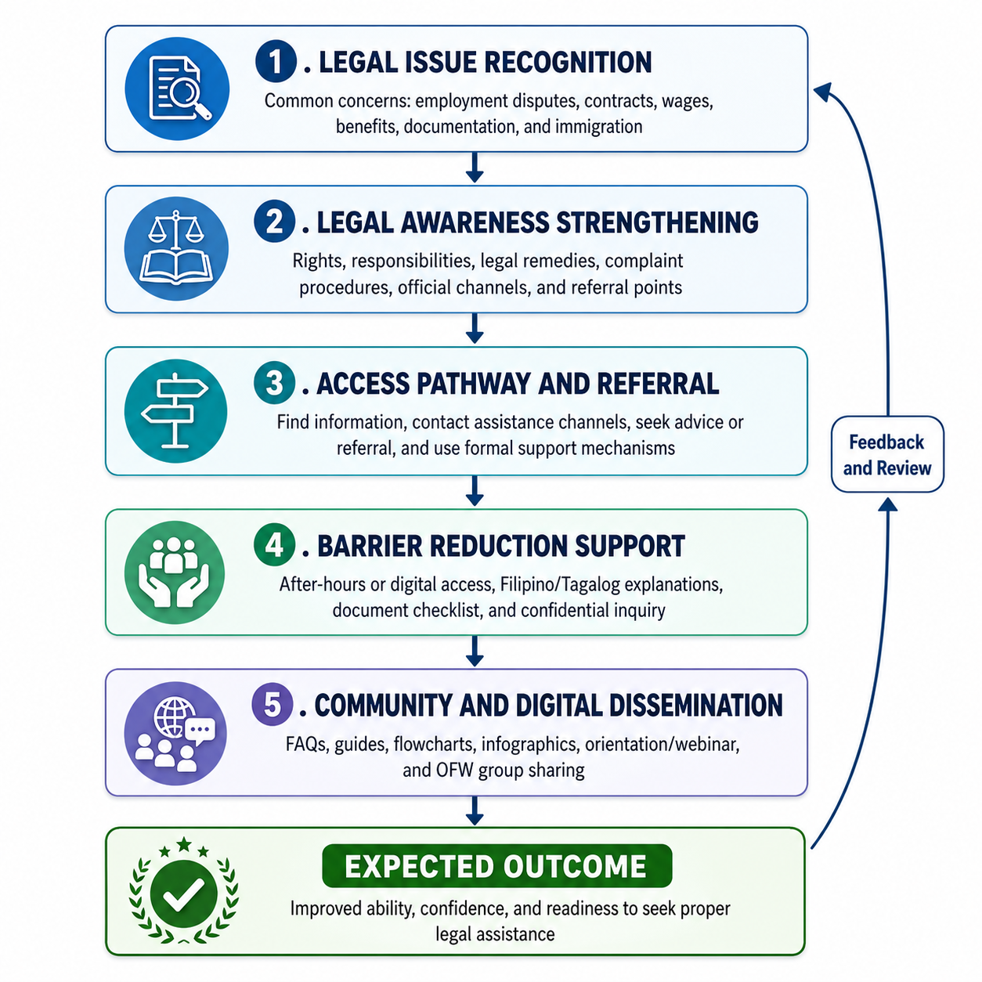
Figure 1: Proposed OFW Legal Support Awareness Framework Based on the Findings
Source. Developed by the researcher based on the findings of the study and the supporting theoretical and legal foundations.
CONCLUSION
This study concluded that OFWs in Riyadh, Saudi Arabia experienced common legal or legally related issues involving employment, contracts, wages, benefits, documentation, immigration, workplace conflict, termination or resignation, and recruitment-related concerns. The respondents demonstrated high legal awareness but only moderate access to legal assistance. This means that awareness exists, but practical access remains limited by work schedules, fear or hesitation, documentation concerns, uncertainty about procedures, and confidence-related barriers.
Legal awareness was significantly and positively related to access to legal assistance. It also significantly predicted access, particularly through awareness of basic rights and responsibilities and employment-related legal remedies. Therefore, improving legal awareness is a practical strategy for strengthening OFWs' ability, confidence, and readiness to seek assistance. However, awareness campaigns should be supported by practical tools such as document checklists, contact directories, FAQs, flowcharts, Filipino/Tagalog explanations, confidential inquiry options, digital posters, webinars, and community-based dissemination.
The proposed OFW Legal Support Awareness Framework may be used as a guide for organizing awareness-building and referral-support efforts for Filipino migrant workers in Riyadh. It is not a substitute for legal advice, legal representation, or official government assistance, but it can support early issue recognition, practical awareness, proper referral, and more accessible legal support information. Future studies may test the framework using larger samples, qualitative interviews, or comparative research involving OFWs in other cities or countries.
ACKNOWLEDGEMENTS
The author expresses sincere gratitude to Almighty God for the wisdom, strength, patience, and guidance necessary to complete this research. Appreciation is also extended to the OFWs in Riyadh, Saudi Arabia, who voluntarily participated in the survey, and to fellow OFWs, friends, colleagues, and members of the Filipino community who provided encouragement and support during the data-gathering and writing process.
ETHICAL APPROVAL AND INFORMED CONSENT
The study involved adult respondents who voluntarily participated through an anonymous online questionnaire. Electronic informed consent was obtained before participation. Respondents were instructed not to provide their names, employer names, company names, case numbers, passport numbers, iqama numbers, or other personal identification details. No animal subjects were involved. No formal ethics approval number was provided at the time of manuscript preparation; if required by the journal or institution, the author should provide the applicable ethics clearance details during final submission.
CONFLICT OF INTEREST
The author declares no known conflict of interest related to this study.
FUNDING
This research received no external funding.
DATA AVAILABILITY
The questionnaire and summarized statistical results are available from the corresponding author upon reasonable request. The raw dataset is not publicly available because of confidentiality considerations and the relatively small community context of OFWs in Riyadh, even though no direct personal identifiers were collected.
REFERENCES
1. Ajzen, I. (1991). The theory of planned behavior. Organizational Behavior and Human Decision Processes, 50(2), 179-211. https://doi.org/10.1016/0749-5978(91)90020-T
2. Andersen, R. M. (1995). Revisiting the behavioral model and access to medical care: Does it matter? Journal of Health and Social Behavior, 36(1), 1-10. https://pubmed.ncbi.nlm.nih.gov/7738325/
3. Creswell, J. W., & Creswell, J. D. (2023). Research design: Qualitative, quantitative, and mixed methods approaches (6th ed.). SAGE Publications. https://edge.sagepub.com/creswellrd6e
4. Commission on Legal Empowerment of the Poor & United Nations Development Programme. (2008). Making the law work for everyone: Volume I, Report of the Commission on Legal Empowerment of the Poor. United Nations Development Programme. https://digitallibrary.un.org/record/633970?ln=en
5. Farbenblum, B., & Berg, L. (2021). Migrant workers' access to justice for wage theft: A global study of promising initiatives. Migrant Justice Institute. https://mwji.squarespace.com/s/Farbenblum-Berg-2021-MWA2J-with-hyperlinks.pdf
6. Faul, F., Erdfelder, E., Lang, A.-G., & Buchner, A. (2007). G*Power 3: A flexible statistical power analysis program for the social, behavioral, and biomedical sciences. Behavior Research Methods, 39, 175-191. https://doi.org/10.3758/BF03193146
7. Faul, F., Erdfelder, E., Buchner, A., & Lang, A.-G. (2009). Statistical power analyses using G*Power 3.1: Tests for correlation and regression analyses. Behavior Research Methods, 41(4), 1149-1160. https://doi.org/10.3758/BRM.41.4.1149
8. Hair, J. F., Black, W. C., Babin, B. J., & Anderson, R. E. (2022). Multivariate data analysis (8th ed.). Cengage Learning. https://books.google.com/books/about/Multivariate_Data_Analysis.html?id=PONXEAAAQBAJ
9. International Labour Organization. (2022). Protection legislation and legal frameworks for migrant workers in Gulf Cooperation Council countries. https://www.ilo.org/sites/default/files/wcmsp5/groups/public/%40arabstates/%40ro-beirut/documents/publication/wcms_886063.pdf
10. International Labour Organization. (2024). Justice across borders: Access to labour justice for migrant workers through cross-border litigation. https://www.ilo.org/sites/default/files/2024-12/Standard%20publication_Justice%20Across%20Borders_EN_web__0.pdf
11. International Organization for Migration. (2024). Access to justice for migrant workers and victims of trafficking in persons. https://publications.iom.int/system/files/pdf/pub2024-023-r-access-to-justice-for-migrant-workers-and-victims.pdf
12. Migrant Workers Office-Riyadh. (n.d.). Contact us. Retrieved June 27, 2026, from https://www.mworiyadh-govph.com/contactus
13. OECD. (2021). OECD framework and good practice principles for people-centred justice. OECD Publishing. https://www.oecd.org/en/publications/oecd-framework-and-good-practice-principles-for-people-centred-justice_cdc3bde7-en.html
14. OECD & Open Society Foundations. (2019). Legal needs surveys and access to justice. OECD Publishing. https://doi.org/10.1787/g2g9a36c-en
15. Philippine Statistics Authority. (2025). Results of the 2024 Overseas Filipino Workers. https://psa.gov.ph/statistics/survey/labor-and-employment/survey-overseas-filipinos
16. Republic Act No. 8042. (1995). Migrant Workers and Overseas Filipinos Act of 1995. https://immigration.gov.ph/wp-content/uploads/2023/11/8_RA_8042.pdf
17. Republic Act No. 10022. (2010). An Act amending Republic Act No. 8042, otherwise known as the Migrant Workers and Overseas Filipinos Act of 1995. https://lawphil.net/statutes/repacts/ra2010/ra_10022_2010.html
18. Republic Act No. 11641. (2021). Department of Migrant Workers Act. https://elibrary.judiciary.gov.ph/thebookshelf/showdocs/2/94035
19. World Justice Project. (2019). Global insights on access to justice 2019. https://worldjusticeproject.org/our-work/research-and-data/global-insights-access-justice-2019
20. World Justice Project. (2023). Dissecting the justice gap in 104 countries: WJP Justice Data Graphical Report Part I. https://worldjusticeproject.org/sites/default/files/documents/WJPJusticeDataGraphicalReport-Part1.pdf

