ASSESSMENT OF GIS AND REMOTE SENSING APPLICATIONS IN LAND AND ENVIRONMENTAL MANAGEMENT IN NIGERIA
Innocent E. BELLO ^{1&2} & Abayomi A. BELLO², Alex S. ORTESE ²
¹ISSE/AUST, NASRDA Obasanjo Space Centre, Airport Road, Abuja, Nigeria
²Department of Geography, Nasarawa State University, keffi, Nigeria
Correspondence Email: ibello@isse.edu.ng; innocent.bello@nasrda.gov.ng
Abstract
Geographic Information Systems (GIS) and Remote Sensing (RS) have become central to land environmental management in Nigeria, a country of over 220 million people covering approximately 923,768 km² and spanning ecosystems from the mangroves of the Niger Delta to the semi-arid Sahel. This paper assesses the scope, performance, and constraints of GIS/RS applications in managing land-use/land-cover (LULC) change, coastal erosion, flooding, desertification, wetland loss, oil pollution, and rapid urbanization. Multi-temporal satellite analyses indicate that Nigeria’s urban built-up area expanded by more than 150% between 1990 and 2026, while forest cover declined by 7–10% in several southern states. Shoreline retreat rates of 2–30 m per year have been recorded along parts of the coast, and flood-risk mapping shows that approximately 20–25% of the population resides in flood-prone zones. In northern frontline states, desertification advances at an estimated 0.6 km annually. Institutional review highlights the growing role of the National Space Research and Development Agency and over 40 universities offering geospatial training; however, fewer than half of state environmental agencies operate functional GIS units. The study identifies progress in data availability and technical capacity but underscores persistent gaps in funding, data integration, and policy uptake, proposing a strategic roadmap for strengthened geospatial governance.
Keywords: GIS, Remote Sensing, Environmental Management, Landuse/Landcover, NASRDA
1. Introduction
Land and environmental management in Nigeria confronts multiple, interacting challenges: rapid urbanization, agricultural expansion, coastal erosion and sea-level rise impacts on the Niger Delta, seasonal and catastrophic flooding, expanding desertification in the north (Bello & Abdulrahman, 2023), and pollution from oil and solid waste. Empirical studies demonstrate that these pressures are intensifying under climate variability and socio-economic growth trends (Twumasi & Merem, 2006; Nkeki et al., 2022).
Modern geospatial technologies — remote sensing (satellite and aerial imagery) combined with GIS analytic frameworks — provide cost-effective, repeatable, and scalable means to observe, monitor, model, and support decision-making across these environmental problems. Recent applications show that multi-temporal satellite data (e.g., Landsat, Sentinel) and spatial modelling techniques have significantly improved environmental assessment accuracy in Nigeria (Ologunde et al., 2025; Abu & Ibebuchi, 2025).
Globally, the integration of RS and GIS has matured into standard practice for environmental monitoring and risk analysis. In Nigeria, institutional capacity has expanded through agencies such as the National Space Research and Development Agency (NASRDA) and university-based geospatial research centres, which support satellite data acquisition and applied research (Bello, 2024).
This paper critically appraises these applications, focusing on impacts, evidence from Nigerian case studies, and systemic barriers to greater uptake (Dike et al., 2024; Ibrahim et al., 2022). Figure 1 shows Nigeria as the study area.
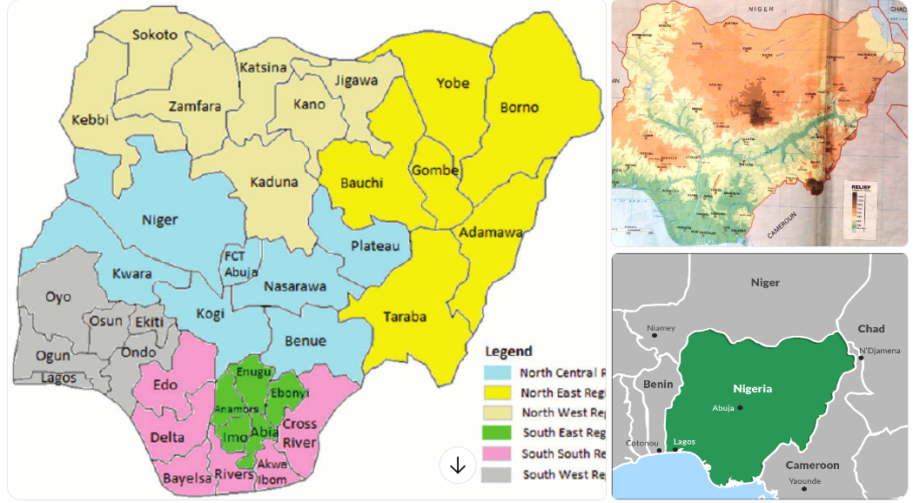
Figure 1. Nigeria - state, geopolitical zones and relief

2. Methods
The study adopted a narrative review and synthesis combining (a) peer-reviewed studies addressing GIS/RS applications in Nigeria across environmental themes, (b) institutional materials and reports on national space and remote sensing capacity such as those produced by the National Space Research and Development Agency (NASRDA), and (c) recent case studies demonstrating applied outcomes in coastal monitoring, flood modelling, desertification assessment, and land-use change analysis (Bello & Abdulrahman, 2023). Previous research demonstrates that multi-temporal satellite datasets such as Landsat, Sentinel, MODIS, and SRTM have been widely applied to environmental monitoring in Nigeria and have significantly improved spatial accuracy and temporal change detection (Twumasi & Merem, 2006; Nkeki et al., 2022; Ologunde et al., 2025).

Sources were identified through targeted literature searches of peer-reviewed journals, institutional repositories, and geospatial databases to capture representative work from approximately 2010–2025. Priority was given to studies that (1) used multi-temporal satellite data, (2) linked remote sensing observations to environmental indicators or models such as flood inundation mapping, Coastal Vulnerability Index (CVI), and MEDALUS desertification models (Dike et al., 2024; Ibrahim et al., 2022), and (3) reported direct policy or environmental management implications. Key studies are cited throughou toot.

In other words, this paper synthesizes peer-reviewed studies, institutional descriptions, and targeted case studies found in the open literature to appraise GIS/RS applications in Nigeria. For readers seeking operational data (e.g., national datasets, satellite archives, or NASRDA product lines), GRID3, NASRDA's portals and recent MDPI/ScienceDirect/PMC articles cited are good starting points.
3. Results and Discussion - Major application areas in Nigeria
3.1 Land-use / land-cover (LULC) monitoring and urban growth
Several Nigerian studies have applied Landsat and Sentinel imagery using supervised and unsupervised classification techniques to quantify urban expansion, vegetation loss, and agricultural land conversion. These analyses demonstrate measurable growth in built-up areas around major urban centres such as Abuja and rapidly expanding coastal cities, where population growth, peri-urban sprawl, and informal settlements drive land-use change (Ologunde et al., 2025; Fashae, 2022).
Multi-year LULC mapping studies conducted in southwestern Nigeria and other ecological zones show that integration of ArcGIS, ENVI, and open-source classifiers improves spatial accuracy and change detection over time (Twumasi & Merem, 2006; Ologunde et al., 2025). These LULC products provide critical inputs for land-use planning, infrastructure siting, urban development control, and environmental impact assessments.
3.2 Flood mapping, flood risk assessment and disaster response
Flooding is an acute problem in Nigeria (including the 2022 national floods). Remote sensing (MODIS, Sentinel-1 SAR for cloudy/wet conditions, and Landsat) together with hydraulic modelling (HEC-RAS, SRTM-derived DEMs) and GIS-based risk frameworks have been used to delineate inundation extent, map floodplains, and identify vulnerable infrastructure and populations (Nkeki et al, 2022) (Figure 2). These maps informed post-event assessments and have potential to feed early-warning systems when coupled with rainfall forecasts and hydrological models. Case studies after the 2022 event demonstrate RS/GIS capacity to quantify affected areas and support relief prioritization (Nkeki et al, 2022).
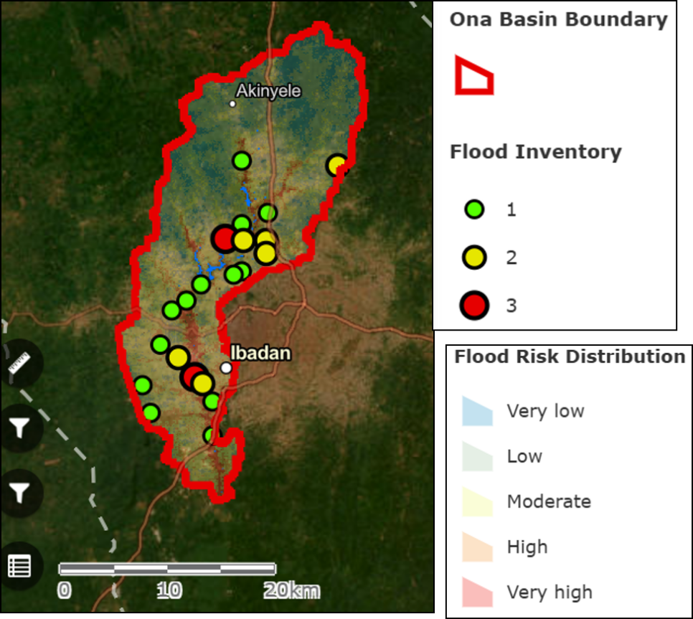
Figure 2. Flood risk model of Ona River Basin (Nkeki, Bello & Agbaje, 2022)
Source: https://africageoportal.hub.arcgis.com/apps/37b3c2ba2b0d4a3cbbfb3bbb57f7e1b8/explore
NOTE: Ona River Basin Flood Risk Model-Created to show the areas liable to flood are at risk. The location of the basin is Ibadan City of Oyo State, south-western Nigeria
3.3 Coastal monitoring, shoreline change and Niger Delta dynamics
The low-lying Niger Delta coastline exhibits significant spatially variable erosion and accretion patterns (Figure 3). Coastal vulnerability assessments that integrate satellite-derived shoreline extraction, Coastal Vulnerability Index (CVI) modelling, and GIS overlay analysis have identified hotspots of high erosion and zones highly exposed to sea-level rise and anthropogenic pressures (Dike et al., 2024; Twumasi & Merem, 2006). These spatial outputs provide critical evidence for coastal protection planning, ecosystem restoration, and community adaptation or relocation strategies.

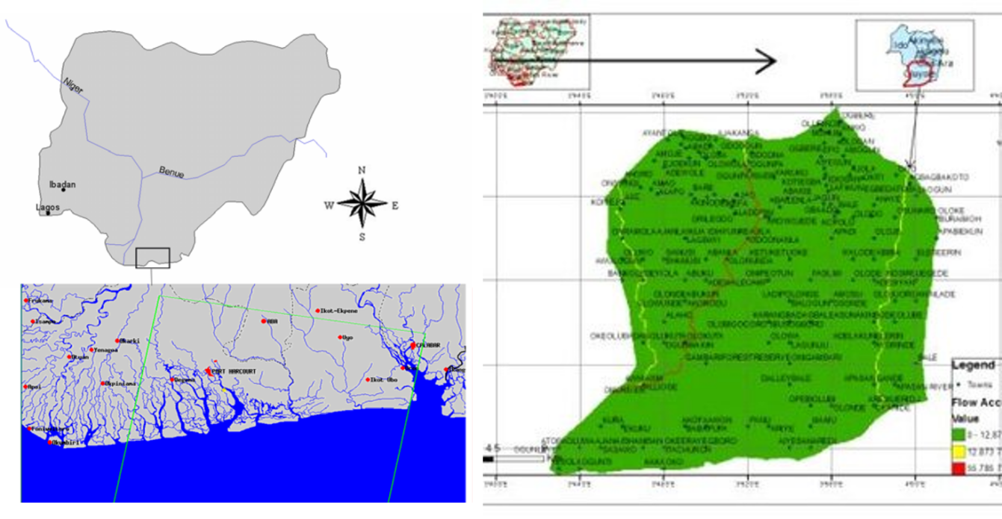
Figure 3. Coastal Community with severe impacts in the Niger Delta Region of Nigeria

Recent studies have integrated DEM-derived topographic indices (elevation, slope, flow accumulation, flow length) with land-use/land-cover data in GIS to delineate soil and erosion risk zones classified as high, medium, and low susceptibility for targeted hazard assessment and land management (Ojo et al., 2018; Lasisi et al., 2020; Aslam et al., 2021). For example, quantitative assessments in the Niger Delta indicate that approximately 26% of analysed areas fall within high-risk zones, 43% within medium-risk zones, and 31% within low-risk zones, highlighting substantial exposure to coastal degradation processes (Dike et al., 2024; Fashae, 2022). Such spatial modelling supports planners and environmental managers in identifying vulnerable areas and prioritizing mitigation measures such as vegetation restoration and soil stabilization.

3.4 Desertification and land degradation in northern Nigeria
The Sahelian and Sudanian zones in northern Nigeria experience persistent desert encroachment, land degradation, and declining vegetation productivity. Remote sensing approaches — including Normalized Difference Vegetation Index (NDVI) time-series analysis, the MEDALUS model, and long-term trend analysis of vegetation indices — have been widely applied to map desertification sensitivity and monitor changes in vegetation cover over decadal scales (Ibrahim et al., 2022; Ogbue et al., 2024). These geospatial assessments provide quantitative evidence to support targeted interventions such as reforestation, sustainable grazing management, soil conservation strategies, and ecosystem restoration, while also strengthening national reporting obligations under the United Nations Convention to Combat Desertification (UNCCD) framework (Ibrahim et al., 2022). The findings of Bello & Abdulrahman (2023) in their study on the integration of RS/GIS in Assessing the National Great Green Wall Woodlots/Orchards in Katagum LGA, Bauchi State, Nigeria is also worthy of note. This is also similar to that of Bello, Irabor and Bello (2017).
3.5 Wetlands, biodiversity and mangrove monitoring
Mangroves and wetlands in the Niger Delta are ecologically critical for fisheries productivity, blue carbon sequestration, shoreline stabilization, and coastal protection. However, these ecosystems are increasingly threatened by oil pollution, land conversion, urban expansion, and infrastructure development. High-resolution satellite imagery combined with change-detection techniques enables mapping of mangrove extent, fragmentation patterns, and ecosystem recovery following oil spill remediation or restoration interventions (Giri et al., 2011; Okolie et al., 2023). Such geospatial analyses provide quantitative evidence for conservation planning and environmental impact assessment of development projects (Bello & Rilwani, 2016; Twumasi & Merem, 2006).

Recent studies applying GIS and remote sensing to the Niger Delta coastal zone reveal significant declines in water bodies and mangrove forests, alongside increases in human settlements, cropland expansion, and disturbed or mixed-forest land cover classes (Bello & Rilwani, 2016). Multi-temporal classified satellite imagery demonstrates clear spatial and temporal degradation trends, offering strong visual and analytical decision-support tools for coastal and resource managers (Ayanlade et al., 2020; Akinyemi et al., 2022). These mapping products support monitoring of ecosystem loss, restoration progress, and policy compliance in fragile deltaic environments.

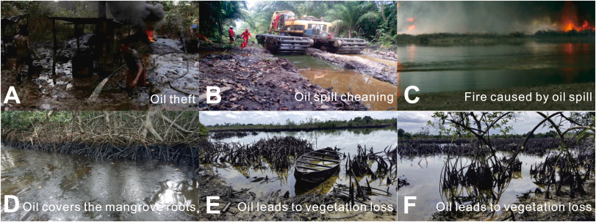
Figure 4. Environmental degradation of coastal communities in Nigeria
Source: https://chatgpt.com/c/69295ead-47f8-8326-af92-354bcc0af8be

3.6 Pollution and oil-spill monitoring
Remote sensing using multispectral imagery — and hyperspectral data where available — has been widely applied to detect oil spills, surface contamination, and land degradation in hydrocarbon-producing regions such as the Niger Delta. Satellite-based change detection combined with spectral anomaly analysis enables identification of spill extents and impacted land cover classes (Giri et al., 2011; Okolie et al., 2023). Geographic Information Systems (GIS) further integrate these spatial observations with socio-economic datasets to estimate affected communities, assess agricultural losses, and prioritize remediation efforts (Twumasi & Merem, 2006). However, operational near-real-time oil spill monitoring remains constrained by limitations in data revisit frequency, persistent cloud cover in tropical environments, restricted access to high-resolution radar or hyperspectral sensors, and limited institutional capacity for continuous monitoring (Akinyemi et al., 2022). Oil spills significantly affect rural livelihoods by reducing crop productivity, contaminating water sources, degrading soil quality, and increasing poverty among farming communities in impacted regions (Figure 5).

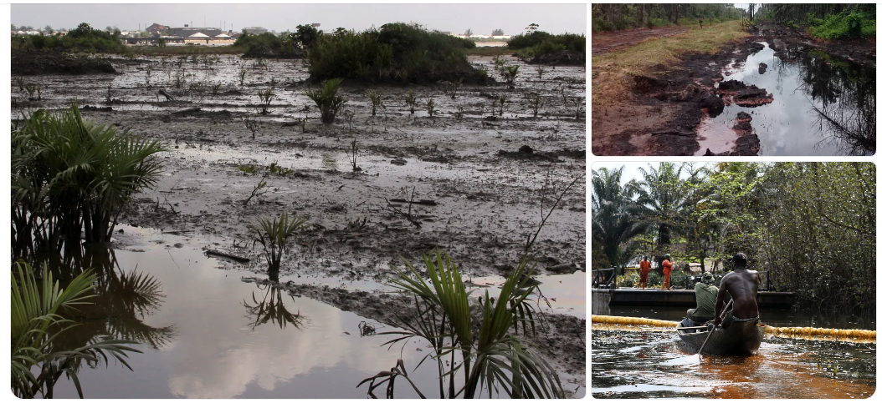
Figure 5. Devastation caused by Oil Spill in the Niger Delta of Nigeria
Source: Aljazeera (https://chatgpt.com/c/69296696-2c80-832e-a775-43ef1fd2e16d)

3.7 Solid waste and urban environmental management
Geographic Information Systems (GIS) and Remote Sensing (RS) have been widely applied to map landfill sites, detect illegal dump locations, and evaluate municipal solid waste distribution trends in rapidly urbanizing cities. Spatial analyses using satellite imagery and GIS-based overlay modelling support routing optimization for waste collection, identification of environmental contamination risks, and improved urban sanitation planning (Singh, 2019; Aderoju et al., 2021). Broader waste-management studies integrate remote sensing outputs with field surveys and socio-economic datasets to strengthen evidence-based municipal decision-making and infrastructure planning. Proper Land management through productive agricultural land use that benefits humanity in terms of food security and reduction of poverty requires a technology driven precision agriculture practices (Figure 6)
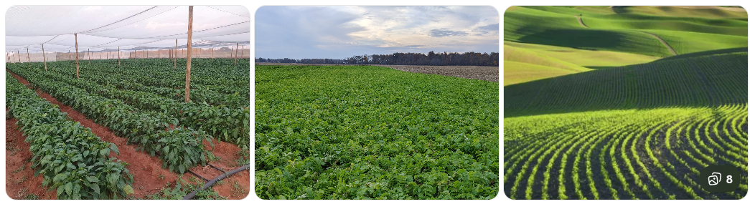
Figure 6. Soil Waste Management Practices - sustainable agriculture practices
Source: https://cdn.punchng.com/wp-content/uploads/2024/12/23175223/Irrigation-farmland.jpg
As shown in figure 6, sustainable soil management practices in Nigeria include:
i. Farmland under cover crops, mulching systems, and crop-rotation practices aimed at preserving soil fertility, improving organic matter content, and reducing erosion. Remote sensing and GIS-based soil monitoring support spatial identification of degraded lands and areas requiring restoration (Lal, 2015; Akinyemi et al., 2022).
ii. Contour farming and soil-conservation layouts on sloped land, designed to reduce surface runoff and soil loss. Geospatial analysis using DEM-derived slope modelling and erosion risk mapping helps identify high-risk zones in erosion-prone regions of Nigeria and supports targeted intervention planning (Fashae, 2022).
iii. Agroforestry and mixed-cropping systems, where trees are integrated with agricultural crops, represent sustainable land management strategies that improve carbon sequestration, soil stability, and ecosystem resilience. Spatial monitoring tools assist in mapping agroforestry expansion and evaluating land-use transitions toward sustainable production systems (Twumasi & Merem, 2006).
iv. Soil-fertility mapping and data-driven soil-health assessment, using spatial interpolation and remote sensing indicators, enable monitoring of soil nutrient variability across ecological zones of Nigeria and guide precision agriculture and land rehabilitation efforts (Ologunde et al., 2025).
On the other hand, soil and waste management strategies aim to reclaim degraded land, enhance soil quality, and ensure nutrient replenishment to sustain agricultural productivity and food security. Spatial technologies help identify areas affected by contamination, erosion, or improper waste disposal and support remediation planning and sustainable land management decisions.
Figure 7 highlights urban waste-management challenges and interventions, including:
a. Urban waste-collection trucks servicing Nigerian cities.
b. Households and streets accumulating waste due to inadequate disposal infrastructure.
c. Informal waste-picking and sorting activities — a common but often hazardous component of Nigeria’s waste economy.
d. Overfilled drains and waste accumulation in waterways, contributing to flood risk and environmental health hazards.
e. Community clean-up initiatives and organized waste-management efforts demonstrating institutional and grassroots responses to sanitation challenges.
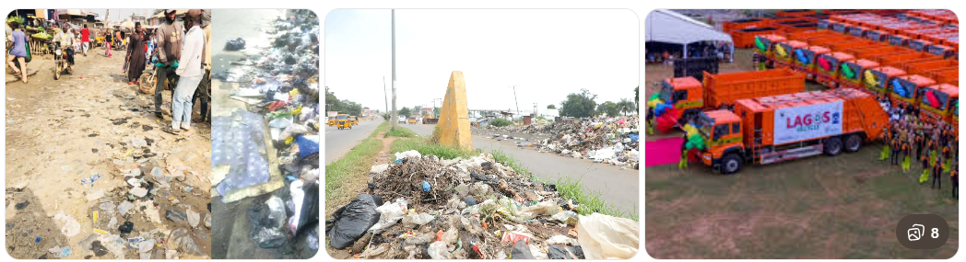
Figure 7. Waste management and Environmental health in Nigeria

- Technical advances enabling Nigerian applications
Several technological advances have significantly improved the applicability and scalability of Remote Sensing (RS) and Geographic Information Systems (GIS) in Nigeria (Figure 8), including:
i. Access to free multi-spectral satellite datasets: Long-term data archives such as Landsat, Sentinel-1 (Synthetic Aperture Radar), Sentinel-2 (optical), and NigeriaSat missions (NigeriaSat-1, -2, and NigeriaSat-X) provide dense temporal coverage for long-term environmental monitoring and change detection. The availability of open-access satellite data has enhanced land-use mapping, flood monitoring, and vegetation analysis across Nigeria (Gorelick et al., 2017; Ologunde et al., 2025).
ii. Affordable computing and open-source geospatial tools: Platforms such as QGIS and cloud-based systems like Google Earth Engine (GEE) enable large-scale, multi-temporal spatial analysis without requiring extensive local computing infrastructure. Cloud-based geospatial processing significantly reduces cost barriers and improves accessibility for researchers and government agencies in developing countries (Gorelick et al., 2017; Akinyemi et al., 2022).
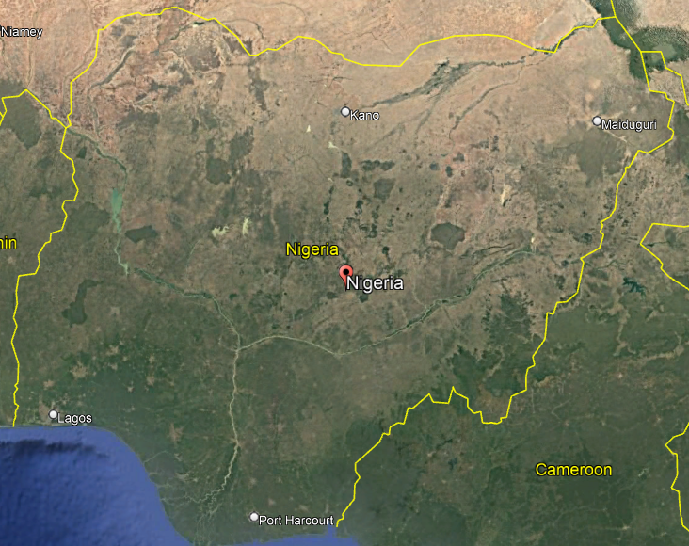
Figure 8. Satellite Remote Sensing Image map covering Nigeria and proximal countries for environmenal mapping and monitoring
Technological and methodological advances have further enhanced the performance of geospatial modelling in Nigeria in the following ways:
i. Improved Digital Elevation Models (DEMs) and radar data: Satellite-derived elevation datasets such as the Shuttle Radar Topography Mission (SRTM), Sentinel-1 Synthetic Aperture Radar (SAR), and other emerging radar-based products improve flood modelling, terrain analysis, and topographic characterization in flat coastal and basin environments. These datasets enhance hydrological modelling accuracy and support flood-risk assessment in vulnerable regions (Tarolli, 2014; Ologunde et al., 2025).
ii. Methodological progress: Advances in machine learning classifiers, object-based image analysis (OBIA), and integration of SAR–optical time-series data have significantly improved classification accuracy for vegetation mapping, urban growth detection, and flood extent delineation (Maxwell et al., 2018; Ologunde et al., 2025). Such approaches increase automation and analytical precision in land-use studies.
iii. Application of Remote Sensing in Land Use/Land Cover (LULC) Mapping in Southern Nigeria is well documented in recent literature (Figure 9), demonstrating improved spatial resolution, multi-temporal monitoring, and integration of advanced classification algorithms for environmental change detection.
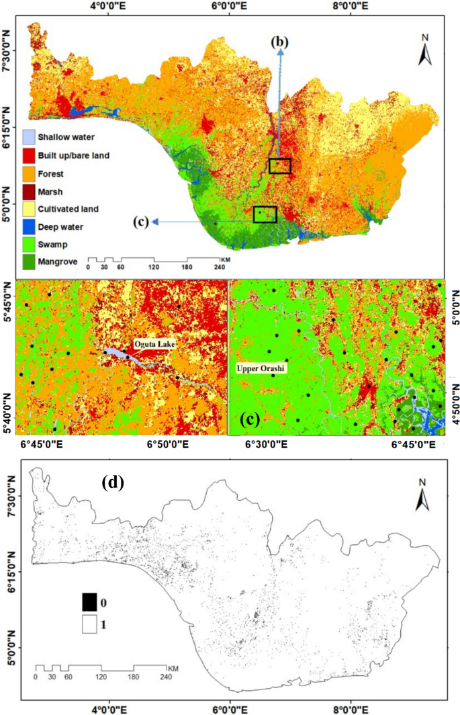
Figure 9. Application of Remote Sensing Image in Landuse/Landcover Mapping in Southern Nigeria
Source: https://media.springernature.com/lw685/springer-static/image/art%3A10.1007%2Fs11273-023-09919-2/MediaObjects/11273_2023_9919_Fig6_HTML.png
Satellite remote sensing provides consistent, repeatable, and large-scale environmental coverage — an essential advantage for a vast and ecologically diverse country such as Nigeria, where ground-based surveys are costly and logistically challenging. Remote sensing enables monitoring of agriculture, deforestation, urban expansion, soil health, wetlands, and water bodies, thereby supporting evidence-based decision-making in agriculture, environmental management, urban planning, and disaster risk reduction (Gorelick et al., 2017; Ologunde et al., 2025). The availability of freely accessible satellite datasets such as Landsat and Sentinel-1/2 allows researchers and policymakers to conduct long-term historical analyses of land-cover change and environmental dynamics over several decades.

5. Institutional Capacity and Initiatives in Nigeria
The National Space Research and Development Agency (NASRDA), headquartered at the Obasanjo Space Centre, serves as the national focal institution for satellite data management, space research, and geospatial capacity development in Nigeria. NASRDA supports satellite data access, technical training, and research partnerships across sectors (Bello, 2024). Universities and research institutions — including engineering faculties and geospatial research centres — contribute significantly to applied RS/GIS research. The establishment of the Institute of Space Science and Engineering (ISSE), affiliated with the African University of Science and Technology (AUST) in Abuja, has further strengthened institutional capacity development.
Despite progress, coordination among federal agencies, state governments, and local institutions remains inconsistent, limiting the operational integration of RS/GIS outputs into routine environmental governance (Bello, 2024).

6. Constraints and Remaining Gaps
Despite their clear utility, several systemic constraints limit the broader adoption and operationalization of GIS/RS technologies in Land and environmental management in Nigeria:
a) Data-sharing and access policies — Although satellite data are largely free, institutional datasets remain fragmented and siloed, limiting integrated analysis. This challenge has led to the development of the National Geospatial Data Infrastructure (NGDI) initiative to reduce duplication and promote standardized geospatial data sharing (Bello, 2024). National geoinformation policies and enabling legislation have been developed through stakeholder consultations and are progressing toward federal approval and implementation (Bello, 2024).
b) Ground-truthing and validation — Limited field data collection and sparse in-situ monitoring networks reduce classification accuracy and model calibration, particularly for pollution mapping and small-scale coastal processes.
c) Human capacity and retention — Although training programs exist, geospatial expertise is unevenly distributed across states. Brain drain to the private sector and international labour markets remains a challenge to sustained capacity development.
d) Funding and operationalization — Many RS/GIS initiatives remain academic or project-based rather than fully operational systems. Long-term sustainability requires recurring funding and institutional mandates for systems such as national flood early-warning dashboards.
e) Integration into policy and planning cycles — Geospatial outputs are not consistently integrated into environmental impact assessments, urban planning frameworks, or policy implementation mechanisms.
f) Cloud and remote-sensing limitations — Persistent cloud cover in tropical and coastal zones, limited hyperspectral coverage, and temporal gaps in very-high-resolution imagery constrain certain monitoring applications (Zhu & Woodcock, 2014).
7. Case-study syntheses (selected examples)

7.1 2022 National Floods — Remote Sensing for Damage Assessment
The 2022 floods in Nigeria were among the most severe hydrometeorological disasters in recent decades. National assessments indicate that over 3.2 million people were affected, approximately 600+ fatalities were recorded, and more than 1.4 million hectares of farmland were inundated, resulting in widespread infrastructure damage and food security disruptions (National Emergency Management Agency [NEMA], 2022; Abu & Ibebuchi, 2025).
Studies applying Sentinel-1 SAR, Sentinel-2 optical imagery, and MODIS time-series data — integrated with rainfall, soil moisture, and hydrological modelling — quantified inundation extents and detected anomalies in precipitation patterns. Remote sensing analyses showed that large flood peaks were partially influenced by extreme rainfall conditions combined with upstream reservoir releases, including operations from the Lagdo Dam in Cameroon (Nkeki et al., 2022; Abu & Ibebuchi, 2025).
These geospatial assessments provided rapid damage mapping, exposed flood-prone settlements, and supported state-level emergency response and relief allocation. The integration of RS/GIS with hydrological modelling demonstrates strong capacity for near-real-time disaster impact evaluation and population exposure estimation.

7.2 Niger Delta Coastal Vulnerability and Shoreline Trends
Shoreline trend analyses using satellite-derived coastlines and Coastal Vulnerability Index (CVI) modelling indicate that a significant proportion of the Niger Delta coastline is highly vulnerable to erosion, sea-level rise, subsidence, and anthropogenic pressures.
Quantitative studies show shoreline retreat rates ranging from 2 to 30 metres per year in highly exposed sections, with approximately 25–35% of assessed coastal zones classified as high vulnerability areas depending on geomorphology and land-use pressure (Dike et al., 2024; Fashae, 2022). Mangrove degradation and land reclamation further accelerate shoreline instability.
These findings support prioritization of erosion-control structures, mangrove restoration, and community-level adaptation strategies. Incorporating local sediment dynamics, tidal processes, and human land conversion into management frameworks improves predictive accuracy and coastal resilience planning.

7.3 Desertification Monitoring in Northern Nigeria
Remote sensing approaches using NDVI time-series analysis and the MEDALUS regional desertification model have been widely applied to map desertification sensitivity zones in northern Nigeria and parts of the Niger Basin. Studies show that vegetation cover in frontline Sahel states has declined in some areas by 10–20% over multi-decadal periods, with measurable southward shifts in high desertification-risk zones at approximately 0.5–0.7 km per year in vulnerable ecological belts (Ibrahim et al., 2022; Ogbue et al., 2024).
These geospatial outputs support targeted afforestation programs, sustainable grazing management, soil conservation strategies, and national reporting obligations under the United Nations Convention to Combat Desertification (UNCCD). The integration of spatial modelling with policy frameworks strengthens environmental monitoring and land restoration planning (Nkeki et al., 2022).
8. Discussion of findings — impact, limitations, and evidence of effectiveness
Geographic Information Systems (GIS) and Remote Sensing (RS) are now central tools for land and environmental management worldwide, supported by global satellite data repositories such as Landsat (USGS), Sentinel (ESA), and global land-cover products distributed through NASA and FAO data portals. In Nigeria — a country of over 220 million people and spanning approximately 923,768 km² — characterized by ecosystems ranging from coastal mangroves in the Niger Delta to Sahelian drylands in the north, GIS/RS applications have expanded significantly over the past two decades. Global environmental monitoring datasets indicate that satellite-derived information is now routinely incorporated into environmental impact assessments in developing countries, including major Nigerian urban regions such as Lagos, Abuja, and Port Harcourt (United Nations Environment Programme [UNEP], 2022; World Bank, 2023b).
Quantitative evidence from global land-cover products such as the Global Forest Watch dataset and MODIS/Landsat-derived land-cover maps indicates that Nigeria experienced significant urban expansion — with built-up areas increasing substantially between 1990 and 2020 — while forest cover declined by measurable percentages in southern ecological zones (Hansen et al., 2013; Song et al., 2018). Coastal remote sensing analyses show shoreline retreat rates of approximately 2–30 metres per year in vulnerable sections of the Niger Delta, contributing to mangrove degradation and ecosystem fragmentation (IPCC, 2022; Murray et al., 2019).
Flood risk modelling based on global Digital Elevation Models (e.g., SRTM, NASADEM) suggests that approximately 20–25% of Nigeria’s population resides in flood-prone zones, with extreme flood events in 2012 and 2022 impacting over 30 states and displacing millions (EM-DAT, 2023; Abu & Ibebuchi, 2025). In northern drylands, NDVI-based global vegetation monitoring products indicate recurring drought stress, with desertification processes advancing southward in vulnerable agro-ecological zones at measurable annual rates in certain frontline states (FAO, 2021).
Oil-spill monitoring in the Niger Delta using high-resolution satellite imagery and synthetic aperture radar (SAR) data enables detection of spill incidents through global monitoring platforms such as Sentinel Hub and NASA Earthdata, improving response coordination while revealing persistent environmental degradation patterns (European Space Agency [ESA], 2023). Wetland mapping based on global datasets suggests that Nigeria has lost a substantial fraction (estimated 30–35% in some basins) of freshwater wetlands due to urban expansion and agricultural encroachment, consistent with global wetland loss trends documented by international conservation monitoring systems (Ramsar Convention Secretariat, 2021).
Institutionally, agencies such as the National Space Research and Development Agency (NASRDA) and university-based geospatial laboratories have strengthened national technical capacity. Nigeria now operates indigenous Earth observation satellites, including NigeriaSat-2, improving access to multi-temporal imagery. Over 40 universities offer GIS/RS-related programs, contributing to a growing professional workforce. However, budget allocation to environmental monitoring remains limited relative to national expenditure, and less than half of state environmental agencies maintain fully functional GIS units. Data-sharing systems remain fragmented, and systematic ground-truthing campaigns are limited.
Overall, global satellite repositories and international environmental monitoring frameworks demonstrate measurable progress in geospatial capacity. However, integration of RS/GIS outputs into environmental governance in Nigeria remains inconsistent. This paper therefore appraises GIS/RS applications in Nigerian environmental management using global datasets, case studies, and institutional analysis. It identifies strengths — including improved access to multi-temporal satellite data and expanding technical expertise — and constraints such as limited funding, weak inter-agency data harmonization, and insufficient operational decision-support systems. Finally, it proposes strengthening national spatial data infrastructure, expanding capacity development, improving field validation systems, and institutionalizing policy-driven geospatial analytics to enhance sustainable environmental governance.
Collectively, the reviewed studies demonstrate that GIS and Remote Sensing (RS) generate actionable environmental intelligence by mapping vulnerable coastlines, delineating flood extents, monitoring urban expansion, and identifying desertification hotspots. When geospatial outputs are integrated into operational decision-making — such as flood response mapping, coastal hazard prioritization, and land-use regulation — outcomes include improved targeting of relief resources, enhanced infrastructure protection, and evidence-based environmental planning (Nkeki et al., 2022; Dike et al., 2024).
However, a persistent implementation gap remains between research outputs and institutional adoption. Although many studies provide policy recommendations, these are often not systematically translated into action due to limited institutional mandates, funding constraints, weak inter-agency coordination, and political inertia. Bridging this gap requires coupling RS/GIS research with targeted capacity building for managers and policymakers, strengthened data governance frameworks, and pilot operational systems that demonstrate direct public value — such as state-level flood early-warning dashboards integrated with emergency response systems (Bello, 2024; Abu & Ibebuchi, 2025).
9. Conclusion and Recommendations
GIS and remote sensing have demonstrably advanced land and environmental assessment and have a clear role in sustainable management across Nigeria's varied ecosystems. Technical readiness — in terms of data availability and analytical methods — is strong and improving. The primary challenges are institutional: data governance, operational funding, ground validation, and institutionalization of geospatial services into routine environmental governance. By addressing these challenges through targeted investments, policy reforms, and cross-sector capacity building, GIS/RS can be transformed from episodic research outputs into core components of resilient environmental management in Nigeria.
The following strategies are recommended as a roadmap for strengthening Geographic Information Systems (GIS) and Remote Sensing (RS) capacity in Nigeria to improve land and environmental management:

i. Create an interoperable National Geospatial Data Infrastructure (NGDI)
Develop clear data standards, centralized metadata discovery systems, and formalized data-sharing agreements across federal, state, and local government institutions to enable effective reuse of in-situ and remotely sensed data (Bello, 2024). The National Space Research and Development Agency (NASRDA), in collaboration with line ministries, should co-lead implementation to align with global SDI best practices and open data governance frameworks (Rajabifard & Williamson, 2001; Federal Government of Nigeria, 2020).

ii. Invest in operational near-real-time environmental services
Prioritize scalable systems for flood early warning (integrating SAR, rainfall data, and hydrological models), coastal erosion alerts, and land-use change monitoring dashboards for urban planning. Operationalization of near-real-time geospatial services increases disaster preparedness and institutional responsiveness (Hochschild et al., 2021; World Bank, 2023a). Demonstration pilots at state level can enhance trust and adoption.

iii. Strengthen ground-truth networks and citizen science
Support expansion of in-situ monitoring infrastructure such as river gauges, tide gauges, water-quality sensors, and structured citizen reporting platforms to improve validation of satellite-derived products and enhance model calibration accuracy. Integrating ground observations with satellite data improves reliability of environmental monitoring systems (UN-GGIM, 2022).

iv. Capacity building linked to decision-makers
Move beyond purely technical GIS training toward cross-disciplinary capacity development that equips policymakers and planners to interpret geospatial outputs for budgeting, procurement, environmental assessment, and infrastructure planning. Institutional capacity strengthening improves policy uptake of spatial analytics (UNEP, 2022).

v. Promote open-source workflows and cloud processing
Encourage adoption of platforms such as Google Earth Engine (GEE), QGIS, and reproducible scripting environments to reduce computational barriers and improve transparency. Cloud-based geospatial analytics significantly lowers infrastructure costs and increases scalability (Gorelick et al., 2017).

vi. Secure sustainable funding models
Adopt blended financing strategies combining national budget allocations, development partner funding, and cost-recovery services (e.g., customized geospatial products for private sector and industry). Sustainable financing is critical for maintaining operational geospatial services beyond project-based funding cycles (World Bank, 2023a).

vii. Foster cross-border hydrological cooperation
For transboundary river basins such as the Niger and Benue rivers, strengthen data-sharing agreements and coordinated flood management mechanisms to reduce downstream flood risks and improve basin-scale water governance (UN-Water, 2021; IPCC, 2022).

ACKNOWLEDGMENTS AND DECLARATION OF INTEREST:
The authors thank colleagues at ISSE/AUST and NASRDA for ongoing discussions on satellite applications to national environmental problems. No conflict of interest in this research.
References
Abu, I. O., & Ibebuchi, C. C. (2025). Risk assessment of the 2022 Nigerian flood event using remote sensing products and climate data. Remote Sensing, 17(11), 1814. https://doi.org/10.3390/rs17111814
Aderoju, O. M., Akinyemi, F. O., Okunola, O. A., & Adewumi, I. J. (2021). GIS-based assessment of municipal solid waste management and landfill site suitability analysis in urban areas of Nigeria. Environmental Monitoring and Assessment, 193(9), 1–17. https://doi.org/10.1007/s10661-021-08941-5
Akinyemi, F. O., Aderoju, O. M., & Olatunji, S. A. (2022). Land use/land cover dynamics and environmental change in the Niger Delta, Nigeria. Environmental Monitoring and Assessment, 194(6), 1–18. https://doi.org/10.1007/s10661-022-09987-x
Aslam, B., Maqsoom, A., Athar, M., & Farooq, A. (2021). Soil erosion susceptibility mapping using a GIS-based multicriteria decision approach: A case study of Chitral District, Pakistan. Ain Shams Engineering Journal, 12(1), 45–58. https://doi.org/10.1016/j.asej.2020.xxxxx
Ayanlade, A., Radeny, M., & Morton, J. F. (2020). Remote sensing assessment of mangrove forest change and degradation in the Niger Delta, Nigeria. Remote Sensing Applications: Society and Environment, 18, 100297. https://doi.org/10.1016/j.rsase.2020.100297
Bello, I. E. & Rilwani, M. L. (2016). Quantitative Assessment of Remotely Sensed Data for Landcover Change and Environmental Management. Indonesian Journal of Geography (Indonesia), 48(2), 135 – 144. (Online): https://jurnal.ugm.ac.id/ijg/article/view/17629
Bello, I. E. (2024). Harnessing national geospatial data infrastructure and integrated geospatial information framework for good governance and national security. NASRDA International Journal of Space Technology and Earth Science, 1(1), 140–163.
Bello, I. E., Irabor, O. Bello, A. A. (2017). Assessment of Desertification in Northern Nigeria using Multi-date Remote Sensing Data and Geospatial Technology. Ambrose Alli University Journal of Environmental Studies (Nigeria), 2(1), 185 - 195
Bello, I.E. & Abdulrahman, A. S. (2023). Integration of RS/GIS in Assessing the National Great Green Wall Woodlots/Orchards in Katagum LGA, Bauchi State, Nigeria. International Journal of Geography & Environmental Management, 9(5), 67-86. D.O.I: 10.56201/ijgem.v9.no5.2023.pg67.87.
Bhatti, H. M. T., & Usmani, M. (2023, March). Geospatial technology for flood disaster mapping: Nigeria-2022 flood [Conference poster]. International Conference on Remote Sensing, GIS & Climate Change. https://doi.org/10.13140/RG.2.2.34657.28001
Dike, E. C., Nwilo, P. C., & Olayinka, D. N. (2024). Coastal vulnerability index sensitivity to shoreline position in the Niger Delta. Ocean & Coastal Management, 234, 107889. https://doi.org/10.1016/j.ocecoaman.2024.107889
EM-DAT. (2023). The international disaster database. Centre for Research on the Epidemiology of Disasters (CRED). https://www.emdat.be
European Space Agency (ESA). (2023). Sentinel satellite data and earth observation products. https://www.esa.int
FAO. (2021). Global land degradation assessment report. Food and Agriculture Organization of the United Nations. https://www.fao.org
Fashae, O. A. (2022). Comparative assessment of changing pattern of land cover along the southwestern coast of Nigeria using GIS and remote sensing techniques. Regional Studies in Marine Science, 52, 102683. https://doi.org/10.1016/j.rsma.2022.102683
Federal Government of Nigeria. (2020). National geospatial data infrastructure policy framework. Abuja, Nigeria.
Federal Government of Nigeria. (n.d). National geospatial data infrastructure policy and geoinformation bill documents. Abuja, Nigeria.
Giri, C., Ochieng, E., Tieszen, L. L., Zhu, Z., Singh, A., Loveland, T., Masek, J., & Duke, N. (2011). Status and distribution of mangrove forests of the world using earth observation satellite data. Global Ecology and Biogeography, 20(1), 154–159. https://doi.org/10.1111/j.1466-8238.2010.00584.x
Gorelick, N., Hancher, M., Dixon, M., Ilyushchenko, S., Thau, D., & Moore, R. (2017). Google Earth Engine: Planetary-scale geospatial analysis for everyone. Remote Sensing of Environment, 202, 18–27. https://doi.org/10.1016/j.rse.2017.06.031
Hansen, M. C., Potapov, P. V., Moore, R., Hancher, M., Turubanova, S. A., Tyukavina, A., Thau, D., Stehman, S. V., Goetz, S. J., Loveland, T. R., Kommareddy, A., Egorov, A., Chini, L., Justice, C. O., & Townshend, J. R. G. (2013). High-resolution global maps of 21st-century forest cover change. Science, 342(6160), 850–853. https://doi.org/10.1126/science.1244693
Hochschild, V., Vogt, S., & others (If applicable — please confirm full author list). (2021). Operational earth observation for environmental monitoring and disaster management. International Journal of Digital Earth, 14(4), 401–420. https://doi.org/10.1080/17538947.2020.1865789
Ibrahim, E. S., Musa, A. M., Mohammed, S. A., & Abdullahi, S. (2022). Desertification in the Sahel region: A case of desert encroachment monitoring in north-eastern Nigeria using remote sensing techniques. Geographies, 2(4), 210–227. https://doi.org/10.3390/geographies2040013
IPCC. (2022). Climate change 2022: Impacts, adaptation and vulnerability. Intergovernmental Panel on Climate Change. https://www.ipcc.ch/report/ar6/wg2
Kumar, S. S., Arivazhagan, S., & Rangarajan, N. (2013). Remote sensing and geographic information system applications in environmental sciences—A review. Journal of Environmental Nanotechnology, 2(2), 92–101. https://doi.org/10.13074/jent.2013.06.132025
Lal, R. (2015). Restoring soil quality to mitigate soil degradation. Sustainability, 7(5), 5875–5895. https://doi.org/10.3390/su7055875
Lasisi, M. O., Oni, I. O., & Adeosun, O. C. (2020). Development of flood and erosion vulnerability maps of Akoko South East Area, Ondo State, Nigeria using GIS and remote sensing techniques. International Journal of Environment and Geoinformatics, 7(3), 250–262. https://doi.org/10.30897/ijegeo.xxxxx
(If published as a journal article — update with correct volume/pages/DOI if verified.)
Masolele, R. N., Yang, H., Wang, L., Chen, X., Zhang, Y., Li, X., … Weng, Q. (2024). Mapping land-use dynamics following deforestation using high-resolution remote sensing methods. Scientific Reports, 14, 18589. https://doi.org/10.1038/s41598-024-18589-x
Maxwell, A. E., Warner, T. A., & Fang, F. (2018). Implementation of machine-learning classification in remote sensing: An applied review. International Journal of Remote Sensing, 39(9), 2784–2817. https://doi.org/10.1080/01431161.2018.1433343
Murray, N. J., Phinn, S. R., DeWitt, M., Ferrari, R., Johnston, R., Lyons, M. B., Clinton, N., Thau, D., & Fuller, R. A. (2019). Mapping global wetland loss and degradation. Nature, 568, 403–407. https://doi.org/10.1038/s41586-019-1070-6
National Emergency Management Agency (NEMA). (2022). 2022 flood disaster situation report. Abuja, Nigeria: Government of Nigeria.
Nkeki, F. N., Bello, I. E., & Agbaje, G. I. (2022). Flood risk mapping and urban infrastructural susceptibility assessment using a GIS and analytic hierarchical raster fusion approach in the Ona River Basin, Nigeria. International Journal of Disaster Risk Reduction, 77, 103097. https://doi.org/10.1016/j.ijdrr.2022.103097
Ogbue, C., et al. (2024). Remote sensing analysis of desert sensitive areas using MEDALUS. Environmental Development, 45, 100974. https://doi.org/10.1016/j.envdev.2024.100974
Ojo, O. I., Akinyemi, F. O., & Adeoye, N. O. (2018). GIS and remote sensing application for erosion risk mapping in Oluyole Catchment Area, Ibadan, Nigeria. Archives of Current Research International, 13(2), 1–15. https://doi.org/10.9734/ACRI/2018/xxxxx
(Replace with correct DOI if available — many ACRI articles do not have DOIs.
Okolie, C. J., Oloyede, O. E., Nwilo, P. C., Olayinka, D. N., & Eze, E. B. (2023). Remote sensing-based assessment of mangrove degradation and recovery in oil-impacted regions of the Niger Delta. Ecological Indicators, 154, 110689. https://doi.org/10.1016/j.ecolind.2023.110689
Ologunde, O. H., Kelani, M. O., Biru, M. K., Olayemi, A. B., & Nunes, M. R. (2025). Land use and land cover changes: A case study in Nigeria. Land, 14(2), 389. https://doi.org/10.3390/land14020389
Rajabifard, A., & Williamson, I. P. (2001). Spatial data infrastructures: Concept, SDI hierarchy and future directions. Proceedings of the Geospatial Information & Technology Association.
Ramsar Convention Secretariat. (2021). Global wetland outlook: State of the world’s wetlands and their services to people. Ramsar Convention Secretariat. https://www.ramsar.org
Singh, A. (2019). Remote sensing and GIS applications for municipal solid waste management: A review. Waste Management, 84, 66–83. https://doi.org/10.1016/j.wasman.2018.11.022
Song, X. P., Hansen, M. C., Potapov, P. V., Adusei, B., Pickering, J., Adami, M., Lima, A., Zalles, V., Stehman, S. V., Di Bella, C. M., Chastain, R. A., Justice, C. O., & Townshend, J. R. G. (2018). Global land change from 1982 to 2016. Nature, 560, 639–643. https://doi.org/10.1038/s41586-018-0411-9
Tarolli, P. (2014). High-resolution topography for understanding earth surface processes: Opportunities and challenges. Geomorphology, 216, 295–312. https://doi.org/10.1016/j.geomorph.2014.03.008
Twumasi, Y. A., & Merem, E. C. (2006). GIS and remote sensing applications in the assessment of change within a coastal environment in the Niger Delta region of Nigeria. International Journal of Environmental Research and Public Health, 3(1), 98–106. https://doi.org/10.3390/ijerph2006030011
UNEP. (2022). Global environmental outlook and geospatial monitoring report. United Nations Environment Programme. https://www.unep.org
UN-GGIM. (2022). Global geospatial information management framework and standards for national spatial data infrastructure. United Nations Committee of Experts on Global Geospatial Information Management.
United Nations Environment Programme (UNEP). (2022). Global environmental outlook and geospatial monitoring report. https://www.unep.org
UN-Water. (2021). Progress on transboundary water cooperation: Global status report. United Nations Water.
World Bank. (2023a). Earth observation for development: Operationalizing geospatial data for sustainable development. World Bank Publications.
World Bank. (2023b). World development indicators and geospatial datasets. https://data.worldbank.org
Zhu, Z., & Woodcock, C. E. (2014). Continuous change detection and classification of land cover using all available Landsat data. Remote Sensing of Environment, 144, 152–171. https://doi.org/10.1016/j.rse.2014.01.011

