A Study On The Impact Of Students Attention In Academics With Influence Of Digital Trends

Authors: Shruthi. K S, Revanna Bhavya, B. Prem Kumar
Bengaluru North University
Master of Business Administration (MBA)
Patel Institute of Science and Management (PISM)
Bangaluru, India

ABSTRACT

Digital platforms are now a part of college life. College students use mobiles, laptops, learning apps and social media every day for college and personal things. These digital tools make life easy for students because they can take classes, get college work, turn in homework and talk to teachers and friends without a lot of trouble. Digital platforms make learning easier and faster. Digital platforms also have a downside. When students spend much time on digital platforms it can distract their focus. When you are using lots of media and doing things at the same time it is hard to focus. Media can be very distracting. You get a lot of messages. It is hard to concentrate on your work. If you sit in front of a screen for a time media can make students feel really tired. Students get tired, from using media for a time. When college students feel tired they have a time paying attention to their college work. The digital platforms that college students use can affect their ability to focus on their studies. This study is, about the platforms and how they affect the ability of college students to focus on their college work. The study looks at how the digital platforms affect college students and their ability to focus on their academics. It uses surveys that college students filled out and other research that has already been done to see what is going on with the platforms and college students. The research shows that digital platforms are helpful.

Keywords: online platforms, Education attention, Higher education students, Online learning, Distractions.

INTRODUCTION

Digital platform has become an important part of everyday life for college students. digital platforms such as smart phones, laptops, and various online platforms are regularly used to attend classes, finishing assignments, and find study materials. At the same time, students also spend much of time on social media, entertainment apps, and general internet browsing. Because of this digital platform are used so often, many of the students have difficulty in staying focused on their studies. Using the phone can be a problem. You take a break and then you end up staring at the phone screen. The phone can make it hard to focus on your studies. If you look at your messages or notifications or social media when you are supposed to be studying or you are in class, the phone can be really distracting. The phone is a distraction when you are trying to study or learn something, in class. The phone can confuse you about what you're trying to learn about studies. The phone can distract you from studies. Make it hard to understand the topic you are studying about the studies. Digital platforms are designed to keep users engaged, and continuous notifications further distract students from academic tasks. Excessive screen time also affects physical and mental health of students by causing eye strain, headaches, sleep disturbances, and fatigue. These factors reduce students’ ability to focus on their studies or academics Therefore, it is very much important to understand how digital platforms influence students’ academic attention. Students and institutions of learning will develop better strategies to balance the use of technologies with performance by understanding both the benefits and challenges of digital usage.

OBJECTIVES OF THE STUDY

- To analyse the time spent on using digital gadgets such as mobile phones and laptops.
- To study the effect of the use of several digital platforms at the same time on attention in academic activities.
- To identify the digital activities that cause the most distraction to students.
- To study the impact of using multiple digital platforms at the same time on academic attention.

SCOPE OF THE STUDY

1. The study is about students and how they use digital things.
2. It looks at how digital platforms and its impact for students when they are studying.
3. The study helps students to understand the balance using technology and doing their academics work.
4. It shows how digital platforms can really help students learn when they are used in the correct way.
5. The results of the study can help students realize their digital habits.

LITERATURE REVIEW

Mondal (2024). Examined a study about distractions and how they affect students. The study was looking at things like watching much media and trying to do a lot of things at once. The study found out that when students use their devices much they get really stressed they do not sleep very well and they do not do very well in college. The person who did the study said that students can do better in college if they put their devices away and chat with friends. This helps them handle distractions. The study was about how distractions affect students and their performance, in college. Digital distractions are a problem, for students.

Alhajjaj et al. (2025). Examined a study on using media affects university students and their college work. Social media is a way for students to get information for college and talk to each other. If students use it too much it can be a distraction and they will not pay attention to their studies. The people who did the study think that if students use media in a moderate way and only for college it can actually help them do better in college and learn more. Social media can be helpful for university students if they use it to get information and talk to other students, about college. University students should use media in a way that helps them with their college work. Social media usage is important for university students to understand so they can use it to their advantage.

Rahman, Hossain, and Akter (2025). Examined a study on the impact of social media affects students. It turned out that using media in moderation and, for college-related things actually helps students learn. On the hand spending too much time on social media and doing non-college things on it can be a distraction make it hard to focus and hurt grades overall. The people doing the research said that social media itself is not bad it's how you use it that matters. They think students should use media responsibly and for college to get better results.

HYPOTHESES OF THE STUDY

H0 (Null Hypothesis): Digital platforms do not have a significant impact on the academic attention of higher education students.

H1 (Alternative Hypothesis): Digital platforms have a significant impact on the academic attention of higher education students.

RESEARCH METHODOLOGY

The research is conducted in a quantitative, and analytical way. The primary data was gathered using structured questionnaires that were distributed to most college students. The questions were framed related to digital usage, social media usage, study routine, and concentration level. The secondary data was gathered from the journals, articles, and online sources. The data gathered was analysed using percentage analysis to provide insight into the trends and pattern.

DATA ANALYSIS AND INTERPRETATION

The data collected shows that students use platforms for college work and for fun. Although platforms for education like Google Classroom and Zoom help in learning, social media distractions like using the platform during the study hour. Notifications and multitasking reduce concentration levels. Students who limit screen time have been found to have more time to concentrate on academic work.

Figure 1. How many hours per day do you spend in social media.

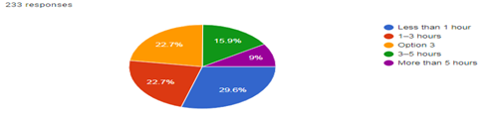

Table 1. How many hours per day do you spend in social media.
SL NO | Description | Responses | Percentage
1 | Less than 1 hour | 69 | 29.6%
2 | 1-3 hours | 53 | 22.7%
3 | Option 3 | 53 | 22.7%
4 | 3-5 hours | 37 | 15.9%
5 | More than 5 hours | 21 | 9%
Total |  | 233 | 100%

For the majority of students (29.6%), less than an hour each day is spent on social networks. About 22.7% of students spend 1–3 hours per day, which indicates moderate usage. Nearly 15.9% spend 3–5 hours, which shows that they are using social media on a regular basis. Heavy usage is less, only 9% of students spend more than 5 hours per day.
Figure 2. How often do social media notifications distract you during studies.

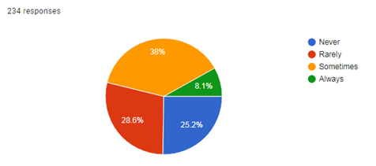

Table 2. How often do social media notifications distract you during studies.

SL NO | Description | Responses | Percentage
1 | Never | 59 | 25.2%
2 | Rarely | 67 | 28.6%
3 | Sometimes | 89 | 38%
4 | Always | 19 | 8.1%
Total |  | 234 | 100%
Most students (38%) say social media notifications sometimes distract them during studies. About 28.6% report that notifications rarely distract them. Around 25.2% say they are never distracted by notifications. Only 8.1% feel that notifications always distract them while studying.
Figure 3. Do you feel your academic performance is affected by social media use.

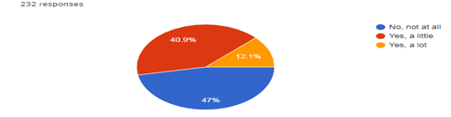

Table 3. Do you feel your academic performance is affected by social media use.

SL NO | Description | Responses | Percentage
1 | No, not at all | 109 | 47%
2 | Yes, a little | 95 | 40.9%
3 | Yes, a lot | 28 | 12.1%
Total |  | 232 | 100%

The pie chart indicates 232 students’ opinions on social media affecting academics. 47% say that social media does not affect them at all. 40.9% say it affects them a little, and 12.1% say it affects them a lot. The group that social media has a strong impact on is quite small compared to the group that social media does not affect the students or affects them a little.
Figure4. Do you use social media for educational purpose.

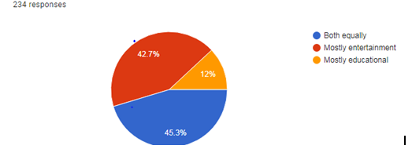

Table 4. Do you use social media for educational purpose.

SL NO | Description | Responses | Percentage
1 | Both equally | 106 | 45.3%
2 | Mostly entertainment | 100 | 42.7%
3 | Mostly Educational | 28 | 12%
Total |  | 234 | 100%
The chart shows that 45.3% of people use social media equally for education and entertainment. About 42.7% use it mostly for entertainment rather than learning. Only 12% of users mainly depend on social media for educational purposes. This shows that entertainment is still the dominant use of social media.
FINDINGS
- The internet and digital platforms make it really easy for the students gather the learning material and academic resources they required.
- When students spend much time on social media it can be a big distraction to them and they have a hard time to focus on their academics.
- Students who can balance their usage and study time tend to do better in college and get good grades because they are able to manage their time effectively and make the most of digital platforms and academic resources.
SUGGESTIONS

- Students should try to stay off media when they are studying.
- Colleges should conduct workshops that teach students how to manage their time and use things in healthy way.
- Use of digital platforms mostly for learning new things.
- Reduction in screen time can help us focus better and feel less stressed.
CONCLUSION

Digital platforms have a real impact on how higher education students are able to focus on their academic work.
Online learning tools are good just because they ease the process of learning and communication among students.
When students spend too much time on social media and try to do too many things at once they have a hard time focusing and become very stressed out. So it is very much important for the students to use platforms in a smart way. Colleges should teach students to harness the power of tools wisely and students need to employ time management skills to ensure that they excel in their studies and remain happy and healthy. Digital platforms can be of great help. Students need to use the digital platform in a way that will benefit their educational performance and mental health. Based on the findings of this study, the alternative hypothesis (H1) is accepted and the null hypothesis (H0) is rejected, given that digital platforms have a major effect on students’ academic attention.

REFERENCES
1. Alhajjaj (2025). Impact of social media on university student’s academic lives, 18.
2. Mondal, P. K. (2024). Exploring the impact of digital distraction on learning: A qualitative analysis of university student’s experiences and strategies, 3(9), 625–632.
3. Rahman, M., Hossain, M. S., & Akter, S. (2025). The impact of social media usage on students’ academic performance: Balancing connectivity and concentration, 12(4), 210–222.

