Usability of Train Ticket Apps for Low-Literacy Migrant Workers in India: A SUS Study

¹Shilpa Rajith, ²Lekshmi M P and ³Prashanth Cherian Kochuveetil

^{1.2}Student at Department of Master of Design Space, National Institute of Fashion Technology,
Bangalore
³ Associate Professor (Department of Design Space), National Institute of Fashion Technology, Bangalore
Abstract
Purpose: India's internal migrant workers estimated at 100 to 200 million drive urban India's construction, manufacturing, and domestic sectors, yet remain excluded from the ticket booking application, the sole official platform for online railway ticket booking. This study examines the app usability for low-literacy urban migrant workers, whose dependence on rail travel is structural and survival-linked, and whose interface needs have never been empirically measured.
Design/methodology/approach: A System Usability Scale (SUS) questionnaire, adapted into Hindi and basic English and administered orally to 44 low-literacy migrant workers in Bengaluru, was used alongside task-based observation. Descriptive statistics, Cronbach's alpha, Spearman correlations, and Mann-Whitney U tests were applied.
Findings: The mean SUS score of 55.16 falls below the accepted benchmark of 68. CAPTCHA complexity, inadequate vernacular language support, and non-linear navigation emerged as primary barriers. Exclusion does not stem from a single flaw but from cumulative technical and design processes across the system.
Research limitations/implications: Findings are limited to a single city with a cross-sectional sample of 44 participants, representing a diagnostic baseline.
Practical implications: The findings provide UX researchers and e-government designers with evidence-based directions for comprehension-first redesign, including simplified navigation, vernacular language support, and accessible authentication.
Social implications: A mandatory public service excluding its most transit-dependent users represents a structural equity failure, directly undermining digital inclusion for India's working poor.
Originality/value: This is among the first studies to measure ticket booking app usability with low-literate migrant workers who actively attempt and fail to book independently, filling a critical gap in HCI research on inclusive design for public-service platforms in the Global South.
Keywords - Low-Literacy Users, Urban Migrant Workers, HCI, Inclusive Design, Cross-sectional

1. Introduction
1.1 The Population
India's cities run on migrant labour. Every construction site, garment factory, and domestic household in urban India depends on workers who left their villages not by choice, but by economic necessity (Datta & Rajan, 2024). These workers are not a marginal population. They are the engine of urban productivity, contributing significantly to India's GDP while living at its periphery (Iyer & Rao, 2024).
But leaving home does not mean leaving it behind. These workers maintain deep, active ties to their villages sending remittances, returning for harvests, festivals, illnesses, and family obligations (Naik, 2024). The movement between city and village is not occasional. It is rhythmic, predictable, and survival-dependent. For an estimated 100 to 200 million circular migrants across India, this movement never stops (Datta & Rajan, 2024).
That movement requires a train ticket.
Indian Railways is not a convenience for this population. It is the only affordable bridge between where they work and where they belong (Datta & Rajan, 2024; Iyer & Rao, 2024). A missed train is a missed funeral. A failed booking is a lost wage. The stakes of accessing rail travel are not abstract; they are immediate, personal, and recurring.
1.2 The Context
For most of India's history, buying a train ticket meant standing in a queue. That option has quietly disappeared. Over the

past decade, Indian Railways has progressively shifted reserved ticket booking to digital platforms, culminating in the COVID-19 pandemic when smartphone applications became the sole authorised channel for accessing special passenger services (Srivastava et al., 2021). The queue was replaced by an app. The counter was replaced by a screen.
This shift was not designed with migrant workers in mind.
The application - the only official platform for online reserved booking, was built around assumptions of textual fluency, English or standard Hindi proficiency, and familiarity with hierarchical digital navigation (Medhi et al., 2011; Srivastava et al., 2021). For a worker who reads at a basic level, whose Hindi is a spoken dialect rather than textbook script, and who has never interacted with a form-based digital interface, the app presents a wall rather than a gateway.
The result is a population that depends on the railway more than any other, yet is systematically excluded from its primary booking channel. And the exclusion is not passive. It actively costs them in agent fees, in failed transactions, in duplicate payments, and in the quiet indignity of needing to ask someone else to perform a task that is, by law, their right to do themselves (Rayed et al., 2023; Jhamb, 2025).

1.3 Research Gap
HCI research has spent two decades designing for users with low literacy. Interfaces for agriculture, healthcare, and mobile banking have all been studied, tested, and redesigned with this population in mind (Medhi et al., 2011; Mohammed et al., 2023). That body of work is substantial and important.
What it has not touched is the digital gateway to India's rail infrastructure.
No published study has measured the usability of the application with low-literacy migrant workers as the primary participant group (Srivastava et al., 2021; Rayed et al., 2023). This is a significant omission. The population most dependent on the platform is the population least represented in research about it.
This study addresses that gap directly. It does not study users who have never touched the app. It studies the users who try, semi-literate workers with basic functional literacy in Hindi and English who actively attempt to book tickets independently, and fail (Medhi et al., 2011). This is the precise population at the point of exclusion, and it is the population whose experience has never been systematically measured.
By identifying where the interface fails these users and why this research proposes a comprehension-first design direction that moves beyond translation to advocate for simpler navigation flows, vernacular language support, and accessible authentication mechanisms (Bayor et al., 2018; Srivastava et al., 2021; Rayed et al., 2023). The goal is to show, with evidence, that the people who need it most cannot currently use it and to point toward what would need to change.

2. Literature Review
2.1 The Landscape of Low-Literacy Users in HCI
Designing technology for people who struggle to read is not a new problem. It is one of the oldest and most persistent challenges in Human-Computer Interaction (HCI) and one that the field has not yet solved (Skarlatidou et al., 2020; Srivastava et al., 2021).
The earliest responses were straightforward. If text is the barrier, remove the text. Researchers in the early 2000s designed text-free interfaces systems built entirely on icons, audio, and visual cues to help non-literate users access basic services (Medhi et al., 2011). These efforts were pioneering. But they were also limited. They assumed that illiteracy was the only problem, and that removing text would solve it.
The field has since learned otherwise.
As smartphones became the dominant platform for public services, research shifted toward a harder question: how do you make a complex, multi-step digital application usable for someone with low literacy? The answer is not simply to add pictures (Srivastava et al., 2021). It requires rethinking navigation structures, language registers, error recovery flows, and the cognitive load embedded in every screen transition.
What the research consistently finds is this: traditional text-based interfaces are functionally unusable for first-time low-literacy users (Medhi et al., 2011; Mohammed et al., 2023). Not difficult. Not frustrating. Functionally unusable meaning users cannot complete basic tasks even with assistance.
This is not a reflection of the users' inability. It is a reflection of design that was never built for them (Srivastava et al., 2021; Mohammed et al., 2023). Current digital architectures are built on an assumption of print literacy. When that assumption does not hold, the interface does not bend. The user is simply excluded. As (Mohammed et al., 2023) argue, this kind of structural exclusion makes literacy access a matter of justice, not just usability.

2.2 Digital Exclusion of Migrant Workers in India
For India's internal migrant workers, the barriers to digital participation go far deeper than not owning a smartphone. Most of them own one. The problem is what happens when they try to use it for something that matters (Naik, 2024; Srivastava et al., 2021).
Language is the first wall. Most government and financial apps in India operate in formal Hindi or English, a register that feels entirely foreign to workers who speak regional dialects at home and on the job (Medhi et al., 2011; Srivastava et al., 2021). The Hindi on a typical app screen is not the Hindi a construction worker from Bihar uses every day. It is a textbook Hindi formal, bureaucratic, and often incomprehensible to someone whose reading stops at a functional level.
The second wall is documentation. Many digital platforms require users to complete KYC verification or upload government-issued identity documents. Migrants who move between states, often without portable paperwork frequently cannot clear these requirements at all (Naik, 2024; Rayed et al., 2023). The digital door closes before they have even entered.
The third wall is fear. Digital transactions feel irreversible to someone who has never used one before. The worry of being scammed, or of making an error that cannot be undone, is not irrational; it is grounded in real experience and community memory (Jhamb, 2025; Mohammed et al., 2023). This fear is a psychological barrier as real as any interface flaw.
Together, these walls push workers toward a workaround that has become the norm. They hand their phone to a mobile shop owner. They ask a relative to book for them. They pay an agent a fee they can barely afford (Ahmed et al., 2013; Rayed et al., 2023). The system has not failed them quietly. It has redirected them into an informal economy built entirely around its own inaccessibility.
Nowhere is this more damaging than in train ticket booking. For India's estimated 100 to 200 million circular migrants, railways are not a travel option, they are a lifeline (Datta & Rajan, 2024; Srivastava et al., 2021). These workers travel to reach work, to send money home, to attend to family emergencies, and to return for festivals that anchor their identity to their place of origin. The shift to mandatory digital-only booking has not modernised this process for them. It has simply locked them out of it (Datta & Rajan, 2024; Srivastava et al., 2021).
Even workers who are motivated to learn the app find the booking flow too complex to complete independently (Rayed et al., 2023). They are not passive or unwilling. They are being failed by a system that was not designed with their reality in mind. The digital divide, in this context, is not about internet access. It is about whether the app itself was ever built for the person trying to use it (Jhamb, 2025; Naik, 2024; Srivastava et al., 2021).

2.3 Usability of Government and Transport Apps
The failures of the platform are not unique to India. They are part of a broader, well-documented pattern in the design of e-government services worldwide.
Research consistently shows that digital government platforms are built to serve institutions, not citizens (Aldrees & Gračanin, 2023). Efficiency, compliance, and administrative clarity are prioritised. The actual experience of the person sitting with the phone in their hand is treated as secondary or not treated at all (Aldrees & Gračanin, 2023; Guimarães et al., 2022). The result is platforms that work well for the educated, the digitally fluent, and the formally employed. For everyone else, they create new barriers where old ones used to be.
In India, this pattern is particularly stark. Digital-first public services covering health, welfare, transport, and payments routinely feature hierarchical menu structures and specialised terminology that users with limited formal education cannot parse (Srivastava et al., 2021). The assumption embedded in these designs is that the user arrives with a certain level of cognitive preparation. When they do not, the platform has no fallback. There is no simpler path. There is only failure.
The same pattern appears in transport services internationally. Digital mobility platforms, ticketing systems, journey planners, booking apps consistently fail what researchers have termed "vulnerable-to-exclusion" groups: older users, low-income users, and users with limited literacy (Delaere et al., 2024). Education level and income remain the strongest predictors of whether a person can successfully navigate these systems (Hall & Owens, 2011). This is not coincidental. It reflects who these systems were designed for, and who was never considered.
What makes this particularly difficult to defend is that these failures are not technical accidents. They are design choices (Aldrees & Gračanin, 2023). When accessibility is treated as an afterthought, something to be added after the core product is built. The result is a platform that gatekeepers essential services behind walls of assumed literacy (Cardinal et al., 2020). For migrant workers attempting to book a train ticket, these walls are not metaphorical. They are the CAPTCHA screen. They are the dropdown menu in formal Hindi. They are the multi-step navigation flow that offers no recovery when a user makes an error (Srivastava et al., 2021; Medhi et al., 2011).
The design did not set out to exclude them. But the outcome is exclusion all the same.
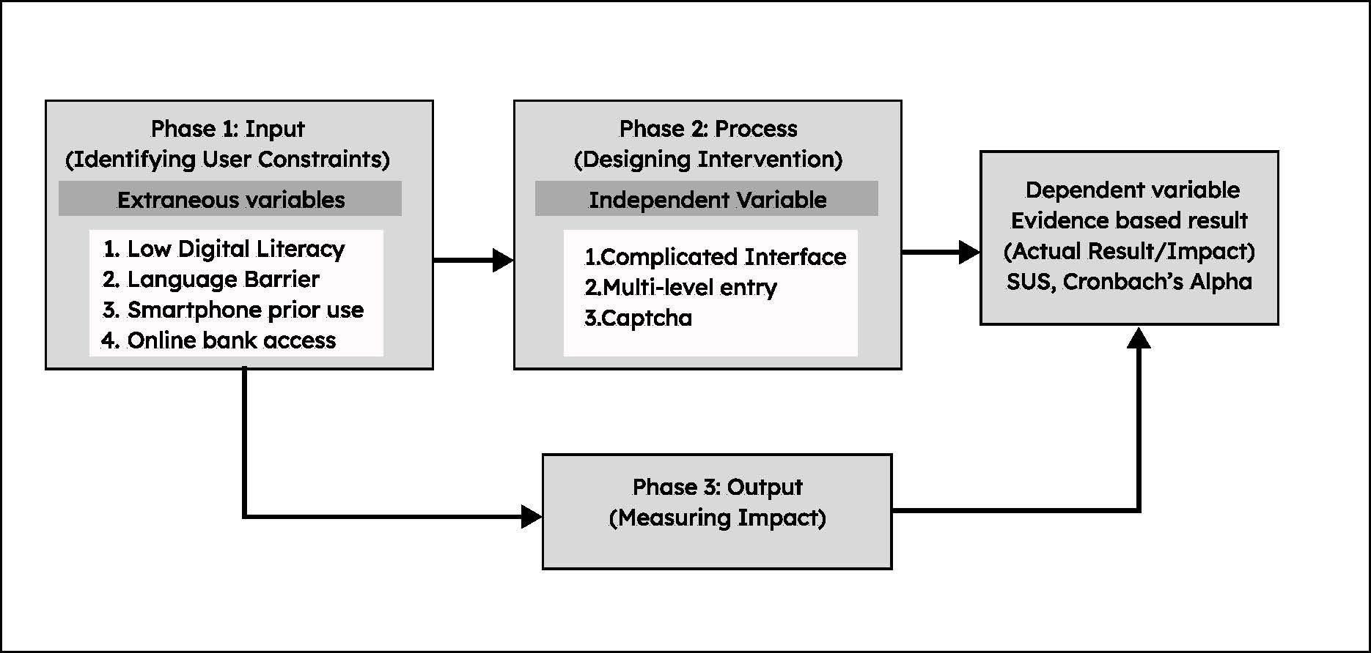

Figure 1. Research framework showing user constraints, design intervention, and measured impact.
Source: Author’s own work.

3. Methodology
3.1 Research Design
This study uses a descriptive quantitative design. The goal is not to test a new interface or propose a solution, not yet. The goal is more foundational than that: to establish, with evidence, how difficult the current booking experience is for the people who need it most, and to identify precisely where that difficulty lives.
A cross-sectional snapshot was chosen deliberately. Before redesign can be argued for, the baseline must be measured. This study provides that baseline.
The study proposes the following hypotheses:

H1: Low-literacy urban migrant workers will report low perceived usability of the current mobile application, reflected in SUS scores below the accepted benchmark and difficulty across key interaction steps.
H2: Low-literacy urban migrant workers will report low confidence in completing train-booking tasks independently using the current mobile application.
H3: Low-literacy urban migrant workers will report significant difficulty with specific interface elements particularly language comprehension, navigation flow, and CAPTCHA entry.
H0 (Null): There is no significant perceived usability challenge among low-literacy urban migrant workers when using the current mobile application.

3.2 Participants
Fifty-three migrant workers were initially approached. Forty-four were included in the final analysis (n=44), nine were excluded due to partially completed responses that could not be reliably scored.
Participants were recruited through purposive and snowball sampling. Purposive sampling ensured that all participants met the study's core eligibility criteria. Snowball sampling allowed access to a population that is mobile, informally employed, and not easily reached through institutional channels, participants referred the researchers to colleagues, neighbours, and co-workers in similar circumstances
To be included, participants had to meet three criteria. First, they needed to be internal migrant workers, residing in Bengaluru but originating from another Indian state. Second, they needed to have limited proficiency in reading and writing standard Hindi or English, functional at a basic level, but not fluent in the formal register used by digital platforms. Third, they needed to have no prior experience with computer interfaces, though regular smartphone use was permitted and expected.
This last criterion deserves explanation. The study does not target people who have never touched a smartphone. It targets people who own and use smartphones but consistently fail to complete the booking flow independently. This is the population at the actual point of exclusion, not those who self-exclude before trying, but those who try and are turned away by the interface itself (Medhi, Cutrell & Toyama, 2010; Gupta et al., 2022).
Participant profiles included domestic workers, construction labourers, mechanics, and vegetable vendors. Average educational attainment ranged from Class 4 to Class 8. Hindi was the primary spoken language for most participants, though dialectal variation was significant, several participants communicated in Urdu, Maithili, or Rajasthani rather than standard Hindi.

3.3 Research Instrument
The primary data collection tool is a ten-item questionnaire adapted from the System Usability Scale (SUS). The SUS was selected for three reasons. It is validated across decades of usability research (Brooke, 1996; Bangor et al., 2008). It is brief enough to administer without exhausting participants with limited reading stamina. And it captures perceived usability in a format that can be adapted for oral administration which this study required.
Standard SUS items were not used verbatim. The original scale uses abstract, double-negative phrasing that is difficult even for educated users. For this population, each item was rewritten into plain, concrete language grounded in the actual booking task. The adapted questions appear in Table 1.
The questionnaire uses a 5-point Likert scale. For participants who indicated they could read sufficiently, printed emoji-anchored scales were provided with a smiling face at one end, a frowning face at the other to reduce dependence on numerical or textual comprehension. For all other participants, responses were collected orally, with the researcher reading each item aloud and recording the response.
The instrument covers two constructs. Items Q1 through Q3 and Q5 through Q9 assess usability with the ease and fluency of interaction with the app. Items Q4 and Q10 assess learnability, how easily participants could complete the booking task and navigate the CAPTCHA step specifically.
The questions are curated as per the Indian context of human understanding;
Q1 | Do you use your smart-phone regularly?
Q2 | Do you play games on your phone?
Q3 | How confident are you using mobile apps on your own without help?
Q4 | How easy was it to book a train ticket?
Q5 | I think I will often use the train booking application.
Q6 | How comfortable are you with the Hindi language which is provided by the app?
Q7 | In my opinion, the features or menus in the ticket booking application are well-integrated.
Q8 | How often do you do the same task?
Q9 | How many times do you press the back button?
Q10 | How difficult did you feel during entering the captcha?
Table 1
3.4 Data Coding and Analysis
Once collected, data was prepared for analysis in two formats.
Questionnaire responses were coded numerically from 1 to 5, corresponding directly to the Likert anchors. Task performance was coded as binary 1 for successful completion, 0 for failure or false completion. A false completion, where a participant believed they had finished the task when they had not, was treated as a failure. It is not a partial success. It signals a deeper problem: the interface gave no meaningful feedback that something had gone wrong.
All analysis was conducted in Microsoft Excel. Four statistical procedures were applied in sequence, each chosen to answer a specific question about the data.
Descriptive statistics were calculated first. Means, medians, and standard deviations were generated for items Q3 through Q10. This step establishes the baseline of what the experience looked and felt like across the sample before any relationships between variables are examined.
Cronbach's alpha was then calculated for the five SUS-adapted items covering language comfort, feature integration, task repetition, back-button frequency, and CAPTCHA difficulty (Q6–Q10). This measures whether the five items are consistently capturing the same underlying construct's perceived usability or whether they are pulling in different directions. The target threshold was α > 0.70, which is the accepted standard for group-level usability research (Nunnally, 1978). Exceeding this threshold would confirm that the adapted scale is internally coherent.
Spearman rank correlations were conducted between perceived ease of booking (Q4) and each of the five usability items (Q6–Q10). Spearman's ρ was chosen rather than Pearson's r because the data is ordinal. Likert-scale responses do not carry equal intervals between points; the gap between "1" and "2" is not the same unit as the gap between "4" and "5." Pearson's r assumes continuous, normally distributed data. Spearman's ρ does not, making it the appropriate choice here (Brooke, 2013; Field, 2013). The correlations reveal which specific interface factors are most tightly linked to how difficult participants found the overall booking experience.
Mann-Whitney U tests were applied to compare usability scores between demographic subgroups specifically, participants who reported regular smartphone use versus those who did not. The Mann-Whitney test was selected as the nonparametric equivalent of an independent-samples t-test, appropriate when data does not meet the normality assumptions required for parametric testing (Field, 2013). A significance level of α = 0.05 was set as the threshold for all inferential tests.

4. Results

4.1 Item-Level Findings

Forty-four participants completed the survey in full. Table 2 presents the mean, standard deviation, and median for each scored item.

Table 2. Descriptive Statistics for Survey Items Q3–Q10
Item | Mean | SD | Median
Q3 | 3.52 | 0.98 | 3
Q4 | 2.43 | 1,47 | 2
Q5 | 2.95 | 1.66 | 3
Q6 | 2.38 | 1.50 | 2
Q7 | 2.67 | 1.46 | 3
Q8 | 2 | 1.14 | 2
Q9 | 1.90 | 1.37 | 1
Q10 | 2.63 | 1.49 | 3
Table 2
The pattern across these items tells a coherent story.
Participants were not digitally naive. Most reported using a smartphone regularly and rated their general app confidence at a moderate level (Q3, M = 3.52). This is an important baseline. The difficulties that follow are not explained by an absence of smartphone exposure. They are explained by something else, the specific demands of the app’s interface.
When participants moved from general app use to the specific task of booking a train ticket, confidence collapsed. Perceived ease of booking scored a mean of just 2.43 out of 5 (Q4) below the scale midpoint, and the second lowest score across all items. The booking process was not mildly inconvenient. It was experienced as genuinely difficult.
Intention to use the app in the future was also below neutral (Q5, M = 2.95). Participants who had just attempted booking were, on balance, uncertain whether they would try again. This matters. A public service platform that leaves its most dependent users reluctant to return is failing at something more fundamental than usability.
The language items were equally revealing. Comfort with the Hindi register used in the app scored the lowest mean of any attitudinal item (Q6, M = 2.38). This was not a population that could not read at all. These were workers with functional literacy in spoken and basic written Hindi. Yet the app's language was formal, technical, and bureaucratic and felt foreign to them. Perception of feature integration was only marginally higher (Q7, M = 2.67), suggesting that the organisation of the app's menus and screens was similarly opaque.
The behaviour-focused items are where the data becomes most concrete. Task repetition (Q8, M = 2.00) and back-button frequency (Q9, M = 1.90) are the two lowest-scoring items in the entire survey. These are not attitudinal responses, they are behavioural ones. Participants were not simply saying the app was hard. They were reporting that they kept getting lost inside it, retracing their steps repeatedly before either completing or abandoning the task. CAPTCHA difficulty (Q10, M = 2.63) added a third compounding barrier at a specific, critical point in the booking flow.

Figure 2
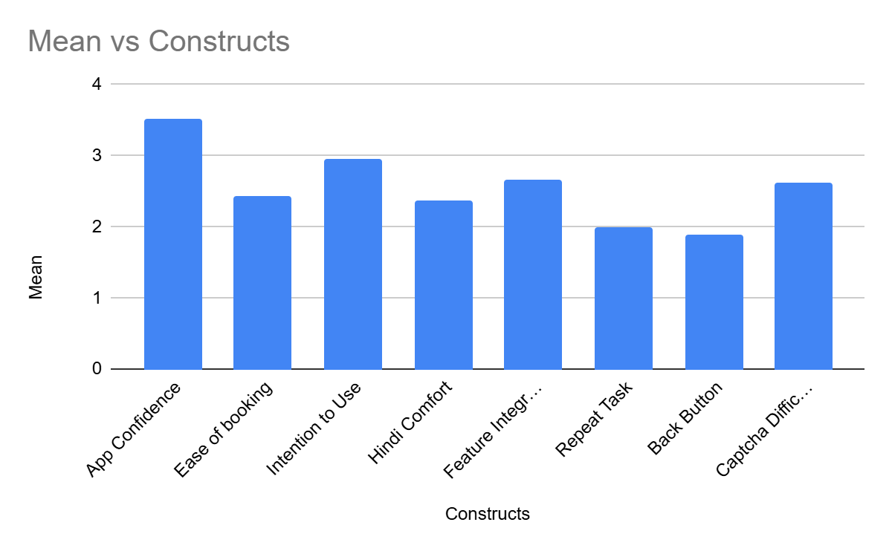

In overall, figure 1 summarises the mean ratings (1–5) for key constructs. (Q3-Q10) Participants reported moderate confidence using mobile apps and moderate ease of booking, but low scores on ‘features integrated’, ‘repeat task’, ‘back button’

and ‘captcha difficulty’ indicate that the interface causes frequent repetition, backtracking and difficulty at the CAPTCHA step.

4.2 Overall SUS usability score
Standard SUS scoring was applied to the 10 core items for all cases with complete, valid responses (n = 44). Individual SUS scores ranged from 42.5 to 65.0, with a mean of 55.16 (SD = 7.10) and a median of 56.25. Compared with commonly cited

SUS benchmarks, where a score around 68 is considered average usability, these results indicate that low‑literacy migrant workers experience the current booking interface as clearly below average and only marginally usable.

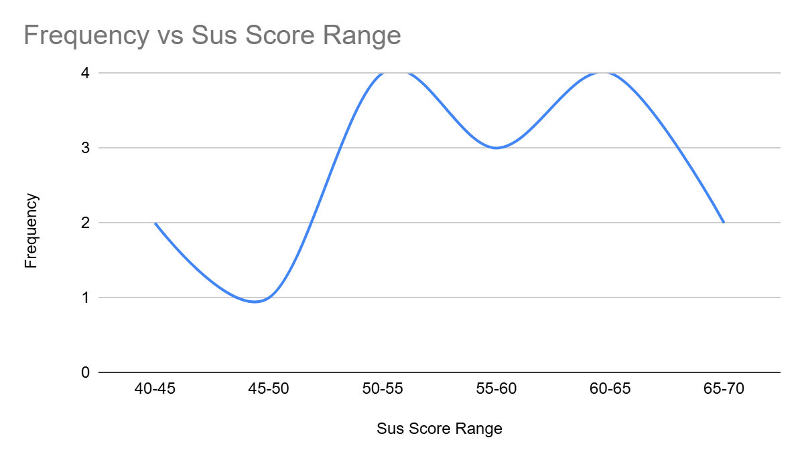

Figure.3- Frequency Distribution Graph

The five SUS‑adapted usability items focusing on language comfort, perceived integration of features, repetition of tasks, back‑button use, and CAPTCHA difficulty (Q6–Q10) demonstrated good internal consistency. Cronbach’s alpha for this set of items was 0.817, exceeding the commonly accepted threshold of 0.70 for group‑level usability research. This suggests that the items capture a coherent latent construct of perceived usability and task difficulty within the booking flow for low‑literacy users.

4.3 Relationships Between Ease of Booking and Interface Factors
Spearman rank correlations were calculated between perceived ease of booking (Q4) and each of the five usability items (Q6–Q10).
All five correlations are statistically significant. But they are not equal and the pattern of their differences is where the most important finding lies.
The two language and navigation items Hindi comfort (Q6, ρ = .562) and feature integration (Q7, ρ = .470) show moderate positive correlations with ease of booking. When participants were more comfortable with the language and found the menus more logical, they found booking easier. This is expected. It confirms what the literature has long argued: that language register and screen organisation are primary usability levers for low-literacy users (Medhi et al., 2011; Srivastava et al., 2021).
But the two strongest correlations in the table are not attitudinal. They are behavioural.
Task repetition (Q8, ρ = .736, p < .001) and back-button frequency (Q9, ρ = .699, p < .001) are the most powerful predictors of low ease scores in this dataset. The more times a participant had to redo a step, the harder they found the experience. The more times they pressed back, the harder they found the experience. These are not feelings. They are actions observable, countable evidence of navigational failure.
CAPTCHA difficulty (Q10, ρ = .610, p = .003) completes the picture. It sits between the attitudinal and behavioural clusters, a specific, identifiable interaction step that consistently broke the flow for participants who were already struggling.
What these correlations collectively show is that perceived ease of booking is not damaged by any single design decision. It is damaged by a sequence of them. Language confusion sets a user off-course. Poor screen organisation keeps them off-course. The back button becomes a survival mechanism. And then the CAPTCHA appears a security mechanism designed for a different user entirely and the session ends

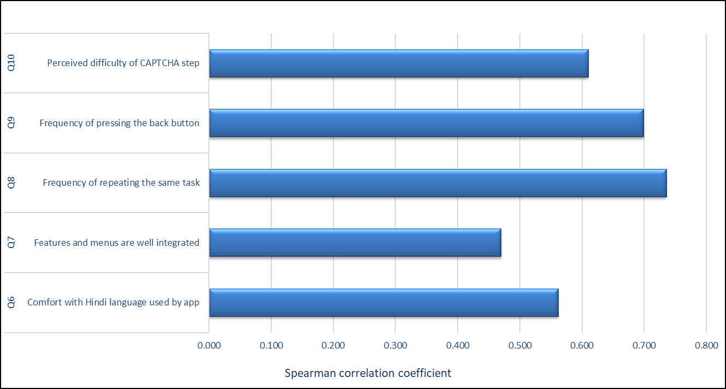

Figure .4

note-ρ = Spearman rank correlation coefficient. Indicates the two strongest correlations (Q8 and Q9), both significant at p < .001. All five correlations are significant at p < .05.

Conclusion
This study set out to measure something that had not been measured before how difficult the application is for the people who depend on it most. The answer, across 44 participants, is unambiguous.
The mean SUS score of 55.16 places the current interface below the accepted threshold for average usability. Every participant scored below the benchmark of 68. This is not a finding about a minority of users struggling at the edges. It is a finding about systematic failure at the centre, a mandatory public service that the population most dependent on cannot independently use.
The data identifies three compounding barriers. Language: the Hindi register of the app is too formal for workers whose literacy is functional rather than academic. Navigation: participants repeatedly lost

their place in the booking flow, pressing back and restarting not occasionally, but as a routine coping strategy. Authentication: the CAPTCHA step, designed for a security context, becomes an insurmountable wall for users already operating at the limit of their digital confidence.
What makes these findings significant is not any single barrier in isolation. It is that they arrive in sequence. Each one compounds the last. By the time a user reaches the CAPTCHA, they have already been worn down by unfamiliar language and disorienting navigation. The cumulative effect is abandonment or a phone handed to someone else.

This is not an interface problem that a translation patch will fix. It requires a comprehension-first redesign: simpler navigation flows with clear forward and back logic, language written for spoken Hindi rather than textbook Hindi, icon-supported wayfinding, and an authentication mechanism that does not assume visual pattern recognition under cognitive load. These are not radical interventions. They are the baseline that inclusive design demands.
India's migrant workers are not peripheral users of the railway system. They are its most frequent and most dependent users.
A platform that excludes them is not partially failing. It is failing at its core purpose. This study provides the empirical baseline for the redesign that equity requires.
Acknowledgement

The authors would like to sincerely thank all the migrant worker participants who generously gave their time and shared their experiences for this study. Shilpa Rajith led the investigation, conceptual framing, field observation, and writing of this paper. Lekshmi M P conducted the primary survey and data collection. The authors express their heartfelt gratitude to Prof. Prashanth Cherian Kochuveetil, Associate Professor, Master of Design Space, NIFT Bengaluru, for his conceptualization, methodological guidance, and supervision throughout this research.

References

Medhi, I., Patnaik, S., Brunskill, E., Gautama, S. N., Thies, W., & Toyama, K. (2011). Designing mobile interfaces for novice and low-literacy users. ACM Transactions on Computer-Human Interaction, 18(1), 1–28. https://doi.org/10.1145/1959022.1959024
Srivastava, A., Kapania, S., Tuli, A., & Singh, P. (2021). Actionable UI design guidelines for smartphone applications inclusive of Low-Literate users. Proceedings of the ACM on Human-Computer Interaction, 5(CSCW1), 1–30. https://doi.org/10.1145/3449210
Mohammed, K. D., Uren, V., Joel-Edgar, S., & Omonedo, P. (2023). Usability and User Experience of Mobile Applications: A Case of Functional Illiterates in Nigeria. Usability and User Experience of Mobile Applications: A Case of Functional Illiterates in Nigeria, 98–105. https://doi.org/10.1145/3628096.3629043
Guimarães, L., Martins, N., Pereira, L., Penedos-Santiago, E., & Brandão, D. (2022). Interface design guidelines for low literature users: a literature review. Interface Design Guidelines for Low Literature Users: A Literature Review, 29–35. https://doi.org/10.1145/3578837.3578842
Bayor, A., Schmidt, C., Dauri, F., Wilson, N., Drovandi, C., & Brereton, M. (2018). The talking book. The Talking Book: Participatory Design of an Icon-based User Interface for Rural People With Low Literacy, 1–10. https://doi.org/10.1145/3283458.3283462
Rayed, M., Elahi, T., Shimon, S. S. A., & Ahmed, N. (2023). MFS Design in Appstore-enabled Smart Featurephones for Low-literate, Marginalized Communities. MFS Design in Appstore-enabled Smart Featurephones for Low-literate, Marginalized Communities, 1–19. https://doi.org/10.1145/3544548.3580661
Chaudry, B. M., Connelly, K. H., Siek, K. A., & Welch, J. L. (2012). Mobile interface design for low-literacy populations. Mobile Interface Design for Low-literacy Populations, 91–100. https://doi.org/10.1145/2110363.2110377
Doke, P., & Joshi, A. (2015). Mobile Phone Usage by Low Literate Users. Mobile Phone Usage by Low Literate Users, 10–18. https://doi.org/10.1145/2835966.2835968
Brooke, J. B. (2013). SUS: a retrospective. Journal of Usability Studies Archive, 8(2), 29–40. https://uxpajournal.org/wp-content/uploads/pdf/JUS_Brooke_February_2013.pdf
Lewis, J. R., & Sauro, J. (2009). The factor structure of the system usability scale. In Lecture notes in computer science (pp. 94–103). https://doi.org/10.1007/978-3-642-02806-9_12
Borsci, S., Federici, S., & Lauriola, M. (2009). On the dimensionality of the System Usability Scale: a test of alternative measurement models. Cognitive Processing, 10(3), 193–197. https://doi.org/10.1007/s10339-009-0268-9
Lewis, J. R., & Sauro, J. (2017). Revisiting the factor structure of the system usability scale. Journal of Usability Studies Archive, 12(4), 183–192. https://doi.org/10.5555/3190867.3190870
Paul, S., & Das, S. (2019). Accessibility and usability analysis of Indian e-government websites. Universal Access in the Information Society, 19(4), 949–957. https://doi.org/10.1007/s10209-019-00704-8
Leist, E., & Smith, D. (2014). Accessibility issues in E-Government. In Lecture notes in computer science (pp. 15–25). https://doi.org/10.1007/978-3-319-10178-1_2
Chohan, S. R., & Hu, G. (2020). Strengthening digital inclusion through e-government: cohesive ICT training programs to intensify digital competency. Information Technology for Development, 28(1), 16–38. https://doi.org/10.1080/02681102.2020.1841713
Ferro, E., Helbig, N. C., & Gil-Garcia, J. R. (2010). The role of IT literacy in defining digital divide policy needs. Government Information Quarterly, 28(1), 3–10. https://doi.org/10.1016/j.giq.2010.05.007
Ray, A. (2024). Coping with crisis and precarity in the gig economy: ‘Digitally organised informality’, migration and socio-spatial networks among platform drivers in India. Environment and Planning a Economy and Space, 56(4), 1227–1244. https://doi.org/10.1177/0308518x231220296
Iyer, S., & Rao, N. (2024). Inclusion or exclusion?: Gendered experiences and strategies of migrants in informal settlements in Bengaluru. Indian Journal of Human Development, 18(1), 20–41. https://doi.org/10.1177/09737030241238821
Singh, P., Sinha, H., Aggarwal, V., & Naik, M. (2024). The Governance of Internal Migration: Learning from the Pre- and Post-COVID-19 Policy Responses of Indian States. Urbanisation, 9(1), 13–36. https://doi.org/10.1177/24557471241251550
Naik, M. (2024). Tracing internal migration governance in India through a ‘Mainstreaming’ lens. Urbanisation, 9(1), 37–48. https://doi.org/10.1177/24557471241234973
Datta, A., & Rajan, S. I. (2024). Internal migration and development in India. Indian Journal of Human Development, 18(1), 7–19. https://doi.org/10.1177/09737030241251865
Dell, N., & Kumar, N. (2016). The Ins and Outs of HCI for Development. The Ins and Outs of HCI for Development, 2220–2232. https://doi.org/10.1145/2858036.2858081
Cardinal, A., Gonzales, L., & Rose, E. J. (2020). Language as Participation: Multilingual User Experience Design. Language as Participation: Multilingual User Experience Design, 1–7. https://doi.org/10.1145/3380851.3416763
Skarlatidou, A., Moustard, F., & Vitos, M. (2020). Experiences from Extreme Citizen Science: Using Smartphone-based Data Collection Tools with Low-literate People. Experiences From Extreme Citizen Science: Using Smartphone-based Data Collection Tools With Low-literate People, 1–8. https://doi.org/10.1145/3334480.3375220
Siew, E., & Munir, S. (2024). Role of mobile Banking in Financial Inclusion: Key challenges and barriers. In Sustainable finance (pp. 215–234). https://doi.org/10.1007/978-3-031-67523-2_13
Delaere, H., Basu, S., Macharis, C., & Keseru, I. (2024). Barriers and opportunities for developing, implementing and operating inclusive digital mobility services. European Transport Research Review, 16(1). https://doi.org/10.1186/s12544-024-00684-8
Hall, T. E., & Owens, J. (2011). The digital divide and e-government services. Proceedings of the 5th International Conference on Theory and Practice of Electronic Governance (ICEGOV '11). ACM. https://doi.org/10.1145/2072069.2072076
Aldrees, A., & Gračanin, D. (2023). Enhancing user experience in e-government: A deep dive into e-government forms and citizen perceptions. Proceedings of the 19th International Conference on Web Information Systems and Technologies (WEBIST 2023), 250–257. https://doi.org/10.5220/0012177700003584
Jhamb, A. (2025). FinTech adoption and financial inclusion in rural India. Journal of Neonatal Surgery, 14(32S), 3054–3062. https://jneonatalsurg.com/index.php/jns/article/view/7884
Ahmed, S. I., Jackson, S. J., Zaber, M., Morshed, M. B., Ismail, M. H. B., & Afrose, S. (2013). Ecologies of use and design: Individual and social practices of mobile phone use within low-literate rickshawpuller communities in urban Bangladesh. Proceedings of the 4th Annual Symposium on Computing for Development (ACM DEV-4 '13), Article 14. https://doi.org/10.1145/2537052.2537066
Field, A. (2013). Discovering statistics using IBM SPSS statistics (4th ed.). SAGE Publications.
Bangor, A., Kortum, P. T., & Miller, J. T. (2008). An empirical evaluation of the System Usability Scale. International Journal of Human–Computer Interaction, 24(6), 574–594. https://doi.org/10.1080/10447310802205776
Nunnally, J. C. (1978). Psychometric theory (2nd ed.). McGraw-Hill.
Gupta, M., Mehta, D., Punj, A., & Medhi Thies, I. (2022). Sophistication with limitation: Understanding smartphone usage by emergent users in India. Proceedings of the ACM SIGCAS/SIGCHI Conference on Computing and Sustainable Societies (COMPASS '22), 1–15. https://doi.org/10.1145/3530190.3534824
Medhi, I., Cutrell, E., & Toyama, K. (2010). It's not just illiteracy. Proceedings of India HCI 2010 / Interaction Design & International Development, Mumbai. https://www.scienceopen.com/document?vid=4b5f563b-8fc2-4d25-a2b5-a74cee5bc29a

