Image-Based Outdoor PM2.5 Concentration Estimation Using a Hybrid BENet-VGG16 Deep Learning Framework with AQI Parameters

- Introduction
Air pollution has become one of the most critical environmental and public health challenges worldwide. Among various atmospheric pollutants, fine particulate matter (PM2.5) is considered particularly hazardous because of its ability to penetrate deep into the respiratory system and enter the bloodstream, contributing to severe cardiovascular and respiratory diseases. According to the World Health Organization (WHO), exposure to ambient air pollution caused approximately 6.7 million premature deaths worldwide in 2019, with major health consequences including ischemic heart disease, stroke, chronic obstructive pulmonary disease, lung cancer, asthma, and diabetes [1]. Consequently, accurate estimation and continuous monitoring of PM2.5 concentrations have become essential for environmental protection, public health management, and smart city development.
Air quality is commonly assessed using the Air Quality Index (AQI), which summarizes the health impacts of multiple atmospheric pollutants into a single indicator. The AQI is calculated using concentrations of pollutants such as PM2.5, PM10, sulfur dioxide (SO₂), nitrogen dioxide (NO₂), ozone (O₃), and carbon monoxide (CO). However, different pollutants are evaluated using different temporal averaging periods. For example, PM2.5 is generally computed using a 12-hour average, whereas CO is calculated using an 8-hour moving average, making real-time AQI estimation challenging. Several studies have demonstrated that PM2.5 contributes most significantly to AQI variations, suggesting that PM2.5 concentration itself provides a more reliable indicator of real-time air quality than the composite AQI value [2], [3].
Existing PM2.5 estimation approaches can generally be divided into two categories: physics-based dispersion models and data-driven methods. Dispersion models simulate the transport and diffusion of pollutants using atmospheric and meteorological equations. Examples include street canyon models and chemical transport models, which estimate pollutant distributions under different environmental conditions [4]–[6]. Although these models provide useful theoretical insights, they require extensive domain expertise, computational resources, and numerous empirical assumptions that often fail to represent the highly nonlinear characteristics of real-world atmospheric environments. Their prediction accuracy is therefore limited under complex urban conditions.
Recent advances in artificial intelligence have significantly promoted data-driven approaches for air quality estimation. Machine learning and deep learning techniques utilize heterogeneous data sources—including meteorological observations, traffic information, industrial emissions, satellite imagery, and environmental images—to learn complex nonlinear relationships associated with pollutant concentrations [7]–[9]. Unlike traditional models, deep learning algorithms automatically extract representative features from large-scale datasets, enabling improved estimation accuracy without explicitly modeling atmospheric diffusion processes.
Conventional air quality monitoring systems mainly depend on fixed monitoring stations equipped with high-precision sensors. Although these stations provide accurate measurements, they involve substantial installation, calibration, and maintenance costs while offering limited spatial coverage. To improve monitoring density, low-cost micro-sensors have been widely deployed in urban and residential environments. Despite their affordability and ease of installation, these sensors often experience calibration drift and reduced measurement reliability, leading to relatively large estimation errors [10], [11]. Consequently, sensor-based monitoring alone cannot provide comprehensive, high-resolution air quality information across large geographic regions.
To overcome these limitations, image-based PM2.5 estimation has emerged as a promising sensor-free alternative. Outdoor images captured by surveillance cameras, roadside monitoring systems, drones, or smartphones contain abundant visual information related to atmospheric visibility, haze intensity, cloud distribution, and sky appearance, all of which are strongly correlated with particulate matter concentrations. Image-based approaches offer several practical advantages, including low deployment cost, extensive spatial coverage, and real-time monitoring capability. Nevertheless, estimating PM2.5 solely from visual information remains challenging because image quality is significantly influenced by illumination changes, weather conditions, seasonal variations, and camera characteristics [12].
Although recent image-based deep learning models have demonstrated encouraging performance, several research challenges remain unresolved. Existing methods often utilize data collected from limited geographic regions, restricting their generalization capability across different environmental conditions. Many approaches also process individual regions independently without adequately modeling the relationships between environmental variables and spatial correlations among neighboring locations. Furthermore, sophisticated attention-based and spatiotemporal learning models have been proposed to capture these dependencies; however, such models typically require extensive computational resources, large-scale datasets, and long training times while exhibiting limited adaptability across diverse geographical scenarios [4], [13].
These limitations motivate the development of a more efficient and generalized PM2.5 estimation framework. In this work, we propose a hybrid BENet-VGG16 deep learning architecture that integrates environmental images with multiple Air Quality Index (AQI) parameters to improve PM2.5 concentration estimation. The proposed framework combines advanced image preprocessing, feature extraction, feature engineering, and multimodal feature fusion techniques to effectively exploit complementary information from both visual and environmental data. The incorporated AQI parameters include PM10 concentration, temperature, humidity, wind speed, atmospheric pressure, and visibility, which collectively provide a comprehensive representation of atmospheric conditions affecting PM2.5 levels.
To further enhance model robustness, the proposed framework performs image preprocessing, normalization, feature extraction, and feature fusion before training the hybrid BENet-VGG16 network. The branch ensemble architecture enables efficient extraction of discriminative visual features while preserving computational efficiency and reducing overfitting. Unlike conventional handcrafted feature approaches, the proposed model automatically learns representative feature embeddings and captures complex nonlinear relationships between environmental images and AQI parameters.
Extensive experiments conducted on real-world datasets demonstrate that the proposed hybrid BENet-VGG16 framework consistently outperforms conventional machine learning models and standalone deep learning architectures in PM2.5 concentration estimation. The proposed method provides improved prediction accuracy, robustness, and generalization capability while maintaining computational efficiency. Owing to its scalability and low deployment cost, the framework offers an effective solution for real-time air quality monitoring and can support environmental management, public health protection, and intelligent smart city applications.
The major contributions of this work are summarized as follows:
- A hybrid BENet-VGG16 deep learning framework is proposed for image-based outdoor PM2.5 concentration estimation.
- Multiple AQI parameters are integrated with visual image features through multimodal feature fusion to improve estimation performance.
- Advanced preprocessing, normalization, feature engineering, and feature extraction techniques are employed to enhance feature quality and model robustness.
- The proposed architecture effectively captures nonlinear relationships between environmental imagery and atmospheric parameters while reducing computational complexity.
- Comprehensive experimental evaluations demonstrate superior performance compared with existing machine learning and deep learning approaches, indicating strong generalization capability for real-world air quality monitoring applications.
The remainder of this paper is organized as follows. Section II reviews related work on PM2.5 estimation methods. Section III presents the proposed hybrid BENet-VGG16 methodology, including data preprocessing, feature engineering, multimodal feature fusion, and model architecture. Section IV discusses the experimental setup, performance evaluation, and comparative analysis. Finally, Section V concludes the paper and outlines future research directions.

- Related Works

A. Traditional Image-Based Methods
Contemporary image-based approaches for air quality assessment can be broadly classified into three categories: traditional image-based methods, deep learning-based approaches, and multimodal data fusion techniques. This section provides a comparative review of these methodologies, with particular emphasis on data preprocessing, image enhancement, feature extraction strategies, and the architectural characteristics of the employed learning models.
Traditional image-based methods primarily investigate the relationship between handcrafted image features and ambient particulate matter (PM) concentrations. These approaches typically rely on atmospheric characteristics extracted from images to estimate air quality.
Fattal [16] proposed an image dehazing framework that exploits atmospheric scattering properties to improve scene visibility and recover haze-free image contrast, thereby facilitating air quality assessment. Similarly, He et al. [17] introduced an atmospheric scattering model to estimate scene transmittance and construct a transmission matrix for haze removal and feature extraction.
Zhang et al. [18] developed a single-image air quality inference framework based on an Air Quality Index (AQI) decision tree. Their method extracted handcrafted features, including medium transmission, power spectrum slope, image contrast, and saturation, to predict air quality categories. Yue et al. [15] proposed a PM2.5 estimation approach using photographic images by analyzing variations in saturation maps under different pollution conditions. Specifically, gradient similarity and the pixel-value distribution of saturation maps were employed to distinguish images captured at different PM2.5 concentration levels. The effectiveness of the proposed method was validated using the Air Quality Image Database (AQID).
While most existing studies analyze the entire image, several researchers have explored the use of salient image regions for air quality estimation. Samsami et al. [19] investigated whether sky images alone are sufficient for air quality level (AQL) classification using datasets collected from Iran and China. After preprocessing, sky regions were manually cropped and transformed into feature maps using Gabor filters, Local Binary Patterns (LBP), and the Dark Channel Prior (DCP). Statistical descriptors, including the mean, kurtosis, and standard deviation, were then extracted and classified using the K-Nearest Neighbors (KNN) algorithm. Although the proposed method achieved an accuracy of 82.02%, its dependence on manually selected sky regions limits its scalability and practical applicability. Moreover, the study did not address the class imbalance commonly observed in PM2.5 datasets, where low-concentration samples substantially outnumber high-concentration samples. Such imbalance can adversely affect model learning and result in prediction bias toward lower PM2.5 concentrations.
Despite their simplicity and interpretability, traditional image-based air quality assessment methods have several inherent limitations. They rely heavily on manually designed feature descriptors and extensive feature engineering, making them highly sensitive to environmental variations such as illumination, humidity, temperature, wind speed, and atmospheric pressure. Consequently, their performance often deteriorates under diverse weather conditions, limiting their robustness and generalization capability for real-world air quality monitoring applications.
B. Deep Learning-Based Approaches
Deep learning has revolutionized image-based air quality assessment by enabling automatic extraction of high-level features from images, thereby overcoming many of the limitations associated with handcrafted feature engineering. Convolutional Neural Networks (CNNs) and transfer learning models have demonstrated remarkable success in various computer vision tasks, including image classification, object detection, and environmental monitoring. Consequently, numerous researchers have adopted deep learning techniques for estimating particulate matter (PM2.5) concentrations from environmental images.
Ma et al. [20] proposed a hybrid CNN-based framework for air quality classification using a single RGB image. Their approach incorporated the Dark Channel Prior (DCP) into the CNN architecture to enhance haze-related feature representation during network training. The trained model subsequently classified input images into three air quality categories corresponding to different PM2.5 concentration levels.
To address the limitations of conventional statistical forecasting models, Bai and Li [21] developed a deep learning-based PM2.5 prediction framework for Internet of Things (IoT)-enabled air monitoring systems. Their model exploits both spatial and temporal correlations in environmental data by integrating cubic spline interpolation, an attention mechanism, a feature encoder, and a feature decoder. Historical PM2.5 measurements are fused with the learned feature representations to generate more accurate concentration predictions over extended forecasting horizons.
Mohan et al. [22] formulated PM2.5 estimation as a regression problem using camera-captured environmental images. Deep features extracted from several pre-trained convolutional neural networks were employed as input to a regression model for predicting continuous PM2.5 concentrations. This transfer learning strategy significantly improved estimation accuracy compared with traditional handcrafted feature-based approaches.
Gu et al. [23] introduced an image-based PM2.5 prediction method founded on Natural Scene Statistics (NSS). Using a large collection of images acquired under favorable weather conditions with low PM2.5 concentrations, they constructed statistical models based on entropy features extracted from both spatial and transform domains. The deviation of a test image from the learned NSS models was subsequently quantified, based on the observation that image naturalness decreases as atmospheric pollution increases. Finally, a nonlinear mapping function was employed to estimate PM2.5 concentrations from the computed deviation.
To further improve prediction performance, Rijal et al. [24] proposed an ensemble transfer learning framework utilizing VGG16, Inception-V3, and ResNet50 as base learners. The preliminary PM2.5 predictions generated by these models were subsequently combined through a feed-forward neural network acting as a meta-learner to produce the final concentration estimates. Experimental results demonstrated that the ensemble architecture consistently outperformed individual deep learning models.
Zhang et al. [25] presented an image recognition-based air quality detection framework for fine-grained air quality assessment without relying heavily on specialized monitoring instruments. Their approach employed ResNet18 as the backbone network and enhanced its feature extraction capability by incorporating improved residual modules, the Gaussian Error Linear Unit (GeLU) activation function, and the ParNet-Attention mechanism. These modifications significantly strengthened channel-wise feature representation and nonlinear modeling capability, leading to improved air quality classification performance.
To address the class imbalance problem commonly encountered in PM2.5 datasets, Fang et al. [26] proposed a dual-branch deep neural network using datasets collected from Beijing and Heshan, China. The primary branch processed RGB images, while the auxiliary branch utilized both Dark Channel Prior (DCP) maps and inverted saturation maps to capture complementary haze-related information. Feature representations extracted from the two branches were fused to estimate PM2.5 concentrations. Furthermore, the authors introduced a histogram smoothing strategy to alleviate data imbalance, enabling the model to learn more effectively from underrepresented high-pollution samples and improving prediction accuracy across different concentration ranges.
Although deep learning-based methods have substantially improved the accuracy of image-based air quality estimation, most existing studies primarily emphasize prediction performance by employing increasingly deeper and more complex network architectures. Such models generally involve a large number of parameters and high computational complexity, resulting in increased inference time and memory requirements. Consequently, despite their superior predictive capability, these approaches may not satisfy the real-time processing and computational efficiency requirements of practical air quality monitoring systems deployed on resource-constrained devices or edge computing platforms.

C. Multimodal Data Integration Strategies
To overcome the limitations of single-modality approaches, recent studies have increasingly explored multimodal data fusion techniques that combine image information with meteorological, environmental, and sensor data. These approaches leverage complementary information from multiple sources to improve the robustness and accuracy of air quality estimation.
Zhang et al. [27] utilized multi-scene images collected in Beijing and observed a strong correlation between image saturation and PM2.5 concentration. Their framework employed the Simple Linear Iterative Clustering (SLIC) algorithm to segment images into superpixels based on saturation values. The extracted superpixel features were subsequently processed using an autoencoder to learn compact feature representations. These representations were then passed through a three-dimensional Softmax layer to generate probability distributions corresponding to good, moderate, and severe pollution levels. Finally, the probability outputs were combined with four meteorological variables—relative humidity, wind speed, atmospheric pressure, and temperature—and fed into a Gaussian Process Regression (GPR) model for PM2.5 estimation. Although this multimodal framework demonstrated improved prediction accuracy, it relied on an additional regression model to effectively integrate heterogeneous data sources, thereby increasing computational complexity.
Chen [28] proposed a regression-based PM2.5 estimation framework using data collected from four air quality monitoring stations in Taiwan. The method first identified image regions exhibiting significant variations under low and high PM2.5 conditions and subsequently extracted representative features from these regions. Experimental results showed that combining five image-derived features with relative humidity in a Support Vector Regression (SVR) model significantly outperformed conventional curve regression models that relied solely on image features. Building upon this work, Lin et al. [29] further incorporated temperature and wind speed into the regression model, resulting in enhanced estimation accuracy. Nevertheless, both studies required extensive manual preprocessing, including the removal of anomalous images and manual image alignment, thereby limiting their applicability in fully automated monitoring systems.
Similarly, Ma et al. [30] employed transfer learning with a Convolutional Neural Network (CNN) to extract deep image features, whose importance was subsequently evaluated using a Random Forest algorithm. These image features were integrated with meteorological parameters, including temperature, relative humidity, sea-level pressure, and historical PM2.5 measurements, before being processed using Complete Ensemble Empirical Mode Decomposition with Adaptive Noise (CEEMDAN). The resulting multiscale signals were then utilized within a hybrid machine learning framework to predict PM2.5 concentrations. Among the evaluated feature extractors, ResNet50 achieved the highest prediction accuracy.
Conventional RGB images often struggle to distinguish PM2.5 from visually similar atmospheric phenomena such as clouds and fog. To address this challenge, Lee and Manova [31] proposed a Double-Channel Ensemble Learning (DCEL-PM2.5) framework for drone-based air quality monitoring. Unlike traditional CNN models that rely exclusively on RGB imagery, the proposed architecture simultaneously processes RGB images and multispectral images captured using aerial multispectral cameras through a dual-channel neural network. The integration of multispectral information significantly enhances the model's capability to discriminate airborne particulate matter from other atmospheric objects.
Recent multimodal approaches have also incorporated distributed intelligence to facilitate real-time environmental monitoring while preserving data privacy. Rahman et al. [32] introduced a multimodal Federated Learning (FL) framework that enables collaborative learning among airborne drones and mobile ground sensors without requiring centralized data collection. By exchanging only model parameters rather than raw sensor data, the proposed framework achieves accurate real-time air quality estimation while reducing privacy risks and communication overhead. However, federated learning introduces considerable computational and communication costs, particularly when training on large-scale multimodal datasets or resource-constrained edge devices.
Beyond image and meteorological data, recent studies have demonstrated the benefits of integrating mobility information, traffic data, and advanced graph-based learning techniques for pollution prediction. Morales-García et al. [33] proposed a Graph Neural Network (GNN)-based framework that incorporates traffic information and synthetic datasets to predict concentrations of PM10, PM2.5, CO, and SO₂. Their results showed a substantial reduction in prediction errors through the combined use of traffic dynamics and graph-based spatial modeling. Nevertheless, dependence on synthetic data introduces the potential risk of overfitting, which may reduce model generalization under unseen environmental conditions. Furthermore, the overall robustness of the framework remains highly dependent on data quality, variability in traffic patterns, and the deployment density and reliability of sensing infrastructure.
Overall, multimodal data integration strategies consistently outperform single-modality approaches by exploiting complementary information from heterogeneous sources. However, these methods often involve increased computational complexity, higher implementation costs, and greater dependence on data synchronization and quality. Consequently, designing lightweight, efficient, and scalable multimodal frameworks remains an important research direction for practical real-time air quality monitoring systems.
D. Advantages of the Proposed Method
From the perspective of PM2.5 estimation, most existing image-based approaches that incorporate meteorological and air pollutant data generally overlook automated image quality assessment. Instead, image exclusion is typically performed manually before model training, making these methods incapable of effectively identifying and eliminating defective or low-quality images. Furthermore, approaches that rely solely on outdoor images often suffer from limited feature diversity and reduced generalization capability under varying environmental conditions. Integrating weather classification into the estimation framework can provide complementary contextual information, thereby improving prediction accuracy. In addition, relatively little research has investigated the discriminative potential of regional image features extracted from sky, non-sky, and entire-scene regions, despite their potential to significantly enhance PM2.5 estimation performance.
To address these limitations, the proposed framework relies exclusively on image data while performing comprehensive feature engineering through the integration of weather classification, sky segmentation, and supplementary image processing techniques. Unlike conventional multimodal approaches that require external meteorological sensors, the proposed method derives auxiliary information directly from images, including weather probability distributions and regional visual characteristics. These heterogeneous feature representations are subsequently fused with the original RGB image data, resulting in an image-centric multimodal feature fusion framework. Consequently, the proposed system extends beyond conventional image preprocessing, feature extraction, and deep learning architectures by incorporating automated weather classification, sky and non-sky region segmentation, defective image detection and exclusion, and regional feature fusion to improve PM2.5 estimation accuracy.
As described in Section IV, the effectiveness of the proposed framework is validated through comprehensive experiments using the same dataset adopted in [28], enabling a fair comparison with existing approaches. Experimental results demonstrate that the proposed deep learning-based image estimation framework not only achieves highly accurate PM2.5 concentration prediction but also provides additional functionalities, including automated weather classification and defective image detection and removal, thereby enhancing its practicality for real-world air quality monitoring applications. Furthermore, transfer learning experiments conducted across multiple monitoring stations confirm the robustness and generalization capability of the proposed model under diverse environmental conditions. Table I summarizes the reviewed literature by comparing the methodologies, input data sources, information processing techniques, strengths, and limitations of existing studies alongside the proposed framework.

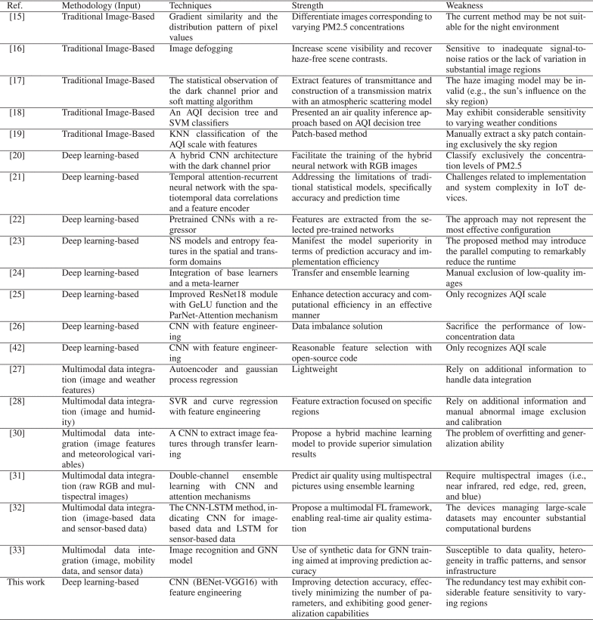
- System Architecture and Methodology
This section presents the overall system architecture and research methodology for estimating PM2.5 concentrations. It describes the datasets used, image preprocessing procedures, YOLO-based weather classification and sky segmentation models, and the proposed BENet-VGG16 deep learning architecture.
Unlike conventional multimodal approaches that combine images with external meteorological or environmental sensor data, the proposed framework relies exclusively on image data while performing comprehensive feature engineering. Specifically, the framework integrates YOLO-based weather classification and YOLO-based sky segmentation, followed by additional image processing techniques to extract informative visual features. These procedures generate supplementary information, including weather probability scores and regional characteristics, which are derived entirely from the input images but represented in heterogeneous feature spaces. Before being fed into the prediction model, the extracted features undergo weather classification, sky ratio estimation, and rule-based filtering to eliminate invalid or low-quality images. The resulting feature representations are subsequently fused with the original RGB image data, producing an image-centric multimodal feature representation. This enables the proposed framework to exploit complementary information from multiple image-derived sources without requiring external sensing devices. Finally, these fused features are provided as input to the customized BENet-VGG16 model to estimate PM2.5 concentrations and evaluate whether the image-derived multimodal representation improves prediction performance.To facilitate practical deployment and performance evaluation, a web-based implementation of the proposed system was developed using two Docker containers. The first container hosts the front-end web server, which provides the user interface, while the second container hosts the Python-based back-end server responsible for PM2.5 estimation. As illustrated in Figure 1, the client or monitoring station uploads an environmental image through the web interface to the back-end server. The uploaded image then undergoes automated weather classification, sky segmentation, image preprocessing, and PM2.5 estimation using the proposed BENet-VGG16 model. Finally, the estimated PM2.5 concentration is returned to the client through the web server, enabling an efficient and scalable real-time air quality monitoring system.

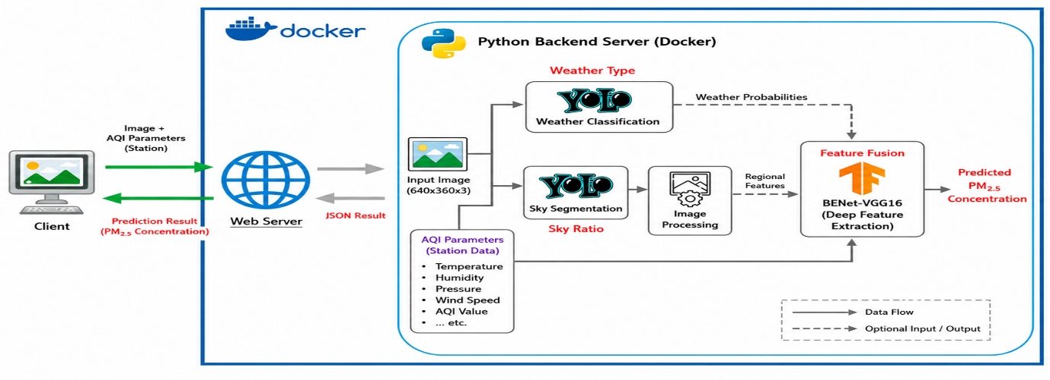
FIGURE 1.The data flow diagram, describing the information exchange among the main components of the system architecture. Note that the client or station uploads the image to the backend server via the web server, where processes such as weather classification, sky segmentation, and model training are conducted.

A. Hardware and Software Configuration
All experiments were conducted on a 64-bit Windows 11 operating system equipped with an Intel® Core™ i5-11400 processor, 48 GB DDR4 RAM, and an NVIDIA GeForce RTX 3060 graphics processing unit (GPU) with 12 GB of dedicated video memory. To accelerate deep learning model training, CUDA 11.8 and cuDNN 8.7.0 were installed. The experimental environment was developed using Python 3.9.13 together with the required deep learning libraries.
As described in Section IV, the proposed framework is evaluated using the same dataset adopted in the studies reported in [28] and [29], enabling a fair and direct performance comparison. Experimental results demonstrate that the proposed image-based framework not only achieves accurate PM2.5 concentration estimation but also incorporates automated weather classification and defective image detection, thereby improving system robustness and extending its applicability to practical real-time air quality monitoring scenarios.
B. Common Image Datasets
The quality, quantity, and diversity of training images play a crucial role in determining the performance and generalization capability of image-based PM2.5 estimation models. This subsection reviews the publicly available datasets commonly used in previous studies and discusses their characteristics and limitations.
The Beijing Tourism website [34] provides a large collection of multi-scene outdoor images accompanied by metadata such as acquisition date, geographical location, temperature, and relative humidity. These images are frequently paired with timestamp-matched PM2.5 measurements obtained from AirNow [35] to construct image-based air quality datasets for Beijing. Liu et al. [36] further developed a dataset comprising images captured at fixed monitoring locations in Beijing (327 samples), Shanghai (1,954 samples), and Phoenix, USA (4,306 samples). Although the Beijing and Shanghai images can be reliably matched with AirNow measurements, the specific PM2.5 data source used for the Phoenix dataset is not clearly specified. Since the images were acquired from fixed viewpoints, they facilitate comparative analysis under varying atmospheric conditions, such as clean and heavily polluted environments. However, the relatively small dataset size and the presence of prominent watermarks require additional preprocessing before model training.
Feng et al. [37] collected a considerably larger dataset consisting of 13,152 images captured at fixed locations in Beijing, together with corresponding PM2.5 measurements obtained from the Ministry of Ecology and Environment. Despite its larger scale, the dataset contains numerous low-quality and unusable images, including nighttime scenes, blurred images, and other defective samples that require filtering prior to training. Similarly, Fang et al. [26] introduced a PM2.5 dataset collected from Heshan, China. Although the dataset was preprocessed and annotated with PM2.5 concentration values, it contains only 306 samples, making it insufficient for effectively training deep learning models.
In this study, images collected from air quality monitoring stations in Taiwan are utilized for PM2.5 estimation. The Taiwan Ministry of Environment [38] provides historical surveillance images from numerous monitoring stations, with new images captured every 10 minutes. Corresponding air quality measurements, including PM2.5 concentrations, are available from the official environmental monitoring platform [39], where observations are updated on an hourly basis. This rich dataset offers abundant temporal information for model development; however, it also presents several challenges, including inconsistent image resolutions, missing observations, varying illumination conditions, and low-quality or corrupted images that necessitate additional preprocessing.
Figure 2 presents representative images acquired from the four monitoring stations employed in this study. These stations exhibit diverse geographical and environmental characteristics, enabling comprehensive evaluation of the proposed framework under different landscape conditions. Linyuan District is characterized by a coastal environment where river and marine ecosystems converge. Renwu District features terrain that gradually transitions from hilly landscapes in the eastern region to relatively flat plains in the west. Qiaotou District primarily consists of a low-lying alluvial plain, whereas Xitun District encompasses two distinct geographical regions, including elevated plateau areas and basin terrain. The diversity of these monitoring environments enhances the robustness and generalization capability of the proposed PM2.5 estimation model across different atmospheric and geographical conditions.

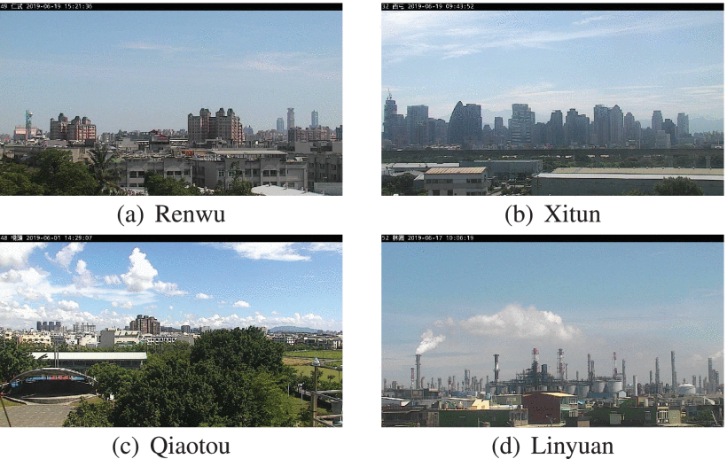

FIGURE 2.Representative images obtained from monitoring stations located in Taiwan under conditions of clear skies with minimal cloud cover.
Show All
C. Preprocessing of the Taiwan Monitoring Station Dataset
Among the datasets reviewed in the previous subsection, the Taiwan monitoring station dataset offers several distinct advantages. First, it is an official government-provided dataset containing high-resolution images captured from diverse geographical environments, making it well suited for developing robust image-based air quality estimation models. Second, the dataset has been adopted as a benchmark in previous studies [28], enabling direct and fair performance comparisons.
Although images are continuously captured throughout the day, only those acquired between 7:00 a.m. and 5:00 p.m. are selected for this study to ensure consistent daytime illumination conditions. Restricting the dataset to daytime images improves the reliability of downstream tasks, including weather classification, sky segmentation, and, most importantly, PM2.5 concentration estimation. To further enhance data quality, several preprocessing operations are performed. These include removing invalid "-s" images, cropping the information bar embedded in each image, and eliminating corrupted or unusable samples. These preprocessing steps improve dataset consistency and reduce the influence of irrelevant visual information during model training.
For model development, the complete image dataset collected during 2023 was initially downloaded and utilized to train the YOLO-based weather classification and sky segmentation models, owing to its larger scale and greater diversity of weather conditions. However, to ensure a fair comparison with the benchmark study in [28], the PM2.5 estimation model was trained using images captured between August 2018 and July 2019, together with their corresponding PM2.5 measurements. Although the YOLO models and the PM2.5 estimation model were trained using datasets from different time periods, the comprehensive 2023 dataset provides abundant image samples that improve the robustness of the weather classification and sky segmentation models and may also serve as a valuable resource for future research on image-based PM2.5 estimation.
It is noteworthy that the framework proposed in [29], which incorporates temperature and wind speed measurements from Taiwan monitoring stations, extends the methodology introduced in [28]. However, its evaluation is limited to the Renwu monitoring station, whereas [28] reports comprehensive experimental results across four different monitoring stations. Since the primary objective of this study is to estimate PM2.5 concentrations using image-derived information alone, the methodology presented in [28] provides a more appropriate benchmark. Furthermore, [28] also reports experimental results obtained by combining image features with relative humidity, making it more closely aligned with the objectives of the proposed framework while offering a broader basis for performance comparison.
During the training of the YOLO-based models, all input images are resized so that both image dimensions are multiples of 32, following the recommendation in [40]. This resizing strategy ensures compatibility with the network architecture, improves computational efficiency, and contributes to more stable feature extraction and model convergence during training.
D. YOLO-Based Weather Classification
The objective of the proposed weather classification module is twofold: (1) to incorporate weather conditions as auxiliary features for improving PM2.5 estimation accuracy, and (2) to automatically identify low-quality or defective images that should be excluded from model training and inference. The weather classification model was developed using images collected from multiple air quality monitoring stations in Taiwan and categorizes each image into one of four weather classes: cloudy, defect, shine, and sunny.
The cloudy category includes rainy conditions and scenes completely covered by dense clouds or exhibiting low illumination. The defect category consists of low-quality images affected by camera faults, water droplets, dust contamination, or other artifacts that degrade image quality. The shine category represents images captured under intense sunlight, resulting in glare or halo effects, while the sunny category corresponds to clear-sky conditions with minimal cloud coverage.
To improve the generalization capability of the model across different monitoring stations, the dataset was constructed by balancing the number of samples from each station as evenly as possible. The dataset comprises 5,000 cloudy images, 2,000 defect images, 2,500 shine images, and 5,000 sunny images. These samples were randomly divided into training, validation, and testing sets using a 70:20:10 ratio.
The weather classification model was initialized using the pre-trained YOLO11s-cls architecture. During training, the hyperparameters were configured with 500 epochs, patience = 50, dropout = 0.2, and an input image size of 640 × 640 pixels. The trained model produces weather probability scores that are subsequently fused with image features in the proposed BENet-VGG16 framework to improve PM2.5 concentration estimation.

E. YOLO-Based Sky Segmentation
The visual appearance of the sky varies considerably under different atmospheric conditions and provides valuable information for estimating air pollution levels. As PM2.5 concentration increases, atmospheric visibility generally decreases, causing the sky to appear increasingly hazy. Consequently, separating images into sky and non-sky regions enables more effective extraction of region-specific features that are closely related to air quality.
Conventional sky segmentation methods, such as thresholding and K-means clustering, are highly sensitive to illumination changes, glare, shadows, and dense cloud formations, resulting in unstable segmentation performance. In contrast, deep learning-based segmentation models provide superior robustness and generalization across diverse environmental conditions. The YOLO family of models supports both object detection and semantic segmentation. While object detection requires relatively simple annotation, semantic segmentation provides pixel-level accuracy at the expense of more labor-intensive annotation, particularly for objects with irregular boundaries such as the sky.
To develop a generalized sky segmentation model, images collected from multiple monitoring stations in Taiwan were utilized. The first step involved verifying the presence of visible sky regions within each image. Similar to the weather classification task, images from multiple monitoring stations were included to improve the model's ability to generalize across different geographical environments.
Traditional semantic segmentation requires manual pixel-wise annotation, which is both time-consuming and labor-intensive. To simplify this process, the Roboflow platform [41] was employed. Specifically, the Smart Polygon annotation tool was used to automatically generate segmentation masks for prominent sky regions, followed by manual refinement when necessary. Since the sky typically represents one of the largest and most distinguishable regions in outdoor images, the Smart Polygon tool proved highly effective for this application.
Roboflow also provides several built-in data augmentation techniques. In this work, horizontal flipping was applied to increase data diversity and improve model robustness. After annotation and augmentation, the dataset was partitioned into training, validation, and testing subsets using a 70:20:10 ratio. The final dataset contains 1,200 sky images, 400 non-sky images, and 862 horizontally flipped images.
To reduce storage requirements and accelerate model training, all images were resized to 640 × 360 pixels, which is compatible with the default input resolution of the YOLO segmentation architecture. The segmentation model was initialized using the pre-trained YOLO11s-seg network and trained with 500 epochs, patience = 50, and an input image size of 640 × 640 pixels.
The resulting segmentation masks are subsequently used to compute the sky ratio and extract regional visual features from the sky and non-sky regions. These features are integrated with the original RGB image and weather classification probabilities to construct the multimodal image representation used by the proposed BENet-VGG16 model for accurate PM2.5 concentration estimation.
F. Image Processing
Unlike approaches that directly employ raw RGB images as model inputs, several existing studies first extract handcrafted visual features and subsequently apply traditional machine learning algorithms for PM2.5 estimation. However, the effectiveness of these methods is highly dependent on the selected image-processing techniques, and operations such as contrast enhancement or saturation adjustment may produce inconsistent feature representations under varying environmental conditions.
As discussed in Section II-B, Yang et al. [42] proposed a systematic image-processing framework that extracts six representative feature maps, namely the refined dark channel, maximum local contrast, maximum local saturation, minimum local color attenuation, hue disparity, and chroma. These feature maps have demonstrated strong correlations with atmospheric visibility and particulate matter concentration.
In the proposed framework, all input images are first resized to 640 × 360 pixels to reduce computational complexity while preserving sufficient visual information. Following the methodology of [42], five of the six feature maps are directly adopted. The refined dark channel is replaced with the standard dark channel to simplify computation without significantly affecting feature quality. Based on the outputs of the YOLO-based sky segmentation model, each image is partitioned into three regions: sky, non-sky, and entire scene. For each feature map, statistical descriptors including the mean, standard deviation (Std), and variance (Var) are computed over the three regions, yielding a total of 54 regional statistical features for every image.
To evaluate the contribution of these regional features to PM2.5 estimation, linear regression analysis is performed between each extracted feature and the corresponding PM2.5 concentration. The regression results are subsequently used to identify the most informative regional descriptors, which are then incorporated as auxiliary inputs into the proposed BENet-VGG16 model to enhance prediction performance.
G. BENet-VGG16 Neural Network Model
This section describes the data preparation procedure, the design principles, and the overall architecture of the proposed BENet-VGG16 deep learning framework for image-based PM2.5 concentration estimation.
1) Data Preparation
The data preparation stage consists of multiple preprocessing operations, including image preprocessing, YOLO-based weather classification, sky segmentation, regional feature extraction, data annotation, invalid sample removal, and image resizing. These procedures are designed to improve data quality and ensure that only informative images are used during model training.
Images exhibiting significant visual degradation, such as those affected by raindrops, dust contamination, lens flare, or halo effects, are classified as defective and automatically excluded. Likewise, images without visible sky regions are removed because they provide insufficient atmospheric information for reliable PM2.5 estimation. Furthermore, images with a computed sky coverage ratio below 5% are considered unsuitable for regional feature extraction and are therefore discarded. Samples associated with PM2.5 concentration values equal to zero are also regarded as invalid and excluded from the dataset.
Chen [28] addressed image quality control by extracting handcrafted features for all images acquired within each hour and removing those whose standard deviation exceeded the average hourly standard deviation. Although effective, this strategy requires repeated feature extraction and statistical analysis throughout the preprocessing stage.
In contrast, the proposed framework introduces a simpler and more efficient rule-based filtering strategy. Rather than relying solely on feature statistics, only images corresponding to the dominant weather condition within each hourly interval are retained for model training. Specifically, an image is excluded if it satisfies any of the following conditions:
- The recorded PM2.5 concentration is zero.
- The calculated sky coverage ratio is less than 5%.
- The weather classification model identifies the image as defective.
- The image does not belong to the dominant weather category within the corresponding hourly interval.
After applying these filtering criteria and completing the image-processing stage, all remaining images are resized to 640 × 360 pixels to provide uniform input dimensions for the proposed BENet-VGG16 model. The complete data preparation pipeline is illustrated in Figure 3.
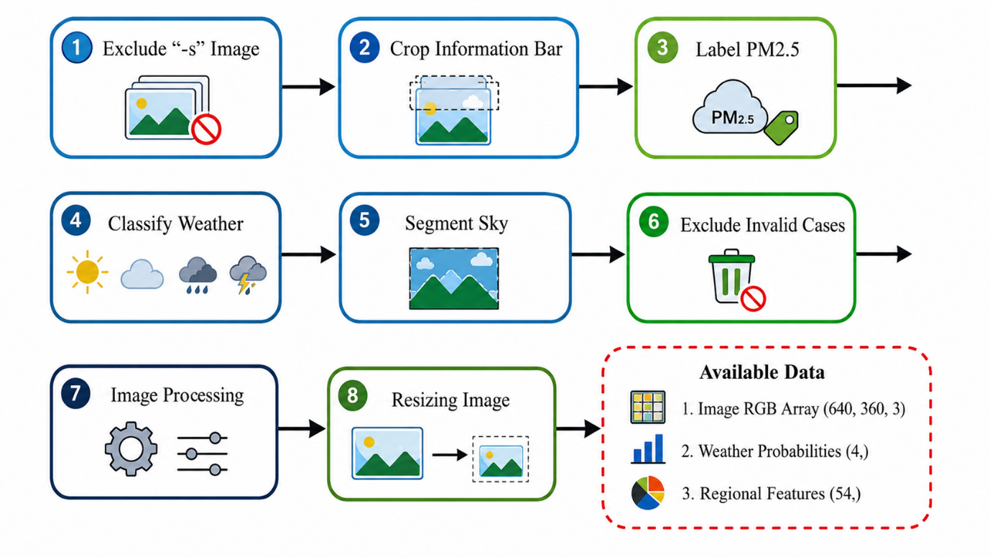

FIGURE 3.Workflow for the preparation of training data for BENet-VGG16.
2) Model Design
TensorFlow provides a wide range of deep learning architectures with pretrained weights that facilitate transfer learning. By leveraging models pretrained on large-scale datasets such as ImageNet, meaningful visual representations can be extracted even when only limited training data are available. In a typical transfer learning framework, the pretrained classification head is removed and replaced with a customized regression layer for the target task. Although this strategy significantly reduces training time and improves feature extraction capability, many pretrained models contain a large number of parameters, increasing computational complexity and the risk of overfitting. Furthermore, architectures such as ResNet incorporate Batch Normalization (BN) layers whose performance is highly dependent on batch size. While large batch sizes generally improve training stability and convergence, they require substantial GPU memory, whereas small batch sizes may lead to unstable training and reduced generalization performance.
To overcome these limitations, the proposed framework adopts the VGG16 architecture pretrained on the ImageNet dataset as the backbone network for transfer learning. VGG16 was selected because its original architecture does not include Batch Normalization layers, making it more suitable for training with relatively small batch sizes. In addition, rather than utilizing the complete VGG16 network, only the feature extraction layers up to block2_pool are retained. This substantially reduces the number of trainable parameters, lowers computational cost, and mitigates the risk of overfitting while preserving effective low-level and mid-level feature extraction.
To further enhance feature learning, the proposed architecture introduces multiple parallel feature extraction branches, referred to as branch blocks. Each branch consists primarily of convolutional and max-pooling layers and is generated through a loop-based implementation, enabling an efficient and scalable network design. These parallel branches independently learn complementary image representations, thereby emulating the advantages of ensemble learning within a single end-to-end neural network. The extracted feature maps from all branch blocks are subsequently concatenated and passed through fully connected regression layers to estimate the PM2.5 concentration. The resulting architecture is referred to as BENet-VGG16 (Branch Ensemble Network based on VGG16).
Figure 4 illustrates the overall architecture of the proposed BENet-VGG16 framework. The primary input (Input_1) is an RGB image with a resolution of 640 × 360 × 3, which serves as the main source of visual information for PM2.5 estimation. To investigate the effectiveness of image-derived multimodal feature fusion, the architecture additionally supports two optional inputs. Input_2 consists of a four-dimensional weather probability vector generated by the YOLO-based weather classification model, where the probabilities of the four weather categories sum to one. Input_3 is a 54-dimensional regional feature vector extracted through image processing and YOLO-based sky segmentation, containing statistical descriptors computed from the sky, non-sky, and entire image regions.
Before feature fusion, Input_2 and Input_3 are independently processed through dedicated fully connected (dense) layers to transform and project the auxiliary information into higher-dimensional feature spaces. These transformed features are then fused with the deep visual features extracted by the main branch, enabling effective multimodal representation learning. This flexible architecture allows direct comparison between models trained with only RGB images and those incorporating additional image-derived contextual information, thereby facilitating a comprehensive evaluation of the contribution of weather probabilities and regional features to PM2.5 estimation.
Despite incorporating multiple feature extraction branches and multimodal inputs, the proposed BENet-VGG16 model remains computationally efficient, containing approximately 2.7 million trainable parameters, which is significantly lower than the approximately 14.7 million parameters required by the conventional VGG16 architecture. Consequently, the proposed model achieves a favorable balance between prediction accuracy, computational efficiency, and model complexity, making it well suited for practical real-time PM2.5 estimation applications.
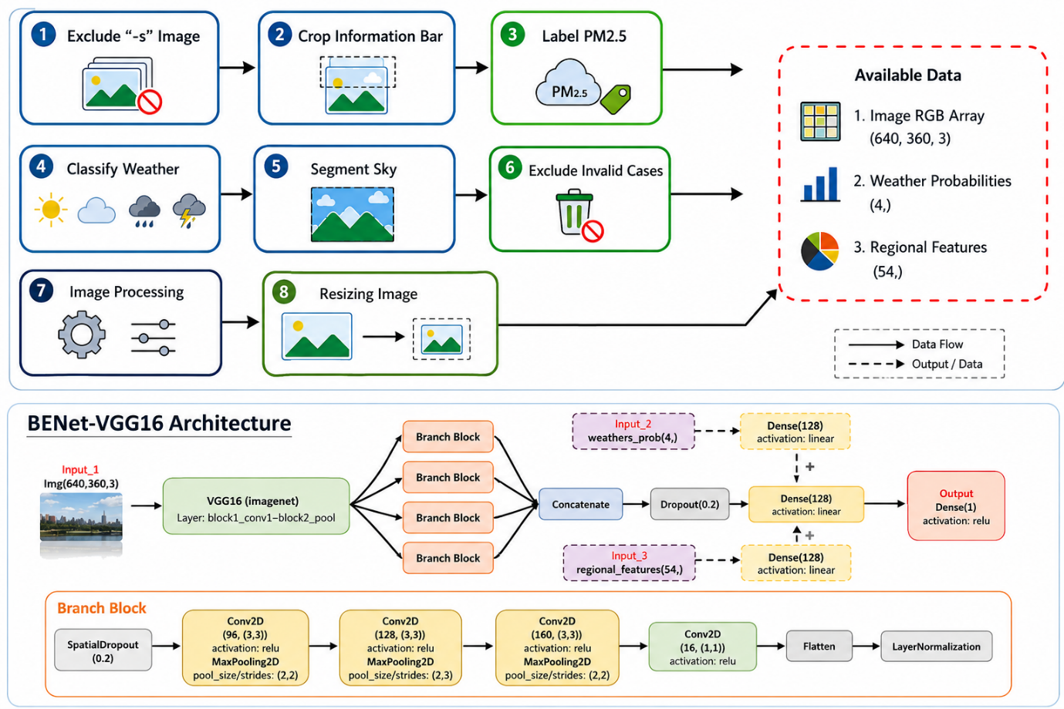
FIGURE 4. The architecture of BENet-VGG16: input_1 consists of a standard image array, as the primary input for estimating PM2.5 in the main branch; input_2 corresponds to weather probabilities, derived from weather classification with values summing to unity; Input_3 comprises regional features, obtained through image processing and sky segmentation techniques.
H. Docker-Based System Deployment
To demonstrate the proposed PM2.5 estimation framework in a practical environment, a web-based application was developed. The system architecture consists of two primary components: a front-end web server that provides the user interface for image upload and result visualization, and a Python-based back-end server that performs weather classification, sky segmentation, image processing, and PM2.5 estimation. The back-end server processes incoming requests and returns the prediction results in JSON format, which are subsequently displayed through the web interface.
To simplify system deployment, improve portability, and ensure reproducibility across different computing environments, the entire application is containerized using the Docker platform. The front-end web server and the Python back-end server are encapsulated as independent Docker containers and orchestrated through a docker-compose.yml configuration file. This containerized architecture enables lightweight deployment, rapid system initialization, simplified dependency management, and efficient version control. Furthermore, Docker ensures a consistent execution environment across development, testing, and production platforms, thereby enhancing the scalability, maintainability, and reproducibility of the proposed PM2.5 estimation system.

- Experimental Results
This section presents the experimental results of the proposed PM2.5 estimation framework, including the performance of the YOLO-based weather classification model, the sky segmentation model, image processing techniques, and the automated exclusion of invalid images. Following the extraction of regional image features, linear regression analysis is performed to investigate the relationship between these features and PM2.5 concentrations, providing a preliminary assessment of their effectiveness in improving estimation performance.
Subsequently, the proposed BENet-VGG16 model is comprehensively evaluated by examining the influence of different input configurations, including RGB images, weather probability vectors, and regional image features. The contribution of the proposed multimodal image representation is analyzed through comparative experiments, and the model's generalization capability is further assessed using transfer learning across multiple monitoring stations.
Model performance is quantitatively evaluated using the coefficient of determination (R²) and the root mean square error (RMSE), where RMSE is reported in micrograms per cubic meter (μg/m³). Finally, a web-based implementation of the proposed system is presented to demonstrate its practical deployment and real-time PM2.5 estimation capability through an interactive user interface.
Mathematical Formulations for Image-Based Outdoor PM2.5 Concentration Estimation Using BENet-VGG16 and Feature Engineering
- Data Normalization (Min-Max Scaling)
The Min-max normalization formula is:
$x_{norm}$=$\frac{X-X_{min}}{X_{max}-X_{\begin{aligned}min \\ \end{aligned}}}$
Where:
X=original feature value
$$X_{min}=minimum value of the feature$$
$$X_{max}=maximun value of the feature$$
$$X_{norm}=normalized value in the range[0,1]$$

- Feature Vector Construction

Let
I_{f} = Image feature vector extracted by the BENET-VGG16 model
A_{f} = AQI parameter vector.
The combined feature vector is given by:
F=[I_{f} $⊕$ A_{f} ]
Where $⊕$ denotes the concatenation operation.
Expanding the equation
F = [ f₁,f₂,….,f_{m},a₁,a₂,…..a_{n}]^{T}

- Convolution Operation in VGG16

In the VGG16 architecture, the convolution operation extracts spatial features from the input image by applying learnable filters (kernels). The output feature map is computed as:
Y _{i,j,k} =($\sum_{m=1}^{M}{}\sum_{u=1}^{K-1}{\sum_{v=1}^{K-1}{}}$W u,v,m,k X i+u, J+v,m + b k)
Where
X = Input Feature map or image
Y i,j,k = Output feature value at position (i,j) in the k^{th} feature map
W u,v,m,k = Weight of the convolution kernel
b_{k} = Bias term of the k^{th} filter.
K × K = Size of the convolution kernel (VGG16 primarily uses 3× 3 kernels)
M = Number of input channels.
⌐(.) = activation function, typically ReLU
After convolution, VGG 16 applies the ReLU activation
F(x) = max(0,x)
The feature map after activation is :
F = ReLU(W * X + b)
Where
- * denotes the convolution operation
- W is the set of learnable filters,
- X is the input feature map,
- B is the bias vector

- Rectified Linear Unit (ReLU)
The Rectified Linear Unit (ReLU) is an activation function used in deep learning models such as VGG16. It introduces non-linearity into the network and helps the model learn complex patterns from data.
Mathematical Formula
F(x) = max(0,x)
Where
- x = input to the neuron
- f(x) = output after applying the ReLU activation function

This means :
f(x) = $\left\{\begin{aligned}0,x<0{} \\ x, x≥0\end{aligned}\right.$
working of ReLU
- if the input value is negative ,the output becomes 0.
- if the input value is positive ,the output remains unchanged.

5. Max-Pooling Operation
The output size of a Max-Pooling layer is calculated using the following formula:
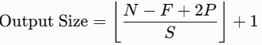
Where:
- N = Input feature map size (Height or Width)
- F = Pooling filter (kernel) size
- P = Padding
- S = Stride
6. Feature Fusion
For the proposed BENet-VGG16 architecture, the fused feature vector is obtained by concatenating the three feature sets:
- Image Features (I) extracted from VGG16
- Weather Probability Features (W) from the weather classifier
- Regional Features (R) from sky segmentation and image processing
where
- I = Image feature vector
- W = Weather probability vector
- R = Regional feature vector
- Concat( ) = Concatenation operation

7. Fully Connected Layer
The output of a fully connected layer is computed as
where:
- x = Input feature vector (fused features)
- W = Weight matrix
- b = Bias vector
- f(⋅) = Activation function (ReLU)
- h = Hidden feature vector

8. PM2.5 Concentration Estimation
The predicted PM2.5_{2.5}2.5​ concentration is calculated as:
where:
- y^​ = Predicted PM2.5​ concentration
- h = Output feature vector from the final fully connected layer
- Wo​ = Output layer weight matrix
- bo​ = Output layer bias
9. Mean Squared Error (MSE)
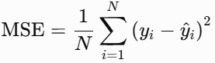
where:
- N = Total number of samples
- yi​ = Actual PM2.5 concentration
- y^​i​ = Predicted PM2.5​ concentration
- (yi​−y^​i​)2 = Squared prediction error for the ith sample

10. Root Mean Square Error (RMSE)

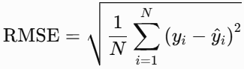

11. Mean Absolute Error (MAE)
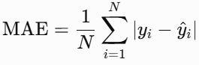
where:
- N = Total number of samples
- yi​ = Actual PM2.5 concentration
- y^​i​ = Predicted PM2.5 concentration
- |∣yi​−y^​i​∣ = Absolute prediction error

12. Coefficient of Determination ((R^2))

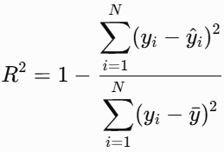
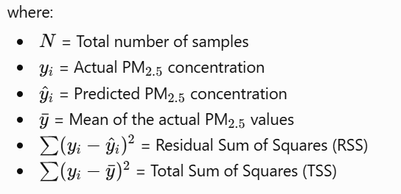
13. AQI Calculation
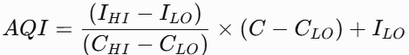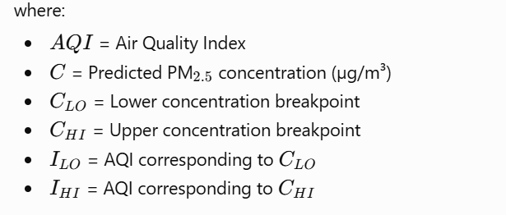
14. Adam Optimizer Update Equations

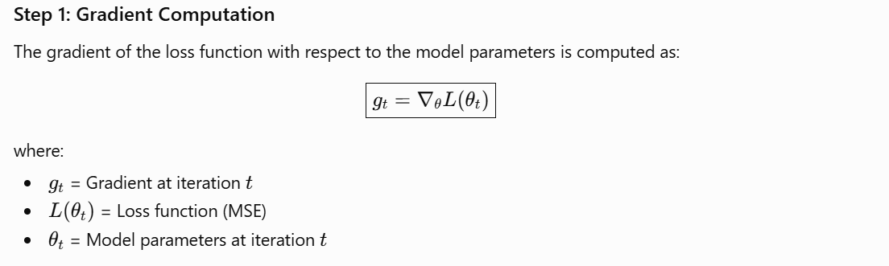
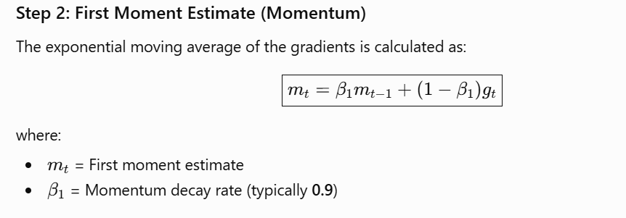
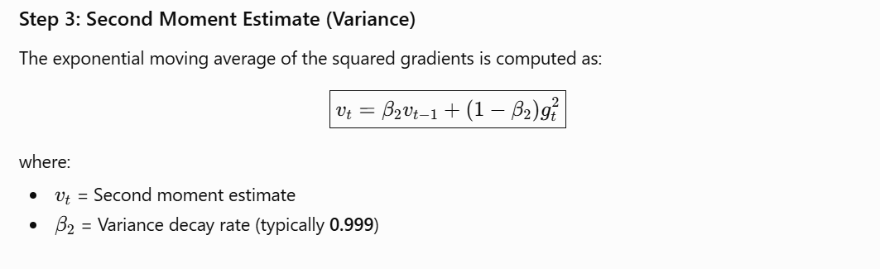
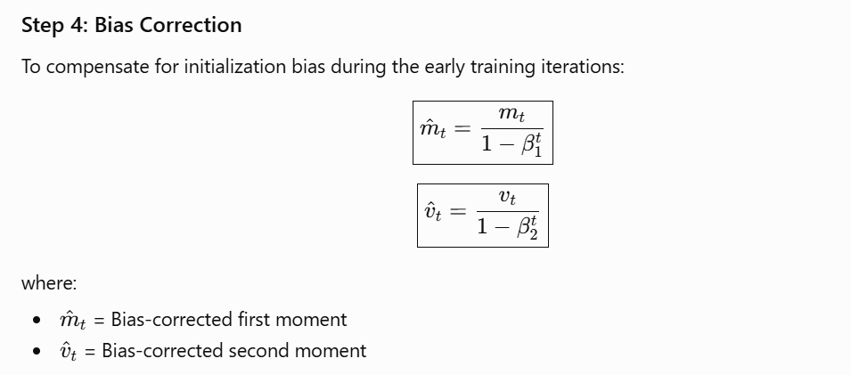
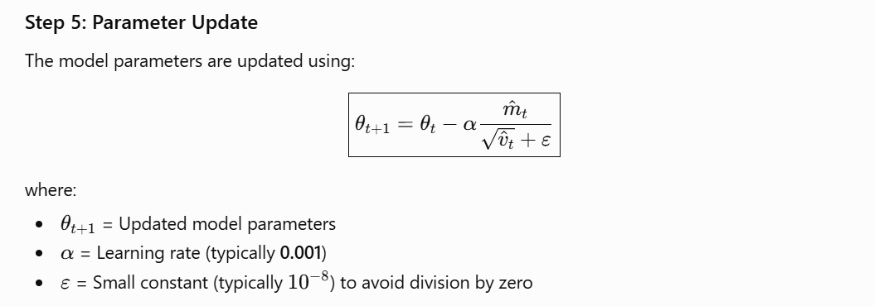
A. Weather Classification Results
The performance of the proposed weather classification model is primarily evaluated using classification accuracy. Figure 5 presents the normalized confusion matrix obtained from the validation dataset. As illustrated, the classification accuracy for all four weather categories exceeds 90%, demonstrating the model's strong capability to accurately distinguish among different weather conditions. Nevertheless, a small number of misclassifications are observed, which are mainly attributed to ambiguous images exhibiting characteristics shared by two visually similar weather categories.
To further evaluate the training process and model convergence, Figure 6 illustrates the evolution of the training and validation metrics throughout the learning process. In particular, the consistently high Top-1 accuracy shown in Figure 6 (right) indicates that the proposed YOLO-based weather classification model converges effectively and achieves excellent classification performance on the validation dataset.
Figure 7 presents representative prediction results generated by the trained YOLO model. The examples demonstrate the model's ability to correctly classify images captured under diverse weather conditions while simultaneously identifying defective images that should be excluded from subsequent PM2.5 estimation. Notably, the middle example illustrates an image affected by dust contamination, which is successfully recognized as a defective image by the proposed model. Such visual artifacts can adversely influence the extraction of image features and consequently degrade PM2.5 estimation accuracy. Therefore, their automatic detection and exclusion contribute to improving the robustness and reliability of the proposed PM2.5 estimation framework.
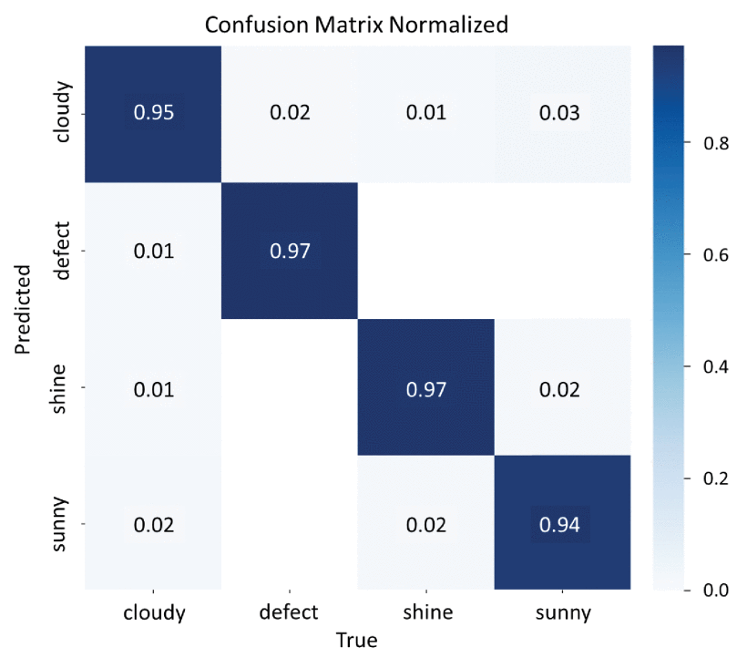

FIGURE 5.Normalized confusion matrix for the weather classification model with cloudy, defect, shine, and sunny classes.
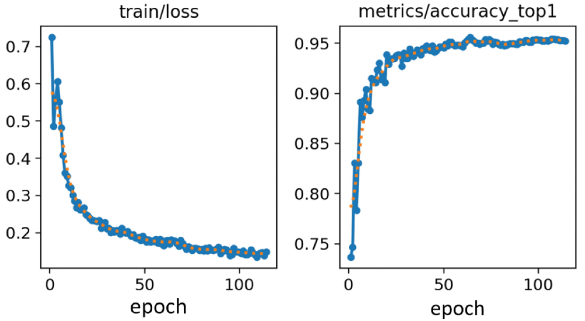

FIGURE 6.The trajectories of evaluation metrics across training epochs of weather classification model: training loss (left) and classification accuracy (right).
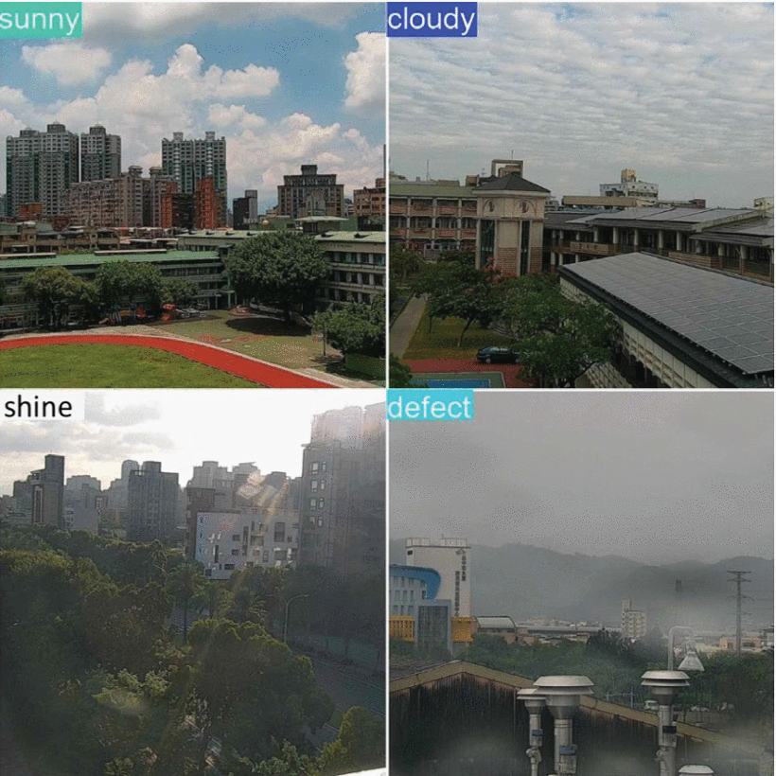

FIGURE 7.Illustrative results produced by the four-class weather classification model.
B. Sky Segmentation Results
B. Sky Segmentation Results
Unlike the weather classification task, the proposed sky segmentation model performs single-class semantic segmentation, where only the sky region is considered as the target class. Consequently, a normalized confusion matrix is less informative for performance evaluation. Figure 8 presents the confusion matrix obtained from the validation dataset. As shown, only five misclassified samples are observed among 304 validation images, demonstrating the model's high accuracy and robust capability to identify and segment sky regions under diverse environmental conditions.
To further evaluate the learning behavior of the proposed segmentation model, Figure 9 illustrates the evolution of the training and validation performance metrics over successive training epochs. Although the validation curves exhibit minor fluctuations during the early stages of training, they gradually stabilize as the model converges, indicating satisfactory learning stability and generalization performance.
Figure 10 presents representative segmentation results generated by the trained YOLO model on the validation dataset. In the visualized outputs, the blue masks denote the sky regions automatically identified by the model. The results demonstrate that the proposed model accurately delineates sky regions across various weather and scene conditions. Moreover, when a visible sky region is absent or cannot be reliably identified, such as in the upper-left example of Figure 10, the model appropriately refrains from generating a segmentation mask. This behavior effectively prevents erroneous sky feature extraction and improves the reliability of subsequent sky ratio computation and regional feature extraction for PM2.5 concentration estimation.
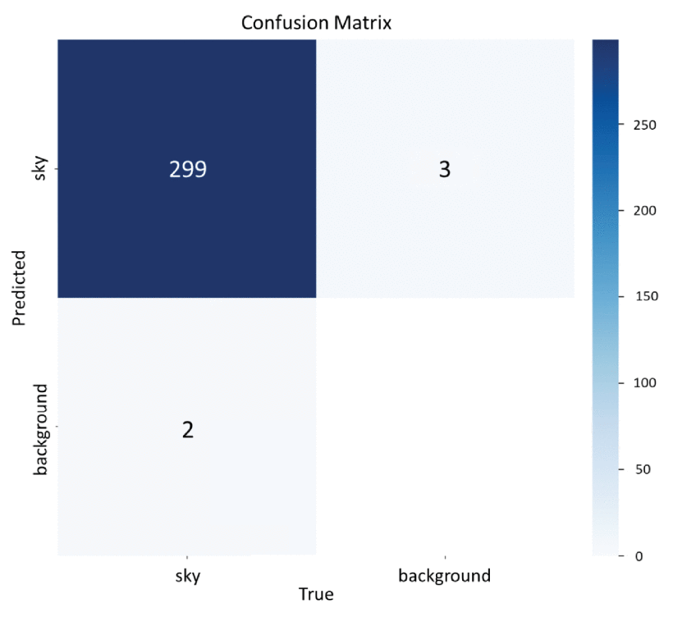
FIGURE 8. Normalized confusion matrix for the sky segmentation model with sky and background classes.
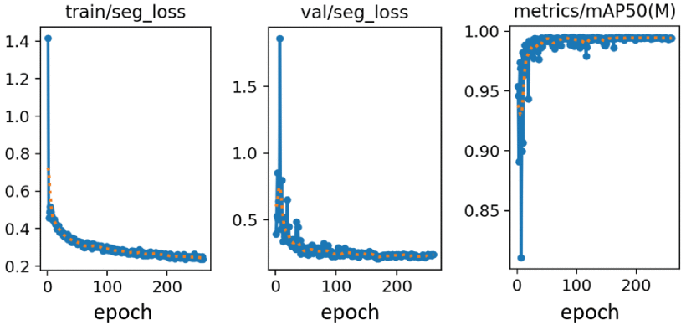
FIGURE 9. The trajectories of evaluation metrics across training epochs of sky segmentation model: training loss (left), validation loss (middle), and classification accuracy (right).

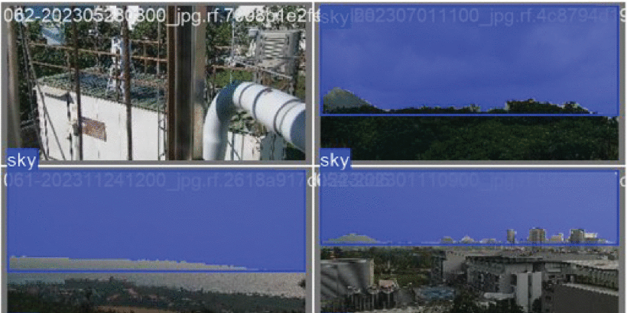
FIGURE 10. Illustrative results produced by the sky segmentation model: sky regions and non-specific sky regions labeled (top left).

C. Training Data Preparation Results
After annotating the PM2.5 values and generating the weather classification probabilities and sky coverage ratios, these image-derived attributes are employed to identify and remove invalid training samples according to the criteria described in Section III-G. This automated filtering process eliminates images that are unsuitable for reliable PM2.5 estimation, including defective images, images with insufficient sky coverage, images associated with zero PM2.5 values, and images that do not correspond to the dominant weather condition within the same hourly interval.
Table II summarizes the number of valid images retained for each monitoring station after the data filtering process. The results indicate that the proposed preprocessing framework preserves approximately 90% of the original dataset after applying the exclusion criteria described in Steps 2–6 of the data preparation procedure. This demonstrates that the proposed quality control strategy effectively removes invalid or low-quality samples while retaining the majority of informative images for model training. Consequently, the resulting dataset provides a reliable foundation for subsequent feature extraction and PM2.5 estimation using the proposed BENet-VGG16 model.
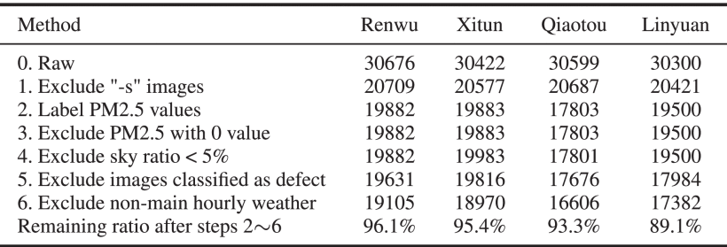

TABLE 2 Number of Images Remaining at Each Station Following the Exclusion Criteria

D. Discussion of Regional Features
This section investigates the relationship between the extracted regional image features and PM2.5 concentrations. Linear regression analysis is employed to evaluate the effectiveness of incorporating features from different image regions into the proposed PM2.5 estimation framework.
1) Relationship Between Regional Features and PM2.5
Following image preprocessing, YOLO-based sky segmentation, and feature extraction, a total of 54 regional statistical features were generated for each image. These features were extracted from three distinct regions: the entire image, the sky region, and the non-sky region, where the latter two regions were identified using the proposed sky segmentation model. Each regional feature was subsequently paired with the corresponding PM2.5 concentration, and correlation analysis was performed to investigate its relationship with air pollution levels. Tables III–V summarize the correlation coefficients between PM2.5 concentrations and the extracted regional features based on the mean, standard deviation (Std), and variance (Var) for each monitoring station.
The correlation analysis yields two important observations.
• Importance of regional feature selection
The correlation coefficients of individual features vary considerably across different monitoring stations, indicating that the relevance of a particular feature is highly location dependent. Consequently, constructing a unified PM2.5 estimation model that employs an identical feature set while achieving optimal performance across all stations remains a challenging task. For example, as shown in Table IV, the correlation between PM2.5 concentration and the Std/Var of the dark channel feature computed over the entire image ranges from −0.73 to 0.15 among different stations. This substantial variation suggests that feature selection should be adapted to the characteristics of individual monitoring environments.
• Regional features exhibit stronger correlations than whole-image features
The experimental results also indicate that regional features extracted from specific image areas can exhibit stronger correlations with PM2.5 concentrations than features computed over the entire image. For example, as presented in Table III, the average chroma extracted from the non-sky region at the Linyuan monitoring station demonstrates a higher correlation with PM2.5 concentration than the corresponding features extracted from either the sky region or the entire image. This observation suggests that region-specific information may better capture visual characteristics associated with atmospheric pollution. Therefore, incorporating regional image features, particularly those derived from the sky and non-sky regions, has the potential to improve the accuracy and robustness of image-based PM2.5 estimation compared with relying solely on whole-image features.
TABLE 3 Relationship Between the Average Values of Image Features and PM2.5 Concentrations
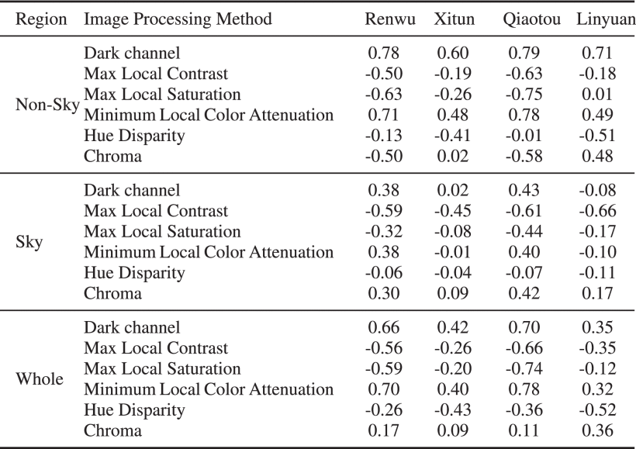

TABLE 4 Relationship Between the Std of Image Features and PM2.5 Concentrations
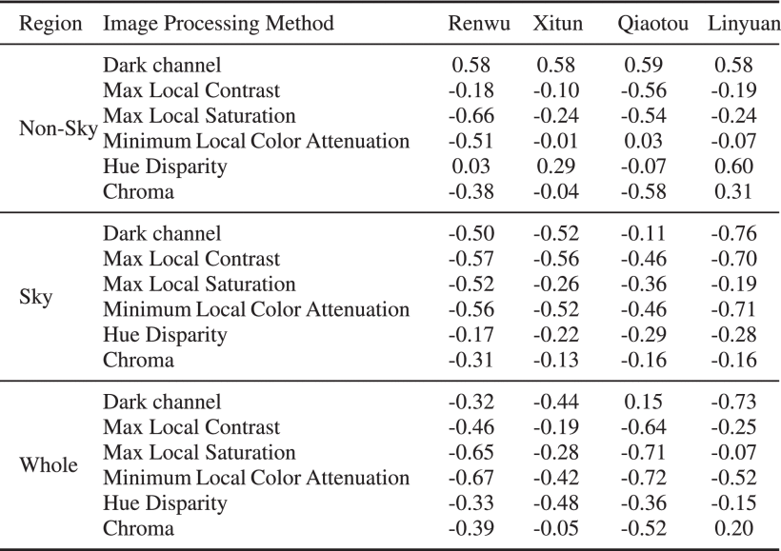

TABLE 5 Relationship Between the Var Values of Image Features and PM2.5 Concentrations
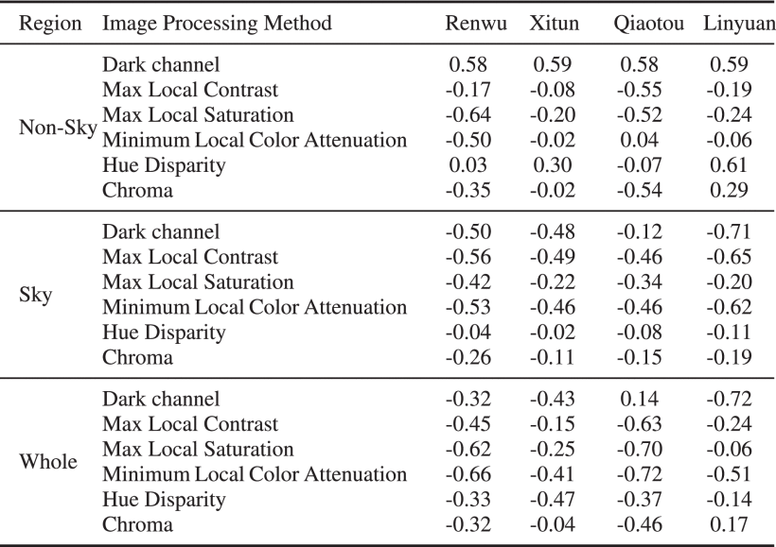
2) Linear Regression Analysis of Regional Features
To further investigate whether integrating features extracted from different image regions can improve PM2.5 estimation, a linear regression analysis was conducted as a preliminary evaluation. Since the primary objective of this study is to develop the proposed BENet-VGG16 model and the extracted feature set contains 54 regional features, a simple linear regression model was adopted to evaluate the predictive capability of these features without applying feature selection or more sophisticated regression techniques. This analysis serves as an initial assessment of the contribution of regional features prior to their incorporation into the deep learning framework.
To alleviate the influence of the imbalanced distribution of PM2.5 concentrations, the continuous PM2.5 values were discretized by grouping every 5 μg/m³ into a single interval, thereby producing a more balanced data distribution for model training and evaluation. The dataset was then divided into 80% for training and validation and 20% for independent testing. During model development, 5-fold cross-validation was employed on the training set to identify the optimal regression model and improve the robustness of the evaluation.
Tables VI–IX summarize the regression results obtained on the test datasets for each monitoring station. These results provide a preliminary assessment of the predictive capability and redundancy of the extracted regional features and help determine whether incorporating sky-region, non-sky-region, and whole-image features is beneficial for improving PM2.5 concentration estimation in the proposed BENet-VGG16 framework.

TABLE 6 Redundancy Test Results Across Multiple Configurations of Regional Sky Features From Renwu Station
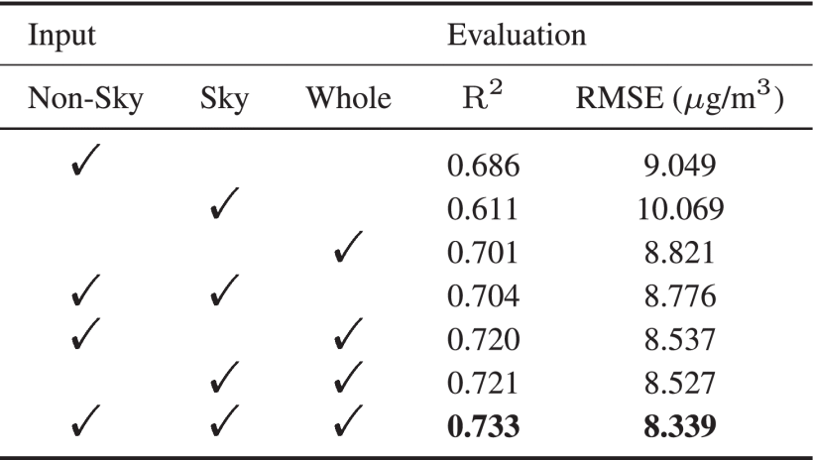

TABLE 7 Redundancy Test Results Across Multiple Configurations of Regional Sky Features From Xitun Station.
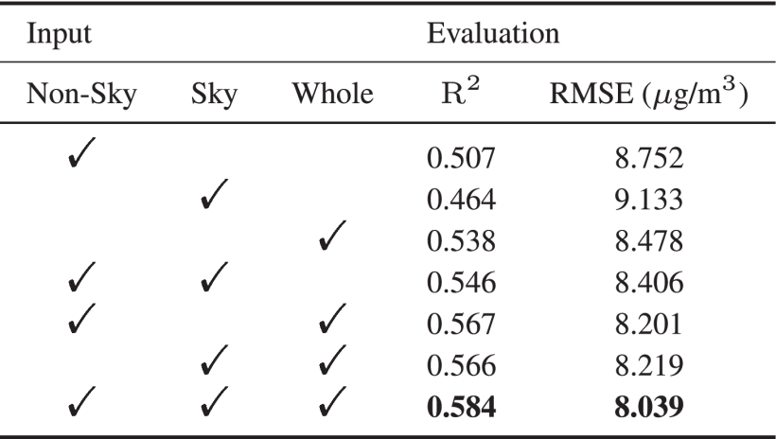

TABLE 8 Redundancy Test Results Across Multiple Configurations of Regional Sky Features From Qiaotou Station

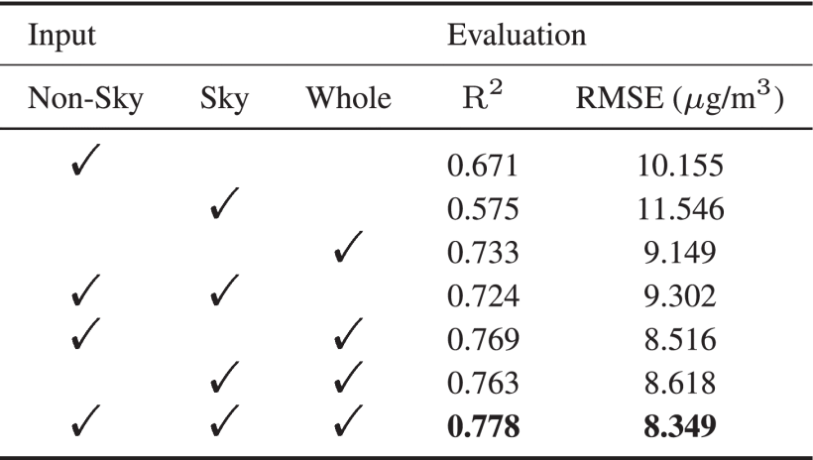

TABLE 9 Redundancy Test Results Across Multiple Configurations of Regional Sky Features From Linyuan Station.

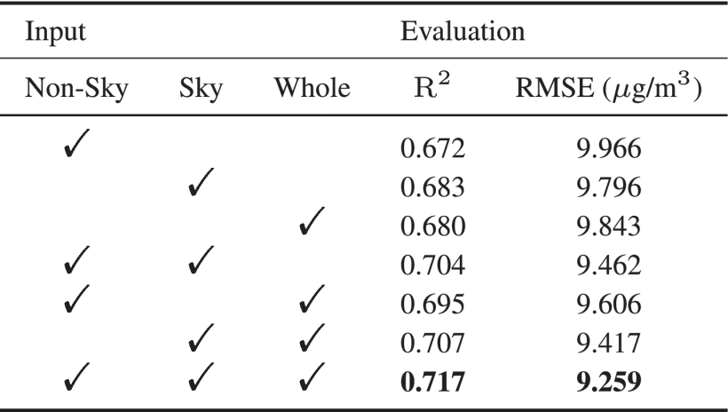

E. BENet-VGG16 Results
This section evaluates the performance of the proposed BENet-VGG16 model for PM2.5 concentration estimation. The evaluation begins with experiments conducted on individual monitoring stations using single-scene datasets and investigates the impact of incorporating additional image-derived inputs, including weather probability vectors and regional image features. Subsequently, the model's generalization capability is assessed through transfer learning across multiple monitoring stations. Finally, the proposed BENet-VGG16 architecture is compared with the conventional VGG16 model to demonstrate its effectiveness in terms of estimation accuracy and computational efficiency.
1) Single-Scene Evaluation
Although the preliminary linear regression analysis produced only moderate estimation performance, the extracted regional features exhibited meaningful correlations with PM2.5 concentrations and provided valuable complementary information. Consequently, all 54 regional features were incorporated into the proposed BENet-VGG16 framework together with the original RGB images and the weather probability vectors generated by the YOLO-based weather classification model.
To evaluate the proposed framework, a 5-fold cross-validation strategy was employed during model training to improve the robustness and reliability of the experimental results. The best-performing model obtained from the cross-validation process was subsequently evaluated on the independent test dataset for each monitoring station. The corresponding estimation results for the four monitoring stations are summarized in Tables X–XIII, providing a comprehensive assessment of the effectiveness of the proposed BENet-VGG16 model under different environmental conditions.
TABLE 10 Redundancy 5-Fold Average Test Results for BENet-VGG16 With Diverse Input Settings Obtained From Renwu Station.
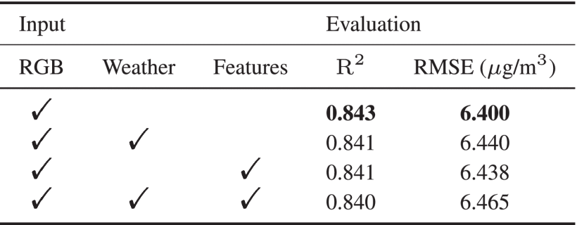

TABLE 11 Redundancy 5-Fold Average Test Results for BENet-VGG16 With Diverse Input Settings Obtained From Xitun Station.
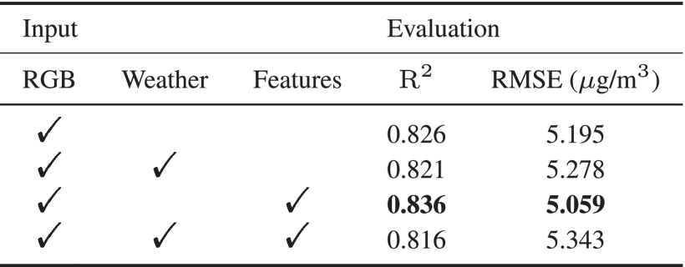

TABLE 12 Redundancy 5-Fold Average Test Results for BENet-VGG16 With Diverse Input Settings Obtained From Qiaotou Station.

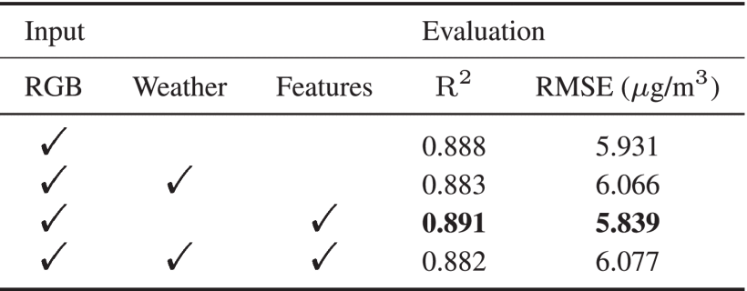

TABLE 13 Redundancy 5-Fold Average Test Results for BENet-VGG16 With Diverse Input Settings Obtained From Linyuan Station
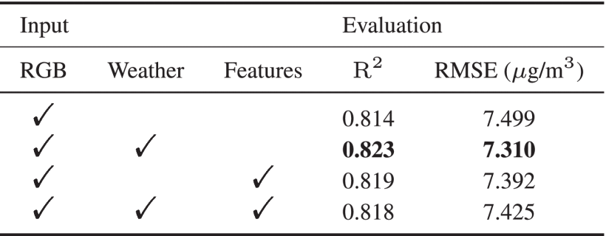

Based on the experimental results obtained from each monitoring station, incorporating additional image-derived input features can improve PM2.5 estimation performance under certain conditions. However, the results also indicate that no single combination of supplementary inputs consistently achieves the best performance across all monitoring stations. This observation suggests that the effectiveness of weather probability vectors and regional image features is influenced by the environmental characteristics and visual attributes of individual monitoring locations.
Table XIV summarizes the inference time associated with different input configurations. As expected, the prediction time decreases when the optional feature inputs are excluded, owing to the reduced computational overhead required for feature extraction and multimodal fusion. Therefore, for applications requiring real-time PM2.5 estimation with low latency, it is preferable to use only the RGB image input while omitting the optional weather probability and regional feature inputs shown in Figure 4. Conversely, when estimation accuracy is prioritized over computational efficiency, incorporating the additional image-derived features can provide performance improvements for certain monitoring stations.
For convenience, the configuration that achieves the highest estimation performance is denoted as Our-Best, whereas the model using only the RGB image as input is referred to as Our-RGB. Comparative performance evaluations between the proposed framework and the method presented in [28] are summarized in Tables XV and XVI, where the results obtained from the 5-fold cross-validation experiments are reported for each monitoring station.
TABLE 14 Average Estimation Time Across Diverse Input Configurations With the RGB Array, Weather Probabilities, and Regional Features.
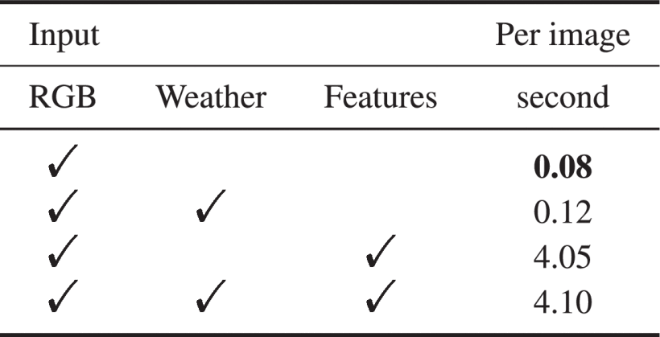

TABLE 15 Comparison of R2 Between the BENet-VGG16 Model and Chen’s Approach Across Various Stations.
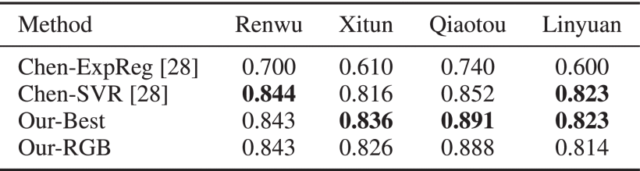

TABLE 16 Comparison of RMSE (μ g/m3) Between the BENet-VGG16 Model and Chen’s Approach Across Various Stations.
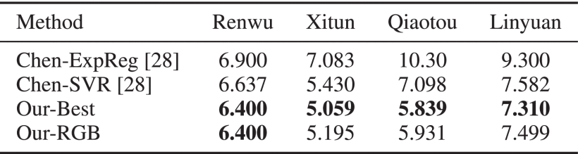

The cross-validation results summarized in Tables XV and XVI demonstrate that the proposed BENet-VGG16 model achieves accurate PM2.5 concentration estimation. Compared with the methods reported in [28], the proposed framework consistently outperforms Chen-ExpReg and attains performance comparable to Chen-SVR, despite the latter incorporating additional humidity measurements. Notably, the Our-RGB configuration, which uses only RGB image data as input, also delivers competitive estimation accuracy. This result indicates that the proposed framework can effectively estimate PM2.5 concentrations without relying on auxiliary regional features or external meteorological information, making it particularly suitable for real-time deployment where computational efficiency and low latency are essential.
Based on the cross-validation results, the optimal model configuration (Our-Best) was selected to generate scatter plots comparing the predicted and ground-truth PM2.5 concentrations on the independent test datasets. These results are illustrated in Figure 11, after which the trained models were deployed within the proposed web-based PM2.5 estimation system.
As shown in Figure 11, the majority of prediction points are concentrated around the reference line (y = x), indicating good agreement between the estimated and measured PM2.5 concentrations. Although several outliers are present, these discrepancies are primarily attributable to images with similar visual characteristics or scene compositions that correspond to substantially different PM2.5 measurements. The scatter plots also reveal larger prediction errors at higher PM2.5 concentrations, which is expected because high-pollution samples are relatively scarce and exhibit greater variability. Nevertheless, the prediction errors do not exhibit a systematic tendency toward either underestimation or overestimation, suggesting that the proposed model remains unbiased across the observed concentration range. Consequently, unlike the approach presented in [26], this study does not incorporate additional techniques specifically designed to address data imbalance.
Combining the scatter plot analysis in Figure 11 with the quantitative results reported in Tables XV and XVI provides further insight into the model's performance across different monitoring stations. Specifically, the Xitun dataset achieves a relatively lower RMSE because its PM2.5 concentration values span a narrower range, resulting in a less complex prediction task. In contrast, the Linyuan dataset exhibits a wider distribution of scatter points and greater variability in PM2.5 concentrations, leading to a comparatively higher RMSE. These observations indicate that the estimation performance of the proposed model is influenced not only by the network architecture but also by the statistical characteristics and environmental variability of the underlying datasets.
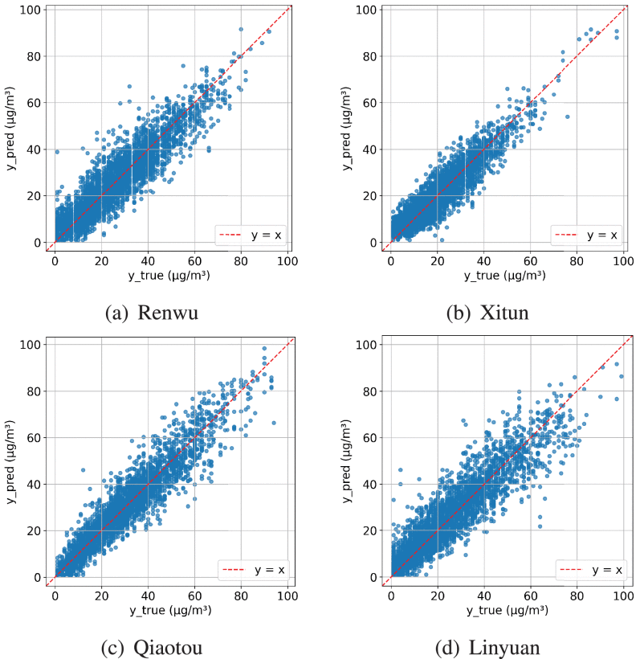

FIGURE 11.Scatter plot illustrating the relationship between observed and predicted PM2.5 concentrations, utilizing the optimal model derived from each monitoring station.
2) Analysis of Supplementary Input Influences
From a meteorological standpoint, Figure 12 illustrates the distribution of PM2.5 concentrations across various weather conditions at each monitoring station, with detailed information provided in Table 17. Irrespective of the station considered, it is evident that all weather categories display a broad spectrum of PM2.5 concentration levels. Notably, elevated concentrations are predominantly linked to cloudy conditions, which may account for the observed enhancement in model performance when weather probabilities are integrated within the Linyuan dataset.
TABLE 17 The Variation and Sample Size of PM2.5 Concentrations Under Different Meteorological Conditions at Each Monitoring Site.
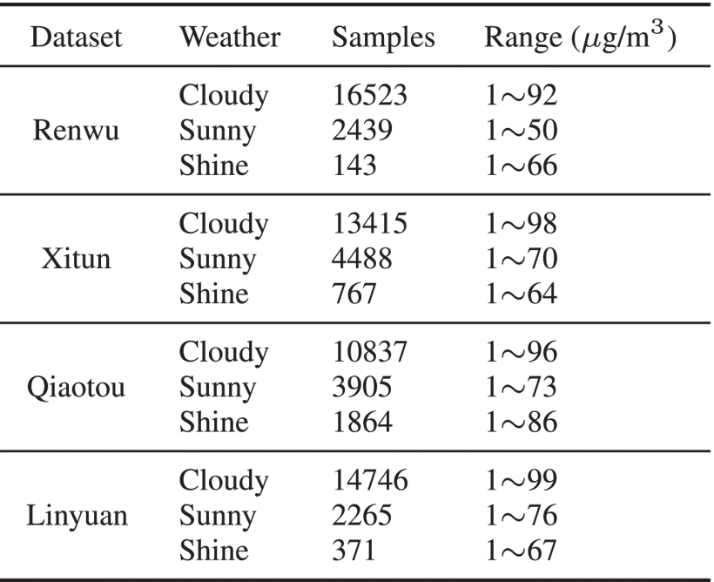

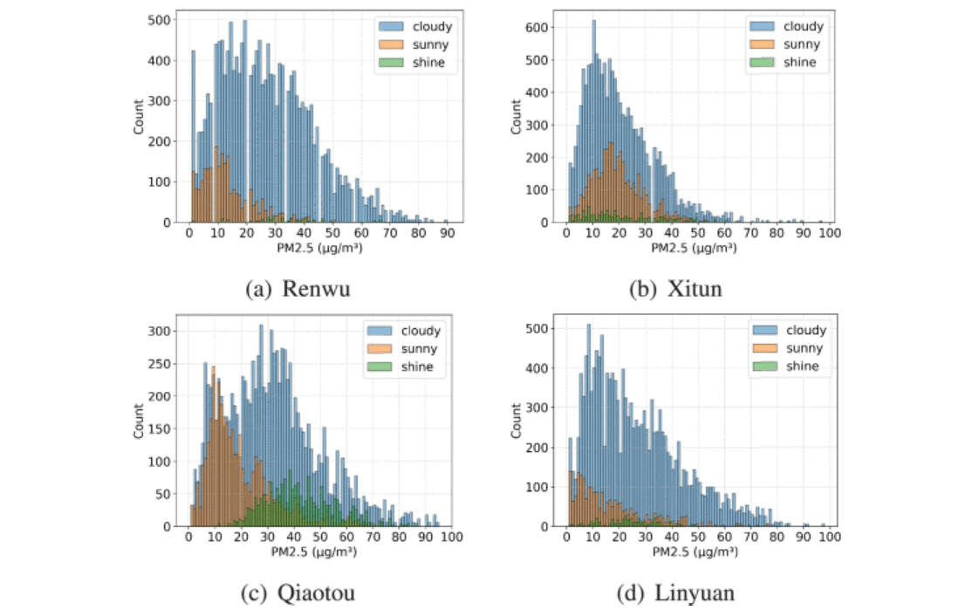
FIGURE 12.The distribution of PM2.5 concentrations according to meteorological conditions at each monitoring station.
From the standpoint of regional characteristics, distinct monitoring stations demonstrate As discussed in Section IV-D1, the extracted regional features exhibit varying degrees of correlation with PM2.5 concentrations. To further investigate this observation, the mean dark channel values computed from different image regions at the Renwu monitoring station were analyzed, as this feature represents one of the informative inputs to the proposed BENet-VGG16 model. The corresponding results are presented in Figure 13, where red represents the non-sky region, green denotes the sky region, and blue corresponds to features extracted from the entire image.
A comparison of the three regional feature distributions indicates that the mean dark channel value computed exclusively from the non-sky region exhibits a stronger correlation with PM2.5 concentration than the same feature calculated over the entire image, which includes both sky and non-sky information. This observation is supported by both the correlation coefficients and the Mean Absolute Error (MAE) values with respect to PM2.5 concentration. The results suggest that region-specific feature extraction can more effectively capture visual characteristics associated with atmospheric pollution than whole-image feature computation.
Despite this stronger correlation, a single regional feature remains insufficient for accurately estimating PM2.5 concentrations. For a fixed value of the mean dark channel feature, the corresponding PM2.5 concentrations still span a wide range, indicating substantial uncertainty. For example, when the mean dark channel value of the non-sky region is approximately 0.1, the associated PM2.5 concentration ranges from approximately 1 μg/m³ to 60 μg/m³. This considerable variation demonstrates that a single handcrafted feature cannot uniquely characterize atmospheric pollution levels.
These findings also provide insight into the experimental results presented in the previous subsection. Since the proposed BENet-VGG16 model learns rich hierarchical visual representations directly from RGB images, it is likely capable of extracting information that overlaps with, or even exceeds, that contained in individual handcrafted regional features. Consequently, when the deep learning model has already captured these discriminative visual patterns, the addition of handcrafted regional features contributes only limited complementary information. This phenomenon may explain why incorporating regional features does not consistently improve PM2.5 estimation performance across all monitoring stations, despite their relatively strong individual correlations with PM2.5 concentrations.
.
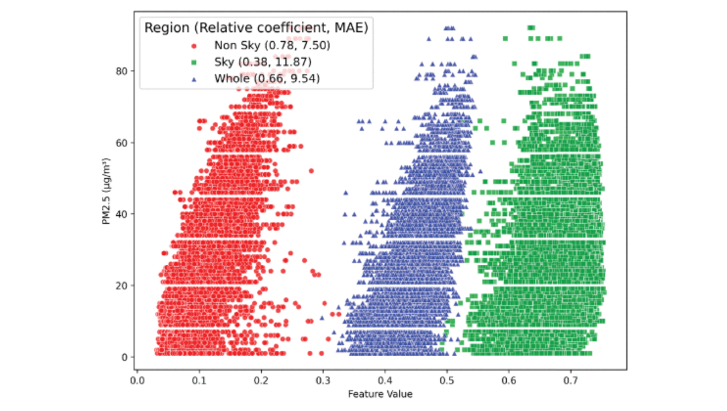
FIGURE 13.
Scatter plots depicting the mean values of the dark channel across various regions at Renwu station were generated, considering the correlation coefficient and MAE.
Show All
3) Generalization Analysis
An important objective of image-based PM2.5 estimation is to develop models that can generalize effectively across different monitoring stations without requiring retraining for each individual scene. A model with strong cross-scene generalization capability can substantially reduce deployment time and computational resources in practical applications.
To evaluate the generalization performance of the proposed framework, models trained on a single monitoring station were tested on datasets collected from other stations. Table XVIII summarizes the evaluation results obtained using the complete input configuration, including RGB images, weather probability vectors, and regional image features.
The experimental results indicate that models trained exclusively on a single scene exhibit limited generalization when applied to different monitoring stations. Although acceptable performance is achieved on the training scene, the estimation accuracy deteriorates noticeably when the model is evaluated on unseen scenes with different environmental characteristics. This limitation is particularly evident from the relatively low R² values reported in Table XVIII, indicating that the learned feature representations are highly dependent on scene-specific visual characteristics and are insufficient for robust cross-scene PM2.5 estimation. These findings suggest that additional strategies, such as transfer learning, domain adaptation, or multi-scene training, are necessary to improve the generalization capability of image-based PM2.5 estimation models.
TABLE 18 Evaluation of Generalization Performance Based on the Average Test Results Obtained From 5-Fold Cross-Validation for Each Station Model.
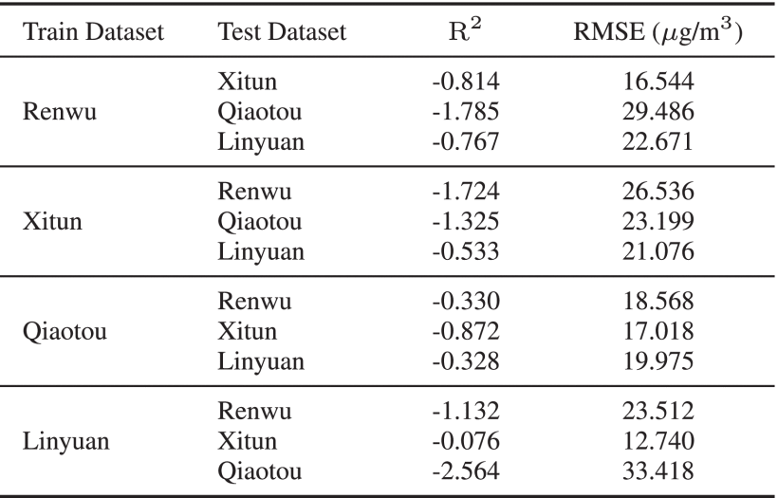

Furthermore, although these models were initially trained using data collected from different monitoring stations, they may provide a better initialization than training the BENet-VGG16 model from scratch and thereby reduce both the amount of target-domain data required and the overall training time. To verify this hypothesis, the Qiaotou model, which exhibited the strongest cross-scene generalization performance, was selected as the source model for transfer learning. The pretrained model was subsequently fine-tuned using different proportions of data from each target monitoring station, and the resulting performance was compared with that of the corresponding BENet-VGG16 models trained solely on single-scene data.
Figure 14 illustrates the average validation RMSE over five-fold cross-validation for different retraining data ratios. Overall, the results indicate that increasing the proportion of target-domain data used for fine-tuning consistently improves estimation accuracy and leads to more stable model convergence. Compared with training the model from scratch, transfer learning using the pretrained Qiaotou model achieves modest but consistent improvements in estimation performance while requiring fewer training epochs and exhibiting more stable training behavior.
In particular, when all available target-domain data are used for fine-tuning, the transfer learning model slightly outperforms the baseline BENet-VGG16 model trained exclusively on the target station. Moreover, the convergence curves demonstrate that transfer learning accelerates the optimization process and shortens the training time required to reach comparable performance. As shown in Figure 14, the transfer learning model initialized from the Qiaotou network and fine-tuned using 75% of the target-domain data achieves validation performance comparable to that of the original single-scene BENet-VGG16 model after approximately 12 training epochs. These results demonstrate that transfer learning effectively improves training efficiency while maintaining competitive PM2.5 estimation accuracy, making it a practical strategy for rapidly adapting the proposed framework to new monitoring stations.
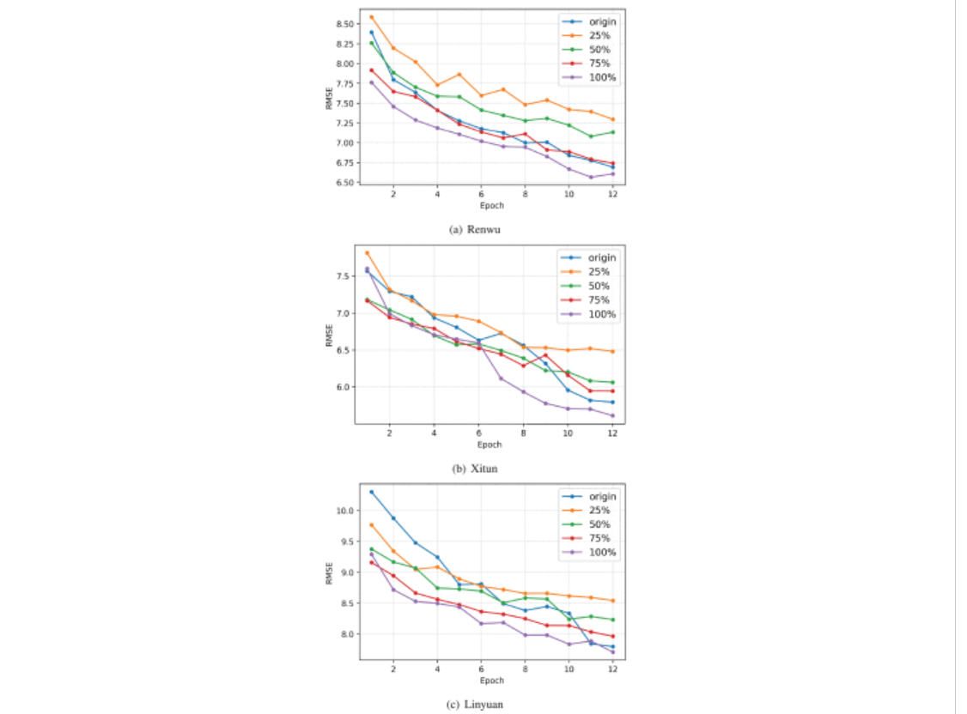
FIGURE 14.Comparison of 5-fold average validation RMSE (μ g/m³) changes for original model and transfer learning based on Qiaotou model with different participation ratios.
4) Comparison With the VGG16 Architecture
As discussed in Section III-G2, BENet-VGG16 is a derivative of the VGG16 architecture but incorporates a reduced number of parameters. To evaluate the differences between the two models, we implemented a baseline VGG16 architecture consisting of a global average pooling layer followed by a fully connected layer. Given that the VGG16 architecture exclusively accepts array inputs, both models were trained under equivalent conditions to guarantee a fair comparison. This process employed the Xitun dataset, with inputs restricted to the image RGB arrays. Figure 15 illustrates the RMSE trajectories throughout the training and validation processes for both architectures. While the VGG16 model demonstrates marginally superior training performance, it clearly exhibits signs of overfitting. Conversely, BENet-VGG16 displays more stable RMSE patterns across both training and validation phases.
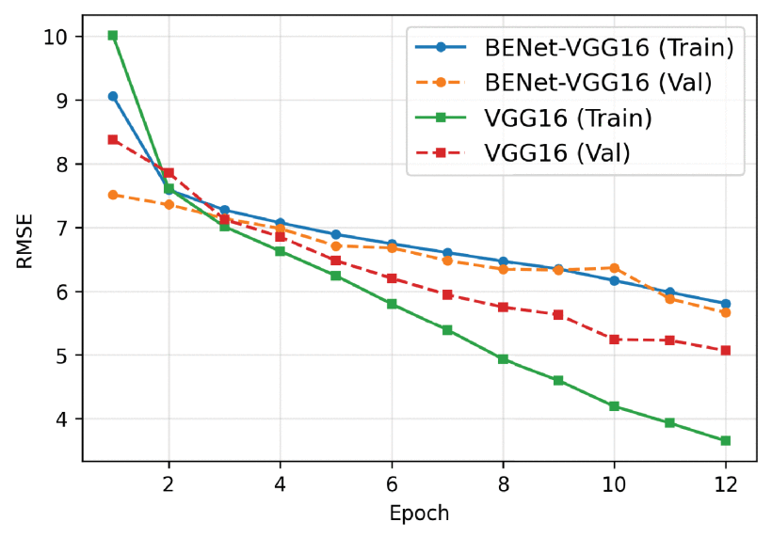

FIGURE 15.RMSE (μ g/m³) variation during the training process comparing BENet-VGG16 and VGG16 models with the Xitun dataset.
F. Docker-Based Web Application
To demonstrate the practical applicability of the proposed PM2.5 estimation framework, a Docker-based web application was developed. The application provides a user-friendly graphical interface for image upload and real-time visualization of estimation results.
As shown in Figure 16, the left panel of the interface enables users to upload an outdoor image and select the corresponding monitoring station for PM2.5 estimation. Once the Upload button is activated, the image is transmitted to the Python back-end server, where weather classification, sky segmentation, image processing, and PM2.5 estimation are performed. During this process, a loading animation is displayed in the right panel to indicate that the request is being processed.
After the back-end server completes the inference and returns the prediction results in JSON format, the web interface automatically displays the corresponding outputs. These include the predicted weather category, the calculated sky coverage ratio, and the estimated PM2.5 concentration. In addition, the system identifies defective images through the proposed weather classification and image validation mechanisms, preventing unreliable inputs from being processed. Figure 16 presents representative examples of both valid estimation results and defective image detection, demonstrating the effectiveness and practicality of the proposed web-based PM2.5 estimation system.
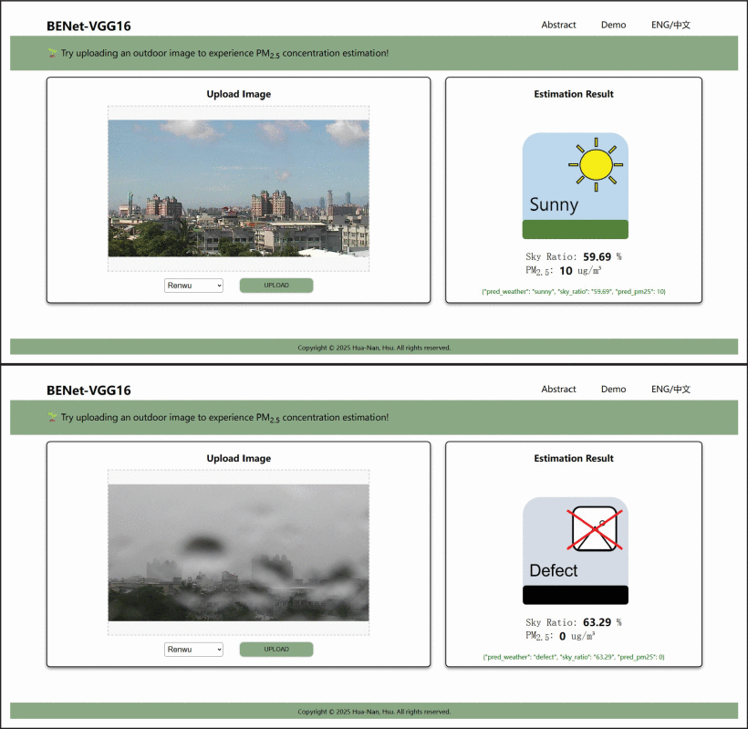

FIGURE 16.A demonstration webpage presenting both typical (top) and defective (bottom) outcomes on our website.

- Conclusion
This study proposed and comprehensively evaluated an image-based framework for estimating outdoor PM2.5 concentrations. The proposed methodology integrates four major components: (1) sky image analysis, (2) image preprocessing and regional feature extraction, (3) deep learning model design, and (4) multimodal data fusion for PM2.5 estimation. A systematic investigation was conducted to assess the effectiveness of incorporating image-derived auxiliary information through redundancy analysis, correlation analysis, and ablation studies.
The proposed BENet-VGG16 architecture was designed to balance estimation accuracy and computational efficiency. By utilizing only the early feature extraction layers of the pretrained VGG16 network and introducing multiple parallel branch blocks, the model substantially reduces the number of trainable parameters while mitigating overfitting and maintaining effective feature representation learning. Compared with conventional transfer learning architectures, the proposed framework achieves a favorable trade-off among model complexity, training efficiency, and prediction performance. In addition to RGB images, the model incorporates weather probability vectors generated by the YOLO-based weather classification model and regional statistical features extracted through sky segmentation and image processing. Experimental results demonstrate that these image-derived auxiliary features can improve estimation accuracy under certain conditions. Overall, the proposed framework achieves performance comparable to that of the multimodal approach proposed by Chen [28], despite relying exclusively on image-derived information and requiring no external meteorological measurements such as humidity.
To further evaluate the robustness of the proposed framework, transfer learning experiments were conducted across multiple monitoring stations. The results indicate that fine-tuning a pretrained model with increasing amounts of target-domain data consistently improves estimation performance and accelerates model convergence. These findings demonstrate that the proposed BENet-VGG16 framework possesses satisfactory adaptability to different monitoring environments while maintaining relatively low computational complexity. Furthermore, a Docker-based web application was developed to validate the practicality of the proposed system, integrating the front-end user interface with the back-end inference server to provide an efficient and user-friendly platform for real-time PM2.5 estimation.
Although the proposed framework demonstrates promising performance, several opportunities remain for future improvement.
Expanded Weather Classification
The current weather classification model is trained using images collected from monitoring stations in Taiwan and categorizes weather conditions into four classes: cloudy, defective, shine, and sunny. Although this classification scheme is adequate for the present study, incorporating additional weather categories and a larger, more diverse dataset could further improve classification accuracy, model robustness, and applicability to different climatic and geographic environments.
Improved Cross-Scene Generalization
As demonstrated in Section IV-E3, models trained using data from a single monitoring station exhibit limited generalization when applied to unseen locations. Future research should investigate training strategies based on multi-scene datasets, domain adaptation techniques, or federated learning frameworks that leverage heterogeneous data collected from multiple monitoring stations while preserving data privacy.
Lightweight and Enhanced Model Architecture
Although the proposed framework reduces the parameter count compared with conventional VGG16-based models, its deployment on resource-constrained embedded devices remains challenging. The current weather classification model, sky segmentation model, and BENet-VGG16 model require approximately 10.5 MB, 19.5 MB, and 29.4 MB of memory, respectively. Future work may investigate more lightweight backbone networks for the two YOLO-based models and replace the VGG16 backbone with computationally efficient architectures to further reduce inference time and memory consumption. Additional improvements may include optimizing the branch network design, refining multimodal feature fusion strategies, and developing more effective methods for integrating auxiliary image-derived information while avoiding issues such as overfitting and data imbalance.
From the perspective of input feature design, more discriminative regional descriptors could be extracted using advanced image processing and computer vision techniques. Furthermore, feature selection methods based on correlation analysis, random forest feature importance, or other explainable machine learning approaches could be incorporated to identify the most informative regional features, thereby reducing redundancy and improving estimation accuracy. These enhancements have the potential to further increase the efficiency, robustness, and generalization capability of the proposed image-based PM2.5 estimation framework.
6.Refenence

1.(2026 ). Health Consequences of Air Pollution on Populations. [Online]. Available: https://www.who.int/news/item/25-06-2024-what-are-health-consequences-of-air-pollution-on-populations.
2.Air Quality Index. Accessed: Feb. 5, 2026. [Online]. Available: https://airtw.moenv.gov.tw/ENG/Information/Standard/AirQualityIndicator.aspx.
3. L. Y. -Ting, “Study on estimating PM 2.5 concentration and AQI using urban images,” Master thesis, Dept. of Information and Communication, Chaoyang University of Technology, Taichung, Taiwan, 2024. [Online].
4. L. Chen, H. Long, J. Xu, B. Wu, H. Zhou, X. Tang, and L. Peng, “Deep citywide multisource data fusion-based air quality estimation,” IEEE Trans. Cybern., vol. 54, no. 1, pp. 111–122, Jan. 2024, doi: 10.1109/TCYB.2023.3245618.
5. M. J. Kim, R. J. Park, and J.-J. Kim, “Urban air quality modeling with full O 3 –NO x –VOC chemistry: Implications for O 3 and PM air quality in a street canyon,” Atmos. Environ., vol. 47, pp. 330–340, Feb. 2012, doi: 10.1016/j.atmosenv.2011.10.059.
6. C. Carnevale, G. Finzi, E. Pisoni, and M. Volta, “Neuro-fuzzy and neural network systems for air quality control,” Atmos. Environ., vol. 43, no. 31, pp. 4811–4821, Oct. 2009, doi: 10.1016/j.atmosenv.2008.07.064.
7. D. A. Vallero, Fundamentals of Air Pollution. New York, NY, USA : Academic, 2014.
8. J. Fan, Q. Li, J. Hou, X. Feng, H. Karimian, and S. Lin, “A spatiotemporal prediction framework for air pollution based on deep RNN,” ISPRS Ann. Photogramm., Remote Sens. Spatial Inf. Sci., vol. 4, p. 15, Jan. 2017, doi: 10.5194/isprs-annals-IV-4-W2-15-2017.
9. D. Seng, Q. Zhang, X. Zhang, G. Chen, and X. Chen, “Spatiotemporal prediction of air quality based on LSTM neural network,” Alexandria Eng. J., vol. 60, no. 2, pp. 2021–2032, Apr. 2021, doi: 10.1016/j.aej.2020.12.009.
10. Manual Monitoring of Fine Particulate Matter. Accessed: Feb. 5, 2026. [Online]. Available: https://airtw.moenv.gov.tw/ENG/EnvMonitoring/Central/spm.aspx
11. Understanding Air Pollution Sensing IoT. Accessed: Feb. 5, 2026. [Online]. Available: https://airtw.moenv.gov.tw/cht/Encyclopedia/AirSensor/AirSensor_2.aspx
12. K. Marzagui, A. A. Abdelouahad, A. Dahmouni, and A. D. El Maliani, “A review on image quality assessment for air quality index estimation,” in Proc.
13. D. Iskandaryan, F. Ramos, and S. Trilles, “Graph neural network for air quality prediction: A case study in Madrid,” IEEE Access, vol. 11, pp. 2729–2742, 2023, doi: 10.1109/ACCESS.2023.3234214.
14. S. Enggari, Sumijan, and M. Tajuddin, “Identification of air pollution levels based on sky image using color histogram method,” in Proc. 6th Int. Conf. Vocational Educ. Electr. Eng. (ICVEE), Oct. 2023, pp. 77–83, doi: 10.1109/icvee59738.2023.10348289.

15.G. Yue, K. Gu, and J. Qiao, “Effective and efficient photo-based PM 2.5 concentration estimation,” IEEE Trans. Instrum. Meas., vol. 68, no. 10, pp. 3962–3971, Oct. 2019, doi: 10.1109/TIM.2018.2886091.
16.R. Fattal, “Single image dehazing,” ACM Trans. Graph., vol. 27, pp. 1–9, Jul. 2008, doi: 10.1145/1360612.1360671.
17.K. He, J. Sun, and X. Tang, “Single image haze removal using dark channel prior,” in Proc. IEEE Conf. Comput. Vis. Pattern Recognit., Miami, FL, USA, Jun. 2009, pp. 1956–1963, doi: 10.1109/CVPR.2009.5206515.

18.Z. Zhang, H. Ma, H. Fu, and X. Wang, “Outdoor air quality inference from single image,” in Proc. MultiMedia Modeling., Jan. 2015, pp. 14–25, doi: 10.1007/978-3-319-14442-9.
19.M. M. Samsami, N. Shojaee, S. Savar, and M. Yazdi, “Classification of the air quality level based on analysis of the sky images,” in Proc. 27th Iranian Conf. Electr. Eng. (ICEE), Apr. 2019, pp. 1492–1497.
20.J. Ma, K. Li, Y. Han, and J. Yang, “Image-based air pollution estimation using hybrid convolutional neural network,” in Proc. 24th Int. Conf. Pattern Recognit. (ICPR), Beijing, China, Aug. 2018, pp. 471–476, doi: 10.1109/ICPR.2018.8546004.
21.W. Bai and F. Li, “PM 2.5 concentration prediction using deep learning in Internet of Things air monitoring system,” Environ. Eng. Res., vol. 28, no. 1, Feb. 2023, Art. no. 210456, doi: 10.4491/eer.2021.456.
22.B. C. Mohan, N. R. Challa, M. L. Babu, T. K. Chaitanya, C. V. M. S. N. P. Kumar, S. K. Panguluri, and N. P. K. Lingisetty, “Deep learning-based PM 2.5 concentration estimation using convolutional neural network on environmental image data,” in Proc. 6th Int. Conf. Recent Adv. Inf. Technol. (RAIT), Dhanbad, India, Mar. 2025, pp. 1–6, doi: 10.1109/RAIT65068.2025.11089033.
23.K. Gu, J. Qiao, and X. Li, “Highly efficient picture-based prediction of PM 2.5 concentration,” IEEE Trans. Ind. Electron., vol. 66, no. 4, pp. 3176–3184, Apr. 2019, doi: 10.1109/TIE.2018.2840515.
24.N. Rijal, R. T. Gutta, T. Cao, J. Lin, Q. Bo, and J. Zhang, “Ensemble of deep neural networks for estimating particulate matter from images,” in Proc. IEEE 3rd Int. Conf. Image, Vis. Comput. (ICIVC), Chongqing, China, Jun. 2018, pp. 733–738, doi: 10.1109/ICIVC.2018.8492790.
25.D. Zhang, B. Yang, X. Liu, J. Jin, and C. Song, “Air quality level detection based on image recognition,” in Proc. 13th Int. Conf. Inf. Commun. Technol. (ICTech), Xiamen, China, Apr. 2024, pp. 305–310, doi: 10.1109/ICTech63197.2024.00064.
26.X. Fang, Z. Li, B. Yuan, and Y. Chen, “Image-based PM 2.5 estimation from imbalanced data distribution using prior-enhanced neural networks,” IEEE Sensors J., vol. 24, no. 4, pp. 4677–4693, Feb. 2024, doi: 10.1109/JSEN.2023.3343080.
27.X. Zhang, D. Shrestha, A. Khan, and J. Zhang, “Image-based particulate matter pollution analysis using a lightweight autoencoder,” in Proc. 8th Int. Conf. Image, Vis. Comput. (ICIVC), Dalian, China, Jul. 2023, pp. 655–659, doi: 10.1109/icivc58118.2023.10270224.
28.C. Kuan-Yu, “The study of PM 2.5 pollution level estimation by calculating the variation of image characteristics,” Master thesis, Dept. of Information and Communication, Chaoyang University of Technology, Taichung, Taiwan, 2022. [Online]. Available: https://hdl.handle.net/11296/x3643z
29.Y.-T. Lin, M.-Y. Jiang, and J.-J. Liaw, “Combination of weather factors and area of high variation to estimation PM 2.5 concentration,” in Proc. Int. Conf. Electr., Comput. Energy Technol. (ICECET), Prague, Czech Republic, Jul. 2022, pp. 1–5, doi: 10.1109/ICECET55527.2022.9872879.
30.M. Ma, Z. Zhao, Y. Ma, Y. Cao, and G. Kang, “PM 2.5 concentration simulation by hybrid machine learning based on image features,” Frontiers Earth Sci., vol. 13, Jan. 2025, Art. no. 1509489, doi: 10.3389/feart.2025.1509489.
31.C.-Y. Lee and L. Moses Manova, “Enhancing PM 2.5 detection via multispectral image-based double-channel ensemble learning for drones,” IEEE Sensors J., vol. 25, no. 17, pp. 33528–33539, Sep. 2025, doi: 10.1109/JSEN.2025.3585177.
32.R. Rahman, F. Patadia, J. Wang, and D.-C. Nguyen, “Multimodal federated learning for air quality estimation with model personalization over aerial-ground networks,” IEEE Geosci. Remote Sens. Lett., vol. 22, 2025, Art. no. 7506305, doi: 10.1109/LGRS.2025.3573214.
33.J. Morales-García, E. Ramos-Sorroche, S. Balderas-Díaz, G. Guerrero-Contreras, A. Muñoz, J. Santa, and F. Terroso-Sáenz, “Reducing pollution health impact with air quality prediction assisted by mobility data,” IEEE J. Biomed. Health Informat., vol. 29, no. 12, pp. 9210–9220, Dec. 2025, doi: 10.1109/JBHI.2024.3508466.
34.Beijing Realtime Weather Photos. Accessed: Feb. 5, 2026. [Online]. Available: https://www.tour-beijing.com/real_time_weather_photo/
35.Embassies and Consulates. Accessed: Feb. 5, 2026. [Online]. Available: https://www.airnow.gov/
36.C. Liu, F. Tsow, Y. Zou, and N. Tao, “Particle pollution estimation based on image analysis,” PLoS ONE, vol. 11, no. 2, Feb. 2016, Art. no. e0145955, doi: 10.1371/journal.pone.0145955.
37.L. Feng, T. Yang, and Z. Wang, “Performance evaluation of photographic measurement in the machine-learning prediction of ground PM 2.5 concentration,” Atmos. Environ., vol. 262, Nov. 2021, Art. no. 118623.
38.Air Quality Monitoring Real-Time Image Data. Accessed: Feb. 5, 2026. [Online]. Available: https://data.moenv.gov.tw/en/dataset/detail/AQX_P_01
39.Taiwan Air Quality Monitoring Network (Publish). Accessed: Feb. 5, 2026. [Online]. Available:
40.Input Image Size of YOLOv8 and YOLOv9 Must Be Multiple of 32. Accessed: Feb. 5, 2026. [Online]. Available: https://github.com/ultralytics/ultralytics/issues/14622
41.Roboflow. Accessed: Feb. 5, 2026. [Online]. Available: https://roboflow.com/
42.Y. Yang, Z. Hu, K. Bian, and L. Song, “ImgSensingNet: UAV vision guided aerial-ground air quality sensing system,” in Proc. IEEE INFOCOM - IEEE Conf. Comput. Commun., Paris, France, Apr. 2019, pp. 1207–1215.

