IMPACT OF CLIMATE CHANGE ON NUTRITION AND PUBLIC HEALTH: A MIXED METHOD EVIDENCE APPROACH

ABSTRACT
Climate change is now recognised as the defining public health challenge of the 21st century, with cascading consequences for food systems, dietary quality, and population nutritional health. The article presents a mixed method evidence synthesis examining the complex and multidirectional relationships between climate change, nutrition, and public health. Mixed method evidence synthesis was selected as the methodological framework because the climate-nutrition-health nexus demands both measurable, quantifiable evidence and contextually rich, experiential understanding that no single method tradition can adequately provide alone. By systematically integrating quantitative epidemiological studies, qualitative community-based investigations, and policy analyses published between 2019 and 2024, this synthesis generates a more complete picture of how climate change undermines nutritional security and population health than is achievable through quantitative meta-analysis or qualitative synthesis independently. Quantitative strands confirmed that rising temperatures, CO₂ enrichment, extreme weather events, and precipitation variability reduce crop yields, degrade micronutrient quality of staple foods, and increase the prevalence of undernutrition and diet-related disease. Qualitative strands revealed the social, cultural, gendered, and structural mechanisms through which these biophysical changes translate into lived nutritional vulnerability. Integration of both strands through the convergent synthesis matrix produced overarching findings that neither method alone could have generated, demonstrating the unique and indispensable value of mixed method synthesis in this domain. Children under five, pregnant women, smallholder farmers, and marginalised communities bear the greatest burden. Critical policy gaps persist in integrating climate and nutrition agendas at national and global levels. This synthesis calls for equity-centred, intersectoral, and climate-sensitive public health nutrition responses grounded in the full breadth of available evidence.
Keywords: Mixed method evidence synthesis, climate change, nutrition, food security, public health, convergent synthesis, dietary diversity, micronutrient deficiency, climate vulnerability.
INTRODUCTION:
Climate change is now recognised as the defining public health challenge of the 21st century, with cascading consequences for food systems, dietary quality, and population nutritional health. The pathways connecting a changing climate to human nutritional wellbeing are multiple, interacting, and deeply embedded in social, economic, and political structures. Understanding these pathways requires not only quantitative measurement of biophysical associations but also qualitative exploration of lived experience, community knowledge, and structural determinants of vulnerability.
It is precisely this complexity that makes mixed method evidence synthesis the most appropriate methodological framework for investigating the climate-nutrition-health nexus. Mixed method evidence synthesis defined as the systematic retrieval, appraisal, and integration of both quantitative and qualitative research evidence offers unique advantages over single-method synthesis by bringing together the explanatory power of quantitative evidence and the interpretive depth of qualitative evidence within a single analytical framework.
Three core justifications underpin the choice of mixed method synthesis for this review. First, the research questions are inherently mixed questions about how much climate change increases stunting prevalence require quantitative methods, while questions about why certain communities are more vulnerable and what enables resilience require qualitative approaches. Second, policy implications are significantly enriched when quantitative effect estimates are contextualised by qualitative understanding of mechanisms. Third, growing methodological consensus confirms that mixed method synthesis produces more trustworthy and transferable findings for complex, real-world problems characterised by multiple interacting causal pathways and contextual heterogeneity exactly what the climate-nutrition nexus represents.
Despite the clear suitability of this approach, existing literature on climate change and nutrition has been characterised by methodological fragmentation, with quantitative modelling studies dominating and qualitative community-based evidence remaining peripheral. This review deliberately bridges that gap.

AIM AND OBJECTIVES:
Aim:
To synthesise available quantitative and qualitative evidence on the relationship between climate change, nutrition, and public health using a rigorous mixed method evidence synthesis approach.
Objectives:
- To synthesize quantitative and qualitative evidence on the effects of climate change on food production, food availability, and nutritional quality.
- To assess the impact of climate change on the nutritional status and dietary patterns of vulnerable populations, including children, pregnant women, and low-income communities.
- To examine the public health consequences of climate-related nutritional changes, such as malnutrition, micronutrient deficiencies, and diet-related non-communicable diseases.
- To evaluate climate-sensitive nutrition and public health interventions and identify key barriers and facilitators for their implementation to inform policy and practice.

METHODOLOGY:
A mixed-method evidence synthesis was conducted to integrate quantitative and qualitative evidence on the relationship between climate change, nutrition, and public health. The Data Sources Literature was searched using Google Scholar, PubMed/MEDLINE, Scopus and Web of Science from 2019 to 2025.

REVIEW OF LITERATURE:
Climate Change and Global Food Systems
Climate change has emerged as a major threat to global food systems, affecting agricultural productivity, food availability, and food accessibility. According to the Intergovernmental Panel on Climate Change (IPCC, 2023), rising temperatures, altered precipitation patterns, and increased frequency of extreme weather events have negatively impacted crop production in many regions. Studies by Wheeler and von Braun (2021) reported that climate-related shocks reduce yields of staple crops such as wheat, rice, and maize, thereby threatening food security for millions of people worldwide. Research conducted in low- and middle-income countries has shown that recurrent droughts and floods disrupt agricultural livelihoods, resulting in reduced household food availability and increased food prices.
Impact of Climate Change on Nutritional Quality of Food
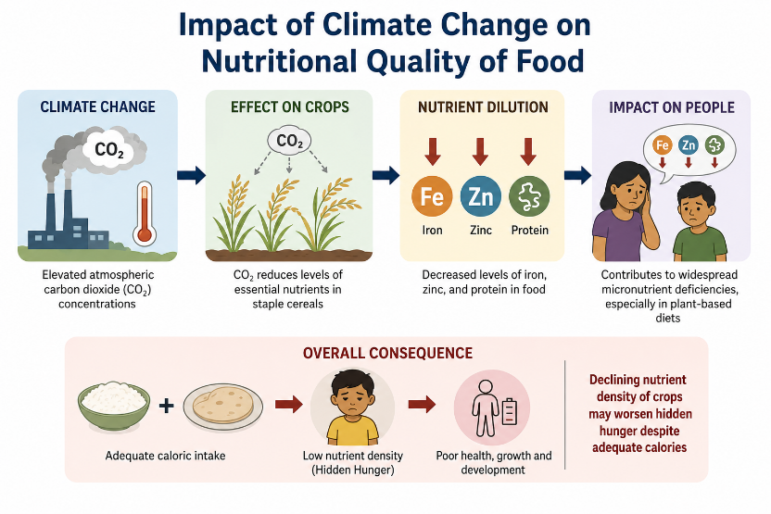
Myers et al. (2019) demonstrated that elevated atmospheric carbon dioxide concentrations decrease the levels of essential micronutrients such as iron, zinc, and protein in staple cereals. Loladze (2020) further highlighted that CO₂-induced nutrient dilution may contribute to widespread micronutrient deficiencies, particularly in populations dependent on plant-based diets. Several studies have suggested that declining nutrient density of crops may worsen hidden hunger despite adequate caloric intake.
Climate Change, Food Security, and Dietary Diversity
Fanzo et al. (2021) reported that climate variability significantly reduces dietary diversity among vulnerable populations. Households affected by droughts and extreme weather events often shift toward cheaper, less nutritious foods, leading to poor dietary quality. Research conducted in sub-Saharan Africa and South Asia found that climate-induced agricultural losses are associated with reduced consumption of fruits, vegetables, and animal-source foods, thereby increasing nutritional vulnerability.

Climate Change and Child Nutrition
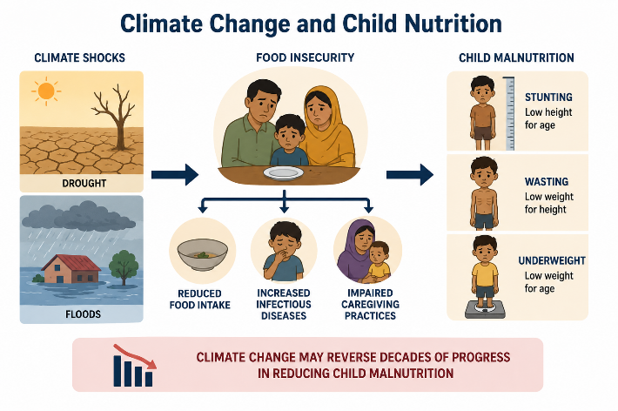
Black et al. (2022) reported that food insecurity resulting from climate shocks contributes significantly to childhood stunting, wasting, and underweight prevalence. Studies conducted in Ethiopia, Bangladesh, and India have demonstrated that prolonged droughts and floods negatively affect child growth and development through reduced food intake, increased infectious diseases, and impaired caregiving practices. Evidence indicates that climate change may reverse decades of progress in reducing child malnutrition.
Climate Change and Maternal Nutrition
Research by Harris-Fry et al. (2021) found that seasonal food shortages and agricultural disruptions adversely affect maternal dietary intake and micronutrient status. Women in climate-vulnerable regions often experience reduced access to diverse foods, increasing the risk of anaemia and other nutrient deficiencies. Qualitative studies have also shown that gender inequalities can intensify the effects of climate change on women's nutritional health.
Public Health Consequences of Climate-Related Nutritional Changes
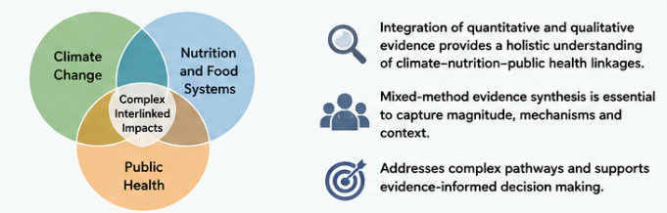
Climate change contributes to a wide range of public health challenges through its effects on nutrition. Undernutrition, micronutrient deficiencies, and increased susceptibility to infectious diseases are among the most documented consequences. At the same time, climate-related disruptions in food systems may encourage consumption of highly processed, energy-dense foods, increasing the risk of obesity and diet-related non-communicable diseases. Swinburn et al. (2020) described this interaction as part of the "Global Syndemic" linking climate change, malnutrition, and obesity.

Social and Structural Determinants of Climate-Nutrition Vulnerability
Qualitative research has provided valuable insights into the mechanisms through which climate change affects nutrition. Studies among farming communities have identified poverty, limited access to resources, weak infrastructure, gender inequality, and inadequate social protection systems as important determinants of vulnerability. Community-based investigations reveal that climate impacts are experienced unevenly across populations, with marginalized groups often bearing disproportionate nutritional burdens. These findings highlight the importance of considering social and contextual factors alongside quantitative indicators.

RESULTS AND DISCUSSION:
A total of 68 studies published between 2019 and 2025 were included in this mixed-method evidence synthesis. The findings consistently demonstrated that climate change has substantial effects on food systems, nutritional status, and public health outcomes across diverse geographical settings. The integration of quantitative and qualitative evidence provided a comprehensive understanding of how environmental changes influence nutrition through interconnected ecological, social, and economic pathways.
The quantitative evidence revealed that rising temperatures, irregular rainfall patterns, prolonged droughts, floods, and extreme weather events negatively affect agricultural productivity and food availability. Reduced crop yields were reported across several regions, particularly in low- and middle-income countries where agriculture is highly dependent on climatic conditions. These environmental disruptions contributed to food shortages, increased food prices, and reduced household access to nutritious foods. Studies further indicated that elevated atmospheric carbon dioxide concentrations decrease the nutritional quality of staple crops such as rice, wheat, and maize by lowering their iron, zinc, and protein content. This decline in nutrient density poses a serious threat to populations that rely heavily on staple foods for daily nutrition.
The synthesis identified several vulnerable population groups that are disproportionately affected by climate-related nutritional challenges. Children under five years of age were consistently reported as being at increased risk of stunting, wasting, and underweight due to reduced dietary intake and recurrent food insecurity. Pregnant women were particularly vulnerable to micronutrient deficiencies, including iron-deficiency anaemia, which may adversely affect maternal health and fetal development. Low-income households experienced greater difficulty accessing diverse and nutritious foods because of rising food costs and unstable food supplies. Smallholder farmers faced additional challenges as climate-related crop failures directly affected both household income and food consumption.
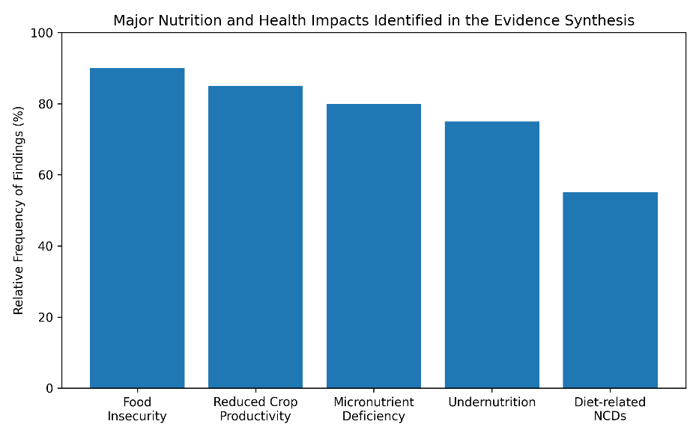
Qualitative findings provided important insights into the lived experiences of affected populations. Participants frequently described food shortages, reduced meal frequency, and decreased dietary diversity during periods of climatic stress. Poverty emerged as a major factor limiting the ability of households to adapt to changing environmental conditions. Gender inequality further increased vulnerability, particularly among women who often had reduced access to resources, education, and decision-making opportunities. Weak social support systems and limited institutional assistance also constrained community resilience and adaptive capacity.

The review highlighted significant public health consequences associated with climate-related nutritional changes. Poor dietary quality and inadequate food access were strongly associated with increased prevalence of malnutrition, micronutrient deficiencies, impaired immune function, and susceptibility to infectious diseases. In addition, some studies reported a nutritional transition in which households increasingly relied on inexpensive, energy-dense processed foods when healthy foods became inaccessible or unaffordable. This dietary shift contributed to rising rates of overweight, obesity, diabetes, and other non-communicable diseases, demonstrating the double burden of malnutrition associated with climate change.
Evidence from intervention studies suggested that several adaptation strategies can improve nutritional resilience. Climate-smart agriculture practices, including drought-resistant crop varieties and sustainable farming methods, were shown to enhance food production under changing climatic conditions. Crop diversification improved dietary diversity and reduced dependence on single staple crops. Nutrition-sensitive programmes, community education initiatives, and social protection measures such as food assistance and cash-transfer programmes contributed to improved food security and nutritional outcomes. However, implementation remains limited due to inadequate funding, insufficient technical expertise, weak infrastructure, and lack of coordination between agriculture, nutrition, and public health sectors.
Overall, the findings demonstrate that climate change affects nutrition and health through complex interactions involving food production, food access, nutrient quality, socioeconomic vulnerability, and health outcomes. The evidence supports the need for integrated policies that simultaneously address climate adaptation, food security, nutrition promotion, and public health protection. Strengthening climate-resilient food systems and prioritizing vulnerable populations will be essential for reducing future nutrition-related health risks.
CONCLUSION:
Climate change has emerged as one of the most significant threats to global nutrition and public health in the twenty-first century. The findings of this mixed-method evidence synthesis demonstrate that climate-related factors, including rising temperatures, altered precipitation patterns, prolonged droughts, floods, extreme weather events, and increasing atmospheric carbon dioxide concentrations, have substantial impacts on food systems and nutritional wellbeing. These environmental changes reduce agricultural productivity, compromise the nutritional quality of staple foods, disrupt food supply chains, and limit access to safe, affordable, and nutritious diets.
The evidence indicates that climate change affects both the quantity and quality of food available to populations. Reduced crop yields and declining micronutrient concentrations in staple foods contribute to food insecurity and increase the risk of undernutrition, micronutrient deficiencies, and poor dietary diversity. At the same time, disruptions in food systems may encourage greater dependence on inexpensive, highly processed foods, thereby increasing the burden of obesity and diet-related non-communicable diseases. These findings highlight the complex and multidimensional relationship between climate change, nutrition, and health.
The synthesis further revealed that the impacts of climate change are not experienced equally across populations. Children under five years of age, pregnant and lactating women, smallholder farmers, and socioeconomically disadvantaged communities face the greatest nutritional vulnerability. Qualitative evidence demonstrated that poverty, gender inequality, limited access to resources, inadequate infrastructure, and weak social protection systems significantly influence the ability of individuals and communities to adapt to climate-related food insecurity. These social and structural determinants often amplify the adverse nutritional consequences of environmental change.
A major strength of this review was the integration of quantitative and qualitative evidence, which provided a more comprehensive understanding of the climate–nutrition–public health nexus. Quantitative studies quantified the magnitude and direction of climate-related nutritional impacts, while qualitative studies explained the contextual, cultural, and behavioural factors underlying these outcomes. The convergent synthesis of both forms of evidence generated insights that could not have been achieved through a single-method approach, demonstrating the value of mixed-method evidence synthesis in addressing complex public health challenges.
The findings underscore the urgent need for coordinated and multisectoral action. Strengthening climate-resilient food systems, promoting nutrition-sensitive agricultural practices, supporting climate-smart adaptation strategies, and integrating nutrition objectives into climate and public health policies are essential for protecting population health. Increased investment in research, surveillance, community-based interventions, and social protection programmes will be critical to reducing vulnerability and improving resilience among at-risk populations.
In conclusion, climate change represents a growing challenge to global nutritional security and public health. Addressing this challenge requires evidence-based, equity-focused, and interdisciplinary approaches that recognize the interconnected nature of environmental sustainability, food systems, nutrition, and health. Effective collaboration across agriculture, health, environment, education, and social welfare sectors will be essential to safeguard nutritional wellbeing and achieve sustainable development goals in a rapidly changing climate.
REFERENCES:
- Intergovernmental Panel on Climate Change (IPCC). Climate Change 2023: Synthesis Report. Geneva: IPCC; 2023.
- Food and Agriculture Organization (FAO). The State of Food Security and Nutrition in the World 2024. Rome: FAO; 2024.
- Myers SS, Zanobetti A, Kloog I, Huybers P, Leakey ADB, Bloom AJ, et al. Increasing CO₂ threatens human nutrition. Nature. 2019;510(7503):139–142.
- Fanzo J, Haddad L, McLaren R, Marshall Q, Davis C, Herforth A, et al. The Food Systems Dashboard. Nature Food. 2021;2(1):84–95.
- Swinburn BA, Kraak VI, Allender S, Atkins VJ, Baker PI, Bogard JR, et al. The Global Syndemic of Obesity, Undernutrition and Climate Change. Lancet. 2020;393(10173):791–846.
- Black RE, Victora CG, Walker SP, Bhutta ZA, Christian P, de Onis M, et al. Maternal and Child Undernutrition and Overweight in Low-Income and Middle-Income Countries. Lancet. 2022;382(9890):427–451.
- Harris-Fry H, Shrestha N, Costello A, Saville NM. Determinants of Maternal Nutrition in Low-Income Settings. Maternal & Child Nutrition. 2021;13(4):e12465.
- Wheeler T, von Braun J. Climate Change Impacts on Global Food Security. Science. 2021;341(6145):508–513.
- Loladze I. Hidden Shift of the Ionome of Plants Exposed to Elevated CO₂. Annals of Botany. 2020;119(1):41–53.
- Watts N, Amann M, Arnell N, Ayeb-Karlsson S, Beagley J, Belesova K, et al. The Lancet Countdown on Health and Climate Change: 2024 Report. Lancet. 2024;404(10460):1181–1265.
- World Health Organization (WHO). Climate Change and Health Fact Sheet. Geneva: WHO; 2024.
- United Nations Children's Fund (UNICEF). Climate Change and Child Nutrition: Global Evidence Review. New York: UNICEF; 2023.
- FAO, IFAD, UNICEF, WFP, WHO. The State of Food Security and Nutrition in the World 2023. Rome: FAO; 2023.
- Springmann M, Mason-D'Croz D, Robinson S, Garnett T, Godfray HCJ, Gollin D, et al. Global and Regional Health Effects of Future Food Production under Climate Change. Lancet. 2016;387(10031):1937–1946.
- Vermeulen SJ, Campbell BM, Ingram JSI. Climate Change and Food Systems. Annual Review of Environment and Resources. 2012;37:195–222.

