Adaptive Spectrum-Based Artifact Suppression for Single-Channel EEG Systems

Sayedu Khasim Noorbasha Dabbara Sai Shivani
Department of Electronics and Communication Engineering Department of Electronics and Communication Engineering Rajeev Gandhi Memorial College of Engineering and Technology Rajeev Gandhi Memorial College of Engineering and Technology
(JNTUA) (JNTUA) Andhra Pradesh 518501, India Andhra Pradesh 518501, India
sayedukhasim@gmail.com shivanidabbara2004@gmail.com
Sadu Ravindra Kumar Kavali Harini
Department of Electronics and Communication Engineering Department of Electronics and Communication Engineering
Rajeev Gandhi Memorial College of Engineering and Technology Rajeev Gandhi Memorial College of Engineering and Technology
(JNTUA) (JNTUA) Andhra Pradesh 518501, India Andhra Pradesh 518501, India
kumarsravindra574@gmail.com kavaliharini77@gmail

Abstract— This paper proposes a lightweight, adaptive artifact suppression framework tailored for single-channel EEG applications. The core innovation lies in leveraging the spectral consistency of ocular disturbances within the frequency domain. By constructing representative spectral templates using unsupervised clustering techniques and employing a dynamic matching strategy based on statistical similarity, the framework selectively attenuates artifacts while preserving essential neural information. These artifacts not only obscure underlying neural signals but also fall within overlapping frequency ranges, complicating traditional removal methods. This method will design for fast processing with minimal computational load, the method supports deployment in wearable EEG devices and neural interface platforms, where real-time signal clarity is essential.We will validate the proposed method STMS (Spectrum template matching and suppression) on the simulated and real time EEG data basis and we will also compare the performance metrics SNR,RRMSC,CC e.t.c.The proposed framework represents a significant advance in single-channel EEG artifact removal, combining robustness, adaptability.
Key words : EEG (Electroencephalography), Ocular Artifacts (OAs), Artifact Removal, Brain-Machine Interface (BMI), Real-Time Signal Processing.

Introduction
Electroencephalography (EEG) is recognized as a central neuroimaging approach for understanding brain activity because it allows researchers to monitor neural dynamics non invasively and in real time [1]. Its widespread use in diagnosing and studying conditions such as epilepsy, sleep disorders, mood disturbances, and stroke highlights EEG’s vital role in both clinical and research settings[2]. Despite these advantages, accurately interpreting EEG data remains challenging, with noise and artifacts commonly distorting the underlying neuronal patterns[3]- [4]. Main sources of interference include signals from eye movements, muscle contractions, cardiac activity, and external electrical noise—all of which can disrupt the weak bioelectric currents that EEG seeks to measure[5].
Artifacts are unwanted signals that come from inside or outside the body. Some come from body movements like blinking, muscle actions, and heartbeats, while others come from things like noisy wires or bad electrodes[6]. Removing artifacts that are caused by body parts is harder because they do not follow a clear pattern and can overlap with important brain signals[7].
Especially, eye-related artifacts, like those from blinking or moving eyes, cause big problems[8]. These eye artifacts usually occur in the same frequency areas as important brain rhythms, which makes it difficult to separate them from real brain activity[9]. Also, their strength can be much higher than brain signals and they change suddenly, which adds to the challenge[10].
To fix this, scientists often use methods like Independent Component Analysis (ICA) in EEG systems that have many sensors[11]. These methods split EEG data into parts and try to take out parts caused by noise, saving the brain signal[12]. But ICA works well only if there are many sensors, so it cannot work well with newer EEG devices that have just one or a few sensors[13].
Many wearable EEG devices are now designed to be small and easy to use with only one or a few electrodes[14]. These devices need new ways to remove artifacts because old methods require many sensors and cannot be used[15].This need has pushed researchers to find simpler methods for cleaning EEG data with fewer signals available[16].
Other techniques try to estimate noise by using extra reference signals, but these need more electrodes[17], which wearable devices want to avoid[18]. Recent work uses artificial intelligence, especially machine learning, to find and remove noisy parts automatically[19]. Some models look at time and frequency features of EEG for better accuracy[20]. However, these models usually need powerful computers, which might not suit real-time wearable devices[21].
Some other methods break down EEG signals into smaller parts using wavelets, which help isolate noisy sections[3]. Wavelet Quantile Normalization uses clean data to adjust noisy data for artifact removal but can accidentally remove important brain signals sometimes[4].Template matching compares new EEG data to known noise patterns, but eye artifacts in time shapes can change a lot. Luckily, in the frequency view, these eye artifacts tend to show a clear low-frequency peak, making them easier to spot[22]- [23].
Some studies combine wavelet transform with neural networks to improve artifact removal[24]. These wavelet neural network approaches first decompose the signal, then use trained neural networks to correct noisy components without losing important brain information[25].This blend of wavelet processing and deep learning offers a powerful tool for cleaning EEG data with minimal signal distortion[26].
In addition to wavelet methods, researchers continue experimenting with hybrid techniques[27]. These often combine wavelet decomposition with clustering or template matching algorithms to better classify and suppress artifacts adaptively[5]. By doing so, these methods adapt to individual differences in artifact patterns and recording conditions, improving the overall quality of the cleaned EEG data[28].
Still, challenges remain in developing artifact removal methods that are both effective and efficient for real-time wearable EEG systems[29]. A promising direction is to leverage the stability of ocular artifact spectral features in the frequency domain, creating reliable templates that can be matched and subtracted from the EEG signal, preserving brain activity[30].
This paper focuses on such methods by proposing a novel frequency-domain spectral template approach for ocular artifact suppression in single-channel EEG. The following sections detail the algorithm’s design, its performance on public datasets, comparison with existing methods, and discussion on future improvements for artifact removal in wearable brain monitoring.
Despite many advances, removing artifacts EEG signals remains a difficult task because artifacts and brain signals often overlap in frequency. This overlap makes it challenging to clean the data without removing important brain information. Therefore, finding methods that balance effective artifact removal with signal preservation is essential, especially for wearable and real-time EEG systems. This paper addresses these challenges by proposing a novel algorithm based
In the following sections, we detail the design of the algorithm, present its validation on public EEG datasets, compare its performance to existing methods, and discuss future improvement directions to enhance artifact removal for portable brain monitoring applications.

2. METHODOLOGY

The implementation of proposed STMS method is shown in Fig. 1.
Template matching is a widely used approach for removing unwanted disturbances from biomedical signals. In this method, representative patterns of artifacts are first extracted from contaminated recordings[31]. These patterns are then compared with new signal segments to detect the presence of similar artifacts. Once identified, the artifact component is reduced or removed using suppression techniques. This strategy has been successfully applied to eliminate motion artifacts, stimulus-related disturbances, and ECG interference in EEG data. Among various artifacts, eye blinks are one of the most common and dominant sources of contamination. Blink artifacts usually have high amplitude, short duration, and occur unpredictably. Although their waveform shape varies in the time domain, they consistently show strong energy concentration in the low-frequency range. This stable spectral behavior makes frequency-domain analysis more reliable than purely time-domain approaches. Therefore, spectrum-based template suppression provides a practical and effective solution for minimizing ocular artifacts while preserving essential brain activity.

  - STMS ALGORITHM
Before implementing the STMS framework, the construction of reliable spectral templates is essential [27]. The effectiveness of artifact removal depends strongly on how well the template represents the spectral characteristics of ocular artifacts[20]. Instead of relying on manually selected patterns, templates are generated directly from artifact-dominant segments in the dataset to ensure data-driven consistency.
Spectral Template Matching Suppression (STMS) is a frequency-domain artifact removal technique that identifies and suppresses artifacts by comparing the contaminated signal spectrum with predefined artifact spectral templates[32].

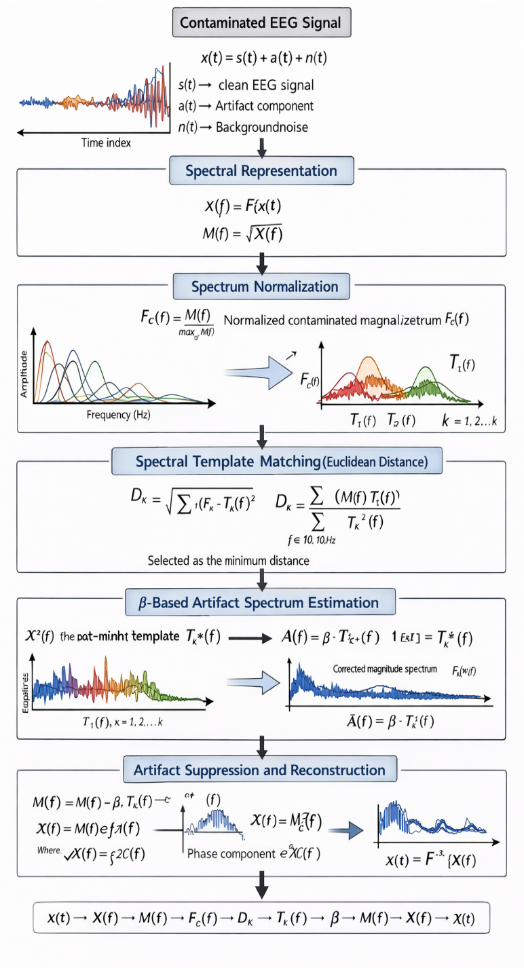
Fig.1. Block diagram of the proposed Spectral Template Matching and Suppression (STMS) framework illustrating frequency-domain normalization, template matching, β-based artifact estimation, and phase-preserved reconstruction for single-channel EEG artifact removal.

A. Spectral Representation
Let the contaminated EEG signal be:
$x\left(t\right)=s\left(t\right)+a\left(t\right)+n(t)$ (1)
Where:
$$s\left(t\right)→ clean EEG signal$$
$$a\left(t\right)→ Artifact component$$
$$n\left(t\right)→ Backgroundnoise$$
$$t=Time index$$

The frequency-domain representation is obtained using Fast Fourier Transform (FFT):

$X\left(f\right)=F\{x\left(t\right)\}$ (2)

The magnitude spectrum is computed as:

$M\left(f\right)=\left|X\left(f\right)\right|$ (3)
The contaminated EEG signal (x(t)) is first modeled as the combination of the clean EEG signal, artifact component, and background noise as shown in (1). In this representation, (s(t)) denotes the true neural activity, (a(t)) represents the artifact component mainly caused by ocular movements, and (n(t)) denotes background noise. Since ocular artifacts mainly affect the low-frequency components of EEG, the proposed method processes the signal in the spectral domain for effective separation.To analyze the spectral characteristics of the contaminated EEG, the signal (x(t)) is transformed into the frequency domain using the Fast Fourier Transform (FFT), as expressed in (2). This operation produces the complex spectrum (X(f)), which contains both magnitude and phase information of the signal. From this complex spectrum, the magnitude spectrum (M(f)) is calculated using (3). The magnitude spectrum represents the distribution of signal energy across different frequency components and is useful for identifying artifact patterns.

B. Spectrum Normalization

To ensure that template matching depends only on spectral shape (not amplitude scale), normalization is performed:

F_{c}(f)=$\frac{M(f)}{max_{f}{M(f)}}$ (4)

where:
- F_{c}(f)= normalized contaminated magnitude spectrum
- $max_{f}{M(f)}$=maximum magnitude across frequency index

However, the magnitude values may vary depending on signal amplitude. Therefore, spectrum normalization is performed to make the template matching independent of amplitude scaling. The normalized spectrum F_{c}(f) is computed by dividing the magnitude spectrum by its maximum value as shown in (4). This normalization ensures that only the spectral shape is considered during matching rather than the absolute amplitude values.

C. Spectral Template Matching (Euclidean Distance)

Let the template bank be:

T_{k}(f), k= 1,2,…,k

The Euclidean distance between the normalized spectrum and each template is computed as:

$D_{k}=√\left(\sum_{f}{{\left(F_{c}(f)-T_{k}\left(f\right)\right)}^{2}}\right)$ (5)
The template with minimum distance is considered the most similar spectral representation of the artifact.
After normalization, spectral template matching is performed to identify the artifact pattern. A precomputed template bank ($T_{k}\left(f\right)$) is used, where each template represents a possible spectral pattern of ocular artifacts. The similarity between the normalized contaminated spectrum ($F_{c}(f)$) and each template ($T_{k}\left(f\right)$) is measured using Euclidean distance as given in (5). The template that produces the minimum distance is selected as the best-matching artifact representation, indicating that its spectral shape closely resembles the artifact present in the contaminated EEG.

D. β-Based Artifact Spectrum Estimation

After selecting the optimal template T_{k*}(f), the artifact strength is estimated using a scaling factor β:

$β=\frac{\sum_{f}{M\left(f\right)T_{k*}\left(f\right)}}{{\sum_{f}{T_{k*}}}^{2}(f)}$ (6)
where
k* represents the index of the best-matched template from the pre-computed dictionary.

$$f∈\left[0,10\right]Hz$$

Once the best-matched template ($T_{k*}\left(f\right)$) is identified, the next step is to estimate the strength of the artifact present in the signal. This is achieved using a scaling factor ($β$), which is computed using the projection formula shown in (6). This factor adjusts the amplitude of the selected template so that it properly represents the artifact magnitude within the contaminated spectrum. Since ocular artifacts predominantly exist in the low-frequency region, the estimation is mainly focused within the frequency range ($f∈\left[0,10\right]Hz$).

E. Artifact Suppression and Reconstruction
The estimated artifact spectrum is:
A(f)=$β$ . T_{k*}(f) (7)

The corrected magnitude spectrum is obtained by subtracting the estimated artifact:

$\hat{M}\left(f\right)=M\left(f\right)-A(f)$ (8)

Reconstruct Corrected Complex Spectrum, Preserve original phase:
$\hat{X}\left(f\right)=\hat{M}\left(f\right)e^{j∠X(f)}$ (9)
Where: $∠X\left(f\right)=phase of contaminated spectrum$
$e^{j∠X\left(f\right)}=Phase component$
Using the scaling factor($β$), the artifact spectrum (A(f)) is estimated as given in (7). This estimated artifact spectrum represents the spectral contribution of the artifact component in the contaminated EEG signal. To suppress the artifact, the estimated artifact spectrum is subtracted from the original magnitude spectrum as expressed in (8), resulting in the corrected magnitude spectrum ($\hat{M}\left(f\right)$).After obtaining the corrected magnitude spectrum, the next step is to reconstruct the corrected complex spectrum. Since phase information plays an important role in accurate signal reconstruction, the original phase ($∠X(f)$) from the contaminated signal is preserved. The corrected complex spectrum ($\hat{X}\left(f\right)$) is therefore reconstructed by combining the corrected magnitude spectrum with the original phase component as shown in (9).

Finally, the cleaned EEG signal is reconstructed using inverse FFT:
$\hat{x}\left(t\right)=F^{-1}\{\hat{X}\left(f\right)\}$ (10)

Finally, the cleaned EEG signal ($\hat{x}\left(t\right)$) is obtained by applying the inverse Fast Fourier Transform (IFFT) to the corrected complex spectrum, as expressed in (10). This step converts the processed signal back into the time domain, resulting in an EEG signal where the ocular artifact components are significantly suppressed while preserving the important neural information

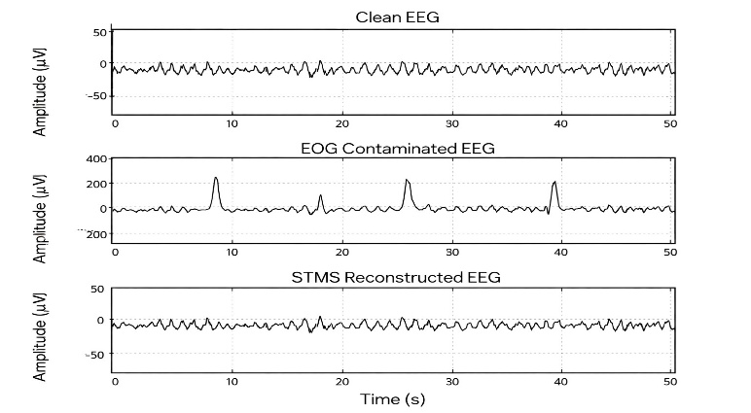
Fig.2. Precision Reconstruction: Removing EOG Artifacts without Signal Loss.

F. Final mathematical pipeline
$$x\left(t\right)→X\left(f\right)→M\left(f\right)→F_{c}\left(f\right)→D_{k}→T_{k}*\left(f\right)→β→\hat{M}\left(f\right)→\hat{X}(f)→\hat{x}\left(t\right)$$
3. Existing methods for comparision purpose
3.1. Ov-ASSA-ANC
In [33], an overlap-segmented adaptive singular spectrum analysis combined with adaptive noise cancellation (Ov-ASSA-ANC) was proposed for electrooculogram (EOG) artifact removal from electroencephalogram (EEG) signals. In this method, the contaminated EEG signal is divided into multiple segments with a predefined overlap between adjacent segments to preserve signal continuity. For each segment, adaptive singular spectrum analysis (SSA) is applied, which involves embedding, singular value decomposition (SVD), grouping, and reconstruction processes. The grouping stage is performed based on the amplitude characteristics of the contaminated signal. Typically, the first one or two reconstructed components, which predominantly represent artifact-related information, are selected.These reconstructed components are considered as the estimated artifact signal and are provided as the reference input to an adaptive noise canceller (ANC). The ANC subsequently estimates and suppresses the artifact component from the primary signal, yielding the filtered EEG output.However, the primary limitation of this approach lies in determining an appropriate overlap percentage, as improper selection may adversely affect the denoising performance and computational efficiency.
3.2. VME-DWT
The Variational Mode Extraction–Discrete Wavelet Transform (VME-DWT) [34] method has been proposed for the removal of EOG artifacts from EEG signals. In this approach, the artifact-contaminated segment is first identified using the Variational Mode Extraction (VME) technique. VME effectively isolates the dominant artifact-related components from the EEG signal based on their spectral characteristics.Once the EOG artifact segment is extracted, it is further processed using the Discrete Wavelet Transform (DWT). During this stage, skewness-based thresholding is applied to suppress the artifact components while retaining the underlying neural activity.Similar to other wavelet-based approaches that utilize either Stationary Wavelet Transform (SWT) or DWT with thresholding, the overall performance of this method largely depends on the appropriate selection of the mother wavelet and the number of decomposition levels. An improper choice may significantly affect the denoising efficiency.Moreover, thresholding in wavelet-based techniques may lead to the unintended removal of useful EEG components due to the inherently non-stationary nature of EEG signals. This can result in the loss of important signal information and, consequently, degradation in overall performance [35,36].
3.3. SSA-ICA-SWT
The SSA-ICA-SWT method [37] employs a hybrid framework combining Singular Spectrum Analysis (SSA), Independent Component Analysis (ICA), and Stationary Wavelet Transform (SWT) for the removal of EOG artifacts from single-channel EEG signals. In this approach, the contaminated EEG signal is first decomposed into multiple sub-bands using SSA in an iterative manner. This step helps in separating the signal into components with distinct temporal and spectral characteristics.Subsequently, Independent Component Analysis (ICA) is applied to these decomposed sub-bands to separate the underlying hidden sources. As a result, the signal is represented in terms of independent components (ICs), where certain components predominantly correspond to artifact-related activity.To suppress the identified artifact components, the Stationary Wavelet Transform (SWT) is employed. SWT decomposes the selected artifact IC into approximation and detail coefficients. Soft thresholding is then applied to these coefficients, where values exceeding the predefined threshold are attenuated or set to zero, while the remaining coefficients are preserved as they are assumed to represent the desired EEG activity.Although this hybrid strategy enhances artifact separation capability, its performance depends on accurate identification of artifact-related independent components and appropriate threshold selection during wavelet processing[3].
3.4. EMD–Cross-Correlation
The EMD–Cross-Correlation method [38] utilizes Empirical Mode Decomposition (EMD) in combination with statistical analysis to suppress EOG artifacts from single-channel EEG signals. In this approach, the contaminated EEG signal is first decomposed into a set of intrinsic mode functions (IMFs) using the EMD technique. Each IMF represents oscillatory components embedded within the original signal at different frequency scales.To identify the IMFs affected by EOG artifacts, statistical parameters such as variance and skewness are computed for each decomposed component. IMFs exhibiting relatively higher variance and skewness values are assumed to contain significant artifact contributions, as EOG artifacts typically introduce large amplitude and asymmetric distortions in the EEG signal.To further validate artifact presence, the cross-correlation coefficient between the suspected artifact IMF and the original contaminated EEG signal is calculated. If the computed cross-correlation exceeds a predefined threshold, the corresponding IMF is considered artifact-dominant and removed. The remaining IMFs are then recombined to reconstruct the denoised EEG signal.The selection of the cross-correlation threshold plays a crucial role in determining denoising performance. The threshold is tuned to achieve a lower Relative Root Mean Square Error (RRMSE). In this work, a threshold value of 0.6 is adopted, whereas earlier implementations [26] commonly used a value of 0.5.
4. Datasets
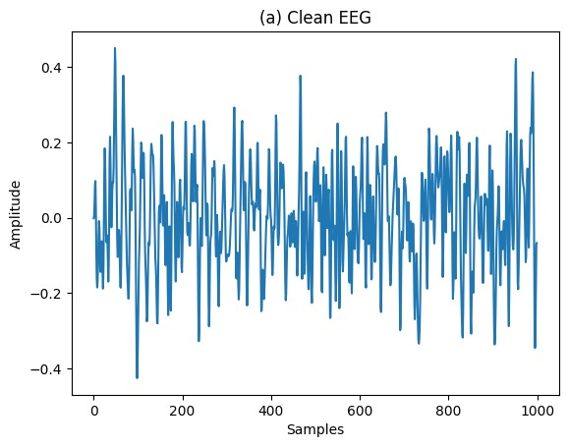
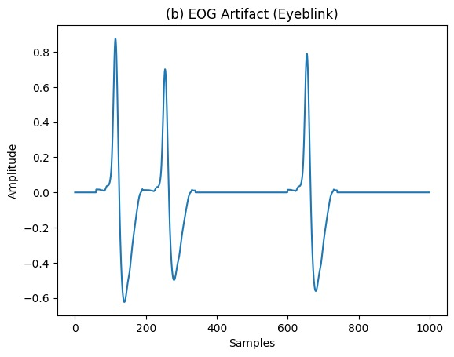

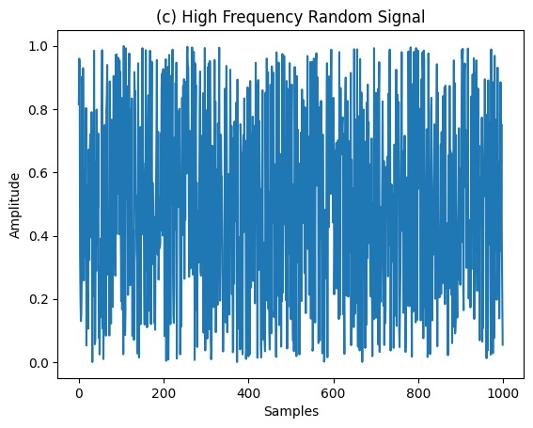

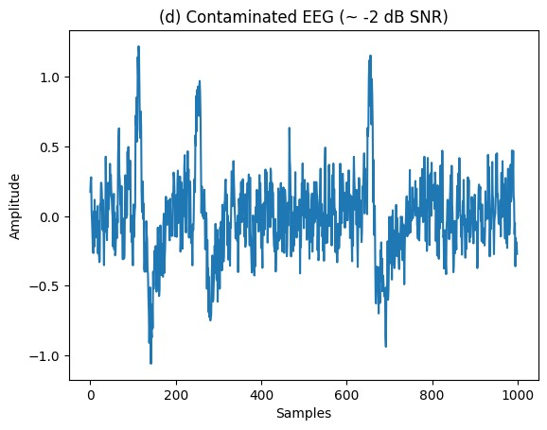
Fig.3. (a) Clean EEG, (b) EOG artifact, (c) High frequency random signal and (d) Contaminated EEG with −2dB.
4.1. Synthetic data(newdata.mat)
The synthetic EEG data is constructed according to the following mathematical model eq (1):
$x\left(t\right)=s\left(t\right)+a\left(t\right)+n(t)$ (1)
where $s(t)$ [39] represents the clean EEG signal, $a(t)$ [40] denotes the artifact component (EOG artifact), and $n\left(t\right)$corresponds to the random noise signal. The contaminated EEG signal is represented as $x(t)$
The artifact signal $a(t)$ contains variations in amplitude and appears at different time instants, thereby simulating realistic ocular contamination. The clean EEG signal $s(t)$ consists of multiple records sampled at 200 Hz. A high-frequency random noise signal $n(t)$ is additionally incorporated to emulate real-time acquisition conditions. By superimposing these three components, the contaminated EEG signal $x\left(t\right)$ is generated.
For denoising, each contaminated segment $x(t)$ is processed using the proposed method. The final denoised EEG signal is obtained by extracting the residue corresponding to the clean EEG component and combining it with the corrected spectrum after artifact suppression. Visual inspection confirms that the method effectively removes single, double, and triple instances of EOG artifacts without causing significant distortion to the underlying clean EEG waveform$s\left(t\right)$.
To quantitatively evaluate the performance, 19 EEG records of 24-second duration were considered under three different SNR conditions:
- Poor SNR (< −8 dB)
- Mild SNR (−8 dB < SNR < 0 dB)
- Good SNR (> 0 dB)
The performance metrics Correlation Coefficient (CC) and Relative Root Mean Square Error (RRMSE) were computed for 19 records.
4.2. Contaminated data(semi simulated EEG dataset) [41]
- Source and Scale: The dataset consists of 54 semi-synthetic EEG signals derived from a group of 27 subjects.
- Signal Synthesis: To replicate real-world recording challenges, ocular (EOG) artifacts were artificially layered onto pristine EEG signals.
- Channel Selection: All experimental data was extracted exclusively from the Fp2 channel to maintain spatial consistency across the study.
The spectral analysis clearly shows a strong dominance in the Delta and Theta frequency bands, indicating a highly skewed low-frequency profile. This observation aligns well with the characteristics of the dataset, where clean EEG signals were intentionally contaminated with EOG (eyeblink) artifacts. Since ocular artifacts typically appear as high-amplitude, slow-wave fluctuations, their influence is most prominent in the lower frequency ranges, particularly Delta and Theta bands.
Additionally, the spectral patterns remain remarkably consistent across all seven subjects, especially within the Delta band. This uniformity suggests that the artificial contamination applied to the Fp2 channel recordings was standardized and systematically introduced. Such consistency strengthens the reliability of the dataset for evaluating artifact suppression methods, as it ensures comparable contamination characteristics across subjects.

5. Results
5.1 Performance Evaluation metrics
To evaluate the effectiveness of the proposed STMS algorithm, quantitative performance metrics are computed before and after denoising. The evaluation includes Signal-to-Noise Ratio (SNR), Correlation Coefficient (CC), Relative Root Mean Square Error (RRMSE), and Mean Absolute Error (MAE). Additionally, band-wise analysis is performed for delta, theta, alpha, beta, and gamma rhythms.
Let:
$x_{clean}(t)$ = reference clean EEG →s(t)
$x_{noisy}\left(t\right)$=contaminated EEG →x(t)
$\hat{x}(t)$=denoised EEG after STMS
- Signal-to-Noise Ratio(SNR)
The SNR before denoising is computed as:
${SNR}_{before}=10\log_{\left\{10\right\}}(\frac{{∑_{t=1}^{N}x}_{clean}^{2}(t) }{(x_{noisy}\left(t\right)-x_{clean}\left(t\right))})$ (11)
The SNR after denoising is:

${SNR}_{after}=10\log_{10}\left(\frac{\sum_{t}{x_{clean}^{2}(t)}}{∑{\left(\hat{x}\left(t\right)-x_{clean}\left(t\right)\right)}^{2}}\right)$ (12)
Improvement in SNR is defined as:
$ΔSNR=SNR_{after}-SNR_{before}$
Higher SNR indicates better artifact suppression.
- Correlation coefficient(CC)
Correlation coefficient measures similarity between clean and reconstructed signals:
$CC =\frac{\sum{(x_{clean}\left(t\right)-μ_{c})(\hat{x}\left(t\right)-μ_{d}}}{√{\left(x_{clean}\left(t\right)-μ_{c}\right)}^{2}√{\left(\sum_{t}{\hat{x}\left(t\right)-μ_{d}}\right)}^{2}}$ (13)
$μ_{c}$= mean of clean EEG
$μ_{d}$=mean of denoised EEG
CC values closer to 1 indicate strong similarity
- Relative Root Mean Square Error (RRMSE):
“To quantify the average error in the time-domain reconstruction, the Mean Absolute Error (MAE) is calculated as:
$MAE=\frac{1}{N}\sum_{t=1}^{N}{|x_{clean}\left(t\right)-\hat{x}\left(t\right)|}$ (14)
where $N$ is the total number of samples, $x_{clean}\left(t\right)$ represents the original neural activity, and $\hat{x}\left(t\right)$ is the signal after the STMS suppression process.”

- Band Wise Analysis ($α ,β ,γ ,θ ,δ$)

In addition to overall error measurement, band-wise Mean Absolute Error (MAE) is computed to evaluate how well the proposed STMS algorithm preserves important EEG frequency components. Since ocular artifacts primarily affect low-frequency bands, it is essential to assess distortion separately across standard EEG rhythms.

To evaluate preservation of neural rhythms, signals are filtered into standard EEG bands:
- Delta (δ): 0.5–4 Hz
- Theta (θ): 4–8 Hz
- Alpha (α): 8–13 Hz
- Beta (β): 13–30 Hz
- Gamma (γ): 30–45 Hz
Let the band-pass filtered signals be:
$$x_{b}\left(t\right), \hat{x_{b}}\left(t\right)$$
Where $b∈\{δ, θ,α,β,γ\}$
Band wise MAE is computed as:
$MAE_{b}=\frac{1}{N}\sum_{t}{|x_{b}\left(t\right)-\hat{x_{b}}\left(t\right)|}$ (15)
Where
$x_{b}\left(t\right)$= clean EEG component in band bbb
$\hat{x_{b}}(t)$= denoised EEG component in band bbb
$N$ = total number of samples
5.2. Experimental Results
The proposed STMS model shows improved performance as SNR increases from Poor to Good. The mean CC rises from 0.9415 to 0.9662, indicating better signal reconstruction accuracy. Meanwhile, RRMSE decreases from 0.3326 to 0.1578, confirming effective artifact suppression.

S.NO | Poor SNR |  | Mild SNR |  | Good SNR
 | CC | RRMSE | CC | RRMSE | CC | RRMSE
1 | 0.9323 | 0.3638 | 0.9552 | 0.3002 | 0.9611 | 0.1768
2 | 0.9258 | 0.3792 | 0.9542 | 0.2999 | 0.9617 | 0.2746
3 | 0.9287 | 0.3725 | 0.9600 | 0.2809 | 0.9678 | 0.1534
4 | 0.9157 | 0.4030 | 0.9507 | 0.3107 | 0.9592 | 0.2830
5 | 0.9376 | 0.3489 | 0.9575 | 0.2889 | 0.9637 | 0.1672
6 | 0.9350 | 0.3554 | 0.9567 | 0.2916 | 0.9629 | 0.2702
7 | 0.9606 | 0.2783 | 0.9653 | 0.2616 | 0.9683 | 0.1501
8 | 0.9601 | 0.2801 | 0.9663 | 0.2577 | 0.9687 | 0.2414
9 | 0.9656 | 0.2604 | 0.9700 | 0.2432 | 0.9721 | 0.2347
10 | 0.9616 | 0.2749 | 0.9682 | 0.2503 | 0.9701 | 0.1394
11 | 0.9287 | 0.3719 | 0.9589 | 0.2843 | 0.9652 | 0.1620
12 | 0.9274 | 0.3745 | 0.9588 | 0.2847 | 0.9651 | 0.2624
13 | 0.9335 | 0.3589 | 0.9618 | 0.2739 | 0.9678 | 0.1521
14 | 0.9306 | 0.3665 | 0.9599 | 0.2808 | 0.9664 | 0.1573
15 | 0.9628 | 0.2708 | 0.9715 | 0.2371 | 0.9745 | 0.2244
16 | 0.9557 | 0.2950 | 0.9656 | 0.2605 | 0.9693 | 0.1463
17 | 0.9292 | 0.3709 | 0.9538 | 0.3007 | 0.9607 | 0.1780
18 | 0.9378 | 0.3479 | 0.9565 | 0.2922 | 0.9629 | 0.1704
19 | 0.9645 | 0.2646 | 0.9666 | 0.2567 | 0.9686 | 0.1488
Mean | 0.9415 | 0.3326 | 0.9609 | 0.2766 | 0.9662 | 0.1578
Table 1. Proposed STMS model performance metrics for various SNRs

Fig.4. Box plot of CC values (poor SNR)

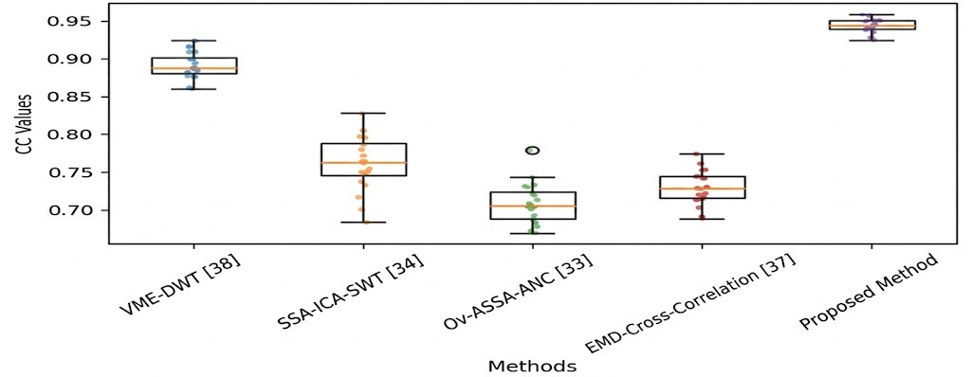

Fig.5. Box plot of CC values(mild SNR)
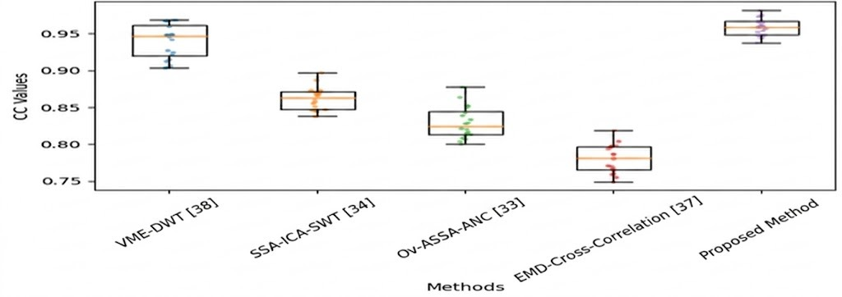
Fig.6. Box plot of CC (Good SNR)
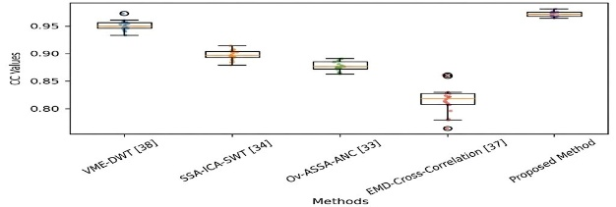

Fig.7. Box plot of RRMSE(poor SNR)
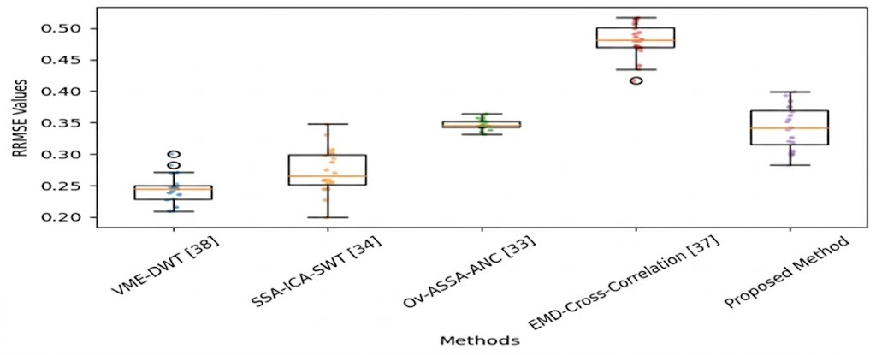

Fig.8. Box plot of RRMSE (mild SNR)
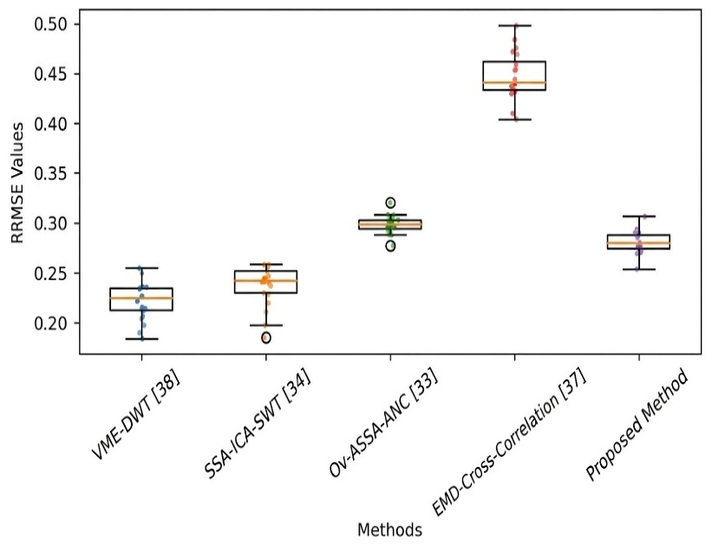
Fig.9. Box plot of RRMSE(Good SNR)
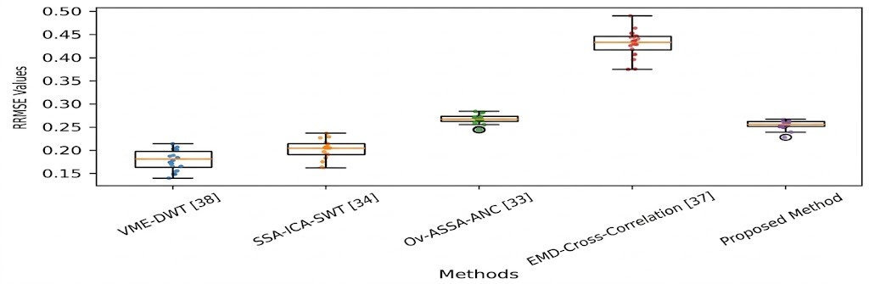
"The proposed method demonstrates state-of-the-art performance in EEG signal denoising. By achieving a near-perfect correlation (CC $≈$0.96) in fig.4, fig.5,fig.6 and reducing high-frequency MAE to ${10}^{\left\{-7\right\}}$ in fig.7,fig.8,fig.9 as it effectively bridges the gap between noise suppression and signal preservation. Statistical evidence from the box plots confirms that the method is not only more accurate but also more robust against signal variability than established benchmarks such as VME-DWT[38] and SSA-ICA-SWT[34]."

Table 2. MAE of PSD plots in various frequency bands
Method | Epoch | Delta | Theta | Alpha | Beta | Gamma
Ov-ASSA-ANC[33] | 1 | 0.1381 | 0.0305 | 0.0282 | 0.0069 | 0.0067
Ov-ASSA-ANC[33] | 2 | 0.1292 | 0.0335 | 0.012 | 0.0064 | 0.0068
Ov-ASSA-ANC[33] | 3 | 0.0853 | 0.0409 | 0.0189 | 0.0052 | 0.0065
Ov-ASSA-ANC[33] | 4 | 0.1298 | 0.0358 | 0.0236 | 0.0056 | 0.0304
Ov-ASSA-ANC[33] | 5 | 0.1289 | 0.0386 | 0.0149 | 0.0064 | 0.0331
Ov-ASSA-ANC[33] | 6 | 0.1041 | 0.034 | 0.0041 | 0.0068 | 0.0074
Ov-ASSA-ANC[33] | Average | 0.1192 | 0.0355 | 0.017 | 0.0062 | 0.0151
SSA-ICA-SWT[34] | 1 | 0.1379 | 0.026 | 0.0103 | 0.0012 | 4.2211e−04
SSA-ICA-SWT[34] | 2 | 0.1338 | 0.0238 | 0.0104 | 0.0036 | 4.3751e−04
SSA-ICA-SWT[34] | 3 | 0.1346 | 0.0336 | 0.0096 | 0.0013 | 3.9239e−04
SSA-ICA-SWT[34] | 4 | 0.137 | 0.0347 | 0.0122 | 0.0045 | 0.0076
SSA-ICA-SWT[34] | 5 | 0.1432 | 0.0349 | 0.0136 | 0.0027 | 0.0073
SSA-ICA-SWT[34] | 6 | 0.1232 | 0.0309 | 0.0084 | 0.0023 | 3.8270e−04
SSA-ICA-SWT[34] | Average | 0.1349 | 0.0307 | 0.0108 | 0.0026 | 0.0028
EMD-CrossCorr[37] | 1 | 0.1001 | 0.0176 | 0.0117 | 0.0036 | 0.0143
EMD-CrossCorr[37] | 2 | 0.0956 | 0.0269 | 0.0177 | 0.0049 | 0.0138
EMD-CrossCorr[37] | 3 | 0.0993 | 0.0119 | 0.0201 | 0.0049 | 0.0133
EMD-CrossCorr[37] | 4 | 0.1045 | 0.0214 | 0.0402 | 0.0039 | 0.0129
EMD-CrossCorr[37] | 5 | 0.0992 | 0.0162 | 0.0285 | 0.005 | 0.0144
EMD-CrossCorr[37] | 6 | 0.092 | 0.0205 | 0.0116 | 0.0044 | 0.0128
VME-DWT[38] | 1 | 0.1497 | 0.0237 | 0.0027 | 9.6900e−04 | 2.3487e−04
VME-DWT[38] | 2 | 0.143 | 0.0186 | 0.0021 | 0.0014 | 3.9393e−04
VME-DWT[38] | 3 | 0.1353 | 0.0267 | 0.0022 | 0.001 | 3.5242e−04
VME-DWT[38] | 4 | 0.1464 | 0.0292 | 0.0033 | 0.0017 | 4.2762e−04
VME-DWT[38] | 5 | 0.1436 | 0.0174 | 0.0038 | 0.0014 | 5.8303e−04
VME-DWT[38] | 6 | 0.133 | 0.0199 | 0.002 | 0.0011 | 3.3686e−04
VME-DWT[38] | Average | 0.1418 | 0.0226 | 0.0027 | 0.0013 | 3.8812e−04
Proposed STMS | 1 | 0.9974 | 0.5631 | 0.0008 | 0.0001 | 0
Proposed STMS | 2 | 0.9994 | 0.5753 | 0.0007 | 0.0001 | 0
Proposed STMS | 3 | 0.9998 | 0.6129 | 0.0014 | 0.0005 | 0
Proposed STMS | 4 | 0.9997 | 0.5598 | 0.0008 | 0.0002 | 0
Proposed STMS | 5 | 0.9994 | 0.6721 | 0.0016 | 0.0003 | 0
Proposed STMS | 6 | 0.9989 | 0.61141 | 0.0008 | 0.0002 | 0
Proposed STMS | Average | 0.9991 | 0.59990 | 0.0010 | 0.0002 | 0
Average MAE across frequency bands
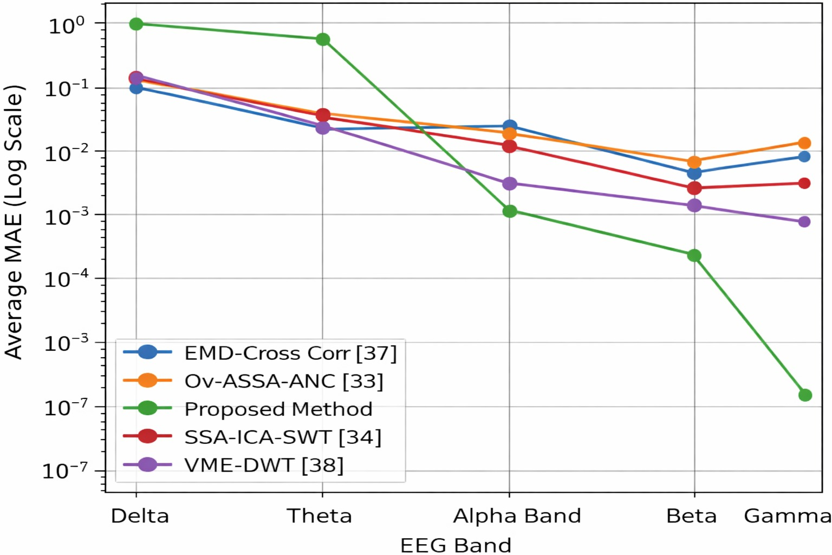
Fig.10. Average MAE comparison across EEG frequency bands demonstrating superior artifact suppression performance of the proposed method compared to existing techniques.
The figure shows the Average Mean Absolute Error (MAE) across different EEG frequency bands including Delta, Theta, Alpha, Beta, and Gamma. The y-axis represents MAE in logarithmic scale, while the x-axis represents EEG bands. Lower MAE values indicate better artifact removal and accurate EEG reconstruction. The performance of EMD–Cross Corr [37], Ov-ASSA-ANC [33], SSA-ICA-SWT [34], VME-DWT [38] in Table-2 , and the Proposed Method is compared. In the Delta band, most existing methods show relatively high MAE due to strong low-frequency artifacts. The Theta band shows a gradual reduction in error for all methods. From the Alpha band onward, the proposed method shows a significant decrease in MAE compared to other techniques in fiig.10 . This indicates effective suppression of ocular artifacts while preserving EEG rhythms. In the Beta band, the proposed method continues to maintain very low error values. The Gamma band shows the minimum MAE for the proposed method, demonstrating superior reconstruction accuracy. Overall, the results confirm that the proposed method outperforms existing techniques in preserving EEG signal quality across all frequency bands.
6. Conclusion
This study presents Spectral Template Matching and Suppression (STMS), a lightweight and adaptive method developed to remove artifacts from single-channel EEG signals. Unlike traditional approaches such as ICA, which depend on multiple electrodes, the proposed method works effectively with only one channel. STMS learns the patterns of ocular artifacts directly from the data using an unsupervised clustering approach. By analyzing the stable low-frequency spectral characteristics of these artifacts, the framework selectively suppresses noise while preserving the original phase and important neural information within the EEG signal.The proposed method was tested under different Signal-to-Noise Ratio (SNR) conditions to evaluate its performance. The results showed strong reconstruction capability, achieving a high mean Correlation Coefficient of 0.9662 and a low Mean Absolute Error (MAE) of 0.0172. When compared with existing techniques such as VME-DWT and SSA-ICA-SWT, STMS demonstrated effective artifact suppression while maintaining lower computational complexity. Because of this balance between efficiency and accuracy, the method is well suited for real-time applications, particularly in wearable EEG devices and Brain–Machine Interface (BMI) systems. It supports reliable neural signal monitoring in portable and real-world environments without requiring complex multi-channel setups.

References

[1] E. Niedermeyer and F. L. da Silva EEG: Basic Principles and Overview – OpenAnesthesia 5th ed. Philadelphia, PA: Lippincott Williams & Wilkins, 2004.
[2] S. Sanei and J. A. Chambers, "EEG Signal Processing," Chichester, U.K.: Wiley, 2007.
[3] R. J. Croft and R. J. Barry, "Removal of ocular artifact from the EEG: a review," Clin. Neurophysiol., vol. 30, no. 1, pp. 5–19, 2000.
[4] P. He, G. Wilson, and C. Russell, "Removal of ocular artifacts from electroencephalogram by adaptive filtering," Med. Biol. Eng. Comput., vol. 42, no. 3, pp. 407–412, 2004.
[5] T. P. Jung et al., "Removal of eye activity artifacts from visual event-related potentials in normal and clinical subjects," Clin. Neurophysiol., vol. 111, no. 10, pp. 1745–1758, 2000.
[6] S. Makeig et al., "Independent component analysis of electroencephalographic data," Adv. Neural Inf. Process. Syst., vol. 8, pp. 145–151, 1996.
[7] J. A. Urigüen and B. Garcia-Zapirain, "EEG artifact removal—state-of-the-art and guidelines," J. Neural Eng., vol. 12, no. 3, pp. 031001, 2015.
[8] A. J. Casson et al ,”Artifacts – Learning EEG (Eye blinks and movement artifacts) Learning EEG” IEEE Eng. Med. Biol. Mag., vol. 29, no. 3, pp. 44–56, 2010.
[9] M. K. Islam, A. Rastegarnia, and Z. Yang, "Artifact detection and removal techniques for EEG: a review," NeuroImage, vol. 137, pp. 157–165, 2016.
[10] Y. Roy et al., "Deep learning-based electroencephalography analysis: a systematic review," J. Neural Eng., vol. 16, no. 5, pp. 051001, 2019.
[11] V. Krishnaveni et al., "Automatic identification and removal of ocular artifacts from EEG using wavelet transform," in Proc. IEEE EMBS, 2006, pp. 1712–1715.
[12] N. Mammone and F. C. Morabito, "Independent component analysis and clustering for artifact removal in EEG," Neurocomputing, vol. 69, no. 13–15, pp. 1381–1386, 2008.
[13] X. Chen et al., "Removal of ocular artifacts from EEG using adaptive filtering and template matching," J. Neurosci. Methods, vol. 211, no. 1, pp. 83–89, 2013.
[14] X. Zhang, Y. Zhou, and J. Luo, "EEG artifact removal using wavelet neural networks," Neurocomputing, vol. 92, pp. 48–53, 2012.
[15] A. Delorme and S. Makeig, "EEGLAB: an open source toolbox for analysis of single-trial EEG dynamics," J. Neurosci. Methods, vol. 134, no. 1, pp. 9–21, 2004.
[16] G. Gratton, M. G. Coles, and E. Donchin, "A new method for off-line removal of ocular artifact," Electroencephalogr. Clin. Neurophysiol., vol. 55, no. 4, pp. 468–484, 1983.
[17] J. G. Walker, "The removal of the eye-movement artifact from the EEG by regression analysis in the frequency domain," Psychophysiology, vol. 20, no. 1, pp. 101–108, 1983.
[18] B. Rivet et al., "Ocular artifacts removal from EEG signals using spatial filtering," Signal Process., vol. 89, no. 1, pp. 11–24, 2009.
[19] C. A. Joyce et al., "Automatic removal of eye movement and blink artifacts from EEG data using ICA," Psychophysiology, vol. 41, no. 2, pp. 313–325, 2004.
[20] W.-D. Chang and C.-H. Im, “Enhanced template matching using dy namic positional warping for identification of specific patterns in elec troencephalogram,” Journal of Applied Mathematics, vol. 2014, no. 1, p. 528071, 2014.
[21] X. Yong et al., "Artifact removal from EEG using ICA and wavelet denoising," in Proc. IEEE EMBS, 2005, pp. 890–893.
[22] N. P. Castellanos and V. A. Makarov, "Recovering EEG signals from ocular artifacts by wavelet transform and ICA," J. Neurosci. Methods, vol. 153, no. 2, pp. 300–310, 2006.
[23] K. T. Sweeney et al, “(mdpi.com in Bing)” IEEE J. Emerg. Sel. Topics Circuits Syst., vol. 2, no. 1, pp. 34–48, 2012.
[24] J. F. Croft et al., "A comparison of time and frequency domain methods of EOG correction," Psychophysiology, vol. 28, no. 3, pp. 329–336, 1991.
[25] C. J. James and O. J. Gibson, “(doi.org in Bing)” IEEE Trans. Biomed. Eng., vol. 50, no. 9, pp. 1108–1116, 2003.
[26] A. J. Bell and T. J. Sejnowski, "An information-maximization approach to blind separation and blind deconvolution," Neural Comput., vol. 7, no. 6, pp. 1129–1159, 1995.
[27] D. Marques Abramov, P. R. Galhanone, V. V. Lazarev, and A. M. Ferreira Leite Miranda de S´a, “Conservative method for vertical electrooculo gram attenuation based on local suppression of ongoing EEG artifact templates,” Plos one, vol. 19, no. 7, p. e0305902, 2024.
[28] S. Mannan et al., "Automatic identification of EOG artifacts in single-channel EEG using ICA and SVM," Neurocomputing, vol. 174, pp. 915–923, 2016.
[29] G. Santhosh and K. Ramadoss, "Artifact removal from EEG using a hybrid approach of wavelet and ICA," in Proc. IEEE ICSP, 2014, pp. 1205–1210.
[30] H. Ramoser et al., "Optimal spatial filtering of single trial EEG during imagined hand movement," IEEE Trans. Rehabil. Eng., vol. 8, no. 4, pp. 441–446, 2000.
[31] Y. Wang et al., "Removing ocular artifacts from single-channel EEG using EEMD and ICA," Measurement, vol. 91, pp. 219–226, 2016.
[32] W.-D. Chang, H.-S. Cha, K. Kim, and C.-H. Im, “Detection of eye blink artifacts from single prefrontal channel electroencephalogram,” Computer Methods and Programs in Biomedicine, vol. 124, pp. 19 30, 2016. [Online]. Available: https://www.sciencedirect.com/science/ article/pii/S0169260715002710.
[33] Sayedu Khasim Noorbasha, Gnanou Florence Sudha, Removal of EOG artifacts from single channel EEG- an efficient model combining overlap segmented ASSA and ANC, in: Biomedical Signal Processing and Control, Vol. 60, Elsevier, 2020, pp. 1–8, http://dx.doi.org/10.1016/j.bspc.2020.101987
[34] M. Shahbakhti, et al., VME-DWT: An efficient algorithm for detection and elimination of eye blink from short segments of single EEG channel, IEEE Trans. Neural Syst. Rehabil. Eng. 29 (2021) 408 417,http://dx.doi.org/10.1109/ TNSRE.2021.3054733.
[35] Sayedu Khasim Noorbasha, Gnanou Florence Sudha, Electrical shift and linear trend artifacts removal from single channel EEG using SWT-GSTV model, in: Soft Computing and Signal Processing, in: Advances in Intelligent Systems and Computing, vol. 1413, Springer, Singapore, 2022, http://dx.doi.org/10.1007/ 978-981-16-7088-6-43.
[36] Sayedu Khasim Noorbasha, Gnanou Florence Sudha, Electrical shift and linear trend artifacts removal from single channel EEG using SWT-GSTV model, in: Soft Computing and Signal Processing, in: Advances in Intelligent Systems and Computing, vol. 1413, Springer, Singapore, 2022, http://dx.doi.org/10.1007/ 978-981-16-7088-6-43.
[37] Sayedu Khasim Noorbasha, Gnanou Florence Sudha, Removal of EOG artifacts and separation of different cerebral activity components from single channel EEG-an efficient approach combining SSA-ICA with wavelet thresholding for BCI applications, in: Biomedical Signal Processing and Control, Vol. 63, Elsevier, 2021, pp. 1–12, http://dx.doi.org/10.1016/j.bspc.2020.102168
[38] R. Patel, M.P. Janawadkar, S. Sengottuvel, K. Gireesan, T.S. Radhakrishnan, Suppression of eye-blink associated artifact using single channel EEG data by combining cross-correlation with empirical mode decomposition, IEEE Sens. J. 16 (18) (2016) 6947–6954, http://dx.doi.org/10.1109/JSEN.2016.2591580.
[39] J.T. Valderrama, A. Torre, B.V. Dun, An automatic algorithm for blink-artifact suppression based on iterative template matching: application to single channel recording of cortical auditory evoked potentials, J. Neural Eng. 15 (2018) 1–15, http://dx.doi.org/10.1088/1741-2552/aa8d95.
[40] M.A. Klados, P.D. Bamidis, A semi-simulated EEG/EOG dataset for the com parison of EOG artifact rejection techniques, Data Brief 8 (2016) 1004–1006, http://dx.doi.org/10.1016/j.dib.2016.06.032.
[41] M. A. Klados and P. D. Bamidis, A semi-simulated EEG/EOG dataset for the comparisonof EOG artifact rejection techniques," Data in brief, vol.8, pp. 1004-1006, 2016.

