PREFACE

Last mile connectivity refers to the last part of the journey made by a commuter where he/she travels from the point where the metro trains stop to his/her final destination. The concept is highly instrumental for assessing the level of efficiency of the entire process. Even if the metro system of a country or city is well established and highly efficient, poor last mile connectivity may make people avoid the system and opt for other means of transport.

This study titled “Access and Last Mile Connectivity to Metro: A Study of Delhi,” aims at analyzing the issues surrounding the accessibility and connectivity of the metro stations within the urban context of Delhi. Although the Delhi Metro Rail Corporation has been successful in terms of its operations, there exist various problems associated with accessibility of the metro stations.

In addition, variations in the pattern of mobility in various metro station areas have been studied in this research. This is because the factors affecting the ease of accessibility and connectivity are not homogenous and vary according to parameters like land use, infrastructure, and transportation facilities. Through this analysis, the researcher tries to give a different point of view on urban mobility in Delhi.

Another aspect discussed in the dissertation concerns the recommendation of appropriate government measures in order to improve last mile connectivity and accessibility around metro stations.

LIST OF CONTENT

Chapter One: Introduction--------------------------------------------------------------1-6

  - Introduction--------------------------------------------------------------------1
  - Statement of the Problem----------------------------------------------------2
  - Scope of the Research--------------------------------------------------------3
  - Research Question-------------------------------------------------------------3
  - Objectives----------------------------------------------------------------------4
  - Study Area---------------------------------------------------------------------4
  - Data base and Methodology-------------------------------------------------5

Chapter Two: Literature Review------------------------------------------------------7-15

Chapter Three: Access and Last-mile connectivity to Metro stations
within the Study area------------------------------------------------16-26

3.1 Rajiv Chowk------------------------------------------------------------------18
3.2 Green Park--------------------------------------------------------------------21
3.3 Chhatarpur--------------------------------------------------------------------24

Chapter Four: Mobility pattern across metro stations----------------------------27-38

4.1 Choice of metro stations-----------------------------------------------------28
4.2 Purpose of trip-----------------------------------------------------------------30
4.3 Rajiv Chowk-------------------------------------------------------------------31
4.4 Green Park---------------------------------------------------------------------34
4.5 Chhatarpur---------------------------------------------------------------------36
4.6 Comparative Analysis of mobility patterns-------------------------------38
4.7 Conclusion---------------------------------------------------------------------38

Chapter Five: Government initiatives towards Last-mile connectivity--------39-41

5.1 Government initiatives------------------------------------------------------39
5.2 Suggestions for improving Last-mile connectivity-----------------------40

Chapter Six: Key Findings---------------------------------------------------------42-44

6.1 Scope of Future Research--------------------------------------------------43
6.2 Conclusion-------------------------------------------------------------------44

LIST OF MAPS
MAP NUMBER | TITLE | PAGE NO.
Map 1.1 | Location map of the study area | 4
Map 3.1 | Delhi Metro network map | 16
Map 4.1 | Yellow line | 29

LIST OF TABLES
TABLE NUMBER | TITLE | PAGE NO.
Table 3.1 | Phase-wise Expansion of Delhi Metro Network: Route Length (km) and Number of Stations | 17
Table 3.2 | Distance between destination areas and metro station | 19
Table 3.3 | Distance between destination areas and metro station | 22
Table 3.4 | Distance between destination areas and metro station | 25
Table 4.1 | Purpose of trip | 30
Table 4.2 | Comparative Analysis | 38

LIST OF FIGURES

FIGURE NO. | TITLE | PAGE NO.
Fig no. 3.1 | Rajiv Chowk Metro station | 18
Fig no. 3.2 | Rajiv Chowk | 18
Fig no. 3.3 | Mode of Transport | 19
Fig no. 3.4 | Time taken | 20
Fig no. 3.5 | Green Park Metro Station | 21
Fig no. 3.6 | Mode of Transport | 22
Fig no. 3.7 | Time taken | 23
Fig no. 3.8 | Chhatarpur Station | 24
Fig no. 3.9 | Mode of transport | 25
Fig no. 4.1 | Rajiv Chowk | 31
Fig no. 4.2 | Entry and exit gates of Rajiv Chowk | 32
Fig no. 4.3 | Mobility conditions of Rajiv Chowk | 33
Fig no. 4.4 | Green Park Station | 34
Fig no. 4.5 | Entry and exit gated of Green Park | 34
Fig no. 4.6 | Mobility conditions of Green Park | 35
Fig no. 4.7 | Chhatarpur Station | 36
Fig no. 4.8 | Mobility conditions of Chhatarpur | 37

CHAPTER- 1
INTRODUCTION
1.1 Introduction
Last-mile connectivity refers to the final part of a passenger’s journey , i.e. the distance between a public transport hub such as a metro station and the commuter’s ultimate origin or destination, such as home, office, or educational institution. Although this distance is usually short (often 1–5 km), it plays an important role in influencing the overall efficiency, convenience and attractiveness of public transport systems. If the last-mile segment is unsafe, expensive, time-consuming, or poorly connected, people may prefer private vehicles over public transport.
In urban transport planning, last-mile connectivity includes various modes such as walking, cycling, feeder buses, e-rickshaws, shared autos, and intermediate public transport. It also involves infrastructure like pathways, cycling tracks, signage, lighting, and traffic management around station areas. Therefore, last-mile connectivity is not merely about distance it is about accessibility, affordability, safety, and integration within the broader urban mobility system.
The Delhi Metro Rail Corporation (DMRC) manages the Delhi Metro, one of the largest and most efficient metro systems in India. Since its launch in 2002, the Delhi Metro has become a significant development in the city’s transport system, transforming the daily travel of millions of people. As a mass rapid transit system, it provides fast, reliable, and efficient mobility. It connects residential areas, commercial hubs, institutional zones, and peripheral regions through an extensive network of lines. Despite its operational efficiency, the effectiveness of the Delhi Metro is highly dependent on the quality of last-mile connectivity. Many commuters face challenges such as traffic congestion near station exits, irregular feeder services, and high dependency on informal transport modes. In some areas, well-developed commercial hubs have better access facilities, while low-density neighbourhoods experience connectivity gaps. This variation creates unequal accessibility patterns across different station areas.

1.2 Statement of the Problem
Rapid urbanization and population growth in Delhi have increased travel demand and resulting in increased stress for the city transport system. The expansion of the Delhi Metro has provided a reliable and efficient mass transit system and has transformed mobility patterns across the National Capital Region. However, despite the operational success and extensive network coverage of the metro system, the issue of last-mile connectivity continues to create a major challenge in ridership of metro.
Last-mile connectivity refers to the accessibility between a metro station and a commuter’s final destination. Although this section of travel may cover a relatively short distance, it often determines whether commuters choose public transport or shift to private vehicles. Irregular feeder services, traffic congestion near station exits, safety concerns, lack of cycling facilities, and dependency on informal transport modes create barriers in accessing metro stations efficiently and affordably. These challenges are not uniform but they depends according to land-use patterns, population density, and the socio-economic characteristics of different station areas.
For instance, central commercial hubs experience congestion and overcrowding, while peripheral stations may suffer from insufficient feeder services and longer access distances. Mixed land-use areas present another set of mobility dynamics. Such spatial variation creates unequal accessibility and influences commuter behaviour, travel time, and transport costs.
The core problem addressed in this research is the gap between metro infrastructure provision and effective neighbourhood-level access to metro stations. While major investments have been made in expanding metro lines, but less attention has been given to station areas and last-mile connectivity with surrounding residential and commercial zones through efficient, affordable, and safe last-mile transport systems.
Therefore, there is a need to systematically examine the nature of last-mile connectivity around selected metro stations, identify infrastructural and service-related gaps, and analyse how mobility patterns differ across varying urban contexts. By assessing station-area accessibility and understanding commuter experiences, this study seeks to highlight planning deficiencies and propose strategies for improving equitable and sustainable last-mile connectivity within Delhi’s metro system.

1.3 Scope of the Research
The scope of this study is limited to examining last-mile connectivity and station-area access around selected Delhi Metro stations on the Yellow Line. The study focuses on understanding how commuters travel between metro stations and nearby residential, commercial, and institutional areas. It covers various aspects of last-mile connectivity, including:
- Modes of transport used from the station to the final destination (walking, e-rickshaw, auto-rickshaw, bus, etc.)
- Distance and time taken to reach the station
- Safety, convenience, and availability of services
- Infrastructure facilities such as footpaths, lighting, and traffic conditions
The research also compares connectivity patterns across three types of station areas: central, mixed-use, and peripheral; to understand how mobility varies across different locations. However, the study does not cover the entire Delhi Metro network. It is limited to selected stations and does not include a detailed technical or engineering analysis of metro infrastructure. Therefore, the findings are specific to the chosen study areas but may contribute to a broader understanding of last-mile connectivity issues in Delhi.
Overall, the scope of this research lies in identifying gaps, analysing accessibility patterns, and suggesting improvements to make metro connectivity more efficient, affordable, and user-friendly.
1.4 Research question
This research mainly focuses on Last mile connectivity to metro rail. It helps to analyse and understand how commuters travel from metro station to final destination places .The main research question that arises is:
- How does last-mile connectivity influence accessibility and mobility patterns around Delhi Metro stations?
- How do mobility patterns vary across different metro station areas?

1.5 Objectives
The objectives for this research are:
- To identify gaps in access and last-mile connectivity to metro stations within the study area
- To analyse variations in mobility patterns across different station areas
- To examine government initiatives and propose recommendations for improving last-mile connectivity and accessibility around Delhi Metro stations.
1.6 Study Area

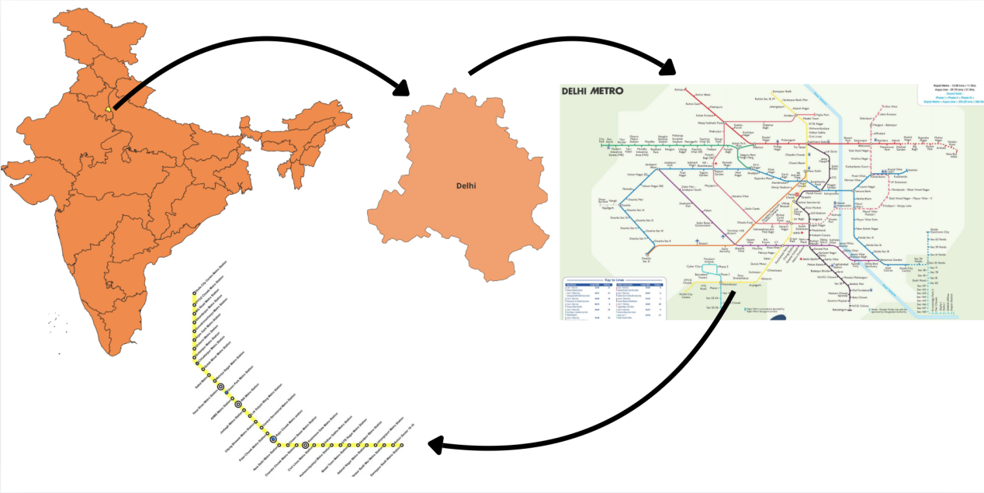
Map 1.1 Location map of the study area

This study focuses on selected stations along the Yellow Line of the Delhi Metro to analyse variations in last-mile connectivity and station-area access. The selected stations-Rajiv Chowk, Green Park, and Chhatarpur represent diverse urban contexts and mobility characteristics within Delhi.
Rajiv Chowk, located in Connaught Place, is one of the busiest interchange stations in the metro network. Situated in a dense commercial and business district, it experiences high daily ridership and offers multiple transport options. The station area is characterised by heavy congestion, complex traffic flows, and a wide range of last-mile transport modes, including auto-rickshaws and e-rickshaws. Studying this station provides insights into last-mile connectivity challenges in a high-density central business district.
Green Park station represents a mixed-use area comprising residential neighbourhoods, commercial markets, educational institutions, and healthcare facilities. It has a moderate density and relatively planned urban form. However, issues such as parking pressure and the presence of informal transport services influence accessibility patterns in the station area.
Chhatarpur station, located towards the southern periphery of Delhi, reflects a contrasting urban setting characterised by lower density, semi-urban settlements, and longer travel distances to surrounding areas. In such contexts, commuters often depend on intermediate public transport and shared mobility services for last-mile access. This station provides insight into connectivity challenges in peripheral and rapidly expanding urban zones.
Together, these three stations provide a comparative framework to examine how last-mile connectivity varies across central, mixed-use, and peripheral urban contexts.

1.7 Data base and Methodology
This study employs both qualitative (surveys and questionnaires) and quantitative (graphs, charts, and percentages) approaches to analyse and assess last-mile connectivity at selected stations on the Yellow Line of the Delhi Metro. Convenience sampling is used for selecting respondents. Both primary and secondary data sources are used to examine the last-mile connectivity system. Primary data is collected through structured questionnaire conducted at the selected metro stations. The questionnaire focuses on aspects such as mode of transport used for last-mile travel, distance and time taken to reach the station, and purpose of travel. A sample size of approximately 60 respondents is targeted to obtain representative insights into last-mile connectivity patterns. In addition, field observations were carried out to assess infrastructure conditions, the availability of feeder services, traffic patterns, parking facilities, and the presence of informal transport modes such as e-rickshaws and auto-rickshaws.
Secondary data is obtained from official reports and publications of the Delhi Metro Rail Corporation, urban transport reports, government transport department documents, academic journals, and planning reports related to last-mile connectivity and urban mobility. These sources help in understanding the broader urban context, ridership trends, and planning frameworks.
The study employs both quantitative and qualitative analytical methods. Descriptive statistics such as percentages, means, and frequencies are used to analyse commuter responses. The data is presented using pie charts, bar graphs, and tables (prepared using MS Excel) to clearly depict trends and patterns. Quantitative data from questionnaires is tabulated and analysed using statistical tools such as percentages, averages, and comparative analysis. Travel time, cost, and distance are compared across the three selected stations to identify variations in accessibility. Mode share analysis is conducted to determine dominant last-mile transport options. Qualitative responses related to commuter perceptions, safety concerns, and infrastructure gaps are interpreted based on questionnaire responses and field observations. The findings of the study are presented in a clear and visually structured manner to facilitate easy interpretation. The analysed data is displayed using:
- Tables and charts to show mode share, travel time, and cost distribution
- Graphs and comparative diagrams to highlight inter-station variations
- Maps to illustrate spatial patterns of neighbourhood-level accessibility
This systematic presentation helps in effectively demonstrating variations in last-mile connectivity and identifying key infrastructural and planning gaps around the selected metro stations.

CHAPTER 2
LITERATURE REVIEW
Access and last mile connectivity act as an important role in determining the regulation and success of metro rail systems. Several researchers have highlighted that even though metro systems provide fast and efficient transportation, the availability of well-grounded first and last mile connectivity strongly influences commuter satisfaction and daily ridership. Das et al. (2026) emphasis in their study that travellers preferences for motorized feeder services as a last mile connectivity option in a commercial hub in India. Their study also revealed that distance from the metro station is an important factor influencing mode choice, with walking preferred for short distances and motorized feeder services preferred for longer distances. The research also showed that socio-economic characteristics such as income, job type influences travellers preferences for feeder services.
Similarly, Panchal et al. (2020) focused on bicycle–metro integration and analyzed user understanding towards bicycling as a last mile connectivity option in Hyderabad. Their findings shows that components such as trip frequency, trip purpose, and safety conditions influence travellers decision to use bicycles for accessing metro stations. The study also identified that lack of safe cycling infrastructure and inadequate parking facilities that may decreases the use of bicycle. Further progress in last mile connectivity systems have been showed by Stevens et al. (2022), who have created a simulation model for evaluating the economic feasibility of automation mobility-on-demand schemes being deployed as feeder lines to public transportation facilities. The findings revealed that automation mobility schemes could enhance connectivity to metro station by decreasing on waiting time and making services more efficient. Roy et al. (2024) examined the role of autonomous shuttle services in improving first and last mile connectivity in urban transport systems. Their study suggested that the execution of advanced technologies such as optimized routing systems and improved scheduling methods can reduce travel time and enhance service performance.
Choudhary et al. (2025) emphasizes the role of infrastructure and service provide in increasing the sustainable urban transport systems in Delhi NCR regions. Their study focused on assess last mile connectivity at metro stations like Botanical Garden & Nehru Place through travellers surveys, spatial analysis, and infrastructure assessment. The findings also tells that accessibility, safety and service availability are main components influencing the effectiveness of last mile connectivity. Also this research emphasized the need for all-in and user-friendly transport planning to support women, elderly people, and differently-abled travellers etc. Similarly, Minal et al. (2022) conducted a study on last mile connectivity in Chennai Metro focusing on participatory approaches and smart mobility concept. Their study examined newly developed metro stations and identified several challenges affecting travellers accessibility. The findings shows the insufficient parking facilities, limited feeder and public transport services etc. Their research also focuses on importance of citizen participation in planning processes to ensure that transport infrastructure meets the needs of travellers.
De et al. (2017) emphases the role of intelligent systems in enhancing last mile connectivity in future smart cities in India. Their study emphasized the use of advanced technologies such as smart parking systems, electronic road pricing, mobile Geographic Information Systems (GIS), use of mobility card and travellers information system to have better connectivity between residential areas and transit stations. The study concluded that integrating intelligent technological solutions can improve safety, accessibility, and commuter convenience in urban areas. Similarly, Scheibe et al. (2006) focused on the application of spatial decision support systems for addressing last mile connectivity issues in wireless broadband communication networks. Their main focused on communication systems, the study demonstrated the importance of integrating Geographic Information Systems (GIS) with decision support tools to determine optimal infrastructure placement and improve accessibility.
Zellner et al. (2016) look into the strategies to overcome the last-mile connectivity problem through transportation and land-use improvements using an agent-based modeling approach. The findings suggested that providing shuttle services and improving urban design elements can significantly reduce dependence on private vehicles and increases the use of public transport. Further research by Dhurai et al. (2023) conducted a study to identify travellers choices for feeder modes in Kochi city. The research used questionnaire surveys to analyze travel behavior and mode selection for first and last mile connectivity. This study highlighted that travellers choices are shaped by the factors like travel distance, cost, convenience, and availability of feeder services. Singh et al. (2025) focused on barriers affecting last-mile connectivity (LMC) to metro stations and highlighted its significance in improving the efficiency and functionality of urban transportation systems. The study identified multiple interconnected barriers, such as technological, infrastructural, social, environmental, logistical, and operational challenges, that limit the effectiveness of last-mile solutions. The authors also focused on social factors such as gender-related safety issues, travellers choices etc. which influence the use of public transport. Also, environmental and policy issues, such as fragmented governance, lack of supportive regulations etc. Venter (2020), Yadav et al. (2025), and Singh et al. (2025) collectively highlight the critical significance of first- and last-mile connectivity (FLMC) in determining the overall success and attractiveness of public transport systems. They focused that the quality of first or last mile connectivity is influenced by mode choice. And also identified a wide range of influencing factors, including physical infrastructure, land use patterns etc. Similarly, Singh et al. (2025) identified technological, infrastructural, social, environmental, and operational issues that hinder smooth last-mile connectivity. Their study emphasized issues such as lack of real-time data integration, concerns, and weak institutional coordination etc.
Azmi et al. (2021), in their study of the Lucknow Metro, highlights last-mile connectivity through field surveys, ridership analysis and findings reveal that a majority of metro users rely on non-motorized transport like walking to access stations, highlighting the importance of pedestrian-friendly infrastructure. They suggested improvements in enhanced road design, better pedestrian pathways, increased metro frequency, and provision of parking and feeder services to strengthen last-mile connectivity. Quadrifoglio et al. (2011) examined the role of road network connectivity which affect first- and last-mile transit performance and focuses that well-connected road networks significantly enhance the efficiency, speed, and dependability of feeder transit services. Their study introduced a connectivity indicator to measure how network design influence travel time and transit performance. According to Srinivasa et al. (2025), there is the spatial decomposition-based methodology for designing structured last mile feeder networks in order to connect metro networks. This study found out that many urban dwellers lie far off beyond the walking distance range from the metro stations and that feeder networks can increase the number of travellers within metro stations.
Considering the Indian perspective, Umair et al. (2025) explored the viability of last-mile connectivity alternatives in Dwarka, New Delhi, and identified that despite the increase in metro infrastructure, last-mile connectivity is not sufficient due to the lack of infrastructure, integration, and regulations. The study found that there is an excess of e-rickshaws, low usage of conventional means, and a growing inclination towards cab services through mobile applications, signifying problems within the existing model. The study called for improvements in the infrastructure for pedestrians and cyclists, feeder buses, and transit-oriented development. Similarly, Malini et al. (2021), in their analysis of the Chennai Metro, pointed out that even if the metro networks ensure effective travel, travelers must rely on several other modes of transportation to cover the entire journey, where walking and public transport such as auto-rickshaws play vital roles.
From a broader planning and design viewpoint, Sorathiya et al. (2024) highlights that last-mile connectivity is important for ensuring the success and acceptance of mass transit systems, particularly in highly populated urban regions. Their study also focused that last-mile networks should be designed alongside mass transit systems, taking into consideration of local socio-economic characteristics, demand patterns, and affordability. Karesdotter et al. (2022) highlights that first-mile and last-mile problems in sustainable and smart city through a case study of Stockholm County. Using Geographic Information Systems (GIS), their study measured accessibility to public transport for 2019 and projected conditions for 2035. Their findings shows that Stockholm have better access to public transport, accessibility but difference occurs among different population groups, especially elderly and mobility-impaired users. Chauhan et al. (2020) focuses on green mobility solutions based on travellers perception to address last-mile connectivity in Surat city, India. Their study highlights the planning of a Public Bicycle Sharing System (PBSS) integrated with public transport. The study concluded that non-motorized transport like, bicycle sharing can decrease carbon emissions and enhance sustainable last-mile connectivity. Mo et al. (2018) pointed out the role played by built environment on first-last mile feeder mode selection based on Singapore as case study. Their work employed the mixed logit framework to determine the effect of built environment characteristics such as density, diversity, design, and proximity to the transit station on the travel mode selection. The data used included travel data drawn from Household Interview Travel Survey which comprised around 23,867 travel records. Proximity to MRT stations and land-use diversity were noted to play a major role in promoting walkability modes. Yadav et al. (2025) focused their study on passenger satisfaction during last-mile connectivity based on Transit Oriented Development in the Tier-2 Indian cities including Jaipur, Bhopal, Coimbatore, and Nagpur. In a structured survey conducted among 400 participants, the study observed that factors like access, cost, safety, reliability, and comfort play a significant role in the level of passenger satisfaction. Among all of them, safety, access, and reliability were considered the top three factors influencing passenger satisfaction. Income and gender emerged as critical elements influencing commuter satisfaction.
Roy et al. (2024), in their study focuses on women’s mobility in Kolkata, Identify problems such as poor walking conditions, inadequate pedestrian facilities, traffic jamming, and inconsistent service provision that have a major impact on access to affordable and acceptable public transport, especially for women. Considering the aspect of sustainability and planning, Chauhan et al. (2020) stress the need for an integrated approach in linking non-motorized transportation systems like public bicycle sharing systems (PBSS) with public transportation systems. When extended to service delivery processes, the study by Jawali et al. (2024) on last-mile deliveries in the e-commerce industry highlights problems like delay, traffic, inflexibility, and poor communication as some of the key factors influencing customer satisfaction. While the scenario is not identical to urban transport, the research highlights parallels with the findings from urban transport services, which reveal inefficiencies in the final mile of delivery contributing to higher expenses, unreliability, and customer dissatisfaction.
Tilahun et al. (2016) emphases on the effect of last-mile issues on transport choice and commuting habits. In their study, they highlighted that the last-mile problem is caused by the poor connectivity between metro stations and the point of travel origin and destination. The crime levels as a social factors make travellers less likely to choose non-motorized transport and public transport. Krishna et al. (2025) explored the problem of last-mile connectivity issues within the framework of urban transport networks in developing nations, especially India. Their study highlighted the key barriers, including fragmented transport networks, insufficient feeder service provision, and the lack of regulation public transport . The study revealed that the lack of last-mile connectivity decreases the use of public transport and results in increased dependency on private vehicles which causes congestion and pollution problem. Behal (2020) examined issues of equity in transport with particular reference to Delhi. Some of the important observations include inequality regarding the availability of mobility and accessibility across various socio-economic classes. Mesquita et al. (2026). the study contains valuable information on the issues of last mile operations in cities. Their study identify the problem of contribution made by last mile deliveries towards urban traffic, pollution, and overall disorganization of transport in urban environments. Chidambara (2016) believes that urban transport planning in India has always considered only the main mode of transportation without considering the whole travel experience, especially during the access process. This issue is also supported by Mukherjee et al. (2023), who state that even though there have been significant developments in the metro rail systems in India, their ridership remains insufficient projected number due to less last-mile connectivity facilities, which includes factors such as pedestrian walkways, feeder service problems, and poor traveler-oriented planning.
Taking a broader view of theory and behaviour, Yadav et al. (2026) consider first and last-mile connectivity as a segment of short distance ranging from 300m to 3 km, which is extremely open to changes in environmental, socio-demographic and infrastructural variables. On the other hand, Hoen et al. (2024) highlight the benefit of shared mobility options, such as e-bikes, e-scooters, and shuttles, in enhancing the attractiveness of public transportation by increasing its coverage and encouraging switching of public transport instead of private which also in improvement of last-mile connectivity. Rahman (2025) analyses last mile connectivity within digital infrastructure systems. He explores the benefits of integrating state-of-the-art technologies such as IoT and MIS in enhancing the importance, effectiveness, and performance of services provided through broadband networks.

The study by Boysen et al. (2020) discusses the increasing issues associated with last-mile logistics amid the fast-paced urbanization process and the development of e-commerce. According to their study, the last mile is considered to be the most complicated and costly component of the chain of operations which causes traffic congestion and pollution of the environment. The main focus of Wang (2019) is on the operation and optimization of LMTS within the context of urban environment. The study develops a MIP model with the objective of minimizing passenger waiting and travel times. The study points out that poor last-mile transport operations tend to encourage passengers not to use public transport.
Prabhu et al. (2025) study the problems associated with first- and last-mile connectivity in the Indian urban setting, pointing out that some of these problems include inadequate infrastructure, poor integration, unreliability, and uncoordinated planning. According to this study, the importance of safety, walkability, cost-effectiveness, and accessibility should be considered because these aspects play a pivotal role in travellers decision-making process when choosing their mode of transport. Neel et al. (2019) examine the possibilities of utilizing autonomous shuttles as a means of solving the problem of last mile connectivity, especially in cities where the number of pedestrians is relatively high. The paper also focuses on the development and implementation of an autonomous shuttle system that can function in a complex environment, such as LiDAR, GPS, and obstacle detection devices.
Ananya et al.(2023) in their study focuses on the impact of non-motorized transportation methods like walking and cycling in improving first and last mile connections. It also acknowledges the fact that walking is one of the simplest forms of transportation that is most commonly used owing to its availability and ease of use, whereas cycling can be considered as an effective way of covering longer distances quickly. Rogers et al. (2022) evaluated the potential for combining bike share systems and MUPs into TOD strategies in order to solve the First or last-mile connectivity challenge. It was concluded that bike share systems have the capacity to increase the catchment zone of transit stations and encourage sustainable transportation. The major obstacle was determined to be the absence of connectivity between bike share facilities, MUPs, and transit networks. Further on, Chakraborty et al. (2025) emphasized the need for prioritizing certain areas to enhance first and last mile connections to metros in developing countries. Their study also focuses on sustainable FLM methods like walking, cycling, and Intermediate Public Transport (IPT) contribute a lot towards increasing accessibility to metros. By utilizing the RIDIT analysis method, it was discovered that safety and security rank highest in determining the travel mode choice by commuters. Reck and Axhausen (2020) analyzed the usefulness of subsidizing ride sourcing services (for example, Uber and Lyft) as an approach to addressing the last-mile connectivity issue. It turned out that despite high expectations, such programs usually have low ridership rates due to such reasons as high cost, transfer penalty, and waiting time. In particular, the notion of “transfer disutility” was emphasized; according to it, passengers find transfers and waiting unpleasant, which deters from combining various means of transportation.
Manning and Babb (2023) considered the potential contribution of micro mobility to the problem of addressing connectivity issues with respect to last-mile mobility from an institutional perspective. Their study recognized the benefits of using micro mobility devices, including e-scooters and e-bikes, as flexible and affordable means of transportation for relatively short distances. Still, the authors underscored the importance of not only technological factors in ensuring the successful development of micro mobility but also institutional ones related to policy-making, regulation, and urban planning.
European Environment Agency (2020), addressed the first or last-mile connectivity in urban transport. In particular, the research stresses that FLM options should be considered crucial for ensuring that a transport system becomes more effective and sustainable. Specifically, the agency notes that "public transport almost never provides door-to-door service" thus making FLM connectivity a critical factor in connecting origin/destination points with transport hubs. At the same time, the paper stresses that walking and cycling are the most sustainable forms of FLM connectivity available, while shared mobility/Mobility-as-a-Service could further improve the system. However, the performance of the two mentioned above depends greatly on the way these services are utilized in the context of the entire transport system.
Bhatnagar et al. (2022) focuses on the substantial funding towards infrastructure development in terms of mass transit systems like metro rail, the demand for transport modes usually falls short of expectations due to poor last -mile connectivity. Their study is based on the assumption that there has been an increasing trend toward choosing personal modes of transport, including ride-hailing services, which further discourages public transport use.
According to Mahajan (2018), the approach to last-mile connectivity is more spatial and design-oriented, and the author claims that the quality of last-mile space is equally important for achieving effective transport. Their study also highlights a number of common barriers to the use of public transport, including poor quality footpaths, insufficient illumination, and poor public safety conditions. However, despite the fact that people have access to means of transport, they prefer not to use public transport because of these barriers. Adaptive strategies of design proposed by Mahajan include ecological planning, spatial organization, and social interaction within last-mile corridors. Gupta and Vignesh (2020), which analyzes the concept of last-mile connectivity in the context of the suburban railway transport system of Mumbai, refers to it as an invisible yet important link. According to the researchers, improving the existing conditions regarding LMC will be beneficial not only in terms of the increased convenience of travellers, but also in view of ensuring the environmental and economic efficiency of the transport system as such. They claim that transport stations could serve as a base for integrating various transport means, such as non-motorized transportation, car sharing, and bus services.
The previously conducted research on last-mile connectivity and metro accessibility has examined infrastructure, feeder services, and technological interventions. Although there is no research on metro line-specific studies on the Delhi Metro Yellow Line, which consists urban diversity. Research focusing on comparative perspectives, conducted at the city level, and the studies focusing on individual station access, have not explored access conditions at the station level as well as integration of last-mile connectivity. However, there is no literature focusing on variations in mobility patterns in different station areas of a metro line. Therefore, this study address the gap and investigate patterns of access and last-mile connectivity including mobility patterns focusing on Rajiv Chowk, Green Park, and Chhatarpur stations on the Yellow Line of Delhi Metro.

CHAPTER 3
ACCESS AND LAST-MILE CONNECTIVITY TO METRO STATIONS WITHIN THE STUDY AREA

Study area access and last mile connectivity play a major part is determining the importance and usability of metro rail systems in urban areas. Well planned access to metro stations ensure smooth travel and encourage travellers to more use of public transportation, this helps in reducing the dependence on private vehicles and decrease traffic congestion. In widely growing metropolitan cities such as Delhi where travelling demand is increasing continuously, mobility pattern is significantly shaped by accessibility of metro stations. The availability of different access modes such as walking, cycling, auto rickshaw and buses etc. forms an essential components of last mile connectivity.
The Delhi Metro Rail Corporation has developed one of the largest and effective metro network in India, which serves millions of people on daily basis and make their travel easy across various part of the city. The system includes 10 colour-coded lines serving 285 stations, with a total length of 390 km. It is one of the India's largest and busiest metro rail system. The metro has a mix of underground, at-grade, and elevated stations using broad-gauge and standard-gauge tracks. The metro makes over 4,300 trips daily (DMRC)
Map 3.1 Delhi Metro Network Map
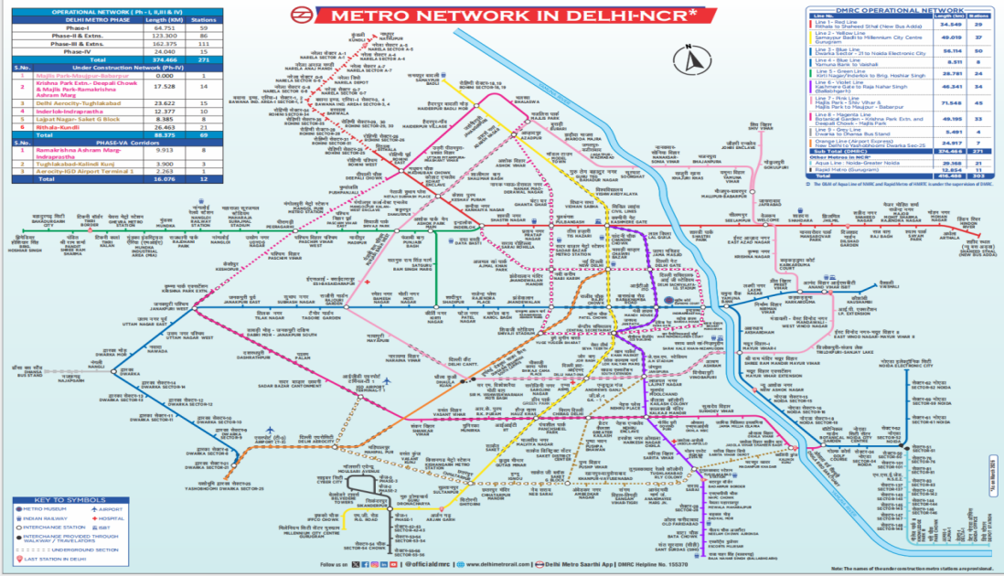
Source: DMRC

Delhi Metro has a significant contribution to urban transportation. The daily number of commuters in the Delhi Metro is more than 5 million, as per the data from the Delhi Metro Rail Corporation. Thus, efficient last-mile connectivity becomes highly important. Last mile connectivity relates to the transportation of commuters between their starting point and the closest station, and then from there to their respective destination point. As per research conducted by the Ministry of Housing and Urban Affairs, better last mile connectivity can enhance the use of public transport while minimizing dependency on private vehicles.

Table 3.1 Phase-wise Expansion of Delhi Metro Network: Route Length (km) and Number of Stations

Phases | Route length (km) | Number of stations
Phase 1 network | 64.75 | 59
Phase 2 network | 123.30 | 86
Phase 3 network | 162.37 | 111
Phase 4 network | 112.42 | 84
Phase 5 network | 244 | 153
Source: DMRC

The existing research carried out by the Institute for Transportation and Development Policy emphasizes that walking and intermediate forms of public transportation, including auto rickshaws and e- rickshaws, are some of the most common means of last-mile connectivity in major Indian urban centers. Such modes have an important role to play in linking metro stations with the areas around them, especially in urbanized regions with a high population density.
This chapter focuses on the evaluation of the access and last mile connectivity at three selected metro stations of yellow line such as Rajiv Chowk, Green Park and Chhatarpur metro station. These stations were selected due to their diverse environment, travellers volumes and surrounding land use patterns, this helps in understanding the suburban, central and peripheral regions. The analysis helps in identifying existing accessibility patterns, challenges and improvement in last mile connectivity. A total 60 respondent were surveyed, with 20 respondent from each three metro stations. The respondent were chosen to represent travellers travelling from different modes for accessing metro stations, therefore providing information about station area access and last mile connectivity pattern.

3.1 RAJIV CHOWK
Rajiv Chowk is considered as an important station of yellow line due to large number of travellers and its location in the commercial hub of city. It is located in the central business district (CBD) of Connaught place and provide a major interchange station between Blue and Yellow line of Delhi Metro. It is one of the busiest and most efficient metro station is DMRC network.
The environment around Rajiv Chowk is mainly composed of high-density commercial zones, which include retail centers, cafes, office spaces, and recreation centers. The presence of footpaths and multiple entrance and exit routes make it relatively easy for commuters to move. Research findings from the Institute for Transportation and Development Policy (ITDP) emphases that central business district (CBD) have greater reliance on walking because of presence of facilities.

Fig no.3.1 Rajiv Chowk Metro Station Fig no.3.2 Rajiv Chowk
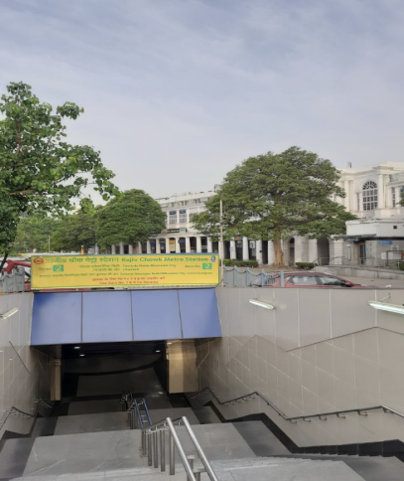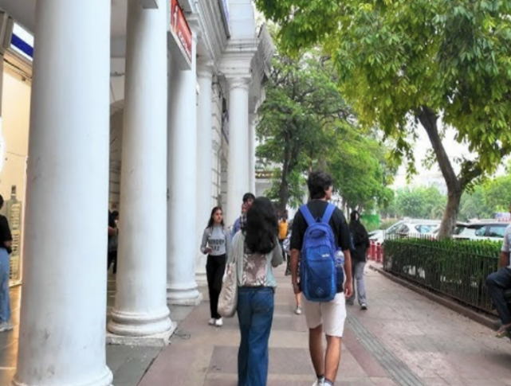
Source: Clicked by Author
During the survey, 70% of the respondents were female and 30% were male. Female respondents were more readily available and appeared more confident compared to male respondents.

3.1.1 Distance between destination areas and metro station
Table 3.2 Distance between destination areas and metro station
Distance | Percentage of Respondent
Less than 500 m | 0%
500m-1km | 85%
1km-2km | 15%
More than 2km | 0%
Source: Primary survey

Nearly 85% of the respondents travel a distance of 500 m to 1 km between the station and nearby facilities (fig. 3.4). This indicates that most services, shops, cafés, and other daily needs are located within walking distance of the metro station. According to urban transport studies, a distance of less than 1 km is considered suitable for walking and promotes greater metro accessibility (MoHUA, 2017).

3.1.2Main mode to reach to the metro station
Fig no.3.3 Mode of Transport
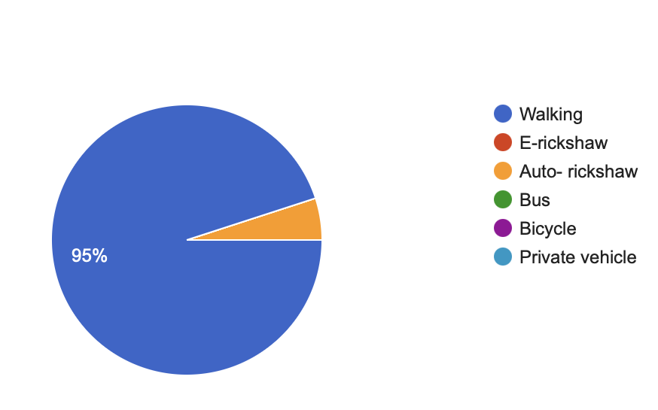
Source: Primary survey

In Rajiv Chowk, nearly 95% of the respondents reported walking as their primary mode to reach the metro station, while other modes of transportation such as auto- rickshaws and buses are used less frequently. The dominance of walking indicates the availability of facilities in the surrounding areas. The finding is supported by studies conducted by the Ministry of Housing and Urban Affairs, which show the central urban areas with high density land use tend to have higher levels of walking activity due to shorter travel distances.

3.1.3 Time taken to reach the metro station
Fig no.3.4 Time taken to reach the metro station

Source: Primary survey

The time taken to reach the metro station for about 90% of respondents is less than 10 minutes. This indicates good last-mile connectivity and the presence of most facilities within a short distance of the station. Markets, cafés, and other services are located close to the station area. Overall, Rajiv Chowk metro station demonstrates a high level of accessibility, largely facilitated by its central location, compact urban form, and strong pedestrian connectivity. The high share of walking reflects well-developed last-mile connectivity in this densely urbanised area.

3.2 GREEN PARK
Green Park Metro Station is one of the major metro stations that is located on the Yellow Line of the Delhi Metro in Southern Delhi. The metro station is based in an area which includes both residential zones, commercial markets, educational establishments, and offices. Since the location of the metro station is near institutions and residential areas, it is a very important metro station for commuters who are either students or working individuals. According to the DMRC, metro stations that are based in mixed land-use areas, travel purposes tend to be diverse. This station plays a major role in serving daily commuters from nearby residential and commercial regions. It is situated in a mixed land-use area comprising residential neighbourhoods, markets, and institutional spaces. The station provides direct access to places such as Green Park Market, Gautam Nagar, and Gulmohar Park. It also offers convenient pedestrian access to several restaurants, including A2B and Evergreen, as well as the National Institute of Fashion Technology (NIFT).
Fig no.3.5 Green Park Metro Station
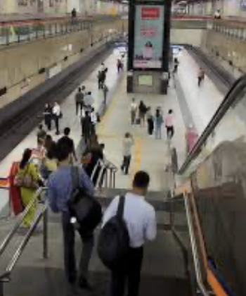
Source: clicked by author

During the survey around Green Park station, 75% of the respondents were female and 25% were male. Female respondents were more readily available, likely due to the presence of nearby women’s educational institutions, which attract a higher number of female students compared to males.

3.2.1 Distance between destination and metro station
Table no.3.3 Distance between destination areas and metro station
Distance | Percentage of Respondent
Less than 500 m | 15%
500m - 1km | 15%
1km-2 km | 35%
More than 2 km | 35%
Source: Primary survey

Based on the survey data, approx. distance of last mile connectivity is 1-2km or more than 2 km. About 35% of respondent travel to more than 2km as compared to other station( Rajiv Chowk) because institutional centres, coaching centres or other facilities are little far from the metro, they need different mode of transport to reach their destination places.
According to the Institute for Transportation and Development Policy, walking is preferable at a lower distance, but other modes of transport are needed at greater distances.

3.2.2 Main mode to reach to the metro station
Fig no.3.6 Mode of Transport

Source: Primary survey

At this station, 50% of the respondent prefers mainly auto rickshaw to reach to the station to destination places. This indicates the importance of public transport in last-mile connectivity, making walking less convenient because of longer distances. The dependency on auto rickshaw shows the need for feeder transport system in mix land use regions.
According to Ministry of Housing and urban Affairs report, the role of feeder services such as auto rickshaws and shared mobility is important in metro accessibility.

3.2.3 Time taken to reach the metro station
Fig no.3.7 Time taken to reach the metro station

Source: Primary survey
Approx. 70% of the respondent took 10-20 min to reach the metro station. The reason that around Green park metro station, many residential colonies and institutions are located beyond the walking distance, this leads to the dependence of people on public transport such as auto rickshaw.
This longer travel time when compared to other central locations like Rajiv Chowk, it can be concluded that many of the housing societies and establishments are found at a certain distance from the metro station.
Therefore, accessibility at Green Park Metro station is moderately high with the presence of mixed land use and moderate distances. Auto-rickshaws dominating as the main mode of accessing this station show that last-mile connections require the existence of intermediate transport means to facilitate access. Traveling from Green Park metro is more difficult than that of central stations like Rajiv Chowk, and this calls for improvement of last-mile connection services.
3.3 CHHATARPUR
Chhatarpur Metro Station is a station located on the Yellow Line of Delhi Metro in the South Delhi region. This region have less density and being in developmental stages, unlike central locations like Rajiv Chowk. The major land use around this metro station such as residential colonies, institutions, and religious places. One of the significant landmarks this station includes the famous Chhatarpur Temple which acts as a major destination for visitors, thereby impacting the travel patterns.
As per Delhi Metro Rail Corporation (DMRC), suburban metro stations situated in developmental regions tend to have low passenger density but tend to have greater dependence on intermediate transport modes than stations in CBD regions owing to the long-distance travel requirements from the residence to metro stations Chhatarpur metro station is located in less dense and developing area. This station experiences lower commuters volumes compared to other stations of yellow line.

Fig no.3.8 Chhatarpur Metro station
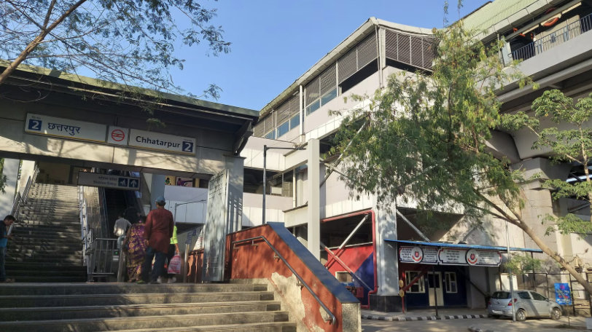
Source: clicked by author
During the survey around Chhatarpur station, 55% respondent were Females and 45% respondent were Males. Some of the commuters were travelling for the first time to visit the religious places. This distribution of respondent shows balanced participation from both the genders, which made the travel purpose varied the nature.

3.3.1 Distance between destination and metro station
Table no.3.4 Distance between destination areas and metro station
Distance | Percentage of Respondent
Less than 500 m | 0%
500m - 1km | 30%
1km-2 km | 25%
More than 2 km | 45%
Source: Primary survey

According to the survey, 45% of the commuters travel to more than 2 km to their destination places mainly through public transport. The reason behind this can be that residential regions and working areas are far from the metro station, this makes longer travel time such as 20-30 mins to reach to the destination.Long distances between stations and destination points are typical for suburban areas. Therefore, this implies that places of residence and institutions are situated far away from the metro station.

3.3.2 Main mode used to reach the metro station
Fig no.3.9 Mode of transport

Source: Primary survey

In Chhatarpur metro station, Auto rickshaw is used as main mode of transport for 45% of the commuters, rest 30% and 15% use walking and E-rickshaw respectively, this indicates the growing importance of shared electric mobility system is last mile connectivity. Walking is convenient for the commuters who are visiting nearby areas mainly temple. The main reason to used auto rickshaw is the distance between residential areas and metro station.
According to the ministry of housing and urban affairs, modes like auto rickshaws and electric rickshaws act as essential modes of intermediate public transport for connectivity in areas where there may not be a system of fixed public transport routes.
Therefore, Chhatarpur Metro Station seems to be less accessible than central and mixed land use stations mainly because of longer travel distances and dispersed settlements. The presence of different modes of transport such as auto-rickshaws and e-rickshaws signifies their reliance on intermediary means of public transport system in suburbs areas. The existence of religious sites greatly affects travel motivations, resulting in the increase of travellers.
It is evident that the Chhatarpur station exhibits common features inherent to suburban metro stations, which have accessibility issues because of distances and infrastructure. Such a situation should attract attention of city planners in order to improve last-mile connectivity.

CHAPTER 4
MOBILITY PATTERN ACROSS METRO STATIONS

Efficient development of urban transport networks is important in developing mobility patterns in metropolis cities. The Delhi Metro stands out as one of the key components of urban mobility in the city of Delhi and offers an efficient and cheap mode of transport for millions of people each day. The development of the Delhi Metro network has led to efficient connection among various sections of the city, leading to reduced reliance on private forms of transport.
Despite the efficiency in the development of the network of the metro, efficient utilization of such facilities requires easy access to these services by commuters. Thus, last-mile connectivity becomes a key factor in influencing the effectiveness of metro services. This involves the process through which commuters travel from their destination or origin to the nearest metro stations. As per the MoHUA, effective last-mile connectivity plays a key role in increasing public transport use (2017). Mobility pattern around different metro stations play a major role in understanding accessibility and last-mile connectivity in urban transport system. The importance of metro rail services does not only depends on rail network itself but also on surrounding urban environment and how commuters reach or leaves the station using different modes of transportation. Dissimilarity in population density, land use and surrounding environment and infrastructure, these made an impact on travel behavior and mobility choices across different metro station areas.
Mobility patterns refers to the movement of people get to places they need to go. When we talk about metro rail systems mobility patterns show us how people get to the metro stations. We look at how people get to the stations what kinds of transportation they use to get and how long it takes them. The movement of people is also effected by several factors such as land use pattern ( esidential or mixed areas), availability of transport, population density, condition of infrastructure etc. Mobility patterns are important because they help us understand how people use metro rail systems. Mobility patterns are influenced by things and they are different, in every city.
Understanding how people move around is crucial for looking at how easy it's to get around cities and last -mile connectivity. The success of metro rail systems relies on how the trains run and how easily people can get to metro stations from their homes, offices or schools. Mobility patterns show us the popular ways people travel, such as walking, taking auto-rickshaws, buses or private vehicles. They also give us an idea of what people prefer when traveling and how they behave when using the metro.
Mobility patterns are vital for metro rail systems to work well. They help figure out the ways to improve the overall travel experience, for metro users. People move around for reasons like going to work, school, stores or having fun. Where people go and why they go there says a lot about what's around them like if it is a place with a lot of shops, houses or schools. When we look at how people move we can see problems that make it hard for people to get around like taking a long time to get somewhere not having many choices for transportation or not having good sidewalks for walking. Mobility patterns are important because they are closely linked to travel purposes like work, education, shopping and recreation. By looking at mobility patterns we can find out what is going on with mobility patterns and travel purposes such, as work, education, shopping and recreation.
Therefore, mobility patterns is really important for understanding how easy it is to get to metro stations. This helps us figure out if the last-mile connectivity is working well. The people who plan and make decisions can use this information to find out where the problems are and come up with solutions to make it easier for people to get around cut down on travel time and make things more convenient for passengers. Mobility patterns are key to making this happen and improving mobility patterns is crucial, for metro stations.
4.1 Choice of metro stations
The choice of metro stations is crucial when studying how people move around and connect to their destination places. Different stations have different travel patterns based on location and surrounding environment. The three metro stations in Delhi of yellow line were chosen to represent types of urban areas. These stations help us understand how people move around in the middle and outer parts of the city. The Delhi Metro network has stations but these three metro stations of yellow line give us different mobility pattern which enhance last-mile connectivity.
The Yellow Line is the first underground metro line and second line for the metro after Red line. With a total length of 49 kilometres, stretching from north to south, the Yellow Line serves as a connection between Samaypur Badli and Millennium City Centre Gurugram in Gurugram. While the northern and southern sections of the route are elevated, the central stretch of the Yellow Line runs underground (in some of the busiest areas in Delhi). The underground stretch between Vishwavidyalaya and Kashmere Gate was started on 20 December 2004. Kashmere Gate-Central Secretariat and Vishwa Vidyalaya-Jahangirpuri stretches were operationalized in 2005 and 2009, respectively. The Yellow Line has the second deepest metro station in India which is Chawri Bazar metro station, at 25 metres underground level.
Map no.4.1 Map of Yellow line
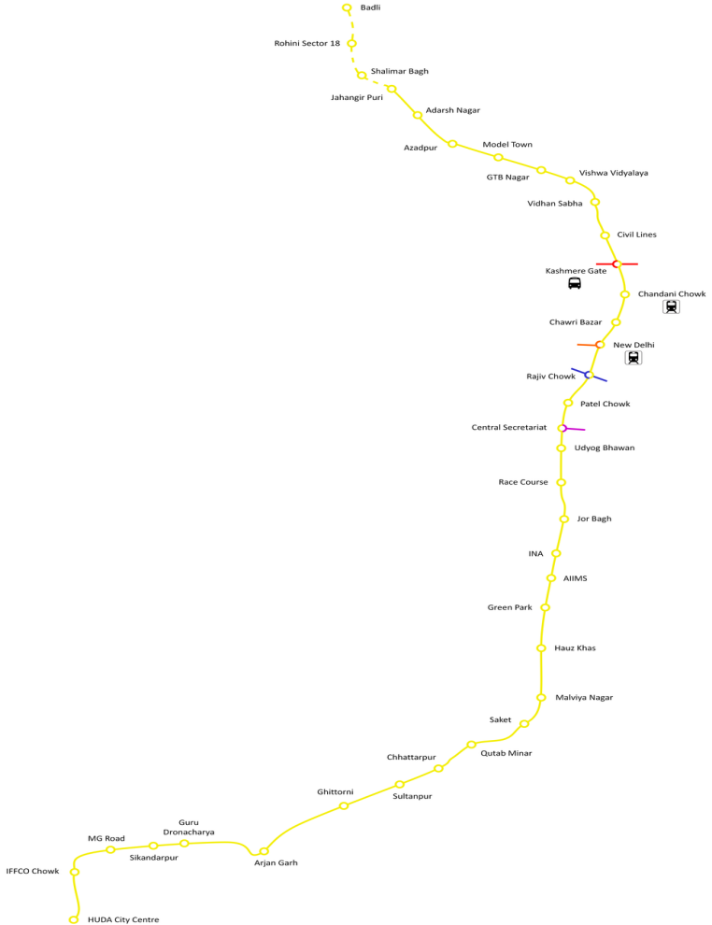
Source : DMRC
By studying these three stations we can learn more about how people travel. The location and surrounding land use of each station play a role in its travel characteristics. We chose these stations to capture the variations in mobility patterns. This will help us understand last-mile connectivity better. The metro stations are a part of the city transportation system. They are used by people every day. Understanding their travel patterns can help us improve the system. The Delhi Metro network is one of the busiest in the country. It has stations but we focused on these three. Each station has its characteristics. This chapter focuses on the mobility patterns across different selected metro station areas in Delhi Metro, such as Rajiv Chowk, Green Park and Chhatarpur metro stations. These stations shows diverse urban setting like, commercial-residential mixed area, suburban zone and CBD( central business district). Understanding these mobility patterns help in identify challenges in last-mile connectivity and accessibility gaps.
Rajiv Chowk Metro Station, Green Park Metro Station and Chhatarpur Metro Station are all different. This makes them ideal for studying mobility patterns. The study of mobility patterns is important for planning and helps us to understand how people move around the city. This information can be used to improve the transportation system. It can also help us plan the city’s development.
4.2 Purpose of trip
The three metro stations are well-connected and also purpose of trip were different at each metro station:
Table 4.1 Purpose of trip
Stations | Purpose of trip | Percentage of respondent
Rajiv Chowk | Leisure | 70%
Green Park | Education | 65%
Chhatarpur | Working or other works | 50%
Source: Primary Survey

The survey data reveal that people travel to Rajiv Chowk mainly for leisure purposes such as spending time or meeting friends and families in cafes, as well as visiting nearby temples. This area function as a major social and cultural hub, especially for young people and working professionals.
At Green Park, 65% of people travelling due the purpose of education. The reason behind this is that this station is mainly surrounded by education institutions, coaching centres and coaching institutes etc. A large number of student travel on daily basis to attend colleges and coaching classes etc. Students travelling to the station or destination places consists of majority of Female students to the establishment of women colleges.
At Chhatarpur, 50% were travelling for other purpose such as visiting temples and for some other works apart from education or shopping. This is due to the presence of major religious sites around nearby station area. This type of travel is highly affected by the presence of religious sites in the area, including the Chhatarpur Temple complex. Religious destinations usually have periodic demand for travel, particularly on weekends and during festivals.
4.3 RAJIV CHOWK:
Fig no.4.1 Rajiv Chowk
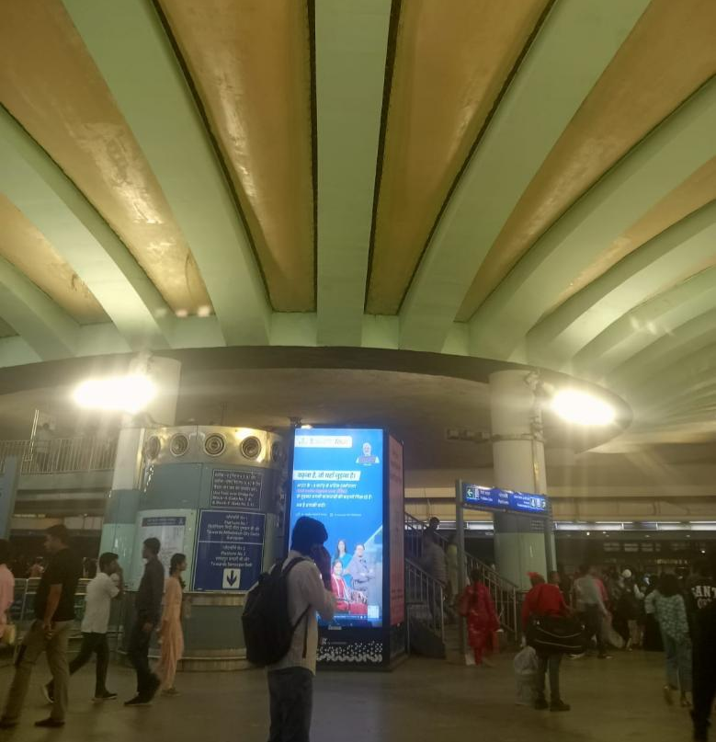
Source: Clicked by author
It is commercial hub and central business district situated in the central part of the Delhi(heart of Delhi) . It experience help volume of commuters due to the interchanging stations of blue and yellow line. The surrounding area consists of offices, cafes, markets, shopping etc.
Rajiv Chowk connects the Blue Line (Dwarka Sector 21–Noida Electronic City/Vaishali) and the Yellow Line(Samaypur Badli–Millennium City Centre Gurugram)
As per October 2023, it is the second busiest station on the network, with a daily ridership of approximately 216,000 travellers. This station covers an area of about 39,503 square feet.
Fig no.4.2 Entry and exit gate of Rajiv Chowk
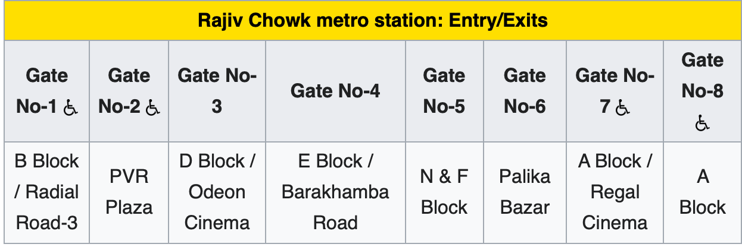
Source: Google
4.2.1 Mobility Conditions at Rajiv Chowk
- Walking
The mobility pattern around Rajiv chowk metro station shows high dependency on walking as the main mode of access. This is because of the concentration of urban form, as well as the density of commercial land use near the metro station. The accessibility of marketplaces, offices, and entertainment centers through walkability facilitates pedestrian transport. Also, good pedestrian paths make walking the most used means of transportation.

- Footpaths conditions
The infrastructure of footpaths around Rajiv chowk is more developed and better as compare to other areas. But during peak hours heavy crowd movement reduces walking comfort.

- Feeder buses and Public transport
Around Rajiv Chowk auto rickshaws are widely available and there is less dependence on feeder buses. Availability of auto rickshaws and other shared transportation options lowers dependency on feeder transport systems in the Rajiv Chowk zone.
Fig no.4.3 Mobility condition of Rajiv Chowk
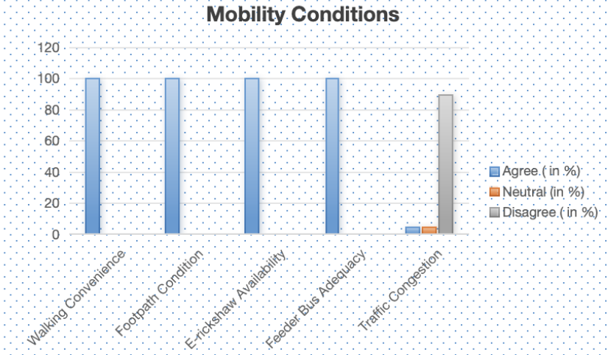
Source: Primary Survey

4.4 GREEN PARK
Fig no.4.4 Green park Station
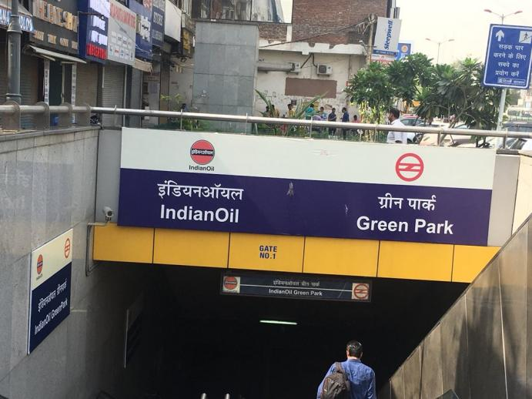
Source: Clicked by author
Green Park Metro Station is an underground station on the Yellow Line of the Delhi Metro, located below Aurobindo Marg in South Delhi. It serves the neighborhoods of Green Park Main, Green Park Extension, Yusuf Sarai Market, and provides access to nearby areas like Gulmohar Park and Gautam Nagar. The station opened to the public on September 3, 2010.In this stations metro connects Samaypur Badli and Millennium City Centre Gurugram.

Fig no.4.5 Entry and exits gate of Green Park
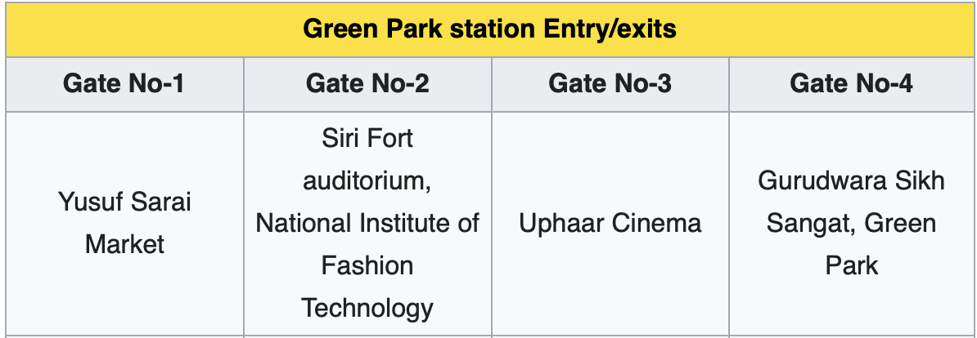
Source: Google

4.3.1 Mobility conditions at Green Park
- Walking conditions
Walking conditions around Green Park Metro station is average compared to Rajiv Chowk. Mixed use of land in terms of institutions and residences gives rise to average levels of walking activity. But the existence of destinations that lie beyond walkable distances enhances dependency on intermediate modes of transport.

- Footpath conditions
The footpath around Green Park are of moderate quality, but still there are some gaps exists some sections which may need improvement for safety purposes and to increase walkability.

- Public transport and Feeder bus Adequacy
Transport modes like auto-rickshaws and electric rickshaws are essential for linking nearby residential areas with the station. The neighboring residential colonies and institutions create a need for feeder buses, especially during peak times. The presence of auto-rickshaws acts as an alternative to feeder buses.

Fig no.4.6 Mobility Conditions of Green Park
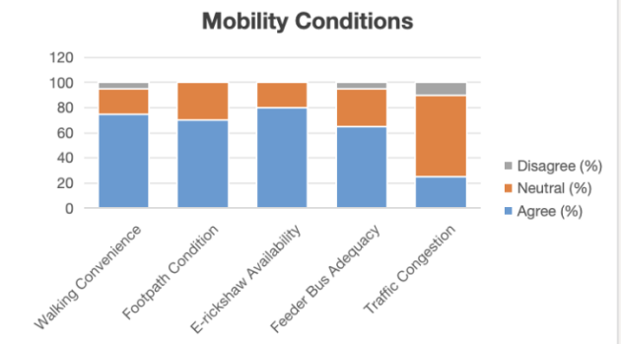
Source: Primary Survey

4.5 CHHATARPUR
Fig no.4.7 Chhatarpur Station
Source: Clicked by author
Chhatarpur is an elevated station on the Yellow Line of the Delhi Metro. Chhatarpur station is located in the South West district of Delhi, India.
This station was planned to be launched in June 2010, together with other stations of elevated corridor of the Yellow Line. But, the development of this station was hindered due to delays in land acquisition. To complete the construction of this station in time for the 2010 Commonwealth Games, the Delhi Metro Rail Corporation took up an innovative method of developing the Chhatarpur station, through prefabricated structures.
The Chhatarpur station has an area of 26,000 sq. m. It has the biggest parking area among all metro stations of Delhi Metro system. Of the total parking space of 4,000 sq. m., which is currently available for public use, there can be a capacity for parking about 800 two wheelers and 200 cars at the same time. The remaining areas of parking would be opened in stages. This station serves the following areas - Chhatarpur, Mehrauli village, Kishangarh Village and Vasant Kunj area along with the devotees visiting the Chhatarpur Temple. As per the detail project report (DPR) done by DMRC, the ridership is 11,723.
It connects major parts of the city. This line runs from HUDA City Centre in Gurgaon to Samaypur Badli in Delhi. It offers seamless connectivity to other key stations and destinations, making it easy for travelers to explore the city.

4.4.1 Mobility conditions at Chhatarpur
- Walking
Walking conditions at Chhatarpur Metro Station is rather poor because of the greater distances between the residential localities and metro station and scattered land use pattern. Walking is discouraged by limited footpaths and wider road networks.

- Footpath infrastructure
The pedestrian facilities along some parts of Chhatarpur are scarce, resulting in poor walking experience for pedestrians.

- Feeder buses and Public transport
It Around Chhatarpur metro station it becomes imperative, since it lies in a suburban setting where greater distances prevail. Feeder transport is highly required here because settlements are scattered and are at some distance from the metro station.

Fig no.4.8 Mobility Conditions of Chhatarpur
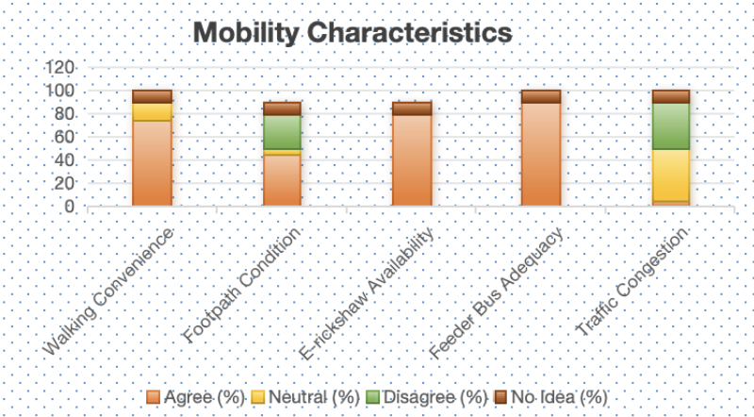
Source: Primary survey

4.5 Comparative Analysis of Mobility patterns:
In comparison with mobility trends at the selected stations, there are significant variations in movement of people around metro stations. On central stations, walking is most prevalent, while on suburban stations, motorized transportation is dominant.
Table no.4.2 Comparative Analysis
Mode | Rajiv chowk | Green park | Chhatarpur
Walking | High | Moderate | Low
Footpaths | Good | Moderate | Limited
Feeder Services | Low | Moderate | High
Source: Primary Survey

4.6 CONCLUSION
Overall, this study shows that mobility pattern is not uniform among metro stations, as it is affected by spatial infrastructure. Thus, a location-based approach needs to be adopted for improving last-mile connectivity at metro stations.

CHAPTER 5
GOVERNMENT INITIATIVES TOWARDS LAST- MILE CONNECTIVITY

Various initiatives have been taken by the Government of the National Capital Territory of Delhi to enhance the last mile connectivity to the Delhi Metro Rail Corporation system. These initiatives focuses to improve accessibility and decrease dependency on private vehicles etc. This chapter is based on the government initiatives towards last-mile connectivity and suggestion of respondent to improve the access and last-mile connectivity.

5.1 GOVERNMENT INITIATIVES
One of the most significant measures includes the expansion and restructuring of the bus system. A huge number of low-floor and electric buses have been added to the Delhi Transport Corporation (DTC) fleet along with the cluster scheme. Particular attention has been paid to feeder routes linking metro stations with their surrounding residential and business districts. Studies have been conducted for reconfiguration of bus routes in such a way that the buses function as feeders to the metro lines rather than in isolation.
Another key initiatives is the Delhi Electric Vehicles (EVs) Policy (2020). It encourages using electric rickshaws and autos for traveling small distances. Electric rickshaws and autos are extensively employed for connecting the last mile in metro stations. Therefore, this program intends to encourage such forms of public transport by offering subsidies and incentives. This program is not only aimed at providing better last-mile connectivity, but it is also intended to address environmental issues such as air pollution.

The government has also suggested establishing a Unified Metropolitan Transport Authority (UMTA) in Delhi. This initiative will ensure proper coordination between various organizations operating in the field of metro and bus transportation and intermediate forms of public transport.
Besides, there have been measures to integrate other transport modes with metro stations in terms of multimodal integration. These include the provision of areas that facilitate feeder transportation to and from metro stations as well as improved interchanges. Transport hubs are created that will facilitate a seamless multimodal operation at metro stations such as bus and para-transit integration with metro stations.
One other major development in metro transportation in India involves the use of the NCMC (National Common Mobility Card). This is a card that facilitates payment using a common payment mode across all modes of transport such as metro and buses in any state of country.

Additionally, the government has paid special attention to non-motorized transport (NMT) infrastructures within urban development initiatives. There have been efforts to upgrade footpath and pedestrian crossings near metro stations, along with improving infrastructure for cyclists near these stations. Such steps are especially crucial for covering last-mile distances and fostering sustainable modes of transportation.
The government of Delhi has also encouraged the use of park-and-ride facilities near metro stations so that users can take advantage of private and public transport systems together.

5.2 SUGGESTIONS FOR IMPROVING LAST-MILE CONNECTIVITY
Several suggestion are suggested to improve the access and mobility pattern around metro stations

- Improvement of pedestrian facilities
It is important that there should be improvement in maintaining continuous footpaths which are safe and properly maintained at all metro stations. There should also be improvements to pedestrian infrastructure like better crossings and lighting to encourage walking especially in suburban areas such as Chhatarpur and other surrounding stations.

- Improving Feeder Transport Systems
Feeder transport systems, especially buses and other forms of sharing transport, need to be more improved. This can be especially achieved through well-coordinated feeder systems.

- Non-Motorized Transport Promotion
Infrastructure development for cycles and pedestrian walkways will promote non-motorized modes of transport especially for the short distance and residential areas and this helps in decreasing traffic congestion. This is consistent with the principles of sustainable urban transport approved by the Ministry of Housing and Urban Affairs.

- Combined Transport Planning
The metro system must integrate itself with other means of transport, including buses, auto rickshaws, and others. It is necessary to coordinate between various transportation organizations to improve urban mobility and last-mile connectivity.

- Improvement in Signage and Wayfinding
It is crucial to implement an efficient signage system to facilitate the commuting process by helping passengers find their way around the metro stations and access related services.

- Dedicated Drop-off Zones
Dedicated zones for picking up passengers need to be created around metro stations to avoid traffic jams on the roads and increase passenger safety and helps in enhancing last-mile connectivity.

CHAPTER-6
KEY FINDINGS

The study shows important findings related to last-mile across the selected metro stations, focusing on the role of distance, land use patterns and availability of transport and mobility conditions:
- Variation in Access levels
This study indicates that there is different accessibility around different metro stations. Metro stations located in the urban centres such as Rajiv Chowk have high level of accessibility due to dense development as compared to metro stations in suburban areas like Chhatarpur have scattered development and Green Park have mixed land-use area.
- Dominance of Walking in Central regions
The walking is main mode to access at Rajiv Chowk metro station, It is is due to the dense urban form and proximity of facilities. Moreover, the provision of walkways makes it an easier choice for passengers to use the metro.
- Importance of Public Transport
The intermediate public transport systems such as auto-rickshaws and e-rickshaws are highly important in providing last-mile connectivity, specifically at the Green Park and Chhatarpur metro stations.
- Role of Distance on Mode Choice
The research reveals that distance between the metro station and the destination is one of the important elements which affect the travel behavior of people. Short distance travel results in walking, whereas long distance travel increases dependence on motor vehicles like auto-rickshaws and feeder services.

- Influence of Land-use Pattern
Land-use pattern have impact on people travelling purpose where commercial zones produce trips related to recreation and shopping and other work related trips, institutional zones produce educational trips, while suburban zones produce mixed trips.
- Poor Infrastructural Development in Suburban Regions
Examples of suburban metro stations such as Chhatarpur, which has problems like poor pedestrian infrastructural development, increased time spent traveling, and the need to use unorganized means of transportation.

- Navigation and Wayfinding Issues
This study reveals that there are some challenges faced by travellers when it comes to navigation within the surrounding roads of Rajiv Chowk Metro Station. The reason behind this is the complex nature of the streets in the neighborhood, which have numerous access points. Additionally, there are no clear signages in the surroundings making the place hard to navigate for new visitors.

6.1 Scope for Future Research
Future research may be able to broaden the focus of this paper by considering additional metro stations and a larger sample size. With the use of GIS technology, future research could be more precise in determining accessibility and mobility trends. Another issue that may be further explored is the effect of socio-economic status on mobility behavior and the potential role of innovations such as smartphone-based public transportation systems.

6.2 Conclusion
The research clearly indicates how vital it is to have good last-mile connectivity, which increases the usability of metros. Access and mobility behavior studies conducted at chosen stations reveal how accessibility can be affected by aspects such as land use, distance to the location, and infrastructure availability.
Better pedestrian infrastructure, better feeder services, and integrated transport planning policies can help promote mobility. This research offers valuable insights into urban mobility patterns and would benefit urban planners and policy makers in establishing sustainable transport solutions in cities like Delhi.

