INTEGRATING LOCALIZED CONTEXT-BASED STEM EDUCATION APPROACH IN TEACHING SCIENCE 3

Frank-Jay M. Fullo
Liezel A. Mirador
Feb Yvonney M. Matugas
Liezel P. Naquines
Najeb B. Aloyod
Mindanao State University – Sultan Naga Dimaporo
Corresponding Authors’ E-mail: fjfullo006@gmail.com
ekyatmirador@gmail.com
febyvonney.molde@g.msuiit.edu.ph
leizel.patadilla-naquines@g.msuiit.edu.ph
najebaloyod@gmail.com

Abstract
Science plays a crucial role in developing problem-solving skills and critical thinking among learners. However, traditional teaching approaches in the elementary level often fail to sustain learners’ interest and engagement, especially in abstract science concepts. While studies have shown the effectiveness of STEM based instruction, there is a lack of research on how localized, context-based STEM approaches can enhance learning outcomes at the primary level, particularly in Grade 3 Science. This study aimed to determine the effectiveness of integrating a localized context-based STEM education approach in teaching selected Science topics among Grade 3 learners at Sultan Naga Dimaporo Memorial Integrated a School (SNDMIS) during the Academic Year 2025-2026. A total of 33 learners officially enrolled in Section A were selected as respondents. A 20-item test was administered before and after the intervention to measure the learners’ performance. Data were analyzed using frequency/percentage distribution, weighted mean, and the Paired Sample T-test. Findings revealed that the pre-test scores of the respondents were generally low, while the post-test results showed a significant increase in achievement levels. The mean score increased from 10.97 to 16.06, the t-test confirmed a significant difference between pre-test and post-test scores (t = -9.10, p<0.05). This proves that the intervention had a positive and significant effect on the learners’ academic performance such as making paper eyeglasses. The learners’ output were evaluated in terms of understanding, creativity and design, and participation which scored between 92.67% and 93.33%. This indicates that the learners generally understood the task well, showed creativity, and actively participated in the activity. Learners’ attitude on their STEM activity got the grand weighted mean of 2.84, interpreted as “Highly Positive”.This study concludes that contextualized STEM instruction, grounded in local and familiar situations, can improve learners’ understanding, retention, and engagement in Science learning.

Keywords: Localized learning, Context-based approach, STEM education.
1. Introduction
An essential component of biology education is the study of the human organs, which include the sense of seeing, hearing, smelling, taste, and touch. In order to perceive and engage with the environment around us, these sense organs are essential. To fully understand the human body's intricate sensory system, students must have a solid understanding of how the eyes and ears work together to enable vision, hearing, and touch detection, respectively. However, the traditional method of teaching these ideas frequently places them in a scientific, abstract framework that may seem distant from the realities of the pupils. Students may find it more difficult to connect the material to their own cultural norms and surroundings as a result of this distance (Edlund & Balgopal, 2021; Damerau et al., 2022; Springer, 2021). Localized, context-based learning has gained more and more recognition in the educational world in recent years. Integrating students' cultural, environmental, and social surroundings into the curriculum is known as "localized learning." This method gives students the chance to relate what they learn in the classroom to their real-world experiences. Mensah (2021) emphasizes that “linking students’ home experiences to the curriculum, embedding cultural references, and acknowledging diverse perspectives can enhance students’ engagement and understanding in science education. It enables students to perceive the significance of what they learn outside of the classroom; context-based learning has been shown to increase student engagement, critical thinking, and information retention. In the context of STEM education, the integration of localized approaches is particularly important. STEM education, which traditionally focuses on Science, Technology, Engineering, and Mathematics, often overlooks the cultural dimensions that influence how students understand and apply scientific concepts.Azizah and Sarwanto (2025), highlight that culturally responsive teaching approaches improve science mastery in elementary pupils by connecting scientific principles to learners’ cultural settings. Furthermore, Chen and Wu (2024) demonstrated how integrating STEM education with indigenous perspectives on disaster prevention improved children’s environmental awareness and supported sustainability goals. While recent studies have emphasized the benefits of localized and culturally responsive STEM instruction, there is limited research focused specifically on teaching the human sense organs through this approach at the Grade 3 level. Most studies address broader science themes or older students, leaving a gap in how context-based learning can be applied to foundational biology content in early elementary education. This study aims to fill that gap by exploring how localized, context-based STEM methods can enhance Grade 3 students’ understanding, engagement, and retention when learning about the functions of the human sense organs. This research will not only contribute to the field of STEM education by offering a new approach to teaching sensory functions but also demonstrate how contextualized learning can improve student engagement, understanding, and retention of scientific content. By integrating local knowledge with biological principles, this study seeks to create an educational model that is both scientifically rigorous and culturally meaningful, ultimately fostering a more inclusive and relevant STEM curriculum.

2. Research objective
The study aimed to determine the effectiveness of Integrating localized context-based STEM education approach in teaching Science 3 at Sultan Naga Dimaporo Memorial Integrated School (SNDMIS). Specifically, it sought to determine the demographic profile of the learners ,analyze the learners’ pre-test of the implementation of the localized context-based STEM approach, evaluate the post-test scores after implementation of the localized context-based STEM approach, compare pre-test and post-test scores to determine if there is a significant difference between the pre-test and post-test scores of pupils taught using a localized context-based STEM education approach, and determine the learners’ attitude on their STEM activity. This approach provided essential evidence on the impact of localized context-based STEM instruction in enhancing pupils’ learning and engagement in Science.

3. Hypothesis
This study proposed that there is no significant difference between the pre-test and post-test scores before and after the implementation of the localized, context-based STEM Education Approach in Teaching Science 3.

4. Theoretical framework
A research framework for implementing the Localized Context-Based STEM Education Approach was anchored on several learning theories that emphasize the importance of experience, context, and social interaction in the learning process. Constructivist Learning Theory (Piaget, 1950; Vygotsky, 1978). Asserts that learners construct their own understanding of concepts based on their prior experiences and interactions with the environment. Jean Piaget (1950) introduced the idea that children develop knowledge through a series of cognitive stages, actively engaging with their surroundings to build new understandings. This aligns with the present study, which integrates localized, community-based knowledge into STEM education. Contextual Learning Theory (Hull, 1993). Builds on constructivist principles by emphasizing the role of real-world applications in education. This theory suggests that students learn best when they can see the relevance of academic content in their everyday lives. This approach helps bridge the gap between theory and practice, ultimately improving engagement and academic performance. Culturally Relevant Pedagogy (Ladson-Billings, 1995) advocates for an educational approach that incorporates students' cultural backgrounds into teaching practices. According to Ladson-Billings, traditional education often disregards the lived experiences of marginalized communities, resulting in disengagement and a lack of motivation. This aligns with the goals of this study, which seeks to bridge the division between scientific knowledge and students' local realities, ensuring that science education is both rigorous and culturally meaningful. STEM Education Framework (Bybee, 2010) emphasizes interdisciplinary learning, inquiry-based instruction, and real-world problem-solving. By integrating localized knowledge into STEM education, students develop not only academic proficiency but also the skills necessary for real-world scientific exploration and innovation. This approach ensures that science education is both globally relevant and locally meaningful, preparing students for future STEM careers.

5. Research methodology
This study employed experimental research design, specifically the one group pre-test and post-test design to measure the effectiveness of integrating a localized, context-based STEM education approach in teaching Science 3. This method involved measuring learners' academic performance before and after implementing the localized context-based STEM education approach in teaching Science 3 to determine any significant differences in learning outcomes.
The study's respondents were chosen using a purposive sampling technique. Thirty-three (33) Grade 3 students from Section A of Sultan Naga Dimaporo Memorial Integrated School made up the participants. They were chosen according to pre-established standards pertinent to the study's goals. These standards guaranteed that the participants were suitable for assessing the impact of the localized STEM intervention.
Data analysis involved both quantitative and descriptive techniques. Pretest and posttest scores were analyzed using frequency, percentage distribution, mean, and paired-sample t-test to determine whether a significant difference existed between learners’ performance before and after the intervention. Learners’ attitude and prototype evaluation results were analyzed using weighted mean and descriptive interpretation.
Ethical considerations were strictly observed throughout the conduct of the study. To guarantee voluntary involvement, respondents' informed consent was obtained before any data was collected. The respondents were properly informed about the study's objectives, their participation role, and their freedom to discontinue participation at any moment without incurring any fees. In compliance with ethical research guidelines, the participants' rights and privacy were protected by the assurance of confidentiality and anonymity of responses.

6. Research findings
4.1 Respondents’ Profile
Table 4.1 presents the frequency and percentage distribution of the respondents according to their age. Reveals that out of thirty-three (33) learners, twenty-three 23 or (69.70%) belongs to the age group of 8, five 5 or (15.15%) aged group of 7, three 3 or (9.09%) are aged 9, one (1) or (3.03%) belongs to the age group of 11, the same percentage as those aged 12. This indicates that majority of the learners were eight 8 years old, which aligns with educational norms where in Grade 3 learners are typically between ages 8 and 9.

Table 4.1. Frequency and Percentage Distribution of the Respondent of the Demographic Profile in terms of Age (n=33)
Age | Frequency | Percentage
7 | 5 | 15.15
8 | 23 | 69.70
9 | 3 | 9.09
11 | 1 | 3.03
12 | 1 | 3.03

Table 4.2 shows the gender distribution of the respondents. Out of thirty-three (33) learners, twenty- one (21) or (63.64%) were females and twelve 12 or (36.36%) were male. This indicates that majority of the learners were female.
This finding aligns with Korpershoek et al. (2022), who observed that primary classrooms often reflect a higher proportion of female learners such gender composition has implications for classroom engagement and learning experiences.

Table 4.2. Frequency and Percentage Distribution of the Learners of the Demographic Profile in terms of Gender (n=33)
Gender | Frequency | Percentage
Male | 12 | 36.36
Female | 21 | 63.64

4.2 Pretest and Posttest Gain Scores of the Respondents
Table 4.3 presents the respondents` pre-test performance before integrating localized context-based education approach in teaching Science 3. Result showed that out of 33 learners, Eighteen (18) or 54.55% got a score of 11-15 with corresponding interpretation of moderately achieved, Nine (9) or 27.37%score between 6-10 interpreted as fairly achieved, four (4) or 12.12% scored 1-5 interpreted as not achieved only two (2) or 6.06 % obtained scores between 16-20 corresponding to Highly Achieved in the pre-test. These result reveal that before the implementation of the Localized Context-based STEM instruction, the majority of the learners demonstrate only an average level of the topic. After the intervention, result revealed that twenty-one (21) or 63.64 % got a score of 16-20 with the corresponding interpretation of Highly Achieved, eleven (11) or 33.33% got a score of 11-15 with the corresponding verbal interpretation of Moderately Achieved. One (1) or 3.03% % got a score of 6-10 with the corresponding verbal interpretation of Fairly Achieved. These results imply a significant improvement in the learners’ performance in science after the integration of localized context-based STEM education approach. The increase in the number of learners who achieved higher scores suggests that contextualizing science lessons through locally relevant experiences effectively enhanced learners’ understanding, engagement, and application of scientific concepts.

Table 4.3 Frequency and Percentage Distribution of the Pupils’ Pre-Test and
Posttest Scores of the Respondents (n=33)
SCORE | PRE- TEST | POST-TEST | VERBAL INTERPRETATION
 | f % | f %
16-20 | 2 6.06 | 21 63.64 | Highly Achieved
11-15 | 18 54.55 | 11 33.33 | Moderately Achieved
6-10 | 9 27.27 | 1 3.03 | Fairly Achieved
1-5 | 4 12.12 | 0 0 | Not Achieved

Figure 4.1 presents the line graph compares the Pretest and Posttest scores of participants across four score ranges (1–5, 6–10, 11–15, and 16–20). As shown, the Pretest scores started low in the 1–5 range and gradually increased, peaking at the 11–15 range before slightly declining in the 16–20 range. The Posttest scores, on the other hand, exhibit a steady upward trend, beginning at zero in the 1–5 range and rising steadily until they reached their maximum point in the 16–20 range.
This suggests that, on average, participants did better on the posttest than the pretest. The improvement implies that the participants' performance was positively impacted by the intervention or learning exercise carried out in between the two tests.

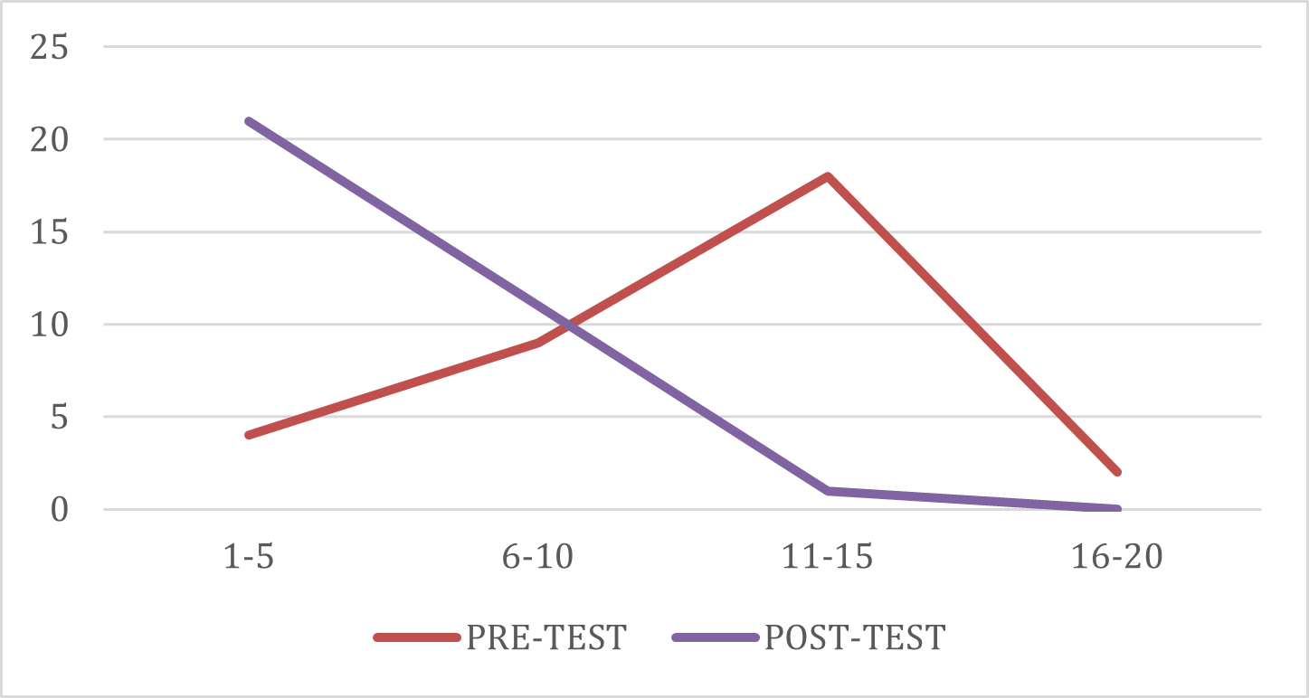

Figure 4.1 Line Graph of the Learners’ Pretest and Posttest Score

4.3 Difference Between Pretest and Posttest Gain Scores of the Respondents
Table 4.4 shows a result of significant difference between pre-test and post-test of the students before and after the intervention. Shapiro-Wilk Test was equal to 0.16 which is greater than 0.05 level of significance. Thus, the data were normally distributed. Since the data met the assumption of normality, a paired-samples t-test was conducted to determine whether there is no significant difference between the pre-test and post-test scores of the learners. The result revealed that the learners’ mean score in the pre-test (M=10.97, SD = 3.56) was significantly lower than their mean score in post-test (M = 16.06, SD = 2.73), t (32) = -9.10, p<0.000. This indicates a highly significant improvement in the learners’ academic performance after the intervention.
The result implies that integrating local and context-based materials in teaching Science effectively enhances learners’ conceptual understanding and engagement. When lessons are drawn from learners’ familiar environment, they are more likely to relate abstract scientific ideas to real-life situations, improving comprehension and retention. This finding is supported by Abella et al. (2024), who reported that contextualized STEM instruction strengthens the connection between students’ prior experiences and new knowledge, resulting in improved performance and interest in science. Similarly, Villanueva and Torres (2022) found that localized and inquiry-based STEM approaches foster greater learner motivation and achievement by providing meaningful, relevant, and authentic learning experiences.

Table 4.4 Significant difference before and after Integrating Localized Context- Based STEM Education Approach (n=33).
Variability | Mean | SD | t-value | p-value | Decision | Interpre-tation
Pretest | 10.97 | 3.56
Posttest | 16.06 | 2.73 | -9.10 | 0.000 | Reject $H_{O}$ | Significant

Note: **Significant at 0.05 level
4.4 Learners’ Attitudes on their STEM Activity
As shown in Table 4.5, there are ten statements of the learners’ attitudes towards STEM activities. All indicators rated as Highly Positive by the respondents are following : I would like to learn other Science topics in this way (using local problems and project) (2.94). I enjoyed learning because it was related to problems in our daily life (like blurry vision) (2.91). Making and testing the eyeglasses helped me understand the lesson better (2.91). I was excited to learn about how the eye works (2.87). I think it is important to learn how to take care of my eyes (2.87). I was able to share my ideas and listen to my classmates (2.81). The lesson made me more interested in Science (2.81). Working together with my classmates made me happy (2.78). I feel proud of the paper eyeglasses we created (2.76). I liked using local and recycled materials in making the paper eyeglasses (2.69. The overall description of students` attitudes towards STEM activities is Highly Positive with grand weighted mean of 2.84.
The findings of this study revealed that the Grade 3 pupils demonstrated a Highly positive toward STEM education with a grand weighted mean of 2.84. This suggests that learners at the primary level show strong interest and readiness to engage in STEM-related activities. These positive attitudes indicated that learners were open to explored scientific concepts, problem-solving tasks, and hands-on learning experiences. Such enthusiasm is essential for effective STEM learning, as learners with favorable attitudes are more likely to participate actively, sustain curiosity, and develop higher-order thinking skills.
The findings that Grade 3 learners demonstrated a highly positive attitude toward STEM education supports the explanation of Jovanic and King (2018), who stated that learners’ attitudes toward science are shaped by their beliefs about their own abilities and perceived relevance of the subject matter. In the present study, the integration of localized and contextualized STEM approaches made the lessons more meaningful and connected to the learners’ daily lives. This relevance likely strengthened their confidence and interest in learning, resulting in their highly positive attitude toward STEM education.

Table 4.5 Learners’ Attitudes on their STEM Activity (Handmade eyeglasses) (n=33).
Statement | Weighted Mean | Interpretation
- I was excited to learn about how the eye works. | 2.87 | Highly Positive
- I liked using local and recycled materials in making the paper eyeglasses | 2.69 | Highly Positive
- I enjoyed learning because it was related to problems in our daily life (like blurry vision). | 2.91 | Highly Positive
- Working together with my classmates made me happy. | 2.78 | Highly Positive
- I feel proud of the paper eyeglasses we created. | 2.76 | Highly Positive
- I think it is important to learn how to take care of my eyes. | 2.87 | Highly Positive
- I was able to share my I deas and listen to my classmates. | 2.81 | Highly Positive
- The lesson made me more interested in Science. | 2.81 | Highly Positive
- Making and testing the eyeglasses helped me understand the lesson better. | 2.91 | Highly Positive
- I would like to learn other Science topics in this way (using local problems and project). | 2.94 | Highly Positive
Grand Weighted Mean | 2.84 | Highly Positive

4.6 Learners Prototype Evaluation on Localized Context-based STEM Education Approach
As shown in Table 4.6, researchers invited 10 persons to evaluate the output of the respondents. The respondents were grouped into four groups where each group was able to make a DIY paper eyeglasses using recycled materials. To rate the eyeglasses according to a set of rubrics. The rubrics assessed the understanding, creativity and design, and participation. The success of the respondents in making paper eyeglasses using local materials is a testament to their creativity and ingenuity.



Figure 4.8 Prototype of the Learners Group 1.

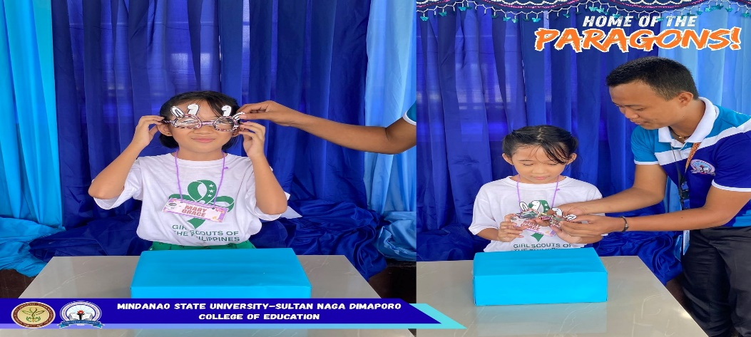

Figure 4.9 Learners’ Prototype Group 2



Figure 4.10 Learners’ Prototype Group 3.



Figure 4.11 Learners’ Prototype Group

According to the results, Group 4 outperformed the others in terms of the criteria itself, scoring 93.33%. Groups 2 and 3 performed well but received somewhat lower presentation scores, with the same percentage of 92.67%. Group 3 got 90.67% for functioning, however their presentation and design might use some work. Overall, the critique encouraged each group to continue inventing by highlighting their areas of strength and improvement.

Table 4.6 Evaluation Result on the Prototype of the Respondents.
Criteria | Group 1 | Group 2 | Group 3 | Group 4
Understanding | 48 | 48 | 43 | 49
Creativity and Design | 46 | 47 | 47 | 47
Participation | 45 | 44 | 46 | 44
Overall Percentage | 92.67% | 92.67% | 90.67% | 93.33%
7. Discussion
The findings of this study revealed significant improvements in the learners' academic performance and attitude towards the subject. The respondents were predominantly 8 years old, which falls within the concrete operational stage of cognitive development according to Piaget. At this stage, children are capable of logical thinking and problem-solving, making them highly receptive to hands-on and inquiry-based learning activities such as those employed in the STEM approach. The majority of the learners were female, which according to literature, often correlates with higher engagement and creativity in collaborative science activities.
Findings showed that the learners had generally low to average scores during the pre-test. This indicates that prior to the intervention, learners found scientific concepts abstract and difficult to relate to their daily lives, which is consistent with studies showing that traditional teaching methods often fail to sustain interest.
However, after the implementation of the Localized Context-Based STEM approach, there was a remarkable increase in scores. The mean score increased from 10.97 to 16.06. The t-test result (t = -9.10, p < 0.05) proved that the difference was statistically significant. This implies that connecting science lessons to the learners' local environment, culture, and experiences made the concepts more tangible and easier to understand. The use of local examples helped bridge the gap between theory and reality, leading to better retention and mastery of the lesson.
In terms of the learners’ level of attitude, exhibited a "Highly Positive" attitude towards the activities, with a grand weighted mean of 2.84. They actively participated in creating prototypes, such as handmade eyeglasses, and showed great interest during discussions. This positive response confirms that when lessons are contextualized and relevant to their community, students become more motivated and engaged. The hands-on nature of the STEM approach allowed them to apply what they learned creatively.
The learners' outputs were rated highly in terms of understanding, creativity, and participation, averaging between 92.67% and 93.33%. This indicates that the approach was not only effective in improving test scores but also in developing higher-order thinking skills and psychomotor skills through design and construction.
This indicates that the localized context-based STEM education approach significantly enhanced learners’ academic performance, engagement, and practical application of Science concepts. The integration of local environmental issues, inquiry-based learning, and hands-on STEM projects provided meaningful learning experiences that promoted critical thinking, collaboration, and environmental stewardship. These findings affirm that localized and context-based STEM instruction is an effective strategy in teaching Science 6 and in fostering meaningful and relevant learning outcomes among elementary learners.
8. Conclusion
This study was undertaken to determine the effectiveness of integrating a localized context-based STEM education approach in teaching Science 3, specifically sense of sight, at Sultan Naga Dimaporo Memorial Integrated School during the School Year 2025-2026. Anchored on constructivist and contextual learning theories, the research addressed the gap between abstract scientific concepts and the real-world experiences of learners by utilizing local culture, environment, and hands-on activities as primary teaching tools. The findings revealed that while the learners had generally low pre-test scores, their performance significantly improved in the post-test, with the mean score increasing from 10.97 to 16.06. The statistical analysis using the Paired Sample T-test confirmed that this improvement was significant, proving that the intervention effectively enhanced academic achievement. Furthermore, the learners exhibited a highly positive attitude towards the activities, as evidenced by their active participation, creativity, and enthusiasm during the implementation of the lesson. Therefore, the study concludes that contextualizing science instruction through localized STEM approaches makes learning more meaningful, relatable, and engaging. This strategy not only improves conceptual understanding and retention but also fosters a deeper appreciation for science by connecting it to the learners' daily lives and cultural identity.

9. Suggestion
Based on the findings of the study, it is recommended that science teachers actively integrate localized and context-based strategies into their instruction to make abstract concepts more relatable and meaningful to learners. School administrators are encouraged to provide professional development opportunities that equip teachers with skills in contextualization and localized STEM material development. Furthermore, curriculum planners may consider embedding local examples, cultural references, and community-based activities into the learning guides to enhance student engagement and retention. Finally, future researchers are advised to conduct similar studies across different grade levels, subject areas, and larger populations to validate and broaden the applicability of localized context-based STEM education.

10. Acknowledgements
The researchers wish to convey their heartfelt appreciation to their thesis adviser and panel members for their insightful guidance and constructive suggestions throughout the completion of this study. They also extend their gratitude to the administrators, teachers, and pupils of Sultan Naga Dimaporo Memorial Integrated School for their cooperation and support.

11. Reference
Azizah, A., & Sarwanto, S. (2025). Culturally responsive teaching approaches improve science mastery in elementary pupils by connecting scientific principles to learners’ cultural settings. Journal of Elementary Science Education, 12(3), 45–5.

Bybee, R. W. (2010). The case for STEM education: Challenges and opportunities. National Science Teachers Association Press.

Chen, L., & Wu, M. (2024). Integrating STEM education with indigenous perspectives on disaster prevention: Improving environmental awareness and supporting sustainability goals. International Journal of Science and Mathematics Education, 22(5), 1123–1140. https://doi.org/10.1007/s10763-023-10456-9

Damerau, K., Schmidt, S., & Weber, M. (2022). Bridging the gap: Connecting abstract science concepts to students’ everyday lives. Research in Science Education, 52(4), 1289–1306. https://doi.org/10.1007/s11165-021-10098-2

Edlund, J., & Balgopal, M. (2021). Making science relevant: Connecting classroom concepts to students’ cultural and environmental contexts. Cultural Studies of Science Education, 16(2), 417–434. https://doi.org/10.1007/s11422-020-09589-7

Hull, G. A. (1993). Contextualized instruction and the teaching of literacy. Teachers College Press.

Korpershoek, H., de Vries, R., & van der Werf, G. (2022). Gender distribution in primary education: Patterns, trends, and implications for learning and instruction. Educational Research Review, 35, Article 100432. https://doi.org/10.1016/j.edurev.2022.100432

Ladson‑Billings, G. (1995). But that’s just good teaching! The case for culturally relevant pedagogy. Theory into Practice, 34(3), 159–165. https://doi.org/10.1080/00405849509543675

Mensah, J. (2021). Linking students’ home experiences to the curriculum: Embedding culture and context in science education. Journal of Science Teacher Education, 32(7), 829–846. https://doi.org/10.1080/1046560X.2021.1923456

Piaget, J. (1950). The psychology of intelligence. Routledge & Kegan Paul.

Springer, S. (2021). Moving beyond abstract concepts: Grounding science learning in students’ lived realities. International Journal of Science Education, 43(11), 1745–1762. https://doi.org/10.1080/09500693.2021.1942987

Vygotsky, L. S. (1978). Mind in society: The development of higher psychological processes. Harvard University Press.

