Soils quality assessment in KAMBELE gold mining area using Multivariate statistical analysis approach
SOP TAMO Berthelot^{1*}; MEFOMDJO FOTIE Blanche²; OTIA KAKWOUN Yvette¹; TARKWA Jean Baptiste¹; TCHUIKOUA Louis Bernard²; MAMBOU NGUEYEP Luc Leroy^{1,3}
- School of Geology and Mining Engineering, University of Ngaoundéré, P.O. Box 115, Meiganga, Cameroon.
- Department of Geography, Faculty of arts, letter and social science, University of Yaoundé 1, Cameroon.
- Laboratory of Mechanics and Materials of Civil Engineering (L2MGC), CY Cergy Paris University, 5 Mail Gay Lussac, Neuville sur Oise, F-95031 Cergy-Pontoise Cedex, France.

*berthelot_sop@yahoo.fr
ABSTRACT
This study concerns the soils assessment in Kambele gold mining area. To obtain the physico-chemical parameters of the different soil samples collected, pH, electrical conductivity, organic matter and moisture content were determined. XRF analyses were performed to identify major elements in soils samples. To estimate the contamination intensity of metals, some soils pollution parameters were determined. The statistical analysis was employed to determine correlation between metal elements present in the soil. Results obtained showed that the soil is acidic. The higher the value of soil organic matter, the higher the adsorption of heavy metals and vice versa. Heavy metal assessment in soil revealed that Pb, Cu, Ni, Fe, As, Zn and trace elements Cr, Mn, had maxima above the WHO limit values. Soils are contaminated at some points and polluted at others. That soil displays a multi element contamination. Correlations show that the heavy metals are interrelated.
Keywords: Mining exploitation, soils, contamination, pollution, metals
- INTRODUCTION
Iindustrials activities such as mining are among the most polluting. With the increasing artisanal and semi-mechanized exploitations, environmental components are not left unharmed. An increase in industrial activities such as mining and smelting has resulted in a broad range of environmental problems (Lee et al., 2019). In particular, the soil becoming contaminated by the accumulation of toxic heavy metals and metalloids (Csavina et al., 2012). These contaminants through emissions from the mining and ore processing industries are considered hazardous waste, causing local and diffuse pollution in the soil (Kim et al., 2022). In general, the soil at industrial sites and natural environment is exposed to distinct groups of toxic heavy metal contaminants (Pawan, 2012; Caeiro et al., 2015; Mandeng et al., 2019).
In the interest of preventing soil heavy metal contamination caused by industrial and mining activities, local and international scientists have studied heavy metal contamination in different regions. By determining the total concentrations and chemical speciation of toxic metals, Zhou et al., (2007) studied soil contamination in the vicinity of the Dabaoshan Mine, China, and found that the environmental pollution in this area over the past decades has been caused by the contamination of Cu, Zn, Cd, and Pb. According to Teixeira et al., (2018) total and available contents of Cu, Mo, Pb,and Zn in the Au mining area of Serra Pelada are high, presenting a risk both to the ecosystem and local population health. The contribution of mining to the accumulation of metals in Southern Ethiopia was studied by Getaneh et al., (2006) who found primary gold sites showed high concentrations in Ni, Cr, Cu, V, Zn, Pb, and As. Heavy metals in soil on spoil heap of an abandoned lead ore treatment plant in Congo Brazzaville was determined by Matini et al., (2011) who found concentration levels in heavy metals above the European union standards. In Namibia, Marta et al., (2014) found arable soils have high concentration in Cu and Pb and the soil is severely contaminated. Gyamfi et al., (2019) found the soil to be extremely polluted in Fe, Pb, Zn, As, Mn and Cu in their study in Kokotesua, Ghana. Investigation of Zn and Pb contamination of soil in Edendale mine, South Africa revealed unacceptably high concentrations (Oyourou et al., 2019). Léopold et al., (2016) in their study in Meiganga-Cameroon found that levels of As, Cr, Cd, Cu, Pb and Sb in soil samples were above average in the Upper Continental Crust. Mominou et al, (2018) performed a physicochemical characterization and pollution evaluation on six gold mining sites at the locality of Bétaré-Oya in Cameroon. They found out that, twelve of the twenty two samples show contamination with arsenic, nickel and lead. In Batouri and Betare-Oya, Dallou et al., (2018) studied the environmental pollution by heavy metals. Soils examined in these gold mining areas are polluted by heavy metals. High concentrations of heavy metals such as Cu, Ni, Mn, Fe and Cr were observed in sediment samples collected in Betare-Oya Gold Area (East Cameroon) by Mambou et al., (2020). Ayiwouo et al., (2022) assesses the spatio-temporal variation and the trace metal contamination in sediments along the Lom River in the gold mining area of Gankombol (Adamawa Cameroon) and shows that the contamination intensity in sediments in the studied section of Lom River globally suggested moderate to signifcant contamination by trace metals and that the mean concentrations of Ni and Cu exceeded the average shale concentrations (ASC) and all the studied standards and indicators.
The soil contamination by heavy metals can be transfer to food and ultimately to consumers due to bioaccumulation (Affum et al ., 2020; Adenuga et al., 2022, Awasthi et al., 2022; Mmaduakor et al., 2022). For the consumers, these types of several metal and metalloids are classified as human carcinogens according to the U.S. Environmental Protection Agency and the International Agency for Research on Cancer, IARC (Tchounwou et al., 2012). According to the Institute for health metrics and evaluation, more than half million deaths per year are caused by the lead exposure (Sawant et al., 2017). Cadmium is classified as a category 1 human carcinogen by IARC due to its potent characteristics with lung cancer, and also the occupational exposure to cadmium is associated with prostate, pancreas, and kidney cancers (Tokar et al., 2010; IARC Monographs, 2012). Furthermore, the inorganic arsenic compounds are classified as Group 1 carcinogen by IARC. The ingestion of arsenic is found to be associated with skin, bladder, lung, kidney and liver cancers (Rossman, 2003).
A field survey in the locality of Kambele revealed that the populations are mainly affected by waterborne and skin diseases. It also revealed early mortality (Mokam et al., 2013; Funoh, 2014). To find out if there is a relationship between the health situation in the Kambele locality and the artisanal and semi-mechanized gold mining that takes place there, we have decided, and this for the first time to the best of our knowledge to carry out an environmental assessment of the soils of this locality. This assessment will ultimately allow us, in the situation of contamination and/or heavy metals pollution to develop an environmental management plan to minimize the health risks associated with gold mining exploitation in this locality.
2. MATERIALS AND METHODS
2.1 Materials

As field materials, a GARMIN eTrex 10 GPS receiver was used to produce a location and a sampling map; a geologic hammer for soil digging, a trowel to take up soil samples, plastic bags for sample collection; opaque bag to store the collected sample and to protect them against the sunlight.

Concerning essential laboratory equipment’s, the determination of metal trace elements was done using a XRF Skyray spectrometer of mark EDX POCKET III, pH of soils solutions was determined using a HACH HW pH meter. Sediment drying was carried out using a Blodgett Mark V-100 electric convection oven.
Software’s used were ArcGIS and Google Earth for map production, Surfer for spatial distribution and Statistica for statistical analysis.
  - Study area

Location of the site
Batouri area is located in the Eastern region of Cameroon (04° 21' to 04° 29' North and 14° 17' and 14° 29' East), within a humid tropical climatic zone. It comprises the localities of Djengo, Mongonam, Bote, Metalicon and Kambele. The study area is within the so-called «Eastern golden district » which is the most mineralized area in Cameroon (Tchouankam et al., 2020). Figure 1 show the location of Kambele mining zone.
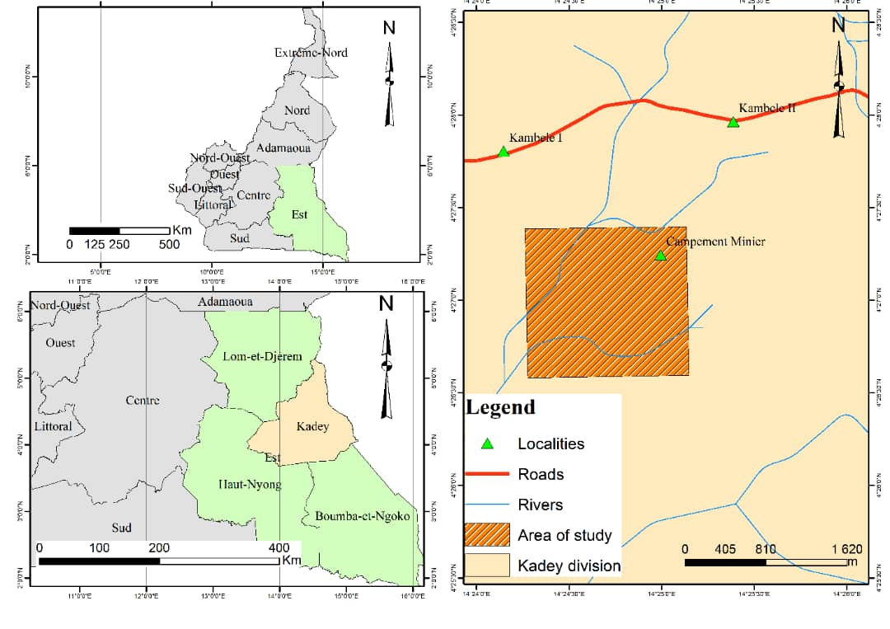
Figure 1: Location of Kambele Mining site.

Climate
Warm and wet equatorial climate with 2 rainy seasons cut through by 2 dry seasons. During the year, the climate is as follows; mild rainy period from mid-March to June, mild dry period from June to mid-August, heavy rainy season from mid-August to mid-November and a pronounced dry season from mid-November to mid-March. Average annual precipitations are between 1500-2000mm. Average temperatures and thermal amplitudes oscillate around 23°C according to the Delegation of agriculture and rural development which is favourable to cattle rearing and agriculture (PCD, 2019).

Geomorphology
Relatively flat relief with an average altitude between 600-1000m. The landscape is undulating and has forest and savannah zone (PCD, 2019). Abrupt slopes are noticed but remain localised. The topographic map of Kambele can be seen in figure 2.
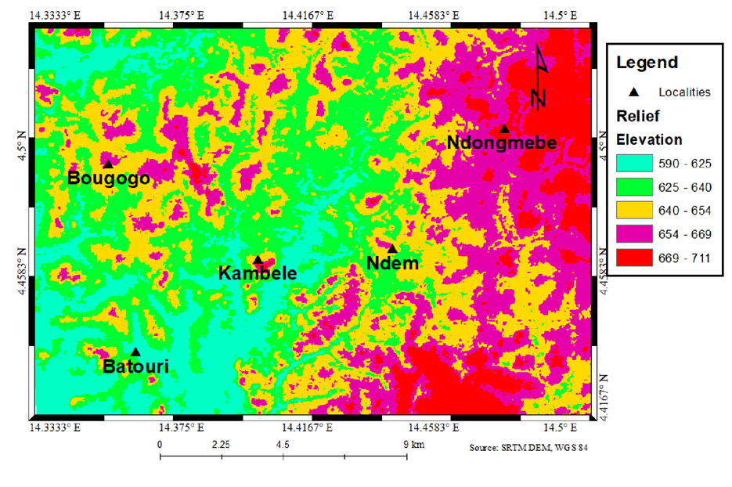
Figure 2: Topographic map of the Kambele Mining Zone.

Petrography
On the petrographic point of view, the main rock type in Batouri is Granitoids which include amphibolite granites, porphyritic biotite and granodiorites cross-cut by numerous quartz veins bearing localized gold mineralization. The metamorphic unit in Batouri area is made up of Schist generally observed as large xenoliths in the granitoids and well-deformed gneisses and amphibolites, (Penaye et al., 2013); this constitutes the country rock intruded by the Pan African granitoids. In these rocks, there are veins and lenticular bodies of quartz containing primary gold (Tchouankam et al., 2020). The secondary gold (eluvial and alluvial) of Batouri is probably their alteration product and erosion (Tchouankam et al., 2020).

Soils
Two principal types of soils can be found in this locality: ferralitic and hydromorphic soils. Hydromorphic soils are soils developed in the presence of an excess moisture which tends to suppress anaerobic factors in soil building. The hydromorphic soils can be found essentially in swampy areas and along river courses (PCD, 2019). The parental material is essentially composed of quartzite and of granites. This area also has a vast reserve of fertile earth suitable for agriculture. The basement soil is also rich in extractable mineral resources such as gold, stones and sand whose exact potentials is yet to be known.

Hydrography
The hydrographic network constitute several rivers Kpwangala, Antobi, Tekam, Djengou, Amorcelin, Mboscorow, Mbil which all converge into the Kadey. These rivers have a great influence on the life style of the local population. Figure 3 depicts the dendritic drainage pattern in the study area.
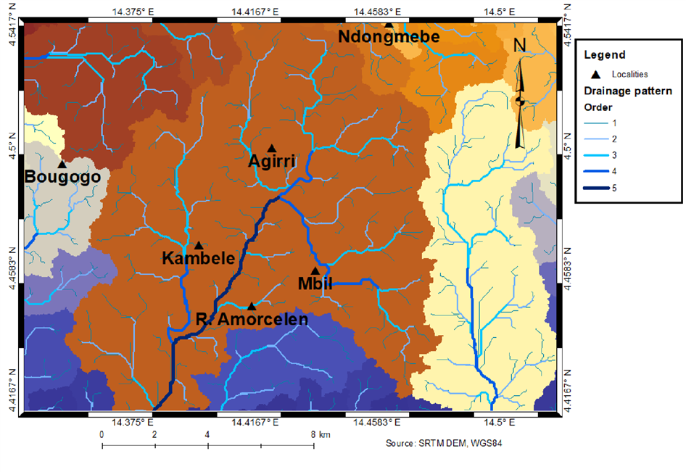
Figure 3: Hydrography of Kambele.

Vegetation
Herbaceous savannah in the North and a luxuriant forest in the South. Some typical activities like bush fire and wild cutting down of trees by the inhabitants and mining activities is known to have greatly destroyed the vegetation cover (PCD, 2019).

Geologic context of the study zone
Kambele is found in the Adamawa-Yade domain of the Pan African Gold Belt in Cameroon. According to Poidevin (1983 ) and Nzenti et al., (1988), this domain is the southernmost branch of the Pan-Africano-Braziliano mobile belt. The evolution of this belt can be attributed to the convergence and collision of the Sao Francisco-Congo Craton, the West African Craton and a Pan African Mobile belt (Castaing et al., 1994). This belt underlies Cameroon, Chad and the Central African Republic, between the Congo Craton to the south and the Western Nigeria shield to the north (Toteu et al., 2004; Van-Schmus et al., 2008). It is underlain by a variety of granitic rocks, including alkali-feldspar granite, syeno-monzogranite, granodiorite and tonalite. It is generally believed that the present structure of the Pan-African belt in Cameroon is characterized by continent- continent collision and post collision of the Congo Craton and the north Cameroon active margins with Archaean-Paleoproterozoic inheritance (Toteu et al., 2004).
The geochemical characteristics of the Batouri granitoids as well as their oxidized state (magnetite series) are typical; of gold associated felsic rocks in subduction settings elsewhere. Figure 4 displays the main rock types in the study area.
Figure 4: Geologic map of kambele (Geological map of Cameroon, 2011).
  - Sample collection and laboratory analysis
Thirty (30) soil samples were collected within selected areas of the gold mining site using a systematic random sampling basis because of the irregular form of the study area, on June 30th 2021 for the purpose of this study.
The samples were collected according to soil sampling guide proposed by (Carter, 2008). When sampling at the predetermined positions, surface impurities were first removed with the hand and the area was leveled. A trowel was then used to sample at the required depths. In order to avoid soil contamination and secondary pollution, the surface soil was first removed from each sampling point using the trowel, and each sample was then removed from the center of the cleared area, at less than 5cm depth, sealed in a sampling bag and carefully labeled. The samples were analyzed in different laboratories for measurement of physicochemical parameters.
The results were used to determine the polluting parameters which permit to estimate the contamination intensity of metals. Table 1 shows the various samples collected and their corresponding coordinates.
Table 1: Coordinates of samples collected on June 30, 2021
Sample | Coordinates |  | Sample |  | Coordinates |  | Sample |  |  | Coordinates
E1 | 4°27'61'' | 14°25'20'' | E11 | 4°26'47'' |  | 14°24'59'' |  | E21 | 4°27'02'' |  | 14°24'32''
E2 | 4°27'10'' | 14°24'58'' | E12 | 4°26'46'' |  | 14°25'00'' |  | E22 | 4°27'15'' |  | 14°24'34''
E3 | 4°27'09'' | 14°24'55' | E13 | 4°26'44'' |  | 14°24'54'' |  | E23 | 4°27'23'' |  | 14°24'37''
E4 | 4°27'06'' | 14°24'57'' | E14 | 4°26'44'' |  | 14°24'42'' |  | E24 | 4°27'25'' |  | 14°24'36''
E5 | 4°27'00'' | 14°24'56'' | E15 | 4°26'45'' |  | 14°24'42'' |  | E25 | 4°27'26'' |  | 14°24'37''
E6 | 4°26'59'' | 14°24'57'' | E16 | 4°26'53'' |  | 14°24'25'' |  | E26 | 4°27'32'' |  | 14°24'34''
E7 | 4°26'58'' | 14°24'55'' | E17 | 4°26'53'' |  | 14°24'21'' |  | E27 | 4°27'33'' |  | 14°24'36''
E8 | 4°26'56'' | 14°24'55 | E18 | 4°27'01'' |  | 14°24'28'' |  | E28 | 4°27'34'' |  | 14°24'39''
E9 | 4°26'54'' | 14°24'55'' | E19 | 4°27'02'' |  | 14°24'27'' |  | E29 | 4°27'29'' |  | 14°24'51''
E10 | 4°26'48'' | 14°25'00'' | E20 | 4°27'02'' |  | 14°24'30'' |  | E30 | 4°27'21'' |  | 14°24'55''

Organic Matter measurement
Soil organic matter is the term used for all living or once-living materials within or added to the soil. This includes roots developing during the growing season, incorporated crop stubble or added manures and slurries. Organic matter was determined by the sulphuric acid and aqueous potassium dichromate $K_{2}{Cr}_{2}O_{7}$ mixture. After complete oxidation from the heat of solution and external heating the unused $K_{2}{Cr}_{2}O_{7}$ or residual $K_{2}{Cr}_{2}O_{7}$ (in oxidation) is titrated against ferrous ammonium sulphate. The used the difference between added and residual $K_{2}{Cr}_{2}O_{7}$, gives a measure of organic matter content of soil.
Electrical Conductivity
Electrical conductivity is used to estimate the concentration of soluble salts in the soil. The electrical conductivity of the saturated paste extract was measured to determine the level of salinity.
X-ray Fluorescence Spectrometry
The sediment was characterized in CAPAM using XRF analysis with a Skyray spectrometer of mark EDX POCKET III. The sample was air dried for about 2 days then compacted before introduction in the apparatus. The sample is bombarded with X-rays (primary) the sample emits another x-ray (secondary).
Moisture content
The moisture content, MC is defined for soil as the ratio of weight of water Wԝ to the weight of solid soil Ws. Oven drying method was used to determine the moisture content of the 30 soils samples collected using equation 1.
$MC\%={W_{2}-W_{3}}/{W_{3}-W_{1}}*100$ (1)
Where :
$W_{1}$ is the weight of tin (g), $W_{2}$ the weight of moist soil + tin (g) and$W_{3}$ the weight of dried soil + tin (g).

Estimation of the contamination intensity
Enrichment ratio (EF)
The enrichment factor (EF), due to its universal formula, is a relatively simple and easy tool for assessing the enrichment degree and comparing the contamination of different environmental media (Chiffoleau, 2001) normalizes metal concentration as a ratio to another constituent of the sediments and differentiates heavy metals originating from anthropogenic sources and those of natural sources (Salati, 2010). In the present study, we chose to normalize metal concentrations using Fe. The EF is defined by equation 2:
$EF={{\left({C_{n}}/{C_{ref}}\right)}_{Sample}}/{{\left({B_{n}}/{B_{ref}}\right)}_{background}}$ (2)
Where, Cn (sample) is the concentration of the examined element in the environment, Cref (sample) is the concentration of the examined element in the reference environment, Bn is the concentration of the reference element in the environment and Bref is the concentration of the reference element in the reference environment. Iron (Fe) was used as the reference element in the crust (Taylor, 1985; Abhijit, 2018).
Geo-accumulation Index
Used to determine and define metal contamination in sediments by comparing current concentrations with preindustrial levels (Cossa, 1989). Igeo is calculated using equation 3.
$I_{geo}=\log{2\left[{C_{n}}/{{1.5B}_{n}}\right]}$ (3)
Where Cn is the measured concentration in the sediment for the metal n, Bn is the background value for the metal n. The constant 1.5 compensates for the natural fluctuations of a given metal and for minor anthropogenic impacts. The quantity Igeo is calculated using the global average share data (Dameron et al., 1998).
Contamination Factor (CF)
It is a quantification of the degree of contamination relative to either average crustal composition of a respective metal or to the measured background values from geologically similar and uncontaminated area. It is expressed by equation 4 (Hakanson, 1980).
$CF={C_{m}}/{B_{m}}$ (4)
Where; Cm is the mean concentration, while Bm is the background concentration of metal either from literature (average crustal abundance).
Single Pollution Index (PI)
It is used to determine which heavy metal represents the highest threat for a soil environment (Lee, 2001). It is calculated from the average ratio of metal concentrations in soil samples to limiting guideline values. These limit values correspond to the tolerable levels in soil suggested by Kloke, (1979) as given by equation 5.
$PI={C_{n}}/{GB}$ (5)
Where Cn is the content of heavy metal in soil and GB the values of the geochemical background. Interpretation of pollution index is depicted in the table below.
Pollution Load Index.
This index assesses the degree of pollution of heavy metals in affected soils (Tomlinson, 1980). This index provides an easy way to prove the deterioration of the soil conditions as a result of the accumulation of heavy metals (Varol, 2011). PLI is calculated as a geometric average of PI based on equation 6.
$PLI=\sqrt[n]{{PI}_{1}+{PI}_{2}+…{PI}_{n}}$ (6)
Where n is the number of analysed heavy metals and PI the calculated values for the Single Pollution Index. PLI values greater than 1 indicates pollution while values less than 1 shows no pollution (Tariq et al., 2018)
Vector Modulus of Pollution Index (PIVector)
This index was introduced by Gong et al., (2008) and is defined by equation 7.
$PIVector=\sqrt{\frac{1}{n}\sum_{i-1}^{n}{{PI}^{2}}}$ (7)
Where n is the number of determined heavy metals and PI the calculated values for the Single Pollution Index.
Multi-element contamination (MEC)
Using MEC gives a measure to assess contamination based on the content of heavy metals in surface soil horizons, with the limits given by Kloke, (1979). This index was introduced by (Adamu et al., 2010). MEC values above 1.0 testify to an anthropogenic impact on heavy metal concentration in soil. MEC is calculated based on equation 8.
$MEC={\left({C_{1}}/{T_{2}+{C_{2}}/{T_{2}+…{C_{n}}/{T_{n}}}}\right)}/n$ (8)
Where C is the content of heavy metal, the tolerable levels given by (Kloke, 1979) and n the number of heavy metals.
Contamination Security Index (CSI)
CSI was introduced by (Pejman et al., 2015). In order to calculate CSI, ‘effects range low’ (ERL) and ‘effects range median’ (ERM) values given by Long et al., (1995) are used. CSI is also helpful to determine the limit of toxicity above which adverse impacts on the soil environment are observed. The index is calculated according to equation 9:
$CSI=\sum_{i-1}^{n}{w}\left({\left(\frac{C}{ERL}\right)}^{1/2}+{\left(\frac{C}{ERM}\right)}^{2}\right)$ (9)
where w is the computed weight of each heavy metal according to Pejman et al., (2015), C is the concentration of heavy metal, and ERL, ERM the values.
Degree of contamination (Cdeg,)
According to Hakanson, (1980), the assessment of contamination can be carried out by using the degree of contamination index, Cdeg, which is calculated using equation 10:
$C_{deg}=\sum_{i-1}^{n}{C_{f}}$ (10)
Where C_{f} is the contamination factor and n the number of analysed heavy metals.
Nemerow pollution index
The NI allowed the assessment of the overall degree of pollution of the soil or sediment and includes the concentrations of all analysed trace metals (Gong et al., 2008). The index is calculated using equation 11 (Gao et al., 2016) :
$IN={\sqrt{{\left(P_{ia}\right)}^{2}+{\left(P_{im}\right)}^{2}}}/2$ (11)
Where P_{ia} is the average value of the individual pollution index for all pollutants in the i-^{th} sampling point; and P_{im} is the maximum single pollution index for all pollutants at the i-^{th} sampling point.
Potential ecological risk index
It is widely used in assessments of the degree of ecological risk caused by heavy metal pollution in the soil (Luo et al., 2018). This method not only reflects the single impact of heavy metals to ecological environment but also takes into accounts the different background values of the geography (Zhang, 2005) and combines environmental chemistry with biological toxicology and ecology. This index is calculated using equations 12 and 13 (Li et al., 2017):
$E_{f}^{i}=C_{f}^{i}×T_{f}^{i}$ (12)
$RI=\sum_{i=1}^{n}{E_{f}^{i}}$ (13)
Where $C_{if}$ is the pollution coefficient for a certain heavy metal, which can reflect the pollution character of the investigated region but cannot reveal the ecological effects and hazards; $T_{f}^{i}$is the response coefficient for the toxicity of the single heavy metal. The formula reveals the hazards of heavy metals on the human and aquatic ecosystem and reflects the level of heavy metal toxicity and ecological sensitivity to the heavy metal pollution. The standardized response coefficient for the toxicity of heavy metals, which was made by (Hakanson, 1980) was adopted to be evaluation criterion. Respectively, the corresponding coefficients based on its toxicity were 40 for Hg; 30 for Cd; 10 for As; 5 for Cu, Pb and Ni; 2 for Cr and 1 for Zn (Zhao et al., 2005).
Exposure factor (ExF)
ExF is very useful to assess where, in a given study area, the greatest heavy metal loads are located (Babelewska, 2010), and it is calculated using equation 14:
$ExF=\sum_{i=1}^{n}{{C_{n}-C_{av}}/{C_{av}}}$ (14)
where C_{n} is the content of heavy metal at an analyzed sampling point and C_{av} the average content of heavy metal in the soil profile.
Modified degree of contamination (mCd)
This index was first used by (Abrahim et al., 2008). It allows the assessment of the overall heavy metal soil contamination. To calculate this index, the sum of the content of heavy metals is necessary mCd is calculated using equation 15:
$mCd={\sum_{i=1}^{n}{C_{n}}}/n$ (15)
where n is the number of analyzed heavy metals and Cn the content of individual heavy metal.

Statistical analysis
Multivariable analysis: Principal Component Analysis
Principal component analysis (PCA) selects uncorrelated linear combinations (eigenvector loadings) of variables in such a way that each component successively extracted linear combinations and has a smaller variance (Singh, 1985) it was apply in this study.

- RESULTS AND DISCUSSION

3.1 Descriptive statistics of heavy metals.
The concentrations of heavy metals in sediments are varied according to the rate of particle sedimentation, the rate of heavy metals deposition, the particle size and the presence or absence of organic matter in the sediments. Descriptive statistics for some heavy metals in the soil samples is shown in table 2. The background values are those given in the reference.
Table 2: Statistical summary of analysed heavy metals.
 | Cr | Ni | Cu | Zn | Pb | Fe | Mn | As
mean | 87 | 162 | 272 | 23 | 16 | 37 292 | 310 | 7
median | 70 | 114 | 261 | 15 | 5 | 31 133 | 294 | 0
std | 89 | 175 | 99 | 34 | 25 | 26 211 | 249 | 14
min | 0 | 0 | 19 | 0 | 0 | 8550 | 0 | 0
max | 457 | 655 | 485 | 139 | 114 | 121 611 | 885 | 60
GB | 90 | 68 | 45 | 95 | 20 | 472 | 600 | 13
WHO | 100 | 50 | 100 | 50 | 85 | 50000 | 2000 | 20
CSQG | 87 | 35 | 63 | 200 | 70 | nd | nd | nd
nd: not defined
Table 3 presents the comparison of values obtained for the present study with those obtained in the literature.
Chromium concentrations varied from 0-457ppm. The highest concentration (457ppm) was recorded at point E28 corresponding to sample collected at Djengou at a washing station. The least concentration was recorded at point E30 (0ppm) corresponding to a zone where exploitation had long finished. As indicated by the wide distribution of this heavy metal, the diffusibility of Cr contamination, which spreads through the industrial wastewater discharged into the ground, should be noted. The presence of chromium can be due to the oxidation of ultramafic rocks or the leaching of ultramafic soils which is large and controlled by the amorphous Fe-oxides (Garnier et al., 2009).
Copper was present in all the soil samples investigated. Cu concentrations were 19ppm to 485ppm. High copper is due to the fact that retention would be governed by ion exchange with clays such as the kaolinite and by complexing with fulvic acids and humic acids (Wu et al., 2002). Almost all the soil samples had concentrations above the WHO, and CSQG limits for soils except sample E18 corresponding to sample collected at Mboscoro. Kabir et al., (2017) in their study in Nigeria had soils with Cu concentrations above the permissible limit. The high concentration of Cu is attributed to the fact that it does not travel very far after being released in soil (Ezeh et al., 2011). Also, Baker et al., (2000) reported that higher copper concentration in surface layer of a soil is an indication of soil additions, from smelters, fertilizers, sewage sludge, pesticides, manures and metal availability in the earth crust. The maximum Cu concentration at point E18 could be due to its mobility in weathering environment and ability to adsorb onto soil constituents’ surfaces through ion exchange process (Wuana et al., 2011).
Nine of the 30 samples were found Lead free. Pb variations were from 0-114ppm. The maximum concentration of Pb was obtained at point E8 and it’s far beyond the maximum limit set by the WHO (85ppm) CSQG (70ppm). High lead concentration could be attributed to mining activities. The main source of lead in nature is galena (PbS). According to Banunle, (2018) this is because many rocks contain lead which when excavated and crushed, it is drained in water which infiltrates the soil. In comparison with other similar studies, the maximum concentration of Pb in soil of study area was significantly higher than the concentrations reported in South Africa Caspah et al., (2016) and Ghana (Crentsil et al., 2016.). Obiora et al., (2016) have also reported high values of Pb in soils of lead-zinc mining district of Enyigba in other part of Nigeria. According to Kabir et al., (2017), it is possible that these levels of Pb is elevated by the presence of automobile emissions, and presence of carbonate which enhance the principal retention mechanism of Pb in soil around the surrounding areas. Also, the higher concentration in Lead is due to its solubility in sediments as compared to metals (Cazalet, 2012). Lead presents a variety of dangers because the Pb accumulated in the human body affects negatively several organs: bones, liver, kidney, brain, lung and central nervous system. Lead concentrations in the Kambele Mining Zone were similar to those reported by Dallou et al., (2018) in their study in Betare-Oya.
Zinc was present in almost all the samples with concentrations varying from 0-139ppm. The maximum zn concentration (139ppm) was above the WHO limit (50) and below the CSQG limit (200) for industrial soils. The maximum value obtained at point E15 could be due to the fact that since both local and semi-mechanized mining have taken place in the vicinity; there is no doubt that the activities have input high concentration of Zn metal in the soils. Similar results were obtained by Kabir et al., (2017) in Nigeria. Other sources of Zn could be from fertilisers containing zinc. Obiora et al., (2016) have also reported high values of Zn in soils of lead-zinc mining district of Enyigba in other part of Nigeria. Zn concentrations in our study area were lower than those obtained by Sijin et al., (2015) but higher than those obtained by Mushtaha, (2017) in an artisanal gold mine in River Nile State, Sudan.
Iron concentrations is extremely high as compared to the other metals in the soil samples and varied from 8550-121611ppm. The mean concentration was below the WHO limit (50000). The High iron concentrations is attributed to the soil type of the Kambele mining zone which is highly ferrallitic. The mean concentrations of Fe in this study area exceeded concentrations reported in similar studies on heavy metals contamination associated with gold mining in Ghana (Crentsil et al, 2016.) and Sudan (Mushtaha, 2017). Also weathered and eroded materials from Fe rich rocks which are transported and deposited could be a reason for the high concentrations. The highest concentration of Fe was recorded at point E28 (121611ppm) which is much higher than the WHO standard. Toxic effects related to iron can appear if concentrations in the human body are higher than the critical value (50000 ppm) indicated by the WHO (World Health Organization), affecting negatively several organs particularly in children (Baby et al., 2010; Chiroma et al, 2014). Dallou et al ., (2018) in their study in Batouri and Betare-oya had similar results.
Arsenic concentrations ranged from 0-60ppm in the 30 samples collected. 4 out of the 8 samples where Arsenic was present had concentrations lower than the WHO permissible limit (20ppm) in soil. The maximum concentration of arsenic was recorded at point E29 (60ppm) which is three times higher than the WHO standard value. This high value could be explained by the machines and mineral residues discharged in the pits scattered around the area. The presence of Arsenic in the soils of Kambele mining site may be justified by the presence of gold veins rich in arsenopyrite on these sites. The relative arsenic content confirmed the migration of arsenic not only from the gangue to the soil, but also from free water collected upstream of these primary gold mining sites. Similar results were obtained by (Mominou et al., 2018). Inorganic arsenic is considered as a human carcinogen (cancer-causing agent) by the U.S. and exposure to arsenic has been linked to increased incidence of irritation of mucous membranes and lung cancer (WHO, 1996; USEPA, 2013). Arsenic concentrations in our study area were higher than those obtained by Dallou et al., (2018) in their study in Batouri and Betare-Oya East Cameroon.

Table 3: comparison of values obtained for the present study with those obtained by other authors
Country | Hg | As | Cd | Pb | Zn | Cu | Ni | Co | Cr | Fe | Mn | Reference
China | 0,12±0,09 | 10,6±6,50 | 0,24±0,29 | 39,2± 19,5 | 112,3±70,6 | 30±22 | 28,4± 13,8 |  | 59,8±25,6 |  |  | Sijin et al. (2015)
South Africa | 0,09 | 79,40 | 0,05 | 4,79 | 51,30 | 42,51 | 112,06 | 25,56 | 278,8 |  |  | Caspah et al. (2016)
Ghana | 1,06±0,65 | 6,83±2,42 | 0,19±0,13 | 19,96±3,11 | 61,87±16,5 | 16,03±3,22 | 41,77±13,60 |  | 16,88±2,47 | 531,5±97 | 445,6±108 | Crentsil et al. (2016)
Sudan |  |  |  | 12,46 | 20,85 | 19 | 15,33 | 5.2 |  | 8473 | 238,1 | Mushtaha et al. (2017)
Cameroon |  | 4±2 |  | 79±9 | 40±8 | 15±7 | 8±4 |  |  | 39300±200 | 730± 70 | Dallou et al. (2018)
Cameroon |  | 70±3 |  | 202,96±6 | 22,6±67 | 21,5 ±11 | 37,6±11 |  | 90±8 |  |  | Mominou et al (2018)
Cameroon |  |  |  | 22 | 69 | 18,5 | 22,25 |  | 152,5 |  |  | Tehna et al. (2019)
  23164,25
Cameroon |  | 5,854 |  | 20,667 | 29,575 | 44,643 | 36,441 |  | 79,79 | 383647,5 | 529,8 | Mambou et al. (2020)
Cameroon |  | 7 |  | 16 | 23 | 272 | 162 |  | 87 | 37292 | 310 | Present study

Manganese concentrations are highr than the average concentration in the upper continental crust (UCC; 60ppm). Manganese concentration varied from 0-88ppm in the Kambele Mining Zone. Although they are hugher than the UCC value, these concentrations were however lower than the WHO permisssible limit (2000ppm) for soil. These results are similar to those obtained in the East region of Cameroon by Dallou et al., (2018). In comparison to other studies carried out in Ghana (Crentsil et al, 2016.), concentrations in our study area are higher. Exposure to concentrations higher than the WHO permissible value can cause toxic effects primarily on the brain and central nervous system.
Nickle concentrations is far above the WHO permissible limit except for 4 samples which were below. It can be due to the batteries and iron and steel equipment used. The trend is from 3.099- 655.464. This indicates that there is a large difference in soil heavy metal content between the different sampling points. The mean value forNi in the Kambele mining zone exceeds the average upper continental crust value given by Taylor, (1985). The values obtained in Kambele are higher than those obtained by Dallou et al., (2018) in Batouri and Wang et al., (2019) in China.
Three types of reaction can be considered to explain the presence of metal ions in excess quantity in the soil sediments of the Kambele area.
The first is the oxidative decomposition of rock minerals due to aqueous acid soil solution. For exemple, the biotite oxidation given by equation 16 (Buss et al., 2008).
${Na}_{0.50}{Ca}_{0.48}K_{0.01}{Al}_{1.43} {Si}_{2.56}O_{8} + 5.76 H_{2}{CO}_{3}+ 2.24 H_{2}O→0.50 {Na}^{+}+ 0.48{Ca }^{2+}+ 0.01K^{+}+ 1.43{Al}^{3+}+2.56H_{4}{SiO}_{4}+ 5.76HCO_{3}^{-}$ (16)

The second type of reaction concerns the non-oxidative dissolution of minerals in an acid medium. There is a formation of ionic species after breaking the bonds between mineral constituents and simultaneously, the transfer of these charged species through the potential difference in the Helmholz layer at the surface of the mineral. This taking into account the hydromorphic nature of the soil which imposes a solid-water mineral coexistence. The equation (17) highlights this non-oxidative dissolution of minerals from the Kambele soil.

$⊳M_{lat}+wH_{2}O⇌M_{\left(aq\right)}^{z+}+⊳^{z-}$ (17)
where ⊳ M_{lat} represents a species in a lattice position on the surface, ⊳ ^{z −} represents the uptake of the excess charge that results from bonds breaking by the surface of the solid, and w represents the stoichiometric coefficient with respect to water. The symbol ⊳ ^{z −} can also be interpreted as an electron, a hole or a charged species at the surface that forms as a result of bond breaking. The electron or hole may not necessarily be mobile it may be captured by surface states and dangling bonds at the surface and contribute to the potential difference (Crundwell, 2014).
The third type of reaction is related to mineral alteration due to organic acids (formic acid, oxalic acid, tartaric acid, citric acid, salicylic acid, benzoic acid, gallic acid, phthalic acid, mandelic acid, protocatechnic acid..) contained in the organic matter of the soil because the sediments of Kambele contain a significant rate of organic matter. Indeed, Kong et al. (2014) show that the weathering of kandic minerals in ferralitic soils, as is the case in Kambele, is strongly influenced by soil organic acids and their anions. Lazo et al. (2017) showed that soil organic acids decompose silicate minerals through a simultaneous action of acid attack and chelation (formation of coordination compounds).
Among these metals, chromium, mercury, and lead have the greatest potential to cause harm on account of their extensive use, the toxicity of some of their combined or elemental forms, and their widespread distribution in the environment (Baird, 2012).
3.2 Physical Properties
Physical properties like pH, conductivity, moisture content and organic matter of the soil samples were determined and the results displayed in table 4.
Table 4: Physical parameters of soil samples.
 | Unit | max | min | mean | std | median | WHO | IASS
MC | % | 18,81 | 1,30 | 9,49 | 3,56 | 9,17 | / | /
pH | / | 6,22 | 5,12 | 5,59 | 0,25 | 5,56 | 6,5-8,5 | 4-8,5
EC | (μS/cm) | 416,00 | 96,00 | 213,33 | 73,44 | 185,50 | 1000 | 40000
OM | % | 1,42 | 0,30 | 0,70 | 0,30 | 0,62 | 13 | >0,86

pH affects the chemical reactions between water and soil minerals (Tirmizi et al., 2005). The pH in the study area ranged between 5.12 and 6.22 which is in the acidic scale of pH. These pH values were all below the maximum permissible limits of pH given by the WHO (6.5-8.5) and within the range given by IASS (4-8.5). These results are similar to those obtained by Jamilu et al., (2014). These pH values show that soils in our study area are acidic. Similar results were obtained by Ramahlo, (2013) in his study in Limpopo Province, South Africa. Indeed, in soils, the oxidation of metal sulphides M_{x}S_{y} in the OM promotes decreasing pH trough the formation of sulfuric acid as shown by equation 18.

$M_{x}S_{y}+2yO_{2}+yH_{2}O⟶M_{x}O_{y}+yH_{2}{SO}_{4}$ (18)

pH values obtained in Kambele are similar to those obtained by Léopold et al., (2016). The acid pH is due to infiltration from metal-rich rocks in the soil that are displaced by the mining operations in the presence of water. The pH influences the mobility and bioavailability of heavy metals. Heavy metals can be mobilized when environmental conditions, especially pH, change (Lorenzo et al, 2007 ). Thus, when the pH decreases, desorption or dissolution processes will tend to lead to the release of metal cations from the sterile and washed sand which are the sources of heavy metals to the dissolved phase. And, when pH is basic, there is precipitation of metals ions M^{x+} and their complexes according to equation 19.
$M^{x+}+x{HO}^{-}⇌ {M(OH)}_{x}$ (19)
These results are in accordance with those reported by Mominou et al., (2018) Bétaré-Oya District in Cameroon.
The measure of EC gives the concentration of soluble salts in the soil. It is the total parameter for dissolved & dissolute substance. The EC range for sampled soils in the Kambele mining zone varied from 96-416µs/cm. These results show that soils in Kambele are conductive. Similar results were obtained by Léopold et al., (2016) in Meiganga, Adamawa Cameroon.
Soil organic matter (OM) derives from the breakdown of plant and animal debris. The organic matter is one of the factors that may reduce the ability of metals to be phytotoxic in the soil due to metal-organic complexation (Gupta et al., 2007). Land rich in organic matter actively retains metallic elements (Fijalkowski et al., 2012). Organic matter in Kambele had a trend of 0.30-1.42%. The low value for OM obtained at points E1, E8, E11, E17 and E22 is due to the sandy texture of the soil at these points. High values of OM accounts for high adsorption of heavy metals and vice versa.

3.3 Contamination intensity
It was calculated to know the degree of contamination relative to either average crustal composition of a respective metal or to the measured background values from geologically similar and uncontaminated area.CF values obtained for 6 heavy metals in our area of study is given in table 5.
Table 5: Contamination factors of heavy metals in the site.
 | Cu | Pb | Zn | Ni | Cr | As
max | 10,8 | 5,7 | 1,5 | 9,6 | 5,1 | 4,6
min | 0,4 | 0,0 | 0,0 | 0,0 | 0,0 | 0,0
median | 5,8 | 0,2 | 0,2 | 1,7 | 0,8 | 0,0
mean | 6,1 | 0,8 | 0,2 | 2,4 | 1,0 | 0,5
std | 2,2 | 1,2 | 0,4 | 2,6 | 1,0 | 1,1

The mean CF of heavy metals in this study site varied in a decreasing order as follows; Cu, Ni, Cr, Pb, As and Zn. Values ranged from 0.4-10 for Cu, 0-5.7 for Pb, 0-1.5 for Zn 0-9.6 for Ni, 0-5.1 for Cr and 0-4.6 for As. These values show that soils of the Kambele mining zone are moderately enriched in As and Zn while significantly enriched in Cu, Pb, Ni and Cr. High CF indicates external sources of contamination due to anthropogenic activities. Similar results were obtained by Chukwu et al., (2018) in their study in Nigeria. High CF of Cu and Ni could be due to as indiscriminate disposal of substances containing metals such as vehicles spare parts. This is in accordance with Abdullateef et al., ( 2020). However these values are higher than those obtained by Dallou et al., (2018) in their study in Batouri and Betare-Oya.
Enrichment factor (EF) is an essential part of geochemical studies and is generally used to differentiate between metals originating from anthropogenic and geogenic sources and to assess the degree of metal contamination. Values for enrichment factor obtained for our area of study is given in table 6.
Table 6: Enrichment factor values.
 | Cu | Pb | Zn | Ni | Cr | As
min | 2 | 0 | 0 | 0 | 0 | 0
max | 7,40 | 8,31 | 1,40 | 5,98 | 3.5 | 0,51
mean | 4,71 | 4,16 | 0,23 | 2,99 | 1,75 | 0,08
median | 0,67 | 0 | 0,18 | 0,18 | 0,07 | 0
std | 2,70 | 2,17 | 0,19 | 0,12 | 0,06 | 0,09
Enrichment factor varied with the trend Pb>Cu>Ni>Cr>Zn>As. Table 6 shows that EF for Cu, Pb and Zn show significant enrichment with Pb being the most enriched. This indicates that human activities greatly influence its concentration in the study area. Zn and As show very minimal enrichment while Cr is moderately enriched. These results differ from those obtained by Tehna et al, (2015) in betare. In general, the mean enrichment of the soil samples is below 5 for all the heavy metals analysed indicating that this area is moderately enriched. Similar results were obtained by Dallou et al., (2018) in Batouri.
According to Axtmann et al., (1991), contamination by heavy metals on soils surface, particularly in mine sites, is associated with a cocktail of contaminants rather than a single metal. Thus, the concept of a pollution index makes it possible to identify the sites contaminated by metal so as to envisage an efficient solution through a good planning of the rehabilitation. Pollution indices of the 6 heavy metals calculated for the study site are given in table 7.
Table 7: Pollution Indices.
 | Cu | Pb | Zn | Ni | Cr | As | PLI | IN | PIvector
max | 10,8 | 5,7 | 1,5 | 9,6 | 5,1 | 4,6 | 1,5 | 8,1 | 11,7
min | 0,4 | 0,0 | 0,0 | 0,0 | 0,0 | 0,0 | 0,0 | 2,3 | 2,8
median | 5,8 | 0,2 | 0,2 | 1,7 | 0,8 | 0,0 | 0,0 | 4,4 | 4,1
mean | 6,1 | 0,8 | 0,2 | 2,4 | 1,0 | 0,5 | 0,2 | 4,7 | 4,5
std | 2,2 | 1,2 | 0,4 | 2,6 | 1,0 | 1,1 | 0,4 | 1,2 | 1,7
The pollution index of Cu varied between 0.4-10.8 and Ni 0.0- 9.6 showing a mild pollution to a very high pollution in the Kambele Mining zone. Their mean values were greater than 1 as compared to those of the other heavy metals in the study area. The analysis results shows a decreasing PI value in the order Cu, Ni, Cr, Pb, As and Zn. These results were higher than those obtained by Jiang et al., (2014) in their study in China. Mominou et al., (2018) in their study in Batouri and Betare-Oya reported similar reseults. High values of PI is due to sludge and waste rock in the site. This indicates that one must have a watchful eye to the discharges produced by primary gold mining. Figure 5 shows the trend of pollution indices of the 30 samples.

Figure 5: Pollution indices of Samples.
The PLI represents the number of times by which the metal content in the soil exceeds the average natural background concentration, and gives a summative indication of the overall level of heavy metal toxicity in a particular sample. Among samples collected, three showed pollution. Globally, the soils in the Kambele mining zone had mean PLI 0.2 (Figure 6) indicating that the site is in low pollution status regarding the total of the studied metals (Mmolawa et al., 2011). Similar results were obtained by (Dallou et al., 2018) in Batouri and Betare-Oya. PLI values obtained at Kambele are lower than those given by Abdullateef et al., (2020) and higher than those obtined by Chukwu et al, (2018).
To quantify the soil heavy metal contamination, the Nemerow index (IN) which describes the integrated contamination levels, was calculated. The IN results at all sampling points indicate the following. (1) In general, the IN value of the study area is between 3 and 5, given the maximum and minimum values of 4.92 and 2.84. This finding reveals that the overall level of heavy metal contamination in the study area is between moderately and heavily contaminated, which indicates heavy metal contamination. (2) The IN values of fourteen sampling points exceed 4, which indicates that the contamination level is approaching extremely contaminated. (3) 9 of the thirty samples have IN values greater than 5 indicating extreme contamination. Similar results were obtained by Yang et al., (2014). The general trend of IN values in the Kambele mining site is 2.3-8.1. This indicates that some units of the soil samples were moderately contaminated while some units were heavily contaminated and the other units showed extreme contamination. Similar results were obtained by Jiang et al., (2014). However, values obtained in our study area for the Nemerow index are greater than those obtained by Wang et al., (2019) in China. Therefore, for the studied area, pollution risks posed by the surface soils, especially for those heavy metals with higher concentrations, require further attention.
Pollution load index, Nemerow pollution index and vector pollution index is displayed in figure 6 for a better understanding of the relationship that exists between them.
The geo-accumulation index (I-geo) is a quantitative measure of the degree of contamination. The geo-accumulation index for the quantification of heavy metal accumulation in the study area is presented in table 8.
Table 8: Geoaccumulation index.
 | Cu | Pb | Zn | Ni | Cr | As
max | 1,2 | 0,9 | 0,3 | 1,1 | 0,8 | 0,8
min | -0,3 | -2,3 | -1,7 | -1,2 | -0,5 | 0,0
median | 0,9 | 0,0 | -0,6 | 0,3 | 0,0 | 0,0
mean | 0,9 | -0,1 | -0,4 | 0,3 | 0,0 | 0,1
std | 0,3 | 0,6 | 0,4 | 0,5 | 0,3 | 0,2
I-geo grade for the study area varies from metal to metal and site to site (across metals and sites). Igeo values (maximum) for the various heavy metals in the Kambele mining site varies in decreasing order as follows: Cu, Ni, Pb, Cr , As and Zn. From the results, we can see that Cu and Ni are moderately contaminated while the other metals show little or no contamination. This high index is caused mainly by the enrichment unit; hence its content in the areas affected by industrial activity may be elevated. Similar results were obtained by Dallou et al., (2018) in Batouri and Betare-Oya and Chukwu et al., (2018). However these values were higher than those obtained by Tehna et al, (2015) in betare and lower than those reported by Obiora et al., (2016) .
The Cd is aimed at providing a measure of the degree of overall contamination in surface layers in a particular sampling site. In the study area, soils varied from low degree of contamination to considerable degree of contamination.
Table 9 displays the mean values of contamination degree. Contamination degree in the study area varied from 6.1-21.1. Table 9 indicates that some units of soil in the Kambele Mining zone show moderate contamination degree, some show considerable contamination degree and others show very high degree of contamination. Similar results were obtained by Syed et al., (2012) in Bangladesh. Mean degrees of contamination of all heavy metals compared to their respective degree of contamination reveal a moderate degree of contamination, indicating a moderate anthropogenic pollution (Abhijit, 2018). Similar results were obtained by Dallou et al., (2018) in Betare-Oya.
Table 9: Contamination Degree.
 | Cdeg | mCdeg
max | 21,1 | 75,9
min | 6,1 | 14,3
median | 10,1 | 22,7
mean | 11,0 | 25,8
std | 3,9 | 11,6
Figure 7 depictss the contamination and the modified contamination degrees obtained in our area of study. The modified degree of contamination was used to assess the level of contamination by considering the simultaneous presence of numerous pollutants. The mCd is widely used in environmental studies to identify the levels of metal pollution accumulation. The mCd as proposed in the present study is based on integrating and averaging all the available analytical data for a set of soil samples. This modified method can therefore provide an integrated assessment of the overall enrichment and contamination impact of groups of pollutants in the soil. Values obtained for mCd in the study area displayed in the table 9 varied from14.3-75.9 indicating that soils in the Kambele site vary from very high to ultra-high contamination. Similar results were obtained by Dallou et al., (2018) in Batouri. High values of mCd could be due to heavy rainfall, dilution and other run-off. Values obtained in the study area are less than those reported by Yang et al., (2014).

Figure 7: Contamination and modified contamination degree.
As soil contaminated with heavy metals can enter the human body through various exposure approaches Bade et al., (2013), highly toxic heavy metals in soil can cause serious ecological and health risks (Dong et al., 2010,). The excessive accumulation of heavy metals in agricultural soil can affect food quality and safety and further increase the morbidity of severe diseases, such as cancer, leukemia, and kidney or liver damage (Khan et al., 2011). The potential ecological risk from the studied six heavy metals was evaluated using the Hakanson potential ecological risk index, shown in the table 10.
Table 10: Potential Ecological Risk.
 | Ef |  |  |  |  |  | RI
 | Cu | Pb | Zn | Ni | Cr | As
max | 53,9 | 28,4 | 1,5 | 48,2 | 10,2 | 46,2 | 127,5
min | 2,1 | 0,0 | 0,0 | 0,0 | 0,0 | 0,0 | 26,7
median | 29,0 | 1,2 | 0,2 | 8,3 | 1,6 | 0,0 | 48,4
mean | 30,3 | 4,1 | 0,2 | 11,9 | 1,9 | 5,5 | 53,8
std | 11,0 | 6,2 | 0,4 | 12,9 | 2,0 | 10,9 | 21,8

The potential ecological risk index values for the single heavy metal pollution in the study area varied generally from slight to medium degree of contamination. Values for copper varied from 2.1-53.9 indicating slight to medium pollution degree. Values obtained for Zinc were extremely low indicating little or no pollution due to this heavy metal. Values obtained in the Kambele mining site for Cu are greater than those obtained by Wang et al., ( 2019) in China but less than those obtained by Weihua et al., (2010). According to the six heavy metals in the mining site, Ef values arrayed in a decreasing order as follows Ef (Cu), Ef (Ni), Ef (As), Ef (Pb), Ef (Cr) and Ef (Zn).
Potential toxicity response index for various heavy metals in the soil in our mining site varied from 26.7- 127.5. Six of the 30 samples had RI values less than 40 indicating very slight toxicity. Out of the 30 samples collected in our study area, only 2 samples had values greater than 80. These units of soil in the mining site indicates strong toxicity. This could be due to the high discharge of waste from the mining companies at these points. Appropriate engineering measures and ecological measures should be taken to control the concentrations of soil heavy metals, and it is also necessary to conduct ecological restoration for the polluted area. The rest of the samples fell in the medium toxicity class. These observations are in accordance with those reported by Jiang et al., (2014). However, the mean value of RI in the Kambele mining site is less than those indicated by Weihua et al., (2010). Figure 8 displays the trend in potential ecological risk factor calculated for the 30 samples.

Figure 8: Potential ecological risk

Contamination Security Index is used for ecological risk assessment of heavy metal pollution in soil. It incorporates two-tier threshold levels of sediment quality guideline values, one below which adverse effects rarely occur (ERL-effects range low) and another above which adverse effects are likely to exist (ERM-effects range median). Values for CSI obtained in our area of study are recorded in table 11. CSI values obtained in the Kambele mining site shows a decreasing trend of Cu, Ni, Cr, Pb, Zn and As. Contamination Security Index values for copper ranged from 2.94-979.58 which is in the extreme severity of contamination category. These high values could be due to the fact that it does not travel very far after being released, its speciation and other geochemical characteristics in soil (Ezeh et al., 2011). These high values indicate a strong anthropogenic source. Activities such as excavation of soil during mining processes could be responsible for the high availability of copper in the study site. CSI values for Ni varied between 0-113.65 which falls under the range of extreme severity of contamination. Contamination severity index obtained for Pb displayed a moderate severity of contamination while values obtained for Cr were categorized as high severity of contamination. In general soils in the Kamnbele Mining site fall within the range of moderate to extreme severity of contamination. Contamination severity index values obtained for Zn and As were all less than 0.5 in the 30 samples collected indicating that these soils are uncontaminated with respect to these 2 metals. The mean values for CSI recorded in the Kambele mining zone are greater than those obatined by Nsikak et al., (2018) in Guinea.

Multielement Contamination (MEC) values obtained in the study area is depicted in the table 11. In general the soil displays a multielement contamination which ranges from 1.01-3.51. These values are greater than one indicating anthropogenic source of contamination by the heavy metals. This is in accordance with the enrichment factors obtained in the study area.
Table 11: CSI, MEC and ExF.
 | ExF | MEC | CSI
 |  |  | Cu | Pb | Zn | Ni | Cr | As
Maximum | 52,72 | 3,51 | 979,58 | 1,06 | 0,43 | 113,65 | 3,89 | 0,41
Min | 0,97 | 1,01 | 2,94 | 0,00 | 0,00 | 0,00 | 0,00 | 0,00
Mean | 10,71 | 1,83 | 351,67 | 0,25 | 0,13 | 15,76 | 1,04 | 0,07
Median | 9,17 | 1,69 | 287,90 | 0,19 | 0,13 | 4,92 | 0,96 | 0,00
Std | 9,52 | 0,65 | 228,23 | 0,27 | 0,11 | 25,62 | 0,71 | 0,12

Exposure Factor (ExF) is very useful to assess when in a given study area the greatest heavy metal loads are located. The values obtained ranged from the soil displays a multi element contamination which ranges from 0.97-52.72. as displyed in table 11 .The highest value was obtained at point E28. Figure 9 shows the variation in exposure and multielement contamination factors and contamination security index.

Figure 9: Contamination security index, exposure and multielement contamination factors.

3.4 Statistical analysis
Soil heavy metals mainly come from soil parent materials and human activities, which PCA can determine (Yu et al., 2016). The projection of Cr, Mn, Fe, Ni, Cu, Zn, As and Pb on the F1 and F2 planes shows principal component 1 explains 49,93% of the data variance and principal component 2 accounts for 22.90%. A first association of variables can be observed which constitutes Cu, Cr, Pb and As. These variables correlate positively with the the F2 factor plane and negatively with the F1 factor plane. A second set composed of Ni and As correlates negatively with the 2 factor planes. Figure 10 displays the projected chemical parameter.
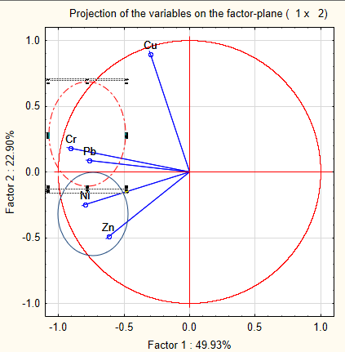
Figure 10: Circle of correlation of PCA on soil chemical parameters

3.5 Spatial Analysis
Contour maps have long been used for environmental studies because of the visualization of pollution (Rohde et al., 2015). The surfer software was used to produce kriged maps to show the spatial dispersion of the heavy metals As, Cu, Mn, Pb and Ni. Arsenic distribution in kambele is uneven. There are areas of high concentrations with values above the background value for arsenic concentration in soil. It is important to note that only one sample had concentrations exceeding the IASS guideline value (30). Figure 11 shows the spatial dispersion of Arsenic in the study area.
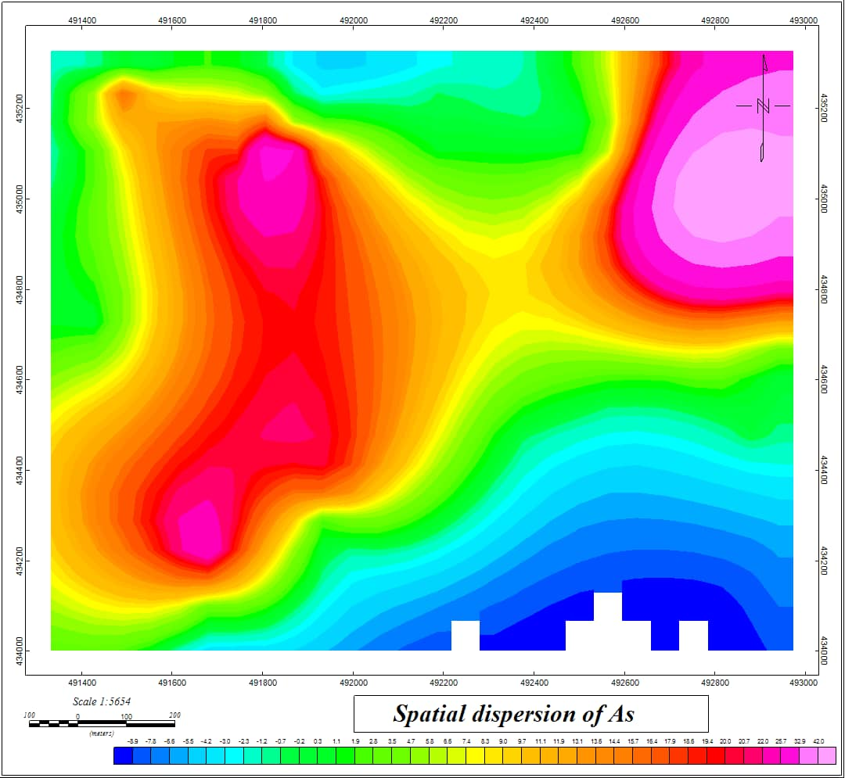
Figure 11: Spatial dispersion of arsenic in Kambele.
Variation of copper followed an irregular trend. Copper concentration in the study area shows very high dispersion varying from 18-484ppm. Copper concentrations were all above the WHO limit (100), IASS limit (5100) as well as above the geochemical background value (45). The blue colour shows less concentration as compared to purple and pink colours which are areas of very high concentrations as displayed in figure 12.

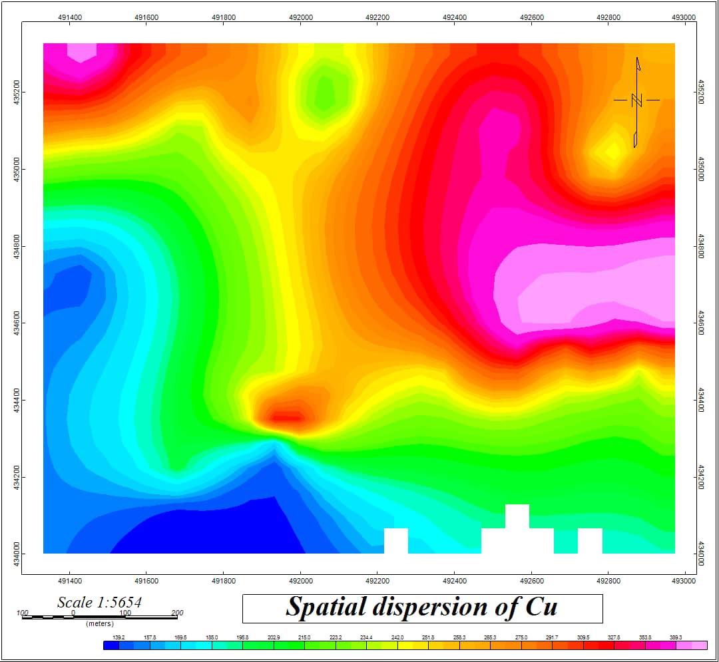
Figure 12: Spatial dispersion of Copper.
Iron is one of the most abundant elements in the earth’s crust. The geology of Kambele shows that soils in this area are highly ferralitic accounting for the high concentrations in the study area as displayed by figure 13.
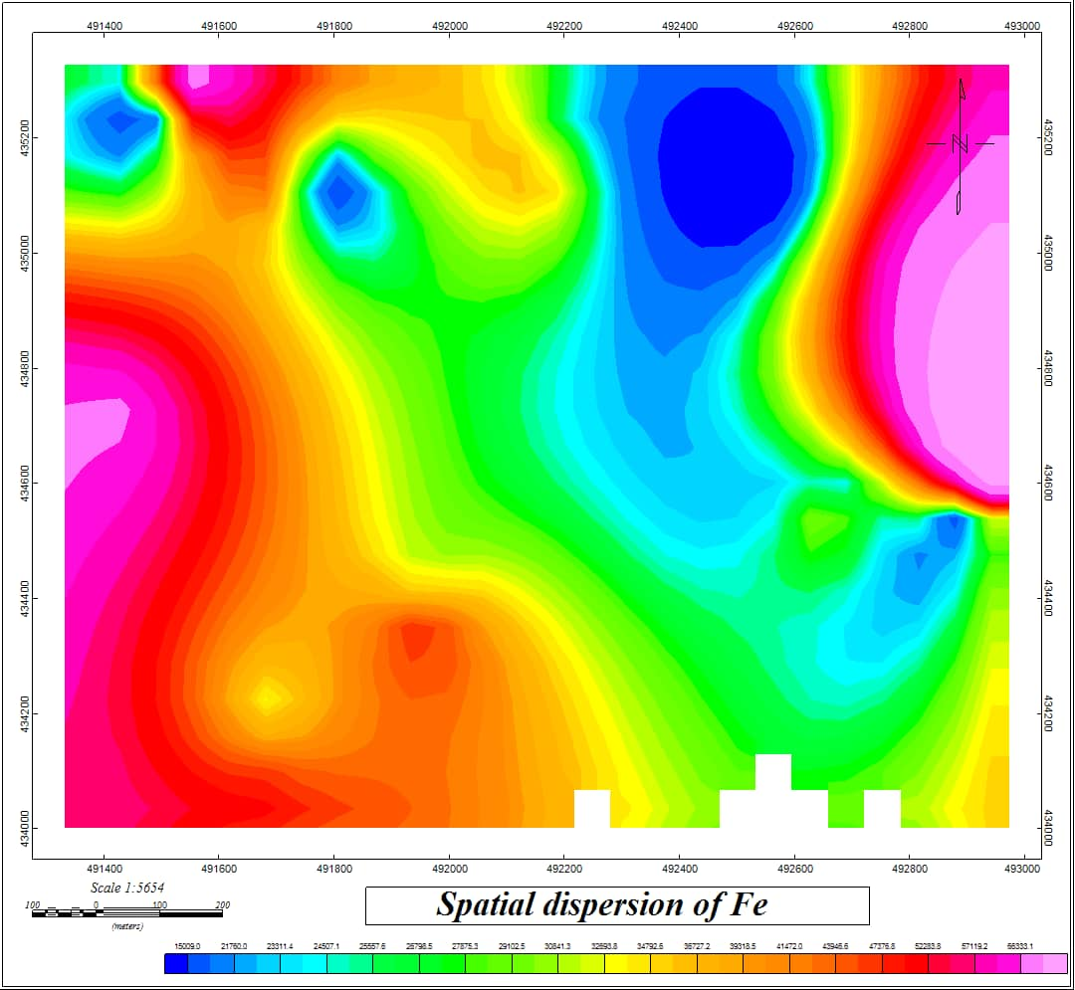
Figure 13: Spatial dispersion of iron
Spatial distribution of manganese shows that concentrations vary from 0 to 770ppm. These observations show that some of the soil samples are greatly above the IASS permissible limit (500) red colour in the figure 14, above the geochemical background (600) pink, purple and below the WHO permissible limit for industrial soils as displayed in figure 14.
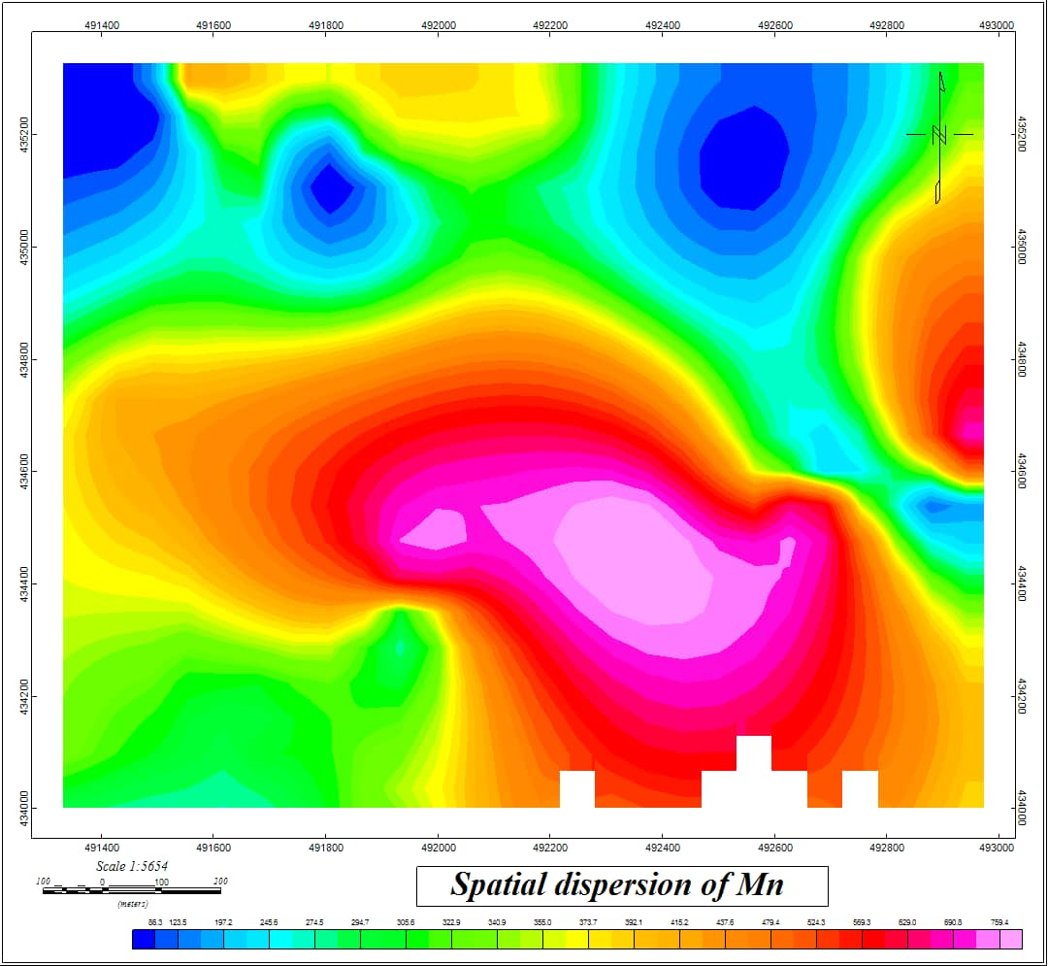
Figure 14: Dispersion of Manganese in Kambele.
Lead varied very slightly in some parts of the study area and greatly in others. Generally, lead concentrations were below the WHO and IASS permissible limits. Figure 15 shows spatial dispersion of lead in Kambele study area.
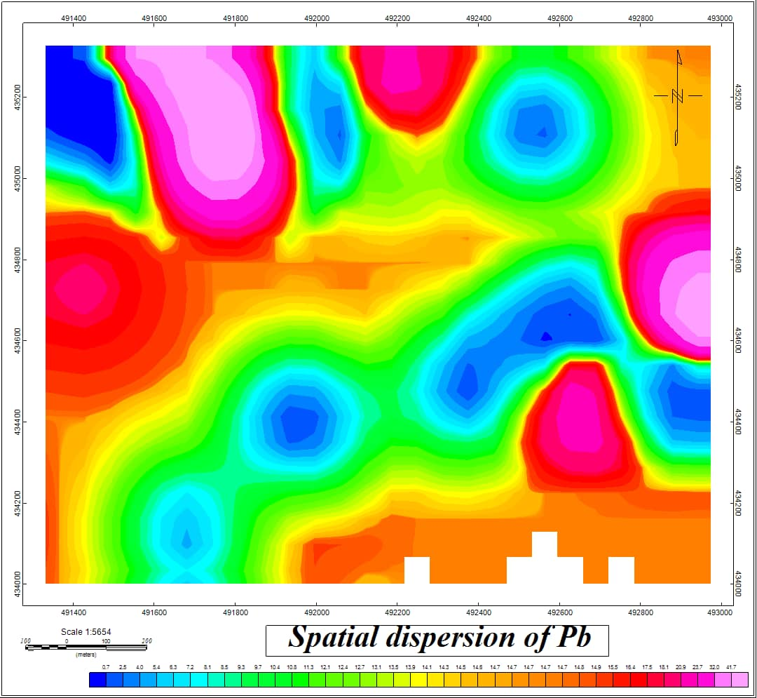
Figure 15: Dispersion of Lead.
Figure 16 depicts the distribution of zinc in the study area. Areas of very high concentrations can be seen in red, purple and pink while areas of mild concentrations are represented in blue and green.
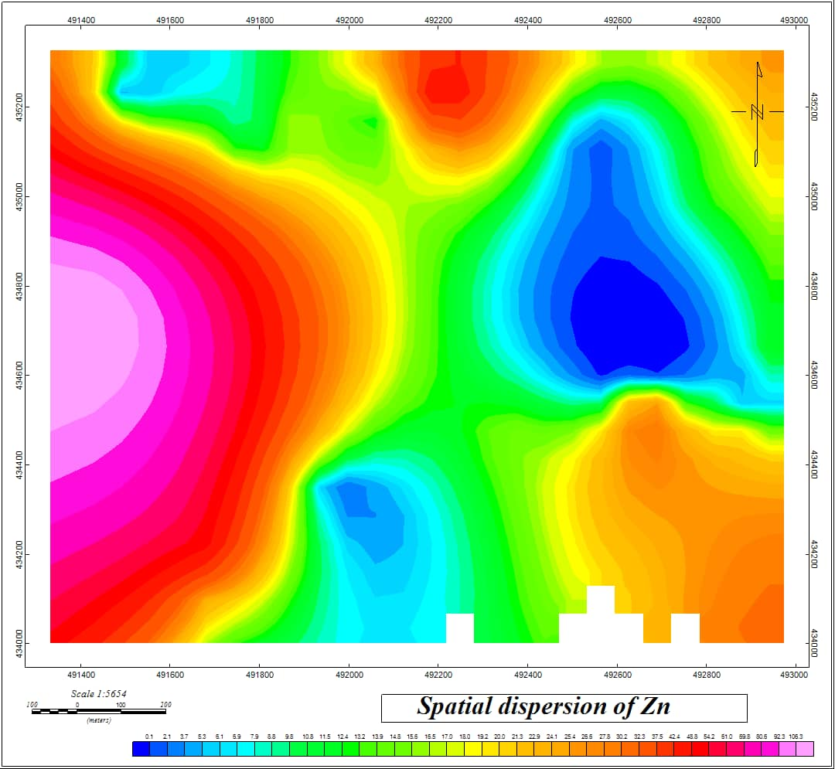
Figure 16: Zinc spatial dispersion.

CONCLUSION
This work focused on the physico-chemical characterisation of soil in the Kambele mining site. Physical parameters showed that, the pH in our study area ranged between 5.12 and 6.22 which is in the acidic scale of pH. These values suggests that, soil in the Kambele mining site is not the best for agricultural activities. Soil Organic matter was high at some points and low at others. High values of soil organic matter accounts for high concentration of heavy metals. Chemical parameters Zn, Pb and Mn were the only heavy metals amongst the selected heavy metals studied in the zone whose average concentrations were below the WHO permissible limit. Assessment of soil heavy metals by the use of pollution indices revealed that the soil in the Kambele mining site is contaminated and polluted to some extent depending on the index calculated. Statistical and spatial analysis showed that, soil in the mining site show great discrepancy with high dispersion of the various analysed parameters. The matrix of correlation shows that the elements are interrelated although there is a possibility of great dispersion. Principal component analysis revealed that projection of Cr, Mn, Fe, Ni, Cu, Zn, As and Pb on the F1 and F2 planes shows principal component 1 explains 49.93% of the data variance and principal component 2 accounts for 22.90%. Kriged maps produced indicated high and low concentrations of heavy metals in our study area. This reveals high dispersion and mobility of these metals on the site. The soil in the zone is contaminated and it’s a call for concern due to the fact that vegetables and crops cultivated on heavy metals polluted sites can take up heavy metals (if pollutant bioavailability is high) greater than the maximum permissible limits and consequently may induce serious public health implications.

Statements and Declarations:
Funding Declaration:
This research received no specific grant from any funding agency in the public, commercial, or not-for-profit sectors.
Author Contributions:
SOP TAMO Berthelot : study conception and design, acquisition of data, analysis and interpretation of data and drafting of the manuscript ; MEFOMDJO FOTIE Blanche : methodology, analysis and interpretation of data, writing - review and editing ; OTIA KAKWOUN Yvette : methodology, writing review and editing ; TARKWA Jean Baptiste : writing-review and editing ; TCHUIKOUA Louis Bernard : Writing - review and editing ; MAMBOU NGUEYEP Luc Leroy : writing - review and editing.
Competing Interests:
The authors declare that they have no known competing financial interests, personal relationships, or professional affiliations that could have influenced the work reported in this manuscript. No funding, grants, or other support was received from any organization or entity with a direct or indirect interest in the subject matter of this article.
Data and Code Availability:
Not Applicable.
Supplemantary Information:
Not Applicable.
Ethical Approval:
Not Applicable.
Open Research
We did not use any new data.
The software used are:
- Pack office (https://www.microsoft.com/fr-fr/microsoft-365) : for typewriting and calculations;
- ArcGIS (https://www.esri.com/fr-fr/arcgis/products/arcgis-pro/overview) and Google Earth (https://www.google.com/earth/versions/): for map production;
- Surfer (https://www.goldensoftware.com/products/surfer): for spatial distribution;
- Statistica (https://www.tibco.com/products/tibco-statistica): for statistical analysis.

REFERENCES
Abdullateef, J., Agbaji1, E.B., Ajibola1, V.O., Funtua, M.A., (2020). Application of Pollution Load Indices, Enrichment Factors,Contamination Factor and Health Risk Assessment of soils. Open J Anal Bioanal Chem. 4(1), 011-019.
Abhijit, M., Maiti, R., (2018). Geochemical contamination in the mine affected soil of Raniganj Coalfield–A river basin scale assessment. Geoscience Frontiers, 9(5), 1577-1590.
Abrahim, G.M.S., Parker, R. J., ( 2008). Assessment of heavy metal enrichment factors and the degree of contamination in marine sediments from Tamaki Estuary, Auckland, New Zealand. Environmental Monitoring and Assessment. 136, 227–238.
Adamu, C.I., Nganje, T.N., (2010). Heavy metal contamination of surface soil in relationship to land use patterns: A case study of Benue State, Nigeria. Materials Sciences and Applications. 1, 127–134.
Adenuga, A.A., Olufemi, D.A., Olajide, O.D., Eludoyin, A.O., Idowu, O.O., (2022). Environmental impact and health risk assessment of potentially toxic metals emanating from different anthropogenic activities related to E-wastes. Heliyon. 8(8), e10296.
Affum, A.O., Osae, S.D., Kwaansa-Ansah, E.E., Miyittah, M.K., (2020). Quality assessment and potential health risk of heavy metals in leafy and non-leafy vegetables irrigated with groundwater and municipal-waste-dominated stream in the Western Region, Ghana. Heliyon. Volume 6 (12), e05829.
Awasthi, G., Nagar, V., K.K., Rajput, V., Bauer, T., Srivastava, S., (2022). Sustainable Amelioration of Heavy Metals in Soil Ecosystem:Existing Developments to Emerging Trends. Minerals. 12, 85.
Axtmann, E.V., Luoma, S.N., (1991). Large-Scale Distribution of Metal Contamination in the Fine-Grained Sediments of the Clark Fork River, Montana, U.S.A. Applied Geochemistry . 6, 75-88.
Ayiwouo, M.N., Mambou, L.L.N., Takougang, S.K., Ngounouno, I., (2022). Spatio‑temporal variation and assessment of trace metal contamination in sediments along the Lom River in the gold mining site of Gankombol (Adamawa Cameroon). Environmental Earth Sciences. 81(379), 1-20.
Babelewska, A., (2010). The impact of industrial emissions on heavy metal and sulphur contamination level within the area of the projected Jurassic National Park. Pra˛dnik Studies and Reports of the Prof Władysław Szafer Museum. 20, 135–145.
Baby, J., Raj, J.S., Biby, E.T., Sankarganesh, P., Jeevitha, M.V., Ajisha, S.U., Rajan, S.S., (2010). Toxic effect of heavy metals on aquatic environment. Int. J. Biol. Chem. Sci. 4, 939-952.
Bade, R., Oh, S., Shin, W., Hwang, I., (2013,). Human health risk assessment of soils contaminated with tal(loid)s by using DGT uptake: A case study of a former Korean metal refinery site. Hum.Ecol. Risk Assessment , 19, 767–777.
Baird, C., Michael, C., (2012). Environmental chemistry. Fifth Edition. Macmillan Higher Education.
Baker, D.E., Alloway, B.J., (2000). Analysis of heavy metals in soil. Int. J. Agric. Policy Res. 1(2), 151-196.
Bhargava, A., Carmona, F.F., Bhargava, M., Srivastava, S., (2012.). Approachesforenhanced phytoextractionofheavymetals. J.Environ.Manage. 105,103–120.
Banunle, A., Fei-Baffoe, B., Otchere, K.G., (2018). Determination of the Physico-Chemical Properties and Heavy Metal Status of the Tano River along the Catchment of the Ahafo Mine in the Brong-Ahafo Mine. Ghana. J Environ Anal Toxicol. 8(3), 2-11.
Brady D, Duncan J.R., (1994). Bioaccumulation of metal cations by Saccharomyces cerevisiae. Applied Microbiology and Biotechnology. 41, 149-154.
Buss, H.L., Sak, P.B., Webb, S.M., Brantley, S.L., (2008). Weathering of the Rio Blanco quartz diorite, Luquillo Mountains, Puerto Rico: Coupling oxidation, dissolution, and fracturing. Geochimica et Cosmochimica Acta 72, 4488-4507.
Caeiro, S., Costa, M.H., Ramos, T.B., Fernandes, F., Silveira, N., Coimbra, A., Painho, M., (2015). Assessing heavy metal contamination in Sado Estuary sediment: An index analysis approach. Ecol. Indicators. 5, 151-169.
Carter, M.R., Gregorich E.G., (2008). Soil Sampling and Methods of Analysis. Second Edition, CRC Press Taylor & Francis Group. 1-173.
Caspah, K.M., Manny, M., Morgan, M., (2016). Health risk assessment of heavy metals in soils from witwatersrand gold mining basin, South Africa. Int.J. Environ. Res. Public Health. 13, 663.
Castaing, C. Feybesse, J.L., Thiéblemont, D., Triboulet, C., Chèvremont, P., (1994). Palaeogeographical reconstructions of the Pan-African/Brasiliano orogen: closure of an oceanic domain or intracontinental convergence between major blocks. Precambrian Research. 69, 1-4.
Cazalet, M.L., (2012). Caractérisation physico-chimique d’un sédiment marin traité aux liants hydrauliques : Évaluation de la mobilité potentielle des polluants inorganiques. Thèse de Doctorat de l'Institut National des Sciences Appliquées de Lyon, 1-226.
Chiffoleau, J.F., Claisse, D., Cossa, D., Ficht, A., Gonzalez, J.L., Guyot, T., Michel, P., Miramand, P., Oger, C., Petit, F., (2001) La contamination métallique. Programme scientifique Seine-Aval, 8-La contamination métallique. ALT Brest, 1-39.
Chiroma, T.M., Ebewele, R.O., Hymore, F.K., (2014). Comparative assessement of heavy metal levels in soil, vegetables and urban grey waste water used for irrigation in Yola and Kano. Int.Ref. J. Eng. Sci. 3: 1-9.
Chukwu, A., Oji, K., (2018). Assessment of Pb, Zn, As, Ni, Cu, Cr and Cd in Agricultural Soils around Settlements of Abandoned Lead-Zinc Mine in Mkpuma Ekwoku, South-eastern, Nigeria. J. Appl. Sci. Environ. Manage. 22 (9) 1485 –1488.
Cossa, D., (1989). Cadmium in Mytilus Spp: Worldwide Survey and Relationship between seawater and Mussel Content. Marine environmental research. 26(4), 265-284.
Crentsil, B.K., EWUSI, A., (2016). Heavy metals contamination and human health risk assessment around Obuasi gold mine in Ghana. Environ. Monit. Assess. 188, 261-261.
Crundwell, F.K. (2014). The mechanism of dissolution of minerals in acidic and alkaline solutions: Part I - A new theory of non-oxidation dissolution. Hydrometallurgy 149, 252-264.
Csavina, J., Field, J., Taylor, M., Gao, S., Landázuri, A., Betterton, E., Sáez, A.E., ( 2012). A review on the importance of metals and metalloids in atmospheric dust and aerosol from mining operations. Sci. Total Environ. 433, 58–73.
Dallou, G.B., Louis, N., Abdourahimi, D. B., Saïdou, N.N.I., Boniface K., Godfroy K., (2018). Environmental Pollution by Heavy Metals in the Gold Mining. American Journal of Environmental Sciences. 14 (5), 212-225.
Dong, X., Li, C., Li, J., Wang, J., Liu, S., & Ye, B. (2010,). A novel approach for soil contamination assessment from heavy metal pollution: A linkage between discharge and adsorption. . J. Hazard. Mater. , 175, 1022–1030.
Emmanuel, A., Cobbina, S. J., Adomako, D., Duwiejuah, A. B., Asare, W., (2014). Assessment of heavy metals concentration in soils around oil filling and service stations in the Tamale Metropolis. Afri.J. Environ. Sci. Techn. 8, 256-266.
Ezeh H.N., Chukwu E., (2011). Small scale mining and heavy metals pollution of agricultural soil. Nig. J. Geol. Mining Res.3(4), 87-104.
Fijałkowski, K., Kacprzak, M., Grobelak, A., Placek, A., (2012). The Influence of Selected Soil Parameters on the Mobility of Heavy Metals in Soils. . Inzynieria i Ochrona Srodowiska. 5, 81-92.
Funoh, K. (2014). The impacts of artisanal gold mining on local livelihoods and the environ,ent in the forested areas of cameroun. Working paper 150. CIFOR. 25-26.
IARC Monographs on the Evaluation of Carcinogenic Risks to Humans (2012). Arsenic, Metals, Fibers and Dust. Vol. 100C. In: International Agency for Research on Cancer, Lyon, France, 46-53.
Gao, J., Du, F., Li, W., Han, J., Wang, X., Bao, J., Fan, A.P., (2016). Content and accumulation characteristics of heavy metals in dominant plants in Xiao Bai He Area of the Yellow River Wetland. . J Agro-Environ Sci. 35 (11), 2180–2186.
Garnier, J., Quantin, C., Echevarria, G., Becquer, T., (2009). Assessing chromate availability in tropical ultramafic soils using isotopic exchange kinetics. Journal of Soils and Sediments. 9(5), 468–475,.
Getaneh, W., Alemayehu, T., (2006 ). Metal contamination of the environment by placer and primary gold mining in the Adola region of southern Ethiopia. Environmental Geology, , 50(3), 339-352.
Gong, Q., Jun, D., Yunchuan, X., Qingfei, W., Liqiang, Y., (2008). Calculating pollution indices by heavy metals in ecological geochemistry assessment and a case study in parks of Beijing. Journal of China University of Geosciences. 19, 230–241.
Gupta, A.K., Sinha, S., (2007). Phytoextraction Capacity of the Plants Growing on Tannery Sludge Dumping Sites. Bioresource Technology. 98, 1788-1794.
Gyamfi, E., Appiah-Adjei, E.K., Adjei, K.A., (2019). potential heavy metal illution of soil and water resources from artisanal mining in Kokoteasua, Ghana. ground water for sustainable development, 8,450-456.
Hakanson, L., (1980). An Ecological Risk Index for Aquatic Pollution Control, a Sediment-Ecological Approach. Water. 14, 975-1001.
Jamilu, S.E., Ntale, M., Origa, H.O., (2014). Physico-Chemical Characteristics of Copper Tailings and Pyrite Soils in Western Uganda: Implication for Phytoremediation.. International Journal of Environmental Monitoring and Analysis. 2(4), 191-198.
Jiang, X., Lu, W.X., Zhao, H.Q., Yang, Q.C., Yang, Z.P., (2014). Potential ecological risk assessment and prediction of soil heavy-metal pollution around coal gangue dump. Nat. Hazards Earth Syst. Sci.14, 1599–1610.
Kabir S.A., Hassan, M.S., Abbas, M.A., Kura, A.M., (2017). Assessment of heavy metals contamination of soil and water around abandoned Pb-Zn mines in Yelu, Alkaleri Local Government Area of Bauchi State, Nigeria. Research Journal of Public and Environmental Health, 4(5), 72-77.
Khan, M. N., Wasim, A.A., Sarwar, A., Rasheed, M.F., ( 2011). Assessment of heavy metal toxicants in the roadside soil along the N-5, national highway, Pakistan. . Environ. Monit. Assess. 182, 587–595.
Kim, H., Cho, K., Purev, O., Choi, N., Lee, J., (2022). Remediation of Toxic Heavy Metal Contaminated Soil by Combining aWashing Ejector Based on Hydrodynamic Cavitation and Soil Washing Process. Int. J. Environ.Res. Public Health. 19, 786.
Kloke, A. (1979). Content of arsenic, cadmium, chromium,fluorine, lead, mercury, and nickel in plants grown on contaminated soils, United Nations-ECE symposium, Geneva. 51–53.
Kong, M., Huang, L., Li, L., Zhang, Z., Zheng, S., Wang, M. (2014). Effects of oxalic acid and citric acids on the tree clays mineral after incubation. Apply clay science. 99, 207-124.
Lazo, D.E., Dyer, L.G. , Alorro, R.D., (2017). Silicate, phosphate and carbonate mineral dissolution behaviour in the presence of organic acids: A review. Minerals Engineering. 100, 115-123.
Lee, P.K., Yu, S., Jeong, Y.-J., Seo, J., Choi, S., & Yoon, B.-Y. ( 2019). Source identification of arsenic contamination in agricultural soils surrounding a closed Cu smelter, South Korea. . Chemosphere. 217, 183–194.
Léopold, E. N., Sabine, D. D., Jung, M. C., (2016). Physical and Metals Impact of Traditional Gold Mining on Soils in Kombo-Laka Area (Meiganga, Cameroon). International Journal of Geosciences. 7, 1102-1121.
Li, W., Wang, F., Yang, W., Cui, Y., Fan, A., Miao, C., (2017). Pollution assessment and source apportionment of heavy metals in NanHai Wetland soil of Baotou City. Ecology Environ Sci. , 26(11),1977–1984.
Long, E.R., MacDonald, D.D., Smith, S.L., Calder, F.D. (1995). Incidence of adverse biological effects within ranges of chemical concentrations in marine and estuarine. Environmental Management. 19, 81–97.
Lorenzo, F., Alonso, A., Pellicer, M.J., Pérez-Arlucea, M., (2007 ). Historical Analysis of Heavy Metal Pollution in Three Estuaries on the North Coast of Galicia (NW Spain). Environmental Geology. 52, 789-802.
Luo, T., Ding, Y., Sun, J., Zou, W., Zhou, F., ( 2018). Pollution characteristics and assessment of heavy metals in wetlandsoil in the area of northern Jiangsu Province. . Environ Chem.., 37(5), 984–993.
Mambou, N.L.L., Mache, J.R., Ayiwouo, N.M., Takougang, K.S., Abende, S.R.Y., Roukaiyatou, S., (2020). Caracterization of Mining Waste from the Betare-Oya Gold Area (East Cameroon) and an Adsorption Test by Sabga Smectite (North-West Cameroon). Scientifica . 1-12.
Mandeng, E.P.B., Bondjè-Bidjeck, L.M., Ekoa-Bessa, A.Z., Ntomb, Y.D., Wassouo-Wadjou, J., Edjengte-Doumo, E.P. Bitom D.L., (2019). Contamination and risk assessment of heavy metals, and uranium of sediments in two watersheds in Abiete-Toko gold district, Southern Cameroon. Heliyon. 5, (10), e02591.
Marta, M., Mapani, B.S., Kamona, A.F., Ružičić, S., Mapaure, I., Chimwamurombe, P.M., (2014). Assessment of agricultural soil by potentially toxic metals dispersed from improperly disposed tailings, Kombat mine. Namibia Journal of geochemical exploration. 144, 409-420.
Matini, L., Ongoka, P.R., Tathy, J.P., (2011). Heavy metals in soil on spoil heap of an abandaoned lead ore treatment plant SE Congo Brzzaville. African journal of environmental science and technology. 5(2), 89-97.
Mmaduakor, E.C., Umeh, C.T., Morah, J.E., Omokpariola, D.O., Ekwuofu, A.A., Onwuegbuokwu, S.S., (2022). Pollution status, health risk assessment of potentially toxic elements in soil and their uptake by gongronema latifolium in peri-urban of Ora-Eri, south-eastern Nigeria. Heliyon. 8(8), e10362.
Mmolawa, K B., Likuku, A.S., Gaboutloeloe, G.K.., (2011). Assessment of heavy metal pollution in soils along major roadside areas in Botswana. . African J.Environ. Sci. Technol. 5, 186-196.
Mokam, S., Aurelle, B., Tsikam, M.C., (2013). Impact de l'exploitation artisanale de l'or sur les populations de Kambele, région de l'Est Cameroun. Journal du CIMEC, 1-30.
Mominou, N., Al Issah, Y., Sarki, B., Kah, E. (2018). Physicochemical Characterisation of Soils at the Gold Exploitation Sites of Bétaré-Oya District in Cameroon and Pollution Evaluation. Open Journal of Inorganic Chemi. 81-90.
Mushtaha, A.L.İ., Elhagwa, A., Elfaki, J., Sulieman, M., (2017). Influence of the artisanal gold mining on soil contamination with heavy metals: A case study from Dar-Mali locality, North of Atbara, River Nile State. Sudan. Eurasian J. Soil Sci. 6, 28-36.
Benson, N.U., Adedapo, A.E., Fred-Ahmadu, O.H., Williams, A.B., Udosen, E.D., Ayejuyo, O.O., Olajire, A.A., (2018). New ecological risk indices for evaluating heavy metalscontamination in aquatic sediment: A case study of the Gulf of Guinea. Regional Studies in Marine Science . 18, 44–56.
Nzenti, J.P., Barbey, P., Macaudiere, J., Soba, D., (1988). Origin and evolution of the late Precambrian high-grade Yaounde gneisses (Cameroon). . Precambrian research. 38(2), 91-109.
Obiora, S.C., Chukwu, A., Toteu, S.F., Davies, T.C., (2016). Assesment of heavy metal contamination in soils around Lead (Pb) - Zinc (Zn) mining areas in Enyigba. Southeastern Nigeria. J. Geol. Soc. India. 87, 453-462.
Oyourou, J.N., McCrindle, R., Combrinck, S., Fourie, C.J.S., (2019). investigation of of Zn and Pb contamination of soil at the abandoned Ededale mine, amelodi (Pretoria South Africa) using a field portable spectrometer. Journal of southen african institute of miningg and metallurgy. 119(1), 55-62.
Pawan, K. (2012). Heavy Metals in Environment. Saarbrucken, Germany. First Edition. Lambert Academic Publishing GmbH and Co.
PCD. (2019). Plan Communal de Développement de Batouri. Commune de BATOURI BP 42.6-407.
Pejman, A., Bidhendi, G.N., Ardestani, M., Saeedi, M., Baghvand, A., (2015). A new index for assessing heavy metals contamination in sediments: A case study. Ecological Indicators. 58, 365–373.
Penaye, J., Hell, J.V., (2013). Abandoned artisanal mining sites of Eastern Cameroon: environmental problems and Cameroon legislation:. Yaounde: institute for geological and mining research. Environmental problems and Cameroon regulation. In Conférence Johannesburg.
Poidevin, A., Ngako, V., Nnange, J. M., & Njanko, T. (2003). Pan-African tectonic evolution in central and southern Cameroon: transpression and transtension during sinistral shear movements. Journal of African Earth Sciences, 36(3), 207-214.
Ramahlo, M. N. (2013). Physico-chemical and biological characterization of soils from selected farmlands around three mining sites in Phalaborwa, Limpopo province (Doctoral dissertation, University of Limpopo (Turfloop Campus)).
Rohde, R. A., Muller, R. A., (2015). Air pollution in China: mapping of concentrations and sources. PloS one.10(8), e0135749.
Rossman, T. G., (2003). Mechanism of arsenic carcinogenesis: an integrated approach. Mutation Research/Fundamental and Molecular Mechanisms of Mutagenesis,.533(1-2), 37-65.
Salati, S., Moore, F.,(2010). Assessment of heavy metal concentration in the Khoshk River water and sediment, Shiraz. Southwest Iran. Environmental monitoring and assessment.164(1), 677-689.
Sawant, S.Y., Pawar, R.R., Lee S.M., Cho M.H., (2017). Binder-free production of 3D N-doped porous carbon cubes for efficient Pb²⁺ removal through batch and fixed bed adsorption. J. Clean. Prod. 168, 290-301.
Sijin L., Wang, Y., Teng, Y., Yu, X., (2015). Heavy metal pollution and ecological risk assessment of the paddy soils near a zinc-lead mining area in Hunan. Environmental monitoring and assessment. 187(10), 1-12.
Singh, A., Harrison, A., (1985). Standardized principal components. International journal of remote sensing, , 6(6), 883-896.
Syed, R.H., Khanam, D., Adyel, T.M., Islam, M.S., Ahsan, M.A., Akbor, M.A. ( 2012). Assessment of Heavy Metal Contamination of Agricultural Soil around Dhaka Export Processing Zone (DEPZ). Bangladesh. Appl. Sci. 2, 584-601.
Tariq, J., Ahmad, N., Mashiatullah, A., (2018). Heavy Metals Contamination and Ecological Risk Assessment in Surface Sediments of Namal Lake, Pakistan. Polish journal of environmental studies, 27(2).
Taylor, S.R., McLennan, S.M., (1985). The Continental Crust: Its Composition and Evolution. Oxford.: Blackwell Scientific Publication.
Tchouankam, J. K., Bertrand, M. M., Elie-Constant, B., Bernard, T., Gilbert, N., François, A. Y. R., Jacques, K.J.E., (2020). Economic Potential of Gold in Batouri (Eastern Cameroon). Earth Science Research. 21-27.
Tchounwou, P.B., Yedjou, C.G., Patlolla, A.K., Sutton, D. J., (2012). Heavy metal toxicity and the environment. Molecular, clinical and environmental toxicology.133-164.
Tehna, N., Daniel, N. F., Jacques, E., Marc, M. E. J., Sylvie, N. T., Cheo, S. E., Paul, B., (2015). Impending Pollution of Betare Oya Opencast Mining Environment (Eastern Cameroon). Journal of Environmental Science and Engineering , 4 37-46.
Teixeira, R.A., de Souza, E.S., Ferreira, J.R., Fernandes, A.R., (2018). Potentially toxic elements in soils and contamination indices at the Serra Pelada gold mine, Para, Brazil. Bioscience Journal. 34(6), 1477-1487.
Tirmizi, S.A., Wattoo, F.H., Wattoo, M.H.S., Khokhar, M.N., Iqbal, J., (2005). Analytical investigation of soil inorganic elements in cotton cultivated areas of Vehari-Pakistan. Journal of the Chemical Society of Pakistan. 27(6), 606-610.
Tokar E.J., Benbrahim-Tallaa L., Ward J.M., Lunn R., Sams R.L., Waalkes M.P. (2010). Cancer in experimental animals exposed to arsenic and arsenic compounds. Crit. Rev. Toxicol. 40 (10), 912-927.
Tomlinson, D.L., Wilson, J.G., Harris, C.R., Jeffrey, D.W., (1980). Problems in the assessment of heavy-metal levels in estuaries and the formation of a pollution index. Helgoländer meeresuntersuchungen. 33(1), 566-575.
Toteu, S.F., Penaye, J., Djomani, Y.P. (2004). Geodynamic evolution of the Pan-African belt in central Africa with special reference to Cameroon. Canadian Journal of Earth Sciences. 41(1), 73-85.
USEPA. (2013). Toxicity Relationship Analysis Program (TRAP) version 1.22 United States Environmental Protection Agency, . Washington D.C., USA.: Division. Mid-Continent Ecology.
Van-Schmus, W.R., Oliveira, E.P., Da-Silva-Filho, A.F., Toteu, S.F., Penaye, J., Guimarães, I.P. (2008). Proterozoic links between the Borborema province, NE Brazil, and the central African fold belt. Geological Society, London, Special Publication. 294(1), 69-99.
Varol, M. (2011). Assessment of heavy metal contamination in sediments of the Tigris River (Turkey) using pollution indices and multivariate statistical techniques. Journal of Hazardous Materials. 195, 355–364.
Wang, X., Sun, Y., Li, S., Wang, H., (2019). Spatial distribution and ecological risk assessment of heavy metals in soil from the Raoyanghe Wetland, China. PLoS ONE , 14(8), e0220409.
Weihua, G., Liu, X., Liu, Z., Li, G., (2010). Pollution and Potential Ecological Risk Evaluation of Heavy Metals in the Sediments around Dongjiang Harbor, Tianjin. Procedia Environmental Sciences. 2, 729–736.
WHO. (1996.). Trace Elements in Human Nutrition and Health. Geneva, Switzerland. ISBN-13: 9241561734, 361.
Wu, J., West, L. J., Stewart, D.I., (2002). Effect of humic substances on Cu (II) solubility in kaolin-sand soil. Journal of Hazardous Materials. 94(3), 223-238.
Guan, Y., Shao, C., Ju, M., (2014). Heavy metal contamination assessment and partition for industrial and mining gathering areas. International journal of environmental research and public health. 11(7), 7286-7303.
Yu, L., Cheng, J., Zhan, J., Jiang, A., (2016). Environmental quality and sources of heavy metals in the topsoil based on multivariate statistical analyses: a case study in Laiwu City, Shandong Province, China. Natural Hazards. 81(3), 1435-1445.
Zhang, X., Zhou, T.F., Yang, X.F., Yin, H.Q., Xiao, Z.H., (2005). Study on assessment methods of heavy metal pollution in river sediments. J. Hefei Univ. Technol. 28, 1419-1423.
Zhao, Q., Qi-xin, X. U., Kai, Y., (2005). Application of Potential Ecological Risk Index in Soil Pollution of Typical Polluting Industries. Journal of Eastchina Normal University (Natural Science). 1, 110-115.
Zhou, J., Dang, Z., Cai, M., Liu, C., (2007). Soil heavy metal pollution around the Dabaoshan mine,China. International Journal of Environmental Research and Public Health. 588-594.

