An Islamic Digital Narrative Literacy Framework for Higher Education

ABSTRACT

The digitalisation of higher education has transformed assessment practices, promoting continuous engagement, real-time reporting, and increased use of digital platforms. However, existing research largely emphasises technical efficiency and student performance, while ethical dimensions of digital assessment remain insufficiently explored. This study aims to address this gap by examining students’ experiences of live-reporting assessment in community-based learning and developing a value-based framework grounded in Islamic principles. A mixed-method exploratory design was employed, involving 57 undergraduate students who participated in digitally mediated community projects. Quantitative data were collected using a Likert-scale survey to assess students’ perceptions of live reporting, while qualitative data were obtained through open-ended responses and analysed thematically. The findings indicate that live-reporting assessment is positively perceived in terms of project management, lecturer support, and relevance to workplace communication, although challenges such as anxiety and distraction were also identified. Thematic analysis revealed four key dimensions: digital accountability, reflective excellence, community stewardship, and ethical digital communication. These dimensions were interpreted through the principles of Amanah, Ihsan, and Khalifah. Based on these findings, the study proposes the Progressive Islamic Digital Narrative Literacy Framework, which integrates Islamic ethical values with digital narrative practices to support responsible, reflective, and value-driven digital assessment in higher education. This framework contributes to advancing ethical digital literacy by positioning moral responsibility as central to technology-mediated learning.

Keywords: Amanah, Digital Assessment, Digital Narrative Literacy, Progressive Islamic Thought

INTRODUCTION

The rapid expansion of digital learning in higher education has significantly transformed assessment practices, student engagement, and modes of participation. Contemporary assessment increasingly emphasises real-time interaction, continuous evaluation, and the use of digital platforms that facilitate collaboration. This shift moves away from traditional high-stakes examinations towards ongoing and formative assessment practices (Chen, 2024; Ramdana et al., 2026). However, existing research predominantly focuses on technological competencies, student engagement, and academic outcomes, while the ethical dimensions of digital assessment remain insufficiently explored. Issues such as fairness, responsibility, and ethical online behaviour often receive limited attention compared to concerns about efficiency and performance (Kayyali, 2024; Zhou et al., 2025).

From an Islamic perspective, education extends beyond knowledge transmission to encompass character development and moral responsibility (Al-Attas, 1991). Classical scholars such as Al-Ghazali emphasised the integration of intellectual and spiritual development in fostering ethically grounded individuals. Accordingly, the integration of digital technologies in education should also support moral growth and social responsibility (Rahman, 1982; Putra et al., 2025). Core principles such as trustworthiness, excellence, and social responsibility provide a normative framework for guiding student behaviour in digital learning environments. Nevertheless, the application of these principles within contemporary digital assessment contexts remains underexplored.

At the same time, Digital Narrative Literacy (DNL) has emerged as an important approach for developing students’ abilities to construct and interpret meaning through digital storytelling (Gidor et al., 2024). While DNL enhances communication skills and creative expression, existing approaches tend to prioritise technical and narrative competencies while giving less attention to the ethical implications of digital content creation. As a result, there remains a conceptual gap between Islamic ethical frameworks and contemporary DNL practices, with limited integration between these domains.
To address this gap, this study proposes the Progressive Islamic Digital Narrative Literacy Framework (PIDNLF), which integrates Islamic ethical principles with digital narrative practices. By examining students’ experiences of live-reporting assessment in community-based learning, the study explores how accountability, reflective thinking, and communication can be aligned with the principles of Amanah, Ihsan, and Khalifah. The study aims to demonstrate how digital assessment can be guided by a value-based framework that promotes ethical awareness, responsible participation, and reflective learning in higher education.

Research Problem and Objectives

Digital assessment is increasingly prominent in higher education; however, existing research largely emphasises technological adoption, student engagement, and academic performance (Chen, 2024; Ramdana et al., 2026). Similarly, studies on digital literacy and storytelling prioritise technical and communication skills while giving limited attention to ethical dimensions (Gidor et al., 2024; Zhou et al., 2025). In contrast, Islamic educational principles such as Amanah, Ihsan, and Khalifah emphasise moral responsibility and character development (Ahmad, 2025; Mirawati, 2025), yet their application within digital assessment contexts remains underexplored.

This study addresses this gap by developing the Progressive Islamic Digital Narrative Literacy Framework (PIDNLF). It examines students’ experiences with live-reporting assessment in community-based learning and interprets these through the principles of Amanah, Ihsan, and Khalifah. The objectives are:

- To examine students’ experiences of live-reporting assessment;
- To identify themes related to accountability, reflection, social responsibility, and digital communication;
- To analyse these themes using Islamic ethical principles; and
- To integrate the findings in developing the PIDNLF.

Importance and Significance of the Study

This study advances Digital Narrative Literacy by foregrounding ethical engagement, accountability, and responsible digital participation beyond technical competencies (Hendawi, 2024; Putra et al., 2025). It also contributes to Progressive Islamic education by demonstrating the applicability of Amanah, Ihsan, and Khalifah within contemporary digital learning environments (Mirawati, 2025; Supaat, 2026). The proposed PIDNLF integrates Islamic ethical principles with digital assessment practices and provides practical guidance for educators and curriculum developers in fostering accountability, reflective excellence, and social responsibility (Kayyali, 2024; Ramdana et al., 2026).

Research Questions

This study addresses the following research questions:

- How do students perceive live-reporting assessment in community-based learning?
- What key themes related to accountability, reflection, social responsibility, and digital communication emerge from students’ experiences?
- How can these themes be interpreted through the principles of Amanah, Ihsan, and Khalifah?
- How can these insights inform the development of a value-based digital assessment framework in higher education?

Literature Review
Classical and Progressive Foundation of Islamic Education

Islamic educational philosophy conceptualises education as an integrated process that combines intellectual development, ethical formation, spiritual awareness, and social responsibility. It does not separate knowledge acquisition from moral character; rather, it aims to cultivate individuals who are both knowledgeable and ethically responsible. Al-Ghazali emphasised that knowledge and moral refinement are interdependent, fostering self-awareness and guiding responsible action. Accordingly, educational success is not measured solely by cognitive achievement, but also by the ethical conduct that knowledge produces (Al-Ghazali, 2015). Similarly, Al-Attas (1991) posits that the primary goal of education is the cultivation of adab, which integrates knowledge, values, and responsibility within a coherent moral framework. Education, therefore, extends beyond the transmission of information to the formation of character. In addition, Al-Faruqi (1982) argues for the integration of modern science and technology with Islamic ethical principles through the Islamisation of knowledge. He rejects the notion of value-neutral knowledge and maintains that intellectual and technological advancement must be guided by moral considerations. These classical perspectives are further developed within Progressive Islamic Thought. Rahman (1982) advocates a dynamic interpretation of Islamic principles that remains faithful to core values while responding to changing social contexts. Contemporary scholars similarly emphasise the need to revitalise Islamic education in light of rapid digital transformation, ensuring that technological advancement does not compromise ethical and moral development (Mirawati, 2025; Putra et al., 2025). Collectively, these perspectives highlight the interconnection between knowledge, ethics, and social responsibility within Islamic education. However, while these foundational theories provide strong ethical guidance, they offer limited direct engagement with contemporary digital learning environments. As such, there is a need to reinterpret and extend these principles to address the ethical challenges emerging in technology-mediated education.

Amanah as a Framework for Digital Accountability

Amanah, a central concept in Islamic thought, refers to trustworthiness, accountability, responsibility, and honesty. Within Islamic education, it is closely associated with adab, which encompasses the fulfilment of responsibilities toward God, oneself, and others (Al-Attas, 1991). Practising Amanah extends beyond compliance with rules and involves the consistent demonstration of ethical conduct. Contemporary scholars increasingly conceptualise accountability as a key dimension of Amanah, linking it to individual behaviour in educational contexts (Ahmad et al., 2025; Muharromah, 2025). With the increasing integration of digital technologies in higher education, ensuring accountability in learning and assessment processes has become increasingly important. Digital tools enable the tracking of student participation and contributions, thereby enhancing transparency (Chen, 2024). Empirical studies suggest that such transparency strengthens accountability by providing accessible records of student activity, including digital logs and timestamped submissions, which encourage responsibility and engagement (Ramdana et al., 2026). However, a significant gap remains. Research on digital accountability often focuses on technological or managerial aspects, whereas discussions of Amanah emphasise moral and character development. As a result, the ethical dimensions of digital accountability are insufficiently integrated. In contexts such as live-reporting assessment, where students continuously document their activities, these practices may reflect the principles of Amanah, yet the relationship between the two perspectives remains underexplored.

Ihsan and Reflective Excellence in Digital Learning

Ihsan is commonly defined as the pursuit of excellence, sincerity, and continuous self-improvement. In Islamic thought, it reflects a heightened level of ethical awareness characterised by discipline, quality, and refinement. Educational processes are therefore expected to cultivate individuals who demonstrate strong moral character, self-regulation, and responsible conduct, as emphasised by Al-Attas (1991). Within educational contexts, Ihsan promotes deep reflection and continuous improvement beyond minimum performance standards. Contemporary educational research emphasises reflective, self-regulated, and lifelong learning. Studies indicate that reflective thinking enhances students’ critical awareness and understanding (Kayyali, 2024; Zhou et al., 2025). When students review what they've learned and plan how to improve, they take control of their education. Digital assessments enhance reflective learning by maintaining learning records, utilising digital portfolios, and providing immediate feedback. This keeps students thinking and improving throughout the course, not just at the end. Ihsan and reflective learning share key similarities where they focus on self-awareness, growth, and excellence. However, most research views reflective learning mainly as a mental skill. Also, studies on Ihsan rarely look at how it fits into digital learning settings. There's a theoretical gap on how digital assessments can boost Ihsan-related behaviors. Looking into this could provide insight into the ethical sides of reflective learning in tech-driven education.

Khalifah, Civic Engagement, and Digital Citizenship

Digital assessment is increasingly prominent in higher education; however, existing research largely focuses on technological adoption, student engagement, academic performance, and digital competencies (Chen, 2024; Ramdana et al., 2026). Limited attention has been given to how these assessment practices influence ethical values, civic responsibility, and notions of good citizenship in digital environments. Within Islamic thought, the concept of Khalifah emphasises stewardship, social responsibility, and the obligation to contribute positively to society. Education, therefore, is not solely concerned with the acquisition of knowledge but also with the application of that knowledge for the benefit of the wider community. Al-Attas (1991) asserts that education should prepare individuals to fulfil their social responsibilities through the integration of knowledge, ethics, and adab. This emphasis on societal engagement is consistent with contemporary educational approaches such as service learning, community-based learning, and civic engagement. Empirical studies demonstrate that linking academic learning to real-world problem-solving fosters key competencies, including leadership, empathy, critical thinking, and social responsibility (Supaat, 2026). In parallel, digital technologies have redefined civic participation, giving rise to the concept of digital citizenship, which emphasises ethical online communication, critical information engagement, and responsible participation in digital spaces (Ramdana et al., 2026). Although Khalifah and digital citizenship share a common emphasis on responsibility and societal contribution, they originate from distinct conceptual frameworks. Digital citizenship predominantly focuses on practical skills and behavioural guidelines within digital environments, whereas Khalifah provides a broader ethical orientation rooted in moral accountability and stewardship. As such, Khalifah offers a deeper normative foundation that extends beyond functional competencies. Despite this compatibility, limited research has explored how Khalifah can inform contemporary digital engagement, particularly within educational contexts. This gap is especially significant in community-based learning environments, where students utilise digital technologies to document activities, communicate findings, and engage with stakeholders. Integrating Khalifah with digital citizenship perspectives may therefore provide a more comprehensive framework for ethical digital participation, particularly in socially oriented learning contexts.

Digital Narrative Literacy Beyond Technical Competence

Digital Narrative Literacy (DNL) plays a significant role in understanding and shaping communication within contemporary digital environments. It extends beyond basic technical proficiency to include the ability to construct, interpret, and communicate meaning through digital narratives. This encompasses storytelling, multimodal composition, audience awareness, and purposeful content creation (Gidor et al., 2024). Empirical research indicates that DNL enhances communication competence, supports professional identity development, fosters creativity, and contributes to graduate employability (Kayyali, 2024). Furthermore, digital storytelling facilitates reflective learning by enabling individuals to organise and articulate experiences in coherent and meaningful ways (Zhou et al., 2025). Recent scholarship on digital literacy also highlights the importance of critical participation, ethical engagement, and digital citizenship (Jenkins et al., 2009; Ribble, 2015; Selwyn, 2016). These perspectives recognise digital interaction as a value-laden practice shaped by social and ethical considerations, thereby providing a foundation for integrating ethical principles within digital literacy frameworks. However, such approaches often lack explicit engagement with deeper moral and philosophical foundations that underpin ethical behaviour in digital contexts. Despite its contributions, existing DNL research continues to prioritise communication effectiveness, technical skills, and narrative construction, with comparatively limited attention given to accountability, moral responsibility, social stewardship, and value formation. As a result, current DNL frameworks offer insufficient guidance on how ethical principles should inform digital communication practices. This limitation is particularly significant within educational contexts, where digital narratives increasingly function as assessment tools, platforms for public communication, and representations of community engagement. In such contexts, the construction and dissemination of digital content require not only technical competence but also ethical awareness. Therefore, a more comprehensive approach to DNL is needed one that integrates narrative competence with ethical principles to support responsible and meaningful digital participation.

Conceptual Gap and Theoretical Positioning

The literature review indicates that both Islamic educational philosophy and Digital Narrative Literacy (DNL) aim to cultivate learners who are responsible, reflective, and socially engaged. However, these domains have largely evolved independently, with limited theoretical integration. Islamic ethical concepts such as Amanah, Ihsan, and Khalifah emphasise accountability, reflective excellence, and social responsibility, whereas DNL primarily focuses on communication competence, narrative construction, and digital engagement. While these perspectives address complementary dimensions of learner development, they remain insufficiently connected in current scholarship. Existing DNL frameworks tend to prioritise technical and communicative aspects of digital participation, with comparatively limited attention to ethical and moral considerations. Conversely, Islamic educational discourse provides a robust ethical foundation but has not been extensively applied to contemporary digital learning and assessment contexts. This separation results in a significant conceptual gap in understanding how ethical principles can inform responsible digital engagement and technology-mediated learning practices. To address this gap, this study proposes the Progressive Islamic Digital Narrative Literacy Framework (PIDNLF). The framework is grounded in the educational philosophies of Al-Ghazali and Al-Attas, which emphasise moral development, adab, and the integration of knowledge with ethical responsibility. It is further informed by the contributions of Al-Faruqi, Fazlur Rahman, and An-Na’im, who advocate the contextualisation of Islamic principles within contemporary social and intellectual environments. Within this framework, Digital Narrative Literacy serves as the practical medium through which ethical principles are enacted in digital learning contexts. By integrating Amanah, Ihsan, and Khalifah with DNL, the PIDNLF offers a conceptual model that reconceptualises digital assessment as a value-oriented practice. Rather than viewing digital assessment as a purely technical process, the framework positions it as an ethically embedded activity that promotes accountability, reflective practice, social responsibility, and meaningful participation in digital environments.

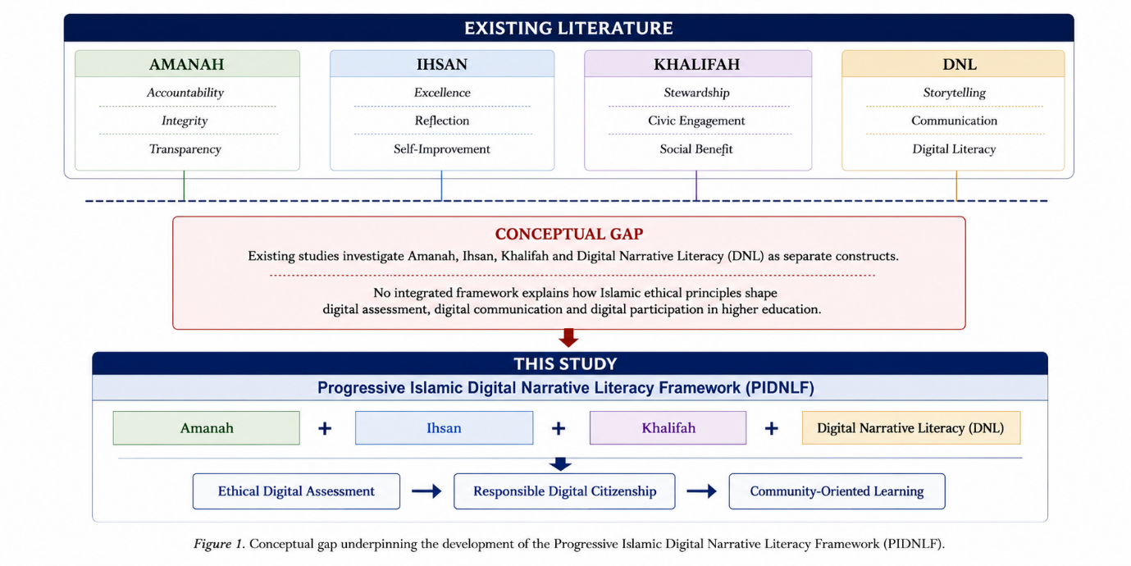
Figure 1. Conceptual Gap Underpinning the Development of the Progressive Islamic Digital Narrative Literacy Framework (PIDNLF)

This gap highlights the need for an integrated framework that connects ethical principles with digital literacy practices in contemporary higher education.

Framework Development

The literature review indicates that Islamic educational philosophy and Digital Narrative Literacy (DNL) both aim to develop responsible, reflective, and socially engaged learners. However, these traditions have largely evolved independently, resulting in limited integration between ethical frameworks and contemporary digital learning practices. Existing discussions on ethics in digital education remain fragmented across Islamic education, digital literacy, reflective learning, and civic engagement, with insufficient theoretical convergence. Consequently, there is a lack of comprehensive frameworks that explain how Islamic ethical principles can inform modern digital assessment practices.

To address this gap, this study proposes the Progressive Islamic Digital Narrative Literacy Framework (PIDNLF), which integrates classical Islamic educational philosophy, Progressive Islamic Thought, and Digital Narrative Literacy. The framework is grounded in the works of Al-Ghazali and Al-Attas, both of whom emphasise the integration of knowledge, ethical development, and character formation. Al-Ghazali highlights the interdependence of intellectual development and moral refinement, while Al-Attas (1991) underscores the importance of adab as the foundation of holistic education. Together, these perspectives establish a strong ethical basis for the framework.

The framework is further informed by scholars such as Al-Faruqi, Fazlur Rahman, and An-Na’im, who advocate the contextualisation of Islamic principles within contemporary social and intellectual environments. Al-Faruqi (1982) emphasises the integration of knowledge and ethical values in scientific and technological advancement, while Rahman (1982) supports a dynamic interpretation of Islamic principles to address evolving societal contexts. An-Na’im (2008) reinforces the relevance of applying Islamic ethical values within modern institutional and social settings. These contributions collectively demonstrate the adaptability of Islamic ethics in addressing contemporary educational challenges. Within this framework, Digital Narrative Literacy functions as the practical mechanism through which ethical principles are enacted in digital learning environments. While existing DNL models primarily emphasise communication skills and technical competencies, they provide limited guidance on ethical engagement and value-based participation. The PIDNLF addresses this limitation by integrating the principles of Amanah (accountability), Ihsan (reflective excellence), and Khalifah (social responsibility) into digital narrative practices.

By incorporating these principles, the framework reconceptualises digital assessment as an ethically grounded process rather than a purely technical or evaluative activity. It emphasises digital accountability, reflective development, and community-oriented engagement, thereby promoting responsible participation in digitally mediated learning contexts. As such, the PIDNLF offers a theoretically grounded model that bridges Islamic educational philosophy and digital literacy, contributing to a more holistic understanding of ethical digital participation in higher education.

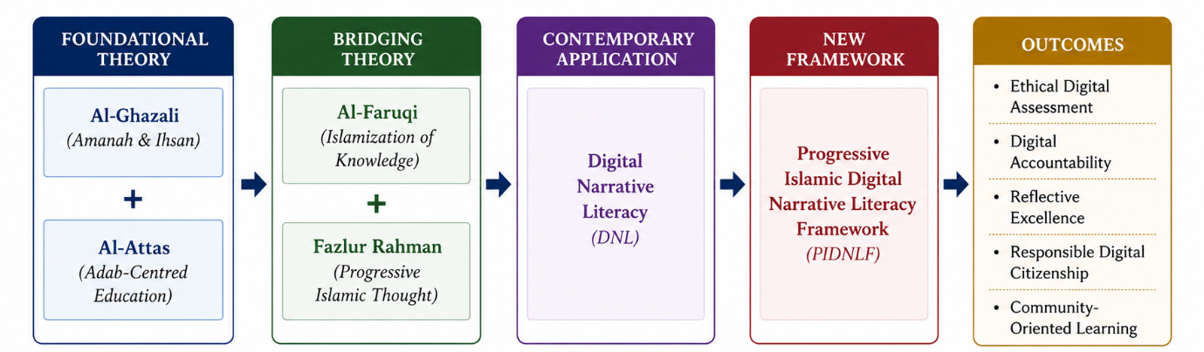
Figure 2. Theoretical Positioning of the Progressive Islamic Digital Narrative Literacy Framework (PIDNLF).

METHODOLOGY

This study employed a mixed-method exploratory design to examine students’ experiences with live-reporting assessment and to develop the Progressive Islamic Digital Narrative Literacy Framework (PIDNLF). A mixed-method approach was adopted to enable the integration of quantitative measurement of students’ perceptions with qualitative exploration of their experiences in digitally mediated community-based activities.

Quantitative data provided an overview of students’ perceptions of live-reporting assessment, while qualitative data enabled in-depth analysis of themes related to accountability, reflective excellence, social responsibility, and digital communication. These themes were subsequently interpreted through the conceptual lens of Progressive Islamic Thought, particularly the principles of Amanah, Ihsan, and Khalifah.

The research was conducted in three stages. First, descriptive analysis was used to examine students’ perceptions of live-reporting assessment. Second, thematic analysis was applied to qualitative responses to identify patterns and meanings. Finally, the empirical findings were integrated with the theoretical perspectives of Progressive Islamic Thought and Digital Narrative Literacy to inform the development of the Progressive Islamic Digital Narrative Literacy Framework (PIDNLF).

Research Context

This study was conducted within a community-based learning course at a Malaysian university. As part of the course requirements, students engaged in field-based projects involving external stakeholders, including schools, community organisations, and local groups. A central feature of the course was the implementation of live-reporting assessment, whereby students were required to document and update their project activities continuously using digital platforms. These real-time reports included visual documentation, descriptive accounts, and reflective entries. The live-reporting approach emphasised transparency, active participation, collaboration, and evidence-based documentation throughout the project process. It provided a structured context for examining students’ experiences of digital accountability, reflective engagement, community participation, and narrative communication in authentic learning environments.

Participants

The study involved 57 undergraduate students enrolled in a community-based learning course. All participants were engaged in live-reporting activities as part of their course requirements and worked in diverse project teams addressing community-based initiatives. Given the study’s focus on exploring collective experiences rather than comparing demographic differences, the analysis was conducted at the aggregate level. Accordingly, the findings represent the overall patterns and shared experiences of participants, without subgroup differentiation.
Data Collection Methods

Data were collected using a structured online questionnaire comprising both quantitative and qualitative components. The quantitative section utilised a five-point Likert scale (ranging from strongly disagree to strongly agree) to assess students’ perceptions of live-reporting assessment. The items measured key dimensions, including accountability, clarity of participation, communication effectiveness, lecturer support and monitoring, student engagement, and perceived usefulness of the live-reporting approach.

The qualitative component consisted of open-ended questions that invited students to reflect on their experiences with live-reporting activities. These responses addressed aspects such as task effectiveness, challenges encountered, learning outcomes, teamwork dynamics, and community engagement. The narratives provided rich insights into students’ experiences related to accountability, reflective development, collaborative practices, community interaction, and digital communication.

The qualitative data were analysed thematically, guided by the conceptual lenses of Amanah, Ihsan, Khalifah, and Digital Narrative Literacy (DNL), in order to identify recurring patterns and underlying meanings.

Instrument Development and Validation

The survey instrument was developed based on existing literature on digital assessment, digital literacy, accountability, and community-based learning. It consisted of ten Likert-scale items and seven open-ended reflective questions. To ensure content validity, the instrument was reviewed by experts in educational assessment and Islamic education. Their feedback contributed to improving the clarity, relevance, and alignment of the items with the study objectives.

Prior to analysis, the quantitative data were examined for completeness and consistency. Internal reliability was assessed using Cronbach’s alpha, yielding an overall coefficient of α = 0.64. This value indicates an acceptable level of reliability for exploratory research, reflecting moderate internal consistency among the items.

Given that the instrument was designed to capture multiple dimensions of students’ experiences such as accountability, communication, lecturer support, workplace relevance, and engagement rather than a single construct, a moderate reliability coefficient is considered appropriate. In line with the exploratory nature of the study, the instrument was deemed sufficient for descriptive analysis and for informing the development of the proposed framework.

Data Analysis

Quantitative data were analysed using descriptive statistics, including frequencies, percentages, means, and standard deviations, to provide an overview of students’ perceptions of live-reporting assessment. Descriptive analysis was considered appropriate as the study aimed to identify general patterns in participants’ responses rather than to establish causal relationships.

Qualitative data were analysed using thematic analysis following the approach proposed by Braun and Clarke (2022). This involved a systematic process of data familiarisation, coding, theme identification, theme review, definition, and interpretation. Through this process, key themes were identified, including accountability, reflective excellence, social responsibility, and digital communication.

These themes were subsequently interpreted through the conceptual lenses of Amanah, Ihsan, Khalifah, and Digital Narrative Literacy (DNL), enabling a value-based understanding of students’ experiences with live-reporting assessment.
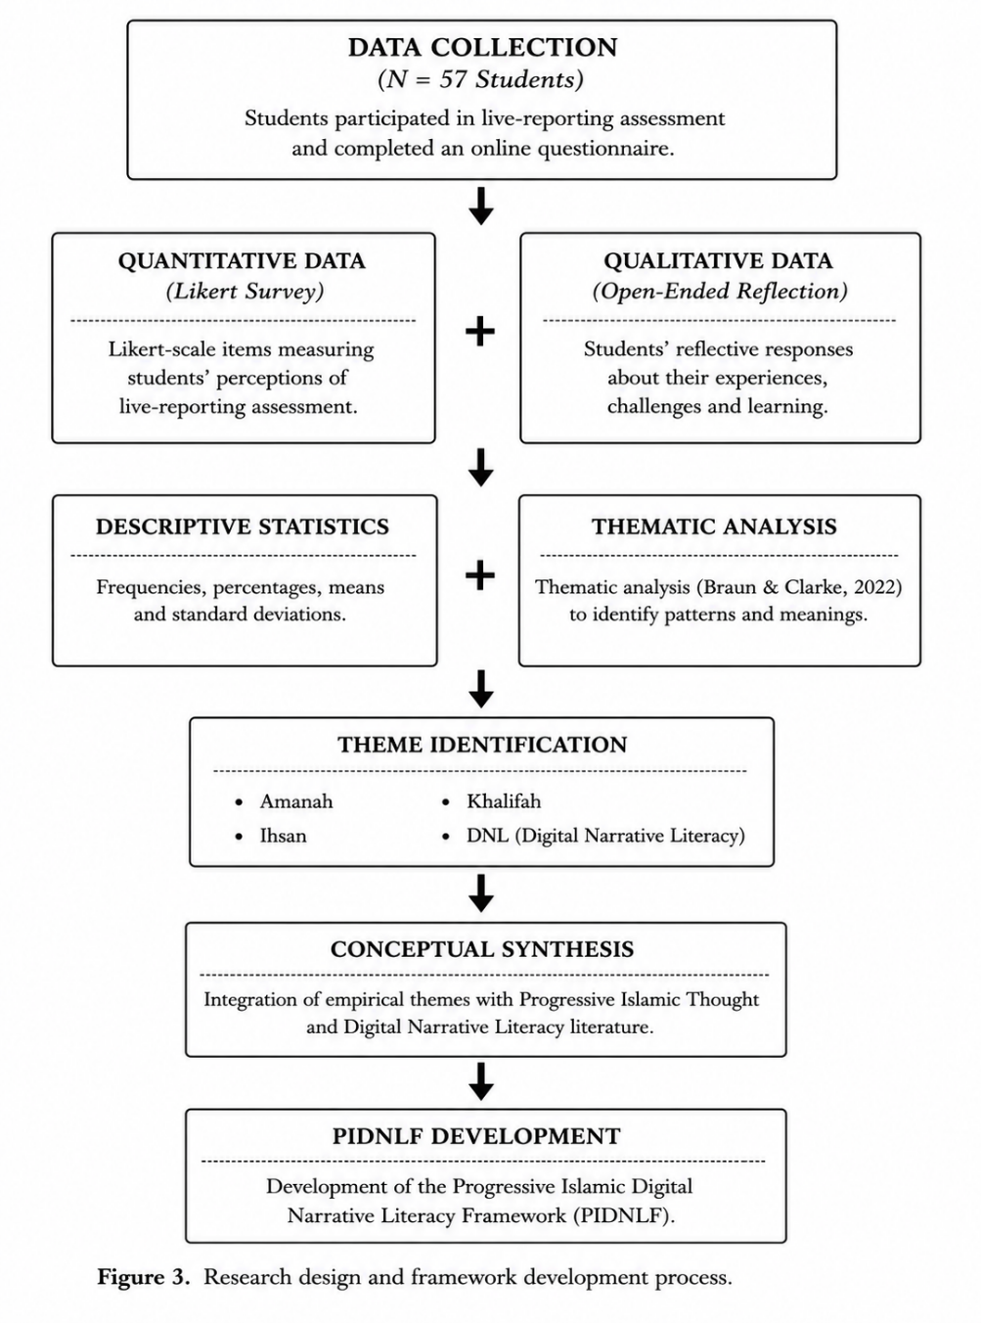
Figure 3. Research design and framework development process

Figure 3 illustrates the overall research design and framework development process. Following this, a conceptual synthesis was conducted to integrate empirical findings with theoretical perspectives.

Following the quantitative and qualitative analyses, the empirical findings were integrated with the theoretical perspectives of Progressive Islamic Thought and Digital Narrative Literacy (DNL). This integration involved interpreting the identified themes in relation to key Islamic principles, namely Amanah (accountability and trustworthiness), Ihsan (reflective excellence and continuous improvement), and Khalifah (social responsibility and stewardship).

In parallel, elements of Digital Narrative Literacy including communication, narrative construction, and meaning-making through digital media were examined to understand how these competencies are enacted within digital learning contexts.

The synthesis of empirical findings and theoretical constructs informed the development of the Progressive Islamic Digital Narrative Literacy Framework (PIDNLF). The framework conceptualises digital assessment as an ethically grounded practice, providing a structured approach to understanding responsible and reflective engagement in digitally mediated learning environments.

Trustworthiness and Rigour

To enhance the trustworthiness of the qualitative analysis, participant responses were reviewed iteratively to ensure accurate representation of their perspectives. The coding process was refined to maintain consistency and coherence, and emerging themes were continuously compared with the original data. An audit trail was also maintained that documenting coding categories, theme development, and interpretative decisions, thereby enabling traceability between thematic findings and participants’ accounts.

For the quantitative data, preliminary checks were conducted to ensure completeness and accuracy. Internal consistency was assessed using Cronbach’s alpha, which yielded a coefficient of α = 0.64. This value is considered acceptable for exploratory research and indicates a moderate level of reliability.

The integration of descriptive statistical analysis with thematic and conceptual analysis provided a comprehensive understanding of students’ experiences. This methodological approach supported the development of the Progressive Islamic Digital Narrative Literacy Framework (PIDNLF), which conceptualises digital assessment as an ethically grounded practice within digitally mediated learning environments.

RESULT AND DISCUSSION

Quantitative Overview of Student Perceptions

Prior to the qualitative thematic analysis, descriptive statistics were used to provide an overview of students’ perceptions of the live-reporting assessment. Overall, participants demonstrated positive perceptions, indicating a high level of acceptance of the approach. The highest-rated dimension was project management skill development (M = 4.29), followed by lecturer support and safety (M = 4.27), and workplace communication relevance (M = 4.20). These findings suggest that students perceived live-reporting assessment as beneficial for both academic organisation and professional communication development.

Table 1. Descriptive Statistics of Students' Perceptions of Live-Reporting Assessment

Dimension | Mean | SD
Initial Anxiety/Stress toward Live Reporting | 2.70 | 0.71
Perception of Live Reporting as "Digital Policing" | 2.90 | 0.83
Reporting Distracted from Physical Participation | 2.45 | 0.64
Concern about Lecturer Judgement During Radio Silence | 3.27 | 1.25
Lecturer Monitoring Provided Support and Safety | 4.27 | 0.98
Digital Log Protected Individual Contributions | 3.86 | 1.01
Immediate Lecturer Feedback Increased Motivation | 4.11 | 1.01
Live Reporting Developed Project Management Skills | 4.29 | 0.98
Live Reporting Reflects Workplace Communication Practices | 4.20 | 1.00
Preference for Live Digital Footprint over Traditional Report | 3.77 | 0.99

Further analysis showed consistently positive evaluations across key dimensions. Students reported that live reporting enhanced project management skills (M = 4.29, SD = 0.98), provided effective lecturer support during field activities (M = 4.27, SD = 0.98), and demonstrated strong relevance to real-world professional communication (M = 4.20, SD = 1.00). Immediate feedback from lecturers was also perceived as motivational (M = 4.11, SD = 1.01), while digital documentation contributed to a greater sense of individual contribution and recognition (M = 3.86, SD = 1.01).

However, several challenges were identified. Students indicated moderate levels of distraction associated with managing physical tasks alongside reporting activities (M = 2.45, SD = 0.64), as well as feelings of anxiety related to real-time reporting (M = 2.70, SD = 0.71). Additionally, some participants expressed concerns about perceived surveillance in digital environments (M = 2.90, SD = 0.83). Despite these concerns, the overall perception of live-reporting assessment remained positive.

The subsequent thematic analysis identified four dominant themes: digital accountability, reflective excellence, community stewardship, and ethical digital communication. Students frequently highlighted accountability through features such as timestamped documentation, visible contributions, and transparent participation. Reflective excellence was evident in narratives describing increased confidence, learning progression, and improved self-regulation. Community stewardship emerged in discussions related to privacy, dignity, informed consent, and responsible engagement with stakeholders. Finally, ethical digital communication was reflected in students’ emphasis on narrative construction, multimodal reporting, and professional communication practices. These themes represent shared patterns across participants’ experiences and form the basis for further analysis.

Table 2. Overview of Dominant Themes Identified in Student Reflections

Theme | Indicative Focus
Digital Accountability | Transparency, contribution tracking, responsible participation
Reflective Excellence | Confidence development, self-regulation, continuous improvement
Community Stewardship | Privacy, dignity, consent, stakeholder welfare
Ethical Communication | Narrative construction, multimodal reporting, audience awareness

Digital Accountability as Contemporary Amanah

Student reflections indicate that live-reporting assessment enhances accountability, transparency, and responsible participation in community-based projects. The use of real-time updates, timestamped entries, and continuous digital documentation enables verifiable records of individual contributions, thereby increasing visibility and accountability within group work. This transparency supports task awareness among team members and promotes more consistent engagement.
Participants consistently reported improved accountability through the live-reporting process. One student noted, “It made us more conscious and careful. You could trace everything back to when it was sent and by whom” (Student 1). Similarly, another participant observed that “timestamped posts altered how the team worked, as conflicts over responsibilities were reduced due to clear documentation” (Student 2). Additional reflections highlighted that timestamped reporting encouraged task focus and minimised disputes regarding individual contributions (Students 4 and 8). These accounts suggest that digital tracking mechanisms enhance both individual responsibility and collective coordination.

The findings further indicate that students perceived digital documentation as more than a procedural requirement; rather, it functioned as a mechanism for ensuring transparency and equitable participation. Real-time reporting reduced ambiguity regarding task distribution, thereby strengthening commitment and collaboration within teams. This interpretation is supported by quantitative findings, which show that students perceived digital logs as contributing to recognition of individual contributions (M = 3.86, SD = 1.01). Overall, both qualitative and quantitative data demonstrate that live-reporting assessment reinforces responsible engagement in digital learning contexts.

These findings can be interpreted through the Islamic concept of Amanah, which emphasises trustworthiness, accountability, and the fulfilment of responsibilities. The Qur’anic principle, “Indeed, Allah commands you to render trusts to whom they are due” (Qur’an 4:58), underscores the moral obligation to act responsibly in entrusted roles. Within digital assessment contexts, practices such as timestamped documentation, evidence-based reporting, and transparent communication may be understood as contemporary manifestations of Amanah.

Importantly, this study extends existing research on digital accountability, which has often been framed in technical or managerial terms (Chen, 2024; Ramdana et al., 2026). By situating accountability within an ethical and value-based framework, the findings suggest that digital assessment practices can serve not only as monitoring mechanisms but also as avenues for cultivating ethical awareness and responsible conduct in line with Islamic educational principles.

Reflective Excellence and the Principle of Ihsan

Student reflections indicate that live-reporting assessment fosters continuous self-improvement, reflective engagement, and increasing confidence throughout the learning process. Initially, many students reported feelings of uncertainty, anxiety, and pressure associated with documenting activities in real time. However, as the project progressed, these initial challenges transitioned into increased confidence, competence, and discipline in managing reporting requirements.

Several participants described this developmental trajectory. One student noted, “At first, I was nervous and stressed about updating everything in real time. However, by the end of the project, I became more confident and capable of managing the reporting process” (Student 3). Similarly, another participant remarked, “As the project progressed, I became more comfortable and confident in handling updates” (Student 4). Additional reflections also highlighted improved confidence and adaptability over time (Students 6 and 10). These responses suggest that live-reporting practices support gradual skill development and self-regulation.

The findings further demonstrate that live reporting enhances students’ reflective engagement with their learning processes. Participants reported monitoring their performance, refining their reporting practices, and developing greater confidence in managing digital tasks. Consequently, the assessment process extended beyond performance evaluation to promote ongoing reflection and personal development.

These qualitative insights are supported by quantitative findings, which show that students rated live reporting highly in relation to project management skill development (M = 4.29, SD = 0.98), the highest-rated dimension in the study. This suggests that students perceived improvements in discipline, organisation, and self-management, which are integral components of reflective learning.

These patterns align with the Islamic concept of Ihsan, which emphasises excellence, sincerity, and continuous self-improvement. The well-known prophetic tradition, “to worship Allah as if you see Him, and if you do not see Him, know that He sees you” (Sahih Muslim), illustrates a heightened level of consciousness and commitment to excellence. Within educational contexts, this principle can be interpreted as the continuous striving for improvement and mindful engagement in learning processes.

Traditionally associated with spiritual development, Ihsan can also be applied to contemporary educational practices. The findings suggest that structured activities such as live reporting encourage students to maintain higher standards of performance through ongoing reflection and self-monitoring. This aligns with prior research highlighting the role of reflective and self-regulated learning in enhancing student outcomes (Kayyali, 2024; Zhou et al., 2025). However, unlike conventional perspectives that frame reflection primarily as a cognitive process, this study positions it as an ethical practice informed by the principle of Ihsan. This interpretation is consistent with Al-Ghazali’s emphasis on the integration of self-reflection and moral refinement in educational development.

Community Engagement and the Practice of Khalifah

Student reflections highlighted their engagement with community stakeholders and the ethical responsibilities associated with representing others in digital reporting. Beyond fulfilling assessment requirements, participants demonstrated a strong awareness of issues related to privacy, dignity, and respectful representation. They frequently described the need to balance evidence-based documentation with ethical considerations when reporting community activities, indicating a conscious effort to act responsibly and sensitively.

Participants consistently emphasised the importance of protecting the dignity and privacy of community members. One student noted, “We took respectful photos, focusing on group activities instead of individual children to protect their privacy” (Student 3). Another explained, “We sought permission and avoided sensitive images to preserve the dignity of community members” (Student 4). Similarly, informed consent was identified as an essential practice, with participants ensuring that permission was obtained prior to capturing photos or videos (Student 8). At the same time, students recognised the need to balance ethical considerations with assessment requirements. As one participant observed, “We balanced the need for visual evidence with respect for privacy and dignity” (Student 7).

These findings indicate that students engaged in ethical decision-making throughout the live-reporting process. Rather than approaching digital documentation as a purely technical or procedural task, they demonstrated reflective consideration of how communities were represented and how their reporting practices might affect others. This reflects an emerging awareness of social responsibility that extends beyond individual academic performance to encompass the well-being of others.

Although the quantitative instrument did not directly measure community stewardship, students reported high levels of perceived lecturer support (M = 4.27, SD = 0.98), suggesting that a supportive learning environment may have facilitated ethical awareness and responsible engagement with stakeholders.
These findings can be interpreted through the Islamic concept of Khalifah, which emphasises stewardship and the responsibility to contribute positively to society. The Qur’anic verse, “Indeed, I will place upon the earth a successive authority” (Qur’an 2:30), underscores the role of human beings as caretakers entrusted with ethical responsibilities. Within educational contexts, Khalifah extends beyond leadership to include ethical engagement, care for others, and responsible decision-making.

In the context of community-based learning, the findings suggest that students recognise digital participation as an activity with ethical and social implications. Their practices demonstrate an understanding that digital representations influence how communities are perceived and therefore require careful and responsible handling. This reflects the application of Khalifah in both physical and digital environments, where students act as stewards in the creation and dissemination of community narratives.

These results are consistent with existing research on service learning and civic engagement, which highlights the development of social responsibility through experiential learning (Putra et al., 2025; Supaat, 2026). However, this study extends prior work by demonstrating how digital reporting practices themselves can function as a site for cultivating ethical awareness and stewardship. From a Progressive Islamic perspective, responsible engagement must also encompass digital spaces, where actions contribute to broader social and ethical outcomes.

Digital Narrative Literacy as Ethical Communication

The final theme highlights the development of students’ communication competencies through continuous narrative reporting. Participants reported improvements in their ability to articulate experiences, construct coherent narratives, and integrate textual and visual elements effectively. Importantly, these skills were not perceived solely as technical competencies but were associated with professionalism, responsibility, and ethical communication in digital contexts.
Students emphasised the importance of combining clear narrative explanations with appropriate visual evidence. For instance, one participant noted, “Combining concise captions with relevant visual media demonstrates strong communication and digital skills” (Student 1). Others highlighted the relevance of these competencies for professional contexts, indicating that effective digital communication is essential for contemporary workplaces (Students 2–4, 6). These reflections suggest that live-reporting activities contribute to the development of transferable communication skills applicable beyond academic settings.

The findings indicate that live-reporting assessment plays a significant role in enhancing Digital Narrative Literacy. Rather than merely documenting activities, students were required to construct meaningful and audience-aware narratives accessible to multiple stakeholders, including lecturers, peers, and community members. This process facilitated the development of skills related to narrative organisation, audience consideration, and multimodal communication.

Quantitative findings support these observations, with students reporting high perceptions of the relevance of live reporting to workplace communication (M = 4.20, SD = 1.00) and the motivational impact of timely lecturer feedback (M = 4.11, SD = 1.01). These results highlight the role of digital reporting practices in preparing students for professional communication demands.

However, the findings also reveal that effective digital communication extends beyond technical proficiency. Participants expressed concerns regarding accuracy, professionalism, respect, and responsible information sharing. Engagement with real-world community contexts required students to consider the ethical implications of their narratives, particularly in terms of representation and audience impact. This indicates that Digital Narrative Literacy involves not only communicative competence but also ethical awareness.

While existing research on DNL emphasises storytelling, multimodal expression, and communication effectiveness (Gidor et al., 2024), the present findings underscore the importance of integrating ethical dimensions into digital narrative practices. Effective digital communication requires not only the ability to construct compelling narratives but also the responsibility to represent individuals and communities accurately and respectfully.

This observation highlights a key limitation in current DNL frameworks, which tend to prioritise technical and communicative skills while underemphasising ethical considerations. The findings of this study suggest that integrating the principles of Amanah, Ihsan, and Khalifah into DNL provides a more comprehensive framework for ethical digital engagement. In this perspective, digital communication reflects accountability, excellence, and social responsibility, thereby promoting value-based participation in digital environments.

Development of the Progressive Islamic Digital Narrative Literacy Framework (PIDNLF)

The findings demonstrate a strong relationship between Islamic ethical principles and students’ engagement in live-reporting assessment within digital learning contexts. Four key themes were identified: digital accountability, reflective excellence, social responsibility, and ethical digital communication. These findings suggest that digital assessment functions not only as a mechanism for evaluating performance but also as a means of cultivating ethical awareness and responsible behaviour.

The principle of Amanah was reflected in students’ emphasis on transparency, accurate documentation, and clear attribution of contributions. Practices such as timestamped reporting and evidence-based documentation enhanced accountability and reinforced trustworthiness in collaborative work. The principle of Ihsan was evident in students’ progression from initial uncertainty to increased confidence, competence, and self-regulation, demonstrating a commitment to continuous improvement and reflective engagement. Meanwhile, Khalifah was manifested in students’ awareness of ethical responsibilities towards community stakeholders, including the protection of privacy, respect for dignity, and adherence to informed consent in digital reporting practices.

In addition, Digital Narrative Literacy (DNL) supported students in developing competencies related to storytelling, multimodal communication, documentation, and audience engagement. Importantly, these skills were integrated with ethical considerations, highlighting the role of responsible communication in digitally mediated contexts.
These empirical insights informed the development of the Progressive Islamic Digital Narrative Literacy Framework (PIDNLF), which conceptualises digital engagement through four interrelated dimensions: digital accountability (Amanah), reflective excellence (Ihsan), social stewardship (Khalifah), and ethical digital communication (DNL). By integrating Islamic ethical principles with digital literacy practices, the framework offers a value-based approach to digital assessment. It demonstrates how traditional ethical concepts can be meaningfully applied to contemporary digital education, thereby supporting the development of responsible, reflective, and socially engaged learners.

Table 3. Empirical Foundations of the Progressive Islamic Digital Narrative Literacy Framework (PIDNLF)

Theme | Empirical Evidence from Student Reflections | Islamic Principle | Educational Outcome
Digital Accountability | Timestamp visibility, contribution tracking, transparent reporting | Amanah | Ethical responsibility and accountability
Reflective Excellence | Increased confidence, self-monitoring, continuous improvement | Ihsan | Reflective learning and self-development
Community Stewardship | Respect for privacy, informed consent, stakeholder dignity | Khalifah | Responsible citizenship and social engagement
Ethical Communication | Narrative construction, multimodal reporting, audience awareness | Digital Narrative Literacy | Ethical digital communication competence

CONCLUSION

This study explored students’ experiences with live-reporting assessment in community-based learning, focusing on four key dimensions: Amanah, Ihsan, Khalifah, and Digital Narrative Literacy (DNL). The findings indicate that live-reporting practices enhance accountability, transparency, and responsible participation, reflecting the principle of Amanah. At the same time, sustained engagement in documentation and reflection fostered self-regulation and continuous improvement, aligning with the concept of Ihsan. Engagement with community-based activities further promoted ethical awareness, particularly in relation to privacy, dignity, and stakeholder responsibility, demonstrating the practice of Khalifah. In parallel, students developed competencies in storytelling, documentation, and multimodal communication, thereby strengthening their Digital Narrative Literacy.

The integration of these findings led to the development of the Progressive Islamic Digital Narrative Literacy Framework (PIDNLF), which reconceptualises digital assessment as a value-oriented practice rather than a purely technical process. By integrating digital accountability, reflective excellence, social stewardship, and ethical digital communication, the framework offers a holistic approach to understanding ethical participation in digitally mediated learning environments. This study contributes to both Islamic education and digital literacy scholarship by demonstrating how foundational Islamic ethical principles can be meaningfully applied within contemporary digital contexts. In doing so, it extends existing digital literacy frameworks by incorporating ethical and value-based dimensions that are often underemphasised.

Despite its contributions, this study is limited by its focus on a single institutional context and a relatively small sample size. Future research should examine the applicability of the framework across diverse educational settings and larger populations, as well as employ more advanced analytical approaches to further validate and refine the proposed model.
Overall, the study highlights the importance of integrating ethical principles into digital assessment practices, demonstrating that technology-mediated learning can effectively support the development of accountability, reflective practice, and social responsibility among students.

Figure 4. Final Progressive Islamic Digital Narrative Literacy Framework (PIDNLF)

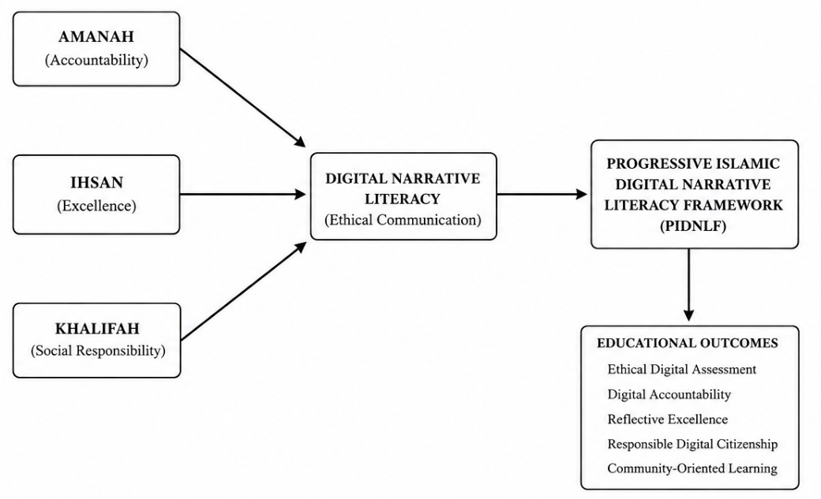

Acknowledgement

The authors gratefully acknowledge UNITAR International University for the support and resources provided, which were instrumental in the completion of this study.

REFERENCES

- Ahmad, N., Ma, M. K., Abd. Rahman, S. F., Syed Mahmood, S. R., Muhamad @ Razak, N. A., & Mohamad, S. N. A. (2025). The Islamic ethical principles and Maqasid al-Shariah to enhance digital competency among adolescents. UMRAN – Journal of Islamic and Civilizational Studies, 12(3), 101–117. https://doi.org/10.11113/umran2025.12n3.833
- Al-Attas, S. M. N. (1991). The concept of education in Islam: A framework for an Islamic philosophy of education. International Institute of Islamic Thought and Civilization (ISTAC).
- Al-Faruqi, I. R. (1982). Islamization of knowledge: General principles and workplan. International Institute of Islamic Thought.
- Al-Ghazali. (2015). Ihya' ulum al-din (Rev. ed.). Dar al-Minhaj. (Original work published ca. 1100)
- Altinsoy, E., & Boyraz, S. (2024). Digital literacy and moral values in digital environments: Secondary students’ perceptions. Brock Education Journal, 33(2), 32–54. https://doi.org/10.26522/brocked.v33i2.1024
- An-Na'im, A. A. (2008). Islam and the secular state: Negotiating the future of Shari'a. Harvard University Press.
- Araniri, N., Nahriyah, S., Nurhidayat, J., Jamaludin, G. M., & Jatisunda, M. G. (2021). The impact of digital literacy ability of Islamic religious education students on fiqh learning achievements. Proceedings of the International Conference on Islamic Education. https://doi.org/10.2991/assehr.k.210304.053
- Chen, Z. (2024). Systematic review on developing digital literacy in higher education: Emerging trends and future directions. Universal Journal of Social Sciences and Humanities, 4(1), 1–15.
- Falloon, G. (2020). From digital literacy to digital competence: The teacher digital competency framework. Educational Technology Research and Development, 68(5), 2449–2472. https://doi.org/10.1007/s11423-020-09767-4
- Gidor, F. M., Abdullah, M. H., & Osman, N. (2024). Digital storytelling and narrative engagement in Malaysian higher education. International Journal of English Language and Pedagogy, 7(1), 1–18. https://doi.org/10.51200/ijelp.v7i1.5418
- Gitadewi, A. J. (2024). Optimizing digital literacy through problem-based learning models to improve students’ critical thinking skills. International Journal of Learning and Development, 14(2), 77–93. https://doi.org/10.53621/ijocer.v3i2.379
- Hendawi, M. (2024). Digital literacy-based learning in Islamic education: Challenges and opportunities in the contemporary era. Journal of Islamic Educational Studies, 9(1), 45–61. https://doi.org/10.7401/j19t2q81
- Ikhwan, M., Fuadi, M., Mailizar, M., & Jannah, M. (2023). The utilization of information technology for the professional development of Islamic education teachers in Indonesia. Progresiva: Jurnal Pemikiran dan Pendidikan Islam, 12(2), 209–222. https://doi.org/10.22219/progresiva.v12i02.31169
- Jenkins, H., Purushotma, R., Weigel, M., Clinton, K., & Robison, A. J. (2009). Confronting the challenges of participatory culture: Media education for the 21st century. MIT Press.
- Kayyali, M. (2024). Digital literacy in higher education: Preparing students for the workforce of the future. International Journal of Education and Development, 8(1), 45–60. https://doi.org/10.30954/2348-7437.1.2024.6
- Kholid, K., & Darmawan, D. (2023). The influence of digital literacy and learning media utilization on student learning motivation. Fitrah: Journal of Islamic Education, 4(2), 115–129. https://doi.org/10.53802/fitrah.v4i2.622
- Li, Y. (2024). Adapting to the digital learning environment: The impact on student learning and outcomes. Lecture Notes in Education Psychology and Public Media, 37, 65–71. https://doi.org/10.54254/2753-7048/37/20240504
- Mirawati, M. (2025). Educating in the midst of digital flow: Teachers’ perspectives on progressive Islamic education. At-Tadzkir: Islamic Education Journal, 5(2), 44–60. https://doi.org/10.59373/attadzkir.v4i2.209
- Muharromah, L. (2025). Digital ethics in the perspective of Islamic education: Challenges and opportunities in contemporary learning. Journal of Educational Management Research, 4(1), 55–70. https://doi.org/10.61987/jemr.v4i3.1397
- Pamuji, S., & Iliasu, S. F. (2026). Strengthening the inclusive role of Muslim communities in the digital space: Preaching strategies and social media literacy in the 5.0 era. International Journal of Preaching Perspectives, 2(2), 88–105. https://doi.org/10.61987/ijpp.v2i2.1788
- Putra, D. H. A., & Ayyaisy, H. I. (2025). Optimizing digital technology in progressive Islamic education to enhance public literacy and combat hoaxes. Multicultural Islamic Education Review, 3(1), 63–74. https://doi.org/10.23917/mier.v3i1.9915
- Rahman, F. (1982). Islam and modernity: Transformation of an intellectual tradition. The University of Chicago Press.
- Ramdana, A. D., Nurhadi, M., & Setiawan, R. (2026). Advancing digital literacy in higher education through pedagogical innovation. Discover Education, 5(1), 1–18. https://doi.org/10.1007/s44217-026-01256-9
- Ribble, M. (2015). Digital citizenship in schools: Nine elements all students should know (3rd ed.). International Society for Technology in Education.
- Rohim, M. A. (2026). Digital literacy in Islamic education: Integrating ethical values and technological competence. Journal of Social Education, 6(1), 1–15. https://doi.org/10.58905/jse.v6i2.725
- Rohmiati, E. (2025). The use of digital media in learning Islamic religious education: Opportunities and challenges. Urwatul Wutsqo: Jurnal Studi Kependidikan dan Keislaman, 14(1), 33–58. https://doi.org/10.54437/urwatulwutsqo.v14i1.1952
- Selwyn, N. (2016). Education and technology: Key issues and debates (2nd ed.). Bloomsbury Academic.
- Supaat, S. (2026). The challenges of Islamic education in the digital era. Malaysian Journal of Social Sciences and Humanities, 11(5), 1–15. https://doi.org/10.47405/mjssh.v11i4.3937
- Zhou, X., Li, H., & Wang, Y. (2025). The impact of digital literacy on university students’ innovation and communication competence. Education and Information Technologies, 30(4), 1–20. https://doi.org/10.3389/fpsyg.2025.1548817

