AI-Powered Cybersecurity Threat Detection and Secure User Authentication System

1. Introduction
The rapid growth of internet-based applications, cloud computing, and online services has significantly increased cybersecurity challenges. Organizations face continuous threats from phishing attacks, credential theft, malware infections, insider attacks, and unauthorized system access.
Traditional authentication systems primarily rely on usernames and passwords, which are vulnerable to brute-force attacks, password leaks, and social engineering techniques. Furthermore, conventional security monitoring systems often fail to identify sophisticated cyber threats in real time.
Artificial Intelligence has emerged as a powerful technology for improving cybersecurity by enabling systems to learn patterns, analyze behavior, and detect anomalies automatically. Machine Learning and Deep Learning algorithms can identify suspicious activities that may not be recognized through traditional rule-based approaches.
This project aims to develop an intelligent cybersecurity platform capable of providing secure authentication and real-time threat detection. By combining user authentication with AI-based analytics, the system improves security while maintaining usability.

Why This Project?
• Increasing cyber threats require intelligent security solutions.
• Traditional authentication methods are vulnerable to attacks.
• AI can improve threat detection accuracy and response time.
• Continuous monitoring helps identify insider threats and suspicious activities.
• Real-time dashboards support proactive security management.
Key Advantages

1. Enhanced User Authentication
The system provides secure user authentication through username-password verification, CAPTCHA validation, and OTP-based authentication, reducing the risk of unauthorized access.

2. AI-Based Threat Detection
Artificial Intelligence techniques are used to identify suspicious activities and cyber threats automatically, improving the efficiency of security monitoring.

3. Real-Time Monitoring
The platform continuously monitors user activities and system events, enabling early detection of malicious behavior and potential security breaches.

4. Machine Learning-Powered Analysis
Machine Learning algorithms such as Random Forest help classify security events accurately and distinguish between normal and malicious activities.

5. Anomaly Detection Capability
Isolation Forest and Deep Learning models can identify unusual behavior patterns, helping detect unknown and zero-day attacks.

6. Improved Cybersecurity
By combining authentication and intelligent threat detection, the system provides multiple layers of security, making it more resilient against cyberattacks.

7. Reduced Human Intervention
The automated threat detection mechanism minimizes the need for manual monitoring and analysis, saving time and effort for administrators.

8. Real-Time Security Dashboard
An interactive dashboard provides visual representation of threats, system performance, user activities, and security statistics for better decision-making.

9. Attack Simulation Feature
The project includes cyber attack simulation, allowing users to understand attack scenarios and evaluate system responses in a controlled environment.

10. Scalability and Flexibility
The system can be extended with additional security features such as biometric authentication, cloud integration, and advanced threat intelligence services.

11. Early Threat Identification
The system can detect suspicious activities at an early stage, reducing the impact of cyberattacks and preventing potential damage.

12. User Activity Tracking
Continuous monitoring of user behavior helps identify insider threats, abnormal activities, and policy violations.

13. Educational and Research Value
The project serves as an excellent platform for learning cybersecurity concepts, machine learning applications, anomaly detection, and secure authentication techniques.

14. Cost-Effective Security Solution
The implementation uses open-source technologies such as Python, Streamlit, Scikit-Learn, TensorFlow, and MySQL, reducing deployment costs.

15. Future-Ready Architecture
The integration of AI, Machine Learning, and Deep Learning makes the system adaptable to future cybersecurity challenges and emerging threats.
Research Trade-offs
- Security vs Usability
Strong security features (CAPTCHA, OTP) improve protection but increase login time.
- Accuracy vs Performance
AI/ML models provide better threat detection but require more processing power.
- Real-Time Monitoring vs Resource Usage
Continuous monitoring improves security but consumes additional system resources.
- Privacy vs Activity Tracking
User monitoring helps detect threats but may raise privacy concerns.
- Complexity vs Maintainability
Advanced AI-based security features increase system effectiveness but make development and maintenance more complex.

The Three Modular Pillars
1.1. Secure Authentication Module
Provides Login, CAPTCHA, and OTP verification for secure user access.
1.2. AI-Based Threat Detection Module
Uses Machine Learning and Deep Learning to detect threats and anomalies.
1.3. Security Monitoring & Dashboard Module
Monitors user activities and displays real-time security alerts and analytics.

Research Focus:

The primary research focus of this project is to develop an intelligent cybersecurity framework that combines secure user authentication with Artificial Intelligence, Machine Learning, and Deep Learning techniques for real-time threat detection. The system focuses on identifying suspicious user behavior, detecting anomalies, preventing unauthorized access, and improving overall cybersecurity through continuous monitoring and intelligent security analysis. By integrating Random Forest, Isolation Forest, and Autoencoder models, the project aims to provide accurate threat detection while maintaining secure and reliable user authentication.

2. Proposed Methodology
The proposed system consists of five major modules:

2.1 User Authentication Module
The authentication module verifies user credentials before granting access.
Features include:
• Username and Password Validation
• CAPTCHA Verification
• OTP-Based Authentication
• Session Management
• Login Activity Tracking
This multi-layer authentication mechanism reduces the risk of unauthorized access.

2.2 User Activity Monitoring Module
The system continuously records user actions after login.
Monitored activities include:
• Login Time
• Logout Time
• Session Duration
• Failed Login Attempts
• User Navigation Patterns
Collected data is stored for security analysis and future investigation.

2.3 Machine Learning Threat Detection
A Random Forest Classifier is trained using cybersecurity datasets to classify activities as:
• Normal Activity
• Suspicious Activity
• Potential Threat
Random Forest is selected because of its high classification accuracy and robustness against overfitting.

2.4 Anomaly Detection Using Isolation Forest
Isolation Forest is employed to detect unusual activities that differ from normal user behavior.
The algorithm identifies:
• Abnormal Login Patterns
• Unusual Access Attempts
• Potential Insider Threats
• Unknown Security Incidents
This allows detection of previously unseen attack behaviors.

2.5 Deep Learning-Based Threat Analysis
An Autoencoder Neural Network is implemented for advanced anomaly detection.
The deep learning model learns normal user behavior patterns and identifies deviations by measuring reconstruction error.
Advantages include:
• Detection of Zero-Day Threats
• Improved Accuracy
• Reduced False Positives
• Continuous Learning Capability

3. Results and Discussion
The developed system was evaluated using cybersecurity datasets and simulated attack scenarios.
Experimental observations indicate:
• Successful secure user authentication.
• Accurate classification of normal and malicious activities.
• Effective anomaly detection.
• Real-time threat visualization.
• Improved security monitoring.
Performance evaluation showed that the Random Forest classifier achieved high classification accuracy while Isolation Forest successfully identified abnormal user activities. The Autoencoder model enhanced detection of unknown attack patterns.
The dashboard provided clear visualization of:
• Total Security Events
• Threat Detection Statistics
• Model Accuracy
• User Activity Logs
• System Alerts
The combination of authentication and AI-based analytics significantly improved overall system security.

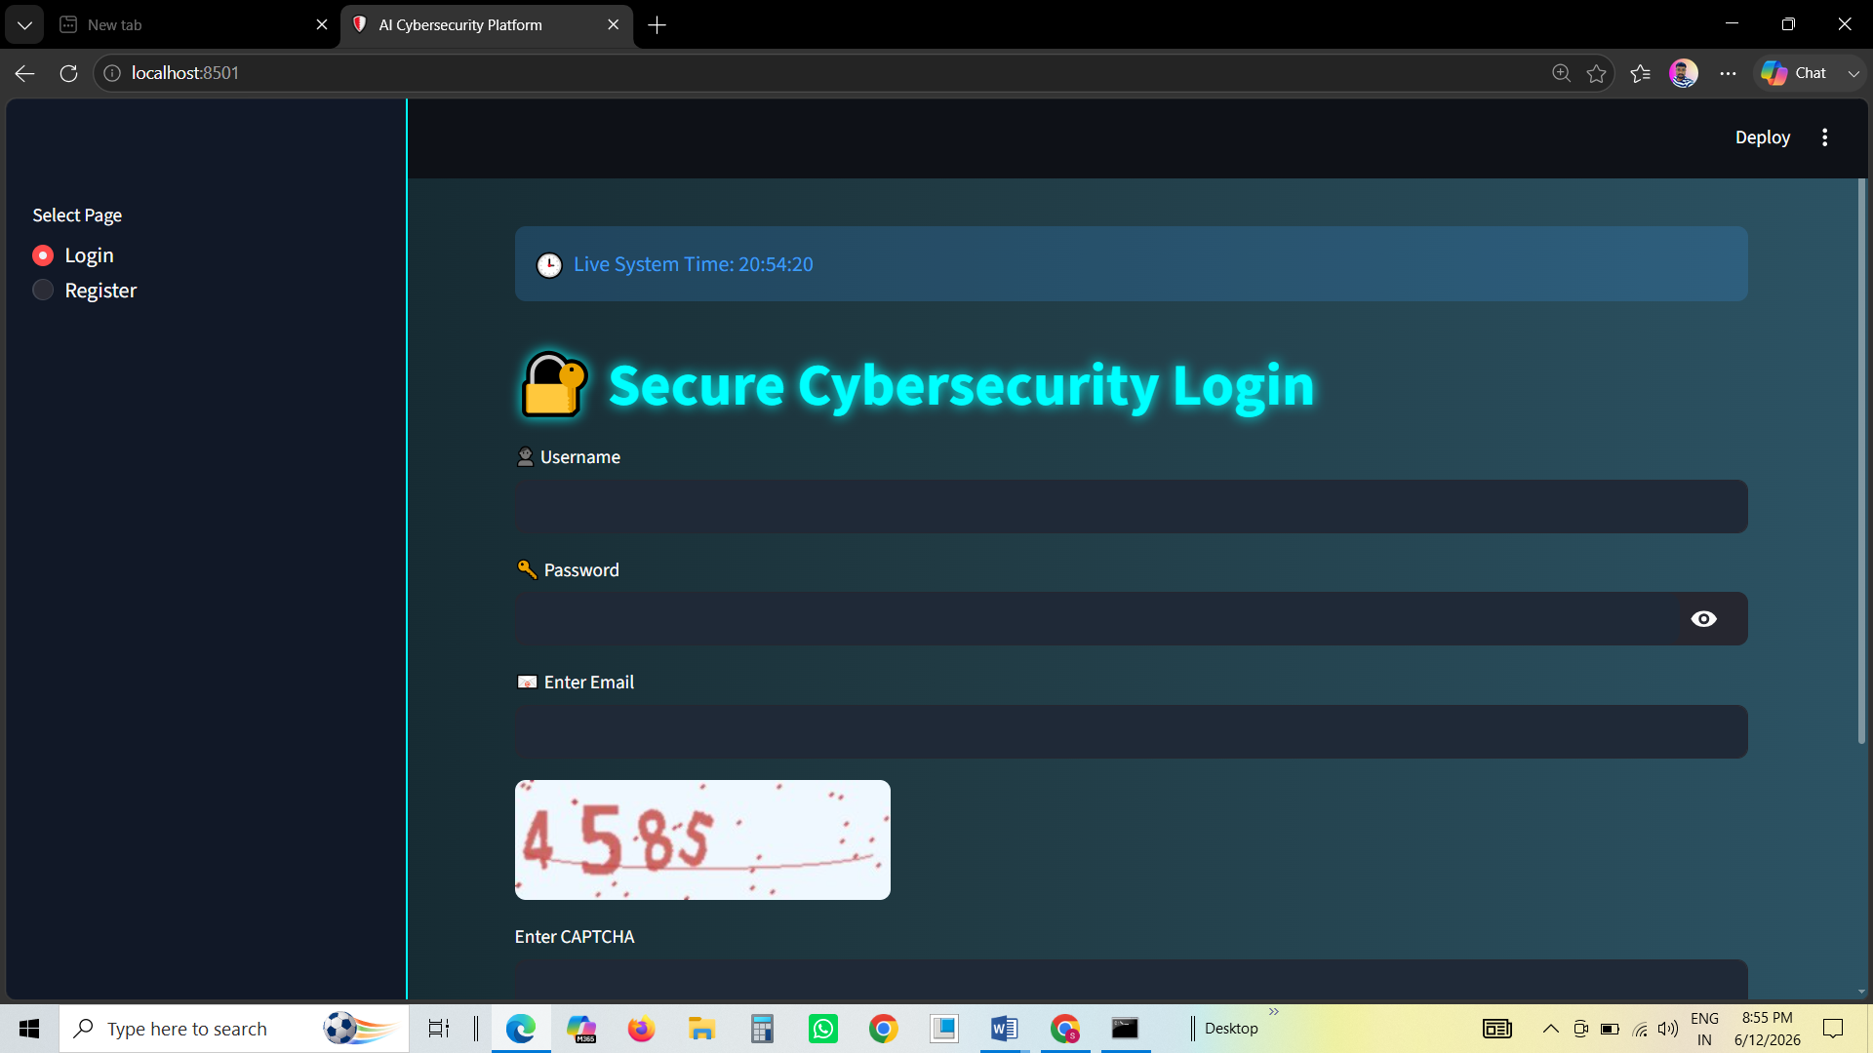

4. Research Outlook & Future Scope
Although the proposed system provides effective cybersecurity protection, several improvements can be incorporated in future versions.

4.1. Multi-Factor Authentication Enhancement
Future systems can integrate biometric authentication such as:
• Fingerprint Recognition
• Face Recognition
• Voice Authentication
This will further strengthen access control mechanisms.

4.2. Real-Time Network Intrusion Detection
The platform can be expanded to analyze live network traffic and detect intrusions instantly.

4.3. Cloud-Based Deployment
Deploying the framework on cloud infrastructure will improve scalability and accessibility.

4.4. Threat Intelligence Integration
Future versions can integrate global threat intelligence feeds for proactive attack prevention.

4.5. Explainable Artificial Intelligence (XAI)
Implementing explainable AI techniques will help security administrators understand why threats are detected.
4. Conclusion
This research presents an AI-Powered Cybersecurity Threat Detection and Secure User Authentication System that combines secure authentication mechanisms with Machine Learning and Deep Learning techniques.
The proposed framework enhances cybersecurity through CAPTCHA validation, OTP authentication, user activity monitoring, anomaly detection, and intelligent threat analysis. Random Forest, Isolation Forest, and Autoencoder models provide effective identification of suspicious activities and cyber threats.
The developed system demonstrates how Artificial Intelligence can be integrated into cybersecurity solutions to provide proactive protection, real-time monitoring, and intelligent threat detection. The results confirm that AI-based security platforms can significantly improve organizational security and reduce cyber risks.

References
[1] Ian Goodfellow, Yoshua Bengio, and Aaron Courville, Deep Learning, MIT Press, 2016.
[2] Christopher Bishop, Pattern Recognition and Machine Learning, Springer, 2006.
[3] Tom M. Mitchell, Machine Learning, McGraw-Hill Education, 1997.
[4] Scikit-Learn Documentation, Machine Learning in Python.
[5] OpenAI Research Publications on Artificial Intelligence and Security.
[6] NIST Cybersecurity Framework Documentation.
[7] OWASP Authentication Security Guidelines.
[8] Microsoft Security Intelligence Reports.
[9] Cisco Annual Cybersecurity Reports.
[10] Research Papers on AI-Based Intrusion Detection Systems and Anomaly Detection.

