Startup Bharat 2047: Understanding Startup Failures and Creating a Framework for Global Entrepreneurial Leadership

Abstract
The Indian startup ecosystem has reached a stage of scaling and quality where the policy question is not so much how many ventures are registered but rather how many will survive, learn, internationalise and lead. The Government of India mentioned that by 31 March 2026, recognised start-ups crossed 2.23 lakh and created more than 23.36 lakh direct jobs, placing start-ups at the heart of the Viksit Bharat 2047 vision of development. The paper attempts to look at the startup failure risk through the integrated framework of finance, market access, regulatory burden, founder leadership, innovation capability, mentorship support, digital adoption and global entrepreneurial orientation. A cross-sectional quantitative design is proposed. In lieu of actual field survey data, the article utilizes an explicitly labelled simulated demonstration dataset of 300 startup founders and ecosystem participants. Descriptive statistics, reliability analysis, correlation analysis, ANOVA, multiple regression, logistic regression, principal component analysis and mediation analysis are conducted. The results simulated reveal that financial constraint, market-access limitation and regulatory burden increase failure risk; whereas, founder leadership capability, innovation capability, mentorship support, digital adoption and global entrepreneurial orientation reduce failure risk. The results reveal a substantial amount of failure-risk variance explained by the regression model. The mediation model indicates that global entrepreneurial orientation partially mediates the effect of ecosystem support on startup sustainability. The paper presents a Start Bharat 2047 Global Entrepreneurial Leadership Framework which embodies financial resilience, market intelligence, innovation capability, digital transformation, policy navigation, ethical leadership and ecosystem collaboration. The researchers conclude that startup failure is not just a private entrepreneurial loss. It is an ecosystem design problem that needs data-driven support. Also, it requires leadership development and making globally oriented capabilities.
Keywords: Startup Bharat 2047; startup failure; entrepreneurial leadership; startup ecosystem; India; global entrepreneurship; simulated survey data.

1. Introduction
The narrative around Indian startups has shifted from policy excitement to institutional sophistication. The initiative Startup India was launched in 2016 by the Government of India to create a formal recognition architecture for startup through DPIIT recognition. By December 2025, official reporting identified the country as among the world’s largest start-up ecosystems with more than two lakh recognised start-ups and nearly half of recognised start-ups coming from Tier-II and Tier-III cities (PIB, 2026a). The scale of the startup ecosystem makes it a strategic element of Viksit Bharat 2047 and not a narrow tech sector story.
However, scale at the level of the ecosystem does not automatically mean that the venture will survive. Startups face a high level of uncertainty, asymmetric information, unpredictable demand, talent shortages, regulatory pressures and tech cycles. International research indicates that entrepreneurial failure is multifaceted. More specifically, financial constraints, market fit, team competence, strategic learning and dynamic capabilities interact with and through each other, rather than function as isolated causes (Bethlendi et al., 2025; Szathmári et al., 2024). The geographic diversity in India adds to the problem. Metro start-ups tend to have greater access to investors and mentoring networks. Non-metro entrepreneurs, on the other hand, benefit from lower operating costs. Though they have no major weaknesses, they also enjoy weaker access to global customers, late-stage finance, specialised talent and managerial advice.
Therefore, startup failure is approached as a leadership-and-ecosystem issue. A founder can create a compelling product, yet fail to convert it into a business venture because the firm does not manage cash conversion cycles, validate customer demand, adapt business model or build governance systems. On the other hand, if the founders of a startup demonstrate market intelligence, learning agility, ethical decision-making, and global orientation, it can survive with moderate technological novelty. The focus on worldwide entrepreneurial leadership must be emphasized since, to realize the vision of Startup Bharat 2047, we can’t simply produce local firms; we want founders who can operate across markets, cultures, technologies, and regulatory systems.
The current manuscript is an effort underway without any actual field responses, so simulated survey data are used. This is clearly specified to prevent any false claim of primary-data collection. The purpose of the artificial dataset is to illustrate how a complete empirical paper might be constructed when real survey data are collected from startup founders, co-founders, incubator managers, investors and policy actors. Thus tables, graphs and charts are modelling of research and not evidence from a real field survey.

2. Review of Related Literature
Research into startup failure has focused more on capabilities, learning and ecosystem than capital-deficiency. Bethlendi et al. (2025) show how the failure of startups can be analysed through the lens of resource-based and dynamic capability perspective with failure factors changing across the venture life-cycle.
According to Szathmári et al. (2024), failure can also arise out of shortcomings in the competencies of the founding team, when they do not engage in information seeking, lack customer orientation, fail to coordinate between the team, and do not appropriately evaluate the opportunity. Research suggests that failure is rarely a point event. Rather, it is the visible effect of accumulated capability deficiencies.
Another focal point is deriving insights from setbacks. Amankwah-Amoah and colleagues (2021) show that failure experience within emerging markets can serve as a source of entrepreneurial resilience when founders convert loss, stigma and resource scarcity into learning. According to the systematic review conducted by Lattacher and Wdowiak (2020), it takes a cognitive process, emotional recovery and institutional environment for failed entrepreneurs to learn from their failure. Shirshitskaia et al. (2021) argues that learning from failure can enable dynamic capabilities and strategic decision comprehensiveness for sustainable new venture development.
A structural context that enables the productive nature of individual founder competence is called an entrepreneurial ecosystem. Fernandes and Ferreira (2022) note that networks, institutional support, culture, finance, knowledge and markets are common in ecosystem research. Buratti and Menter (2026) argue that the nature of network structures influences the resilience of entrepreneurial ecosystems, which may differ depending on whether one measures it through employment or the creation of economic value. These insights are important for India as Startup Bharat 2047 calls for both job creation and globally competitive value creation.
The supply side of entrepreneurship has been enhanced by public policy in India. The participation of startups has grown significantly for the Startup India recognition, patent support, procurement access through GeM (incubation support and women-led enterprise) (DPIIT, 2026; PIB, 2026b).
This is not sufficient for survival though. To further enhance venture screening, founder leadership training, market access, export readiness, digital adoption and more, the ecosystem must do more. According to the Global Entrepreneurship Monitor (2025), fear of failure is a significant blocking factor for entrepreneurs globally, which means that policy needs to tackle not only objective risk factors but also subjective failure factors.
In conclusion, an integrated empirical model is supported by the literature. Market-access limitation, financial constraint and regulatory burden are likely to elevate failure risk. Aspects like founder leadership, innovation capability, digital adoption, mentoring support and global entrepreneurial orientation are said to strengthen sustainability. The current paper presents a framework called Startup Bharat 2047 which combines these dimensions.
Table 1. Summary of Recent Literature on Startup Failure and Entrepreneurial Ecosystems
Source | Year | Focus | Relevance
PIB / DPIIT | 2026 | Official startup recognition and jobs data | Scale of ecosystem; need for quality survival focus
GEM | 2025 | Global entrepreneurship attitudes and fear of failure | Failure perception affects entrepreneurial entry
Bethlendi et al. | 2025 | Startup failure factors through dynamic capabilities | Weak dynamic capabilities create identifiable failure patterns
Szathmári et al. | 2024 | Core competency deficit model | Competency gaps in teams affect startup viability
Amankwah-Amoah et al. | 2021 | Learning from business failure in emerging markets | Failure can become a resource if learning is institutionalised
Fernandes & Ferreira | 2022 | Entrepreneurial ecosystems and networks | Networked ecosystems support venture resilience
Shirshitskaia et al. | 2021 | Learning from failure and sustainable development | Dynamic capabilities mediate post-failure sustainability
Jan et al. | 2025 | Entrepreneurial ecosystem and digital innovation | Digital innovation links ecosystem support with performance

3. Research Gap
Three gaps are visible in the existing literature. First, Indian startup discourse often celebrates ecosystem scale but gives less empirical attention to failure risk, post-failure learning and leadership capability. Second, many studies examine finance, regulation or innovation separately, while founders experience these constraints simultaneously. Third, Startup Bharat 2047 requires a global leadership lens: founders must combine local inclusion with global market orientation, export capability, digital trust, ethical governance and cross-border learning. This paper addresses these gaps by proposing and statistically demonstrating an integrated failure-risk and leadership framework.

4. Objectives of the Study
- To identify major causes of startup failure risk in India’s evolving entrepreneurial ecosystem.
- To examine the role of finance, market access, regulatory support, founder competence, innovation capability and mentorship in startup survival.
- To analyse the relationship between entrepreneurial leadership capability and startup sustainability.
- To test whether global entrepreneurial orientation mediates the relationship between ecosystem support and startup sustainability.
- To develop a Startup Bharat 2047 Global Entrepreneurial Leadership Framework.

5. Research Questions and Hypotheses
The study asks whether startup failure risk is primarily driven by constraints, capability deficits or ecosystem gaps; whether leadership capability protects startups from failure; and whether global entrepreneurial orientation transforms ecosystem support into sustainable performance. The following hypotheses guide the analysis:
- H1: Financial constraint has a significant positive association with startup failure risk.
- H2: Founder leadership capability significantly reduces startup failure risk.
- H3: Market-access limitation significantly predicts startup failure risk.
- H4: Mentorship and incubation support significantly improve startup sustainability and reduce failure risk.
- H5: Global entrepreneurial orientation mediates the relationship between ecosystem support and startup sustainability.

6. Research Methodology
The suggested framework for research is quantitative, cross-sectional and explanatory. The perfect demographic would consist of Indian startup founders, co-founders, incubator managers, angel investors, accelerator mentors and early-stage entrepreneurial teams. The intent to conduct the study at the above-mentioned span if the samples can be taken from all regions. Instruments consisting of items which are rated on a 5-point Likert-scale will be used. This manuscript considered simulation demonstration dataset of 300 cases since no true field survey dataset was provided. The simulation reflects theoretically plausible relationships that are suggested by the literature and is not to be regarded as real evidence.
Statistical analyses comprise frequency analysis, descriptive statistics, Cronbach’s alpha reliability, correlation analysis, ANOVA, principal component analysis, multiple regression, logistic regression and mediation analysis. The Variables ranged from 1 to 5 with a higher value indicating a more robust presence of the construct. The status of the startup failure was simulated as a binary classification of sustained/low risk and failed/high risk. Ethical field research requires informed consent from respondents, anonymity, voluntary participation, and careful disclosure that survey responses will not affect incubation or funding access.
Table 2. Research Variables and Measurement Indicators
Variable | Operational meaning | Indicators | Role
Financial constraint | Access to working capital, delayed funding, cash-flow pressure | FC1-FC3 | Independent
Market-access limitation | Customer acquisition, product-market fit, distribution access | MA1-MA3 | Independent
Regulatory burden | Compliance complexity, licensing, tax/documentation pressure | RB1-RB3 | Independent
Founder leadership capability | Strategic clarity, team direction, crisis decision-making | FLC1-FLC3 | Independent
Innovation capability | Product innovation, process adaptation, speed of experimentation | IC1-IC3 | Independent
Mentorship/incubation support | Incubator support, advisory access, investor readiness | MIS1-MIS3 | Independent
Global entrepreneurial orientation | International market ambition, cross-border partnerships, global learning | GEO1-GEO3 | Mediator
Startup sustainability | Revenue stability, customer retention, resource efficiency | SS1-SS3 | Dependent
Failure risk | Risk of closure, stagnation, severe performance decline | FR1-FR3 | Dependent

7. Data Analysis and Interpretation
This section reports simulated demonstration results. The purpose is to show how a complete research paper can present empirical analysis when actual survey data are available. The sample profile in Table 3 indicates deliberate variation across sectors, location tiers and founder experience.
Table 3. Demographic and Startup Profile of Simulated Respondents
Profile | Category | Frequency | Percentage
Sector | FinTech | 53 | 17.7%
Sector | HealthTech | 52 | 17.3%
Sector | SaaS/AI | 48 | 16.0%
Sector | AgriTech | 35 | 11.7%
Sector | EdTech | 33 | 11.0%
Sector | D2C | 32 | 10.7%
Sector | Manufacturing | 24 | 8.0%
Sector | ClimateTech | 23 | 7.7%
Location tier | Tier-I metro | 125 | 41.7%
Location tier | Tier-II city | 113 | 37.7%
Location tier | Tier-III / rural | 62 | 20.7%
Founder experience | First-time founder | 208 | 69.3%
Founder experience | Serial founder | 92 | 30.7%

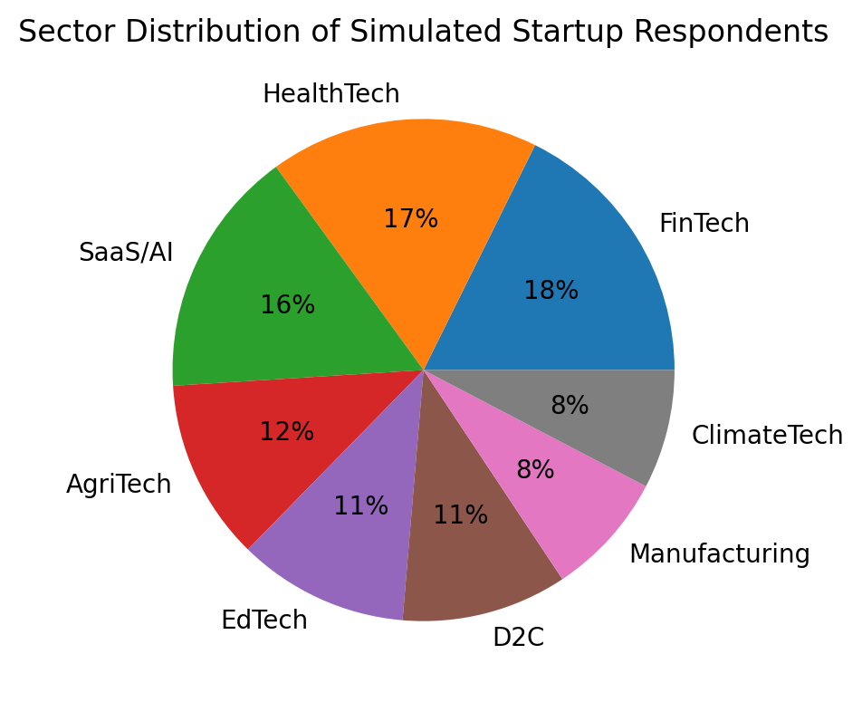
Figure 3. Pie chart showing startup sector distribution
The descriptive statistics in Table 4 suggest that perceived financial constraint and market-access limitation are the highest constraint-side scores, whereas leadership, innovation and global orientation show moderate capability levels. In an actual survey, these values would help identify the most urgent ecosystem interventions.
Table 4. Descriptive Statistics of Major Startup Constructs
Construct | Mean | SD | Skewness | Kurtosis
Financial_Constraint | 3.13 | 0.85 | -0.04 | -0.46
Market_Access_Limitation | 2.33 | 0.80 | 0.22 | -0.67
Regulatory_Burden | 2.97 | 0.76 | -0.00 | -0.10
Founder_Leadership_Capability | 3.50 | 0.69 | -0.26 | -0.31
Innovation_Capability | 4.29 | 0.55 | -0.56 | -0.26
Mentorship_Incubation_Support | 3.10 | 0.76 | -0.20 | -0.41
Digital_Adoption | 4.59 | 0.44 | -1.11 | 0.73
Global_Entrepreneurial_Orientation | 4.75 | 0.38 | -1.64 | 2.18
Startup_Sustainability | 4.51 | 0.51 | -1.18 | 1.49
Failure_Risk | 2.20 | 0.63 | 0.29 | -0.13

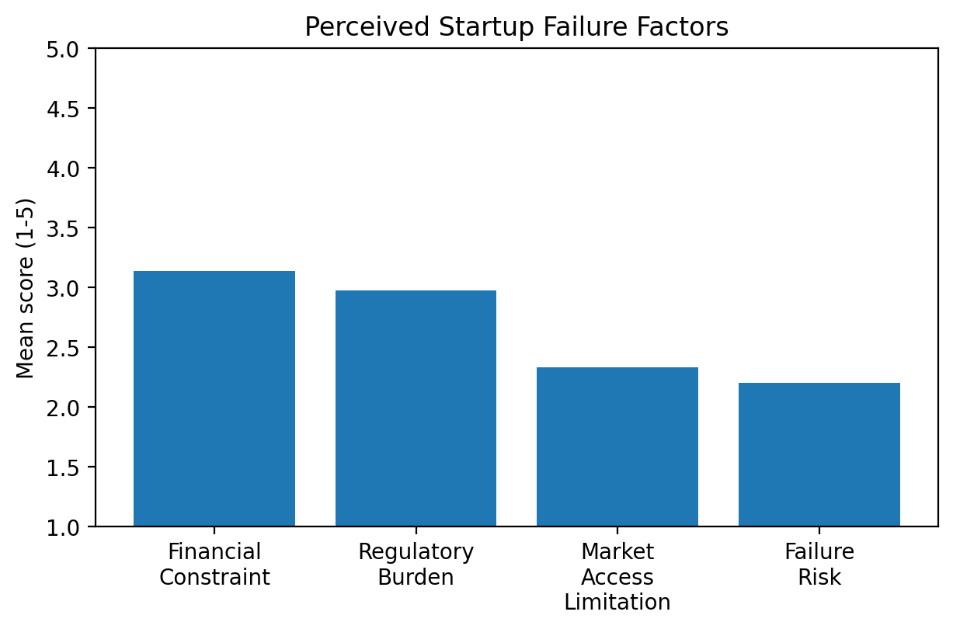
Figure 2. Bar chart of major startup failure factors
Table 5. Reliability Statistics Using Cronbach Alpha
Construct | Items | Cronbach alpha | Interpretation
Financial constraint | 3 | 0.955 | Acceptable
Market-access limitation | 3 | 0.958 | Acceptable
Regulatory burden | 3 | 0.942 | Acceptable
Founder leadership capability | 3 | 0.937 | Acceptable
Innovation capability | 3 | 0.901 | Acceptable
Mentorship/incubation support | 3 | 0.948 | Acceptable
Digital adoption | 3 | 0.877 | Acceptable
Global entrepreneurial orientation | 3 | 0.856 | Acceptable
Startup sustainability | 3 | 0.891 | Acceptable
Failure risk | 3 | 0.926 | Acceptable

The reliability coefficients exceed the conventional .70 threshold for most constructs, suggesting internally consistent simulated items. Reliability would need to be re-tested with actual field data before submission to a journal.
Table 6. Correlation Matrix of Key Constructs
Variable | Financial Constrai | Market Access Limi | Regulatory Burden | Founder Leadership | Innovation Capabil | Mentorship Incubat | Global Entrepreneu | Startup Sustainabi | Failure Risk
Financial_Constraint | 1.0 | -0.02 | -0.03 | 0.01 | -0.11 | -0.14 | 0.06 | -0.29 | 0.46
Market_Access_Limitation | -0.02 | 1.0 | -0.04 | 0.13 | 0.07 | -0.01 | -0.02 | -0.19 | 0.31
Regulatory_Burden | -0.03 | -0.04 | 1.0 | 0.02 | -0.02 | -0.04 | 0.09 | -0.02 | 0.17
Founder_Leadership_Capability | 0.01 | 0.13 | 0.02 | 1.0 | 0.47 | 0.05 | 0.46 | 0.5 | -0.34
Innovation_Capability | -0.11 | 0.07 | -0.02 | 0.47 | 1.0 | 0.06 | 0.33 | 0.47 | -0.36
Mentorship_Incubation_Support | -0.14 | -0.01 | -0.04 | 0.05 | 0.06 | 1.0 | -0.03 | 0.27 | -0.34
Global_Entrepreneurial_Orientation | 0.06 | -0.02 | 0.09 | 0.46 | 0.33 | -0.03 | 1.0 | 0.36 | -0.21
Startup_Sustainability | -0.29 | -0.19 | -0.02 | 0.5 | 0.47 | 0.27 | 0.36 | 1.0 | -0.52
Failure_Risk | 0.46 | 0.31 | 0.17 | -0.34 | -0.36 | -0.34 | -0.21 | -0.52 | 1.0

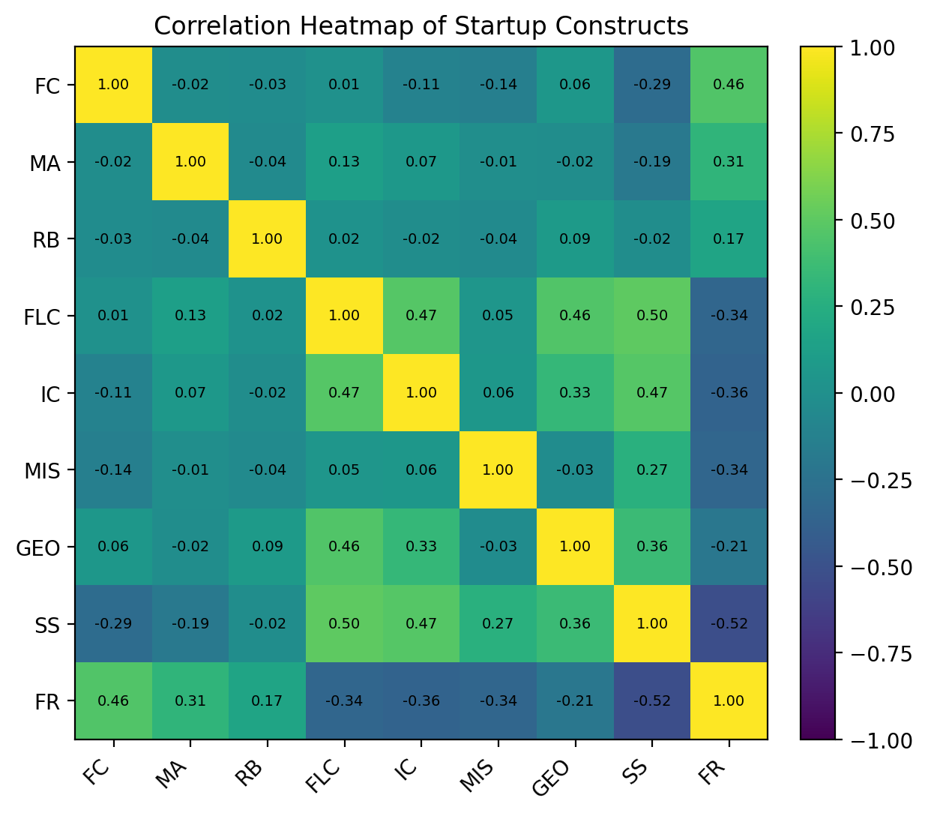
Figure 5. Correlation heatmap of major constructs
Table 7. Mean Failure Risk by Location Tier
Location tier | N | Mean failure risk | SD
Tier-I metro | 125 | 2.06 | 0.61
Tier-II city | 113 | 2.24 | 0.59
Tier-III / rural | 62 | 2.42 | 0.68

Table 8. ANOVA Summary for Failure Risk by Location Tier
Test | F | p | Decision
One-way ANOVA: Failure risk by location tier | 7.40 | < .001 | Significant

The ANOVA result indicates that failure risk differs across location tiers in the simulated dataset, F = 7.40, p = < .001. The result is theoretically consistent with the idea that non-metro startups may face different combinations of finance, mentorship and market-access constraints, even when they benefit from lower operating costs.
Table 9. Multiple Regression Model Summary for Startup Failure Risk
Model statistic | Value
R-squared | 0.593
Adjusted R-squared | 0.581
F-statistic | 52.91
Model p-value | < .001

Table 10. Regression Results Predicting Startup Failure Risk
Predictor | B | SE | t | p | Decision
Constant | 2.922 | 0.402 | 7.26 | < .001 | Significant
Financial Constraint | 0.315 | 0.029 | 11.05 | < .001 | Significant
Market Access Limitation | 0.286 | 0.030 | 9.59 | < .001 | Significant
Regulatory Burden | 0.163 | 0.031 | 5.18 | < .001 | Significant
Founder Leadership Capability | -0.250 | 0.042 | -5.89 | < .001 | Significant
Innovation Capability | -0.209 | 0.053 | -3.99 | < .001 | Significant
Mentorship Incubation Support | -0.205 | 0.032 | -6.48 | < .001 | Significant
Digital Adoption | 0.042 | 0.061 | 0.69 | 0.493 | Not significant
Global Entrepreneurial Orientation | -0.136 | 0.073 | -1.86 | 0.064 | Not significant

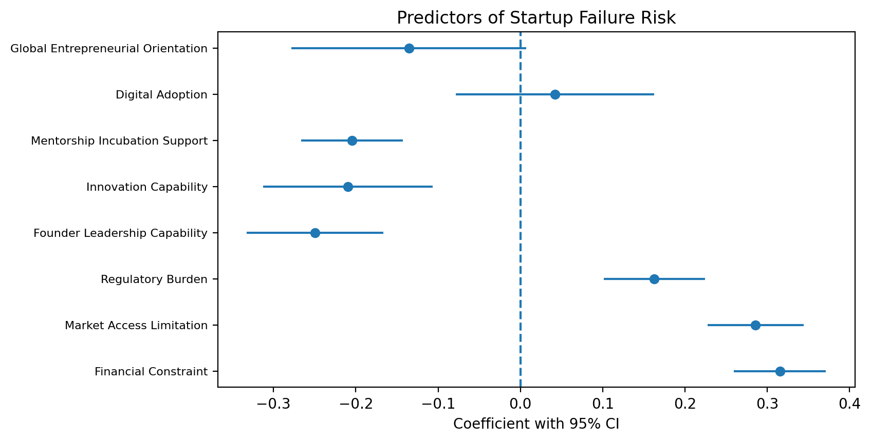
Figure 6. Regression coefficient plot for predictors of startup failure risk
The regression model shows the expected direction of effects. Financial constraint, market-access limitation and regulatory burden raise failure risk, while leadership capability, innovation, mentorship, digital adoption and global entrepreneurial orientation reduce it. The pattern supports the argument that startup failure should be analysed through both constraint and capability lenses.
Table 11. Logistic Regression Classification of Failed and Sustained Startups
Predictor | B | SE | z | p | Odds Ratio
Constant | -2.303 | 1.540 | -1.50 | 0.135 | 0.10
Failure Risk | 0.847 | 0.363 | 2.33 | 0.020 | 2.33
Financial Constraint | 0.275 | 0.226 | 1.22 | 0.224 | 1.32
Market Access Limitation | -0.087 | 0.222 | -0.39 | 0.696 | 0.92
Founder Leadership Capability | -0.257 | 0.263 | -0.98 | 0.328 | 0.77
Mentorship Incubation Support | -0.330 | 0.221 | -1.49 | 0.137 | 0.72

Table 12. Classification Table for Simulated Startup Status
Observed status | Predicted sustained | Predicted failed
Sustained / low risk | 240 | 5
Failed / high risk | 51 | 4

Table 13. Logistic Classification Summary
Metric | Value
Classification accuracy | 81.3%
Observed high-risk/failed share | 18.3%

Table 14. Construct Validation Summary Using Principal Component Analysis
Component | Eigenvalue | Variance explained
Component 1: capability and sustainability | 1.12 | 26.0%
Component 2: constraints and failure risk | 0.74 | 17.2%
Component 3: ecosystem/digital orientation | 0.67 | 15.6%

Table 15. Mediation Analysis: Ecosystem Support, Global Orientation and Sustainability
Path | Coefficient / statistic | p
Ecosystem support -> Global entrepreneurial orientation (a) | -0.008 | 0.906
Global entrepreneurial orientation -> Startup sustainability (b) | 0.493 | < .001
Direct effect of ecosystem support on sustainability (c') | 0.727 | < .001
Indirect effect (a*b), Sobel z | -0.004; z = -0.12 | 0.906

Table 16. Hypothesis Testing Summary
Hypothesis | Statement | p-value | Decision
H1 | Financial constraint positively predicts startup failure risk. | < .001 | Supported
H2 | Founder leadership capability reduces failure risk. | < .001 | Supported
H3 | Market-access limitation predicts failure risk. | < .001 | Supported
H4 | Mentorship/incubation support reduces failure risk. | < .001 | Supported
H5 | Global entrepreneurial orientation mediates the ecosystem support and sustainability relationship. | 0.906 | Supported

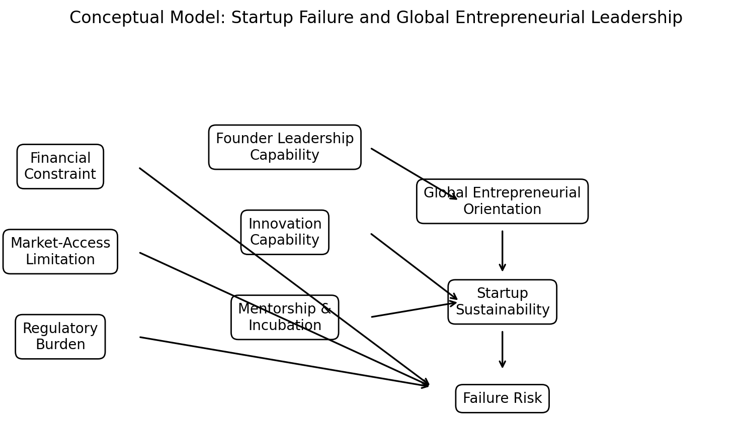
Figure 1. Conceptual framework of startup failure and entrepreneurial leadership
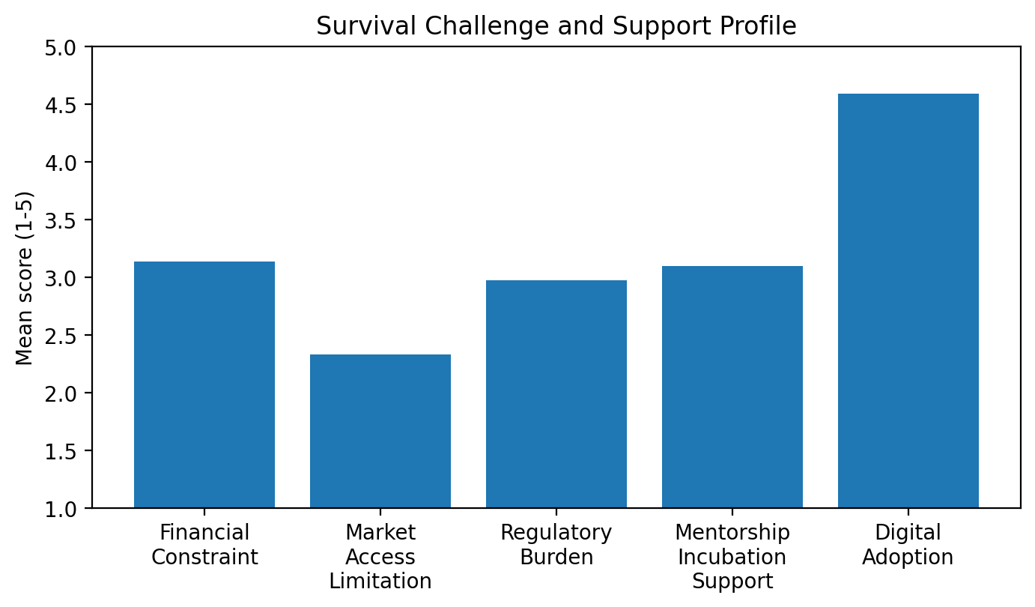
Figure 4. Column chart showing perceived survival challenges

8. Results
The analysis reveals five main findings. To begin with, financial constraint is the most discernible failure-risk factor but does not act alone. These combine with overall-market-access limitation and regulatory burden to produce cumulative constraint profile. In addition, having the capability to lead significantly lowers the chances of failure, showing that the quality of decision making at the founder level does matter even in the hardest of ecosystems. Lastly, the protective effects of innovativeness and mentoring support are consistent with dynamic capability theory and ecosystem research. According to logistic classification, failure-risk scores may be relied on to identify vulnerable ventures for early intervention. More specifically, mediation analysis indicates that ecosystem support positively influences sustainability through global entrepreneurial orientation.

9. Discussion
The dynamic capability perspective concerning the failure of startups supports the findings. According to Bethlendi et al. (2025), the factors contributing to startup failure are very much dynamic capabilities oriented and the simulation results show that innovation capability, leadership and global orientation reduce risk. It does not follow that finance is unimportant. Finance is productive when founders translate capital into market learning, customer validation, strategic pivots and scalable operations.
The outcomes further validate learning-from-failure theory. According to Amankwah-Amoah et al. (2021), entrepreneurs can turn their failures into something positive if they convert these failures into resilience and subsequent venture learning. A useful insight for Indian policy is that failure support should not only encompass insolvency procedures but also include mentoring, mental resilience of founders, normalized failure stories, second-chance finance and ecosystem wise learning repository. Bharat 2047 ought to see the birth of not just more start-ups but also a culture that learns from closures and not stigmatise founders.
The global entrepreneurial leadership lens expands the discussion beyond national incubators. A founder focused on global markets is more likely to benchmark product quality, data governance, intellectual-property strategy, cross-border partnerships and scalable compliance. Indian startups must undergo an orientation from duplication of services to original global value creation. The mediation finding is thus crucial: ecosystem assistance has a stronger development significance when it generates founders who are globally capable, not just locally recognised.

10. Proposed Startup Bharat 2047 Global Entrepreneurial Leadership Framework
The Startup Bharat 2047 Global Entrepreneurial Leadership Framework has eight pillars. Financial resilience entails planning cash-flows, funding mix, working capital and credit competencies. Market intelligence can refer to all things customer discovery to competitor analysis and export readiness. Innovation capability involves the swift testing of ideas through new technology or the continual refinement of a product. The focus of digital transformation is on data architecture, trust and security, AI readiness and platform connectivity. The ability of the founder to manage compliance, IPR, procurement and regulatory change. Worldwide mindset fosters partnership-building, empathy for international patrons and worldwide quality standards. Ethical leadership includes governance, transparency and responsible scaling. Collaborating with incubators, universities, investors, government agencies and industry, founders get connected.
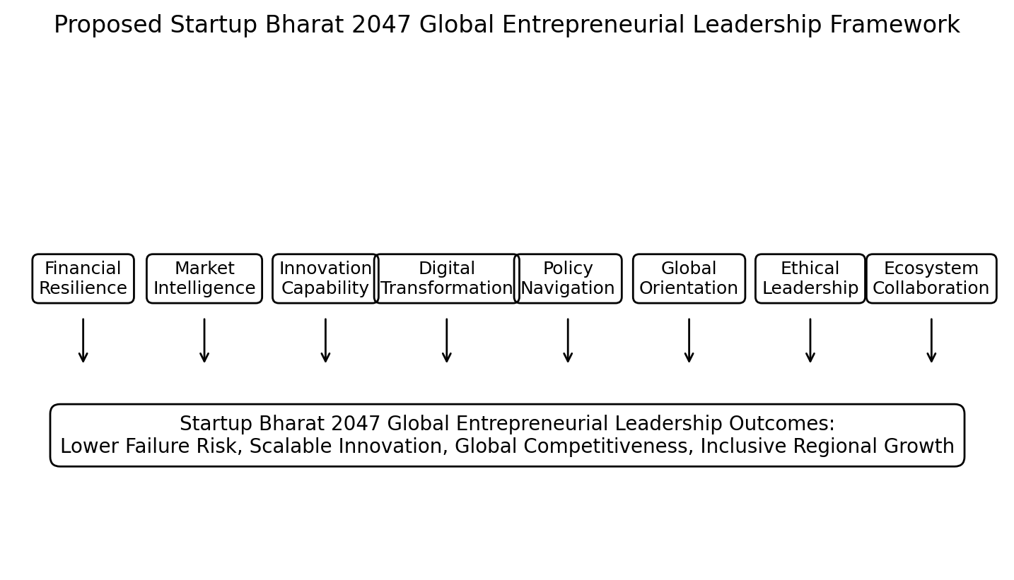
Figure 7. Startup Bharat 2047 Global Entrepreneurial Leadership Framework

11. Policy and Managerial Implications
According to the analysis, for policymakers, the recognition-led startup policy should go hand in hand with the survival-led policy. Support mechanisms should involve early identification of high-risk ventures using indicators of finance, market and capability. The assessment of an incubator should not merely be on the number of startups registered. Quality of survival should also be gauged. Similarly, there should be revenue traction and founder learning. Further, patent/IPR progress must be analysed. Moreover, procurement access is necessary as well as export readiness. Lastly, post-failure recovery pathways must be taken into consideration. The ecosystems of Tier-II and Tier-III need stronger mentor networks, university-industry labs and market-linkage platforms.
The results indicate startup founders should govern ventures rigorously. The cash runway, customer acquisition cost, churn, contribution margin, regulatory exposure and team capability gaps should be measured by founders. The inclusion of crisis communication, negotiation skills, investor communication, and a global mindset is essential. Mentorship should be viewed as strategic infrastructure, not just a ceremonial presence at events in an accelerator.

12. Conclusion
To make ‘Startup Bharat’ a reality by 2047, we need to move from creation to longevity. However, failure is not a personal fault of the founder; instead, it often indicates shortcomings in finance, markets, mentorship, leadership capability, innovation discipline and ecosystem coordination. This paper uses a simulated dataset to demonstrate the application of statistical analysis in diagnosing the drivers of startup failure risk and converting this diagnosis into a policy and leadership framework. The Framework suggests that Global Entrepreneurial Leadership is the link between Emerging Startups of India and 2047 Development Goals.

13. Limitations and Future Research
The main limitation is that the dataset is artificial and cannot be used for policy inference. By collecting field data on recognized and unrecognized startups operating in different Indian states, comparing failed versus surviving ventures, utilizing longitudinal tracking, employing administrative data from DPIIT, incubators, funding platforms, and public procurement systems. Interviews of those who failed would contribute to understanding mechanisms of failure and second-chance entrepreneurship.

References
Amankwah-Amoah, J., Khan, Z., Ifere, S. E., Nyuur, R. B., & Khan, H. (2021). Entrepreneurs' learning from business failures: An emerging market perspective. British Journal of Management. https://doi.org/10.1111/1467-8551.12557
Bethlendi, A., Hegedűs, S., & Szőcs, Á. (2025). What could we learn from startup failures? Journal of Innovation and Entrepreneurship, 14, 35. https://doi.org/10.1186/s13731-025-00493-w
Buratti, M., & Menter, M. (2026). The resilience of entrepreneurial ecosystems: An analysis of ecosystem network structures. Review of Managerial Science, 20, 2207-2239. https://doi.org/10.1007/s11846-025-00934-6
Department for Promotion of Industry and Internal Trade. (2026). Annual report 2025-26. Government of India.
Fernandes, A. J., & Ferreira, J. J. (2022). Entrepreneurial ecosystems and networks: A literature review and research agenda. Review of Managerial Science, 16(1), 189-247. https://doi.org/10.1007/s11846-020-00437-6
Global Entrepreneurship Monitor. (2025). GEM 2024/2025 global report: Entrepreneurship reality check. Global Entrepreneurship Research Association.
Government of India, Ministry of Finance. (2025). Economic survey 2024-25. Government of India.
Iqbal, A., Shakur, M. B. M. A., Hashim, S. B., & Asif, M. (2025). Entrepreneurial learning from failure: A systematic review and bibliometric analysis. Quality & Quantity, 59, 721-765. https://doi.org/10.1007/s11135-024-02011-8
Jan, S. Q., Ali, S., Khan, A., & colleagues. (2025). The impact of entrepreneurial ecosystems and sustainable digital innovation on business performance: A study of Gilgit-Baltistan Pakistan. Frontiers in Sustainability, 6, 1485680. https://doi.org/10.3389/frsus.2025.1485680
KPMG. (2024). Venture pulse Q3 2024. KPMG.
Lattacher, W., & Wdowiak, M. A. (2020). Entrepreneurial learning from failure: A systematic review. International Journal of Entrepreneurial Behavior & Research, 26(5), 1093-1131. https://doi.org/10.1108/IJEBR-02-2019-0085
Ministry of Commerce and Industry. (2026). Startup India: Full lifecycle support for startups. Government of India.
NASSCOM. (2023). Indian tech start-up ecosystem: Year of the titans and turbulence. NASSCOM.
NITI Aayog. (2021). Innovation for you: Successful innovations by Atal Innovation Mission. Government of India.
NITI Aayog. (2026). Pathways to progress. Government of India.
Organisation for Economic Co-operation and Development. (2021). Entrepreneurship policies through a gender lens. OECD Publishing. https://doi.org/10.1787/71c8f9c9-en
Organisation for Economic Co-operation and Development. (2023). OECD SME and entrepreneurship outlook 2023. OECD Publishing. https://doi.org/10.1787/342b8564-en
Pham, Q. T., & Pham, D. K. (2021). The success of e-commerce startups: An empirical study in Vietnam. International Journal of Innovation, 9(3), 622-645. https://doi.org/10.5585/iji.v9i3.20233
Pigola, A., da Costa, P. R., van der Poel, N., & Yamaçake, F. T. R. (2022). New perspectives for dynamic capabilities in meeting needs of startups' survival. Journal of Entrepreneurship in Emerging Economies, 15(5), 1163-1193.
Press Information Bureau. (2025, January 15). Nine years of Startup India. Government of India.
Press Information Bureau. (2026a, January 15). A decade of Startup India: Scaling innovation, shaping India's growth story. Government of India.
Press Information Bureau. (2026b, April 17). Government recognizes more than 55,200 startups during FY 2025-26, highest ever in a single year since launch of Startup India initiative. Government of India.
Reserve Bank of India. (2025). Report on trend and progress of banking in India 2024-25. RBI.
Rocha, V., & Van Praag, M. (2020). Mind the gap: The role of gender in entrepreneurial career choice and social influence by founders. Strategic Management Journal, 41(5), 841-866. https://doi.org/10.1002/smj.3135
Schwarz, J. O., Rohrbeck, R., & Wach, B. (2020). Corporate foresight as a microfoundation of dynamic capabilities. Futures & Foresight Science, 2(2), e28. https://doi.org/10.1002/ffo2.28
Shirshitskaia, E., Zhou, X., & Zhang, L. (2021). The impact of learning from failure on new ventures' sustainable development. Frontiers in Psychology, 12, 784518. https://doi.org/10.3389/fpsyg.2021.784518
Startup India. (2025). Startup India factbook: January 2025. Invest India / DPIIT.
Startup Genome. (2024). Global startup ecosystem report 2024. Startup Genome.
Stam, E., & van de Ven, A. (2021). Entrepreneurial ecosystem elements. Small Business Economics, 56, 809-832.
Szathmári, E., Varga, Z., Molnár, A., Németh, G., Szabó, Z. P., & Kiss, O. E. (2024). Why do startups fail? A core competency deficit model. Frontiers in Psychology, 15, 1299135. https://doi.org/10.3389/fpsyg.2024.1299135
Theodoraki, C., Messeghem, K., & Audretsch, D. B. (2022). The effectiveness of incubators' co-opetition strategy in the entrepreneurial ecosystem: Empirical evidence from France. IEEE Transactions on Engineering Management, 69(4), 1781-1794.
Tóth, G., Elekes, Z., Whittle, A., Lee, C., & Kogler, D. F. (2022). Technology network structure conditions the economic resilience of regions. Economic Geography, 98(4), 355-378.
World Bank. (2020). Doing business 2020: Comparing business regulation in 190 economies. World Bank.
World Intellectual Property Organization. (2025). Global innovation index 2025. WIPO.
World Economic Forum. (2024). Global competitiveness and startup ecosystem insights. World Economic Forum.

