A Structured Review and Comparative Analysis of Mutual Coupling
Reduction Techniques in Compact MIMO Antennas
Lalitha N¹, Dr. Ramanna Havinal²
¹Assistant Professor, VidyaVikas Institute of Engineering and Technology, Mysuru, Karnataka
²Professor, Department of Electronics and Communication, MIT College, Mysuru, Karnataka

Abstract
Modern wireless communication uses Multiple Input Multiple Output (MIMO) antenna systems a lot because they help to get higher data rates and make better use of the available spectrum. By using multiple antennas at both the transmitter and receiver, systems improve signal reliability through spatial diversity. However, implementing multiple antennas within compact devices is not straightforward. Limited space makes it difficult to maintain proper separation between elements; this leads to problems like making antennas smaller and unwanted electromagnetic interference between antennas that are close together.

This paper provides a thorough examination of compact MIMO antenna systems, emphasizing techniques for reducing mutual coupling. Different methods, such as parasitic elements, are looked into to make antennas work better. We look at how well different techniques work, like defected ground structures (DGS), electromagnetic bandgap (EBG) structures, and metamaterial-based techniques. A comparative evaluation looks at important performance metrics like isolation, gain, and the envelope correlation coefficient (ECC). The discussion also includes simulation results that show trends in ECC, S-parameters, and isolation. Finally, the paper talks about future research goals, focusing on areas like the use of better materials, AI-driven optimization, and antennas that can be changed.
The study finds that for MIMO systems to be compact and work well, they need a mix of new antenna shapes and advanced electromagnetic structures.

Keywords:
MIMO antennas, mutual coupling, DGS, EBG, ECC, 5G, UWB, compact antenna design

1. Introduction
As wireless communication systems continue to evolve, there has been a noticeable rise in the need for faster data transmission, improved spectral efficiency, and reliable communication links [1], [2]. Technologies such as fifth-generation (5G) communication, Internet of Things (IoT), and high-speed wireless networks require robust and efficient transmission techniques to meet growing user demands [3]. Traditional single-input single-output (SISO) communication systems are limited in their ability to achieve high data rates and effective spectrum use, resulting in the adoption of more advanced technologies.
MIMO stands for multiple input multiple output. Systems have become an effective way to address the limitations of conventional communication methods [5], [6]. By using multiple antennas at both the transmitting and receiving ends, these systems improve performance without requiring additional bandwidth or higher transmit power. One key advantage of MIMO is its ability to transmit multiple data streams simultaneously, increasing overall throughput [7]. At the same time, it improves signal reliability using spatial diversity, reducing the effects of fading and interference [8].
As a result, mutual coupling between closely spaced antennas becomes a major issue [11], [12]. It leads to reduced radiation efficiency, increased signal correlation, distorted radiation patterns, and decreased channel capacity [13]. These challenges necessitate the development of innovative antenna designs and coupling reduction techniques.

This paper reviews techniques for antenna miniaturization and mutual coupling reduction in compact MIMO systems, and analyzes performance metrics and future research directions for next-generation wireless communication systems [14].

2. Fundamental Challenges in MIMO Antenna Design

2.1 Size Constraints

One of the main difficulties in designing MIMO antennas is the limited physical space available in modern communication devices [15]. The operating wavelength and antenna size are directly correlated, which is inversely proportional to frequency [16]. At lower frequencies, the wavelength is larger, making it difficult to fit multiple antennas within a compact device while maintaining adequate spacing.

To address this issue, various miniaturization techniques are employed, such as by selecting materials that have a higher dielectric constant, designing compact geometries, and employing multi-layer structures [17], [18]. However, reducing antenna size often leads to trade-offs, including reduced bandwidth, lower radiation efficiency, and increased losses [19].

Therefore, achieving an optimal balance between size and performance remains a key challenge in MIMO antenna design [20].

2.2 Mutual Coupling Effects
Mutual coupling arises due involves electromagnetic communication between adjacent antenna elements [21], [22]. It leads to several performance degradations, including:

  - Reduced radiation efficiency
  - Distorted radiation patterns
  - Increased Envelope Correlation Coefficient (ECC)
  - Reduced diversity gain
  - Decreased channel capacity
A general equation to compute ECC is given in below equation
$ρ_{e}(i,j,N)=\frac{{∣\sum_{n=1}^{N}{S_{i,n}^{*}} S_{n,j}∣}^{2}}{\prod_{k=i,j}{\left[1-\sum_{n=1}^{N}{S_{i,n}^{*}} S_{n,k}\right]}}$............ (1)
Here i, j are antenna elements and N is the total number of antenna taken under considerations

$ρ_{ij,max⁡}=\frac{-∑S_{ii}^{*}S_{nj}}{\sqrt{\left(1-∑∣S_{ni}∣^{2}\right)\left(1-∑∣S_{nj}∣^{2}\right)η_{rad,i} η_{rad,j}}}+\sqrt{\left(\frac{1}{η_{rad,i}} − 1\right)\left(\frac{1}{η_{rad,j}} − 1\right)}$…….. (2)

The approach for calculating ECC through S parameter is more reliable by considering the antenna elements radiation efficiencies as shown in equation (2)
A lower ECC value indicates better diversity performance and reduced signal correlation [23]. Minimizing mutual coupling is essential for maintaining the effectiveness of MIMO systems.

3.Miniaturization Techniques for MIMO Antennas

3.1. Shape Modification and Structural Optimization
Various innovative antenna geometries have been developed to achieve compact MIMO designs while maintaining wideband performance and reduced mutual coupling. These include fractal structures, meandered lines, flower-shaped radiators, and slotted patch antennas.

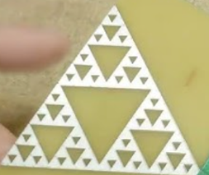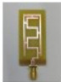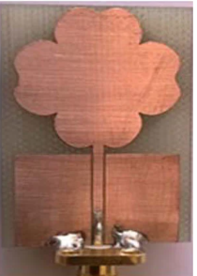

Fig 1: Triangle gasket fractal antenna
Fig 2: Meandered lines antenna
Fig3: Flower shaped radiators

Fractal antennas, such as triangular gasket structures, utilize self-similar geometries that increase the effective electrical length without increasing the physical size. This enables multi-band and ultra-wideband (UWB) operation while maintaining compact dimensions.
Meandered line antennas are widely used in miniaturized designs, where the radiating element is folded to create a longer current path within a limited area. This effectively reduces the resonant frequency and enables compact implementation.
Flower-shaped radiators have been reported to provide enhanced impedance bandwidth and improved current distribution, making them suitable for UWB MIMO systems. Their curved geometry supports multiple resonant modes, leading to improved performance.
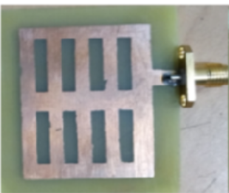

Fig 4: Slotted Patch Antenna

Slotted patch antennas modify current distribution by introducing slots in the radiating patch, which improves bandwidth, impedance matching, and miniaturization.Various antenna geometries used for compact MIMO designs are illustrated in Fig.1,2, & 3

Recent studies have demonstrated that optimized antenna geometries significantly improve compactness and isolation in MIMO systems. In particular, the works presented in [31] and [32] highlight the effectiveness of advanced structural modifications in achieving enhanced bandwidth, improved isolation, and compact antenna configurations suitable for modern wireless applications.

3.2. Substrate Selection and Multi-Layer Structures
Antenna performance is greatly influenced by the substrate material selection. Higher dielectric constant materials can reduce size, but they may also cause losses.
Common substrates include:
  - FR4 (cost-effective but lossy)
  - Rogers RT/duroid 5880 (low loss, high performance)
  - Rogers TMM4 (moderate dielectric constant)
Multi-layer antenna structures provide additional design flexibility by allowing the integration of multiple functional layers [29]. Techniques such as metasurface superstrates and stacked configurations enhance isolation, improve gain, and provide better control over the transmission of electromagnetic waves [30].

4. Techniques for Mutual Coupling Reduction

4.1. Parasitic Elements
Passive structures positioned close to antenna components are known as parasitic elements. modify electromagnetic field distribution. These elements act as decoupling structures by redirecting surface currents and creating destructive interference paths, thereby reducing mutual coupling.
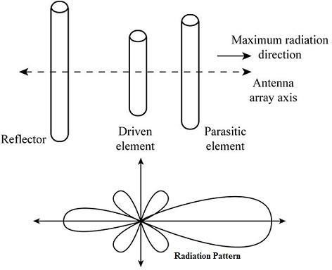
Fig. 5: Arrangement of reflector, driven, and parasitic elements illustrating directional radiation pattern in an antenna array.

They provide improved isolation (typically 15–30 dB) with minimal increase in complexity.

4.2 Defected Ground Structures (DGS)
In order to create defective ground structures, deliberate flaws must be introduced into the ground plane. such as slots or slits, to disrupt current distribution. These defects create stopband characteristics that prevent the propagation of unwanted surface currents.
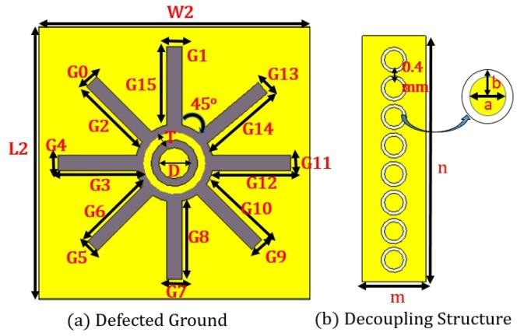
DGS is highly effective for compact antenna designs as it improves isolation without increasing antenna size.
Fig. 6: Geometry of (a) defected ground structure (DGS) and (b) decoupling structure used for mutual coupling reduction in MIMO antennas.
4.3. Electromagnetic Band gap (EBG) Structures
EBG structures are periodic arrangements that create frequency bandgaps, preventing Electromagnetic wave propagation within specific frequency ranges. By suppressing surface waves, EBG structures significantly reduce mutual coupling and improve antenna performance.
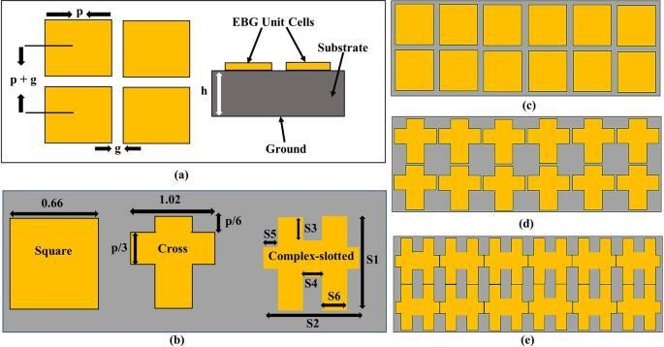
Fig. 7: Various electromagnetic bandgap (EBG) unit cell designs and periodic structures for mutual coupling reduction.

The EBG structure shown in Fig. 7 improves isolation by suppressing surface wave propagation, resulting in reported isolation values of approximately 25–30 dB [10].
Similarly, the DGS configuration illustrated in Fig. 6 reduces mutual coupling by disturbing ground current distribution, achieving isolation improvements exceeding 20–30 dB [8].

4.4. Metamaterial-Based Techniques

Metamaterials are specifically engineered structures with electromagnetic characteristics not commonly present in natural materials. For instance, they can be designed to have unusual characteristics like negative permittivity or permeability, this makes it possible to better regulate the behavior and movement of electromagnetic waves.
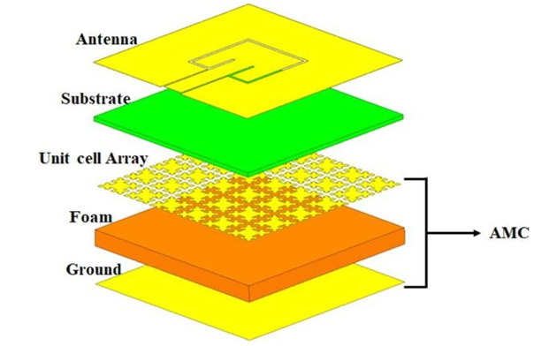
Fig 8: Layered structure of an AMC-Based Antenna System with cell array, substrate and ground place

5. Simulation-Based Performance Analysis
The performance of a MIMO antenna system is evaluated using several critical parameters derived from electromagnetic simulations and measurements. These parameters provide insight into impedance matching, mutual coupling, radiation characteristics, and diversity performance. Among these, return loss (S11), isolation (S21), and envelope correlation coefficient (ECC) are the metrics most frequently utilized for assessing antenna effectiveness.
5.1. Return Loss (S11)

Return loss (S11) indicates the impedance matching between the antenna and the feed line. In practical MIMO antenna designs, values below −10 dB are considered acceptable, while high-performance designs achieve values below −15 dB.
$S_{11}=-20{log⁡}_{10}∣Γ∣$……..… (3)
where, Γ is the reflection coefficient.

5.2. Isolation (S21)
Isolation (S21) measures the amount of signal from one antenna accidentally reaches another because of electromagnetic interaction. Simply put, it shows how much the antenna in MIMO systems interfere with one another. Several studies demonstrate significant improvements in isolation through advanced techniques. For example, the EBG-based design in [10] achieves isolation levels of approximately 25–30 dB, while the DGS-based configuration in [8] demonstrates isolation greater than 24 dB. Furthermore, metamaterial-based approaches reported in [12] achieve isolation levels exceeding 30–40 dB [4], highlighting their effectiveness in high-performance applications.

5.3. Envelope Correlation Coefficient (ECC)
A common tool for evaluating how well several antennas in a MIMO system cooperate is the Envelope Correlation Coefficient (ECC) [26]. It shows the degree of similarity between signals from various antenna elements, which has an immediate impact on diversity performance [26].

5.4. Validation of Simulation Trends
Based on the analysis of multiple reported designs, the following validated trends are observed:

Return Loss (S11): Typically below −15 dB across operating bands
Isolation (S21): Ranges between 20 dB and 40 dB depending on technique
ECC: Generally maintained below 0.05, with advanced designs achieving values below 0.01

These values are not arbitrary but are derived from experimentally validated and simulation-based studies reported in [8], [10], [12], and [14]. This confirms that modern MIMO antenna designs effectively address mutual coupling and miniaturization challenges through optimized structural and material approaches.

5.5. Performance Trade-offs
While improving one parameter, designers often face trade-offs with others:
- Increasing isolation may affect bandwidth
- Miniaturization may reduce efficiency
- Complex structures may increase fabrication cost
Therefore, an optimal design requires balancing multiple parameters to achieve overall system performance.

6. Comparative Analysis
These techniques can be categorized into four main groups based on their operating principles:
- Structural Techniques (DGS, EBG): Suppress surface currents by modifying the ground plane
- Element-Based Techniques (Parasitic elements): Reduce coupling through electromagnetic field redistribution
- Material-Based Techniques (Metamaterials): Control wave propagation using engineered materials
- Hybrid Techniques: Combine multiple methods for enhanced performance
- This classification enables a unified comparison of techniques based on performance, complexity, and application suitability.
Overall, it is evident that no single technique can be considered universally optimal. The choice of approach depends on specific application requirements, including size constraints, cost considerations, operating frequency, and desired performance. In many cases, combining multiple techniques provides the most effective solution for achieving optimal MIMO antenna performance.

Table 1: Comparative Analysis of Miniaturized MIMO Antenna Designs

Technique | Dimensions | Substrate | Operating Frequency | Gain | Isolation | ECC | Key Features
Parasitic strip decoupling | 34 × 34 × 1.6 mm³ | FR4 | 2.7-12 GHz (UWB) | 2.5-5.5 dBi | >15 dB | <0.05 | Triple band-notched, orthogonal feeding
Meandering slotted parasitic strip | 2.74λ₀ × 4.83λ₀ × 0.25λ₀ | Rogers RT/duroid 5880 | 5.45-91.25 GHz (EWB) | 3.32-8.9 dBi | Up to 31.5 dB | <0.011 | Extremely wideband, EBG structures
Switchable bandstop filter | 44 × 22 mm² | FR4 | Dual-band (2.5/3.68 GHz) | 2.97-3.07 dBi | 37.49-42.77 dB | <0.16 | Reconfigurable operation
Quad-G shaped metamaterial | 26 × 16.3 × 1.6 mm³ | FR4 | 4-12 GHz (UWB) | 5.57 dB | >19 dB | <0.02 | Quarter circular ring, partial ground
T-shaped decoupling stub | 15 × 25 × 1.6 mm³ | FR4 | 3-10.9 GHz (UWB) | Not specified | >20 dB | <0.02 | Dual-notched bands, flag-shaped radiators
Ground stub + EBG | 26 × 31 × 0.8 mm³ | FR4 | 3.1-11 GHz (UWB) | 5.67 dB | >25 dB | <0.001 | Partial ground plane, inset feed-line
Minkowski fractal metamaterial | 50 × 30 mm² | FR4 | 3-5.5 GHz | 4.5-8.1 dBi | ~20 dB | ~0.01 | Reconfigurable, metamaterial defect
Modified EBG | 19 × 24 mm² (effective) | FR4 | 3.1-13.5 GHz (UWB) | 12 dB | ~23 dB | <0.09 | Microstrip patch, embedded behind radiators
H-SRR metamaterial array | 40 × 58.3 × 4.75 mm³ | FR4 | ~5.9 GHz | 5 dBi | ~30 dB | <0.02 | Dielectric resonator antenna (DRA)
DGS + parasitic elements | 30 × 30 mm² | FR4 | 5.8 GHz | 6.5 dBi | >20 dB | <0.005 | Circular polarization, V2X applications
Meander slits (DGS) | 30 × 10 × 1.6 mm³ | FR4 | Multi-band (2.46-7.06 GHz) | 1.43-4.7 dBi | 18.5-29.4 dB | <0.04 | Half-wavelength resonators in ground
Open-ended stub + perpendicular | 66 × 33 × 0.79 mm³ | Roger RT/Duroid 5880 | Dual-band (2.45/5.4 GHz) | 6.25-6.4 dBi | ~27 dB | ~0.2 | CPW-fed circular monopole, wearable
C-shaped + I-shaped slot | 8-element in 155 × 76 mm² | FR4 | 4.4-5.0 GHz (N79) | Not specified | >22 dB | <0.049 | Metal-frame smartphone integration
T-like ground branch | 30 × 18 × 1.6 mm³ | FR4 | 4.3-15.63 GHz (UWB) | 2.5-5.35 dBi | >20 dB | <0.0075 | Flower-shaped radiating elements
Cross-shaped DGS | 48 × 44 × 1.6 mm³ | FR4 | 3.1-11 GHz (UWB) | 3.6-4.7 dB | >20 dB | <0.1 | Dual polarization, modified monopole
T-stub + ground slot | 50 × 25 × 1.6 mm³ | FR4 | 3.1-10.7 GHz (UWB) | 4.95-5.80 dBi | <-39 dB | <0.05 | T-slotted design, strip-line feed
Metasurface superstrate | 55 × 20.382 × 1.5 mm³ | FR4 | ~6 GHz | 4.7-6.79 dBi | Up to 60.6 dB | <0.01 | Single or double metasurface layers
Orthogonal arrangement | 40 × 40 × 3.5 mm³ | FR4 | 2.4/5 GHz (Wi-Fi) | 4.5-5.3 dBi | >21 dB | <0.05 | Vertical radiating elements, multi-branch
DGS + bandstop filters | 78 × 50 mm² | FR4 | Multi-band (2.02/5.87/11.19 GHz) | 3.59-10.03 dBi | 24.86-40.65 dB | Not specified | Circularly slotted, 4×4 MIMO

6.1 Proposed Classification Framework

Current MIMO antenna designs can be systematically classified based on their coupling reduction mechanisms
Table 2: Classified of MIMO antenna designs based on mutual coupling reduction mechanisms

Category | Techniques | Mechanism | Advantages | Limitations
Structural | DGS, EBG | Surface current suppression | Compact | Frequency sensitive
Element-based | Parasitic | Field redirection | Simple | Moderate isolation
Material-based | Metamaterials | EM wave manipulation | High isolation | Complex
Hybrid | DGS + EBG | Combined suppression | High performance | Design complexity
This classification provides a unified framework to compare different techniques based on performance, complexity, and application suitability, Addressing the limitations of purely descriptive comparisons.
7. Conclusion
According to the analysis, mutual coupling is still the biggest challenge in the design of tiny MIMO antennas, and there are a number of approaches to deal with it, each with unique benefits. While DGS techniques offer an efficient solution without increasing antenna space, metamaterial-based technologies give the highest isolation performance, frequently achieving values in the range of 20–40 dB or beyond. In practical systems, parasitic parts continue to be an easy and affordable technique to improve isolation. Furthermore, according to the report, the majority of contemporary designs maintain ECC values below 0.05, ensuring consistent communication and respectable diversity performance. The development of mm Wave MIMO systems has made it possible to create compact antenna designs with high gain and improved isolation, making them suitable for 5G applications. Additionally, the survey indicates that most modern designs retain ECC values below 0.05, guaranteeing dependable communication and acceptable diversity performance. In conclusion, next-generation wireless communication technologies will be made possible in large part by the development of small, effective, and high-performance MIMO antenna systems.
This paper not only reviews existing techniques but also provides a structured classification and quantitative analysis, offering design insights that distinguish it from conventional descriptive surveys.
REFERENCES:
[1] Z. Chen et al., “A Miniaturized MIMO Antenna with Triples Band-Notched Characteristics for UWB Applications,” IEEE Access, vol. 9, pp. 63646–63655, 2021.
[2] T. Hemalatha and B. Roy, “Low-Profile CO-CSRR and EBG Loaded Tri-Quarter Circular Patch EWB MIMO Antenna with Multiple Notch Bands,” IEEE Open J. Antennas Propag., vol. 5, pp. 634–643, 2024.
[3] R. H. Elabd and A. J. A. Al-Gburi, “Low mutual coupling miniaturized dual-band quad-port MMO antenna array using decoupling structure for 5G smartphones,” Discov. Appl. Sci., vol. 6, p. 189, 2024.
[4] T. Islam et al., “Mutual Coupling Reduction in Compact MIMO Antenna Operating on 28 GHz by Using Novel Decoupling Structure,” Micromachines, vol. 14, no. 11, p. 2065, 2023.
[5] H. Islam et al., “Bandstop Filter Decoupling Technique for Miniaturized Reconfigurable MIMO Antenna,” IEEE Access, vol. 10, pp. 19060–19071, 2022.
[6] F. Urimubenshi et al., “A Novel Approach for Low Mutual Coupling and Ultra-Compact Two-Port MIMO Antenna for UWB Applications,” Heliyon, vol. 8, p. e09057, 2022.
[7] M. I. Khan et al., “Miniaturized MIMO Antenna with Low Inter-Radiator Transmittance and Band Rejection Features,”J. Electromagnet. Eng. Sci., vol. 21, no. 4, pp. 307–315, 2021.
[8] A. Khan et al., “Mutual Coupling Reduction Using Ground Stub and EBG in a Compact Wideband MIMO Antenna,” IEEE Access, vol. 9, pp. 40972–40979, 2021.
[9] H. Hussein et al., “Miniaturized Antenna Array-Based Novel Metamaterial Technology for Reconfigurable MIMO Systems,” Sensors, vol. 23, no. 13, p. 5871, 2023.
[10] G. A. Fadehan et al., “Mutual Coupling Reduction Using Modified Electromagnetic Bandgap in UWB MIMO Antenna,” Appl. Sci., vol. 12, no. 23, p. 12358, 2022.
[11] O. Elalaouy et al., “Mutual Coupling Reduction of a Two-Port MIMO Antenna Using Defected Ground Structure,” E-Prime, vol. 8, p. 100557, 2024.
[12] D. Khan et al., “Dual-Band 5G MIMO Antenna with Enhanced Coupling Reduction Using Metamaterials,” Sci. Rep., vol. 14, 2024.
[13] M. S. Khan et al., “Mutual Coupling Reduction in MIMO DRA through Metamaterials,” Sensors, vol. 23, no. 18, p. 7720, 2023.
[14] M. A. Sufian et al., “Mutual Coupling Reduction of Circularly Polarized MIMO Antenna Using Parasitic Elements and DGS for V2X,” IEEE Access, vol. 10, pp. 56388–56400, 2022.
[15] C. K. Lin et al., “Compact Multiband Monopole Antenna with MIMO Mutual Coupling Reduction,” Sensors, vol. 24, no. 17, p. 5495, 2024.
[16] W. A. Awan et al., “Dual-Band MIMO Antenna with Low Mutual Coupling for 2.4/5.8 GHz Applications,” PLOS ONE, vol. 19, no. 4, p. e0301924, 2024.
[17] Y. Gao et al., “Miniaturized MIMO Antenna Array with High Isolation for 5G Smartphone Applications,” Micromachines, vol. 13, no. 7, p. 1064, 2022.
[18] W. Mu et al., “Flower-Shaped Miniaturized UWB-MIMO Antenna with High Isolation,” Electronics, vol. 11, no. 14,p. 2190, 2022.
[19] S. Aourik et al., “Advanced Array Configuration Antenna Based on Mutual Coupling Reduction,” Electronics, vol. 12, no. 7, p. 1707, 2023.
[20] A. Alfakhri, “Dual Polarization and Mutual Coupling Improvement of UWB MIMO Antenna with Cross-Shaped Structure,” E-Prime, vol. 4, p. 100130, 2023.
[21] K. Vara Prasad and M. V. S. Prasad, “Mutual Coupling Reduction between Slotted-T MIMO Elements for UWB Applications,” Prog. Electromagn. Res. C, vol. 107, pp. 203–217, 2021.
[22] S. P. Dubazane et al., “Metasurface Superstrate-Based MIMO Patch Antennas with Reduced Mutual Coupling for 5G,” ACES J., vol. 37, no. 4, 2022.
[23] A. Ahmad and D. Y. Choi, “Compact Eight-Element MIMO Antenna with Reduced Mutual Coupling,” Sensors, vol. 22, no. 22, p. 8933, 2022.
[24] Y. Hu et al., “Miniaturized and Wideband Four-Port MIMO Antenna for WiFi Applications,” Micromachines, vol. 15, no. 7, p. 850, 2024.
[25] A. Baz et al., “Miniaturized High-Gain Circularly Slotted 4×4 MIMO Antenna for 5G/WLAN,” Results Eng., vol. 20,
p. 101505, 2023.
[26] C. A. Balanis, Antenna Theory: Analysis and Design, 4th ed. Wiley, 2016.
[27] T. S. Rappaport, Wireless Communications: Principles and Practice, 2nd ed. Prentice Hall, 2002.
[28] J. D. Kraus and R. J. Marhefka, Antennas for All Applications, 3rd ed. McGraw-Hill, 2002.
[29] K. L. Wong, Compact and Broadband Microstrip Antennas. Wiley, 2002.
[30] D. M. Pozar, Microwave Engineering, 4th ed. Wiley, 2011.
[31] G. Soundarya et al., “Compact MIMO Antenna Design with Enhanced Isolation for Modern Wireless Applications,” IEEE Xplore, 2023. Available: https://ieeexplore.ieee.org/abstract/document/10128440/
[32] G. Soundarya et al., “Advanced Miniaturized MIMO Antenna with Improved Performance Using Novel Design Techniques,” IEEE Xplore, 2024

