Contemporary translation of local new year print symbol - Taohuawu door god creative design and communicate

Abstract
Against the backdrop of traditional cultural revival and the growth of the cultural and creative industry, the transformation of local New Year painting symbols has become an important issue. The Door God images in Suzhou Taohuawu woodblock New Year paintings have distinctive visual features and cultural value, but current products suffer from superficial design, weak cultural expression, and fragmented communication.This study takes the Taohuawu Door God symbol as its object. Using literature analysis, case study, survey, interview, and design practice, it deconstructs the visual and cultural system of the symbol, explores pathways for transforming folk symbols into contemporary creative language, and proposes design solutions and communication strategies for modern life scenarios. The aim is to provide a practical and cultural reference for the translation of Taohuawu and other local New Year painting symbols, promoting creative transformation and innovative development of intangible cultural heritage.

Keywords: Regional New Year Paintings, Taohuawu Woodblock Prints, Door Gods, Cultural Innovation, Design-Driven Heritage Communication

1.Introduction
The contemporary revitalization of local New Year painting symbols has become an important topic in advertising and design research. This section clarifies the research background, theoretical basis, and methods, laying the foundation for subsequent branding and reconstruction.

1.1Research Background and Significance

1.1.1 Research Background
Under China’s “creative transformation and innovative development” policy, Suzhou Taohuawu New Year prints—a national intangible cultural heritage—possess a complete visual symbol system. The Door God image exhibits a clear signifier-signified relationship, aligning with contemporary blessing needs and providing a foundation for cultural creative translation.
However, current Taohuawu Door God cultural creative products face practical challenges: most designs remain superficial, weakening symbolic meaning and failing to achieve deep translation from cultural connotation to visual form. This prevents effective brand recognition and value resonance in contemporary consumer contexts.
This study takes the Taohuawu Door God symbol as its object, aiming to overcome superficial translation practices through systematic deconstruction and contemporary translation. From an advertising perspective, it explores innovative pathways to transform traditional imagery into modern design language, providing a practical reference for the revitalization of local intangible cultural heritage.

1.1.2 Research Significance
(1) Theoretical Significance
Suzhou Taohuawu New Year prints carry profound historical and cultural connotations. In-depth research on the Door God theme, mastering its formative language, folkloric meanings, and cultural implications, holds significant contemporary value for exploring its visual potential and inheriting excellent national spirits. Through the research and translation of the Taohuawu Door God, public awareness of the artistic characteristics and historical culture of Taohuawu New Year prints can be enhanced, which also has far-reaching practical significance for the protection and inheritance of similar intangible cultural heritage.
(2) Practical Significance
This paper summarizes a strategy of symbol extraction, form transformation, and context reconstruction, enhancing local cultural brands’ communication power and market value. It strengthens young people’s emotional connection with the Door God symbol and provides solutions for Suzhou’s urban cultural promotion and cultural creative market expansion, achieving dual growth in cultural and market value.

1.2 Related Concepts and Theories
This paper adopts cultural translation as its core perspective, combined with semiotics and advertising communication, to establish a theoretical foundation for the contemporization of traditional symbols.

1.2.1 Semiotics: An Analytical Tool for Cultural Translation
Semiotics focuses on the entire process of meaning generation, transmission, and reconstruction of symbols within the social field, providing an analytical path from "form" to "meaning" for cultural translation. According to Saussure's dyadic theory of the sign, the signifier and signified are conventional and socially constructed. The visual form of the Door God and its meaning of protection are not naturally corresponding but were constructed through long-term folk culture, thus possessing the potential for recoding and contemporary translation.
Roland Barthes’ mythology is particularly important: he divides the sign system into two levels—the linguistic system and the myth system where a sign becomes a new signifier endowed with a new signified.
In this study, the Door God belongs to the first-level sign system (primitive belief in warding off evil). Its cultural creative translation moves it into the second-level myth system: using the traditional symbol as a new signifier, design innovation endows it with contemporary values such as emotional companionship and cultural identity (new signified), achieving meaning reconstruction from “guardian tool” to “emotional symbol.” This mythologization is the main theoretical basis for cultural translation.
Building on this, Peirce's semiotic triad provides more practical support for audience research and design practice. Peirce divides the sign into three parts: the sign (representamen), the object, and the interpretant. These three form a dynamic, interactive triadic relationship. The interpretant refers to the audience's perception, attitude, and behavioral response to the Door God symbol, which can be directly linked to the questionnaire surveys, interviews, and audience analysis in this paper. This transforms the symbol translation from a one-way design process into a two-way construction that the audience can understand, resonate with, and accept. This theory brings the visual extraction, meaning transformation, and communication effect of the Door God symbol closer to real audience cognition, providing crucial theoretical support for subsequent design practice and market validation.
This paper uses semiotics to deconstruct the Taohuawu Door God schemas from four dimensions: line, color, composition, and character attributes, revealing how they collectively construct protection, blessing, and order.

1.2.2 Cultural Translation: Contemporary Reconstruction of Traditional Symbols
"Translation" is a term from linguistics, referring to the specific act of translating one language into another through a mediating language. This paper defines "cultural translation" as: using design innovation as the transformation carrier, migrating the cultural semantics of the Taohuawu Door God from the traditional folk ritual field to contemporary consumption and daily life scenarios, completing the recoding of symbolic meaning and the reproduction of communication value.

1.2.3 Symbol Communication Theory: Market Presentation of Translation Outcomes
Symbol communication theory studies how symbols transmit cultural meaning through advertising, media, or social interaction. Integrated marketing communication theory posits that brand communication is essentially symbolic communication. In the digital age, symbol communication is emotional and participatory. This paper applies symbol communication theory to the third stage of Door God translation, using the chain of "symbol encoding - emotional arousal - brand awareness" to transform design outcomes into market value and build the brand asset of the "Taohuawu Door God."

1.3 Research Content and Methods

1.3.1 Research Content
This paper takes the Door God image in Suzhou Taohuawu woodblock New Year prints as its research object, conducting research from the three aspects of semiotics, advertising communication, and cultural creative design.

1.3.2 Research Methods
Literature Analysis: During the research process, relevant literature was collected to understand and master theories related to the Door God. Research focused on three aspects: "Taohuawu New Year Prints," "Door Gods," and "Cultural Translation," building a knowledge structure system, understanding the current status and frontiers of the research field, and providing comprehensive and in-depth theoretical support for the thesis.
Case Study Method: Selected representative cases of cultural creative translation to summarize mechanisms, patterns, and differences.
Combination of Questionnaire Survey and In-depth Interview Method: A questionnaire was designed to investigate the target audience's level of awareness, visual preferences, and promotion preferences regarding the Taohuawu "Door God" symbol. Interviews were conducted with relevant practitioners, and conclusions were drawn.
Design Practice Method: Conducted purposeful design translation based on theoretical and case studies, resulting in an integrated visual communication solution.

1.3.3 Research Questions
This paper systematically analyzes and explores the contemporary translation of the Taohuawu Door God symbol through three core questions: (1) How to systematically deconstruct its visual system and cultural connotations? (2) How to reconstruct its visual expression and cultural meaning in contemporary contexts? (3) How to balance cultural heritage and innovative expression in cultural creative practice and promotion?

2.Cultural Framework of Local New Year Paintings and Overview of Taohuawu New Year Prints and the "Door God" Symbol
This chapter deconstructs the signifier-signified structure of the Taohuawu Door God and analyzes its potential transformation from a folk religious object to a cultural aesthetic symbol and brand emotional carrier (Li et al., 2024).

2.1Cultural Functions and Communication Characteristics of Local New Year Paintings
New Year paintings originally originated from "Door Gods." New Year paintings are a form of Chinese folk art, and their themes and content reflect the simple folklore and beliefs of ancient people(Zhang, 2024). The cultural function of local New Year paintings is not limited to decoration and aesthetics; it also implies praying for blessings, welcoming good fortune, and warding off evil and disasters. Modern communication channels have led to phenomena such as reduced posting behavior, dilution of symbolic meaning, and severe product homogenization.
Therefore, contemporary translation must maintain symbolic authenticity while reshaping communication carriers and visual language to recode cultural semantics.

2.2Historical Origins and Artistic Style of Taohuawu New Year Prints

2.2.1Origin and Development Issues of Taohuawu New Year Prints
Suzhou Taohuawu New Year prints are a treasure of traditional culture in the Suzhou area, rich in folk cultural connotations. Currently, the inheritance work for Taohuawu New Year prints mainly focuses on the maintenance and transmission of manual skills, while the development of related cultural and creative products appears extremely scarce. This art form has significant deficiencies in transforming into market-attractive cultural and creative products, and its means of communication are relatively single, lacking diverse promotion methods. These issues collectively form the challenges faced by Taohuawu New Year prints in their contemporary inheritance and development.

2.2.2Visual Language and Socio-Cultural Connotations of Taohuawu New Year Prints
The visual language of Taohuawu New Year prints is characterized by the introverted and elegant qualities of Jiangnan culture: lines are fine and flexible, colors are bright yet understatedly elegant. Constituent elements such as "Door Gods," "pomegranates," and "babies" carry broad symbolic meanings. In the contemporary era, its visual language is shifting from folk representation to cultural brand identity, requiring new translation pathways.

2.3The Symbol System of "Door Gods" in Taohuawu New Year Prints

2.3.1Origin and Cultural Symbolism of the "Door God" Image
The "Door God" is one of the most representative mascots in Chinese folk art. It originated from the door worship beliefs of the Han and Tang dynasties. In folk belief, it is regarded as the deity guarding the door. People like to paste their images on their doors to achieve functions such as warding off evil spirits, protecting the household, ensuring safety, praying for blessings, and welcoming good fortune.
The Door Gods of Taohuawu New Year prints inherit this cultural context, possessing the gentle and refined temperament of Jiangnan aesthetics. Their image is no longer merely a symbol of mighty guardianship but has acquired functions of protection, blessing, and decoration. Door Gods hold weapons or talismans, with solemn but calm expressions, reflecting the Jiangnan region's idea of "peace within protection." Taohuawu Door Gods replace the strong contrasts of Northern New Year paintings with soft tones and detailed engraving, representing an aesthetic shift in regional culture from "deterrent guardianship" to "symbolic blessing."

2.3.2Visual Structure and Semiotic Analysis of the "Door God" Symbol in Taohuawu New Year Prints
From a semiotic perspective, the Door God image is a visual symbol system composed of the signifier, signified, and symbolic value. Its meaning is determined not only by the form of the image but also by the co-construction of cultural context and audience psychology. According to Saussure's dyadic theory of the sign, the Door God is a combination of signifier and signified, constantly being reinterpreted in contemporary contexts. The following table analyzes and processes the visual system of the Taohuawu Door God symbol for translation.
Table 2.1: Semiotic Analysis Table of the Visual Symbol System of the "Door God" in Taohuawu New Year Prints

Analysis Dimension | Visual Signifier | Visual Signifier | Translation Design Processing Method | Contemporary Translatable Meaning
Line Symbol | Dense, strong sense of rhythm | Protection and stability | Enhance the authority and visual memory of the character image | Integration of neatness and aesthetic feeling
Color Symbol | Warm colors and color matching | Festival blessing, auspicious psychology | Reduce saturation to form an affinity Chinese style color spectrum | Warmth, wishes, healing feeling
Composition Symbol | Symmetrical composition | Door guarding order, family balance | Retain the central axis relationship, convert into two-piece set / paired packaging | Sense of ritual, sense of stability, paired companionship
Image Symbol | Sword-holding, suppressing posture, etc. | Suppress evil spirits | Weaken aggressive movements, strengthen stable standing posture | Psychological sense of security, sense of reliability
Observing this, it is clear that the four symbolic elements of line, color, composition, and image in the Taohuawu Door God all possess clear semantic structure and potential for contemporary translation. Based on formal simplification, semantic transformation, and scene adaptation, the function of warding off evil and guarding can be transformed into emotional companionship.

2.3.3Regional Aesthetics and Cultural Extension of the "Door God" Symbol in Taohuawu New Year Prints
The Door God schemas of Taohuawu New Year prints fully reflect the unique aesthetic orientation of the Jiangnan region. In terms of form, they emphasize fine line drawing and compositional balance, not pursuing exaggerated postures but favoring a gentle and harmonious beauty. The coloring uses a warm tone as the base, emphasizing the color's temperature and psychological pleasure, presenting a visual effect of "gentle but not weak, elegant but not bland." This style aligns more closely with the Jiangnan cultural preference for gentleness and introversion.
In terms of cultural dissemination, the Door God symbol is undergoing a transformation from traditional folklore to contemporary cultural asset. After the meaning of warding off evil and inviting fortune transforms into good luck, emotional attachment, and blessing, the Door God symbol still has space for development in the contemporary era.

3.Research and Pathway Construction for the Contemporary Translation of the Door God" Symbol in Taohuawu New Year Prints
Based on the previous theoretical analysis, this chapter uses empirical research methods to study the current audience's perception of the "Door God" symbol and their consumption psychology. Perceived value theory and consumer behavior models are used to understand the target group's aesthetic preferences for intangible cultural heritage symbols and the patterns of cognitive shift. On this basis, it attempts to form a translation pathway model from cultural extraction to strategy formulation, providing scientific decision support for subsequent design practice.

3.1Case Studies of Cultural Translation
Cases were selected not for fame but for providing diverse perspectives for Taohuawu Door God translation, examining cross-domain and similar cases to identify general pathways for traditional symbols to enter contemporary consumption contexts.
(1) Gansu Provincial Museum, Sanxingdui Museum
Their core strategy is "cute-ugly" and geometric visual reconstruction, transforming high-context archaeological cultural symbols into low-threshold, high-emotional-value trendy symbols. Through social media virality and cross-border collaborations, they rapidly break out of their niche and attract young traffic. Their advantage lies in strong emotional resonance and communication power, but there is a risk of difficulty controlling the interpretation of cultural connotations.
(2) Hongshan Forest Zoo, Hangzhou Botanical Garden
Their core strategy is creating anthropomorphic IPs, giving animals and plants names, personalities, and stories, transforming their natural attributes into emotional projection carriers. Personified narratives lower the understanding threshold, and offline experiences are tied to drive consumption. The advantage is strong emotional attributes and high communication power, but the visual symbol system can be fragmented, and brand integration is relatively weak.
(3) Tianjin Yangliuqing New Year Paintings
They focus on the digital and trendy redesign of the "baby" image, adhering to the core auspicious meaning while updating the visual presentation. E-commerce platforms are the main channel, and the product system development is mature. However, the translation concentrates on a single symbol, with insufficient exploration of other themes like "Door Gods" and a lack of narrative depth.
(4) Zhuxiantown New Year Paintings
Their approach primarily involves faithful reproduction and direct derivation, with a low degree of innovative transformation and meaning reconstruction of the New Year painting schemas. They cooperate with universities and cultural tourism institutions to build a closed-loop local industrial chain. The advantage is the formation of a stable system for intangible cultural heritage study tours and sales, but the form lacks innovation, and there is a high risk of homogenization.
Through case comparison, it can be found that the emotional pathway and personification pathway offer direct reference value for the Taohuawu Door God. The former can transform the meaning of "protection" into the contemporary needs of "security" and "companionship," while the latter can use IP narrative to establish emotional connections. The stylized pathway needs careful use; excessive "cute-ugly" or entertainment could undermine the ritual sense of the Door God symbol. Faithful reproduction and simple derivation lack meaning reconstruction and cannot meet contemporary audience needs, so they are unsuitable. Therefore, the translation of the Taohuawu Door God should focus on symbol deconstruction, meaning reconstruction, personified narrative, and integrated communication.

3.2Market Research and Audience Analysis

3.2.1Current Status Assessment of Cultural Creative Translation for the Taohuawu "Door God" Symbol
After preliminary data collection and online data feedback, it can be observed that Suzhou Taohuawu woodblock New Year prints, as a national-level intangible cultural heritage, are gradually becoming active in the field of cultural and creative regeneration. Overall, the cultural creative translation of Taohuawu New Year prints mostly centers on the classic work "Harmony and Unity," with less exploration of other elements in the prints, especially Door Gods. Furthermore, it often remains at the level of surface visualization, with insufficient in-depth expression of cultural semantics and systematization of the brand system. Commercial promotion exhibits trends of content homogenization and symbolization.

3.2.2Fieldwork and Interview Results
(1) Field Investigation of Offline Cultural Creative Translation Products and Cultural Bases
To better and more comprehensively understand the current status of cultural creative translation of Taohuawu New Year prints, after preliminary data and information gathering, the author conducted fieldwork in Gusu District, Suzhou.
Cultural creative products featuring the Door God symbol from Taohuawu New Year prints are displayed and sold in museums, cultural creative integrated stores, and major tourist attractions. Product types include simple painting derivatives, bookmarks, keychains, canvas bags, and other cultural souvenirs; co-branded products like New Year gift boxes and apparel; and digital derivatives like emojis and AR New Year painting exhibitions.
(2) Interview Records and Results with Professionals
To better understand the current translation practices and market communication mechanisms of the Taohuawu New Year print "Door God" symbol, this paper used purposive sampling to select interview subjects. Based on research needs, three types of core practitioners were chosen: intangible cultural heritage inheritors, cultural creative designers, and marketing professionals, to ensure diversity and representativeness of information sources. Ultimately, seven interviewees were selected: two Taohuawu New Year print intangible cultural heritage inheritors, three cultural creative designers, and two cultural creative brand and marketing personnel. They provided authentic views on the translation, design, and communication of the Door God symbol from different perspectives.
The interviews were conducted using a semi-structured format (see appendix for interview framework and personnel coding), with themes focusing on cultural understanding of the Door God symbol, design translation strategies, market response, and communication challenges. All interviews were recorded and transcribed verbatim, and thematic analysis was used to process the text.
Respondents generally believed that the contemporary revitalization of Door Gods should start from the cultural core and align with modern emotional needs. Inheritor A stated that the core of Door Gods is the symbol of safety and protection, which innovation cannot abandon. Designer B stated the need to make Door Gods step from the door into daily life, becoming symbols that can create emotional connections with young people. Regarding design translation, Inheritor B stated that innovation cannot just change the appearance; the cultural root of the Door Gods must not be damaged.
In summary, the contemporary translation of the Taohuawu "Door God" should maintain the cultural core, using emotional value and scenario-based design to achieve long-term communication, providing practical support for subsequent research.

3.2.3Questionnaire Survey and Conclusion Analysis
To understand the public's level of awareness, aesthetic preferences, and product needs regarding Taohuawu woodblock New Year prints and the "Door God" symbol. Due to distribution channel limitations, this sample mainly consists of young people and urban residents, with certain limitations in age and geographical distribution. This may bias the results towards youth consumption preferences and result in poorer representation of middle-aged, elderly, and non-local groups, indicating some sample bias.
(1) Research Positioning and Sample Description
A total of 400 questionnaires were distributed, and 370 valid questionnaires were collected. The survey used convenience sampling and snowball sampling, distributed through the Questionnaire Star platform, with main distribution channels including social media, Suzhou local cultural tourism communities, and university student groups. The distribution period was two weeks around the New Year to cover people interested in traditional culture and cultural creative products.
The effective response rate was 92.5%. The sampling strategy aimed to cover core audience types, with working professionals aged 25-45 accounting for 72%, consistent with the target consumer group structure identified in preliminary interviews. After collecting 350 questionnaires, the data fluctuations across various dimensions of the survey stabilized, and distribution stopped. Female respondents accounted for 58%, with main identities being working professionals (53%) and freelancers (26%), exhibiting strong group characteristics of "young, middle-aged, high cultural identity, active aesthetic participation."
Figure 3.1: Questionnaire on Age Distribution & Questionnaire on Respondents' Occupational Status
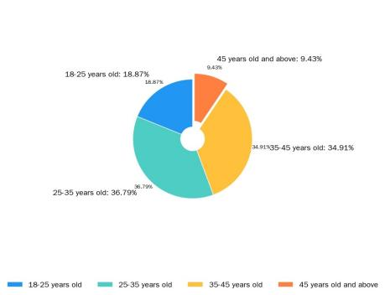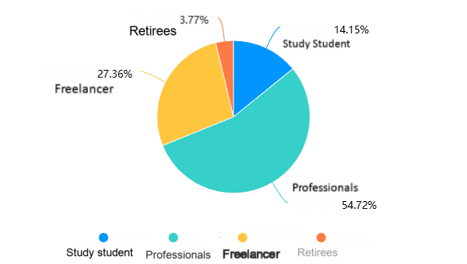
Source：Drawn by the author
(2) Consumption Preference and Type Analysis
Through cross-observation of various factors such as age, identity, purchase purpose, style preference, color preference, and preferred promotion format, three ideal consumer types can be roughly outlined: Cultural Traditionalist, Emotionally Practical, and Fun Trend-seeker. From the cross-analysis results, the Emotionally Practical type is the main audience for this study, while the Cultural Traditionalist and Fun Trend-seeker types are important reference groups. Subsequent design will focus on the needs of the core group, considering the differences in aesthetic and usage preferences of the other two types to make the Door God symbol translation more targeted.
It is worth noting that the preferences of the Emotionally Practical group aged 26-35 (accounting for 53% of the total) show obvious characteristics of "meaning consumption." 62.3% of respondents buy cultural creative products for "unique commemorative meaning," with cultural connotation (54.7%) and design aesthetics (48.2%) tied as the second reasons. This indicates that this group buys not the product itself, but the meaning it carries and the taste it displays. This group has high acceptance for both traditional Chinese style and cute cartoon styles; a single style cannot satisfy this composite demand. This means subsequent design must find a balance between cultural depth and visual affinity, that is, retaining the recognizability of the Door God symbol while lowering the aesthetic threshold through line simplification and color softening.
The Cultural Traditionalist type's insistence on the "integrity of the traditional schema" indicates the need to retain a classic reproduction product line to meet the needs of the core cultural consumer group. The Fun Trend-seeker type's pursuit of "visual stimulation" and "social currency" points towards the development direction of lightweight, low-unit-price, highly transmissible digital derivatives.
Figure 3.2: Questionnaire on "Purpose of buying cultural creative products" , Questionnaire on "Factors influencing purchase" , Questionnaire on "Which style do you prefer?" & Questionnaire on "Which color scheme do you prefer?"
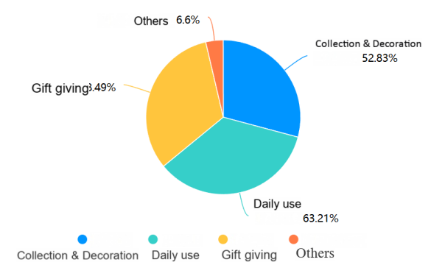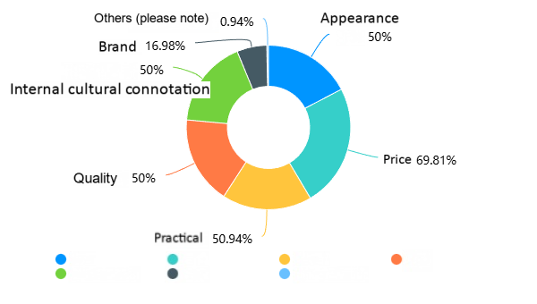
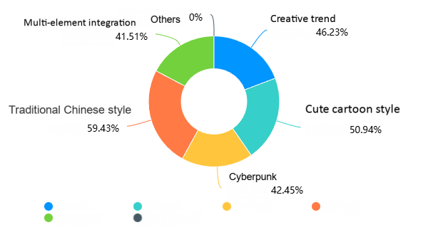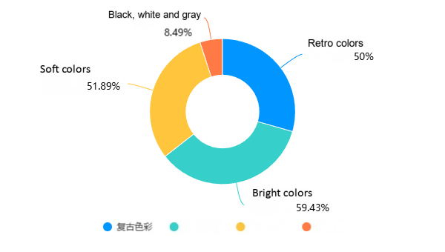
Source：Drawn by the author
(3) Research Conclusions and Advertising Strategy Implications
Based on the questionnaire data, three main conclusions can be drawn, providing clear guidance for subsequent translation and advertising strategy.
From the perspective of cultural cognition, market and audience understanding has shifted from original "folk belief" to current "aesthetic symbol." Research data shows that only 23.7% of respondents still associate Door Gods with the traditional belief function of "warding off evil and ghosts." Most audiences now regard them as aesthetic symbols and cultural markers carrying auspicious meanings. This indicates that in the minds of contemporary audiences, Door Gods have completed the transformation from religious belief objects to cultural aesthetic objects. Translation cannot rigidly force the complete reproduction of traditional rituals but should focus on the visual presentation of abstract meanings like protection and blessing, enhancing the symbol's recognizability and aesthetic value.
Consumption emotional value is gradually surpassing practical value. In terms of purchase motivation, unique commemorative meaning, cultural connotation, and design aesthetics rank much higher than practical function. According to perceived value theory, the core consumer group pays far more attention to the emotional added value of a product than its material function. The competition for Door God cultural creative products cannot remain solely on product practicality but should use symbolic design to convey a feeling of being protected and accompanied, making the product an emotional outlet for people.
In terms of communication preference, dynamism and experiential feeling have become new hotspots. Regarding preferred promotion formats, "short video dynamic display" ranks first, while traditional "graphic display" accounts for only 31.9%. In the digital age, the audience's demand for experienceable content has changed. Subsequent promotion should be based on storytelling and scenario-based experiences, establishing emotional connections during the participation process, rather than just passive information reception.
Figure 3.3: Questionnaire on "Through which channels do you buy?" , Questionnaire on "Which promotion format do you prefer?" Image Source: Drawn by the author
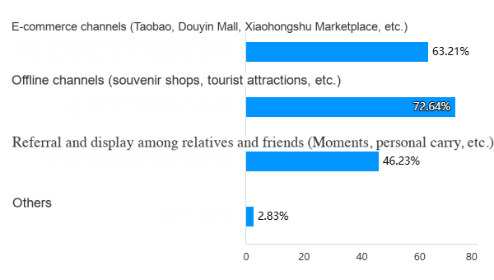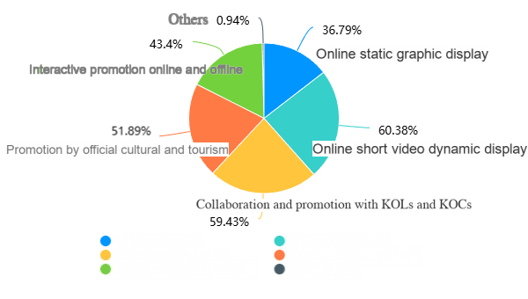
Source：Drawn by the author
The research data not only outlines the profile of the target audience but also reveals important pathways from cultural cognition to consumption transformation, providing data support for the subsequent translation design and promotion strategy of the Door God symbol.

3.3Pathways for Cultural Creative Translation of the "Door God" Symbol in Taohuawu New Year Prints

3.3.1Theoretical Model of the Translation Pathway
Based on semiotics, mythology, and communication theory, this paper attempts to summarize a three-stage progressive model for the contemporary translation of the Taohuawu "Door God" symbol (see Figure 3-10). This model is not a linear one-way process but a cyclic system of "deconstruction - reconstruction - implantation - feedback," aiming to transform traditional folk symbols into a cultural IP that contemporary audiences can perceive, consume, and share.
The first stage uses semiotic tools to deconstruct the traditional Door God symbol: what is its "signifier" and what is its "signified."
The second stage uses mythological logic, taking the deconstructed traditional Door God symbol system as a new signifier, using design to inject emotional values needed by contemporary people. Warding off evil becomes a sense of psychological security; guarding the house becomes emotional companionship.
The third stage uses market communication theory to implant the new Door God into daily scenarios such as homes, offices, travel, and mobile phone screens, transforming traditional folklore into contemporary consumption rituals, generating market feedback. Simultaneously, market feedback can in turn nourish and optimize the previous two steps, forming a virtuous cycle mechanism.
Figure 3.4: Schematic Diagram of the Three-Stage Translation Process Image Source: Drawn by the author
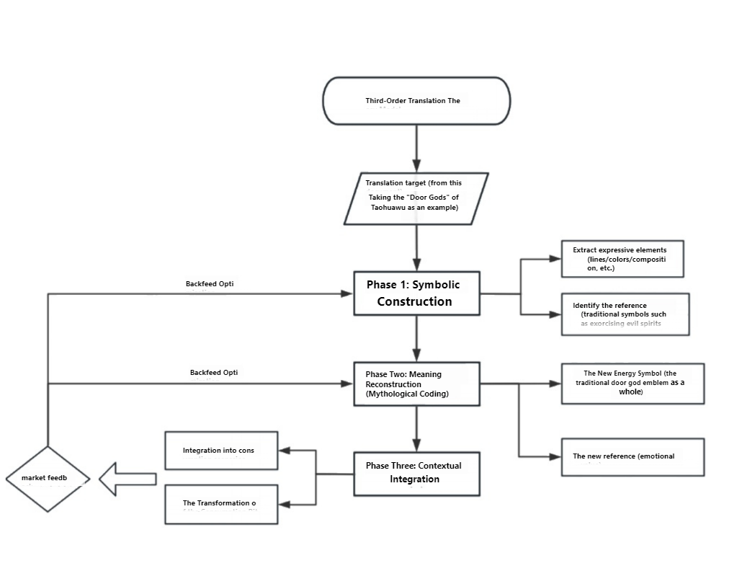
Source：Drawn by the author

3.3.2Process of the Cultural Creative Translation Pathway for the "Door God" Symbol
Based on market analysis and interview results, an innovative translation pathway for the "Door God" symbol is constructed in both theoretical and practical aspects, using the three-stage translation theoretical model as the basic process.
The color system, compositional rules, and formal characteristics of the "Door God" in Taohuawu prints are modernized, achieving simplification, symbolization, and life adaptation in form, allowing the Door God image to enter contemporary consumption scenarios and aesthetic contexts with higher visual affinity. From a communication studies perspective, the translation of the Door God symbol follows the basic laws of traditional communication. The contemporary translation of the Door God symbol is a two-way process of "content - audience - feedback." Creators reshape the symbol using modern design; the audience generates cultural identity through visual understanding; the audience's emotional feedback in turn promotes the social reproduction and continuous spread of the symbol.

3.3.3Product Positioning for Cultural Creative Translation of the "Door God" Symbol
The fundamental purpose of the cultural creative translation products of the Taohuawu "Door God" is the contemporary dissemination of traditional intangible cultural heritage symbols, using advertising communication logic to reshape cultural value, making the "Door God" a cultural brand symbol that embodies both the spirit of protection and emotional identity.
The brand concept of the Taohuawu Door God cultural creative product takes the "new protection culture" as its ideological core, shaping a warm, trustworthy, and ritualistic cultural personality, transforming the Door God symbol from a "deterrent guardian" into a "partner guarding happiness."

3.4Analysis of the Brand Plasticity of the Taohuawu "Door God" Symbol
From the perspectives of advertising and brand building, the Taohuawu "Door God" symbol has strong plasticity for transformation into a modern cultural creative brand:
Plasticity of Visual Identity: The Taohuawu Door God uses central axis symmetry and pairing as basic compositional elements, combined with a soft and stable traditional color system. It has high visual recognition and memorability, can quickly form a unified brand visual identity, and is applicable to various occasions such as packaging, derivatives, and communication, conducive to shaping a stable, coordinated, and recognizable brand visual system.
Plasticity of Cultural Semantics: It can shift from traditional functions to contemporary emotional values. The traditional meaning of Door Gods mainly focuses on "warding off evil and protecting." In the contemporary context, this can be further translated into more universal emotional values such as "safety, protection, companionship, security," better aligning with the psychological needs and cultural identity of modern consumers, thus forming a warm brand core value and enhancing audience emotional resonance and consumption willingness.
Plasticity of Narrative Scenarios: The multi-image system can cover various life scenarios. The Taohuawu Door God is not a single image; it includes a complete symbol system including Qin Qiong, Yuchi Gong, Zhong Kui, Liu Hai, Five Sons Achieving High Rank, etc. Different images can correspond to different life scenarios, such as family protection, academic growth, financial success, emotional stability, etc., providing sufficient narrative space for brands to conduct scenario segmentation, audience segmentation, and content marketing, thereby enhancing brand extensibility and practicality.
Plasticity of Consumption Rituals: Traditional folklore can be transformed into modern consumption and communication nodes. The folk customs associated with Door Gods, such as posting during Spring Festival and giving gifts during festivals, inherently possess a strong sense of ritual. These can be transformed into modern consumption nodes like festival moments, gift-giving scenarios, and social topics, facilitating brands to conduct node marketing, gift box development, and social communication, enhancing product topic discussion, shareability, and purchase motivation.
Therefore, the Taohuawu "Door God" can gradually evolve from a traditional folk symbol into a cultural creative brand symbol with recognition, emotional resonance, and communication power.

4.Design Practice and Communication for the Translation of the "Door God" Symbol in Taohuawu New Year Prints
This chapter transforms the previous theoretical research and survey results into an operational brand plan, testing the feasibility of the Taohuawu Door God symbol's revitalization in the contemporary market through the complete closed loop of advertising research: research, positioning, design, and communication.

4.1Extraction of "Door God" Design Elements and Translation Principles
Based on the "new protection culture" positioning proposed in Chapter 3, the main problem this chapter aims to solve is how to transform the traditional meaning of warding off evil and guarding of the Door God into the modern value of emotional companionship, achieving this transformation visually. This paper establishes three major translation principles: first, the recognizability principle: retain the core visual genes of the Taohuawu Door God to ensure symbol identification; second, the affinity principle: weaken traditional majesty and deterrent feeling, strengthen emotional warmth and psychological security; third, the scenario principle: make the visual system adaptable to diverse modern life scenarios such as home, office, and digital media.

4.2Presentation of Cultural Creative Translation Design Outcomes

4.2.1Visual Design for Cultural Creative Translation
This graphic translation is based on the Taohuawu Door God themes of "Happiness Descends from Heaven," "Zhong Kui Captures Ghosts," "Five Sons Achieving High Rank," and "Liu Hai Playing with the Golden Toad." It follows the line of thinking: "symbol source --- translation principle --- scenario adaptation --- communication consideration." It retains the original auspicious meanings and visual identification features of Taohuawu New Year prints, using methods such as simplified forms, softer colors, and weakened religious narratives to adapt to current life aesthetics and the cultural creative communication environment, making the traditional Door God images more aligned with audience preferences.
Figure 3.5: Taohuawu Woodcut New Year Print Museum collection and translated schema 1, Happiness Descends from Heaven Design Image
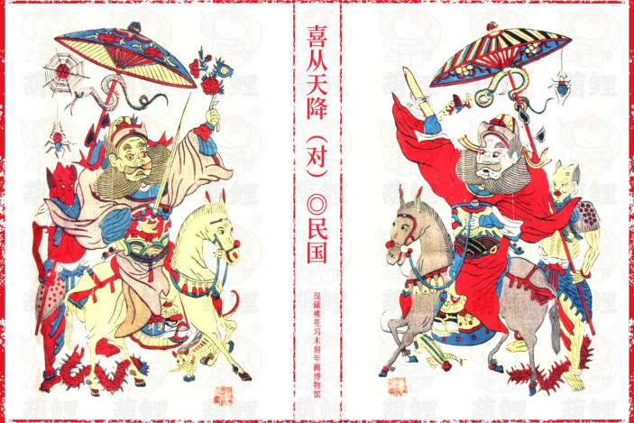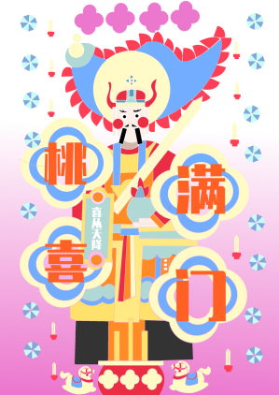
Source：Drawn by the author
Figure 3.6: Taohuawu Woodcut New Year Print Museum collection translated schema 2: Zhong Kui Captures Ghosts Design Image
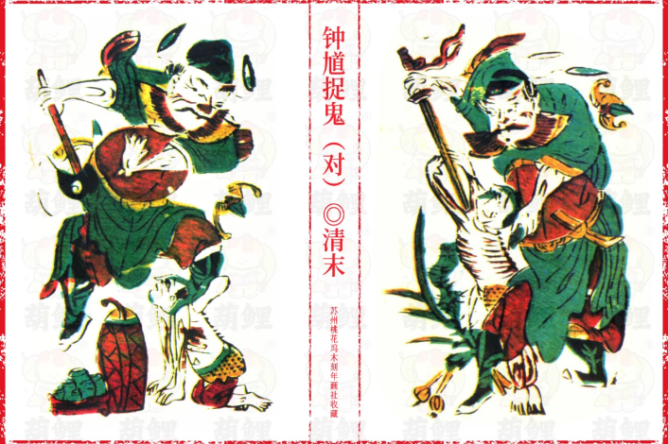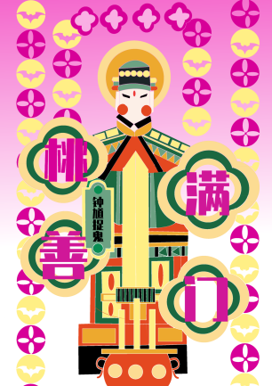
Source：Drawn by the author
Figure 3.7: Taohuawu Woodcut New Year Print Museum collection translated schema 3: Door God Five Sons Achieving High Rank Design Image
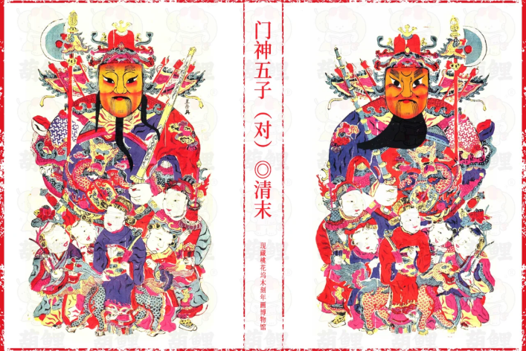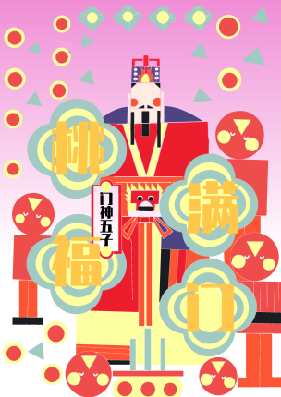
Source：Drawn by the author
Figure 3.8: Taohuawu Woodcut New Year Print Museum collection translated schema 4: Liu Hai Playing with the Golden Toad Design Image
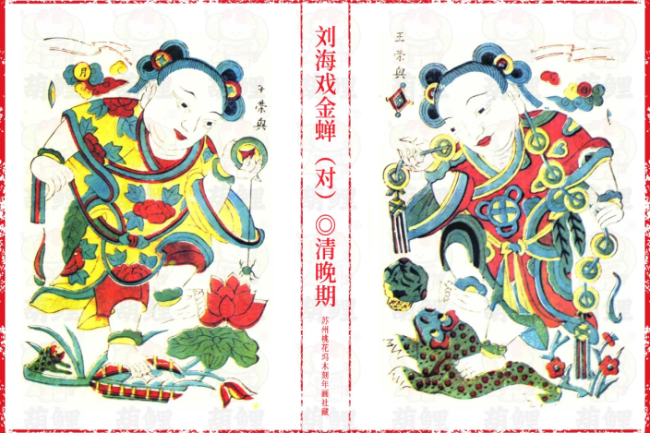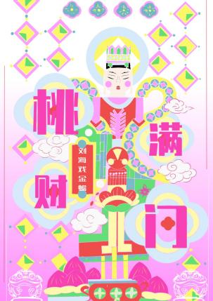
Source：Drawn by the author
"Happiness Descends from Heaven" originates from the traditional New Year painting's auspicious idea of welcoming happiness and good fortune. During translation, the cultural connotation of happiness is retained, overly complex traditional decorative relationships are weakened, the sense of lightness and joy in the picture is strengthened, transforming festival images into more intimate blessing symbols. It is more suitable for use in festival gift-giving, greeting card packaging, social communication, etc. Communication should also highlight the emotional expression of receiving good luck and spreading good news.
"Zhong Kui Captures Ghosts" has the functions of guarding the house, suppressing evil, and deterring. During translation, the stable subject recognition of Zhong Kui is maintained, intense actions and strong religious colors are weakened, and the meaning of protection is shifted from "external evil expulsion" to "internal stability," thus reshaping it into a visual symbol that can bring modern people a sense of psychological security and emotional stability. Its application scenarios are more suitable for daily life such as home spaces, solo living, and car companionship. Communication methods mostly revolve around the sense of guardianship and security, more easily generating emotional resonance with young audiences.
"Five Sons Achieving High Rank" carries the ideal of success in imperial examinations in traditional society, with strong connotations of wishing for scholarly honors. The translation retains its spiritual connotation of growth and advancement, weakens the narrative of the old examination system, and reinterprets it under new contemporary conditions as wishes for realistic goals such as academic studies, job seeking, and promotion, connecting traditional images with the life stage needs of contemporary youth. In terms of scenarios, this design is suitable for use during school start, exams, job entry, etc. In terms of communication, it can revolve around keywords like "success," "advancement," and "growth companionship" to enhance its periodic communication value and gift-giving attributes.
"Liu Hai Playing with the Golden Toad" traditionally refers to wealth, good luck, and harvest. In the translation design, the highly recognizable combination of Liu Hai and the golden toad is retained, supernatural elements are weakened, and "attracting wealth" is transformed into smoothness, abundance, and good luck companionship in the modern context, changing it from a folk belief symbol into a more daily blessing symbol. In terms of scenarios, this design is suitable for communication in life scenarios like office desks and store opening gifts. In terms of communication, attention can be paid to light expressions like "good luck start work," "fortune follows," to enhance its practical communication value.

4.2.2Derivative Product Design for Cultural Creative Translation
The design of derivatives is not simply printing Door God graphics on products, but based on the "new protection culture" positioning proposed earlier, transforming the traditional cultural semantics of Door Gods into product language suitable for modern life. Based on the preferences of the three audience types identified in the research (Cultural Traditionalist, Emotionally Practical, Fun Trend-seeker), and using the four visual symbols (Happiness Descends from Heaven, Zhong Kui Captures Ghosts, Five Sons Achieving High Rank, Liu Hai Playing with the Golden Toad) as objects, layered, scenario-based, and differentiated development is carried out, ensuring the same Door God symbol system can accurately connect to the aesthetic, usage, and communication needs of different groups.
For Cultural Traditionalist audiences, who value the authenticity and cultural integrity of the symbol, the classic composition, orthodox meaning, and ritual sense of the Taohuawu Door God are maintained. Cultural creative products such as door stickers, small-scale reproduced prints, and auspicious pendants are developed, highlighting cultural connotation and authenticity to cater to audiences who value traditional New Year atmosphere and folk rituals.
For Emotionally Practical audiences, the focus is on the role of emotional companionship in daily life. Based on their auspicious meanings and gentle temperament, high-frequency use products such as desk ornaments, car hanging decorations, stationery sets, and fabric items are designed, integrating the emotional connotations of protection, safety, and good luck into modern living spaces, meeting young people's needs for healing, practicality, and ritual.
For Fun Trend-seeker audiences, derivatives focus on lightweight, high aesthetics, and social communication potential. The four groups of Door God symbols are transformed into lightweight product forms such as stickers, postcards, emojis, and badges. These have small forms, fresh styles, and are easy to share, suitable for young people to take photos for social media, display, and give as casual gifts, transforming traditional cultural symbols into low-threshold, highly transmissible social currency.
Through the above planning and processing, a complete system encompassing traditional rituals, daily practicality, and lightweight communication is formed, retaining the cultural core of the Taohuawu Door God while effectively matching the different usage habits and aesthetic preferences of various audiences, truly realizing the transformation of the Door God symbol from festival decoration to contemporary daily culture.

4.3Promotion Plan and Communication Strategy

4.3.1Communication Objectives and Positioning Strategy
The main objective of the promotion plan is to enhance the cultural awareness and emotional identification of Taohuawu Door God cultural creative products through systematic communication, making them a cultural creative product that connects intangible cultural heritage with contemporary life and has a symbolic brand image.
In terms of positioning, "new protection culture" and "blessing symbol" are the two cores of the brand, shaping a communication image that possesses both traditional spirit and modern aesthetics. The "Door God" image is transformed from a traditional New Year print schema into a contemporary cultural symbol with brand symbolic power.

4.3.2Integrated Marketing Communication Strategy
This plan follows integrated marketing communication theory, using the symmetry, pairing, ritual sense, and color system of the Door God symbol as the visual hammer, creating a differentiated communication system where "one voice speaks." Relying on the deep integration of symbolic characteristics with contemporary consumption scenarios, it aims to achieve a comprehensive transformation from cultural awareness and emotional identification to consumption behavior.
(1) Semiotic Encoding of the Visual Identity System
Based on the visual characteristics of the Door God symbol (central axis symmetry, paired appearance, soft tones), following the translation principles of retaining cultural recognizability and conforming to modern aesthetics, the central axis symmetrical composition is maintained in the communication visual system, making it the most recognizable visual feature of the brand. Peach red and golden yellow are selected as the brand's main colors, retaining the color genes of Taohuawu New Year prints while differentiating from common Spring Festival marketing colors, conveying the emotional connotation of gentle protection.
(2) Scenario-Based Experiential Communication
According to the theory of involvement in advertising communication and the conclusion from interviews that audiences prefer a perceptible sense of ritual, high-participation scenario-based experiences are created to enhance communication effectiveness. Interactive experience exhibitions are set up in cultural tourism scenic spots and art spaces, using digital technology to transform static Door God symbols into immersive content that can be participated in and experienced, allowing the audience to actively perceive the intangible cultural heritage connotations. This breaks the seasonal limitation of Door Gods being used only during Spring Festival, linking different Door God images with year-round life scenarios such as academic growth, emotional healing, wealth management, and solo living safety, using full-scenario narrative to extend the symbol's communication cycle and applicability.
(3) Personification and Cross-Border Communication
Following the theoretical logic of semiotic meaning reconstruction, the Door God symbol is transformed from a traditional folk symbol into a contemporary life symbol. Different Door God images are endowed with emotional labels that meet modern needs, weakening their traditional ritual attributes and strengthening the daily value of companionship and protection. Simultaneously, cross-border collaborations with local Suzhou lifestyle brands are carried out, integrating Door God symbols into daily consumption scenarios such as dining, home furnishings, and travel. Relying on the mature user base of partner brands, cultural barriers are broken down, and the penetration and acceptance of the "protection culture" in daily life are enhanced.
(4) Omni-Channel Synergistic Communication
According to the AISAS communication model, a complete online-offline integrated communication closed loop is created. Offline, online entry points are set up through subway advertisements, pop-up stores, museum exhibitions, etc., transforming on-site experiences into online attention. Online, social media topic management and tiered content collaborations are used to stimulate users' autonomous communication, turning the audience from content receivers into word-of-mouth spreaders. Relying on the brand community to continuously output cultural content and conduct user interactions, short-term communication heat is transformed into long-term stable brand assets, achieving the complete communication chain from awareness, interest, search to consumption, and sharing.

5.Conclusion
This paper studies how the Taohuawu Door God symbol can be culturally translated into cultural creative designs with communication power and application value.
Through the comprehensive application of literature analysis, fieldwork, interviews, questionnaire surveys, and design practice methods, the conclusions are as follows: The Taohuawu Door God symbol possesses outstanding visual recognition and cultural extensibility. Contemporary audiences' perception of Door Gods has shifted from the traditional primitive belief of warding off evil to three levels: auspicious wishes, aesthetic symbols, and emotional value. Young consumer groups' acceptance of Door God cultural creative products relies more on emotional resonance, matching life scenarios, and shareability, rather than merely mechanical preservation of traditional forms.
The contemporary translation of the Taohuawu Door God symbol involves three aspects: visual, application, and communication. Visually, retain symmetrical composition and warm tones, simplifying them to transform warding-off-evil into psychological security and emotional companionship. In application, shift Door Gods from festival images to home, gift, and digital media presences. For communication, use social interaction, node marketing, and cross-border collaborations to turn image resources into cultural brand assets.
The modern transformation of the Taohuawu Door God is not a simple imitation of form but a process encompassing symbol extraction, meaning reconstruction, scenario matching, and communication renewal. Responding to the questions raised in the introduction, this paper respectively answers the three questions: systematically sorting out the correspondence of "signifier --- traditional signified --- contemporary translatable meaning" for the Taohuawu Door God's visual system; transforming the Door God from a "folk religious object" to a "life emotional symbol," achieving a meaning shift from traditional ritual to modern consumption context; and establishing balancing mechanisms and communication strategies in cultural creative design and promotion practice, thus achieving a logical closed loop.
design practice only at solution presentation stage, not market launch. Real communication effects and commercial transformation not verified. Research focuses on representative schema, comparisons between different Door God lineages and with other regions’ New Year paintings need strengthening. Future research needed.

6.References
Chen, J. (2022). A study on the living inheritance and development of Taohuawu New Year prints in the post-intangible cultural heritage era. Art Market, (11), 107-109.6.
Chen, X. (2022). Cultural creative development and design of traditional New Year paintings: Taking Suzhou Taohuawu woodblock New Year prints as an example[Master's thesis]. Soochow University.
Cheng, C. (2013). The color characteristics and application of Suzhou Taohuawu woodblock New Year prints* [Master's thesis]. Yangzhou University.
Gu, Z., & Gu, S. (2025). Innovative application of traditional New Year painting symbol language in cultural creative product design. Screen Printing Industry, (2), 56-58.
Guo, H. (2022). "Full of five colors and abundant joy" - The coloring of Taohuawu woodblock New Year prints and its influence on my figure painting creation[Master's thesis]. Minzu University of China.
Huang, Q., & Ghazali, M. M. M. (2024). Research on narrative design of creative products based on regional cultural elements. Journal of Contemporary Educational Research,8(1), 112-119. https://doi.org/ 10.26689/JCER.V8I1.5971
Liu, Y., & Yin, J. (2022). Digital cultural creative design of Taohuawu woodblock New Year prints based on cultural translation. Packaging Engineering, 43(10), 312-318. https://doi.org/10.19554/j.cnki.1001-3563.2022.10.039.
Li, J., Cheng, X., & Zhang, D. (2024). Research on cultural creative design strategy and application of "Fu Character Picture" in Taohuawu New Year prints. Beijing Cultural Creativity, (6), 17-28.
Li, T., & Li, M. (2025). Analysis of cultural creative product design of Zhuxiantown woodblock New Year prints from a semiotic perspective. Hunan Packaging, 40(1), 102-105. https://doi.org/10.19686/j.cnki.issn1671-4997.2025.01.037
Li, C., Sun, F., Jiao, Y., et al. (2021). Research on regional cultural creative product design based on Morris semiotics. Packaging Engineering, 42(20), 88-93. https://doi.org/10.19554/j.cnki.1001-3563.2021.20.019
Li, J. (2025). A study on the door god images in traditional Chinese folk crafts: The guardians on the door. Journal of Art Design, (9), 87-89.
Meng, X., & Li, H. (2024). Intelligent design and application of traditional cultural and creative products based on digital art elements. Applied Mathematics and Nonlinear Sciences, 9(1), 1-14.
Ren, G., & Wu, X. (2020). The everyday aesthetic of cultural creative products. Mingrifengshang, (20), 23-24.
Russo, A. (2021). The value of design in cultural heritage communication: A framework for evaluation. Design Management Journal, 16(3), 78-91. https://doi.org/
Sima, J. (2020). Design semiotics and cultural innovation: A framework for analyzing visual translation. Design Studies, 71, 100-115.
Vassallo, S. (2024). From tradition to trend: Heritage branding strategies for fashion and design. Fashion Practice, 16(1), 45-67.
Wang, Y. (2023). Research on the innovative expression of the Door God schema in Taohuawu New Year prints in Suzhou embroidery [Master's thesis]. Suzhou University of Science and Technology.
Wang, G. (2018). Brief discussion on Door Gods: On the development origin and nature evolution of Door Gods. Art Work, (4), 89-93.
Yao, W. (2010). A socio-cultural history study of modern Suzhou Taohuawu woodblock New Year prints[Master's thesis]. Soochow University.
Zhang, A. (2018). Exploration of visual design translation of intangible cultural heritage. Packaging Engineering, 39(20), 121-125. https://doi.org/10.19554/j.cnki.1001-3563.2018.20.019.
Zhang, H. (2025). Research on cultural creative product design of Taohuawu woodblock New Year prints. Packaging Engineering, 46(2), 88-93. https://doi.org/10.27267/d.cnki.gqfsu.2025.000386
Zhu, L. (2024). Research on innovation strategies for Suzhou Taohuawu woodblock New Year prints in the digital age. Journal of Suzhou Art & Design Technology Institute, 22(4), 45-49.
Zhang, W. (2024). Research on the realization path of modern transformation of "Door Gods" in Liangping woodblock New Year prints. Art and Design (Theory), 2(3), 67-70. https://doi.org/10.16824/j.cnki.issn10082832.2024.03.014
Zhong, S., Zheng, W., Zhao, W., et al. (2021). Research on cultural creative product design based on regional cultural elements. Art and Design (Theory), 2(8), 92-95. https://doi.org/10.16824/j.cnki.issn10082832.2021.06.027
Zhang, C. (2023). Research on cultural creative product design in the context of regional culture [Master's thesis]. Jilin University of the Arts.
Appendix
Interviewee Information Coding
Code | Identity Category | Years of Experience | Specific Background
CR-A | Intangible Cultural Heritage Inheritor | 25 | National-level representative inheritor of Taohuawu woodblock New Year prints, specializing in Door God theme creation
CR-B | Intangible Cultural Heritage Inheritor | 18 | Municipal-level inheritor of Taohuawu woodblock New Year prints, engaged in teaching and promotion of New Year prints
D-A | Cultural Creative Designer | 5 | Independent cultural creative designer, focusing on visual design of intangible cultural heritage
D-B | Cultural Creative Designer | 4 | Design staff at a cultural company, participated in multiple intangible cultural heritage IP development projects
D-C | Cultural Creative Designer | 2 | Young illustrator, skilled in youthful expression of traditional elements
PM-E | Cultural Creative Promoter | 4 | Brand operations manager at a cultural tourism enterprise, responsible for market promotion of intangible cultural heritage creative products
PM-F | Cultural Creative Promoter | 2 | Manager of cultural creative category on an e-commerce platform, familiar with online operation of New Year painting products
Note:Interview Period: November , 2025–December , 2025
Interview Location: Suzhou City
Interview Format: Semi-structured interviews
Number of Interviewees: 7 people
Average Duration: 20 minutes per person
Recording Method: Audio recording with transcription supplemented by written notes
Interview Records Summary:
Interview subject: CR-A
Q: As someone who has long been engaged in creating Taohuawu New Year prints, how do you understand the cultural connotation of the Door God theme?*
CR-A: Door Gods are not just "paintings"; they represent the safety in common people's hearts. From the earliest Shentu and Yulei, Qin Qiong and Yuchi Gong, to the current Taohuawu Door Gods, the core has always been protecting the household, praying for blessings, and welcoming good fortune – the simplest wish of ordinary people for a stable life. It's folklore, it's belief, and it's an emotional sustenance passed down through generations.

Q: What is the biggest difference between Taohuawu Door Gods and Door Gods from New Year paintings of other regions?
CR-A: Northern New Year paintings are more powerful and emphasize momentum, with thick lines and strong color contrasts. Taohuawu belongs to the Jiangnan cultural lineage, emphasizing gentleness, elegance, and delicacy. Our Door Gods are not fierce or frightening; their guardianship embodies a kind of peace. The lines are fine and flexible, the colors are clear and clean – this is a unique Jiangnan characteristic that cannot be lost.

Q: Young people no longer post Door Gods. Does the Door God still have value today?
CR-A: The value always exists, only the form has changed. In the past, they were posted on doors to ward off evil. Today, young people living alone or under work pressure need a sense of psychological security, companionship, and ritual even more. The Door God is transforming from a "painting on the door" to a daily companion symbol.

Q: In your opinion, what aspects are absolutely unchangeable when innovating cultural creative products?
CR-A: The core cannot be lost, but the appearance can be new. The core of protection, safety, and good fortune cannot be moved. The line quality, symmetrical composition, and gentle colors of Taohuawu cannot be lost. However, the carrier can change – made into ornaments, pendants, stationery, etc. As long as the cultural soul remains, it is a Taohuawu Door God.

Q: What do you think is the biggest problem with current Door God cultural creative products?
CR-A: Too superficial. Many just print the old image without interpretation, emotion, or story. Young people might buy it once and then forget it. True revitalization means making people understand it, like it, and be willing to use it.

CR-B
Q: In teaching and promotion, how do you explain Door Gods to young people?
CR-B: Door Gods are not just about doors; they represent expectations in life – family safety, everything going well, peace of mind. This feeling has been the same from ancient times to today.

Q: What suggestions do you have for current cultural creative translation?
CR-B: Innovation is fine, but you can't abandon the foundation or change things arbitrarily. Simplifying forms and making them younger is not a problem, but excessive entertainment is not allowed; you can't change it so much that it loses the flavor of Taohuawu. Design can be light, but culture cannot be thin.

Q: What do you think is the key point for young people to accept Door Gods?
CR-B: First, it needs to look good and meet modern aesthetics; second, it needs to be practical and enter daily life scenarios; third, it needs to have meaning and be able to express emotions. A single picture to hang on the wall no longer fits modern life.

Q: In the long run, how should the Taohuawu Door God develop?
CR-B: It must be developed into a systematic IP. It needs unified visuals, product series, communication stories, and experiential scenarios. We cannot just rely on old craftsmanship to make a living; we need to make the old craftsmanship a cultural symbol that contemporary people are willing to consume and share.

A
Q: When working on intangible heritage symbol design, how do you understand the contemporary translation of Door Gods?
D-A: The core idea is very clear: transform high-context traditional culture into low-threshold, high-emotional-value visual symbols.
Q: How do you balance tradition and innovation?
D-A: Retain recognizable features: symmetry, character identity, protective posture. Reduce visual pressure: simplify lines, soften colors, weaken the sense of deterrence.

Q: What kind of Door God cultural creative products do young people prefer now?
D-A: Small, practical, meaningful, photogenic, and preferably shareable on social media. Cultural creative products that can become social currency are truly alive. Car hangings, small desk ornaments, phone holders, stickers – these are high-frequency scenarios.

Q: What do you think is the easiest pitfall to avoid in Door God cultural creativity?
D-A: Direct image application, no design, no semantic translation. It might look traditional on the surface but has no vitality. Translation is not copying; it's retelling.

D-B
Q: In actual projects, how do you carry out the visual translation of the Taohuawu Door God?
D-B: First, deconstruct the symbols: lines, colors, composition, props, postures. Then adapt them for the modern era. The ultimate goal is to make the Door God step from the door into daily life, becoming a symbol that can create emotional connections with young people.

Q: Which elements must be retained in the design?

D-B: The symmetrical structure, character identity features, and the dynamic intention of protection. These are the basis for public recognition of Door Gods. Lose them, and it no longer looks like a Door God.

Q: In market feedback, what do users care about most?
D-B: First, whether it looks good at first sight; second, whether it has an auspicious meaning; third, whether it can be used in life. Simple, traditional products no longer have appeal.

Q: What do you think is the biggest problem with similar cultural creative products currently?
D-B: Severe homogenization. Many use the same images, lack deep translation, and lack emotional resonance. If it's just a souvenir, it's only a souvenir, not cultural creativity.

D-C
Q: As a young designer, how do you prefer to express Door Gods?
D-C: I prefer a healing, gentle, and light style. Remove the sense of oppression, highlight safety, smoothness, and good mood. Use softer colors and simpler lines, closer to the currently popular national style aesthetics.

Q: From a visual communication perspective, what kind of Door God is easier to remember?
D-C: High irreconcilability, strong emotion, consistent style. Seeing the gentle symmetrical composition and warm colors, you know it's the Taohuawu Door God.

Q: Have you observed the acceptance of themes like protection among young people?
D-C: Very high. Young people living alone, preparing for exams, or in the workplace have a high demand for safety, protection, and good luck. The click-through and conversion rates for such products are also high.

PM-E
Q: From a market operations perspective, what is the real user feedback on Door God cultural creative products?
PM-E: Products with meanings like protection, blessing, and safety are most popular. Consumers value emotional value and a sense of ritual more.

Q: What is the most difficult aspect during promotion?
PM-E: High seasonality. They are almost only mentioned during the Spring Festival. Brand awareness is low. People know Taohuawu but don't know the unique value of the Taohuawu Door God. Product homogenization is severe, making it hard to generate repurchases and word-of-mouth.

Q: How do you think long-term brand power can be established?
PM-E: Identify the work that needs to be done and consistently output content. Transform the Taohuawu Door God from a New Year painting into a cultural IP that can be promoted year-round.

Q: Which form of online communication is most effective?
PM-E: Short videos, scenario-based displays, and KOL experience sharing are much more effective than static graphics and text.

PM-F
Q: From an e-commerce operations perspective, what are the characteristics of the consumer group for Door God cultural creative products?
PM-F: Mainly young people aged 18-35, half for personal use and half for gifting. They pay for design, meaning, and emotional value.

Q: What are the most common comments from online users?
PM-F: Good-looking, atmospheric, good meaning, craftsmanship texture, suitability for gifting, etc. Price sensitivity is medium, but they care more about whether it's worth it.

Q: What do you think is the future direction for Door God cultural creativity?
PM-F:Personified IP, lightweight products, scenario-based embedding, social communication. Make the Door God a cultural symbol that can be used daily and shown off, not just a traditional item only during festivals.

