An Phishing Website Detection

Abstract:
In the modern digital space, phishing attacks are becoming one of the most widespread and harmful cyber-threats. These attacks threaten and use the appearance of similar sites to trick the users into providing sensitive information including login passwords, bank account details and personal data. The old phishing detection methods, including blacklist based and rule based systems, may not detect new phishing websites or zero-day phishing websites because the websites are static. In a bid to overcome these shortcomings, this project suggests an artificial intelligence-oriented solution to the detection of phishing sites in an efficient and effective manner.
The suggested system will examine different characteristics of websites such as URL-based, domain-based and content-based characteristics to categorize websites as either legit or phishing. Several machine learning models are trained and tested to come up with the most precise and trusted model that can be used in detecting phishing. The system will be able to offer high-accuracy real-time detection, which will minimize the chances of phishing attacks on users. The experimental findings prove that machine learning methods are much better in detecting performance than conventional methods. The project is one of the steps towards improving cybersecurity through offering a smart and automated phishing detection system. [3], [7], [8], [12].

Introduction
Due to the increasing fast rate of internet adoption, there is
a change in the way people and organizations perceive information, transact, and communicate. This online growth has, however, come with exposure to online threats, which are especially common in phishing attacks. Phishing websites represent reputable organizations in order to exploit users to share sensitive information and lose money, steal identity and data.[4], [5]. [6].
Traditional phishing prevention systems are based on blacklists that are either manually maintained or on predefined rules. Although they are handy in detecting the existence of familiar phishing websites, they find it difficult to detect phishing sites that have recently been established and often their format and look changes. There is constant development of techniques by attackers and the various methods of detection have evolved making the system of static detection ineffective.[1], [8], [10].
A solution promising to address the problem of phishing sites as well is offered by machine learning, which allows the systems to learn patterns utilizing the past history and determine the websites which are phishing based on their features and not the signature list. Phishing detection systems can use the supervised learning algorithms to generalize the patterns between legitimate and malicious websites, and as such, they are able to identify future never-before-seen phishing attacks. The proposed project aims at creating and deploying a machine learning-enabled phishing web site detector that improves the detection rate and flexibility in the real world.[3], [9], [12].

Literature Review
A number of studies have been conducted on the use of machine learning methods in phishing detection. Different feature extraction techniques and classification algorithms are investigated by the researchers in order to enhance detection accuracy.
The detection systems used early on phishing were based on blacklists, comparing URLs to known malicious databases. These systems cannot be effective against the phishing websites that are of the zero-day nature though they are effective against known attacks. The rule-based systems added heuristic checks like URL length, special characters, suspicious domain patterns, etc but these are usually circumvented by hackers.

In recent works, machine learning algorithms including Decision Trees, Support Vector Machines (SVM), Random Forests as well as Naive Bayes classifiers have been used to identify phishing websites. Such models examine features that are obtained on the URL, the HTML content and the domain. Other ensemble learning methods have demonstrated better performance because of the capacity to capture intricate feature interactions such as the Random Forest and Gradient Boosting.
There have also been propositions of deep learning methods based on neural networks and particularly webpage based content analysis and visual similarity. These approaches however, can be very demanding in terms of computation resources and large data sets. According to the literature, the conventional machine learning models are still efficient and useful in detecting phishing attacks when used with carefully designed features.

Methodology
The phishing website detection system that is suggested adheres to a machine learning workflow that is systematic involving data collection, feature extraction, model training, and evaluation. [1],[4].

Dataset Collection
A labelled dataset of both phished and legitimate site URLs is obtained by means of publicly available resources.[5] Supervised learning is available because each item of the dataset is a phishing or a legitimate item.

Feature Extraction
Characteristics of phishing websites such as the URLs and metadata of the websites are processed into features that are used to extract them. These include:[3], [6]
URL length and structure
Availability of special characters like '@', - and //.
IP address has been used rather than domain name. Number of subdomains
HTTPS availability
Domain age and domain registration information.
These characteristics assist the model to discriminate the authentic and phishing sites.

Machine Learning Models [1], [3]
There are various machine learning algorithms that are used and compared and they are:
Logistic Regression Decision Tree Random Forest
Support Vector Machine (SVM)
Every model is trained on the extracted features and analyzed on the standard performance metrics.

System Architecture
Python is used as a core programming language in designing the system. The process of model training is performed by libraries like Scikit-learn, and the data preprocessing is performed by Panda and NumPy. The trained model may be incorporated into a web based or browser-extension system of real-time phishing detection.

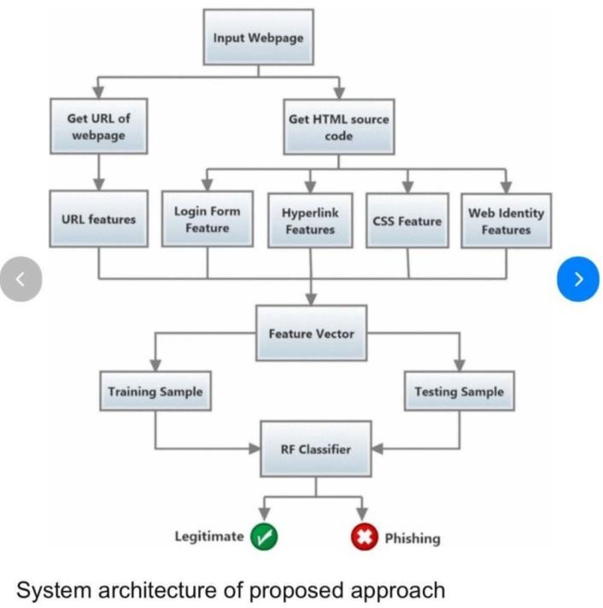
Fig 1.

Expected Outcomes
The effective Phishing Website Detection with the help of the Machine Learning project should have a huge technical, security, and user-centric impact. All of these results illustrate the usefulness of machine learning methods to fight contemporary phishing and enhance cybersecurity awareness in general.

Predominant Detection of Phishing Sites.
An appropriate categorization of websites as phishing and legitimate is one of the main anticipated results of this project. The trained machine learning models should identify malicious patterns, which the conventional rule-based systems usually fail to detect by analyzing various features on the URL and domain level. The system has been created so that it can limit the false negatives such that potentially malicious phishing sites can be detected before users have the possibility to interact with them.

Zero-Day Phishing Attack Detection.
The proposed system is likely to perform well in identifying zero-day phishing websites unlike blacklist-based system, which uses already reported phishing URLs. The machine learning models are capable of detecting newly developed phishing sites that are not yet included in database of security sites because they learn generalized patterns using previous data. Such an achievement

goes a long way in preventing the rapidly developing phishing methods.

Better Detection Accuracy than Traditional Methods.
The project will have a high detection rate compared to the traditional phishing detection systems. Using the supervised machine learning algorithms like Decision Trees, Random Forest, and Support Vector Machines, the system will be able to analyze relationships between features that are complex and enhance the performance of classification. Evaluation metrics that will be improved include accuracy, precision, recall and F1-score.
4.4.1 Decrease in False Positive and False Negative.
One of the most important anticipated results is the minimized number of inaccurate classifications. A false positive that is the legitimate websites as phishing can adversely impact user confidence whereas false negatives result in exposing users to cyber risks. The proposed system sets out to balance out the choice of features and model parameter by ensuring that predictive indicators are reliable and consistent.
  - Real-Time and Automated Website Analysis.
The system will be expected to offer fast and automatic phishing detection without the involvement of manual work. After training, the machine learning model will be able to analyze a URL of a webpage in real time and decide its legitimacy immediately. This allows a smooth interoperability with web browsers, email filters or security software and phishing detection is more viable and efficient to end users.
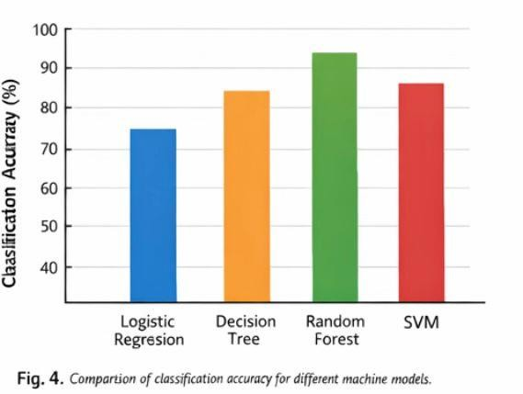

Improved Awareness of the users and cybersecurity measures.
The system helps to enhance user awareness on online threats by enabling people to detect them by identifying phishing websites. Before users access the suspicious sites, they are cautioned and the chances of stealing credentials, committing financial fraud and identity abuse are minimized. This is the result of safer Internet use and security-conscious online environment.

Expandable and Flexible Detection Architecture.
The solution proposed will be scalable and changeable to the challenges of the future. The model can be retrained on new datasets to keep detecting phishing as the methods used to commit them keep changing. This is flexible and will guarantee the durability of the system usage and the ability to keep up
with new phishing attacks and domains as well as attack methods.

Applicability in Real-life situations.
The project will have a practical applicability over academic experimentation. The system is lightweight and effective in the extraction of features, which make this system ideal to be deployed in real-world applications like browser extensions, organization security systems, and online platforms. This finding shows that the project is relevant to the current cybersecurity issues.
  - Research and Learning Contributions to Cybersecurity.
Lastly, the project is likely to impact the academic study and research by offering information on the use of machine learning in cybersecurity. It also increases the knowledge of phishing behavior, feature engineering, and model evaluation methods and thus acts as a stepping stone towards future study and improvement of the system.

System Security and Data Privacy Considerations
The detection system of phishing websites is not only as effective as its accuracy in classifying the sites, but also how safely the system clears the data and maintains the privacy of the users. Seeing that the proposed system will be implemented in the sphere of cybersecurity, particular focus is put on making sure that security principles and ethical considerations are upheld throughout the lifecycle of the system.
The phishing detection system suggested is meant to analyze non-confidential and publicly available data of websites, i.e., URL structure, domain properties, protocol use, and lexical characteristics. The system does not need to deal with access to confidential user data at any point in time (usernames, passwords, banking details or personal identifiers). This design will greatly minimize the chances of breaching privacy and users would not be subjected to any other security risk as they use the system.
Each of the datasets applied in training and testing of the machine learning models are gathered using reliable and publicly accessible sources. Before the training of the model, the data is preprocessed to eliminate data redundancy, incomplete, or possibly sensitive data. This guarantees the integrity of the data and reduces the chances of inflicting biased or malicious data in the learning process. Correct dataset validation is also used in enhancing the reliability and robustness of the trained models.
On the side of system security, controlled permissions do not allow access to the application and trained machine learning model.

Datasets, models retraining, or system-level settings can only be modified by authorized users or administrators. This discourages manipulation of the model by unauthorized persons who may end up with wrong classifications or abusing the system.
The system architecture facilitates the deployment of a safe system by adhering to the standard practices of secure code and development. There is input validation that is done to counter malicious data injection and error-handling that is used to avoid leakage of information through system responses. The system when implemented in a web-based setting can be used on secure communication channels to facilitate uncompromised communication between the users and the application.
Also, the system is supposed to be robust to adversarial abuse. Caution is observed in using various and meaningful sets of features since phishing attackers can seek to break the detection systems, and it is challenging to avoid these systems by merely altering the URL. It is also suggested that periodic model retraining using new datasets should be performed to keep the detection efficient against new phishing methods.
Ethical concerns also form part of the system design. The system does not accuse and punish legitimate websites but rather gives a probabilistic grouping which can be inspected or confirmed when necessary. This will minimize the unwarranted blocking of legitimate sites and user confidence. System behavior transparency removes the confusion of the user regarding the intention and restriction of the detection mechanism.
In general, incorporating robust security measures, responsible data management, and ethical design, the suggested phishing website detection system will provide a secure, privacy-sensitive, and trustworthy solution. Such considerations render the system appropriate to use in the real world, as well as it correlates with the cybersecurity standards and the best practices in the academic community.[4]

Conclusion and Future Scope
Due to the alarming rate at which phishing campaigns increase, online security has become a key issue to individuals and organizations. A realistic and effective machine learning-based phishing websites detection system was developed and deployed in this project. The suggested model takes advantage of URL- and domain-based indicators to effectively categorize the legitimate and phishing websites, and hence, the detection performance of the model is better than using conventional blacklist-based techniques. Blacklist strategies are frequently not capable of identifying new risks because they are based on already identified phishing URLs. Conversely, the suggested system is able to learn phishing patterns based on historical records and by doing so, it is able to recognize unknown and zero-day phishing sites better [1], [4].
The system is highly security, privacy and ethically
sensitive. It does not retrieve any user-specific data and does not store any, instead, analyzing only publicly available information on websites, which guarantees privacy maintenance and reliability. On top of this, it was also aimed at reducing false positives to ensure that the legitimate sites are not labeled as spam, which increases the usability and reliability. These features render the suggested framework to be applicable to real-life applications and show the feasibility of machine learning methods in solving contemporary cybersecurity issues [3], [6].
To enrich the system, deep learning models that can analyze webpage contents and visual similarity can be extended in the future and have demonstrated potentials in enhancing the accuracy of phishing [2]. The model can be implemented in real-time as browser extensions and email filtering systems to offer real-time protection. Moreover, employing ongoing learning systems will enable the model to adjust to the changing phishing techniques and the new patterns of attacks as they arise. Scalability, robustness, and global applicability of the system will be enhanced by the expansion of the dataset, for example, by adding bigger and more heterogeneous phishing datasets to the public repositories [5], as well as multilingual phishing detection.

References
- R. Mohammad, F. Thabtah, and T. McCluskey, “Predicting phishing websites based on self-structuring neural networks,” Neural Computing and Applications, vol. 25, no. 2, pp. 443–458, 2014.
- A. Jain and B. Gupta, “Phishing detection: Analysis of visual similarity based approaches,” Security and Communication Networks, vol. 2017, pp. 1–12, 2017.
- M. Aburrous, M. A. Hossain, K. Dahal, and F. Thabtah, “Intelligent phishing detection system for e-banking using fuzzy data mining,” Expert Systems with Applications, vol. 37, no. 12, pp. 7913–7921, 2010.
- C. Whittaker, B. Ryner, and M. Nazif, “Large-scale automatic classification of phishing pages,” in Proc. Network and Distributed System Security Symp. (NDSS), San Diego, CA, USA, 2010.

- UCI Machine Learning Repository, “Phishing Websites Data Set,” Univ. of California, Irvine, CA, USA, 2015. [Online]. Available: https://archive.ics.uci.edu/ml
- S. Marchal, J. Francois, R. State, and T. Engel, “Proactive discovery of phishing-related domain names,” in Proc. Int. Symp. Research in Attacks, Intrusions, and Defenses (RAID), 2014, pp. 190–209.
- Antonio Molina-Garc´ıa, Ana Jos´e Cisneros-Ruiz, Mar´ıa Deseada L´opez-Subires, and Julio Di´eguez-Soto. How does financial literacy influence undergraduates’ risk-taking

propensity? The International Journal of Management Education, 21(3):100840, 2023. [11]
- Lucas Schneider Mu¨ller, Lu´ıs Guilherme Eich, Rose-mary Francisco, and Jorge Luis Vict´oria Barbosa. Adam: An intelligent virtual assistant for personal fi- nancial management. In XVIII Brazilian Symposium on Information Systems, pages 1–8, 2022. [12]
- Jyoti Prakash Rath and Samira Patra. Financial liter-acy in india ˆa€“a new way forward. ComFin Research, 11(2):20–27, 2023. [1]
- D Sari, M Pradana, DW Nugraha, and F Oktafani. Web-based design of financial apps: Case of kosan 54. In IOP Conference Series: Materials Science and En-gineering, volume 1071, page 012020. IOP Publishing, 2021. [2]
- Faheem Shaheen, Muhammad Adnan Tariq, Qasim Za- hoor, and Abid Mehmood. Role of financial literacy in investment decisions: Exploring the individual in-vestors’ perspective through a qualitative approach. Journal of Business and Social Review in Emerging Economies, 8(4):719–726, 2022. [3]
- Krzysztof Waliszewski and Anna Warchlewska. At-titudes towards artificial intelligence in the area of personal financial planning: a case study of selected countries. Entrepreneurship and Sustainability Issues, 8(2):399,2020.[4]

