WEB BASED DIGITAL PORTAL FOR PERSONS WITH DISABLITIES (PWD) EMPLOYMENT OPPORTUNITIES
^{[1]}Christian Paul O. Cruz, ^{[2]}Kyle G. De Guzman, ^{[3]}Monica A. Dona, ^{[4]}Pheomela R. Donato, ^{[5]}Kristine Joy C. Mallanao
Information Technology, Pangasinan State University, Alaminos City Campus
ABSTRACT
Persons with Disabilities in Alaminos City face significant challenges in securing employment due to limited access to job opportunities and reliance on manual, inefficient referral processes. This study developed a web-based job portal to bridge this gap, providing a centralized and accessible platform that directly connects Persons with Disabilities job seekers with potential employers. The system was designed to streamline the job search and hiring process, promoting inclusivity and empowering Persons with Disabilities to independently pursue suitable employment. The project utilized the Rapid Application Development methodology, emphasizing iterative prototyping and continuous user feedback to ensure the platform effectively addressed user needs. The developed portal features distinct user levels for Persons with Disabilities job seekers and PDAO administrators, facilitating profile creation, job posting, application management, and administrative oversight. Findings indicate that the portal successfully addresses the inefficiencies of the traditional employment referral system. User evaluations confirmed the system's high levels of usability, functionality, and reliability, establishing it as a very acceptable solution. The platform enhances the job-seeking experience for PWDs while providing employers with a streamlined tool for inclusive hiring. In conclusion, the web-based portal offers a sustainable digital solution that fosters greater employment equity for PWDs in Alaminos City. It is recommended for adoption by the PDAO to enhance their employment facilitation services. Future enhancements could include integrating assistive technologies and developing a mobile application to further expand accessibility and reach.

Keywords: employment, digital portal, person with disability
INTRODUCTION
Persons With Disabilities (PWDs) face significant challenges in securing employment due to social stigma, accessibility barriers, and limited job opportunities. The global unemployment rate among PWDs remains disproportionately high, making employment accessibility a critical issue (United Nation, 2021)^{[9]}.

Globally, an estimated 1.3 billion people, or 16% of the world's population, live with disabilities. Of this number, approximately 785 million individuals or 80% are of working age (Word Health Organization, 2023)^{[10]}. However, a significant proportion of the main unemployed are due to discrimination, inadequate skill development, and inaccessible work environments. In low-income nations, roughly 80% of PWDs rely on government assistance, with their official unemployment rate being at least twice that of individuals without disabilities (United Nations, 2021)^{[9]} .

The digital era has transformed job recruitment through online job portals and social media platforms, making job postings more accessible worldwide. Traditional job-seeking methods such as newspaper advertisements, employment agencies, and personal networks have been supplemented or replaced by digital job platforms that optimize recruitment and hiring processes (Indeed, 2024)^{[5]}.

Online job portals serve as bridges between job seekers and employers, offering job listings, resume uploads, application tracking, and remote interview capabilities. These platforms provide PWDs with expanded job opportunities and help employers connect with qualified candidates more efficiently (Ahmed et al., 2024)^{[1]}.

Despite advances in digital employment solutions, people with disabilities (PWDs) continue to encounter challenges to job access due to social stigma, inaccessible digital interfaces, and limited inclusive employment programs (Lashari et al., 2022)^{[7]}. Research also indicates that PWDs often struggle with self-confidence as a result of social stigma and insufficient career development support, which negatively affects their job-seeking efforts (Dispenza, 2021)^{[4]}. Digital innovations, such as web-based employment platforms, assist in connecting people with disabilities with potential employers and promoting a more inclusive employment opportunities (Samonte et al., 2024)^{[8]}. Furthermore, incorporating computer-based learning into skills training programs boosts digital literacy and increases job chances for persons with disabilities (Bansal et al., 2024)^{[2]}.

The authors aim to address significant challenges of finding job of the persons with disability, through design and development of the job portal, will provide an easy access to finding and applying a job online for PWDs inclusively.

METHODOLOGY
This project uses the Rapid Application Development (RAD) model because it makes software development faster and more flexible (GeeksforGeeks, 2025)^{[6]}, which is crucial for satisfying the changing needs of PWDs and associated stakeholders. The RAD has four phases whish is requirements planning, user design, construction, and cutover. Figure 1 shows the RAD model.
Figure 1. Rapid Application Development (RAD) Model
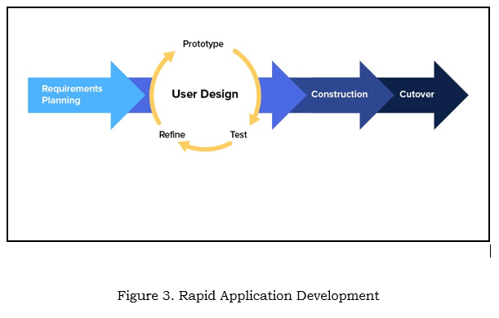
Source:https://medium.com/@chathmini96/agile-methodology-30ec4cdf3fc
Requirements Planning Phase. This initial phase focused on defining the project’s scope, objectives, and specific user needs. The proponents conducted interviews and surveys with key stakeholders in Alaminos City, including officers from the Persons with Disability Affairs Office (PDAO), PWD job seekers, and local employers. This process helped identify the inefficiencies in the current manual job-referral system and established the core functional and accessibility requirements for the portal.
User Design Phase. During this phase, initial system prototypes and interface mockups were created using Figma. These designs were presented to PWD users and stakeholders for feedback. Through an iterative process of review and revision, the user interface was refined to ensure it was intuitive, accessible, and tailored to the needs of users with various disabilities, incorporating features like adjustable text size and high-contrast modes.
Construction Phase. The functional system was built in this phase using a Three-Tier Architecture (Presentation, Application, and Data Layers). The Presentation Layer (HTML, CSS, JavaScript) provided the accessible user interface. The Application Layer, developed with PHP and the Laravel framework, handled core logic like user authentication, job matching, and application processing. The Data Layer, managed via MySQL, stored all user profiles, job listings, and application data. Development and initial testing were performed in a local environment using XAMPP and Visual Studio Code.
Cutover Phase. The completed system was deployed to a live web environment. Final integration and user acceptance testing were conducted with 19 respondents, comprising 17 PWD job seekers and 2 IT experts in Alaminos City. Training sessions and demonstrations were provided to ensure users could navigate the portal effectively.
Primary data were gathered through surveys, interviews, and usability tests targeting PWD job seekers and employers in Alaminos City, Pangasinan. A purposive sampling method was used, resulting in 19 respondents for system evaluation. Secondary data from journals, government reports, and existing literature supported the analysis of employment challenges and digital solutions for PWDs.
The research study was conducted in Alaminos City, Pangasinan. The key participants who provided essential data for this study were identified through purposive sampling. These respondents included Persons with Disabilities (PWD) job seekers and IT experts, as illustrated in Table 1 below
Table 1. Respondents of the Study
Respondents | Number of Respondents
PWD job seekers | 17
IT Experts | 2
Total Respondents | 19

To effectively evaluate the level of acceptability and overall performance of the Web-Based Digital Portal for Persons with Disabilities (PWD) Employment Opportunities, the proponents utilized a five-point Likert scale. This standardized measurement tool allowed for the systematic and objective assessment of user feedback by enabling respondents to indicate their level of agreement or satisfaction with the portal’s features, usability, accessibility, and overall performance. Table 2 shows the scale of measurement.

Table 2. Scale of Measurement
Scale | Statistical Limits | Rating
1 | 1.00-1.80 | Strongly Disagree
2 | 1.81-2.60 | Disagree
3 | 2.61-3.40 | Fair
4 | 3.41-4.20 | Agree
5 | 4.21-5.00 | Strongly Agree

RESULTS AND DISCUSSION
The Web-Based Digital Portal for Persons with Disabilities (PWD) Employment Opportunities was developed to address the significant challenges faced by PWD job seekers in Alaminos City, Pangasinan. The existing job-seeking process is predominantly manual, fragmented, and inefficient, relying on paper-based referrals, in-person coordination between the Public Employment Service Office (PESO) and the Department of Social Welfare and Development (DSWD), and word-of-mouth communication. This process often results in delayed job matching, limited access to suitable opportunities, and a lack of direct communication between PWDs and employers.
To overcome these barriers, a centralized, accessible, and user-friendly web portal was designed and implemented. The system streamlines the entire employment process from job posting and searching to application and tracking, specifically tailored to the needs of PWDs. The development followed the Rapid Application Development (RAD) methodology, emphasizing iterative prototyping and continuous user feedback to ensure the platform effectively meets user requirements.
The portal was built using a Three-Tier Architecture to ensure modularity, scalability, and maintainability. This structure clearly separates the presentation, application logic, and data management layers, as illustrated in the system framework in Figure 2 below.
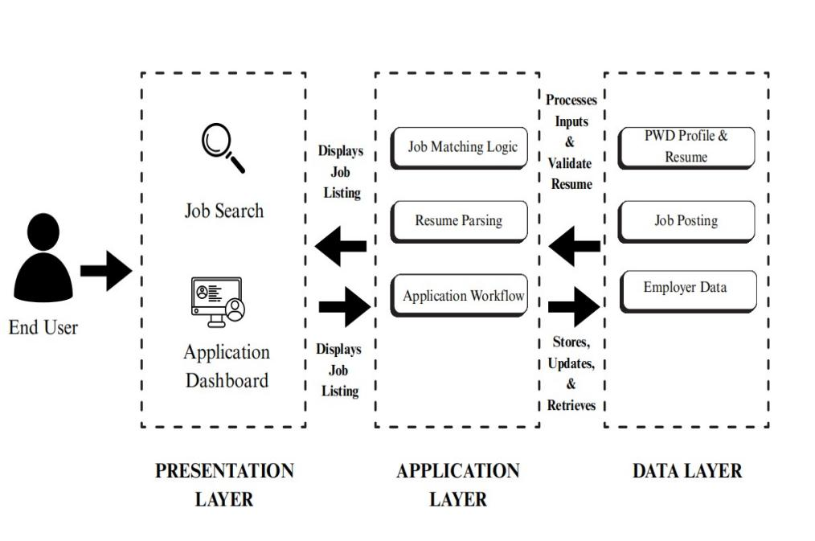
Figure 2. System Three-Tier Architecture

Presentation Tier. This is the user interface, accessible via web browsers. It was designed with a strong emphasis on accessibility, featuring adjustable text sizes, high-contrast modes, dyslexia-friendly fonts, and a clear layout to accommodate users with various disabilities (e.g., visual, motor). The interface allows PWD job seekers to browse jobs, manage profiles, and track applications easily.
Application Tier. This tier contains the core business logic. It handles user authentication, job search algorithms, application processing, and administrative functions. Key features like job matching based on skills and disability type, application status updates, and notification systems are managed here.
Data Tier. This tier manages all data storage using a structured database. It securely stores PWD user profiles, employer details, job postings, application records, and training information, ensuring data integrity and efficient retrieval.
CONCLUSION
Based on the successful development and evaluation of the Web-Based Digital Portal for Persons with Disabilities (PWD) Employment Opportunities, it can be concluded that the system effectively and efficiently bridges the significant employment gap for PWDs in Alaminos City.
The portal has proven to be a highly acceptable and reliable digital solution, successfully addressing the inefficiencies of the traditional manual and referral-based job-seeking process. By providing a centralized, accessible platform, it directly connects PWD job seekers with inclusive employers, streamlining the entire application and hiring workflow. Key strengths of the system include its user-friendly interface, robust accessibility features such as adjustable contrast and text size, and comprehensive functionalities for profile management, job searching, and application tracking.
Developed using the Rapid Application Development (RAD) methodology, the portal was iteratively refined with continuous user feedback, ensuring it closely aligns with the real needs of PWD users and administrators. The system’s high evaluation scores across all criteria—including functionality, usability, security, and portability, with an overall weighted mean of 4.784 (Strongly Agree)—confirm its quality, dependability, and readiness for real-world implementation.
In summary, this web-based portal stands as a sustainable and empowering tool that promotes greater employment equity, fosters economic independence for PWDs, and provides a modern, efficient platform for inclusive hiring practices in the community

REFERENCE
- Ahmed, M., Meghana, B. L., Durga, N. S., Sri, M. N., & Shabuddin, S. (2024). Online job portal (Unpublished project report). Sri Vasavi Institute of Engineering & Technology (Autonomous), Nandamuru.
- Bansal N, Tandon M, Das H (2024), "Importance of computer in learning of person with disabilities in skill training". Journal of Applied Research in Higher Education, Vol. 16 No. 3 pp. 966–976, doi:https://doi.org/10.1108/JARHE-05-2023-0187
- CUEMATH. (n.d.). Scale of Measurement Nominal, Ordinal, Interval, Ratio Scales. Cuemath. https://www.cuemath.com/measurement/scales-of-measurement/
- Dispenza, Franco. (2021). Empowering the career development of persons with disabilities (PWD). Journal of Career Development.
https://journals.sagepub.com/doi/abs/10.1177/0894845319884636
- Indeed. (2024). What is a job board? Definition, types, and benefits. IndeedCareerGuide.
https://www.indeed.com/careeradvice/career-development/recruitment-portals
- GeeksforGeeks. (2025, July 11). Rapid Application Development Model (RAD) Software Engineering. GeeksforGeeks.
https://www.geeksforgeeks.org/software-engineering/software-engineering-rapid-application-development-model-rad/
- Lashari, T. A., Lashari, S. A., Lashari, S. A., & Nawaz, S. (2022). Job embeddedness: Factors and barriers of persons with disabilities (PWDs). Journal of Technical Education and Training, 14(3), 153–165. HTTP://doi.org/10.30880/jtet.2022.14.03.014
- Samonte, M. J. C., Dela Cruz, A. Z., Uy, D. A., & Gabriel, E. S. (2024). CanDo: A web-based job portal for jobseekers and freelancers with disabilities. In 2024 4th International Conference on Computer Systems (ICCS) (pp.112–121).
https://doi.org/10.1109/ICCS62594.2024.10795846
- United Nations. (2021). Chapter Six: From provisions to practice: Implementing the Convention Work and employment.
- World Health Organization. (2023). Improving disability inclusion in health services. https://www.who.int/westernpacific/activities/improving-health-services-for-people-with-disability

