Abdulazeez Mohammed, Misbahu Ladan Mohammed, Kabir Ahmed Dabai, Muhammad Mustapha
Institution: Usmanu Danfodiyo University Sokoto, Nigeria
Email: abdulazeezmohammed6@gmail.com
misbahu.ladan@udusok.edu.ng
kabir.ahmed@udusok.edu.ng
binmustapha042@gmail.com

Performance Evaluation of Solar-Powered DC Milking Machine for Dairy Cattle

Abstract
This research practically evaluates the impact and performance of the solar-powered DC milking machine on dairy cattle. The milking machine was tested and evaluated on the Sokoto Gudali and Geurnsey cattle with respect to the milking time, milk yield, milking efficiency and energy efficiency. The environmental impact of the design was assessed using RETScreen software to ascertain the level of greenhouse gas emissions in comparison to conventional milking machine. The results indicated that both breeds of cattle takes approximately 8 – 15 minutes per day and 4 - 8minutes across morning and evening milking sessions. They produce 2.3 – 6.6litres of milk per day and 1.0 - 4.4litres of milk across the morning and evening milking session. Milking efficiency ranged from 0.26l/min - 0.62l/min while the energy efficiency was at the range of 0.15kJ/l - 0.36kJ/l. The environmental impact of the solar-powered DC milking machine showed to have a 93% significant reduction in gross annual greenhouse gas emissions.

Keywords: Milking Time; Milk Yield; Milking Efficiency; Energy Efficiency; Milking Machine

Introduction
This notable improvement in efficiency has made milking machines a crucial tool for contemporary dairy farms. In contrast to naturalist frameworks, modern advancements in the domain of food production demonstrate the potential to enhance food accessibility, reduce greenhouse gas emissions, and maintain animal welfare (Wesseler & Zilberman 2021).
Efficiency is an essential factor in the design of milking machines, as it directly impacts the productivity of the farm. Efficient DC milking machine will aim to maximize milk extraction while minimizing energy consumption, operational costs, and labor requirements. Through the optimization of milking efficiency, dairy farmers can augment milk production, alleviate stress on animals, and enhance overall farm profitability. The utilization of sustainable energy sources, particularly solar, wind, and biomass, will not deplete their availability. The growing demand for clean energy can be met with the presence of abundant sunlight which serves as a constant energy reservior (Qazi et al., 2019).
The principle of machine milking is to extract milk from the cow by vacuum. The machines are designed to apply a constant vacuum to the end of the teat to extract the milk and transport it to an appropriate container, while also applying periodic external pressure to the entire teat to promote blood circulation. The milking machine is a rather an automatic machine installation for milking cows. It is vital to choose an appropriate milking machine practice and understand the impact of various milking techniques on dairy operations to sustain milk quality and udder health (Dohmen et al., 2010).
Milking machine is mostly not a single unit, but rather an assembly of components designed to handle as many as hundred cows an hour as opposed to the use of hand milking which is quite stressful, strenuous and time consuming. Conventional hand milkers are prone to experience joint pain in knees, backone and stiffness in shoulder, as well as overall weakness of the body after milking large herd of cattle in a day (Gadekar et al., 2017). Therefore it is mostly inefficient, energy intensive and poses significant health risks due to potential contamination during and after the milking procedure.
Several milking machines incorporate modern technology at a high level. However, the milking system chosen is not always suitable for all animals in pastoral system, since the physiological control mechanisms and oxytocin release in animals are specific and cannot be changed by humans. In order to achieve maximum milk extraction, the milking routine and technology must be adapted to the animal body structure and function (Kaskous, 2016).
OBJECTIVES
The specific objectives are to:
- Evaluate the milking time and milk yield of the solar-powered milking machine.
- Evaluate the milking efficiency and energy efficiency of the solar-powered milking machine.
- Assess the environmental impact of using the solar-powered DC milking machine in comparison with the conventional milking machine.

MATERIALS AND METHOD
Materials for the Evaluation of Milking Time and Milk Yield of the Solar-Powered DC Milking Machine
The materials used for the evaluation of milking time and milk yield are:-
Calibrated Milk Bucket:- A calibrated milk bucket was used to measure the amount of milk produced by each cow. It was vital for keeping track of milk production.
Stop Watch:- A stop watch was used to accurately monitor the time taken to milk each cow using the milking machine.
Materials for Evaluation of Milking Efficiency and Energy Efficiency of the Solar-Powered DC Milking Machine
The materials used for the evaluation of the milking efficiency and energy efficiency are:-
Stop Watch:- A stop watch was used to accurately monitor the milking time of each of the cows to evaluate its efficiency in respect to quantity of the milking extracted.
Energy Meter:- An energy meter was used to measure the amount of energy consumed by the milking machine in order to evaluate its efficiency.
Methods
The performance evaluation and energy determination of the milking machine was carried out using the appropriate statistical tools, while RETScreen software was used to determine environmental impact of the design.
Experimental Data Collection and Statistical Analysis
The milking was carried out on dairy farm in Kasarawa, Sokoto State. The milking process began by gently washing the cow’s udder and milk bucket with clean water to prevent contamination of milk. The teat cup was gently placed on the four teat of the cow’s udder in an air tight manner to prevent air leakages during milking. The solar-power DC milking machine was then turned-on to enable suction of milk to the milk bucket. Morning milking was carried out at 7am while the evening was done by 4:30pm using a calibrated milk bucket to measure the quantity of milk extracted and a stop watch to record the milking time for each cattle using the solar-powered DC milking machine. The energy consumed was recorded using an energy meter while energy efficiency was determined by dividing the quantity of milk extracted by the energy consumed milking each cow, similarly the milking efficiency was determined by dividing the quantity of milking extracted by the time taken to milk each cow. Plate 1 shows the solar-powered DC milking machine during milking session.
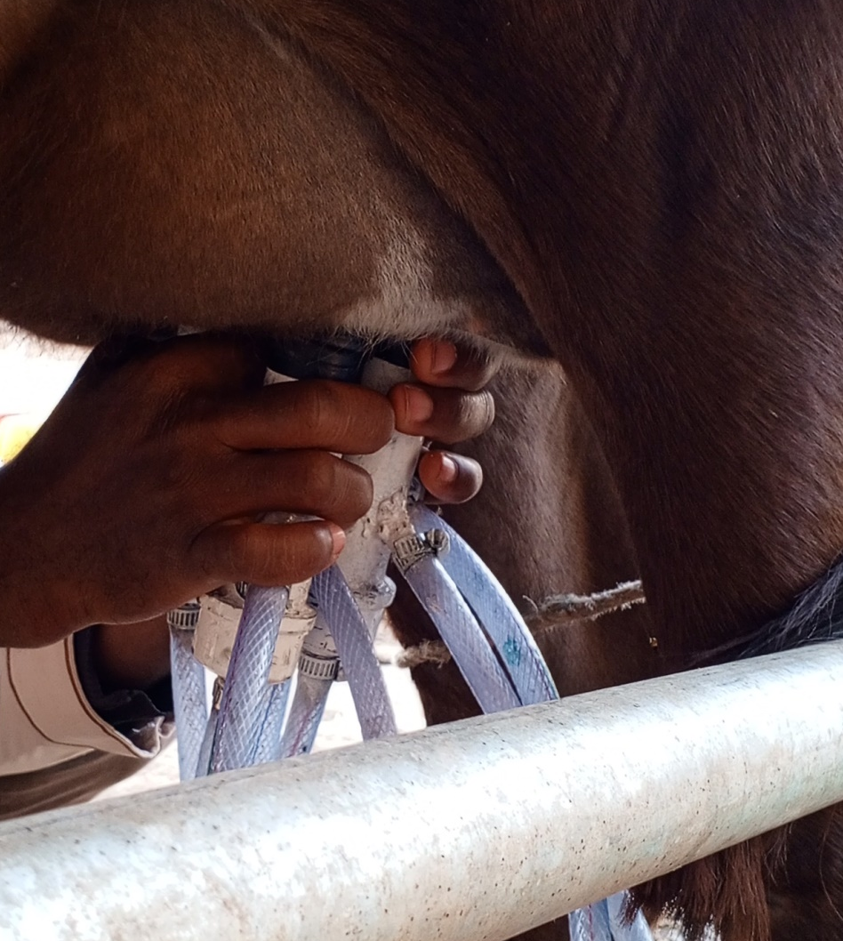
Plate 1: Solar-Powered Milking During Performance Evaluation
Evaluation of the Milking Time and Milk Yield of the Solar-Powered DC Milking Machine.
The milking time and milk yield of the solar-powered DC milking machine was evaluated using regression analysis to show the relationship between the two sets of variables. The results obtained from the evaluation was assessed to determine:-
The Average Morning and Evening Milking Time per Cow
The assessment showcased the time of the day with the longest and shortest milking time for each cow and was illustrated using a bar chart.
The Average Morning and Evening Milk Yield per Cow
A bar chart was used to illustrate the quantity of milk produced by each cow per day across morning and evening milking session.
Evaluation Milking Efficiency and Energy Efficiency of the Solar-Powered DC Milking Machine.
The milking efficiency and energy efficiency of the solar-powered DC milking machine was evaluated using a Two sample t-test. To obtain the milking efficiency, the total milk yield of each cow per-day was divided by the total milking time of each of the cow. $Milking Efficiency=\frac{Milk yield per day (l)}{Time (m)}$
The energy efficiency per liter of milk extracted using milking machine was obtained by dividing the litres of milk produced by total energy consumed (Sefeedpari et., al 2020).
$Energy Efficiency=\frac{Milk yield (l)}{Energy consumed (kJ)}$
The results obtained from the evaluation was assessed to determine:-
The Energy Efficiency and Milking Efficiency per Cow
A line graph was used to illustrate the effect of milking efficiency on energy efficiency for each cow evaluated across the two milking session.

Assessing the Environmental Impact of Using the Solar-Powered DC Milking Machine in Comparison to the Conventional Milking Machine Using Retscreen Software
A simulation was carried out using RETScreen software to determine the level of greenhouse gas emission of the design in comparison to the conventional milking machine. Abdulhameed et., al (2019) conducted a simulation using RETScreen software to determine the techno-economic and environmental sustainability of solar photovoltaic technology in Nigeria.

The Design Worksheet
The design worksheet in RETScreen Software was used to enter general information about the design such as capacity and type of suction pump, solar module, battery and charge controller.

Emission Analysis
The Emission Analysis worksheet was provided to facilitate the estimation of the greenhouse gas emission reduction (mitigation) potential for the proposed milking machine. The initial phase involved selecting the preferred type of analysis from the ribbon interface. The ribbon also contained global warming potential factors for greenhouse gases (GHG). For Level 1, this emission reduction analysis worksheet comprises three principal sections: Base Case Electricity System (Baseline), GHG Emission, and GHG Reduction Revenue. Conversely, for Levels 2 and 3, it encompasses five principal sections: Base Case Electricity System (Baseline), Base Case System GHG Summary (Baseline), Proposed Case System GHG Summary (Plan), GHG Emission Reduction Summary, and GHG Reduction Revenue. The sections titled Base Case Electricity System and Base Case System GHG Summary provided a comprehensive description of the emission profile associated with the baseline system.
The results obtained from the assessment was illustrated in form of a bar chart showcasing:-
The Base Case and Proposed Case of Greenhouse Gas Emission
The base case and proposed case of greenhouse gas emission was assessed to ascertain the level of greenhouse gas emission reduction of the milking machine prototype.

Results and Discussion
Evaluation of the Milking Time and Milk Yield of the Solar-Powered DC Milking Machine
The milking time and milk yield for each cow was recorded and measured using a stopwatch and a calibrated milk bucket. Table 1 shows the breeds of cattle evaluated using the solar-powered DC milking machine.
Table 1: Breeds of Cattle Evaluated
Cattle | Breed
A | Sokoto Gudali
B | Sokoto Gudali
C | Guernsey
D | Guernsey
E | Sokoto Gudali
Table 1 showing the breeds of cattle evaluated
From Table 1, five cattle of two breeds were evaluated using the solar-powered DC milking machine, the Sokoto Gudali and the Guernsey cattle.
Sokoto Gudali
The Sokoto Gudali is an indigenous cattle breed of Sokoto State which can produce up to 3 litres of milk per milking session in first lactation year. The quantity of milk produced by this breed increases over time as they give birth to more offsprings. However the quantity may also decrease in some case due to a number of factors such as feeding, weather, mood and age of the cow as evaluated.
Guernsey Cattle
The Guernsey cattle on the other hand are breeds of dairy cattle that originated on the island of Guernsey. This breeds can produce 4-5lites of milk per milking session. However, this number is not specific as it may vary due to factors like feeding, weather mood and age of the cattle.
The total milking time and milk yield of the solar-powered DC milking machine was evaluated using a regression analysis as shown in Figure 1.
The regression equation is
Milking Time = 5.277 + 1.117 Milk Yield
S = 2.18744 R-Sq = 66.8% R-Sq(adj) = 55.7%
Analysis of Variance
Source | DF | SS | MS | F | P
Regression | 1 | 28.8453 | 28.8453 | 6.03 | 0.091
Error | 3 | 14.3547 | 4.7849
Total | 4 | 43.2000

Figure 1: Fitted Line Plot of Milking Time Against Milk Yield
From the result in Figure 1, the P-value 0.091 is greater than the alpha value 0.05 which indicates that the result is not statistically significant. This further shows that the milking time has no significant effect on the overall milk yield per day.

Milking Time
The milking time of each cow per milking session (morning and evening) was further evaluated as shown in using Figure 2.

Figure 2: Morning and Evening Milking Time
From Figure 2, it is worthy of note that the morning milking time for cow A, B and D are longer than their evening milking time. However the morning milking time of cow C is seen to take longer in the evening than morning and that of cow E is seen to be at Equilibrium. The morning and evening milking time for cow A, B and D is observed to be normal due to the high quantity of milk produced by cattle in morning, which leads to longer milking time than evening. The deviation in cow C is due to liner slip during the evening milking process, thereby leading to longer milking time while that of cow E is due to lower battery current leading to reduced suction, hence equal morning and evening milking time.

Milk Yield
Figure 3 shows the morning and evening milk yield of each cow to ascertain the session with highest and lowest output.

Figure 3: Morning and Evening Milk Yield
From Figure 3, it is observed that the average milk yield of each cow per morning session is higher than that of evening. The reason for the surge in morning yield is simply due to the time duration between evening to morning and that of morning to evening. Milking is carried out as early as 7am for morning milking and 4:30pm for evening milking. Hence the time duration between evening and morning is longer than between morning and evening, thereby leading to lower evening yield. Another reason is that the cattle are well fed and rested in the evening thereby enabling them produce more milk in the morning.
Evaluation of the Milking Efficiency and Energy Efficiency of the Solar-Powered DC Milking Machine
The milking efficiency and energy efficiency each cow per day was evaluated using a Two sample t-test as shown using a Boxplot in Figure 4.
Two-sample T for Milking Efficiency vs Energy Efficiency
Null hypothesis (H0) - μ₁ = μ₂ All means are equal
Alternative hypothesis (H₁) - μ_{1 ≠} μ₂ At least one mean is different
 | N | Mean | StDev | SE Mean
Milking Efficiency | 5 | 0.482 | 0.140 | 0.063
Energy Efficiency | 5 | 0.2820 | 0.0823 | 0.037
Difference = μ (Milking Efficiency) - μ (Energy Efficiency)
Estimate for difference: 0.2000
95% CI for difference: (0.0222, 0.3778)
T-Test of difference = 0 (vs ≠): T-Value = 2.75 P-Value = 0.033 DF = 6
The p-value is 0.033 which is less than the alpha value 0.05, suggesting a statistically significant effect between the variables. Hence we reject the null hypothesis in favor of the alternative hypothesis. Which means there is a relationship between the two variables being studied (at least one variable affects the other).
Figure 4: Boxplot of Milking Efficiency and Energy Efficiency
It can be observed from the Boxplot in Figure 4 that there is a significant difference in efficiency when the milking efficiency is at 0.44l/min and energy efficiency at 0.26kJ/l.
Figure 5 illustrate the relationship between the milking efficiency and energy efficiency of the solar-powered DC milking machine.

Figure 5: Milking Efficiency and Energy Efficiency
Figure 5 shows that the energy efficiency increases as the milking efficiency increases and vice versa. Hence they are parallel to one another.

4.4.1 The Impact of the Design on United Nation’s Sustainable Development Goals
The solar-powered DC milking machine design will equip farmers with the proper machine required to boost productivity and increase income (SDG 1 - No Poverty). The components used in design of the milking machine was sourced locally and powered strictly by solar, hence making it more affordable and eco-friendly (SDG 7 – Affordable and Clean Energy). The use of the design would promote decent work amongst dwellers in remote communities as most will engage more in dairy farming which will in turn boost economic growth (SDG 8 – Decent Work and Economic Growth). The design is an innovative one that would provide opportunity for industry to develop and produce in large scale (SDG 9 – Industry, Innovation and Infrastructure). Considering the fact that the design was made from locally available materials and powered by clean energy from solar module, the system would make our cities and communities more sustainable (SDG 11 – Sustainable Cities and Communities). Energy consumption was optimised with the use of the design, hence increase productivity as oppose to the use AC powered milking machine (SDG 12 – Responsible Consumption and Production). The milking machine was specifically designed to mitigate greenhouse gas emission and combat climate crisis (SDG 13 – Climate Crisis).
Assessment of the Environmental Impact of Using the Solar-Powered DC Milking Machine in Comparison to the Conventional Milking Machine Using RETScreen Software
The environmental impact of the solar-powered DC milking machine was assessed using RETScreen software to ascertain the level of greenhouse emission and environmental friendliness of the machine compared to conventional milking machine. The design parameters, location and climatic data were used in the evaluation.
The assessment of the level of greenhouse emission using the solar-powered DC milking machine compared to the conventional milking machine can be seen in Plate 1.

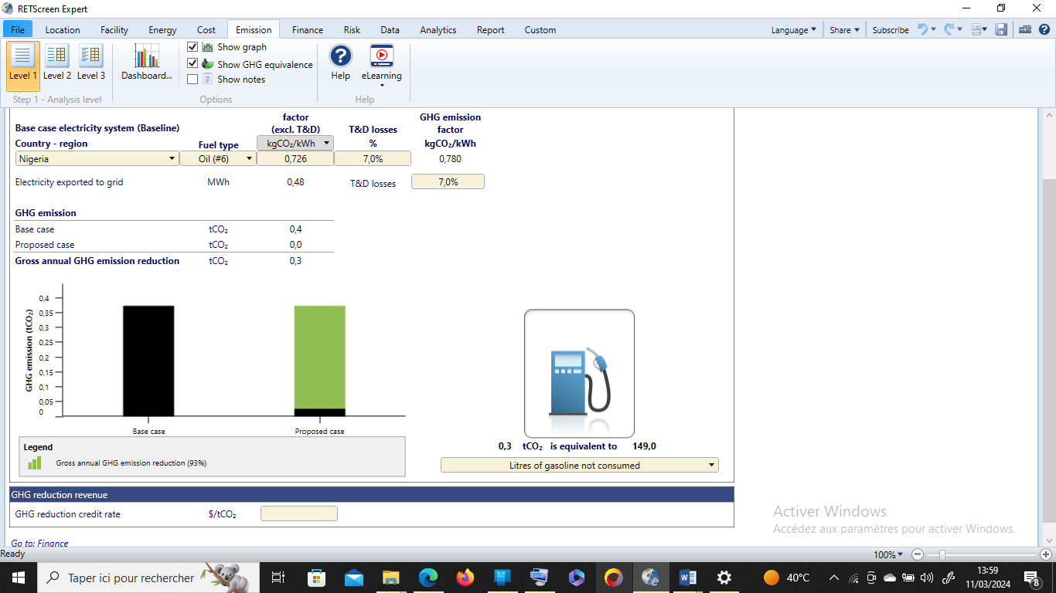
Plate 1: Assessment of GHG Emission Reduction
Plate 1 illustrates the level of greenhouse emission reduction using RETScreen software. For level 1, the base case electricity, greenhouse gas emission and greenhouse gas reduction revenue for the host location was imputed in the worksheet. It was observed that the greenhouse emission factor/electricity utilized annually was about 0.780 kilogram carbon dioxide/kilowatt hour (kgCO₂/kWh) using conventional source of energy. However in level 2 and 3, the base case electricity system (Baseline), base case system of greenhouse gas summary (Baseline), proposed case system greenhouse gas summary (Plan) and greenhouse gas emission reduction summary we evaluated. The greenhouse emission after transmission and distribution was evaluated to be 0.726 kilogram carbon dioxide/kilowatt hour (kgCO₂/kWh) while the electricity losses during transmission and distribution to grid was 7.0%. Base case of conventional greenhouse gas emission was computed to be 0.4 tonnes of carbon dioxide, while the proposed case was simulated to emit 0.0 tonnes of greenhouse gas. The gross annual greenhouse gas emission reduction using the solar-powered milking machine was assessed to be 93%.

Conclusion
From the result of the performance evaluation of the milking time and milk yield carried out, both breeds of cattle takes approximately 8 – 15 minutes per day and 4 - 8minutes across morning and evening milking sessions. They produce 2.3 – 6.6litres of milk per day and 1.0 - 4.4litres of milk across the morning and evening milking session.
The result of the milking efficiency and energy efficiency evaluation showed that the milking efficiency ranged from 0.26l/min - 0.62l/min milking the two breeds of cattle while the energy efficiency was at the range of 0.15kJ/l - 0.36kJ/l.
The environmental impact of the solar-powered DC milking machine was assessed compared to conventional milking machine using RETScreen software and was found to have 93% reduction in annual greenhouse gas emission.

Acknowledgements
The authors gratefully acknowledge the financial support provided by Efficiency for Access Design and IKEA foundation in collaboration with Engineers without Boarders UK. Special recognition goes to Transforming Energy Access (TEA), our partners in the Transforming Energy Access-Learning Partnership (TEA-LP). The authors are also grateful to Usmanu Danfodiyo University Sokoto (UDUSOK), Nigeria.

References
Abdulhameed, B. O., Benyoh Emmanuel, K. N., Jong Wook, R., Dongjun, S., & Jeung-Soo, H. (2019). Validating the techno-economic and environmental sustainability of solar PV technology in Nigeria using RETScreen Experts to assess its viability, Sustainable Energy Technologies and Assessments, 36 (1) 100542, ISSN22131388 2019. 100542.
Dohmen, W., Neijenhuis, F., & Hogeveen, H. (2010). Relationship between udder health and hygiene on farms with an automatic milking system. J Dairy Sci. Sep;93(9):4019-33. doi: 10.3168/jds.2009-3028.
Gadekar, S. V., Karle, R., Surase, R. K., Handal, G. K., &. Kiran. M. P. (2017). Design and fabrication of cyclic operated milking machine. Internation Journal of Advance Research and Innovative Ideas in Education, 3(2): 3134-3140.
Kaskous, S. (2016). MultiLactor milking system, a revolution in milking technology. In research report, Department of Research and Development; Siliconform: Türkheim, Germany; pp. 1–40.
Qazi, A., Hussain, F., Rahim, N. A., Hardaker, G., Alghazzawi, D., Shaban, K., & Haruna, K. (2019). Towards sustainable energy: a systematic review of renewable energy sources, technologies, and public opinions. IEEE access, 7, 63837-63851.
Sefeedpari, Paria, Shokoohi, Zeinab, Seyyed, Hassan, & Pishgar-Komleh. (2020). Dynamic energy efficiency assessment of dairy farming system in Iran: Application of window data envelopment analysis, Journal of Cleaner Production, Volume 275 , 124178, ISSN0959-6526 2020. 124178.
Wesseler, J. H. H., & Zilberman, D. (2021). Biotechnology, bioeconomy, and sustainable life on land. In Transitioning to sustainable life on land (Vol. 15, pp. 415–435). MDPI. Xepapadeas, A. (2011). The economics of non-point-source pollution. Annual Review of Resource Economics, 3(1), 355–373.

