AHMAD LABIB'S POLITICAL COMMUNICATION STRATEGY IN THE 2024 DPR-RI LEGISLATIVE ELECTION FOR EAST JAVA ELECTORAL DISTRICT X (LAMONGAN-GRESIK)

ABSTRACT
This study aims to analyze the political communication strategy of Ahmad Labib, S.H., M.H.I. in winning the 2024 Legislative Election for the House of Representatives of the Republic of Indonesia (DPR-RI) in East Java Electoral District X (Lamongan-Gresik). Ahmad Labib secured 241,581 votes and ranked third among the six contested seats, a significant achievement considering that he had never previously won a legislative contest. This study employed a qualitative method with a constructivist paradigm, in which data were obtained through in-depth interviews, observation, and documentation involving Ahmad Labib and his campaign team. The findings indicate that Ahmad Labib's political communication strategy was implemented through four main steps: understanding the audience based on attention area, public area, and sentiment area; constructing a persuasive message entitled "Wes Wayahe Putra Asli Lamongan"; applying redundancy in message delivery; and utilizing Instagram and printed media such as billboards and banners. The campaign model applied was a candidate-oriented campaign with dialogical and face-to-face approaches, using The Five Functional Stages Development Model, which includes identification, legitimacy, participation, penetration, and distribution. Ahmad Labib's electoral success demonstrates that a candidate's personal appeal, proximity to grassroots constituencies, and community-based campaign strategy can surpass the structural power of a political party in local political contestation.

Keywords: Political Communication Strategy; Political Campaign; Legislative Election

ABSTRACT
This study aims to analyze the political communication strategy of Ahmad Labib, S.H., M.H.I. in winning the 2024 Legislative Election for the House of Representatives of the Republic of Indonesia (DPR-RI) in East Java Electoral District X (Lamongan-Gresik). Ahmad Labib successfully secured 241,581 votes, placing third among six contested seats; this was a notable achievement because he had never previously won a legislative election. This study used a qualitative method with a constructivist paradigm. Data were collected through in-depth interviews, observation, and documentation involving Ahmad Labib and his campaign team. The findings show that Ahmad Labib's political communication strategy was carried out through four key steps: understanding the electorate through attention area, public area, and sentiment area; developing a persuasive message under the slogan "Wes Wayahe Putra Asli Lamongan" (It is time for a true son of Lamongan); applying message redundancy techniques; and utilizing Instagram and printed media, including billboards and banners. The campaign model applied was a candidate-oriented campaign with dialogical and face-to-face approaches, structured through The Five Functional Stages Development Model, covering identification, legitimacy, participation, penetration, and distribution. Ahmad Labib's electoral success demonstrates that a candidate's personal appeal, grassroots proximity, and community-based campaign strategies can surpass the structural influence of a political party in local political contestation.

Keywords: Political Communication Strategy; Political Campaign; Legislative Election

- BACKGROUND
In a representative democratic system, a general election should ideally function as a constitutional mechanism through which citizens determine their political representatives rationally and on the basis of public interest (Putri et al., 2023). However, in the context of Indonesian electoral politics, this ideal often collides with oligarchic dominance, identity mobilization, and money-based patronage that distort the principles of honest, fair, and equally competitive elections. Anthony Downs, in An Economic Theory of Democracy (1957), explains that voters in a democratic system act as rational agents who make decisions based on calculations of benefits and costs from each available alternative (Downs, 1957). Within this framework, candidates are required to formulate strategies that are not only effective in political communication but also capable of meeting the rational expectations of voters who are increasingly intelligent, critical, and exposed to digital dynamics. The 2024 legislative election showed a new phenomenon marked by the dominance of young voters from the Millennial and Gen Z generations as the majority. This situation encouraged candidates and political parties to adapt by optimizing digital campaigns through social media as an efficient and effective political communication instrument for reaching voters widely. In addition to digital strategies, patronage practices were still used to gain support through money politics. Community-based mobilization and coalition formation also expanded the support base, meaning that candidates relied not only on financial capital but also on the construction of an attractive political image among the public (Adar BakhshBaloch, 2017).
Ahmad Labib S.H., M.H.I.'s victory in the 2024 DPR-RI Legislative Election, with the third-highest number of votes in East Java Electoral District X, constitutes the main reason for this study. Two notable facts underlie his election: first, Ahmad Labib had never previously won a DPR-RI legislative contest; second, he was nominated by the Golkar Party, which in the 2019 legislative election won only one seat in the district, forcing him to compete against an incumbent candidate from his own party. Ahmad Labib is a politician with a student activist background. He once served as Chair of the Student Executive Board of Universitas Muhammadiyah Surabaya and was also a member of the Muhammadiyah Student Association of Surabaya. Born in Lamongan, he also served as Deputy Director for Services and Membership of the East Java Provincial BPJD and became Commissioner of PT Kelola Mina Bumi in 2018 before deciding to run as a DPR-RI legislative candidate in the 2024 election. According to Anwar Arifin, political communication is discourse intended to influence the life of the state; it is also the art of designing what is possible (art of possible), and even the art of making the impossible possible (art of impossible). This study discusses political communication strategies using Anwar Arifin's works entitled Political Communication: Paradigms, Theories, Applications, Strategies and Indonesian Political Communication, as well as political campaign studies using Hafied Cangara's work Political Communication: Concepts, Theories, and Strategies.
The 2024 DPR-RI Legislative Election was a democratic process that determined political representation for the following five years. It was held simultaneously with the Presidential Election on Wednesday, 14 February 2024, as stipulated in General Elections Commission Regulation (PKPU) Number 3 of 2022 concerning the Stages and Schedule for the 2024 General Election. Citizens were given the freedom to choose representatives whom they believed could convey their aspirations and improve their lives. The Golkar Party, which nominated Ahmad Labib, is one of Indonesia's largest political parties. In the 2019 election, Golkar ranked third with 17,229,789 votes (12.31%) and 85 seats, declining from the 2014 election, when it obtained 18,432,312 votes and 91 seats (republika.co.id). This decline became a consideration for Golkar to continue renewing its political communication strategy ahead of the 2024 simultaneous elections. In the 2024 election, the Golkar Party rose to second place nationally, as quoted from the KPU vote-recapitulation visual design by Jurnas.com on its Instagram account.

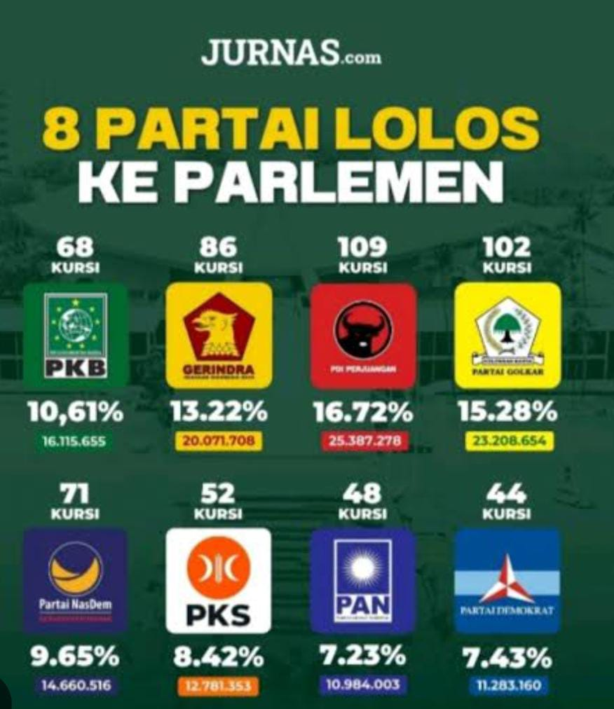

Figure 1. National Vote Recapitulation of the 2024 Election
Source: Instagram Jurnas.com
The eight parties that qualified for Senayan were, in order: PDIP with 25,387,279 votes (16.72%); Golkar with 23,208,654 votes (16.28%); Gerindra with 20,071,708 votes (13.22%); PKB with 16,115,655 votes (10.61%); Nasdem with 14,660,516 votes (9.65%); PKS with 12,781,353 votes (8.42%); Demokrat with 11,283,160 votes (7.43%); and PAN with 10,984,003 votes (7.23%).

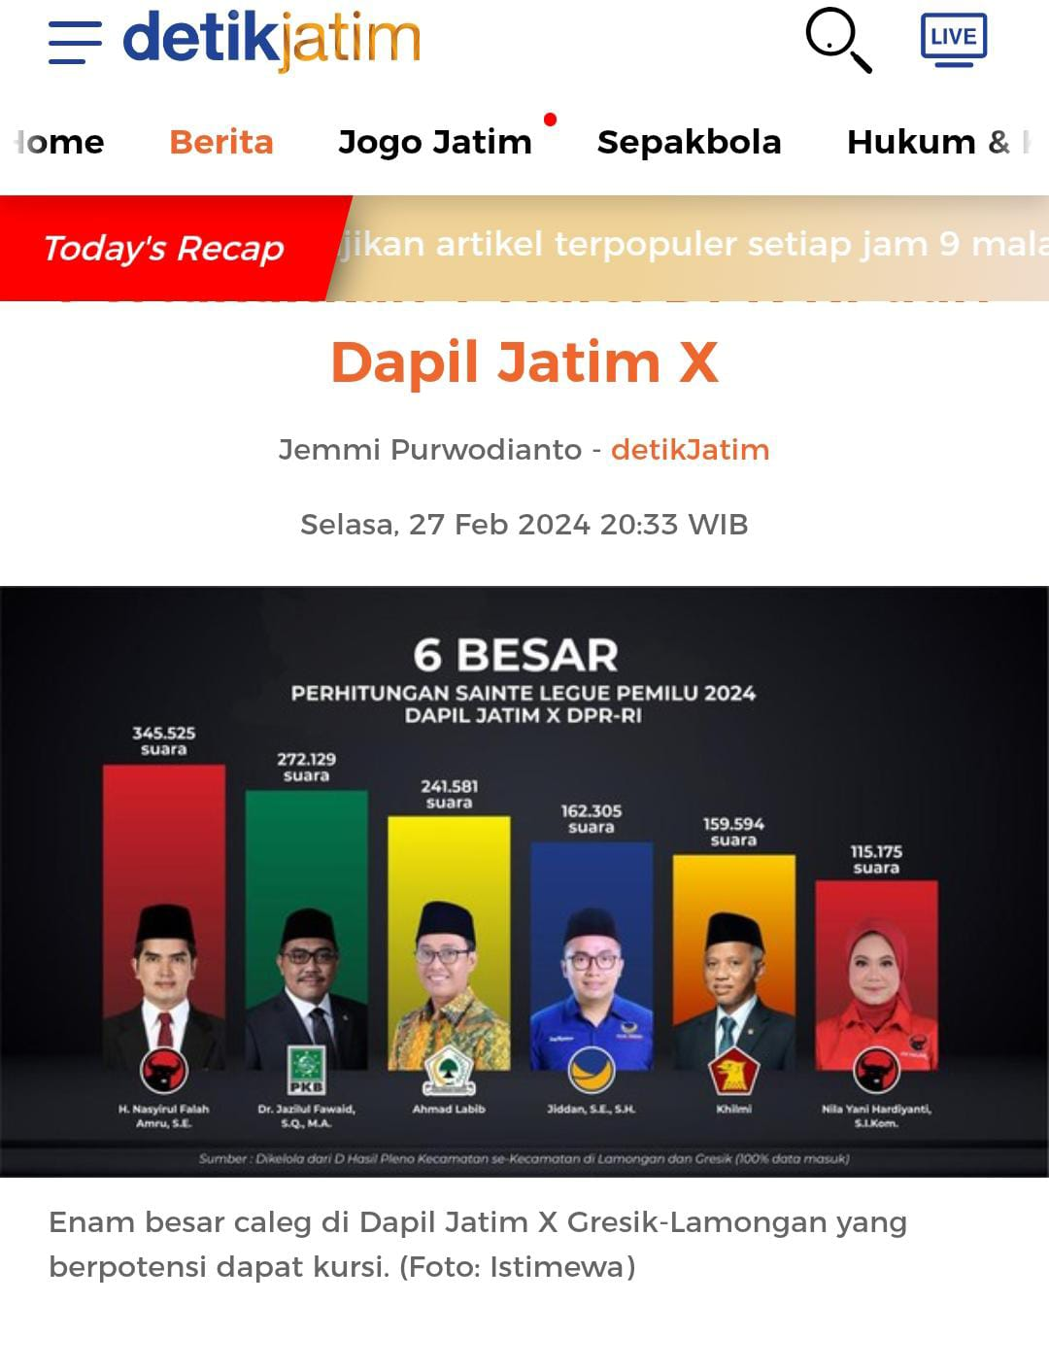
Figure 2. Visualization of Vote Recapitulation Design across All Subdistricts (Form D) in East Java Electoral District X, Lamongan Regency and Gresik Regency
Source: Detik.jatim
Based on the vote recapitulation for East Java Electoral District X (Lamongan-Gresik), Ahmad Labib ranked third with 241,581 votes. First place was won by H. Nasyirul Falah Amru, S.E. (PDI-Perjuangan) with 345,525 votes; second place by Dr. Jazilul Fawaid S.Q., M.A. (PKB) with 272,129 votes; fourth place by Jiddan, S.E., S.H. (Nasdem) with 162,305 votes; fifth place by Khilmi (Gerindra) with 159,594 votes; and sixth place by Nila Yani Hardiyanti S.I.Kom (PDI-Perjuangan) with 115,175 votes.
Ahmad Labib's success was inseparable from the political communication he conducted. Political communication carried out by political actors aims to obtain support by prioritizing interaction in the form of dialogue, which, from an interactional perspective, is referred to as a form of the constructivist paradigm. In dialogue, a political actor as communicator views the community as part of a basic role-taking process that enables the formation of empathy, self-identification, and mutual understanding.
Ahmad Labib's electoral success demonstrates the strength of personal-based politics that can go beyond the boundaries of formal party institutions. This victory indicates that the individual appeal of a candidate, effective campaign strategies, and proximity to grassroots constituencies play a highly significant role in the electoral process, while also challenging the general assumption that the structural strength of a party is the main determinant in local political contestation.
Against this background, the researcher is interested in conducting an in-depth study of the political communication strategy implemented by Ahmad Labib in winning voters' support in Lamongan Regency and Gresik Regency during the 2024 DPR-RI Legislative Election, with the aim of contributing ideas to the renewal of strategies used by political actors and political parties in an evolving electoral environment.

- LITERATURE REVIEW
- Communication
Communication is an interaction among individuals in which one party acts as the message sender and another as the message receiver. According to Effendy in Ferica & Parlindungan (2020), communication is the delivery of ideas, thoughts, and messages to others within a particular time, whether intentionally or unintentionally. Thus, communication can be understood as an interaction in conveying messages or ideas either directly or indirectly. Sutrisno (2017:17) emphasizes that communication is a concept with many meanings, one of which, in the social sciences, is closely related to messages and human behavior. Effective communication requires not only an understanding of the process but also the ability to apply such knowledge creatively in order to create good relationships among individuals and within the workplace.
Communication is also defined as symbolic interaction in which people create their environment through relationships built together by exchanging information to strengthen attitudes and behavior (Mardiyanto & Giarti, 2019). Meanwhile, according to Hermawan in Grisatita & Lestari (2020), communication is a process that occurs between two or more people as they exchange information through various means, including sign language, speech, letter writing, gestures, and broadcasting (Firmansyah, 2020). According to Yusuf (2021), the functions of communication include four main aspects. First, the social function is related to the formation of self-concept and respect for others. Second, the expressive function enables individuals to convey feelings through facial expressions, gestures, and expressions on social media. Third, the ritual function plays a role in religious and cultural activities. Fourth, the instrumental function is persuasive in nature, positioning communication as a tool for achieving particular interests, such as informing, educating, and entertaining.
Based on Seiler's view in Purba et al. (2021), communication has four basic principles. Communication is a process that takes place continuously and changes according to its constituent components. Communication is also a system consisting of communicators, information, media, communicants, and feedback, all of which are interconnected. In addition, communication is transactional and interactional because it involves the exchange of messages between communicators and communicants. Communication may occur intentionally when a message has a specific purpose, or unintentionally when a message can be received by anyone within its reach who interprets it as information. The communication process begins with a person's thoughts, which transmit a message in the form of symbols, either spoken words or images, and then channel it through a particular medium to the recipient (Busro, 2015:48). The recipient then interprets the message and provides feedback, while change in the recipient becomes an indicator of successful communication.
According to Arni (2016:7), communication barriers are divided into three types. Technical barriers arise from limitations in communication facilities and equipment, although they can be minimized through developments in information technology. Semantic barriers occur because of unclear messages caused by inappropriate word choice, requiring communicators to choose words that match the characteristics of communicants in order to avoid miscommunication.

- Politics and Political Communication
Politics originates from the word polis, meaning city-state in Classical Greek, and later developed into various forms such as polity, politics, and policy. In Arabic, politics is called siyasah, which was absorbed into Indonesian as siasat or strategy, referring to how goals related to state affairs are achieved. According to the Indonesian Dictionary (KBBI), politics is the science of statecraft concerning the process of determining goals and their implementation, including the state, power, decision-making, policy, and the distribution or allocation of resources. According to McNair in Introduction to Political Communication, political communication is purely talk about the allocation of public resources, the authority to grant power in lawmaking, and sanctions in the form of rewards or penalties. Meanwhile, according to Anwar Arifin, political communication is discourse intended to influence life within the state, and it is the art of designing what is possible (art of possible) and even making the impossible possible. Denton and Woodward add that the most important aspect of political communication is not the source, but the issues and objectives that serve as determining factors.
Brian McNair defines political communication simply as purposeful communication about politics. This includes all forms of communication by politicians to achieve specific goals, communication directed at political actors by voters and mass-media columnists, and communication about political actors and their activities published in news reports, editorials, and political discussions in mass media. As in Lasswell's paradigm, who says what in which channel to whom with what effect, political communication occurs when politically charged messages are delivered through a particular medium to communicants and thereby change their political orientation (Gun Gun Heriyanto). The elements of political communication are essentially no different from the elements of communication in general. Nimmo divides political communication elements into political communicators, political messages, political media, political audiences, and the consequences or effects of political communication. Political communicators consist of individuals, groups, organizations, institutions, or governments that consistently convey political messages, and Nimmo classifies them into three categories: politicians, professional communicators, and activists.
Political messages are messages delivered by political communicators, whether verbally or nonverbally, implicitly or explicitly, for example through speeches, statements, news broadcasts, logos, banners, and billboards. Political messages are divided into three types: notification messages that contain only facts without explanation, informative messages that contain facts with explanations, and persuasive messages that seek to persuade and influence changes in attitudes through rhetoric, agitation, propaganda, political advertising, and campaigns. Political media are the means used by communicators to deliver political messages to communicants, ranging from interpersonal communication (face-to-face and door-to-door), group and organizational communication, print and electronic mass media, to new media in the form of social media such as Facebook, Instagram, Twitter, YouTube, and TikTok. In the modern era, social media are preferred by communicators because they provide broader, faster, and more independent reach than traditional or conventional media. Political audiences are anyone who receives political messages, divided into the general public, attentive publics such as activists, and elite opinion leaders consisting of politicians and professionals.
The effect of political communication is the impact of the message delivered and, in the context of elections, is expected to take the form of votes for the party or candidate being promoted. According to Wilburn Schram, the purpose of studying communication effects is to determine what happens to humans when they receive certain messages. The effects that occur in political communication include changes in opinions, attitudes, behavior, perceptions, beliefs, and image, which are then measured through feedback in the form of zero feedback, neutral feedback, positive feedback, or negative feedback (Ralph Webb Jr.).

- Political Communication Strategy
Political communication strategy is essentially the totality of conditional decisions regarding actions to be carried out in order to achieve future political goals, by maintaining personal prominence, strengthening political institutions, creating togetherness, and building consensus (Anwar Arifin). According to Arifin, a political campaign is a form of political communication application carried out by a person, group, or political organization to form and nurture a positive image and public opinion so that they can be elected in an election. Roger and Storey define a campaign as a series of communication activities between organizations aimed at creating a certain impact on a large portion of the target audience continuously within a particular period. Larson divides campaigns into three categories based on their motivation. Product-oriented campaigns are product-oriented campaigns based on the motivation to obtain financial profit and build a corporate image. Candidate-oriented campaigns are based on the motivation to gain public support for a candidate from a political party in order to obtain power. Meanwhile, ideologically or cause-oriented campaigns aim to create social change related to public attitudes and behavior in addressing social issues (Larson, in Hafied Cangara).
According to Pfau and Parrot, the functions of campaigns are always related to the aspects of knowledge, attitude, and behavior, which align with Ostegaard's Triple A concept: Awareness, Attitude, and Action. Campaigns function to arouse awareness and attract public attention, generate sympathy and public alignment with the issue raised, and create concrete and measurable actions from the campaign targets (Pfau & Parrot, in Hafied Cangara). According to Anwar Arifin, political campaign models are divided into three methods. Dialogical or face-to-face campaigns are conducted directly, in which candidates engage in dialogue, shake hands, and interact with prospective voters without media intermediaries. Monological or mass campaigns are conducted in open fields by presenting campaign speakers who deliver speeches in turn, making communication one-directional. Organizational campaigns rely on the support of political parties, social organizations, and supporting groups, because without organizational support political campaigns will be less effective and highly inefficient (Anwar Arifin). Anwar Arifin identifies four targets of political campaigns: maintaining the loyalty of loyal party followers along with their families and relatives; fostering the loyalty of members of social organizations affiliated with the party; conducting intensive outreach to independent voters, particularly young people and professionals; and convincing supporters of other parties that the promoted candidate deserves to be elected because of superior vision, mission, and programs. Achieving these four targets requires total campaign management, beginning with the formulation of persuasive ideas and campaign themes, followed by planning, organizing, budgeting, implementation, and evaluation through the formation of a Campaign Team or Winning Team commonly called a Success Team (Tim Sukses).

- RESEARCH METHOD
This study used a qualitative method that emphasizes the understanding of meaning, reasoning, definition, and specific contexts that are dynamic and flexible, including observation, interview, and document-analysis techniques (Danadharta, 2019). The paradigm used was the constructivist paradigm introduced by Peter L. Berger and Thomas Luckman, in which the social reality observed by a person cannot be generalized to everyone as positivists usually do (Eriyanto, 2012:13). The research subjects consisted of Ahmad Labib as a DPR-RI member elected from the Golkar Party and his Winning Team, with the research location focused on Lamongan Regency and Gresik Regency, where approximately 75% of Ahmad Labib's voters came from Lamongan Regency.
The data sources in this study consisted of primary and secondary data. Primary data were obtained directly from informants through interviews, observation, and documentation using purposive sampling, namely sample selection based on specific considerations regarding informants deemed to have the most knowledge of the information required by the researcher (Sugiyono, 2019). Secondary data were obtained indirectly through previous research, archives, journals, and supporting books (Siyoto & Sodik, 2015). Data validity testing used technique triangulation, namely checking data from the same source through different techniques, including interviews, observation, and documentation. If the resulting data differed, further discussion was conducted to determine the correct data (Sugiyono, 2013).
Data analysis in this study used the interactive model analysis technique of Miles, Huberman, and Saldana in Hardani et al. (2020), which consists of four stages. First, data collection refers to activities for obtaining information needed to achieve the research objectives. Second, data condensation is the process of focusing and selecting data according to classification. Third, data presentation is carried out after the data have been grouped. Fourth, conclusion drawing is adjusted to the research problem formulation. Seiddel in Moleong (2019) explains that qualitative data analysis involves a series of steps such as recording, collecting, sorting, classifying, and identifying meaningful general findings.

- RESULTS AND DISCUSSION
- General Description of the Research Object
In this study, the research subject focused on Ahmad Labib's communication strategy, while the research object was Ahmad Labib as an elected DPR-RI member according to the predetermined criteria. In Ahmad Labib's campaign, the researcher identified the Five Functional Stages Development Model. This model consists of several stages, namely identification, legitimacy, participation, penetration, and distribution.
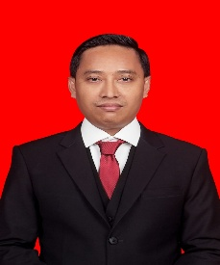
Ahmad Labib (born 11 February 1979) is an Indonesian politician. He is affiliated with the Golongan Karya Party (Golkar). In the 2024 Indonesian legislative election, he ran in East Java Electoral District X, gained 78,174 votes, and was appointed as a member of the House of Representatives of the Republic of Indonesia for 2024-2029. He once served as Chair of the Student Executive Board of Universitas Muhammadiyah Surabaya (UMS) and was also a member of the Muhammadiyah Student Association of Surabaya (IMM). From 2015 to 2018, he served as Chair of the Central Leadership of Pemuda Muhammadiyah. He also served as Deputy Director for Services and Membership of the East Java Provincial BPJD. In 2018, he became Commissioner of PT Kelola Mina Bumi.

- Data Presentation
In the data presentation, the researcher presents data obtained from interviews and survey-based observation. This was conducted to obtain understanding and identify the meaning behind the interview results, making data presentation a central part of the study. To fulfill research validity, the researcher conducted interviews to answer questions referring to communication theories and concepts, in order to obtain direct validity from two informants consisting of Ahmad Labib and Ahmad Labib's Success Team. The second stage of the study involved observation. The researcher observed the communication strategy content used by Ahmad Labib. The third stage of the study involved analyzing the data that had been obtained by describing the observation results in sentences. The writing of the data presentation was adjusted to what was obtained during the interview and observation stages, with the aim of answering the questions formulated by the researcher regarding Ahmad Labib's Communication Strategy in the 2024 DPR-RI Legislative Election for Electoral District X (Lamongan-Gresik).

- Presentation of Findings
- Ahmad Labib's Political Communication Strategy
Ahmad Labib's political communication strategy began by understanding the audience in East Java Electoral District X (Lamongan-Gresik), where the majority of the population is Muslim and Islamic organizations have developed rapidly. According to Laswell, there are three forms of group influence: attention area, public area, and sentiment area. In the attention area, Ahmad Labib benefited from being the only native son of Lamongan among the six elected DPR-RI members, which attracted substantial public attention, as stated by Chusnul, Ahmad Labib's political consultant. In the public area, Ahmad Labib presented influential figures such as Golkar faction members of the Regional House of Representatives (DPRD), Muhammadiyah figures, and networks of Korcam and Kordus volunteers to create psychological attachment among the public. Meanwhile, in the sentiment area, Ahmad Labib was considered quite fortunate because he was born in Lamongan and built his career in Gresik, making the two regions a strong foundation for his election as a people's representative, as explained by Aden, Expert Staff and Treasurer of the Golkar Party in Gresik Regency.
Ahmad Labib constructed a persuasive message using the phrase "Wes Wayahe Putra Daerah Asli Lamongan," which was distributed through banners and billboards along main roads. The message attracted public attention because he was the only native son of Lamongan running in the DPR-RI Legislative Election for Electoral District X. In determining the method, Ahmad Labib used redundancy or repetition techniques, repeatedly delivering political messages to audiences so that they would be easier to remember and encourage action, including repeated socialization on how to mark the ballot using sample ballots as teaching aids. Chusnul explained that Ahmad Labib's winning team system consisted of three layers: layer 1 consisted of the central team, including administrative and data teams as well as Korkab, Korcam, and Kordus; layer 2 consisted of district DPRD candidate teams using a bundling or package system; and layer 3 consisted of community groups from youth, religious, and social organizations. Its distinctive feature was the elimination of Kordes and the direct use of Kordus, which was considered more effective.
In selecting and sorting media, Ahmad Labib used various political communication channels to reach audiences widely. As McLuhan (1964) argues that media are extensions of the human senses, political channels or media are tools used by communicators to deliver political messages. One medium used by Ahmad Labib was Instagram through his personal account @ahmadlabib.official, which was combined with face-to-face communication and organizational campaigns to maximize the reach of political messages among communities in Lamongan Regency and Gresik Regency.

- Ahmad Labib's Political Campaign
The campaign conducted by Ahmad Labib took the form of dialogical or face-to-face interpersonal campaigning, namely a campaign without media intermediaries conducted through direct visits to the community, dialogue, handshakes, casual conversation, and direct engagement with residents' homes and food stalls. The campaign type used was a candidate-oriented campaign, in which Ahmad Labib introduced himself and conveyed his vision if elected as a DPR-RI member. Based on the researcher's observation, the campaign methods applied included limited meetings with 150-250 participants, direct face-to-face meetings, distribution of brochures and stickers, installation of campaign materials, use of Instagram, print and electronic-media advertising in the form of billboards and banners, public meetings at the request of community leaders, as well as door-to-door activities and social service activities, in accordance with General Elections Commission Regulation (PKPU) No. 15 of 2023 Article 26.
Ahmad Labib's campaign model used the Five Functional Stages Development Model, which includes identification, legitimacy, participation, penetration, and distribution. At the identification stage, Ahmad Labib created a campaign identity through symbols, colors, and uniforms so that he would be easily recognized by the public. At the legitimacy stage, Ahmad Labib obtained ballot number 6 from the Golkar Party Central Executive Board as a DPR-RI legislative candidate, which became a strong asset in his election. At the participation stage, support flowed from various circles because Ahmad Labib was a native son of Lamongan as well as a Muhammadiyah activist whose name was widely known by the public, as confirmed by Chusnul as Ahmad Labib's political consultant.
At the penetration stage, campaigners convinced the public that Ahmad Labib was the best candidate by presenting his track record as a Pemuda Muhammadiyah figure and entrepreneur who was a native son of Lamongan. Thus, Ahmad Labib only needed to introduce himself directly and convey his goal as a DPR-RI candidate. At the distribution stage, as the final proof stage, Ahmad Labib successfully obtained a total of 241,581 votes in Lamongan and Gresik Regencies and ranked third among six DPR-RI members from East Java Electoral District X (Lamongan-Gresik) in the 2024 election. Afterward, he needed to fulfill the campaign promises he had communicated to the public so as not to disappoint his voters.

- Ahmad Labib's Vote Acquisition Results
As Chusnul stated, the method used was sufficiently effective in increasing Ahmad Labib's votes. As a result, he was elected as a DPR-RI member for Electoral District X of Lamongan-Gresik. East Java 10 is an electoral district in the DPR-RI legislative election within East Java Province. This district covers Lamongan Regency and Gresik Regency. It is represented by six members of the House of Representatives. The following is the recapitulation of the Domestic Final Voter List for the 2024 Election in East Java Electoral District X.

Table 1. Ahmad Labib's Vote Acquisition in East Java Electoral District X
Prov. | Regency | Districts | Villages/Wards | TPS | DPT Voters
 |  |  |  |  | Male | Female | Total
EAST JAVA X | LAMONGAN | 27 | 474 | 4.153 | 518.423 | 526.353 | 1.044.776
EAST JAVA X | GRESIK | 18 | 356 | 1.868 | 484.669 | 487.669 | 971.740
Total |  | 45 | 830 | 6.021 | 1.003.092 | 1.014.022 | 2.016.513

The General Elections Commission of the Republic of Indonesia (KPU RI) established the Permanent Candidate List (DCT) for legislative candidates (caleg) of the House of Representatives of the Republic of Indonesia (DPR RI) for the 2024 Election in East Java Electoral District X on 2 November 2023. A total of 98 legislative candidates competed to obtain the highest number of votes in order to contest six DPR-RI seats through East Java Electoral District X. Among these legislative candidates were incumbent DPR-RI members who had been elected in 2019, such as H. Nasyirul Falah Amru (PDI-P), Dr. Jazilul Fawaid, S.Q., M.A. (PKB), and Khilmi (Gerindra). In the same electoral district, the Golkar Party also backed Dyah Roro Esti, BA, PC.Dip., M.Sc., an incumbent DPR-RI member and senior figure in the Golkar Party Central Executive Board. There was also Ahmad Nabil Haroen, a senior figure in PBNU, while from the Nasdem Party there was Ir. Suhandoyo, who was a candidate for Regent of Lamongan in 2019.

- Discussion
This discussion constitutes the final result elaborated based on the findings and data presentation described by the researcher. Through observation and interviews with informants, the study provides an overview of Ahmad Labib's Political Communication Strategy in the 2024 Legislative Election for East Java Electoral District X (Lamongan-Gresik). The discussion above explains in detail the methods used by Ahmad Labib. There are several campaign models, one of which is the Five Functional Stages Development Model. This campaign model was developed by a team of campaign researchers and practitioners at Yale University in the United States in the early 1960s. This model is considered the most popular and widely used because its flexibility makes it easy to apply, whether in candidate-oriented campaigns or other types of campaigns. This model focuses on the stages of campaign activities, not on the process of message exchange between the campaigner and the campaign target. Its stages include identification, legitimacy, participation, penetration, and distribution.

- CONCLUSION AND RECOMMENDATIONS
- Conclusion
Ahmad Labib's political communication strategy in the 2024 DPR-RI Legislative Election for East Java Electoral District X (Lamongan-Gresik) was carried out through four main steps: understanding the audience based on three group influences according to Laswell (attention area, public area, and sentiment area); constructing a persuasive message using the phrase "Wes Wayahe Putra Asli Lamongan"; applying the redundancy method by repeatedly delivering political messages; and selecting media in the form of his personal Instagram account and printed media such as banners and billboards. The campaign model applied was a candidate-oriented campaign with dialogical and direct face-to-face approaches to the community, using The Five Functional Stages Development Model, which includes the identification stage through Golkar's yellow color symbol and the letter "L"; the legitimacy stage as General Treasurer of Satkar Ulama, a wing of the Golkar Party; the participation stage through layered volunteer support; the penetration stage through campaigners who presented Ahmad Labib's track record as an entrepreneur and Pemuda Muhammadiyah activist; and the distribution stage, which proved his success in obtaining 241,581 votes and ranking third in the DPR-RI Electoral District X of Lamongan-Gresik in the 2024 election.

- Recommendations
After completing this study, from preparing the background to formulating the conclusion, the researcher considers it necessary to propose several recommendations to the following parties:
- Ahmad Labib
The researcher recommends that Ahmad Labib continue maintaining communication with volunteers and the community as the foundation of his victory and be able to fulfill the political promises conveyed during the campaign.
- Ahmad Labib's Official Team
The researcher recommends that the official team continue giving special attention to Ahmad Labib so that he remains accepted by the public, especially by ensuring that social-media administrators become more active and intensive in playing their role on social media.
- Students
This study can be developed more broadly by analyzing the political communication of other candidates, so that various forms of political communication strategies for winning voters can be identified.

REFERENCES

Books:
A. (2010). Communication Strategy. Bandung: Armico Bandung.
Amin, E. (2017). Transnational Ummatic Communitarian Da'wah:
A Study of Said Nursi's Da'wah Conception and Its Application in Indonesia. Graduate School of UIN Syarif Hidayatullah Jakarta, 53.
Creswell, J. W. (2019). Research Design: Qualitative, Quantitative, and Mixed Methods Approaches. Yogyakarta: Pustaka Pelajar.
Anggito, A., & Setiawan, J. (2018). Qualitative Research Methodology. Sukabumi: CV. Jejak.
Arifin, A. (2011). Political Communication: Philosophy, Paradigms, Theories, Objectives, Strategies, and Indonesian Communication and Politics. Yogyakarta: Graha Ilmu.
Arrianie, L. (2022). Political Communication: Theories, Models, Perspectives, and Media. Jakarta: PT Gramedia.
Anggito, A., & Setiawan, J. (2018). Qualitative Research Methodology. Sukabumi: CV. Jejak.
Arifin, A. (2011). Political Communication: Philosophy, Paradigms, Theories, Objectives, Strategies, and Indonesian Communication and Politics. Yogyakarta: Graha Ilmu.
Arrianie, L. (2022). Political Communication: Theories, Models, Perspectives, and Media. Jakarta: PT Gramedia.
D. N. (2005). Political Communication: Communicators, Messages, Media, trans. Tjun Surjaman. Bandung: Remaja Rosdakarya.
Moleong, L. (2000). Qualitative Research Methodology. Bandung: Remaja Rosdakarya.
Mulyana, D. (2014). Communication Science: An Introduction, 18th ed. Bandung: PT Remaja Rosdakarya.
Nasution, Z. (1990). Political Communication: An Introduction. Jakarta: Ghalia Indonesia.
Pawito. (2009). Political Communication: Mass Media and Campaigns.
Journals:
Bakti, A. F., & Leconte, I. (2015). Integration of Da'wah in Peace Journalism. Journal of Islamic Communication, Vol. 05, No. 01, 193.
Faisal, A. (2010). The Social Fiqh Nuance of K. MA. Sahal Mahfudh.
Al-Ulum Journal, Vol. 10, No. 12, 365.
Haryanto, R. L. (2021). Women candidates and Islamic personalization in social media campaigns for local parliament election in Indonesia. South East Asia Research, 1-20.
Huda, R. I., Fauziah, N., et al. (2022). Empathic and Homophilic Political Communication of Ganjar Pranowo. Madani Journal of Politics and Social Affairs, 472-483.
Indriyani, I. I. (2009). Media and Image Politics in Contemporary Indonesian Politics. Scriptura Scientific Journal, 129-139.
Koiranen, I. K. (2019). Shared Context, shared background, shared values - Homophily in Finish Parliament member's social Network on Twitter. Telematics and Informatics, 117-131.
Krause, S. R. (2011). Empathy, Democratic Politics, and the Impartial Juror. Journal of Law, Culture and the Humanities, Vol. 1.
L. K. (2020). Political Communication in the Qur'an. Hikmah Journal, Vol. 14, No. 1, 153-154.
Leonhardt, J. M., & T. P. (2022). Vaccination Acceptance across cultures: The Roles of Collectivism, Empathy, and Homophily. Journal of International Marketing, 13-27.
Leonhardt, J. M., & T. P. (2022). Vaccination Acceptance Across Cultures: The Roles of Collectivism, Empathy, and Homophily. Journal of International Marketing, 13-27.
Leonhardt, J. M., T. P., & J.-E. N. (2020). We're Not So Different: Collectivism Increases Perceived Homophily, Trust, and Seeking User-Generated Product Information. Journal of Business Research, 160-169.
Muna, C., F., G., Febrina, N., et al. (2019). Empathy and Homophily in Political Communication for Legislative Victory. Scriptura, 82-90.
Websites:
Banten, K. (2019, May 13). Banten General Elections Commission. Retrieved from kpubanten.id: https://rpp- kpubanten.id/suara/dprDAPIL/3
Budi, F. F. (2023, June 4). Metrotv News. Retrieved from Metrotvnews.com: https://www.metrotvnews.com/play/k8oCL0pW-partai- golkar-gelar-rakernas-bahas-pemenangan-pemilu-2024
KPU. (2019, December 19). General Elections Commission. Retrieved from kpu.go.id: https://pemilu2019.kpu.go.id/#/dprri/hitung-suara/
Golkar Party, A. (n.d.). partaigolkar.com/profil. Retrieved June 24, 2022, from partaigolkar.com: http://www.partaigolkar.com/profil

