Formulation and Evaluation of Herbal Soap Using Neem, Tulsi, and Ritha Extracts
MR.RASANE SOMNATH ARUN ¹ MR.BHALSING MAHESH DILIPRAO² MISS.KALE RAJESHRI AVINASH³ MISS.TELORE ASHWINI⁴ MISS. NAGARGOJE PRATIKSHA⁵
1 Lecturer, Pravara Medical Trust’s College of Pharmacy, Shevgaon, Ahmednagar, MH, India.
2 Principal, Pravara Medical Trust’s College of Pharmacy, Shevgaon, Ahmednagar, MH, India.
3 Lecturer, Pravara Medical Trust’s College of Pharmacy, Shevgaon, Ahmednagar, MH, India.
4.Student, Pravara Medical Trust’s College of Pharmacy, Shevgaon, Ahmednagar, MH, India.
5.Student, Pravara Medical Trust’s College of Pharmacy, Shevgaon, Ahmednagar, MH, India.

Abstract
Herbal soaps are gaining attention as safe and natural alternatives to conventional soaps. This study aimed to formulate and evaluate a herbal soap using Neem (Azadirachta indica), Tulsi (Ocimum tenuiflorum), and Ritha (Sapindus mukorossi) extracts. A vegetable-based, unscented soap base was used, enriched with coconut oil and glycerin for moisturizing, and rose water and vitamin E for fragrance and antioxidant protection. The soap was evaluated for physical, chemical, functional, organoleptic, and biological properties, including pH, texture, lathering, foam stability, moisturizing effect, spreadability, stability, antimicrobial activity, and saponin content. The formulated soap exhibited a smooth appearance, firm texture, skin-friendly pH, effective foaming, moisturizing effect, and antimicrobial activity. Stability studies confirmed no significant changes under room and accelerated conditions. The results demonstrate that the developed herbal soap is safe, effective, and suitable for daily skincare, providing a natural and eco-friendly alternative to synthetic soaps.

Keywords
Herbal soap, Neem, Tulsi, Ritha, Natural foaming, Antimicrobial, Cosmetic formulation

1. Introduction
Plants have been used for medicinal and cosmetic purposes since ancient times. The Greek philosopher Theophrastus classified plants into three major groups: trees, shrubs, and herbs, forming the foundation of botanical science. Over time, herbs have been extensively utilized for their therapeutic, nutritional, and cosmetic benefits. Herbal soaps are natural cleansing products formulated using plant-based ingredients that help maintain skin health and enhance its appearance.
The primary advantage of herbal soaps lies in their natural composition, which provides nourishment and protection to the skin without producing harmful side effects. Skin condition is influenced by several factors, including lifestyle, environmental exposure, personal hygiene, and overall health status. Prolonged exposure to heat and environmental pollutants often results in skin dehydration, leading to wrinkles, pigmentation, blemishes, and sunburn.
Most commercially available soaps contain synthetic chemicals, preservatives, and additives that may cause skin irritation and long-term adverse effects. Soaps and detergents, commonly used as disinfectants for daily hygiene, are available in various forms such as solid, liquid, semi-solid, and powder, and are intended to remove dirt, microorganisms, stains, and unpleasant odors. However, many commercial soaps may contain potentially harmful substances such as plastics, aluminum, mercury, barium, and bisphenol compounds, which can be absorbed through the skin and adversely affect human health.
According to WHO mortality statistics, 17,857 deaths due to skin diseases were reported in India in 2020, representing 0.21% of total deaths. Incorporating herbal potentials into formulations offers a promising approach for management, providing effective treatment with improved safety and minimal adverse effects.³
In recent years, the use of herbal medicines and plant-based products has increased significantly worldwide. It is estimated that nearly 80% of the global population relies on herbal formulations for primary healthcare, particularly in developing countries. This growing interest has led to the emergence of Herbal Medicinal Products as an important field of pharmaceutical research, focusing on the development of safe, effective, and eco-friendly alternatives to synthetic cosmetic products.
The objective of this study was to formulate a herbal soap combining these three plant extracts and evaluate its physical, chemical, functional, organoleptic, and biological properties, ensuring safety, efficacy, and consumer acceptability.

2.Materials and Methods
2.1 Collection of Neem Leaves of Azadirachta indica (Neem) were collected from Shevgaon, Maharashtra .The leaves were then shade-dried and coarsely powdered using a mortar and pestle.
2.2Collection of Tulsi Leaves of Ocimum tenuiflorum (Tulsi) were collected from Shevgaon Maharashtra.The leaves were shade-dried and coarsely powdered using a mortar and pestle.
2.3Collection of Ritha Seeds
Seeds of Sapindus mukorossi (Ritha) were collected from Shevgaon, Maharashtra. The seeds were shade-dried to remove moisture and then ground into a coarse powder using a mortar and pestle for further use in the study.

3.Extraction of Plant Materials for Herbal Soap Formulation

3.1. Extraction of Azadirachta indica (Neem) Leaves
Fresh leaves of Azadirachta indica were collected and washed thoroughly with distilled water to remove adhering dust and extraneous matter. The leaves were shade-dried at room temperature and then pulverized to obtain a coarse powder using a mortar and pastel. Accurately weighed 10 gm of the powdered neem leaves were transferred into a conical flask containing 100 mL of distilled water. The mixture was heated at a temperature of 65 °C for a period of 35 minutes with occasional stirring, ensuring that vigorous boiling was avoided.
After completion of the heating process, the extract was allowed to cool to room temperature and was subsequently filtered through muslin cloth followed by Whatman filter paper to obtain a clear aqueous extract. The obtained filtrate was used directly for the preparation of herbal soap formulations. When necessary, the extract was gently concentrated to achieve the required consistency and strength.⁵
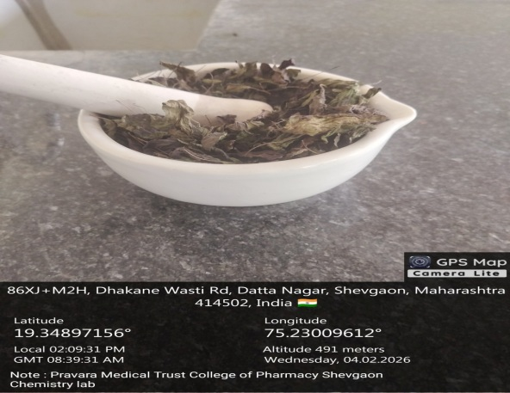
Figure 1: Collection of Neem Leaves (Azadirachta indica)

3.2 Extraction of Ocimum tenuiflorum (Tulsi) Leaves by Decoction Method
Fresh leaves of Ocimum tenuiflorum were collected, washed thoroughly with distilled water, and shade-dried for 15 days until a constant weight was achieved. The dried leaves were coarsely powdered using a mortar and pestle.
An accurately weighed 5 g of Tulsi leaf powder was transferred into a clean beaker, and 150 ml of distilled water was added. The mixture was heated on a water bath and gently boiled until the volume was reduced to one-third (50 ml).
The decoction was allowed to cool to room temperature and filtered through muslin cloth followed by Whatman filter paper. The filtrate was further concentrated on a water bath maintained at 55°C to obtain a thick aqueous extract. The extract was cooled in a desiccator, weighed, and stored in an airtight container under refrigeration until use.

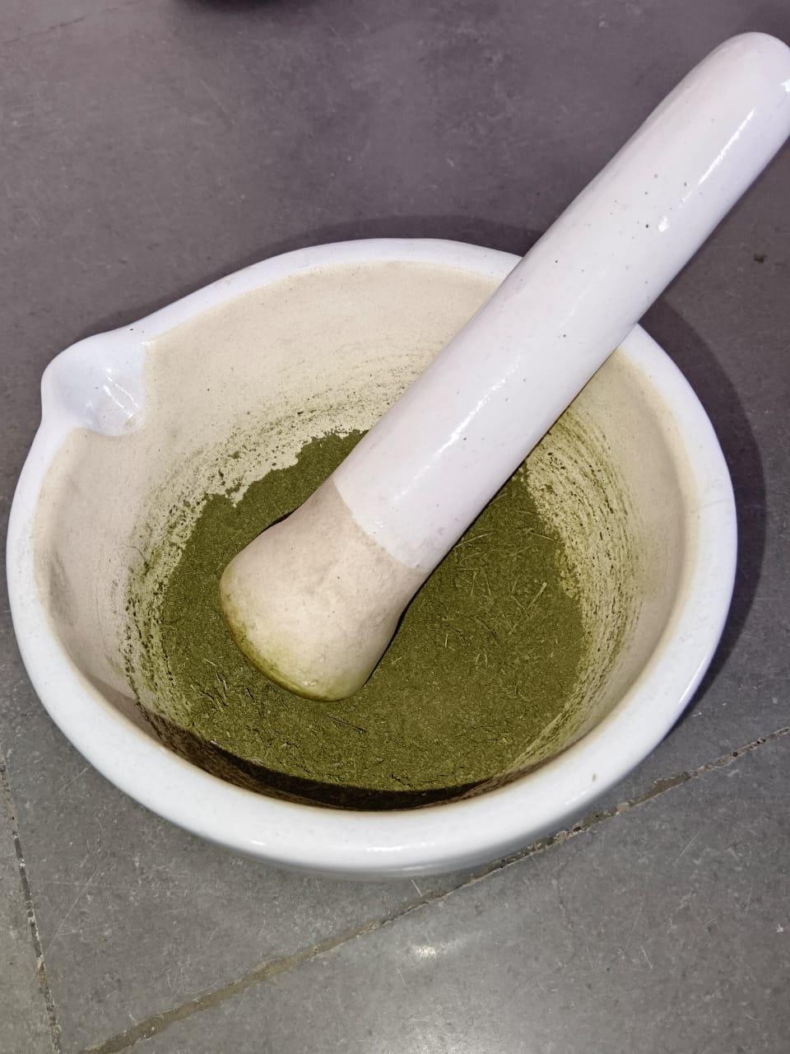
Figure 2: Powder of Tulsi Leaves (Ocimum tenuiflorum)

3.3. Extraction of Sapindus mukorossi (Ritha) Pericarp by Decoction Method
Dried fruits of Sapindus mukorossi were collected, cleaned to remove dust and foreign matter, and the outer pericarp was separated and shade-dried. The dried pericarp was coarsely powdered using a mortar and pestle.
An accurately weighed 50 g of Ritha pericarp powder was transferred into a clean beaker, and 500 ml of distilled water was added with continuous stirring. The mixture was gently boiled on a water bath/heating mantle until the volume was reduced to one-third (170 ml).
The decoction was allowed to cool to room temperature and filtered through muslin cloth followed by Whatman filter paper. The filtrate was further concentrated on a water bath below 60°C to obtain a thick aqueous extract rich in saponins. The extract was cooled in a desiccator, weighed, and stored in an airtight container under refrigeration until use in herbal soap formulation.

4.Formulation Table of Herbal soap:-
Sr. No. | Name of Ingredient | Quantity | Function
1 | Aqueous Neem extract | 25 ml | Provides antimicrobial and antibacterial activity; helps in cleansing the skin and preventing skin infections
2 | Aqueous Tulsi extract | 2.5 ml | Acts as an antioxidant and anti-inflammatory agent; soothes the skin and protects against microbial damage
3 | Aqueous Ritha extract | 25 ml | Rich in saponins; acts as a natural surfactant providing foaming, cleansing, and dirt-removal properties
4 | Soap base (vegetable/oil-based, unscented) | 100 g | Serves as the base matrix of the soap, providing structure, hardness, and basic cleansing action
5 | Glycerine | 10% w/w of soap base | Functions as a humectant; retains moisture and prevents dryness of the skin
6 |  |  | Acts as an emollient; improves lather formation, enhances moisturizing effect, and prevents skin dryness
  Coconut oil
  10 ml
7 | Rose water | 2 ml | Imparts mild fragrance and provides skin-soothing and refreshing properties
8 | Vitamin E (Tocopherol) | 5 ml | Acts as an antioxidant; protects skin cells from oxidative damage and improves skin conditioning
9 | Distilled water | q.s. | Used to adjust consistency and ensure uniform mixing of all ingredients

Table 1: Formulation Table with Detailed Functions
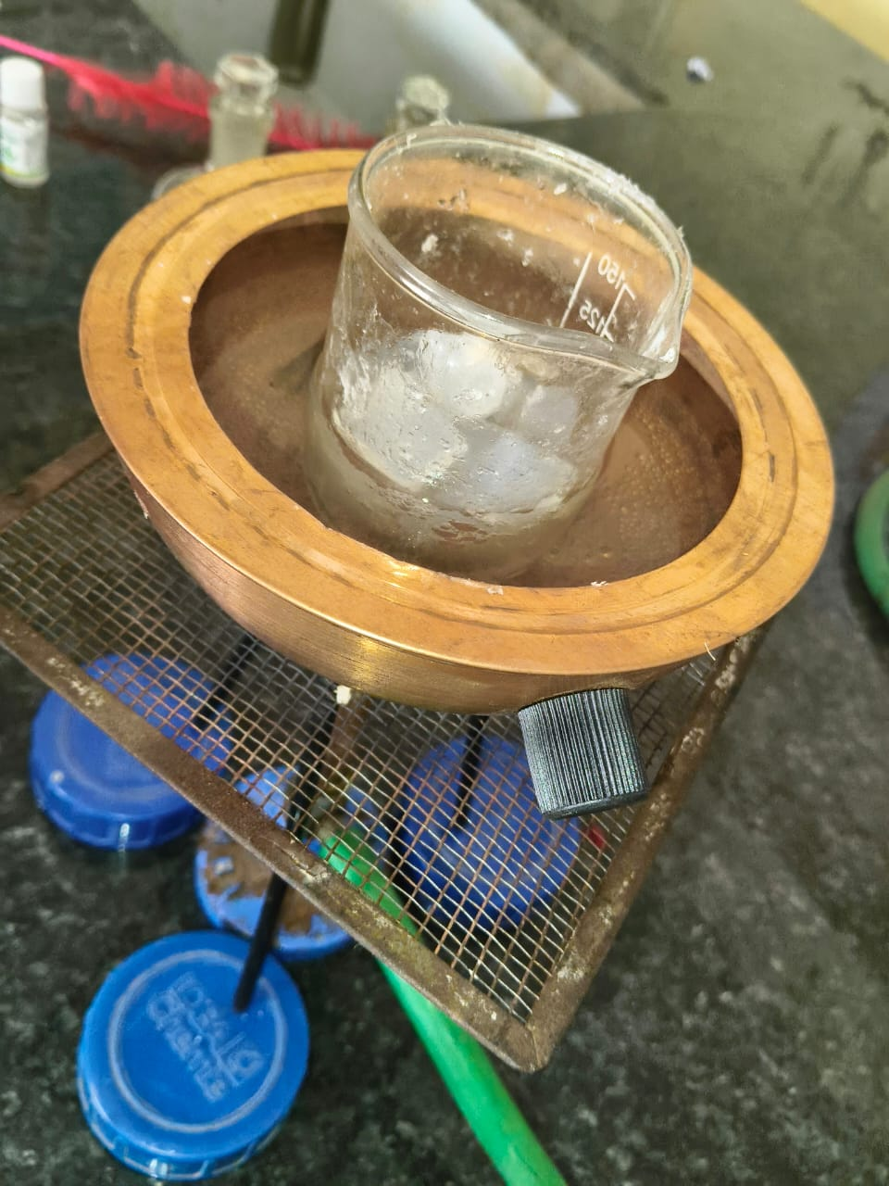 Figure 4: Melting of Soap Base on Water Bath

5.Preparation of Herbal Soap Using Neem, Tulsi, and Ritha Extracts
- The soap base (100 g) was cut into small pieces and melted on a water bath at 50–55°C.
- Coconut oil (10 ml) and glycerin (10% w/w) were added to enhance emollient and moisturizing properties.
- The mixture was cooled slightly (<55°C) to prevent degradation of thermolabile phytoconstituents.
- Neem extract (25 ml) was added gradually, followed by Ritha extract (25 ml) and Tulsi extract (2.5 ml), ensuring uniform dispersion.
- Vitamin E (5 ml) and rose water (2 ml) were added for antioxidant protection and fragrance.
- Distilled water was added to adjust the consistency.
- The mixture was stirred gently, poured into molds, and allowed to solidify at room temperature for 24 hours.
- Soap bars were demolded, wrapped, and stored in airtight containers for evaluation.

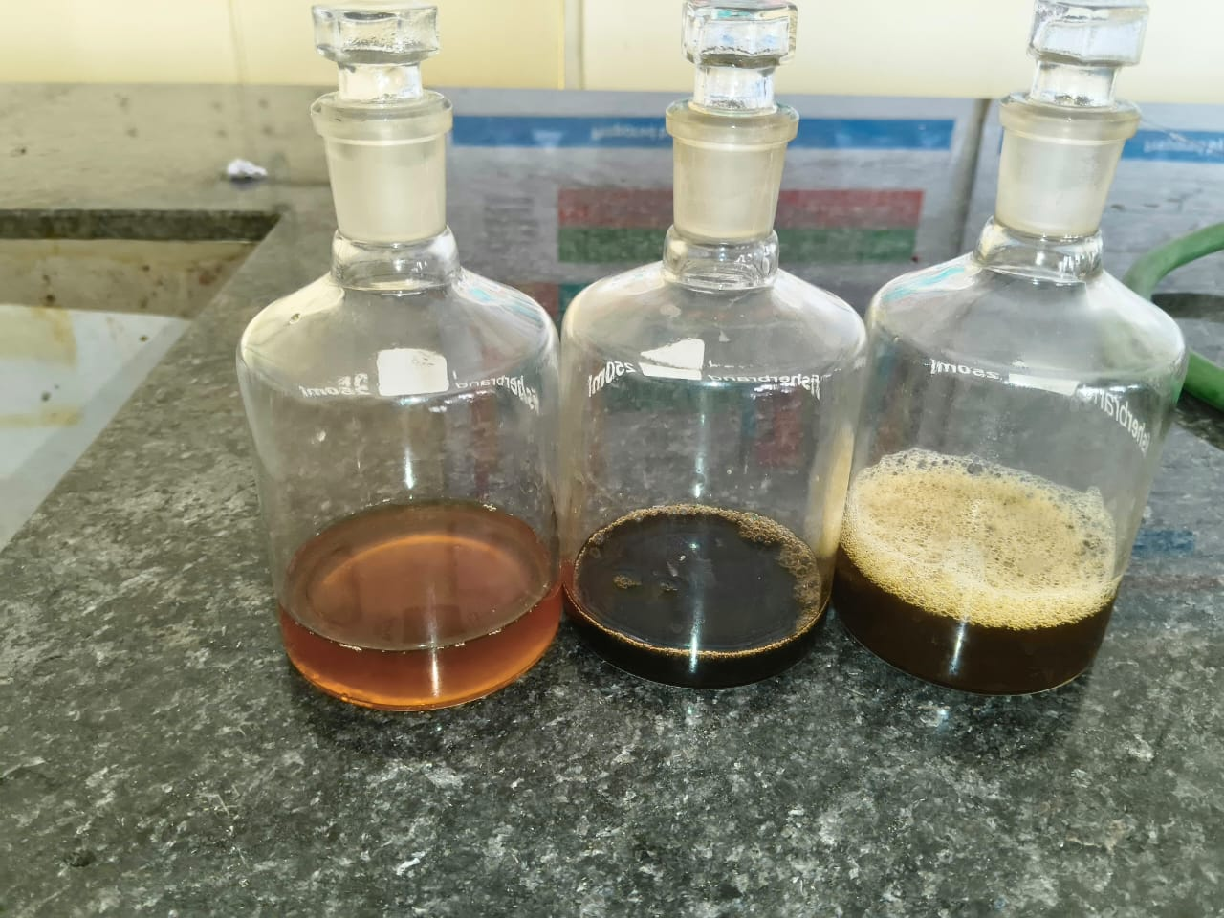
Figure 5: Neem,Tulsi and Ritha of Herbal Extracts

Figure 6: Pouring into Moulds
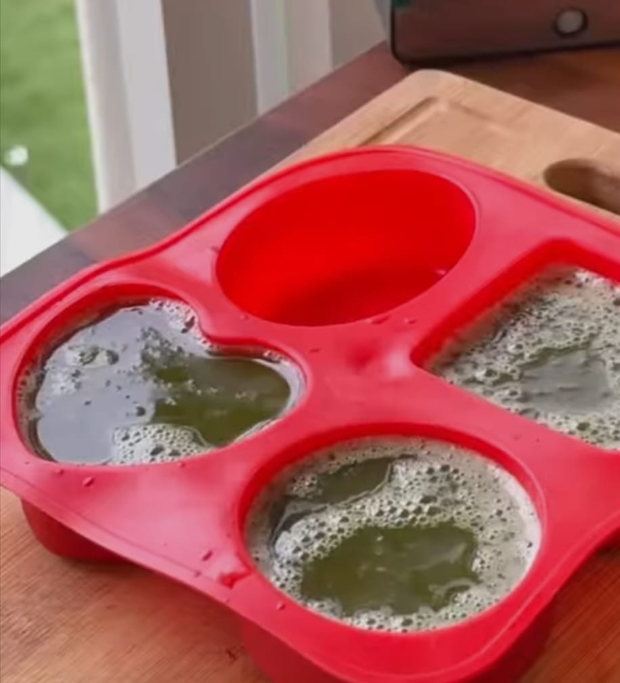
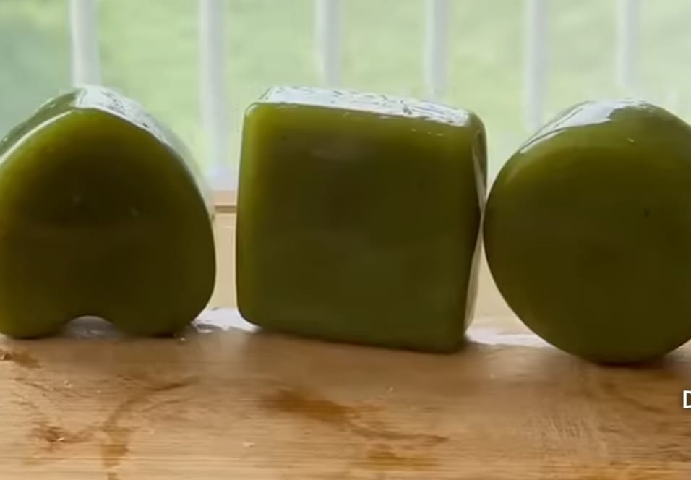
Figure 7: Final Prepared Herbal Soap Bars
6.Evaluation Parameter of Herbal soap:-
Sr. No. | Parameter | Method / Procedure | Standard / Reference Value | Observation | Remark
1 | Organoleptic (color, appearance, fragrance, texture) | Visual inspection and touch test by panel of 5–10 evaluators | Uniform color, pleasant fragrance, smooth texture | Uniform color, pleasant fragrance, smooth texture | Good
2 | pH | 1 g soap dissolved in 10 ml distilled water, measured with pH meter | 5.5–8 | 7.2 | Good
3 | Appearance & Color | Visual inspection under natural light | Smooth surface, uniform color, no cracks | Smooth surface, uniform color | Good
4 | Texture / Hardness | Manual press test / texture analyzer | Firm, not brittle | Firm, easy to handle | Good
5 | Foaming / Lathering Ability | 1 g soap in 50 ml water, shaken for 1 min | Good foam formation | Good lather formed | Good
6 | Foam Stability | Foam allowed to stand for 5–10 min; volume observed | Foam persists ≥5 min | Foam persisted 6–8 min | Good
7 | Moisturizing Effect | Skin application / in-vitro moisture retention | Soft, hydrated skin | Skin felt soft and hydrated | Good
8 | Solubility / Dissolution Rate | 1 g soap in 50 ml water, time recorded | Dissolves in 2–3 min | Dissolved easily within 2 min | Good
9 | Spreadability | Applied on skin / glass surface | Uniform coverage | Even coverage observed | Good
10 | Stability / Shelf-life | Stored at room temp & accelerated conditions for 1–3 months | No color, odor, or texture changes | No color change, odor or texture change | Good
11 | Antimicrobial Activity | Agar well diffusion method against S. aureus, E. coli, C. albicans | Zone of inhibition ≥10 mm | Clear zone of inhibition observed | Good
12 | Total Saponin Content | Gravimetric / spectrophotometric method | ≥5% (sufficient for foaming) | Saponin content sufficient for foaming | Good
Table 2: Evaluation Parameters , Detailed Procedures, Observation and Remarks

7.Discussion
The present study successfully formulated a herbal soap using Neem (Azadirachta indica), Tulsi (Ocimum tenuiflorum), and Ritha (Sapindus mukorossi) extracts, combining therapeutic benefits with cosmetic functionality. The soap was prepared using a vegetable-based, unscented soap base, with coconut oil and glycerin for emollient and moisturizing effects, and rose water and vitamin E for fragrance and antioxidant protection.
The selected extracts contributed antimicrobial, antioxidant, and foaming properties, with Neem and Tulsi providing broad-spectrum antibacterial activity and Ritha ensuring natural foaming due to its saponin content. The extracts were incorporated at optimized concentrations to maintain efficacy while ensuring compatibility with the soap base.
Evaluation revealed a smooth, uniform appearance, firm but manageable texture, and a skin-friendly pH (7.2). The soap demonstrated good lathering, foam stability, solubility, spreadability, and moisturizing effects, confirming its cleansing efficiency and user acceptability. Organoleptic assessment indicated pleasant fragrance and smooth feel. Stability studies under room and accelerated conditions showed no significant changes, and antimicrobial testing confirmed the bioactive potential of the herbal extracts. Total saponin content validated Ritha’s contribution to foaming.
Overall, the formulated soap exhibited excellent physical, chemical, functional, and sensory properties, making it suitable for daily skincare. These findings support the development of herbal cosmetic products as safe, natural alternatives to conventional soaps and provide a basis for further commercial application.

8.Conclusion
The study successfully formulated a herbal soap incorporating Neem (Azadirachta indica), Tulsi (Ocimum tenuiflorum), and Ritha (Sapindus mukorossi) extracts, which provided antimicrobial, antioxidant, and natural foaming properties. The soap exhibited good physical characteristics (smooth appearance, uniform color, firm texture), skin-friendly pH, and effective moisturizing, lathering, and spreadability, making it suitable for daily use.
Organoleptic evaluation confirmed pleasant fragrance and smooth feel, while stability studies showed no significant changes under room and accelerated conditions, indicating physical and chemical stability. Antimicrobial testing validated the bioactive potential of Neem and Tulsi extracts, and total saponin content confirmed Ritha’s role in natural cleansing and foaming.
Overall, the formulated herbal soap is safe, effective, and consumer-friendly, providing a natural alternative to conventional soaps. This research supports the potential commercial development of herbal cosmetic products that combine therapeutic benefits with aesthetic appeal.

9. References
- Kumar, R., Singh, P., & Sharma, S. (2020). Herbal soap formulations: Antimicrobial and antioxidant activity. Internationa
- l Journal of Cosmetic Science, 42(5), 450–460.
- World Health Organization. (2020). WHO Mortality Database. Cause-of-death statistics: Skin diseases, India
- Patel, V., Mehta, R., & Joshi, S. (2019). Effect of herbal extracts on moisturizing and cleansing properties of soap. Pharma Science Monitor, 10(3), 45–53.
- Kokate, C. K., Purohit, A. P., & Gokhale, S. B.
Pharmacognosy. 55th ed., Nirali Prakashan, Pune, 2023.
- Singh, R., Kumar, V., & Chauhan, S. (2017). Evaluation of herbal soaps enriched with Neem and Tulsi extracts. Asian Journal of Pharmaceutical and Clinical Research, 10(5), 245–250.
- Sindhu, Rakesh K, et al. Formulation development and antimicrobial evaluation of polyherbal soap. Plant Archives 2019;19(2):1342-1346.
- Joshi, Jyoti, et al. Formulation and Evaluation of Herbal Soap, Shampoo and Face Wash Gel. Journal of Plant Resources 2019;17(1):112-117.
- Akuaden, Namo Jeremiah IY. Chindo, Joel Ogboji. "Formulation, Physicochemical and Antifungi Evaluation of Herbal Soaps of Azadirachta indica and Ziziphus ~ 18 ~ Journal of Pharmacognosy and Phytochemistry https://www.phytojournal.com Mauritiana. IOSR Journal of Applied Chemistry. 2019;12(8):26-34.
- Shah, Rutuja R, Rohan R, Vakhariya. Formulation and Evaluation of Antifungal Soap of Garlic Oil. Asian Journal of Pharmaceutical Research 2020;10(1):13-16. DOI: 10.47583/ijpsrr. 2021.v71i02.019
- Devi, Seetha A, et al. Formulation and Evaluation of Antimicrobial Herbal Soap. Int. J Pharm. Sci. Rev. Res. 2021;71(2):122-125.
- Ahmed, Latif Hazarika MU, Sarma D. Formulation and evaluation of an ayurvedic bath soap containing extracts of three ayurvedic herbs. Journal of Medicinal Plants. 2021;9(2):115-117.
- Krishna K.R., et al. Physical Characteristics and Stability of Herbal Soap Formulation. Journal of Pharma Insights and Research. 2024;02(04):258–263. The study reported pH 7.2 ± 0.1 for herbal soap with good foam retention and stability, and confirmed antimicrobial potential. Jopir
- Afshan Ashraf & Khadija Rafiq. Preparation and Characterization of Antibacterial Herbal Soap. Journal of Pharmacognosy and Phytochemistry. 2025;14(1):388–397. Evaluated herbal soap pH, foam formation, foam retention, and antimicrobial activity. Phyto Journal
- Indira P. Sarethy, et al. Antibacterial Activity of Plant Biosurfactant Extract from Sapindus mukorossi. International Journal of Pharmacy and Pharmaceutical Sciences. 2025. Provided insight into saponin antimicrobial effects relevant to soap evaluation. Innovare Academics Journals

