Research on Design Strategies for Traditional Chinese Medicine (TCM) Health and Wellness Cultural and Creative Products Based on "Five-Sense Experience"—A Case Study of Fanghuichuntang

Abstract
Under the background of the deepening development of cultural and creative industries, the creative transformation and innovative development of traditional culture have become an important issue in the field of cultural and creative design. At present, there are still some problems in the design practice of traditional Chinese medicine health cultural and creative products, such as single experience dimension, fragmentation of cultural expression and insufficient connection with young groups. Based on this, this paper introduces the theory of "Five-Sense Experience", systematically combs the relevant research results of cultural and creative design, "Five-Sense Experience" theory and cultural and creative design of traditional Chinese medicine health preservation at home and abroad, and takes the time-honored brand of traditional Chinese medicine Fanghuichuntang as the research object, combined with field research, questionnaire survey and user interview, to analyze the sensory design characteristics in its existing cultural and creative products and experience scenarios. On this basis, this paper proposes a three-level progressive design strategy of TCM health preservation cultural and creative products based on the "Five-Sense Experience" of sensory immersion, narrative interaction and value internalization, in order to provide reference for the experiential dissemination of TCM health preservation culture and the youthful development of time-honored brands.
Keywords:Five-Senses Experience;Chinese Medicine Health;Cultural And Creative Product Design;Time-Honored Brand;Fanghuichuntang

1. Introduction
In recent years, cultural and creative products have evolved from simple cultural symbols into designs that integrate cultural value, emotional experience, and lifestyle. Driven by the experience economy and the Chinese-style Fashion trend, consumers increasingly seek emotional resonance and cultural identity in products. As a key part of traditional Chinese culture, TCM wellness culture holds strong potential for creative transformation. However, existing products often suffer from narrow experiential dimensions and fragmented cultural expression, hindering their appeal to younger audiences.
Fanghuichuntang, a nearly 400-year-old time-honored TCM brand, has accumulated rich experience in cultural and creative design and experiential innovation, making it a representative case. This study takes Fanghuichuntang as a case to explore design strategies for TCM wellness cultural and creative products from the perspective of "Five-Sense Experience" By examining how sight, hearing, touch, smell, and taste are applied in the brand’s stores and products, this research summarizes actionable design strategies. The goal is to lower the cognitive barriers to TCM wellness culture and support the brand’s rejuvenation and integration into daily life.The research framework of this paper is as follows:
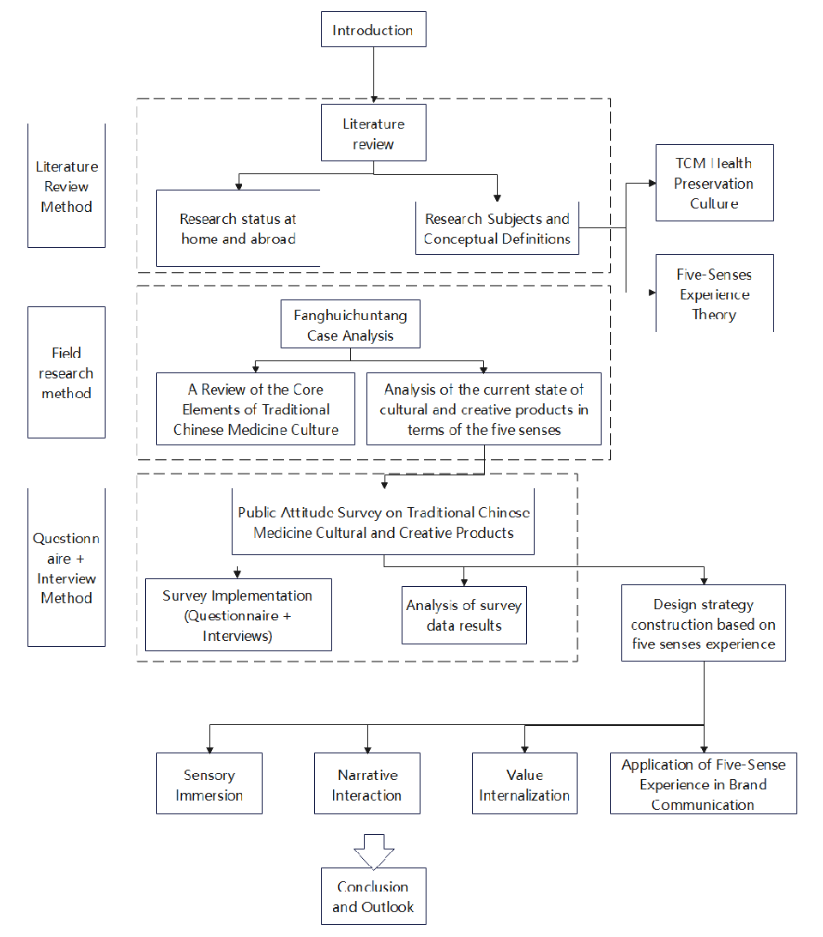
Figure 1 Technology Roadmap

2. Literature Review

2.1 Domestic and International Research Status

2.1.1 Research on Cultural and Creative Design
Current Status of Domestic Research.Domestic research on cultural and creative design started later than its foreign counterparts. However, driven by national policy support and the upgrading of cultural consumption, it has developed rapidly. Existing studies can be broadly categorized into three main areas: the extraction of cultural elements and visual expression, the construction of design methods, and user experience and emotional value.
Liu Lihua (2021), starting from cultural symbols and visual expression, explored the principles for applying traditional visual elements in cultural and creative products, arguing that such design should achieve a modern aesthetic transformation while respecting the cultural prototype. Hou Mingming (2020) proposed that cultural and creative product design must take cultural value as its core. The design should enrich the content and forms of the products through multifaceted inspiration and enhance their value through innovative design. Ge Chang (2018) conducted an in-depth analysis of need analysis and transformation pathways in the design process. He proposed that a corresponding relationship between needs and design elements must be established, to improve the products' market adaptability.
As research on user experience and consumer psychology deepens, scholars have gradually shifted their perspective from the "object" to the "human." They emphasize building an emotional connection between products and users through design. This aims to satisfy consumers' dual demands for cultural experience and personalized needs. Guo Meini (2018) used empirical research to point out that the perceived value of cultural and creative products has a significant impact on consumers' purchase intentions. Wang Tianxiong and Zhou Meiyu (2020) constructed a design paradigm based on users' perceptual needs. This paradigm emphasizes unifying the functional and emotional value of products by exploring users' emotional appeals.
On the whole, domestic research on cultural and creative design has formed a relatively systematic theoretical framework. China's cultural and creative industry, driven by policy support, consumption upgrades, and technological innovation, has entered a new development stage. This stage is marked by "simultaneous improvement in quantity and quality." The industry also exhibits distinct characteristics of being "experience-oriented, segmented, and 'China-chic.'"
Current Status of Foreign Research.Foreign research on cultural and creative design boasts a mature theoretical framework and diverse practical pathways. Originating from the historical shift from traditional handicrafts to institutionalized "creative industries" , foreign design paradigms have evolved from a traditional "cultural act" into a highly integrated "industrial system". In recent years, foreign research has further focused on digitalization and personalization. The application of technologies such as virtual reality and artificial intelligence in product design has become a hot topic. The field of cultural and creative endeavors is evolving from product design to experience design and scenario construction. It now emphasizes enhancing users' immersive experiences through technological empowerment.

2.1.2 Research on the "Five-Sense Experience" theory
Current Status of Domestic Research.The study of the "Five-Sense Experience" theory in China's design field mainly originates from the introduction of the experience economy and sensory design theories. It focuses on multiple areas, including landscape design, cultural and creative product design, and packaging design. The overall development trajectory moves from theoretical research to methodological exploration, and then to practical application.
Liu Xiaobin and Zhu Qingxiang (2022) systematically reviewed the application strategies of the Five-Sense Experience in cultural and creative product design. They proposed that such products should adopt the "Five-sense" design concept to enhance users' visual, auditory, olfactory, tactile, and gustatory experiences. The aim is to optimize user experience and strengthen the innovative capacity of cultural and creative products. Li Hong (2024) studied the application of the Five-Sense Experience in cultural and creative product design. He proposed that designers should use sensory stimuli to make the products deeply impressive. They should also optimize product design through interactive experiences and infuse sensory elements into the products through element extraction.
In the sub-directions of multi-sensory research, Sun Shan (2025) systematically studied design strategies for cultural and creative products based on multi-sensory experiences. From the perspectives of sensory need exploration and experience scenario construction, she identified tactile experience as a core factor influencing the perception of texture and the premium potential of cultural and creative products. Wu Qian (2024) focused on popular science cultural and creative products for children about Chinese herbal medicine culture. She explored the application of multi-sensory experiences in children's cultural and creative products. Through the integrated design of vision, touch, and smell, she aimed to enhance children's cognitive interest in and acceptance of traditional Chinese medicine culture, thus expanding the application scenarios of the Five-Sense theory in the field of TCM culture dissemination. Tong Jie (2016), from the perspective of traditional handicrafts, explored the design and development of multi-sensory experiences in traditional handicraft cultural and creative products. He emphasized the multi-sensory transmission of textural quality and cultural atmosphere to enhance the cultural experience of the products.
Furthermore, Yuan Yuze (2022), Li Shuo and Huang Sheng (2020) applied sensory design concepts to cultural and creative product packaging. Through the visual and tactile design of packaging, they strengthened the sensory experience and brand expression of the products. They argued that multi-sensory design helps reinforce brand recognition and user memory.
Current Status of Foreign Research.Foreign research on the "Five-Sense Experience" theory originates from a multidisciplinary intersection, encompassing physiology, psychology, neuroscience, and design studies. It has formed a systematic theoretical framework and a wide range of application scenarios. At the theoretical level, scholars generally regard the Five-Sense Experience as a comprehensive perception formed through physiological sensory input, integrated with emotion, cognition, and cultural background. In 1976, psychologists Harry McGurk and John MacDonald published an article titled "Hearing Lips and Seeing Voices" in the academic journal Nature. They pointed out that the combined effect of multiple sensory systems is far greater than that of any single sensory system (McGurk, H., & MacDonald, J. 1976). The introduction of the multi-sensory experience concept into design began with the American anthropologist Edward T. Hall. In his book The Hidden Dimension, he noted that the proportions of different senses involved in human perception of objects vary. Vision accounts for 78%, the highest proportion, while hearing, taste, touch, and smell account for 13%, 3%, 3%, and 3%, respectively. This finding provided designers with detailed data support for incorporating multi-sensory concepts into subsequent product design processes.
As the experience economy developed, the "Five-Sense Experience" theory was gradually introduced into the fields of design and marketing. Related research indicates that multi-sensory integration can increase user memory retention by 40% and significantly enhance user memory and brand recognition (Lindstrom, M. 2005). In recent years, with the advancement of digital technology, multi-sensory experiences have been further integrated with virtual reality, immersive spaces, and brand experience design. The emphasis is on constructing immersive experiential environments through technological means to strengthen user engagement and emotional connection.

2.1.3 Research on Traditional Chinese Medicine cultural and creative design
Current Status of Domestic Research.In recent years, domestic research on TCM health preservation cultural and creative product design has gradually increased. The overall development trajectory moves from the extraction of cultural elements to the exploration of design transformation pathways, and then to popular science communication.
Based on an in-depth study of the external visual aspects and internal cultural connotations of TCM culture, Liu Jie (2019) proposed that TCM cultural and creative product design should follow these design principles: attracting people through form, touching people through meaning, captivating people through novelty, and moving people through emotion. Liu Zengxiu (2020) reviewed and summarized the forms and characteristics of traditional culture applied in cultural and creative design. This work preliminarily provided a theoretical foundation and practical experience for cultural and creative design based on traditional Chinese medical culture.
Wang Jingnan (2020) summarized the concrete visual elements in TCM culture. She elaborated on the construction principles of cultural and creative products from four dimensions: concrete transformation, abstract transformation, IP construction, and communication carriers. Wu Yi (2025) focused on herbal medicinal materials. She explored the design of popular science cultural and creative products based on "tactile texture + olfactory experience," verifying the positive effect of multi-sensory elements on the effectiveness of popular science communication.
From a policy perspective, the Chinese government has issued multiple support measures to promote the dissemination and development of TCM health preservation culture. However, research indicates that this field still faces challenges. These include a prominent contradiction between supply and demand, a lack of innovation momentum, and weak brand influence. How to effectively promote TCM health preservation culture through design and integrate it into people's daily lives requires further exploration.
Current Status of Foreign Research.Compared with the systematic research on cultural and creative design and the "Five-Sense Experience" theory, TCM health preservation culture represents a unique knowledge system originating from China. Its academic research and dissemination practice abroad present a gradual deepening process, moving from the perception of "alternative medicine" towards the recognition of "health culture." Direct research on the cultural and creative design of TCM culture remains scarce (Li, Y. 2021).
For a long period, mainstream Western academia placed TCM health preservation culture within the framework of "complementary and alternative medicine"(Liu, J. 2019). The research focus was primarily on verifying the clinical effectiveness and mechanisms of action of therapies such as acupuncture and herbal medicine. During this stage, health preservation concepts such as "Yin-Yang balance" and "treating disease before it arises" were largely regarded as philosophical or cultural concepts. They had not yet been fully integrated into the mainstream narratives of product design and consumer experience.
In recent years, with the vigorous development of the global health industry, the overseas dissemination of TCM health preservation culture has begun to reach the public in more intuitive and perceptible ways.

2.2 Research Object and Concept Definition

2.2.1 Overview of TCM Health Preservation Culture
TCM health preservation culture is a core component of excellent traditional Chinese culture. It is a systematic health concept formed through long-term practice. Concepts such as "the unity of heaven and humanity," "Yin-Yang balance," and "syndrome differentiation and treatment" constitute its unique cultural connotations. It is scientific, practical, and cultural in nature(Wu, Q. 2024).
TCM health preservation culture is grounded in a holistic view. It emphasizes the coordinated unity of the human body with nature and society. It advocates maintaining dynamic balance through compliance with the solar terms and the regulation of diet, daily routines, and emotions(Liu, J. 2019). Its health preservation practices encompass multi-dimensional pathways. At the conceptual level, it takes "treating disease before it arises" as the core. It emphasizes prevention before illness, preventing progression after illness, and preventing recurrence after recovery. At the material level, it relies on genuine medicinal materials, classic formulas, and food items based on the homology of medicine and food. It forms a unique health preservation system of "integrating medicine with food and combining medicine with nourishment." At the technical level, it includes intangible cultural heritage skills such as paste formula processing, medicinal material identification, sachet formulation, and meridian regulation. It embodies the thinking of "syndrome differentiation-based health preservation." At the spiritual level, it contains the value pursuit of "sincere health preservation and conformity with nature."
TCM health preservation culture is a culture with strong continuity and practicality. From the “Yellow Emperor's Inner Canon” to the “Compendium of Materia Medica”, and further to the skill inheritance of modern time-honored brands, a complete system has been formed. However, it is not an esoteric theoretical knowledge but a method applicable to daily life.

2.2.2 Cultural and Creative Products and the Five-Sense Experience Theory
In his experiential marketing theory, Bernd Schmitt divided experience into five different types: sense, feel, think, act, and relate. Among them, sensory experience ranks first, reflecting its core position in the overall experience(Liu, X., & Zhu, Q. 2022). Tracing the origins of theoretical development, research on the Five-Sense Experience can be dated back to studies on multi-sensory perception in fields such as psychology and cognitive science. Subsequently, this theory was gradually introduced into design studies and experience economy research, eventually becoming a relatively important theoretical foundation in product design, spatial design, and cultural experience design. In the field of cultural and creative product design, the Five-Sense Experience is considered helpful in enhancing the product's sense of immersion, emotional value, and cultural memory. It is an important means of improving the effectiveness of cultural dissemination(Li, H. 2024).
Within the disciplinary context of design studies, the Five-Sense Experience is not simply the superimposition of multiple sensory stimuli. Rather, it emphasizes the coordination and hierarchical construction among the senses(Liu, X., & Zhu, Q. 2022). Different senses undertake distinct tasks in the user's experiential process. This division of functions allows the design to leave a more lasting and stable impression in the user's memory. This study defines the Five-Sense Experience as follows: vision, hearing, smell, taste, and touch jointly serve as the medium of design. Through the coordinated organization of these sensory elements and the construction of different layers, users are guided to gradually complete the perception, understanding, and ultimate identification with TCM health preservation culture during the experiential process. This concept not only accounts for the joint participation of multiple senses but also attends to the progressive and layered nature of the experiential process, thereby providing a theoretical foundation for the construction of subsequent design strategies.

3.Analysis of the Five-Sense Experience of Fanghuichuntang's TCM Health Preservation Cultural and Creative Products
Compared with the serious atmosphere and singular diagnostic function of traditional TCM clinics, Fanghuichuntang's Hefang Street branch places greater emphasis on the comprehensive sensory experience of its customers during its transformation. The cultural and creative products in the store no longer exist as standalone commodities. Instead, they are integrated into the entire space, providing customers with a full range of visual, auditory, tactile, olfactory, and gustatory sensations. This makes originally abstruse TCM knowledge simple and easy to understand, and more readily accepted by young people.
A detailed analysis from the Five-Sense dimension will be presented below.

3.1 Visual Experience Analysis
Vision serves as the dominant sense in receiving information. It has therefore become the primary medium for Fanghuichuntang's cultural and creative products in building brand recognition and cultural identification. The visual design of Fanghuichuntang's Hefang Street branch mainly relies on traditional elements. These elements are used to reinforce its identity as a "time-honored brand." In terms of color application, the store and product packaging often use colors with traditional Chinese characteristics, such as vermilion red, herbal green, off-white, and dark brown. These colors correspond well with the natural properties of Chinese medicinal materials. They also create a gentle and nourishing health preservation atmosphere at the visual level. In the design of specific product packaging, such as health tea bags, foot bath sachets, and essential oils, as well as daily items like thermos cups, elements such as ancient book layouts, botanical line drawings, or traditional seal stamps are commonly used for decoration. This approach allows the products to retain a modern packaging form while carrying the flavor of traditional culture, thereby naturally integrating traditional elements into modern living scenarios. Combined with the store's predominantly natural wood interior structure and the display of herbal decorations, these visual elements collectively evoke a cultural atmosphere unique to traditional Chinese medicine. They also allow the cultural and creative products to blend naturally into the overall environment.
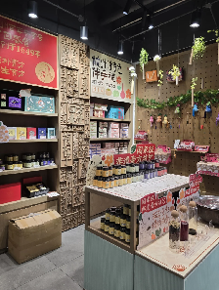  （a） | 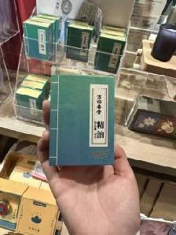  （b） | 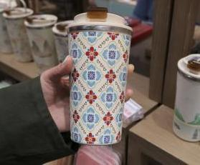  （c） | 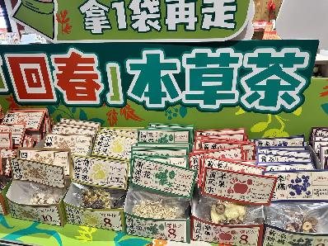  （d）
Figure 2 Fanghuichuntang Visual Experience

3.2 Auditory Experience Analysis
From the auditory perspective, Fanghuichuntang maintains a relatively quiet environment, free from excessive commercial noise. This aligns with the concepts of "tranquility" and "harmony" advocated in TCM health preservation culture. Within the Hefang Street branch, the overall sound level is low. The main sounds are people's conversations and soft music. This helps to soothe customers' moods and creates a relaxed feeling when purchasing cultural and creative products.
In addition to the gentle background music, the audible sounds in the store are primarily operational sounds, such as the pounding of medicine, the placing of medicinal materials into cloth bags, and the brewing of tea. These are authentic sound feedbacks that accompany physical actions. They convey a sense of handcrafted authenticity and the solemnity of traditional techniques. They also help customers focus more intently on the present moment, achieving a state of concentration or meditation. This is precisely the "calming of the mind" referred to in health preservation philosophy.
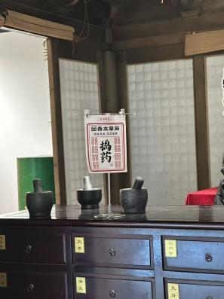
Figure 3 Fanghuichuntang Auditory Experience

3.3 Tactile Experience Analysis
Tactile sensation is an important part of using cultural and creative products. Through material, craftsmanship, and structure, it provides users with an experience of product quality and cultural warmth. Some of Fanghuichuntang's cultural and creative products use raw materials such as cotton-linen, paper, and wood. This aligns with the TCM philosophy of "learning from nature" and also gives the products a greater sense of texture. For example, the soft cotton touch of the sachet exterior forms a sharp contrast with the granular feel of the medicinal materials inside.
Furthermore, in the interactive area specially set up within the store, consumers can directly touch herbs of different forms and textures through hands-on actions such as picking and weighing medicinal materials. Compared to passive viewing, this hands-on process helps consumers deepen their understanding of the physical characteristics of the products more effectively.
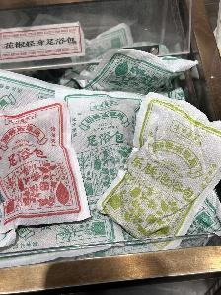  （a） | 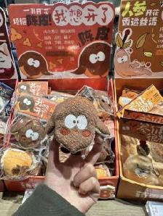  （b） | 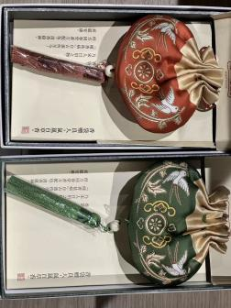  （c）
Figure 4 Fanghuichuntang Tactile Experience

3.4 Olfactory Experience Analysis
Smell is the sense most strongly linked to emotion and memory. Chinese medicinal materials possess distinctive scent characteristics, and Fanghuichuntang has transformed these into a part of the olfactory experience. At the product level, by developing herbal sachets or fragrances using relatively mild-scented materials such as tangerine peel and chrysanthemum, the brand weakens the public's ingrained impression of Chinese medicine as "bitter" and "pungent." At the spatial level, the large quantity of medicinal materials displayed in the store naturally diffuses herbal scents into the environment. Consumers do not need to actively smell these scents. However, in the actual experience, they subtly reinforce the consumer's memory of the brand as "herbal" and "natural." This allows the perception and memory of health preservation culture to be formed unconsciously.
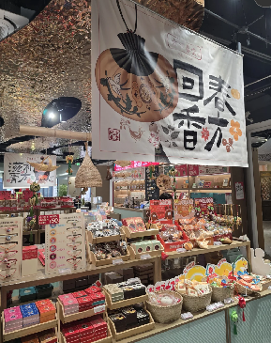  （a） | 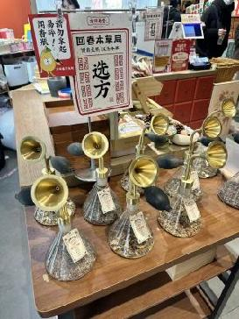  （b） | 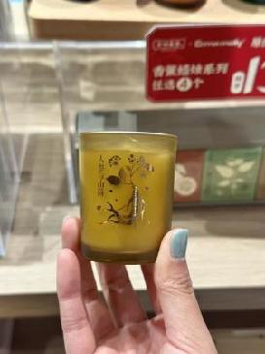  （c） | 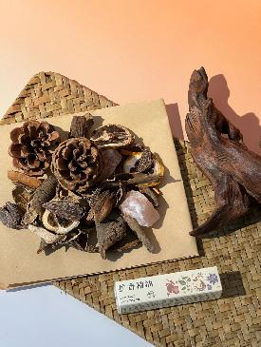  （d）
Figure 5 Fanghuichuntang Olfactory Experience

3.5 Gustatory Experience Analysis
Gustatory experience is a highly life-oriented sensory dimension within TCM health preservation culture. Through a range of food-based products, Fanghuichuntang transforms the "bitter" taste of Chinese medicine in the public's perception into a daily experience that can be tasted and enjoyed. For example, its "Herbs Are Not Tea" beverage shop creatively combines herbal ingredients with elements of modern drinks, such as honey, milk, and tea bases. This harmonizes the traditionally bitter taste of Chinese medicine and creates a new-style taste with rich layers. By adopting this approach, the barrier to experience is lowered. It also allows TCM health preservation to be accepted in a relaxed, delicious, and even fashionable way. In addition, other edible products, such as specialty intangible cultural heritage nourishing pastes, herbal throat lozenges, and herbal substitute teas, enable consumers to directly engage with TCM health preservation culture through the sense of taste. This makes the gustatory experience an intuitive pathway to understanding the TCM concept of "the homology of medicine and food."
In practical application scenarios, this type of product effectively lowers the acceptance threshold of TCM culture. It helps consumers establish a positive impression of Chinese medicine in a relatively relaxed consumption environment. It also gradually fosters a sense of familiarity with TCM health preservation culture through taste memory, thereby facilitating a transformation from a one-time experience to a long-term behavioral habit.
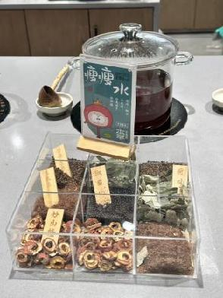  （a） | 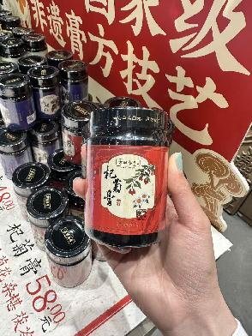  （b）
Figure 6 Fanghuichuntang Taste Experience

3.6 Summary
Centered on TCM culture, Fanghuichuntang has built an immersive "Five-Sense Theater" through the coordinated design of the five senses: vision, hearing, touch, smell, and taste. This theater aligns with health preservation concepts while meeting the needs of young consumer groups. In doing so, it has successfully broken the rigid stereotype of traditional TCM clinics and achieved the dual goals of cultural dissemination and brand rejuvenation.
The five sensory dimensions echo and progressively deepen one another. They individually carry out functions such as cultural transmission, atmosphere creation, and cognitive deepening, while also collectively forming a complete experiential loop. This transforms abstract TCM culture into a tangible, participatory, and memorable embodied experience. It preserves the cultural core of the time-honored brand while aligning with the aesthetics and needs of modern consumers, providing a vivid example for the innovative development of TCM cultural and creative products.

4.Public Attitudes and Perceptions Towards TCM Cultural and Creative Products
To gain a clearer understanding of the public's cognitive status, acceptance level, and experiential preferences regarding TCM health preservation cultural and creative products, this paper adopts a combination of questionnaire surveys and interviews to conduct the research. The questionnaire was primarily distributed to potential consumer groups such as young health preservation enthusiasts and traditional culture aficionados. A total of 154 valid questionnaires were collected. In terms of sample structure, the respondents were predominantly young people, with the 18 to 25 age group accounting for 81.17% and the 26 to 35 age group accounting for 16.23%. Regarding occupational distribution, students accounted for 60.39% and office workers accounted for 24.03%. At the same time, representative respondents were selected for semi-structured interviews to supplement the shortcomings of the quantitative data.

4.1 Analysis of Questionnaire Results

4.1.1 Current Status of Public Cognition of TCM Cultural and Creative Products
According to the data obtained from the survey, respondents aged 18-25 accounted for 81.17% of the sample. Meanwhile, female respondents accounted for 79.87%. This indicates that the potential core customer base of TCM cultural and creative products is primarily composed of female university students and young women who have recently entered the workforce. They belong to the "refined health preservation" group. 75.32% of the respondents stated that they had a certain level of understanding of TCM health preservation culture. However, only 7.14% explicitly indicated that they "know it very well." This result reflects that the public's current mastery of TCM knowledge remains at a relatively basic level. A deep cognitive system has yet to be established.
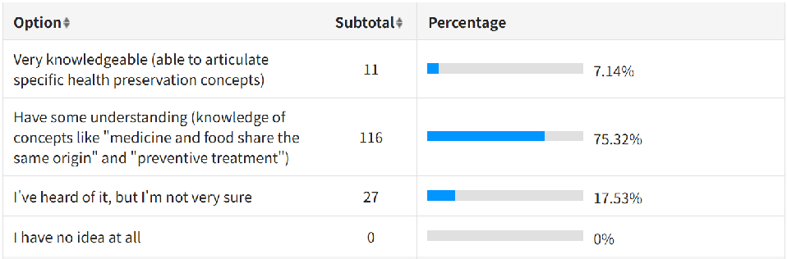
Figure 7 The level of understanding of traditional Chinese medicine and health preservation culture
In terms of actual consumption behavior, 76.62% of the respondents stated that they only "purchase occasionally" such cultural and creative products. Furthermore, 61.69% of the respondents had purchased such products no more than twice in the past year. This situation reflects that TCM cultural and creative products largely remain at the stage of "trial consumption" in the current market. They are essentially still "low-frequency consumer goods" and have not yet been truly and deeply integrated into the public's daily life.
On the whole, the sample exhibits characteristics of a high degree of youthfulness, a relatively shallow cognitive level, and a low consumption frequency. This provides a realistic basis for the targeted design optimization strategies proposed later in this paper.

4.1.2 Public Acceptance and Purchase Intention of TCM Cultural and Creative Products
The questionnaire data reveal the following findings. Respondents showed a stronger purchase inclination towards products "with cultural stories or historical origins" (scoring 4.14 points) and those "integrating solar terms or health preservation knowledge" (scoring 4.34 points). In terms of price sensitivity, nearly 70% (69.48%) of the respondents preferred products priced between 30 and 100 yuan. The acceptance of high-priced products exceeding 300 yuan was low (accounting for only 4.55%). This situation indicates that at the current stage, consumers prioritize the cultural added value and overall cost-effectiveness of products when purchasing TCM cultural and creative products. The acceptable price range tends towards the affordable level.
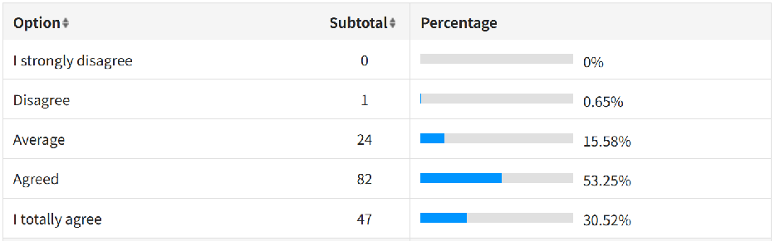
Figure 8 More willing to buy products with cultural stories or historical background
Furthermore, the respondents also demonstrated a high willingness to engage in word-of-mouth communication. 93.38% of them (57.79% strongly agreeing and 33.12% agreeing) expressed willingness to recommend good products to people around them. The questionnaire results further revealed that among the core factors driving repeat purchase behavior, the top-ranking ones were "good experience" (scoring 4.42 points) and "comfort" (scoring 4.27 points).
On the whole, the public holds a relatively positive attitude towards TCM cultural and creative products. Their purchase intention is primarily influenced by the dual factors of cultural empowerment and functional recognition.

4.1.3 Analysis of Public Preferences for Five-Sense Experience Forms
Based on the "Five-Sense Experience" theory, the questionnaire further investigated preferences for different forms of sensory experience. The results show that multi-sensory experience plays a significant role in enhancing product appeal. Different sensory dimensions exhibit distinct preference characteristics. 93.5% of respondents believed that "the simultaneous engagement of multiple senses" would make it easier for them to develop an interest in a product. This confirms that the theory of Five-Sense coordination proposed in this study has a very high market demand and psychological foundation. Furthermore, among the sensory experiences that consumers care about most, smell (68.18%) and taste (53.25%) received the highest attention. Vision (31.82%) and touch (29.22%) ranked next. Hearing (12.34%) received the lowest attention.
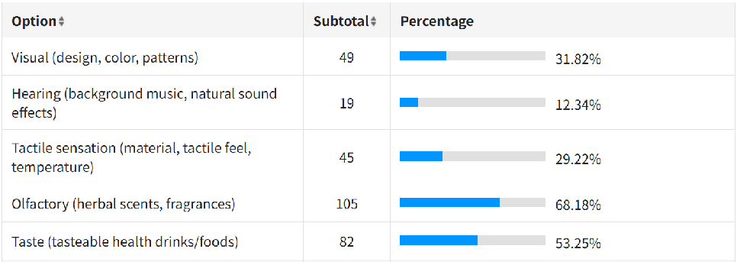
Figure 9 Sensory experience preference analysis
In terms of visual style, respondents preferred the Chinese retro style (68.18%) and the modern minimalist style (47.4%). This indicates that designs possessing traditional cultural elements while aligning with modern aesthetics are more likely to gain recognition.
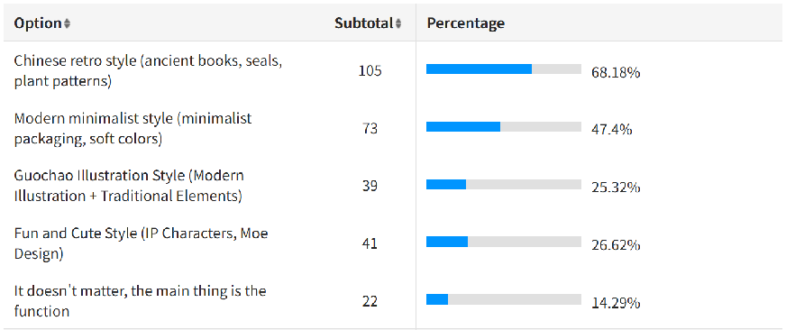
Figure 10 Visual style preference analysis
In terms of material and tactile sensation, the public demonstrated a relatively high level of attention, with an interest score of 4.1 points. Regarding the sense of smell, the public acceptance of mild scents (85.06%) and fresh scents (72.08%) was significantly higher. In contrast, the acceptance of traditionally strong medicinal smells was relatively low. The sense of smell itself possesses unique advantages in stimulating emotions and evoking memories. It serves as an important dimension for the differentiation of TCM cultural and creative products. In terms of taste, 72.08% of the respondents were more receptive to modified new Chinese-style flavors, rather than the original taste of Chinese medicine. Adjusting and improving the taste of Chinese medicine, transforming the "bitter" sensation into an "acceptable or even somewhat pleasant" experience, is a key pathway to enhancing acceptance. Compared with the other senses, the enhancement score of sound atmosphere was relatively low (3.84 points). This also indicates that hearing should primarily play a supplementary role in creating the ambient atmosphere within overall design, helping to strengthen the holistic sense of experience.
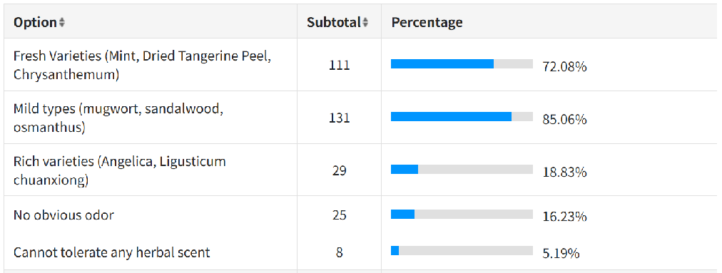
Figure 11 Olfactory Odor Preference Analysis
On the whole, the public's demand for the Five-Sense Experience exhibits a structural characteristic. Smell occupies a dominant position. Taste and vision are prominent. Touch plays a reinforcing role. Hearing serves as a supplementary element. At the same time, a considerable proportion of respondents believed that an experience form combining multiple senses is significantly more effective than stimulation from a single sense. This further validates the necessity of Five-Sense coordinated design in cultural and creative products.

4.1.4 Main Issues Affecting Public Cognition and Consumption
Analysis of the multiple-choice questions and reverse evaluation questions reveals that the factors currently hindering the popularization of TCM cultural and creative products are concentrated in the following three areas. First, the perceived efficacy barrier (61.69%). Most respondents stated that they "do not understand the specific effects and dare not purchase casually." This indicates that current products fail to clearly and scientifically convey their health preservation value in terms of packaging and promotion. Second, sensory aversion (56.49%). The overly strong traditional "medicinal taste/smell" remains a major pain point that prevents young people from trying such products. Third, design homogenization and "form over content." 42.21% of the respondents believed that the product "design is too traditional and not attractive enough to young people." However, a large proportion of the respondents also held reservations about the view that current TCM cultural and creative products on the market "only have formal innovation with limited practical value" (average score of 2.84). This indicates that the design of TCM health preservation cultural and creative products needs to strike a balance between sensory aesthetics and practical functions.
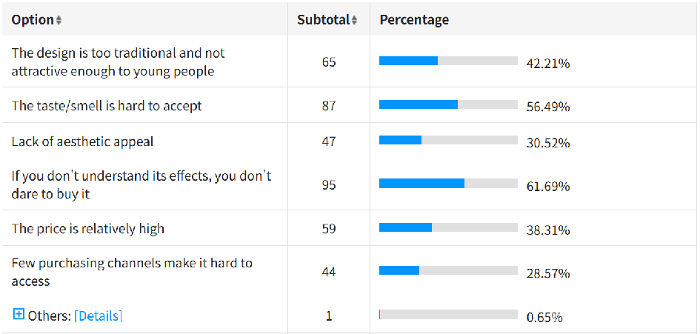
Figure 12 Analysis of issues affecting public perception and consumption
In the open-ended questions at the end of the questionnaire, many respondents expressed expectations and opinions such as: "Products need to be genuinely beneficial to health, not just gimmicks"; "I hope the products can more clearly indicate the efficacy principles and applicable groups"; "I hope prices and efficacy can be standardized to avoid false advertising and arbitrary pricing"; "Products should be younger and lighter, closer to daily life... allowing TCM culture to enter everyday life, rather than just being displayed in museums"; "Create cultural and creative products that are safe, compliant, and possess both popular science value and a sense of daily life"; "Integrate intangible cultural heritage craftsmanship to make the products more valuable." These responses indicate that the public is not lacking in interest in TCM cultural and creative products. Rather, the existing products are insufficient in terms of the accessible expression of professional TCM culture and deep integration into daily life.

4.2 Analysis of Interview Results
To further supplement the quantitative analysis results of the questionnaire data, this paper selected two young respondents to conduct semi-structured interviews. One was User A, who has consumption experience with TCM cultural and creative products. The other was User B, a potential user who has never purchased such products. Through the organization and summary of the interview content, the public's genuine attitudes towards and demand characteristics for TCM cultural and creative products can be summarized from the following aspects.

4.2.1 High Aesthetic Appeal and Practicality are Core Factors
Based on the interview results, when selecting TCM cultural and creative products, both respondents first focused their attention on the visual design of the products. The functional attributes of the products came second. Respondent A preferred products that "modernize traditional Chinese patterns and color schemes." She believed that this type of design not only conveys the aesthetic connotations behind TCM culture but also better aligns with the aesthetic standards of current young consumer groups. Respondent B, in contrast, expressed a strong aversion to outdated, symbol-laden traditional designs. She favored the simple, new Chinese-style, fresh, and gentle modern visual style instead.
At the same time, practicality is also an important factor influencing purchase decisions. Products with clearly defined usage scenarios, such as sachets and health teas, are more likely to be favored by consumers. The respondents mentioned that such products "can be integrated into daily life and will not be left unused." This indicates that if TCM cultural and creative products remain solely at the level of appreciation, it will be difficult to generate sustained consumption. "Usability" is a significant advantage that distinguishes them from ordinary cultural and creative products.

4.2.2 Olfactory Experience is an Important Influencing Factor
In the specific usage experience, the sense of smell has become one of the important factors affecting user satisfaction. Both respondents expressed a preference for "mild and natural herbal scents." They believed that such scents can evoke relatively intuitive feelings, such as relaxation, pleasure, or improved sleep. Respondent A stated that her "sleep quality improved" after placing a calming sachet at her bedside. This demonstrates that the sense of smell plays a role in emotional regulation. Respondent B, however, explicitly rejected overly strong and pungent traditional medicinal smells. This was also an important reason why she had never purchased TCM cultural and creative products. Taken together, in terms of scent design, TCM cultural and creative products need to find an appropriate balance between "expressing the authentic medicinal properties" and "ensuring user acceptance." By adjusting the intensity and layers of the scent, the comfort of the overall experience can be enhanced.

4.2.3 The Importance of Multi-Sensory Engagement
In the discussion on multi-sensory experience, the respondents believed that, compared with a single visual presentation, cultural and creative products that allow one to feel the material texture or even taste the contents often provide a greater sense of authenticity. Respondent A pointed out that rich sensory details "make it feel more real, rather than just a commodity. If the experience is relatively complete, I would be more willing to accept the concepts behind it and would also be more interested in it." Respondent B also stated that the atmosphere created by multi-sensory experiences would make her more willing to purchase and learn about the products.
This feedback indicates that multi-sensory experience not only enriches the process of product use but also bridges the psychological distance between consumers and traditional culture. It prompts them to develop a sense of identification through subtle and unconscious influence.

4.2.4 Diverse Pathways for Disseminating TCM Culture
The interviews also revealed how young consumer groups come into contact with and accept TCM culture. Taking Respondent A as an example, she was first exposed to TCM culture through film and television works. This sparked her interest, which she then transformed into concrete offline actions, such as visiting time-honored brand stores and purchasing related cultural and creative products. This is a typical transformation process from perceptual attraction to rational cognition. In the questionnaire survey, many respondents also expressed views such as: "I hope there can be IP collaborations to enhance promotional effectiveness"; "Expand communication channels, and use cross-industry collaborations and co-branding to strengthen promotion"; "I suggest collaborating with self-media bloggers to help everyone better understand this field."
This also indicates that the dissemination of TCM culture can leverage multiple media approaches. Cultural and creative products can serve as important media connecting cultural content and user perception, playing a bridging and transformative role in the process.

4.2.5 Offline Spatial Experience
Regarding offline space experience, user interviews further validate the efficacy of these sensory designs. For instance, User A explicitly noted that the signature herbal aroma in the air enhanced their perception of brand professionalism, while the complimentary herbal tea effectively decoupled the psychological bias of "TCM equals bitterness". This indicates that the sensory synergy of smell and taste in physical spaces can significantly lower the psychological threshold for younger consumer groups.
In the experience feedback regarding the Fanghuichuntang store, Respondent A gave a positive evaluation. She believed that this store broke her stereotypical impression of traditional TCM clinics as "serious and singular in function." The store combines cultural and creative products, health preservation milk tea, and various interactive activities, such as DIY sachet making, to form an interesting cultural experience venue. In terms of specific sensory perceptions, Respondent A stated that she was deeply impressed by the store's visual elements, such as the wooden structures and traditional color schemes, the product packaging, such as herbal patterns and ancient book formats, and the atmosphere created by the overall space. This indicates that well-executed sensory design can significantly enhance the customer's overall experience and strengthen the cultural value of the brand.

5.Design Strategies for TCM Health Preservation Cultural and Creative Products Based on the "Five-Sense Experience"
Based on the preceding discussion of the Five-Sense Experience theory and Fanghuichuntang's TCM health preservation cultural and creative products, this paper argues that the modern presentation of TCM health preservation culture cannot be limited to a design concept confined to a single aspect or function. The development of cultural and creative products needs to rely on guiding design strategies. By contemplating the relationships between products, culture, users, and the market, it should extend from tangible functional carriers to intangible cultural values(Liu, X., & Zhu, Q. 2022). On this basis, this paper proposes a three-level progressive design strategy for TCM health preservation cultural and creative products: "sensory immersion — narrative interaction — value internalization." This strategy aims to enable people to gradually recognize and accept TCM health preservation culture, starting from sensory experience.
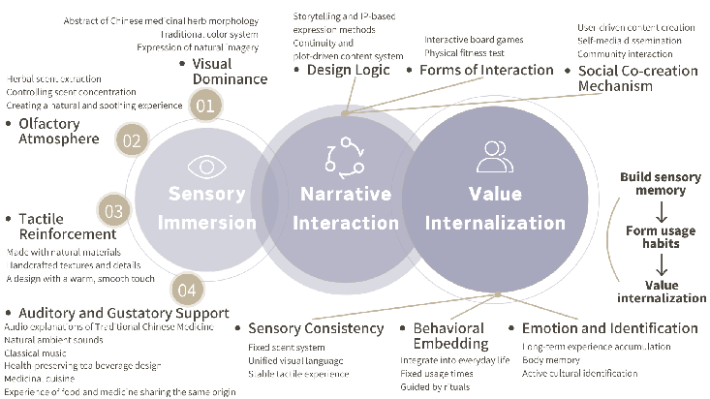
Figure 13 A three-tiered, progressive design strategy for TCM-based health and wellness cultural and creative products.

5.1 Sensory Immersion
"Sensory immersion" serves as the foundational layer and necessary precondition of the design. Its core task is to directly stimulate the user's physiology through the Five-Sense elements. Through the most direct sensory input, it aims to break the public's stereotypical impression of Chinese medicine as bitter and outdated, thereby establishing an immediate cultural affinity. Integrating the Five-Sense concept into the cultural and creative product design process can train the coordination among different human senses. This facilitates users in appreciating the beauty of art and culture from different dimensions during their interaction with and perception of the products(Liu, X., & Zhu, Q. 2022).

5.1.1 Visual Dominance
Vision occupies a dominant position among all human perceptual systems. It should play the leading role in cultural expression. Within the limited time for information reception, it also needs to accomplish the multiple tasks of cultural recognition, brand identification, and emotional arousal. The preceding questionnaire survey revealed that consumers prefer product design styles that are Chinese retro or modern minimalist. In terms of specific strategies, the forms of Chinese medicinal materials can be extracted for abstract design. Cultural content can be conveyed through lines or color blocks. The modeling and graphic language of packaging can also be optimized. The ritualistic aspect of the opening method can be considered. For example, a pull-out packaging design can be adopted. As the inner box is slowly drawn out, the hollowed-out windows on the outer box will sequentially reveal different herbal graphics. This simulates the experience of gradually unrolling a scroll painting. It not only enhances brand recognition but also achieves a "comprehensible" cultural expression.

5.1.2 Olfactory Atmosphere
The sense of smell possesses the characteristic of directly affecting emotions and memory. In the design, fresh and mild herbal scents, such as mugwort, mint, and tangerine peel, can be extracted to create a unique olfactory memory. The intensity of the scent should be controlled. Fruity or floral notes can be added as a harmonious blend. Using familiar scents can reduce the sense of unfamiliarity with herbal smells and avoid the rejection caused by excessively strong medicinal odors. Specific scents should be repeatedly associated with specific usage behaviors. For example, when using an acupoint massage comb, the user smells a fixed herbal fragrance each time. The brain then links the act of "combing hair" with the feeling of "relaxation." This achieves a health preservation experience that is "perceptible through smell."

5.1.3 Tactile Reinforcement
Tactile experience directly influences users' judgment of product texture and cultural warmth. Natural materials are often associated with values such as nature, handcraftsmanship, tradition, and sustainability. Artificial materials, in contrast, tend to suggest modernity, efficiency, industrialization, and a sense of coldness. The tactile design of time-honored brands should prioritize the use of natural materials with local cultural identity. For instance, cotton-linen fabric is soft, breathable, and possesses a slight fibrous grain. It conveys imagery of simplicity, intimacy, and everyday life, making it suitable for product packaging, storage bags, and binding straps. Wooden materials are warm and textured, with color and feel that can change over time with use. They convey imagery of age, sedimentation, and reliability, making them suitable for combs, massage tools, and incense holder bases. These natural materials also need to emphasize handcrafted texture and detailed craftsmanship. This builds a gentle and warm tactile experience, achieving a cultural warmth that is "perceptible through touch."

5.1.4 Auditory and Gustatory Support
Auditory and gustatory senses serve as auxiliary senses. They can enhance the completeness of the immersive experience. In the auditory aspect, TCM explanatory audio, natural environmental sounds, such as the sound of wind, water, and birdsong, or healing classical instrumental music can be adopted. Guided by the TCM theory of five-note therapy, these sounds can be naturally integrated into the product usage scenarios. In the gustatory aspect, a food experience based on the homology of medicine and food can be created. This includes health teas, medicinal cuisine, daily snacks, and seasonings. This achieves a multi-dimensional experience that is "audible and tastable."
Through the coordinated interaction of the five senses, a multi-dimensional experience that is visible, smellable, touchable, audible, and tastable can be constructed. This enables users to form an overall perception of TCM health preservation culture within a short period of time. It lowers the barrier to cultural understanding and simultaneously lays the foundation for the further deepening of the subsequent experience.
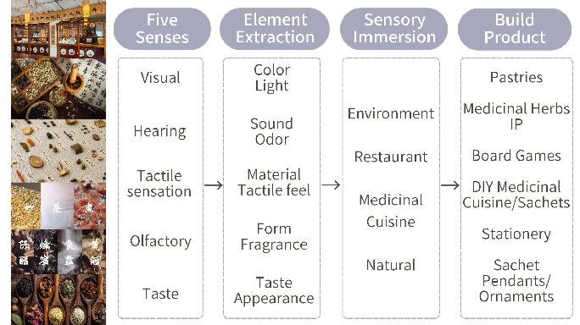
Figure 14 Design Strategy - Sensory Immersion

5.2 Narrative Interaction
Although "sensory immersion" successfully builds the user's initial favorable impression through physiological stimulation, it can easily lead to a fragmented experience if there is a lack of deep content support. The preceding case analysis of Fanghuichuntang shows that it combines sensory experiences with brand stories and everyday life scenarios. This enables users to understand the spiritual connotations of TCM culture through interaction. This indicates that when constructing user experience, it is necessary to introduce the narrative interaction layer on the basis of sensory immersion to strengthen the emotional connection between the brand and consumers(Tao, Z. 2024).
Narrative interaction is the core layer of the design strategy. Its focus lies in the spiritual transmission of TCM health preservation culture. Unlike sensory immersion, which emphasizes direct stimulation at the physiological level, this stage focuses on transforming sensory elements into a "narrative medium." Through the dynamic combination of Five-Sense Experiences, it guides users to gradually understand the internal logic of TCM culture during the process of operation and interaction. The goal of this stage is to enable users to complete a transformation from "physical engagement" to "spiritual resonance." Cultural information does not appear in the form of one-way indoctrination but is naturally embedded into the interactive process.

5.2.1 Design Logic
Effective IP design possesses both high recognizability and affinity. Integrating fragmented traditional cultural elements into the details of the IP image and its worldview setting serves as an effective pathway for the audience to establish an emotional connection with tradition and deepen cultural understanding(Wang, J. 2020). A story-based and IP-based approach can be introduced. This transforms TCM health preservation knowledge into a content system with continuity and plot. For instance, a brand story IP can be constructed around themes such as "solar term health preservation" or "the history of Fanghuichuntang." Through character settings and story content, relatively abstract TCM concepts become concrete and personified. This can enhance the user's sense of emotional engagement and willingness to actively understand. Another approach is to transform core TCM concepts such as "treating disease before it arises" into modern life stories that resonate with users. For example, targeting the pain points of young people—such as staying up late, prolonged sitting, and irregular eating habits—a "health preservation mini-drama" narrative series can be created. Through comics and interactive handbooks, the concept of treating disease before it arises can be translated into a contemporary life logic of sub-health management and chronic disease prevention. This allows users to truly understand the contemporary value of TCM health preservation culture, rather than merely seeing visually appealing images.

5.2.2 Forms of Interaction
TCM knowledge can be transformed into lightweight gamified interactions. TCM knowledge is integrated into game tasks and operational procedures. The user's desire for exploration is leveraged to lower the cognitive barrier to TCM culture. For example, a medicinal material identification board game can be designed. Consumers observe the form, smell the scent, and feel the texture to match the names, effects, and historical allusions of medicinal materials. They thus memorize the knowledge of medicinal materials during the game process. Another example is designing an interactive mini-program for health preservation constitution testing. Users answer simple questions to match their own constitution type and receive corresponding health preservation plans and related product recommendations. Through this interaction, they understand the TCM concept of syndrome differentiation-based health preservation, rather than merely gaining a one-time sensory pleasure.

5.2.3 Social Co-creation Mechanism
In terms of narrative interaction, the scope of dissemination can also be expanded through content co-creation with users and community communication. Users are encouraged to participate in content creation. For example, users can blend their own DIY sachets or health tea combinations and perform personalized customization based on their own body constitution. During the hands-on process of picking, weighing, and mixing medicinal materials, they gradually comprehend the TCM logic of "syndrome differentiation-based health preservation." On the other hand, users can also be encouraged to share their co-created results and health preservation experiences on social platforms. Relying on self-media dissemination and community interaction, users gradually transform from mere experiencers into content co-creators. At this point, culture is no longer a unidirectionally transmitted message. Instead, it is continuously reproduced and reinterpreted through the process of interaction between users and the brand. Meanwhile, through the dissemination on social media, users' experiential outcomes can spread among wider groups, forming a network of cultural expression with communicative power.
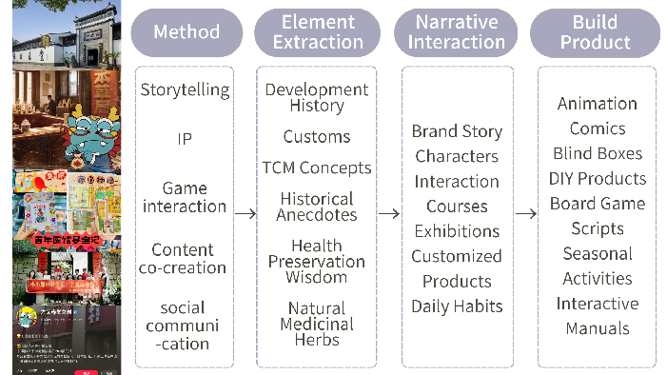
Figure 15 Design Strategy - Narrative Interaction

5.3 Value Internalization
Value internalization refers to the process of using stable and continuous sensory guidance to transform the audience's cognition of TCM health preservation culture from superficial physiological stimulation to deep conceptual identification. Under this model, sensory experience is not merely a means to attract users' attention. It itself becomes a medium for conveying cultural connotations. Through long-term accumulated interaction, health preservation concepts can gradually permeate users' lifestyles and value systems, thereby achieving the long-term goal of cultural dissemination.

5.3.1 Sensory Consistency
The essence of sensory consistency is to provide the audience with a continuous and predictable perceptual experience. This consistency allows consumers to develop an increasingly profound cognition of the brand through repeated use, leaving a "brand sensory memory" in their minds. For example, a unique herbal fragrance can be established as the brand's signature base scent and applied across all product lines. Even if the specific functions or appearances of individual products differ, people can still identify which brand the product belongs to by smelling the scent. On the other hand, a culturally distinctive and highly recognizable visual identity system can be formed through the unified management of color, graphics, and typography. Materials with cultural imagery, such as bamboo, wood, and clay, can be selected to maintain a warm, natural tactile characteristic and hand feel.
Through the synergistic effect of the above three elements, the product can establish a differentiated brand cognition in the user's mind. This allows brand recognition to no longer rely solely on the brand logo or text but to be accomplished through the senses.

5.3.2 Behavioral Embedding
The goal of behavioral embedding is to transform relatively abstract cultural concepts into concrete actions that the audience can execute in their daily lives. The key to the design here lies in deeply integrating the product's functions with the user's life scenarios. This allows health preservation behaviors to establish a logical connection with daily life, ensuring that people's cognition of TCM culture no longer remains at the superficial level of subject matter(Deng, Y. 2025).
In the specific implementation process, scenarized product design can be used to allow the product to naturally integrate into the user's daily life scenarios, such as tea drinking, sleep aiding, and massage. Each product must carry a relatively clear usage scenario and functional goal to ensure that the product itself indeed possesses practical value. Then, through packaging prompts, audio guidance, or visual reminders, users can be guided to use the product at fixed time points or in fixed situations. During the continuous interaction process, the user's health preservation behavior will gradually transform from deliberate attempts into spontaneous habits. This achieves the transition from short-term experience to long-term behavior, thereby integrating TCM health preservation concepts into the rhythm of daily life.

5.3.3 Emotion and Identification
Long-term sensory interaction helps users establish a sense of belonging to TCM culture, shifting cultural transmission from knowledge indoctrination to proactive emotional identification. Initially, TCM culture may be unfamiliar to users, even perceived as external knowledge carrying a sense of distance. However, if sustained and rich sensory feedback can be provided, these abstract concepts will gradually transform into intuitive life experiences. Eventually, users no longer need to consciously contemplate and memorize them. For example, users no longer need to remember the health preservation logic of "eating fruits in autumn" and "eating roots in winter." Instead, their bodies will naturally develop an expectation for related products when the seasons change. This long-term interactive process not only brings users physiological pleasure. More importantly, it subtly establishes their sense of closeness to and trust in TCM culture. Ultimately, health preservation is no longer passively received health advice. It evolves into a natural lifestyle and a stable value concept.

5.4 Application of Five-Sense Experience in Brand Communication
Five-Sense Experience is an important factor in product design and an effective means of brand communication. From the perspective of advertising, brand marketing is the process of forming a unique brand image in the user's mind through information transmission and emotional communication. Five-Sense Experience utilizes multi-sensory coordinated stimulation to create richer and multi-layered emotional connections between people and brands. This, in turn, enhances brand awareness, memorability, and loyalty.
Five-Sense Experience is conducive to building a "sensory brand identity." Time-honored brands possess a long history and good reputation. They have significant brand value and influence and occupy a certain market share in the traditional market. However, in today's society, which is characterized by information overload and fragmented attention, time-honored brands generally face problems such as brand aging and singular communication methods. Traditional brand identity emphasizes visual expression. In contrast, Five-Sense design shapes the brand image by mobilizing people's multiple senses, making the brand more intuitive and perceptible.
Five-Sense Experience can evoke consumers' emotional resonance, transforming brand information from being "passively received" to being "actively felt." In the questionnaire survey, when asked whether "I find it easier to develop an interest in a product when multiple senses are engaged simultaneously," 93.33% of the respondents chose "strongly agree" or "agree." This also demonstrates the effectiveness of multi-sensory experience in capturing consumer attention.
Five-Sense Experience provides an innovative pathway for the rejuvenated communication of time-honored brands. In the minds of consumers, time-honored brands are generally associated with tradition, outdatedness, and old-fashionedness. However, the design method of Five-Sense Experience adds new sensory elements, establishing a new image without negating the brand's existing historical and cultural foundation. Moreover, introducing products with cultural connotations into daily life can enable consumers to form brand associations through cultural experiences(Gao, Y. 2021). Compared with directly changing the brand's slogan or logo, this approach is more readily accepted and favored by consumers.
Traditional brand communication generally follows a process from informing to persuading and then to purchasing, with an emphasis on communication efficiency. In contrast, Five-Sense Experience is a model based on experience, which then generates memory and ultimately forms identification. This is highly suitable for time-honored brands with rich cultural heritage. The key to revitalizing time-honored brands is not to discard their historical assets but to transform them. The method of cultural and creative empowerment can increase both the endogenous and extended value of the brand(Li, X., & Jia, Y. 2024). Through sensory reshaping and the innovation of cultural expression, traditional brands such as Fanghuichuntang can find more enduring momentum for development in the new consumption environment.

6.Conclusion and Outlook

6.1 Research Conclusions
Through this study, it can be concluded that TCM health preservation cultural and creative products inherently possess a sound foundation for multi-sensory experience. TCM culture contains rich visual forms, herbal scents, material textures, sound imagery, and gustatory experiences. All of these lay a solid foundation for the application of Five-Sense Experience in this field. The analysis reveals that Five-Sense Experience can not only enrich the emotional value of cultural and creative products and enhance their cultural influence but also enable users to better understand and remember TCM health preservation culture.
Based on the Five-Sense Experience theory and the analysis of the Fanghuichuntang case, this paper proposes a design strategy of "sensory immersion, narrative interaction, and value internalization." This strategy holds inspirational significance for the cultural and creative development of time-honored TCM brands. It transforms TCM health preservation culture from mere one-way information transmission in the past into a more appealing experiential form of cultural dissemination. This is conducive to better integrating cultural and creative products into the market and enhancing brand image. Meanwhile, in the brand promotion process of time-honored brands, Five-Sense Experience also plays an important role. Building a "sensory brand identity" can enhance the influence of brand communication. It represents an attempt at the rejuvenation of time-honored brands.

6.2 Research Limitations
Due to limitations in research conditions and time, this study still has certain shortcomings. First, the sample size is limited. The age structure of the survey respondents is overall relatively young. The conclusions are largely concentrated on young people aged 18 to 35 and fail to cover the middle-aged and elderly consumer groups of Fanghuichuntang. Given that the two generations exhibit significant differences in consumption habits and health preservation needs, the applicability of the conclusions to middle-aged and elderly groups remains insufficient. Second, the number of interview samples is small. Only two young respondents were interviewed. The study was unable to cover more user types, such as parent-child families. The grasp of deep-seated needs is therefore not comprehensive enough. In addition, the Five-Sense Experience design strategy proposed in this study currently remains at the theoretical level. Its effectiveness has not been verified through actual design, and its validity still requires confirmation through subsequent empirical research.

6.3 Future Outlook
In view of the limitations of the aforementioned research, future work can be advanced in multiple directions. First, the scope of quantitative surveys can be expanded to further verify the correlational characteristics between Five-Sense Experience and user profiles, thereby providing more precise data support for the design strategies. Second, the diversity of research subjects needs further expansion. In addition to the Fanghuichuntang case, several other time-honored TCM brands can be selected for horizontal comparative analysis. This can help explore the differentiated pathways of Five-Sense Experience design under different brand positionings. Third, design practice and effectiveness evaluation can be carried out. The design strategies proposed in this study can be gradually transformed into specific cultural and creative product proposals to test their actual effectiveness in enhancing user experience, brand identification, and purchase intention. Furthermore, research can be further advanced from the perspective of advertising. It can explore more innovative application methods of Five-Sense Experience in the directions of brand communication strategies, user cognition mechanisms, and media integration. In this way, it can also provide more systematic theoretical support for the experiential dissemination of TCM culture.

References
Deng, Y. (2025). Research on intangible cultural heritage cultural and creative design of musk fire therapy based on traditional Chinese medicine culture (Master's thesis, Yangtze University). https://doi.org/10.26981/d.cnki.gjhsc.2025.001663
Gao, Y. (2021). The protection and inheritance of intangible cultural heritage by cultural and creative product design. Art Appreciation, (33), 36–38.
Ge, C. (2018). Requirement analysis and transformation in the process of cultural and creative product design. Zhuangshi, (02), 142–143. https://doi.org/10.16272/j.cnki.cn11-1392/j.2018.02.038
Guo, M. (2018). Research on perceived value and consumption intention of museum cultural and creative products. Packaging Engineering, 39(16), 223–227. https://doi.org/10.19554/j.cnki.1001-3563.2018.16.037
Hou, M. (2020). On the design and innovation of cultural and creative products. Packaging Engineering, 41(12), 311–313+324. https://doi.org/10.19554/j.cnki.1001-3563.2020.12.051
Li, H. (2024). Application research of five-sense experience in the design of cultural and creative products. Packaging Engineering, 45(18), 384–387. https://doi.org/10.19554/j.cnki.1001-3563.2024.18.040
Li, S., & Huang, S. (2020). Application of sensory design concept in packaging design of cultural and creative products. Drama House, (17), 115.
Li, X., & Jia, Y. (2024). Research on brand renewal strategies of time-honored traditional Chinese medicine brands: Taking Tonghanchentang in Yuyuan National Medicine Store as an example. Marketing of Time-Honored Brands, (07), 1–3.
Li, Y. (2021). Refinement and drawing lessons from traditional Chinese cultural elements for cultural and creative product design. Proceedings of Business and Economic Studies, 4(4), 89–92. https://doi.org/10.26689/pbes.v4i4.2391
Lindstrom, M. (2005). Brand sense: How to build powerful brands through touch, taste, smell, sight, and sound. Free Press.
Liu, J. (2019). Research on cultural and creative product design based on traditional Chinese medicine culture (Master's thesis, Xi'an Academy of Fine Arts). https://kns.cnki.net/kcms2/article/abstract?v=VfSiRbMmQk1RGFGyW2NPGBm3-49dNRGh9BxeDk-uZCzxk50ICo7AlCPSKDriHHh6KyCL5Lzw77UB1u8-C9kByIpk0hFmQBOARlRz6m7m8SWAYHpcFi5wdmwCeVlSy9RX7zUg6m8sMznCOcxobmEbVKQ6MMNvRY2jYdUJas8y__yD6J45E80CmQ==&uniplatform=NZKPT&language=CHS
Liu, L. (2021). Research on the application of traditional visual elements in packaging design of cultural and creative products. Light and Textile Industry and Technology, 50(11), 68–70.
Liu, L., & Zhao, H. (2024). Research on consumers' purchase intention of cultural and creative products: Metaphor design based on traditional cultural symbols. PLOS ONE, 19(5), e0301678. https://doi.org/10.1371/journal.pone.0301678
Liu, X., & Zhu, Q. (2022). Research on design strategies of cultural and creative products based on five-sense experience. Packaging Engineering, 43(06), 329–335. https://doi.org/10.19554/j.cnki.1001-3563.2022.06.043
Liu, Z. (2020). Cultural and creative design practice based on the perspective of traditional Chinese medicine culture (Master's thesis, Shandong University of Arts and Crafts). https://doi.org/10.27789/d.cnki.gsdgy.2020.000058
McGurk, H., & MacDonald, J. (1976). Hearing lips and seeing voices. Nature, 264(5588), 746–748.
Sun, S. (2025). Research on design strategies of cultural and creative products based on multi-sensory experience (Master's thesis, Anhui Jianzhu University). https://doi.org/10.27784/d.cnki.gahjz.2025.000507
Tao, Z. (2024). Research on visual image reshaping of Hangzhou time-honored brands based on narrative design (Master's thesis, Zhejiang A&F University). https://doi.org/10.27756/d.cnki.gzjlx.2024.000119
Tong, J. (2016). Development of traditional handicraft cultural and creative product design from the perspective of multi-sensory experience (Master's thesis, East China University of Science and Technology). https://kns.cnki.net/kcms2/article/abstract?v=VfSiRbMmQk3II95FVxqUfxA6QqhxiPcAlXYc5NjlRCPxfx8qX0SowVATkQ4PvKGDwbZ0jqnZza0Cg7Qwa5heOsY8LUhZpz5BaovDkjv5fL238AaxO5Ro4nHVtVsn5pO-7yJqo-3AT4Q0XbjECOP_1SEMBH_7dEPb-Cqv3czjYmsPjpdYPjolWw==&uniplatform=NZKPT&language=CHS
Wang, J. (2020). Research on the design of cultural and creative products with the theme of popular science of traditional Chinese medicine (Master's thesis, Jiangnan University). https://doi.org/10.27169/d.cnki.gwqgu.2020.001145
Wang, T., & Zhou, M. (2020). Construction of cultural and creative product design paradigm based on users' perceptual needs. Packaging Engineering, 41(20), 14–18+23. https://doi.org/10.19554/j.cnki.1001-3563.2020.20.003
Wu, Q. (2024). Research and practice on creative product design for children's science popularization of Chinese herbal medicine culture with multi-sensory experience (Master's thesis, Tianjin University of Technology). https://doi.org/10.27360/d.cnki.gtlgy.2024.000582
Wu, Y. (2025). Research on the design of popular science cultural and creative products based on traditional Chinese medicine culture: Taking herbal medicines as an example. Footwear Design and Technology, 5(12), 48–50.
Yuan, Y. (2022). Research on the application of sensory design concept in packaging design of cultural and creative products. Green Packaging, (04), 97–100. https://doi.org/10.19362/j.cnki.cn10-1400/tb.2022.04.020

