Overhead AC Line Fault Detection
Mrs. K. Suganya*, Sri Ragadharshini K**, Divyananth K**, Jai Anandh S**, Manikandan R**
* Assistant professor, IT, Hindusthan Institute of Technology, Coimbatore
** Student, Fourth year, IT, Hindusthan Institute of Technology, Coimbatore

Abstract- Electrical power distribution systems often face challenges due to environmental disturbances and delayed fault detection. This paper presents an Overhead AC Line Fault Detection and Monitoring System for improving safety and reliability. The system uses an ESP32 microcontroller integrated with IoT technology for real-time monitoring. It continuously observes voltage levels across multiple AC poles to detect faults and abnormalities. Temperature and flame sensors are used to monitor battery health and detect fire hazards. Sensor data is processed using embedded programming with predefined threshold values. In case of faults, the system generates instant alerts and updates the IoT cloud platform. An automatic cooling mechanism using a DC fan prevents overheating conditions. The ESP32 enables wireless data transmission for remote monitoring and quick response. The system reduces downtime, manual inspection, and improves operational efficiency. Overall, the solution is cost-effective, scalable, and suitable for modern power distribution networks.

Keywords: Overhead AC Line Monitoring, Fault Detection, ESP32, Internet of Things (IoT), Voltage Monitoring, Temperature Monitoring, Flame Detection, Real-Time Alerts, Power Distribution, Smart Grid, Automatic Cooling System, Remote Monitoring.

I. Introduction
Electrical power distribution is essential for delivering electricity to consumers, with overhead AC lines widely used due to their cost-effectiveness and easy installation. However, these lines are highly exposed to environmental conditions, leading to faults such as voltage fluctuations, short circuits, and power failures. Fault detection often depends on manual inspection or consumer complaints, causing delays, increased downtime, and higher maintenance costs.
With the advancement of IoT and embedded systems, intelligent monitoring solutions for power distribution have become possible. Microcontrollers like ESP32 with sensors can monitor voltage, temperature, and fire conditions in real time, analyze data, and generate instant alerts. IoT communication enables remote monitoring through cloud platforms, ensuring quick and efficient fault response.
Modern IoT technologies and embedded systems enable the development of efficient and scalable monitoring solutions for power distribution networks. These systems provide real-time data analysis, fault detection, and instant alert mechanisms to improve system performance and reliability. However, most existing solutions focus only on basic fault detection and lack integration of multiple safety features.
There is a need for a unified, intelligent, and user-friendly system that combines voltage monitoring, temperature control, fire detection, and remote IoT-based monitoring in a single platform. The proposed system addresses this gap by integrating multiple monitoring and safety features, thereby improving fault detection accuracy, reducing downtime, and enhancing the overall efficiency and safety of electrical power distribution systems..

II BLOCK DIAGRAM
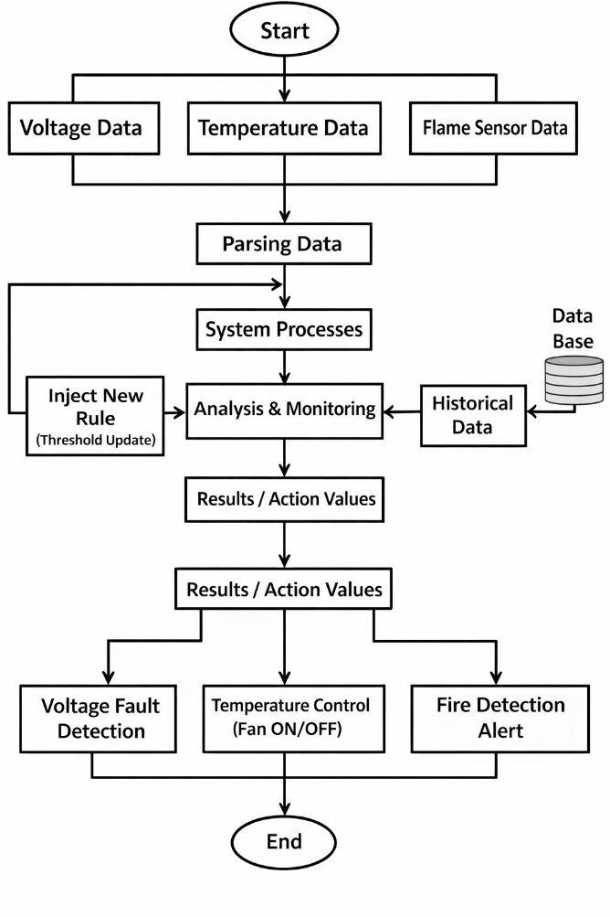

- FEASIBILITY STUDY

The feasibility of the Overhead AC Line Fault Detection and Monitoring System is analyzed in terms of technical, economic, and operational aspects. Technically, the system is feasible as it utilizes reliable components such as ESP32 for accurate monitoring and fault detection. The system ensures real-time performance, scalability, and smooth integration with IoT-based applications..
  - Economic feasibility
  - Technical feasibility
  - Behavioral feasibility

ECONOMIC FEASIBILITY:
The Overhead AC Line Fault Detection and Monitoring System is economically feasible as it primarily relies on low-cost electronic components rather than expensive infrastructure. The implementation cost includes microcontroller setup, sensor integration, IoT cloud services, and maintenance, which are relatively affordable compared to traditional manual monitoring systems. By using efficient real-time monitoring techniques, the system reduces maintenance costs, minimizes downtime, and prevents major failures through early fault detection.
Additionally,the system automates fault identification and alert mechanisms, reducing the need for continuous manual inspection and labor costs. Developed using scalable IoT technologies, the system ensures cost-effective deployment and easy maintenance. Overall, the project is financially viable as it reduces operational expenses while improving efficiency and reliability in power distribution systems..

TECHNICAL FEASIBILITY:
The feasibility of the Overhead AC Line Fault Detection and Monitoring System is based on its use of technology, as it is developed using established and reliable components. For instance, the system is built using a microcontroller such as ESP32, which is efficient for handling real-time data from sensors such as voltage, temperature, and flame sensors.
These components are capable of providing accurate monitoring and high-performance fault detection..
The system is designed using embedded programming, which enables fast processing, real-time response, and smooth integration with IoT platforms. Additionally, it can be connected to cloud services for remote monitoring and data storage. Thus, with proper hardware components, stable power supply, and internet connectivity, it is possible to implement and maintain the system. IoT platforms such as cloud dashboards support real-time data visualization. Wi-Fi and communication modules enable remote data transmission..

3.3 BEHAVIORAL FEASIBILITY

The Overhead AC Line Fault Detection and Monitoring System is behaviorally feasible because it is simple and user-friendly and can be easily operated by electricity board staff or maintenance personnel. The system provides clear information about voltage status, temperature levels, and fire detection using reliable sensors and IoT technology. This is important because users will be able to understand the system outputs and take appropriate action quickly.

4.1 REQUIREMENTS

4.1.1 Functional Requirements
The Overhead AC Line Fault Detection and Monitoring System should be capable of performing the following functions:
- Allow continuous monitoring of voltage levels across multiple AC poles.
- Detect voltage absence, fluctuations, and fault conditions in real time.
- Monitor battery temperature to prevent overheating issues.
- Detect fire hazards near electrical poles using flame sensors.
- Generate alerts through buzzer and IoT notifications during abnormal conditions.
- Automatically control a cooling fan when high temperature is detected.
- Display system status on a user-friendly IoT dashboard.
- Ensure high reliability and accuracy in fault detection.
- Provide fast response time for quick fault identification and action.
- Enable remote monitoring through smartphones and computers.
- Support internet connectivity for real-time data transmission and alerts.

4.1.2 Non-Functional Requirements
In addition to functional capabilities, the system should meet the following quality requirements:
- The system should be reliable and provide consistent fault detection results.
- It should be scalable to monitor multiple AC poles and expand for larger networks.
- The system should ensure secure data transmission and user authentication.
- The interface should be user-friendly and easy to monitor through IoT dashboards.
- The system should maintain high performance with minimal delay in alert generation..

4.1.3 Hardware Requirements
The following hardware components are required for the effective operation of the system:
- An ESP32 microcontroller for processing and control operations..
- Voltage sensors for monitoring AC line voltage levels.
- Temperature sensor for detecting overheating conditions.
- Flame sensor for identifying fire hazards near electrical lines.
- Communication modules such as Wi-Fi for real-time data transmission.
- Power supply unit to provide stable power to the system.
These hardware components ensure smooth system operation and support accurate monitoring, fault detection, and data transmission.

4.1.4 Software Requirements
The system requires the following software tools and technologies:
- Embedded programming (C/C++) for ESP32 microcontroller operation.
- IoT platform / cloud for real-time data monitoring and storage.
The software should be reliable, scalable, and capable of handling real time data efficiently.

4.2 ANALYSIS

4.2.1 Functional Analysis
The system is designed to support key operations that help in efficient monitoring and fault detection in power distribution networks. The major functions include:
• Monitoring of voltage levels across AC transmission lines.
• Detection of faults such as voltage failure and fluctuations.
• Monitoring of temperature conditions to prevent overheating.
• Detection of fire hazards using flame sensors.
• Storage of system data for future analysis and maintenance.
These functionalities enable efficient fault management, reduce downtime, and improve the reliability of power distribution systems.

METHODOLOGY

  - SYSTEM DESIGN AND DEVELOPMENT METHODOLOGY

Requirement Analysis:
The first step in developing the Overhead AC Line Fault Detection and Monitoring System is identifying the needs of power distribution authorities and maintenance personnel. In this phase, factors such as voltage levels, environmental conditions, fault occurrences, and safety requirements are studied. The system requirements are analyzed to determine what features the system should provide, such as real-time voltage monitoring, temperature control, fire detection, and fault alert mechanisms.

Data Collection
In this stage, relevant electrical and environmental data is collected from different sources. The data includes voltage levels, temperature readings, and flame sensor outputs from the system. These data sources help the system understand operating conditions and detect potential faults. Modern monitoring systems combine data from sensors, real-time measurements, and stored system records to generate useful insights for maintenance. The collected data is then stored in a database or IoT platform for further processing.

5.2. FEATURES
The Overhead AC Line Fault Detection and Monitoring System includes several useful features that help in efficient power distribution management. The system continuously monitors voltage levels, temperature conditions, and fire hazards to detect faults in real time. It provides instant alerts through buzzer and IoT notifications, helping operators take quick action. Another important feature of the system is automatic temperature control using a cooling fan, which prevents overheating and ensures safe operation.
5.3. Machine Learning Model Implementation
The Overhead AC Line Fault Detection and Monitoring System uses embedded logic and threshold-based algorithms for fault detection and monitoring. The system processes data collected from sensors such as voltage, temperature, and flame sensors to identify abnormal conditions..
Data preprocessing involves filtering sensor noise, validating input signals, and setting threshold limits for different parameters. Parameter selection is performed to identify critical values that indicate faults such as voltage failure, overheating, or fire hazards..
The system uses real-time monitoring to analyze sensor data and detect faults instantly. The data is stored for future analysis, ensuring accurate and reliable performance.

VI. IMPLEMENTATION

6.1. IMPLEMENTATION TECHNIQUES
The Overhead AC Line Fault Detection and Monitoring System uses data collection, processing, and real-time monitoring for efficient fault detection. It gathers data such as voltage, temperature, and flame sensor readings from connected sensors.

The data is continuously collected from sensors and transmitted through the microcontroller. It is then processed and filtered to remove noise and convert it into a structured format for analysis..

After preprocessing, the system applies threshold-based logic and monitoring techniques to analyze the data. These thresholds are defined based on safe operating conditions of electrical systems. The system also uses previously stored data to compare conditions and identify abnormal patterns. By combining real-time data with stored information, the system can detect faults accurately.
Finally, the analyzed results are used to trigger appropriate actions. The system generates alerts, activates safety mechanisms such as cooling fans, and displays information on IoT dashboards. These actions help in quick fault identification, reduce downtime, and improve the overall reliability of the power distribution system.
.

6.2 MAINTENANCE
Maintenance of the Overhead AC Line Fault Detection and Monitoring System refers to the regular activities performed to ensure that the system continues to work efficiently and detect faults accurately. This includes:

- Software Updates: Updating the embedded code, IoT platform, and system configurations to improve performance and add new monitoring features.
- Hardware Checks: Regular inspection of components such as ESP32, voltage sensors, temperature sensors, and flame sensors to ensure proper functioning.
- Data Backup: Periodically backing up system data and fault records to prevent data loss and support future analysis.
- Error Correction: Identifying and fixing system errors or sensor issues to maintain accurate fault detection. Providing support for users to handle system alerts and monitoring.
- Proper maintenance ensures that the system remains reliable, accurate, and effective in monitoring power distribution and detecting faults.

VI. WEAKNESS
The Overhead AC Line Fault Detection and Monitoring System has certain limitations that may affect its overall performance. The system depends on continuous power supply and stable internet connectivity for real-time monitoring and alert transmission. Any interruption in connectivity may delay fault detection and notifications. In addition, sensor accuracy can be influenced by environmental conditions, which may sometimes result in incorrect readings or false alerts.
Another limitation is that the system operates based on predefined threshold values, which may not cover all types of faults in complex power distribution networks. The hardware components also require regular maintenance and may need replacement over time, increasing operational effort. These factors can impact the efficiency and reliability of the system in certain conditions.
VII. TESTING TECHNIQUES
Testing techniques are applied to ensure that the Overhead AC Line Fault Detection and Monitoring System functions correctly, detects faults accurately, and remains reliable for users. The major testing methods are as follows:
8.1 UNIT TESTING
Each module of the system, such as voltage monitoring, temperature sensing, and flame detection, is tested individually to ensure proper functionality.
8.2 INTEGRATION TESTING
After unit testing, all modules are integrated and tested collectively to verify proper interaction and smooth data flow between sensors, microcontroller, and IoT platform.
8.3 SYSTEM TESTING
System testing ensures that all integrated hardware and software components function correctly according to the specified requirements.
8.4 USER ACCEPTANCE TESTING
User Acceptance Testing (UAT) is conducted with actual users, such as maintenance staff or operators, to verify that the system is user-friendly and provides accurate alerts.
8.5 REGRESSION TESTING
Regression testing ensures that new updates or changes do not affect existing functionalities. For example, when threshold values are updated, previous system operations are re-tested to ensure consistency.

IX. ADVANTAGES
- Provides a single platform for real-time fault detection and monitoring.
- Improves decision-making for maintenance and power distribution management.
- Reduces maintenance costs and minimizes system downtime
- User-friendly and easy to operate
- Supports efficient and safe power distribution operations

X. DISADVANTAGES
- Depends on sensor accuracy for correct fault detection
- Requires regular maintenance of hardware components and system updates

XI. CONCLUSION
The Overhead AC Line Fault Detection and Monitoring System is a technology-driven solution designed to improve the safety and reliability of power distribution systems. By integrating multiple components such as voltage sensors, temperature sensors, flame sensors, and IoT technology, the system provides accurate and real-time fault detection that helps reduce system failures and maintenance delays.
The system combines features such as data collection, preprocessing, threshold-based analysis, and real-time alert mechanisms to ensure effective monitoring. Its user-friendly interface and IoT-based dashboard make it easy for operators to monitor system conditions and respond quickly to faults, making it suitable for practical implementation.
Furthermore, proper implementation and maintenance strategies ensure long-term reliability, while testing techniques validate system performance and accuracy. Overall, the system acts as an efficient monitoring solution that enhances power distribution efficiency, reduces downtime, and ensures safer electrical infrastructure.

XII. REFERENCES

- “IoT-based Overhead Power Line Fault
Detection System,” International Journal of Electrical Engineering and Technology, 2025.
- A. Kumar, “Smart fault detection in power transmission lines using IoT,” IEEE Access, 2024.
- R. Sharma and P. Singh, “Real-time monitoring of electrical distribution systems using ESP32,” arXiv preprint, 2025.
- S. Raj and M. Karthik, “IoT-enabled voltage monitoring and fault detection system,” Journal of Smart Grid
Technology, 2024.
- “Fire detection and safety system for electrical infrastructure,” IET Research Journals, 2025.
- P. Verma et al., “IoT applications in smart grid and power system monitoring,” ScienceDirect Review, 2025.
- K. Ramesh et al., “Embedded system-based fault detection using sensors and IoT,” Springer, 2025.
- D. Prakash, "Temperature monitoring and protection system for battery units using IoT," 2023.
- M. S. Kumar, "Real-time power system monitoring using ESP32 and cloud platform," 2023.
- D. Prakash, "IoT-based electrical fault detection and alert system," 2023.

