A Study On Recent Technology Trends In Higher Education.

Authors: Nayana Shree. L, Sheetal Gowda
Bengaluru North university
Master of business administration (MBA)
Patel Institute of Science and Management (PISM)
Bengaluru, India

ABSTRACT
Technology has actually brought about a sea change in the way things function in the field of education in India. It is almost a game-changer that can actually help in making education more accessible to people and changing the way things are taught and achieving results in the field of education. Therefore, this paper will discuss how technology has evolved over the years in educational institutions. It will describe the use of concepts such as Learning Management Systems, Artificial Intelligence in Education, Virtual Classrooms and Video Conferencing, Smart Classrooms, Cloud Computing, E-libraries and Digital Resources, Learning Analytics, and Mobile Learning. These technologies can truly help students become more engaged and learn better. The study also examines some of the major challenges such as teachers not being prepared to use these new technologies, lack of appropriate infrastructure, and some people not having access to the internet. According to the paper, we need to enhance our infrastructure, help teachers become better at using technology, and collaborate with the public and private sectors to develop new technologies that will endure. If we harness technology in a manner that it will truly help make the Indian higher education system better and help us compete with other nations. Technology in the education sector, in India, is a very important issue and we should focus on it. Technology can bring a huge change in the Indian education system by providing better access and quality to education, and it will be very helpful for the readiness of the future of the country.
Keywords: Digital transformation in education, technology adoption in education, online learning, artificial intelligence in education.

INTRODUCTION
Higher education is an important factor in the development of a country as it provides qualified and knowledgeable human resources. Technology has been one of the biggest turning point in the Indian higher education system and in the last few years. The application of technology such as Learning Management Systems, Artificial Intelligence in education, virtual classrooms, smart classrooms, cloud computing, e-libraries, learning analytics, and mobile learning has resulted in a huge shift in the teaching and learning process. The application of technology has been found to be beneficial in enhancing student engagement, learning, and efficiency.However technology in schools is facing some challenges. These include not having trained teachers not having the right equipment and some students not having access to digital tools at home. To solve this we need to work on building digital systems training more teachers and getting help from both public and private sectors. This will help us make the most of technology in education. We need to focus on making teachers ready for tools and making sure everyone has equal access, to them. Technology can really help improve education system.
OBJECTIVES OF THE STUDY
- To assess students’ perceptions of technology being used as a support versus a replacement for traditional teaching methods.

- To evaluate the effectiveness of online or technology-based assessments in measuring students’ academic performance.

- To examine whether technology is utilized as a support system or as a replacement for the traditional teaching process.

SCOPE OF THE STUDY
- The research aims to understand the technology in higher education and the level to which supports the objectives of the course.

- The scope includes analysing students’ perceptions of the role of technology—whether it acts mainly as a support tool or replaces traditional classroom teaching.

- The study covers the evaluation of online and technology-based assessment methods to determine their effectiveness in measuring students’ academic performance.

- The study is restricted to the views of students in higher education institutions, and the results are Collected from primary data gathered using questionnaires/surveys.

LITERATURE REVIEW
Dr. Vijeta Banwari. (2019). A study about what's happening with technology in higher education in India.She saw things like e-learning and learning analytics and MOOCs. These are important for making sure people can learn in their way. The main thing she found out is that technology is going to change education a lot. Teachers will have to help people learn of just teaching them things. This way people can keep learning their lives.

Shailla Draboo. (2020). A study about what's happening with technology in higher education in India. She looked at things like SWAYAM and NMEICT. These are important for teaching and research and other things. With the COVID-19 pandemic technology helped people learn. The main thing she found out is that technology has made it easier for people to get an education and has improved the quality.We need better policies and infrastructure and training for teachers.

Dr. N. Sundar. (2022). A study about what's happening with higher education in India. He looked at things like blended learning and MOOCs like SWAYAM. He also seen the changes in the NEP 2020. How digital technologies and Artificial Intelligence are being used. The main thing he found out is that using technology has made it easier for people to learn and has given them choices. We still have problems with infrastructure and some people do not have access, to technology.

HYPOTHESIS OF THE STUDY
H₀ (Null Hypothesis): There is no significant alignment between the use of technology and course objectives and academic requirements of students in higher education.
H₁ (Alternative Hypothesis): Students can consider a technology as a support system rather than a replacement for traditional teaching methods.

RESEARCH METHODOLOGY
This study follows a descriptive research design to analyse recent technology trends in higher education. Primary data was collected through structured questionnaires shared to the college students. The questionnaires include questions related to recent trends in higher education like, online learning platforms, LMS (Learning Management System), and online assessments. secondary data was collected from of journals, articles, and online sources. The collected data was analysed using percentage analysis to understand trends and pattern.
DATA ANALYSIS AND INTERPRETATION
The information we got from students and faculty members shows that using technology in education makes a difference in how well teachers teach, how much students participate and how much students learn in colleges and universities in India. A lot of the people we asked said they use things, like class systems, virtual classrooms, smart boards and digital resources all the time, which makes it easier and more flexible for students to learn.
TABLE 1. How effective are online or technology-based assessments in evaluating your performance.
Description | Responses | Percentage
Very effective | 23 | 20.5%
Effective | 51 | 45.5%
Neutral | 33 | 29.5%
Ineffective | 5 | 5%
TOTAL | 112 | 100%

FIGURE 1. How effective are online or technology-based assessment in evaluating your performance.

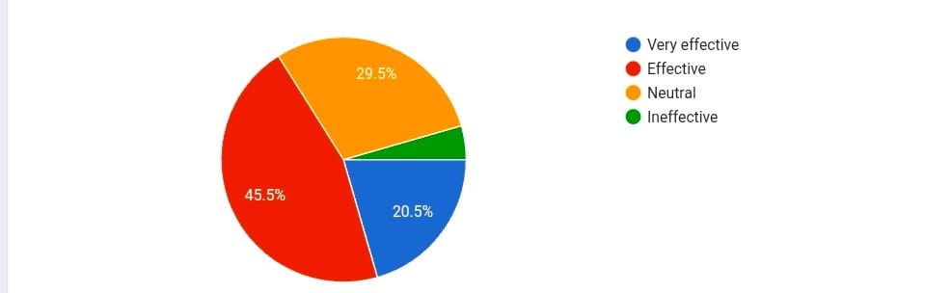

Most students of opinion that online assessments are effective in assessing their performance. This tells us that online quizzes, tests on the LMS and online assessments are okay with most students. A lot of students are not sure if these assessments really show how well they are doing. They think the assessment might not be a picture of their performance. Online assessment tools are widely accepted I think. Many students are neutral, about them.
TABLE 2. Do you feel that technology sometimes used as a replacement rather than a support for teaching.
Description | Responses | Percentage
Strongly agree | 18 | 16.1%
Agree | 42 | 37.5%
Neutral | 34 | 30.4%
Disagree | 15 | 13.4%
Strongly disagree | 3 | 2.7%
Total | 112 | 100%

FIGURE 2. Do you feel that technology sometimes used as a replacement rather than a support for teaching.
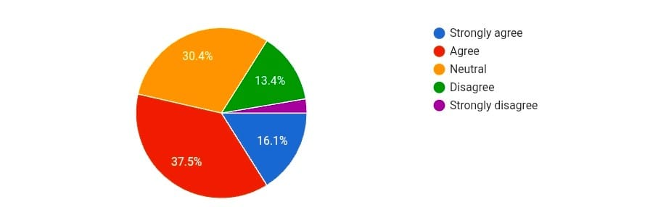
Over all Half of the students believe that technology is replacing traditional teaching approaches rather than enhancing them. This is an indication that there are fears that relying on technology may lead to a reduction in teacher interaction. The high percentage of neutrality shows that there is an insufficient of clarity on the role of technology.

TABLE 3. Does the use of technology align with your course objectives and academic requirements.
Description | Responses | Percentage
Always | 23 | 20.5%
Often | 28 | 25%
Sometimes | 41 | 36.6%
Rarely | 17 | 15.2%
Option 5 | 3 | 3%
Total | 112 | 100%

FIGURE 3. Does the use of technology align with your course objectives and academic requirements.
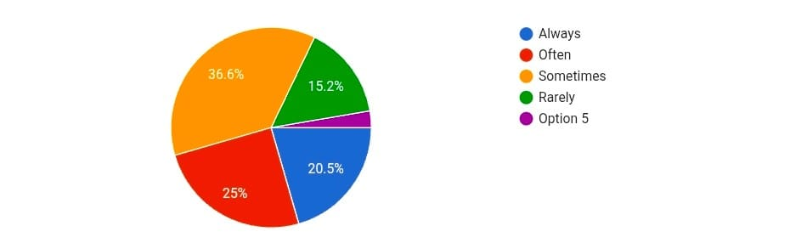
Although many students feel that technology supports academic goals, the dominant Sometimes response suggests inconsistent alignment. This Indicates that while technology is being integrated into the Study program, it is not necessarily being mapped into learning outcomes in a way that its relevance to academics is being well utilized by the faculty members.

FINDINGS
- The study shows that technology integration has Contributed to improved teaching quality in higher educational institutions in India.

- Most participants have shown that Learning Management Systems (LMS) are widely used for distribution study materials, assignments, and Virtual classrooms and video conferencing have made education more accessible, especially after the improvement in student performance.

- Smart classrooms have improved interactions between teachers and students.

- Artificial Intelligence applications have helped in personalized learning and improved academic support.

SUGGESTIONS
- The higher education institutions should provide training programs for faculty members to increase their digital skills.

- The Institutions should invest in the development of digital infrastructure such as high-speed internet, smart classrooms.

- The government should make sure that students from rural and weaker sections of society have equal access to technology to bridge the difference.

- Universities should emphasize the use of Learning Management Systems, teaching learning and assessments.

- The Institutions should encourage to the use of Artificial Intelligence tools for learning and academic support.

CONCLUSION
The study concludes that the recent trends in technology has led to a significant transformation in higher education sector by making it more accessible, flexible, and improving the quality of teaching and learning. Technologies like Learning Management Systems, virtual classrooms, artificial intelligence, smart classrooms, and online testing have improved student engagement and helped in learning. The results show that most students feel that technology is an effective educational support tool but some students feel that technology sometimes substitutes teaching. which requires more effective implementation in education. The major Challenges are lack of infrastructure, limited internet connectivity, and a lack of technology skills among teachers. There Four the higher education system in India can be improved by making effective use of technology to meet the future demands of learning.

REFERENCES
- Dr. Vijeta Banwari. (2019). Recent Technological Trends in Higher Education sector in India, 6, 533-538.
- Shailla Draboo. (2020). Analysis of recent trends in higher education in India using information communication technology (ICT), 2, 108-120.
- Dr. N. Sundar, (2022), Trends in Indian higher education system, 4, 16-25.

