HACKIFY: CYBERSECURITY AWARNESS PLATFORM

ABSTRACT
Hackify is an interactive cybersecurity awareness and training platform designed to enhance users' knowledge and practical skills in identifying and preventing cyber threats. Traditional cybersecurity education often relies on theoretical learning, which may not effectively prepare users for real-world cyberattacks. This research presents Hackify, a web-based platform that combines gamification, hands-on challenges, quizzes, attack simulators, and awareness modules to create an engaging and practical learning environment. The system incorporates secure user authentication, progress tracking, leaderboard-based motivation, and real-time feedback mechanisms to improve learning outcomes. By simulating common cybersecurity threats such as phishing attacks, password vulnerabilities, and social engineering techniques, Hackify enables users to gain practical experience in a safe and controlled environment. The platform promotes cybersecurity awareness, skill development, and proactive defense strategies while providing an accessible and scalable solution for educational institutions, organizations, and individual learners. Through interactive learning and continuous assessment, Hackify contributes to building a more cyber-aware and security-conscious digital society.
Keywords: Cybersecurity Awareness, Gamification, Web Application, Cybersecurity Training, Attack Simulation, Phishing Detection, Password Security, User Authentication, Interactive Learning, Information Security.

INTRODUCTION
Problem Statement: Challenges in Traditional Cybersecurity Awareness Systems
The increasing use of digital technologies, online platforms, and internet-based services has led to a significant rise in cybersecurity threats. However, traditional cybersecurity awareness and training systems face persistent challenges that compromise digital safety, user preparedness, and organizational security. Contemporary cybersecurity education systems suffer from multiple critical limitations: lack of practical learning opportunities remains a major concern, with conventional training methods often relying on theoretical content that fails to simulate real-world cyber threats. Users frequently struggle to recognize and respond to attacks such as phishing, malware, and social engineering, increasing their vulnerability to cyber incidents.
Beyond awareness concerns, engagement remains a fundamental challenge in modern cybersecurity education. Individuals and organizations require continuous training to stay updated with evolving cyber threats, yet many existing programs fail to maintain user interest and participation. This lack of engagement results in poor knowledge retention, limited practical skills, and ineffective application of cybersecurity best practices. Furthermore, users often lack access to safe environments where they can experience and learn from realistic cyberattack scenarios without risking actual systems or sensitive information.
Users also lack personalized learning experiences, with training content typically delivered through standardized approaches rather than individual skill levels and learning requirements. Existing systems provide limited mechanisms for tracking progress, assessing practical competencies, and measuring overall awareness improvement. These limitations fundamentally restrict the development of cybersecurity skills and informed decision-making in digital environments.
To address these challenges, Hackify provides an interactive cybersecurity awareness platform that integrates gamification, quizzes, attack simulations, cybersecurity challenges, and real-time feedback mechanisms. The system enables practical learning through realistic threat scenarios, tracks user progress, and encourages continuous skill development. By combining interactive education, experiential learning, and performance assessment, Hackify offers a scalable solution for next-generation cybersecurity training that prioritizes awareness, engagement, skill enhancement, and digital safety while promoting a strong cybersecurity culture among users.

Need for Interactive Cybersecurity Awareness Systems
The increasing use of digital technologies has created an urgent need for effective solutions that simultaneously address cybersecurity awareness, skill development, user engagement, and threat preparedness concerns. Interactive cybersecurity platforms present a transformative approach that leverages gamification, attack simulations, real-time feedback, and practical learning mechanisms to overcome the inherent limitations of traditional training systems.
By providing hands-on learning experiences, cybersecurity platforms reduce the gap between theoretical knowledge and real-world application. The interactive nature of these systems enables users to identify and respond to cyber threats while improving awareness of common attacks such as phishing, malware, and social engineering. Continuous assessment and progress tracking help users evaluate their skills and strengthen their cybersecurity practices.
Gamification features such as quizzes, challenges, and leaderboards enable engaging and transparent learning experiences without relying solely on conventional teaching methods, thereby improving participation and knowledge retention. These mechanisms reduce learning fatigue and human error while promoting cybersecurity best practices and helping individuals develop the skills necessary to protect themselves in an increasingly digital world.

2.Literature Review
2.1 Cybersecurity Awareness Platforms: Current State and Limitations
Cybersecurity awareness platforms have improved digital safety by educating users about common cyber threats and secure online practices. These platforms facilitate cybersecurity learning, enhance threat recognition, and support the development of basic security skills. However, current cybersecurity training systems predominantly rely on theoretical content and static learning materials, creating limitations in practical skill development and user engagement.
Traditional cybersecurity awareness systems introduce multiple learning challenges. Training content is often delivered through lectures, presentations, or reading materials, making it difficult for users to apply concepts in real-world situations. As cyber threats continue to evolve, many existing platforms provide limited opportunities for hands-on practice, reducing users' ability to identify and respond effectively to attacks such as phishing, malware, and social engineering. Additionally, low engagement levels often result in poor knowledge retention and reduced learning effectiveness.
User engagement challenges fundamentally limit the effectiveness of current cybersecurity training systems. Different users possess varying levels of cybersecurity knowledge and learning requirements, yet many platforms adopt a one-size-fits-all approach. Users often lack personalized learning experiences, continuous progress tracking, and practical assessment mechanisms. The absence of interactive simulations, gamification features, and real-time feedback prevents comprehensive cybersecurity skill development and limits the ability to build long-term security awareness across different user groups.
2.2 Gamification and Interactive Learning in Cybersecurity: Opportunities and Applications
Gamification and interactive learning improve cybersecurity training by providing engaging activities such as quizzes, challenges, simulations, and reward-based tasks. This approach encourages active participation and helps users develop practical skills for identifying and responding to cyber threats.
Cybersecurity awareness platforms use features such as points, badges, leaderboards, and achievements to track progress and motivate learners. Real-time feedback helps users understand mistakes, improve weak areas, and apply cybersecurity best practices. Interactive challenges also provide safe environments to practice handling phishing attacks, password vulnerabilities, and social engineering threats.
These platforms support personalized learning by adapting content to different skill levels and monitoring user performance. Progress tracking and activity logs help identify knowledge gaps and measure learning outcomes.
Successful implementations show that gamification and challenge-based learning improve user engagement, knowledge retention, and practical cybersecurity skills, making cybersecurity education more effective and interactive.
2.3 Key Cybersecurity Awareness Platform Applications
Cybersecurity awareness platforms are widely used in educational institutions and organizations to improve cybersecurity knowledge through interactive learning. Features such as quizzes, simulations, and challenges help users gain practical experience while enhancing engagement and knowledge retention.
Modern platforms use real-world attack scenarios and hands-on activities to help users recognize and respond to cyber threats effectively. These systems improve threat awareness, reduce security mistakes, and build confidence through practical learning and real-time feedback.
Cybersecurity awareness solutions also support personalized learning through analytics and assessment mechanisms. Institutions can track user progress, identify knowledge gaps, and continuously improve training programs to enhance overall cybersecurity preparedness.
2.4 Learning Mechanisms and System Architecture
Different cybersecurity awareness platforms employ various learning mechanisms optimized for effective skill development and user engagement. Gamification-based approaches reduce learning fatigue compared to traditional training methods, making them suitable for cybersecurity education where continuous participation and knowledge retention are critical. Interactive learning architectures provide structured training environments that enhance awareness while maintaining accessibility and scalability.
Modern cybersecurity platforms utilize modular architectures that enable educational institutions and organizations to create customized training environments balancing engagement, assessment, and learning requirements. The platform supports multiple learning modules, flexible user access controls, and personalized learning paths that enable users to focus on specific cybersecurity topics and skill areas. Real-time feedback and progress tracking mechanisms further enhance learning effectiveness while ensuring continuous improvement in cybersecurity awareness and practical competencies.
4. PROPOSED SYSTEM: Hackify Architecture
4.1 System Overview and Design Philosophy
Hackify implements a user-centric, interactive cybersecurity awareness platform that prioritizes practical learning, engagement, and skill development. The architecture integrates gamification techniques for motivation, attack simulators for hands-on experience, quizzes and challenges for knowledge assessment, and real-time feedback mechanisms for continuous improvement.
The system philosophy emphasizes active learning through user participation and practical experience. Unlike traditional cybersecurity training systems where users primarily consume theoretical content, Hackify enables users to interact with realistic cybersecurity scenarios and test their knowledge in a safe environment. Users can participate in quizzes, solve cybersecurity challenges, and engage with attack simulations while tracking their progress and improving their cybersecurity skills over time.

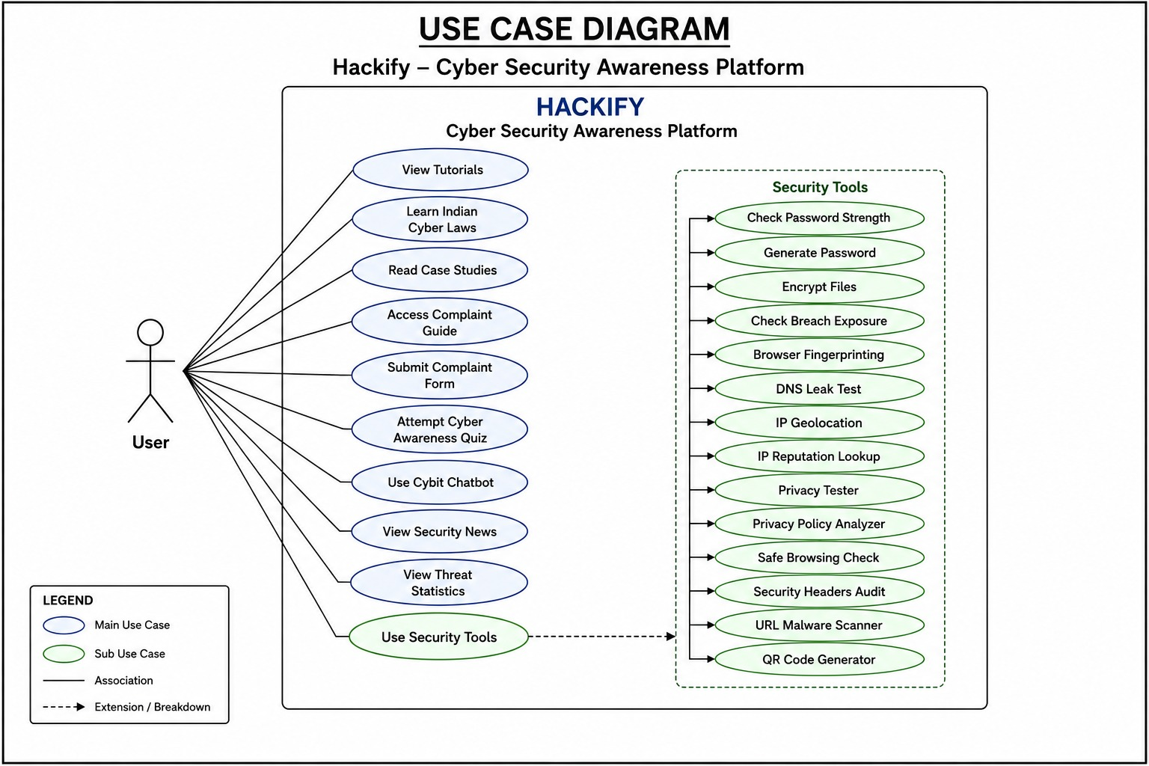
Figure 1: Hackify Use Case Diagram
4.2 System Architecture: Key Components
4.2.1 Application and Learning Layer
Hackify utilizes a web-based application layer as the core infrastructure for delivering cybersecurity awareness content, interactive challenges, quizzes, and attack simulations. User profiles, quiz results, challenge completion records, progress statistics, and achievement data are maintained within the system, creating a comprehensive learning and assessment environment. The application layer ensures secure user authentication and efficient data management, enabling users to access learning resources and track their cybersecurity development.
The platform maintains learning integrity through real-time assessment and performance tracking mechanisms, where every user activity, challenge attempt, and quiz result is recorded and evaluated. This continuous monitoring process creates a reliable record of user progress, enabling personalized feedback and helping users identify areas for improvement. The application layer supports a scalable and interactive learning experience while promoting cybersecurity awareness and practical skill development.
4.2.2 Assessment and Gamification Layer
The assessment and gamification layer in Hackify automates user evaluation, progress tracking, and reward management. The system manages quizzes, cybersecurity challenges, attack simulations, and achievement mechanisms without requiring manual monitoring by administrators. When a user participates in a quiz or completes a challenge, the platform automatically evaluates performance, calculates scores, updates progress records, and awards badges or rewards based on predefined rules.
The assessment layer ensures continuous learning by providing real-time feedback and personalized recommendations. User activities are automatically recorded, enabling the system to track skill development and identify areas requiring improvement. Gamification features such as points, badges, leaderboards, and achievements encourage active participation while maintaining user engagement. Additionally, the system generates activity logs and performance records, ensuring transparency and effective monitoring of learning outcomes.
4.2.3 Content and Data Storage Layer
The Content and Data Storage Layer stores cybersecurity tutorials, challenge data, quiz content, attack simulation scenarios, and user performance records in a centralized database. This structured storage ensures secure, efficient, and reliable access to educational content and user information.
When users participate in quizzes, challenges, or simulations, the system records their responses, scores, achievements, and progress using unique identifiers. This enables accurate performance tracking, continuous assessment, personalized learning, and real-time progress monitoring while maintaining data consistency.
The storage layer works closely with the application and assessment layers to provide seamless access to content and user records. By ensuring organized content management and secure data storage, it supports reliable platform operation and an effective learning experience for users.

4.2.4 Security and Authentication Mechanisms
The Authentication and Security Layer protects user data and platform resources through secure login, password protection, and session management mechanisms. These measures ensure that sensitive information is accessible only to authorized users and help prevent unauthorized access.
User identities are verified before granting access to quizzes, challenges, simulations, and progress reports. The platform uses role-based access control, providing different permission levels for users, administrators, and trainers. This ensures that each user can access only the resources relevant to their role while maintaining system security.
4.3 Hackify System Architecture
User Tier: Students, Cybersecurity Learners, General Users, Administrators↓ Frontend Layer: React + Vite User Interface, React Router Navigation, Dashboard, Tutorials, Quizzes, FAQ, Case Studies, Complaint Portal
↓ Application Layer: Security Toolkit, Cybit AI Assistant, Cyber Laws Module, Security News Module, Threat Statistics Dashboard ↓ Backend Layer: Node.js + Express.js Server, REST APIs, Route Handling, Data Processing, Authentication & Request Management ↓ AI & Intelligence Layer: Google Gemini AI Integration, Cybersecurity Guidance, Question Answering, Learning Assistance ↓ Security Services Layer: Password Strength Checker (zxcvbn), Breach Detection (Have I Been Pwned), File Encryption & Decryption (OpenPGP.js), DNS & URL Security Tools ↓ Threat Intelligence Layer: Live Threat Monitoring, Threat Intelligence APIs, Cyber Attack Statistics, Security Alerts ↓ External Data Sources: RSS Feeds from The Hacker News, BleepingComputer, KrebsOnSecurity, Cybersecurity News Sources ↓
Storage & Data Management Layer: User Profiles, Quiz Results, Learning Progress, Complaint Records, Threat Intelligence Data ↓ Access Interfaces: Web Application, Admin Dashboard, Security Toolkit Interface, AI Chat Assistant Portal.
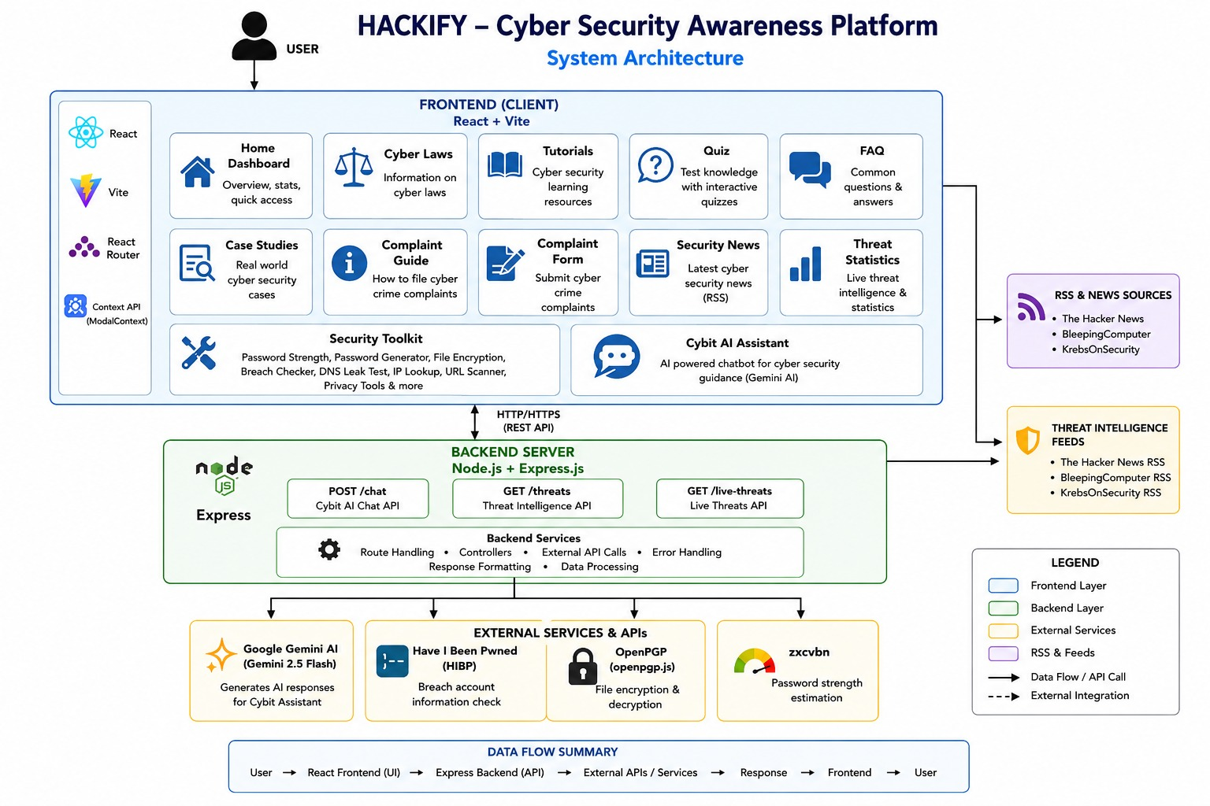
Figure 2: Hackify System Architecture

5. Methodology: System Design and Implementation
5.1 System Design Approach
Hackify development follows an iterative, agile methodology incorporating regular feedback from students, cybersecurity professionals, and system administrators. The design emphasizes:
• User-Centric Learning: All design decisions prioritize user engagement, practical learning, and skill development.
• Cybersecurity Awareness: System features are evaluated based on their effectiveness in improving cybersecurity knowledge and threat recognition.
• Secure Platform Design: The system incorporates secure authentication, access control, and data protection mechanisms to ensure a safe learning environment.
• Scalability and Accessibility: System design enables easy access across different devices and supports future integration of advanced cybersecurity modules and learning resources.

5.2 Implementation Framework
Development Environment:
• Next.js / React.js for frontend development and interactive user interfaces.
• Node.js and Express.js for backend development and API management.
• MongoDB for storing user profiles, quiz results, challenge data, and progress records.
• Firebase Authentication / JWT for secure user authentication and authorization.
Testing Methodology:
• Unit Testing for individual modules such as quizzes, challenges, and authentication functions.
• Integration Testing for interactions between frontend, backend, database, and learning modules.
• Security Testing including authentication validation, access control verification, and vulnerability assessment.
• Performance Testing measuring system responsiveness, user activity handling, content loading speed, and overall platform efficiency.
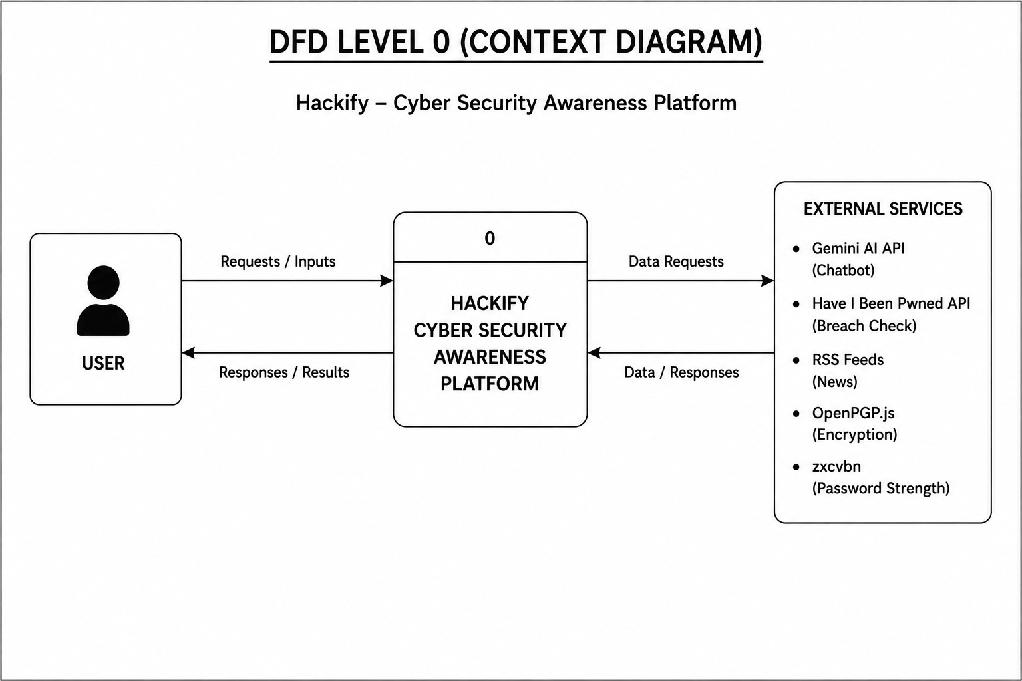
Figure 3: Hackify Context Diagram (DFD Level 0)

5.3 Data Flow and Transaction Processing
User Registration Process:
- Patient accesses Hackify web interface and initiates registration
- User accesses the Hackify web interface and initiates registration.
- The system collects user details and securely creates an account.
- Authentication credentials are verified and stored securely in the database.
- The system creates a unique user profile with a distinct identifier.
- User preferences, progress tracking, and learning records are initialized.

Quiz and Challenge Participation Process:
- User selects a quiz, cybersecurity challenge, or attack simulation from the dashboard.
- The system retrieves the selected content and presents it to the user.
- User submits answers or completes the assigned cybersecurity task.
- The platform automatically evaluates responses based on predefined rules.
- Scores, completion status, and performance metrics are recorded in the database.
- The system updates progress records, awards points or badges, and generates real-time feedback.
Access Request and Verification Process:
- User activity and learning performance are continuously monitored.
- Quiz scores, challenge results, and achievements are stored in the database.
- The system analyzes performance and identifies areas requiring improvement.
- Personalized feedback and recommendations are generated.
- Progress reports and leaderboard rankings are updated automatically.
- Users can view their learning history and cybersecurity skill development through the dashboard.
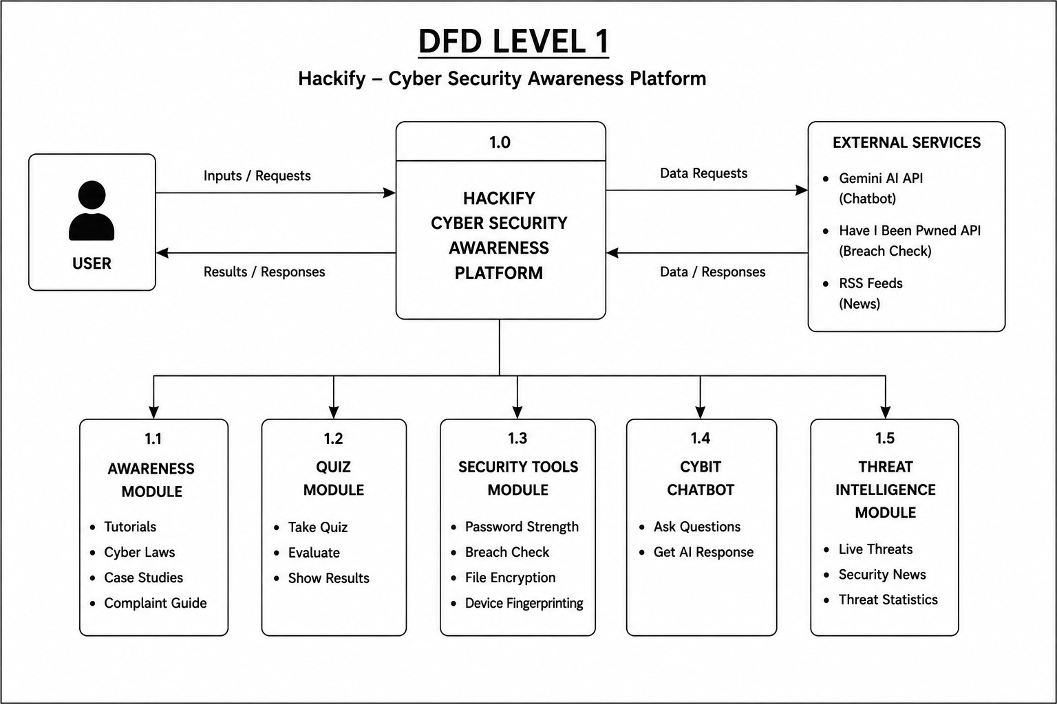
Figure 4: Hackify DFD Level 1

6. ADVANTAGES OF HACKIFY
6.1 Enhanced Cybersecurity Awareness and Skill Development
Hackify enhances cybersecurity awareness and practical skills through interactive quizzes, challenges, and attack simulations. These activities provide hands-on experience, helping users recognize cyber threats and improve their response capabilities. Real-time feedback supports continuous learning and skill improvement.
The platform makes learning more engaging through gamification features such as points, badges, and leaderboards. This increases user participation, improves knowledge retention, and encourages the adoption of cybersecurity best practices.
User performance is monitored through automated assessments, with quiz scores, challenge results, and achievements stored in the system. Personalized feedback and progress reports help users identify skill gaps and strengthen their cybersecurity knowledge.
6.2 Transparency, Progress Tracking, and Accountability
Hackify maintains detailed activity logs of user interactions, including quiz attempts, challenge completions, simulation activities, and achievements. These records allow users to view their learning history, monitor progress, and identify areas for improvement.
The platform improves transparency by providing real-time feedback and progress reports. Users can continuously track their performance, while administrators and trainers can monitor participation and learning outcomes to ensure training objectives are achieved.
Activity records also support performance evaluation by storing completion status, scores, and assessment results. This transparent tracking mechanism promotes accountability, encourages continuous learning, and helps users strengthen their cybersecurity awareness and practical skills.
6.3 User Empowerment and Personalized Learning
Hackify transforms cybersecurity learning from passive education to active participation by allowing users to choose quizzes, challenges, and attack simulations based on their interests and skill levels.
The platform provides personalized learning through continuous assessment and progress tracking. Users can focus on specific cybersecurity topics such as phishing, password security, social engineering, and network security while receiving targeted feedback to improve their skills.
Users can learn at their own pace, track achievements, and monitor progress through detailed reports. Gamification features such as badges, points, and leaderboards encourage participation and motivate users to continuously enhance their cybersecurity awareness and practical skills.
  - Accessibility and Seamless Learning Experience
Hackify provides a centralized and interactive platform that makes cybersecurity learning accessible to students, professionals, and cybersecurity enthusiasts, regardless of their skill level.
The platform offers quizzes, cybersecurity challenges, and attack simulations through a single interface. Its modular design allows new learning content and cybersecurity topics to be added easily, ensuring access to updated training materials.
Built using modern web technologies, Hackify works efficiently across different devices and platforms. User progress, achievements, and assessment records are synchronized within the system, enabling uninterrupted learning and continuous cybersecurity skill development.

7.Limitations and Challenges
7.1 Scalability Constraints
Cybersecurity awareness platforms face scalability challenges as the number of users, learning modules, and assessment activities increases. As Hackify grows, the system must handle a large number of simultaneous quiz attempts, challenge submissions, and attack simulation sessions. High user traffic may affect system responsiveness, content delivery speed, and overall platform performance.
Cloud-based infrastructure and database optimization techniques can improve scalability and performance. However, supporting a large user base requires additional computing resources, efficient data management, and continuous system monitoring. As the platform expands, maintaining consistent performance while providing real-time feedback and progress tracking becomes increasingly challenging.
7.2 Content Management and Learning Challenges
The effectiveness of Hackify depends on the quality and relevance of its cybersecurity content. Since cyber threats evolve rapidly, quizzes, challenges, and attack simulations must be regularly updated to ensure users learn current security practices.
Users have different levels of cybersecurity knowledge, making it challenging to create content that is both beginner-friendly and engaging for advanced learners. Hackify addresses this through multiple difficulty levels and personalized learning experiences.
Maintaining long-term user engagement is also a challenge. Although gamification features such as badges, points, and leaderboards encourage participation, continuous content updates, new challenges, and interactive activities are necessary to keep users motivated and improve cybersecurity awareness over time.
7.3 Integration with Existing Learning Systems
Many educational institutions and organizations already use Learning Management Systems (LMS) that lack cybersecurity-specific features such as attack simulations, gamification, and practical challenges. Integrating Hackify with these systems may require additional APIs and middleware to ensure compatibility.
Organizations may also hesitate to adopt a new platform due to implementation costs, unfamiliarity with interactive learning methods, and the need to modify existing training processes. This can make the transition to gamified cybersecurity education challenging.
Additionally, users and administrators may require training to effectively use platform features such as quizzes, simulations, progress tracking, and assessments. Proper guidance, awareness programs, and technical support are essential for successful adoption and long-term use of Hackify.
7.4 User Engagement and Retention Challenges
Hackify relies on continuous user participation for effective cybersecurity learning and skill development. If users stop using the platform regularly, they may miss new learning opportunities and fail to develop long-term cybersecurity awareness. Unlike traditional classroom environments where participation can be monitored directly, online learning platforms depend heavily on user motivation and engagement.
Hackify must implement engagement and retention mechanisms while maintaining educational effectiveness. Options include:
• Gamification features such as badges, points, and leaderboards to encourage participation.
• Personalized learning paths that recommend content based on user performance and interests.
• Regular content updates including new quizzes, challenges, and attack simulations to maintain user interest.
7.5 Resource and Maintenance Considerations
Hackify requires regular maintenance and content updates to stay effective against evolving cyber threats. Quizzes, simulations, and learning materials must be updated frequently to ensure accuracy and relevance.
Organizations using the platform need resources for content creation, system maintenance, and technical support. Large-scale deployments may also require additional server capacity and administrative management for smooth operation.
Additionally, the platform must balance interactive features with system performance and accessibility. Regular monitoring and optimization help ensure a reliable, efficient, and engaging cybersecurity learning experience for users.

8. Future Scope
8.1 Advanced Learning and Security Features
Artificial Intelligence (AI) represents a critical future enhancement for Hackify. AI-powered learning systems can analyze user performance, identify knowledge gaps, and provide personalized cybersecurity training recommendations. Intelligent assessment mechanisms can adapt quiz difficulty levels and challenge complexity based on individual learning progress, improving learning effectiveness and user engagement.
Adaptive learning techniques enable the platform to deliver customized educational experiences without requiring manual intervention. These technologies would allow Hackify to support personalized cybersecurity training while ensuring continuous skill development and improved learning outcomes.
8.2 Integration with Emerging Technologies
Artificial Intelligence and Machine Learning: Integration of AI and machine learning can enable intelligent threat simulations, automated performance analysis, and personalized learning recommendations. AI-driven systems could identify user weaknesses and generate targeted cybersecurity training content to improve specific skills.
Virtual Reality (VR) and Augmented Reality (AR): Integration with VR and AR technologies would enable immersive cybersecurity training environments where users can experience realistic cyberattack scenarios and practice defensive strategies in interactive virtual settings.
Cloud-Based Learning and Analytics: Cloud integration would enable scalable content delivery, centralized progress tracking, and advanced analytics. Educational institutions and organizations could monitor learning outcomes, user engagement, and cybersecurity awareness levels through real-time dashboards and reporting systems.
Advanced Cybersecurity Simulations: Hackify could be extended to include more sophisticated attack simulations such as ransomware attacks, network intrusion scenarios, malware analysis, and incident response exercises. These advanced simulations would provide users with practical experience in handling real-world cybersecurity threats while improving their defensive capabilities and decision-making skills.
8.3 Integration with Educational Institutions and Certification Systems
Future development could enable seamless integration between Hackify and educational institutions, universities, and corporate training platforms. This would allow students and employees to maintain unified cybersecurity learning records and certifications that can be accessed across different organizations and learning environments. Such integration would support standardized cybersecurity education and improve recognition of acquired skills.
8.4 Automated Assessment and Skill Verification

Advanced assessment mechanisms could automate cybersecurity skill evaluation and certification processes, reducing manual effort and improving assessment accuracy. Intelligent evaluation systems could automatically verify challenge completion, analyze user performance, and generate skill-based certifications.

Automated verification of cybersecurity competencies could help educational institutions and organizations identify qualified individuals for specialized cybersecurity roles and training programs. This approach would streamline the assessment process, improve transparency, and encourage continuous cybersecurity skill development while providing users with recognized evidence of their achievements and expertise.

9.CONCLUSION

Hackify demonstrates how interactive learning, gamification, and cybersecurity simulations can improve cybersecurity education by providing practical training, real-time assessment, and engaging learning experiences. The platform addresses the limitations of traditional theory-based learning and helps users develop essential cybersecurity skills.

The system enhances awareness through quizzes, challenges, and attack simulations, while gamification features such as points, badges, and leaderboards increase user engagement. Progress tracking and real-time feedback support personalized learning and continuous skill improvement.

Hackify also provides secure user authentication, efficient content management, and real-time performance monitoring through a user-friendly interface. These features create a reliable and scalable environment for cybersecurity training.

Although challenges such as content maintenance, user engagement, and system integration remain, they can be addressed through regular updates, improved personalization, and advanced technologies. Overall, Hackify represents an effective and practical solution for promoting cybersecurity awareness, developing digital safety skills, and building a more security-conscious society.

REFERENCES

[1] W. Stallings, Network Security Essentials: Applications and Standards, 6th ed. Pearson Education, 2017.
[2] W. Stallings and L. Brown, Computer Security: Principles and Practice, 4th ed. Pearson Education, 2018.
[3] C. Hadnagy, Social Engineering: The Science of Human Hacking, Wiley Publishing, 2018.
[4] K. Scarfone and P. Mell, “Guide to Intrusion Detection and Prevention Systems (IDPS),” National Institute of Standards and Technology (NIST), Special Publication 800-94, 2007.
[5] S. Furnell and N. Clarke, “Power to the People? The Evolving Recognition of Human Aspects of Security,” Computers & Security, vol. 31, no. 8, pp. 983–988, 2012.
[6] A. Taneski, M. Heričko, and B. Brumen, “Gamification in Cybersecurity Education: A Literature Review,” IEEE Access, vol. 8, pp. 131303–131315, 2020.
[7] M. Bishop, Computer Security: Art and Science, Addison-Wesley, 2019.
[8] OWASP Foundation, “OWASP Top 10 Web Application Security Risks,” 2021.
[9] National Institute of Standards and Technology (NIST), “Cybersecurity Framework Version 2.0,” 2024.
[10] J. Mirkovic and P. Reiher, “A Taxonomy of DDoS Attack and DDoS Defense Mechanisms,” ACM SIGCOMM Computer Communication Review, vol. 34, no. 2, pp. 39–53, 2004.
[11] S. Garfinkel and G. Spafford, Web Security, Privacy and Commerce, O'Reilly Media, 2002.
[12] A. Jang-Jaccard and S. Nepal, “A Survey of Emerging Threats in Cybersecurity,” Journal of Computer and System Sciences, vol. 80, no. 5, pp. 973–993, 2014.
[13] Cisco Networking Academy, Introduction to Cybersecurity, Cisco Press, 2022.
[14] EC-Council, Certified Ethical Hacker (CEH) Version 12 Official Courseware, EC-Council Press, 2022.
[15] P. W. Singer and A. Friedman, Cybersecurity and Cyberwar: What Everyone Needs to Know, Oxford University Press, 2014.
[16] S. Mansfield-Devine, “The Human Factor in Cybersecurity,” Computer Fraud & Security, vol. 2017, no. 2, pp. 15–20, 2017.
[17] IBM Security, “Cost of a Data Breach Report,” IBM Corporation, 2024.
[18] Microsoft Security, “Cybersecurity Awareness and Training Best Practices,” Microsoft Documentation, 2023.
[19] Google Cybersecurity Team, “Phishing Protection and User Awareness Techniques,” Google Security Blog, 2023.
[20] SANS Institute, “Security Awareness Planning Toolkit,” SANS Security Awareness Report, 2024.

