Emerging Research Areas in Financial Technology: A Bibliometric Analysis of Scopus Publications (2016–2026)
Subham Sahoo¹*
DR. Prakash Chandra Swain²

¹ Research Scholar
Kalinga Institute of Industrial Technology, Bhubaneswar, Odisha, India.
¹Assistant Professor
Centurion University of Technology and Management, Jatni, Odisha.
Email: subhamsahoo80@gmail.com
ORCiD: 0009-0004-6849-5959

² Assistant Professor
School of Economics and Commerce
Kalinga Institute of Industrial Technology, Bhubaneswar, Odisha, India.

Abstract:
Fintech can be considered a revolutionary domain, having made significant contributions to the financial sector by introducing innovations such as mobile money transfer, artificial intelligence, and blockchain technology. The rapid evolution of these technologies has not only transformed traditional financial practices but has also stimulated extensive academic research across multiple disciplines. However, the growing volume and interdisciplinary nature of FinTech literature necessitate a systematic evaluation of existing research trends, influential contributions, emerging themes, and future research directions. Therefore, this paper aims to evaluate the existing areas of fintech research through a comprehensive bibliometric analysis of studies published in the Scopus database between 2016 and January 2026. The findings highlight the importance of researching this topic and reveal that the important themes of research are connected to the development of financial inclusion and digital finance. Moreover, an important theme that could be included is the emergence of new technologies like blockchain and artificial intelligence. Additionally, the review pinpoints China, India, and the US as the prominent contributors, with a strong level of research cooperation between the authors and institutions. Although there is a considerable growth trend, the review highlights various research gaps, especially regarding practical applications in specific sectors, such as the business performance of retail organisations. The paper will contribute to the literature on this topic by providing the current state of affairs in terms of fintech research trends as well as the direction that future research should take.
Keywords: FinTech, Digital Finance, Financial Inclusion, Blockchain, Artificial Intelligence.
Introduction:
Financial technology is the use of technological innovations to enhance the services provided in the finance industry and make them more efficient (Arner et al., 2016; Philippon, 2016; Nicoletti, 2017). This transformation has reshaped traditional banking and financial intermediation, creating new opportunities for efficiency, accessibility, and innovation (Lee & Shin, 2018; Broby, 2021; Boot et al., 2021).The FinTech revolution has been driven by innovation, disruption, and the transformation of traditional financial services, leading to the emergence of new digital business models and financial ecosystems (Gomber et al., 2018). Through such innovations, financial services have been made efficient and more accessible to users from various economic backgrounds. The fast rise of FinTech has garnered much interest among scholars, policymakers, and practitioners around the world. FinTech innovations have challenged traditional banking systems by providing financial alternatives such as peer-to-peer lending, crowdfunding, mobile banking, and digital wallets. In addition to increasing efficiency in the financial industry, the introduction of FinTech has helped in making financial services more accessible to underprivileged people, especially those in developing countries (Lee & Shin, 2018). This explains why FinTech is considered one of the most thriving areas of research in both finance and IT.
Understanding the evolution of research trends in the fintech domain is therefore essential for identifying key themes, influential contributors, and emerging research directions (Gomber et al., 2018). Bibliometric analysis is considered one of the most effective approaches for conducting an investigation of the evolution of scientific publications in a specific research area. It means that the analysis implies a quantitative evaluation of publications on the basis of which it is possible to make conclusions about the evolution of publication trends, citation patterns, influential authors, leadings universities, and scientific collaboration. In addition, bibliometric analysis allows one to get an idea about the intellectual structure of a certain area of research. Thus, it is clear that due to the rapid growth of FinTech research, the bibliometric analysis needs to be made to identify the evolution of scholarly publications in the area and identify potential future research areas. The objective of this paper is to perform a bibliometric analysis of global research trends in FinTech. The analysis was conducted using Biblioshiny and VOSviewer. Biblioshiny, developed within the Bibliometrix package, provides comprehensive science mapping and bibliometric visualization capabilities (Aria & Cuccurullo, 2017).
Literature Gap Section
Several bibliometric studies have examined trends in FinTech research from various angles. For instance, Milian et al. (2019) analyzed the developments in FinTech literature and suggested future research directions. Another study by Bo Li and Xu (2021) focused on the intellectual structures and themes in FinTech research. Khurana (2023) specifically examined FinTech adoption literature using VOSviewer and identified emerging themes related to technology adoption, digital transformation, and innovation in financial services.Recent bibliometric analyses conducted by Brika (2022), Garg et al. (2023), Abad-Segura et al. (2024), Belouarrat and Azegagh (2025), Salem and Shahimi (2025), and Syamsiah (2025) explored the latest trends including digital finance, sustainability, and financial inclusion among others. Nevertheless, few studies have comprehensively analyzed the Scopus-indexed FinTech publications up to 2026. This study seeks to bridge this research gap.
Methodology:
Identification of Data Source
The method utilized in this paper is bibliometric analysis. It has been a common method applied in scientific publication studies, recognising research patterns, as well as investigating the intellectual structure of a particular field of research. The data in this study was obtained from Scopus database. Scopus was selected because it is one of the largest and most reliable databases for bibliometric research, offering extensive coverage of peer-reviewed journals and high-quality metadata for science mapping studies (Baas et al., 2020; Donthu et al., 2021). Search Criteria
The following research process has been used to conduct a systematic search for publications on FinTech. Keywords corresponding to the main themes of this domain were used in the search process. In particular, the keywords “FinTech”, “Financial Technology”, “Digital Payment”, and “Digital Finance” have been used to perform the systematic search. They were chosen as reflecting the diversity of innovations implemented in finance and banking technologies. Bibliometric studies use keyword-based approaches to search for publications (Donthu et al., 2021).
Screening and Selection of Documents
To enhance the credibility and pertinence of the dataset, a number of screening criteria were employed. Firstly, journal papers alone were selected as the document type, as peer-reviewed journal papers tend to generate better and more credible research outcomes. Secondly, the time range was set between 2016 and early 2026 to include the recent evolution and rapid growth stage of FinTech literature, considering that the FinTech industry and academic research have grown rapidly since the mid-2010s following the rise of digital payments, blockchain technology, and platform finance (Douglas W. Arner et al., 2016). Lastly, only English publications were selected for consistency purposes during the data analysis process. Such selection criteria are commonly employed in bibliometric analysis (Mojca Zupic & Tomaž Čater, 2015).
Data Extraction
After applying the above filters and screening procedures, the relevant records were exported from the Scopus database. The extracted bibliographic information included authors, titles, abstracts, keywords, publication year, source titles, and citation information. These metadata elements are essential for conducting bibliometric analyses such as productivity analysis, citation analysis, and thematic exploration (Aria and Cuccurullo, 2017).
Data Analysis
The final dataset consisted of 9,190 documents used for the bibliometric analysis. The analysis focused on identifying patterns in annual scientific production, influential journals, and emerging research themes in the FinTech domain. Bibliometric techniques help in mapping the development of a research field and identifying its intellectual and conceptual structure (Donthu et al., 2021; Zupic and cater, 2015).
Table 1. Descriptive Characteristics of the Bibliometric Dataset
Indicator | Value
Documents | 9,190
Sources | 2,121
Source: Authors' analysis using Biblioshiny and Scopus database.
Key Variables to Analyse:
Data Overview and Selection:
Figure 1. Main Information about the Bibliometric Dataset
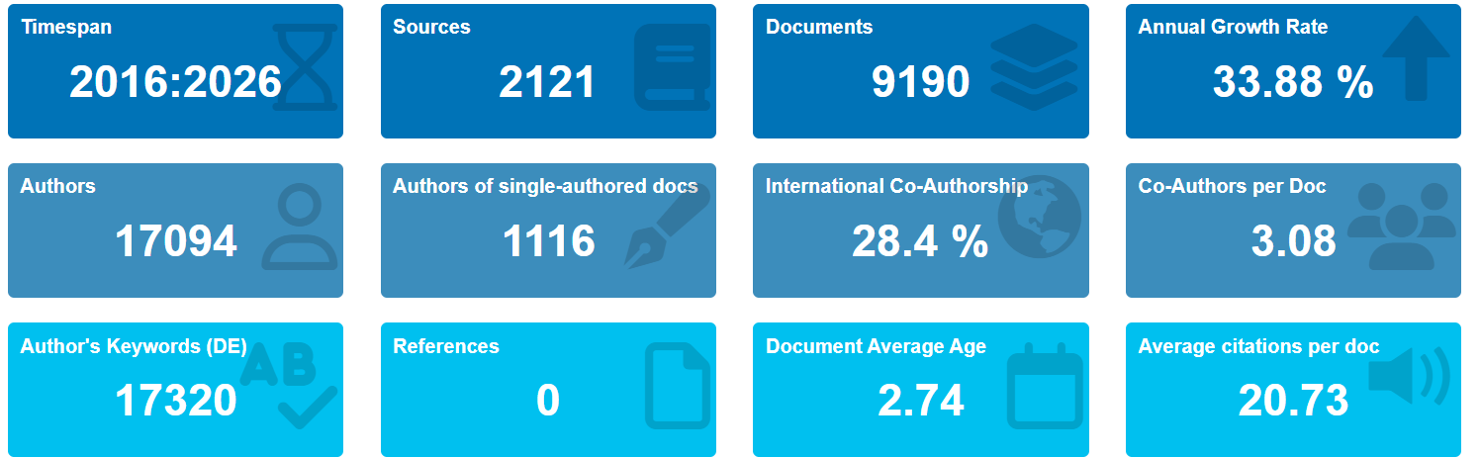
Source: Authors' analysis using Biblioshiny and Scopus data.
The bibliometric analysis of the field shown in the figure offers an all-encompassing picture of the scientific activities undertaken within the chosen research domain during the timeframe of 2016 to 2026. The data set is composed of a large pool of literature, including 9,190 articles that were published in 2,121 unique journals, demonstrating that the field is rich and diverse. The very large number of authors (17,094) shows great academic participation in the field.
The first remarkable indicators is an annual growth rate of 33.88% as it shows that the number of documents on the research grows rapidly and, thus, the theme itself is quite new and developing at present. The reason behind such dynamics may be linked to technological progress in the sphere and changes in the industry. Another important statistic in this regard is that the average age of the document is quite low – it equals 2.74 years.
Another feature worth discussing in relation to collaboration among researchers is the number of authors collaborating per document, on average, which equals 3.08, and the rate of international co-authorship equal to 28.4%. These statistics allow us to draw a conclusion that collaboration becomes an increasingly important aspect of scientific development.
Additionally, the number of author keywords is quite high, which indicates the presence of diverse research topics and themes. It is worth noting that author keywords are essential for determining the trends in the development of this sphere, core research topics, and emerging research interests. Nevertheless, the lack of registered references might be associated with issues regarding data collection and indexing, which should be taken into account while analysing the results.
Concerning the scholarly impact of research, one can say that the citation index shows a fairly positive result of 20.73 citations per document. Thus, it can be stated that the studies have made a valuable contribution to the scientific community.
To conclude, bibliometric analysis has shown that the research area is very dynamic and fast-developing since the output of publications increases constantly, there is active participation of authors, and international cooperation grows. Therefore, the topic of the study is current and highly relevant, which makes it interesting from the scientific point of view.
Scientific Production:
Figure 2. Annual Scientific Production
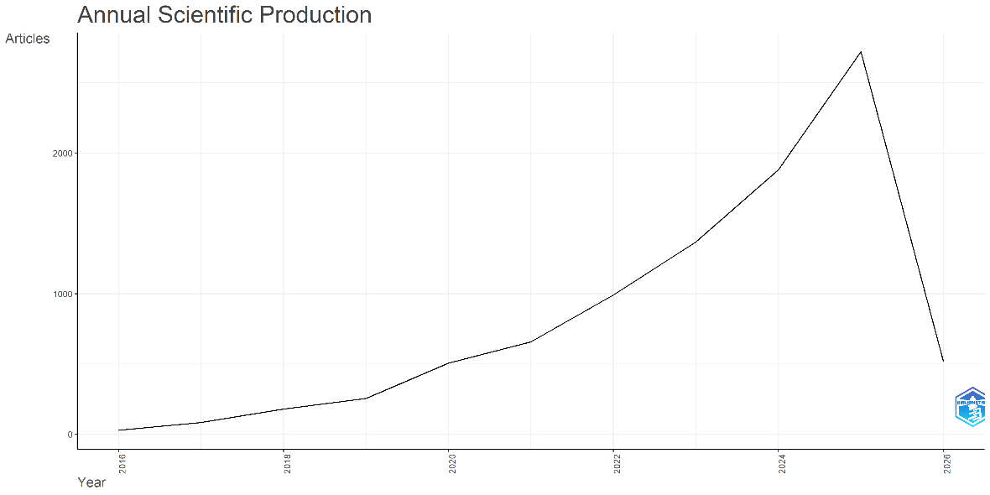
Source: Authors' analysis using Biblioshiny and Scopus data.
The annual scientific output on FinTech shows a steady and significant rise from 2016 to 2026, indicating its emergence as a key research area. Publications grew rapidly after 2018, with a sharp surge post-2020 due to increased digital adoption during the COVID-19 pandemic. This rapid increase in FinTech-related research is consistent with earlier bibliometric studies, which reported exponential growth in scholarly publications after 2020 due to accelerated digitalisation and continuous financial innovation (Abad-Segura et al., 2024; Salem & Shahimi, 2025). The upward trend persisted, reaching its highest level in 2025, reflecting strong interest from both academic researchers and industry practitioners. Overall, FinTech has evolved into a highly dynamic and rapidly expanding field of study, while the comparatively lower publication count observed in 2026 is likely attributable to partial-year data reporting
Average Citations Per Year
Earlier FinTech publications show higher average citations due to longer citation windows with 2017 (89.63) and 2018 (78.26), while recent years record lower averages despite increased output. Overall, the findings reflect rapid growth in research, with citation impact favoring older studies.
Life Cycle of Scientific Production:
The life cycle graph for studies on FinTech shows that this field has undergone a normal growth-maturity phase, beginning with slow emergence from 2016-2018, followed by rapid growth until 2019-2024, after which it began to fall. This trend indicates that the topic has begun maturing, and there has been a stabilising trend in its growth rate.
Most Relevant Authors:
Most Relevant Authors’ section determines those authors who have made the highest number of publications in the database. Of these authors, Y. Wang and Y. Zhang are the authors who have made the highest number of publications with 103 publications each, whereas Y. Liu and Y. Li are ranked second and third with 87 and 86 publications, respectively. Others like X. Li, J. Li, and J. Wang have made considerable contributions in research through their various papers.
Most Relevant Sources:
Figure 3. Most Relevant Sources

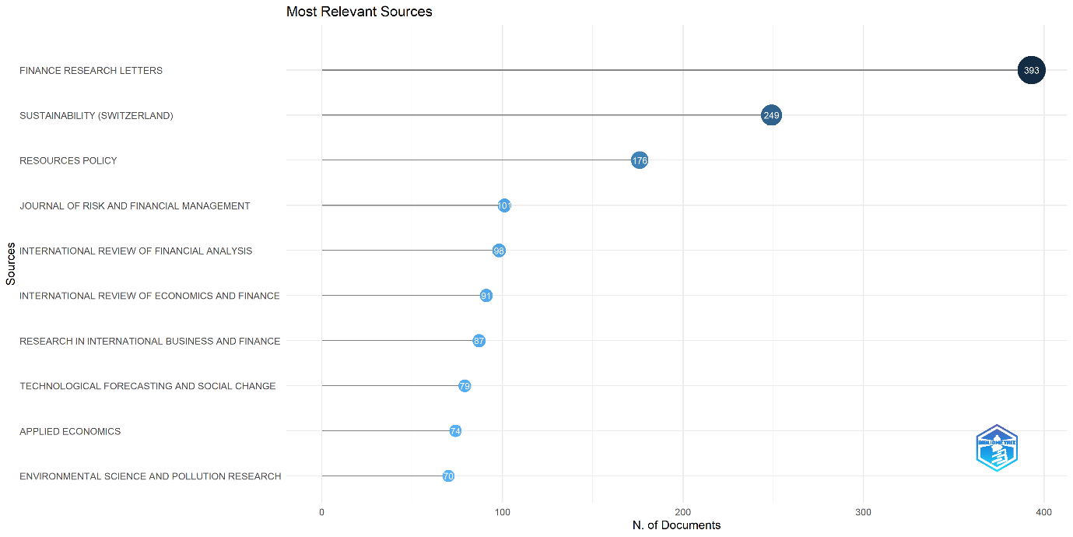
Source: Authors' analysis using Biblioshiny and Scopus data.
The Most Relevant Sources analysis highlights the leading journals in the dataset, with Finance Research Letters contributing the highest number of publications (393), followed by Sustainability (249) and Resources Policy (176) documents. Overall, the findings indicate that research in this field is primarily concentrated in finance, economics, sustainability, and technology-oriented journals.
Productivity based on Lotka's Law
Figure 4. Productivity based on Lotka's Law

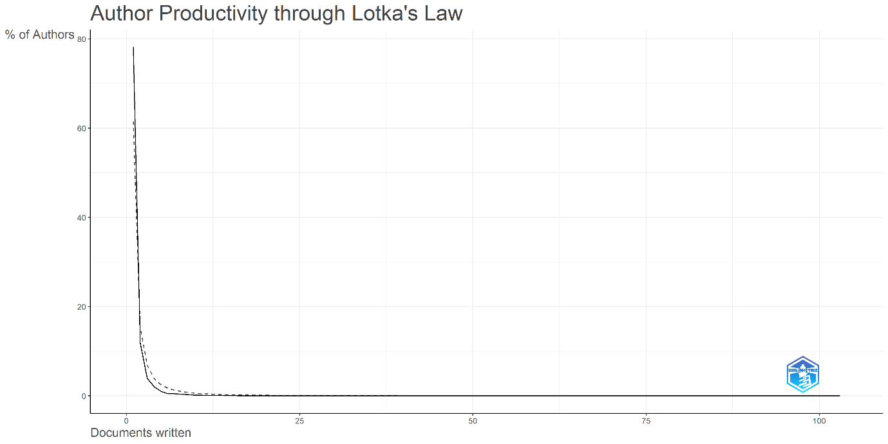
Source: Authors' analysis using Biblioshiny and Scopus data.
Productivity of authors for Financial Technology literature was analysed through the application of Lotka’s Law. According to the results, the significant majority of authors (about 78.2%) had written just a single document, whereas the number of authors progressively decreased along with an increase in their publications. Just a few FinTech scholars published several documents on FinTech. Overall, the obtained data closely correspond to the expected Lotka’s distribution law. This implies that the FinTech research area conforms to a common bibliometric trend according to which a considerable number of scholars participate irregularly in scientific activities, while a few productive scholars produce the major portion of research.
Sources' Production over Time
Figure 5.Sources' Production over Time

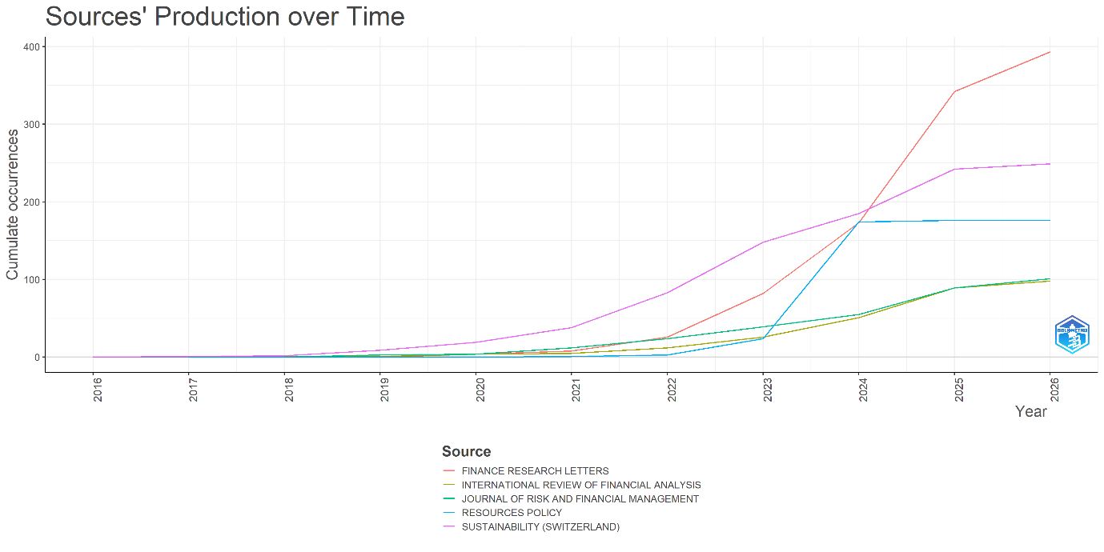
Source: Authors' analysis using Biblioshiny and Scopus data.
The table reveals the annual number of publications of the most productive journals within FinTech research in the period of 2016-2026. From the data provided, one can conclude that journal contributions were minimal in the beginning (in 2016-2018), whereas since 2020 their productivity has increased considerably, which reflects growing interest among academics in the topic of FinTech. One of the journals with the most substantial and stable increases is Sustainability (Switzerland). Thus, starting from only one publication in 2017, this source managed to reach the productivity of 249 publications in 2026. Moreover, the journal Finance Research Letters shows high levels of publications, especially from 2022, where it reached 393 publications, which proves the journal's interest in innovations in finance.
Additionally, journals Resources Policy, Journal of Risk and Financial Management, and International Review of Financial Analysis demonstrate a growing trend in publication numbers over time.
Most Relevant Affiliations
The analysis of institutional affiliations shows that a few leading universities such as Southwestern University of Finance and Economics, lead with 116 publications, followed by Peking University with 87 publications and Zhongnan University of Economics and Law with 79 publications, particularly from China, dominate FinTech research output, with consistent contributions from top institutions. Overall, the findings indicate a strong and growing academic focus on digital finance, with publication activity increasing significantly in recent years.
Countries' Scientific Production
China leads global FinTech research output with 6,054 publications and citations by a wide margin, followed by India(1,889) and the United States (1,409) with significant contributions. Overall, both emerging and developed economies show strong research activity and global influence in this field.
Tree Map:
Figure 6. Tree Map Analysis

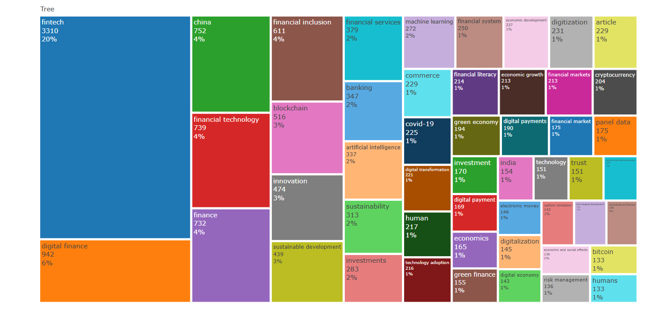
Source: Authors' analysis using Biblioshiny and Scopus data.
The Treemap presents a graphical depiction of the significance of different research themes in the field of FinTech and digital finance. As observed from the figure, the most significant section consists of FinTech (3310; 20%). Clearly, FinTech dominates the field in terms of conceptual and practical considerations of FinTech in the industry. Other research themes include digital finance (942; 6%), which demonstrates that digitization in finance has become more significant in today's economy.
Other notable mid-size clusters include China (752; 4%), finance (732; 4%), financial technology (739; 4%), and financial inclusion (611; 4%). Notably, China appears prominent due to the significant contributions in FinTech and the implementation of digital payments. On the other hand, the presence of financial inclusion among the top themes suggests ongoing academic interest in FinTech. The emerging technology category takes up some noticeable space as well, especially blockchain (516; 3%), innovation (474; 3%), and sustainable development (439; 3%). Moreover, artificial intelligence (337; 2%), financial services (379; 2%), and banking (347; 2%) are notable themes, highlighting the increasing integration of advanced technologies into financial systems. Similar keyword patterns emphasizing financial inclusion, blockchain, digital finance, and artificial intelligence have also been reported in earlier bibliometric investigations (Bo Li & Xu, 2021; Garg et al., 2023; Belouarrat & Azegagh, 2025).Niche research categories include digital payments, financial literacy, green finance, trust, and risk management (all about 1%), which are significant for the research field. In terms of the FinTech domain, these themes are essential because they focus on understanding customer behaviour, FinTech adoption, and sustainability effects in the industry.
In conclusion, the tree map reveals a rather diverse set of FinTech-relevant categories and a clear concentration on FinTech. The main part of research topics concerns the foundational area of the subject. At the same time, the tendency shows that researchers' interests are increasingly interdisciplinary – sustainability, AI, and digitization become popular among scholars.
Network Visualisation:
The visualization presented here is a bibliometric co-occurrence network of keywords, which is probably produced using the software known as VOS viewer, which is widely used for mapping connections within literature studies.
As seen from the picture, “fintech” is the biggest and the most significant keyword present at the core of the map. The size of the nodes denotes the frequency with which the particular keyword was used in the literature under study, and the thickness of the connection indicates the number of simultaneous occurrences.
The map can be split into a number of color-coded groupings, each denoting a particular theme:
Figure 7. Network Visualisation:

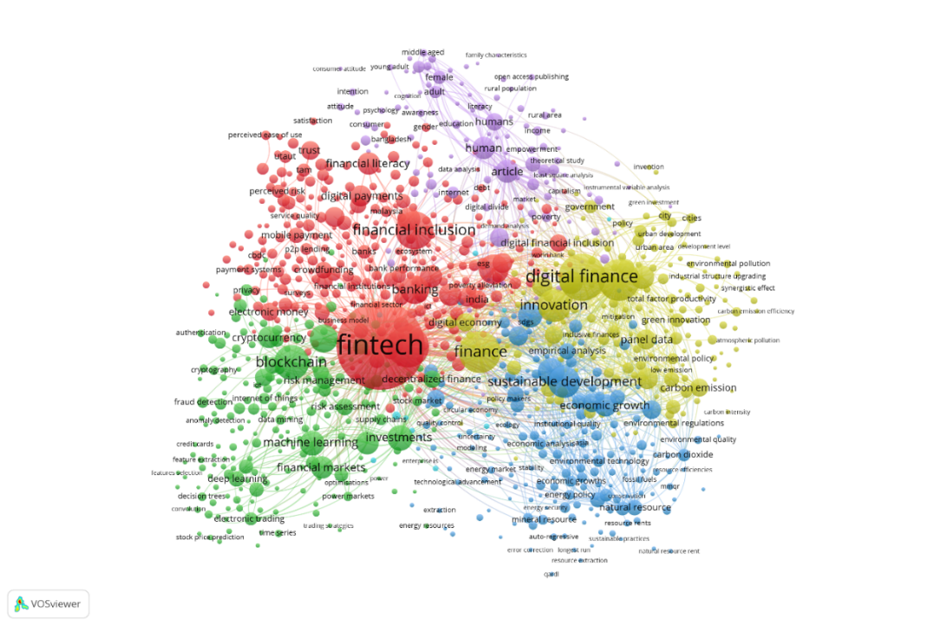

Source: Authors' analysis using VOSviewer and Scopus data.
• The red cluster (financial services and inclusion):
This grouping contains key areas like financial inclusion, digital payments, banking, and financial literacy. The importance of studying fintech as a means of expanding access to financial services among underprivileged groups is highlighted here.
• The green cluster (technology and infrastructure):
Terms in this grouping include blockchain, cryptocurrency, machine learning, and financial markets. These terms reflect the technologies behind the concept of fintech. Innovations in data processing and decentralized algorithms play an important role.
• The yellow cluster (digital finance and innovation):
Digital finance, innovations, and economic development fall under this category. This grouping shows the link between technological innovations and their impact on the economy and productivity.
• The blue cluster (sustainability and environment):
This grouping features sustainable development, carbon emissions, economic growth, and the environmental impact. Fintech contribution to sustainability goals appears to be increasingly researched.
• The purple cluster (human and social factors):
This theme comprises human behaviour, trust, adoption, and demographics. The spatial layout also matters: keywords positioned closer together are more closely related. For example, fintech is centrally located because it connects all clusters, while blockchain sits closer to the technology cluster but still links to finance and innovation.
The interdisciplinary nature of FinTech research identified in this study aligns with findings from Gomber et al. (2017), Brika (2022), and Jafri et al. (2025), who reported strong linkages between finance, technology, innovation, and sustainability.In general, from the map above, it can be seen that the field of fintech research is highly interdisciplinary. In fact, it involves aspects of finance, technology, sustainability, and even social sciences, with financial inclusion being a very important element of the discipline. The emergence of such emerging topics in fintech as machine learning and green finance shows its growing links with other spheres of life.
Findings:
These findings are consistent with previous bibliometric analyses conducted by Bo Li and Xu (2021), Garg et al. (2023), Abad-Segura et al. (2024), Salem and Shahimi (2025), and Syamsiah (2025), all of which reported substantial growth in FinTech-related publications worldwide. This is indicative of FinTech becoming an emerging dynamic interdisciplinary area of research. The major research topics identified include financial inclusion, digital payments, blockchain, artificial intelligence, and sustainability. Financial inclusion and digital finance appear to be the dominant research topics due to the growing role of FinTech in enhancing financial access. Collaboration among researchers and institutions appears to be strong, suggesting an increasing global interest in academia. Regionally, China, India, and the United States appear to be the largest contributors to studies on FinTech. In terms of journal types, studies appear to be mainly disseminated through journals associated with finance, technology, and sustainability. While there has been rapid progress in FinTech, it appears that there is an absence of research studies on how the adoption of FinTech may impact business performance, especially in the organized retail industry.
Implications:
The primary objective of this study was to conduct bibliometric analysis on global research trends in Financial Technology (FinTech) between 2016 and 2026. The findings show that FinTech has become one of the leading fields of scientific research owing to growing digitalization, technology adoption, and alteration of people's financial behaviours across the world. Some dominating themes include financial inclusion, blockchain, digital payments, artificial intelligence, and sustainability, proving that FinTech research is inherently multidimensional.
The findings support earlier studies that identified FinTech as a rapidly evolving multidisciplinary field encompassing finance, technology, sustainability, and innovation (Milian et al., 2019; Broby, 2021; Del Sarto & Ozili, 2025). Moreover, the prominence of financial inclusion and digital finance themes confirms observations made in recent bibliometric studies (Belouarrat & Azegagh, 2025; Jafri et al., 2025).
The Findings of the paper are aligned with existing bibliometric analyses of FinTech, which have identified blockchain and digital finance as crucial aspects of FinTech developments. However, while previous studies focused primarily on technological innovations or FinTech applications in banking, the current research expands the scope of the analysis by considering sustainability and performance-related themes, thus providing an additional level of comprehensiveness and a more up-to-date view on FinTech research dynamics in the digital economy post-COVID pandemic.
One of the main advantages of the study is that it integrates both structural and thematic bibliometric analysis, which helps identify emerging research clusters and evolving scholarly ties. Understudied topics highlighted in the analysis include the use of FinTech tools for enhancing operational efficiency and retail business performance, as well as improving customer experience.
Although the research offers various insights, some limitations apply. Firstly, the methodology is limited to analyzing the bibliometrics available from chosen databases and the scientific literature. Secondly, the focus of the research was mainly on the methods used to map the field in question, without conducting any further empirical examination of FinTech applications.
Future Scope:
Future research should include a study on how the use of FinTech affects business and organizational performance. Future research can include a study on how FinTech like digital payments, mobile wallets, BNPL solutions, and AI-powered financial system affects sales volume, customer satisfaction, efficiency, and profitability. Another aspect that researchers can consider in their future studies is how FinTech can contribute to creating sustainable business practices, including green finance and going paperless.
Moreover, future researchers can incorporate constructs from behavioural and psychological theories in their research in order to shed more light on the factors affecting the adoption of FinTech. Future studies may also explore factors influencing FinTech adoption across different sectors and economies, as recent bibliometric evidence highlights growing scholarly interest in adoption drivers and implementation challenges (Silva et al., 2026). Researchers may further conduct comparative studies between developed and emerging economies to better understand contextual differences in FinTech adoption and usage.
Concluding Remarks:
In summary, the study highlights the emergence of FinTech as an increasingly growing multidisciplinary field of research with immense theoretical and practical significance. There is a considerable increase in the number of articles published, collaborations between scholars, and a variety of research areas over the last decade. Financial inclusion, digital finance, blockchain, artificial intelligence, and sustainability continue to be the leading areas of FinTech research. However, the research reveals some crucial research areas, especially relating to the role of FinTech in enhancing the efficiency of business and retail operations. The results of the study will assist researchers, policymakers, and practitioners with insights into recent trends, promising areas of study, and future directions in FinTech research.
Reference:
- Abad-Segura, E., González-Zamar, M. D., & López-Meneses, E. (2024). FinTech development: A bibliometric analysis of the Scopus database (2014–2024). Procedia Computer Science, 251, 49–56. https://doi.org/10.1016/j.procs.2024.11.083
- Aria, M., & Cuccurullo, C. (2017). Bibliometrix: An R-tool for comprehensive science mapping analysis. Journal of Informetrics, 11(4), 959–975. https://doi.org/10.1016/j.joi.2017.08.007
- Arner, D. W., Barberis, J., & Buckley, R. P. (2016). The evolution of FinTech. Northwestern Journal of International Law & Business, 37(1), 127–157. https://doi.org/10.2139/ssrn.2676553.
- Baas J, Schotten M, Plume A, Côté G, Karimi R (2020) Scopus as a curated, high-quality bibliometric data source for academic research in quantitative science studies. Quant Sci Stud 1(1):377–386. https://doi.org/10.1162/qss_a_00019
- Belouarrat, Y., & Azegagh, J. (2025). The role of FinTech in digitalization of financial services: A bibliometric analysis. International Journal of Research in Economics and Finance. https://doi.org/10.71420/ijref.v2i2.53
- Bo li, & Zeshui Xu (2021). Insights into financial technology (FinTech): A bibliometric and visual study. Financial Innovation, 7, 69. https://doi.org/10.1186/s40854-021-00285-7
- Boot A, Hoffmann P, Laeven L, Ratnovski L (2021) Fintech: what’s old, what’s new? J Financ Stab. https://doi.org/10.1016/j.jfs.2020.100836
- Brika SKM (2022) A bibliometric analysis of Fintech trends and digital finance. Front Environ Sci. https://doi.org/10.3389/fenvs.2021.796495
- Broby D (2021) Financial technology and the future of banking. Financ Innov. https://doi.org/10.1186/s40854-021-00264-y.
- Del Sarto, N., & Ozili, P. K. (2025). FinTech and financial inclusion in emerging markets: A bibliometric analysis and future research agenda. International Journal of Emerging Markets. https://doi.org/10.1108/IJOEM-08-2024-1428
- Donthu, N., Kumar, S., Mukherjee, D., Pandey, N., & Lim, W. M. (2021). How to conduct a bibliometric analysis. Journal of Business Research, 133, 285–296. https://doi.org/10.1016/j.jbusres.2021.04.070
- Douglas W. Arner, Janos Barberis, & Ross P. Buckley (2016). The evolution of Fintech: A new post-crisis paradigm. Georgetown Journal of International Law, 47(4), 1271–1319. https://doi.org/10.2139/ssrn.2676553
- Garg, G., Shamshad, M., Gauhar, N., Tabash, M. I., Hamouri, B., & Daniel, L. N. (2023). A bibliometric analysis of FinTech trends: An empirical investigation. International Journal of Financial Studies, 11(2), 79. https://doi.org/10.3390/ijfs11020079
- Gomber, P., Koch, J. A., & Siering, M. (2017). Digital finance and FinTech: Current research and future research directions. Journal of Business Economics, 87(5), 537–580. https://doi.org/10.1007/s11573-017-0852-x
- Jafri, J. A., Amin, S. I. M., & Rahman, A. A. (2025). Financial technology (Fintech) research trend: A bibliometric analysis. Discover Sustainability, 6(513). https://doi.org/10.1007/s43621-025-01225-6
- Khurana, K. (2023). A bibliometric analysis of FinTech adoption research using VOSviewer. Journal of Educational Technology Systems, 51(4), 503–512. https://doi.org/10.1177/00472395231165715
- Lee, I., & Shin, Y. J. (2018). FinTech: Ecosystem, business models, investment decisions, and challenges. Business Horizons, 61(1), 35–46. https://doi.org/10.1016/j.bushor.2017.09.003
- Milian, E. Z., Spinola, M. D. M., & de Carvalho, M. M. (2019). FinTechs: A literature review and research agenda. Electronic Commerce Research and Applications, 34, 100833.https://doi.org/10.1016/j.elerap.2019.100833
- Nicoletti Bernardo,(2017). The future of FinTech: Integrating finance and technology in financial services. Springer. https://doi.org/10.1007/978-3-319-51415-4
- Nitesh Donthu, Satish Kumar, Debmalya Mukherjee, Nir K. Pandey, & Weng Marc Lim (2021). How to conduct a bibliometric analysis: An overview and guidelines. Journal of Business Research, 133, 285–296. https://doi.org/10.1016/j.jbusres.2021.04.070
- Peter Gomber, Robert J. Kauffman, Chris Parker, & Bruce W. Weber (2018). On the Fintech revolution: Interpreting the forces of innovation, disruption, and transformation in financial services. Journal of Management Information Systems, 35(1), 220–265. https://doi.org/10.1080/07421222.2018.1440766
- Syamsiah, S. (2025). Bibliometric analysis of financial technology (FinTech) and its implications for financial management. International Journal of Education, Social Studies, and Management, 5(2), 1276–1289. https://doi.org/10.52121/ijessm.v5i2.867
- Salem, M. R. M., & Shahimi, S. (2025). A comprehensive analysis of FinTech (1968–2025): A bibliometric approach. Future Business Journal, 11, 233. https://doi.org/10.1186/s43093-025-00652-1
- Silva, S. R. T., Coelho, A. F. M., & Proença, C. A. N. (2026). Drivers of FinTech adoption: A bibliometric approach. Financial Innovation, 12(83). https://doi.org/10.1186/s40854-025-00855-z
- Thomas philippon (2016). The FinTech opportunity. National Bureau of Economic Research Working Paper No. 22476. https://doi.org/10.3386/w22476.

