SYNTHESIS AND CHARACTERIZATION OF LOW OXIDATION STATE COLBALT CHELATES USING 8-HYDROXYQUINOLINE OXINE AS A LIGAND.
Aquiline Kathambi
Department of Chemistry, Kenyatta university
Abstract
Square planar complexes of cobalt in any of its common oxidation states are rare and attempt to make them either yield tetrahedral or octahedral complexes. The aim of this study was to synthesize and characterize low oxidation state complexes of cobalt using selected chelating ligands including 8-hydroxyquinoline (oxine). It was of interest to synthesize cobalt (I) complexes of square planar geometry as these are expected to have the same mode of action as the square planar cis-platin used in the treatment of some forms of cancer. Square planar cobalt (I) complexes are rare in the literature. The reactions of CoCl₂ with 8-hydroxyquinoline (oxine) were studied under different solvent conditions under inert conditions. Reaction of cobalt (II)chloride with oxine in tetrahydrofuran (THF) solvent gave unexpected blue crystals of the tetrachloridocobaltate (III) complex [CoCl₄]⁻[C₉H₇NOH]⁺, in which protonated oxine is the counter cation. The molecular structure of the complex [CoCl₄]⁻[C₉H₇NOH]⁺ was confirmed using single crystal X-ray crystallography. It forms monoclinic crystals in the C2/c space group with respective unit cell parameters beingα= 90.00, β= 91.0900, γ= 90.00; a = 15.1890(3), b = 7.99120(10), c = 16.6770(3). When the same reaction was carried out in water/ethanol mixture, a yellow non crystalline solid, [Co(oxine)₂(H₂O)₂]Cl₂ was obtained. These compounds were characterized by melting point determination, elemental analysis and FTIR spectroscopy

Keywords: Oxine; Cis-platin; Colbalt (i) complexes; Tetrahydrofuran; FTIR Spectroscopy
- Introduction
The discovery of the platinum-based pharmaceutical cis-platin about 4 decades ago spurred research in medicinal inorganic chemistry that is still thriving [2]. Cis-platin remains the best-selling antitumor drug in world more than 30 years since it was approved as an antitumor agent. During the last three decades, a number of coordinated metal complexes have been synthesized, characterized and tested both in cell culture and animal models for antitumor activity [1] However, only the complexes of platinum are currently in routine clinical use. Cis-platin also known as cisdiamminedichloridoplatinum(II) (CDDP) is used to treat various types of cancers including breast, head, cervical, testicular, neck, ovarian, stomach, bladder, lung, oesophageal and prostate cancer. Complexes of platinum react in vivo, by binding and causing cross links to DNA (Figure 1) triggering apoptosis [2]. There are various major challenges associated with the current platinum drugs, regardless of the achievements. These platinum drugs are active to a limited number of tumors. Intrinsic resistance is acquired by some tumors causing nausea, vomiting, suppression in bone marrow and toxicity in the kidney which are severe side-effects [3]. Although around ten other complexes of platinum are undergoing clinical trials currently, derivatives of cis-platin are still not yet able to adequately address some challenges related to cis-platin chemotherapy.
New ways that target purposefully better complexes should be studied to overcome the challenges.
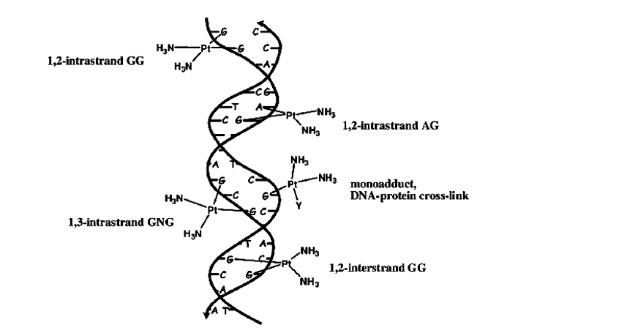
Figure 1: Various types of DNA-Cis-platin adducts

Many studies on the working of transition metal complexes biologically have shown encouraging pathways to target antitumor drug developed with classical and non-classical targets [1].

Over the last years, cis-platin analogues have been viewed as possible anticancer agents. However, only two of those analogies such as carboplatin and oxaliplatin have been used clinically. Cis-platin alters the physical structure of DNA (Figure 1) when it binds to it, but the overall structure remains undestroyed [1]. The drug operates by damaging the RNA or DNA that directs the cell to be copied during the cell division. It influences self death (cell suicide or apoptosis). Its use clinically is limited due to high adverse effects of the 3 drug, especially nausea, vomiting, nephrotoxicity [4] neurotoxicity [5] and ototoxicity [6].
Many examples of metal complexes used as drugs have been cited in the literature. For instance rheumatoid arthritis is treated using gold containing complexes such as Auranofin [7].
More studies have been carried out on complexes of cobalt having bidentate and tri-dentate cytotoxic ligands [1]. These studies indicated that hypoxia selectivity of complexes cobalt (III) is not based on redox cycling completely. They are based on many more mechanisms such as exchanging the ligand without first reducing cobalt (III) or competing for O₂ for biological reductants. Cobalt (III) can be coordinated to ascorbate and cysteine when reduced [1]. Yamamoto and co-workers showed that cysteine and ascorbate can give fluorescent ligands from their complexes. The release of the ligand is in accordance with their reducing potentials. The reduction step of cobalt (III) complexes leads to the release of cytotoxic ligands and generation of ROS based on the process of catalytic auto oxidation step [8].

- Materials and methods
2.1 Materials

All preparations were done in an atmosphere of dry, oxygen-free nitrogen. Unless stated otherwise, all organic solvents were freshly distilled before use. Dichloromethane was refluxed over phosphorous pentoxide and distilled in an atmosphere of dry, oxygen-free nitrogen to further remove any traces of water. Tetrahydrofuran (THF) was refluxed over sodium metal until the benzophenone indicator turned deep purple, then distilled under inert atmosphere. Methanol and Ethanol obtained after treatment with anhydrous magnesium sulphate were refluxed over calcium oxide in an atmosphere of dry, oxygen-free nitrogen. Analytical grade 8 hydroxyquinoline (oxine) was bought from precise laboratory and allied supplies. CoCl₂ and glycine were bought from Kobian Kenya Limited. Single crystal XRD for the oxine complex was done at the school of Chemistry, University of Kwa-Zulu Natal, South Africa. C/H/N/O determination was done on a Perkin Elmer 2400 CHN elemental analyzer. Infrared spectra were recorded at the of range 4000 cm-1 - 400 cm-1 on an FTIR-8400 Shimadzu spectrometer. Solid samples were molded into KBr discs by grinding them (0.1-0.2%) with KBr into fine powder which was then pressed into transparent discs, mounted onto the spectrometer and scanned. Single crystal XRD data for one oxine complex was recorded using Bruker APEX II 4 K CCD Detectors at 100(2) K.

2.2 Gravimetric determination of halides

The halogens were determined gravimetrically as the silver halide [9]. The sample containing chloride ions was accurately weighed and transferred into a 250 ml beaker and digested using 5 ml of AR grade concentrated nitric acid. 100ml of the solution were transferred into a 250 ml beaker. 30 ml of 0.1M AgNO₃ from a burette were added to the solution drop by drop while stirring until no more precipitate formed. The beaker was covered using a watch glass then, wrapped with an aluminum foil to prevent photodecomposition of the silver halide precipitate. The precipitate was coagulated by gently warming it on a hot plate for 30 minutes. When the supernatant was clear, a few drops of 0.1mol AgNO₃ were added to test for completion of precipitation of the halide ions. When no turbidity was seen, the beaker was kept in a dark cupboard to cool for two hours and the filtrate separated by filtration in a pre weighed G-4 sintered glass crucible. Residue was washed many times using very dilute HNO₃ until the filtrate gave no turbidity with 0.1M HCl. The residue on the sintered glass crucible was dried on an electric oven at 140 °C cooled in a desiccators containing phosphorous pentoxide and weighed. The process of heating, cooling and weighing was repeated until a constant weight was obtained. The determinations were carried out in duplicate.

2.3 Reaction of cobalt (II) chloride with oxine in THF

A three-necked round bottomed flask equipped with a condenser was set up on a heating mantle. As dry, oxygen-free nitrogen was passing through the system, accurately weighed 5.95 g (0.025 moles) of cobalt (II) chloride was transferred into the round bottomed flask. About 20mL of THF was added. 20 ml SOCl₂ was poured to the solvent and the mixture refluxed for one hour to dry the solvent. 3.63 g (0.025 moles) of 8-hydroxyquinoline was weighed and dissolved in THF. The solution was added to the round bottomed flask in small portions in a period of about 10 minutes. The mixture was refluxed for 2-3hrs after which it was allowed to cool under nitrogen to room temperature. A blue precipitate was formed at the bottom of the flask. The solid was recovered by filtration and transferred to a Schlenk tube, where it was dried under reduced pressure. 24 Melting point of the complex was determined using Gallen Kamp melting point apparatus and was found to be 217-242ºC.

2.4 Reaction of cobalt (II) chloride with oxine using water

Accurately weighed 5.93g (0.025moles) of hydrated cobalt (II) chloride was dissolved in 20mL water. 3.63g (0.025moles) of oxine was dissolved in 25 ml ethanol. The two solutions were mixed and stirred with magnetic stirrer while heating with a hot plate maintained at 65ºC for 2-4 hours. The solution was cooled until a yellow precipitate was formed which was filtered, washed using ethanol and then dried under reduced pressure. The melting point was determined in duplicate and was found to be 187-197ºC. Elemental analysis results were consistent with the formulation CoCl₂(Oxine)₂(H₂O)₂.

2.5 Reduction of CoCl₂.6H₂O with NaBH4 in the presence of oxine

suspension of NaBH₄ (0.2g, 0.0052 moles) in 10mL ethanol was added drop wise to a stirred suspension of CoCl₂.6H₂O (4g, 0.016moles) and oxine (1.2g, 0.008moles) in benzene/ethanol 2:1 10ml. A gas assumed to be H₂ was produced during the initial stages of the NaBH₄ addition and the blue suspension changed instantly to orange and then to dark orange within a period of 15 minutes. After adding NaBH₄ suspension, dark crystals were produced. They were filtered off, then washed with ethanol, followed by water and ether then dried under reduced pressure.

2.6 Single crystal X-ray diffraction data

Crystals of [CoCl4]-[C9H7NOH]⁺ suitable for X-ray diffraction studies were obtained by slow solvent evaporation. Intensity data were collected on a Bruker APEX II 4k CCD area detector diffractometer with graphite monochromatic Mo Kα radiation (λ = 0.71073 Å) (50 kV, 30 mA) using the APEX II data collection software. Data reduction was carried out using the program SAINT+ and face indexed absorption corrections were made using XPREP. “The crystal structure was solved by direct methods using SHELXTL [13]. Using SHELXTL non-hydrogen atoms were isotropically refined first followed by anisotropic refinement by full matrix least-squares calculations based on F2. First hydrogen atoms were located in the difference map then geometrically positioned and then allowed to ride on their respective parent atoms. Diagrams and publication material were generated using SHELXTL, platon and ORTEP”. Table 3.3 summarizes crystal data and structure refinement information while specific bond length and angles are given in Tables 3.2.

- Results and discussions

3.1 Elemental analysis

Table 3:1: Elemental analysis for oxine cobalt complexes
Compound | C (%) | N (%) | H (%) | O (%)
[CoCl₄]-[C9H7NOH]⁺ | 30.04(30.4) | 3.79(3.95) | 2.33(2.02) | -
CoCl₂(Oxine)2(H2O)₂ | 56.07(56.41) | 7.58(7.31) | 4.17(4.21) | 16.35(16.70)
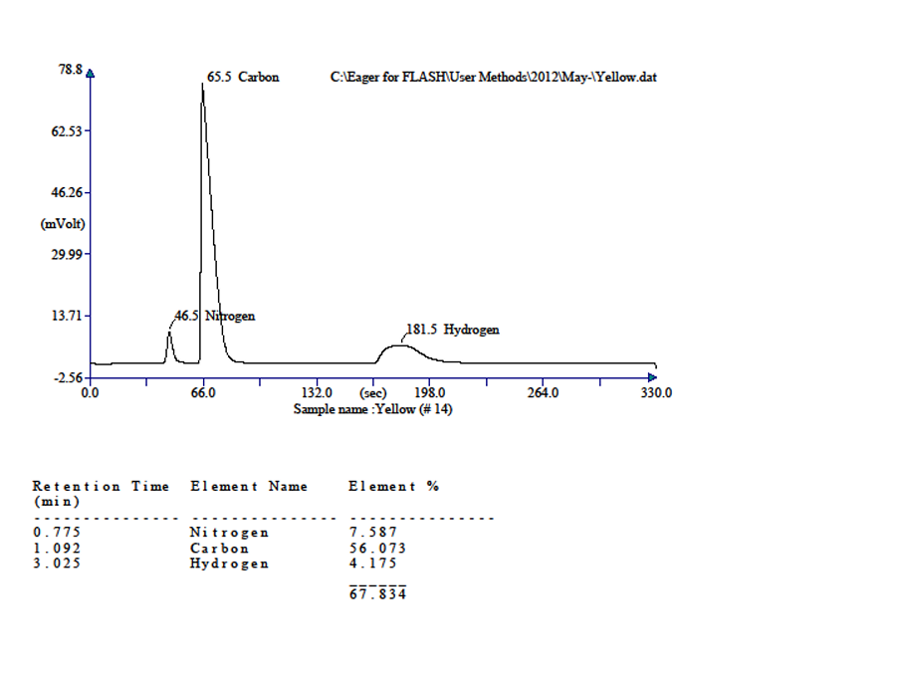
3.1 Infra-red absorption data.

3.2.1 Reaction of cobalt(II) chloride with oxine in THF using SoCl₂

Reaction of CoCl₂ with glycine in 1:2 mole ratios in methanol/ethanol at 40^{oC} resulted in the formation of a purple solid which was found to be Co(gly)Cl₃ in which only one glycine ligand was coordinated to the metal centre. This formulation was arrived at on the basis of elemental analysis as well as gravimetric analysis. This solid simply precipitated out of solution once it was cooled to room temperature. The solid melted without decomposition at 128-141ºC. The IR 27 spectrum showed broad bands in the region 3550 cm⁻¹ to 3050 cm⁻¹assignable to the N-H stretching of the amine coordinated to the Co centre. In the free ligand this band occurs in the region 3050-2675 cm⁻¹. Shifting indicates that the glycine is coordinated to the metal through the amine centre. The infra-red of the complex was measured in the region 400-700cm⁻¹ in so as to identify frequencies of M-O and M-N. The spectrum showed a band at 606cm⁻¹ assigned to M-O while M-N frequencies were identified 501cm⁻¹.”These results are in agreement with literature value being similar to other metal complexes with amino acid” [10]. Weak band at around 2822 cm⁻¹ compares favorably with the CH₂ symmetric stretch. The strongest absorption bands in all the spectrum of glycine are those associated with N-H stretching appearing at 3170 cm⁻¹, C=O stretching at 1650 cm⁻¹, N-H deformation at 1540 cm⁻¹.

3.2.2 Reaction of cobalt (II) chloride with oxine in water

Reaction of CoCl₂ with oxine in 1:1 mole ratio in water at 65ºC, resulted in the formation of a yellow solid which was found to be [Co(oxine)₂(H₂O)₂]Cl₂ from elemental and gravimetric analysis. This solid is soluble in water at room temperature. The solid melted without decomposition at 187-197ºC The IR spectrum of the complex shows new bands at 450 cm⁻¹ corresponds to ν (M-O) and 503 cm⁻¹ corresponds to ν (M-N), which are not found in the spectrum of the free oxine. The carbon-oxygen (C-O) vibration bands at 1104.25 cm⁻¹ show a frequency change due to change of electronic distribution in the environment of the C-O band on chelating. The vibration bands in the region of 1650 cm⁻¹ to 1400 cm⁻¹ of C=N and C=C stretching vibration are shifted to the lower frequencies in the spectra of the metal complexes than the respective bands in the oxine. The shift could be explained on the assumption that during chelating, the electron distribution of the quinoline ring is disturbed slightly and partially due to chelation. The usual ring skeleton ν(C-C) and ν(C-N) bands are observed around 1600 cm ⁻¹ , 1450 cm⁻¹, and 1370 cm⁻¹. In the chelates the band observed around 450 cm⁻¹ corresponds to ν 29 (M-O), suggesting that phenolic groups are involved in bond formation with metal ion and 503 cm⁻¹ corresponds to ν (M-N). One more band in the range of 750-830 cm⁻¹ attributable to rocking and wagging modes of vibration of water (H₂O) was present in the coordination complex but not in the free oxine ligand [11].

3.3 Structural characterization of [CoCl₄]-[C₉H₇NOH]⁺

Crystals of [CoCl₄]-[C₉H₇NOH]⁺ were obtained as blue-green blocks that crystallized in the monoclinic C2/c space group, with one anion and two cations in the asymmetric unit (see packing in Figure (3.1).

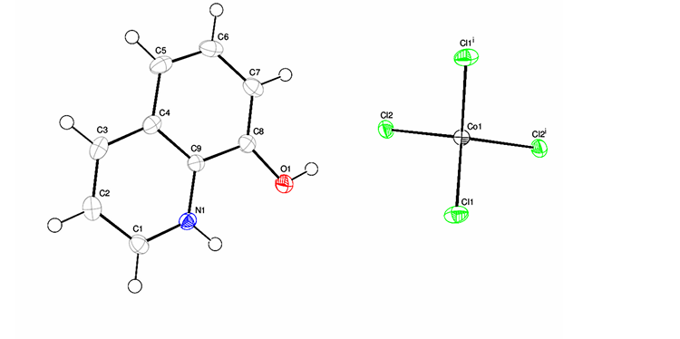
Figure 3.1: ORTEP diagram of [CoCl4]-[C9H7NOH]+

The bond angles around the Co metal Cl(1) Co(1) Cl(2) (112.65) shows slight deviations from the tetrahedral angles of 109° giving the crystal a distorted tetrahedral geometry. Figure 3.2 illustrates the parking of the molecules in the crystal viewed down the axis b. The molecules are 30 arranged in layers and the asymmetric units alternate in orientation along the c axis such that the pairs of cations have the OH groups facing opposite directions in a staggered manner.

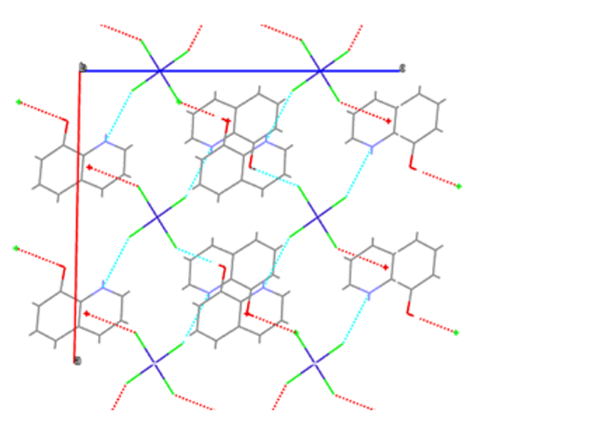

Figure 3.2: The parking diagram for [CoCl₄]-[C₉H₇NOH]⁺ viewed along b axis

Figure 3.3 shows the hydrogen bonds between the cations and anions in the structure. Each anion is surrounded by four cation pairs which are in staggered orientation such that the anion is hydrogen-bonded to four different cations from the four pairs i.e. two Cl atoms are hydrogen bonded to the OH groups while the remaining two are hydrogen-bonded to the NH groups of the cations. The remaining four cations are hydrogen bonded to four of the surrounding [CoCl₄]- chlorides.

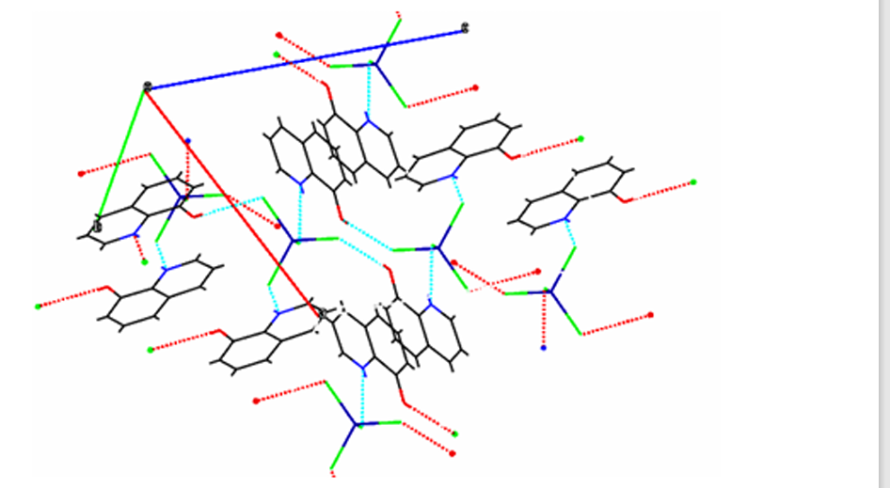
Figure 3.3: The parking diagram for [CoCl₄]-[C₉H₇NOH]⁺ showing H-bonds
The bond distances and angles are given in table 2 and the parameters for crystal data in Table 3.2. The Co1-Cl1 bond lengths are notably longer than Co1-Cl2. The average bond between the metal Co and the surrounding chlorides Cl1 and Cl2 does not compare well with those reported for a similar complex [12].
Table 3:2: Bond lengths (Å) and angles (°) for [CoCl₄]-
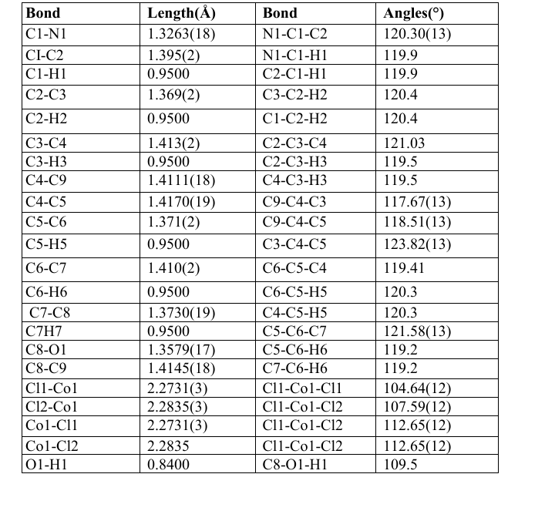
Table 3.3: Crystallographic data for [CoCl4]-[C9H7NOH] +
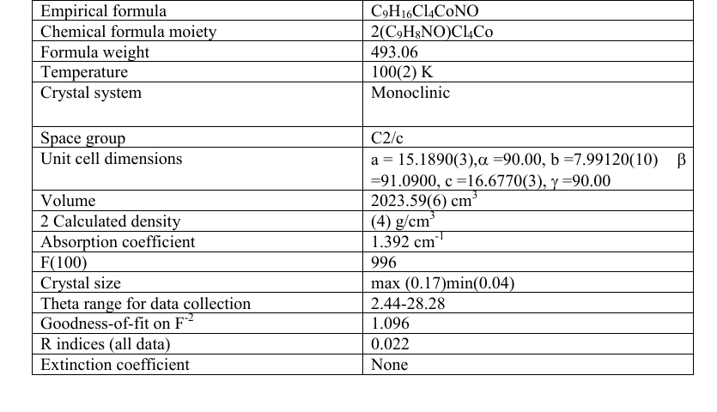
4.0 Conclusion

The Co(II) chloride salt reacts with chelating ligands to give high yields of the chelates but the kind of complex obtained depends on the conditions of synthesis. When hydrated cobalt(II) chloride reacts with the chelating ligand oxine in THF in the presence of thionyl chloride, the result was the unexpected Co(II) complex [CoCl₄]-[C₉H₇NOH]⁺ in which protonated oxine acts as the counter anion and not a ligand. Reaction of cobalt(II) salt with the same ligand in water/ethanol solvent mixture gave [Co(oxine)₂(H₂O)₂]Cl₂ in which the metal retained oxidation state (II) and the chelating ligand is coordinated to the metal.

Conflict of interest
The authors declare that they have no conflict of interest
Acknowledgement
Special thanks to the Mr. Antony Njagi Chemistry Department, laboratory technician of Kenyatta University, for assisting in providing relevant glassware, chemicals and reagents used during the study. Thanks to all staff members of Chemistry Department, Kenyatta University for assist me in various ways.
REFERENCE
- Jungwirth, U., Christian, R., Bernhard, K., Christian, G. Walter, B., and Petra, H. (2011). Anticancer activity of metal complexes: involvement of redox processes, Journal of PMC Author Manuscripts, 4, 1085-11327.
- Sabine, H., and Rujt, V., Peter, J. (2009). Drugs discovery, 14, 22-24. Sasaki, Y., Amano, T., Morita, M., Shinkai, T., Eguchi, K., Tamura, T., Ohe, Y., Kojima, A., and Saijo, N. (1991). Phase I study andpharmacological analysis of cis-diammine(glycolato)platinum administered by 5-day continuous intravenous infusion, Cancer Research Journal, 5, 1472-1477.
- Ana, M., and Deitrich, B. (2011). Cisplatin as an antitumor drug: cellular mechanisms of activity, drug resistance and induced side effects, Cancers (Basel), 3, 1351-1371.
- Pabla, N., and Dong, Z. (2008). Cisplatin nephrotoxicity: mechanisms and renoprotective strategies, Journal of Kidney International, 73, 994-1007. Pantoja, L. (2005). Differences between asymmetric cis and trans platinum complexes. 10-11
- Whinney, S., Goldberg, R., and McLeod, H. (2009). Platinum neurotoxicity pharmacogenetics. Journal of Molecular Cancer Therapy, 8, 10-16.
- Rybak, L., Whitworth, C., Mukherjea, D., and Ramkumar, V. (2007). Mechanisms of cis-platin induced ototoxicity and prevention, Journal of Hearing Research, 226, 157-167.
- Kean, W., Hart, L., and Buchanan, W. (1997). Disease-modifying drugs, British Journal of Rheumatology, 36, 560-572. Magdalene, K. (1982). Synthesis, characterization, antitumor and antimicrobial activities of heterocyclic transition metal complexes. 24-28
- Telma, F., Luisa, M., Martins, F., Fatima, C., Gledes, D., Alexandra, R., Fernandes, S., Ana, S., Pedro, M., and Borracho, S. (2012). Cobalt complexes bearing scorpionate ligands, Dalton Transactions, 41, 12-288.Afshin, Z., and Sara, A. (2011). Selective COX-2 inhibitors, Journal of Pharmaceutical Research, 4,655-683.
- Sharma, A., Gangrade, S., and Bakshi, J. (2014). Ruthenuim complexes-potential candidate for antitumor activity, International Journal of Chemical Technological Research, 6, 828-837 Agnieseka, C., Artur, S., Aleksandra, D., and Lech, C. (2013). Potassium trans bis(oxalito)diaquacobaltate(II) tetrahydrate: synthesis, structure, potentiometric and thermal studies, European Journal of Chemistry, 1, 8-15.
- Sokol, V., Kolyadina, N., Kvartalov,V., Sergienko, A., Soldatenkov, V., and Davydov, V. (2011). Synthesis and molecular structure of cobalt(II) chloride complexes with bis(α-pyridyl substituted bispidinaoza-14-crown 4, Russian Chemical Bulletin International Edition, 60, 2124 2127 Ana, M., and Peter, J. (2009). Unusual binding modes for metal anticancer complexes, Biochemie, 10, 1198-1211.
- Chuhhua, H., Qi, L., and Ulli, E. 2003. Structural trends in one and two dimensional coordination polymers of cadmium (III) with halide bridges and pyridine type ligand, Journal of Crystal Engineering Communication, 5, 519-529.
- Faliah, H., and Thaera, A. (2013). Synthesis and investigation of complexes formation between amino acid glycine and various metal ion by using spectroscopic methods, Journal of Chemical and Pharmaceutical Research, 11, 318-321.Anna, K. (2014). Transition metal complexes with bioactive ligand: mechanisms for selective ligand release and application for drug delivery. Royal Society of Chemistry, 6, 1345-1355.
- Basset, J., Denny, R., Jeffrey, G., and Mendham, H. (1978).Vogel’s Textbook of Quantitative Inorganic Analysis 4th edition ELBS and Longman London, 433-435. Bernard, D. (2004). Metals and metal compounds in cancer treatment, Journal of Anticancer Research, 24, 1529-1544.

