Analyzing the behavior of rotor side Converter during the Symmetrical grid voltage dips occur with crowbar protection in of Doubly Fed Induction Generator (DFIG) based Wind Turbine (WT).

Abstract
During the voltage dips what kind of behavior is appeared in the rotor side control of DFIG biased wind turbine is discussed in this paper. When grid voltage drops happen in the WT that has an impact on rotor side system because of the windings of stator & rotor are connected with each other magnetically, thus abnormal current will be flowed through the rotor side converter and damage the system. The stator voltage falls very quickly but stator flux can’t fall as quickly as stator voltage, & impedance voltage is going to be small but at same time rotor voltage is increased too high at the beginning of the voltage dips and the system lose the control. The Crowbar protection is connected to solve this problem in parallel with the rotor side converter. The main issue of this paper is to analyze the behavior of the rotor side converter control during the voltage dips. The Matlab Simulink results are showed the behavior of the rotor side converter control during the voltage dips.

Keyword: DFIG, Voltage Dips, Crowbar protection & Rotor Side converter.

Introduction

At Present, Renewable Energy [1 & 2] is one of the most extended and popular technology for generating power all over the world like wind energy, Solar energy. Wind energy is taken into consideration the source of high energy potential. Wind power generation is increasing very fast because of its environment friendly. Owing of this environment friendly it is manufactured widely. Several kind of disturbances could be occurred in the wind power system so gird voltage dips disturbance is one of them [3 & 4].
When voltage dropoccurs in the grid side [5], at that time excessive current is flowed through the rotor circuit & the rotor side converter thus rotor side converter could be damaged.
When occur the grid voltage drop which is called voltage dips. In this paper is discussed about symmetric voltage dips, not the asymmetric voltage dips. It is very important to analyze the voltage dips occur in the stator of doubly fed induction generator (DFIG) in order to realize the problems caused by dips [6].
At the beginning of the gird voltage dips, stator voltage drop very fast & rotor voltage is increased to fast whereas, stator flux can’t drop as fast as stator voltage so system lose the control, Rotor & grid side converter could be damaged thus whole system will be affected. Afore conducting some methods for solving the unstable system like one is hardware configuration changing & second one is changing the converter control of DFIG, lately these two techniques don’t apply in the system due to the efficiency is not enough well & not cost effective, whereas active crowbar protection is widely applied to recover the voltage dips. It performance is very high & cost effective as well.

How to unstable the DFIG control during grid voltage dips

If Sudden occur the grid voltage drops which is called voltage dips. This section will be discussed about symmetric voltage dips, not the asymmetric voltage dips. It is an important to analyze the voltage dips occur in the stator of Doubly fed induction generator (DFIG) in order to realize the problems caused by dips. Following equations help to understand what happen during the voltage dips.

⃗→s
s d⃗ψ→s

V = R 𝚤→ + ^{s}
s s
s
dt
………… (1)

⃗→s
s d⃗ψ→s s

V_{r} = R_{𝑟}𝚤→_{𝑟} + ^{s} − 𝑗ω_{𝑚}⃗ψ→ ……… (2)
dt r

⃗ψ→^{s} = L 𝚤→^{s} + L 𝚤→^{s} (3)

s s s
𝑚 r

⃗ψ→^{s} = L
r
m s
𝚤→^{s} + L
𝚤→^{s} (4)

For eliminating stator current make together Eq. (1) & (4) & get following equation
𝑟 r

d⃗ψ→s
R s L

s = V⃗→s − ^{s} ⃗ψ→ + R ^{m} 𝚤→^{s} …… (5)

dt s
Ls s
s Ls r

when sudden voltage dips happen in the grid side that moment stator flux can’t be steady state quickly as the stator voltage & lose the control. In Fig. 1, rotor current function can be consumed the stator flux very fast.

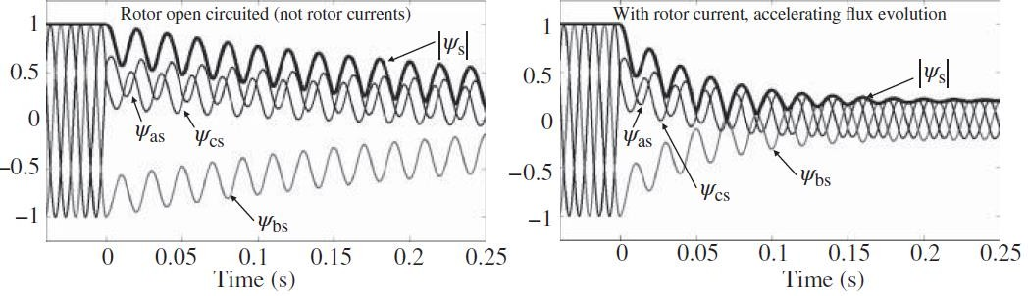

Fig. 1 Behavior of the stator flux without rotor current and with rotor current.

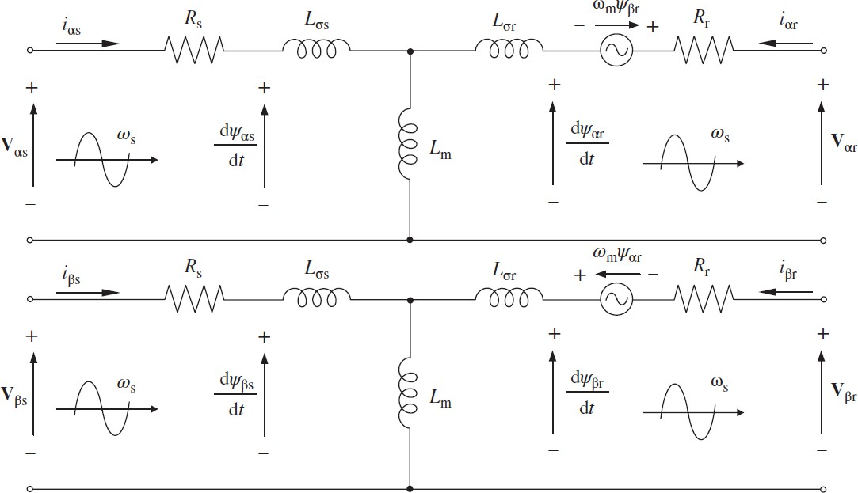
Fig. 2 Equivalent Circuit of DFIG in the 𝜶 − 𝜷 rotating reference frame

Whereas, it is important to change the equivalent circuit of the DFIM (Fig. 2). For this motive eq. (1) to
(4) it should be easy to get the below equation

V⃗→r = Lm (V⃗→r − j𝜔 ⃗ψ→^{r}) + ⌊R + (Lm)²R ⌋ 𝚤→^{r} + R 𝑑 𝚤→^{r} …… (6)

r Ls s
𝑚 s
r Ls s r
s 𝑑𝑡 r

If notice the above equation, in Fig. 3 The space vector diagram is described. The adding of the rotor
r
voltage &j𝜔_{𝑚}⃗ψ→ are nearly to the Stator voltage.
s
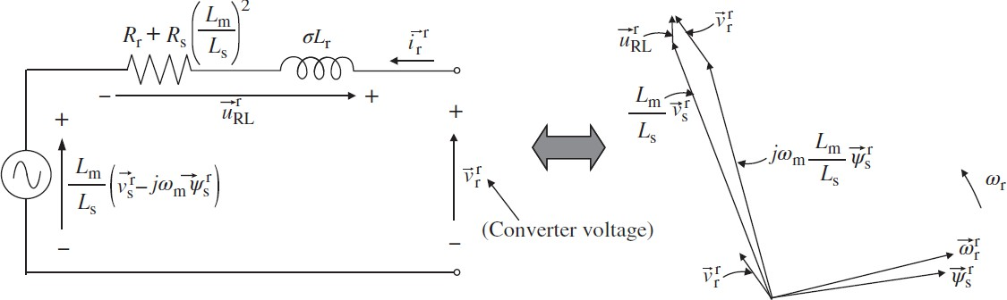

Fig. 3.Equivalent circuit of DFIG for voltage dips analysis. & Phasor diagram of equivalent circuit of DFIM.

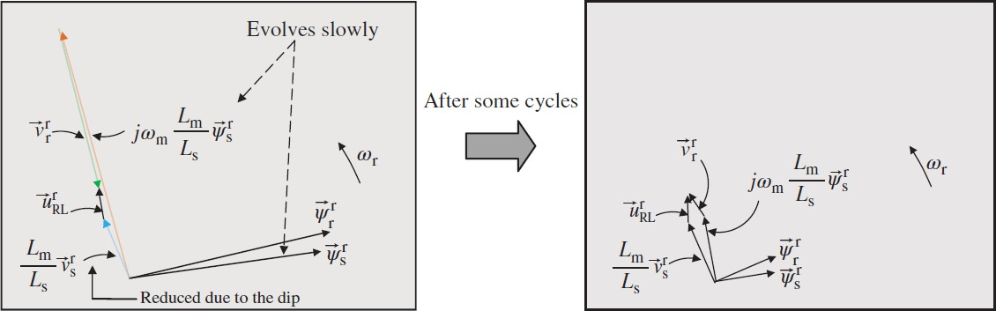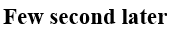

Fig. 4. Phasor diagram during voltage dips & New steady state phasor diagram.

In Fig. 4(a), When sudden voltage dips happen, the stator voltage, V⃗→r fall very quickly but stator flux, ⃗ψ→^{r}
s s
can’t fall as quickly as stator voltage & impedance voltage is going to be small but at same time rotor voltage, V⃗→r is increased too high at the beginning of the voltage dips and the system lose the control. After few moments in fig. 4(b), get new stable system like before to the voltage dips but these phasor diagram’s magnitudes are very smaller amplitude because of reduce the stator voltage that is also conduct the lower electro-mechanical torque, T_{em} and stator reactive power, Q_{s}. For acute to the rotor voltage, V⃗→r restrictions, the wind turbine don’t ensure during occur the acute voltage dips therefore rotor current,
r
r
𝚤→^{r} is controlled by its safe line except losing the control. For the voltage restrictions, crowbar protection will be solved the acute voltage dips.
r

Model of Crowbar Circuit & Working Principle
As per inner construction, generally two type of crowbar circuit is joined in parallel within the rotor circuit & RSC. One crowbar is composed by 3 resistances and 3 bidirectional switches, & another active crowbar circuit is composed by universal diode bridge, resistance & unidirectional switch (Fig. 5). Universal diode bridge is connected through resistance with unidirectional switch. The unidirectional switch has a control system that is worked during the voltage dips. This Crowbar circuit is joined between the rotor circuit & rotor side converter in parallel. Two parameters are vital in active crowbar. 1) Crowbar resistance ( 𝑅_{𝐶𝑟𝑜𝑤𝑏𝑎𝑟}) & 2) opening time.

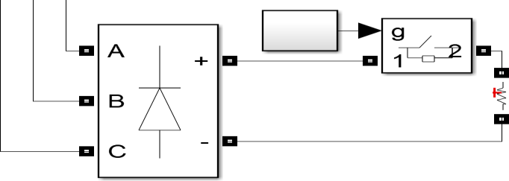

Fig. 5. Circuit Diagram of Crowbar

During the grid voltage dips, stator voltage is fall down very quickly whereas, stator flux can’t fall down as quickly as stator voltage thus the system is unstable. For recovering the unable system before conducting some methods like one method is hardware configuration changing & another method is changing the converter control of DFIG. At present, above two methods normally don’t conducted in the system because of performance is not enough well and are not cost effective whereas, active crowbar protection is used for recovering the unable system in order to this circuit performance is excellent and also cost effective. Excessive current flow through the stator and rotor circuit when sudden voltage drop is happened in the grid, during this time stator voltage reduce very quickly but stator flux can’t fall down like stator voltage thus rotor side converter (RSC) could be damaged. So, for saving the RSC circuit at present is used active crowbar protection because there is a crowbar circuit have resistance which help to fall down as quickly as stator voltage for making stable.

Analyze the RSC Behavior during voltage dips
When sudden voltage drop occurred in the grid then over current flow through the rotor that can damage the converter circuit thus crowbar protection circuit is connected with the rotor side in parallel. When crowbar circuit is worked, in the meantime what behavior will be showed in the rotor side converter during the voltage dips, that ll be discussed in this section.
The stator voltage during the grid voltage dips will be 10% of the normal voltage. The electromagnetic torque equation is:
𝑻 = = 𝟑 𝒑 𝑳𝒎 [𝝍⃗⃗→ ]𝒊

𝒆𝒎

𝟐 𝑳𝒔
𝒔 𝒒𝒓

= − 𝟑 𝒑 𝑳𝒎 [𝝍⃗⃗→ ]𝒊
= 𝑲 𝒊
……….. (7)

𝟐 𝑳𝒔
𝒔 𝒒𝒓
𝑻 𝒒𝒓

The rotor current of q axis is proportional to the electromagnetic torque,𝑻_{𝒆𝒎} . So rotor current of q axis can governance the electromagnetic torque. So, behavior of the 𝑖_{𝑞𝑟}&𝑇_{𝑒𝑚} will be zero during the voltage

dips of the grid. Therefore, what happen that MPPT algorithm is requiring this torque in order to control this speed. During the voltage dips of the grid, lose control to the speed & therefore rotational speed is modified and in this simulation there is a quite big speed variation. In reality we should have more inertia that we have perform much bigger than this value so rotational variation should be smaller.

𝟑 𝑳
|𝝍⃗⃗→ |

𝑸_{𝒔} = − 𝝎_{𝒔} ^{𝒎} [𝝍⃗⃗→ ] (𝒊_{𝒅𝒓} − ^{𝒔} ) (8)

𝟐 𝑳𝒔 𝒔
𝑳𝒎

In general, as grid code mended all the reactive current pass through the grid side, this made by rotor current of d axis component. As per Eq. 8 , providing 𝑖_{𝑑𝑟} as much current & put positive value of 𝑖_{𝑑𝑟} with this negative value, & get stator reactive power in negative value as the mended by the grid code. All reactive current going to be at 𝒊_{𝒅} during the grid voltage dips.

Simulations Result

Observing the behavior by MATLAB simulink of the rotor side converter when sudden grid voltage dips occurred. After time 2s going to apper the harmonic of the grid and therefore the remaining voltage of the grid is 0.1 that voltage dips of depth 0.9. The recovery time of the voltage will be started aftertime 2.5s and ll be full recovery voltage at this time 3.17s with the ramp of 15 pu/s. After second 3 harmonic will be appear but after 2.1s rotor side converter
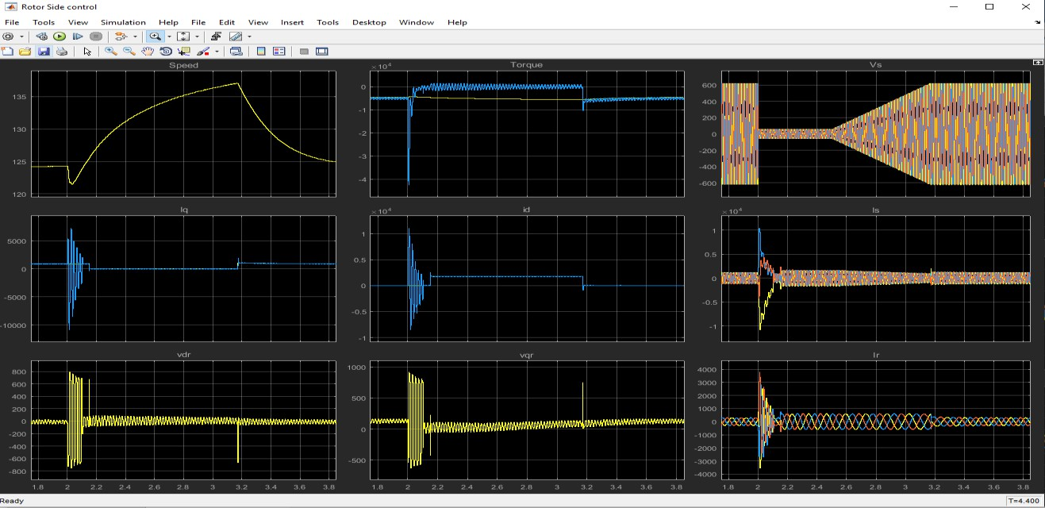
Fig. 6. Bahvior of the rotor side control of DFIG WT during grid voltage dips

will be zero that means Electormagnatic torque (Tem) &𝑖_{𝑞𝑟} current afte 2s it goes to zero & it will be recovery after time 3.17s. because the relation between torque and rotor currnt of q axis have been showed equation (7). All reactive currents will be flow throuth the rotor current of the d-axis during the grid voltage fault. During the grid fault, the stator voltage, 𝑽_{𝒔} will be 10% of the normal voltage (Fig. 6).

Conclusion
When voltage dips occur in the grid side, at that moment stator voltage decrease but stator flux cannot decrease as fast as stator voltage thus lose the control of the system. The crowbar protection is used in parallel with the rotor side & RSC in order to reduce the stator flux as fast as stator voltage for going to the steady state condition. During the voltage dips crowbar protection is activated at time second 2 & it will continue till time 2.5s. After time 2.5s it will be started to recover & it will be totally recovered at time 3.17s & the System will be stable.

Reference:
  - Evelyn Brudler ; Michel Golba ; Andreas Günther ; Hans Holtorf ; Leonie Ibing ; Edu Knagge ; Udo Kulschewski, ‘24 years postgraduate program renewable energy’; 2nd International Conference on the Developments in Renewable Energy Technology (ICDRET 2012).
  - B. Kroposki ; D. Mooney ; T. Markel ; B. Lundstrom: ‘Energy systems integration facilities at the national renewable energy laboratory’; IEEE Energytech, 2012.
  - Jinhua Zhang ;Baohui Zhang ; ZhiguoHao; “Equivalent circuit of DFIG with crowbar protection for relay protection analysis”; International Conference on Development in Power System Protection (DPSP), IET, 2016.
  - Sun Li-ling ; Yang Pu ; Wang Yi; “Simulation research for LVRT of DFIG based on rotor active crowbar protection”; International Conference on Sustainable Power Generation and Supply (SUPERGEN 2012); IET, 2012.
  - HammamSoliman, Dr. Mostafa I. Marei, Prof. Rania Metwally El-Sharkawy& Dr. Khaled Mohamad El-Bahrawy; “Analysis of the Dynamic Behavior of a DFIG during Grid Disturbances using Active Crowbar Protection”; 2013, IEEE.
  - Haitham Abu-Rub; Mariusz Malinowski & Kamal Al-Haddad; “POWER ELECTRONICS FOR RENEWABLE ENERGY SYSTEMS, TRANSPORTATION AND INDUSTRIAL APPLICATIONS”; IEEE Press
and John Wiley & Sons Ltd.
  - Mona N. Eskander ; Sanaa I. Amer; “Mitigation of voltage dips and swells in grid-connected wind energy conversion systems”; IEEE; 2009.

  - Jaroslav E Shklyarskiy ; Aleksey I Bardanov; “Novel Approach to Active Rectifier Control During Voltage Dips”; International Multi-Conference on Industrial Engineering and Modern Technologies, IEEE, 2018;
  - YeniuQian ;Yanyan Zhang ; Mengqi Chen ; Jian Sun ; Chenhong Du ; Yujie Wang; “Research and application of test system for voltage dip ride through capability of electrical equipments”; China International Conference on Electricity Distribution (CICED); 2014.
  - Francesco Sulla, Fault Behavior of Wind Turbines, PhD Thesis, Department of Measurement Technology and Industrial Electrical Engineering, Lund University, Sweden, 2012, ISBN:978-91-88934-55-0.
  - Pannell G., Atkinson D. J., Zahawi B., “Analytical Study of Grid-Fault Response of Wind Turbine Doubly Fed Induction Generator”, IEEE Trans. on Energy Conversion, Vol. 25, No. 4, 2010
  - Kundur, P.; Paserba, J.; Ajjarapu, V.; Andersson, G.; Bose, A.; Canizares, C.; Hatziargyriou, N.; Hill, D.; Stankovic, A.; Taylor, C.; Van Cutsem T.; Vittal, V. Definition and Classification of Power System Stability IEEE/CIGRE Joint Task Force on Stability Terms and Definitions. IEEE Trans. Power Syst. 2004, 19, 1387–1401.
  - Salles, M.B.C.; Cardoso, J.R.; Grilo, A.P.; Rahmann, C.; Hameyer, K. Control Strategies of Doubly Fed Induction Generators to Support Grid Voltage. In the Proceedings of IEEE International Electric Machines and Drives Conference—IEMDC'09, Miami, FL, USA, May 2009.
  - Global Wind Energy Council. Global Wind 2008 Report. Available online: http://www.gwec.net/ fileadmin/documents/Global%20Wind%202008%20Report.pdf (accessed on 10 December 2009).
  - R. Pena, J. C. Clare, and G.M. Asher, “Doubly fed induction generator using back-to-back PWM converters and its application to variable-speed wind energy generation”,
IEEE Proceedings - Electric Power Applications, 143(3):231, 1996;
  - M. B. C. Salles, K. Hameyer, J. R. Cardoso, A. P. Grilo, C.Rahmann “Crowbar System in Doubly Fed Induction Wind Generators”, Energies 2010, 3, 738-753, ISSN 1996-1073;
  - M. B. C. Salles, K. Hameyer, J. R. Cardoso, A. P. Grilo, C. Rahmann “Crowbar System in Doubly Fed Induction Wind Generators”, Energies 2010, 3, 738-753, ISSN 1996-1073;
  - Pannell G., Atkinson D. J., Zahawi B., “Analytical Study of Grid-Fault Response of Wind Turbine Doubly Fed Induction Generator”, IEEE Trans. on Energy Conversion, Vol. 25,
No. 4, 2010.
  - Răzvan Beniugă, Marcel Istrate, “Voltage Recovery of DFIG Wind Turbines After a Grid Fault”, Proceedings of International Conference and Exposition on Electrical and Power Engineering EPE 2012, ISBN 978-1-4673-5001-3, pp. 904–908, October 2012;
  - Erlich, H. Wrede, and C. Feltes, Dynamic Behavior of DFIG-Based Wind Turbines during Grid Faults, 14244-0844-X/07, 2007 IEEE, pp 1195-1200.

