Cultural Heritage Preservation in Rapidly Urbanizing Cities: A Case Study of Civic Buildings in Rivers State, Nigeria
JOHNSON Tamuno-Iminabo¹, OHOCHUKU Chinwennwo Phillips², LAWSON Tamunoiminabo³
Department of Architecture,Rivers State university,
Nkpolu- Oroworukwo, Port Harcourt, Nigeria.
JOHNSON Tamuno-Iminabo*
tamunoiminabojohnson@gmail.com
Abstract
Rapid urbanization in different parts of Nigeria has gradually erased indigenous cultural identity with modern development. In Rivers State, this change poses threat to both tangible and intangible cultural heritage of the various cultural groups. Therefore, there was a need for this study to find out ways in which the various cultures in rivers state can be preserved using civic buildings. The study examines the implications of rapid urbanisation on cultural heritage preservation and explores architectural strategies for preserving cultural identity. The study was guided by two (2) objectives: To examine the role of civic architecture in preserving cultural identity and to explore how civic buildings can be used to preserve culture. This paper addresses two research questions: How can civic buildings be designed and used to preserve cultural heritage and how can architecture support the preservation of local culture. A qualitative research method was used through literature review and case study analysis of civic buildings in Nigeria, as well as theoretical examination of international civic buildings. The case studies reveal that civic buildings can be used to tell the stories, memories and identity of a group of people with the use of local building materials, the method or technique with which the construction is done, landscape and the use of the building. This study concluded that cultural heritage is dynamic because it evolves in response to environmental and socio- cultural forces. This study recommends that culture can be preserved using symbolic architecture, integrating cultural activities with modern activities and using exhibition spaces that show different cultures as transition spaces.
Keywords: Cultural Heritage, Cultural Preservation, Urbanization, Civic Buildings.

INTRODUCTION
Urbanisation refers to the process by which an increasing proportion of a population moves from rural areas to urban centres (UNESCO, 2013). This change in population leads to other changes in land use, economic activity and culture. This rapid and unregulated change in Nigeria has resulted in significant socio-cultural transformations, and the gradual erosion of cultural heritage which embodies the identity of the people is a critical consequence of this change.
Culture refers to the collective beliefs, values, customs and practices that characterize a particular group or society. It encompasses language, art, religion, and social norms, shaping how individuals interact with one another and perceive the world (UNESCO, 2013). The deliberate act of maintaining and protecting different aspects of cultural heritage from past and present cultures and societies is known as cultural preservation. Cultural heritage consists of tangible elements like historic buildings and monuments, and intangible elements like traditions, rituals, oral histories and festivals that define the identity and historical continuity of communities. As rapid urbanisation occurs, these elements are threatened by land use changes, infrastructural developments and globalization. Unsustainable urbanisation can lead to the disruption of cultural practices, thereby undermining social cohesion and cultural identity (Abdulkarim Rashed, 2026). In Rivers state, the traditional spatial and cultural systems have been altered by the economic activities of the Niger delta, where economic activities like oil exploration have accelerated urban growth and environmental changes. Indigenous architectural forms are being replaced by modern structures while communal spaces that once facilitated social interactions and cultural activities are diminishing. As cities develop and modernise, there is a tendency to prioritize economic and infrastructural development over cultural considerations, resulting in environments that lack local character and identity (Logan, 2012). Despite these challenges, cultural heritage is a critical resource for sustainable development. It contributes to social cohesion, fosters a sense of belonging and can serve as a driver of economic growth through tourism and creative industries (Timothy and Nayaupane, 2009). This study seeks to examine how cultural heritage can be preserved within such rapidly changing urban contexts, with a focus on the role of civic and architectural interventions.

STUDY AREA: RIVERS STATE
Rivers State is in the Niger Delta region of the southern part of Nigeria; it is one of Nigeria’s oil rich states with different cultures and Port Harcourt as its capital. Rivers State has a tropical monsoon climate with lengthy and heavy rainy seasons and very short dry seasons. The heaviest precipitation occurs by September while December is the driest month.
Figure 1. The rainfall chart of Port Harcourt
(source: Climaticdata.org)
Figure 2. The average temperature in Port Harcourt
(source: Climaticdata.org)
AIM
This paper aims to determine ways in which cultural heritage can be preserved using civic buildings.

OBJECTIVES
- To examine the role of civic architecture in preserving cultural identity.
- To explore how civic buildings can be used to preserve culture

RESEARCH QUESTIONS
- How can civic buildings be designed and used to preserve cultural heritage
- How can architecture support the preservation of local culture

LITERATURE REVIEW
Civic buildings are important in defining the quality of life in a community. Civic buildings are buildings owned or leased by a public agency, non- profit organisation or the government for the primary purpose of providing a service to the general public dedicated to arts, culture, education, recreation, government, transit or public parking (City of Ventra, n.d.). Hennebery Eddy opined that civic buildings create a place for community members, therefore it should integrate elements that celebrate local culture, strengthen interpersonal connections and promote engagement.
Cultural heritage evolves in response to environmental and socio- cultural forces, it is not static (Brisibe, 2016). Smith (2006) argues that heritage is a cultural process that involves the ways in which societies remember, interpret and engage with the past. This point of view shows the importance of preserving both tangible and intangible parts of culture. Urbanization is a socio-spatial process that reshapes physical environment and social relationships. While it creates opportunities for economic development and innovations, it disrupts cultural systems and practices. In our rapidly urbanizing environment, cultural preservation in architecture stands as a testament to the resilience and identity of communities. By integrating cultural elements and narratives into contemporary designs we not only honour our past but also enrich our present and future environment.
Architecture and cultural preservation
Culture is a means of identifying a community, it can be demonstrated by different traditional events and symbols. Culture drives architecture, from the beginning architecture has been designed to serve community. The shape, form and components of a building is influenced by cultural individuality. Therefore, architecture brings about the representation of culture in built form. Architecture is an expressive aspect that defines culture (Abhist S., n.d)
Impact of urbanization on cultural heritage
According to Abdulkarim Rashed (2026), Rapid urbanisation in a city can lead to the following:
- Loss of historic sites due to redevelopment: expansion of the urban environment lead to the destruction or neglect of traditional sites and structures, example is the kano city wall that have suffered from encroachment.
- Erosion of traditions and values: urban life gradually removes traditional norms, which leads to the dilution of social structures and the abandonment of customary practices.
- Transformation of traditional architecture into modern non- contextual forms
- Decline of intangible heritage, including festivals and oral traditions: traditional festivals are increasingly adapted for tourism and profit, which often alters the original significance.
Significance of cultural heritage
Cultural heritage has a great role in lives and history, it influences values, beliefs and sense of belonging. These are some reasons why cultural heritage is significant according to Luis Stephnson (2023):
- Identity and Belonging: cultural identity gives a sense of belonging and defines a person’s identity.
- Historical perspective: cultural heritage allows one to learn from the past and appreciate progress we have made as a society
- Tourism and economic growth: as cultural sites and heritage attract tourists, it creates economic growth and creates jobs in the tourism industry
- Cultural diversity: cultural diversity reminds people of the importance of respecting and celebrating different cultures.

Architectural strategies in preserving culture
The intersection of culture and architecture is a dynamic interplay that influences both form and function (studio B architects, 2024), creating spaces that are not only aesthetic but also rich with historical and cultural significance. Culture can be preserved with architecture by:
- integrating elements that reflect a community’s values, traditions and heritage. This requires a thoughtful engagement with the cultural stories that inform a space, incorporating traditional motifs and materials that pay homage to local craftsmanship, also using climate responsive techniques and traditional spatial configurations like courtyards. This approach ensures continuity between the past and the present while responding to modern needs (International Council on Monuments and Site, 2018)
- Designing for cultural practices and social interaction: cultural heritage is not seen only in physical structures but also in practices like festivals, ceremonies and social gatherings. Therefore, spaces that actively support these activities should be provided (International Council on Monuments and Site, 2018).
- Flexibility of space: cultural practices evolve with time; architectural spaces should therefore be flexible to adapt to the diverse shift in use.
- Community involvement in the design process: community involvement is important to authentic cultural preservation. Local communities are the custodians of cultural knowledge, and their participation ensures that architectural interventions reflect lived experiences and values (Djabarouti, 2023)
- Adaptive reuse of heritage structures: this involves changing the purpose of existing historic/old buildings for new functions while preserving their historical and cultural significance. This allows heritage structures to remain relevant in modern society (Okoli et al, 2023).
- Creation of cultural landscapes and public spaces: public spaces such as squares, streets, etc. play an important role in shaping social and cultural interactions (International Council on Monuments and sites, 2011a)
- Development of civic and cultural infrastructure: civic buildings can serve as important venues for cultural preservation. Facilities like cultural centres, civic centres, museums, serve as spaces for education, performance and community engagement (Department for Development and Economic Cohesion, 2021)

METHODOLOGY
The data for this project was collected using qualitative research methods, which included a comprehensive literature review, design techniques alongside case study analysis of different civic buildings in Nigeria, as well as theoretical examination of international case studies. The literature review provided a theoretical foundation by combining opinions from existing research, technical reports and scholarly perspectives on cultural heritage preservations. This study analysis data from secondary sources, including publications and journal articles to discover how culture can be preserved in civic buildings.
Design documentation: Conceptual materials and images from different civic buildings were analysed to examine the architectural strategies used to preserve culture.
Case study Selection criteria
- Geographic location and microclimate
- Relevance to the study
The selected case studies include;
International case studies
Freedom Park, South Africa
Local case study
Hikima Complex, Nigeria
John Randle centre for Yoruba culture, Lagos, Nigeria

DISCUSSION
Freedom Park, South Africa
Freedom Park in Pretoria, South Africa, is a 52-hectare heritage site on salvokop hill dedicated to celebrating the country’s history, democracy and humanity. This park is a civic institution with a museum and a memorial dedicated to honouring those who contributed to south Africa’s liberation struggle. The facility has a museum to narrate the story of the African continent from the dawn of humanity, through pre- colonial, colonial and apartheid history to south Africa today. The facility has a museum that preserves their culture, a sacred garden of remembrance, representing the resting ground of those who died fighting for freedom and it serves as a communal space, the main memorial comprising of an amphitheatre and a wall of names and a spiral pathway that guides visitors through the parks architecture and botanical landscapes.
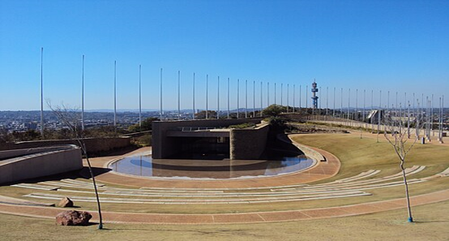
Figure 1. showing the amphitheatre, Freedom Park
Source: South African Tourism, 2026
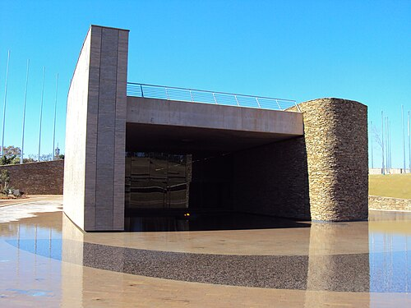
Figure 2. showing Freedom Park, South Africa
Source: South African Tourism
Hikma Complex, Niger
The Hikma Complex in Dandaji, Niger, is an example of adaptive reuse of heritage structures. The facility was originally a historic mosque, and it has been converted to a vibrant community library while introducing a new mosque beside it. The two (2) structures are connected by a landscaped public space and has become a vital civic hub for both religious and secular activities in the region. The facility was restored with the use of locally sourced materials like compressed earth blocks, which provide a good thermal comfort that suits the harsh desert climate and the traditional techniques that was used to construct the mosque. This facility emphasizes community driven, inclusive design, that demonstrates how architecture can elevate both environmental and social sustainability.
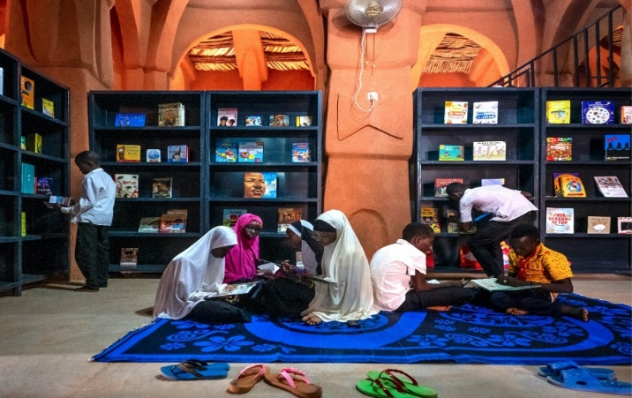
Figure 3. Showing the interior of hakima library, Niger State
Source: https://awards.holicimfoundation.org
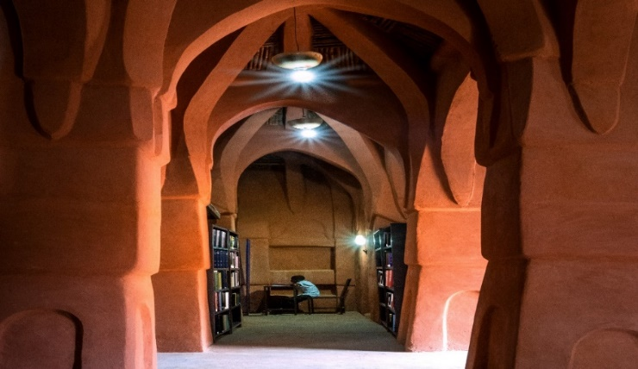
Figure 4. showing the interior of Hakima Complex, Niger state
Source: https://awards.holicimfoundation.org
John Randle centre for Yoruba culture, Lagos, Nigeria
The John Randle centre for Yoruba culture is a modern cultural hub inspired by traditional Yoruba aesthetics. it features earth toned concrete, green roofs and golden aluminium screens that mimic traditional Yoruba craft.
The façade features gold lattice screens that reference Yoruba weaving. metal work and carving. these screens provide both aesthetic appeal and shading. earth-coloured concrete finishes are used to mimic the mud structures found in traditional Yoruba settlements. this facility is designed with a green roof to blend with landscape. there is a restored 1928 swimming pool, a 1000 square meter exhibition gallery, a library, a performance hall and a public square.
the layout is influenced by the traditional Yoruba town layout, with buildings radiating from the central courtyard. The building is said to be harmoniously integrated with its surrounding, increasing the cultural experience of the user. Traditional motifs and ornaments are used to communicate cultural meanings (Frontiers in Built Environment, 2025).
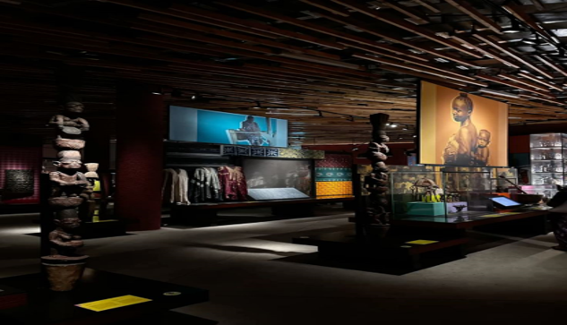
Figure 5. showing the interior of John Randle centre for Yoruba culture
Source: https://en. Wikipedia.org
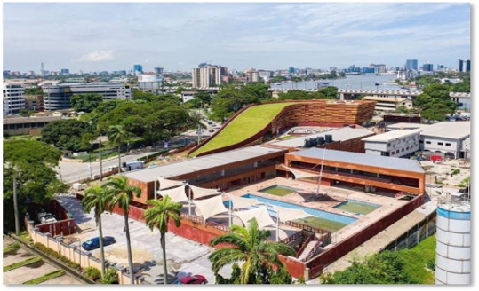
Figure 6. showing John Randle Centre for Yoruba culture
Source: https://en. Wikipedia.org
INTERPRETATION OF RESULTS
These civic buildings show that to preserve the culture of an area effectively, there has to be a shift from static preservation to dynamic and participatory design strategies. They also show that architecture can act as a medium if memory and a platform for living cultural expression thereby reinforcing identity and continuity within rapidly urbanizing environment. Freedom Park created a framework for memory using architecture, where preservation happens through symbolism and spatial experience. This facility combines landscape, architecture and African cosmology to create a collective identity. Recently Freedom Park has been a nation building space, with cultural meanings embedded into architecture through commemorative practices and ritual performances such as healing ceremonies (Schulze, 2025). These practices make the site an active place for cultural engagement instead of a passive monument. The design of the freedom park intentionally uses symbolic landscape to represent memory, identity and to avoid conventional monumentality (Young and Vosloo, 2020). The Hikma Complex reveals how cultural preservation can be shown in materiality and construction techniques. Culture is preserved in this complex through how it was built instead of relying on symbolic representations alone. It is important that traditional forms and materials are interpreted to satisfy modern use to maintain cultural identity (Frontiers in Built Environment, 2025). The Hikma complex uses earth-based materials and passive climatic strategies gotten from Sahelian traditions, thereby preserving environmental knowledge and cultural craftsmanship. The John Randle Centre for Yoruba Culture is a participatory cultural environment. The facility preserves culture by transforming heritage into a lived experience. Dehghan, (2024) described the facility as a “Theatre of living memory”. The building displays Yoruba forms, metaphors and craftsmanship, using cultural narratives to design spaces that support storytelling, exhibitions and performance (Adams, 2024).
CONCLUSION
This study reveals that while urbanisation is a good driver of economic growth and spatial development, it poses challenges to both tangible and intangible cultural heritage. These challenges include; spatial encroachment, gradual erosion of cultural identity and practices. This study also reveals that cultural heritage is not static, but it is an evolving process shaped by social interaction, memory and environmental context. Therefore, preservation strategies must move more than conventional conservation approaches towards an adaptive framework. The various case studies show that culture is preserved by creating spaces that actively support living cultural practices.
The results from this study have led to the following strategies to preserve culture architecturally in civic buildings:
- Adaptive reuse of heritage buildings
- Participatory design
- Experiencing culture in every transition space
- Incorporation of local materials and symbols
Cultural heritage preservation in rapidly urbanising cities require an approach that combines architecture, planning and community engagement. In Rivers State, civic buildings can act as catalyst for preserving culture to ensure that urban development does not come at the expense of identity and cultural resilience. The study recommends that culture can be preserved using symbolic architecture, and creation of spaces that combine cultural activities and modern use.
REFERENCE
- Abdulkarim Rashed. (2026, January 13). The Impact of Unsustainable Urbanization on the... (Incomplete reference.)
- Abhist Sharma. (n.d.). Architecture and Cultural Preservation. https://www.re-thinkingthefuture.com/architectural-community
- Adams, S. (2024). The John Randle Centre Rises from the Earth in a Nod to Yoruba Spirituality. Wallpaper. http://www.wallpaper.com/architecture/public-buildings/the-john-randle-centre-studio-imagine-simply-architecture-lagos-nigeria
- Brisibe, W. G. (2016, March 23). Base Camp Architecture: Examining Variations in Fisher Dwellings in Nigeria and Cameroon. http://doi.org/10.1177/2158244016636942
- City of Ventra. (n.d.). Definition of Civic Buildings. Development Code Definitions. https://www.cityofventrra.ca.gov/24S.300
- Dehghan, S. K. (2024). Noisy, performative and unapologetically non-European: Nigeria welcomes a museum like no other. The Guardian. https://www.theguardian.com/global-development/2024/apr/30/john-randle-centre-yoruba-culture-lagos-nigeria
- Frontiers in Built Environment. (2025). User Perception of Neo-Vernacular Architecture in Cultural Centres. https://doi.org/10.3389/fbuil.2025.1634880
- Logan, W. (2012). Cultural Diversity, Cultural Heritage and Human Rights: Towards Heritage Management as Human Rights Based Cultural Practice. International Journal of Heritage Studies, 18(3), 231–244.
- Luis Stephenson. (2023). Cultural Heritage: Its Significance and Preservation.
- Okoli, C., Jude, B., & Agwu, K. (2023). Historical Heritage Preservation: The Role of Architectural Strategies. https://researchgate.net/publication/374449269-historical-heritage-preservation
- Schulze, A. (2023). SI.SA reimagines museum design to highlight Yoruba culture and heritage.
- UNESCO. (2013). Convention for the Safeguarding of the Intangible Cultural Heritage.
- Young, G., & Vosloo, P. (2020). Isivivane, Freedom Park: Commemoration and Landscape Design. https://doi.org/10.18820/24150487/as27i1.4

