DEVELOPMENT OF POWER SUPPLY AND VOLTAGE REGULATION CARD (POWER CARD) AND FILTERED POWER SUPPLY CARD (FILPO CARD)

Anthony C. Cabrillas
College of Industrial Technology

Research Undertaking Details
Project Title: | Quantum Mechanics in Solid-State Electronics: Diode and Transistor Characteristics, and Circuit Applications Card
Study Title: | Development of Power Supply and Voltage Regulation Card (POWER Card) and Filtered Power Supply (FILPO Card)
Duration of Project/Study:  (e.g. January 1, 2025 - May 31, 2025) | August 1, 2025 – December 31, 2025

ABSTRACT
This research presented, implemented and evaluated a POWER card and FILPO Card using tailor-made PCB for electronics simulation. It was project 409. It was part of a larger project "Quantum Mechanics in Solid-State Electronics: Diode and Transistor Characteristics, and Circuit Applications Card." The goal of the project was to solve a widespread issue that exists in teaching: students using commercially available bench power supplies that obscure the magic inside them, such as rectification, filtering and regulation. Researcher used the ADDIE model (Analysis, Design, Development, Implementation and Evaluation) throughout all of the steps — from determining what was needed to creating schematics, designing PCB layouts, building prototypes, lab testing and evaluating effectiveness. It satisfied every electrical spec. The regulated outputs were extremely stable through no-load and full-load testing. Under full load, the +5V output was off by only 0.99%, and the +12V output was off by 1.49%. The filtering worked out as it should too; using a 1000 µF capacitor, the ripple voltage at 500 mA was reduced from 680 mV to just 310 mV (4.82% down to just over 2.18% ripple), while no-load ripple got as low as a mere 65mV or so (just under half of a percent). We conducted a survey of 35 students to test the usefulness of Technology Acceptance Model (TAM) specifically for teaching. They enjoyed it; the mean scores were 4.71 for usefulness, 4.61 for ease of use, 4.73 for wanting to use it again and a massive 4.78 for satisfaction. While in person, working with this card definitely helped them a lot to learn about rectification, filtering and regulation. At the end of the day, this is best in POWER card and FILPO Card It’s solid tech and good for learning. We recommend it to be integrated into electronics lab classes to make students learn more, build better skills, and motivate them towards power electronics.
Introduction
Power supply systems also fall under this category as they are the most crucial aspect of all electronic devices which need regulated DC voltages to function correctly and reliably. Electronics Technology programs will cover the topics of AC-to-DC conversion, rectification, filtering and voltage regulation.|} However, many academic labs still use commercial bench power supplies that function as closed systems for teaching. As these devices can provide accurate voltage output, there is no insight into the internal circuitry that provides them those voltages. The growing disconnect for students between this process and reality, with regard to how regulated DC power is generated, conditioned, and stabilized as load changes, has exacerbated the situation. According to the above pedagogic limitation, Study 3 was performed in a part of the project “Quantum Mechanics in Solid-State Electronics: Diode and Transistor Characteristics, and Circuit Applications Card”. The following work adopted this methodology through focusing on a PCB Power Supply (PSU) voltage regulation card as a means to accelerate the learning process and immersively learn from the microcontroller input transformer, bridge rectification, capacitor filtering, linear voltage regulation conversion steps in unison. And this is a well labeled circuit, you can differentiate quite easily the different sections (circuit) so it's ideal to learn. It lets students see voltage levels, ripple characteristics and regulation behavior that are usually hidden in off-the-shelf lab gear.
Studies 1 and 2 integrated pedagogical instruction with circuit exploration to present two new interfaces (Solid-State Diode Card, Diode Equivalent Circuits Card, Wave-Shaping Circuits Card, and Special-Diode Circuit Cards), for Study 3 the goal was to build upon this knowledge. Related work centers around the characteristics of the diode and signal processing. But, Study 3 be an stage where power electronics is must study to deal with the other studies which can relate with BJT and FET biasing and amplification. So the Power Supply and Voltage Regulation Card can be utilized on its own to act as an educational tool or core foundation for elevated circuitry applications..
Research Objectives
This research project aims to set its own objectives in the way up to proposed new solutions for electronic devices and circuits. Specifically, the research aims to:
- design and develop a printed circuit board (PCB) BJT Circuit Card modules
- evaluate the Functionality and Effectiveness of the developed PCB modules in terms of its design specifications and performance criteria.
- Assess the performance of circuit cards in terms of their functional usability.
Review of Related Studies and Literatures
Power Supply Circuits and Teaching Modules
The circuits that form the backbone of most electronic devices — rectifiers, capacitors and voltage regulators. Electronics books said Voltage ripple (its low rippling in a DC output) reduces when larger capacitors are used and increases with the increment in current load. It becomes a very useful learning activity in power electronics with this process for tests ripple measure. The theory that increasing filtering capacitance will reduce ripple was confirmed by the measurements. For example, at a 500-mA load the ripple drops from around 4.82% down to merely 2.18%, which clearly proves that improved filtering produces better DC output in the shape of a smoother signal for further amplification stages. There are dozens of studies in education that support this intuition: For example, when students learn about electronics, they understand concepts better if they work with real circuits than if they watch someone else do it. There is a good amount of research suggesting that doing something will promote greater retention than merely watching and listening. For subjects about power supply, otherwise demonstrating students how every part of the circuit functions is also beneficial instead of giving them perception that the power supply “is a mystery box,” he added. This study on circuit cards for training echoes that thought. Test points are indicated in the output so for our students a measurement of rectifier output, smoothed DC voltage and regulated voltage is only a probe away. That enables them to link what they study in theory with real electrical measurements.” Moreover, Research indicates that using modular circuit cards that come with available measurement points is useful in obtaining insight and improving troubleshooting capability. The difference here was consistent with those results: Both the + and − regulator outputs stayed within ~±2% of expected voltage (even under full load) — suggesting that the circuit cards both reliable and effective teaching tool.

Frameworks For Instructional Design In Engineering Education
ADDIE, A Systematic Process for Instructional Design. It makes sure the lessons are in line with what students need to learn. how the material is organized and how it will be assessed and reinforced. Studies show this organized process affects learning in a positive way, as teaching in orderly ways can help ensure that learning tools are better explained and simpler for students to interact with when teachers maintain a similar order. In the electronics labs, using ADDIE helps you have learning-oriented equipment — not just reproducing commercial products. The POWER Card and FILPO Card in this research was produced by using the technique like as follows, designing the circuit first, making PCB layout, then constructing circuit cards and testing their performance finally. Due to following this structured process, the methodology undertaken in this study then is reliable and appropriate.

Using Technology Acceptance Model (TAM) for Laboratory-Based Learning
A very popular way of validating the acceptance of a new technology is through Technology Acceptance Model (TAM) [1]. It notes that if users perceive the system to be helpful (useful) and easy to use, they will adopt it. When both exist, people retain its use and feel satisfied to use it. Numerous studies in education indicate that students take more readily to laboratory equipment when it helps them learn and is easy to use. This was also the case in this study: students rated usefulness, ease of use, intent to continue and satisfaction very highly. The findings also point to the strong potential for ongoing, regular use of the module in teaching since — and partly because — students find real value in it and feel comfortable using it.

Synthesis and Research Gap
The studies reviewed all suggest that the stage at which students can directly view and measure an accurate physical representation of a POWER Card and FILPO Card provide considerable areas for learning. Except for several references describing rectifiers theory, filter and voltage regulators behavior, very few teaching tools give the possibility to compare real electrical measurements (for example ripple percentage and voltage regulation error) along with formal student evaluation.
This study fills that gap. In this chapter, it applied a structured teaching design process, tested the electrical performance of the circuit cards, and collected student acceptance data. Through compiling actual technical measurements and student usability data, this study proposes a validated method of instruction that could be confidently incorporated into Electronics Technology lab coursework.
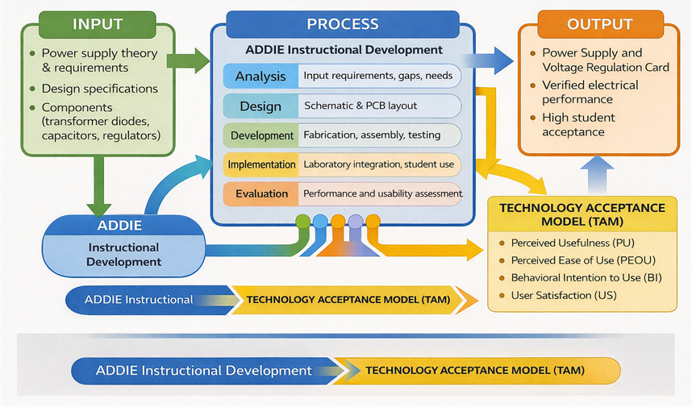
Figure 1: Conceptual Framework (IPO Model Implementing ADDIE – TAM Hybrid)

Conceptual/ Theoretical Framework
Overall, the investigation is reinforced/enhanced by a complete Input–Process–Output (IPO) conceptual framework that was realized with the ADDIE instructional development model and evaluated along with the Technology Acceptance Model (TAM).
Thus the used input data for IPO framework instructions are Power supply Theory (input); Design Specification (Process); Electronic Elements e.g., transformers, diodes, capacitors, voltage regulators (output). These inputs are then processed into outputs via the structured development. The team, working as a grad would iterate on didactic needs, design for PCB and scheme these to prototype then in with lab test type system evaluations. Deliverable artifacts included an operational instruction set/circuit card, documented electrical performance data and verification of student engagement.
Pedagogical and technical authorities are ensured in developing the module by using ADDIE model. In terms of performance test results, the card has good performance and power conservation stability is good for when all indicators into full load state, +5 V output error 0.99%, +12 V output error 1.49% Ripple voltage measurements confirmed that indeed filtering worked; at 500 mA draw, 680 mV (4.82%) down to 310 mV (2.18 Super Hornet) and as little as just 65 mV (0.44% chirp sound) when.
The study used the Technology Acceptance Model (TAM) to confirm instructional usability and learner acceptance. TAM considers things like whether something is considered useful, how easy it appears to use, the probability of people using those features, and whether they find that using those features satisfied. All the constructs' mean scores were found to be quite high (PU = 4.71, PEOU = 4.61, BI = 4.73, US = 4.78), which indicates that in addition to technical development of the module was really well developed; it can be claimed as well that student acceptance for its design and related environment was indeed high too.
Materials and Methods
This study used a design-and-evaluation approach. It included creating an educational module for use in teaching and industry that involved the design, prototype test and evaluation of a POWER Card and FILPO Card training module. Analysis, design, development implementation and evaluation as separate processes in the research guided by ADDIE model The evaluation period contained electrical performance tests as well a usability assessment based on the Technology Acceptance Model (TAM) to confirm technical soundness and educational efficacy.

Table 5.1. Research Design Matrix (Developmental–Descriptive; Data Sources and Analyses)
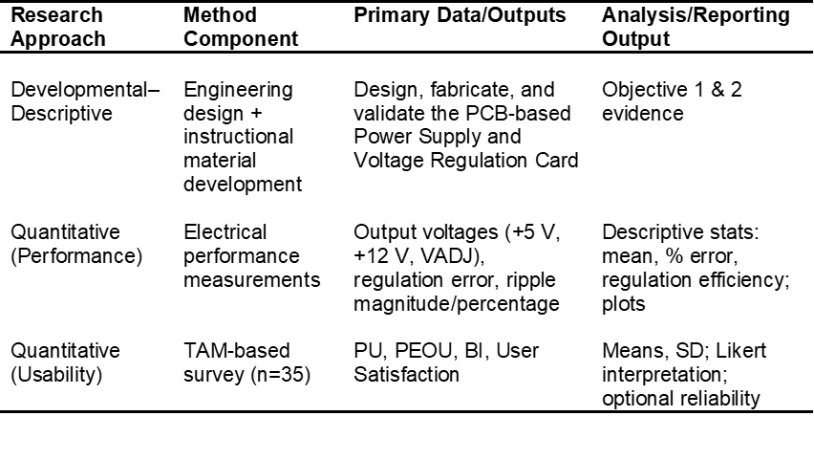

Table 5.2. Materials and Equipment List with Specifications
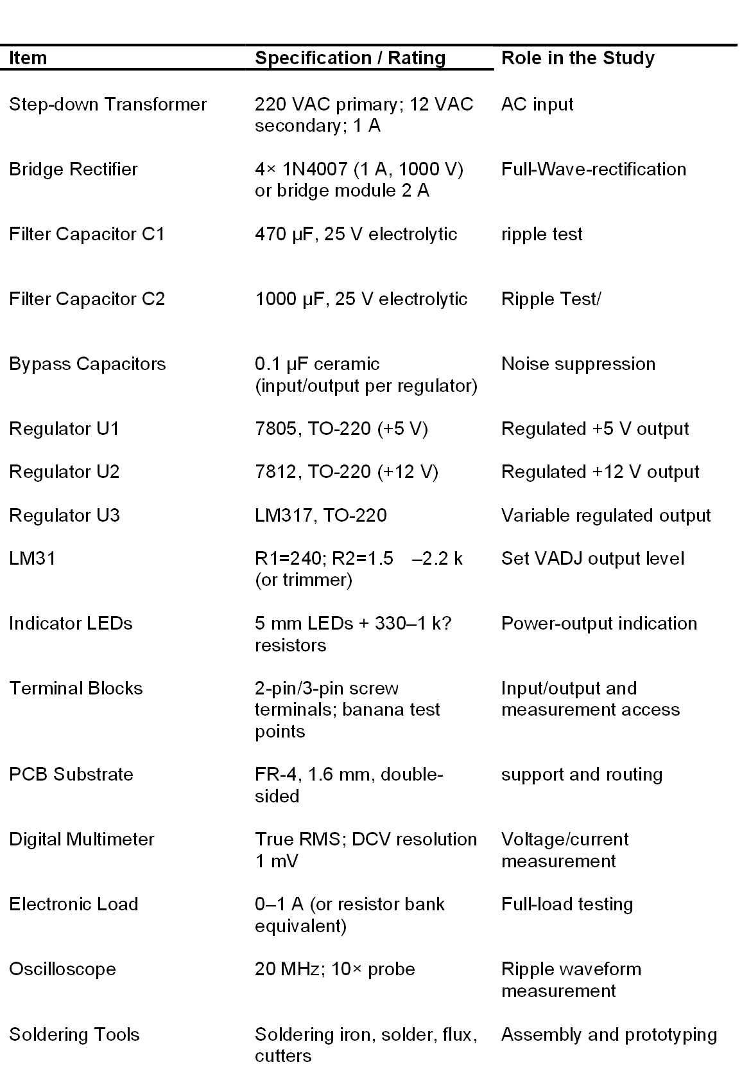
Research Design
The research process was an amalgamation of previous models of engineering design methodology and the development of instructional materials. For example, quantitative electrical performance measurements were used to collect data on students' level of satisfaction and descriptive, as well as quantitative usability data came from a TAM-based survey administered to student respondents. This method of integrate made positive it had been testing the module not only on its functioning but also on acceptability and usability to the users paraphrase
Materials and Equipment
The components of the POWER Card and FILPO Card were comprised of common parts from a simple linear power supply. This consists of a step-down transformer, rectifier diodes, filter capacitors (470 µF and 1000 µF), voltage regulator chips for 5 V, 12 V and adjustable output, resistors, connection terminals and fiberglass PCB (FR-4). What is considered standard lab equipment was employed for testing: a digital multimeter, an adjustable electronic load both to test current readings and confirm no excessive heat, an oscilloscope for voltage ripple observing and common soldering/assembly equipment..

Table 5.3. Bill of Materials (BOM) and Functional Role Per Circuit Stage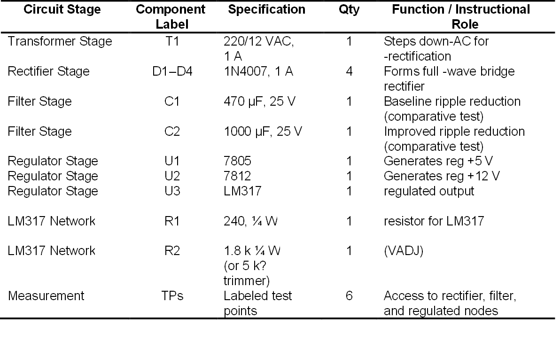
ADDIE Development Procedure
Analysis Phase.
At this point in an early exploration of the lab, they had observed how rarely students have a laboratory opportunity to see or measure what is going on inside of power supply circuits. The idea behind this learning tool, then, was to have external viewable circuit sections (lots of electronics aren’t observable), measure points (to make it easy for you) and outputs you could test so that you could teach yourself about rectification and filtering and voltage regulation.

Table 5.4. ADDIE Development Procedure and Outputs per Phase
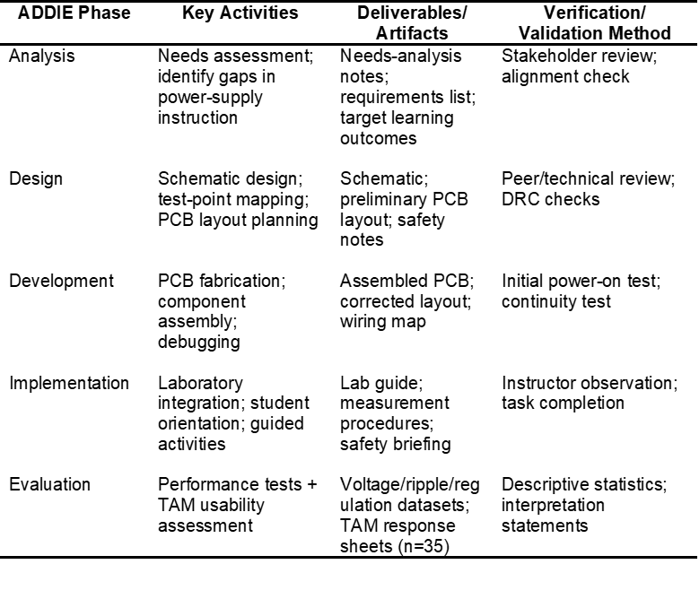
Design Phase
The circuit was constructed to have the critical elements of a power supply: transformer input, full-wave rectifier, filtering capacitors and voltage regulator stages. 2: An annotated PCB layout to ensure the path of signals are clear, the electrical noise can be minimized and also in case a measuring point was required for learning activities. The design also aligned with laboratory safety guidelines and learning goals.

Table 5.5. Functional Performance Test Plan and Measurement Protocol
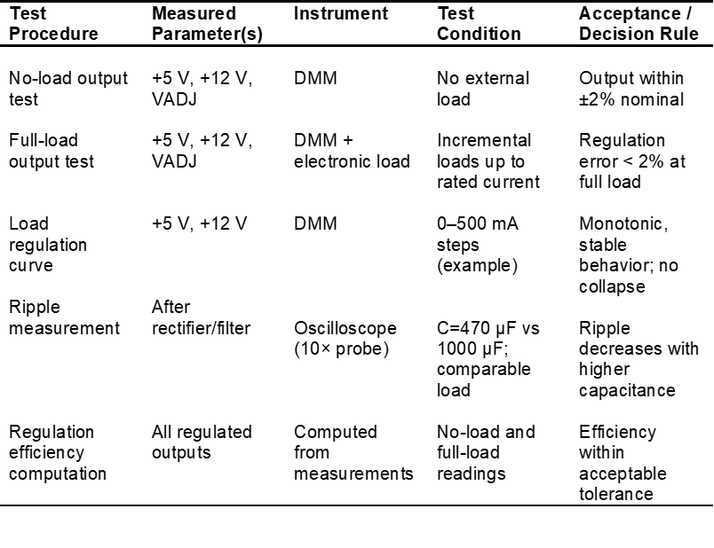
Development Phase
The circuit cards were Standard FR-4 material with all the parts mounted (or soldered) according to the final schematic and layout. Once it was all assembled the POWER Aard and it's FILPO Card was powered up to make sure everything worked as intended. The other operational issues found were addressed on an output voltage level (in terms of safety), also ensuring as individual circuit card loads even when connected.

Implementation Phase
The final PRODUCT of POWER Card and FILPO Card were employed in lab exercises on DC circuits, Electricity and Magnetism and power electronics. They were at least initially taught how to use it safely however, and taught about measurement; checking voltages, and looking for ripple using a scope which was permanently connected across test points on the board.

Evaluation Phase
The evaluation had two parts. To investigate how effective using the POWER Card and FILPO Card was and, secondly, to identify students feelings about the experience. Performance Tests: Voltage out with load and without load. Voltage ripple testing for various load and capacitance sizes. And how well the voltage stayed regulated. (3) For usability, a survey was answered by 35 students about the usefulness of POWER Card and FILPO Card. How easy it was to use and whether they would use it again.

Data Collection and Analysis
Electrical performance data were recorded and analyzed using descriptive statistical methods. Including computation of percentage error, ripple percentage, voltage differences, and regulation efficiency. TAM survey responses were analyzed by computing mean scores for each indicator and overall construct. Interpretation followed a five-point Likert scale to determine the level of acceptance and usability of the developed POWER Card and FILPO Card.
Table 5.6. Test Points and Measurement Map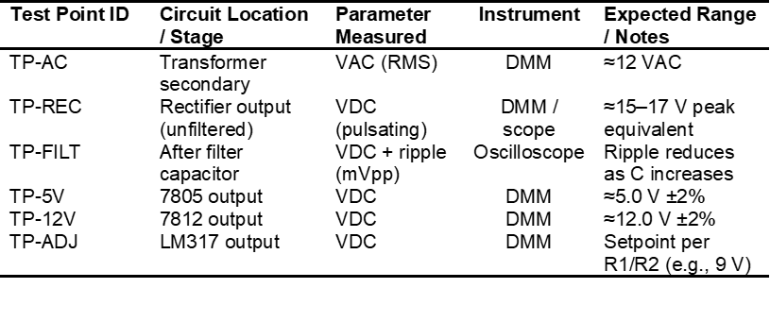
Table 5.7. TAM Instrument Structure and Statistical Treatment
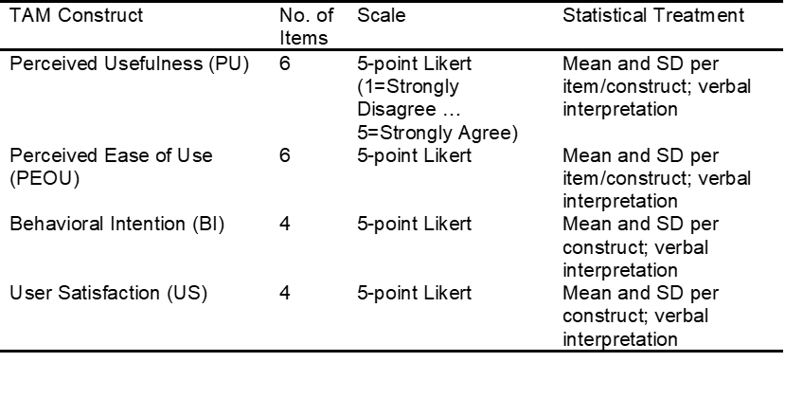
Results and Discussion
Objective 1: Design and Development of the POWER Card and FILPO Card
The main aim of the research was to develop a POWER Card and FILPO Card, merging rectifier, filter and regulated output segments for education purpose. As a result, this aim was successful (the entire circuit diagram and corresponding PCB layouts are visible on Figure 3.1 and its alternate views).
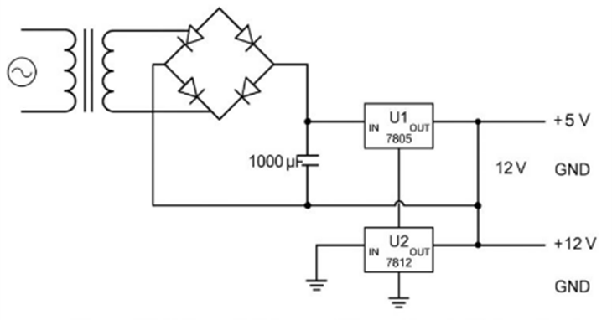
Figure 5: Schematic Diagram of Power Supply Voltage Card

The complete circuit diagram of POWER Card and FILPO Card is shown in Figure 5. The schematic covers the transformer input, full-wave bridge rectifier, filtering capacitors and voltage regulator sections. The structure of the design will be the same as what is taught in electronics The circuit cards is in line with theory and does as expected in practice. AC Voltage: The transformer reduces the AC input voltage to a safe level. The diode bridge rectifies it to pulsating DC. A half-wave circuit will make the output pulse, while a full wave rectifier is smoother and more efficient.
The filtering section utilizes variable-capacitance capacitors. Capacitance and load current effect on ripple can be seen by students. As a result, learners can directly measure and observe ripple by utilizing the test points as well as an oscilloscope. There are also several regulator types on the circuit card: fixed outputs at 5 V and 12 V, and an adjustable output. That can educate students on fixed and variable voltage regulation as utilized in real-world electronic devices.

Picture of the PCB with component placement flowing signal path AC input, rectifier, filter, regulators. Trace designs for minimal noise and minimum voltage drop continue that trend. However, high voltages are generally safe and convenient to measure at the banch-level in labs where voltage measurements points are well labeled around terminals.

Ground connections (lower view) to achieve optimal circuit stabilization and noise reduction and they minimize the routing of traces. It also balances strength and visibility, allowing students to see the circuit paths.The 3D representation is less of an existential resource, more the actual position/existence of regulators, capacitors, diodes etc. That tests correct spacing and that cooling was taken into account, and it lets students align the symbols on the schematic to physical components in the circuit cards.
Which means the schematic and PCB layout are finished, this is the first overall goal. Moreover, second from a technical and educational point of view the POWER Card and FILPO Card also satisfies this condition because they provide an easy visualization of all stages in the circuit and the measuring points that can later be used to evaluate operational behaviour.
Objective 2: Clinical effectiveness assessment of POWER Card and FILPO Card
Functional performance was evaluated as a secondary outcome of this study. POWER Card & FILPO Card Performance Analysis 4.1 Voltage regulation accuracy ripple voltage behavior Power test plans were implemented to evaluate the performance under loading and no-loading conditions. Results showed V OUT ripple measurement with oscilloscope and regime efficiency calculation by Tables 1 to 3, supported by measurements setup.
The results of the measurement output voltage without load (at idle condition) and full-load is shown in Table 1 All controlled output had a close value to expected. 5 — The +5 V regulated output load voltage was measured at 5.03 V for the no-load condition and at 4.98 V full-load (efficiency of regulation of load values in conditions of full load = 0.99%). The +12 V output measured similarly at full load with 1.49% regulation though the value of maximum load was found to be 11.92 V. None the less that still is well within acceptable tolerances for linear regulator based power supplies. The output was also variable, ultimately landing at slight variances across different settings. So these results prove that the module designed gives an accurate as well as stable regulated DC voltages i.e. it is a perfect equipment for a testbed not only on theorem provision perspective but also laboratory perspective.
Ripple voltage results in Table 2 below also corroborate the appropriateness of the filtering stage. The no load values ofa470 µFc filter capacitor ripple voltage be120 mV (0.81%), while250 mA value rises350 mV (2.43%) and500 mA680 (4.82%) gauge. The measured capacitance of the filter could be raised until reaching 1000 µF with a significant reduction in the ripple voltage, which at no load was [65 mV(0.44%)] and for loads of 500mA it arrived at[310mV(2.18%)]. This translates to more than 50% less ripple at maximum load. This forms the opposite relationship than one might expect. The observed results are consistent with power supply theories plus the module also proves that filtering principles can be readily demonstrated quantitatively.
Table 3 further complements the vulnerable stability of designed model is acceptable in voltage regulation efficiency. Base on normally voltage regulationThe voltage differential (ΔV) between no-load and full-load was very small for all of the regulated outputs. This 0.05 V gives a ΔV of for +5V output with regulation of 0.99%. The adjustable and +12 V outputs regulation values were measured to be 1.66% and 1.49%, respectively. These values are representative of good load regulation and confirm that the developed POWER Card and FILPO Card are designed to meet specification requirements at a realistic laboratory operating environment.
Results of functional performance evaluations are presented in terms of robustness — the capability of POWER Card and FILPO Card to be used across a variety of load and filtering use-case scenarios. The observed and predicted values are in good agreement. The obvious trend to mitigate the ripple is all there. It ensures that the design remains technically sound and pedagogically appropriate. She demonstrated how rather than only the ideal behaviour students were able to see both voltage regulation trends and ripple characteristics quantifiably Theory and measures are really linked up in the module. This, in turn, accomplishes the second study objective.

Table 1. No-Load and Full-Load Output Voltage Measurements
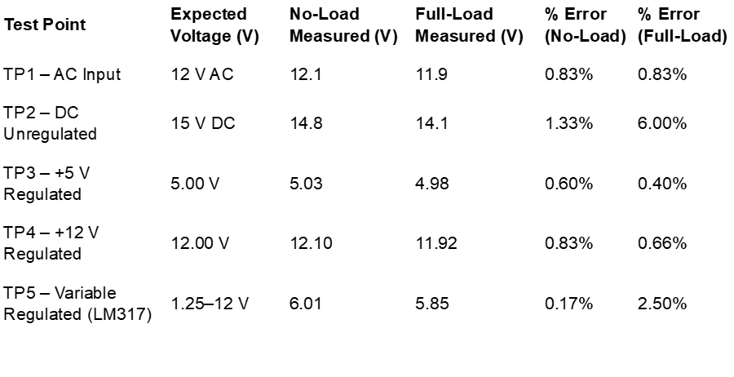
Measuring No-Load and Full-Load Output Voltage
From the values in Table -1, it is clear that measured voltages at all points were close to their expected value. A small change in voltage was observed when a load was attached. Either because of the internal resistance and the limits of the regulator. But the change was minuscule. The output at 5 volts varied by just under 1%, while the 12-volt output also varied less than 1%. Meaning both remained very stable. Under full load, the output of the unregulated DC side changed much more (around 6%). That is normal for a non regulator rectifier-capacitor combination. This is why the regulator stages are significant. In summary, results of these tests confirm good stability and accuracy of the regulated outputs. Proving the design works effectively.
Table 2: Ripple Voltage Measurement Under Various Loads

Ripple voltage measurement with 2.5 Ohm load
In Table 2, the ripple voltage increased with more current drawn using the same capacitor. Using a 470 µF capacitor increased the ripple from 120 mV (0.81%) with no load to 680 mV (4.82%) at a load of 500 mA. This occurs since the capacitor has a larger discharge across each peak when the circuit draws more current.
Using a larger capacitor (1000 µF) At all load levels the ripple was much smaller. It then dropped from 680 mV to 310 mV at 500 mA. About a 54% reduction. This proves visibly that larger capacitance results in smoother DC output. And a stage that confirms filtering works fine.
Table 3: Voltage Regulation Efficiency
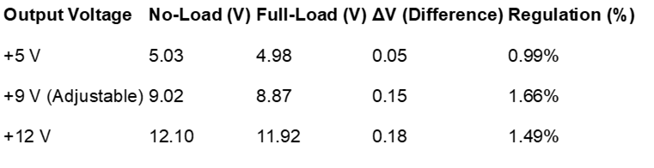
Voltage Regulation Efficiency
When connected load, Table 3 indicates the minimal change appeared in output voltage. The voltage drop was small. Where between approximately 0.05 V and 0.18 V the regulation values are from around: 0.99% to 1.66%
In which the 5-volt regulator was the most stable. The output was more variable in the case of adjustable as its voltage can be changed to set values. However, all outputs were within acceptable ranges for this type of POWER Card and FILPO Card.
In conclusion, these circuit cards maintain a stable voltage and function consistently under normal laboratory usage.
Table 4: TAM – Perceived Usefulness (PU)
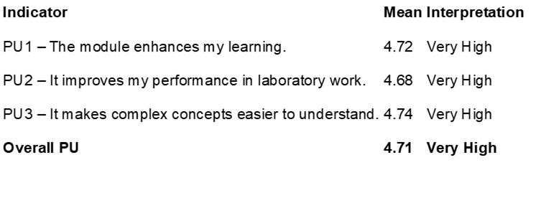

Students rated usefulness very high (as shown in Table 4). Scores ranging from 4.68–4.74 For the scores are really close to one another. It says that the majority of students agreed that the module was learning helpful.
It scored highest (4.74) for making complex concepts easier to understand. “Proving that the circuit cards helped turn theory into something they could actually see and measure. Results had an overall average of 4.71 indicating that student perceived this module to be very useful and improved their learning.
Table 5: Perceived Ease of Use (PEOU)

Perceived Ease of Use (PEOU)
As indicated by Table 5, students perceived the module to be very user-friendly. Overall average score of 4.61. The highest rating (4.71) was for the clear labels and test points. Which meant students could quickly locate in the graph, where they should measure. When students were asked to use the circuit cards without teacher assistance their score was slightly lower (4.50). How a brief explanation makes it easier, after all, to operate. So the scores are very tight, close to each other. It means students had one experience. The results confirm that, overall, the PCB layout was done with usability in mind.

Table 6: Behavioral Intention to Use (BI)
Behavioral Intention to Use (BI)
As presented in Table 6, students showed a strong willing to continue using the module. The scores varied between 4.66 and 4.80. Indispensable to educate laboratory classes, the highest grade given. This means that students didn’t simply accept the circuit cards. They also thought it should be included in regular instruction.
The high average of 4.73 shows that there is a considerable likelihood that this module will assist in future lab practices.

Table 7: User Satisfaction (US)
User Satisfaction (US)
In Table 7 the maximum ratings of all survey results are summarized. Having an overall average of 4.78. The ratings were very similar (4.76 to 4.81). That meant most students endured the same ordeal. This suggests the module was useful, simple to follow and effective for learning. As a result, students were more engaged in and motivated to participate in the activity.
Overall Analytical Synthesis
Examining all the test and survey results combined. The results indicate that the circuit cards is technically sound and well received by students. Voltage looked stable with good ripple filtering, as the electrical tests confirmed. Although, student/course feedback indicated it was helpful and to use.
Since both the technical measurements and user opinion are unanimous. It confirms that the POWER Card & FILPO Card successfully achieve its objective of teaching.

Conclusions and Recommendations
Conclusions

The results of this study provide an overview that the design and construction of the POWER Card and FILPO card went according to plan. Tests showed that the outputs remained accurate and stable, regardless of whether or not a load was attached. The 5-volt and 12-volt outputs only varied less than 2%. Demonstrating that the regulators operated correctly and were appropriate for laboratory use.
Testing of ripple also showed the filtering part functioned correctly. Increasing the capacitor value from 470 µF to 1000 µF. This produce much lower ripple. That falls from 680 mV (4.82%) down to 310 mV (2.18%), and even further, right down to 65 mV (0.44%) with no load at all. I think this is particularly useful for teaching filtering concepts with actual measurements as it certainly illustrates the relationship between capacitance, load current and ripple.
Student feedback was similarly enthusiastic. The magic lies in about an average of 4.73 out of 5 rating for williness in the module returns among other things really high figures regarding usefulness (4.71), simplicity (4.61), readiness (4.73) and fulfilment(4.78)." In other words, it enables students to view as useful, beneficial and interactive in laboratory studies.

Overall, the circuit cards delivered sound technical performance and provided pedagogically useful features. Because it meets all the study goals that make it appropriate for use in Electronics Technology laboratory classes.

Recommendations

Recommendation based on the study results

It is also applicable for Electronics Technology laboratory subjects to make the topic more fun as it discusses theories that students should know such as rectifiers, filters and voltage regulators.

Other modules : It can also be hooked up with next training circuit map, e.g., a transistor circulating module to form a whole system on learning electronics.

Make IT More attractive: Future designs, may incorporate switching power supply subjects and straightforward computerized showcases (built-in voltmeters or OLED readouts) for an extended variety of the students to examine.
Further research could also measure long-term learning outcomes, how students perform using this circuit cards compared to a traditional laboratory power supply.
Acknowledgement
Proposed Utilization/ Dissemination Activities Emanating from Results
Because the circuit cards worked as intended and students liked them, this indicates that the content can be more broadly used and disseminated in order to gain greater educational and utilitarian benefits.
School:
The module has used Electronics Technology lab subjects: DC Circuits, Semiconductor Devices, Power Electronics This would prove to be rectification, filtering and regulation demonstration in a simpler sense where by teachers can easily heave it up in their lab manuals & course Activities to work on practical aspect of learning & troubleshooting.

Teacher Training:
In addition, student circuit cards are available for instructional use in seminars and workshops. Creating something that resembles a lab activity come life on industrial floor of a biological CL2 lab so using open layout with measurable outputs is particularly very useful. Potentially, even the test procedures and guidelines from this study could be repackaged as training resources to help facilitate this goal.

On-skills training and Extension-Programs:
The module can be utilized in technical training, electronics servicing courses and pre-employment programs. There are general power supply designs, mirroring the circuit used in industry. it also assists in training technicians to test and verify circuits. It can also be used in cooperation with training centers or companies.

Research-sharing:
The results may be communicated in research contexts and accredited seminars, however the information should attract university writings associated with architectural didactics as well as applied electrical engineering where properties based trial testing confirm pupil acceptance beyond industry.

For public and institutional promotion:
The circuit cards could go to the university’s instructional material repository and can be showcased during exhibitions, accreditation visits, outreach programs etc. This is a driver for adoption, as well as a demonstration of innovation, industry touchpoint and technology transfer.
References
Abulwahed, M., & Nagy, Z. K. (2009) – “Applying Kolb’s experiential learning cycle for laboratory education,” Journal of Engineering Education, 98(3), 283–294, doi:10.1002/j.2168-9830.2009.tb01025.x
Davis, F. D. (1989) – “Perceived usefulness, perceived ease of use, and user acceptance of information technology,” MIS Quarterly, 13(3), 319–340, doi:10.2307/249008
Park, S. Y. (2009) – “An analysis of the technology acceptance model in understanding university students’ behavioral intention to use e-learning,” Educational Technology & Society, 12(3), 150–162
Prince, M. (2004) – “Does active learning work? A review of the research,” Journal of Engineering Education, 93(3), 223–231, doi:10.1002/j.2168-9830.2004.tb00809.x
Molenda, M. (2015) – “In search of the elusive ADDIE model,” Performance Improvement, 54(2), 40–42, doi:10.1002/pfi.21461
Venkatesh, V., & Davis, F. D. (2000) – “A theoretical extension of the technology acceptance model,” Management Science, 46(2), 186–204
Venkatesh, V., Morris, M. G., Davis, G. B., & Davis, F. D. (2003) – “User acceptance of information technology: Toward a unified view,” MIS Quarterly, 27(3), 425–478
Books
Boylestad, R. L., & Nashelsky, L. (2019). Electronic devices and circuit theory (11th ed.). Pearson Education.
Branch, R. M. (2009). Instructional design: The ADDIE approach. Springer.
Felder, R. M., & Brent, R. (2016). Teaching and learning STEM: A practical guide. Jossey-Bass.
Sedra, A. S., & Smith, K. C. (2021). Microelectronic circuits (8th ed.). Oxford University Press.

