MIDDLE TRANSPORT CORRIDOR: SOIL AND MAIZE CONTAMINATION

Dimitri Pataridze, David Kuparadze, Violeta Kirakosyani, Nino Khundadze

Department of the Geoecology and Applied Geochemistry. Tbilisi State University, A. Tvalchrelidze Caucasian Institute of Mineral Resources, Georgia

ABSTRACT
The Middle Corridor is increasingly gaining strategic importance, as north of it, the war between Russia and Ukraine has created a stalemate, while to the south, there is significant instability due to periodic armed conflicts related to Iran. Georgia, with access to the Black Sea, is one of the key countries in the Middle Corridor. According to World Bank forecasts, transit traffic through Georgia will increase by 52% in the coming years. This article examines the impact of increasing freight traffic on the geo-ecological state of the territories adjacent to the international highways E60 and E70, which are part of the Middle Transport Corridor. A study of soil samples and maize grown on them was carried out. The concentrations of heavy metals and toxic chemical elements were determined. Based on the results obtained, calculations were made of the Contamination Factor (CF) of soil and corn and the Translocation Factors (TF) of polluting elements from the root layers to cereal grains.

Keywords: soil, maize, heavy metal, contamination, translocation.

INTRODUCTION
Heavy metal pollution of soils is a global environmental problem caused by natural and anthropogenic processes [1], affecting food safety. Contaminants pose a health hazard to humans, as they enter the body through the food chain in ecosystems [2, 3].
Georgia's economic growth and sustainable development largely depend on the effective development of transit capabilities, particularly in the area of ​​road transport. A map of international highways passing through Georgia is shown in Figure 1. The E60 and E70 highways are part of the East-West corridor, and the E117 is part of the North-South Corridor.

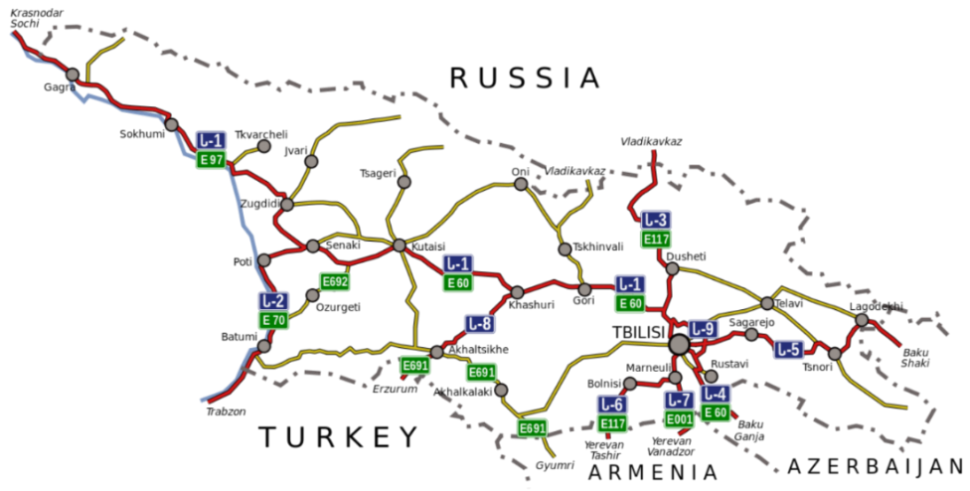
Fig. 1 Map of international highways crossing the territory of Georgia

Following annexation of Crimea in 2014 and the occupation of parts of Ukraine's Donetsk and Luhansk regions by Russian Federation, followed by full-scale aggression in 2022, Western countries imposed economic sanctions against the Russian Federation. Consequently, the security of the Northern Transport Corridor (China-Europe), which passes through Russia, was called into question. To diversify international trade routes, the idea of a Middle Transport Corridor, also known as the Trans-Caspian International Transport Route, was proposed. This is the shortest transport route connecting China with European countries. According to the World Bank [4], by 2030, the volume of transport along this route will increase by 11 million tons (Fig. 2).

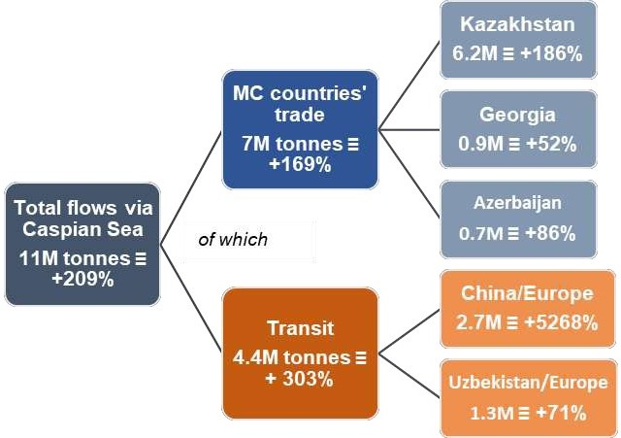
Fig. 2. Project traffic volume along the Middle Corridor by 2030

According to these projects, the volume of transit traffic through Georgia will increase by 52%. This will lead to a sharp increase in heavy metal and petroleum product pollution in populated areas, agricultural lands, and pastures located along highways.
Assessing the environmental status of lands and agricultural areas located along highways and creating a point source pollution database are important for socio-economic development and improving public health in Georgia.
One of the most common annual grain crops in Georgia is maize. According to the Georgian State Statistics Service (Sakstati) [5], in 2024, maize cultivation areas totaled 70,000 hectares, which is 32% more than wheat cultivation areas and almost three times more than oat cultivation areas.
Maize is a key ingredient in many processed foods, widely used in human diets, and also used in pet and poultry feed. Therefore, the ecological safety of maize grains is critical.
The purpose of our research:
- Collect soil and maize samples grown on them in areas adjacent to international highways;
- Determine the levels of heavy metals and toxic elements in both soil samples and maize grains;
- Determine pollution factors and pollutant transfer coefficients from soil to plants.

MAIN PART

Samples were taken along the E60 international highway in western Georgia and the E60 and E117 in eastern Georgia. The sampling locations are shown in figure 3. A total of 156 samples were taken, including 78 soil and corn samples each.
Spot samples of soil were collected using the envelope method (a square with sides approximately five meters long), specifically at the vertices and center of the square, which also contained the maize plant. The pooled soil sample obtained by mixing point samples was sent for laboratory study. The combined maize grains sample was collected from three maize cobs.

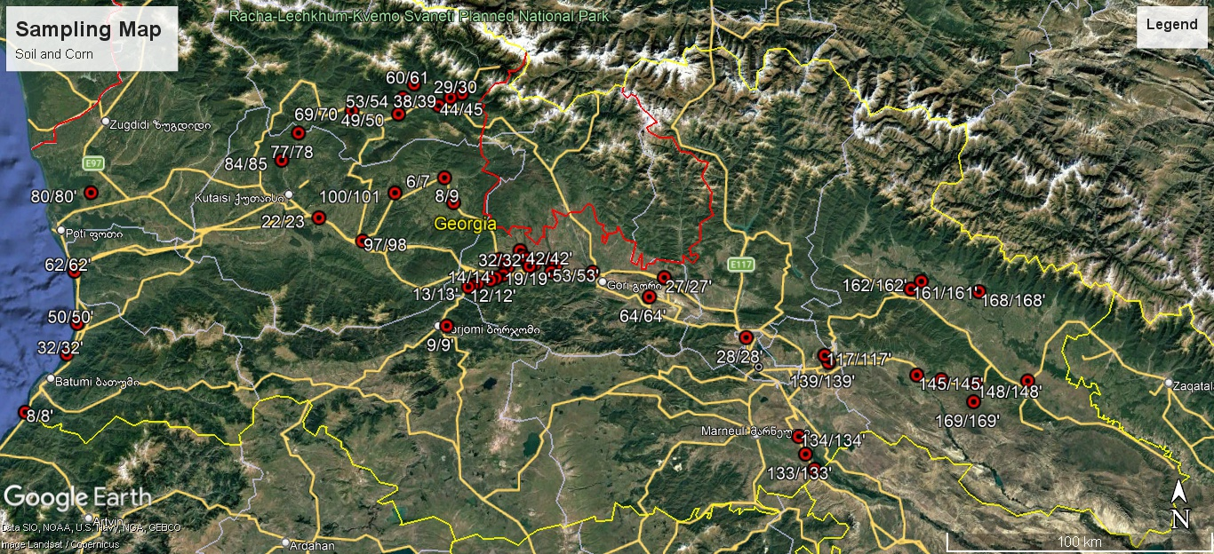

Fig. 3 Sampling locations

To assess the environmental status of areas adjacent to international highways, two types of statistical analyses were performed:
1. Determining the contamination factors (CF) of soils and maize grown on them;
2. Determining the transfer factors of heavy metals and toxic elements (TF) from soil to plants.
To avoid overloading the text with tables and to facilitate understanding of the results, all study results are presented graphically.

Contamination Factor (CF)

Contamination Factor (CF) is a measure used to assess the level of contamination, particularly focusing on heavy metal pollution. It evaluates contamination by comparing the concentration of metals at a specific site to established background values, helping to indicate the degree of pollution present. This measure serves as an essential tool in understanding and addressing environmental health [6]. Contamination Factor (CF) was calculated using the formula:
CF = Cm / Bm, where:
Cm is the average concentration of the element; Bm is the background concentration of the element, which can be taken from the literature (average content in the earth's crust) or directly determined in a geologically similar uncontaminated area [7].
The degree of contamination is determined by the Contamination Factor (CF) as follows:
- CF < 1 - low contamination factor;
- 1 < CF < 3 - moderate contamination factor;
- 3 < CF < 6 - significant contamination factor;
- CF> 6 - very high contamination factor.
In the case of Western Georgia, the estimated background concentration of heavy metals and toxic elements was determined at sampling point 60/61, the farthest from the roads. The same principle was used for Eastern Georgia (sampling point 169/169').
Fig. 4 and 6 present graphical results of determinations of Contamination Factor (CF) of heavy metals and toxic chemical elements for Western Georgia and separately for the Black Sea coast.

Fig. 4 Pollution assessment: Contamination Factor (CF): Western Georgia

- Soils in Western Georgia are significantly contaminated with arsenic (3<CF<6), due to the presence of two large deposits: Lukhuni (Racha) and Tsana (Svaneti).
Although the Lukhuni deposit is currently not in operation, and the enrichment plants located on its territory have been inactive since 1993, 100-110 thousand tons of arsenic-containing waste remain scattered across the former sites. Some of this waste was temporarily stored in a tailings dam (sarcophagus). Because everything temporary usually becomes permanent, the sarcophagus still exists and is in a state of destruction (Fig. 5).
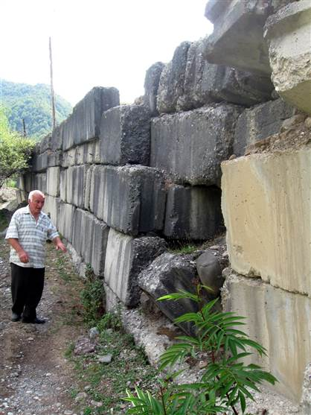
Fig. 5. Wall of the sarcophagus (right bank of the Lukhunistskali River, a tributary of the Rioni River)

A similar situation is observed at the Tsana arsenopyrite deposit. Large quantities of waste are scattered along the banks of the Tskhenistskali River. In some areas, contamination exceeds the legal limit by 15,000 times or more. In addition to arsenic, the waste contains toxic elements such as Hg, Sb, Cr, and Bi. Every spring, when the river spills off its banks, the waste is washed away and transported to the surrounding area. The waters of the Rioni and Tskhenistskali Rivers are widely used to irrigate agricultural lands in western Georgia.
- Other heavy metals and toxic substances in both soils and maize grains are characterized by moderate levels of pollution.

The ecological situation on the Black Sea coast is different from the situation in the rest of Western Georgia (fig. 6).

Fig. 6 Pollution assessment: Contamination Factor (CF): Western Georgia (Black Sea Shore)
Maiz Samples Soil Samples

- Soil has a low or moderate contamination rate.
- The contamination of maize grains with a heavy metal is characterized by a moderate pollution ratio, except for nickel. The very high Contamination Factor (7.5) indicates significant pollution. Particularly high levels of this metal are observed in the Chakvi-Kobuleti area. The cause of this phenomenon cannot be explained, as the concentration of this metal in soil is low.
Similar results for Eastern Georgia are presented in Fig. 7.

Fig. 7 Pollution assessment: Contamination Factor (CF): Eastern Georgia
Maiz Samples Soil Samples

- Soils are characterized by low to moderate contamination factors, with the exception of cobalt. The contamination factor value indicates very high pollution. Surprisingly, a high cobalt contamination factor (7.5) is observed on the S5 highway from Manavi to Tsnori. The road leads to the Lagodekhi border crossing (Georgia-Azerbaijan border). This is probably the remains of the 430th Engineering Munitions Depot of the Transcaucasian Military District in Sagarejo.
- Maize grain pollution is characterized by low to moderate contamination factors.
Soils are characterized by low and moderate levels of pollution, with the exception of cobalt.

TF, Translocation Factor
Translocation Factor (TF) from soil to plants are indicators that reflect the ability of an element to move from the root system to the above-ground parts of the plant (stems, leaves, fruits), calculated as the ratio of the concentration of the element in the above-ground part to its concentration in the soil or roots. They are important for assessing bioavailability, phytoextraction and the risk of heavy metal contamination of food chains. Different elements and plants have different TFs, depending on the mobility of the element in the soil, the type of plant and its adaptation mechanisms (avoidance or accumulation), with values ​​ranging from low to high [8].
The value of Translocation Factor (TF) is determined as follows:
TF = Cp/Cg, where:
Cp is the concentration of the element in the aboveground part of the plant; Cg is the concentration of the element in the soil.
By size:
- TF <1: the element does not move well from the soil (roots) to the shoots;
- TF> 1: the element actively accumulates and moves to the above-ground parts of the plant.
As in the case of Contamination Factor (CF), calculations were performed both for Western Georgia and separately for the Black Sea coast, and for Eastern Georgia. Due to the fact that in all these cases the Translocation Factor (TF) values ​​turned out to be less than one, that is, heavy metals and toxic elements do not move well from the soil to the corn shoots. Since the results obtained do not require special interpretation due to their obviousness, all three diagrams are placed in one figure (Fig. 7).

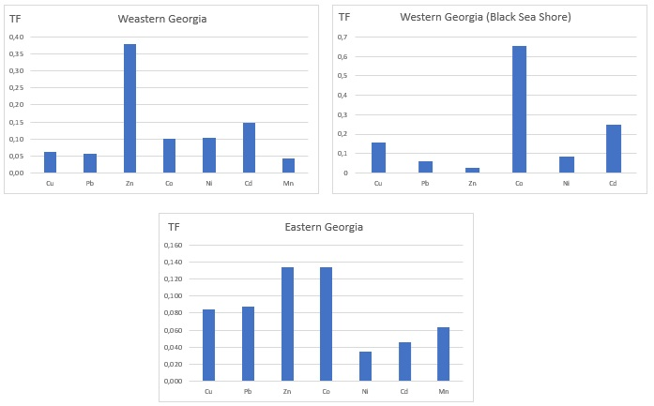

Pic. 7 Translocation Factors (TF)

CONCLUSIONS

The following work has been carried out:
- Samples of soil and maize grown on them were taken from areas adjacent to the international highways E60 and E70;
- The content of heavy metals and toxic elements was defined both in soils and in corn grains;
- Using the analysis results, the Contamination Factors of soils and maize were defined in samples taken in both Western and Eastern Georgia;
- Translocation Factors of heavy metals and toxic elements from soils and the root system to the above-ground parts of maize have been defined.

Results obtained:
Contamination Factor (CF).
- Western Georgia:
- Soils: significantly contaminated with arsenic due to the presence of two large deposits: Lukhuni (Racha) and Tsana (Svaneti);
- Maize: moderate contamination.
- Black Sea coast:
- Soils: characterized by moderate CF;
- Maize: contamination with heavy metals is characterized by a moderate CF, with the exception of nickel, which has a very high Contamination Factor (7.5). A particularly high content of this metal is observed in the Chakvi-Kobuleti area. The reason for this phenomenon cannot be explained, since the concentrations of this metal in the soil are not high.
- Eastern Georgia:
- Soils: characterized by low and moderate pollution factors with the exception of cobalt. A high cobalt pollution factor (7.5) is observed on the section of the S5 highway from Manavi to Tsnori. The road leads to the Lagodekhi border crossing (border with Azerbaijan). It is likely that these are echoes of the presence in Sagarejo of the 430th engineering ammunition depot of the Transcaucasian Military District.
- Maize: characterized by low and moderate pollution factors.
Translocation Factor (TF).
In all regions of Georgia, the Translocation Factor (TF) values ​​turned out to be less than one, that is, heavy metals and toxic elements do not move well from the soil to the shoots and grain of corn.

Based on the above, we believe it is necessary to conduct similar studies at least every two years. This will help to provide timely solutions to the problems and prevent growing contamination of soils and plants by heavy metals and toxic chemicals in areas adjacent to international roads.

REFERENCES

- S. Wang, W. Wu, F. Liu, R. Liao, Y. Hu, Accumulation of heavy metals in soil-crop systems: a review for wheat and corn, Environ. sci. Pollution Res., 24 (2017)
- M. Arora, B. Kiran, S. Rani, A. Rani, B. Kaur, N. Mittal, Heavy metal accumulations in vegetables irrigated with water from different sources, Food Chem., 111 (2008)
- H. Avci, T. Deveci, Assessment of trace element concentrations in soil and plants from cropland irrigated with wastewater, Ecotoxicology. Environ. Saf., 98 (2013)
- Middle trade and transport corridor. Policies and investments to triple fright volumes and halve travel time by 2030. World Bank Report, 2023, p. p. 66
- https://www.geostat.ge/media/76143/Yearbook_2025.pdf
- https://www.wisdomlib.org/concept/Contamination Factor
- A. Jimoh, E. Agbaji, V. Ajibola, M. Funtua. Application of Pollution Load Indices, Enrichment Factors, Contamination Factor and Health Risk Assessment of Heavy Metals Pollution. Open J Analytical and Bioanalytical Chemistry 4(1). (2020) p.p. 011-019.
- D. Islam, M. Hasan, A. Rahaman, P. Haque1, S. Islam, M. Rahman. Translocation and bioaccumulation of trace metals from industrial effluent to locally grown vegetables and assessment of human health risk in Bangladesh. SN Applied Sciences (2020) 2:1315 https://doi.org/10.1007/s42452-020-3123-3

