The Benefits of Barn Owls (Tyto alba Sco.) in the Management to Rice Field Rat (Rattus argentiventer Rob. & Klo.) in Guntur District, Demak Regency, Central Java Province, Indonesia

ABSTRACT
The attack of rice field rats (Rattus argentiventer) is spread almost all of rice fields in Indonesia at all growth stadium, both vegetative and early and late of generative. Several control methods have been implemented including rodenticides (poison baiting), fumigant (poison smoke), hunting (gropyokan), and electric fencing. However, it is not yet effective in controlling field rats in the fields, so it needed an environmental friendly and safe control innovation, namely the use of predator to the rat pests in the form of barn owls (Tyto alba). The aim of this study is to obtain the benefits use of barn owls (T. alba) to manage rice field rats population in the role of ecological, economical, and social factors. The research was conducted in Guntur District, Demak Regency, Central Java, Indonesia, from August to October 2022 by conducting a direct survey using a structured questionnaire and field observations. The sampling location and determination of respondents using the purposive sampling method with 30 respondents. Data was processed and analyzed using the Microsoft excel 2019 application. The results showed that the benefits of using T. alba was effective in controlling rats which was seen in ecological, economical, and social factors. Barn owl was able to control 3-5 rats in one night. As the result, it increased the yield of rice production with a R/C ratio of 2.81 and a B/C ratio of 3.84, it means the barn owl is feasible to be developed in the rice fields area. The successful management of rice field ras population using T. alba in Guntur District was supported by stakeholder collaboration and policies in the form of written regulations.
Keywords: Ecological factors, environmental friendly management, predator of rats, rice production

INTRODUCTION
The popular food crop commodity among Indonesian people is rice (Oryza sativa L.). In 2021, Central Java became the second-highest rice-producing province in Indonesia after East Java, with a production of 9,618,656.81 tons (Central Bureau of Statistics 2022). The production of primary (food) crops is influenced by two factors: internal and external factors. Internal limiting factors include the varieties of rice used, such as those with low productivity and long harvesting periods. External limiting factors include land area, harvesting area, plant care practices, and attacks by plant pests and diseases that cause crop damage and yield loss for farmers. Optimizing land potential or intensifying land use can increase rice productivity. However, it can also lead to new problems, such as an increase in pest and diseases populations. One of them is the rice field rat (Rattus argentiventer Rob. & Klo.) (Siregar et al. 2020).
Rice field rat infestations are widespread across almost all rice-growing areas in Indonesia, including in Demak Regency. In 2013, a 150 hectare of rice field in Bumirejo Village, Guntur District, Demak Regency, experienced crop failure due to rice field rat attacks. Farmers have tried various control methods such as using poisonous baits (rodenticides), poisonous smoke (fumigants), hunting, trapping, and even electric fence to kill rats. All of which have been ineffective in controlling the rat pests (Widodo 2013). Due to the adverse effects of using electric fence and chemicals, there is a need for innovation in rat pest control that is safe, environmentally friendly, and easy to implement. One such innovation involves using predators of rats, such as barn owls (Tyto alba). Tlogoweru Village, Guntur District, Demak Regency, is one area that has successfully implemented rodent pest control using the predator of rice field rats, the barn owl.
The aimed of these studies to investigate the benefits of barn owls (T. alba) in managing rice field rats (R. argentiventer) population in the form of ecological, economical, and social factors. The research was conducted in Guntur District, Demak Regency, Central Java, expected to serve as a source of information for manage rice field rats population using T. alba and to increase awareness in preserving the conservation of T. alba.

METHOD

Place and Time
The research was conducted in Tlogoweru Village and Pamongan Village, Guntur District, Demak Regency, Central Java Province, Indonesia for a period of 3 months from August to October 2022.

Method
Types and Sources of Data
The research was conducted using two data collection methods, namely primary data and secondary data. Primary data were obtained from interviews using written questionnaires and observations in the rice field. Secondary data were obtained from literature reviews and data from institutions, namely the Demak Regency Agriculture and Food Office, the Guntur District Agricultural Extension Agency, the Demak Regency Central Bureau of Statistics (2021), and the Tyto Alba Village Tlogoweru Team.

Selection of Respondents
The interview location was conducted in Tlogoweru Village as the pioneering village for controlling rice field rats using barn owls (T. alba). A total of 30 respondents were directly interviewed using structured questionnaires as primary data. The interviews were conducted in both formal and informal manners.

Field Observation
The observation locations were determined using the purposive sampling method, which is a data collection technique based on specific considerations (Sugiyono 2013). The observations followed the “Barn Owl Methodology Survey” (Shawyer 2011), which consists of several stages: Desk Study to gather information about the location to be studied. This information includes the presence status of T. alba in that location through interviews and literature reviews.
Survey Phase I to determine the presence of T. alba and identify research areas with potential nesting sites or active nests, perching areas, and foraging grounds.
Survey Phase II to identify locations that could serve as active nests for T. alba.
Survey Phase III to confirm the breeding grounds of owls by observing the presence of a pair of adult T. alba, chicks, eggs, and pellets.

Species Identification and Population Counting
Species identification was carried out through interviews with farmers and direct observation of owls found in the rice fields of Tlogoweru Village. After identifying the barn owl species, the owl population was counted by tallying the number of roosts, the distance between roosts, and the individuals within each roost.

Data Analysis
The data was processed in tabulated tables and graphs using Microsoft Excel 2019, which were then described. Conclusions were drawn from the final data to determine the ecological, economical, and social factors in controlling R. argentiventer using T. alba.

RESULTS AND DISCUSSION

Location Overview
The research location is in Tlogoweru and Pamongan Villages, Guntur District, Demak Regency (6° 43’ 26” to 7° 09’ 43” South and 110° 27’ 58” to 110° 48’ 47” East spread out 49 km from West to East and 41 km from North to South), Central Java, Indonesia (Figure 1). Tlogoweru Village was the first place to implement rice field rat (R. argentiventer) management using barn owls (T. alba). It also serves as a breeding center for T. alba, serving as a site for monitoring rice field rats and drawing respondents. Furthermore, rice field rat observations were also conducted in Pamongan Village. Monitoring of the rice field rats and determining respondents' sampling were conducted to determine the effectiveness of using T. alba in controlling rice field rats in Guntur District.

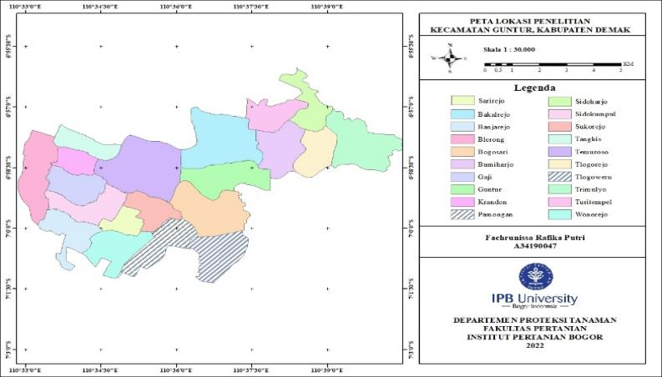

Tlogoweru
Pamongan
Figure 1. Research map in Guntur District, Demak Regency, Central Java, Indonesia

Respondent Characteristics
Interviews were conducted using a structured questionnaire with 30 respondents working as rice farmers in Tlogoweru Village, Guntur District, Demak Regency, Central Java Province. The respondents were predominantly male (73%), while only 27% were female. Respondents varied in age, with the majority (50%) aged between 46-55 years. According to research by Susanti et al. (2016), the range of age for productive rice farmers is between 30-59 years. Farmers of productive age are open to new ideas in rice farming to increase rice production (Novita et al. 2016). The majority of respondents (47%) had an elementary school education. Most respondents' primary occupation was farming (33%), with more than 35 years (47%) of rice farming experiences. All respondents belonged to three farmer groups in Tlogoweru Village: Tani Mintorogo Group, Margo Kamulyan Group, and Tulodho Tani Group. Seventy three percent (73%) of farmers own land less than 5,000 m² (< 0.5 Ha), while 27% own land between 5,000 and 10,000 m² (0.5 Ha < X < 1 Ha). The majority (70%) of rice fields in Tlogoweru Village are privately owned and cultivated by themselves. The remaining (30%) are tenant farmers who rent land from others. The primary crops grown by all farmers are rice with Inpari 32 varieties (73%) and Inpari 42 varieties (27%).

The Problems Caused by Rats Pest
Rice cultivation in Guntur District is inextricably linked to the problem of rice field rats, which attack rice crops. Interviews revealed that all respondents reported that the rat species, R. argentiventer, is present in the rice fields. Rats’ attack to rice crops aged: Less than 15 days after planting (DAP) (3%), between 15-40 DAP (20%), between 40-65 DAP (53%), and more than 65 DAP (24%). Farmers often use more than one control method i.e. mechanical (hunting and rat nest), biological, and chemical control to achieve effective results (Figure 2).

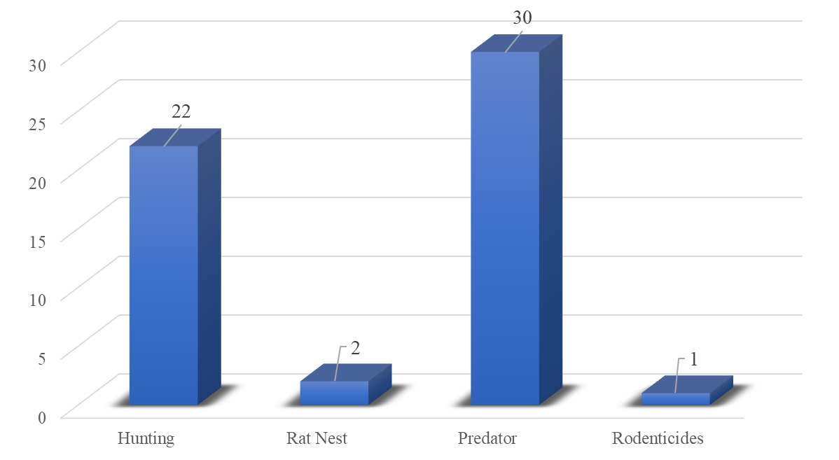
Figure 2. Types of rat control carried out

The Role of Barn Owls (T. alba)
Ecological Factors
Managing the rice field rats population using barn owls (T. alba) is influenced by various supporting factors, including environmental conditions, habitat suitability, food availability, and competition of owls with other predators. T. alba is territorial birds, establishing a territory, or establishing a nest, whether natural or artificial. The number of its nests in Guntur District at the beginning of the control program was 50 nest. It was constructed from simple materials such as wood, bamboo, and planks. From year 2010 to 2022, the number of bird nests spread across the rice fields area in Guntur District, continued to grow and be modified in terms of shape, size, number of doors, and materials used (Figure 3). The total number of bird nests in Guntur District is 663, consisting of 264 permanent nests and 399 simple nests (Agricultural Extension Agency 2022). In Tlogoweru Village, the number of permanent nests is 108 (40.9%) and the number of simple nests is 62 (15.5%). Meanwhile, in Pamongan Village, the number of permanent nests is 15 (5.7%) and simple nests is 22 (5.5%).

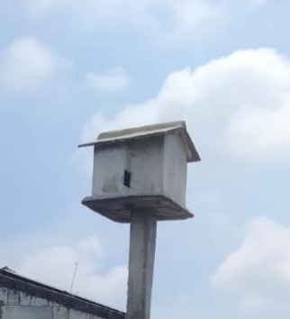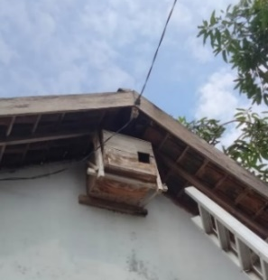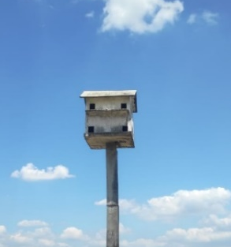
- (b) (c)
Figure 3. Shape and location of the barn owl house doors in Guntur District: (a) Side door barn owl nest; (b) Single door barn owl nest; (c) Barn owl nest with four doors

Several variations of the barn owl houses were observed, with an average size of 60 cm x 60 cm x 40 cm. The observed barn owl house had three shapes: (a) the door was positioned next to the barn owl nests, with the door projecting backward; (b) the barn owl nests had only one room with the door facing east; and (c) the barn owl nests had four doors and four rooms. However, in the observation of nests of barn owl (c), only one room contained traces of the owls in the form of feces, feathers, and pellets.
Based on light intensity, the barn owl (a) was the most ideal compared to other nest shapes. This type of nests offers greater safety because the T. alba room is located next to the door, so T. alba chicks are less likely to fall and are protected from wind and rain. The door, located next to the nests, allows minimal light to enter the room. Meanwhile, the least ideal shelter is nests (b) because it faces the morning light source and is located in a building/human house in the middle of a busy residential area. Furthermore, this nests/shelter lacks a perch for T. alba. According to Baskoro (2005), the retina of T. alba contains numerous light-sensitive rod cells. This is because T. alba's eyes are not eyeballs but rather cube-shaped.
The nests is built in areas close to rat nests/shelters, such as rice field embankments and buildings surrounding the rice fields. The support posts for the permanent shelter are constructed with a chicken claw foundation, making it more sturdy and less likely to collapse in the soft rice field soil. For the simple nests, the support posts are made of PVC or bamboo poles embedded in the ground to a depth of approximately 0.5 m. The height of the bird nests ranges from 3.5 to 4 meters, with a spacing of 50 to 100 meters between them.
Observations of nests were conducted at 08.00 am with the aim to observed T. alba resting in their nests or still showing traces of hunting activity the previous night. Fourteen nests were observed, with nests numbered 1-12 located in Tlogoweru Village and nests numbered 13-14 located in Pamongan Village (Table 1). Indicators of active nests were marked by the presence of T. alba traces in the form of pellets, feces, bone remains, and loose feathers. In addition, eggs and young eggs and individuals were found in several nests (Figure 4).

Table 1. Observation of the barn owl nests in Tlogoweru and Pamongan Villages
No. | Barn owl nests | Barn owl nests material | Object observed
No. | Barn owl nests | Barn owl nests material | Faeces | Pellet | Egg | Adult | Sub Adult
1 | R1 | Asbestos | √ | √ | - | - | 4
2 | R2 | Wooden board | √ | √ | - | - | -
3 | R3 | Concrete casting | √ | √ | - | - | 3
4 | R4 | Concrete casting | √ | √ | 3 | - | -
5 | R5 | Concrete casting | √ | √ | - | - | -
6 | R6 | Concrete casting | √ | √ | - | - | -
7 | R7 | Wooden board | √ | √ | - | 1 | -
8 | R8 | Concrete casting | √ | √ | - | - | -
9 | R9 | Concrete casting | √ | √ | - | - | -
10 | R10 | Asbestos | √ | √ | - | - | -
11 | R11 | Concrete casting | √ | √ | - | - | -
12 | R12 | Concrete casting | √ | √ | - | 1 | -
13 | R13 | Asbestos | √ | √ | - | 1 | -
14 | R14 | Asbestos | √ | √ | - | 1 | -
Description: the √ sign indicates the presence of faeces and pellets.
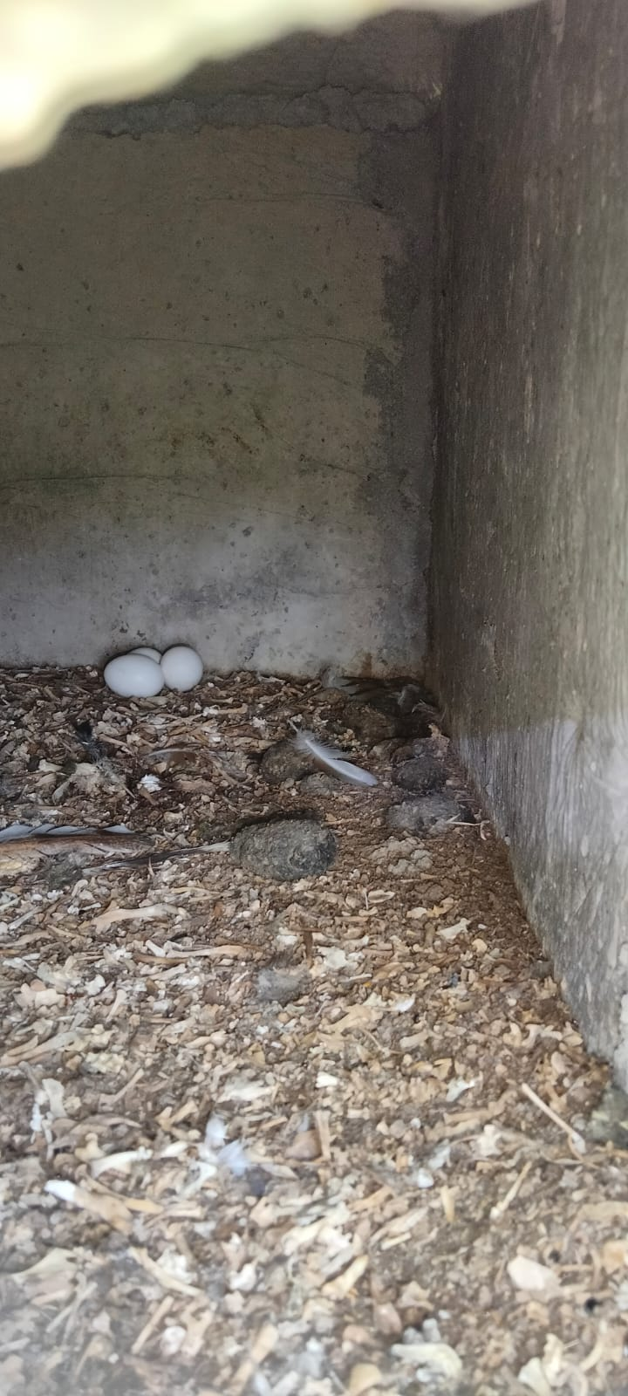
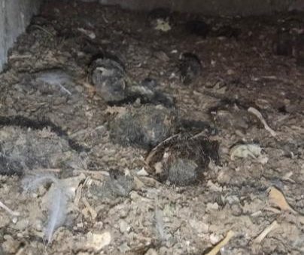
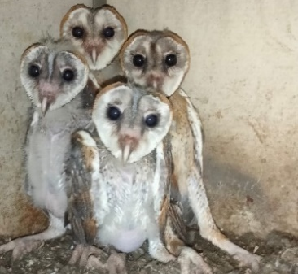

C
B
A
Figure 4. Objects observed in the barn owl nests: (A) owl’s feathers, droppings, bone
remains, and wet pellets, (B) T. alba chicks, (C) eggs.

Pellets are food waste regurgitated by T. alba with an oval shape and are made of indigestible materials such as fur or hair of rats, bones, nails, and teeth with a length of approximately 2-3 cm and a width of 1-2 cm (Hidayat 2014). From the results of the analysis of T. alba droppings, 99% consisted of rats, while the rest were insects (Hadi 2008). Based on interviews, a single T. alba can consume 3-5 rats in one night under various field conditions. Meanwhile, at the beginning of control, a single T. alba can hunt 8-10 rats per night. This aligns with research by Berliani et al. (2021), assuming a 10 meter distance, each T. alba can prey on 3-4 rats in one night.
Nests without owls but with droppings and traces of wet pellets are considered active. According to research by Mulyana (2020), nests without eggs and chicks are rarely occupied by parents, so owls spend most of their time outside the nest. In addition to direct observations, to determine the T. alba population, interviews were conducted with farmer respondents to determine the average number of T. alba found on their rice farm land.All respondents stated that each barn owl nests, they owned contained a pair of owls. The presence of T. alba was identified based on the sounds it made, droppings, food scraps, and white fluid found around the barn owl nests. The number of T. alba individuals in Guntur District can be estimated using the following calculation: Number of T. alba = Number of active barn owl nests x 2 (assuming there is a pair of T. alba) = 663 x 2 = 1,326 individuals.
T. alba has a two to four years life cycle with two breeding seasons per year. During a single breeding season, T. alba can lay 6-9 eggs at regular intervals, preventing them from hatching simultaneously, with an average hatching rate of 70-90%. At the beginning of rat control, and when the rat population was abundant, a female T. alba could produce 12 eggs. This is consistent with research conducted by Mulyana (2020) on Sulawesi owls (Tyto rosenbergii), which found that the reproductive rate of T. rosenbergii is influenced by environmental conditions and the availability of food, which is directly proportional to the number of eggs produced. Not all of the eggs that hatch and become chicks in T. alba develop into adults. This is due to the limited food requirements provided by the mother, so only strong chicks with sufficient food can grow and develop into adults (Figure 5).

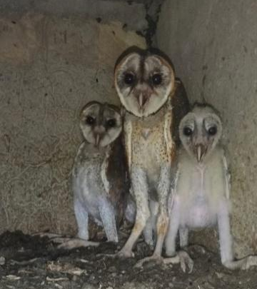
Figure 5. Differences in body size of T. alba chicks in the barn owl nests.

The success of rice field rat control using T. alba in Guntur District is also supported by integrated pest management (IPM). Mechanical control, namely hunting (gropyokan), was carried out in Tangkis, Tlogoweru, and Wonorejo Villages before the first planting season using fire arms, group hunting, composting, and the dismantling of active rat burrows coordinated by the pest control team. Before dismantling active rat burrows, fence/nets or trap barrier system (TBS) were installed with rice plants as bait or lure, measuring 25 m x 25 m to 50 m x 50 m and multiple live traps called bubu were set at each corner. The use of T. alba was able to reduce the frequency of mechanical control (hunting = gropyokan). Before the presence of this predator (T. alba), hunting (gropyokan) was carried out three to four times in one planting season. Meanwhile, after biological control application, hunting (gropyokan) was carried out only one to two times in one planting season.

Economic Factors
The beneficial of T. alba to control rice field rats requires significant capital, namely the construction of temporary nests/shelters. Initially, capital came from three farmer groups: Margo Kamulyan, Mintorogo, and Tulodho Makaryo, as well as one women's farmer group, each contributing an initial capital of IDR 1,000,000. Construction of temporary nests/shelters began with village officials, who were required to construct one simple nests/shelter, followed by the assistance from the Demak Agriculture Service, which provided five nests units. The private sector contributed 10 additional nests/shelters. The cost of constructing a simple nests/shelter was IDR 300,000. The cost of constructing a permanent nests/shelter was higher, at IDR 2,325,000.
Managing the rice field rats with the predator (T. alba) reduced control costs, including the purchase of rodenticides (poisoned bait), the use of trapping equipment, and electric fence. A comparison of rat control using T. alba and other control methods can be seen in Table 2. Overall, the biological control method using T. alba was able to save IDR 87,500 (IDR 240,000 minus IDR 152,500) compared to chemical control, and IDR 847,500 (IDR 1,000,000 minus IDR 152,500) compared to mechanical control activities per planting season (Table 2).

Table 2. Comparison of control using T. alba with other control methods
No. | Control Method | Cost per one planting season
1. | Chemical (rodenticide) | 2 kg/Ha x IDR 30,000 x 4 time of application = IDR 240,000
2. | Mechanical (hunting) | 1 Ha x 10 working man’s day x IDR 50,000 = IDR 500,000/hunting equal with IDR 1,000,000
3. | Biological (T. alba) | Permanent barn owl nests IDR 2,325,000 for 15 years or 30 planting season plus bird keeping IDR 300,000 for 4 planting season = IDR 77,500 + 75,000 = IDR 152,500
4. | Electric fence | IDR 2,000,000 - 3,000,000

Rat control using electric fence is very expensive for equipment, electricity, and labor, even if the equipment is used several times. Biological control using T. alba shows lower costs and is environmentally safe, because farmers only need to build a nests/shelter at the beginning of its control and adaptation of T. alba during quarantine. Furthermore, the T. alba is able to hunt prey (rice field rats) without farmer assistance. To date, there have been no public complaints about the negative impact of T. alba attacking chicken or ducks farms owned by local residents. Controlling rice field rats using T. alba has shown positive results as seen in production results after control. Since 2011, rice production in Guntur District has tended to be stable and has experienced a significant increase (Figure 6).
Before T. alba control, farmers experienced losses of 40% in rice production and nearly 100% in corn and other secondary crops (palawija). According to respondents, the effectiveness of T. alba in controlling rice field rats was seen in 2012, the second year after control, at 64.42 hundred kg/Ha (6.442 Ton/Ha). Costs expenditure per hectare for rice farming activities during one planting season in the observation area (Demak Regency) can be seen in Table 3.

Figure 6. Rice production (Ton/Ha) in Guntur District from 2010 to 2018
(Source: Central Bureau of Statistics 2019).

Table 3. Average farmer expenditure per hectare per planting season
No | Input Factor | Cost | Total
1. | Rice seed (Inpari 32 varieties) | IDR 65,000.00 x 5 pack | IDR 325,000.00
2. | Fertilizer | IDR 4,000,000.00 | IDR 4,000,000.00
3. | Pesticide | IDR 400,000.00 | IDR 400,000.00
4. | Biological control T. alba | IDR 152,500.00 | IDR 152,500.00
5. | Labour | IDR 4,000,000.00 | IDR 4,000,000.00
Total |  |  | IDR 8,877,500,00

Based on interviews, one hectare after rat control with barn owls T. alba can produce 5-6 tons of rice with an average selling price of IDR 5,000.00/kg, so that the total income obtained by farmers in every harvest is IDR 25,000,000.00 to IDR 30,000,000.00. The high cost of pest control incurred by farmers is influenced by other pests and diseases attacks. To determine the feasibility of farming using T. alba as a rice field rat controller, the Revenue Cost Ratio (R/C Ratio) is calculated as follows:

R/C ratio = $\frac{Revenue}{Cost}$ = $\frac{\text{IDR}\text{ 25}\text{,}\text{000}\text{,}\text{000}\text{.}\text{00}}{\text{IDR}\text{ 8}\text{,}\text{877}\text{,}\text{500}\text{.}\text{00}}$ = 2.81

In the R/C Ratio calculation, the result obtained was more than 1, so the farming business was considered feasible to develop. To determine the profitability of farming using T. alba as a rice field rat control, the Benefit Cost Ratio (B/C Ratio) was calculated using the following formula:

B/C ratio = $\frac{\text{Benefit}}{\text{Cost}}$ = $\frac{\left(\text{6}\text{,}\text{063} \text{kg-5}\text{,}\text{946} \text{kg}\right)\text{ x }\text{IDR}\text{ 5}\text{,}\text{000}\text{.}\text{00}\text{/kg}}{\text{IDR}\text{ 1}\text{5}\text{2}\text{,}\text{500}\text{.}\text{00}}$ = $\frac{\text{IDR}\text{ 585}\text{,}\text{000}\text{.}\text{00}}{\text{IDR}\text{ 152}\text{,}\text{500}\text{.}\text{00}}$ = 3.84

The benefit calculation is obtained from the difference in production yields between 2010 (before control) and 2011 (after control), as seen in Figure 6, by multiplying it by the selling price of rice. The benefit is then divided by the control costs using T. alba. The B/C ratio calculation yields a result more than 1, thus making the farming business profitable.

Social Factors
All respondents stated that the community participates in the preserving T. alba to control rice field rats in the field. Community roles and participation in supporting conservation include complying with regulations, not disturbing the life and habitat of barn owls, and participating in the construction of temporary nests/shelters. Initially, residents were fearful because T. alba was considered a bad omen. However, with appropriate outreach by the “Tyto Alba Team”, the community became more confident and fully supported the control efforts. Currently, the people of Guntur District, particularly in Tlogoweru Village, are more familiar with the barn owl as "Tyto alba".
Farmer groups play a crucial role in the success of rice field rat control using T. alba. Support provided by farmer groups includes financial support, labor, and ideas. Financial support provided by farmer groups includes contributions for building temporary nests/shelters during the initial stages of control and maintaining T. alba in the quarantine area. Labor support provided by farmer groups includes participation in building temporary nests/shelters and monitoring the development of T. alba in the field. Meanwhile, the farmer groups provided support for ideas in the form of creating variations of the tree-planting system (barn owl nests) in terms of shape, material, and location to compare and identify the most effective tree-planting system.
In collaboration between various stakeholders to support successful control using T. alba, the government, as the policymaker, plays an equally important role. This support includes providing labor for tree-planting, tree-planting propagation, outreach and training activities, and developing regulations related to the barn owls protection. The regulation issued to protect T. alba in Tlogoweru Village is Tlogoweru Village Regulation No. 4 of 2011 concerning Rat-Predatory Birds (Tyto alba). In addition to this regulation, to support sustainable T. alba control and educational tourism, a Village-Owned Enterprise (Badan Usaha Milik DESa) was established, as outlined in Tlogoweru Village Regulation No. 4 of 2021, to manage the finances and financing of T. alba.

CONCLUSION
Biological control using predator/raptor bird (T. alba) is able to control the rice field rat population and is more effective than other control methods, considering ecological, economic, and social factors. A single T. alba can consume 3-5 rice field rats per night and is able to control rats in various field conditions. Overall, the use of T. alba resulted in savings of IDR 87,500.00 compared to chemical control and IDR 847,500.00 compared to mechanical control. The calculated R/C ratio and B/C ratio for rat control using T. alba were 2.81 and 3.84, respectively, making the farming business feasible. The success of rat control using T. alba is also influenced by the participation of stakeholders, such as the government, farmer groups, and the surrounding community, supported by other integrated pest control methods.

BIBLIOGRAPHY
Agricultural Extension Center. 2022. Data Rubuha Aktif di Kecamatan Guntur, Kabupaten Demak. Demak : BPP Kecamatan Demak.
Baskoro K. 2005. Tyto alba: Biologi, Perilaku, Ekologi dan Konservasi. Semarang: Pecinta Alam Haliaster Biologi. Universitas Diponegoro.
Berliani S, Pradiana W, Trisnasari W. 2021. Tyto alba inovasi pengendali hama tikus (Rattus argentiventer) melalui pemberdayaan petani padi sawah. Jurnal Inovasi Penelitian. [diakses 2023 Jan 15]; 2(2):691-698. doi:10.47492/jip.v2i2.740.
Central Bureau of Statistics. 2019. Kecamatan Guntur dalam Angka 2019. Demak: Badan Pusat Statistika, Kabupaten Demak.
Central Bureau of Statistics. 2022. Luas Panen dan Produksi Padi di Indonesia 2021. Jakarta: Badan Pusat Statistika.
Hadi M. 2008. Pola aktivitas harian pasangan burung serak jawa (Tyto alba) di sarang Kampus Psikologi Universitas Diponegoro Tembalang Semarang. Bioma. [accessed 2023 Feb 5]; 6(2):23-29. doi:10.14710/bioma.10.1.23-29.
Hidayat S. 2014. Morfologi esofagus dan lambung burung serak jawa (Tyto alba) [skripsi]. Bogor: Institut Pertanian Bogor.
Mulyana AN. 2020. Pemanfaatan burung serak sulawesi (Tyto rosenbergii Schlegel) untuk mengendalikan tikus pada perkebunan kelapa sawit di Sulawesi [tesis]. Bogor: Institut Pertanian Bogor.
Novita S, Denmar D, Suratno T. 2016. Hubungan karakteristik sosial ekonomi petani dengan tingkat penerapan teknologi usahatani padi sawah lahan rawa lebak di Kecamatan Sekernan Kabupaten Muaro Jambi. Jurnal Sosio Ekonomika Bisnis. 19(1): 22-52.
Shawyer CR. 2011. Barn Owl Tyto alba Survey Methodology and Techniques for use in Ecological Assessment : Developing Best Practice in Survey and Reporting. Winchester: IEEM.
Siregar HM, Priyambodo S, Hindayana D. 2020. Preferensi serangan tikus sawah (Rattus argentiventer) terhadap tanaman padi. Agrovigor. 13(1): 16-21. [accessed 2023 Jan 21]. https://journal.trunojoyo.ac.id/agrovigor/article/view/6249.
Sugiyono. 2013. Metode Penelitian Kuantitatif, Kualitatif, dan R&D. Bandung: CV Alfabeta.
Susanti N, Listriana NH, Widaya T. 2016. Pengaruh umur petani, tingkat pendidikan dan luas lahan terhadap hasil produksi tanaman sembung. Jurnal Tumbuhan Obat Indonesia. 9(2):75-82.
Widodo A. 2013 Nov 13. Diserbu Tikus, Ratusan Hektar Sawah di Demak Gagal Panen. Kompas.com. [accessed 2023 Jan 10]. https://tekno.kompas.com/read/2013/11/ 13/1147280/Diserbu.Tikus.Ratusan.Hektar.Sawah.di.Demak.Gagal.Panen.

