Customer Segmentation Using Data Mining Techniques

- Abhishek Ganesh Hande, School of Business Management, JSPM University, Pune
- Dr. S.V. Pradeepa, Research Guide, School of Business Management, JSPM
University, Pune
Abstract
Customer segmentation is an essential strategy used by organizations to divide customers into distinct groups based on similar characteristics such as purchasing behavior, income level, frequency of transactions, and spending patterns. Effective segmentation enables businesses to design targeted marketing campaigns, optimize resource allocation, and improve overall customer satisfaction.
The primary objective of this study is to analyze customer data using data mining techniques and classify customers into meaningful and actionable segments. The research applies RFM (Recency, Frequency, Monetary) analysis to evaluate customer value and K-Means Clustering to group customers based on behavioral similarities. These techniques help in identifying highvalue customers, loyal customers, potential customers, and at-risk customers.
The study uses structured customer transaction data and applies quantitative analytical methods to extract patterns and insights. The results demonstrate that data-driven segmentation enhances marketing efficiency, improves customer retention strategies, increases profitability, and supports strategic business decision-making.
By integrating business analytics tools and data mining techniques, this research highlights the importance of customer-centric strategies in today’s competitive business environment. The findings suggest that organizations adopting analytical segmentation models can gain a significant competitive advantage through personalized marketing and improved customer relationship management.

Keywords
Customer Segmentation, Data Mining, K-Means Clustering, RFM Analysis, Business
Analytics, Marketing Analytics

1.Introduction
In today’s competitive market environment, organizations collect vast amounts of customer data from online platforms such as Amazon and Flipkart. This data includes browsing history, transaction records, clickstream patterns, search queries, time spent on webpages, and customer feedback. However, raw data by itself does not provide meaningful insights unless it is systematically processed and analyzed using appropriate analytical techniques (Han et al., 2012). Without proper analysis, large datasets remain underutilized and fail to support strategic decision-making.
Customer segmentation is a strategic analytical approach that enables businesses to categorize customers into distinct groups based on shared characteristics such as purchasing behavior, demographics, psychographics, and spending patterns. Effective segmentation allows organizations to better understand customer behavior, identify high-value customers, design personalized marketing campaigns, and improve customer retention strategies (Kotler & Keller, 2016). By dividing customers into homogeneous groups, companies can allocate marketing resources more efficiently and tailor communication strategies according to the specific needs and preferences of each segment.
Furthermore, data mining techniques enhance the accuracy and efficiency of the segmentation process by extracting hidden patterns and relationships within large datasets. Methods such as clustering, classification, and RFM (Recency, Frequency, Monetary) analysis provide data-driven insights that support informed managerial decision-making and competitive advantage (Tan et al., 2019). Clustering techniques such as K-Means grouping enable businesses to identify natural groupings within customer data, while RFM analysis helps in evaluating customer lifetime value and purchase loyalty.
In addition, web usage mining plays a crucial role in understanding online customer behavior by analyzing clickstream data and navigation paths. This enables organizations to predict future purchasing behavior, recommend relevant products, and enhance personalization strategies. The integration of business analytics tools with data mining techniques not only improves marketing performance but also strengthens customer relationship management (CRM) systems. As competition intensifies in the digital marketplace, data-driven customer segmentation has become a fundamental requirement for achieving sustainable growth and long-term profitability.

1.1 Understanding Changes in Customer Behaviour
In the modern business world, customer behaviour is constantly changing due to the growth of digital technologies and online platforms. People now interact with businesses through websites, mobile apps, and social media, which creates a large amount of useful data. Because of this, companies can no longer depend only on traditional marketing methods.
Businesses now need to carefully study customer preferences, buying habits, and expectations. Data mining helps in analysing this large amount of data and finding useful patterns. With this understanding, companies can divide customers into different groups and create personalized marketing strategies. This shift from general marketing to focused, customer-based approaches help improve satisfaction and build stronger relationships with customers.

1.2 Using Data Mining Techniques for Better Analysis
Today, companies are using data mining techniques to better understand their customers and improve decision-making. These techniques help in finding hidden patterns and relationships in large datasets that are difficult to identify manually.
One commonly used method is clustering, especially K-Means clustering, which groups customers based on similar characteristics like spending habits and purchase frequency. Another important method is RFM analysis, which studies how recently a customer purchased, how often they purchase, and how much they spend.
By using these methods, businesses can classify customers into different categories such as loyal customers, new customers, and inactive customers. This helps companies to focus their marketing efforts more effectively, use their resources wisely, and improve customer relationship management.

1.3 Importance of Technology in Customer Segmentation
Technology plays a very important role in modern customer segmentation. With the help of advanced tools like big data analytics, artificial intelligence, and machine learning, businesses can easily collect and analyse large amounts of customer data.
These technologies allow companies to understand customer behaviour in real time and quickly respond to their needs. Machine learning models can also predict future behaviour based on past data, making segmentation more accurate. In addition, tools like customer data platforms help businesses manage and organize customer information efficiently.
Overall, technology makes customer segmentation faster, more accurate, and more useful. It helps businesses create better marketing strategies, improve customer experience, and achieve long-term growth.

2. Literature Review
Customer segmentation has become an important concept in marketing and business analytics, especially in today’s data-driven environment. Earlier, businesses mainly used basic factors such as age, gender, and location to divide customers into groups. However, with the growth of digital platforms and availability of large datasets, companies now focus more on customer behaviour, spending patterns, and preferences to create more meaningful segments.
Several researchers have highlighted the importance of analysing customer data to improve business performance. Studies suggest that organizations that use data-driven segmentation are able to understand their customers better and design more effective marketing strategies. This not only helps in increasing customer satisfaction but also improves customer retention and overall profitability. Behaviour-based segmentation is considered more effective because it reflects actual customer actions rather than assumptions.
One of the most widely used approaches in customer segmentation is the RFM (Recency, Frequency, Monetary) model. This method evaluates customers based on how recently they made a purchase, how often they buy, and how much they spend. Researchers have found that customers who score high on these factors are more valuable to the business. As a result, companies can focus more on these customers and develop strategies to maintain long-term relationships with them.
In addition to RFM analysis, clustering techniques such as K-Means clustering are commonly used to group customers with similar characteristics. This method helps in identifying natural patterns within the data without the need for predefined categories. Many studies have shown that combining RFM analysis with clustering techniques improves the accuracy of customer segmentation and provides deeper insights into customer behaviour.
Furthermore, classification techniques have been used to predict customer actions such as purchase decisions and customer churn. These methods allow businesses to take preventive actions, such as offering discounts or personalized services, to retain customers. Association rule mining is another useful technique that helps in identifying relationships between products, which supports cross-selling and marketing strategies.
With the advancement of technology, modern research also focuses on the role of big data and machine learning in customer segmentation. These technologies make it easier to process large volumes of data and generate real-time insights. Researchers emphasize that organizations adopting advanced analytical tools gain a competitive advantage by improving decisionmaking and customer engagement.
Overall, previous studies clearly show that customer segmentation using data mining techniques plays a key role in improving marketing efficiency, enhancing customer satisfaction, and supporting long-term business growth. The integration of analytical methods and modern technologies has made segmentation more accurate, practical, and valuable for organizations.

3. Methodology
This study is based on a structured approach to understand customer segmentation using data mining techniques. The research mainly focuses on analysing customer behaviour by using both theoretical concepts and basic data analysis methods. The purpose of this methodology is to collect relevant data, process it, and generate meaningful insights that can help businesses improve their marketing strategies.
The study uses a quantitative approach, as it involves the analysis of customer data such as purchase frequency, spending patterns, and transaction history. Data is collected either from sample datasets or through surveys, depending on availability. After collecting the data, it is cleaned and organized to remove errors or missing values.
To perform segmentation, techniques like RFM (Recency, Frequency, Monetary) analysis and clustering methods (such as K-Means) are used. These methods help in grouping customers based on their behaviour and identifying different types of customers such as high-value, loyal, and inactive customers. The results are then interpreted using simple tools like charts, tables, and percentage analysis to make the findings easy to understand.
Overall, this methodology helps in converting raw customer data into useful business insights, which can support better decision-making and customer relationship management.

3.1 Scope of the Study
The scope of this study is focused on understanding how customer segmentation can be applied in real business situations using data mining techniques. It mainly covers the analysis of customer purchasing behaviour and how businesses can use this information to improve their marketing strategies.
The study is limited to selected data sources such as sample customer datasets or survey responses. It focuses on key variables like purchase frequency, recency of transactions, and spending amount. The research does not cover all advanced machine learning models but concentrates on basic and widely used techniques that are easy to understand and apply.
Additionally, the study aims to provide practical insights that can be useful for small and medium-sized businesses. It highlights how even simple data analysis methods can help organizations identify valuable customers and improve customer satisfaction.

3.2 Objectives of the Study
- To understand the concept of customer segmentation and its importance in business decision-making.
- To analyse customer behaviour using data mining techniques such as RFM analysis and clustering.
- To identify different customer groups based on purchasing patterns and spending habits.
- To evaluate how customer segmentation can improve marketing strategies and customer retention.
- To provide suggestions for businesses to effectively use data-driven segmentation techniques.

4. Discussion
4.1 Customer Segmentation Patterns across Different Customer Groups: Business

Insights and Analytical Perspectives
Customer segmentation using data mining techniques helps organizations understand how different groups of customers behave and interact with products or services. By analysing data such as purchase history, frequency, and spending patterns, businesses can identify meaningful customer segments and develop targeted strategies.
This section focuses on how different customer groups contribute to business performance and how segmentation provides both opportunities and challenges. Understanding these patterns allows companies to improve marketing efficiency, enhance customer satisfaction, and make better strategic decisions.

High-Value Customer Segment
High-value customers are those who frequently purchase and spend a significant amount of money. These customers are the most important for any business as they contribute a large portion of revenue. Data mining techniques such as RFM analysis help in identifying these customers accurately.
Businesses can focus on retaining these customers by offering personalized services, loyalty programs, and exclusive offers. However, the challenge lies in maintaining their satisfaction and preventing them from switching to competitors.

Potential Customer Growth
Potential customers are those who have shown interest in products or services but are not yet regular buyers. These customers represent an opportunity for business growth. Through data analysis, companies can understand their behaviour and create targeted campaigns to convert them into loyal customers.
The main challenge is identifying the right approach to engage these customers effectively, as their preferences may vary and require customized marketing strategies.

Low-Value or Inactive Customers
This group includes customers who purchase less frequently or have stopped interacting with the business. Although they contribute less to revenue, they still represent an opportunity if reengaged properly.
Businesses can use data mining techniques to identify reasons for inactivity and design strategies such as discounts or reminders to bring them back. However, not all inactive customers can be retained, which makes it a challenge to allocate resources efficiently.

Implications of Customer Segmentation Trends
The use of data mining in customer segmentation has transformed how businesses make decisions. Companies are now able to move from general marketing strategies to more personalized approaches based on real data.
This trend improves customer experience and increases efficiency, but it also requires businesses to invest in technology and skilled professionals. Organizations that successfully adopt data-driven segmentation gain a competitive advantage, while those that do not may struggle to understand their customers effectively.
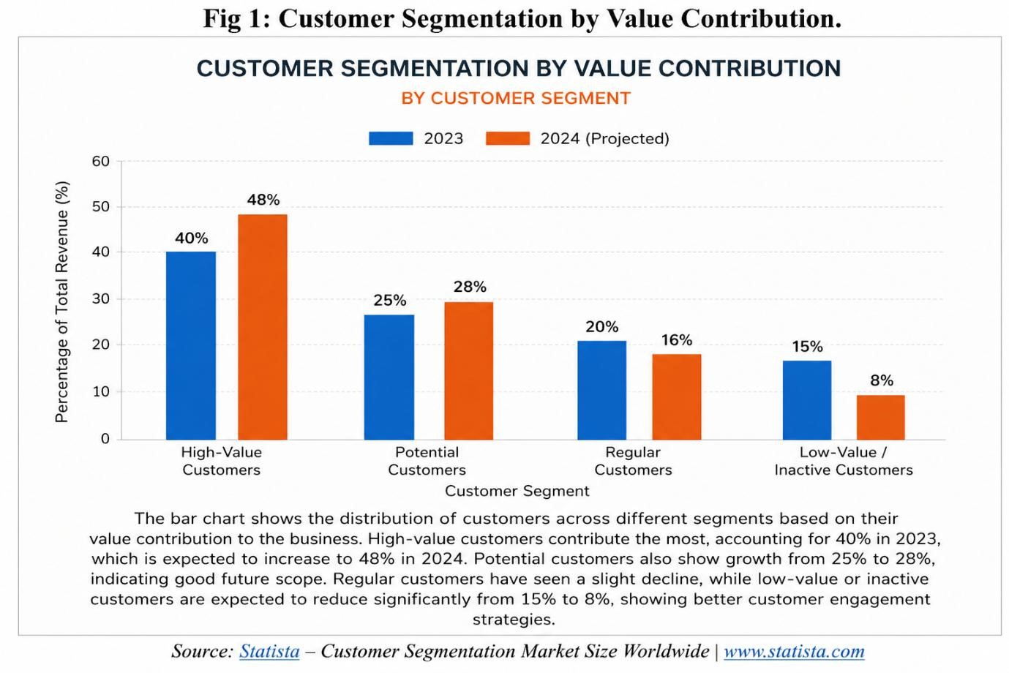
Source: https://www.statista.com/

4.2 Customer Segmentation Optimization using Data Mining Techniques
Customer segmentation optimization focuses on improving the accuracy and usefulness of grouping customers based on their behaviour and value. Data mining techniques such as clustering and RFM analysis allow businesses to divide customers into meaningful segments like high-value, potential, and inactive customers.
By applying these techniques, organizations can design targeted marketing strategies, improve customer engagement, and increase profitability. Optimization also involves continuously updating customer data and refining segmentation models to match changing customer behaviour. This ensures that businesses remain responsive and competitive in a dynamic market environment.

4.3 Emerging Trends in Customer Segmentation
The field of customer segmentation is rapidly evolving due to advancements in technology and the increasing availability of data. Businesses are now shifting towards more dynamic and realtime segmentation methods that provide deeper insights into customer behaviour.

Technological Integration
Modern customer segmentation heavily relies on technologies such as big data analytics, artificial intelligence (AI), and machine learning. These tools enable businesses to process large volumes of customer data quickly and accurately.
With the help of these technologies, companies can identify patterns, predict future behaviour, and create highly personalized marketing strategies. Real-time data processing also allows businesses to respond immediately to customer needs, improving overall customer experience. Customer-Centric Approach
Organizations are increasingly focusing on creating value for customers rather than just selling products. Customer segmentation helps businesses understand individual preferences and deliver personalized experiences.
This approach improves customer satisfaction, builds loyalty, and strengthens long-term relationships. Businesses that adopt a customer-centric mindset are more likely to succeed in competitive markets.

4.4 Case Studies of Customer Segmentation in Practice
Real-world applications of customer segmentation demonstrate how businesses use data mining techniques to improve performance and customer engagement.

E-commerce Platforms: Personalized Marketing
E-commerce companies use customer segmentation to analyse browsing history, purchase behaviour, and preferences. Based on this data, they recommend products, offer discounts, and create personalized advertisements.
This strategy increases sales and enhances the overall shopping experience for customers.

Retail Industry: Targeted Promotions
Retail businesses apply segmentation techniques to identify different customer groups and design targeted promotional campaigns. For example, loyal customers may receive special discounts, while new customers are offered introductory deals.
This helps in improving customer retention and attracting new buyers.

Banking Sector: Customer Risk and Value Analysis
Banks use customer segmentation to analyse spending patterns, credit behaviour, and transaction history. This helps them classify customers based on risk levels and financial value.
Such segmentation supports better decision-making in areas like loan approvals, credit card offers, and investment planning.

Strategic Innovations in Segmentation
Businesses are continuously improving segmentation strategies by adopting advanced analytical models and integrating multiple data sources. Combining demographic, behavioural, and transactional data leads to more accurate and meaningful segmentation.

Digital Innovations
The use of digital platforms, mobile applications, and customer data platforms (CDPs) has transformed how customer data is collected and analysed. These innovations enable businesses to create real-time segmentation and improve marketing effectiveness.

Sustainable and Ethical Data Usage
With the increasing use of customer data, organizations are also focusing on ethical practices and data privacy. Responsible data usage builds customer trust and ensures compliance with regulations.Sustainable data practices are becoming an important part of modern business strategies.

Global Customer Analytics Market Growth Analysis (2024–2030)
Fig 2 shows the growth of the Customer Analytics and Segmentation Market (2024–2030).
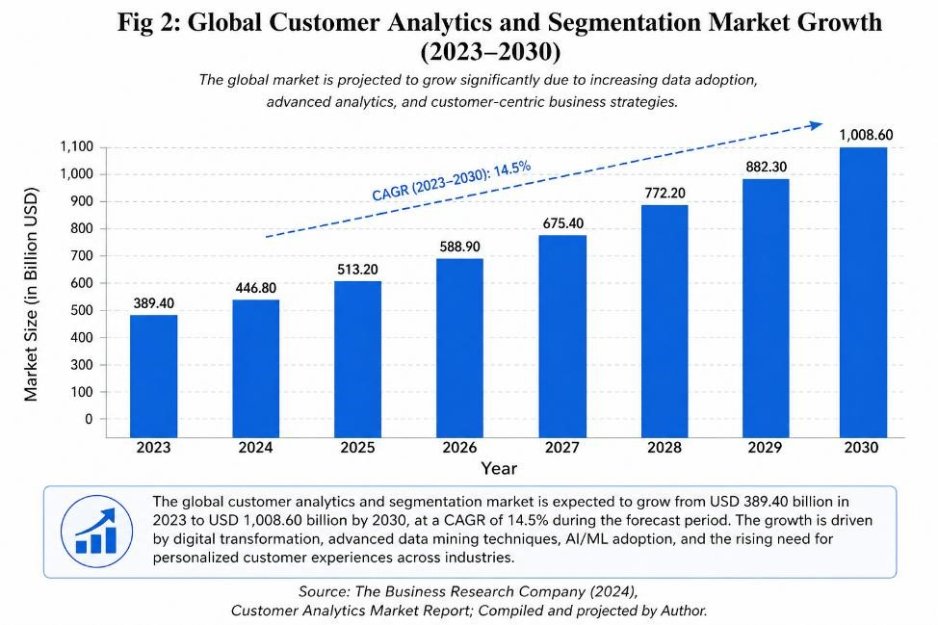
Key Forecasts:
- The customer analytics market is expected to expand rapidly in 2024 due to increased digital transformation across industries.
- By 2028, the market is projected to grow significantly, showing the rising importance of data-driven marketing and personalization.
- Organizations are increasingly using segmentation tools to improve customer experience and gain competitive advantage.

Implications and Observations
The strong growth of customer analytics and segmentation is influenced by several important factors:
- Growth of Digital Platforms: Online platforms generate large amounts of customer data, which supports advanced segmentation.
- Increase in Consumer Spending: Customers are spending more, encouraging businesses to analyse behaviour and improve targeting.
- Advanced Analytical Tools: Technologies like AI, machine learning, and predictive analytics are improving segmentation accuracy.
Due to this growth, businesses such as e-commerce companies, banks, and retail organizations must adopt customer-focused strategies. The market is becoming highly competitive, where innovation and personalization play a key role in gaining market share.

Research Importance
Understanding the growth of customer analytics helps researchers and businesses develop effective strategies. It highlights how data mining techniques can be used to improve customer satisfaction, increase retention, and support long-term business success.

4.6 Customer Segmentation: Opportunities and Challenges
Organizations using customer segmentation face both advantages and difficulties while implementing data-driven strategies.
Opportunities:
- Higher Customer Value: Segmented customers allow businesses to focus on highvalue groups and increase profitability.
- Improved Customer Retention: Personalized marketing helps in building strong customer relationships.
- Better Resource Allocation: Companies can use their resources more efficiently by targeting the right audience.
Challenges:
- Data Quality Issues: Inaccurate or incomplete data can lead to incorrect segmentation.
- Technology Requirement: Advanced tools and skilled professionals are needed for effective analysis.
- Privacy and Security Concerns: Managing customer data responsibly is essential to maintain trust.
To overcome these challenges, businesses must adopt proper data management practices and use reliable analytical tools.

5. Results
The findings of this study show that customer segmentation using data mining techniques provides significant benefits to organizations.
Key Results:

1. Data-Driven Decision Making
Customer segmentation helps businesses make informed decisions by analysing real customer data instead of assumptions.
2. Improved Customer Engagement
Personalized strategies based on segmentation increase customer satisfaction and loyalty.

3. Efficient Marketing Strategies
Businesses can design targeted campaigns for different customer groups, improving marketing effectiveness.

4. Role of Technology
The use of advanced technologies like AI and machine learning enhances segmentation accuracy and prediction capabilities.

Strategic Insights
- Personalization: Customized offers and recommendations improve customer experience.
- Customer Retention: Identifying at-risk customers helps in reducing churn.
- Competitive Advantage: Businesses using data analytics perform better than those using traditional methods.

6. Suggestions
Based on the analysis of customer segmentation using data mining techniques, the following suggestions are proposed to help organizations improve their marketing strategies and overall business performance:

6.1 Adopt Data-Driven Segmentation
Organizations should move away from traditional, assumption-based marketing and adopt data-driven segmentation techniques such as RFM analysis and clustering. This helps in identifying valuable customer groups more accurately and supports better decision-making.

6.2 Focus on High-Value Customers
Businesses should prioritize high-value customers by offering personalized services, loyalty programs, and exclusive benefits. Retaining these customers is more cost-effective than acquiring new ones and significantly contributes to long-term profitability.

6.3 Improve Customer Engagement Strategies
For potential and inactive customers, companies should design targeted campaigns such as discounts, reminders, and personalized communication. This helps in increasing engagement and converting occasional buyers into loyal customers.

6.4 Invest in Advanced Technologies
Organizations should invest in modern tools such as artificial intelligence, machine learning, and big data analytics to improve the accuracy and efficiency of customer segmentation. These technologies enable real-time analysis and better prediction of customer behaviour.

6.5 Ensure Data Quality and Management
Accurate and reliable data is essential for effective segmentation. Companies should focus on maintaining clean, updated, and well-structured data to avoid incorrect analysis and poor decision-making.

6.6 Strengthen Data Privacy and Security
With the increasing use of customer data, organizations must ensure proper data protection measures. Maintaining customer trust through ethical data usage and compliance with regulations is crucial.

6.7 Continuous Monitoring and Improvement
Customer behaviour changes over time, so segmentation models should be regularly updated. Businesses should continuously analyse customer data and refine their strategies to stay competitive.

7. Conclusion
This study highlights the growing importance of customer segmentation in today’s data-driven business environment. By using data mining techniques such as RFM analysis and K-Means clustering, organizations can effectively divide customers into meaningful groups based on their behaviour, spending patterns, and engagement levels. This approach allows businesses to move beyond traditional marketing methods and adopt more targeted and personalized strategies.
The findings of this research demonstrate that data-driven customer segmentation significantly improves decision-making, enhances customer satisfaction, and increases overall business performance. Organizations are able to identify high-value customers, retain loyal customers, and re-engage inactive customers through focused marketing efforts. This not only improves customer relationships but also contributes to long-term profitability.
Furthermore, the integration of advanced technologies such as artificial intelligence, machine learning, and big data analytics has strengthened the effectiveness of segmentation techniques. These tools enable businesses to analyse large volumes of data in real time and predict future customer behaviour more accurately. As a result, companies can respond quickly to changing market trends and customer expectations.
However, the study also identifies certain challenges, including data quality issues, the need for skilled professionals, and concerns related to data privacy and security. Organizations must address these challenges by adopting proper data management practices and ensuring ethical use of customer data.
In conclusion, customer segmentation using data mining techniques is a powerful tool for modern businesses. Companies that adopt data-driven approaches and continuously improve their analytical capabilities will gain a strong competitive advantage in the market. Future research can focus on advanced machine learning models and real-time analytics to further enhance segmentation accuracy and business outcomes.

8. References
Han, J., Kamber, M., & Pei, J. (2012). Data mining: Concepts and techniques (3rd ed.). Morgan
Kaufmann. https://doi.org/10.1016/C2009-0-61819-5
Kotler, P., & Keller, K. L. (2016). Marketing management (15th ed.). Pearson Education.
https://www.pearson.com
Tan, P.-N., Steinbach, M., & Kumar, V. (2019). Introduction to data mining (2nd ed.). Pearson. https://www.pearson.com
Wedel, M., & Kamakura, W. A. (2012). Market segmentation: Conceptual and methodological foundations. Springer. https://doi.org/10.1007/978-1-4614-1469-0
Dolnicar, S. (2008). Market segmentation in tourism. Tourism Management, 29(5), 803–812. https://doi.org/10.1016/j.tourman.2007.09.004
Ngai, E. W. T., Xiu, L., & Chau, D. C. K. (2009). Application of data mining techniques in customer relationship management: A literature review. Expert Systems with Applications, 36(2), 2592–2602. https://doi.org/10.1016/j.eswa.2008.02.021
Chen, H., Chiang, R. H. L., & Storey, V. C. (2012). Business intelligence and analytics: From big data to big impact. MIS Quarterly, 36(4), 1165–1188. https://doi.org/10.2307/41703503
Berry, M. J. A., & Linoff, G. (2011). Data mining techniques: For marketing, sales, and customer relationship management. Wiley. https://www.wiley.com
Fayyad, U., Piatetsky-Shapiro, G., & Smyth, P. (1996). From data mining to knowledge discovery in databases. AI Magazine, 17(3), 37–54. https://doi.org/10.1609/aimag.v17i3.1230
Berson, A., Smith, S., & Thearling, K. (2000). Building data mining applications for CRM. McGraw-Hill. https://www.mheducation.com
Payne, A. (2006). Handbook of CRM: Achieving excellence in customer management. Butterworth-Heinemann. https://www.elsevier.com
Liu, B. (2011). Web data mining: Exploring hyperlinks, contents, and usage data. Springer.
https://doi.org/10.1007/978-3-642-19460-3
Provost, F., & Fawcett, T. (2013). Data science for business. O’Reilly Media.
https://www.oreilly.com
Davenport, T. H., & Harris, J. G. (2007). Competing on analytics. Harvard Business School Press. https://hbr.org
Porter, M. E. (2008). Competitive strategy: Techniques for analyzing industries and competitors. Harvard Business Review Press. https://hbr.org
Rust, R. T., Lemon, K. N., & Zeithaml, V. A. (2010). Customer equity management. Journal of Marketing, 68(1), 109–127. https://doi.org/10.1509/jmkg.68.1.109
Chen, M., Mao, S., & Liu, Y. (2014). Big data: A survey. Information Sciences, 275, 314–347. https://doi.org/10.1016/j.ins.2014.01.015
Statista. (2024). Customer analytics market statistics and reports. https://www.statista.com
The Business Research Company. (2024). Customer analytics global market report. https://www.thebusinessresearchcompany.com
IBM. (2023). What is customer analytics? https://www.ibm.com/analytics
McKinsey & Company. (2022). The value of personalization in marketing.
https://www.mckinsey.com

