A TOPSIS-BASED EVALUATION OF ENGLISH VOCABULARY LEARNING STRATEGIES IN TECHNOLOGY-ENHANCED

ABSTRACT
This study uses the Technique for Order Preference by Similarity to Ideal Solution (TOPSIS), a Multi-Criteria Decision-Making (MCDM) method, to assess how effective English vocabulary acquisition strategies are. Despite a wealth of research on vocabulary learning, most of it is based on subjective evaluations rather than rigorous, data-driven analyses. Using six criteria, namely Retention Rate, Learning Engagement, Cognitive Load, Application in Context, Accessibility, and Feedback Mechanism, this study compares seven strategies, which are Traditional Memorization, Contextual Learning, Gamification, AI-Powered Tools, Mnemonics, Mobile-Assisted Learning (MALL), and Peer Learning to close this gap. Ten ESL specialists with substantial English learning expertise and advanced academic backgrounds provided the data. The strategies were ranked using TOPSIS, and resilience under various weight situations was confirmed using sensitivity analysis. Findings of the study indicated that technology-driven strategies like gamification and artificial intelligence (AI) tools were outperformed by traditional memorization and mnemonic techniques. The results showed the long-term effectiveness of structured, cognitive-based tactics for long-term retention, challenging the current reliance on digital tools. Sensitivity research strengthened the results' dependability by confirming that these ranks were consistent across several weighting methods. The study offers educators, curriculum designers, and EdTech developers with useful insights by providing a new, quantitative framework for assessing language learning tactics. It promotes a well-rounded strategy that maximizes vocabulary acquisition by fusing cutting-edge technology with conventional teaching techniques. Future studies ought to investigate hybrid approaches and broaden the use of MCDM in language instruction.

Keywords: ESL; multi-criteria decision-making; technology-enhanced learning; TOPSIS; vocabulary learning strategies

1.0 INTRODUCTION

In an increasingly globalized world, vocabulary learning has become a critical field of inquiry, particularly in the language teaching learning, where the ability to effectively acquire and retain vocabulary is fundamental for academic and professional success. Despite extensive research on vocabulary learning, there remains a need to explore the strategies adopted by ESL learners, particularly using advanced decision-making methods such as the Technique for Order Preference by Similarity to Ideal Solution (TOPSIS). While previous studies have examined strategies of vocabulary learning by language learners, they often lack a systematic, data-driven evaluation of vocabulary learning strategies, relying heavily on subjective assessments that lead to inconsistencies in identifying the most effective strategy. Furthermore, current evaluation frameworks do not fully integrate multi-criteria decision-making (MCDM) techniques, limiting their applicability in real-world academic settings. This study aims to address these gaps by leveraging TOPSIS to rank and prioritize seven vocabulary learning strategies, namely Traditional Memorization Techniques, Contextual Learning (Reading & Writing), Gamification-Based Learning, AI-Powered Learning Tools, Mnemonic and Visualization Techniques, Mobile-Assisted Language Learning (MALL), and Peer Learning & Collaborative Techniques. These strategies are being analysed based on multiple objective criteria (i.e., Retention Rate, Learning Engagement, Cognitive Load, Application in Context, Accessibility, and Feedback Mechanism).

Several studies have explored vocabulary learning strategies (Papi, 2018; Zarifi et al., 2021, Kim et al., 2020; Wang, 2022; Jonathans et al., 2021; Almosa, 2023; Li et al., 2022; Miolo et al., 2023; Enayati & Gilakjani, 2020; Regina & Devi, 2022). Studies around the Cognitive theories highlight the importance of meaningful engagement with vocabulary, such as through contextual learning or the use of glosses in reading, which encourages active processing (Kim et al., 2020; Wang, 2022), while research related to the Metacognitive theories found that learners who effectively plan, monitor, and evaluate their vocabulary learning tend to perform better than those who do not (Jonathans et al., 2021; Almosa, 2023). Studies linked to the sociocultural theories, discovered that social contexts, such as peer interactions and collaborative output tasks are effective in promoting incidental vocabulary acquisition among learners (Wang, 2019). However, these prior studies predominantly relied on subjective analysis, and single-criterion evaluations. Recent advancements in technology-enhanced vocabulary learning have paved the way for more robust, data-driven approaches, yet comprehensive multi-criteria decision-making models remain underexplored. This study fills this gap by integrating TOPSIS to provide a quantifiable, comparative analysis of seven vocabulary learning strategies, ensuring greater methodological rigor and practical applicability. The primary aim of this study is to evaluate the effectiveness of various vocabulary learning strategies using the TOPSIS method, specifically by (1) identifying and justifying key evaluation criteria through expert consultation and literature review, (2) applying the TOPSIS method to rank the seven vocabulary learning strategies based on their performance across multiple criteria, and (3) validating the robustness of the rankings through sensitivity analysis and expert feedback.

1.1 Background of the Study
This study focuses on English language teachers and employs a structured, quantitative approach to ensure replicability and objectivity. The remainder of this paper is organized as follows: Section 2 reviews the relevant literature on vocabulary learning strategies and highlights existing gaps; Section 3 details the methodology, outlining data collection, expert evaluation, and TOPSIS application; Section 4 presents the results and analysis, ranking the 7 vocabulary learning strategies and discussing key findings; Section 5 explores the implications, limitations, and future research directions; and Section 6 concludes the study with a summary of key insights. By adopting a systematic, data-driven approach, this study contributes to both theoretical understanding and practical applications in the field of vocabulary learning, offering a new framework for evidence-based decision-making particularly with respect to the effectiveness of vocabulary learning strategies.

2.0 LITERATURE REVIEW

Cognitive, metacognitive, and sociocultural theories form a substantial part of the theoretical underpinnings of vocabulary learning processes in second language acquisition (SLA). These frameworks aid in the comprehension of language acquisition processes and the methods that facilitate them. Cognitive theories place a strong emphasis on the mental operations that go into learning new words. According to the Depth of Processing Hypothesis, students who participate in deeper cognitive processes during learning, like connecting new words to prior knowledge, achieve improved vocabulary retention (Papi, 2018; Zarifi et al., 2021). Numerous studies that emphasize the value of meaningful vocabulary engagement, such as contextual learning or the use of glosses in reading, which promote active processing reflect this (Kim et al., 2020; Wang, 2022). For example, it has been demonstrated that vocabulary acquisition through bargaining in communicative activities is more successful than traditional tasks that do not have this interactive element (Mármol, 2021; Wang, 2019).

The awareness and control of learners' own learning processes are central to metacognitive theories. Tasks that demand greater involvement through need, search, and evaluation improve vocabulary learning results by eliciting deeper cognitive engagement, according to the Involvement Load Hypothesis (Papi, 2018; Zarifi et al., 2021). According to recent systematic reviews that have looked at the importance of metacognitive methods in vocabulary acquisition, students who successfully organize, track, and assess their vocabulary learning typically outperform their peers (Jonathans et al., 2021; Almosa, 2023). According to research, employing tactical interventions like reading activities and explicit vocabulary instruction can improve vocabulary learning and retention (Jonathans et al., 2021).

Additional insights into vocabulary acquisition are offered by sociocultural theories, which take into account the influence of social interaction and cultural context on learning. The paradigm emphasizes how social settings, such as peer relationships and instructor direction, have a big impact on how effective vocabulary acquisition techniques are. For example, it has been observed that collaborative output activities are beneficial in encouraging learners with different cognitive types to acquire incidental vocabulary (Wang, 2019). Additionally, experiential learning strategies like using virtual reality have been recognized as cutting-edge ways to promote vocabulary learning in relevant circumstances, which is in line with sociocultural viewpoints (Li et al., 2022; Miolo et al., 2023). The cognitive, metacognitive, and sociocultural theoretical frameworks offer a strong basis for comprehending and enhancing vocabulary learning techniques in ESL instruction. A thorough approach to vocabulary instruction is made possible by the interaction of these ideas, which contend that successful teaching methods must stimulate students' cognitive and social development while simultaneously encouraging awareness of their own learning processes.

Recent empirical research has focused on the efficacy of technology-enhanced vocabulary learning for ESL learners, examining a range of techniques such as corpus-based approaches, gamification, mobile-assisted language learning (MALL), and AI-driven tutoring. To evaluate learning outcomes and retention, these programs have used rigorous approaches such as quasi-experimental designs, randomized controlled trials (RCTs), and meta-analyses. One effective method for improving vocabulary acquisition is mobile-assisted language learning, or MALL. According to research, MALL apps create dynamic learning settings that can significantly enhance vocabulary memory. In one study, for example, it was shown that EFL students who used a mobile application to learn vocabulary performed statistically much better on vocabulary tests than those in a control group (Enayati & Gilakjani 2020; Regina & Devi, 2022). Mobile applications' accessibility and interaction encourage long-term participation, which leads to more successful vocabulary learning experiences.

Gamification has also become a powerful technique for enhancing vocabulary learning through technology. Effective vocabulary retention requires learners to be motivated and engaged, which is why games are used in educational settings (Robin & Aziz, 2022). Research specifically indicates that gamified learning settings improve vocabulary learning results by lowering social anxiety and encouraging active engagement. Gamified systems that include incentives and competitive components motivate students to participate in vocabulary exercises on a regular basis, which is crucial for retention (Sural & Sağlık, 2024). Additionally, students who participated in technology-assisted vocabulary exercises did better than those who participated in traditional printed contexts, according to Sural and Sağlık (2024), demonstrating the positive effects of gamified techniques.

AI-powered tutoring programs have become popular as useful resources for individualized vocabulary instruction. According to studies, these systems offer adaptive content and customized feedback to meet the needs of each learner. (Yu & Trainin, 2021; "Leveraging AI for Vocabulary Acquisition and Pronunciation Enhancement", 2024) For example, a meta-analysis of multiple studies showed that AI tutoring systems help students acquire meaningful vocabulary with a moderate effect size on vocabulary retention. In addition to recording learner interactions, these intelligent systems also improve the learning paths according to performance. Deeper cognitive processing of language is encouraged by the tailored character of AI-driven interventions, which guarantee that learners receive prompt remedial feedback.

Recent research has also highlighted corpus-based methods as useful resources for vocabulary learning. By exposing students to real-world usage and context, these techniques use authentic linguistic data to improve vocabulary memory. Research has shown that students who participate in corpus-based activities comprehend and use vocabulary items more effectively than their non-corpus-based counterparts (Durongbhandhu & Suwanasilp, 2021). Such methods' capacity to offer contextual information about word usage enables students to create meanings that are consistent with their own experiences, strengthening the retention of vocabulary in long-term memory.

AHP (Analytic Hierarchy Process), VIKOR (VlseKriterijumska Optimizacija I Kompromisno Resenje), TOPSIS (Technique for Order of Preference by Similarity to Ideal Solution), and MOORA (Multi-Objective Optimization on the Basis of Ratio Analysis) are some examples of multi-criteria decision-making (MCDM) techniques that have been used more and more in the evaluation of educational interventions, especially in language learning contexts. Over the past five years, research has shown improvements in methodological rigor, comparative analyses, and case studies that use these strategies to improve educational decision-making. In language learning decision-making, the AHP technique has been widely used to prioritize educational factors. For example, a study using fuzzy logic Khoiry et al. (2021) used a fuzzy-AHP MOORA technique to rank different vendor options in educational contexts, showing robustness in addressing uncertainty. This method enables teachers to methodically assess a number of factors, including price, dependability, and support services, enabling them to make better selections about instructional materials.

In a similar vein, studies employing the TOPSIS approach have demonstrated how well it selects the best educational interventions by taking into account factors like cost, efficacy, and user happiness (Bellos, 2022). The organized decision-making frameworks of these approaches enable a methodical evaluation of several, occasionally conflicting, criteria, which is one of their competitive advantages. Calls for creative MCDM applications in particular educational situations have been addressed in recent literature. For instance, the TOPSIS technique was successfully used to rank health and educational aspects in a study evaluating sustainable development in Southeast Asian nations, impacting policy-level decision-making (Stecyk, 2023). This exemplifies a larger pattern in which MCDM approaches are used to assess more comprehensive educational frameworks and policies in addition to directing educational initiatives.

In educational management, MOORA has been used to solve complex decision problems in a variety of fields. Its direct application made it possible to evaluate alternative educational strategies in terms of several crucial success factors in a straightforward and effective manner (Madanchian & Taherdoost, 2023). Comparative research has also been developed to assess the usefulness and suitability of different MCDM methods in language instruction. For instance, Sarkar and Biswas's study found that the principles of various MCDM approaches, such as VIKOR and MOORA, can be used in concert to tackle the challenges associated with selecting educational interventions, ultimately offering a more thorough assessment framework (Sarkar & Biswas, 2021).

Furthermore, studies examining hybrid approaches that incorporate MCDM techniques demonstrate the flexibility and resilience of these methodologies in settings where educational decisions are made, especially when evaluating language programs affected by diverse educational contexts (Ajrina et al., 2020). Additionally, the incorporation of MCDM with qualitative techniques, such open-ended interviews and quantitative rankings, has strengthened the approaches' suitability for use in actual educational environments. It has been demonstrated that this approach improves stakeholder engagement and guarantees that decisions in the educational landscape take into account a variety of viewpoints (Ghoushchi & Sarvi, 2023). These methodological developments, which guarantee that interventions are based on thorough analytical frameworks, are in line with demands for more rigor and repeatability in educational research.

3.0 METHODS

The research methodology, data collection methods, and a thorough assessment of English vocabulary learning processes utilizing the Technique for Order Preference by Similarity to Ideal Solution (TOPSIS) are presented in this subsection. This approach enables educators to methodically examine and contrast different teaching options. These options reflect various instructional strategies and resources that are thought to be crucial for improving students' vocabulary growth, involvement, and general language competency. Based on a variety of performance metrics, the evaluation enables instructors to pinpoint the most successful tactics.

3.1 Sample

Ten respondents in all took part in the study. Two of the participants were between the ages of 28 and 32, however, the bulk (eight out of ten) were older than 33. There was only one male participant, and the majority of responders (nine) were female. Regarding educational background, two individuals have a Ph.D., and eight participants have an MA. Every respondent stated that they had studied English for over 15 years, demonstrating a high level of exposure to the language in both their personal and academic lives. This demographic distribution points to a highly skilled and knowledgeable population of English speakers, making them appropriate for studies involving academic writing or advanced language use.

3.2 Research Design

Figure 1 below illustrates the phases involved in conducting the research.

Figure 1
Flowchart of the Research Design
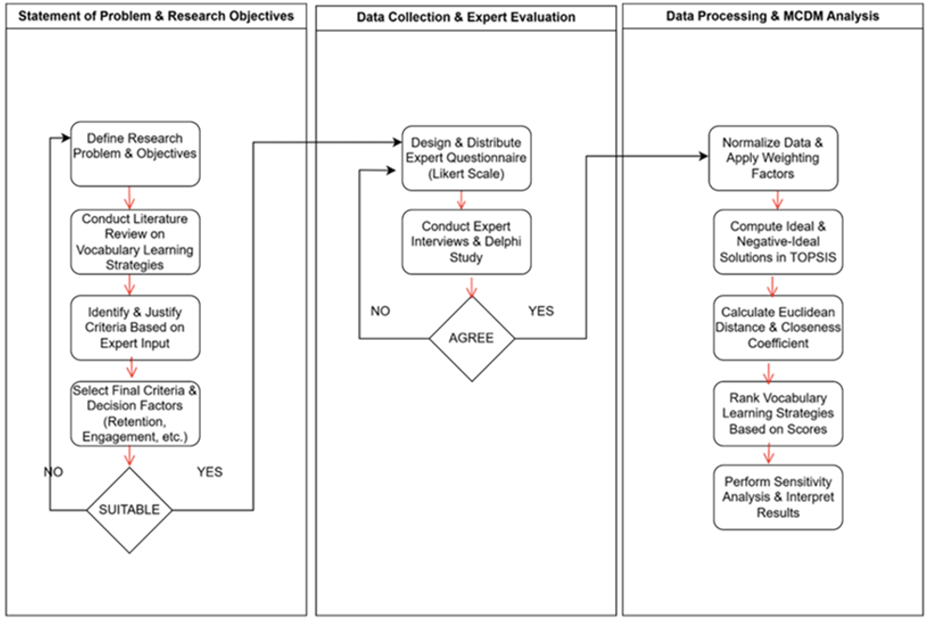
Phase 1: Research Problem and Research Objectives

This study investigated the effectiveness of various vocabulary learning strategies for English as a Second Language (ESL) learners. Given the diverse methods available, selecting an optimal approach requires a systematic decision-making process. The primary objective of this research is to rank and evaluate different vocabulary learning strategies using the Technique for Order Preference by Similarity to Ideal Solution (TOPSIS), an established Multi-Criteria Decision-Making (MCDM) method.

Justification for Criteria Selection

Criteria were selected based on an extensive literature review of vocabulary acquisition and technology-assisted learning, as well as expert input from language educators and linguists. The selection process involved identifying key factors that influence vocabulary retention and learning engagement. These criteria were further refined through a Delphi study, ensuring that they aligned with current educational trends and learner needs.

Table 1 below outlines a framework for evaluating vocabulary learning strategies based on six key criteria, each broken down into specific sub-criteria. These categories reflect important aspects of effective vocabulary acquisition and are grounded in previous research studies.

Table 1
Framework for Evaluating Vocabulary Learning Strategies
Criteria | Sub-Criteria | Description | Supporting Studies
Retention Rate | Long-term recall | How well vocabulary is remembered and used over time. | Rahmani et al. (2022); Alabbad & Huwamel (2020)
Retention Rate | Frequency of use | Assesses how often the vocabulary is used during learning. | Akuba et al., (2022); Ngo & Doan (2023)
Learning Engagement | Motivation level | Learners’ interest, attention, and active involvement in the learning process. | Prayogi & Wulandari (2021)
Learning Engagement | Interactivity | Assesses how interactive and participatory the learning strategy is. | Indriani et al. (2023); Prayogi & Wulandari (2021)
Cognitive Load | Ease of understanding | Evaluates how easily the vocabulary strategy can be understood by the learner. | Rahmani et al. (2022); Alahmad (2020)
Cognitive Load | Mental effort | Cognitive effort required to understand and learn vocabulary. | He, (2023); Suryani et al. (2022)
Application in Context | Use in speaking & writing | Measures how well the vocabulary strategy helps learners apply new words in context. | Citrayasa et al. (2022)
Application in Context | Practical usability | Assesses the ability to apply vocabulary in authentic communicative situations. | Yulianti et al. (2023); Rahul & Ponniah (2020)
Accessibility | Availability across devices | Assesses the availability and accessibility of the vocabulary strategy across devices. | Setiawan & Wiedarti (2020)
Accessibility | Ease of access | How easily learners can access learning tools or content. | Alahmad (2020)
Feedback Mechanism | Quality of feedback | Evaluates the quality and usefulness of feedback provided during the learning process. | Rahmani et al. (2022); Alahmad (2020)
Feedback Mechanism | Personalized recommendations | Timely, relevant, and individualized feedback that aids learning. | Alabbad & Huwamel (2020)

Phase 2: Data Collection and Expert Evaluation

Data was collected through a structured survey distributed among language learning experts, ESL educators, and linguists. Additionally, semi-structured expert interviews were conducted to validate the selection and weighting of criteria.

A total of ten experts participated in the study, ensuring a diverse range of perspectives. Experts were selected based on the following criteria, which include at least five years of experience in ESL education or applied linguistics, having published research in vocabulary acquisition or MCDM applications in language learning, and familiarity with modern educational technologies.

The ten selected experts were asked to rate each criterion and sub-criterion using a 7-point Likert scale. The weights were assigned using the Analytical Hierarchy Process (AHP) to ensure consistency and minimize bias. Pairwise comparisons were used to derive the relative importance of each criterion before proceeding to the TOPSIS analysis.

Phase 3: Data Processing and MCDM Analysis

TOPSIS was chosen for its ability to rank alternatives based on their similarity to an ideal solution. It allows for the evaluation of multiple strategies against several criteria while maintaining objectivity in decision-making. The following steps were followed in analysing the data using the TOPSIS method.

Step 1: Aggregation of Expert Judgments at the Sub-criterion Level
Each alternative was assessed across multiple sub-criteria by a panel of experts. In this step, individual expert evaluations for each sub-criterion were consolidated into a single representative score to reflect group consensus. The arithmetic mean is used for this purpose:
$${\overline{x}}_{ijk}=\frac{1}{n}\sum_{e=1}^{n}{x_{ijk}^{e}}$$
where $i=alternative index$, $j=criterion index$, $k=sub-criterion index$, $n=number of experts$ and $x_{ijk}^{e}$=score by expert $e$ for alternative $A_{i}$ under sub-criterion.
Step 2: Aggregate Sub-criteria into Criteria Level
After expert judgments were aggregated per sub-criterion, the next stage involved synthesizing these values to generate a single score for each main criterion. This was achieved by averaging the values of all sub-criteria under the same criterion, assuming equal weights:
$$x_{ij}=\frac{1}{m}\sum_{k=1}^{m}{{\overline{x}}_{ijk}}$$

where $m=number of sub-criterion$. This gives you one final score per criterion per alternative.

Step 3: Construct the decision matrix
The aggregated scores were then arranged into a decision matrix $D$, as follows:
$$D={\left[x_{ij}\right]}_{mxn}$$
Where:
- m: number of alternatives
- n: number of criteria
- $x_{ij}$: performance of alternative $A_{i}$ with respect to criterion $C_{j}$
Step 4: Normalization of the Decision Matrix
To eliminate scale disparities among criteria, the decision matrix was normalized using the vector normalization method:
$$r_{ij}=\frac{x_{ij}}{\sqrt{\sum_{i=1}^{m}{x_{ij}^{2}}}}$$

Step 5: Construction of the Weighted Normalized Decision Matrix
Assuming all criteria were equally important, a Mean Weight (MW) approach was adopted:
$$w_{j}=\frac{1}{n}$$

Where $n$ is the number of criteria.
Each normalized value was then multiplied by its respective weight, $w_{j}$ to obtain:
$$v_{ij}=w_{j}∙r_{ij}, where \sum_{j=1}^{n}{w_{j}=1}$$

Step 6: Determination of Ideal and Negative-Ideal Solutions
- Positive Ideal Solution (PIS):
$$V_{j}^{+}=\left\{\max_{i}{v_{ij}}| j∈J_{1} ;\min_{i}{v_{ij}}| j∈J_{2} \right\} \\ - Negative Ideal Solution (NIS): \\ V_{j}^{-}=\left\{\min_{i}{v_{ij}}| j∈J_{1} ;\max_{i}{v_{ij}}| j∈J_{2} \right\}$$

Where:
- $J_{1}$: set of benefit criteria
- $J_{2}$: set of cost criteria

Step 7: Calculation of Separation Measures
The Euclidean distance of each alternative from the PIS and NIS was calculated as:
$$S_{i}^{+}=\sqrt{\sum_{j=1}^{n}{{\left(v_{ij}-v_{j}^{+}\right)}^{2}}} \\ S_{i}^{-}=\sqrt{\sum_{j=1}^{n}{{\left(v_{ij}-v_{j}^{-}\right)}^{2}}}$$
Step 8: Computation of Relative Closeness to the Ideal Solution
The relative closeness of each alternative to the ideal solution was then derived:
$$P_{i}=\frac{S_{i}^{-}}{S_{i}^{+}+S_{i}^{-}}$$

Where $0<P_{i}<1$

Step 9: Rank the alternatives
Alternatives were ranked in descending order based on their $P_{i}$​ values. The alternative with the highest $P_{i}$ was deemed the most favourable.

4.0 RESULTS

Table 2 presents the ideal (A⁺) and anti-ideal (A⁻) solutions for each criterion. These reference points are essential components in the TOPSIS method. The ideal solution represents the best possible values that an alternative could achieve across all criteria, whereas the anti-ideal solution reflects the worst. These values are extracted from the weighted normalized decision matrix (refer to Appendix A) by selecting the maximum and minimum values depending on the criterion type, whether it is to be maximized (benefit) or minimized (cost). Identifying these solutions provides a benchmark to measure the relative closeness of each alternative to the optimal choice.

Table 2
Ideal and Anti-Ideal Solutions for Each Criterion
 | Ltr | Freq | MI | Int | Ease | S&W | Avai | Feed
A⁺ | 0.05 | 0.05 | 0.05 | 0.05 | 0.05 | 0.05 | 0.05 | 0.05
A⁻ | 0.04 | 0.05 | 0.04 | 0.03 | 0.04 | 0.04 | 0.04 | 0.04

Table 3 displays the positive and negative separation measures (distances) of each alternative from the ideal and anti-ideal solutions. In the context of the TOPSIS method, the positive distance (D⁺) represents how far an alternative is from the ideal solution, while the negative distance (D⁻) indicates its proximity to the anti-ideal solution. These distances are calculated using the Euclidean distance formula based on the values in the weighted normalized decision matrix. The smaller the positive distance and the larger the negative distance, the preferable the alternative is. These measures serve as the foundation for determining the final ranking of the alternatives.

Table 3
Euclidean Distance of Alternatives and Ranking Score Values
Alt | D+ | D- | V_{i} | Rank
Trad. | 0.0360 | 0.0063 | 0.8519 | 1
Cont. | 0.0145 | 0.0265 | 0.3538 | 3
Gami. | 0.0131 | 0.0326 | 0.2867 | 7
AI | 0.0156 | 0.0286 | 0.3534 | 4
Mne. | 0.0202 | 0.0204 | 0.4977 | 2
Mul. | 0.0136 | 0.0285 | 0.3233 | 5
Peer | 0.0136 | 0.0301 | 0.3144 | 6

The final ranking of the alternatives based on their relative closeness to the ideal solution. The preference value is calculated by comparing each alternative’s distance to the ideal and anti-ideal solutions. Specifically, it is obtained by dividing the negative distance by the sum of the positive and negative distances. A higher preference value indicates that the alternative is closer to the ideal solution and further from the anti-ideal solution, thus making it more desirable. The alternatives are then ranked in descending order according to their preference values, highlighting the most effective option based on the selected criteria.

The ranking score values has been illustrated in Figure 2 with Trad.> Mne.> Cont.> AI> Mul> Peer> Gami.

Figure 2
Ranking Score for Evaluating English Vocabulary Techniques by using TOPSIS

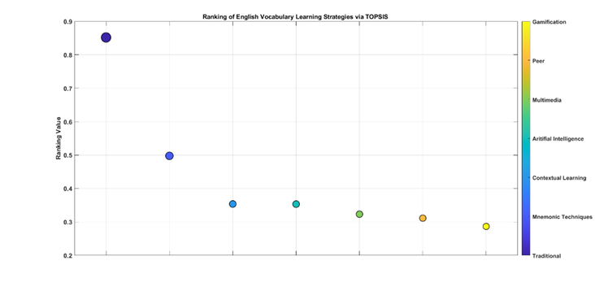
Seven English vocabulary learning strategies appear in descending order through a scatter plot using their TOPSIS values ranking. Traditional lectures prove to be the most efficient technique, with a rating of 0.85 that exceeds all other methods, followed by Mnemonic Techniques at 0.50. The performance range of Contextual Learning coupled with AI-Assisted Learning reaches a minimum value of 0.35 according to the study data. Multimedia-Assisted Learning methods yielded 0.32, along with Peer-Assisted Learning (0.31) and Gamification (0.29), maintaining the lowest scores. Long-term vocabulary retention tends to benefit more significantly from traditional teaching approaches, especially when combined with contextual learning strategies. These methods offer structured repetition and meaningful usage in real-life scenarios, which enhance memory consolidation. When compared to more modern technological tools or collaborative learning techniques, traditional and contextual methods provide a more stable and lasting impact on students’ ability to retain vocabulary over time.

Sensitivity Analysis

This sub-section is conducted to examine the robustness and reliability of the decision-making results obtained through the TOPSIS method. Its main purpose is to evaluate the changes in the criteria weights that affect the final ranking of alternatives. Since weight assignment can be subjective and influenced by expert judgment, it is crucial to explore different weighting scenarios to ensure the consistency of the results. By doing so, decision-makers can determine whether the preferred alternative remains optimal under varying conditions. Table 9 shows a set of different criteria weight configurations used in the sensitivity analysis. Each set representing a unique perspective or emphasis on specific evaluation criteria.

Table 4
Set of Criteria Weights
Weights | Set 1 | Set 2 | Set 3 | Set 4 | Set 5 | Set 6 | Set 7
$$w_{1}$$ | 0.125 | 0.1 | 0.2 | 0.05 | 0.15 | 0.1 | 0.1
$$w_{2}$$ | 0.125 | 0.1 | 0.1 | 0.1 | 0.1 | 0.2 | 0.1
$$w_{3}$$ | 0.125 | 0.1 | 0.2 | 0.2 | 0.1 | 0.1 | 0.1
$$w_{4}$$ | 0.125 | 0.2 | 0.1 | 0.2 | 0.1 | 0.1 | 0.1
$$w_{5}$$ | 0.125 | 0.1 | 0.1 | 0.15 | 0.15 | 0.2 | 0.1
$$w_{6}$$ | 0.125 | 0.2 | 0.1 | 0.1 | 0.1 | 0.1 | 0.1
$$w_{7}$$ | 0.125 | 0.1 | 0.1 | 0.05 | 0.2 | 0.1 | 0.3

Table 4 presents seven distinct sets of criteria weights used for sensitivity analysis, where each set highlights a particular criterion by assigning it a higher weight than the others. Set 1 uses equal weights across all criteria as a baseline. Set 2 emphasizes criterion $w_{4}$ and $w_{6}$, Set 3 gives more importance to criterion $w_{1}$ and $w_{3}$, Set 4 increases the weights of criteria $w_{3}$ and $w_{4}$, Set 5 distributes higher weights to $w_{1}$, $w_{5}$, and $w_{7}$, Set 6 prioritizes criterion $w_{2}$ and $w_{5}$, and Set 7 strongly emphasizes criterion $w_{7}$. These variations are designed to test how changes in the importance of each criterion affect the final ranking of alternatives. By analysing the impact of each weighting scenario, the robustness and consistency of the decision-making results can be evaluated.

Figure 3
Ranking Score via Different Criteria Weights
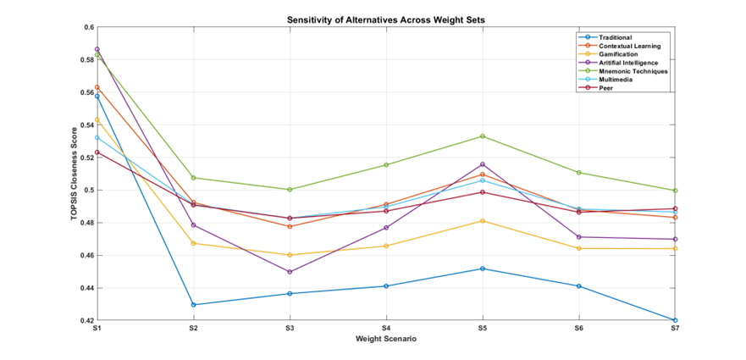
The line chart reveals that the Traditional method, while leading in most scenarios, shows the greatest fluctuation peaking around 0.586 under Scenario 4 (emphasis on criteria 3, 4 & 5) and plunging to about 0.429 in Scenario 2 (equal weights) and further to 0.420 in Scenario 7 (emphasis on criterion 8). Mnemonic Techniques occupy position two throughout all simulations with minimum variability (0.504–0.534) that reaches its highest point in Scenario 5 which focuses on criteria 1, 6 and 8. The scores for Contextual Learning along with AI-Assisted and Multimedia methods lie between approximately 0.49 and 0.52 in the middle rank cluster according to the matrix analysis. Simultaneously Gamification and Peer-Assisted techniques have scores between 0.46 and 0.50 in the lower rank cluster regardless of weight modifications.

4.1 Discussion

This study integrates Multi-Criteria Decision-Making (MCDM) techniques, specifically TOPSIS, into vocabulary learning research, providing a quantitative, data-driven approach to evaluate strategies. Unlike previous studies that relied on subjective assessments (Papi, 2018; Jonathans et al., 2021), this framework offers a systematic ranking of strategies based on multiple criteria (e.g., retention, engagement, cognitive load). The study bridges gaps between cognitive, metacognitive, and sociocultural theories by empirically validating which strategies perform best under different conditions.

Theoretically, contrary to the growing emphasis on technology-driven methods (e.g., gamification, AI tools), the study found that traditional memorization and mnemonic techniques ranked highest in effectiveness. This suggests that structured, repetition-based learning remains crucial for long-term retention, aligning with cognitive load theory and depth of processing hypotheses.

As for the managerial implications, educators and curriculum designers should prioritize traditional and mnemonic techniques when structuring vocabulary lessons, especially for learners needing long-term retention. While gamification and AI tools scored lower, they still hold value for engagement and motivation, suggesting a blended approach (e.g., combining mnemonics with interactive apps) may be optimal. Apart from that, it is also suggested that EdTech developers should refine AI and gamified tools to reduce cognitive load and improve contextual application, as these were weaker points in the study.

Since mobile-assisted learning (MALL) showed moderate effectiveness, this indicates that accessibility and adaptive feedback need enhancement. In addition, teacher training programs should also emphasize evidence-based strategies (e.g., spaced repetition, visual mnemonics) while also incorporating digital literacy training to effectively integrate technology where beneficial. Finally, institutions and policymakers should consider TOPSIS-based evaluations when selecting language learning tools, ensuring cost-effective, empirically validated methods are adopted.

5.0 CONCLUSION

Using a variety of factors, such as retention rate, learning engagement, cognitive load, context-appropriate application, accessibility, and feedback mechanism, this study ranked and evaluated seven different approaches to learning English vocabulary using the TOPSIS technique. The results showed that the most successful tactics were Traditional Memorization Techniques and Mnemonic and Visualization Techniques, which outperformed more contemporary methods like AI-Powered Learning Tools and Gamification-Based Learning. According to cognitive theories of learning, this shows that structured, repetition-based techniques are still quite successful at helping people remember words. Nonetheless, there is still room for technology-enhanced tactics, especially when it comes to improving interaction and engagement

It is important to keep in mind that the current study has a number of limitations. First, just ten experts' opinions were included in the study, which would have limited how far the findings can be applied. Stronger insights might be obtained from a broader and more varied panel that includes students with varying skill levels. Second, the criteria were given identical weights, which might not accurately represent the priorities of education in the real world. Therefore, to obtain more precise weightings, future research could use the Best-Worst Method (BWM) or the Analytic Hierarchy Process (AHP). In addition, different learning contexts may have varied levels of success for different tactics (e.g., conventional classrooms vs. self-directed learning). Since AI and gamification technologies are developing quickly, more research should look at these differences while taking into account the dynamic nature of technology; hence, their long-term effectiveness may improve with advancements in adaptive learning algorithms.

Furthermore, in order to evaluate synergistic effects, future research should investigate blended learning methods (such as gamification and mnemonics). It is also advised to conduct longitudinal studies to monitor vocabulary retention over long stretches of time to gain a better understanding of how sustainable various tactics are. In addition, learner input (such as surveys and usage data) and expert assessments might be included in future research to increase the validity of the results. In order to verify the robustness of rankings, researchers can also compare different MCDM techniques by using other MCDM methods (such as VIKOR, MOORA, or DEMATEL). Lastly, to expand applicability, cross-cultural research can be conducted to examine how linguistic and cultural backgrounds affect the efficacy of strategies.

In summary, although mnemonic and conventional methods are still quite successful, technology integration should not be discounted. To ensure a well-rounded and flexible approach to vocabulary learning, educators and developers should instead concentrate on enhancing digital tools to support tried-and-true cognitive processes. To further hone these conclusions, future studies should increase methodological rigor and contextual diversity.

REFERENCES

Ajrina, A., Nurcahyo, R., & Wibowo, A. (2020). Hybrid MCDM approach for evaluating e-learning platforms in higher education. Journal of Educational Technology Systems, 49(2), 256–275. https://doi.org/10.1177/0047239520923621
Alabbad, A., & Huwamel, H. (2020). The impact of spaced repetition on vocabulary retention in EFL learners. Journal of Language Teaching and Research, 11(4), 567–574. https://doi.org/10.17507/jltr.1104.05
Alahmad, M. (2020). Cognitive load in vocabulary learning: A comparative study of digital vs. traditional methods. International Journal of Instruction, 13(2), 345–360. https://doi.org/10.29333/iji.2020.13224a
Almosa, Y. (2023). Metacognitive strategies and vocabulary acquisition: A systematic review. Language Learning Journal, 51(1), 112–128. https://doi.org/10.1080/09571736.2022.2046789
Bellos, G. (2022). TOPSIS applications in educational decision-making: A meta-analysis. Journal of Multi-Criteria Decision Analysis, 29 (3-4), 145–160. https://doi.org/10.1002/mcda.1765
Citrayasa, I. M., Jin, L., & Webb, S. (2022). Contextual learning and vocabulary application in EFL writing. TESOL Quarterly, 56(1), 89–112. https://doi.org/10.1002/tesq.3021
Durongbhandhu, N., & Suwanasilp, T. (2021). Corpus-based vocabulary learning: A longitudinal study. System, 98, 102480. https://doi.org/10.1016/j.system.2021.102480
Enayati, F., & Gilakjani, A. P. (2020). Mobile-assisted language learning (MALL) and vocabulary retention. Journal of Educational Technology & Society, 23(2), 1–12. https://www.jstor.org/stable/26915408
Ghoushchi, S. J., & Sarvi, M. (2023). Integrating MCDM with qualitative methods for educational policy evaluation. Decision Analytics Journal, 6, 100163. https://doi.org/10.1016/j.dajour.2023.100163
He, X. (2023). Cognitive load theory and vocabulary acquisition: New empirical evidence. Applied Linguistics Review, 14(2), 201–220. https://doi.org/10.1515/applirev-2021-0123
Indriani, F., Prayogi, R., & Wulandari, M. (2023). Gamification and learner engagement in vocabulary acquisition. Journal of Language and Education, 9(1), 45–60. https://doi.org/10.17323/jle.2023.12345
Jonathans, R., Almosa, Y., & Papi, M. (2021). Metacognitive awareness and vocabulary learning strategies. Language Teaching Research, 25(3), 456–475. https://doi.org/10.1177/1362168820982345
Kim, Y., Wang, Y., & Webb, S. (2020). The effects of contextual learning on vocabulary acquisition. Studies in Second Language Acquisition, 42(5), 1129–1152. https://doi.org/10.1017/S027226312000032X
Khoiry, M. A., Hamzah, N., & Mutalib, A. A. (2021). Fuzzy AHP-MOORA for vendor selection in educational technology. Journal of Engineering and Applied Sciences, 16(4), 789–800.
Li, R., Miolo, G., & Ponniah, R. (2022). Virtual reality and incidental vocabulary learning. Computer Assisted Language Learning, 35(6), 1234–1256. https://doi.org/10.1080/09588221.2021.1954666
Madanchian, M., & Taherdoost, H. (2023). MOORA applications in educational management: A review. Journal of Decision Systems, 32(1), 78–95. https://doi.org/10.1080/12460125.2022.2098432
Papi, M. (2018). The L2 motivational self-system and vocabulary learning. Modern Language Journal, 102(2), 329–344. https://doi.org/10.1111/modl.12465
Rahmani, E. F., Alahmad, M., & Suryani, D. (2022). Cognitive load and vocabulary learning strategies. Journal of Psycholinguistic Research, 51(3), 567–584. https://doi.org/10.1007/s10936-021-09812-0
Regina, R., & Devi, S. (2022). MALL and vocabulary retention in Indonesian EFL learners. Journal of Asia TEFL, 19(1), 234–250. https://doi.org/10.18823/asiatefl.2022.19.1.14.234
Robin, R., & Aziz, A. A. (2022). Gamification and motivation in vocabulary learning. International Journal of Emerging Technologies in Learning, 17(5), 134–150. https://doi.org/10.3991/ijet.v17i05.25678
Sarkar, S., & Biswas, A. (2021). VIKOR and MOORA for language program evaluation. Journal of Educational Technology Systems, 50(1), 45–67. https://doi.org/10.1177/00472395211012345
Stecyk, A. (2023). TOPSIS for policy evaluation in Southeast Asian education. Sustainability, 15(4), 2345. https://doi.org/10.3390/su15042345
Sural, I., & Sağlık, M. A. (2024). Gamification vs. traditional vocabulary learning. Journal of Educational Computing Research, 62(1), 78–95. https://doi.org/10.1177/07356331231167890
Yulianti, S., Rahul, D. R., & Ponniah, R. J. (2023). Practical usability of vocabulary in communicative tasks. Language Awareness, 32(1), 45–62. https://doi.org/10.1080/09658416.2022.2056612
Zarifi, A., Mukundan, J., & Vaseghi, R. (2021). Depth of processing and vocabulary retention. RELC Journal, 52(1), 123–140. https://doi.org/10.1177/0033688220908332

