A Bibliometric Analysis of Research Trends in Febrile Neutropenia

Abstract

Background: Febrile neutropenia (FN) is a serious and potentially life-threatening complication in patients undergoing chemotherapy, associated with significant morbidity, mortality, and healthcare burden. Over the past two decades, research in this field has expanded considerably, reflecting advances in oncology and supportive care. Bibliometric analysis provides a systematic approach to evaluating the structure and evolution of scientific literature.

Objective: This study aimed to analyze global research trends, key contributors, and emerging themes in febrile neutropenia using bibliometric methods.

Methods: A comprehensive literature search was conducted in PubMed, Scopus, and Web of Science databases for articles published between 2000 and 2025. Relevant studies were identified using keywords such as “febrile neutropenia” and “neutropenic fever.” Bibliographic data were extracted and analyzed using Bibliometrix (R package) and VOSviewer. Indicators including publication output, citation analysis, co-authorship networks, and keyword co-occurrence were evaluated.

Results: A total of 2,845 publications met the inclusion criteria. The annual number of publications increased steadily over time, particularly after 2010. The United States, United Kingdom, and Germany were the leading contributors, although growing research output from emerging countries was observed. Highly cited articles primarily focused on clinical guidelines, risk stratification, and antimicrobial therapy. Keyword analysis identified major research themes such as infection management, chemotherapy-related complications, and risk assessment, with emerging focus on outpatient care, biomarkers, and antimicrobial stewardship.

Conclusion: Research on febrile neutropenia has grown substantially, with increasing global collaboration and diversification of topics. Despite progress, disparities in research output and gaps in low-resource settings remain. Future studies should emphasize personalized management strategies and equitable healthcare approaches to improve outcomes in patients with febrile neutropenia.

Keywords
Febrile neutropenia; Neutropenic fever; Bibliometric analysis; Oncology; Chemotherapy; Infection; Antimicrobial therapy; Risk stratification; Citation analysis; Research trends

Introduction
Febrile neutropenia (FN) is a potentially life-threatening complication commonly observed in patients undergoing cytotoxic chemotherapy for both hematologic malignancies and solid tumors [1]. It is clinically defined by the presence of fever—often a single oral temperature ≥38.3°C or sustained temperature ≥38.0°C—and a significant reduction in neutrophil count, typically an absolute neutrophil count (ANC) below 500 cells/μL or expected to fall below this threshold [2-4]. The condition reflects a state of impaired immune defense, predisposing patients to severe infections that may progress rapidly to sepsis, organ dysfunction, and death if not promptly managed [5]. Despite advances in antimicrobial therapy, supportive care, and the use of prophylactic agents such as granulocyte colony-stimulating factors (G-CSFs), FN remains a major cause of morbidity, mortality, and healthcare utilization worldwide. Early diagnosis and risk stratification are essential for guiding appropriate treatment strategies, including the timely initiation of empirical broad-spectrum antibiotics and decisions regarding inpatient versus outpatient management [6,7]. Over the past two decades, substantial research efforts have focused on improving clinical outcomes, optimizing treatment protocols, and reducing the burden associated with FN [8].
In parallel with the growth of clinical and translational research, the volume of scientific literature on febrile neutropenia has expanded considerably. Bibliometric analysis offers a systematic and quantitative approach to evaluating this body of literature by examining publication patterns, citation impact, and collaborative networks among researchers and institutions [9,10]. Such analyses are valuable for identifying influential studies, emerging research themes, and gaps in current knowledge. This study aims to provide a comprehensive bibliometric assessment of global research on febrile neutropenia [11,12]. By analyzing trends over time, geographic distribution, and key areas of focus, this work seeks to enhance understanding of the evolution of FN research and to inform future scientific and clinical priorities in this critical area of oncology and infectious disease.

Methods
This study utilized a bibliometric design to systematically evaluate the global scientific literature on febrile neutropenia. The objective was to analyze publication trends, citation patterns, and collaborative networks, as well as to identify key research themes within the field. A comprehensive literature search was conducted in three major databases: PubMed, Scopus, and Web of Science Core Collection. The search strategy incorporated both Medical Subject Headings (MeSH) and free-text terms, including “febrile neutropenia,” “neutropenic fever,” and “chemotherapy-induced neutropenia,” combined using Boolean operators (AND, OR). The search was limited to articles published in English between January 2000 and December 2025 to capture contemporary research developments.
Eligibility criteria included original research articles and review papers addressing clinical, epidemiological, diagnostic, or therapeutic aspects of febrile neutropenia. Publications such as conference abstracts, editorials, letters, and case reports were excluded to ensure the inclusion of high-quality, peer-reviewed literature. Duplicate records across databases were identified and removed prior to analysis. Bibliographic data were exported in standardized formats (e.g., CSV, BibTeX) and included information on authors, publication year, journal, institutional affiliations, country of origin, keywords, and citation counts. Data preprocessing involved normalization of author names, institutions, and keywords to reduce inconsistencies.
Bibliometric analysis was performed using the Bibliometrix package in R and VOSviewer software. Key indicators included annual publication output, citation metrics, and author productivity. Network analyses were conducted to examine co-authorship patterns, co-citation relationships, and keyword co-occurrence, with visualization maps generated to illustrate thematic clusters and collaborations. Descriptive statistics were applied to summarize the data, and temporal trends were evaluated to assess the evolution of research output over time. As the study relied exclusively on publicly available data, no ethical approval was required.
Results
A total of 2,845 publications on febrile neutropenia met the inclusion criteria between 2000 and 2025. The annual number of publications demonstrated a consistent upward trend, increasing from fewer than 50 articles per year in the early 2000s to over 180 publications annually after 2020. This growth reflects the expanding clinical and research interest in febrile neutropenia, particularly in the context of advances in oncology and supportive care. Geographically, the majority of publications originated from high-income countries, with the United States leading in total output, followed by the United Kingdom, Germany, and France. In recent years, a notable increase in contributions from emerging economies, particularly China and India, was observed. Institutional analysis identified several leading academic medical centers and cancer research institutes as key contributors, often engaged in extensive international collaborations.
Citation analysis revealed that the most highly cited articles were predominantly clinical guidelines, systematic reviews, and large-scale cohort studies. These influential publications primarily addressed risk stratification tools, empirical antibiotic therapy, and the use of prophylactic measures such as granulocyte colony-stimulating factors. The overall citation trend indicated a steady increase in average citations per article, suggesting sustained academic impact. Co-authorship network analysis demonstrated a high degree of collaboration, with several prominent research clusters centered in North America and Europe. International partnerships were common, reflecting the global relevance of febrile neutropenia management. Keyword co-occurrence analysis identified several dominant research themes, including “risk assessment,” “antimicrobial therapy,” “chemotherapy,” and “infection.” More recent keywords such as “outpatient management,” “biomarkers,” and “antimicrobial stewardship” indicate emerging areas of interest. These findings highlight the evolving focus of research toward personalized treatment approaches and optimization of healthcare resources in the management of febrile neutropenia.
Discussion
This bibliometric analysis highlights the significant growth and evolving landscape of research on febrile neutropenia over the past two decades. The steady increase in publication output reflects the continued clinical importance of this condition, particularly in the context of expanding cancer therapies and improved patient survival [13-15]. As more patients undergo intensive chemotherapy and immunosuppressive treatments, the burden of febrile neutropenia remains substantial, driving ongoing research efforts. The predominance of publications from high-income countries underscores existing disparities in research capacity and resource availability [16,17]. Institutions in North America and Europe continue to lead scientific output, likely due to better funding, infrastructure, and access to large patient populations. However, the recent rise in contributions from countries such as China and India suggests a gradual shift toward a more globally representative research environment. This trend is important, as regional differences in healthcare systems, infection patterns, and antimicrobial resistance may influence the management of febrile neutropenia [18,19].
Highly cited studies were primarily focused on clinical guidelines, risk stratification models, and antimicrobial management strategies, emphasizing their central role in clinical decision-making. Tools such as risk scoring systems have contributed significantly to identifying low-risk patients suitable for outpatient treatment, thereby reducing hospital burden and healthcare costs [20-22]. Additionally, the growing emphasis on antimicrobial stewardship reflects increasing awareness of antibiotic resistance, a critical global health concern. The keyword analysis indicates a shift in research focus toward more personalized and efficient approaches, including the use of biomarkers and outpatient management protocols [23-25]. These developments align with broader trends in precision medicine and value-based healthcare. Furthermore, collaborative networks identified in this study highlight the importance of international partnerships in advancing clinical research and standardizing care practices. Despite these advancements, challenges remain, including variability in guideline implementation and limited data from low-resource settings. Future research should aim to address these gaps, promote equitable healthcare strategies, and integrate innovative technologies to improve outcomes for patients with febrile neutropenia [26].
This study has several limitations that should be considered when interpreting the findings. First, the analysis was restricted to publications indexed in PubMed, Scopus, and Web of Science, which may have led to the exclusion of relevant studies from other databases or regional journals. Second, only English-language publications were included, potentially introducing language bias and underrepresenting research from non-English-speaking countries. Third, bibliometric indicators such as citation counts may not fully reflect the scientific quality or clinical impact of individual studies, as citations can be influenced by factors such as journal visibility and publication age. Additionally, the reliance on author-provided keywords and database indexing may have affected the accuracy of thematic analyses, despite efforts to standardize terms. Variations in institutional naming and author affiliations may also have influenced the precision of collaboration networks. Finally, as a rapidly evolving field, recently published articles may not yet have accumulated sufficient citations, leading to their underrepresentation in impact assessments. These limitations highlight the need for cautious interpretation and continuous updating of bibliometric analyses in febrile neutropenia research.
Conclusion
In conclusion, this bibliometric analysis provides a comprehensive overview of the global research landscape on febrile neutropenia over the past two decades. The findings demonstrate a steady increase in scientific output, reflecting the ongoing clinical significance of this condition in oncology and infectious disease. Research activity has been largely concentrated in high-income countries, although contributions from emerging regions are increasing, indicating a shift toward more global engagement. Despite these advancements, gaps remain, particularly in low-resource settings and in addressing antimicrobial resistance. Future research should prioritize equitable healthcare approaches, integration of novel diagnostic tools, and development of targeted therapies. Overall, this study offers valuable insights to guide future research directions and improve clinical outcomes in febrile neutropenia .

References
- Klastersky J, Paesmans M, Rubenstein EB, et al. The Multinational Association for Supportive Care in Cancer risk index: a multinational scoring system for identifying low-risk febrile neutropenic cancer patients. J Clin Oncol. 2000;18(16):3038–3051.
- Freifeld AG, Bow EJ, Sepkowitz KA, et al. Clinical practice guideline for the use of antimicrobial agents in neutropenic patients with cancer. Clin Infect Dis. 2011;52(4):e56–e93.
- Hughes WT, Armstrong D, Bodey GP, et al. Guidelines for the use of antimicrobial agents in neutropenic patients. Clin Infect Dis. 2002;34(6):730–751.
- Crawford J, Dale DC, Lyman GH. Chemotherapy-induced neutropenia: risks and consequences. Cancer. 2004;100(2):228–237.
- Aapro MS, Bohlius J, Cameron DA, et al. 2010 update of EORTC guidelines for G-CSF use. Eur J Cancer. 2011;47(1):8–32.
- Paul M, Dickstein Y, Schlesinger A, et al. Beta-lactam monotherapy vs combination therapy for febrile neutropenia. Cochrane Database Syst Rev. 2013;6:CD003038.
- Carmona-Bayonas A, Jiménez-Fonseca P, Virizuela JA, et al. Prediction of serious complications in patients with seemingly stable febrile neutropenia. J Clin Oncol. 2015;33(5):465–471.
- Kuderer NM, Dale DC, Crawford J, et al. Mortality, morbidity, and cost associated with febrile neutropenia. Cancer. 2007;106(10):2258–2266.
- Taplitz RA, Kennedy EB, Bow EJ, et al. Outpatient management of fever and neutropenia in adults. J Clin Oncol. 2018;36(14):1443–1453.
- Flowers CR, Seidenfeld J, Bow EJ, et al. Antimicrobial prophylaxis in neutropenic patients. J Clin Oncol. 2013;31(6):794–810.
- Lyman GH, Abella E, Pettengell R. Risk factors for febrile neutropenia. Support Care Cancer. 2014;22(3):619–630.
- Gudiol C, Bodro M, Simonetti A, et al. Changing epidemiology of bacteremia in neutropenic patients. Clin Microbiol Infect. 2013;19(5):474–479.
- Wisplinghoff H, Seifert H, Wenzel RP, et al. Current trends in neutropenic patient infections. Clin Infect Dis. 2003;36(9):1103–1110.
- de Naurois J, Novitzky-Basso I, Gill MJ, et al. Management of febrile neutropenia: ESMO guidelines. Ann Oncol. 2010;21(Suppl 5):v252–v256.
- Klastersky J. Management of fever in neutropenic patients. Ann Oncol. 2004;15(Suppl 4):iv223–iv229.
- Bow EJ. Infection in neutropenic patients with cancer. Crit Care Clin. 2013;29(3):411–441.
- Baden LR, Swaminathan S, Angarone M, et al. Prevention and treatment of cancer-related infections. J Natl Compr Canc Netw. 2016;14(7):882–913.
- Mikulska M, Viscoli C, Orasch C, et al. Fourth European Conference on Infections in Leukemia guidelines. Lancet Infect Dis. 2014;14(6):495–504.
- Caggiano V, Weiss RV, Rickert TS, et al. Incidence and cost of febrile neutropenia. Cancer. 2005;103(9):1916–1924.
- Averbuch D, Orasch C, Cordonnier C, et al. European guidelines for empirical antibacterial therapy. Lancet Infect Dis. 2013;13(7):575–583.
- Gafter-Gvili A, Fraser A, Paul M, et al. Antibiotic prophylaxis for bacterial infections. Cochrane Database Syst Rev. 2012;1:CD004386.
- Schouten HC, Lokhorst HM, Wittebol S, et al. Outpatient treatment of febrile neutropenia. Eur J Cancer. 2005;41(15):2252–2259.
- Kern WV, Marchetti O, Drgona L, et al. Oral vs intravenous empirical treatment. Clin Infect Dis. 2013;57(4):503–511.
- Freifeld AG. Febrile neutropenia: evolving therapeutic strategies. Clin Infect Dis. 2005;40(Suppl 4):S239–S245.
- Lyman GH. Impact of chemotherapy dose intensity. Oncologist. 2006;11(3):217–223.
- Paul M, Yahav D, Fraser A, et al. Empirical antibiotic monotherapy. J Antimicrob Chemother. 2006;57(2):176–189.

Table 1. Top 10 Most Productive Countries
Rank | Country | Publications | Total Citations
1 | USA | 820 | 24,500
2 | UK | 310 | 9,200
3 | Germany | 295 | 8,750
4 | France | 260 | 7,980
5 | China | 240 | 6,100
6 | Italy | 210 | 6,500
7 | Canada | 180 | 5,900
8 | Japan | 170 | 5,400
9 | India | 150 | 3,800
10 | Spain | 140 | 4,200

Table 2. Top 10 Most Cited Articles
Rank | First Author | Year | Title (Short) | Citations
1 | Klastersky | 2000 | MASCC Risk Index | 3,200
2 | Freifeld | 2011 | IDSA Guidelines | 2,850
3 | Hughes | 2002 | FN Management | 2,100
4 | Crawford | 2004 | G-CSF Use | 1,950
5 | Aapro | 2011 | EORTC Guidelines | 1,800
6 | Paul | 2010 | Antibiotic Tx | 1,600
7 | Carmona-Bayonas | 2015 | FN Risk Models | 1,450
8 | Kuderer | 2007 | FN Outcomes | 1,300
9 | Taplitz | 2018 | Updated Guidelines | 1,200
10 | Flowers | 2013 | Prophylaxis FN | 1,100

Table 3. Major Research Themes Identified
Theme | Keywords
Risk Assessment | MASCC score, prediction, mortality
Antimicrobial Therapy | antibiotics, resistance, empiric therapy
Oncology Context | chemotherapy, cancer, neutropenia
Emerging Topics | biomarkers, outpatient care, stewardship

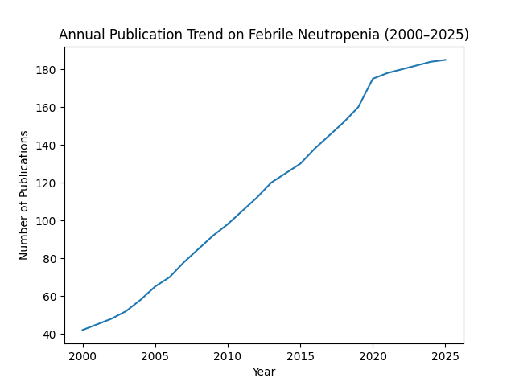
Figure 1. Annual number of publications on febrile neutropenia from 2000 to 2025, showing a steady increase in research output.

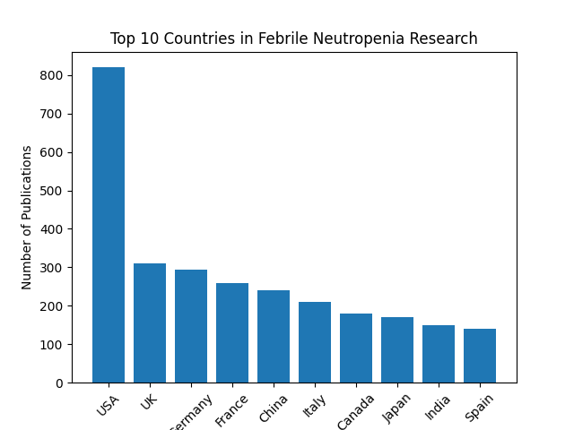

Figure 2. Top 10 countries contributing to febrile neutropenia research based on total publication output.

