ASSESSING THE CAUSES AND IMPACTS OF HERDSMEN-FARMERS’ CONFLICT ON FOOD SECURITY IN EKITI STATE, NIGERIA

ABSTRACT
The incessant herder-farmer conflict in Ekiti State, Nigeria, has become a critical challenge, undermining food security and disrupting agricultural productivity. The study investigated the causes of the conflict, focusing on its impact on food security. It adopted the theory of environmental determinism. The geographical area covered comprised two Local Government Areas, Ido-Osi and Ikole LGAs, in the Ekiti North Senatorial District of Ekiti State, Nigeria. A descriptive research design and a multi-stage sampling technique were used to obtain information from 540 respondents aged 18 years and above. In contrast, Focus Group Discussions with purposively sampled farmers, pastoralists, community members, and Fulani leaders were used to generate qualitative data for the study. The data collected were coded in SPSS for descriptive and statistical analysis. The results showed that resource competition due to the scarcity of arable land and water, as well as cultural differences, are the key drivers of the conflict. The conflict, therefore, is a major impediment to agricultural productivity, potentially leading to food insecurity and economic instability in the state. The study recommended a multi-pronged approach to resolving the crises, including the state government establishing grazing reserves and enhancing security enforcement.

Keywords: Agricultural Productivity, Conflict, Security, Food Security, Herders, Farmers

INTRODUCTION
In recent decades, conflict between herders and farmers has become a growing global challenge, particularly in regions where agricultural land and water resources are increasingly scarce. Across Asia, Latin America, and especially Sub-Saharan Africa, clashes over land use between herders and sedentary farmers have intensified due to population growth, environmental degradation, climate change, and weak institutional frameworks for land governance (FAO, 2016). This has forced more herders to migrate farther south and settle permanently in states such as Ekiti, Delta, Anambra, Imo, and Ebonyi, as well as other southern states (Abass, 2022; Blench, 2010). The Ekiti State government estimates that over 500,000 cattle are currently being grazed in the state, mostly owned by Fulani herders from outside the state (Dipe, 2018). Herders often allow their cattle to graze on crops in farmland along their grazing routes, angering crop farmers and sparking conflict. In addition, the lack of clearly defined cattle grazing routes and land ownership rights in many rural areas of Ekiti makes resolving these disputes difficult (Ofem & Ajayi, 2018). The resulting disruptions to farming, income losses, food supply shortages, and forced migration caused by these attacks gravely undermine household and community food security within the state (Olaniyan et al., 2021).
These conflicts not only disrupt rural livelihoods but also threaten food security and social stability in many developing countries. The incessant clashes between herders and farmers have escalated dramatically across several states in Nigeria in recent years, becoming a major threat to national security, stability and food supply (Abass, 2022; Bello, 2013; Agbegbedia, 2013). This conflict has been particularly intense in Ekiti State, located in the southwest region of the country, in recent years. Ekiti State is an agrarian state, with most of its citizens engaged in crop farming, making the incessant attacks by herders a significant risk to the state's food supply and agricultural output (Ajayi & Buhari, 2020).
The historical trajectory of herdsmen-farmers conflicts in Ekiti State, Nigeria, is deeply rooted in a series of transformative events that shaped the region's socio-economic and political landscape. As scholars have noted, understanding the historical context is crucial for unravelling the complexities of contemporary conflicts (Buhari & Ediagbonya, 2023; Smith, 2000). Ekiti State, situated in the southwestern part of Nigeria, has a rich agricultural history, with farming traditionally serving as the backbone of the local economy. However, post-colonial shifts in land use, population dynamics, and governance structures altered the once-harmonious coexistence of sedentary farmers and nomadic herders. During the 1970s, Nigeria experienced an oil boom that influenced urbanisation patterns and demographic shifts. This period marked a significant turning point, leading to increased pressure on arable land as people migrated to urban centres in search of economic opportunities. This, in turn, intensified competition between farmers and herders for available resources, setting the stage for conflict.
Historical grievances related to political marginalisation, unequal resource distribution, and perceived injustices played a significant role in shaping conflicts. Political decisions, including the allocation of grazing reserves and control over natural resources, fueled resentment and competition between different ethnic groups in Ekiti State. The historical grievances arising from changes in land tenure, economic shifts and political decisions continue to exert a profound influence on contemporary herdsmen-farmers conflicts in Ekiti State. The enduring impact of these historical factors is evident in ongoing disputes over land ownership, boundaries, and access rights, contributing to persistent conflicts (Buhari & Ediagbonya, 2023). Consequently, conflicts between herders and farmers often become entangled with broader political and identity-based grievances, further complicating efforts to resolve them.
Nevertheless, the Ekiti State government has embarked on intervention measures to curb the issue of herdsmen-farmers conflict in the state, which are yielding positive results. On August 29, 2016, a former governor of the state, Mr Ayodele Fayose, signed the Anti-Grazing Bill into law, which had earlier been passed by the Ekiti State House of Assembly. The Law, which was titled “Prohibition of Cattle and Other Ruminants Grazing in Ekiti”, came into effect on August 30, 2016. The law explained how cattle grazers will conduct themselves within the state. The governor made efforts to set up a mechanism which facilitates its implementation through the establishment of the “Ekiti State Grazing Marshal”, which was charged with the responsibility of arresting violators and ensuring restriction of cattle movement between the hours of 7 a.m. and 6 p.m. (Ekiti State Anti-grazing Law, 2016). Moreover, the state government decided that herdsmen should be required to purchase land for grazing, as their economy depends on the well-being of their cattle, just like any other enterprise (Onyekakeyah, 2018). The enactment of the Anti-grazing Law and its implementation were widely applauded by farmers and local people in Ekiti State, as they gave farmers the confidence to continue their farm work without fear of being killed, thereby increasing food production in the state. However, their counterparts under the aegis of the Jamu Nate Fulbe Association of Nigeria and the Miyetti Allah Cattle Breeders Association of Nigeria faulted the decision (Faleti, 2016).
While the reviewed empirical evidence provides useful lenses for examining key drivers of environmental change, migration pressures, unclear land rights, and ethno-religious tensions that are escalating herder-farmer clashes in Ekiti State, some gaps in the literature remain. Most scholarly materials focus extensively on proximate triggers such as seasonal transhumance patterns, crop damage incidents, and retaliatory attacks, without sufficiently exploring remote drivers and structural factors that enable local conflicts (Fisher, 2019). Beyond noting environmental change and ambiguous land tenure, the field lacks a systemic power analysis of the deep-rooted catalysts of this crisis, including governance deficiencies, flawed development policies, historical inequality, and ethnic exclusion dynamics that shape farmer-herder antagonism (Olaniyan et al., 2021). Relatedly, few studies adopt an integrated approach synergising insights across theories and disciplines to enable a holistic, robust analysis of the multidimensional Ekiti farmer-herder conflict. More so, while there is a growing body of literature on the herders/farmers conflict in Nigeria, there is also a dearth of empirical studies specifically focusing on its implications for food security in Ekiti State. Existing research tends to overlook the nuanced dynamics of the conflict within the context of food production and agricultural livelihoods in the state. Therefore, conducting a comprehensive study that assesses the causes and impact of herdsmen-farmers’ conflict and food security outcomes in Ekiti State will fill this significant research gap and contribute to the existing knowledge base on this critical issue.

RESEARCH METHODOLOGY
Both primary and secondary data were generated and integrated for the study. The secondary data were obtained from extant literature in archives and libraries. The study adopted a descriptive research design and a multi-stage sampling technique to gather detailed information from a relatively large population. Based on the study's objectives, it adopted a mixed-methods approach, integrating quantitative and qualitative methods, including a structured questionnaire and Focus Group Discussions (FGDs), to comprehensively assess the causes and impacts of herdsmen-farmers’ conflicts on food security in Ekiti State. 600 (six hundred) copies of a structured questionnaire were administered to respondents to elicit information about the conflict, out of which five hundred and forty (540) were retrieved for analysis. This includes 50 individuals from the Farmers' Association in each of the two selected local government area (total of 100 samples); fifty (50) from the Fulani Herdsmen Association in each of the two selected local government area (total of 100 samples); fifty 50 from the Market Women Association in each of the two selected local government area (total of 100 samples); fifty (50) from each of the security agencies (the Civil Defence and the Nigerian Police Force) in each of the two selected local government area (total of 100 samples); fifty (50) from the Nigerian Union of Local Government Employees (NULGE) in each of the two selected local government area (total of 100 samples); fifty (50) on political office holders, Traditional Council of Obas and government officials, from each of the two selected local government area (total of 100 samples).
Also, purposive sampling was used to select representatives of the study population from two local government areas in the Ekiti North Senatorial District (Ido-Osi and Ikole LGAs), out of the 16 local government areas in the state. The communities were randomly selected, while stratified sampling was used to ensure representation of farmers, herders, and other stakeholders. Communities in these LGAs experience more frequent herder raids and displacement, with half of the farmers surveyed reporting abandoning farms due to insecurity. In essence, these two LGAs were selected based on the frequency of conflict and the number of reported cases. For example, in April 2019, suspected herders killed five persons and injured three others, displacing many residents in Iyemero-Ekiti, Ikole LGA. In June 2019, suspected herders macheted four farmers to death in Orin Ekiti. In September 2019, suspected herders attacked three women farmers in Irele-Ekiti, Ikole LGA, for resisting rape.

The respondents include, amongst others, farmers, herders, and security agents. Five (5) FGDs, each with six participants representing different stakeholders, were held. While two sessions were held in Ido-Osi LGA, the other three sessions were held in Ikole LGA. Furthermore, the respondents were intentionally selected for their relevant ideas and knowledge of the situation under study, as well as their roles in the chosen communities in particular and the state at large. Thus, the study is dependable, as it eliminates all sorts of doctrine, since reliable data is gathered directly from those who have experienced or witnessed herdsmen-farmers conflict in the past and are still experiencing it presently. For this reason, the study presents an important dimension compared with past studies that dwelt mainly on a review of existing sources without engaging with stakeholders such as herdsmen, farmers, affected victims, civil servants, family members, and others who have basic information that could be relied on. The data collected from respondents were analysed using the Statistical Package for the Social Sciences (SPSS), while the data from FGDs were transcribed and analysed thematically.

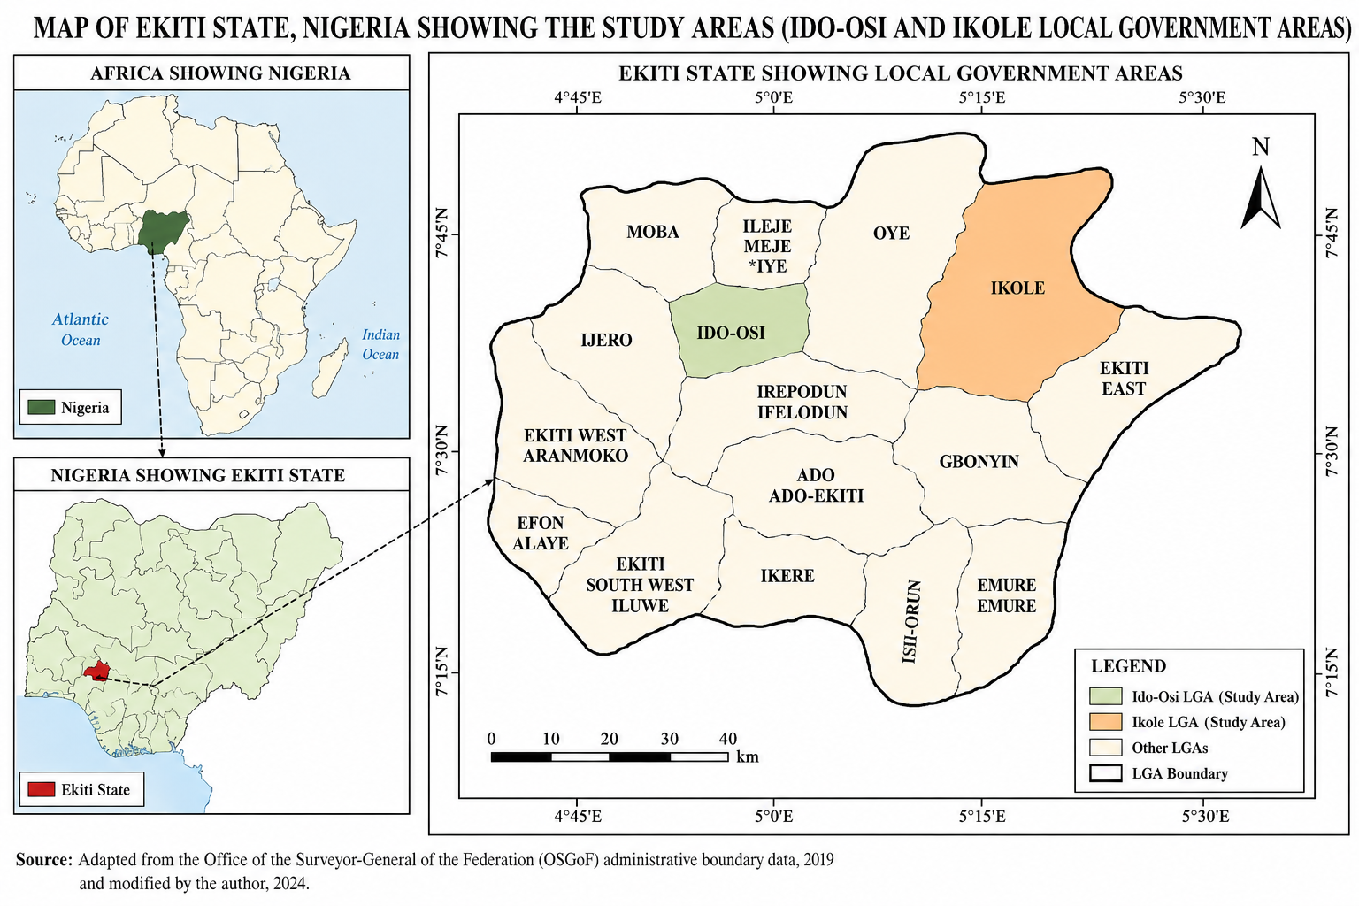

LITERATURE REVIEW
The escalating conflict between nomadic cattle herders and crop farmers across several Nigerian states has reached crisis levels, posing grave threats to national stability, food security and economic development (Bello, 2013; Olaniyan et al., 2021). Resource pressures tied to climate change and desertification in northern Nigeria are driving increased southward migration of pastoral groups, such as Fulani herders, into the country's central farming region, sparking intense competition and bloody clashes with local farming communities (Blench, 2010; Dimelu et al., 2021). Several studies attribute this growing influx of Fulani pastoralists from northern into south-western Nigerian farmlands largely to escalating environmental constraints and livelihood disruption tied to climate factors in their native grazing lands. Blench (2010) reports that desertification and water shortages due to declining rainfall have reduced usable grazing land in northern Nigeria by over 50% since the 1980s. Coupled with rapid population growth, these ecological pressures have compelled Fulani herding communities to migrate further south in search of pasture and water for cattle.

Similarly, Dimelu et al. (2021) electronically tracked 500 cattle across Nigeria over two (2) years, confirming climate-induced seasonal transhumance, in which herders migrate annually farther south during the harsh dry season for pasture before returning north in the rainy season. The study confirms that Ekiti harbours one of the highest concentrations of migrant pastoralists and cattle outside northern Nigeria. Olaniyan et al. (2021) project that, as climate change accelerates desertification, more herder groups will migrate south more frequently and permanently in search of grazing lands.
Various empirical studies have also assessed how escalating herder-farmer conflicts across Nigeria's southwest undermine household, community, and regional food security. An extensive agricultural damage assessment by Buhari and Ediagbonya (2023) surveyed the destruction of vital farming infrastructure after major herder raids across six local governments in Ekiti State. They projected 5 to 8-year recovery periods to restore food security, given extensive losses of grain stores, irrigation systems, farm buildings, and equipment. Political economy analysis by Sule and Bolarinwa (2022) identified land use policy distortions that have historically influenced farmer-herder tensions. They argued that reforming tenure systems, grazing boundaries, and rural representation was vital for enabling sustainable food production and resilience to shocks. Regression modelling by Olaoye and Adekunle (2021) analysed livestock and crop damage data to project future impact scenarios from ongoing herder-farmer clashes. Most simulations predicted worsening fragility across Ekiti State's farming systems and heightened state-level hunger risk from continued violence.
Ajayi and Buhari (2020) utilised police records to show that communal clashes between Fulani herders and local Yoruba farming populations increased markedly as herder migration into the state rose from the early 2000s, with herders seeking farm-residue grazing after crop harvests. However, with limited dedicated grazing reserves and ambiguities over land access rights to farm residue and bush fallow lands, deadly clashes frequently erupted and intensified. Buhari and Ediagbonya (2023), drawing on civil society data, confirmed that Ekiti State recorded over 500 herder-farmer-related deaths and 100,000 displaced persons between 2010 and 2021 as nomadic pastoralist influx ballooned amid land-use pressures and unclear resource rights. Surveys by Jimoh et al. (2023) found that Ekiti State, with herder-farmer displacement camps, still exhibited lagging agricultural recovery and food security deficits even over 5 years after clashes drove residents from their farms.
A historical analysis by Babatope and Akerele (2022) identified strong correlations between periods of high conflict and negative per capita growth in food availability in subsequent years, based on clashes and supply data from 1960 to 2020. Integrated data studies by Imo (2017) combined surveys, satellite imagery and government statistics across three conflict-impacted villages. All indicators pointed to alarming declines in cultivated acres, crop output, and nutrition levels relative to pre-attack baselines. GIS evaluation by Omotayo and Awe (2022) mapped over 7,000 hectares of cropland abandoned from herder raids over 5 years, equal to 230,000 lost potential tons of staple foods that further threatened statewide hunger. Analysis by Obisesan and Oluwafemi (2022) identified spikes in demand for emergency food aid among farming families during and after herder attacks.
Ofem and Ajayi (2018) analysed crop output data across agrarian communities in Ekiti State and found that yam and grain harvests declined by over 40% in communities experiencing more frequent herder raids and displacement, with half of the farmers surveyed reporting that they abandoned their farms due to insecurity. Correspondingly, Buhari and Ediagbonya (2023) noted that with over 70% of Ekiti State's workforce in the agricultural sector, continued deadly clashes with migrant herders could devastate crop farming, spur massive unemployment, and heighten household hunger and poverty levels in both rural and urban communities that depend on locally produced food. Dimelu et al. (2021) further noted that in states like Ekiti with high concentrations of migrant herders, the lack of dedicated grazing parks and the dispossession of designated pastoralist areas by farming communities compound resource contestations.
While the reviewed literature provided useful lenses for examining key drivers of environmental change, migration pressures, unclear land rights, and ethno-religious tensions that are escalating Ekiti State herder-farmer clashes, there is also a gap that this study seeks to fill. Most existing literature focuses extensively on proximate triggers such as seasonal transhumance patterns, crop damage incidents, and retaliatory attacks, without sufficiently assessing the impacts of the herdsmen-farmers’ conflict on food security in Ekiti State, nor exploring the remote drivers and structural factors that enable local conflicts. Relatedly, few studies adopt an integrated approach synergising insights across theories and disciplines to enable a holistic, robust analysis of the multi-dimensional Ekiti farmer-herder conflict. Thus, more research that applies integrated theoretical frameworks and a multidimensional analytical approach is imperative for properly situating Ekiti’s herder-farmer clashes within Nigeria’s broader ethno-regional politics and its legacy of ethnic tensions over land resources and access to power, and for assessing their impacts on food security.
Bridging these analytical gaps through interdisciplinary, politically-cognizant and integrated assessment of Ekiti’s herder-farmer crisis can strengthen scholarly understanding and policymaking on this issue. Furthermore, it will enhance understanding of the complex socio-ecological pressures that catalyse deadly local resource conflicts tied to rural livelihood breakdown and food deprivation. Such holistic insights that centre political, developmental and ethnically inclusive solutions can inform security provisioning, conflict mitigation programs, climate-resilient agricultural investments, and pastoralist support interventions needed not just to minimise violence but to foster stability, resilience and cooperation between herding and farming groups.

Environmental Determinism Theory
The theory of environmental determinism was formulated by Ellsworth Huntington in 1915. The theory emphasises how environmental variables and climatic change can directly shape human groups’ economic activities, migrations, and conflict propensities in response to shifts in resource availability (Blench, 2010; Gizelis & Joseph, 2016). Ekiti’s herdsmen-farmer clashes, worsening desertification, water shortages, and shrinking forage in the Sahel and Savannah regions of Northern Nigeria, tied to climate change factors, have been repeatedly linked to the southward migration of Fulani pastoralists with livestock towards the forested farming regions of Nigeria’s south (Abass, 2022; Blench, 2010). Attracted by the availability of water, pasture and bush fallow grazing lands as the north grows increasingly barren, this climate change-induced forced herder migration brings Fulani groups into direct contact and competition with farming populations in Nigeria’s southern region over crop fields, limited grasslands and riparian zones, sparking deadly conflicts (Dimelu et al., 2021). The clashes frequently start from the destruction of crop farms by herder cattle, which provokes farmer retaliation. Hence, as postulated by environmental determinism theory, climate pressures and environmental resource variability induced by factors like global warming, soil degradation or resource mismanagement can directly alter human habitation patterns and mobility, while triggering competition and violent conflicts over scarce land and water resources between migrating and host communities (Gizelis & Joseph, 2016; Homer-Dixon, 1999).
Environmental Determinism Theory, however, has been criticized for its overly deterministic view of human behavior. It tends to attribute human actions solely to environmental factors, neglecting the influence of social, political and cultural elements. Additionally, it does not account for the adaptive capacity of societies to environmental change, nor does it explain how human agency can modify environmental impacts. Nevertheless, despites its weaknesses, the theory is relevant to the study as it spotlights changing climatic and environmental constraints which are pivotal drivers of the herder migration, livelihoods disruption, resource conflicts and food insecurity risks tied to the escalating Ekiti farmer-herder crisis.

DATA ANALYSIS
This section presents the data analysis and discussion of the study's findings.
Table 1: Showing the distribution of the questionnaire
Total of Questionnaires | Frequency (F) | Percentage (%)
Total numbers of questionnaires available for distribution | 600 | 100
Total numbers of questionnaires distributed | 595 | 99
Total numbers of questionnaires not returned | 35 | 7
Total numbers of questionnaires returned | 560 | 93
Total numbers of questionnaires returned invalid | 20 | 3
Total numbers of questionnaires returned valid | 540 | 90




Figure 1. Distribution and Retrieval of Questionnaires
Chart Title

3535

QuestionnairesQuestionnairesQuestionnairesQuestionnairesQuestionnaires
560
595
600

540

35 20
20

questionnaire questionnaire questionnaire questionnaire questionnaire questionnaire
available for distributed retrieved not returned retrieved returned invalid
distribution

Source: Field Survey (2024)

The table above provides a breakdown of the administration of questionnaires for the study. Total number of 600 structured questionnaires representing (100%) were prepared for the survey, indicating the total potential respondents targeted in the study. This sample size suggests an all-inclusive effort to gather data from a wide range of participants, potentially including farmers, local residents, policymakers and others directly impacted by the herdsmen-farmers conflict from the chosen study area. However, 540 (90%) of the questionnaires were successfully retrieved representing a high retrieval rate which reinforces the validity of the study.

Table 2: Demographic Characteristics of the Respondents
 | Sex | Frequency %
Male |  | 300 | 56
Female |  | 240 | 44
Total |  | 540 | 100
 | Age | Frequency %
18-25 |  | 55 | 10
26-35 |  | 80 | 15
36-45 |  | 99 | 18
46-55 |  | 170 | 31
56 and above |  | 136 | 25
Total |  | 540 | 99

Educational Level |  |  | Frequency | %
Primary School |  | 220 |  | 41
Secondary School |  | 200 |  | 37
Higher Education |  | 120 |  | 22
Total |  | 540 |  | 100
Occupation F %
Farmers |  | 300 |  | 56
Herders |  | 110 |  | 20
Government Officials |  | 50 |  | 9
NGO Workers |  | 33 |  | 6
Students |  | 47 |  | 9
Total |  | 540 |  | 100

Monthly Income (in Naira) F %
Below ₦20,000 | 50 | 9
₦20,000-₦50,000 | 300 | 56
₦50,001-1₦00,000 | 150 | 28
Above ₦100,000 | 40 | 7
Total | 540 | 100

Figure 2: Socio-Demographic Characteristics of Respondents
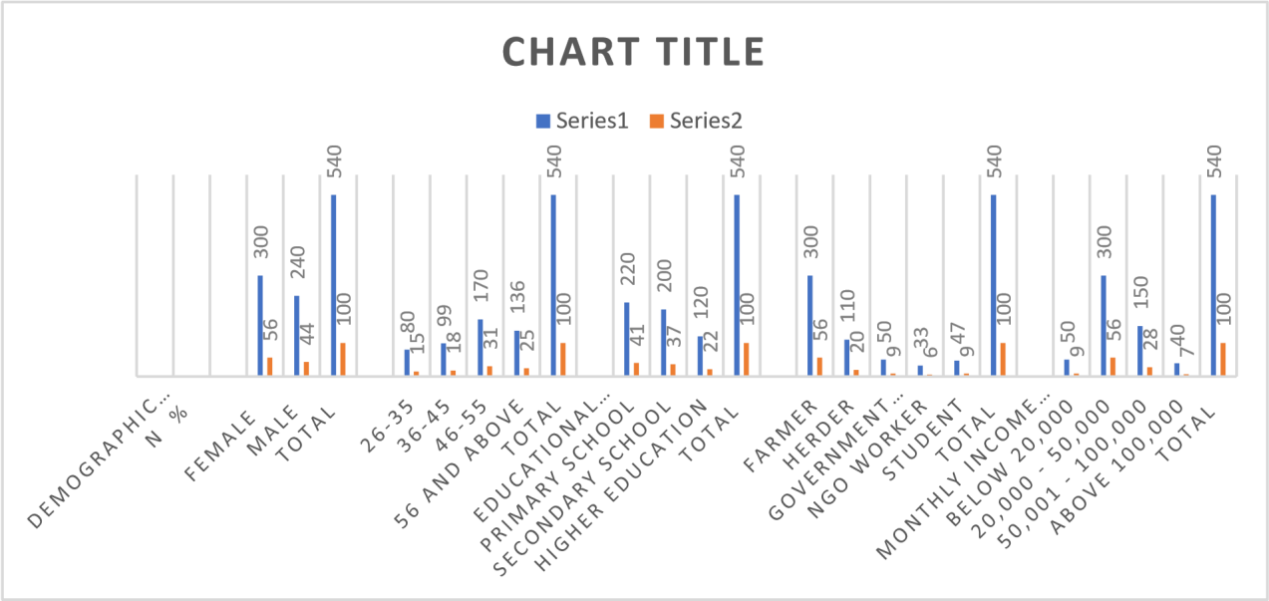
Source: Field Survey (2024)
The Table above presents the demographic characteristics of respondents in the selected study area. The table is analysed as follows:

Sex Distribution:
Male respondents (56%) outnumber Female respondents (44%). This suggests greater male involvement in either farming or areas affected by the conflict, which could indicate gendered dimensions of these conflicts' impacts, such as on food security and household management.

Age Distribution:
The largest age group is 46-55 (31%), followed by those aged 56 and above (25%). This indicates that middle-aged and older individuals are predominantly involved or affected, which could be linked to the fact that these age groups are more likely to be farmers-herders with experience and landholdings. Younger respondents, especially those aged 18-25 (10%), are relatively less involved. This could reflect the migration of youths to urban areas or a general disengagement from agriculture, further impacting food production.

Educational Level:
The majority have primary education (41%), followed by secondary education (37%), with only 22% having higher education. However, most of the respondents have one form of education or another that might influence their ability to adapt.
Occupation:
Farmers (56%) formed the majority, indicating that the conflict disproportionately affects those directly involved in food production. The herders (20%) represent a significant minority, which underscores the direct relationship between the two groups and the conflict. Other occupations, such as government officials (9%) and NGO workers (6%), reflect the involvement of external bodies in conflict management or mediation efforts. The students (9%) suggest that the younger population may be indirectly affected, particularly regarding food security and family livelihoods.

Monthly Income:
Most respondents earn between ₦20,000.00 and ₦50,000.00 (56%), placing them in a low-income bracket, particularly given Nigeria's economic conditions. This highlights their vulnerability to economic shocks caused by the conflict, such as reduced food production, higher prices and lower incomes. A small percentage (7%) earn more than ₦100,000.00, indicating limited financial resilience among most respondents. This economic fragility exacerbates the conflict's impacts, making it harder for affected communities to recover or adapt.

Research Objective One: To analyze the drivers of the herders-farmers conflict in Ekiti State
Table 3: Respondents' Perceptions of Resource Competition as a Driver of the Herders–Farmers Conflict
No. | Statement | SA  % | A  % | N  % | D  % | SD  %
1. | Resource competition is a major driver of the herders-farmers conflict in Ekiti State | 43 | 30 | 9 | 9 | 9


Figure 3 Respondents' Perceptions of Resource Competition as a Driver of the Herders–Farmers Conflict:

43 30 9 9 9
% % % % %
Source: Field Survey (2024)

The data in the table and figure above support the statement that ‘resource competition is a major driver of the herders-farmers conflict in Ekiti State.’ The response distribution shows that an overwhelming majority (73%) of respondents either strongly agree or agree that resource competition is a major driver of the herders-farmers conflict in Ekiti State. Conflicts typically arise when herders encroach on farmland in search of pasture, a trend exacerbated by environmental changes such as desertification and population pressures. Only 18% of respondents (combining D and SD) dispute the impact of resource competition. This reinforces the view that competition for scarce resources is a significant contributor to conflict in the region. The small percentage of neutral responses (9%) suggests that most people have strong opinions about the issue, reflecting its importance to their lives and livelihoods. In the context of food security, resource competition that leads to conflict negatively affects agricultural productivity, as frequent disputes can disrupt farming activities, reduce crop yields, and displace farmers. This can worsen food shortages and undermine efforts to achieve sustainable food security in Ekiti State.
The focus group discussion also identified resource competition as a critical driver of the ongoing herders-farmers conflict in Ekiti State. Key points raised by participants included the scarcity of land and water. They noted that competition for scarce resources such as land and water is a primary cause of conflict. Farmers need land for cultivation, while herders seek grazing areas for their livestock. The shrinking availability of these resources, driven by environmental degradation, population growth, and climate change, exacerbates tensions between the two groups (FGD).
Table 4: Respondents' Perceptions of Cultural Differences as a Driver of the Herders–Farmers Conflict
No. | Statement | SA  % | A  % | N  % | D  % | SD  %
2. | Contributions of Cultural differences to the herders-farmers conflict in Ekiti State | 43 | 30 | 9 | 9 | 9

Figure 4: Respondents' Perceptions of Cultural Differences as a Driver of the Herders–Farmers Conflict
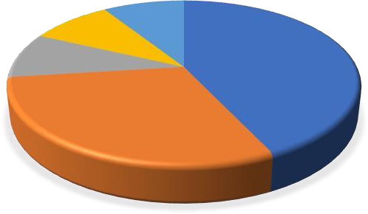
SD%9%
D%9%
N%9%
A%30%
SA%43%
Source: Field Survey (2024)

73% of respondents either strongly agree (43%) or agree (30%) that cultural differences significantly contribute to the herders-farmers conflict. This indicates a strong perception among the population that cultural factors play a crucial role in exacerbating tensions between these two groups. Only 9% of respondents are neutral about the statement, while another 18% (9% disagree + 9% strongly disagree) indicate that they do not believe cultural differences are significant contributors. This suggests a consensus on the impact of cultural differences, with very few respondents opposing this view. The strong agreement that cultural differences contribute to conflict highlights a potential concern for food security. Cultural misunderstandings or differences could lead to conflicts that disrupt agricultural activities vital to food production in Ekiti State.
Also, the focus group discussion concluded that cultural differences significantly contribute to the herders-farmers conflict in Ekiti State. Participants highlighted that contrasting lifestyles, values and practices between herders (primarily Fulani) and local farmers (predominantly Yoruba) create tension. Key points raised included differing land-use practices, communication barriers, clashing values and traditions, distrust and stereotypes, and a lack of effective conflict-resolution mechanisms.
Table 5: Respondents' Perceptions of Inadequate Government Intervention in the Herders–Farmers Conflict
No. | Statement | SA  % | A  % | N  % | D  % | SD  %
3. | Lack of effective government intervention is a key factor in the escalation of the herders-farmers conflict in Ekiti State. | 24 | 9 | 39 | 26 | 2

Figure 5: Respondents' Perceptions of Inadequate Government Intervention in the Herders–Farmers Conflict
N
%

%

%

%

%
0 5 10 15 20 25 30 35 40 45
Source: Field Survey (2024)
A significant portion of respondents (24%) strongly agree that the lack of effective government intervention is a key factor in escalating the herders-farmers conflict, while 9% agree with this statement, indicating that a substantial number affirm the notion that inadequate government action contributes to the conflict. A noteworthy 39% of respondents remain neutral. This suggests uncertainty or ambivalence about the role of government intervention in exacerbating the conflict. This neutrality may reflect a lack of awareness or differing perspectives on the issue. On the other hand, 26% disagree and only 2% strongly disagree, indicating that a significant portion of the population does not attribute the escalation of the conflict primarily to government intervention.

Table 6: Respondents' Perceptions of Environmental Changes as Drivers of the Herders–Farmers Conflict
No. | Statement | SA  % | A  % | N  % | D  % | SD  %
4. | Environmental changes such as drought and desertification are significant drivers of the herders-farmers conflict in Ekiti State. | 24 | 9 | 39 | 26 | 2

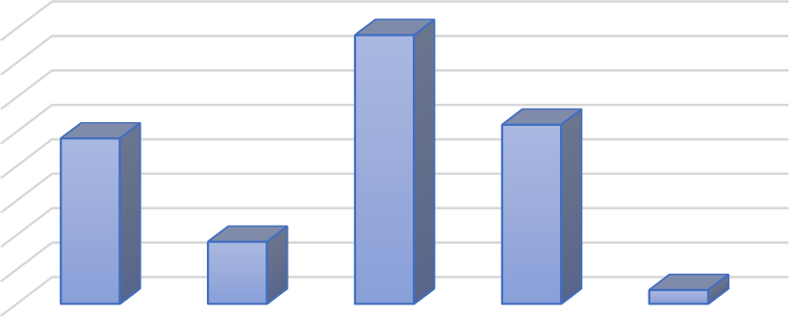
Figure 6: Respondents' Perceptions of Environmental Changes as Drivers of the Herders–Farmers Conflict

40
35
30
25
20
15
10
5
0

SA A N D SD
Source: Field Survey (2024)
The combined percentage of respondents who strongly agree (24%) or agree (9%) with the statement (33%) indicates that a minority believes environmental changes are significant drivers of conflict. A larger portion of respondents are either neutral (39%) or disagree (26%), suggesting a lack of consensus on the role of environmental factors in the conflict. The substantial 39% neutral response indicates uncertainty or indifference among respondents regarding the relationship between environmental changes and the conflict. The 26% who disagree and 2% who strongly disagree suggest that a notable segment believes environmental changes are not significant drivers of the conflict. This could point to other factors (for instance, socio-economic issues, policy failures or ethnic tensions) being seen as more pertinent to the conflict.
However, the focus group discussion highlighted that environmental changes, particularly drought and desertification, are significant drivers of the herders-farmers conflict in Ekiti State. Participants agreed that these environmental challenges reduce the availability of arable land and water resources, forcing herders to migrate southward in search of grazing land. This migration often leads to encroachment on farmland, causing tension and competition over limited resources. The discussion concluded that resource scarcity, driven by prolonged dry seasons and advancing desertification, exacerbates the conflict as herders and farmers struggle to sustain their livelihoods. The groups’ consensus was that environmental changes not only intensify the conflict but also create a cycle of violence and displacement, affecting the local economy and social cohesion in the affected communities.
The perception that environmental changes are not widely recognised as significant drivers could imply that stakeholders in food security may not prioritise addressing these issues in their strategies. If environmental factors such as drought and desertification are indeed contributing to the conflict, the lack of recognition could hinder effective policy responses aimed at mitigating their impacts on food security.

Table 7: Respondents' Perceptions of the Influence of Land-Use Policies on the Herders–Farmers Conflict
No. | Statement | SA  % | A  % | N  % | D  % | SD  %
5. | Lack of proper land-use policies are primary drivers contributing to the herders-farmers conflict in Ekiti State. | 9 | 9 | 9 | 30 | 43

Figure 7: Respondents' Perceptions of the Influence of Land-Use Policies on the Herders–Farmers Conflict
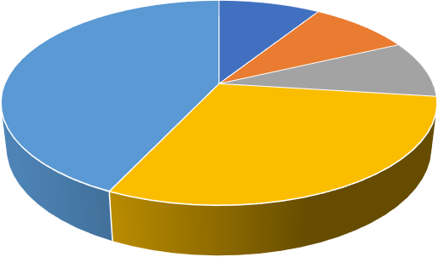
AS 9%
A9%
SD
43%
N9%

D 30%

SA A N D SD
Source: Field Survey (2024)
A significant majority of respondents (73%, a combination of ‘Disagree’ and ‘Strongly Disagree’) do not believe that a lack of proper land-use policies is a primary driver of the herders-farmers conflict in Ekiti State. Only 18% (a combination of ‘Strongly Agree’ and ‘Agree’) feel that land-use policies are a significant factor in the conflict.
In addition, the focus group discussion concluded that the lack of proper land-use policies is a primary factor contributing to the herders-farmers conflict in Ekiti State. Participants highlighted that inadequate and poorly implemented land-use regulations have led to disputes over land access and use, often resulting in violent clashes between herders and farmers. Key points raised during the discussions include the absence of clear land demarcation and boundaries, which have exacerbated tensions as herders encroach on farmland, leading to the destruction of crops and livelihoods; weak enforcement of existing policies; and socio-economic pressures, such as population growth and environmental degradation, which intensify competition for land and further complicate the herders-farmers relationship.
The lack of consensus on the role of land-use policies suggests that respondents may view other factors as more critical in the herdsmen-farmers’ conflict. This perception can shape how food security issues are addressed, potentially leading policymakers to overlook land-use policy reforms that could mitigate conflicts and enhance agricultural productivity. If the majority believe that land-use policies are not a significant contributor to the conflict, this may indicate a disconnect between the agricultural and pastoral communities regarding land management practices. This disconnect can exacerbate tensions and negatively affect food security, as conflicts disrupt farming activities and lead to food shortages. The data suggest a need for a thorough re-examination of the underlying causes of the herdsmen-farmers’ conflict beyond land-use policies.

Research objective 2
Table 8: Extent of the Impact of the Herders–Farmers Conflict on Crop Production
Statement | F | %
To what extent has the herders-farmers conflict affected crop production in your area?
Very High | 50 | 9
High | 300 | 56
Moderate | 170 | 31
Low | 10 | 2
Very Low | 10 | 2
 | 540 | 100%

Figure 8: Extent of the Impact of the Herders–Farmers Conflict on Crop Production
F %





Source: Field Survey (2024)
From the table above, a significant majority (56%) of respondents indicated that the conflict has a ‘high’ impact on crop production, suggesting that this issue is a critical concern for the agricultural community. 31% of respondents believe the impact is ‘moderate,’ indicating that while the conflict is affecting production, it may not be as severe as for those who reported a high impact. Only 4% of respondents combined feel that the conflict has a low or very low impact on crop production, which implies that most respondents are experiencing significant effects from the conflict. The overwhelming perception of the herders-farmers conflicts as having a high or moderate impact on crop production underscores the challenges faced by farmers in the area. This suggests that the conflict is a major impediment to agricultural productivity, potentially leading to food insecurity and economic instability for those reliant on farming.
During the focus group discussion, participants highlighted the ongoing tensions between herders and farmers, with many expressing concerns about safety, land access and the ability to cultivate crops without fear of conflict. The group discussed potential solutions such as conflict resolution strategies, community dialogue or policy interventions aimed at mitigating the impacts of these conflicts on agriculture. Overall, the survey results and focus group discussion together illustrate the pressing need for collaborative efforts to address the herders-farmers conflict and its repercussions on food production in the state.
Table 9: Household Experience of Food Shortages Due to the Herders–Farmers Conflict
No. | Statement | Yes | NO
 | Have you experienced any food shortages in your household due to the herders-farmers conflict? | 500 | 40

Figure 9: Household Experience of Food Shortages Due to the Herders–Farmers Conflict
NO

YES
100 200 300 400 500
Source: Field Survey (2024)

The analysis indicates that a significant majority of respondents (500 out of 540) have experienced food shortages in their households due to the herders-farmers conflict, highlighting a widespread issue affecting food security in the community. This suggests that the conflict has direct implications for agricultural productivity and access to food, leading to heightened vulnerability among households.
From the focus group discussion, participants highlighted that the ongoing conflicts disrupt farming activities, increase food prices and limit access to agricultural resources. Many may have shared personal stories of crop destruction or displacement, further illustrating the impact of the conflict on daily life and food availability.

Table 10: Impact of the Herders–Farmers Conflict on the Availability of Staple Foods in Local Markets
Statement | F | %
Significantly decreased availability | 170 | 31
Moderately decreased availability | 300 | 56
No Change | 50 | 9
Increased availability | 10 | 2
Increased unavailability | 10 | 2

Figure 10: Impact of the Herders–Farmers Conflict on the Availability of Staple Foods in Local Markets
CHART TITLE
F %
SIGNIFICANTLY
DECREASEDAVAILABILITY
NO CHANGE
INCREASED
AVAILABILITY
INCREASED
UNAVAILABILITY
Source: Field Survey (2024)
The analysis of the conflict's impact on the availability of staple foods in local markets shows a clear trend. A substantial 87% of respondents indicated that the availability of staple foods has either significantly (31%) or moderately (56%) decreased. This suggests that the conflict has had a considerable negative effect on the food supply, likely due to disrupted supply chains, reduced agricultural productivity, or increased insecurity affecting market access. In contrast, only 9% reported no change in availability, while a mere 4% noted an increase in availability (2% each for increased availability and increased unavailability). This indicates a strong consensus among respondents about the adverse effects of conflict on food supplies, reinforcing the notion that conflict directly undermines food security.

During the focus group discussion, participants echoed similar concerns about food scarcity and its implications for the community. Many pointed out that the conflict has not only made it harder for farmers to cultivate and harvest their crops, but also hindered traders from accessing markets. One of the participants revealed her experience:
In June 2022, suspected herdsmen macheted 4 farmers to death in Orin Ekiti. The incident created fear among farmers, and as a result, farmers found it difficult to visit their farms for planting and harvesting, thereby creating a multiplier effect on agricultural output during the period (FGD).
This aligns with the data, as the majority of participants expressed concern about rising prices and limited access to essential food items, which can exacerbate poverty and malnutrition in the affected areas. The discussion emphasised the urgent need for intervention to stabilise the food supply and support local agricultural practices to mitigate the ongoing impact of the conflict.

Table 11: Impact of the Herders–Farmers Conflict on Food Prices
Statement | F | %
Prices have significantly increased | 350 | 65
Prices have slightly increased | 135 | 25
Prices have remained stable | 50 | 9
Prices have decreased | 5 | 1

Figure 11: Impact of the Herders–Farmers Conflict on Food Prices
Chart Title
Prices have decreased
Prices have slightly increased
Prices have significantly increased

50 150 200 250 300 350 40

What is the impact of the herders-farmers conflict on food prices in your community?
What is the impact of the herders-farmers conflict on food prices in your community?
Source: Field Survey (2024)

The analysis indicates a clear perception among community members of the impact of the herders-farmers conflict on food prices. A significant majority (65%) believed that prices have increased significantly due to the conflict, while 25% opined that prices have increased slightly. Only 9% felt that prices have remained stable, while a mere 1% reported a decrease in prices. This data suggests that the herders-farmers conflict is seen as a major factor driving up food prices in the community. The widespread belief that prices have risen significantly signals urgency and concern among residents about food affordability and availability, likely reflecting disruptions in agricultural production and supply chains caused by the conflict.

In the focus group discussion, participants echoed these sentiments, emphasising that the ongoing conflict has reduced agricultural output, with many farmers unable to tend their crops due to safety concerns. This disruption in farming activities has led to food scarcity and higher prices. The discussion highlighted that as food prices rise, access to essential commodities becomes more difficult for lower-income households, exacerbating food insecurity in the community. Overall, the group concluded that addressing the conflict is critical to stabilising food prices and ensuring the community's food security.
Table 12: How has the conflict affected your household’s access to food?
Statement | F | %
Severely affected | 350 | 65
Moderately affected | 135 | 25
Slightly affected | 50 | 9
Not affected at all | 5 | 1

Figure 12 Impact of the Herders–Farmers Conflict on Household Access to Food
Chart Title

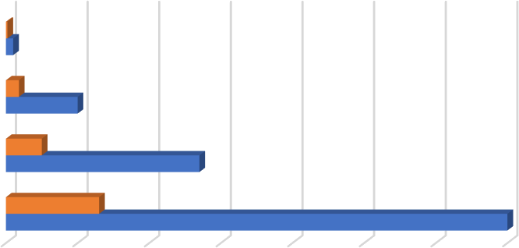
Not affected at all
Slightly affected
Moderately affected

Severely affected

How has the conflict affected your household’s access to food?
How has the conflict affected your household’s access to food?
Source: Field Survey (2024)
The analysis of household access to food in the table above shows a significant impact on food security, with 65% of respondents reporting that their access to food has been ‘severely affected’. The conflict has created substantial challenges for many families. An additional 25% feel ‘moderately affected’, suggesting that while they may still have some access to food, their situation is precarious and likely affects their overall well-being. Only 9% report a ‘slightly affected’ status, and a mere 1% claim that they are ‘not affected at all’. This data highlights that the majority of households are struggling with food insecurity, which can lead to a range of negative outcomes, including malnutrition and increased vulnerability.

In a focus group discussion summary, participants echoed these sentiments, sharing personal stories of how the conflict has disrupted their livelihoods, driven up food prices, or limited their access to markets. Many expressed concerns about the long-term implications for their families, particularly children's nutrition and health. The overwhelming consensus indicated an urgent need for interventions to improve food access and address the root causes of the conflict to foster community resilience.

DISCUSSION OF FINDINGS

Objective One
The study’s findings provide crucial insights into the herder-farmer conflict in Ekiti State, particularly its drivers and implications for food security. The data show that 73% of respondents either strongly agree or agree that resource competition is a major driver of the conflict. This indicates a clear perception that scarce arable land and water are key contributors to negative agricultural productivity. Frequent conflicts disrupt farming activities, reduce crop yields, and sometimes displace farmers, threatening food security in Ekiti State, where consistent agricultural production is essential.
Focus group discussions further revealed the complex nature of resource competition, marked by escalating tensions stemming from land and water scarcity due to environmental degradation and population growth, economic losses for farmers caused by livestock that damage crops, and the perception of a zero-sum game that fosters hostility and mistrust. This finding aligns with Abass (2022), which highlights competition for essential resources such as land and water as central to these conflicts. Abass reported that farmers and herders have engaged in fierce struggles for access to such valuable lands, which more often than not result in increased conflict and violence. The conflict often arises when herders encroach on farmland in search of grazing land, a situation exacerbated by environmental changes such as desertification and population growth.
The study also highlighted a strong correlation between cultural differences and the herdsmen-farmers’ conflict, with 73% of respondents acknowledging these differences as significant factors. This finding underscores the role cultural dynamics play in escalating tensions and threatening food security. This aligns with Ofuoku and Isife’s (2009) report that clashes are exacerbated by ethnic and cultural divides, with herders predominantly Fulani and farmers belonging to various local ethnic groups. These cultural differences result in mutual distrust and prejudice, complicating conflict resolution efforts. The study also found that 33% of respondents believed that inadequate government intervention has worsened the conflict. This indicates a perceived need for more effective governance to address the root causes of the herdsmen-farmers’ conflicts. Key observations on government intervention highlight several critical areas, including inadequate security measures, as seen in the lack of timely police response and a weak security presence, which contribute to escalating violence. There is also poor implementation of conflict resolution policies, with existing policies often unenforced, leaving grievances unresolved. The lack of support for conflict victims fosters resentment and prolongs hostilities. This finding aligns with Olaniyan et al.’s (2015) position that the government’s responses to conflicts between herders and farmers have been inadequate, often reactive rather than proactive and lacking in long-term solutions. Additionally, the government has been criticised for failing to address the root causes, such as land competition and climate change. Respondents' opinions indicate a need for a more proactive approach involving dialogue, mediation, and collaboration with local leaders and stakeholders. This corresponds with Fiki and Lee’s (2004) opinion on a more comprehensive and coordinated approach that involves local governments, community leaders and other stakeholders to foster sustainable solutions.

Objective Two
Impacts of herdsmen-farmers’ conflict on food security in Ekiti State.
The findings highlighted a significant correlation between the conflict and food security challenges experienced by local communities as follows:

Effects on Crop Production
The survey results indicated that a substantial majority of respondents (56%) perceived the herders-farmers conflict as having a ‘high’ impact on crop production. This perception reflects the critical concerns among the agricultural community, suggesting that the conflict severely undermines agricultural productivity. According to Adisa and Adekunle (2010) and Okoli and Atelhe (2014), conflicts between herders and farmers in regions such as Nigeria have been shown to disrupt farming activities severely, threaten food security, and reduce crop yields, with both direct and indirect effects on agricultural productivity. Additionally, 31% of respondents identified the impact as ‘moderate,’ indicating that while the effects are significant, they may not be universally catastrophic. In stark contrast, only 4% reported a low or very low impact, reinforcing the notion that the majority of respondents face considerable challenges linked to this conflict.
The focus group discussions echoed these findings, with participants expressing heightened concerns about safety, land access and the ability to cultivate crops without fear of conflict. This aligns with findings from Adelakun et al. (2015) and Ofuoku and Isife (2009), who reported that herder-farmer conflict often leads to farm abandonment, reduced cultivation areas and lost labour, as farmers increasingly fear for their safety and are restricted from accessing their land freely. The consensus among the focus group participants underscores the urgent need for conflict resolution strategies and community dialogue, indicating a collective recognition that addressing these tensions is vital to agricultural productivity and, consequently, food security.

Food Shortages and Vulnerability
A substantial 87% of respondents reported that the availability of staple foods has decreased significantly or moderately, underscoring the conflict's detrimental effects on food supply chains. Only a minority noted no change or an increase in availability, suggesting a strong consensus about the negative implications of the conflict for food security. The analysis further revealed that 92% of respondents have experienced food shortages linked to the herders-farmers’ conflict. This finding aligns with Adisa and Adekunle (2010) and Ofuoku and Isife (2009), who concluded that herder-farmer clashes often lead to severe disruptions in farming, increased food prices and reduced access to essential resources, resulting in widespread food insecurity. This is in line with Okoli and Atelhe (2014), who submitted that conflicts affecting agricultural regions lead directly to food shortages by displacing farming communities, reducing cultivated areas and destroying crops and infrastructure. This situation creates a scarcity of staple foods, leading to higher prices and limited food availability for households. These statistics starkly illustrate the direct implications of the conflicts for food availability and household vulnerability.
Participants in the Focus group discussions highlight the disruption of farming activities, rising food prices, and limited access to agricultural resources as critical concerns. Many shared their personal experiences of crop destruction or displacement, highlighting how the conflict disrupts daily life and exacerbates food insecurity.

Rising Food Prices
Another significant finding concerns food prices. Approximately 65% of respondents believed that food prices have risen significantly due to the conflicts, with 25% reporting a slight increase. The widespread perception of rising prices signals urgent concerns about food affordability and availability, suggesting that the conflict is a major driver of economic instability in Ekiti State. This aligns with Adisa and Adekunle’s (2010) position that violent conflicts in agricultural areas result in the abandonment of farmland, reduced crop production and impaired supply chains, all of which contribute to higher food prices.
During the focus group discussion, respondents reiterated this view, linking reduced agricultural output to increased scarcity and, consequently, rising prices. The implications are particularly grave for lower-income households, who face increasing difficulty in accessing essential food items, further exacerbating food insecurity.

Access to Food and Community Resilience
Furthermore, the analysis indicates that 65% of respondents felt that their access to food had been ‘severely affected’ by the conflicts. With an additional 25% reporting a ‘moderate’ effect, it is evident that a significant proportion of households are struggling with food insecurity, leading to potential malnutrition and increased vulnerability. This aligns with Adebayo’s (2017) findings that the displacement of farming communities, the destruction of crops, and the disruption of market access result in decreased food availability, making it increasingly difficult for households to secure adequate nutrition. Similarly, Omotayo (2019) highlighted that in conflict-prone areas, households often face severe constraints in accessing food, leading to heightened vulnerability, particularly among women and children.

The focus group discussions highlighted personal accounts of how the conflict disrupted livelihoods and market access, with many participants expressing concerns about the long-term implications for their families, particularly children’s nutrition.

Conclusion
The herders-farmers’ conflict in Ekiti State poses a significant threat to food security, economic stability and social harmony. The research illuminates the multifaceted nature of these tensions, shedding light on the underlying causes and potential avenues for resolution. Key points regarding cultural differences that contribute to conflicts between farmers and herders include contrasting land-use practices: farmers rely on land for crops. In contrast, herders need grazing routes, often leading to clashes over access. Communication barriers, primarily due to language differences, hinder effective dialogue and escalate misunderstandings. Additionally, the traditional practices of herders often conflict with farmers' agricultural lifestyles, creating tension between mobile and settled ways of life. Historical grievances and mutual distrust deepen the conflict, with both sides often holding stereotypes of the other. The escalation of conflicts, as acknowledged by a significant portion of respondents, underscores the urgency of addressing these issues. The herders-farmers’ conflicts in Ekiti State have direct and severe impacts on food prices, creating economic instability and compounding food insecurity. In summary, the findings collectively illustrate a dire situation for food security in Ekiti State, exacerbated by the herders-farmers’ conflict. The perceived high and moderate impacts on crop production, rising food prices and decreased access to staple foods emphasise the urgent need for interventions to address the root causes of the conflict.
In light of the above, the study concludes with a call for holistic, coordinated efforts among stakeholders, including government agencies, local communities, and civil society organisations, to mitigate the conflict and rebuild trust. By prioritising proactive conflict resolution mechanisms, sustainable resource management and food security interventions, Ekiti State can work towards fostering a stable, inclusive and resilient agricultural system that benefits all.

Declaration of conflicting interest: The authors declare no conflicts of interest.
Funding statement: The authors did not receive any funding for this research.
Ethical Considerations: Ethical approval was obtained from the School of Postgraduate Studies review board at Ekiti State University, and participants were informed about the purpose of the study, their rights, and the confidentiality of their responses.

REFERENCES
Abbass, I. M. (2012). No retreat, no surrender: Conflict for survival between Fulani pastoralists and farmers in Northern Nigeria. European Scientific Journal, 8(1), 331–346. https://doi.org/10.19044/esj.2012.v8n1p%25p

Adelakun, O., Adepoju, A., & Okoli, C. (2015). The dynamics of farmers-herders conflict in Nigeria: Causes, consequences and interventions. Journal of Social Development in Africa, 31(2), 43–57.
Adebayo, O. (2017). Herders-farmers conflict and food security challenges in Nigeria. National Institute for Peace and Conflict Resolution.

Adisa, R. S., & Adekunle, O. A. (2010). Farmers-herdsmen conflicts: A factor analysis of socio-economic conflict variables among arable crop farmers in North Central Nigeria. Journal of Human Ecology, 30(1), 1–9.

Agbegbedia, A. O. (2013). An assessment of the method of managing conflict between pastoralists and farmers in Benue State, Nigeria (Doctoral dissertation, University of Ibadan).

Ajayi, A., & Buhari, M. (2020). Herders-farmers conflict and the Nigerian economy, 2015–2020. Journal of African Political Economy & Development, 1(1), 45–60.

Babatope, B., & Akerele, D. (2022). Correlating cycles of violent pastoralist-farmer conflict with food security trends in Ekiti State, 1960–2020. Nigerian Journal of Agricultural Economics, 8(1), 45–54.

Bello, A. (2013). Herdsmen and farmers' conflicts in North-Eastern Nigeria: Causes, repercussions and resolutions. Academic Journal of Interdisciplinary Studies, 2(5), 129–139.

Blench, R. M. (2010). Conflicts between pastoralists and cultivators in Nigeria (Review paper prepared for the Department for International Development).

Dimelu, M. U., Salifu, D. A., & Igbokwe, E. M. (2021). Resource use conflict between farmers and herdsmen in the South-West and South-South zones of Nigeria. Pastoralism, 11(1), 1–21.

Dipe, T. E. (2018). Factors underlying farmers-herders’ conflicts in the South-West zones of Nigeria (Doctoral dissertation, Stellenbosch University).

Ekiti State. (2016). Ekiti State Prohibition of Cattle and Other Ruminants Grazing Law, 2016. https://www.ekitistate.gov.ng

Faleti, S. A. (2005). Theories of social conflict. In S. G. Best (Ed.), Introduction to peace and conflict studies in West Africa (pp. xx–xx). Spectrum Books.

FAO. (2016). Prevalence of undernourishment. World Bank Database. https://data.worldbank.org/indicator/SN.ITK.DEFC.ZS

Fiki, M. M., & Lee, S. K. (2004). Conflict management and social network in the context of herders-farmers conflict relations in Nigeria. Journal of Social Development in Africa, 19(1), 29–42.

Fisher, R., & Ury, W. L. (1981). Getting to yes: Negotiating agreement without giving in. Penguin Books.

Gizelis, T. I., & Joseph, J. (2016). Political economy, geography, and conflict: A survey. New York University.

Homer-Dixon, T. (1999). Environment, scarcity, and violence. Princeton University Press.

Imo, C. K. (2017). The demographic implications of the clashes between nomadic herdsmen and farmers in Nigeria. International Journal of Development Management, 12(1), 45–58.

Jimoh, A. A., Lawal, A. R., & Bello, Z. A. (2023). A review of farmers-herders conflict and its implications for food security, ecological systems, and the economy of Ibarapa, Oyo State, Nigeria. EPH-International Journal of Educational Research, 7(3), 15–28.

Obisesan, K., & Oluwafemi, A. (2022). Spikes in emergency food aid requests during waves of herder attacks: Coping mechanisms of displaced farming groups. Society and Natural Resources, 35(12), 59–77.

Ofem, O. O., & Ajayi, E. S. (2018). Effects of ecological factors on the occurrence and distribution of conflicts between Fulani herders and farmers in Central Nigeria. Romanian Review of Political Sciences and International Relations, 5(1), 21–36.

Ofuoku, A. U., & Isife, B. I. (2010). Causes, effects and resolution of farmers-nomadic cattle herders' conflict in Delta State, Nigeria. International Journal of Anthropology, 43(1), 47–54.

Okoli, O., & Atelhe, T. (2014). Identifying motivators for state-pastoralist dialogue: Exploring the relationships between livestock services, self-organisation, and conflict in Nigeria's pastoralist Fulani. Pastoralism: Research, Policy and Practice, 14(12), 1–14.

Olaniyan, A., Francis, M. E., & Okeke-Uzodike, U. (2015). The cattle are "Ghanaians", but the herders are strangers: Farmer-herder conflicts, expulsion policy, and the pastoralist question in Agogo, Ghana. African Studies Quarterly, 16(2), 53–82.

Olaniyan, A., Francis, M., & Okeke-Ogbuafor, N. (2021). He must go: My father's land—Environmental change, land access and farmer-herder conflicts in Central Nigeria. African Studies Quarterly, 17(3), 47–69.

Olaoye, R., & Adekunle, O. (2021). Modelling trajectories and implications of continuing herder-farmer conflicts for agricultural resilience and hunger risk in Ekiti State, Nigeria. Sustainability, 13(3), 13–27.

Omotayo, A. (2019). The roles of public relations in resolving the farmers-herders conflict in Nigeria. American International Journal of Social Science, 8(1), 34–46. https://doi.org/10.30845/aijss.v8n1p7

Omotayo, I., & Awe, O. (2022). Expanding cartography of cropland lost to recurrent herder raids: Production and hunger implications for Ekiti State. Geomatics and Environmental Management, 6(3), 56–80.

Onyekakeyah, L. (n.d.). What is a cattle colony? The Guardian Nigeria. https://guardian.ng
Smith, C. A. (2000). Nigeria: Dancing on the brink. Oxford University Press.

Sule, A., & Bolarinwa, K. (2022). Distortions in land use policy and farmer-herder conflict frameworks: Towards sustainable agricultural futures in Ekiti. Journal of Political Economy and Agriculture, 4(8), 21–33.

