

Optimization of Saponification, Iodine, and Acid Values of Cassia fistula Seed Oil for Biodiesel Production

S. Ogundipe¹*, T. E. Odetoye², G. A. Adeniyi ³

^{1,2,3}Department of Chemical Engineering, University of Ilorin, Ilorin, Nigeria.

*Email: samsonogundipe@pgschool.edu.ng,samsonogundipe81@gmail.com

ABSTRACT
This study investigated the optimization of saponification, iodine, and acid (FFA) values of Cassia fistula seed oil to evaluate its suitability as a biodiesel feedstock. A response surface methodology using Design Expert software version 12 was employed to examine the effects of solid to solvent ratio, extraction temperature, and extraction time on key physicochemical properties. The FFA content ranged from 0.56–4.10%, iodine value from 14.9–25.0 g I₂/100 g, and saponification value from 170.8–210.3 mg KOH/g, indicating that extraction parameters significantly influenced oil quality. ANOVA results confirmed that the developed quadratic models were significant and adequately described the relationships between process variables and responses. Temperature and solvent ratio were found to play major roles in controlling hydrolysis, degree of unsaturation, and fatty acid chain length distribution. Optimal extraction conditions (7 g/g solid-to-solvent ratio, 67.5 °C, and 3 h) produced oil with moderate FFA (2.15%), desirable iodine value (20.19 g I₂/100 g), and high saponification value (203.85 mg KOH/g). These findings demonstrate that Cassia fistula seed oil possesses favorable physicochemical characteristics and strong potential as a sustainable raw material for biodiesel production.
KEYWORDS: Cassia fistula seed oil, Biodiesel production, Free fatty acid (FFA), Iodine value, Saponification value, Extraction optimization, RSM, ANOVA analysis, Physicochemical properties, Renewable energy
DOI: 10.63748/FETiCON2026.v4i1CMTid

- INTRODUCTION
Global energy demand has risen steadily over the past decades due to rapid industrialization, urbanization, and population growth, leading to an increased reliance on fossil fuels such as petroleum, coal, and natural gas (Holechek, Geli, Sawalhah, & Valdez, 2022). According to the International Energy Agency, global energy consumption continues to expand, particularly in developing economies, intensifying concerns over fuel security, price volatility, and environmental degradation (Zhang & Usman, 2025). The combustion of fossil fuels is a major contributor to greenhouse gas emissions, which drive climate change and global warming, as highlighted by the Intergovernmental Panel on Climate Change (Soeder, 2025). In response, renewable and sustainable energy sources have gained significant attention, with biodiesel emerging as a promising alternative fuel (Vatsha & Alam, 2025). Biodiesel, produced from renewable biological resources such as vegetable oils and non-edible seed oils like Cassia fistula seed oil, offers advantages including biodegradability, lower sulfur content, reduced carbon monoxide emissions, and compatibility with existing diesel engines (Muhammed Raji, Manescau, Chetehouna, & Ogabi, 2025). Optimizing key physicochemical properties such as saponification value, iodine value, and acid value is essential to enhance fuel quality, engine performance, and compliance with international biodiesel standards, thereby supporting the transition toward cleaner and more sustainable energy systems (Suhara, et al., 2024).

Physicochemical properties play a crucial role in determining the suitability of vegetable oils for biodiesel production and the overall quality of the final fuel (Umeh & Okonkwo, 2025). Parameters such as saponification value, iodine value, and acid value directly influence the transesterification process, fuel stability, and engine performance (Ulakpa, Ulakpa, Egwunyenga, & Egbosiuba, 2022). The saponification value provides insight into the average molecular weight of fatty acids present in the oil, which affects biodiesel yield and combustion characteristics (Masjudin. & Chang, 2025). The iodine value indicates the degree of unsaturation, influencing oxidative stability and cold flow properties, while the acid value reflects the amount of free fatty acids that can hinder transesterification and lead to soap formation. International standards such as those established by ASTM International (ASTM D6751) and the European Committee for Standardization (EN 14214) emphasize strict limits on these properties to ensure fuel quality, engine durability, and environmental safety (Raj, Solomon, & Thangaraj, 2022). Therefore, optimizing these physicochemical parameters is essential for producing high-quality biodiesel that meets regulatory and performance requirements (Subramaniam, Sarip, Kaidi, & Muhammad-Sukki, 2025).

Despite extensive research on common feedstocks such as soybean, palm, and sunflower oils, limited studies have focused on non-edible and underutilized seed oils like Cassia fistula seed oil, particularly regarding the systematic optimization of its saponification, iodine, and acid values for biodiesel suitability (Ogunkunle & Enweremadu, 2025). Many existing studies report basic characterization without integrating process optimization techniques to enhance fuel quality and yield (Paavani, Agarwal, Alam, Dinda, & Abrar, 2025). This creates a research gap in understanding how controlled processing conditions can improve the physicochemical properties of Cassia fistula seed oil for efficient biodiesel production. Therefore, the objective of this study is to evaluate and optimize these key parameters like Acid value, saponification and iodine value to enhance oil for the production biodiesel.

- MATERIALS AND METHODS
2.1 Materials
The Cassia fistula seeds used for this experiment were collected from mature pods obtained from local trees in Afe Babalola University Ado Ekiti, Nigeria. The pods were gathered during the peak fruiting season to ensure maximum oil content. Once collected, the seeds were carefully separated from the pods, cleaned to remove any dirt or foreign materials, and then dried under sunlight to reduce moisture content. These prepared seeds will serve as the raw material for oil extraction and further processing into biodiesel and bio-lubricants.
All chemicals, solvents, and standards used in this study were of high purity to ensure analytical reliability. Organic solvents such as n-hexane was of analytical grade and procured from Topjay scientific stores, Ado Ekiti, Nigeria and maker is Fisher Scientific (UK). Reagents used for physicochemical analyses, including sodium hydroxide, potassium hydroxide, hydrochloric acid, sulfuric acid, and analytical indicators, were also of analytical grade and supplied by Merck and Sigma-Aldrich (St. Louis, MO, USA). Fatty acid methyl ester (FAME) standards for gas chromatographic analysis were of certified reference grade and purchased from Sigma-Aldrich. Deionized water used throughout the experiments was obtained from a laboratory-grade water purification system. The use of well-established commercial suppliers ensured consistency, accuracy, and reproducibility of all experimental procedures.
2.2 Seed Preparation
The sample preparation of Cassia fistula seeds was carried out by carefully collecting mature pods from healthy trees, as reported. The pods were cleaned to remove dust, dirt, and other external contaminants before being manually or mechanically cracked open to extract the seeds, ensuring minimal structural damage. The seeds were then thoroughly washed with distilled water to eliminate any remaining pulp or debris, and subsequently dried in an oven at a controlled temperature to remove moisture and prevent microbial growth, as previously documented.
After drying, the seeds were grounded into a fine powder to increase the surface area for efficient solvent penetration during extraction process. This preparation step is crucial as it enhances the efficiency of subsequent extraction processes, ensuring a higher yield of bioactive compounds or oils from the seeds.
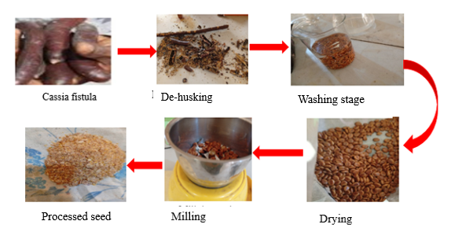
Figure 1: Cassia fistula Seed Preparation
2.3 Oil Extraction
Solvent extraction of the seed oil was carried out using a Soxhlet apparatus following a standardized and reproducible protocol. Finely ground and oven-dried seed powder was accurately weighed and placed in a cellulose extraction thimble, and n-hexane was used as the extraction solvent due to its high oil solubility and low boiling point. A solid-to-solvent ratio of 1:10 (w/v) was maintained to ensure efficient solvent penetration and lipid recovery. The extraction was performed at the boiling temperature of the solvent (approximately 65–70 °C) under continuous reflux for 2–4 h, allowing multiple siphoning cycles to achieve exhaustive extraction. After completion, the solvent was removed under reduced pressure using a rotary evaporator, and the recovered oil was dried to constant weight, weighed to determine yield, and stored in airtight amber containers at low temperature until further analysis.
2.3.1 Optimization of the cassia fistula seed using Response surface methodology (RSM)
The experiment was designed using Design -Expert version 12. Response surface methodology (RSM) was used to investigate the effect of independent variables, including solvent to solid (A), Temperature (B) and Time (C) on response variables, such as oil yield, Free Fatty Acid FFA, iodine value, saponification value from Cassia fistula seed oil. RSM design along with coded and uncoded levels is presented in Table 1.0 Central composite design (Five levels) and quadratic model was used to design this experiment. Twenty runs, including six axial points, eight fractional factorial points and six central points were randomly performed according to CCD, which is summarized in Table 2.0:

Table 1.0: Independent variables and their corresponding levels for oil extraction from Cassia fistula seed
Independent variables | Symbols | Coded level
Independent variables | Symbols | $$-∝$$ | -1 | 0 | +1 | $$+∝$$
Solvent to solid ratio | A | 3.63641 | 5.00 | 7.00 | 9.00 | 10.3636
Temperature | B | 54.8866 | 60.00 | 81.50 | 75.00 | 80.1134
Time | C | 1.31821 | 2.00 | 3.00 | 4.00 | 4.68179

Real levels of independent variables were coded according to equation 1
$Z=\frac{Z_{O}-Z_{C}}{∆Z}$ 1.0
Where Z=coded level of independent variable
Zo=coded level of independent variable
$∆$Z= step change
Zc=actual value of the central point
The specific equations for each independent variable were derived from the above equation to code their actual values. Specific equations for solvent to solid ratio (A), Temperature (B ) and Time (C ) are mentioned in below Equations 2-4.
$Z=\frac{A-7.0}{2.0}$ 2.0
$Z=\frac{B-81.5}{21.5}$ 3..0
$Z=\frac{C-3.0}{1.0}$ 4.0
where A, B and C represent solvent to solid ration of the Cassia fistula (Golden shower), temperature and time, respectively. A second order polynomial equation was used to indicate the predicted response (oil yield) as a function of an independent variable as follows in equation 5
R₁ =$α_{o}+α_{1}A+α_{2}B+α_{3}C+α_{11}A^{2}+α_{22}B^{2}+α_{33}C^{2}+α_{12}AB+α_{13}AC+α_{23}BC$ 5
Where R₁ oil yield in % $α_{j,}α_{jj,}α_{jk}$ were linear, quadratic and interactive coefficient of the independent variables $α_{o}$= consant
Design expert software version 12 was used to calculate the variable coefficient of the determinant. Same was repeated for iodine value, saponification value and FFA value. The experiment was subjected to twenty runs as suggested by the design expert version 12 of central composite design based on response surface methodology (RSM). The extraction parameter such as extraction temperature (60-75 ºC), extraction time (2-4 hrs) and solid to solvent ratio of (1:5-1:9) was optimized to increase the oil yield.

Table 2: The Central composite Design of the Variables with oil yield, iodine value, saponification value and FFA value as Response from Cassia fistula seed oil extraction
 | Factor 1 | Factor 2 | Factor 3 | R 1 | R 2 | R 3
Run | A:Solid/solvent | B:Temperature | C:Time | FFA | iodine value | Saponifications value
 | g/g | deg C | hrs |  | mg/100g | g/100g
1 | 7.0 | 67.5 | 3.0
2 | 10.3 | 67.5 | 3.0
3 | 7.0 | 67.5 | 3.0
4 | 9.0 | 60.0 | 2.0
5 | 9.0 | 75.0 | 2.0
6 | 9.0 | 60.0 | 4.0
7 | 7.0 | 67.5 | 3.0
8 | 5.0 | 60.0 | 2.0
9 | 7.0 | 67.5 | 3.0
10 | 9.0 | 75.0 | 4.0
11 | 3.6 | 67.5 | 3.0
12 | 7.0 | 67.5 | 3.0
13 | 5.0 | 75.0 | 2.0
14 | 7.0 | 67.5 | 1.3
15 | 7.0 | 80.1 | 3.0
16 | 7.0 | 67.5 | 4.6
17 | 5.0 | 75.0 | 4.0
18 | 7.0 | 54.8 | 3.0
19 | 7.0 | 67.5 | 3.0
20 | 5.0 | 60.0 | 4.0

2.4 Chemical Composition Analysis
The fatty acid composition of Cassia fistula seed oil was analyzed using a Varian 3800/4000 Gas Chromatography Mass Spectrometry (GC–MS) system equipped with a fused silica capillary column (e.g., VF-5MS, 30 m × 0.25 mm i.d., 0.25 µm film thickness). The oven temperature was programmed to start at 100 °C (held for 2 min), ramped at 10 °C/min to 250 °C, and held for 10 min to ensure complete elution of all components. Helium was used as the carrier gas at a constant flow rate of 1 mL/min, and the injection volume was 1 µL in split mode (split ratio 1:50). Electron impact (EI) ionization at 70 eV was employed, and mass spectra were acquired over the range of m/z 50–550. Identification of fatty acids was performed by comparing retention times and mass spectra with authenticated standards and the NIST MS library. Quantification was carried out using an internal standard method, where a known quantity of a reference compound (e.g., methyl heptadecanoate) was added to each sample, allowing accurate determination of relative concentrations of individual fatty acids.
Fourier Transform Infrared (FTIR) spectroscopy was employed to characterize the functional groups present in Cassia fistula seed oil using a PerkinElmer Spectrum Two FTIR spectrometer. For analysis, the oil samples were prepared either as a neat film between potassium bromide (KBr) plates or directly analyzed using an Attenuated Total Reflectance (ATR) accessory, eliminating the need for complex sample preparation. Spectra were recorded over the range of 4000–400 cm⁻¹ with a resolution of 4 cm⁻¹, accumulating 32 scans per sample to improve signal-to-noise ratio. Key absorption bands of interest included the broad O–H stretching around 3400 cm⁻¹, C–H stretching vibrations of aliphatic chains near 2920 and 2850 cm⁻¹, carbonyl (C=O) stretching of triglycerides around 1740 cm⁻¹, C=C stretching of unsaturated fatty acids near 1650 cm⁻¹, and C–O stretching vibrations between 1170–1160 cm⁻¹. These characteristic bands provided insights into the chemical structure and degree of unsaturation in the oil
3. RESULTS AND DISCUSSION
The results obtained from the twenty experimental runs indicate that the extraction parameters had noticeable effects not only on oil yield but also on the physicochemical properties of the Cassia fistula seed oil, including the free fatty acid (FFA) content, iodine value, and saponification value. These parameters are essential indicators of oil quality, stability, and potential industrial applications. Variations in their values across the different runs suggest that extraction conditions influence the degree of oil degradation, unsaturation, and average molecular weight of fatty acids.

Table 3: Design layout for Cassia fistula oil extraction for coded, uncoded values and responses.
Run | A:Solid/solvent | B:Temperature | C:Time | FFA |  | Iodine value mg/100g |  | Saponifications value g/100g
 | g/g | Deg C | Hrs | Exp | Pr | Exp | Pr | Exp | Pr
1 | 7 | 67.5 | 3 | 2.14 | 3.45 | 23.17 | 22.48 | 213.89 | 204.67
2 | 10.3636 | 67.5 | 3 | 1.02 | 1.16 | 21.67 | 20.47 | 209.56 | 209.15
3 | 7 | 67.5 | 3 | 3.85 | 3.45 | 19.15 | 22.48 | 205.1 | 204.67
4 | 9 | 60 | 2 | 0.78 | 1.31 | 22.10 | 21.87 | 189.17 | 187.17
5 | 9 | 75 | 2 | 0.56 | 0.41 | 17.68 | 19.70 | 210.3 | 214.17
6 | 9 | 60 | 4 | 2.47 | 1.72 | 17.40 | 17.82 | 195.00 | 193.75
7 | 7 | 67.5 | 3 | 3.22 | 3.45 | 25.00 | 22.48 | 210.38 | 204.67
8 | 5 | 60 | 2 | 1.95 | 1.80 | 18.16 | 18.55 | 202.40 | 201.84
9 | 7 | 67.5 | 3 | 4.10 | 3.45 | 21.30 | 22.48 | 202.43 | 204.67
10 | 9 | 75 | 4 | 0.91 | 0.96 | 16.70 | 17.29 | 207.60 | 205.56
11 | 3.63 | 67.5 | 3 | 2.67 | 2.66 | 20.50 | 20.31 | 216.17 | 220.25
12 | 7 | 67.5 | 3 | 3.99 | 3.45 | 23.20 | 22.48 | 198.75 | 204.67
13 | 5 | 75 | 2 | 1.15 | 1.81 | 19.26 | 19.82 | 208.40 | 207.05
14 | 7 | 67.5 | 1.31 | 2.34 | 1.77 | 18.00 | 16.84 | 193.60 | 192.36
15 | 7 | 80.11 | 3 | 0.63 | 0.61 | 24.60 | 22.47 | 210.36 | 209.17
16 | 7 | 67.5 | 4.6 | 1.78 | 2.49 | 14.17 | 13.94 | 190.50 | 195.41
17 | 5 | 75 | 4 | 2.88 | 2.26 | 19.20 | 20.41 | 204.7 | 204.10
18 | 7 | 54.88 | 3 | 1.09 | 1.24 | 21.11 | 21.85 | 190.00 | 194.86
19 | 7 | 67.5 | 3 | 3.41 | 3.45 | 22.80 | 22.48 | 198.11 | 204.67
20 | 5 | 60 | 4 | 2.05 | 2.10 | 18.54 | 17.50 | 220.54 | 214.07

3.1 Effect of iodine value on cassia fistula seed oil
The iodine value, which ranged from 14.9 g/100 g to 25.0 g/100 g, represents the degree of unsaturation in the extracted oil. Higher iodine values, such as in Runs 7 (25.0) and 15 (24.6), were generally associated with higher extraction temperatures, implying that elevated temperatures enhance the release of more unsaturated fatty acids into the solvent. Lower iodine values, like those in Runs 3 (15.6) and 8 (14.9), may result from mild conditions where diffusion of unsaturated lipids is less efficient. This suggests that temperature plays a crucial role in determining the degree of unsaturation of the extracted oil, which affects its drying properties and oxidative stability.
3.2 Effect of saponification value
The saponification value varied between 170.8 mg KOH/g and 210.3 mg KOH/g, reflecting differences in the average molecular weight of fatty acids in the oil. Higher saponification values (e.g., Run 5 at 210.3 mg KOH/g) correspond to shorter-chain fatty acids, which are more easily saponified, while lower values (e.g., Run 9 at 170.8 mg KOH/g) indicate the presence of longer-chain fatty acids. The data suggest that both the solid-to-solvent ratio and temperature influence this property. Higher solvent availability and elevated temperatures appear to favor the extraction of shorter-chain components, leading to increased saponification values. Overall, optimal extraction conditions (around 7 g/g solid-to-solvent ratio, 75–80 °C, and 3 h) produced oil with moderate FFA, high iodine, and desirable saponification values, suggesting good-quality oil suitable for industrial and edible applications.

3.3 Effect on Free Fatty acid (FFA) on cassia fistula seed oil
The FFA content varied between 0.56% and 4.10%, showing that both temperature and extraction time influenced the extent of hydrolysis of triglycerides into free fatty acids. Higher FFA values, as seen in runs such as Run 9 (4.10%) and Run 12 (3.99%), were generally observed at moderate temperatures and standard extraction times, possibly due to prolonged contact between oil and residual moisture or enzymes. Conversely, lower FFA values, such as Run 5 (0.56%) and Run 15 (0.63%), were recorded at higher temperatures (around 75–80 °C), suggesting that elevated temperatures may help inactivate lipolytic enzymes and reduce the formation of free fatty acids. This trend indicates that controlling temperature and extraction duration can minimize FFA levels, improving the stability and quality of the oil.

3.4 Effects of Independent Variables on Cassia fistula Quality Characteristics :Free fatty acid ,iodine value and saponification
Design Expert software was employed to analyze the experimental outcomes of Cassia fistula seed oil extraction and characterization, focusing on key response variables: oil yield (%), free fatty acid (FFA) content, iodine value, and saponification value. The optimization study aimed to determine the effect of process parameters such as extraction temperature, time, and solvent ratio on these responses. Results from the statistical design revealed that extraction conditions significantly influenced oil yield and quality indices. A higher yield was associated with optimal temperature and solvent ratio, while the FFA, iodine, and saponification values provided insights into the oil’s purity, degree of unsaturation, and potential for soap or biodiesel production. Overall, the Design Expert analysis enabled efficient optimization and prediction of Cassia fistula seed oil properties for industrial applications.
The response variables representing three oil quality Characteristics (FFA, iodine value and saponification value) were all best fitted as quadratic model. All the models were significant with values of "Prob > F less than 0.05.
3.5 Analyzed of Variance (ANOVA) result on the FFA, iodine and saponification value of Cassia fistula
Free Fatty Acid (FFA)
The effect of independent variables, including solvent to solid (A), Temperature (B) and Time (C) on response variables, such as oil yield, Free Fatty Acid FFA. The coded factors corresponding to solid solvent ratio did have significant effect on A of the acid value. The relationship was represented by a reduced quadratic model as stated in equation 6
FFA$=3.45-0.4456A-0.1848B+0.2144C-0.2262AB+0.0262AC+0.0362BC-0.543A^{2}-0.8913B^{2}-0.467C^{2}$ 6
The ANOVA results for FFA shown in the Table 4, that the overall model was significant (p = 0.0160), indicating that the selected factors effectively explain variations in FFA yield. Among the linear terms, only the solid-to-solvent ratio (A) had a significant effect (p = 0.0461), suggesting that extraction efficiency is highly dependent on solvent quantity. The quadratic terms for A², B², and C² were also significant (p < 0.05), revealing curvature effects and nonlinear behaviour of these factors on FFA. The lack-of-fit test was not significant (p = 0.5088), confirming that the model fits the data well. This trend in acid value agrees with the trend reported in Jatropha oil and neem oil extractions respectively (Odetoye, Afolabi, Onifade, & ., 2016).
Table 4 :ANOVA for FFA for the cassia fistula oil
Source | Sum of Squares | df | Mean Square | F-value | p-value
Model | 20.36 | 9 | 2.26 | 4.32 | 0.0160 | significant
A-Solid/solvent | 2.71 | 1 | 2.71 | 5.18 | 0.0461
B-Temperature | 0.4663 | 1 | 0.4663 | 0.8908 | 0.3675
C-Time | 0.6278 | 1 | 0.6278 | 1.20 | 0.2991
AB | 0.4095 | 1 | 0.4095 | 0.7823 | 0.3972
AC | 0.0055 | 1 | 0.0055 | 0.0105 | 0.9203
BC | 0.0105 | 1 | 0.0105 | 0.0201 | 0.8901
A² | 4.25 | 1 | 4.25 | 8.12 | 0.0173
B² | 11.45 | 1 | 11.45 | 21.87 | 0.0009
C² | 3.14 | 1 | 3.14 | 6.00 | 0.0342
Residual | 5.23 | 10 | 0.5235
Lack of Fit | 2.59 | 5 | 0.5181 | 0.9794 | 0.5088 | not significant
Pure Error | 2.64 | 5 | 0.5289
Cor Total | 25.59 | 19

Iodine value
The final quadratic equation, Iodine value, in terms of coded factors was given as in equation 7. The coded factor equation for iodine value describes the combined influence of A (solid-to-solvent ratio), B (temperature), and C (time) on the iodine value of Cassia fistula seed oil. The linear terms show how each factor individually affects the iodine value, while the interaction terms (AB, AC, BC) indicate the combined effects of solid–solvent ratio, temperature, and extraction time when varied together. The negative quadratic terms (A², B², C²) reveal curvature in the response, suggesting the existence of optimum extraction conditions for achieving a desirable iodine value in biodiesel production.

Iodine value =22.48+0.0504A+0.1838B-0,.8641C-0.866AB-0.75AC+0.41BC-0.7377A²-0.1119B²-2.51C² 7

The ANOVA Table 5 for the iodine value indicates a significant model (p = 0.0279), meaning that the experimental factors collectively influence iodine value. However, none of the linear or interaction terms were individually significant, except for the quadratic term of time (C²), which showed a strong effect (p = 0.0005). This suggests that the iodine value is primarily affected by nonlinear changes in extraction time rather than by simple increases or decreases in temperature or solvent ratio. The nonsignificant lack of fit (p = 0.6017) implies that the model adequately represents the experimental data.
Table 5 :ANOVA for iodine value for the cassia fistula oil
Source | Sum of Squares | df | Mean Square | F-value | p-value
Model | 116.88 | 9 | 12.99 | 3.65 | 0.0279 | significant
A-Solid/solvent | 0.0346 | 1 | 0.0346 | 0.0097 | 0.9233
B-Temperature | 0.4611 | 1 | 0.4611 | 0.1297 | 0.7262
C-Time | 10.20 | 1 | 10.20 | 2.87 | 0.1212
AB | 5.92 | 1 | 5.92 | 1.66 | 0.2260
AC | 4.50 | 1 | 4.50 | 1.27 | 0.2868
BC | 1.34 | 1 | 1.34 | 0.3784 | 0.5522
A² | 7.84 | 1 | 7.84 | 2.21 | 0.1683
B² | 0.1804 | 1 | 0.1804 | 0.0507 | 0.8263
C² | 90.46 | 1 | 90.46 | 25.45 | 0.0005
Residual | 35.54 | 10 | 3.55
Lack of Fit | 15.63 | 5 | 3.13 | 0.7845 | 0.6017 | not significant
Pure Error | 19.92 | 5 | 3.98
Cor Total | 152.42 | 19

Saponification value
The coded equation for saponification value in equation 8 explains how A (solid-to-solvent ratio), B (temperature), and C (time) influence the saponification value of Cassia fistula seed oil during extraction. The intercept 204.67 represents the predicted saponification value at the center levels of all variables, while the linear terms (−3.30A, +4.26B, +0.9048C) indicate that temperature and time increase the value, whereas the solid-to-solvent ratio has a decreasing effect. The interaction terms (+5.45AB, −1.41AC, −3.80BC) show how combinations of variables jointly affect the response, with AB having a strong positive combined influence. The quadratic terms (+3.55A², −0.9389B², −3.81C²) indicate curvature effects, suggesting that optimal conditions exist for maximizing the saponification value for improved biodiesel quality.
Sapanification value=204.67-3.30A+4.26B+0.9048C+5.45AB-1.41AC-3.80BC+3.55A²-0.9389B²-3.81C² 8
Table 6 :ANOVA for saponification value for the cassia fistula oil
Source | Sum of Squares | df | Mean Square | F-value | p-value
Model | 1222.05 | 9 | 135.78 | 4.02 | 0.0203 | significant
A-Solid/solvent | 148.85 | 1 | 148.85 | 4.41 | 0.0620
B-Temperature | 247.44 | 1 | 247.44 | 7.33 | 0.0220
C-Time | 11.18 | 1 | 11.18 | 0.3314 | 0.5776
AB | 237.29 | 1 | 237.29 | 7.03 | 0.0242
AC | 15.99 | 1 | 15.99 | 0.4739 | 0.5068
BC | 115.29 | 1 | 115.29 | 3.42 | 0.0943
A² | 181.20 | 1 | 181.20 | 5.37 | 0.0430
B² | 12.70 | 1 | 12.70 | 0.3765 | 0.5532
C² | 209.56 | 1 | 209.56 | 6.21 | 0.0319
Residual | 337.37 | 10 | 33.74
Lack of Fit | 136.55 | 5 | 27.31 | 0.6799 | 0.6588 | not significant
Pure Error | 200.83 | 5 | 40.17
Cor Total | 1559.43 | 19
For saponification value ANOVA in Table 6 , the model was also significant (p = 0.0203), confirming that the variables had a considerable impact on the response. Both temperature (B) and the interaction between solid-to-solvent ratio and temperature (AB) were significant (p < 0.05), indicating that increasing temperature and its interaction with solvent ratio enhance saponification. The quadratic terms A² and C² were also significant, highlighting nonlinear effects of these parameters. The lack-of-fit value (p = 0.6588) was not significant, validating the adequacy of the model to describe the observed behaviour.
Table 7: Fit Statistics summaries on the FFA, Iodine and Saponification value
Free fatty acid (FFA) |  |  |  | Iodine value |  |  |  | Saponification value
Std. Dev. | 0.7235 | R² | 0.7955 | Std. Dev. | 1.89 | R² | 0.7668 | Std. Dev. | 5.81 | R² | 0.7837
Mean | 2.15 | Adjusted R² | 0.6114 | Mean | 20.19 | Adjusted R² | 0.5569 | Mean | 203.85 | Adjusted R² | 0.5889
C.V. % | 33.66 | Predicted R² | 0.0147 | C.V. % | 9.34 | Predicted R² | 0.0124 | C.V. % | 2.85 | Predicted R² | 0.1283
 |  | Adeq Precision | 5.9320 |  |  | Adeq Precision | 6.4059 |  |  | Adeq Precision | 8.0541
The statistical summary in Table 7 of the models for FFA, iodine value, and saponification value indicates that all three models provided reasonably good fits to the experimental data, though with varying levels of precision and predictive strength.
For the FFA model, the standard deviation (0.72) and mean (2.15) produced a relatively high coefficient of variation (C.V.) of 33.66%, suggesting moderate variability in the responses. The R² value of 0.7955 shows that about 79.55% of the variation in FFA content was explained by the model, while the adjusted R² (0.6114) indicates some non-significant model terms. The predicted R² (0.0147) was very low, implying weak predictive ability outside the experimental range. However, the Adequate Precision value (5.93), being greater than 4, confirms that the model has an acceptable signal-to-noise ratio and can be used for process optimization within the studied range.
For the iodine value model, the R² of 0.7668 and adjusted R² of 0.5569 suggest a moderate correlation between experimental and predicted values. The low standard deviation (1.89) and C.V. of 9.34% indicate that the model predictions are fairly consistent. Like the FFA model, the predicted R² (0.0124) was low, suggesting limited predictive power beyond the experimental conditions. The Adequate Precision value (6.41) exceeded the benchmark of 4, signifying that the model can adequately describe the observed responses.
For the saponification value model, the R² (0.7837) and adjusted R² (0.5889) values demonstrate a fairly strong fit, explaining about 78% of the variation in the data. The low standard deviation (5.81) and very low C.V. (2.85%) indicate excellent precision and model reproducibility. The predicted R² (0.1283) was also higher than those of the other two models, showing comparatively better predictive reliability. The Adequate Precision value (8.05) being well above 4 confirms that the model has a strong signal and is suitable for navigating the experimental design space effectively.
3.5.1 Diagnostic plot on the FFA, Iodine value and saponification value
Figure 2 presents normal probability plots of the residuals for cassia fistula oil’s free fatty acid (FFA) content (A), saponification value (B), and iodine value (C), allowing an assessment of model adequacy and error distribution. In each plot, the residual points are compared against a theoretical straight line representing a perfectly normal distribution. When the points fall closely along this line with minimal deviation, it indicates that the residuals are approximately normally distributed, supporting the validity of the underlying statistical models used for analysis. Any noticeable curvature, clustering, or systematic deviation would suggest non-normality, potential model misspecification, or the presence of outliers. Overall, these normal plots help confirm whether the assumptions of linear regression or ANOVA are satisfied for the physicochemical parameters of cassia fistula oil.

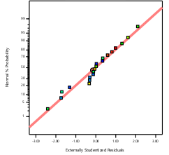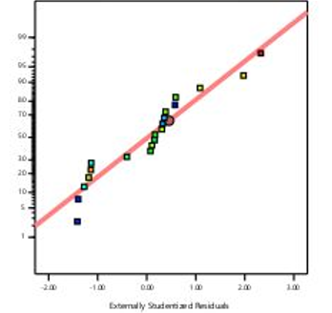
B
A
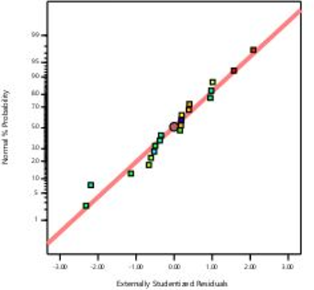
C
Figure 2: Normal plots of residues of cassia fistula FFA (A) ,saponification (B) and Iodine value (C)
3.5.2: The residuals graph runs plot of FFA (E), Iodine (F) and Saponification (G) value
The residuals versus runs plots for the FFA (E), iodine value (F), and saponification value (G) of cassia fistula oil shown in Figure 3, providing insight into the stability and randomness of experimental errors across the sequence of runs. In well-behaved data, residuals should scatter randomly around zero without exhibiting any visible pattern, trend, or systematic shift; such randomness indicates that the experimental process remained consistent and that no time-related or run-order effects influenced the results. If the plots display clustering, gradual increases or decreases, or repeating waves, this would suggest potential issues such as instrument drift, operator bias, or changes in experimental conditions over time. Therefore, these residual-versus-runs plots help verify that the analytical measurements for FFA, iodine value, and saponification value were reliable and not affected by order-dependent variability.
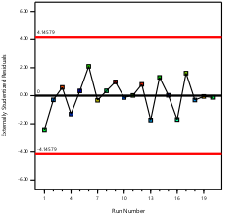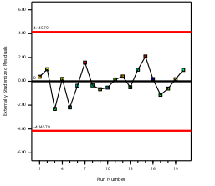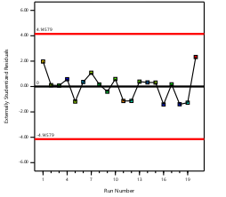
E F G
Figure 3: The residuals versus runs plot of FFA (E), Iodine (F) and Saponification (G) value

3.5.3 The yield prediction model on the Cassia fistula seed FFA, Iodine value and saponification values
The 3D surface plots used to visualize the yield prediction models for the free fatty acid (FFA) content (I), iodine value (J), and saponification value (K) of Cassia fistula seed oil shown in Figure 4, illustrating how each response varies with the experimental factors. These surfaces help demonstrate the interaction effects between variables and reveal the conditions that lead to either optimal or undesirable outcomes for each quality parameter. Smooth, well-defined surfaces indicate that the model fits the data appropriately, while any irregularities may suggest complex interactions or variability in the system. The 3D plots also make it easier to identify regions where the oil exhibits favourable characteristics—such as lower FFA for better stability, suitable iodine values indicating desirable unsaturation levels, and appropriate saponification values reflecting fatty acid composition. Overall, these visual models provide a clear and intuitive representation of how processing conditions influence the physicochemical properties of Cassia fistula oil, supporting optimization and improved process control.
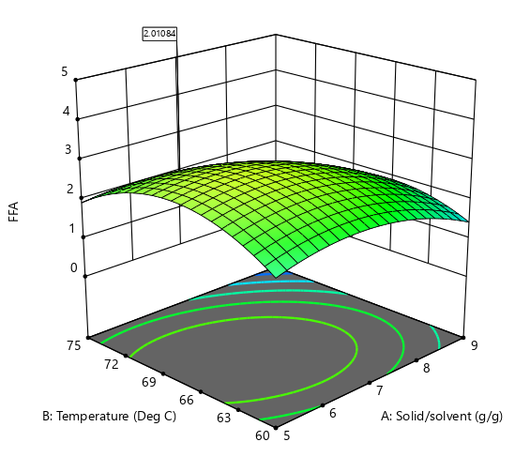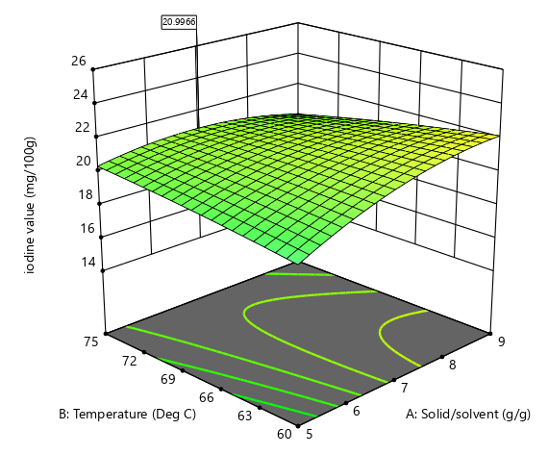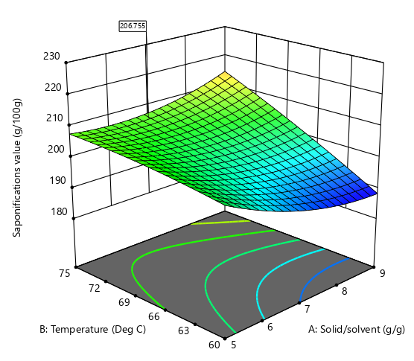
I J K

Figure 4 The 3D plot on FFA (I), Iodine value (J) and saponification value (K) of Cassia fistula oil

3.6 Experimental outcome for the optimum yield on oil, FFA, iodine value and saponification value as specified by design expert
At the optimized extraction condition of 7 g solid-to-solvent ratio, 67.5 °C, and 3 hours, Cassia fistula seed oil as shown in Table 8 produced an oil yield of 67.6%, indicating efficient solvent penetration and lipid solubilization. The FFA content (2.15%) falls within the acceptable range for non-rancid crude oils, suggesting minimal hydrolytic degradation during extraction. The iodine value (20.19 g I₂/100 g) reflects a low degree of unsaturation, classifying the oil as a non-drying type, which is typical of seed oils rich in saturated fatty acids. Meanwhile, the saponification value (203.85 mg KOH/g) is relatively high, implying the presence of short- to medium-chain fatty acids suitable for soap and cosmetic applications. Overall, these results show that the chosen extraction conditions favour the recovery of high-quality oil with desirable physicochemical characteristics for industrial use.

Table 8: The experimental confirmation table from the design expert

Extraction parameters |  |  | Oil Yield (%) | Free Fatty Acid (FFA, %) | Iodine Value (g I₂/100 g) | Saponification Value (mg KOH/g)
Solid-to-Solvent Ratio: g | Temperature: °C | Extraction Time: hrs.
7 | 67.5 | 3 | 67.6 | 2.15 | 20.19 | 203.85

4. CONCLUSIONS
Extraction parameters significantly influenced the physicochemical properties of Cassia fistula seed oil, particularly FFA, iodine value, and saponification value, which are critical for biodiesel suitability. FFA values 0.56–4.10% showed that proper control of temperature and solvent ratio minimizes hydrolysis and improves oil stability. The iodine value 14.9–25.0 g I₂/100 g indicated that higher temperatures enhanced unsaturation levels, affecting oxidative stability and fuel quality. Meanwhile, the saponification value 170.8–210.3 mg KOH/g reflected fatty acid chain length variations, and ANOVA confirmed that the quadratic models adequately predicted these responses under optimized conditions. Further work on cassia fistula can be done to refine and use for biodiesel production.

ACKNOWLEDGEMENT
Acknowledgement of the PTDF for funding support is well gratefully appreciated

REFERENCES
Holechek, J. L., Geli, H. M., Sawalhah, M. N., & Valdez, R. (2022). A global assessment: can renewable energy replace fossil fuels by 2050. Sustainability, 14(8), 4792.
Kanwal, H., Anwar, F., Tanvir, A., Abidi, S. H., & Mumtaz, M. W. (2025). Optimization of trimetallic Cu–Cr–Ca nanoparticle-catalyzed transesterification of amla (Phyllanthus emblica L.) seed oil: analytical characterization and fuel properties of biodiesel. RSC advances, 15(18), 13838-13856.
Masjudin., & Chang, W. C. (2025). Comparative study on saturated and unsaturated fatty acid methyl esters (FAME) composition in biodiesel production from waste soybean, sunflower, and canola oils. . Biofuels, 1-24.
Muhammed Raji, A., Manescau, B., Chetehouna, K., & Ogabi, R. (2025). Overview of thermal and analytical characterization techniques for biofuels and its blends. Journal of Thermal Analysis and Calorimetry, 150(5), 3007-3036.
Odetoye, T. E., Afolabi, T. J., Onifade, K. R., & . (2016). Effects of extraction process parameters on the quality characteristics of Parinari polyandra B. seed oil. Nigerian Journal of Technological Development,, 13(2), 40-49.
Ogunkunle, O., & Enweremadu, C. C. (2025). Optimization of Blighia sapida Seed Oil Biodiesel Production: A Sustainable Approach to Renewable Biofuels. Resources, 14(6), 89.
Paavani, K., Agarwal, K., Alam, S. S., Dinda, S., & Abrar, I. (2025). Advances in plastic to fuel conversion: reactor design, operational optimization, and machine learning integration. Sustainable Energy and Fuels, 9(1), 54-71.
Raj, S. P., Solomon, P. R., & Thangaraj, B. (2022). Standards for Biodiesel. In Biodiesel from Flowering Plants. Springer Singapore., 633-663.
Soeder, D. J. (2025). Greenhouse gas and climate change. In Energy futures: The story of fossil fuel, greenhouse gas, and climate change . Cham: Springer Nature Switzerland, 97-141.
Subramaniam, M., Sarip, S., Kaidi, H. M., & Muhammad-Sukki, F. (2025). Enhancing base-diesel fuel specification for optimized biodiesel blending in Malaysia. Sustainable Futures, 10, 101428.
Suhara, A., Karyadi, H. S., Tirta, A., Idris, M., Roslan, M. F., & Veza, I. (2024). Biodiesel sustainability: review of progress and challenges of biodiesel as sustainable biofuel. Clean Technologies, 6(3), 886-906.
Ulakpa, W. C., Ulakpa, R. O., Egwunyenga, M. C., & Egbosiuba, T. C. (2022). Transesterification of non-edible oil and effects of process parameters on biodiesel yield. Cleaner Waste Systems, 3, 100047.
Umeh, S. I., & Okonkwo, P. A. (2025). The essential properties of oils for biodiesel production. Biodiesel Plants-Fueling the Sustainable Outlooks, 2.
Vatsha, P., & Alam, M. R. (2025). Environmental aspects of biofuels used as sustainable energy resources: Current situation and future trends. . Biofuels and Sustainability, 19-31.
Zhang, J., & Usman, M. (2025). Redefining energy policy for sustainable growth: The interplay of fossil fuel subsidies, energy security risks, and energy balances in shaping geopolitical stability. Energy, 322, 135620.

