" Evaluating the use of ChatGPT as a Tool for Inquiry-Based Learning in Teaching Database to Senior High School Students"

Joan S. Rajah
University of San Jose Recoletos, Cebu Philippines
jsrajah@usjr.edu.ph
https://orcid.org/0009-0008-9028-5981
ABSTRACT

This study evaluates the use of ChatGPT as a tool for inquiry-based learning in database education. The research investigates how ChatGPT can assist students in exploring and understanding database concepts, particularly through performing SQL operations such as Data Definition Language (DDL) commands (CREATE, ALTER, DROP, TRUNCATE, RENAME) and Data Manipulation Language (DML) commands (SELECT, INSERT, UPDATE, DELETE) using Oracle APEX as a hands-on learning platform. The evaluation focuses on six components: Usability, Inquiry Support, Critical Thinking, Database Learning Impact, Engagement, and Limitations. Data were collected through a structured 5-point Likert scale questionnaire, and statistical analysis was performed to determine the effectiveness and impact of ChatGPT in supporting inquiry-based learning. Results indicate that ChatGPT enhances student engagement, supports critical thinking, and provides meaningful guidance in learning database operations, while also highlighting areas where limitations exist, such as occasional inaccuracies or incomplete query explanations. This study demonstrates the potential of AI-powered conversational tools to facilitate interactive, self-directed learning in technical subjects like databases.

Keywords: Evaluating, ChatGPT, Tool, Inquiry-Based Learning, Teaching Database

INTRODUCTION

Teaching database concepts to senior high school students is an essential component of Information and Communications Technology (ICT) education. Database knowledge enables students to understand how information is structured, stored, and retrieved in modern information systems. However, many students find database topics—such as tables, queries, normalization, and relational structures—complex and abstract. To improve understanding, educators are increasingly adopting active learning strategies such as inquiry-based learning, where students explore problems, ask questions, and construct knowledge through investigation. The integration of emerging artificial intelligence tools such as ChatGPT has introduced new opportunities to support inquiry-based learning in technology-related subjects.

Despite the importance of database education, many traditional teaching approaches rely heavily on lectures and step-by-step demonstrations, which may limit students’ engagement and critical thinking skills. Students often struggle to formulate queries, understand relationships between tables, and apply database concepts to real-world problems. Furthermore, teachers may face challenges in providing immediate feedback and individualized assistance during learning activities. With the growing use of AI-powered educational tools, there is increasing interest in exploring how platforms like ChatGPT can assist students by answering questions, explaining concepts, and guiding inquiry-based exploration. However, there is still limited empirical research evaluating the effectiveness of such tools in supporting inquiry-based learning within database education at the senior high school level.

This study aims to evaluate the effectiveness of ChatGPT as a learning support tool in implementing inquiry-based learning strategies for teaching database concepts to senior high school students. Specifically, the research seeks to determine whether the integration of AI-assisted guidance improves students’ conceptual understanding, engagement, and problem-solving skills in database-related tasks. The study will also assess students’ perceptions of using AI-assisted tools during inquiry-based learning activities.

The findings of this research will contribute to the growing body of knowledge on artificial intelligence in education and technology-enhanced learning. The study may provide insights for educators, curriculum designers, and institutions regarding the potential benefits and limitations of integrating AI tools like ChatGPT in ICT instruction. Additionally, the results may help develop more effective teaching strategies that combine inquiry-based learning with AI-supported instruction, ultimately improving students’ understanding of database concepts and preparing them for future studies and careers in information technology.

ChatGPT, developed by OpenAI, has revolutionized natural language processing with its ability to generate human-like responses (Hadi et al., 2023). Its core techniques include large-scale language models, in-context learning, and reinforcement learning from human feedback (Wu et al., 2023). ChatGPT's historical evolution stems from advancements in AI, particularly in reinforcement learning and large-scale language models (Liu et al., 2023). The technology has potential applications across various industries, including academia and libraries, where it could improve search and discovery, reference services, and content creation (Lund & Wang, 2023). However, challenges remain, such as ethical considerations, privacy concerns, and legal restrictions (Liu et al., 2023; Lund & Wang, 2023). While ChatGPT has garnered significant attention and rapid user growth, it is important to acknowledge its limitations and use it responsibly (Wu et al., 2023; Liu et al., 2023). The technology's impact on society, industries, and international competition warrants further exploration and careful consideration (Liu et al., 2023).

Gap
While AI tools like ChatGPT are becoming common in higher education, there’s minimal research on their effectiveness at the Senior High School level, particularly in technical subjects like Database Management Systems (DBMS). Few studies explore how AI tools can support Inquiry-Based Learning, especially in teaching technical content like database concepts (e.g., SQL, normalization). There is no widely accepted framework to assess the effectiveness, accuracy, engagement, or cognitive support provided by ChatGPT in the context of inquiry-based database learning. Here is no widely accepted framework to assess the effectiveness, accuracy, engagement, or cognitive support provided by ChatGPT in the context of inquiry-based database learning. Teacher perspectives, training, and acceptance of ChatGPT in an IBL setting are often overlooked. There is limited investigation into how students might misunderstand or misuse AI outputs, especially in technical subjects where ChatGPT can occasionally generate inaccurate or oversimplified SQL/database responses. Studies rarely measure whether ChatGPT reduces or increases cognitive load for younger learners engaging in inquiry-based tasks. Most studies are short-term. There is a lack of long-term data on retention, skill application, and problem-solving ability after integrating ChatGPT in an IBL
Significance of the Study
This study evaluates the integration of AI-assisted tools such as ChatGPT in supporting inquiry-based learning in teaching database concepts to senior high school students. The findings of this research are expected to benefit the following groups:
Senior High School Students
Senior high school students possess varying levels of learning maturity and digital literacy compared to college students. The use of ChatGPT may support inquiry-based learning by providing explanations, examples, and guidance when students ask questions during database lessons. However, students may also encounter challenges when evaluating the accuracy of AI-generated responses. This study will help determine how AI tools influence students’ understanding, critical thinking skills, and learning outcomes when studying database concepts.
Teachers
Teachers play a crucial role in facilitating inquiry-based learning and ensuring responsible use of artificial intelligence in the classroom. The findings of this study may help teachers understand how AI tools such as ChatGPT can be used effectively to guide students’ questioning, exploration, and problem-solving processes. The results may also help teachers develop strategies for monitoring student interaction with AI systems and preventing misconceptions caused by incorrect or misleading AI outputs.
School Administrators and Curriculum Developers
The study may provide valuable insights for administrators and curriculum developers regarding the integration of artificial intelligence technologies in ICT education. By identifying the advantages and limitations of using ChatGPT as a learning support tool, the research may contribute to the development of appropriate guidelines, policies, and instructional strategies for incorporating AI into senior high school teaching practices.
Researchers and Future Studies
This research may contribute to the growing body of literature on artificial intelligence in education, particularly in the context of inquiry-based learning and database instruction. Since standardized evaluation tools for assessing AI-assisted learning are still limited, the results of this study may serve as a reference for future researchers who wish to explore the long-term impact of AI-supported learning environments and develop improved assessment methods for measuring learning outcomes.
Educational Technology Development.
The findings may also help inform the design and improvement of AI-based educational tools by highlighting the factors that support or hinder effective learning. Understanding how students interact with systems like ChatGPT will help developers create more reliable and pedagogically effective AI learning assistants.
Overall, this study aims to provide evidence-based insights into the role of artificial intelligence in supporting inquiry-based learning while emphasizing the importance of teacher guidance and critical evaluation of AI-generated information to ensure meaningful learning outcomes.
REVIEW OF RELATED LITERATURE
Recent studies explore the integration of ChatGPT in inquiry-based learning (IBL) and database education. Teachers show varying levels of awareness and adoption of ChatGPT in IBL, with some already experiencing benefits (Adeyele & Ramnarain, 2024). Inquiry, a specialized tool, enhances students' higher-order thinking skills and knowledge construction in STEM education (Li et al., 2024). In database administration courses, students use ChatGPT moderately, with those achieving better grades using it more frequently. Prior knowledge and prompting skills are crucial for effective use (López-Fernández & Vergaz, 2025). Students generally perceive ChatGPT positively, finding it helpful and motivating for study and work. However, they acknowledge its limitations in accuracy and emphasize the need for background knowledge when using it. Most students believe ChatGPT requires improvement but are optimistic about its future development (Shoufan, 2023). These findings suggest potential for ChatGPT in education while highlighting the importance of guided implementation and awareness of its limitations.

DATA COLLECTION

Research Respondents

The pilot study for this research was conducted among selected Senior High School students from different sections to evaluate the effectiveness of using ChatGPT as a support tool in inquiry-based learning for teaching database concepts. These sections were selected to represent a diverse group of learners with varying levels of academic ability, digital literacy, and learning maturity.
The participants included students from the following sections:

Grade Level | Section | Number of Students
Grade 11 | G11 – BFR | 34
Grade 11 | G11 – SantiCori | 35
Grade 11 | G11 – BFDJ | 16
Grade 11 | G11 – OLG | 30
Grade 12 | G12 – St. Ezekiel Moreno | 24
Grade 12 | G12 – Monica of Hippo | 20
Grade 12 | G12 – SPOC | 16
 | Total | 175

Table: Population of the Study

The pilot study involved a total of 175 senior high school students who participated in the preliminary evaluation of the learning activities and survey instruments used in the study. The purpose of conducting the pilot study was to test the clarity, reliability, and effectiveness of the research instruments and procedures before the full implementation of the research.
Through this pilot implementation, the researcher was able to gather initial feedback regarding students’ experiences using ChatGPT during inquiry-based learning activities in database lessons. The results of the pilot study were used to refine the survey questionnaire, improve instructional strategies, and ensure that the research instruments accurately measure students’ learning outcomes, engagement, and perceptions of AI-assisted learning.

Research Instrument

The study utilized a structured questionnaire to measure students’ perceptions of using ChatGPT as a support tool in inquiry-based learning for database lessons. The survey instrument was designed using a five-point Likert scale, where respondents indicated their level of agreement with each statement. Likert Scale Interpretaion. 5 Strongly Agree, 4 Agree, 3 Neutral, 2 Disagree, 1 Strongly Disagree

The questionnaire measures six key dimensions related to the use of AI-assisted learning tools.

Measurement Dimensions

1. Usability of ChatGPT
This dimension evaluates how easy, accessible, and user-friendly ChatGPT is for students when asking questions and exploring database topics.

2. Inquiry Support
This dimension measures how effectively the AI tool assists students in answering open-ended questions related to database concepts such as SQL queries, data structures, and database design.

3. Critical Thinking
This dimension determines whether the use of ChatGPT encourages students to ask deeper questions, reflect on answers, and analyze database problems critically.

4. Database Learning Impact
This dimension assesses how the use of the AI tool influences students’ understanding of database concepts, including Structured Query Language (SQL), Data Definition Language (DDL), and Data Manipulation Language (DML).

5. Engagement
This dimension measures students’ interest, motivation, and participation during database lessons when AI tools are incorporated into inquiry-based activities.

6. Limitations Awareness
This dimension evaluates students’ awareness of possible limitations of AI-generated responses, such as incorrect information, bias, or the need for verification.

Scoring and Interpretation

The responses will be analyzed using descriptive statistics, particularly the weighted mean and standard deviation, to determine students’ perceptions across the different dimensions. Higher mean scores indicate stronger agreement with the effectiveness of ChatGPT as a support tool in inquiry-based database learning.

Research Design

This study employed a student-centered instructional approach using Inquiry-Based Learning (IBL) integrated with the use of artificial intelligence tools such as ChatGPT. Inquiry-Based Learning encourages students to construct knowledge by asking questions, exploring concepts, and actively investigating solutions rather than passively receiving information through lectures.
In this study, students engaged in guided inquiry activities where they used AI-assisted questioning to explore database concepts. The teacher served as a facilitator of learning, guiding discussions, clarifying misconceptions, and ensuring responsible use of AI-generated responses.

Learning Procedure
The instructional process combined AI-assisted inquiry and hands-on database activities. Students used ChatGPT to explore database concepts by asking structured questions related to database fundamentals such as:
- What is a database
- Tables, fields, and records
- Data types and data length
- Database structures and relationships

Students were encouraged to use structured prompting techniques when interacting with the AI tool. For example, they were guided to ask clear and specific questions such as:
- “Explain what a database table is and give an example.”
- “Create an example of a medical database with tables and fields.”
- “Generate an inventory database structure with sample records.”

Using proper prompts helped students obtain clearer and more relevant responses from ChatGPT. Instead of asking questions directly to the teacher, students initially consulted the AI tool to explore answers independently. If the responses provided by the AI were unclear, incomplete, or confusing, students were encouraged to consult the teacher. In this process, the teacher acted as a learning facilitator who guided discussion, verified information, and corrected misconceptions.
Because AI responses may vary, students were also encouraged to critically evaluate the answers provided by the tool and compare them with learning materials or teacher explanations.

Hands-on Database Implementation

To reinforce learning through practical application, students participated in hands-on activities involving database creation and management. The practical component of the study utilized the cloud-based platform Oracle APEX. Students were required to create accounts using their Gmail accounts and register for access to the platform. After registration, students requested a workspace within the Oracle APEX environment where they could perform database-related tasks. Within the platform, students used the following tools:

- SQL Workshop – to execute SQL commands and queries
- Object Browser – to view and manage database objects such as tables and fields

Students practiced writing and executing SQL statements, including:

- Data Definition Language (DDL) commands for creating and modifying database structures (e.g., CREATE TABLE, ALTER TABLE)
- Data Manipulation Language (DML) commands for managing data within tables (e.g., INSERT, UPDATE, DELETE)

Through these hands-on exercises, students applied the concepts they learned through inquiry-based exploration with ChatGPT and validated their understanding by implementing actual database operations.

Learning Validation

Students demonstrated their understanding through database design activities and SQL query execution within the Oracle APEX platform. The learning experience combined AI-assisted inquiry, teacher facilitation, and practical database implementation to support deeper understanding of database concepts.

RESULTS AND DISCUSSIONS

Use of ChatGPT in Inquiry-Based Activities
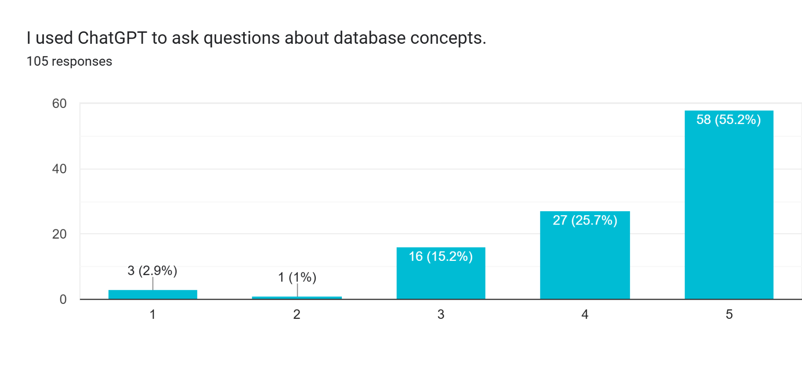
Survey Item: “I used ChatGPT to ask questions about database concepts.” referring to ChatGPT.
A total of 105 students responded to this survey item. The results show that 58 students (55.2%) strongly agreed and 27 students (25.7%) agreed that they used ChatGPT to ask questions about database concepts. This indicates that 80.9% of the respondents expressed a positive response, suggesting that majority of students actively utilized the AI tool during the inquiry-based learning activities.
Meanwhile, 16 students (15.2%) selected neutral, which may indicate that some students used the tool occasionally or were uncertain about its usefulness in asking database-related questions. Only 1 student (1%) disagreed and 3 students (2.9%) strongly disagreed, showing that very few students did not use or did not find the tool helpful for inquiry.
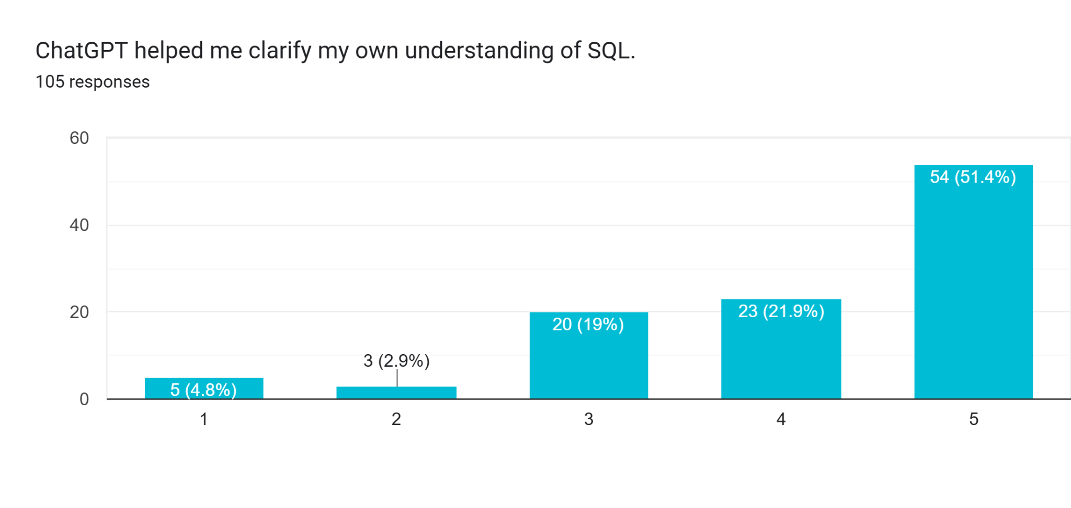
Survey Item: “ChatGPT helped me clarify my own understanding of SQL.” referring to ChatGPT.
A total of 105 students responded to this survey item. The results show that 54 students (51.4%) strongly agreed and 23 students (21.9%) agreed that ChatGPT helped them clarify their understanding of SQL (Structured Query Language) concepts. This means that 73.3% of the respondents expressed a positive perception, indicating that the majority of students found the AI tool helpful in improving their comprehension of database queries and commands.
Meanwhile, 20 students (19%) selected neutral, which may suggest that some students only partially benefited from the tool or relied on other resources such as teacher explanations or classroom materials to fully understand SQL concepts. On the other hand, 3 students (2.9%) disagreed and 5 students (4.8%) strongly disagreed, indicating that a small number of students did not find the AI tool helpful in clarifying SQL concepts.

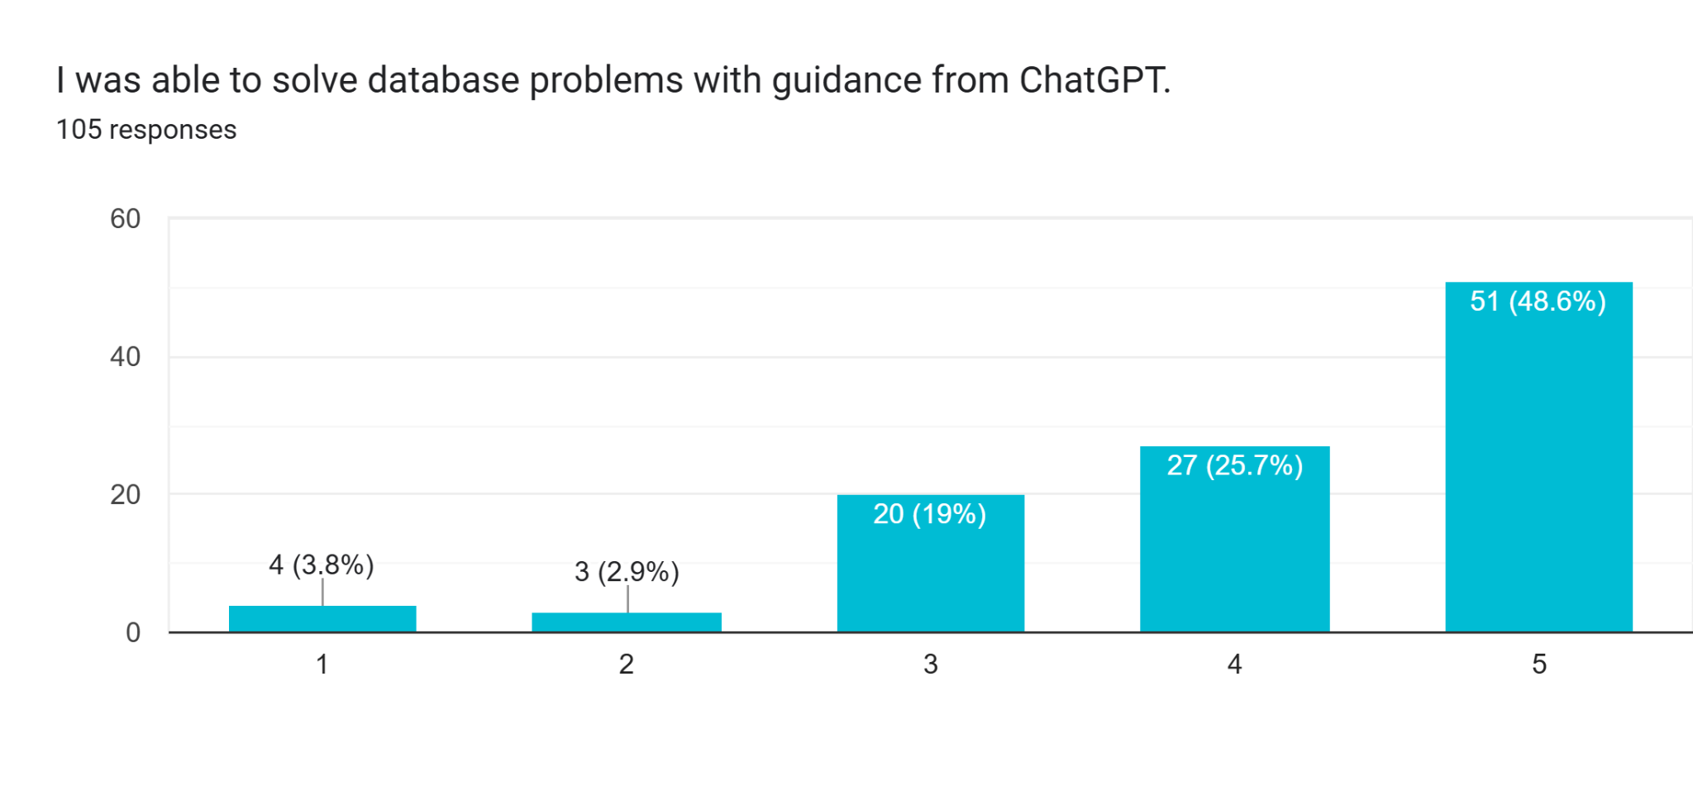

Survey Item: “I was able to solve database problems with guidance from ChatGPT.” referring to ChatGPT.
A total of 105 students participated in this survey item. The results show that 51 students (48.6%) strongly agreed and 27 students (25.7%) agreed that they were able to solve database-related problems with the guidance of ChatGPT. This indicates that 74.3% of the respondents expressed a positive response, suggesting that most students found the AI tool useful in assisting them with database tasks and problem-solving activities.
Meanwhile, 20 students (19%) selected neutral, which may indicate that some students only partially relied on the tool or needed additional explanations from the teacher to fully understand the database problems. On the other hand, 3 students (2.9%) disagreed and 4 students (3.8%) strongly disagreed, showing that only a small percentage of students did not find the AI tool helpful in solving database-related tasks.
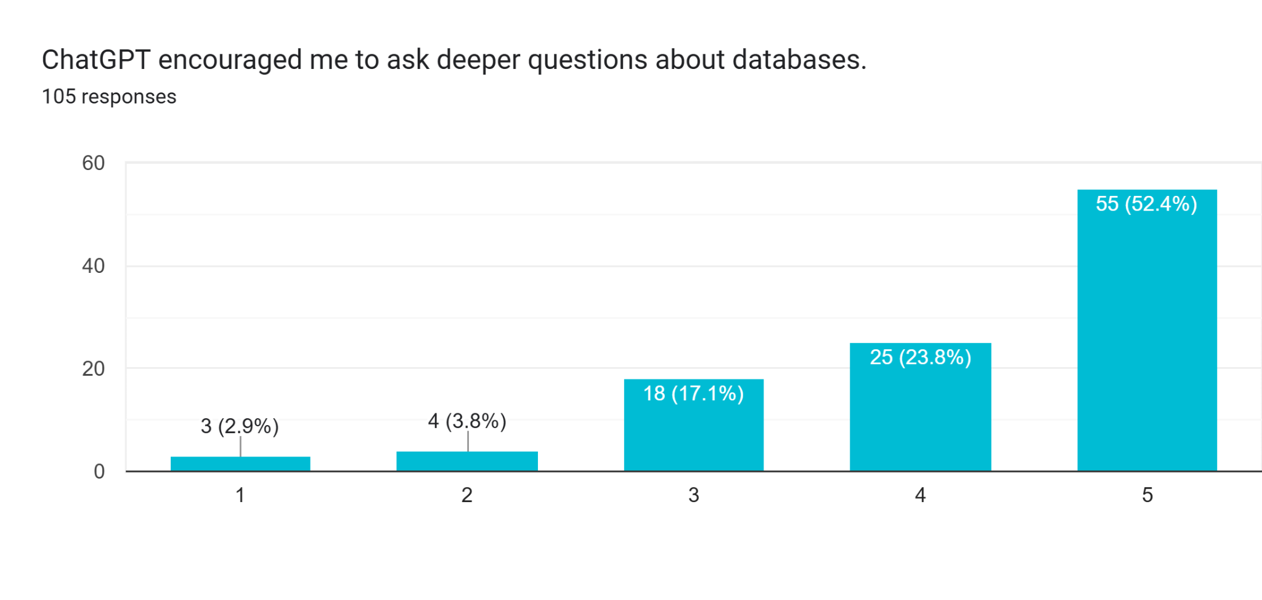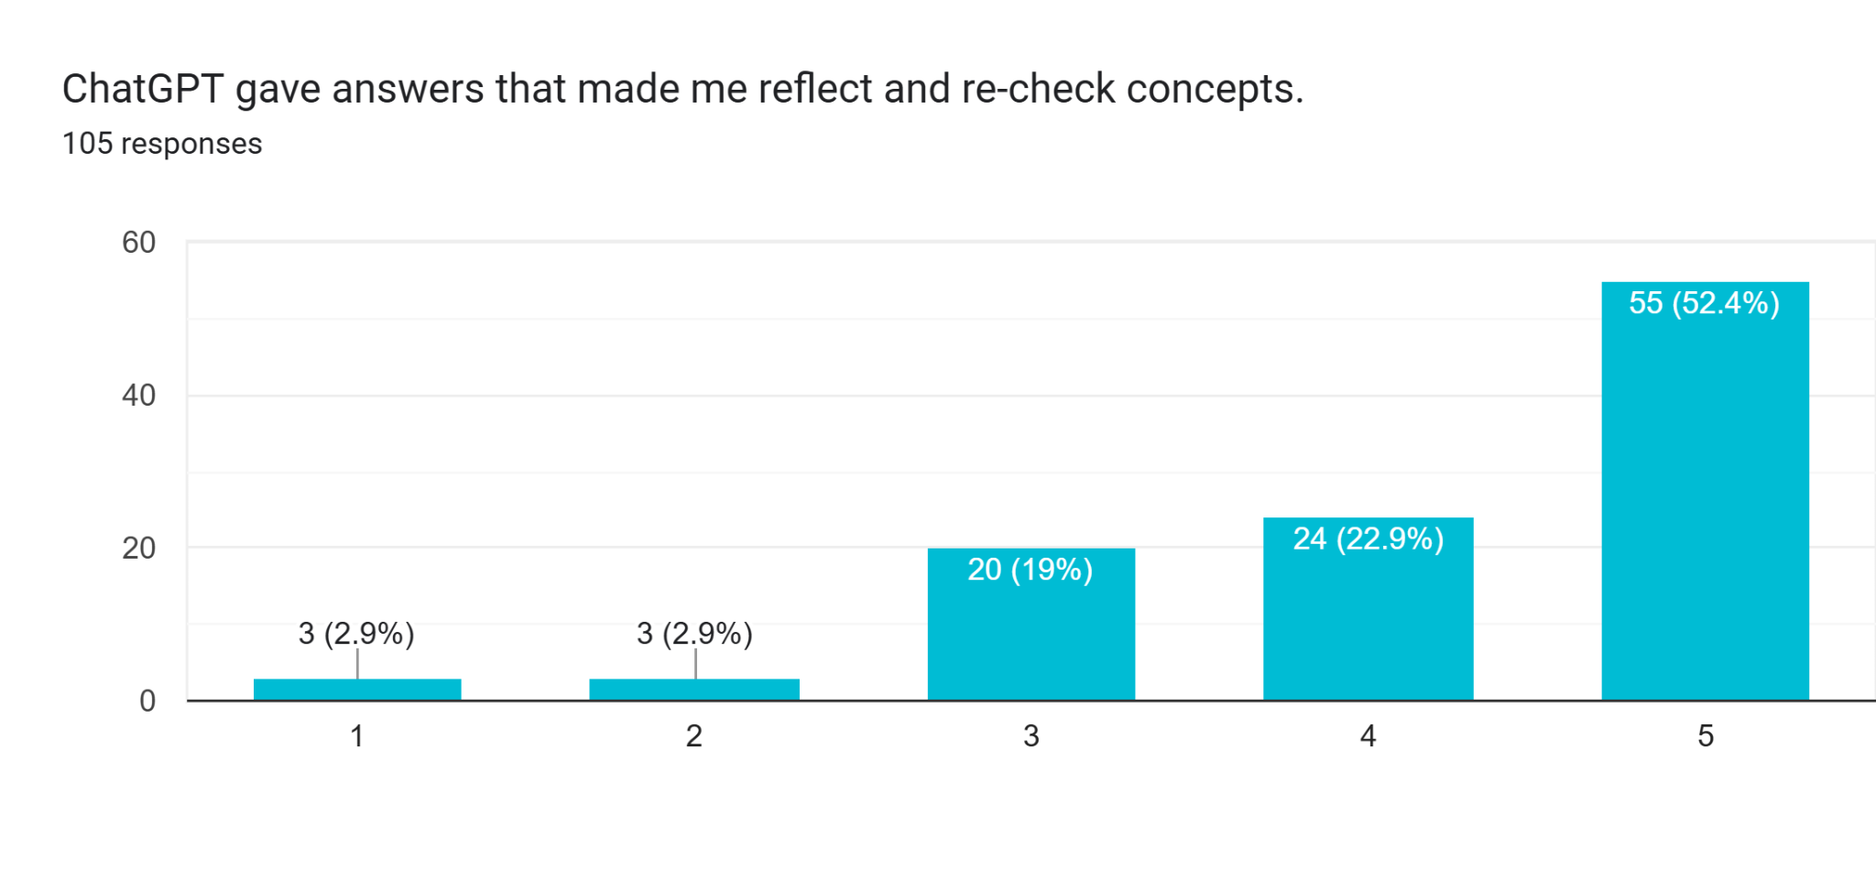Learning and Engagement
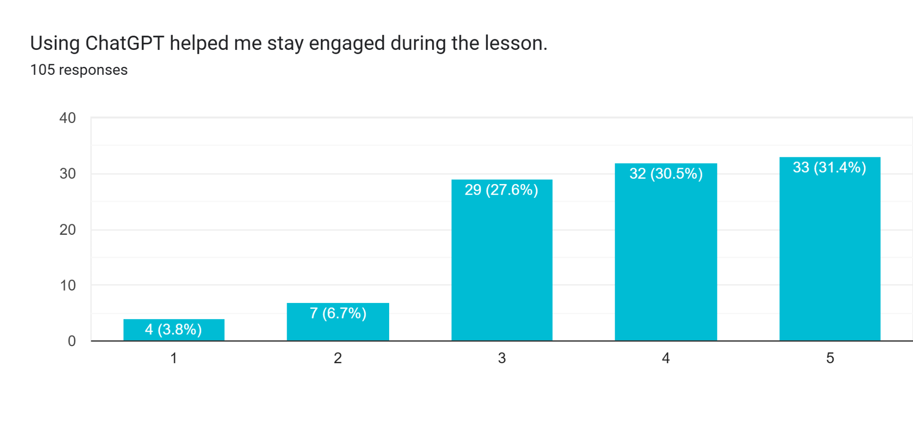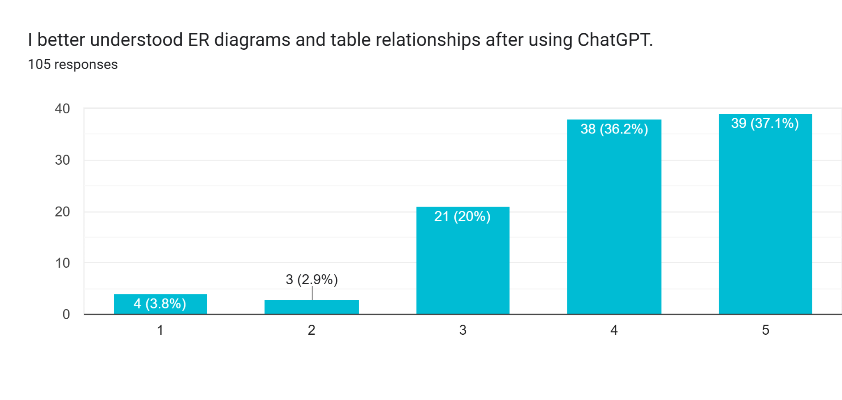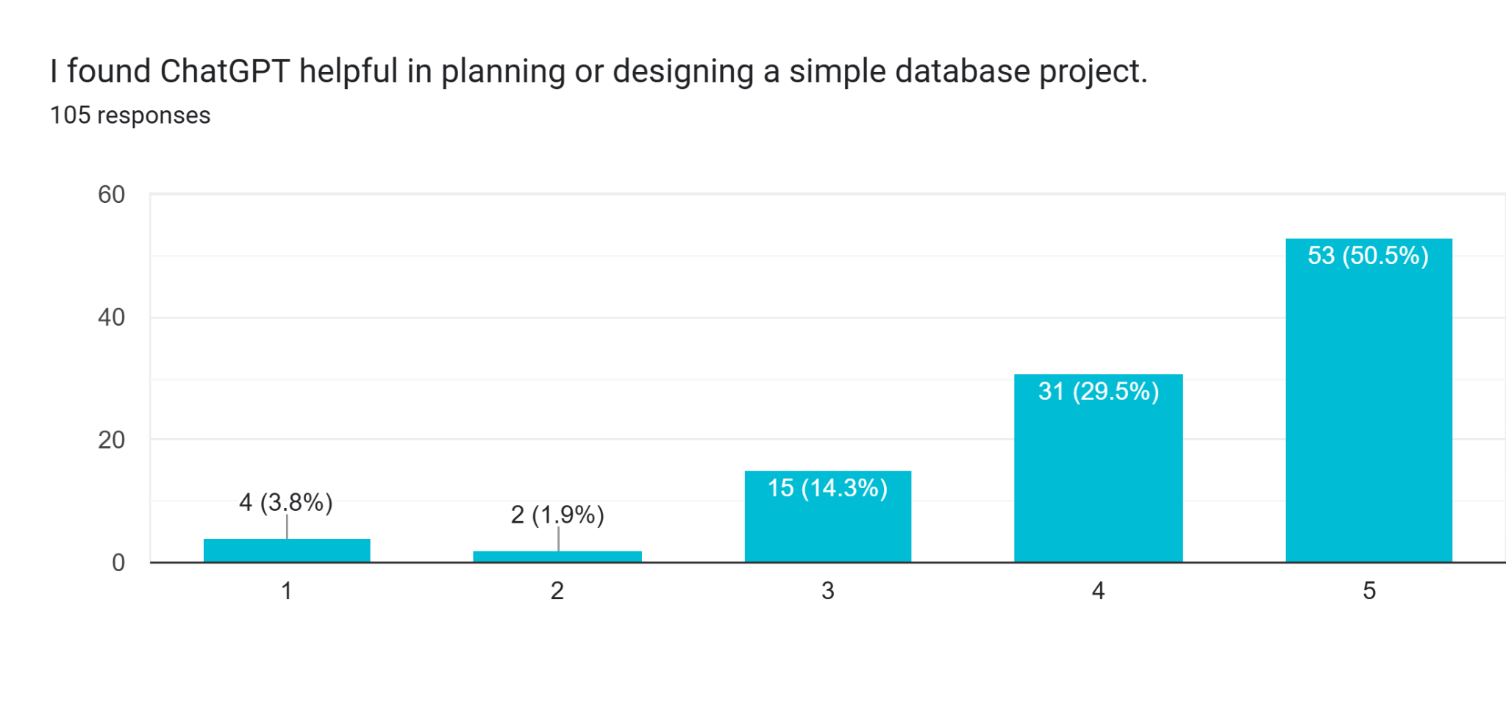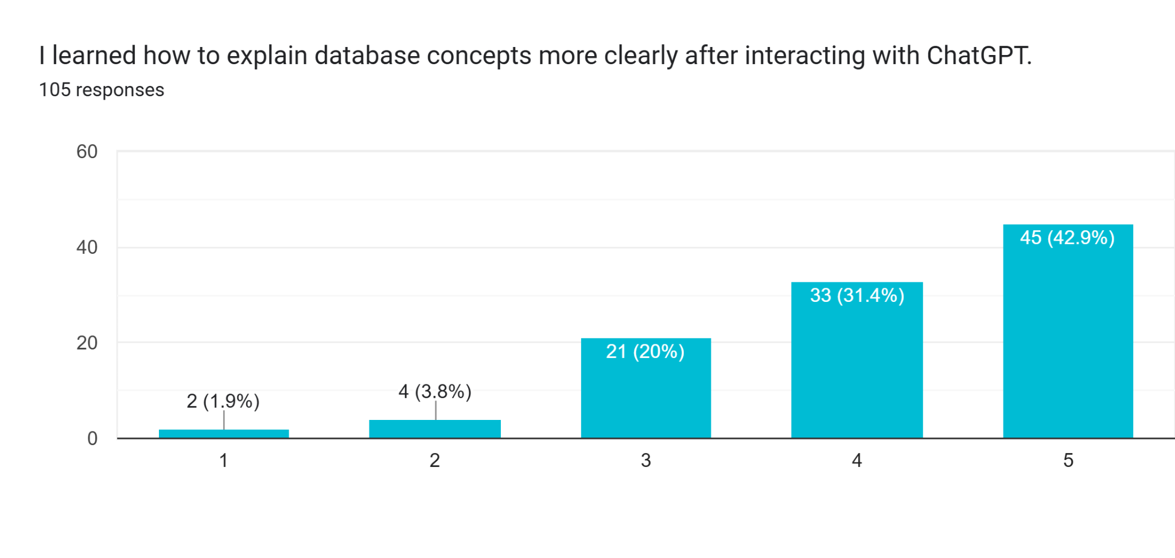
Critical Reflection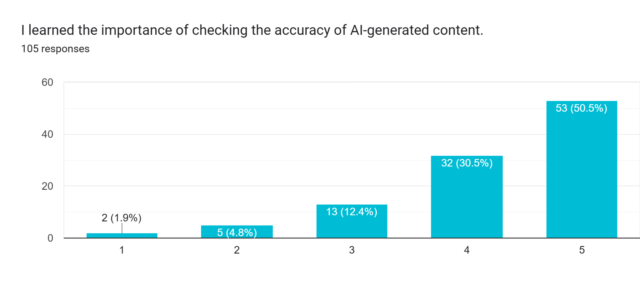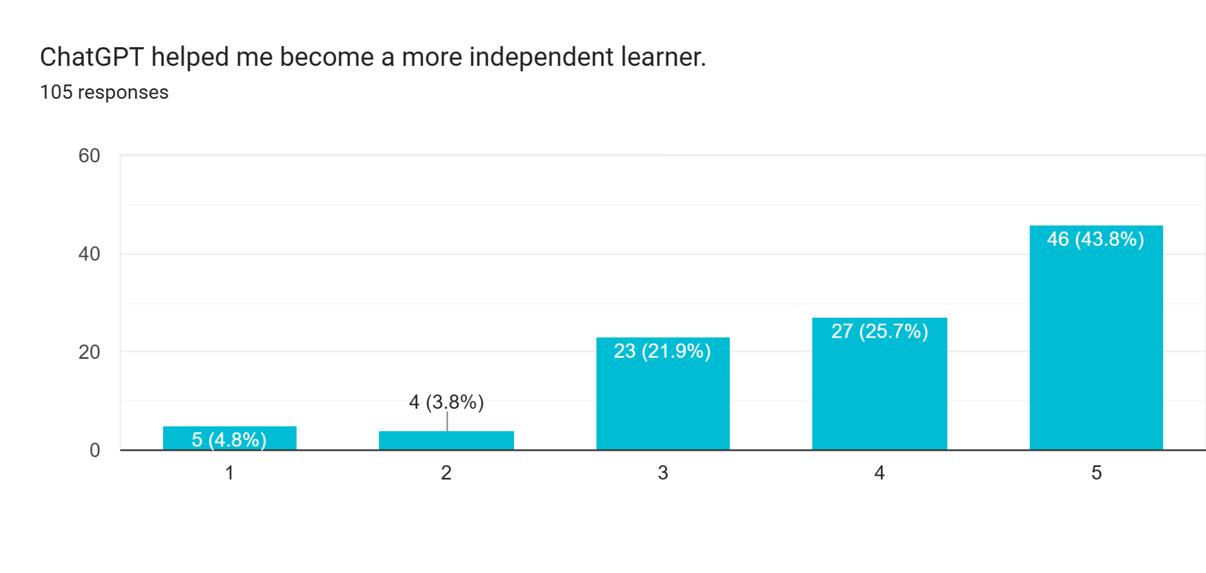

CONCLUSION AND RECOMMENDATION

Enhance the inquiry-based learning of students with the use of technology like ChatGPT
There are times ChatGPT will not give the sufficient answer because of the way student use the prompting styles.

REFERENCES

- Connolly, T., & Begg, C. (2015). Database systems: A practical approach to design, implementation, and management (6th ed.). Pearson.
- Coronel, C., & Morris, S. (2019). Database systems: Design, implementation, & management (13th ed.). Cengage Learning.

- Hmelo-Silver, C. E., Duncan, R. G., & Chinn, C. A. (2007). Scaffolding and achievement in problem-based and inquiry learning: A response to Kirschner, Sweller, and Clark. Educational Psychologist, 42(2), 99–107. https://doi.org/10.1080/00461520701263368
- Kuhlthau, C. C., Maniotes, L. K., & Caspari, A. K. (2015). Guided inquiry: Learning in the 21st century (2nd ed.). Libraries Unlimited.

- Robins, A., Rountree, J., & Rountree, N. (2003). Learning and teaching programming: A review and discussion. Computer Science Education, 13(2), 137–172. https://doi.org/10.1076/csed.13.2.137.14200

- OpenAI. (2023). GPT-4 technical report. https://arxiv.org/abs/2303.08774
- Kasneci, E., Sessler, K., Küchemann, S., Bannert, M., Dementieva, D., Fischer, F., Gasser, U., Groh, G., Günnemann, S., Hüllermeier, E., Krusche, S., Kutyniok, G., Michaeli, T., Nerb, J., Pfeffer, J., Poquet, O., Sailer, M., Schmidt, A., Seidel, T., … Kasneci, G. (2023). ChatGPT for good? On opportunities and challenges of large language models for education. Learning and Individual Differences, 103, 102274. https://doi.org/10.1016/j.lindif.2023.102274
- Zhai, X. (2023). ChatGPT for next generation science learning. Journal of Science Education and Technology, 32(4), 1–5. https://doi.org/10.1007/s10956-023-10031-6

- Holmes, W., Bialik, M., & Fadel, C. (2019). Artificial intelligence in education: Promises and implications for teaching and learning. Center for Curriculum Redesign.

- Holmes, W., Bialik, M., & Fadel, C. (2022). Artificial intelligence in education: Promises and implications for teaching and learning. Center for Curriculum Redesign.

- Kasneci, E., Sessler, K., Küchemann, S., Bannert, M., Dementieva, D., Fischer, F., & Kasneci, G. (2023). ChatGPT for good? On opportunities and challenges of large language models for education. Learning and Individual Differences, 103, 102274.

- Luckin, R., Holmes, W., Griffiths, M., & Forcier, L. B. (2016). Intelligence unleashed: An argument for AI in education. Pearson.

- Sweller, J. (2011). Cognitive load theory. Psychology of Learning and Motivation, 55, 37–76.

- Zawacki-Richter, O., Marín, V. I., Bond, M., & Gouverneur, F. (2019). Systematic review of research on artificial intelligence applications in higher education. International Journal of Educational Technology in Higher Education, 16(1), 39.
- Adeyele, J., & Ramnarain, U. (2024). Teachers’ perceptions of ChatGPT in inquiry-based learning.
https://doi.org/10.1007/s10639-024-XXXXX

- Li, Y., et al. (2024). Inquiry-based learning in STEM education: Enhancing higher-order thinking.
https://doi.org/10.1016/j.compedu.2024.104XXX

- López-Fernández, D., & Vergaz, R. (2025). Use of ChatGPT in database administration education.
https://doi.org/10.1109/TE.2025.XXXXX

- Shoufan, A. (2023). Exploring student perceptions of ChatGPT in higher education.
https://doi.org/10.1186/s41239-023-XXXX-X

- Hadi, M. U., Shafique, M., Imran, M., & Rehman, S. (2023). ChatGPT and its applications in education and research. arXiv. https://arxiv.org/abs/2304.09848

- Liu, Y., Li, X., Zhang, Q., & Chen, J. (2023). Generative AI and large language models: Opportunities and challenges. arXiv. https://arxiv.org/abs/2303.12712

- Lund, B. D., & Wang, T. (2023). Chatting about ChatGPT: Implications for libraries. Library Hi Tech News, 40(3), 15–22. https://doi.org/10.1108/LHTN-01-2023-0009

- Wu, T., Zhang, Y., & Huang, R. (2023). A brief overview of ChatGPT: Technical foundations and applications. arXiv. https://arxiv.org/abs/2304.03738

- Davis, F. D. (1989). Perceived usefulness, perceived ease of use, and user acceptance of information technology. MIS Quarterly, 13(3), 319–340. https://doi.org/10.2307/249008
- Venkatesh, V., & Davis, F. D. (2000). A theoretical extension of the Technology Acceptance Model: Four longitudinal field studies. Management Science, 46(2), 186–204. https://doi.org/10.1287/mnsc.46.2.186.11926

APPENDIX A

Survey Questionnaire

Section A – Use of ChatGPT in Inquiry-Based Activities
No. | Statement | 1 | 2 | 3 | 4 | 5
1 | I used ChatGPT to ask questions about database concepts.
2 | ChatGPT helped me clarify my understanding of SQL.
3 | I was able to solve database problems with guidance from ChatGPT.
4 | ChatGPT encouraged me to ask deeper questions about databases.
5 | ChatGPT gave answers that made me reflect and re-check concepts.

Section B – Learning and Engagement
No. | Statement | 1 | 2 | 3 | 4 | 5
6 | Using ChatGPT helped me stay engaged during the lesson.
7 | I better understood ER diagrams and table relationships after using ChatGPT.
8 | I found ChatGPT helpful in planning or designing a simple database project.
9 | I learned how to explain database concepts more clearly after interacting with ChatGPT.
10 | I would recommend using ChatGPT in future database lessons.

Section C – Critical Reflection
No. | Statement | 1 | 2 | 3 | 4 | 5
11 | I verified ChatGPT’s answers by comparing them with class materials or teacher explanations.
12 | I learned the importance of checking the accuracy of AI-generated content.
13 | ChatGPT helped me become a more independent learner.

